FIFTEEN SHARDS OF LIGHT
LEVEL_05 — «То, что остается»
ART PRODUCTION BIBLE v1.1
Environment production design • Blender technical art • Godot art integration architecture

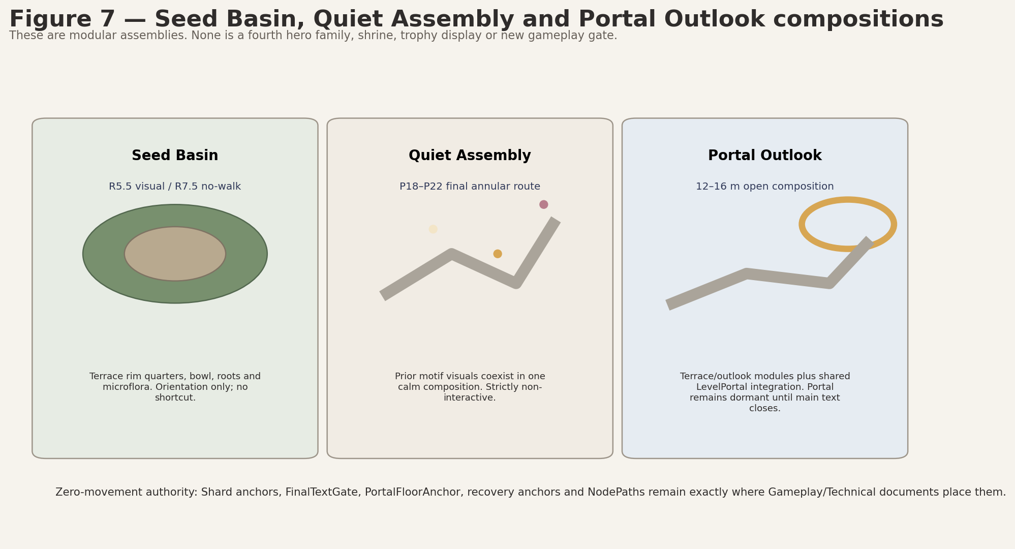
Control | Value
Project | Fifteen Shards of Light
Repository | MindDevastation/fifteen-shards-of-light
Target scene | res://scenes/levels/Level_05.tscn
Document | Level_05_Art_Production_Bible_v1.1.docx
Status | VERSION 1.1 ART-PRODUCTION DESIGN CANDIDATE - repeat Producer review required
Mode | Documentation only — no Blender files, GLBs, textures, materials, Godot wrappers or runtime changes
Audited source snapshot | main = a9380f7afce1c0bb0727ccaf6e3f0e76a13df78d; Level_05 placeholder blob = 43d29b9e8b486e56584e89169675b12ea2d7bddd
Prepared | 27 June 2026

EMOTIONAL SAFETY CONTRACT
The garden and Alena are already alive and valuable. Art progression records the author’s attention and memory; it never repairs, captures, catalogues, surveils, proves knowledge, creates obligation or claims access to her inner state.

Version 1.1 Change Log
Correction | Version 1.1 resolution
Shard-surround registry deduplication | Removed the duplicate shard-surround production entry. L05_ShardRest_Surround_A is the sole canonical visual-only surround, reused x3 around gameplay-owned Shard_10, Shard_11 and Shard_12 anchors.
Canonical path uniqueness audit | Locked unique canonical names, Blender source paths, raw GLB paths and wrapper paths; semantic duplicates and implicit variants are prohibited.
Mesh-backed VFX runtime ownership | Defined one canonical environment wrapper and one sole runtime visual instance owner for every mesh-backed VFX; VFX scenes do not instantiate a second raw GLB or wrapper.
Blender metric unit contract | Added 1 Blender unit = 1 meter while preserving +Z up, authored -Y forward and the approved transform workflow.
Collision naming / conditional export normalization | Locked _COL.glb as the only custom collision suffix and marked every custom collision GLB CONDITIONAL - ART-A08 ONLY; primitive collision remains the baseline.
Full render QA | All pages re-rendered and inspected; clipping, broken tables, comments and tracked changes are prohibited in the delivered file.

0. Document control, source hierarchy and scope

0.1 Four-source authority hierarchy
Priority | Source | Authority in this Bible
1 — Narrative | Level_05_Narrative_and_Level_Scenario_Package_v1.1.docx | Title, exact texts, emotional function, fixed order, safety and MVP boundaries.
2 — Visual | Level_05_Visual_Master_Concept_Package.docx | Inward spiral, blue-hour close-up garden, motif language, state intent, three-family budget.
3 — Gameplay | Level_05_Gameplay_Map_and_Level_Design_Spec_v1.2.docx | Exact P00–P24 coordinates, dimensions, route/clearance, targets, recovery and camera QA.
4 — Technical | Level_05_Technical_Architecture_and_State_Model.docx | Node ownership, authoritative pivots/markers, exact root composition, shared-system boundaries and validation gates.

0.2 Scope boundary
- Defines Boundary Map, layer split, asset registry, production sheets, collision matrix, pivot contracts, material/VFX families, wrapper-first pipeline, priorities and acceptance gates.
- Does not authorize Blender production, GLB export, textures, final materials, Godot wrappers, runtime scenes/scripts, branch, commit, PR, Greybox Development Reference or Codex prompt.
- The current one-shard 12×12 placeholder is factual repository drift only and is not art, route or gameplay canon.

0.3 Art production verdict
VERDICT - VERSION 1.1 CANDIDATE FOR REPEAT PRODUCER ART-PRODUCTION REVIEW
The four Level_05 source documents remain aligned. Version 1.1 corrects registry deduplication, path uniqueness, mesh-backed VFX ownership, metric scale and conditional collision export. The immediate runtime handoff remains primitives only. All listed art assets remain post-greybox and require Producer approval after accepted greybox.

0.4 Current repository snapshot
Item | Verified current fact | Production implication
Level_05.tscn | Flat 12×12 floor, one SoulShard, legacy LevelManager and PoemRewardUI, portal target Level_06. | Replace later; do not infer art layout or shard count from placeholder.
Level_06.tscn | Legacy one-shard placeholder. | Only current portal target is relevant to Level_05.
AGENTS.md | Godot/GDScript and greybox-before-polish constraints remain useful; old 15-micro-level canon is stale. | Preserve narrow scope and no polished assets before greybox.
Preflight refresh | Any later main/PR drift touching Player, Camera, SoulShard, reward/finale, SoulOrb_Follow or LevelPortal invalidates the compatibility snapshot. | Re-audit before Blender or runtime work.

0.5 Document map
Section | Purpose
1 | Production principles
2 | Boundary Map
3 | Layer split and ownership
4 | Coordinate / naming contract
5 | Complete asset registry
6 | Budgets and materials
7 | Production sheets
8 | Collision matrix
9 | Pivot/origin contracts
10 | Wrapper-first workflow
11 | Immediate greybox handoff
12 | Post-greybox art slices
13 | Production priority
14 | Export checklist
15 | Acceptance gates
16 | Risks and handoff

1. Locked production principles
- One continuous inward spiral; no hub, branches, mandatory backtracking or direct Seed Basin shortcut.
- Exactly three later modular families: Terrace / Stone–Moss Kit; Grass / Seed Microflora Kit; Dew / Glow Surface Kit.
- Central Seed Basin, shard rest places, Ordinary Mosaic field, Quiet Assembly and Portal Outlook are compositions, not additional hero families.
- Gameplay scenes exclusively own IDs, target footprints, authoritative pivots, markers, shard anchors, FinalTextGate, PortalFloorAnchor, LevelPortal root, recovery Areas and recovery anchors.
- Raw GLB and art wrappers own visual meshes, approved static collision, materials, optional presentation-only AnimationPlayer and non-authoritative ArtAlignment_* markers only.
- No invisible catch floor. SoftReturnVolume/OOB Areas remain recovery authority. Optional underside collision exists only immediately below visible walkable geometry and never bridges a gap.
- All instances use positive scale. Any required handed or mirrored geometry must be applied in Blender and exported as an explicit asset.
- Visual-only replacement occurs before any collision-proxy replacement. Final art is never part of the initial greybox PR.

2. Boundary Map

2.1 Boundary classes
Boundary class | Exact contract | Owner | Art-production rule
Playable surface | P00–P24 route; 5.5 m minimum, 6–7 m at major curves, pocket entries, shard spaces and outlook. | EnvironmentRoot block surfaces; gameplay dimensions from Spec | Visual mesh may replace primitive after greybox; collision preserved first.
Legal shoulder | 1.25 m minimum outside mandatory route edge. | EnvironmentRoot | No dressing or boundary may reduce it.
Camera-safe corridor | 8.5 m clear corridor centered on mandatory route. | Art/level composition; validated at CP0–CP9 | No tall grass, ruin, arch or VFX density may create severe foreground occlusion.
Hard physical boundary | StaticBody3D belt outside legal route/side spaces. | EnvironmentRoot/Boundaries or approved block-local collision root | Not owned by SafetyRoot or raw GLB gameplay logic; must preserve route openings.
Visible rim | Stone/moss/root edge that visually explains the boundary. | STRUCT / DECOR | Separate from hard collision; may be absent at open route mouths.
Seed Basin no-walk | Exact disk centered (-9,0), R7.5 m. | EnvironmentRoot/Boundaries + GameplayRoot/SafetyRoot/RV_BASIN_DISK | Visual basin R5.5; legal viewing rim begins R8.5. No climbable shortcut.
Soft return envelope | RV_FALL_GLOBAL, perimeter volumes, RV_BASIN_DISK, RV_OUTLOOK_S. | GameplayRoot/SafetyRoot | Art must not overlap or obscure recovery exclusions.
Puzzle clearances | 3.0 m clear radius around 9 gameplay targets. | GameplayRoot/PuzzleRoot | No blocking décor, collision or heavy VFX.
Shard clearances | 3.5 m visual/camera clear radius around Shard_10/11/12. | GameplayRoot/ShardRoot | No pedestal family; use low reusable surround only.
Portal clearance | 4.5 m clear radius around PortalFloorAnchor; shared interaction envelope remains authoritative. | GameplayRoot/PortalRoot | No arch, grass or rim may reduce this envelope.

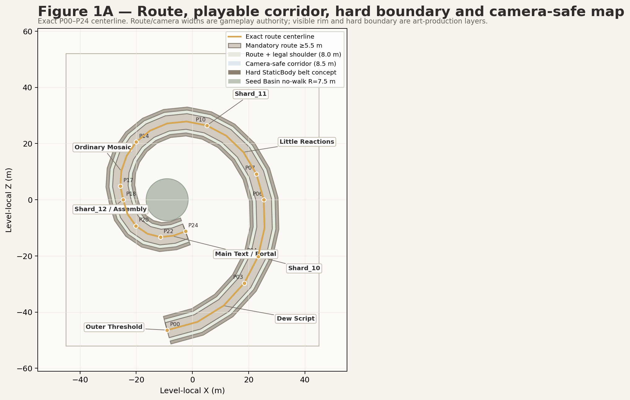
Figure 1A. Exact route, legal shoulder, camera corridor and conceptual hard-boundary belt. Diagram = art-production boundary authority.
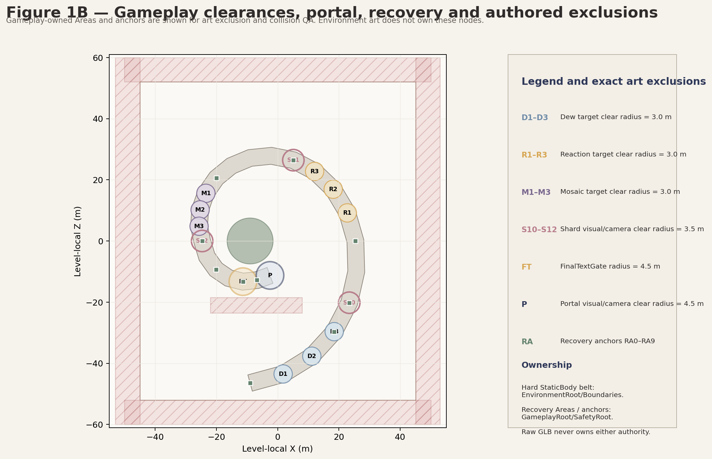
Figure 1B. Target, shard, portal and recovery exclusions. Gameplay nodes remain authoritative.

2.2 Zone boundary schedule
Zone | Approved footprint | Centerline | Required openings / clearances | Safety relation
Block_05_00 Outer Threshold | 12×10 m | P00 | 5.5 m exit; camera corridor open toward Dew entrance | RA0; south perimeter >1.56 m away
Block_05_01 Dew Script Walk | 33×20 m crescent | P01–P03 | Three target R3.0 clear spaces; local route 5.5–7 m | RA1 after completion
Block_05_02 Shard10 Rest Ledge | 10×8 m | P04 | Shard R3.5; no cliff-edge occlusion | RA2
Block_05_03 Moss Bend | 13×22 m curve | P05–P06 | No puzzle; route remains primary | RA3 at P06
Block_05_04 Little Reactions | 22×20 m elongated | P07–P09 | Three R3.0 clear target circles | RA3 / RA4 continuity
Block_05_05 Shard11 Rest Stone | 10×8 m | P10 | Shard R3.5 and camera view to descent | RA4
Block_05_06 Inner Spiral Descent | 22×15 m | P11–P14 | Slope <=8°, no step >0.15 m | RA5 at P14
Block_05_07 Ordinary Mosaic | 19×24 m crescent | P15–P17 | Three R3.0 pad clearances; shared field visible | RA5 / RA6
Block_05_08 Shard12 / Assembly | 18×17 m | P18–P20 | Shard R3.5; final annular route outside basin | RA6 / RA7
Block_05_09 Portal Outlook | annular crescent R8.5–17.5, 235°–315° | P21–P24 | FinalTextGate R4.5; portal R4.5; RV_OUTLOOK_S exclusion | RA8 / RA9

3. Layer split and node ownership
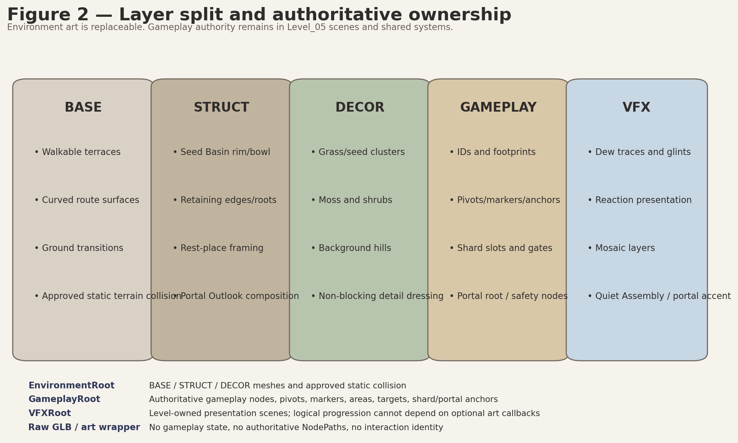
Figure 2. Layer matrix and ownership boundary. Imported art remains non-authoritative.
Layer | Contains | Owner | May contain | Must not contain
BASE | Terrain, route, transitions, elevation, approved static terrain collision | EnvironmentRoot block scenes | MeshInstance3D, StaticBody3D, CollisionShape3D approved after tests | Puzzle IDs, state, Areas, shard/portal/recovery anchors
STRUCT | Seed Basin rim/bowl, retaining roots, low ruins, rest framing, outlook composition | EnvironmentRoot | Visual mesh; optional simple static collision | Gameplay pivots, interaction targets, hidden gates
DECOR | Grass, seeds, moss, roots, shrubs, far silhouettes | EnvironmentRoot / block DecorRoot | Non-blocking visuals, LOD, MultiMesh candidates | Mandatory navigation, progression state, collision that narrows route
GAMEPLAY | Puzzle footprints, IDs, shards, gates, portal root, recovery nodes | GameplayRoot and shared scenes | Authoritative pivots/markers/Areas/targets | Production mesh hierarchy assumptions
VFX | Dew/reaction/mosaic guidance, Quiet Assembly, portal accent, haze | VFXRoot / scenes/levels/level_05/vfx | Godot-only or mesh-backed presentation | Macro progression authority or required success callback

3.1 Authoritative ownership matrix
Authority | Exact owner | Art contract
Route dimensions / exact coordinates | Gameplay Spec + Level_05 parent scene | Zero movement; art conforms around anchors.
Hard StaticBody boundary belt | EnvironmentRoot/Boundaries or approved block-local collision root | Separate from visible rim and SafetyRoot.
Target footprints and IDs | GameplayRoot/PuzzleRoot | Art shell follows; GLB never owns target identity.
Rotation/animation pivots | Gameplay scenes | Mesh origin is documented, but authoritative pivots remain parent-owned.
Shard anchors / slots | GameplayRoot/ShardRoot | Low surround only; no position change.
FinalTextGate / PortalFloorAnchor / LevelPortal | GameplayRoot/RouteAuthorityRoot and GameplayRoot/PortalRoot | Art clears exact radius and never duplicates shared portal ownership.
Recovery Areas and anchors | GameplayRoot/SafetyRoot | Art keeps volumes clear; SafetyRoot owns no hard boundary mesh.
SoulOrb_Follow | Shared existing scene under PlayerRoot | Reuse only; no Level_05 orb asset or fourth semi-hero family.

4. Blender, GLB and Godot coordinate / transform contract

4.1 Coordinate and dimension-axis conventions
Domain | Locked convention
Blender source | +Z up; project-authored forward = -Y. Do not manually axis-bake merely to imitate Godot.
Blender metric unit | 1 Blender unit = 1 meter.
Blender rectangular dimensions | local X width × local Y depth/forward × local Z height.
Circular dimensions | diameter/radius × height, always stated explicitly.
Godot import | +Y up; imported -Z forward through standard GLB/glTF conversion.
Godot imported rectangular dimensions | local X width × local Z depth/forward × local Y height.
Origin workflow | Set the required origin first. Place exported root at world origin. Apply rotation and scale. Final root transforms: location 0/0/0; rotation 0/0/0; scale 1/1/1.
Placement scale | Positive scale only. Mirrored/handed geometry is applied in Blender and exported explicitly.
Verification | Test-import every GLB in a Godot import scene; verify scale, orientation, pivot, materials, normals and collision independently.

4.2 Naming and exact-path conventions
- Prefix all production assets with L05_. Final suffix _A/_B denotes geometry variant only, never puzzle or shard identity.
- Canonical geometry has exactly one Blender source path, one raw GLB path, optional collision GLB or “N/A - Godot primitive”, and one environment wrapper path.
- Environment wrappers remain under scenes/environment/level_05/**. Level-owned VFX scenes remain under scenes/levels/level_05/vfx/**.
- Non-authoritative wrapper markers use ArtAlignment_* prefix. Authoritative Gameplay NodePaths never point into imported GLB internals.

- Canonical custom collision suffix: _COL.glb. No alternative collision suffix is permitted.
- Every custom collision GLB is CONDITIONAL - ART-A08 ONLY. It is created only after accepted greybox and evidence that the Godot primitive baseline is insufficient.
- Primitive collision is the baseline. Visual-only replacement always precedes any collision-proxy replacement. Invisible catch floors and geometry that bridges gaps remain forbidden.

5. Complete asset registry
Registry rule: every actual art asset below is post-greybox. “Greybox input” means dimensions/proxy intent only; it never authorizes a .blend, .glb, texture, final material or wrapper in the initial runtime PR.

5.0 Canonical registry uniqueness contract
Audit item | Mandatory registry rule
Canonical asset names | Unique across BASE, STRUCT, DECOR and GAMEPLAY-VISUAL registries.
Blender source paths | Unique per canonical geometry asset. One canonical geometry source cannot be silently duplicated under another folder.
Raw GLB paths | Unique per canonical geometry asset. Intentional VFX reuse references the registered GLB and does not create a second geometry file.
Godot wrapper paths | Unique per canonical geometry asset. Each canonical geometry has one wrapper and one runtime visual owner.
Semantic duplicates | Prohibited. Assets with the same purpose, dimensions and placement role must be merged into one canonical entry.
_A / _B suffix | Used only for real geometry or silhouette variation. Puzzle identity, shard identity, height labels and placement roles do not create fake variants.
Intentional mesh reuse | Marked explicitly as reuse xN or existing registered visual asset + Godot presentation; reuse is not a new asset.

5.1 BASE registry
Canonical asset | Purpose | Blender dimensions | Origin / pivot | Variant strategy | Material families | Collision policy | LOD / triangle budget | Greybox input | Post-greybox priority
L05_Terrace_Path_Straight_A | Reusable broad walkable segment | 5.5 × 6.0 × 0.5 m | Bottom center; -Y forward | One reusable geometry | M_L05_Stone_Matte; M_L05_Moss_Velvet | Accepted primitive first; optional simplified static proxy later | 2–6k tris; LOD1 50% | GB-P0 proxy dimensions only | ART-P1
L05_Terrace_Path_Curve_Gentle_A | 45° gentle spiral curve | 5.5 m lane; centerline R8.0 m; 0.5 m height | Arc center at world origin; start tangent -Y | One reusable geometry; rotated positive-scale instances | M_L05_Stone_Matte; M_L05_Moss_Velvet | Accepted primitive/CSG first; custom proxy only after test | 3–8k; LOD1 50% | GB-P0 proxy dimensions only | ART-P1
L05_Terrace_Path_Curve_Tight_A | 45° tighter curve for local transitions | 5.5 m lane; centerline R6.0 m; 0.5 m height | Arc center at world origin; start tangent -Y | One reusable geometry; rotated positive-scale instances | M_L05_Stone_Matte; M_L05_Moss_Velvet | Accepted primitive first; optional custom proxy | 3–8k; LOD1 50% | GB-P0 proxy dimensions only | ART-P1
L05_Terrace_Ramp_Rise020_A | Low elevation transition | 5.5 × 8.0 × 0.4 m envelope; rise 0.20 m | Low-end bottom center; -Y uphill | One reusable geometry | M_L05_Stone_Matte; M_L05_Moss_Velvet | Accepted ramp primitive first | 2–6k; LOD1 50% | GB-P0 proxy dimensions only | ART-P1
L05_Terrace_Ramp_Rise040_A | Higher but still safe transition | 5.5 × 8.0 × 0.6 m envelope; rise 0.40 m | Low-end bottom center; -Y uphill | One reusable geometry | M_L05_Stone_Matte; M_L05_Moss_Velvet | Accepted ramp primitive first | 2–6k; LOD1 50% | GB-P0 proxy dimensions only | ART-P1
L05_Terrace_Transition_Cap_A | Straight/curve/ramp seam cap | 5.5 × 3.0 × 0.5 m | Bottom center; -Y forward | One reusable geometry | M_L05_Stone_Matte; M_L05_Moss_Velvet | Accepted primitive first | 1–3k; no LOD required | GB-P0 proxy dimensions only | ART-P1
L05_Terrace_Pocket_10x8_A | Reusable dry shard/rest pocket | 10.0 × 8.0 × 0.5 m | Bottom center; -Y entry | One reusable geometry for Shard_10/11 compositions | M_L05_Stone_Matte; M_L05_Moss_Velvet | Accepted box/convex proxy first | 3–8k; LOD1 50% | GB-P0 proxy dimensions only | ART-P1
L05_Terrace_Pocket_18x14_A | Little Reactions elongated pocket base | 18.0 × 14.0 × 0.5 m | Bottom center; -Y entry | One geometry | M_L05_Stone_Matte; M_L05_Moss_Velvet | Accepted primitive composite first | 5–12k; LOD1 50% | GB-P0 proxy dimensions only | ART-P1
L05_Terrace_Crescent_20x16_A | Ordinary Mosaic crescent base | 20.0 × 16.0 × 0.5 m envelope | Bottom center; opening toward -Y | One geometry | M_L05_Stone_Matte; M_L05_Moss_Velvet | Accepted primitive composite first | 6–14k; LOD1 50% | GB-P0 proxy dimensions only | ART-P1
L05_Terrace_Outlook_16x12_A | Portal Outlook walkable composition base | 16.0 × 12.0 × 0.5 m | Bottom center; -Y approach | One geometry | M_L05_Stone_Matte; M_L05_Moss_Velvet | Accepted primitive first | 5–12k; LOD1 50% | GB-P0 proxy dimensions only | ART-P1
L05_Terrace_Edge_Straight_A | Visible route edge / retaining lip | 1.0 × 6.0 × 0.8 m | Bottom center; -Y along length | One reusable geometry | M_L05_Stone_Matte; M_L05_Moss_Velvet | Visible rim collision separate from authoritative hard belt | 1–3k; LOD1 optional | GB-P0 dimensions only | ART-P2
L05_Terrace_Edge_Curve_A | Visible curved route edge | 1.0 m width; R8.0 m; 45°; 0.8 m high | Arc center; start tangent -Y | One reusable geometry | M_L05_Stone_Matte; M_L05_Moss_Velvet | Visible rim collision separate; never crosses route opening | 2–4k; LOD1 optional | GB-P0 dimensions only | ART-P2
L05_Terrace_Underside_Straight_A | Visible underside directly below straight route | 5.5 × 6.0 × 1.2 m | Top center; -Y forward | One reusable geometry | M_L05_Stone_Matte | No collision unless immediately beneath visible walkable surface; never bridge gaps | 1–3k; LOD1 40% | Not in initial PR | ART-P2
L05_Terrace_Underside_Curve_A | Visible underside directly below curved route | 5.5 m lane; R8.0 m; 45°; 1.2 m depth | Arc center at top plane | One reusable geometry | M_L05_Stone_Matte | Same restriction; no catch floor | 2–5k; LOD1 40% | Not in initial PR | ART-P2

5.1B Exact production paths
Canonical asset | Blender source path | Raw GLB path | Collision GLB / primitive baseline | Godot wrapper path
L05_Terrace_Path_Straight_A | assets/blender/level_05/base/L05_Terrace_Path_Straight_A.blend | assets/environment/level_05/base/L05_Terrace_Path_Straight_A.glb | N/A - Godot primitive baseline | scenes/environment/level_05/base/L05_Terrace_Path_Straight_A.tscn
L05_Terrace_Path_Curve_Gentle_A | assets/blender/level_05/base/L05_Terrace_Path_Curve_Gentle_A.blend | assets/environment/level_05/base/L05_Terrace_Path_Curve_Gentle_A.glb | CONDITIONAL - ART-A08 ONLY: assets/environment/level_05/base/L05_Terrace_Path_Curve_Gentle_A_COL.glb | scenes/environment/level_05/base/L05_Terrace_Path_Curve_Gentle_A.tscn
L05_Terrace_Path_Curve_Tight_A | assets/blender/level_05/base/L05_Terrace_Path_Curve_Tight_A.blend | assets/environment/level_05/base/L05_Terrace_Path_Curve_Tight_A.glb | CONDITIONAL - ART-A08 ONLY: assets/environment/level_05/base/L05_Terrace_Path_Curve_Tight_A_COL.glb | scenes/environment/level_05/base/L05_Terrace_Path_Curve_Tight_A.tscn
L05_Terrace_Ramp_Rise020_A | assets/blender/level_05/base/L05_Terrace_Ramp_Rise020_A.blend | assets/environment/level_05/base/L05_Terrace_Ramp_Rise020_A.glb | N/A - Godot primitive baseline | scenes/environment/level_05/base/L05_Terrace_Ramp_Rise020_A.tscn
L05_Terrace_Ramp_Rise040_A | assets/blender/level_05/base/L05_Terrace_Ramp_Rise040_A.blend | assets/environment/level_05/base/L05_Terrace_Ramp_Rise040_A.glb | N/A - Godot primitive baseline | scenes/environment/level_05/base/L05_Terrace_Ramp_Rise040_A.tscn
L05_Terrace_Transition_Cap_A | assets/blender/level_05/base/L05_Terrace_Transition_Cap_A.blend | assets/environment/level_05/base/L05_Terrace_Transition_Cap_A.glb | N/A - Godot primitive baseline | scenes/environment/level_05/base/L05_Terrace_Transition_Cap_A.tscn
L05_Terrace_Pocket_10x8_A | assets/blender/level_05/base/L05_Terrace_Pocket_10x8_A.blend | assets/environment/level_05/base/L05_Terrace_Pocket_10x8_A.glb | CONDITIONAL - ART-A08 ONLY: assets/environment/level_05/base/L05_Terrace_Pocket_10x8_A_COL.glb | scenes/environment/level_05/base/L05_Terrace_Pocket_10x8_A.tscn
L05_Terrace_Pocket_18x14_A | assets/blender/level_05/base/L05_Terrace_Pocket_18x14_A.blend | assets/environment/level_05/base/L05_Terrace_Pocket_18x14_A.glb | CONDITIONAL - ART-A08 ONLY: assets/environment/level_05/base/L05_Terrace_Pocket_18x14_A_COL.glb | scenes/environment/level_05/base/L05_Terrace_Pocket_18x14_A.tscn
L05_Terrace_Crescent_20x16_A | assets/blender/level_05/base/L05_Terrace_Crescent_20x16_A.blend | assets/environment/level_05/base/L05_Terrace_Crescent_20x16_A.glb | CONDITIONAL - ART-A08 ONLY: assets/environment/level_05/base/L05_Terrace_Crescent_20x16_A_COL.glb | scenes/environment/level_05/base/L05_Terrace_Crescent_20x16_A.tscn
L05_Terrace_Outlook_16x12_A | assets/blender/level_05/base/L05_Terrace_Outlook_16x12_A.blend | assets/environment/level_05/base/L05_Terrace_Outlook_16x12_A.glb | CONDITIONAL - ART-A08 ONLY: assets/environment/level_05/base/L05_Terrace_Outlook_16x12_A_COL.glb | scenes/environment/level_05/base/L05_Terrace_Outlook_16x12_A.tscn
L05_Terrace_Edge_Straight_A | assets/blender/level_05/base/L05_Terrace_Edge_Straight_A.blend | assets/environment/level_05/base/L05_Terrace_Edge_Straight_A.glb | N/A - Godot primitive baseline | scenes/environment/level_05/base/L05_Terrace_Edge_Straight_A.tscn
L05_Terrace_Edge_Curve_A | assets/blender/level_05/base/L05_Terrace_Edge_Curve_A.blend | assets/environment/level_05/base/L05_Terrace_Edge_Curve_A.glb | N/A - Godot primitive baseline | scenes/environment/level_05/base/L05_Terrace_Edge_Curve_A.tscn
L05_Terrace_Underside_Straight_A | assets/blender/level_05/base/L05_Terrace_Underside_Straight_A.blend | assets/environment/level_05/base/L05_Terrace_Underside_Straight_A.glb | N/A - Godot primitive baseline | scenes/environment/level_05/base/L05_Terrace_Underside_Straight_A.tscn
L05_Terrace_Underside_Curve_A | assets/blender/level_05/base/L05_Terrace_Underside_Curve_A.blend | assets/environment/level_05/base/L05_Terrace_Underside_Curve_A.glb | N/A - Godot primitive baseline | scenes/environment/level_05/base/L05_Terrace_Underside_Curve_A.tscn

5.2 STRUCT registry
Canonical asset | Purpose | Blender dimensions | Origin / pivot | Variant strategy | Material families | Collision policy | LOD / triangle budget | Greybox input | Post-greybox priority
L05_SeedBasin_Rim_Quarter_A | Seed Basin visual rim, four rotated instances | Quarter ring; inner R5.5 m; outer R7.0 m; 0.8 m high | Basin center at origin | One geometry; 4 rotations, positive scale | M_L05_Stone_Matte; M_L05_Moss_Velvet | Visible rim only; hard exclusion remains EnvironmentRoot/Boundaries + Gameplay RV_BASIN_DISK | 4–10k; LOD1 45% | GB-P0 primitive ring only | ART-P1
L05_SeedBasin_Bowl_A | Non-walkable visual basin interior | Diameter 11.0 m × 1.2 m depth | Center at upper plane | One geometry | M_L05_Stone_Matte; M_L05_Moss_Velvet | No authoritative collision in raw GLB; gameplay exclusion already defined | 5–12k; LOD1 40% | GB-P0 primitive visual only | ART-P2
L05_RetainingRoot_Straight_A | Soft non-climbable retaining composition | 1.2 × 5.0 × 1.1 m | Bottom center; -Y along run | One geometry | M_L05_Stone_Matte; M_L05_Seed_Dry | Static blocker only when approved; otherwise visual | 2–6k; LOD1 50% | GB-P0 blocker proxy only | ART-P2
L05_RetainingRoot_Curve_A | Curved non-climbable retaining composition | 1.2 m width; R7.5 m; 45°; 1.1 m high | Arc center | One geometry | M_L05_Stone_Matte; M_L05_Seed_Dry | Same; cannot reduce route/camera corridor | 3–7k; LOD1 50% | GB-P0 blocker proxy only | ART-P2
L05_RuinMarker_Low_A | Low crescent landmark fragment | 3.0 × 1.0 × 1.8 m | Bottom center; -Y face | Variant A explicit geometry | M_L05_Stone_Matte; M_L05_Moss_Velvet | Simple box/convex only if blocker-approved | 1–4k; LOD1 optional | Not in initial PR | ART-P2
L05_RuinMarker_Low_B | Low upright landmark fragment | 2.0 × 1.2 × 2.4 m | Bottom center; -Y face | Variant B explicit geometry | M_L05_Stone_Matte; M_L05_Moss_Velvet | Simple box/convex only if blocker-approved | 1–4k; LOD1 optional | Not in initial PR | ART-P2
L05_RestStone_A | Reusable broad rest stone | 3.2 × 2.4 × 0.45 m | Bottom center | One geometry | M_L05_Stone_Matte; M_L05_Moss_Velvet | No separate collision if embedded in accepted floor; otherwise simple box | 1–3k; no LOD | GB-P0 primitive only | ART-P2
L05_PortalOutlook_ArchFragment_A | Restrained outlook fragment, not portal owner | 4.0 × 1.0 × 2.8 m | Bottom center; -Y open face | One geometry | M_L05_Stone_Matte; M_L05_Moss_Velvet | Simple blocker only after portal/camera clearance tests | 2–6k; LOD1 optional | Not in initial PR | ART-P2
L05_PortalOutlook_Edge_A | Outer visual rim of outlook | 1.0 × 8.0 × 0.8 m | Bottom center; -Y along edge | One geometry | M_L05_Stone_Matte; M_L05_Moss_Velvet | Separate from hard boundary; must clear portal R4.5 | 2–5k; LOD1 optional | GB-P0 rim proxy only | ART-P2

5.2B Exact production paths
Canonical asset | Blender source path | Raw GLB path | Collision GLB / primitive baseline | Godot wrapper path
L05_SeedBasin_Rim_Quarter_A | assets/blender/level_05/struct/L05_SeedBasin_Rim_Quarter_A.blend | assets/environment/level_05/struct/L05_SeedBasin_Rim_Quarter_A.glb | CONDITIONAL - ART-A08 ONLY: assets/environment/level_05/struct/L05_SeedBasin_Rim_Quarter_A_COL.glb | scenes/environment/level_05/struct/L05_SeedBasin_Rim_Quarter_A.tscn
L05_SeedBasin_Bowl_A | assets/blender/level_05/struct/L05_SeedBasin_Bowl_A.blend | assets/environment/level_05/struct/L05_SeedBasin_Bowl_A.glb | N/A - Godot primitive baseline | scenes/environment/level_05/struct/L05_SeedBasin_Bowl_A.tscn
L05_RetainingRoot_Straight_A | assets/blender/level_05/struct/L05_RetainingRoot_Straight_A.blend | assets/environment/level_05/struct/L05_RetainingRoot_Straight_A.glb | N/A - Godot primitive baseline | scenes/environment/level_05/struct/L05_RetainingRoot_Straight_A.tscn
L05_RetainingRoot_Curve_A | assets/blender/level_05/struct/L05_RetainingRoot_Curve_A.blend | assets/environment/level_05/struct/L05_RetainingRoot_Curve_A.glb | N/A - Godot primitive baseline | scenes/environment/level_05/struct/L05_RetainingRoot_Curve_A.tscn
L05_RuinMarker_Low_A | assets/blender/level_05/struct/L05_RuinMarker_Low_A.blend | assets/environment/level_05/struct/L05_RuinMarker_Low_A.glb | N/A - Godot primitive baseline | scenes/environment/level_05/struct/L05_RuinMarker_Low_A.tscn
L05_RuinMarker_Low_B | assets/blender/level_05/struct/L05_RuinMarker_Low_B.blend | assets/environment/level_05/struct/L05_RuinMarker_Low_B.glb | N/A - Godot primitive baseline | scenes/environment/level_05/struct/L05_RuinMarker_Low_B.tscn
L05_RestStone_A | assets/blender/level_05/struct/L05_RestStone_A.blend | assets/environment/level_05/struct/L05_RestStone_A.glb | N/A - Godot primitive baseline | scenes/environment/level_05/struct/L05_RestStone_A.tscn
L05_PortalOutlook_ArchFragment_A | assets/blender/level_05/struct/L05_PortalOutlook_ArchFragment_A.blend | assets/environment/level_05/struct/L05_PortalOutlook_ArchFragment_A.glb | N/A - Godot primitive baseline | scenes/environment/level_05/struct/L05_PortalOutlook_ArchFragment_A.tscn
L05_PortalOutlook_Edge_A | assets/blender/level_05/struct/L05_PortalOutlook_Edge_A.blend | assets/environment/level_05/struct/L05_PortalOutlook_Edge_A.glb | N/A - Godot primitive baseline | scenes/environment/level_05/struct/L05_PortalOutlook_Edge_A.tscn

5.3 DECOR registry
Canonical asset | Purpose | Blender dimensions | Origin / pivot | Variant strategy | Material families | Collision policy | LOD / triangle budget | Greybox input | Post-greybox priority
L05_GrassCluster_Tall_A | Tall close-up grass silhouette | 1.8 × 1.4 × 2.8 m | Ground center | Variant A explicit | M_L05_Moss_Velvet | No collision | 0.4–1.5k; billboard/LOD1 | Not in initial PR | ART-P2
L05_GrassCluster_Tall_B | Tall grass alternate silhouette | 1.6 × 1.6 × 2.5 m | Ground center | Variant B explicit | M_L05_Moss_Velvet | No collision | 0.4–1.5k; billboard/LOD1 | Not in initial PR | ART-P2
L05_GrassCluster_Low_A | Low path-edge grass | 1.6 × 1.2 × 0.9 m | Ground center | One geometry | M_L05_Moss_Velvet | No collision | 0.2–0.8k; no LOD | Not in initial PR | ART-P3
L05_SeedHead_A | Ordinary dry seed-head prop | 0.7 × 0.7 × 2.2 m | Stem base | One geometry | M_L05_Seed_Dry | No collision | 0.3–1.2k; LOD1 optional | Not in initial PR | ART-P2
L05_SeedPod_Cluster_A | Non-interactive seed-pod cluster | 1.5 × 1.2 × 1.8 m | Ground center | One geometry | M_L05_Seed_Dry | No collision | 0.6–2k; LOD1 optional | Not in initial PR | ART-P2
L05_MossPatch_A | Reusable floor moss patch | 2.0 × 1.6 × 0.08 m | Bottom center | One geometry/decal mesh | M_L05_Moss_Velvet | No collision | 0.1–0.5k; no LOD | Not in initial PR | ART-P3
L05_MossEdgeStrip_A | Route-edge moss seam | 0.4 × 4.0 × 0.15 m | Bottom center; -Y length | One geometry | M_L05_Moss_Velvet | No collision | 0.2–0.8k; no LOD | Not in initial PR | ART-P3
L05_RootCluster_A | Low decorative root cluster | 2.5 × 1.5 × 0.7 m | Ground center | One geometry | M_L05_Seed_Dry | No collision unless approved blocker composition | 0.8–2.5k; LOD1 optional | Not in initial PR | ART-P3
L05_Shrub_Low_A | Low microflora mass | 2.0 × 1.6 × 1.2 m | Ground center | One geometry | M_L05_Moss_Velvet | No collision | 0.5–1.8k; billboard/LOD1 | Not in initial PR | ART-P3
L05_BackgroundHill_A | Low-detail far silhouette | 20 × 5 × 8 m | Bottom center; -Y view face | Variant A explicit | M_L05_Background_Matte | No collision | 1–4k; LOD1 25% | Not in initial PR | ART-P3
L05_BackgroundHill_B | Low-detail alternate far silhouette | 16 × 6 × 10 m | Bottom center; -Y view face | Variant B explicit | M_L05_Background_Matte | No collision | 1–4k; LOD1 25% | Not in initial PR | ART-P3

5.3B Exact production paths
Canonical asset | Blender source path | Raw GLB path | Collision GLB / primitive baseline | Godot wrapper path
L05_GrassCluster_Tall_A | assets/blender/level_05/decor/L05_GrassCluster_Tall_A.blend | assets/environment/level_05/decor/L05_GrassCluster_Tall_A.glb | N/A - Godot primitive baseline | scenes/environment/level_05/decor/L05_GrassCluster_Tall_A.tscn
L05_GrassCluster_Tall_B | assets/blender/level_05/decor/L05_GrassCluster_Tall_B.blend | assets/environment/level_05/decor/L05_GrassCluster_Tall_B.glb | N/A - Godot primitive baseline | scenes/environment/level_05/decor/L05_GrassCluster_Tall_B.tscn
L05_GrassCluster_Low_A | assets/blender/level_05/decor/L05_GrassCluster_Low_A.blend | assets/environment/level_05/decor/L05_GrassCluster_Low_A.glb | N/A - Godot primitive baseline | scenes/environment/level_05/decor/L05_GrassCluster_Low_A.tscn
L05_SeedHead_A | assets/blender/level_05/decor/L05_SeedHead_A.blend | assets/environment/level_05/decor/L05_SeedHead_A.glb | N/A - Godot primitive baseline | scenes/environment/level_05/decor/L05_SeedHead_A.tscn
L05_SeedPod_Cluster_A | assets/blender/level_05/decor/L05_SeedPod_Cluster_A.blend | assets/environment/level_05/decor/L05_SeedPod_Cluster_A.glb | N/A - Godot primitive baseline | scenes/environment/level_05/decor/L05_SeedPod_Cluster_A.tscn
L05_MossPatch_A | assets/blender/level_05/decor/L05_MossPatch_A.blend | assets/environment/level_05/decor/L05_MossPatch_A.glb | N/A - Godot primitive baseline | scenes/environment/level_05/decor/L05_MossPatch_A.tscn
L05_MossEdgeStrip_A | assets/blender/level_05/decor/L05_MossEdgeStrip_A.blend | assets/environment/level_05/decor/L05_MossEdgeStrip_A.glb | N/A - Godot primitive baseline | scenes/environment/level_05/decor/L05_MossEdgeStrip_A.tscn
L05_RootCluster_A | assets/blender/level_05/decor/L05_RootCluster_A.blend | assets/environment/level_05/decor/L05_RootCluster_A.glb | N/A - Godot primitive baseline | scenes/environment/level_05/decor/L05_RootCluster_A.tscn
L05_Shrub_Low_A | assets/blender/level_05/decor/L05_Shrub_Low_A.blend | assets/environment/level_05/decor/L05_Shrub_Low_A.glb | N/A - Godot primitive baseline | scenes/environment/level_05/decor/L05_Shrub_Low_A.tscn
L05_BackgroundHill_A | assets/blender/level_05/decor/L05_BackgroundHill_A.blend | assets/environment/level_05/decor/L05_BackgroundHill_A.glb | N/A - Godot primitive baseline | scenes/environment/level_05/decor/L05_BackgroundHill_A.tscn
L05_BackgroundHill_B | assets/blender/level_05/decor/L05_BackgroundHill_B.blend | assets/environment/level_05/decor/L05_BackgroundHill_B.glb | N/A - Godot primitive baseline | scenes/environment/level_05/decor/L05_BackgroundHill_B.tscn

5.4 GAMEPLAY-VISUAL registry
Canonical asset | Purpose | Blender dimensions | Origin / pivot | Variant strategy | Material families | Collision policy | LOD / triangle budget | Greybox input | Post-greybox priority
L05_DewArc_A | Reusable Dew Script visual shell | 4.5 × 1.0 × 2.4 m envelope | Floor center; -Y crossing direction | One geometry reused x3 | M_L05_Dew_Translucent; M_L05_Mote_Emissive | No collision; trigger gameplay-owned | 1–3k; no LOD | GB-P0 proxy silhouette only | ART-P1
L05_DewTraceSurface_A | Surface receiving persistent abstract traces | 6.0 × 2.0 × 0.25 m | Bottom center; -Y view face | One geometry | M_L05_Stone_Matte; M_L05_Dew_Translucent | No collision or accepted floor primitive only | 1–3k; no LOD | GB-P0 proxy only | ART-P1
L05_Reaction_SeedTurn_A | Seed-turn station shell | 1.2 × 1.2 × 2.6 m | Stem base; mesh origin only | One explicit geometry | M_L05_Seed_Dry; M_L05_Mote_Emissive | No collision; authoritative pivot/footprint gameplay-owned | 0.8–2.5k; no LOD | GB-P0 proxy only | ART-P1
L05_Reaction_PollenPod_A | Pollen-puff station shell | 1.4 × 1.4 × 1.8 m | Ground center | One explicit geometry | M_L05_Seed_Dry | No collision; particle VFX separate | 0.8–2.5k; no LOD | GB-P0 proxy only | ART-P1
L05_Reaction_FoldingGlow_A | Folding-glow station shell | 1.8 × 1.2 × 1.5 m | Ground center; leaf origins documented | One explicit positive-scale geometry | M_L05_Moss_Velvet; M_L05_Mote_Emissive | No collision; authoritative pivots gameplay-owned | 1–3k; no LOD | GB-P0 proxy only | ART-P1
L05_Mosaic_Foreground_Stone_A | Foreground layer shell | 5.0 × 2.5 × 0.6 m | Bottom center; -Y view face | One geometry | M_L05_Stone_Matte | Accepted floor collision remains separate | 1–4k; no LOD | GB-P0 primitive only | ART-P1
L05_Mosaic_Midground_Grass_A | Midground grass layer shell | 6.0 × 2.5 × 2.0 m | Ground center; -Y view face | One geometry/cluster set | M_L05_Moss_Velvet | No collision | 1–4k; LOD1 optional | GB-P0 proxy only | ART-P1
L05_ShardRest_Surround_A | Sole canonical visual-only shard surround reused at Shard_10, Shard_11 and Shard_12 rest places | Diameter 3.0 m x 0.25 m height | Center at floor plane; gameplay floor anchor remains authoritative | One reusable geometry, positive-scale reuse x3; no B/C variants | M_L05_Stone_Matte; M_L05_Dew_Translucent | No collision; shard anchors and Level05ShardSlot remain gameplay-owned | 1–3k; no LOD | Not in initial PR | ART-P2

5.4B Exact production paths
Canonical asset | Blender source path | Raw GLB path | Collision GLB / primitive baseline | Godot wrapper path
L05_DewArc_A | assets/blender/level_05/gameplay/L05_DewArc_A.blend | assets/environment/level_05/gameplay/L05_DewArc_A.glb | N/A - Godot primitive baseline | scenes/environment/level_05/gameplay/L05_DewArc_A.tscn
L05_DewTraceSurface_A | assets/blender/level_05/gameplay/L05_DewTraceSurface_A.blend | assets/environment/level_05/gameplay/L05_DewTraceSurface_A.glb | N/A - Godot primitive baseline | scenes/environment/level_05/gameplay/L05_DewTraceSurface_A.tscn
L05_Reaction_SeedTurn_A | assets/blender/level_05/gameplay/L05_Reaction_SeedTurn_A.blend | assets/environment/level_05/gameplay/L05_Reaction_SeedTurn_A.glb | N/A - Godot primitive baseline | scenes/environment/level_05/gameplay/L05_Reaction_SeedTurn_A.tscn
L05_Reaction_PollenPod_A | assets/blender/level_05/gameplay/L05_Reaction_PollenPod_A.blend | assets/environment/level_05/gameplay/L05_Reaction_PollenPod_A.glb | N/A - Godot primitive baseline | scenes/environment/level_05/gameplay/L05_Reaction_PollenPod_A.tscn
L05_Reaction_FoldingGlow_A | assets/blender/level_05/gameplay/L05_Reaction_FoldingGlow_A.blend | assets/environment/level_05/gameplay/L05_Reaction_FoldingGlow_A.glb | N/A - Godot primitive baseline | scenes/environment/level_05/gameplay/L05_Reaction_FoldingGlow_A.tscn
L05_Mosaic_Foreground_Stone_A | assets/blender/level_05/gameplay/L05_Mosaic_Foreground_Stone_A.blend | assets/environment/level_05/gameplay/L05_Mosaic_Foreground_Stone_A.glb | N/A - Godot primitive baseline | scenes/environment/level_05/gameplay/L05_Mosaic_Foreground_Stone_A.tscn
L05_Mosaic_Midground_Grass_A | assets/blender/level_05/gameplay/L05_Mosaic_Midground_Grass_A.blend | assets/environment/level_05/gameplay/L05_Mosaic_Midground_Grass_A.glb | N/A - Godot primitive baseline | scenes/environment/level_05/gameplay/L05_Mosaic_Midground_Grass_A.tscn
L05_ShardRest_Surround_A | assets/blender/level_05/gameplay/L05_ShardRest_Surround_A.blend | assets/environment/level_05/gameplay/L05_ShardRest_Surround_A.glb | N/A - visual-only; no art collision | scenes/environment/level_05/gameplay/L05_ShardRest_Surround_A.tscn

5.5 VFX registry
Canonical VFX ID | Delivery type | Purpose | Blender source | Raw GLB | Collision | Godot VFX scene path | Post-greybox priority
L05_VFX_BlueHourHaze | Godot-only | Whole-level atmospheric support | N/A | N/A | N/A | scenes/levels/level_05/vfx/L05_VFX_BlueHourHaze.tscn | ART-P2
L05_VFX_DewArc_Preglow | Godot-only | Local unvisited / onboarding glint | N/A | N/A | N/A | scenes/levels/level_05/vfx/L05_VFX_DewArc_Preglow.tscn | ART-P1
L05_VFX_DewTrace_Persistent | Existing registered visual asset + Godot presentation | Persistent trace on L05_DewTraceSurface_A | assets/blender/level_05/gameplay/L05_DewTraceSurface_A.blend | assets/environment/level_05/gameplay/L05_DewTraceSurface_A.glb | N/A | scenes/levels/level_05/vfx/L05_VFX_DewTrace_Persistent.tscn | ART-P1
L05_VFX_Reaction_SeedTurn | Existing registered visual asset + Godot presentation | Presentation on L05_Reaction_SeedTurn_A | assets/blender/level_05/gameplay/L05_Reaction_SeedTurn_A.blend | assets/environment/level_05/gameplay/L05_Reaction_SeedTurn_A.glb | N/A | scenes/levels/level_05/vfx/L05_VFX_Reaction_SeedTurn.tscn | ART-P1
L05_VFX_Reaction_PollenPuff | Godot-only | Short particle puff; no geometry asset | N/A | N/A | N/A | scenes/levels/level_05/vfx/L05_VFX_Reaction_PollenPuff.tscn | ART-P1
L05_VFX_Reaction_FoldingGlow | Existing registered visual asset + Godot presentation | Presentation on L05_Reaction_FoldingGlow_A | assets/blender/level_05/gameplay/L05_Reaction_FoldingGlow_A.blend | assets/environment/level_05/gameplay/L05_Reaction_FoldingGlow_A.glb | N/A | scenes/levels/level_05/vfx/L05_VFX_Reaction_FoldingGlow.tscn | ART-P1
L05_VFX_Mosaic_ForegroundLayer | Existing registered visual asset + Godot presentation | Reveal/persist L05_Mosaic_Foreground_Stone_A | assets/blender/level_05/gameplay/L05_Mosaic_Foreground_Stone_A.blend | assets/environment/level_05/gameplay/L05_Mosaic_Foreground_Stone_A.glb | N/A | scenes/levels/level_05/vfx/L05_VFX_Mosaic_ForegroundLayer.tscn | ART-P1
L05_VFX_Mosaic_MidgroundLayer | Existing registered visual asset + Godot presentation | Reveal/persist L05_Mosaic_Midground_Grass_A | assets/blender/level_05/gameplay/L05_Mosaic_Midground_Grass_A.blend | assets/environment/level_05/gameplay/L05_Mosaic_Midground_Grass_A.glb | N/A | scenes/levels/level_05/vfx/L05_VFX_Mosaic_MidgroundLayer.tscn | ART-P1
L05_VFX_Mosaic_BackgroundLayer | Godot-only | Warm mote background layer | N/A | N/A | N/A | scenes/levels/level_05/vfx/L05_VFX_Mosaic_BackgroundLayer.tscn | ART-P1
L05_VFX_Guidance_Glint | Godot-only | 20/35 s non-punitive hint family | N/A | N/A | N/A | scenes/levels/level_05/vfx/L05_VFX_Guidance_Glint.tscn | ART-P1
L05_VFX_QuietAssembly | Godot-only | Non-interactive synthesis presentation | N/A | N/A | N/A | scenes/levels/level_05/vfx/L05_VFX_QuietAssembly.tscn | ART-P2
L05_VFX_PortalAccent | Godot-only | Level-local restrained accent around shared LevelPortal | N/A | N/A | N/A | scenes/levels/level_05/vfx/L05_VFX_PortalAccent.tscn | ART-P2

VFX DELIVERY CONTRACT
Godot-only effects use Blender source = N/A, Raw GLB = N/A and Collision = N/A. Mesh-backed presentation reuses one registered geometry GLB through its one canonical environment wrapper. The VFX scene/controller never creates a second raw-GLB instance, second wrapper or second geometry source under /vfx/. Gameplay logic calls wrapper-level/presentation APIs only and never depends on imported GLB child names. Optional VFX failure may never block puzzle completion, shard reveal, main text or portal activation.

5.5A Mesh-backed VFX runtime ownership
Canonical VFX ID | Canonical environment wrapper / geometry | Presentation owner / VFX scene | Single-instance ownership contract
L05_VFX_DewTrace_Persistent | scenes/environment/level_05/gameplay/L05_DewTraceSurface_A.tscn | VFXRoot/DewPresentationRoot -> scenes/levels/level_05/vfx/L05_VFX_DewTrace_Persistent.tscn | Wrapper instance is the sole geometry owner. Presentation changes wrapper-level material/visibility API only; no second GLB or wrapper.
L05_VFX_Reaction_SeedTurn | scenes/environment/level_05/gameplay/L05_Reaction_SeedTurn_A.tscn | VFXRoot/ReactionsPresentationRoot -> scenes/levels/level_05/vfx/L05_VFX_Reaction_SeedTurn.tscn | One wrapper instance owns the visual. Gameplay reports semantic completion to presentation API; no imported-child NodePath dependency.
L05_VFX_Reaction_FoldingGlow | scenes/environment/level_05/gameplay/L05_Reaction_FoldingGlow_A.tscn | VFXRoot/ReactionsPresentationRoot -> scenes/levels/level_05/vfx/L05_VFX_Reaction_FoldingGlow.tscn | One wrapper instance owns all mesh parts. Any leaf animation uses wrapper-level presentation controls and positive-scale geometry.
L05_VFX_Mosaic_ForegroundLayer | scenes/environment/level_05/gameplay/L05_Mosaic_Foreground_Stone_A.tscn | VFXRoot/MosaicPresentationRoot -> scenes/levels/level_05/vfx/L05_VFX_Mosaic_ForegroundLayer.tscn | Registered wrapper is the sole foreground geometry instance. VFX scene reveals/persists it without re-instancing the raw GLB.
L05_VFX_Mosaic_MidgroundLayer | scenes/environment/level_05/gameplay/L05_Mosaic_Midground_Grass_A.tscn | VFXRoot/MosaicPresentationRoot -> scenes/levels/level_05/vfx/L05_VFX_Mosaic_MidgroundLayer.tscn | Registered wrapper is the sole midground geometry instance. Presentation API owns visibility/motion; imported hierarchy remains private.

6. Asset budgets, LOD and material-slot guardrails
Class | Recommended target | Textures / materials | Collision / LOD
Focal structures / large repeated modules | 6k–18k triangles per asset; 20k only when silhouette justifies it | 1K shared families; selective 2K for large repeated stone surface | Simple proxy required only if replacing accepted collision; LOD1 40–60%
Medium structure modules | 2k–10k triangles | 1K shared; 1–3 material slots | Primitive or simplified custom collision; LOD1 optional
Small props / gameplay shells | 300–3k triangles | 512–1K atlas/shared | No collision unless explicitly approved; no LOD for close focal shell
Foliage / microflora | 100–2k triangles | Shared atlas and materials | No collision for small foliage; billboard/LOD for repeated tall clusters
VFX | Overdraw and particle budget more important than triangle count | Shared emission/translucency families | No collision; bounded particle count and conservative bloom

- Silhouette and readability outrank density. No 4K textures. No unique texture set per route pocket.
- Maximum three later modular families remains locked; individual assets are modules/variants inside those families, not new hero families.
- MVP cuts first: advanced foliage simulation, real dew refraction, procedural texture-painting mosaic, custom macro-flower hero set and dynamic focus.

7. Material and VFX family plan
Canonical family | Purpose | Maps / shader needs | Restrictions
M_L05_Stone_Matte | Walkable terraces, rim, ruins, rest spaces | Base Color, Normal, Roughness, optional AO; dampness parameter | No glossy/slippery reading; no baked state change.
M_L05_Moss_Velvet | Moss, broad grass masses, soft seams | Base Color, Normal, Roughness; optional wind mask | Avoid high-frequency noise and dense transparency.
M_L05_Seed_Dry | Seed heads, pods, roots | Base Color, Normal, Roughness | No toy plastic; no face-like markings.
M_L05_Dew_Translucent | Dew arcs and restrained glints | Base Color/opacity, Normal, Roughness, optional emission mask | No full-scene refraction; conservative transparency.
M_L05_Mote_Emissive | Sparse guidance / persistent marks | Base Color + emission mask | Bloom must not merge with shard/portal light.
M_L05_Background_Matte | Distant hills and low-detail skyline | Base Color, optional Normal, Roughness | No grand-vista contrast that steals Level_06 payoff.

7.1 Environment-state compatibility
State | Art/material requirement
E0 Initial | Natural color already visible at 75–85% final richness; faint motion and glints active.
E1 After Shard_10 | Dew traces persist; only next-pocket silhouette and route edge clarify.
E2 After Shard_11 | Micro-motions persist quietly; descent/Mosaic glints clarify.
E3 After Shard_12 | All motifs coexist; Quiet Assembly primary; portal dormant.
E4 After Main Text | Garden stays stable; shared portal activates with restrained local accent.

8. Production sheets

8.1 Terrace / Stone–Moss route kit
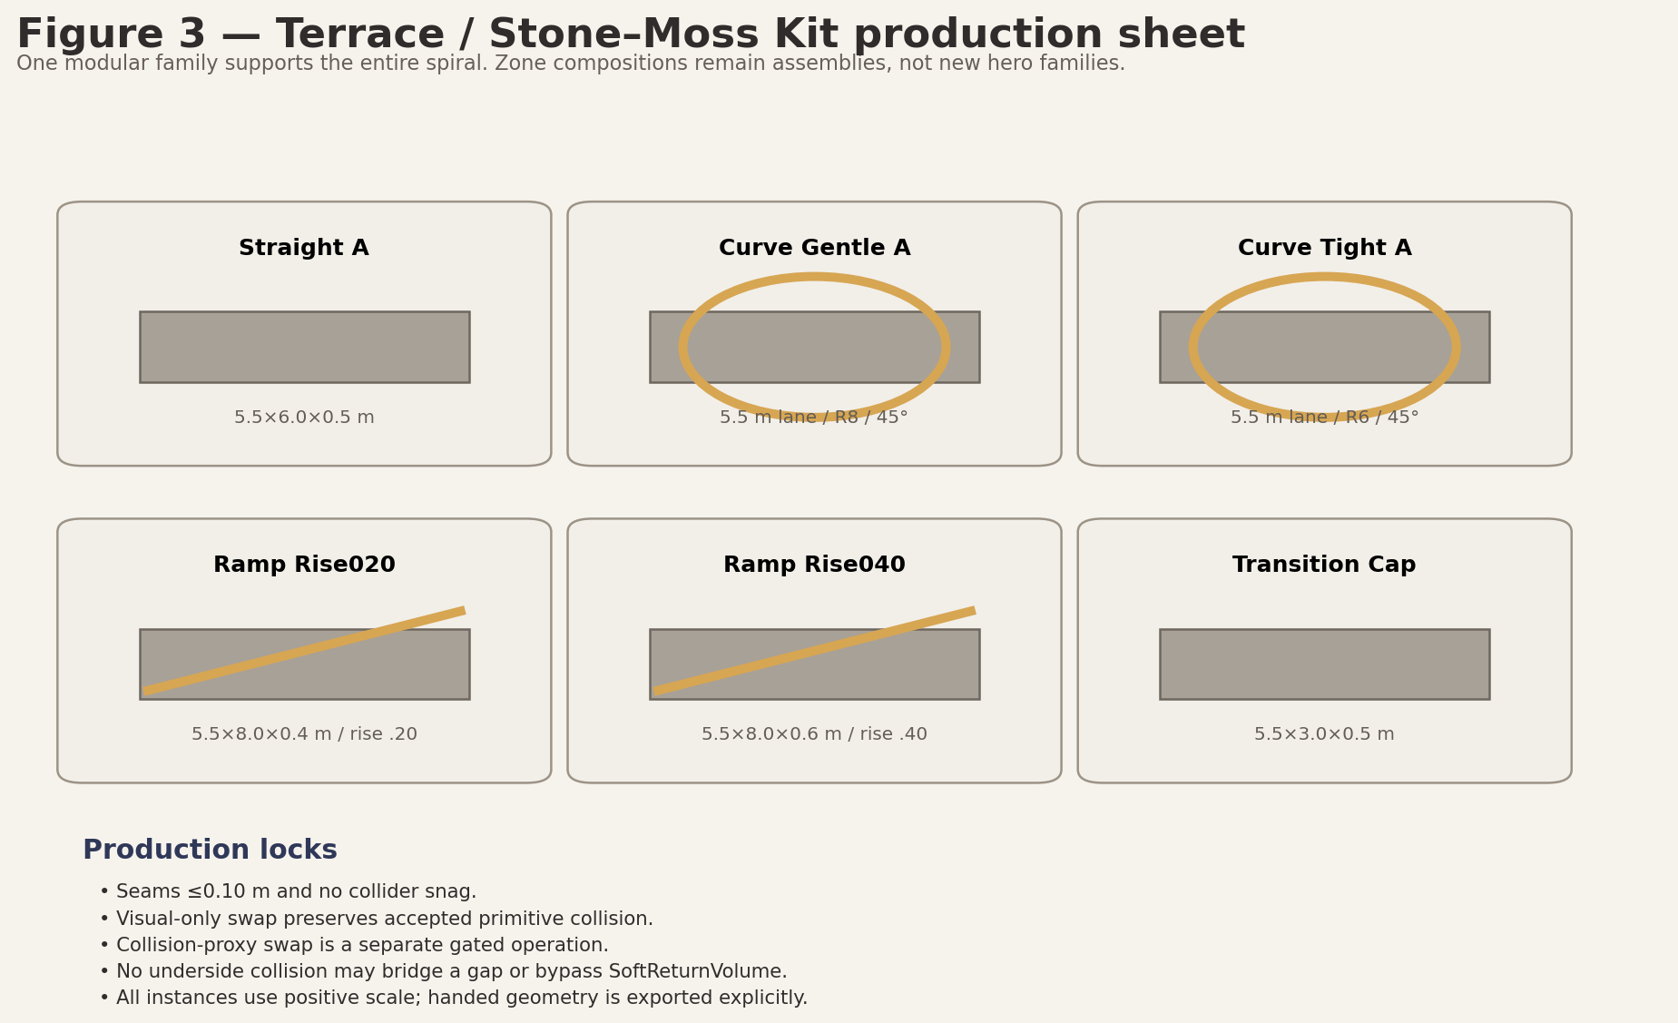
Figure 3. Route family modules and replacement gates.

8.2 Dew Script
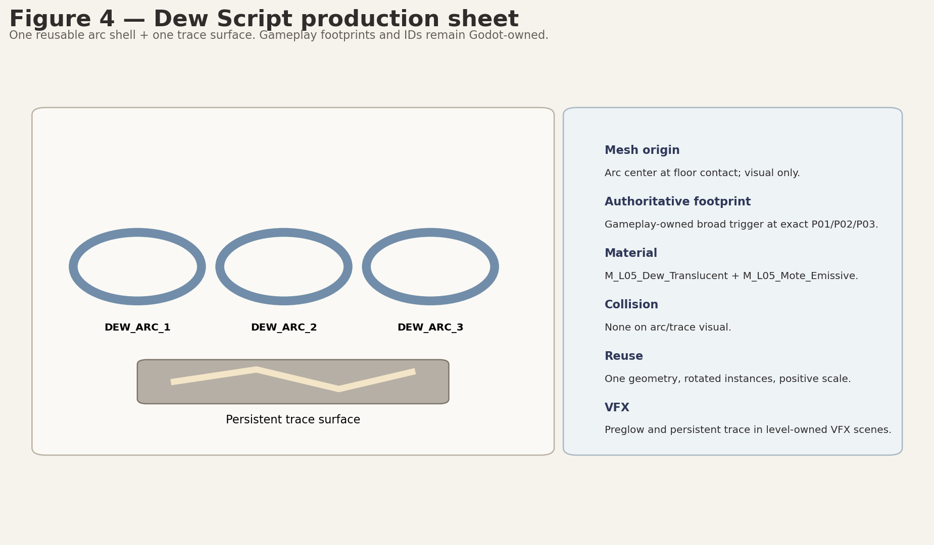
Figure 4. Dew shell, trace surface and ownership contract.

8.3 Little Reactions
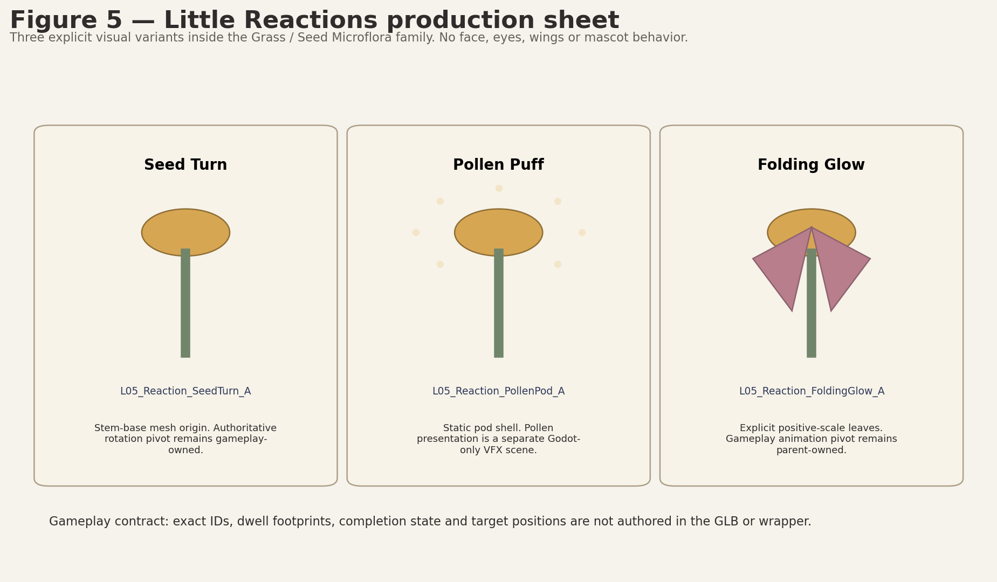
Figure 5. Three explicit microflora variants; gameplay pivots remain parent-owned.

8.4 Ordinary Mosaic
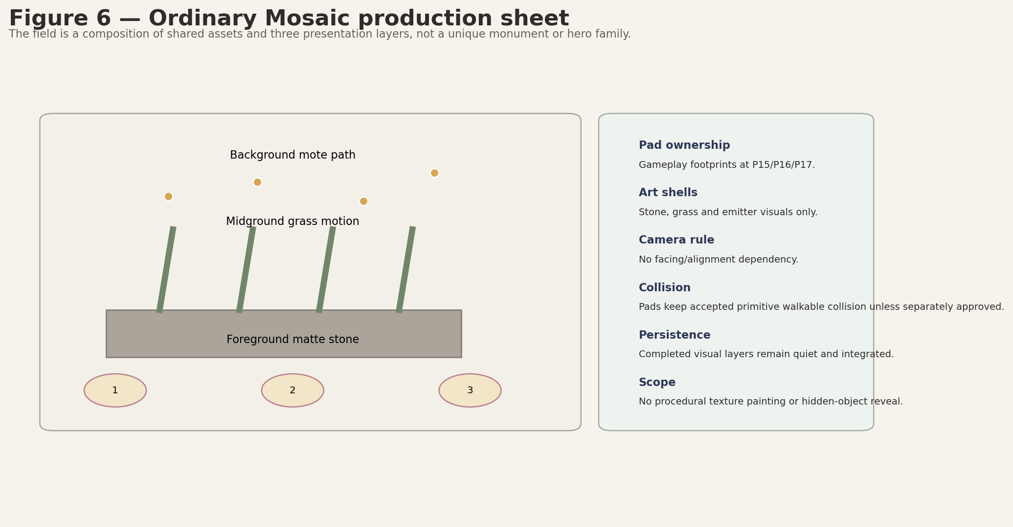
Figure 6. Shared-field composition and three presentation layers.

8.5 Seed Basin, Quiet Assembly and Portal Outlook

Figure 7. Focal compositions built from the three modular families.

9. Collision matrix
Object / class | Collision owner | Initial greybox | Post-greybox default | Swap gate / acceptance
Walkable terraces / ramps | EnvironmentRoot block scenes | Godot primitives | Keep primitives during visual-only swap | Custom proxy only after traversal/seam/slope/grounding tests.
Hard boundary belt | EnvironmentRoot/Boundaries or approved block-local collision root | Godot StaticBody primitives | May remain primitives permanently | Never owned by SafetyRoot or raw GLB; preserve openings and camera corridor.
Visible rim / retaining roots | STRUCT/DECOR | Visual proxy only | No collision unless approved blocker function | Must not reduce legal shoulder or target/portal clearances.
Seed Basin bowl/rim | EnvironmentRoot visuals + boundary primitives | Primitive rim + exact gameplay recovery disk | Visual art independent of RV_BASIN_DISK | No walkable/climbable shortcut into R7.5 disk.
Small grass/moss/seed props | None | None | None | Major trunk/blocker exception requires separate approval.
Dew arcs / trace surfaces | None or accepted floor primitive | No art collision | No collision | Gameplay footprints remain Areas.
Reaction visual shells | None | No art collision | No collision | Pivots/footprints remain gameplay-owned.
Mosaic layers | Accepted floor collision separate | Primitives | Visual-only presentation | No camera/facing dependency.
L05_ShardRest_Surround_A (visual-only, reuse x3) | None | None | None | Shard Area/collision stays shared SoulShard/slot authority.
Portal Outlook art | EnvironmentRoot / shared LevelPortal separately | Primitive floor and clear radius | Visual composition only | Portal interaction envelope and root remain shared/gameplay-owned.
Underside meshes | Usually none | None | Collision only immediately below visible surface if tunneling evidence | May never bridge gaps or act as catch floor.

10. Pivot, origin and marker contracts
Element | Required art origin / pivot | Authoritative gameplay owner | Rule
Route modules | Documented bottom/arc origin; -Y authored forward | Environment placement / accepted block composition | Origin supports snapping; exact route centerline does not move.
Dew arc shell | Floor center | Gameplay Dew footprint at P01/P02/P03 | ArtAlignment_DewCenter optional; no authoritative Beam/Target markers.
Seed Turn visual | Stem base mesh origin | Gameplay reaction footprint / presentation pivot | Mesh origin aids animation only; gameplay pivot is parent-owned.
Folding Glow visual | Ground center; leaf mesh origins documented | Gameplay presentation pivot(s) | No negative scale or mirrored runtime instance.
Mosaic visuals | Bottom center / shared field view face | Gameplay pad footprints P15/P16/P17 | No camera-alignment marker in GLB.
L05_ShardRest_Surround_A | Center at floor plane | Shard_10/11/12 FloorAnchor and Level05ShardSlot | Zero movement.
Portal Outlook art | Composition origin independent of portal | PortalFloorAnchor / shared LevelPortal | No wrapper marker may replace portal root authority.
Recovery / camera QA | N/A | SafetyRoot anchors/Areas and CP0–CP9 markers | Art only validates clearance and clipping.

10.1 Locked art tolerance
- Gameplay anchors, triggers, Area3D nodes, pivots, shard anchors, FinalTextGate, PortalFloorAnchor, recovery anchors and NodePaths: 0.00 m movement.
- Free non-authoritative dressing has no universal displacement tolerance. Acceptance is determined by route width, legal shoulder, puzzle/shard/portal clearance, camera corridor, sightlines, boundary rules and recovery exclusions.
- Block seams remain <=0.10 m. No tolerance may reduce route width, camera corridor or any approved clearance.

10.2 SoulOrb_Follow decision
REUSE SHARED ASSET
Reuse the existing shared SoulOrb_Follow. Do not create a Level_05 orb asset; it is not a fourth semi-hero family. Target and orientation ownership remain Technical Architecture authority. Art must preserve Player/orb/camera clearance and pass CP0–CP9 clipping QA.

11. Wrapper-first Blender → GLB → Godot workflow
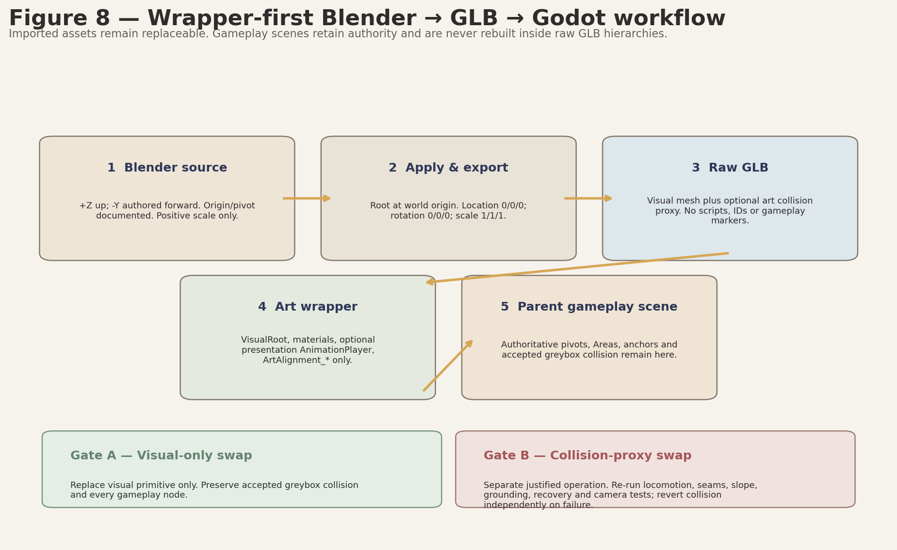
Figure 8. Wrapper-first pipeline and two distinct replacement gates.

11.1 Wrapper content contract
Wrapper may own | Wrapper must not own
VisualRoot and raw GLB instance | Gameplay IDs or state
Material overrides and local duplicated resources | Authoritative pivots/markers/targets/spawn points
Optional presentation-only AnimationPlayer | Interaction Area3D or shard/portal state
Approved static collision child where explicitly gated | NodePaths into raw imported hierarchy from gameplay controllers
ArtAlignment_* non-authoritative markers | Recovery Areas, FinalTextGate or LevelPortal root

11.1A Mesh-backed VFX instance mapping
The following mappings are mandatory. In every case the environment wrapper owns the only runtime mesh instance; the Level_05 presentation root/VFX scene controls it through wrapper-level API. No VFX scene may instantiate the raw GLB again, create a second wrapper, or bind gameplay logic to imported child names.
- L05_DewTraceSurface_A -> L05_DewTraceSurface_A.tscn -> VFXRoot/DewPresentationRoot / L05_VFX_DewTrace_Persistent.tscn.
- L05_Reaction_SeedTurn_A -> L05_Reaction_SeedTurn_A.tscn -> VFXRoot/ReactionsPresentationRoot / L05_VFX_Reaction_SeedTurn.tscn.
- L05_Reaction_FoldingGlow_A -> L05_Reaction_FoldingGlow_A.tscn -> VFXRoot/ReactionsPresentationRoot / L05_VFX_Reaction_FoldingGlow.tscn.
- L05_Mosaic_Foreground_Stone_A -> L05_Mosaic_Foreground_Stone_A.tscn -> VFXRoot/MosaicPresentationRoot / L05_VFX_Mosaic_ForegroundLayer.tscn.
- L05_Mosaic_Midground_Grass_A -> L05_Mosaic_Midground_Grass_A.tscn -> VFXRoot/MosaicPresentationRoot / L05_VFX_Mosaic_MidgroundLayer.tscn.

11.2 Safe primitive replacement
Gate | Allowed operation | Required validation | Failure response
Visual-only swap | Replace visual primitive with wrapper/GLB; keep accepted greybox collision and gameplay hierarchy. | Scale/orientation, silhouette, target visibility, camera QA, performance. | Revert visual only; gameplay remains intact.
Collision-proxy swap | Replace collision separately only when justified by visible geometry or tunneling evidence. | Traversal, seams, step, slope, cross-slope, grounding, recovery, boundary openings and camera collision. | Revert collision independently; keep visual if safe.

12. IMMEDIATE GREYBOX HANDOFF
INITIAL LEVEL_05 GREYBOX PR — PRIMITIVES ONLY
Do not include any Blender source, GLB, texture, production material, art wrapper, polished VFX or post-greybox asset from this Bible.

Immediate input | Exact content allowed
Dimensions and coordinates | Exact P00–P24, envelope 90×104 m, zone footprints and Seed Basin radii.
Proxy surfaces | Primitive route, pockets, ramps, basin boundary, shard/rest floors and outlook.
Clearances | Route >=5.5 m; shoulder >=1.25 m; camera corridor 8.5 m; targets R3.0; shards R3.5; portal R4.5.
Collision policy | Primitive static walkable collision, EnvironmentRoot/Boundaries hard belt, no invisible catch floor.
Pivot contracts | Gameplay-owned targets, anchors, gate, portal and recovery nodes; zero movement.
Acceptance criteria | Traversal, camera QA, permutations, hints, recovery, stationary pre-overlap and exact copy.
Layer placeholders | BASE / STRUCT / DECOR / GAMEPLAY / VFX root boundaries only; no final art.

12.1 Greybox acceptance preconditions before art swap
- P00–P24 and all exact target/shard/gate/portal/recovery coordinates validated.
- Route widths, shoulder, slope, cross-slope, step and no-gap requirements pass.
- Seed Basin exact R7.5 recovery/exclusion and final radial-clearance proof pass.
- All puzzle permutations, leave/re-enter persistence and 20/35 s hints pass.
- Shard and portal stationary early-overlap gates pass or trigger an approved shared prerequisite.
- CP0–CP9 camera QA and muted/reduced-color readability pass.
- Full route reaches Level_06 exactly once; exact copy matches character-for-character.

13. POST-GREYBOX ART INTEGRATION SLICES
DO NOT EXECUTE THESE SLICES IN THE INITIAL LEVEL_05 GREYBOX PR
Each slice begins only after Producer accepts the greybox and explicitly authorizes post-greybox art production.

Slice | Scope | Entry gate | Exit evidence
ART-A01 Route visual kit | Model Terrace / Stone–Moss modules and wrappers; visual-only swap. | Greybox accepted. | No anchor movement; route/camera/clearance QA passes.
ART-A02 Seed Basin composition | Rim quarters, bowl, roots and microflora visual composition. | A01 stable. | No shortcut/climb; R7.5 exclusion and viewing rim remain clear.
ART-A03 Dew Script art | Dew arc shell, trace surface, preglow and persistent trace. | Dew gameplay passes all permutations/fallbacks. | Readable without literal letters; optional VFX failure non-blocking.
ART-A04 Little Reactions art | Three explicit microflora variants and presentation. | Reaction gameplay stable. | No mascot/face reading; all targets visible and clear.
ART-A05 Ordinary Mosaic art | Foreground, grass and mote layers. | Mosaic gameplay stable. | No camera alignment implication or hidden-object reading.
ART-A06 Rest spaces / outlook | L05_ShardRest_Surround_A reused x3 plus modular Portal Outlook composition; no new hero family. | Anchors/gate/portal validated. | No trophy/shrine framing; all clear radii preserved.
ART-A07 Environment states | Local material/VFX state compatibility E0–E4. | All visual modules integrated. | World alive from E0; no global repair/transformation reading.
ART-A08 Optional collision proxies | Justified selective collision replacements only. | Visual integration accepted; evidence that primitive mismatch matters. | Complete locomotion/safety/camera test matrix passes; independent revert available.
ART-A09 Final optimization / QA | LOD, MultiMesh, overdraw, import warnings, visual acceptance. | All slices stable. | 60 FPS target, clean imports, full documentation QA.

14. Production priority
Priority | Assets / work | Reason
ART-P1 — Gameplay readability | Route visual kit, Dew Arc/trace, three Reaction shells, Mosaic layer shells, guidance VFX | Defines navigation and mechanic readability; still post-greybox.
ART-P2 — Visual identity | Seed Basin composition, ruin markers, tall grass/seed clusters, L05_ShardRest_Surround_A reused x3, outlook composition, environment-state VFX | Creates the close-up blue-hour identity after mechanics are stable.
ART-P3 — Decorative filler / optimization | Low grass, moss patches, roots, shrubs, background hills, LOD/MultiMesh polish | Cut first if scope or performance is threatened.

No actual final-art asset has GB-P0 priority. GB-P0 consumes proxy dimensions and collision contracts only.

15. Blender / GLB / Godot export checklist
- Metric scale verified: 1 Blender unit = 1 meter.
- Correct Blender +Z up and authored -Y forward.
- Universal dimension-axis contract followed or explicit exception documented.
- Required origin set before applying transforms.
- Export root location 0/0/0, rotation 0/0/0, scale 1/1/1.
- Positive scale only; handed geometry exported explicitly.
- Clean names; no hidden unused objects or export-breaking modifiers.
- Minimal material slots and exact M_L05_* family names.
- No gameplay scripts, IDs, authoritative markers, Areas or state inside GLB/wrapper.
- Collision proxy, when justified, uses the _COL.glb suffix and is exported only as CONDITIONAL - ART-A08 ONLY after accepted greybox evidence; Godot primitive collision remains the baseline.
- GLB test-imported in Godot; scale, orientation, normals, pivots and materials verified.
- Wrapper created at exact registry path and uses ArtAlignment_* only when needed.
- Visual-only replacement is tested and accepted before any collision-proxy swap; invisible catch floors and geometry bridging gaps are prohibited.
- No import warnings, duplicate geometry source paths or wildcard paths.
- Performance / LOD / overdraw reviewed at gameplay camera distance.

16. Art acceptance gates
Gate | Exact acceptance
A-01 Authority | All gameplay anchors, Areas, pivots, NodePaths and portal/recovery ownership unchanged; zero movement.
A-02 Route readability | Mandatory route >=5.5 m, shoulder >=1.25 m and next-pocket silhouette readable without UI arrows.
A-03 Camera safety | CP0–CP9 pass at 16:9; no severe grass/ruin/portal foreground occlusion; SoulOrb_Follow does not clip.
A-04 Puzzle readability | All nine targets readable from local entrance/natural camera turn; distinct visual verbs preserved.
A-05 Boundaries | Hard belt is under EnvironmentRoot/Boundaries or approved block-local root; route openings/legal side spaces/camera corridor clear.
A-06 Recovery | No art/collision overlaps recovery exclusions; no invisible catch floor; Seed Basin disk remains exact.
A-07 Collision | Visual-only swap passes first. Any custom proxy passes seams <=0.10 m, step/slope/grounding/recovery/camera tests.
A-08 Materials / states | M_L05_* families coherent; E0 already alive and colored; E1–E4 are local clarity changes only.
A-09 Emotional safety | No museum, archive, surveillance, word-code, mascot, shrine, perfect portrait or proof-of-attention reading.
A-10 Performance / import | Stable 60 FPS target, bounded overdraw, LOD/MultiMesh where justified, clean Godot import.
A-11 Registry uniqueness | Audit passes only when canonical asset names, Blender source paths, raw GLB paths and wrapper paths are unique; semantic duplicates are absent; _A/_B denotes real geometry/silhouette variation only; each canonical geometry has one runtime visual owner; intentional mesh reuse is explicitly marked as reuse rather than a new asset.

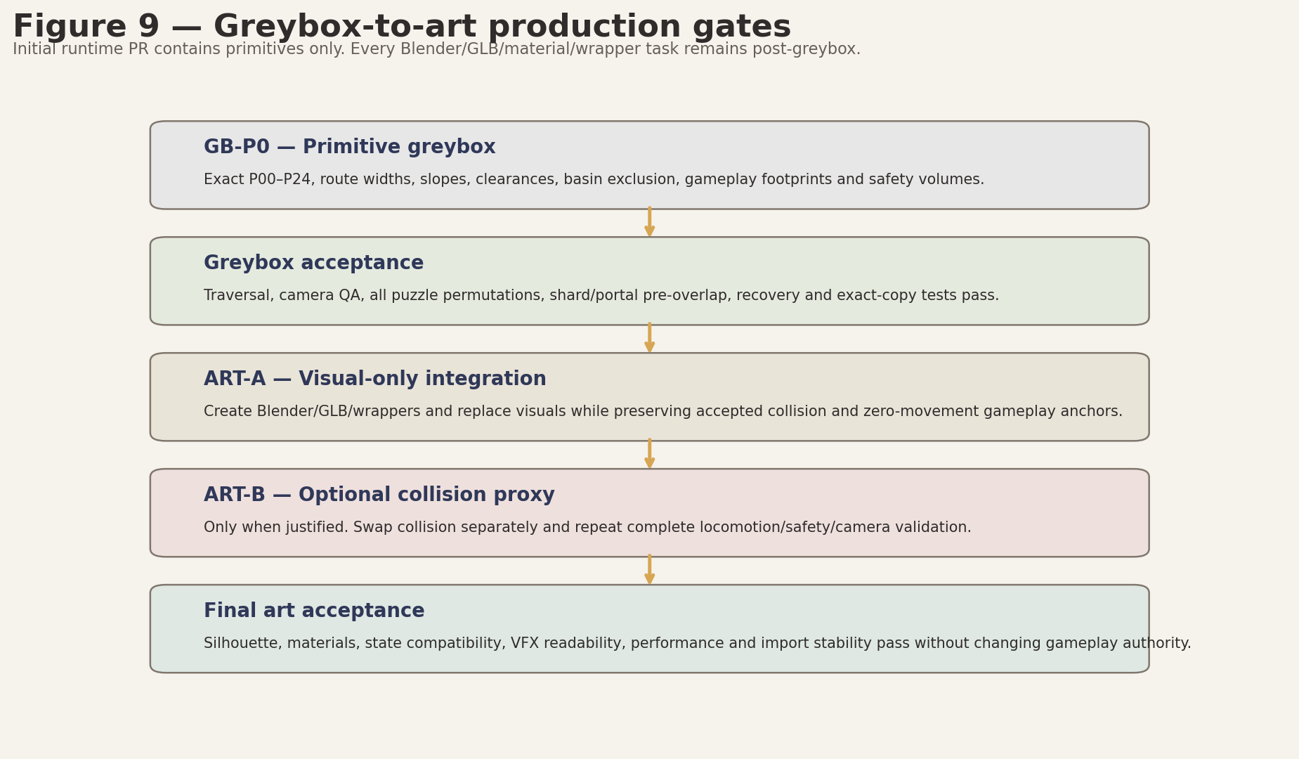
Figure 9. Production gating from GB-P0 through final acceptance.

17. Production risks and corrections
Risk | Severity | Production correction
Macro-garden asset count grows beyond MVP | High | Enforce three modular families; cut unique plant heroes and decorative variants first.
Art narrows route / hides target | High | Use exact clearances and CP0–CP9 checks before accepting dressing.
Seed Basin becomes a hub or shortcut | High | Keep R7.5 hard/recovery exclusion, non-climbable rim and fragmented orientation reading.
Dew Script becomes literal handwriting/code | High | Keep abstract curves; exact word exists only in copy.
Little Reactions becomes anthropomorphic | High | No face/eyes/wings/mascot behavior; autonomous plant motion only.
Mosaic implies proof, surveillance or perfect portrait | High | Use ordinary layers; no lens, camera score, hidden object or rare treasure.
Visual and collision swapped together | High | Mandatory two-gate replacement with independent collision revert.
Transparent dew/foliage overdraw | Medium | Conservative layers, atlas use, distance LOD and bloom cap.
Portal becomes grand climax | Medium | Outlook remains restrained; shared portal activates only after main text.
Repository/shared-contract drift | High | Repeat preflight before any later Blender or runtime work.

18. Handoff boundary

18.1 What may pass to Greybox / Codex planning
- Exact dimensions and P00–P24 coordinates.
- Proxy shapes, route/shoulder/camera clearances and zone footprints.
- Hard-boundary and recovery ownership policy.
- Gameplay-owned pivot/marker/anchor contracts.
- Primitive-only layer roots and art acceptance criteria.

18.2 What passes to Blender / Art only after greybox approval
- Complete canonical asset registry and exact source/GLB/wrapper paths.
- Three-family modular production plan and production sheets.
- M_L05_* material families and VFX delivery types.
- Wrapper-first import and two-gate primitive replacement workflow.
- Post-greybox ART-A01–A09 slices and final acceptance gates.

Appendix A. Exact gameplay anchors — art must not move
Anchor | Exact Level_05 scene-local floor position
P00 | Vector3(-9.000, 2.400, -46.440)
P01 | Vector3(1.790, 2.480, -43.490)
P02 | Vector3(11.140, 2.580, -37.670)
P03 | Vector3(18.460, 2.680, -29.650)
P04 | Vector3(23.360, 2.760, -20.180)
P05 | Vector3(25.650, 2.720, -10.030)
P06 | Vector3(25.370, 2.620, 0.000)
P07 | Vector3(22.730, 2.520, 9.180)
P08 | Vector3(18.130, 2.420, 16.920)
P09 | Vector3(12.060, 2.320, 22.750)
P10 | Vector3(5.120, 2.220, 26.420)
P11 | Vector3(-2.090, 2.080, 27.840)
P12 | Vector3(-9.000, 1.880, 27.140)
P13 | Vector3(-15.100, 1.680, 24.580)
P14 | Vector3(-20.000, 1.480, 20.570)
P15 | Vector3(-23.430, 1.280, 15.590)
P16 | Vector3(-25.310, 1.080, 10.170)
P17 | Vector3(-25.650, 0.900, 4.820)
P18 | Vector3(-24.650, 0.820, 0.000)
P19 | Vector3(-23.095, 0.760, -5.130)
P20 | Vector3(-20.108, 0.720, -9.319)
P21 | Vector3(-16.000, 0.680, -12.124)
P22 | Vector3(-11.344, 0.680, -13.295)
P23 | Vector3(-6.742, 0.740, -12.802)
P24 | Vector3(-2.500, 0.820, -11.258)

Appendix B. Puzzle, shard, finale and portal clearances
Identity | Coordinate | Protected art clearance
DEW_ARC_1 | Vector3(1.79,2.48,-43.49) | R3.0
DEW_ARC_2 | Vector3(11.14,2.58,-37.67) | R3.0
DEW_ARC_3 | Vector3(18.46,2.68,-29.65) | R3.0
REACTION_SEED_TURN | Vector3(22.73,2.52,9.18) | R3.0
REACTION_POLLEN_PUFF | Vector3(18.13,2.42,16.92) | R3.0
REACTION_FOLDING_GLOW | Vector3(12.06,2.32,22.75) | R3.0
MOSAIC_FOREGROUND | Vector3(-23.43,1.28,15.59) | R3.0
MOSAIC_MIDGROUND | Vector3(-25.31,1.08,10.17) | R3.0
MOSAIC_BACKGROUND | Vector3(-25.65,0.90,4.82) | R3.0
Shard_10 | Vector3(23.36,2.76,-20.18) | R3.5
Shard_11 | Vector3(5.12,2.22,26.42) | R3.5
Shard_12 | Vector3(-24.65,0.82,0.00) | R3.5
FinalTextGate | Vector3(-11.344,0.68,-13.295) | R4.5
PortalFloorAnchor | Vector3(-2.500,0.82,-11.258) | R4.5 visual/camera; shared interaction authoritative

Appendix C. Recovery and camera QA references
Recovery volume | Exact transform / size
RV_FALL_GLOBAL | pos (0,-8,0); Box 100×8×116
RV_PERIM_N | pos (0,3,56); Box 100×12×8
RV_PERIM_S | pos (0,3,-56); Box 100×12×8
RV_PERIM_W | pos (-49,3,0); Box 8×12×120
RV_PERIM_E | pos (49,3,0); Box 8×12×120
RV_BASIN_DISK | pos (-9,-0.5,0); Cylinder R7.50 × H5.00
RV_OUTLOOK_S | pos (-7,2,-21); Box 30×10×5

Camera QA | Player floor position | View target / required reading
CP0 Arrival | (-9.00,2.40,-46.44) | Dew entrance, Arc 1, partial basin glimpse
CP1 Dew Entrance | (-0.50,2.47,-44.50) | All three dew silhouettes
CP2 Shard_10 | (23.36,2.76,-20.18) | Persistent traces + Moss Bend
CP3 Reactions Entry | (25.37,2.62,0.00) | All three reaction stations
CP4 Shard_11 | (5.12,2.22,26.42) | Descent + all Mosaic pad silhouettes
CP5 Mosaic Entry | (-20.00,1.48,20.57) | All pads + shared field
CP6 Shard_12 | (-24.65,0.82,0.00) | Quiet Assembly arc outside basin
CP7 Final Approach | (-16.00,0.68,-12.124) | FinalTextGate + outlook continuation
CP8 Main Text Gate | (-11.344,0.68,-13.295) | Portal Outlook; portal dormant
CP9 Portal Outlook | (-6.742,0.74,-12.802) | Shared LevelPortal with 4.5 m visual clearance

Appendix D. Visual authority references
The following existing Visual Master boards are included as non-production visual authority references. Text and technical diagrams in this Bible override mood-image geometry.
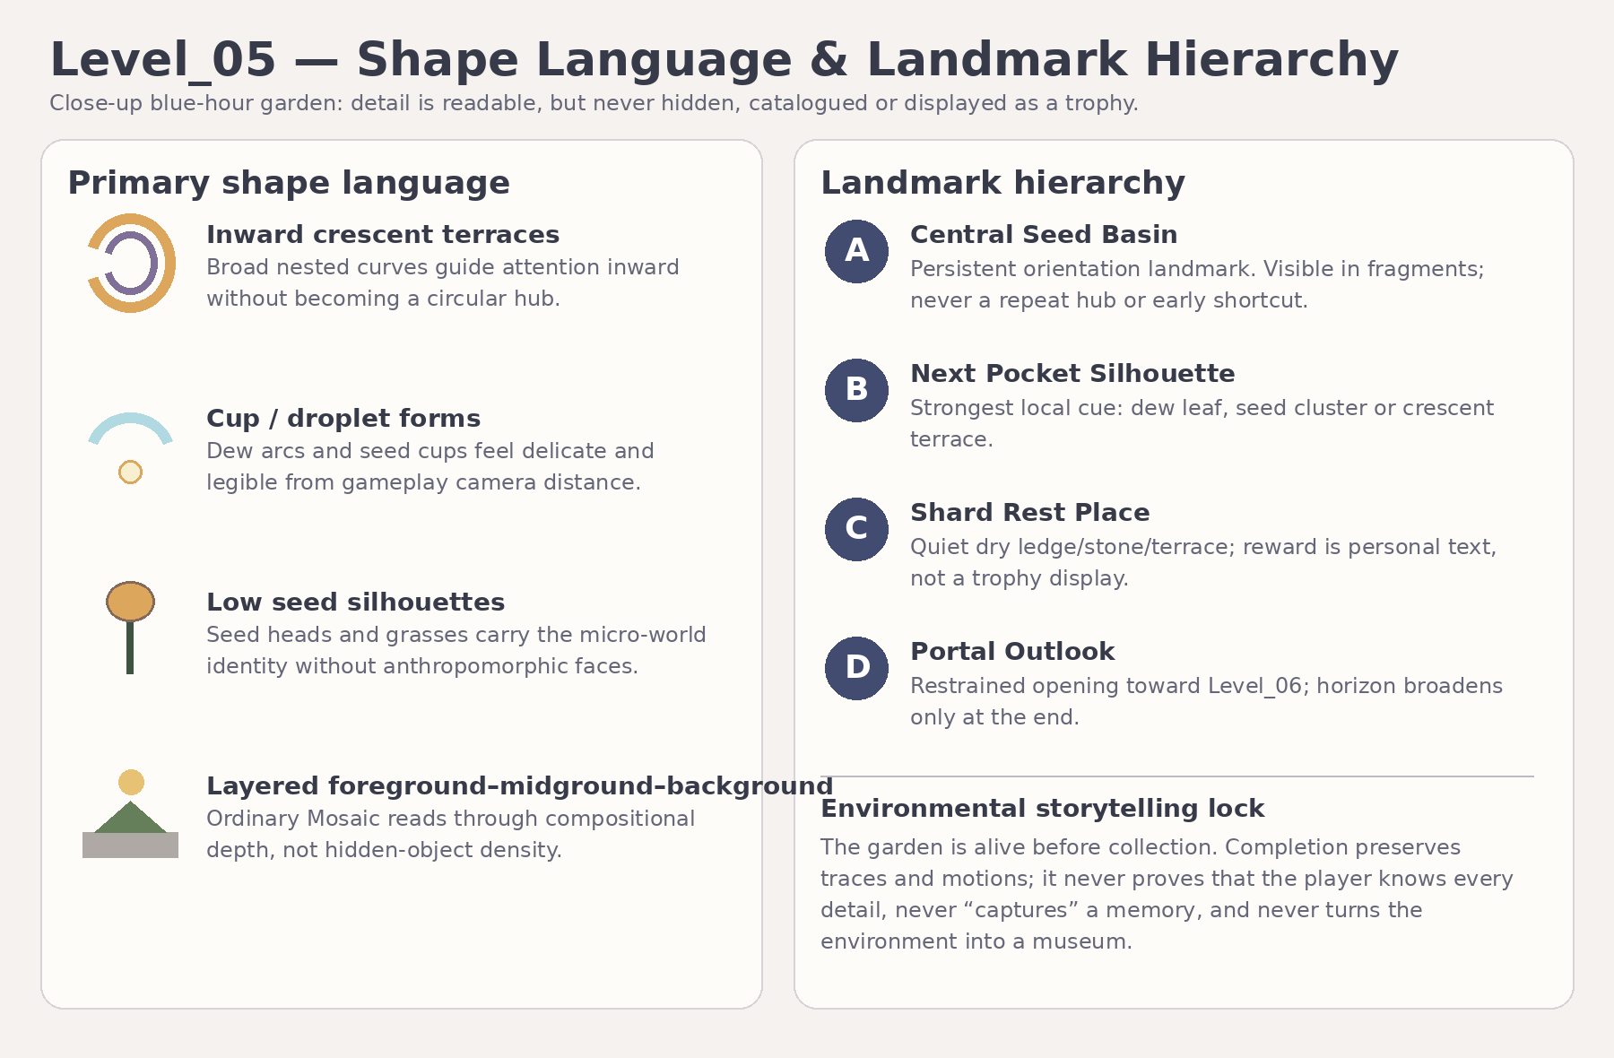
Visual Master reference: shape language and landmark hierarchy.
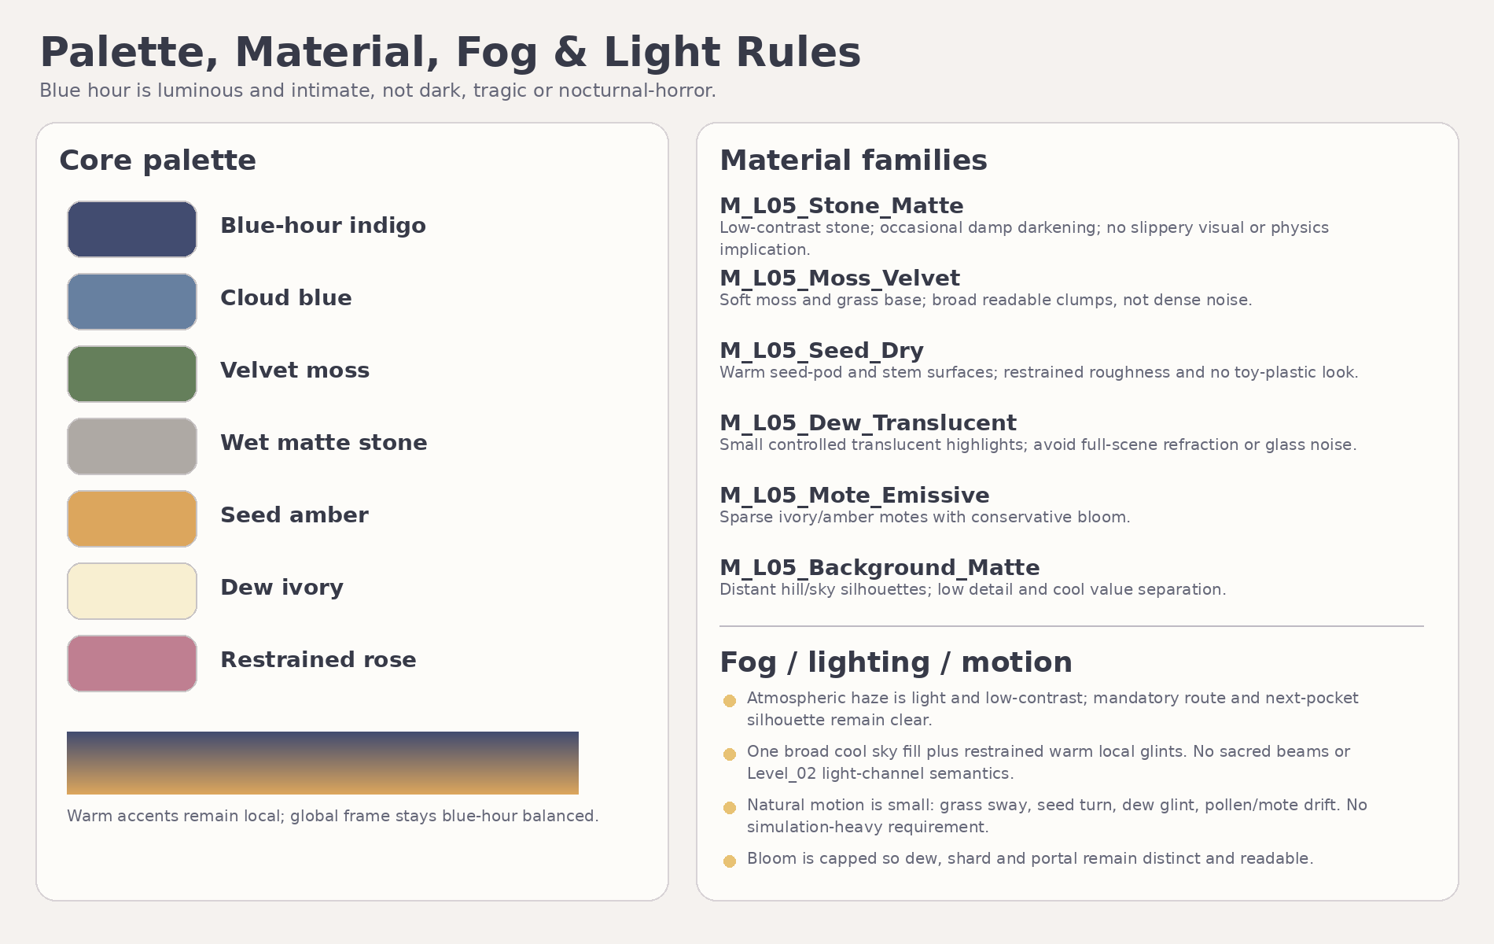
Visual Master reference: palette, material, fog and light direction.
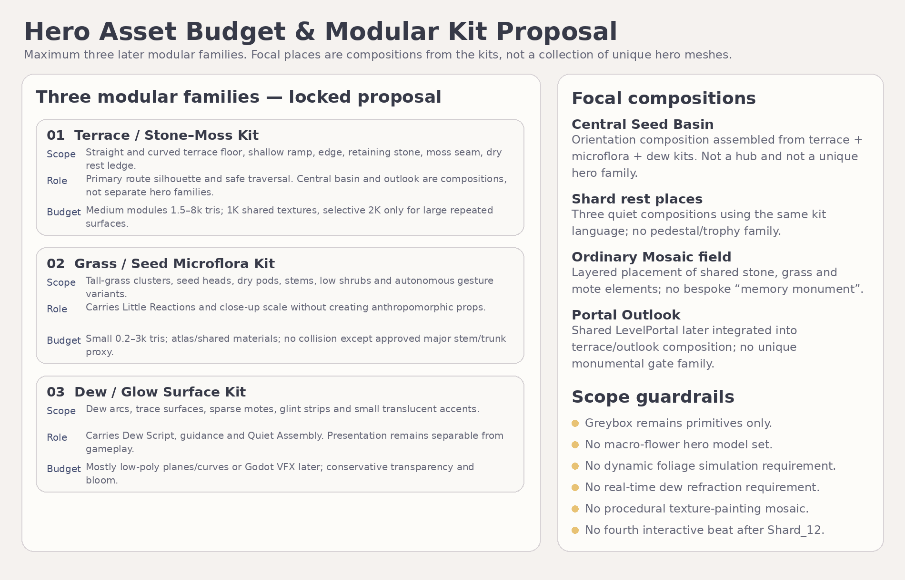
Visual Master reference: locked three-family budget and focal-composition rule.

Document completion statement
DOCUMENTATION-ONLY COMPLETION
Level_05_Art_Production_Bible_v1.1.docx defines the Version 1.1 candidate for repeat Producer review only. No Blender files, GLBs, textures, final materials, Godot scenes/wrappers, runtime code, branch, commit, PR, Greybox Development Reference or implementation prompt was created or modified.

