FIFTEEN SHARDS OF LIGHT

Level_05
Gameplay Map and Complete Level Design Specification
  - «То, что остается»

FINAL LEVEL DESIGN VERDICT
READY FOR PRODUCER REVIEW. After approval, this document may authorize only the Godot Technical Architecture stage. It does not authorize runtime implementation, a greybox branch/PR, Blender production, GLB creation or Codex implementation decomposition.

Control | Value
Project | Fifteen Shards of Light
Repository | MindDevastation/fifteen-shards-of-light
Target scene | res://scenes/levels/Level_05.tscn
Document | Level_05_Gameplay_Map_and_Level_Design_Spec_v1.2.docx
Version | 1.2
Mode | Documentation only - no Godot scenes/scripts, runtime assets, Blender/GLB, branch, commit or PR
Narrative authority | Level_05_Narrative_and_Level_Scenario_Package_v1.1.docx
Visual authority | Level_05_Visual_Master_Concept_Package.docx
Portal target | res://scenes/levels/Level_06.tscn

Version 1.2 Change Log
Correction | Version 1.2 resolution
Finale coordinates | Removed obsolete gate/portal values and synchronized Section 10 with P22/P24.
Seed Basin recovery | Replaced incomplete box union with one exact R=7.5 m cylindrical recovery footprint.
Deferred recovery | Added latch-safe single pending event across overlays and continued fall below Y=-12.
Recovery-anchor gating | Locked exact earliest canonical state for RA0-RA9 and safe RV_OUTLOOK_S destination logic.
QA closure | Updated Figure 2A, matrices, A4 sections, page-number footers and package cleanliness requirements.

Version 1.1 Change Log
Correction | Version 1.1 resolution
Final approach | Rebuilt P19-P24 as a valid inward annular arc. P24 is the PortalFloorAnchor; centerline total is exact.
Seed Basin clearance | Added per-segment radial proof, gate/portal footprint proof and non-intersecting Portal Outlook footprint.
Puzzle contracts | Separated activation prerequisite, input acceptance, unique target set, completion, reveal, reward transition and persistence.
Recovery geometry | Added exact volume registry, RA activation footprints, AABB proof and recovery diagram.
Acceptance coverage | Expanded geometry, persistence, assistance, fallback, reload, exact-copy and portal race tests.
Decision closure | Replaced all APPROVE / ADJUST states with locked/deferred/runtime-validation statuses.
Repository snapshot | Recorded main, audited SHA, 0 open PRs and Level_05 blob SHA.
DOCX QA | Standardized A4 portrait/landscape, page-number footers, clean comments/tracked-change policy and full render review.

Contents
- Authority hierarchy and repository snapshot
- Final design verdict and order model
- Exact world layout, footprint and coordinates
- Traversal geometry, clearances and recovery
- Beat-by-beat playable flow and pacing
- Dew Script and Shard_10
- Little Reactions and Shard_11
- Ordinary Mosaic and Shard_12
- Progression and environment states
- Quiet Assembly, main-text gate and portal
- Progress preservation, duplicates and reload policy
- Guidance, accessibility and camera QA
- Failure / softlock matrix
- Acceptance criteria and manual playtest matrix
- Simplification fallback and production handoff
- Producer decision table

Executive summary
Level_05 is specified as one continuous inward spiral through a luminous blue-hour close-up garden. The route is sequential at the chapter level - Dew Script, Shard_10, Little Reactions, Shard_11, Ordinary Mosaic, Shard_12, Quiet Assembly, main text and Level_06 portal - while each puzzle's local targets remain persistent and any-order.
The exact visual/gameplay envelope is 90 x 104 m (X -45..+45, Z -52..+52). The proposed mandatory centerline is 177.71 m, inside the approved 155-180 m planning range. The authored centerline slope peaks at 2.0 degrees; final terrain shaping may reach 8 degrees without changing anchors.
EMOTIONAL-SAFETY LOCK
The garden is alive before progress. The player notices three already-visible details; they do not capture, repair, catalogue or prove knowledge of Alena. No mechanic requires hidden-object searching, exact camera alignment, a response, gratitude or access to her inner state.

1. Authority hierarchy and repository snapshot
Priority | Authority | Controls
1 | Narrative Package v1.1 | Exact title/copy, three-shard fixed order, emotional function, mechanic intent and forbidden readings.
2 | Visual Master Concept | Spiral visual composition, landmark hierarchy, detail-pocket language, environment states and art-budget intent.
3 | Gameplay Spec (this document) | Exact scene-local gameplay layout, coordinates, dimensions, deterministic behavior, recovery and acceptance contracts.
4 | Current repository | Factual shared compatibility and placeholder drift only; cannot override approved gameplay design in its domain.

Repository fact | Locked implication
Default branch | main
Audited main SHA | a9380f7afce1c0bb0727ccaf6e3f0e76a13df78d
Open pull requests | 0
Level_05 scene blob SHA | 43d29b9e8b486e56584e89169675b12ea2d7bddd
Current placeholder | 12 x 12 flat floor, one SoulShard, legacy LevelManager and generic PoemRewardUI.
Gameplay authority | Placeholder has factual compatibility value only and no gameplay-design authority.
Portal target | Current Level_05 points to res://scenes/levels/Level_06.tscn; retain.
Player collider carry-over | Shared Player collision shape is vertically offset from CharacterBody root.
Shared portal carry-over | AUTO_ENTER and shared scene ownership exist; stationary early-overlap remains unproven and requires runtime validation.
Runtime status | No repository file, runtime asset, branch, commit or PR is created by this document.

PLACEHOLDER RULE
The current one-shard flat scene is technical evidence only. It is not canon for shard count, layout, route order, copy, puzzle rules or finale staging.

2. Final design verdict and order model
Layer | Model | Locked result
Macro order | LINEAR | Shard_10 -> Shard_11 -> Shard_12 -> Main Text -> Portal.
Dew Script targets | LOCAL ANY-ORDER | Three persistent arcs; no wrong order.
Little Reactions targets | LOCAL ANY-ORDER | Three persistent autonomous stations.
Ordinary Mosaic targets | LOCAL ANY-ORDER | Three persistent view pads; no facing test.
Quiet Assembly | LINEAR / NON-INTERACTIVE | No fourth puzzle.
Exit | LINEAR | Main text closes, then shared LevelPortal activates toward Level_06.

2.1 Why the macro-order is linear
- Shard_10 names one remembered word, establishing the most compact and concrete trace.
- Shard_11 moves from language to a brief visible reaction, deepening specificity without implying surveillance.
- Shard_12 broadens from one moment to the valued quality of sincerity in conversations.
- The main text depends on this exact accumulation: word -> smile -> sincerity -> understanding of depth.
- A free macro-order would weaken the intended sentence and duplicate Level_04's order-independent identity.
- Local any-order targets preserve relaxed exploration without changing the narrative order or duration budget.

3. Exact world layout, footprint and coordinates
Convention | Definition
Coordinate frame | All coordinates are Level_05 scene-local. Level_05 root transform is identity.
Scene-local origin | Vector3(0, 0, 0). No secondary local re-origin is permitted.
Forward | +Z is forward in the general scene frame; the spiral turns continuously around the Seed Basin.
Floor anchors | Y values are exact authored floor elevations, not Player-root positions.
Construction tolerance | Terrain seams and adjoining primitive surfaces may differ by <=0.10 m if no snag, step or slope violation results.
Anchor authority | Gameplay floor anchors are exact and may move only through Producer-approved design revision.
Decor acceptance | No universal displacement tolerance. Dressing is accepted only through route widths, camera corridor, target visibility, clearances, sightlines and recovery exclusions.

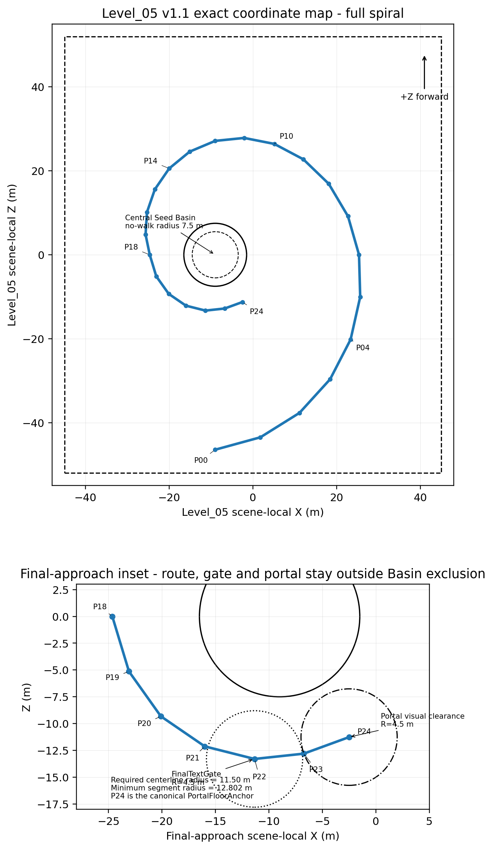
Figure 1. Exact Level_05 scene-local coordinate map.
Area | Position | Exact size / footprint | Function
Whole envelope | X -45..+45; Z -52..+52 | 90 x 104 m | Within approved Visual Master range.
Outer Threshold | Center (-9,2.40,-46) | 12 x 10 m | Spawn and first detail cue.
Dew Script Walk | Center (10,2.55,-36) | 33 x 20 m crescent | Three locally visible arcs.
Shard_10 Rest Ledge | Center (23,2.76,-20) | 10 x 8 m | Dry reward space.
Moss Bend | Center (25,2.67,-5) | 13 x 22 m curve | Pacing reset.
Little Reactions | Center (18,2.42,16) | 22 x 20 m elongated | Three autonomous stations.
Shard_11 Rest Stone | Center (5,2.22,26) | 10 x 8 m | Dry reward space.
Inner Spiral Descent | Center (-9,1.85,25) | 22 x 15 m | Broad safe descent.
Ordinary Mosaic | Center (-24,1.10,10) | 19 x 24 m crescent | Three pads + shared field.
Shard_12 / Assembly | Center (-20,0.76,-3) | 18 x 17 m | Third reward and corrected final arc.
Portal Outlook | Annular crescent about Basin | R 8.5-17.5 m; angle 235°-315° | FinalTextGate and portal remain outside no-walk geometry.

3.1 Exact route centerline
Control point | X | Floor Y | Z
P00 Spawn / Outer Threshold | -9.000 | 2.400 | -46.440
P01 Dew Arc 1 | 1.790 | 2.480 | -43.490
P02 Dew Arc 2 | 11.140 | 2.580 | -37.670
P03 Dew Arc 3 | 18.460 | 2.680 | -29.650
P04 Shard_10 Rest Ledge | 23.360 | 2.760 | -20.180
P05 Moss Bend East | 25.650 | 2.720 | -10.030
P06 Basin Glimpse East | 25.370 | 2.620 | 0.000
P07 Seed Turn Station | 22.730 | 2.520 | 9.180
P08 Pollen Puff Station | 18.130 | 2.420 | 16.920
P09 Folding Glow Station | 12.060 | 2.320 | 22.750
P10 Shard_11 Rest Stone | 5.120 | 2.220 | 26.420
P11 Descent Start | -2.090 | 2.080 | 27.840
P12 Descent North | -9.000 | 1.880 | 27.140
P13 Descent West | -15.100 | 1.680 | 24.580
P14 Mosaic Entry | -20.000 | 1.480 | 20.570
P15 Mosaic Pad 1 | -23.430 | 1.280 | 15.590
P16 Mosaic Pad 2 | -25.310 | 1.080 | 10.170
P17 Mosaic Pad 3 | -25.650 | 0.900 | 4.820
P18 Shard_12 Inner Terrace | -24.650 | 0.820 | 0.000
P19 Quiet Assembly West | -23.095 | 0.760 | -5.130
P20 Quiet Assembly Mid | -20.108 | 0.720 | -9.319
P21 Final Approach West | -16.000 | 0.680 | -12.124
P22 Main Text Gate | -11.344 | 0.680 | -13.295
P23 Portal Approach | -6.742 | 0.740 | -12.802
P24 LevelPortalRoot | -2.500 | 0.820 | -11.258

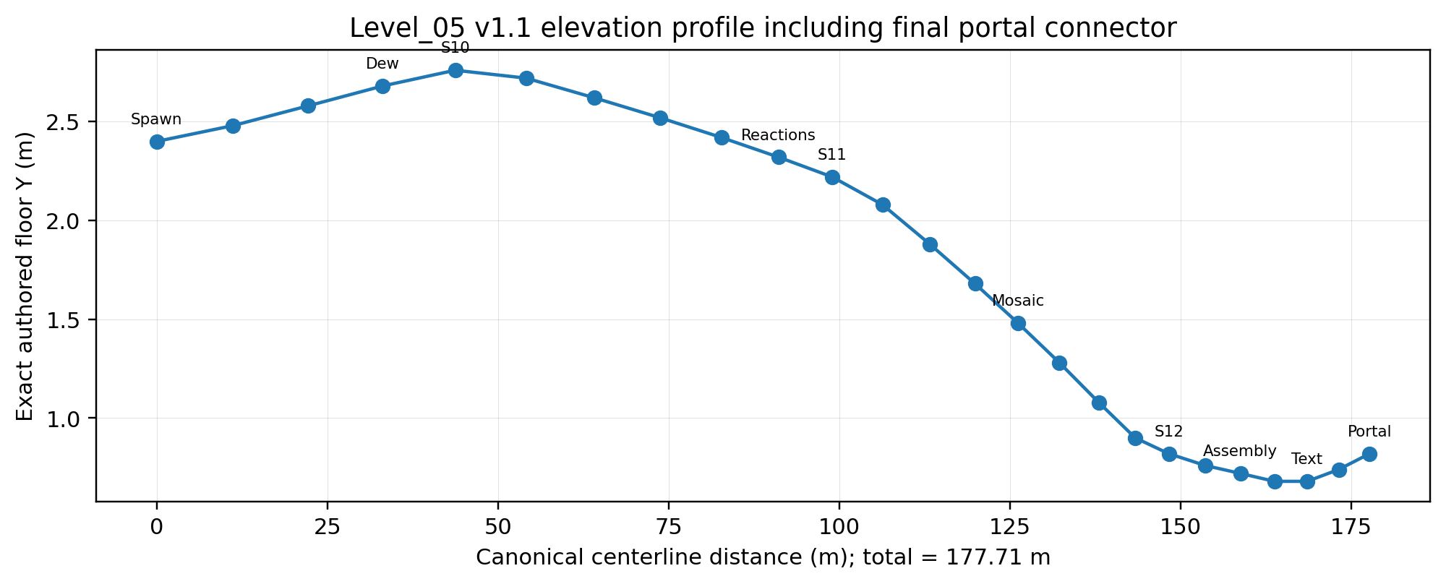
Figure 2. Corrected elevation profile. Canonical centerline total including P23-P24 portal connector = 177.71 m.

3.2 Gameplay target coordinates
Unique target | Route point | Exact floor position | Function
DEW_ARC_1 | P01 | Vector3(1.79, 2.48, -43.49) | Broad arc trigger; abstract trace A.
DEW_ARC_2 | P02 | Vector3(11.14, 2.58, -37.67) | Broad arc trigger; abstract trace B.
DEW_ARC_3 | P03 | Vector3(18.46, 2.68, -29.65) | Broad arc trigger; abstract trace C.
REACTION_SEED_TURN | P07 | Vector3(22.73, 2.52, 9.18) | Autonomous seed turn.
REACTION_POLLEN_PUFF | P08 | Vector3(18.13, 2.42, 16.92) | Brief pollen puff.
REACTION_FOLDING_GLOW | P09 | Vector3(12.06, 2.32, 22.75) | Restrained folding glow.
MOSAIC_FOREGROUND | P15 | Vector3(-23.43, 1.28, 15.59) | Adds matte-stone foreground layer.
MOSAIC_MIDGROUND | P16 | Vector3(-25.31, 1.08, 10.17) | Adds grass-motion midground layer.
MOSAIC_BACKGROUND | P17 | Vector3(-25.65, 0.90, 4.82) | Adds warm-mote background layer.

3.3 Shard, main-text and portal anchors
Anchor | Exact floor position | Contract
Shard_10_FloorAnchor | Vector3(23.36, 2.76, -20.18) | Dry 10 x 8 m ledge.
Shard_11_FloorAnchor | Vector3(5.12, 2.22, 26.42) | Dry 10 x 8 m rest stone.
Shard_12_FloorAnchor | Vector3(-24.65, 0.82, 0.00) | Dry inner terrace.
FinalTextGate center | Vector3(-11.344, 0.68, -13.295) | Radius 4.5 m; radial center 13.50 m; footprint clears Basin by 1.50 m.
LevelPortalRoot / PortalFloorAnchor | Vector3(-2.500, 0.82, -11.258) | Canonical final centerline point P24; visual clear radius clears Basin by 1.00 m.

ROOT-TO-FLOOR CARRY-OVER
Technical Architecture must validate Player root-to-floor semantics, grounding and floor snap because the shared collider is vertically offset. Spawn Player-root Y must not be inferred from half collider height. The same floor-anchor principle applies to shared SoulShard and LevelPortal instances.

3.4 Seed Basin shortcut-prevention contract
Parameter | Locked rule
Center | Vector3(-9.00, 0.00, 0.00)
Visual radius | 5.5 m
No-walk radius | 7.5 m
Legal viewing-rim inner radius | 8.50 m minimum
Boundary | Low retaining stone, roots and dense non-climbable planting outside the mandatory camera corridor.
Exact recovery footprint | RV_BASIN_DISK uses one cylinder whose horizontal footprint is exactly R <= 7.5 m; uncovered area = 0 and horizontal overshoot = 0.
Early access | No direct crossing, jumpable lip, step-up shortcut or climbable prop into the Basin.
Final reading | Orientation landmark only; never a hub, shortcut or collectible container.

3.5 Final-approach radial-clearance proof
Required minimum centerline radius = no-walk radius 7.50 m + route half-width 2.75 m + legal shoulder 1.25 m = 11.50 m. Segment values use the exact minimum point-to-segment distance from the Seed Basin center, not endpoint-only distance.
Segment / footprint | Measured inner radius | Required radius | Margin | Result
P18-P19 | 14.977 m | 11.50 m | 3.477 m | PASS
P19-P20 | 14.455 m | 11.50 m | 2.955 m | PASS
P20-P21 | 13.960 m | 11.50 m | 2.460 m | PASS
P21-P22 | 13.465 m | 11.50 m | 1.965 m | PASS
P22-P23 | 12.970 m | 11.50 m | 1.470 m | PASS
P23-P24 | 12.802 m | 11.50 m | 1.302 m | PASS
FinalTextGate footprint | 13.500 - 4.500 = 9.000 m | 7.500 m | 1.500 m | PASS
Portal visual/camera circle | 13.000 - 4.500 = 8.500 m | 7.500 m | 1.000 m | PASS
Portal Outlook legal inner boundary | 8.500 m | 7.500 m | 1.000 m | PASS
Canonical centerline total including the final P23-P24 portal connector: 177.71 m. The portal anchor is the final canonical centerline point.

4. Traversal geometry, clearances and recovery
Parameter | Locked gameplay rule
Mandatory route width | 5.5 m minimum; 6.0-7.0 m at turns, pocket entries, shard spaces and outlook.
Clear legal shoulder | 1.25 m minimum beyond each mandatory route edge.
Final radial centerline requirement | 7.5 + 2.75 + 1.25 = 11.50 m minimum from Seed Basin center.
Safe camera corridor | 8.5 m clear corridor centered on mandatory route.
Canonical centerline | 177.71 m including P23-P24 portal connector; approved range 155-180 m.
Authored centerline slope | Maximum 2.00 degrees.
Final preferred slope | <=8 degrees; isolated absolute maximum 10 degrees over <=4 m.
Cross-slope | <=3 degrees on path, target footprints and shard floors.
Mandatory step height | <=0.15 m.
Mandatory gaps | None.
Target clearance | 3.0 m clear radius.
Shard clearance | 3.5 m visual/camera clear radius; >=2.5 m from recovery boundary.
Portal interaction clearance | Shared portal interaction envelope authoritative; runtime validation required.
Portal visual/camera clearance | 4.5 m clear radius; radial inner edge 8.50 m, 1.00 m outside no-walk boundary.

4.1 Fall and out-of-bounds recovery
Recovery is triggered only by explicit SoftReturnVolume below the playable world and explicit authored out-of-bounds volumes. Standing still, walking slowly, touching a normal blocker, entering legal side space or pausing during an overlay never causes recovery.
Recovery anchor | Exact floor position | Earliest allowed canonical state | Activation contract
RA0 Arrival | Vector3(-9.000, 2.400, -46.440) | L05_INIT+ | Grounded >=0.20 s inside exact footprint. Before earliest state, grounded presence is ignored and RA_LATEST_VALID is unchanged.
RA1 Dew Complete | Vector3(18.460, 2.680, -29.650) | All 3 Dew IDs complete / SHARD_10_REVEALING+ | Grounded >=0.20 s inside exact footprint. Before earliest state, grounded presence is ignored and RA_LATEST_VALID is unchanged.
RA2 Shard_10 Ledge | Vector3(23.360, 2.760, -20.180) | SHARD_10_AVAILABLE+ | Grounded >=0.20 s inside exact footprint. Before earliest state, grounded presence is ignored and RA_LATEST_VALID is unchanged.
RA3 Little Reactions | Vector3(25.370, 2.620, 0.000) | SHARD_10_REWARD_COMPLETE / REACTIONS_ACTIVE+ | Grounded >=0.20 s inside exact footprint. Before earliest state, grounded presence is ignored and RA_LATEST_VALID is unchanged.
RA4 Shard_11 Stone | Vector3(5.120, 2.220, 26.420) | SHARD_11_AVAILABLE+ | Grounded >=0.20 s inside exact footprint. Before earliest state, grounded presence is ignored and RA_LATEST_VALID is unchanged.
RA5 Mosaic Entry | Vector3(-20.000, 1.480, 20.570) | SHARD_11_REWARD_COMPLETE / MOSAIC_ACTIVE+ | Grounded >=0.20 s inside exact footprint. Before earliest state, grounded presence is ignored and RA_LATEST_VALID is unchanged.
RA6 Shard_12 Terrace | Vector3(-24.650, 0.820, 0.000) | SHARD_12_AVAILABLE+ | Grounded >=0.20 s inside exact footprint. Before earliest state, grounded presence is ignored and RA_LATEST_VALID is unchanged.
RA7 Quiet Assembly | Vector3(-20.108, 0.720, -9.319) | ALL_REWARDS_COMPLETE+ | Grounded >=0.20 s inside exact footprint. Before earliest state, grounded presence is ignored and RA_LATEST_VALID is unchanged.
RA8 Main Text Gate | Vector3(-11.344, 0.680, -13.295) | ALL_REWARDS_COMPLETE / MAIN_TEXT+ | Grounded >=0.20 s inside exact footprint. Before earliest state, grounded presence is ignored and RA_LATEST_VALID is unchanged.
RA9 Portal Approach | Vector3(-6.742, 0.740, -12.802) | EXIT / portal activation+ | Grounded >=0.20 s inside exact footprint. Before earliest state, grounded presence is ignored and RA_LATEST_VALID is unchanged.
The first valid entry into a recovery volume creates one latched pending recovery event. The event is single-shot and does not require another body_entered callback.
- If a reward or main-text control lock is active, the pending event is retained until the lock ends. After unlock, recovery executes once when the player remains outside proven legal playable space, even after falling below Y=-12 or leaving the originating volume.
- A pending event may be cancelled only when the player has already returned to legal playable space by a proven safe path before the lock ends.
- Teleport resets Player.velocity = Vector3.ZERO, or an equivalent separately proven public Player API, and preserves all logical progress.
- Recovery remains disarmed after teleport until the player exits the destination safety footprint. Recovery volumes cannot overlap legal route, legal shoulder, normal blockers, targets, shard floors, the Seed Basin viewing rim, FinalTextGate or Portal Outlook.
- Generic stuck detection is outside the MVP unless separately specified and approved.

4.2 Exact recovery-volume registry
All recovery is authored spatially. No inactivity, low-speed, blocker-contact or generic stuck detector belongs to the MVP.

4.2.1 Geometry registry
Volume ID | Purpose / shape | Exact transform | Exact size
RV_FALL_GLOBAL | Below-world catch / Box | Position Vector3(0.00,-8.00,0.00); rotation Vector3(0,0,0) | Vector3(100,8,116)
RV_PERIM_N | North same-height OOB / Box | Position Vector3(0.00,3.00,56.00); rotation Vector3(0,0,0) | Vector3(100,12,8)
RV_PERIM_S | South same-height OOB / Box | Position Vector3(0.00,3.00,-56.00); rotation Vector3(0,0,0) | Vector3(100,12,8)
RV_PERIM_W | West same-height OOB / Box | Position Vector3(-49.00,3.00,0.00); rotation Vector3(0,0,0) | Vector3(8,12,120)
RV_PERIM_E | East same-height OOB / Box | Position Vector3(49.00,3.00,0.00); rotation Vector3(0,0,0) | Vector3(8,12,120)
RV_BASIN_DISK | Complete Basin no-walk recovery / Cylinder | Position Vector3(-9.00,-0.50,0.00); rotation Vector3(0,0,0) | Radius 7.50 m; height 5.00 m
RV_OUTLOOK_S | Final-approach outer edge / Box | Position Vector3(-7.00,2.00,-21.00); rotation Vector3(0,0,0) | Vector3(30,10,5)

4.2.2 Coverage, destination and latch behavior
Volume ID | Covered edge / zone | Destination | Activation / re-arm
RV_FALL_GLOBAL | All authored terrain; top face Y=-4.00 | RA_LATEST_VALID | First entry latches one pending event; re-arm after destination-footprint exit
RV_PERIM_N | Z 52..60 | RA_LATEST_VALID | Latched single-shot event
RV_PERIM_S | Z -60..-52 | RA_LATEST_VALID | Latched single-shot event
RV_PERIM_W | X -53..-45 | RA_LATEST_VALID | Latched single-shot event
RV_PERIM_E | X 45..53 | RA_LATEST_VALID | Latched single-shot event
RV_BASIN_DISK | Exact disk (x+9)^2+z^2<=56.25; Y -3.00..2.00 | RA_LATEST_VALID | Footprint equals full no-walk disk; no uncovered or outside points
RV_OUTLOOK_S | X -22..8; Z -23.5..-18.5 | RA8 if valid; otherwise RA_LATEST_VALID | Never teleports forward; latched single-shot event

4.3 Recovery-anchor activation footprints
Anchor | Activation-volume center | Shape / size | Earliest state | Grounded condition | Result
RA0 Arrival | Vector3(-9.000, 3.650, -46.440) | Cylinder; radius 2.25 m; height 2.50 m | L05_INIT+ | Grounded continuously >=0.20 s; not inside a recovery volume | Activate only when state gate is valid; future-state presence is ignored
RA1 Dew Complete | Vector3(18.460, 3.930, -29.650) | Cylinder; radius 2.25 m; height 2.50 m | All 3 Dew IDs complete / SHARD_10_REVEALING+ | Grounded continuously >=0.20 s; not inside a recovery volume | Activate only when state gate is valid; future-state presence is ignored
RA2 Shard_10 Ledge | Vector3(23.360, 4.010, -20.180) | Cylinder; radius 2.25 m; height 2.50 m | SHARD_10_AVAILABLE+ | Grounded continuously >=0.20 s; not inside a recovery volume | Activate only when state gate is valid; future-state presence is ignored
RA3 Little Reactions | Vector3(25.370, 3.870, 0.000) | Cylinder; radius 2.25 m; height 2.50 m | SHARD_10_REWARD_COMPLETE / REACTIONS_ACTIVE+ | Grounded continuously >=0.20 s; not inside a recovery volume | Activate only when state gate is valid; future-state presence is ignored
RA4 Shard_11 Stone | Vector3(5.120, 3.470, 26.420) | Cylinder; radius 2.25 m; height 2.50 m | SHARD_11_AVAILABLE+ | Grounded continuously >=0.20 s; not inside a recovery volume | Activate only when state gate is valid; future-state presence is ignored
RA5 Mosaic Entry | Vector3(-20.000, 2.730, 20.570) | Cylinder; radius 2.25 m; height 2.50 m | SHARD_11_REWARD_COMPLETE / MOSAIC_ACTIVE+ | Grounded continuously >=0.20 s; not inside a recovery volume | Activate only when state gate is valid; future-state presence is ignored
RA6 Shard_12 Terrace | Vector3(-24.650, 2.070, 0.000) | Cylinder; radius 2.25 m; height 2.50 m | SHARD_12_AVAILABLE+ | Grounded continuously >=0.20 s; not inside a recovery volume | Activate only when state gate is valid; future-state presence is ignored
RA7 Quiet Assembly | Vector3(-20.108, 1.970, -9.319) | Cylinder; radius 2.25 m; height 2.50 m | ALL_REWARDS_COMPLETE+ | Grounded continuously >=0.20 s; not inside a recovery volume | Activate only when state gate is valid; future-state presence is ignored
RA8 Main Text Gate | Vector3(-11.344, 1.930, -13.295) | Cylinder; radius 2.25 m; height 2.50 m | ALL_REWARDS_COMPLETE / MAIN_TEXT+ | Grounded continuously >=0.20 s; not inside a recovery volume | Activate only when state gate is valid; future-state presence is ignored
RA9 Portal Approach | Vector3(-6.742, 1.990, -12.802) | Cylinder; radius 2.25 m; height 2.50 m | EXIT / portal activation+ | Grounded continuously >=0.20 s; not inside a recovery volume | Activate only when state gate is valid; future-state presence is ignored

4.4 Spatial coverage and legal-space non-overlap proof
Registry group | Recovery footprint / boundary | Nearest legal feature | Mathematical result
Global below-world | RV_FALL_GLOBAL top Y=-4.00 | Lowest legal floor Y=0.68 | Vertical gap >=4.68 m
North perimeter | RV_PERIM_N south face Z=52.00 | Legal route + shoulder max Z=31.84 | Gap >=20.16 m
South perimeter | RV_PERIM_S north face Z=-52.00 | Spawn route + shoulder min Z=-50.44 | Gap >=1.56 m
West perimeter | RV_PERIM_W east face X=-45.00 | Legal route + shoulder min X=-29.65 | Gap >=15.35 m
East perimeter | RV_PERIM_E west face X=45.00 | Legal route + shoulder max X=29.65 | Gap >=15.35 m
Basin full coverage | RV_BASIN_DISK: (x+9)^2+z^2<=56.25 | No-walk disk uses identical inequality | Uncovered area = 0
Basin no overshoot | Every footprint point satisfies r<=7.50 | Legal viewing rim begins r>=8.50 | Horizontal gap >=1.00 m
Final route shoulder | Min centerline r=12.802; route+shoulder half-width=4.00 | Basin no-walk r=7.50 | Gap >=1.302 m
Outlook south | RV_OUTLOOK_S north face Z=-18.50 | FinalTextGate footprint min Z=-17.795 | Gap >=0.705 m
Portal clear area | Portal center r=13.00; clear radius 4.50 | Basin no-walk r=7.50 | Gap =1.00 m
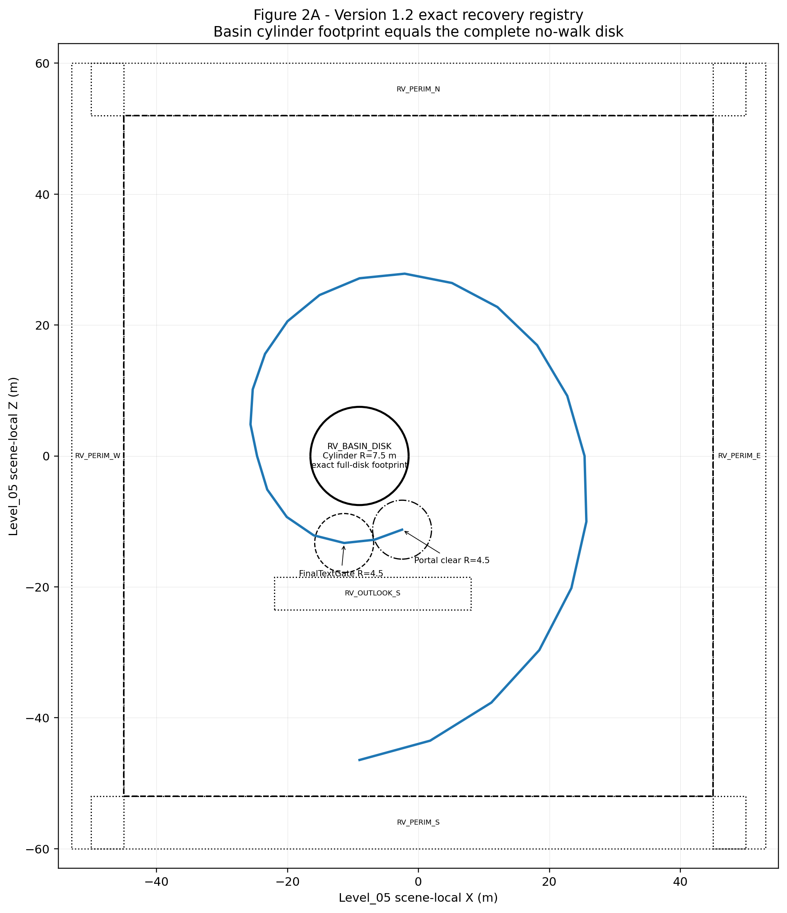
Figure 2A. Exact recovery/OOB registry. RV_BASIN_DISK is one cylinder whose horizontal footprint equals the complete Seed Basin no-walk disk.
Registry acceptance: all below-world falls, perimeter escapes, the complete no-walk disk and the Final Outlook outer edge are covered. No registered volume intersects legal route, legal shoulder, normal blockers, mandatory targets, shard floors, the legal viewing rim, FinalTextGate or Portal Outlook.

5. Beat-by-beat playable flow and pacing
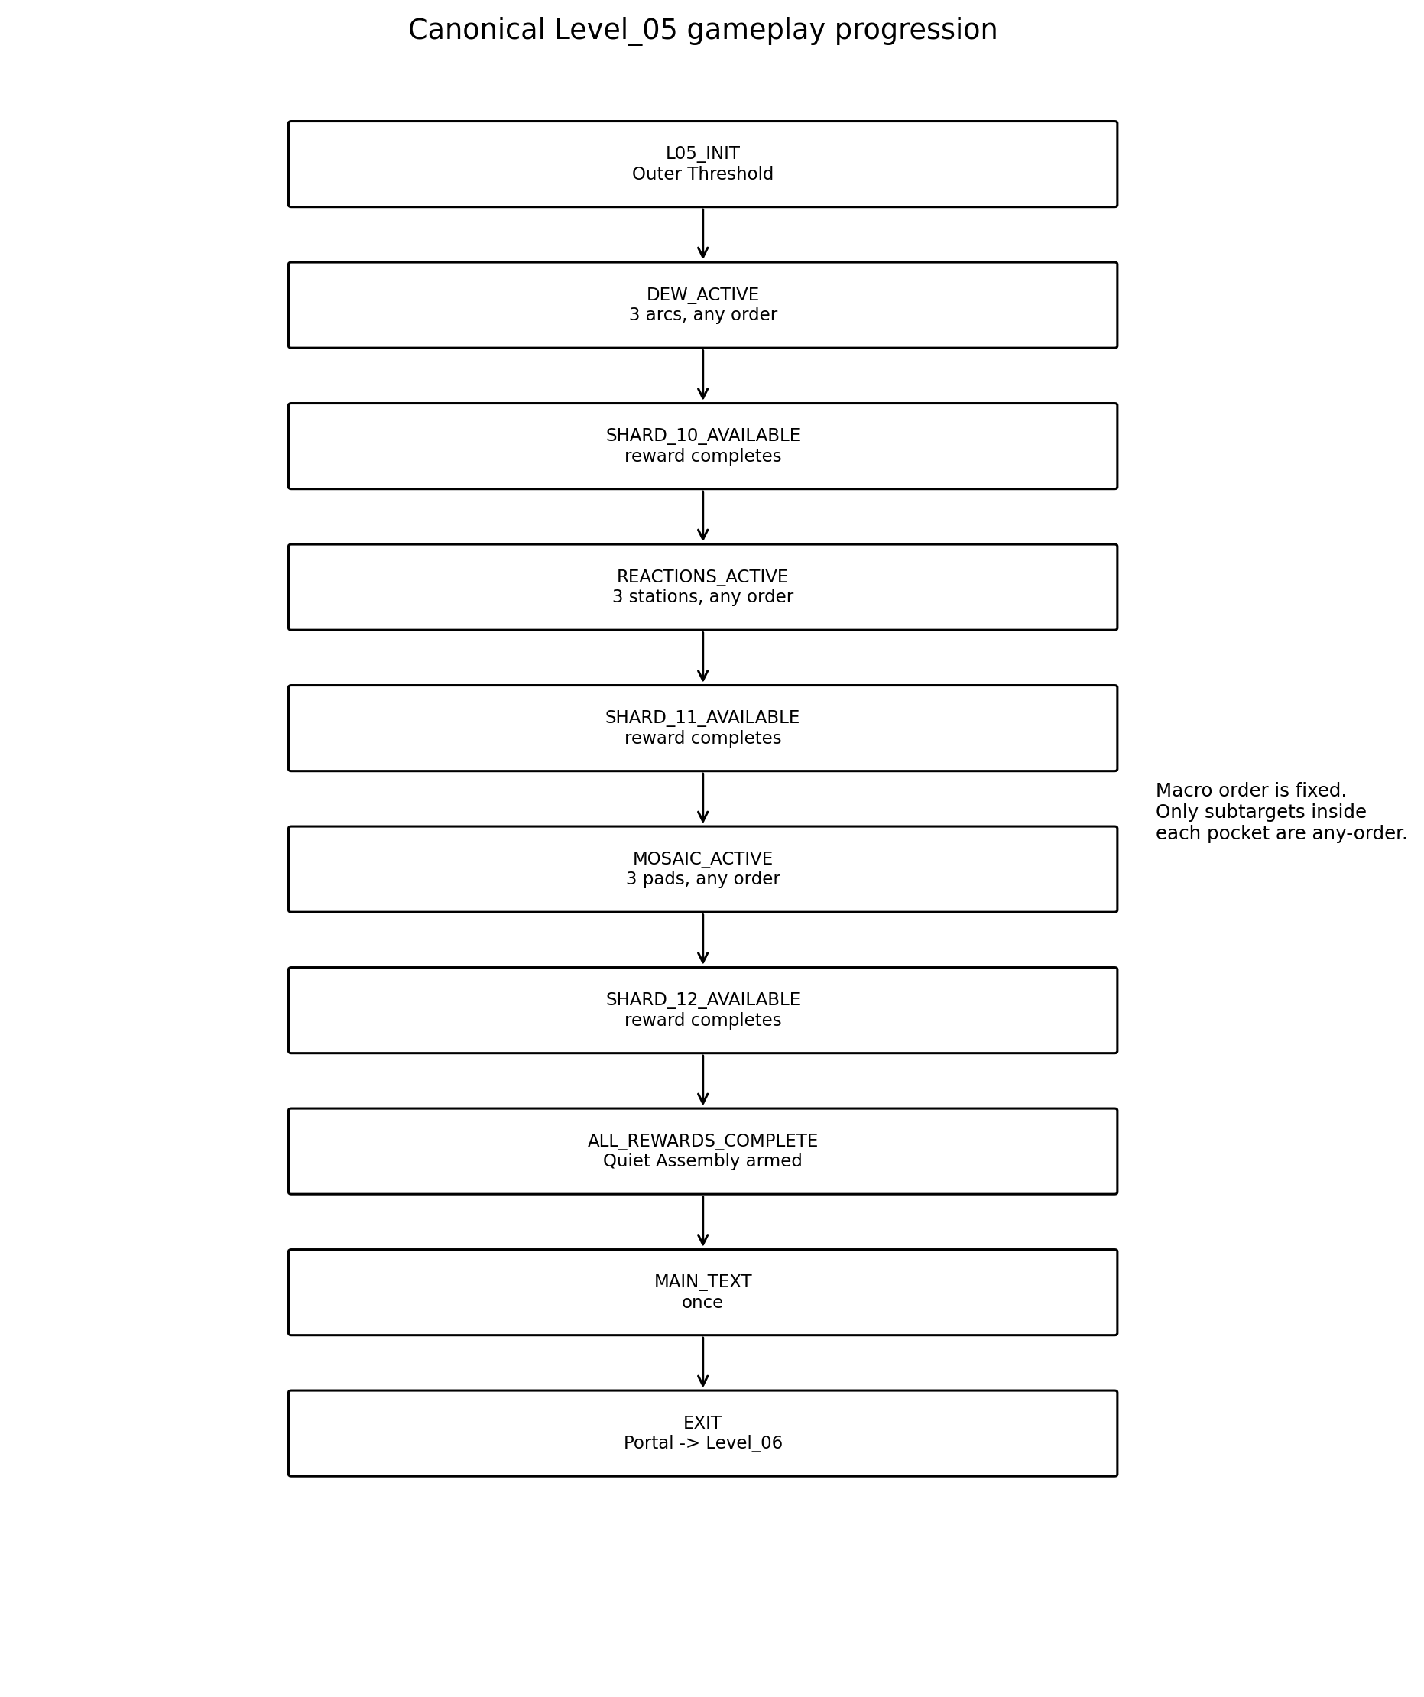
Figure 3. Fixed emotional macro-order with relaxed any-order local targets.

5.1 Complete beat table
ID | Beat | Budget | Location | Goal | Landmark | Action | Narrative | Environment | Confusion | Fallback
B00 | Arrival | 0:00-0:25 | Outer Threshold | Orient and begin spiral | Dew entrance + basin fragment | Walk/camera | Scale shifts closer | E0 natural blue-hour life | Turns backward | Route framing returns view
B01 | Close-up onboarding | 0:25-0:50 | P00-P01 | Read broad detail triggers | Arc 1 | Walk through broad cue | Attention without pixel hunting | First arc preglow | Does not cross arc | 4 s broad path pulse
B02 | Dew Script | 0:50-1:35 | Dew crescent | Complete D1-D3 | Three arcs + trace surface | 0.35 s grounded presence | One word leaves a trace | Persistent abstract curves | Misses target | 20/35 s hint escalation
B03 | Shard_10 reveal | 1:35-1:45 | Rest Ledge | Approach available shard | Shard_10 | E collect when available | Remembered «понимяу» | 0.9 s restrained reveal | Collects early | Interaction disabled until ready
B04 | Shard_10 reward | 1:45-2:15 | Rest Ledge | Read exact phrase | Moss Bend silhouette | Existing short overlay | Specific verbal memory | E1 next-pocket glints | Overlay callback missing | Bounded completion fallback
B05 | Moss Bend | 2:15-2:35 | P04-P06 | Walk without task | Basin glimpse + seed silhouettes | Walk | Pacing reset | Completed traces remain peripheral | Searches for task | Only next pocket has primary cue
B06 | Little Reactions | 2:35-3:30 | Elongated pocket | Complete R1-R3 | Three stations | 0.45 s grounded observation | Brief autonomous reaction | Distinct one-time motions + marks | Approaches in any order | No wrong order
B07 | Shard_11 reveal | 3:30-3:40 | Rest Stone | Approach shard | Shard_11 | E collect | Brief camera smile memory | 1.0 s reveal after 3/3 | Motion still running | Reveal waits or fallback settles
B08 | Shard_11 reward | 3:40-4:10 | Rest Stone | Read exact phrase | Inner descent + pads | Existing short overlay | Specific brief smile | E2 descent glints | Duplicate callback | Unique-ID ignore
B09 | Inner descent | 4:10-4:30 | P10-P14 | Descend safely | Three pad silhouettes | Walk | From reaction to whole conversation | Low edge glints | Basin looks reachable | Retaining edge blocks shortcut
B10 | Ordinary Mosaic | 4:30-5:25 | Crescent terrace | Complete M1-M3 | Shared layered field | 0.65 s grounded presence | Ordinary sincerity | One persistent layer per pad | Tries camera alignment | No facing check
B11 | Shard_12 reveal | 5:25-5:35 | Inner Terrace | Approach shard | Shard_12 | E collect | Value of sincerity | 1.0 s reveal | Optional layer missing | Logical reveal unaffected
B12 | Shard_12 reward | 5:35-6:00 | Inner Terrace | Read exact phrase | Quiet Assembly route | Existing short overlay | Third concrete memory beat | E3 motifs coexist | Repeated callback | Ignored
B13 | Quiet Assembly | 6:00-6:20 | P18-P22 corrected annular final arc | Walk to MainTextGate without entering Basin exclusion | Combined motifs + modest horizon | Walk | Understanding of depth | No fourth puzzle | Waits for interaction | P19-P22 remain outside required 11.50 m centerline radial clearance
B14 | Main text | 6:20-6:45 | P22 FinalTextGate | Read exact main text once | Open outlook | Presence + overlay close | Three memories form one insight | Portal dormant | Gate entered early | Re-evaluate after rewards
B15 | Portal formation | 6:45-6:55 | P22-P24 Portal Outlook | Wait for calm shared portal activation | Portal side-forward | No required input | Continuation to admiration chapter | E4 local activation | Player overlaps early | Runtime contract validation required
B16 | Exit | 6:55-7:00 | P24 LevelPortalRoot | AUTO_ENTER transition to Level_06 | Stable portal | AUTO_ENTER | Handoff to Level_06 | Garden remains stable | Rapid enter/exit | One shared transition

5.2 Pacing budget
Segment | Target | Guardrail
Arrival + onboarding | 0:40-0:55 | No 360-degree search.
Dew Script + Shard_10 | 1:10-1:25 | Includes short reward reading.
Moss Bend | 0:15-0:25 | No puzzle or collectible.
Little Reactions + Shard_11 | 1:15-1:35 | No waiting for random motion.
Descent + Mosaic + Shard_12 | 1:30-1:55 | No exact camera alignment.
Quiet Assembly + text + portal | 0:50-1:15 | No fourth puzzle or long cinematic.
Normal first completion | 5:30-7:00 | Scope alarm if traversal without reading >7:30.
Correct repeat completion | 3:15-4:15 | All local rules already known.

6. Dew Script and Shard_10 specification
LOCKED SHARD_10 TEXT
«Я до сих пор улыбаюсь, когда вспоминаю твое «понимяу».»

Field | Deterministic contract
Canonical ID | Shard_10
Activation prerequisite | L05_INIT / DEW_ACTIVE.
Input acceptance condition | Grounded presence inside one active broad Dew trigger for 0.35 s.
Unique target set | DEW_ARC_1, DEW_ARC_2, DEW_ARC_3.
Local completion condition | All three unique Dew IDs complete; order-independent.
Shard reveal prerequisite | Local completion condition true; reveal settle or bounded fallback terminal event.
Shard reward completion transition | SHARD_10_REWARD_COMPLETE; activates Little Reactions and E1 guidance.
Leave/re-enter persistence | Unique IDs and abstract traces persist; no reset.
Trigger footprint | 4.5 m wide x 2.5 m deep recommended; no precision.

State | Entry condition | Result
LOCKED | Before L05_INIT | Visible only.
DEW_ACTIVE (0/3) | L05_INIT / Dew pocket activation | Accept unique Dew IDs.
DEW_ACTIVE (1/3) | First unique Dew ID | One trace persists.
DEW_ACTIVE (2/3) | Second unique Dew ID | Two traces persist.
SHARD_10_REVEALING | Third unique Dew ID | Reveal presentation/fallback race is idempotent.
SHARD_10_AVAILABLE | Reveal terminal event | Shard interaction enabled.
SHARD_10_REWARD_COMPLETE | Reward terminal event | Little Reactions active; E1.

Rule | Contract
Wrong input | None. Revisiting a completed arc gives a quiet completed-state response only.
Assistance 1 | 20 s without new completion: nearest unvisited arc gets slow rising glint.
Assistance 2 | 35 s: restrained ground cue repeats every 6 s.
Race protection | Duplicate body/area callbacks and presentation timeout race are idempotent.
Presentation fallback | Missing trace VFX cannot block logical completion or shard reveal.
No-softlock | No timer, reset, audio dependency, thin beam, alignment or hidden mandatory target.

7. Little Reactions and Shard_11 specification
LOCKED SHARD_11 TEXT
«Я до сих пор помню, как ты на несколько секунд включила камеру и улыбнулась.»

Field | Deterministic contract
Canonical ID | Shard_11
Activation prerequisite | SHARD_10_REWARD_COMPLETE / REACTIONS_ACTIVE.
Input acceptance condition | Grounded presence inside one active station radius 2.4 m for 0.45 s.
Unique target set | REACTION_SEED_TURN, REACTION_POLLEN_PUFF, REACTION_FOLDING_GLOW.
Local completion condition | All three unique Reaction IDs complete; order-independent.
Shard reveal prerequisite | Local completion true; active motion settle or 1.3 s bounded fallback.
Shard reward completion transition | SHARD_11_REWARD_COMPLETE; activates Ordinary Mosaic and E2 guidance.
Leave/re-enter persistence | Unique IDs, route marks and simplified background motion persist.
Autonomy rule | Motions are environmental and do not represent or imitate Alena.

State | Entry condition | Result
LOCKED | Before SHARD_10_REWARD_COMPLETE | Ambient only.
REACTIONS_ACTIVE (0/3) | Activation prerequisite satisfied | Accept unique Reaction IDs.
REACTIONS_ACTIVE (1/3) | First unique Reaction ID | One route mark.
REACTIONS_ACTIVE (2/3) | Second unique Reaction ID | Two route marks.
SHARD_11_REVEALING | Third unique Reaction ID | Motion/fallback terminal race idempotent.
SHARD_11_AVAILABLE | Reveal terminal event | Shard interaction enabled.
SHARD_11_REWARD_COMPLETE | Reward terminal event | Ordinary Mosaic active; E2.

Rule | Contract
Wrong input | None. Approaching completed or future station is allowed and never penalized.
Concurrent visits | Logical target acceptance is immediate; presentations may overlap but completion count remains unique.
Assistance 1 | 20 s without new completion: nearest unvisited station gets low vertical mote cue.
Assistance 2 | 35 s: ground-edge cue repeats every 6 s.
Motion fallback | If a motion never reports completion, mark presentation terminal after 1.3 s; logical completion is preserved.
No-softlock | No chase, random waiting, speed reaction, mascot behavior, sound requirement or facial imitation.

8. Ordinary Mosaic and Shard_12 specification
LOCKED SHARD_12 TEXT
«Мне дорога твоя искренность в наших разговорах.»

Field | Deterministic contract
Canonical ID | Shard_12
Activation prerequisite | SHARD_11_REWARD_COMPLETE / MOSAIC_ACTIVE.
Input acceptance condition | Grounded presence within one active pad radius 2.8 m for 0.65 s.
Unique target set | MOSAIC_FOREGROUND, MOSAIC_MIDGROUND, MOSAIC_BACKGROUND.
Local completion condition | All three unique Mosaic IDs complete; order-independent.
Shard reveal prerequisite | Local completion true; 1.0 s settle or bounded fallback terminal event.
Shard reward completion transition | ALL_REWARDS_COMPLETE; activates E3, Quiet Assembly and FinalTextGate eligibility.
Leave/re-enter persistence | Unique pad IDs and all accepted composition layers persist.
Camera rule | No facing, alignment, screenshot, lens or composition score.

State | Entry condition | Result
LOCKED | Before SHARD_11_REWARD_COMPLETE | Visible silhouettes only.
MOSAIC_ACTIVE (0/3) | Activation prerequisite satisfied | Accept unique Mosaic IDs.
MOSAIC_ACTIVE (1/3) | First unique Mosaic ID | One layer persists.
MOSAIC_ACTIVE (2/3) | Second unique Mosaic ID | Two layers persist.
SHARD_12_REVEALING | Third unique Mosaic ID | Reveal/fallback terminal race idempotent.
SHARD_12_AVAILABLE | Reveal terminal event | Shard interaction enabled.
ALL_REWARDS_COMPLETE | Shard_12 reward terminal event | E3, Quiet Assembly and FinalTextGate eligibility.

Rule | Contract
Wrong input | None. Completed pad remains readable and cannot increment again.
Assistance 1 | 20 s without new completion: nearest unvisited pad gains restrained edge outline.
Assistance 2 | 35 s: path motes repeat every 6 s.
Dwell interruption | Leaving before 0.65 s resets only current dwell; prior pads remain complete.
Race protection | Duplicate pad callbacks and presentation/fallback races are idempotent.
No-softlock | No hidden object, rare treasure, camera alignment, surveillance framing, timer or reset.

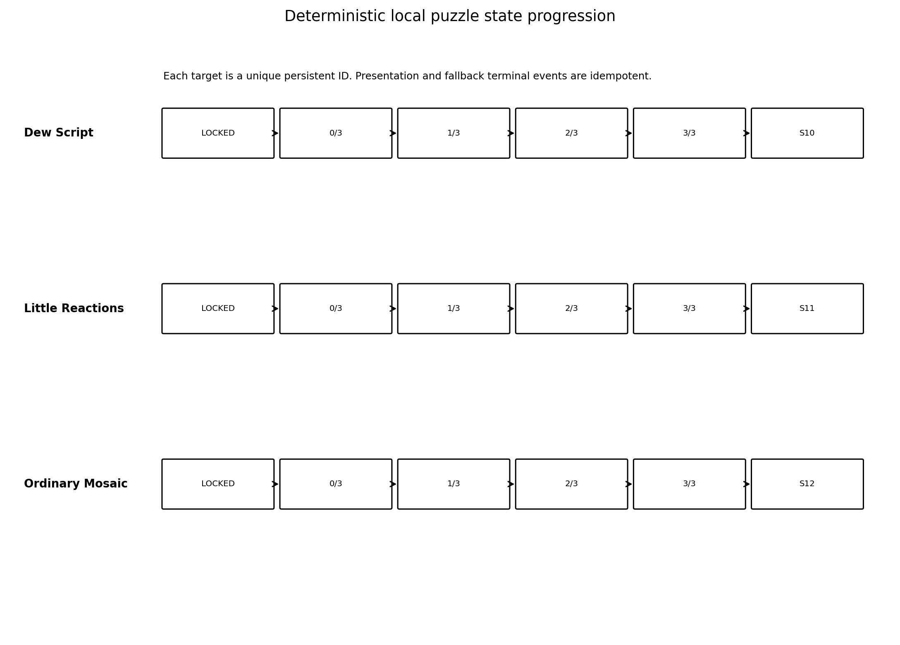
Figure 4. Local puzzle states; logical completion cannot depend on optional presentation.

9. Progression and environment states
Canonical state | Entry condition | Result
L05_INIT | Spawn and onboarding | Dew Script is the only accepting mechanic.
DEW_ACTIVE | Dew activation prerequisite satisfied | Accept DEW_ARC_1..3 unique IDs.
SHARD_10_AVAILABLE | All three Dew IDs + reveal terminal | Shard_10 enabled.
SHARD_10_REWARD_COMPLETE | Shard_10 reward terminal | Little Reactions activates; E1.
REACTIONS_ACTIVE | Activation prerequisite satisfied | Accept three unique Reaction IDs.
SHARD_11_AVAILABLE | All three Reaction IDs + reveal terminal | Shard_11 enabled.
SHARD_11_REWARD_COMPLETE | Shard_11 reward terminal | Ordinary Mosaic activates; E2.
MOSAIC_ACTIVE | Activation prerequisite satisfied | Accept three unique Mosaic IDs.
SHARD_12_AVAILABLE | All three Mosaic IDs + reveal terminal | Shard_12 enabled.
ALL_REWARDS_COMPLETE | Shard_12 reward terminal | Quiet Assembly and FinalTextGate eligible; E3.
MAIN_TEXT | Eligible player present in FinalTextGate | Exact main text opens once.
EXIT | Main text closes | Shared LevelPortal activation requested once; E4.

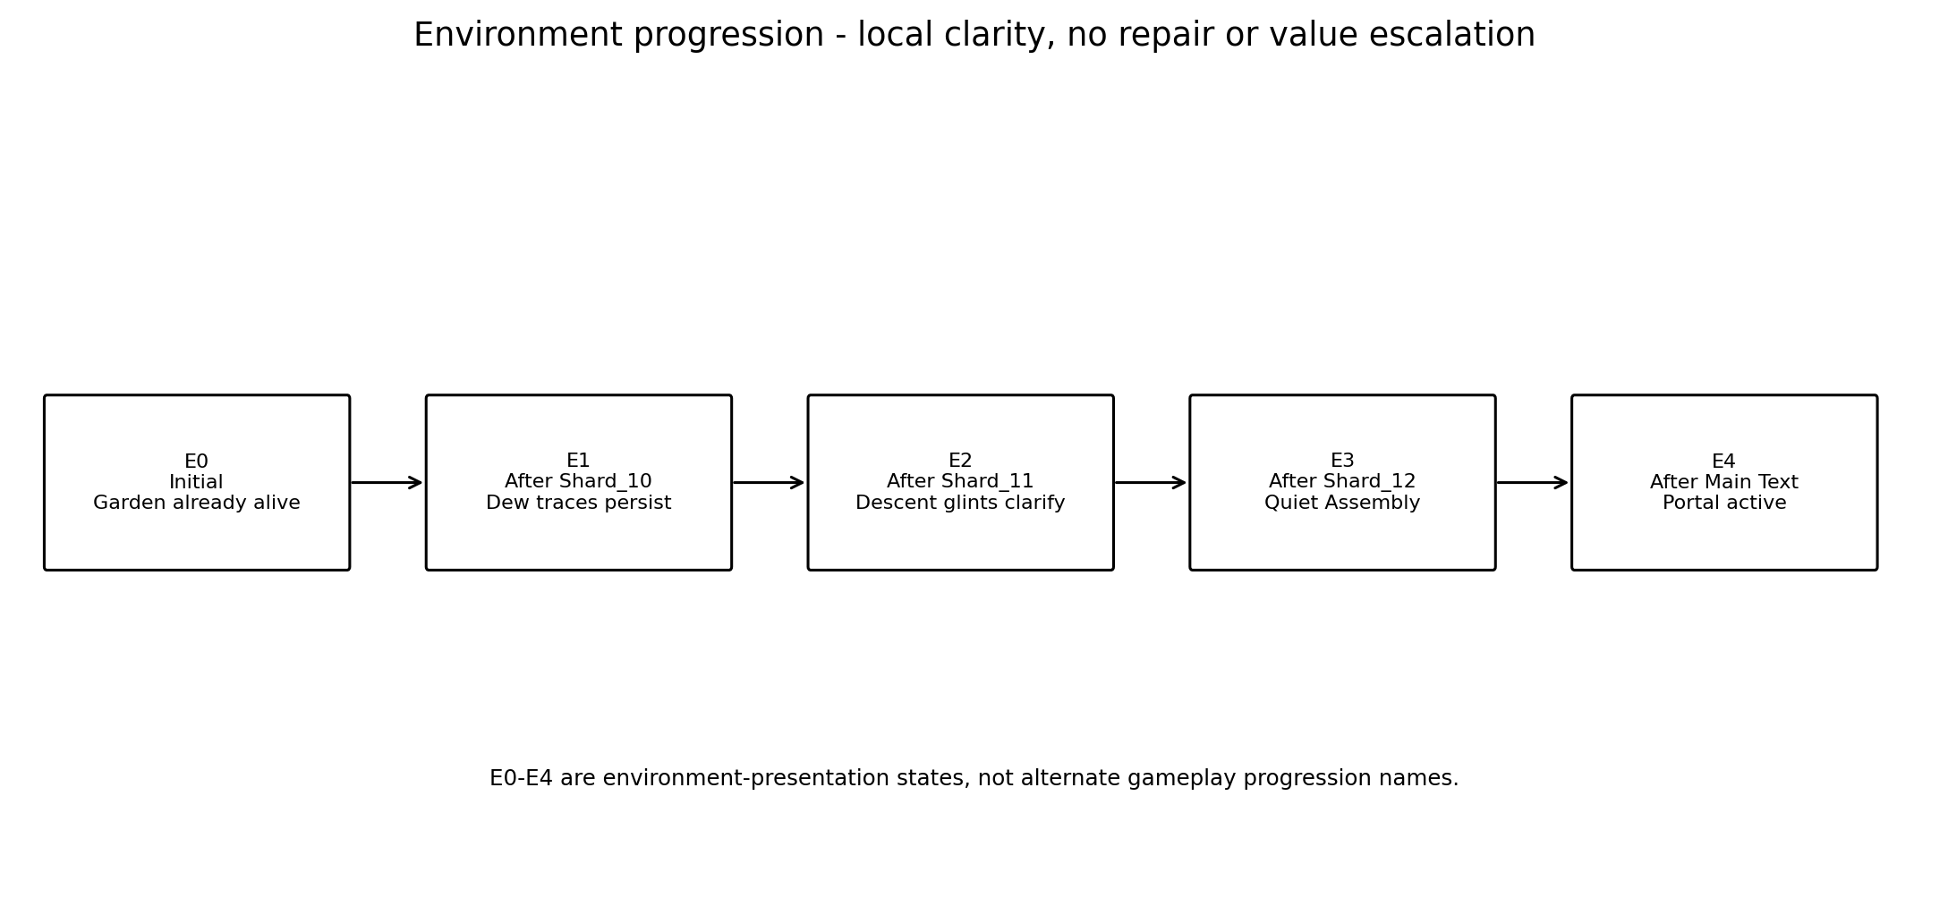
Figure 5. E0-E4 are environment presentation states layered over canonical gameplay progression.
Presentation state | Timing | Visual contract
E0 Initial | L05_INIT through Dew completion | Natural color 75-85% of final; all motif families faintly alive.
E1 After Shard_10 | 4 s nonblocking | Dew traces persist; next-pocket silhouette and route edge clarify.
E2 After Shard_11 | 4 s nonblocking | Completed motions remain subtle; descent and pads gain low glints.
E3 After Shard_12 | 5 s nonblocking | All motif families coexist; Quiet Assembly becomes primary; portal dormant.
E4 After Main Text | Shared portal activation | Portal activates calmly; garden remains stable and alive.

- Gameplay progression is keyed to canonical shard IDs and unique target IDs, never blind count += 1 alone.
- Environment callbacks are optional presentation and cannot block a logical state transition.
- Completed traces, motions and layers persist; no earlier zone is turned off or converted into a trophy.
- No environment state implies repair, ownership, capture, surveillance or proof of knowledge.

10. Quiet Assembly, main-text gate and portal
Field | Contract
Prerequisite | ALL_REWARDS_COMPLETE.
Input | Walk from P18 through P19-P22. No fourth puzzle or interaction.
Duration | 15-25 s normal traversal.
Presentation | Dew traces, minimal autonomous motions and Mosaic layers share one composition.
Fallback | Optional synthesis terminal timeout <=2.5 s; FinalTextGate must remain reachable.
Narrative role | Three memories form an understanding of deeper feeling; admiration payoff remains for Level_06.

LOCKED MAIN TEXT
«Я помню твое «понимяу», ту короткую улыбку в камеру и то, как искренне ты говоришь со мной. В тот момент это могло казаться мелочами, но именно они возвращаются в память снова и снова. Из них постепенно сложилось понимание: мое чувство к тебе глубже, чем один легкий разговор или яркий момент.»

Field | Locked behavior
FinalTextGate | Center Vector3(-11.344, 0.68, -13.295), radius 4.5 m.
Gate prerequisites | Shard_10, Shard_11 and Shard_12 reward sequences logically complete.
Early presence | If player is already inside when prerequisites complete, gate re-evaluates automatically.
Main text | Shows exactly once; controls lock only while the existing overlay requires it.
Portal floor anchor | LevelPortalRoot / PortalFloorAnchor = Vector3(-2.500, 0.82, -11.258), canonical point P24.
Target | target_scene_path = res://scenes/levels/Level_06.tscn
Entry behavior | entry_mode = LevelPortal.EntryMode.AUTO_ENTER; require_entry_confirmation = false.
Activation timing | Portal activation begins only after main text closes.
Scene ownership | Level_05-local orchestration never changes scene directly; shared LevelPortal owns loading.
Stationary early overlap | No early transition. A player remaining inside through activation must transition exactly once without exit/re-entry.
Shared carry-over | Current shared portal handles AUTO_ENTER from active-state body_entered; already-overlapping activation behavior is not proven.
Architecture blocker | Technical Architecture must runtime-validate the hard contract. If unsupported, hard-stop for a separately approved narrow shared prerequisite.

11. Progress preservation, duplicates and reload policy
Domain | Contract
Dew targets | Three unique IDs; persistent during the scene; duplicates ignored.
Reaction stations | Three unique IDs; persistent marks; presentation races idempotent.
Mosaic pads | Three unique IDs; persistent layers; interrupted dwell loses only current dwell.
Shard collection | Shard_10/11/12 each accepted once; duplicate collection/reward callbacks ignored.
Environment | E0-E4 requests idempotent and derived from canonical progression.
Main text | Open and close terminal events accepted once.
Portal activation | Requested once; duplicate activation completion cannot create second transition.
Recovery | Preserves all logical scene progress.

11.1 Reload policy
MVP FULL-SCENE RESET
A full Level_05 scene reload reconstructs a clean L05_INIT / E0 state at Outer Threshold. The project has no approved partial Level_05 save/checkpoint contract. No stale target, shard, overlay, environment or portal state survives reload.

- Normal falls use SoftReturnVolume recovery, not scene reload.
- A future save system may restore only an atomic set of canonical target IDs, shard IDs, progression state and environment state before control resumes.
- Partial restoration and global save architecture are outside this stage.

12. Guidance, accessibility and camera QA
Area | Rule
Navigation | Next-pocket silhouette + partial Seed Basin glimpse + local glint/motion cue. No minimap or UI arrow required.
Audio independence | All mandatory states and targets readable muted.
Color independence | Target identity uses position, silhouette, motion and persistent shape, not color alone.
Motor accessibility | No jump, chase, reaction test or precision alignment; broad presence footprints.
Cognitive load | Three targets per puzzle, any order, persistent; no wrong answer or reset.
Motion sensitivity | No camera shake, rapid flash, forced focus or strong depth-of-field gameplay.
Text safety | All reward and main-text positions are broad dry floors; player is not moved during reading.
Emotional safety | No catalogue, monitoring, proof quiz, ideal portrait or claim to know every detail.

Beat | Trigger | Assistance
Close-up onboarding | 4 s without meaningful movement/camera change | Arc 1 broad path pulse.
Dew Script | 20 s idle | Nearest unvisited rising glint; at 35 s ground cue every 6 s.
Little Reactions | 20 s idle | Nearest unvisited low mote; at 35 s edge cue every 6 s.
Ordinary Mosaic | 20 s idle | Nearest unvisited outline; at 35 s path motes every 6 s.
Quiet Assembly | 25 s idle | Stronger outlook silhouette and repeated combined-motif path cue; portal remains dormant.

12.1 Exact Camera QA points
Point | Exact floor-relative player position | Viewing target | Required landmarks / targets | Prohibited occlusion / relevant state
CP0 Arrival | Vector3(-9.00, 2.40, -46.44) | Vector3(5.00, 2.55, -37.00) | Dew entrance, Arc 1 silhouette, partial Seed Basin glimpse | E0; no tall-grass route wall
CP1 Dew Entrance | Vector3(-0.50, 2.47, -44.50) | Vector3(13.50, 2.60, -35.00) | All three dew-arc silhouettes in one natural sweep | DEW_ACTIVE; no arc hidden
CP2 Shard_10 Ledge | Vector3(23.36, 2.76, -20.18) | Vector3(25.40, 2.65, -2.00) | Persistent traces and Moss Bend next-pocket silhouette | E1; reward not occluded
CP3 Reactions Entry | Vector3(25.37, 2.62, 0.00) | Vector3(18.00, 2.42, 17.00) | Seed Turn, Pollen Puff, Folding Glow | REACTIONS_ACTIVE; no mascot framing
CP4 Shard_11 Stone | Vector3(5.12, 2.22, 26.42) | Vector3(-10.00, 1.75, 24.00) | Inner descent and all Mosaic-pad silhouettes | E2; Basin shortcut not readable
CP5 Mosaic Entrance | Vector3(-20.00, 1.48, 20.57) | Vector3(-24.50, 1.05, 8.50) | All three pads and shared composition field | MOSAIC_ACTIVE; no alignment implication
CP6 Shard_12 Terrace | Vector3(-24.65, 0.82, 0.00) | Vector3(-20.10, 0.72, -9.32) | Corrected Quiet Assembly arc outside Basin exclusion | E3; no direct Basin crossing
CP7 Final Approach | Vector3(-16.00, 0.68, -12.124) | Vector3(-11.344, 0.68, -13.295) | Main Text Gate and annular Outlook continuation | E3; inner retaining edge unobstructed
CP8 Main Text Gate | Vector3(-11.344, 0.68, -13.295) | Vector3(-2.500, 0.82, -11.258) | Portal Outlook and side-forward portal anchor | Portal dormant before/during text
CP9 Portal Outlook | Vector3(-6.742, 0.74, -12.802) | Vector3(-2.500, 1.90, -11.258) | Shared LevelPortal with 4.5 m visual clearance | E4; no severe foreground occlusion

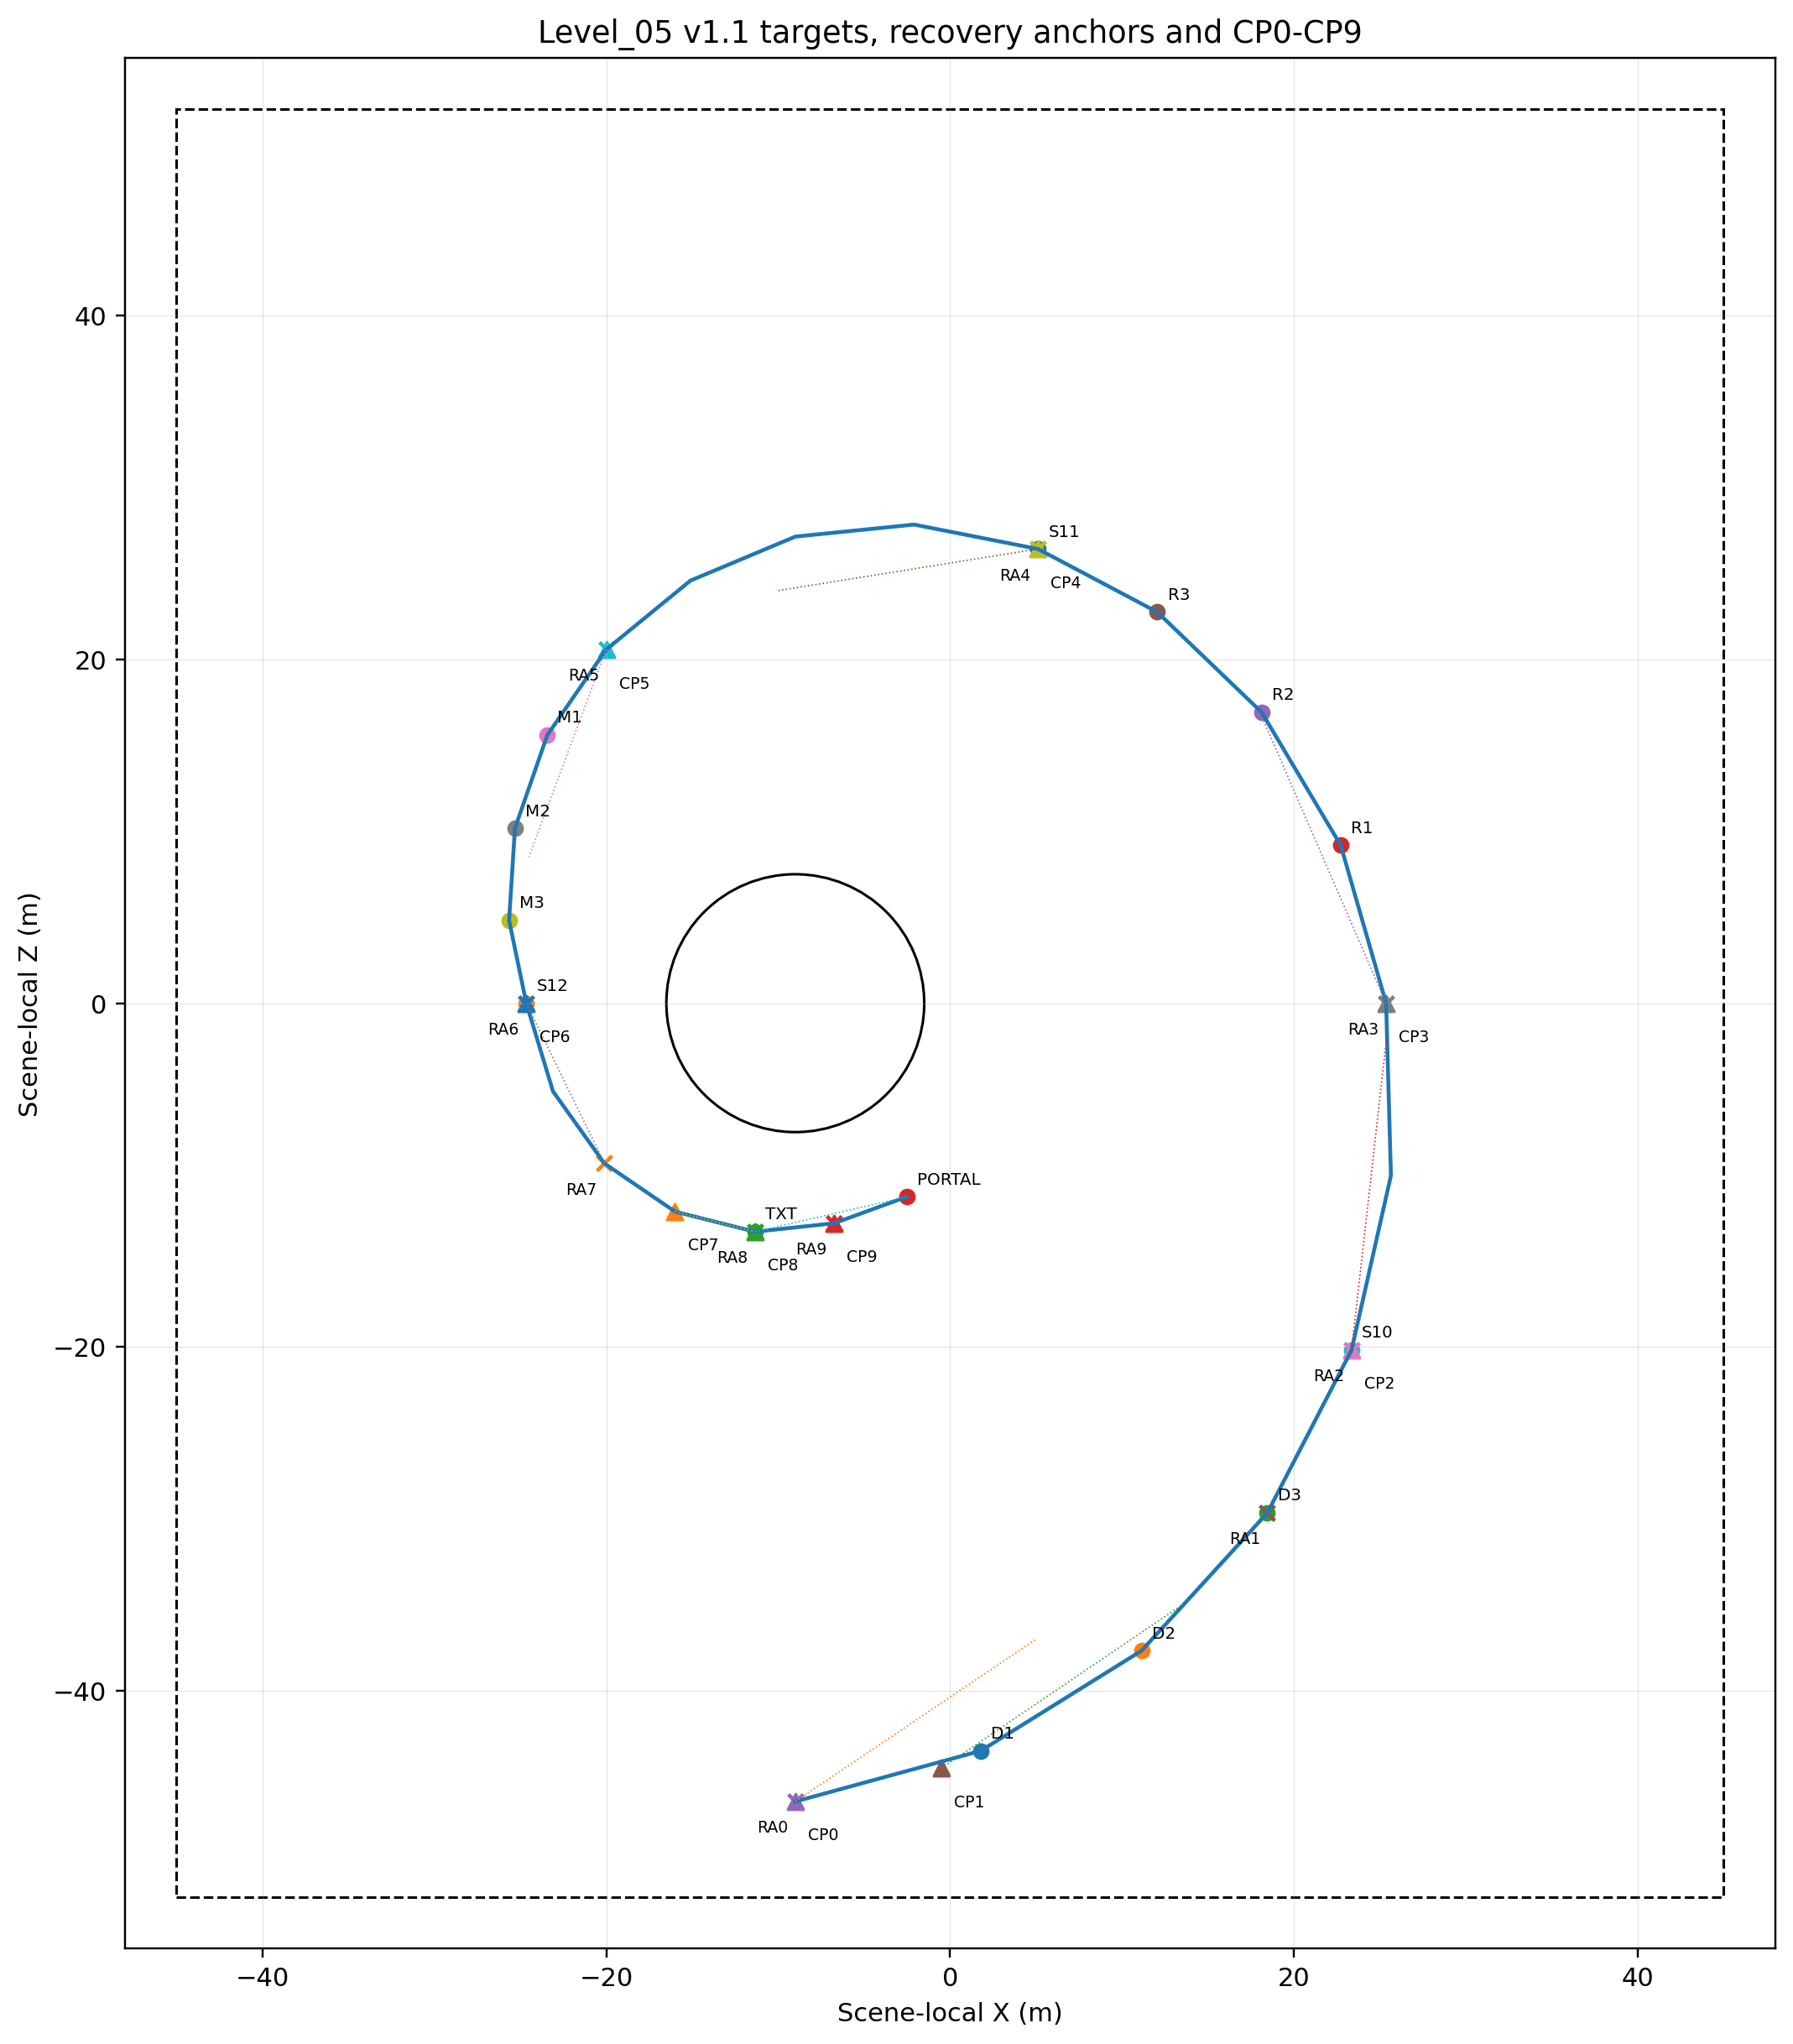
Figure 6. Mandatory targets, recovery anchors and CP0-CP9 camera QA positions.

13. Failure and softlock matrix
Risk | Prevention | Fallback | Exact acceptance evidence
Local puzzle targets visited in any permutation | Unique-ID acceptance; no local order authority. | Keep prior progress; first accepted callback per ID wins. | All six permutations yield one completion and one shard reveal.
Leave/re-enter Dew, Reactions or Mosaic | Accepted unique IDs persist. | Hints resume; only unfinished current dwell resets. | No local reset.
Future mechanic entered early | Canonical activation prerequisite fail-closed. | Current valid guidance remains primary. | No future unique ID accepted.
Duplicate target/shard callback | Completed canonical ID ignored. | Completed-state feedback only. | Counts and overlays occur once.
Presentation completion races fallback | Terminal events idempotent. | First accepted terminal event wins. | One logical completion/reveal.
Missing Dew/Reaction/Mosaic presentation | Logical completion independent of optional VFX. | Bounded fallback continues. | All shards remain reachable.
Missing E1/E2/E3 callback | Canonical state does not wait indefinitely. | Bounded state-owned fallback. | Next mechanic/finale becomes available.
Seed Basin shortcut or diagonal entry | Blocking geometry plus exact cylinder footprint. | RV_BASIN_DISK catches every r<=7.5 point. | Relative (4,6), r≈7.21, and all sampled disk points covered.
Basin recovery overshoot | Cylinder radius exactly 7.50. | None. | No point r>7.50 is inside recovery footprint.
Standing still / slow movement / normal blocker | No movement-state recovery trigger. | None. | No teleport.
Fall during overlay and continue below Y=-12 | First valid entry latches pending recovery. | After unlock recover once if still outside legal space; no second body_entered. | One teleport, velocity zero, progress preserved, no loop.
Safe return before unlock | Pending event validates legal-space state at unlock. | Cancel only after proven safe return. | No unnecessary teleport.
Future RA footprint entered early | Exact canonical-state gate per RA. | Ignore presence; keep RA_LATEST_VALID. | Anchor activates only at/after earliest state.
RV_OUTLOOK_S before RA8 valid | Destination validity check. | Use RA_LATEST_VALID. | No teleport forward.
RV_OUTLOOK_S after RA8 valid | RA8 gate satisfied. | RA8 may be used. | Correct final-area recovery.
FinalTextGate entered early | Fail-closed, overlap retained. | Re-evaluate at ALL_REWARDS_COMPLETE. | No exit/re-entry.
Main text closed then gate re-entered | One-time terminal flag. | No reopen. | Exactly one presentation.
Duplicate main-text close | First valid close advances. | Later events ignored. | One portal activation.
Stationary portal overlap during activation | No early transition. | Runtime re-evaluation required. | Exactly one Level_06 transition without re-entry.
Rapid portal enter/exit or duplicate activation complete | One-way entering/loading state. | Ignore later callbacks. | At most one transition.
Reload in any major state | Full scene reset. | Reconstruct L05_INIT/E0. | No stale state.

14. Acceptance criteria
Domain | Locked acceptance criterion
Coordinates | Section 10 and all other finale references use only FinalTextGate (-11.344,0.68,-13.295) and PortalFloorAnchor (-2.500,0.82,-11.258/P24).
Envelope / route | Exact P00-P24 route, centerline 177.71 m, envelope 90 x 104 m.
Traversal | Route >=5.5 m, shoulder >=1.25 m, slope <=8°, cross-slope <=3°, step <=0.15 m, no mandatory gap.
Basin recovery footprint | RV_BASIN_DISK equals the entire R<=7.5 disk exactly: uncovered area 0, horizontal overshoot 0.
Recovery latch | First valid volume entry latches one event across overlays and continued falling without repeated body_entered.
Recovery execution | One teleport, Player.velocity=Vector3.ZERO, all logical progress preserved, destination-exit re-arm.
Recovery cancellation | Pending event cancels only after proven safe legal-space return before unlock.
RA gating | RA0-RA9 activate only at exact earliest canonical state; future footprints cannot change RA_LATEST_VALID.
Outlook recovery | RV_OUTLOOK_S uses RA8 only when valid, otherwise RA_LATEST_VALID; never advances progression.
Puzzle persistence | Dew, Reactions and Mosaic preserve unique IDs on leave/re-enter.
Puzzle assistance | Each puzzle provides exact 20 s and 35 s assistance.
Presentation fallback | Missing Dew VFX, Reaction motion, Mosaic layer or E1/E2/E3 callback cannot softlock.
Exact copy | Shard_10, Shard_11, Shard_12 and main text match approved copy character-for-character.
Main text | Opens once and never reopens after close/re-entry.
Portal | P24 root anchor, AUTO_ENTER, no confirmation, shared portal owns Level_06 loading.
Stationary early overlap | No early transition and exactly one post-activation transition after runtime validation.
Reload | Every major-state reload returns clean L05_INIT/E0.
Emotional safety | World alive from E0; no repair, surveillance, proof quiz, ownership, response demand or emotional debt.

14.1 Manual playtest matrix
ID | Setup | Action | Exact expected evidence
P0-COORD-01 | Built document/data | Search for obsolete finale coordinate pairs | No old coordinates; all finale references match P22/P24.
P0-GEO-01 | Authored scene | Validate P00-P24, envelope and centerline | Exact anchors; X[-45,45], Z[-52,52], total 177.71 m.
P0-GEO-02 | Traversal surfaces | Measure width, shoulder, slope, cross-slope, step, gaps | >=5.5 m; >=1.25 m; <=8°; <=3°; <=0.15 m; no mandatory gaps.
P0-BASIN-01 | RV_BASIN_DISK | Analytically compare footprint with disk equation | Footprint exactly {(x,z):(x+9)^2+z^2<=56.25}; uncovered area 0.
P0-BASIN-02 | RV_BASIN_DISK | Sample boundary/interior including relative point (4,6) | Every r<=7.5 point inside; (4,6), r≈7.211, covered.
P0-BASIN-03 | RV_BASIN_DISK | Sample immediately outside circumference | Every r>7.5 point outside; no overshoot.
P0-BASIN-04 | Legal route/viewing rim | Sweep all adjacent legal space | No recovery overlap; documented separation retained.
P0-REC-01 | Reward/main-text overlay open | Enter RV_FALL_GLOBAL, continue below Y=-12, close overlay | Exactly one recovery to valid RA; velocity zero; progress preserved; no loop.
P0-REC-02 | Pending event latched | Return safely to legal space before unlock | Pending event cancels; no teleport.
P0-REC-03 | Post-recovery | Remain inside destination safety footprint | No repeat teleport; re-arm only after exit.
P0-REC-04 | Each RA0-RA9 before earliest state | Enter footprint grounded >=0.20 s | RA_LATEST_VALID unchanged.
P0-REC-05 | Each RA0-RA9 at/after earliest state | Enter footprint grounded >=0.20 s | Anchor becomes RA_LATEST_VALID.
P0-REC-06 | Before RA8 valid | Enter RV_OUTLOOK_S | Uses current RA_LATEST_VALID; no forward teleport.
P0-REC-07 | After RA8 valid | Enter RV_OUTLOOK_S | May recover to RA8 exactly once.
P0-REC-08 | Recovery registry | Validate every transform, shape and size | Section 4.2 and Figure 2A match exactly.
P0-DEW-01 | DEW_ACTIVE | Run all 6 target permutations | Three unique IDs; one Shard_10 reveal.
P0-DEW-02 | Dew partial | Leave/re-enter and wait 20/35 s | Progress persists; exact assistance appears.
P0-DEW-03 | Dew VFX disabled | Complete all IDs | Shard_10 remains available once.
P0-REA-01 | REACTIONS_ACTIVE | Run all 6 station permutations | Three unique IDs; one Shard_11 reveal.
P0-REA-02 | Reaction partial | Leave/re-enter and wait 20/35 s | Progress/marks persist; exact assistance appears.
P0-REA-03 | Reaction motion disabled | Complete station | Logical completion succeeds through fallback.
P0-MOS-01 | MOSAIC_ACTIVE | Run all 6 pad permutations | Three unique IDs; one Shard_12 reveal.
P0-MOS-02 | Mosaic partial | Leave/re-enter and wait 20/35 s | Progress/layers persist; exact assistance appears.
P0-MOS-03 | Mosaic layer disabled | Complete pad | Logical completion and reveal remain possible.
P0-ENV-01 | E1 callback missing | Complete Shard_10 reward | REACTIONS_ACTIVE still begins after fallback.
P0-ENV-02 | E2 callback missing | Complete Shard_11 reward | MOSAIC_ACTIVE still begins.
P0-ENV-03 | E3 callback missing | Complete Shard_12 reward | FinalTextGate eligibility still begins.
P0-TEXT-01 | Main text closed | Exit/re-enter FinalTextGate | Main text never reopens.
P0-TEXT-02 | Main text close | Send duplicate close | One portal activation request.
P0-PORT-01 | Stationary early overlap | Remain in future portal area through activation | No early load; exactly one Level_06 transition after active; no re-entry.
P0-PORT-02 | Activation boundary | Rapid enter/exit and duplicate completion | At most one transition.
P0-RELOAD-01 | Every major canonical state | Reload scene | Clean L05_INIT/E0; no stale state.
P0-COPY-01 | Player-facing data | Character-for-character compare | Three shard texts and main text exactly match approved copy.
P1-CAM-01 | CP0-CP9 at 16:9 | Capture all views | Required landmarks visible; prohibited occlusions absent.
P1-ACC-01 | Muted/reduced-color play | Complete level | No audio or color-only dependency.
P1-PACE-01 | Blind and experienced testers | Complete canonical route | First 5:30-7:00; repeat 3:15-4:15.

15. Simplification fallback and production handoff
Blocker | Approved simplification
Dew surfaces too expensive | Keep 3 broad triggers and persistent simple curve meshes/decals; no refraction or dynamic droplets.
Reaction motions read as anthropomorphic | Use approved Passing Gestures: autonomous wind/seed motions at same coordinates and same unique IDs.
Mosaic technology too expensive | Toggle three pre-authored layer groups; no runtime texture painting or camera composition.
Macro-garden asset cost too high | Retain exact route and gameplay using only 3 modular families: terrace/stone-moss, grass/seed, dew/glow.
Seed Basin shortcut costly to block visually | Use primitive retaining ring plus non-climbable collision belt; do not make it a hub.
Scope pressure | Cut optional VFX, camera emphasis and decorative microflora first. Do not cut shard, exact text, unique IDs, recovery or portal contracts.

15.1 Handoff to Godot Technical Architecture
- Exact scene-local floor anchors, centerline, zones, target footprints, clearances, Seed Basin exclusion and recovery anchors.
- Canonical progression states and deterministic local puzzle states.
- Unique-ID, duplicate/race, persistence and fallback contracts.
- FinalTextGate, LevelPortal root anchor, AUTO_ENTER and early-overlap validation requirement.
- P0/P1 acceptance tests as architecture inputs.

15.2 Deferred
- Final Godot scripts, APIs, signals, NodePaths, ownership and implementation slices.
- Greybox scene, runtime branch, commit or pull request.
- Blender meshes, GLB hierarchy, UVs, materials or final collision generation.
- Art Production Bible, Technical Architecture deliverable or Codex implementation prompt.

16. Producer decision table
ID | Decision | Status | Locked effect
PD-01 | Exact P00-P24 route and 177.71 m centerline | LOCKED FOR NEXT GATE | No downstream coordinate changes.
PD-02 | FinalTextGate P22 and PortalFloorAnchor P24 | LOCKED FOR NEXT GATE | All obsolete coordinates removed.
PD-03 | RV_BASIN_DISK exact cylinder | LOCKED FOR NEXT GATE | Full disk coverage and zero horizontal overshoot.
PD-04 | Deferred recovery latch contract | LOCKED FOR NEXT GATE | Single-shot event survives overlays and continued fall.
PD-05 | RA0-RA9 canonical-state gating | LOCKED FOR NEXT GATE | No future anchor activation or forward recovery.
PD-06 | Recovery registry and Figure 2A | LOCKED FOR NEXT GATE | Exact geometry and tests.
PD-07 | Full-scene reload reset | LOCKED FOR NEXT GATE | No partial save contract.
PD-08 | Shared portal integration | DEFERRED TO GODOT TECHNICAL ARCHITECTURE | Public compatibility validated later.
PD-09 | Stationary early-overlap | RUNTIME VALIDATION REQUIRED - HARD CONTRACT PRESERVED | Hard-stop if unsupported.
PD-10 | Narrative copy, E0-E4 and emotional safety | LOCKED FOR NEXT GATE | No redesign.

DOCUMENT COMPLETION STATUS
Level_05_Gameplay_Map_and_Level_Design_Spec_v1.2.docx is the closed documentation-only gameplay-design deliverable. After Producer acceptance it may authorize only Godot Technical Architecture. No Godot implementation, runtime asset work, Blender/GLB production, branch, commit or PR is authorized.

Appendix A. Canonical copy and safety lock
Item | Exact locked copy
Shard_10 | Я до сих пор улыбаюсь, когда вспоминаю твое «понимяу».
Shard_11 | Я до сих пор помню, как ты на несколько секунд включила камеру и улыбнулась.
Shard_12 | Мне дорога твоя искренность в наших разговорах.
Main text | Я помню твое «понимяу», ту короткую улыбку в камеру и то, как искренне ты говоришь со мной. В тот момент это могло казаться мелочами, но именно они возвращаются в память снова и снова. Из них постепенно сложилось понимание: мое чувство к тебе глубже, чем один легкий разговор или яркий момент.

- The heroine is not broken and is not repaired.
- The world is already alive before collection.
- No mechanic proves how well the author knows Alena or claims access to her internal state.
- No text demands repetition, availability, openness, response, gratitude or relationship status.
- Level_05 ends on depth of feeling; direct admiration remains reserved for Level_06.

