FIFTEEN SHARDS OF LIGHT
LEVEL_05
TECHNICAL ARCHITECTURE
AND STATE MODEL
«То, что остается»
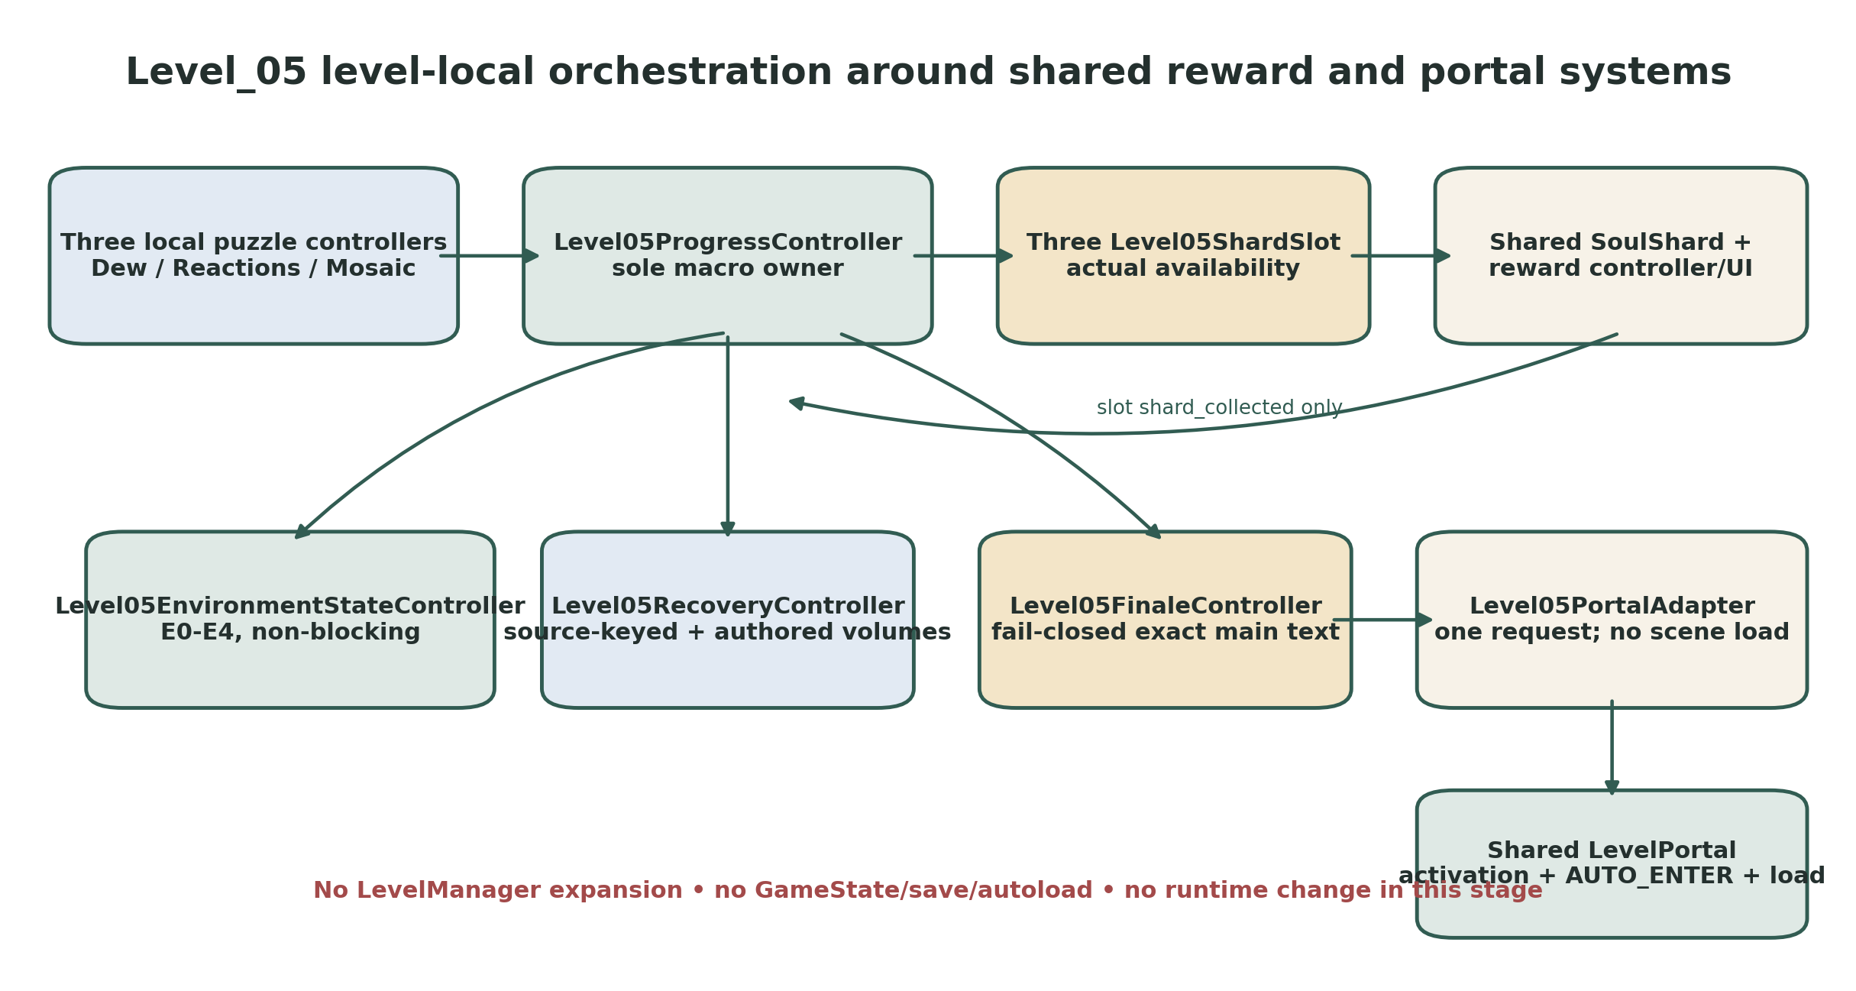
Figure 1. Level-local orchestration preserves shared reward and portal ownership.
Control | Value
Document | Level_05_Technical_Architecture_and_State_Model.docx
Mode | Documentation only - architecture and validation authority; no runtime implementation
Repository | MindDevastation/fifteen-shards-of-light
Audited main commit | a9380f7afce1c0bb0727ccaf6e3f0e76a13df78d
Target scene | res://scenes/levels/Level_05.tscn
Engine baseline | Godot 4.6 / Forward Plus / Jolt Physics
Canonical shards | &"Shard_10", &"Shard_11", &"Shard_12"
Portal target | res://scenes/levels/Level_06.tscn
Prepared | 27 June 2026

DOCUMENT VERDICT
READY FOR PRODUCER TECHNICAL REVIEW. This file defines the recommended Level_05 level-local architecture and future validation contracts. It does not authorize Godot scene/script creation, greybox production, Blender/GLB production, Codex decomposition, a branch, a commit or a pull request.

Technical verdict
Level_05 should replace its one-shard placeholder with a level-local orchestration layer. Level05ProgressController is the sole owner of the exact twelve canonical macro states. Dew Script, Little Reactions and Ordinary Mosaic each retain an independent state machine and emit semantic facts upward. Three Level05ShardSlot instances own actual shard availability around the existing shared SoulShard implementation. The existing shared reward and portal systems remain intact unless a named P0 compatibility gate proves one narrowly scoped prerequisite is required.
The architecture separates puzzle completion, optional presentation terminal, shard reveal request, verified collectability, collection/reward completion, environment presentation, exact main text and portal activation. Environment phases are non-blocking. Main text is fail-closed. Scene loading remains exclusively inside shared LevelPortal. Recovery is fully authored through exact registered volumes and state-gated anchor zones; no inactivity detector, nearest-anchor guess or per-frame world-position scan is introduced.
CORE SAFETY RULE
The heroine and the garden are already alive. Progress records the author's attention and memory; no mechanic may encode repair, capture, surveillance, proof of knowledge, emotional obligation or access to Alena's inner state.

Document contents
- 1. Source hierarchy and repository preflight snapshot
- 2. Architecture principles and ownership boundaries
- 3. Recommended root node tree and scene composition
- 4. Canonical IDs, exact texts, coordinates and visual mapping
- 5. Data flow, controller responsibilities and public APIs
- 6. Signal contract, idempotency and asynchronous race protection
- 7. Exact relative NodePaths and parent-scene overrides
- 8. High-level Level_05 macro state machine
- 9. Dew Script architecture
- 10. Little Reactions architecture
- 11. Ordinary Mosaic architecture
- 12. Level05ShardSlot and shared reward integration
- 13. Environment-state and Quiet Assembly architecture
- 14. Main-text and finale integration
- 15. Portal adapter and shared LevelPortal integration
- 16. Spawn and recovery architecture
- 17. File ownership and future changed-file boundaries
- 18. Test harness, validation and acceptance matrices
- 19. Risks, simplifications and mandatory STOP conditions
- 20. Producer decisions and next-gate requirements
- Appendices A-D.

1. Source hierarchy and repository preflight snapshot

1.1 Hierarchy of sources
Priority | Source | Authority
1 - Narrative authority | Level_05_Narrative_and_Level_Scenario_Package_v1.1.docx | Title, emotional function, exact Shard_10/11/12 copy, exact main text, fixed narrative order and forbidden readings.
2 - Visual authority | Level_05_Visual_Master_Concept_Package.docx | Inward-spiral composition, blue-hour close-up garden, landmark hierarchy, motif families, environment-state intent and three-family art budget.
3 - Gameplay authority | Level_05_Gameplay_Map_and_Level_Design_Spec_v1.2.docx | Exact scene-local coordinates, route metrics, target behavior, canonical state labels, recovery registry and acceptance tests.
4 - Repository factual authority | current main at audited commit | Existing APIs, placeholder drift, engine settings and shared-system compatibility. It cannot override approved Level_05 design.

1.2 Repository preflight snapshot - current main
Item | Blob SHA / status | Technical implication
Audited main commit | a9380f7afce1c0bb0727ccaf6e3f0e76a13df78d | Latest inspected main commit; documentation-only update, no shared runtime contract change.
Open pull requests | 0 | No active PR currently changes Player, SoulShard, reward UI/controller, LevelFinaleOverlay or LevelPortal.
AGENTS.md | f0a50cd2710487923f2de649813301a2899a723d | Godot/GDScript and narrow-scope rules remain useful; 15 micro-level/couplet canon and Stage 0B label are stale.
scenes/levels/Level_05.tscn | 43d29b9e8b486e56584e89169675b12ea2d7bddd | Flat 12 x 12 placeholder, one SoulShard, legacy LevelManager/PoemRewardUI, portal target Level_06.
scenes/core/Player.tscn | 201e27c9e1ba8b94a1792abdbb691fcadb5ebdef | CharacterBody3D; collider 0.706 x 1.728 x 0.522 and center offset Y=0.85528576.
scripts/player/player_controller.gd | 0e39eaddd44cb97e1475b745095d4d9ef4dc8918 | Public set_controls_enabled(); public velocity; step-climb has private transient state.
scripts/player/camera_controller.gd | 51d47f0ee7ff1952e5033912ae92533996ce5c53 | Exported target_path; collision-aware orbit; blocks input for mouse_blocking_ui.
scenes/core/SoulShard.tscn | c01285b4dcf92e89a523c0cea5d436f2e612e7c4 | Area3D with prompt, collision and current visual/VFX hierarchy.
scripts/soul/soul_shard.gd | 6c3e1bd7161a9980f0d0f57fc164fdc7adf515b9 | reward_sequence_requested + collected; can_player_interact/interact/complete_collection_sequence; no public availability overlap refresh.
ShardRewardSequenceController | scene 7b727e2d... / script ad664e35... | Serial shared reward lifecycle; register_shard(); control lock; normal return to visible soul_orb_visual.
ShardRewardOverlay | script 3ef53c9e... | play_reward(), play_return_to(), reset_overlay(); generation-token cancellation.
LevelFinaleOverlay | script 2859a981... | show_finale_text(text)->bool and closed; responsive exact-text presentation.
LevelPortal | scene f485d3b5... / script d6eeef57... | Owns activation state/presentation, InteractionArea, AUTO_ENTER, transition latch and scene loading.
SoulOrb_Follow | scene 6ca1d3fc... / script a5233fe7... | Shared continuity object with target_path and orientation_source_path.
LevelManager | 56ad20b3ca3f161cdd625ed999711ea9906c5902 | Legacy single-shard flow; unsuitable and must not be expanded.
project.godot | c667dba79e5a96243b3b68cc51c82eab98569a4e | Godot 4.6, Forward Plus, 60 FPS, Jolt; SceneTransition and DevLevelMenu autoloads. No change required.

PREFLIGHT REFRESH RULE
Before any later authorized implementation preflight, repeat this audit. Any active PR or main change touching Player, Camera, SoulShard, ShardRewardSequenceController, ShardRewardOverlay, LevelFinaleOverlay, SoulOrb_Follow, LevelPortal or SceneTransition invalidates the compatibility snapshot until reviewed.

1.3 Legacy replacement decision
PLACEHOLDER IS NOT CANON
The current Floor, SpawnPoint, one SoulShard, LevelManager and PoemRewardUI are replaced by the future Level_05 composition. The existing Level_06 portal target remains valid. No architecture decision may infer shard count, route shape, copy or puzzle behavior from the placeholder.

2. Architecture principles and ownership boundaries
- Level05ProgressController is the only authority allowed to change the exact twelve canonical macro states.
- Puzzle controllers own local unique-target state only. They never collect shards, change environment phases, open main text or activate the portal.
- Puzzle completion and bounded optional presentation terminal are separate signals. A missing presentation callback cannot softlock reveal.
- Each Level05ShardSlot owns one canonical shard ID, hidden/reveal/collectability state and adapter signals. Shared SoulShard owns interaction and collection implementation.
- Macro progression advances only on Level05ShardSlot.shard_collected after the shared reward lifecycle completes.
- Level05EnvironmentStateController owns E0-E4 presentation only. It never locks Player and never mutates a resource shared with another scene.
- Level05FinaleController owns FinalTextGate occupancy, exact main-text UI and only its own control lock. Failure is fail-closed.
- Level05PortalAdapter owns one activation request, local PortalAccentVFX and diagnostics. Shared LevelPortal exclusively owns activation state, presentation, InteractionArea, AUTO_ENTER, transition latch and scene loading.
- Level05RecoveryController exclusively owns fall-event token/latch/pending state, latest valid recovery anchor and source-keyed suspension.
- No GameState, save system, new autoload, project-wide puzzle framework, LevelManager expansion or project.godot change is introduced.

2.1 Authoritative ownership matrix
Domain | Owner | Boundary
Macro state / fixed narrative order | Level05ProgressController | Exact canonical IDs and events; no blind count.
Dew target completion | DewScriptController | Three unique IDs; any local order.
Reaction target completion | LittleReactionsController | Three unique IDs; autonomous presentation, no waiting challenge.
Mosaic target completion | OrdinaryMosaicController | Three unique IDs; no facing/alignment test.
Shard availability | One Level05ShardSlot per shard | Only after real/fallback reveal terminal and verified collectability.
Shard interaction / charge / reward request | Shared SoulShard | Existing public API retained.
Short reward UI lifecycle | Shared ShardRewardSequenceController + ShardRewardOverlay | Serial flow, Player lock and normal return to SoulOrb_Follow.
Environment phase / Quiet Assembly presentation | Level05EnvironmentStateController | Non-blocking E0-E4 and local resource copies.
Main text gate / exact text | Level05FinaleController + shared LevelFinaleOverlay | Fail-closed on missing/incompatible UI.
Portal activation / scene load | Shared LevelPortal | Adapter requests once and cannot load scenes.
PortalAccentVFX | Level05PortalAdapter exclusively | Environment E4 cannot start, stop or time it out.
Recovery volume events / token / destination | Level05RecoveryController | Explicit registered volumes; latest valid authored RA; no guessing.
Recovery anchor arrival sensing | Level05RecoveryAnchorZone instances | Grounded dwell and overlap reevaluation; no macro ownership.
Static terrain / collision | Environment block scenes | No progression scripts inside imported art.
Local puzzle/VFX presentation | VFXRoot children | May fail without corrupting logical state.


Figure 2. Ownership and event flow. Shared systems remain behind Level_05-local adapters.

3. Recommended root node tree and scene composition
Level_05 (Node3D; identity transform)
├── EnvironmentRoot (Node3D)
│ ├── Block_05_00_OuterThreshold
│ ├── Block_05_01_DewScriptWalk
│ ├── Block_05_02_Shard10RestLedge
│ ├── Block_05_03_MossBend
│ ├── Block_05_04_LittleReactions
│ ├── Block_05_05_Shard11RestStone
│ ├── Block_05_06_InnerSpiralDescent
│ ├── Block_05_07_OrdinaryMosaic
│ ├── Block_05_08_Shard12QuietAssembly
│ ├── Block_05_09_PortalOutlook
│ └── Boundaries
├── GameplayRoot (Node3D)
│ ├── PuzzleRoot
│ │ ├── DewScriptPuzzle
│ │ ├── LittleReactionsPuzzle
│ │ └── OrdinaryMosaicPuzzle
│ ├── ShardRoot
│ │ ├── Shard_10_FloorAnchor / ShardSlot_10
│ │ ├── Shard_11_FloorAnchor / ShardSlot_11
│ │ └── Shard_12_FloorAnchor / ShardSlot_12
│ ├── RouteAuthorityRoot / FinalTextGate
│ ├── PortalRoot / PortalFloorAnchor / LevelPortal
│ └── SafetyRoot
│ ├── RecoveryVolumes / RV_FALL_GLOBAL ... RV_OUTLOOK_S
│ └── RecoveryAnchors / RA0_Arrival ... RA9_PortalApproach
├── EnvironmentStateRoot
│ ├── Level05EnvironmentStateController
│ ├── WorldEnvironment
│ └── LightingRoot
├── VFXRoot
│ ├── DewPresentationRoot
│ ├── ReactionsPresentationRoot
│ ├── MosaicPresentationRoot
│ ├── GuidanceRoot
│ ├── QuietAssemblyVFX
│ └── PortalAccentVFX
├── PlayerRoot
│ ├── PlayerFloorSpawnMarker
│ ├── Player (shared Player.tscn)
│ └── SoulOrb_Follow (shared, mandatory)
├── CameraRoot / FollowCamera
├── LevelRuntimeRoot
│ ├── Level05ProgressController
│ ├── ShardRewardSequenceController (shared)
│ ├── Level05FinaleController
│ ├── Level05PortalAdapter
│ └── Level05RecoveryController
├── MarkerRoot
│ ├── RouteCenterline / P00 ... P24
│ └── CameraQA / CP0 ... CP9
└── UILayer
├── ShardRewardOverlay (shared)
└── LevelFinaleOverlay (shared)

3.1 Local puzzle scene trees
DewScriptPuzzle (Node3D)
├── DewScriptController (Node)
└── FootprintRoot
├── DEW_ARC_1_Footprint (Level05PresenceFootprint)
├── DEW_ARC_2_Footprint
└── DEW_ARC_3_Footprint
LittleReactionsPuzzle (Node3D)
├── LittleReactionsController (Node)
└── FootprintRoot
├── REACTION_SEED_TURN_Footprint
├── REACTION_POLLEN_PUFF_Footprint
└── REACTION_FOLDING_GLOW_Footprint
OrdinaryMosaicPuzzle (Node3D)
├── OrdinaryMosaicController (Node)
└── FootprintRoot
├── MOSAIC_FOREGROUND_Footprint
├── MOSAIC_MIDGROUND_Footprint
└── MOSAIC_BACKGROUND_Footprint
Level05ShardSlot (Node3D)
├── RevealVFXRoot (Node3D)
└── SoulShard (shared SoulShard.tscn; packed disabled)
Level05RecoveryAnchorZone (Node3D at exact floor coordinate)
├── FloorAnchor (Marker3D; identity local transform)
└── ArrivalZone (Area3D; local position Vector3(0,1.25,0))
└── CollisionShape3D (Cylinder r=2.25, h=2.50)
Level05RecoveryVolume (Area3D)
└── CollisionShape3D

3.2 Scene classification
Classification | Scene / node | Rule
Root composition | Level_05.tscn | Wires all layers and exact scene-local overrides. No puzzle logic in EnvironmentRoot.
Environment-only blocks | Block_05_00...Block_05_09 | StaticBody3D, meshes, authored collision and visual markers only.
Reusable Level_05 local | Level05PresenceFootprint.tscn | Broad grounded dwell sensor; explicit Player path; current-overlap reevaluation.
Reusable Level_05 local | Level05ShardSlot.tscn | Hidden/reveal adapter around one shared SoulShard.
Reusable Level_05 local | Level05RecoveryAnchorZone.tscn | Exact floor anchor plus grounded arrival sensor.
Reusable Level_05 local | Level05RecoveryVolume.tscn | Dumb Area3D source with unique volume_id only.
Local gameplay | DewScriptPuzzle / LittleReactionsPuzzle / OrdinaryMosaicPuzzle | Independent unique-ID state machines.
Existing shared | Player / SoulShard / SoulOrb_Follow | Do not fork unless a named compatibility gate proves a minimal prerequisite.
Existing shared | ShardRewardSequenceController / ShardRewardOverlay / LevelFinaleOverlay | Exact short-reward and main-text lifecycle.
Existing shared | LevelPortal | Exclusive portal activation and scene-transition owner.
Authoring markers | P00-P24 and CP0-CP9 Marker3D nodes | Exact data/QA only; never used as implicit identity or nearest-path logic.
VFX-only nodes | Dew, Reactions, Mosaic, guidance, Quiet Assembly, portal accent | Cannot advance macro state.

4. Canonical IDs, exact texts, coordinates and visual mapping

4.1 Locked IDs and runtime strings
Type | Canonical ID | Exact value / meaning
Puzzle | &"DEW_SCRIPT" | Dew Script
Puzzle | &"LITTLE_REACTIONS" | Little Reactions
Puzzle | &"ORDINARY_MOSAIC" | Ordinary Mosaic
Shard | &"Shard_10" | Я до сих пор улыбаюсь, когда вспоминаю твое «понимяу».
Shard | &"Shard_11" | Я до сих пор помню, как ты на несколько секунд включила камеру и улыбнулась.
Shard | &"Shard_12" | Мне дорога твоя искренность в наших разговорах.
Dew target | &"DEW_ARC_1" | P01 / abstract trace A
Dew target | &"DEW_ARC_2" | P02 / abstract trace B
Dew target | &"DEW_ARC_3" | P03 / abstract trace C
Reaction target | &"REACTION_SEED_TURN" | P07 / autonomous seed turn
Reaction target | &"REACTION_POLLEN_PUFF" | P08 / brief pollen puff
Reaction target | &"REACTION_FOLDING_GLOW" | P09 / restrained folding glow
Mosaic target | &"MOSAIC_FOREGROUND" | P15 / matte-stone foreground layer
Mosaic target | &"MOSAIC_MIDGROUND" | P16 / grass-motion midground layer
Mosaic target | &"MOSAIC_BACKGROUND" | P17 / warm-mote background layer
Main text ID | &"LEVEL_05_MAIN_TEXT" | Exact Level_05 main text
Portal target | String path | res://scenes/levels/Level_06.tscn

EXACT MAIN TEXT
Я помню твое «понимяу», ту короткую улыбку в камеру и то, как искренне ты говоришь со мной. В тот момент это могло казаться мелочами, но именно они возвращаются в память снова и снова. Из них постепенно сложилось понимание: мое чувство к тебе глубже, чем один легкий разговор или яркий момент.

Runtime strings are stored without decorative outer quotation marks. Documentation quotation marks are delimiters only. Exact Cyrillic spelling and punctuation are preserved character-for-character; no automatic normalization is allowed.

4.2 Gameplay identity to coordinate and visual component mapping
Gameplay identity | Exact floor coordinate | Node mapping | Visual / runtime result
DEW_ARC_1 | Vector3(1.79,2.48,-43.49) | DewPresentationRoot/Arc_1 | persistent abstract trace A
DEW_ARC_2 | Vector3(11.14,2.58,-37.67) | DewPresentationRoot/Arc_2 | persistent abstract trace B
DEW_ARC_3 | Vector3(18.46,2.68,-29.65) | DewPresentationRoot/Arc_3 | persistent abstract trace C
REACTION_SEED_TURN | Vector3(22.73,2.52,9.18) | ReactionsPresentationRoot/SeedTurn | autonomous seed turn + route mark
REACTION_POLLEN_PUFF | Vector3(18.13,2.42,16.92) | ReactionsPresentationRoot/PollenPuff | brief pollen puff + route mark
REACTION_FOLDING_GLOW | Vector3(12.06,2.32,22.75) | ReactionsPresentationRoot/FoldingGlow | restrained folding glow + route mark
MOSAIC_FOREGROUND | Vector3(-23.43,1.28,15.59) | MosaicPresentationRoot/ForegroundLayer | matte-stone foreground
MOSAIC_MIDGROUND | Vector3(-25.31,1.08,10.17) | MosaicPresentationRoot/MidgroundLayer | grass-motion midground
MOSAIC_BACKGROUND | Vector3(-25.65,0.90,4.82) | MosaicPresentationRoot/BackgroundLayer | warm-mote background
Shard_10 | Vector3(23.36,2.76,-20.18) | Shard_10_FloorAnchor/ShardSlot_10 | one canonical child SoulShard
Shard_11 | Vector3(5.12,2.22,26.42) | Shard_11_FloorAnchor/ShardSlot_11 | one canonical child SoulShard
Shard_12 | Vector3(-24.65,0.82,0.00) | Shard_12_FloorAnchor/ShardSlot_12 | one canonical child SoulShard
FinalTextGate | Vector3(-11.344,0.68,-13.295), r=4.5 | RouteAuthorityRoot/FinalTextGate | actual occupancy + fail-closed exact text
PortalFloorAnchor | Vector3(-2.500,0.82,-11.258) | PortalRoot/PortalFloorAnchor/LevelPortal | anchor owns placement; shared portal identity-local

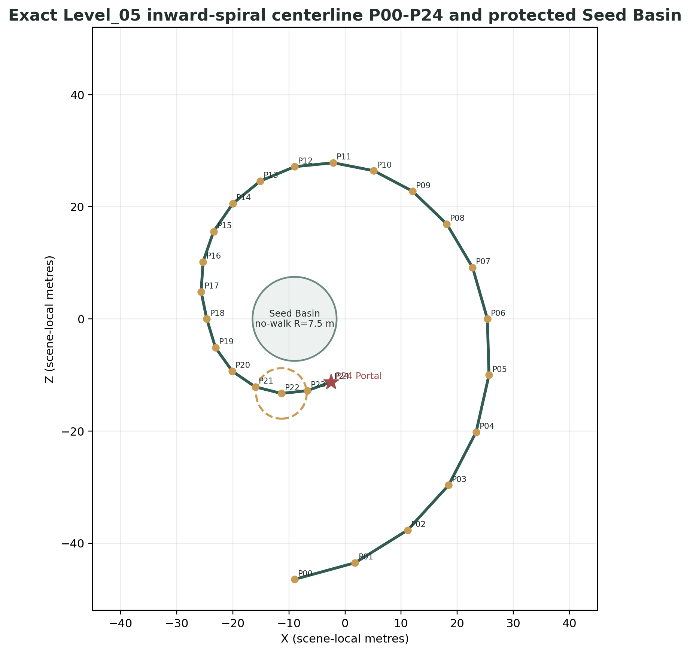
Figure 3. Exact Level_05 scene-local route centerline and protected Seed Basin geometry.

4.3 Exact P00-P24 route centerline
Control point | Exact scene-local floor position
P00 Spawn / Outer Threshold | Vector3(-9.000, 2.400, -46.440)
P01 Dew Arc 1 | Vector3(1.790, 2.480, -43.490)
P02 Dew Arc 2 | Vector3(11.140, 2.580, -37.670)
P03 Dew Arc 3 | Vector3(18.460, 2.680, -29.650)
P04 Shard_10 Rest Ledge | Vector3(23.360, 2.760, -20.180)
P05 Moss Bend East | Vector3(25.650, 2.720, -10.030)
P06 Basin Glimpse East | Vector3(25.370, 2.620, 0.000)
P07 Seed Turn Station | Vector3(22.730, 2.520, 9.180)
P08 Pollen Puff Station | Vector3(18.130, 2.420, 16.920)
P09 Folding Glow Station | Vector3(12.060, 2.320, 22.750)
P10 Shard_11 Rest Stone | Vector3(5.120, 2.220, 26.420)
P11 Descent Start | Vector3(-2.090, 2.080, 27.840)
P12 Descent North | Vector3(-9.000, 1.880, 27.140)
P13 Descent West | Vector3(-15.100, 1.680, 24.580)
P14 Mosaic Entry | Vector3(-20.000, 1.480, 20.570)
P15 Mosaic Pad 1 | Vector3(-23.430, 1.280, 15.590)
P16 Mosaic Pad 2 | Vector3(-25.310, 1.080, 10.170)
P17 Mosaic Pad 3 | Vector3(-25.650, 0.900, 4.820)
P18 Shard_12 Inner Terrace | Vector3(-24.650, 0.820, 0.000)
P19 Quiet Assembly West | Vector3(-23.095, 0.760, -5.130)
P20 Quiet Assembly Mid | Vector3(-20.108, 0.720, -9.319)
P21 Final Approach West | Vector3(-16.000, 0.680, -12.124)
P22 Main Text Gate | Vector3(-11.344, 0.680, -13.295)
P23 Portal Approach | Vector3(-6.742, 0.740, -12.802)
P24 LevelPortalRoot | Vector3(-2.500, 0.820, -11.258)

5. Data flow, controller responsibilities and public APIs

5.1 Level05ProgressController
Purpose: sole canonical macro-progression owner. It validates semantic facts, enforces the fixed narrative order, requests slot reveals after bounded puzzle presentation terminals, commits collection only on slot shard_collected, requests non-blocking environment phases, arms the finale and requests portal activation exactly once after actual main-text close.
Export | Type | Exact parent-scene value
dew_controller_path | NodePath | ../../GameplayRoot/PuzzleRoot/DewScriptPuzzle/DewScriptController
reactions_controller_path | NodePath | ../../GameplayRoot/PuzzleRoot/LittleReactionsPuzzle/LittleReactionsController
mosaic_controller_path | NodePath | ../../GameplayRoot/PuzzleRoot/OrdinaryMosaicPuzzle/OrdinaryMosaicController
shard_slot_10_path | NodePath | ../../GameplayRoot/ShardRoot/Shard_10_FloorAnchor/ShardSlot_10
shard_slot_11_path | NodePath | ../../GameplayRoot/ShardRoot/Shard_11_FloorAnchor/ShardSlot_11
shard_slot_12_path | NodePath | ../../GameplayRoot/ShardRoot/Shard_12_FloorAnchor/ShardSlot_12
environment_controller_path | NodePath | ../../EnvironmentStateRoot/Level05EnvironmentStateController
finale_controller_path | NodePath | ../Level05FinaleController
portal_adapter_path | NodePath | ../Level05PortalAdapter
recovery_controller_path | NodePath | ../Level05RecoveryController

Public API | Contract
get_state() -> MacroState | Read-only canonical state accessor.
get_collected_shard_ids() -> Array[StringName] | Copy of unique collected IDs.
report_puzzle_completed(puzzle_id) | Accept expected active puzzle only; store logical terminal once.
report_puzzle_presentation_terminal(puzzle_id, source) | Accept real/fallback terminal once; request matching slot reveal when logical terminal also exists.
report_shard_available(shard_id) | Advance only from matching reveal phase to exact *_AVAILABLE state.
report_shard_collected(shard_id) | Advance only from expected availability state; ignore duplicate/stale IDs.
can_activate_recovery_anchor(anchor_id) -> bool | Authoritative state/puzzle predicate used by RecoveryController; no rank guessing.
request_debug_snapshot() -> Dictionary | Structured state for harnesses; no mutation.

5.2 Local controller responsibility table
Controller | Owns | Must not own
DewScriptController | Three Dew IDs, dwell acceptance, hints, final trace terminal. | Shard reveal, reward, environment, main text, portal.
LittleReactionsController | Three Reaction IDs, autonomous presentation requests, hints, final motion terminal. | Random waiting, mascot behavior, shard reveal.
OrdinaryMosaicController | Three Mosaic IDs, layer requests, hints, final layer terminal. | Camera facing/alignment score, shard reveal.
Level05PresenceFootprint | Exact Player binding, grounded dwell generation, overlap reevaluation. | Identity inference, macro state, nearest-node lookup.
Level05ShardSlot | Packed hidden state, reveal generation, effective availability, child signal adaptation. | Puzzle completion, shared reward implementation, macro order.
Level05EnvironmentStateController | E0-E4 presentation, local resource duplication, Quiet Assembly and guidance. | Player lock, puzzle rules, PortalAccentVFX.
Level05FinaleController | Gate occupancy, exact main text, owned lock and recovery source. | Scene load, environment or macro order.
Level05PortalAdapter | One activate request, exclusive local accent, diagnostics, shared signal forwarding. | Portal state, InteractionArea, AUTO_ENTER, scene load.
Level05RecoveryController | Registered volumes, token/latch/pending, latest valid RA, suspension, destination and rearm. | Nearest guessing, per-frame world-position scan, macro mutation.
Level05RecoveryAnchorZone | Grounded 0.20 s arrival and current-overlap reevaluation. | Macro gate policy or destination selection.
Level05RecoveryVolume | Unique volume_id and authored Area3D shape only. | Token, destination, Player matching or state logic.

6. Signal contract, idempotency and asynchronous race protection
Signal | Emitter | Receiver | Emission condition | Duplicate protection
presence_accepted(target_id) | Level05PresenceFootprint | Owning puzzle controller | Configured Player remains grounded for dwell; one occupancy generation. | Controller deduplicates target_id.
target_completed(target_id) | Each puzzle controller | Presentation/tests | First accepted unique target. | completed_ids set.
puzzle_completed(puzzle_id) | Each puzzle controller | Level05ProgressController | Exactly once at 3/3 logical terminal. | _completion_emitted.
puzzle_presentation_terminal(puzzle_id, source) | Each puzzle controller | Level05ProgressController | Real final visual settle or bounded fallback. | generation token + terminal latch.
shard_available(shard_id) | Level05ShardSlot | Level05ProgressController | After reveal terminal and verified collectability. | State HIDDEN->...->AVAILABLE once.
shard_collection_started(shard_id) | Level05ShardSlot | Progress + Recovery | Re-emitted from child reward_sequence_requested. | _collection_started_emitted.
shard_collected(shard_id) | Level05ShardSlot | Progress + Recovery | Re-emitted from child collected after shared reward completion. | _collected_emitted.
environment_phase_changed(previous,current) | Environment controller | Debug/QA | Semantic phase accepted; tweens may still run. | Monotonic phase map.
quiet_assembly_terminal(source) | Environment controller | Debug/QA only | Real presentation completion or <=2.5 s fallback. | Never gates finale eligibility.
main_text_started(text_id) | Finale controller | Progress | Validated overlay accepted exact text. | One-shot.
main_text_closed(text_id) | Finale controller | Progress | Actual shared overlay closed. | One-shot.
portal_activation_requested() | Portal adapter | QA | Immediately before sole shared activate() call. | One request latch.
portal_activated() | Portal adapter | Progress/debug | Actual shared activation_completed only. | One completion latch.
portal_activation_blocked(reason) | Portal adapter | QA/Producer | Missing signal/API after bounded timeout. | Diagnostic only; no success.
recovery_anchor_reached(anchor_id) | Anchor zone | RecoveryController | Grounded 0.20 s after accepting enabled. | Zone occupancy generation + controller same-anchor no-op.
recovery_anchor_departed(anchor_id) | Anchor zone | RecoveryController | Configured Player leaves ArrivalZone. | Used for post-teleport rearm.
recovery_performed(anchor_id,volume_id,token) | RecoveryController | QA | One teleport for current internal token. | Latch and token validation.
configuration_error(component,message) | Any local controller | QA/startup blocker | Fail-closed validation failure. | One per unique key.

6.1 Connection policy
- Use explicit exported NodePaths and typed cached references. Normal progression never searches the whole scene tree by node name.
- Parent Level_05.tscn owns exported overrides. Local puzzle scenes may register only their direct footprint children.
- Direct methods are used downward from an owner to a known subordinate: progress -> slot.request_reveal(), progress -> environment.request_phase(), progress -> finale.arm_finale(), progress -> adapter.request_activation().
- Signals carry facts upward or across ownership boundaries: puzzle_completed, shard_available, shard_collected, main_text_closed and actual shared activation_completed.
- node_added, child-order identity, world-position identity, group lookup for Player and absolute /root paths are forbidden in Level_05 gameplay orchestration.

6.2 First-terminal-wins and generation-token policy
Every asynchronous optional presentation that can complete by callback or timeout owns an integer generation. Starting, cancelling or superseding a presentation increments the generation. Each awaited continuation captures the current token and exits silently when stale. A separate terminal latch guarantees that a real callback racing the fallback cannot emit twice.
_generation += 1
var token := _generation
_terminal_emitted = false
start_optional_presentation(token)
await get_tree().create_timer(timeout_seconds).timeout
if token != _generation or _terminal_emitted:
return
_terminal_emitted = true
presentation_terminal.emit(&"timeout")
This pattern applies to puzzle completion settle, shard reveal, Quiet Assembly and PortalAccentVFX. It is not permission to synthesize shared LevelPortal activation success, bypass exact main text or fabricate shard collection.

7. Exact relative NodePaths and parent-scene overrides
Owning node | Export | Exact relative NodePath
Level05ProgressController | dew_controller_path | ../../GameplayRoot/PuzzleRoot/DewScriptPuzzle/DewScriptController
Level05ProgressController | reactions_controller_path | ../../GameplayRoot/PuzzleRoot/LittleReactionsPuzzle/LittleReactionsController
Level05ProgressController | mosaic_controller_path | ../../GameplayRoot/PuzzleRoot/OrdinaryMosaicPuzzle/OrdinaryMosaicController
Level05ProgressController | shard_slot_10_path | ../../GameplayRoot/ShardRoot/Shard_10_FloorAnchor/ShardSlot_10
Level05ProgressController | shard_slot_11_path | ../../GameplayRoot/ShardRoot/Shard_11_FloorAnchor/ShardSlot_11
Level05ProgressController | shard_slot_12_path | ../../GameplayRoot/ShardRoot/Shard_12_FloorAnchor/ShardSlot_12
Level05ProgressController | environment_controller_path | ../../EnvironmentStateRoot/Level05EnvironmentStateController
Level05ProgressController | finale_controller_path | ../Level05FinaleController
Level05ProgressController | portal_adapter_path | ../Level05PortalAdapter
Level05ProgressController | recovery_controller_path | ../Level05RecoveryController
DewScriptController | footprint_root_path | ../FootprintRoot
DewScriptController | presentation_controller_path | ../../../../VFXRoot/DewPresentationRoot
DewScriptController | player_path | ../../../../PlayerRoot/Player
LittleReactionsController | footprint_root_path | ../FootprintRoot
LittleReactionsController | presentation_controller_path | ../../../../VFXRoot/ReactionsPresentationRoot
LittleReactionsController | player_path | ../../../../PlayerRoot/Player
OrdinaryMosaicController | footprint_root_path | ../FootprintRoot
OrdinaryMosaicController | presentation_controller_path | ../../../../VFXRoot/MosaicPresentationRoot
OrdinaryMosaicController | player_path | ../../../../PlayerRoot/Player
All 9 Level05PresenceFootprint instances | player_path | ../../../../../PlayerRoot/Player
ShardSlot_10 / 11 / 12 | player_path | ../../../../PlayerRoot/Player
ShardSlot_10 / 11 / 12 | soul_shard_path | SoulShard
ShardSlot_10 / 11 / 12 | reveal_vfx_path | RevealVFXRoot
ShardRewardSequenceController | overlay_path | ../../UILayer/ShardRewardOverlay
ShardRewardSequenceController | player_path | ../../PlayerRoot/Player
ShardRewardSequenceController | shard_search_root_path | ../../GameplayRoot/ShardRoot
Level05EnvironmentStateController | world_environment_path | ../WorldEnvironment
Level05EnvironmentStateController | lighting_root_path | ../LightingRoot
Level05EnvironmentStateController | reactions_guidance_path | ../../VFXRoot/GuidanceRoot/ReactionsGuidance
Level05EnvironmentStateController | mosaic_guidance_path | ../../VFXRoot/GuidanceRoot/MosaicGuidance
Level05EnvironmentStateController | quiet_assembly_vfx_path | ../../VFXRoot/QuietAssemblyVFX
Level05FinaleController | player_path | ../../PlayerRoot/Player
Level05FinaleController | final_text_gate_path | ../../GameplayRoot/RouteAuthorityRoot/FinalTextGate
Level05FinaleController | finale_overlay_path | ../../UILayer/LevelFinaleOverlay
Level05FinaleController | recovery_controller_path | ../Level05RecoveryController
Level05PortalAdapter | portal_path | ../../GameplayRoot/PortalRoot/PortalFloorAnchor/LevelPortal
Level05PortalAdapter | portal_accent_vfx_path | ../../VFXRoot/PortalAccentVFX
Level05RecoveryController | player_path | ../../PlayerRoot/Player
Level05RecoveryController | progress_controller_path | ../Level05ProgressController
All RA0-RA9 Level05RecoveryAnchorZone instances | player_path | ../../../../PlayerRoot/Player
FollowCamera | target_path | ../../PlayerRoot/Player
SoulOrb_Follow | target_path | ../Player
SoulOrb_Follow | orientation_source_path | ../Player/CharacterVisualRoot

7.1 Exact recovery-volume registration paths
Volume ID | Exact path from Level05RecoveryController
RV_FALL_GLOBAL | ../../GameplayRoot/SafetyRoot/RecoveryVolumes/RV_FALL_GLOBAL
RV_PERIM_N | ../../GameplayRoot/SafetyRoot/RecoveryVolumes/RV_PERIM_N
RV_PERIM_S | ../../GameplayRoot/SafetyRoot/RecoveryVolumes/RV_PERIM_S
RV_PERIM_W | ../../GameplayRoot/SafetyRoot/RecoveryVolumes/RV_PERIM_W
RV_PERIM_E | ../../GameplayRoot/SafetyRoot/RecoveryVolumes/RV_PERIM_E
RV_BASIN_DISK | ../../GameplayRoot/SafetyRoot/RecoveryVolumes/RV_BASIN_DISK
RV_OUTLOOK_S | ../../GameplayRoot/SafetyRoot/RecoveryVolumes/RV_OUTLOOK_S

7.2 Exact recovery-anchor registration paths
Anchor ID | Exact path from Level05RecoveryController
RA0_Arrival | ../../GameplayRoot/SafetyRoot/RecoveryAnchors/RA0_Arrival
RA1_DewComplete | ../../GameplayRoot/SafetyRoot/RecoveryAnchors/RA1_DewComplete
RA2_Shard10Ledge | ../../GameplayRoot/SafetyRoot/RecoveryAnchors/RA2_Shard10Ledge
RA3_LittleReactions | ../../GameplayRoot/SafetyRoot/RecoveryAnchors/RA3_LittleReactions
RA4_Shard11Stone | ../../GameplayRoot/SafetyRoot/RecoveryAnchors/RA4_Shard11Stone
RA5_MosaicEntry | ../../GameplayRoot/SafetyRoot/RecoveryAnchors/RA5_MosaicEntry
RA6_Shard12Terrace | ../../GameplayRoot/SafetyRoot/RecoveryAnchors/RA6_Shard12Terrace
RA7_QuietAssembly | ../../GameplayRoot/SafetyRoot/RecoveryAnchors/RA7_QuietAssembly
RA8_MainTextGate | ../../GameplayRoot/SafetyRoot/RecoveryAnchors/RA8_MainTextGate
RA9_PortalApproach | ../../GameplayRoot/SafetyRoot/RecoveryAnchors/RA9_PortalApproach

7.3 Required Level_05.tscn override syntax
[node name="PortalFloorAnchor" type="Marker3D" parent="GameplayRoot/PortalRoot"]
position = Vector3(-2.5, 0.82, -11.258)
[node name="LevelPortal" parent="GameplayRoot/PortalRoot/PortalFloorAnchor" instance=ExtResource("...")]
target_scene_path = "res://scenes/levels/Level_06.tscn"
entry_mode = 0 # AUTO_ENTER
require_entry_confirmation = false
# transform property omitted: identity local transform is preserved
[node name="SoulOrb_Follow" parent="PlayerRoot" instance=ExtResource("...")]
target_path = NodePath("../Player")
orientation_source_path = NodePath("../Player/CharacterVisualRoot")
Startup validation uses approximate vector/transform comparison. Exact floating-point equality is forbidden. The parent PortalFloorAnchor is the only Level_05 placement authority; shared LevelPortal internal child transforms are never overridden.

8. High-level Level_05 macro state machine
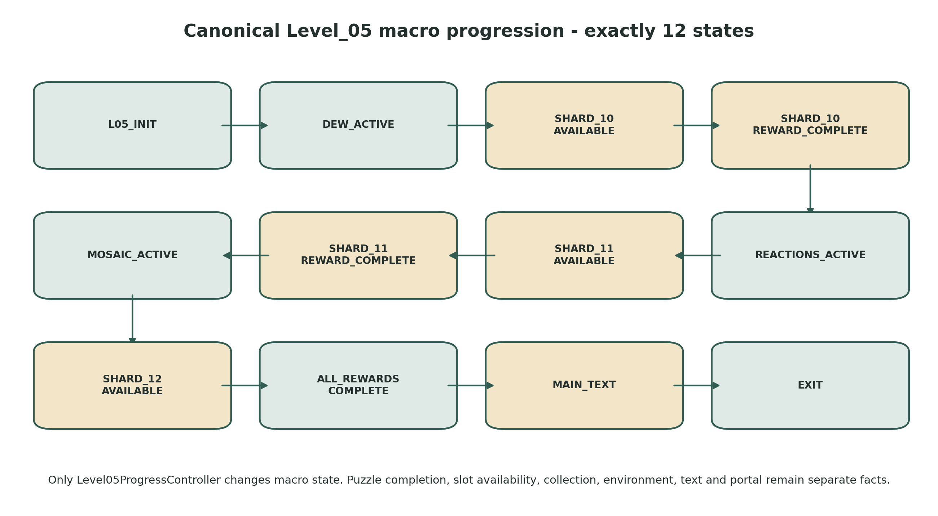
Figure 4. Exact twelve-state canonical macro progression. Only Level05ProgressController may change it.
Canonical state | Invariant | Only valid forward event
L05_INIT | Startup validation, hidden shards, E0, clean reload state. | Deferred successful initialization -> DEW_ACTIVE.
DEW_ACTIVE | Only Dew IDs accepted. | Dew logical completion + bounded presentation terminal -> Shard_10 reveal request; actual shard_available.
SHARD_10_AVAILABLE | Only Shard_10 collectable. | slot shard_collected(Shard_10).
SHARD_10_REWARD_COMPLETE | Shard_10 reward committed; E1 requested non-blockingly. | Deferred activation of Little Reactions; no environment callback wait.
REACTIONS_ACTIVE | Only Reaction IDs accepted. | Reaction completion + terminal -> Shard_11 reveal; actual availability.
SHARD_11_AVAILABLE | Only Shard_11 collectable. | slot shard_collected(Shard_11).
SHARD_11_REWARD_COMPLETE | Shard_11 reward committed; E2 requested non-blockingly. | Deferred activation of Ordinary Mosaic; no environment callback wait.
MOSAIC_ACTIVE | Only Mosaic IDs accepted. | Mosaic completion + terminal -> Shard_12 reveal; actual availability.
SHARD_12_AVAILABLE | Only Shard_12 collectable. | slot shard_collected(Shard_12).
ALL_REWARDS_COMPLETE | All three rewards committed; E3 + Quiet Assembly requested, finale armed immediately. | Actual accepted main_text_started.
MAIN_TEXT | Exact main text visible; recovery source main_text active; portal dormant. | Actual shared LevelFinaleOverlay.closed.
EXIT | E4 requested; adapter requests shared activation once. | Terminal Level_05 macro state; shared portal owns transition.

8.1 Invalid transition policy
- Future puzzle target events are rejected before their exact active macro state. They do not queue silently.
- Wrong shard IDs, duplicate availability, duplicate collection and stale presentation terminals are ignored with at most one development warning per key.
- SHARD_10_REWARD_COMPLETE and SHARD_11_REWARD_COMPLETE are observable commit states; transition to the next active puzzle is deferred, but never waits for E1/E2 presentation completion.
- ALL_REWARDS_COMPLETE arms the finale immediately. Quiet Assembly presentation is parallel and cannot delay main text.
- No backward transition exists. Full scene reload constructs clean L05_INIT/E0; no partial restoration or save contract exists.

9. Dew Script architecture
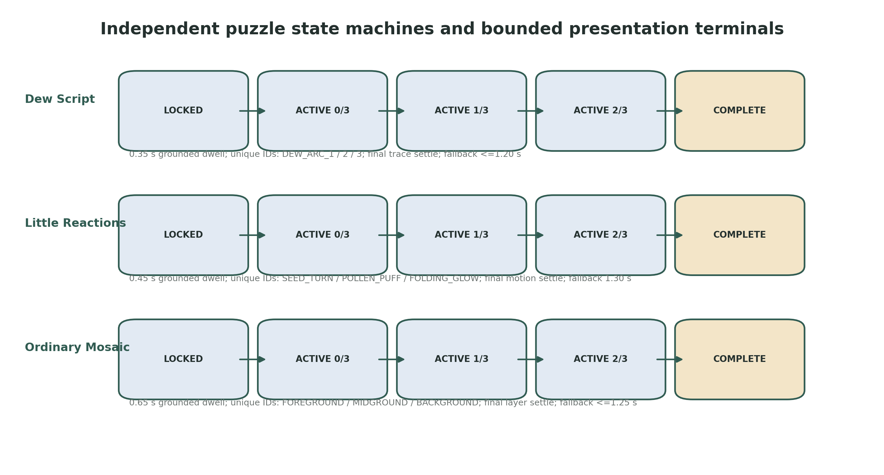
Figure 5. Independent local state machines. Logical completion is separate from bounded presentation terminal.

9.1 Deterministic identity and occupancy model
Target ID | Exact floor position | Dwell | Presentation
DEW_ARC_1 | Vector3(1.79,2.48,-43.49) | 0.35 s grounded | abstract trace A persists
DEW_ARC_2 | Vector3(11.14,2.58,-37.67) | 0.35 s grounded | abstract trace B persists
DEW_ARC_3 | Vector3(18.46,2.68,-29.65) | 0.35 s grounded | abstract trace C persists

9.2 Controller exports and API
Export | Type | Contract/default
puzzle_id | StringName | &"DEW_SCRIPT"
expected_target_ids | Array[StringName] | DEW_ARC_1..3 exactly
footprint_root_path | NodePath | ../FootprintRoot
presentation_controller_path | NodePath | ../../../../VFXRoot/DewPresentationRoot
player_path | NodePath | ../../../../PlayerRoot/Player
hint_level_1_delay | float | 20.0 s
hint_level_2_delay | float | 35.0 s
hint_repeat_interval | float | 6.0 s
completion_presentation_timeout | float | 1.20 s maximum

Public API | Contract
activate() | Idempotently enable exactly three footprints; one-frame overlap reevaluation.
report_presence_accepted(target_id) | Accept expected unique ID once; request persistent trace; reset hints.
is_target_completed(target_id) -> bool | Read-only.
is_complete() -> bool | True at exactly 3/3.
request_current_hint() | Nearest unvisited explicit footprint by Player distance.
debug_validate_identity_map() -> bool | Exactly three explicit IDs/paths; no node-name or array-order authority.

9.3 Presence semantics and race rules
- Each footprint is packed non-accepting. activate() enables it and schedules one physics-frame get_overlapping_bodies() reevaluation.
- Only the exact Player resolved through ../../../../../PlayerRoot/Player is accepted. No group lookup, node-name test or any-CharacterBody fallback is allowed.
- The footprint starts an occupancy-generation coroutine. It counts grounded time only while overlaps_body(Player) and Player.is_on_floor() are both true. Airborne time contributes zero.
- Leaving cancels only the current dwell generation. Previously accepted Dew IDs never reset.
- If Player entered while locked and remains inside through activation, the current-overlap reevaluation starts dwell without exit/re-entry.
- The third unique ID emits puzzle_completed immediately, starts the final trace settle generation, and emits puzzle_presentation_terminal after real completion or the 1.20 s fallback. First terminal wins.

10. Little Reactions architecture

10.1 Identity and autonomous presentation model
Target ID | Exact floor position | Dwell | Presentation rule
REACTION_SEED_TURN | Vector3(22.73,2.52,9.18) | 0.45 s grounded | one autonomous seed turn; minimal background motion persists
REACTION_POLLEN_PUFF | Vector3(18.13,2.42,16.92) | 0.45 s grounded | brief pollen puff; route mark persists
REACTION_FOLDING_GLOW | Vector3(12.06,2.32,22.75) | 0.45 s grounded | restrained fold/glow; no character imitation

10.2 Controller exports and API
Export | Type | Contract/default
puzzle_id | StringName | &"LITTLE_REACTIONS"
expected_target_ids | Array[StringName] | exact three Reaction IDs
footprint_root_path | NodePath | ../FootprintRoot
presentation_controller_path | NodePath | ../../../../VFXRoot/ReactionsPresentationRoot
player_path | NodePath | ../../../../PlayerRoot/Player
hint_level_1_delay | float | 20.0 s
hint_level_2_delay | float | 35.0 s
hint_repeat_interval | float | 6.0 s
final_motion_timeout | float | 1.30 s bounded fallback

Public API | Contract
activate() | Enable three footprints only in REACTIONS_ACTIVE; current-overlap reevaluation.
report_presence_accepted(target_id) | Accept unique target immediately; presentation may overlap.
is_target_completed(target_id) -> bool | Read-only.
is_complete() -> bool | Exactly three IDs.
request_current_hint() | Nearest unvisited station; no route order.
debug_validate_identity_map() -> bool | Exact ID/path set and Player binding.

10.3 Motion-settle and occupancy contract
- Proximity is accepted through grounded dwell, not by waiting for a random animation state.
- Presentation begins after logical target acceptance. A late or missing presentation callback cannot revoke the accepted ID.
- On the third ID, logical puzzle_completed emits immediately. The controller waits only for the active final motion settle or 1.30 s fallback before puzzle_presentation_terminal.
- Duplicate body-enter callbacks, overlapping presentation callbacks and fallback races cannot produce a fourth target or second puzzle terminal.
- No animation may depict Alena, a face, eyes, wings, mascot behavior or a response to the Player.

11. Ordinary Mosaic architecture

11.1 Identity and persistent layer model
Target ID | Exact floor position | Dwell | Persistent layer
MOSAIC_FOREGROUND | Vector3(-23.43,1.28,15.59) | 0.65 s grounded | matte-stone foreground
MOSAIC_MIDGROUND | Vector3(-25.31,1.08,10.17) | 0.65 s grounded | grass-motion midground
MOSAIC_BACKGROUND | Vector3(-25.65,0.90,4.82) | 0.65 s grounded | warm-mote background

11.2 Controller exports and API
Export | Type | Contract/default
puzzle_id | StringName | &"ORDINARY_MOSAIC"
expected_target_ids | Array[StringName] | exact three Mosaic IDs
footprint_root_path | NodePath | ../FootprintRoot
presentation_controller_path | NodePath | ../../../../VFXRoot/MosaicPresentationRoot
player_path | NodePath | ../../../../PlayerRoot/Player
hint_level_1_delay | float | 20.0 s
hint_level_2_delay | float | 35.0 s
hint_repeat_interval | float | 6.0 s
final_layer_timeout | float | 1.25 s bounded fallback

Public API | Contract
activate() | Enable pads only in MOSAIC_ACTIVE; current-overlap reevaluation.
report_presence_accepted(target_id) | Accept unique ID once and request one layer.
is_target_completed(target_id) -> bool | Read-only.
is_complete() -> bool | Exactly three IDs.
request_current_hint() | Nearest unvisited pad; no camera direction.
debug_validate_identity_map() -> bool | Exact ID/path set and one-to-one layer mapping.

11.3 Camera-independence and completion rules
- No camera facing, angle, screenshot, lens, composition score or visual-recognition query exists.
- Presence on a broad pad is the only mandatory input; Player.is_on_floor() is the only grounded test.
- Leaving before 0.65 s cancels only current dwell. Accepted layers persist.
- The third accepted ID emits logical completion immediately; the final layer settle or 1.25 s fallback emits one presentation terminal.
- Missing or visually simplified layers cannot prevent Shard_12 reveal.

12. Level05ShardSlot and shared reward integration
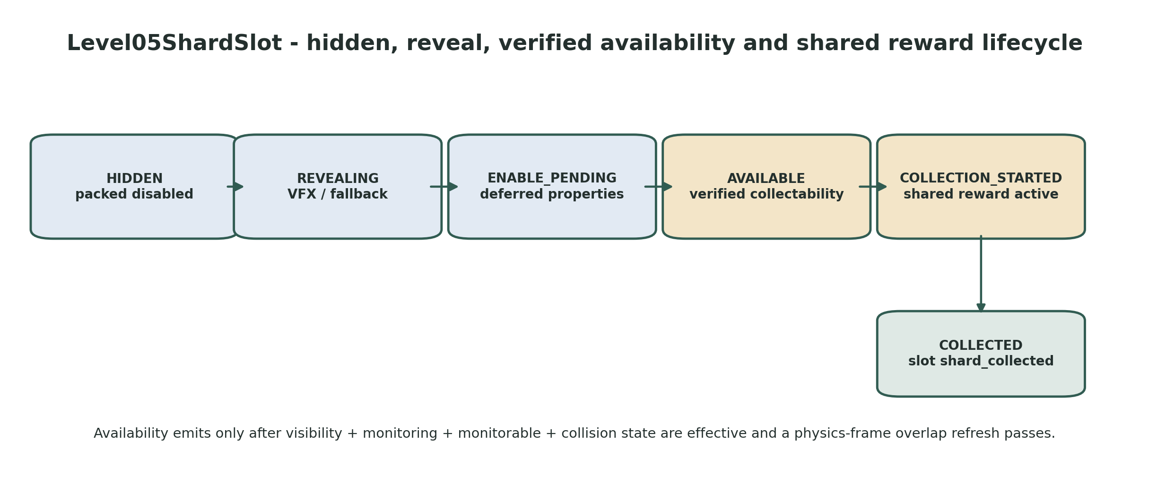
Figure 6. Level05ShardSlot hidden/reveal/availability/collection lifecycle.

12.1 Packed hidden and reveal contract
PACKED-SCENE REQUIREMENT
The SoulShard child is disabled before the first runtime frame: hidden, monitoring=false, monitorable=false, CollisionShape3D.disabled=true and prompt hidden. Level05ShardSlot is the only owner of availability.

- prepare_hidden() is idempotent and reasserts disabled properties during _enter_tree/_ready without reading SoulShard private fields.
- request_reveal() is accepted only once while HIDDEN. The parent floor-anchor Marker3D owns exact placement; slot and SoulShard remain identity-local.
- Collection remains disabled through REVEALING. Real reveal completion or fallback enters ENABLE_PENDING; generation token and terminal latch enforce first-terminal-wins.
- ENABLE_PENDING applies visibility, monitoring, monitorable and collision properties with deferred-safe setters, then waits one physics frame.
- The slot verifies effective state. shard_available emits only after real collectability and stable prompt/range behavior are confirmed.
- If Player already overlaps the future radius, collection must become possible exactly once without exit/re-entry. Private _player_in_range access is forbidden.

12.2 Per-slot values
Slot | Parent floor anchor | shard_id | Exact reward text | Reveal target / timeout
ShardSlot_10 | Vector3(23.36,2.76,-20.18) | &"Shard_10" | Я до сих пор улыбаюсь, когда вспоминаю твое «понимяу». | 0.90 s / 1.20 s
ShardSlot_11 | Vector3(5.12,2.22,26.42) | &"Shard_11" | Я до сих пор помню, как ты на несколько секунд включила камеру и улыбнулась. | 1.00 s / 1.25 s
ShardSlot_12 | Vector3(-24.65,0.82,0.00) | &"Shard_12" | Мне дорога твоя искренность в наших разговорах. | 1.00 s / 1.25 s

12.3 Shared reward lifecycle
- ShardRewardSequenceController remains unchanged and is scoped to ../../GameplayRoot/ShardRoot. Each child SoulShard is explicitly register_shard() validated at startup.
- The slot re-emits shard_collection_started from child reward_sequence_requested. Recovery adds source shard_reward. Macro does not advance.
- Shared controller owns the Player lock, exact short reward overlay, return animation and complete_collection_sequence().
- SoulShard.collected is re-emitted as slot shard_collected. Recovery removes source shard_reward; Level05ProgressController then advances.
- Exactly one visible shared SoulOrb_Follow is mandatory, with target_path=../Player and orientation_source_path=../Player/CharacterVisualRoot. Normal reward return must resolve its visible soul_orb_visual.
- Safe completion without an orb remains an emergency shared fallback, not the expected production flow.
P0 SHARD PRE-OVERLAP GATE
Place Player inside each future shard radius before reveal and keep Player stationary. Before shard_available, prompt and interaction are impossible. After availability, the shard becomes interactable exactly once without exit/re-entry. Failure is a STOP condition for a separately approved minimal shared availability/overlap-refresh API.

13. Environment-state and Quiet Assembly architecture
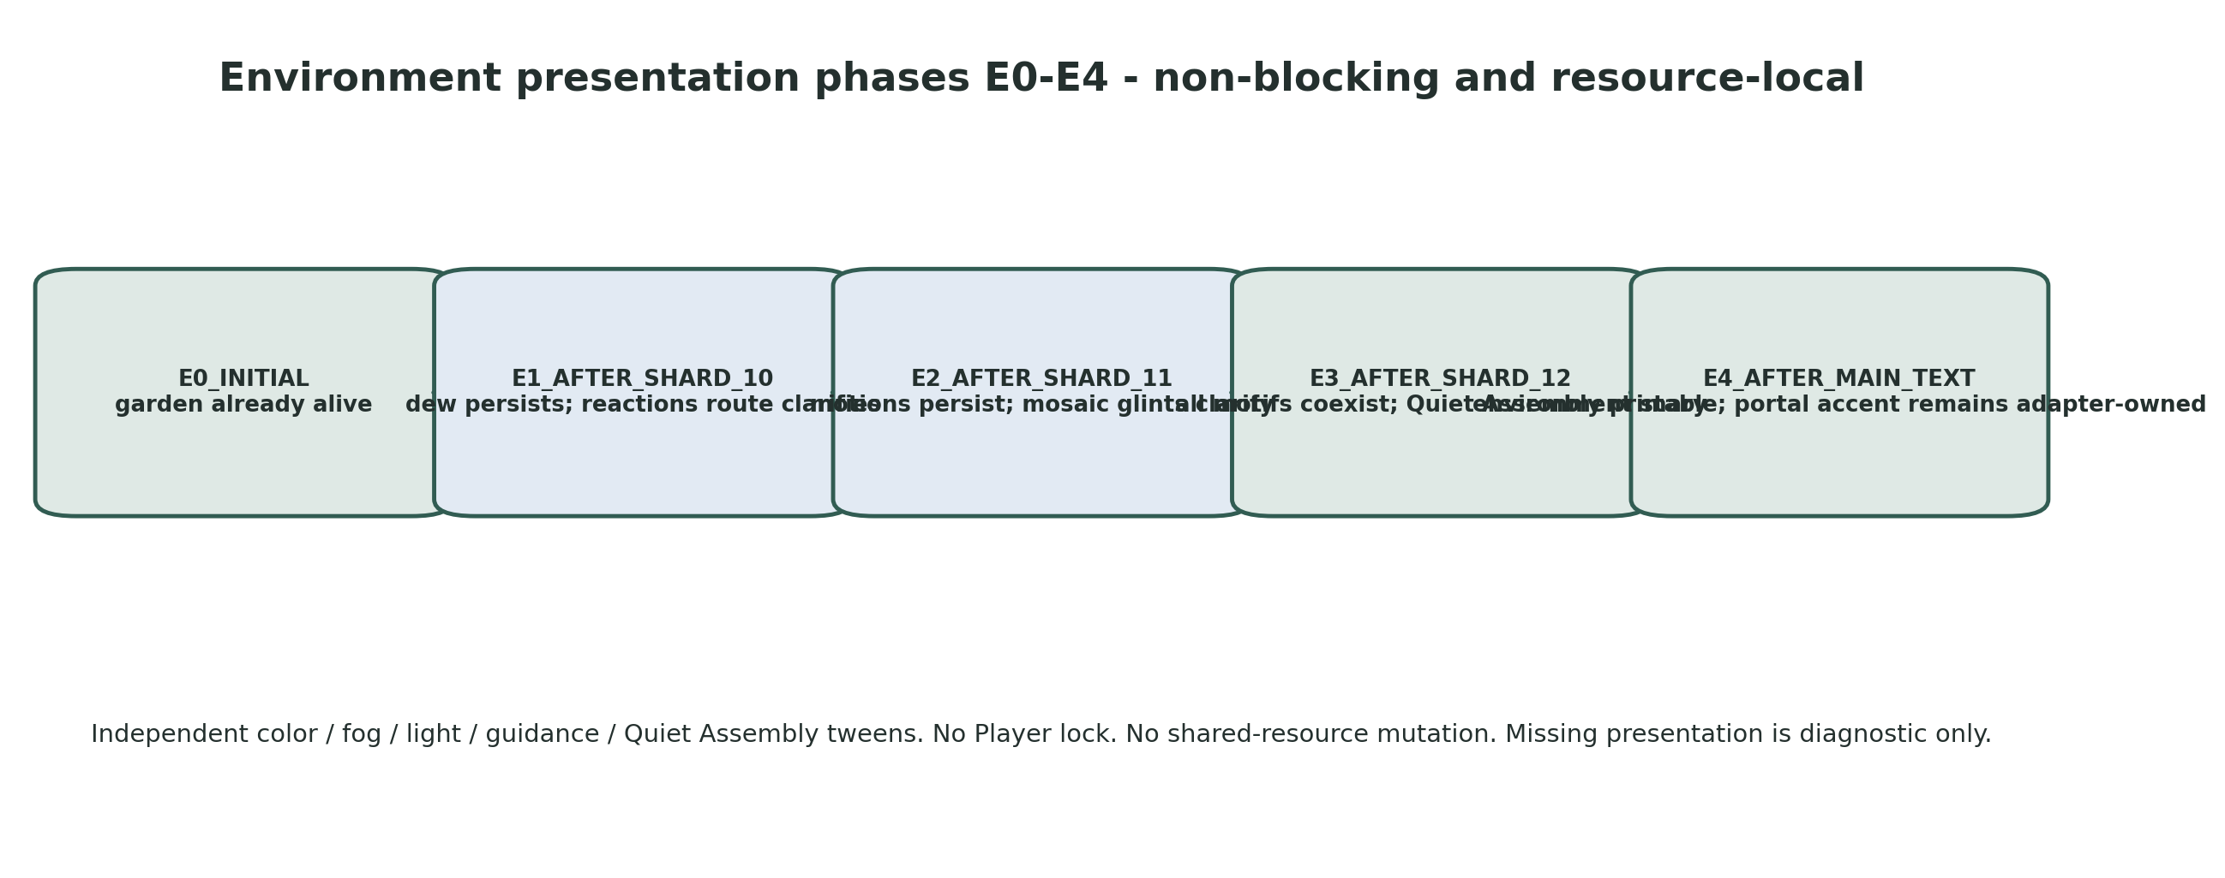
Figure 7. E0-E4 presentation phases are layered over, not substituted for, canonical gameplay states.

13.1 Phase behavior
Phase | Trigger | Required presentation | Logical effect
E0_INITIAL | L05_INIT / DEW_ACTIVE | Natural 75-85% richness; all motif families faintly alive. | None.
E1_AFTER_SHARD_10 | Shard_10 collected | Dew traces persist; Reactions silhouette/path clarify over 4 s. | REACTIONS_ACTIVE begins independently.
E2_AFTER_SHARD_11 | Shard_11 collected | Completed motions persist; descent/Mosaic glints clarify over 4 s. | MOSAIC_ACTIVE begins independently.
E3_AFTER_SHARD_12 | Shard_12 collected | All motif families coexist; Quiet Assembly primary over 5 s; portal dormant. | Finale armed immediately.
E4_AFTER_MAIN_TEXT | Actual main text close | Garden stays stable; restrained horizon support only. | PortalAdapter separately owns accent + activation request.

13.2 Resource and tween ownership
- Deep-duplicate WorldEnvironment.environment at startup, or validate resource_local_to_scene. Any runtime-mutated material is duplicated before parameter changes.
- Use separate owned tweens: _color_tween, _fog_tween, _light_tween, _guidance_tween and _quiet_assembly_tween. Starting one domain never kills another.
- Phase requests are idempotent and monotonic. Invalid backwards requests are configuration warnings.
- Environment transitions never call Player.set_controls_enabled(false).
- PortalAccentVFX is absent from EnvironmentStateController exports and methods. E4 is semantic only; Level05PortalAdapter exclusively starts, cancels and times out the accent.

13.3 Quiet Assembly non-blocking contract
After Shard_12 collection, request_phase(E3_AFTER_SHARD_12) and start_quiet_assembly() run in parallel with Level05FinaleController.arm_finale(). Quiet Assembly is not a fourth puzzle and does not own a gameplay gate. A real presentation completion or <=2.5 s fallback may emit quiet_assembly_terminal for diagnostics, but main-text eligibility never waits for it.
Public API | Contract
request_phase(phase) -> bool | Accept valid monotonic semantic phase and start independent tweens.
start_quiet_assembly() -> int | Start one optional presentation generation; return token.
get_phase() -> EnvironmentPhase | Read-only.
debug_get_active_tween_domains() -> Array[StringName] | QA independence check.
validate_local_resources() -> bool | Confirm local/deep-duplicated resources and no PortalAccentVFX ownership.

14. Main-text and finale integration

14.1 FinalTextGate occupancy semantics
- FinalTextGate is an Area3D centered at Vector3(-11.344,0.68,-13.295) with radius 4.5 m.
- The gate records exact Player occupancy even while unarmed. Non-Player CharacterBody3D nodes are rejected.
- arm_finale() waits one physics frame and reevaluates get_overlapping_bodies(). A Player already inside starts main text without exit/re-entry.
- The gate can start the finale once only. Re-entry after close cannot reopen it.
- Quiet Assembly presentation completion is not a prerequisite; only ALL_REWARDS_COMPLETE and gate occupancy are required.

14.2 Fail-closed exact-text contract
MANDATORY STARTUP VALIDATION
LevelFinaleOverlay, show_finale_text(text)->bool and closed are required. Missing node, mismatched API or false return leaves the portal dormant and main text incomplete.

- Before opening, FinaleController adds recovery suspension source main_text and acquires only its own Player control lock.
- It calls show_finale_text(exact_text). Only a true result permits main_text_started and macro MAIN_TEXT.
- On actual closed, FinaleController releases its owned lock, removes main_text source and emits main_text_closed exactly once.
- On error, it releases only owned lock/suspension, logs configuration_error and leaves ALL_REWARDS_COMPLETE with portal activation forbidden.
- No timer may mark unread text complete. A local wrapper or narrow shared responsive fix requires separate Producer approval after UI-fit evidence.

14.3 Finale API
Public API | Contract
arm_finale(text_id, exact_text) -> bool | Validate gate/overlay/player, arm once and reevaluate occupancy.
is_armed() -> bool | Read-only.
is_main_text_active() -> bool | Read-only.
debug_force_gate_reevaluation() | Harness only; cannot bypass prerequisites.

EXACT MAIN TEXT
Я помню твое «понимяу», ту короткую улыбку в камеру и то, как искренне ты говоришь со мной. В тот момент это могло казаться мелочами, но именно они возвращаются в память снова и снова. Из них постепенно сложилось понимание: мое чувство к тебе глубже, чем один легкий разговор или яркий момент.

15. Portal adapter and shared LevelPortal integration
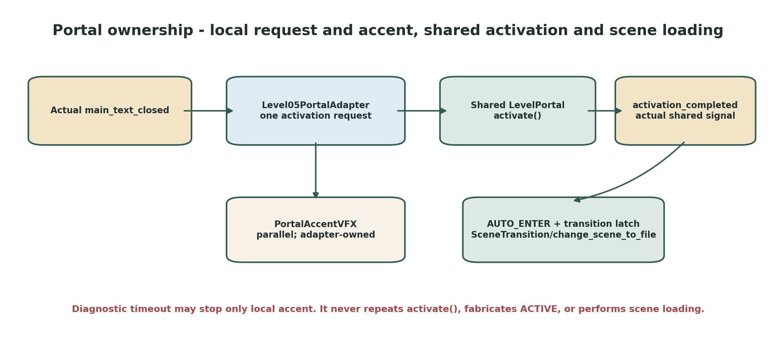
Figure 8. Level_05 requests once; shared LevelPortal owns activation through Level_06 loading.

15.1 Placement and ownership contract
Boundary | Exact rule
Placement authority | PortalFloorAnchor Marker3D at Vector3(-2.500,0.82,-11.258); LevelPortal is its identity-local child.
Shared LevelPortal owns | PortalState, staged activation presentation, InteractionArea/shape, AUTO_ENTER, transition latch, SceneTransition fallback, change_scene_to_file and transition failure recovery.
Level05PortalAdapter owns | One request latch, exclusive Level_05-local PortalAccentVFX, local generation/terminal latch, bounded diagnostics and forwarding actual activation_completed.
Adapter never | Repeats activate(), calls private _finish_activation(), fabricates ACTIVE, enables InteractionArea, emits success without shared signal, or changes scene.
Environment controller never | Starts, stops, cancels or times out PortalAccentVFX.

15.2 Activation sequence
- Actual LevelFinaleOverlay.closed -> FinaleController emits main_text_closed.
- Level05ProgressController enters EXIT, requests E4 non-blockingly and calls Level05PortalAdapter.request_activation() once.
- Adapter starts local PortalAccentVFX in parallel and calls shared LevelPortal.activate() exactly once.
- Only actual shared activation_completed permits adapter.portal_activated.
- Shared LevelPortal owns AUTO_ENTER, transition lock and exactly one Level_06 scene transition.
A bounded diagnostic timeout longer than shared activation duration may stop/calm only the local accent and emit portal_activation_blocked. Missing shared activation_completed is a configuration/runtime blocker, never a successful fallback.
P0 STATIONARY EARLY-OVERLAP GATE
Player stands inside the future shared InteractionArea before activation and remains stationary. No early load may occur. After actual activation_completed, exactly one Level_06 transition must begin without exit/re-entry. If current shared LevelPortal fails, STOP for separately approved minimal public reevaluate_auto_enter_overlap(); scene loading remains inside LevelPortal.

16. Spawn and recovery architecture

16.1 Spawn floor-anchor semantics
FLOOR MARKER, NOT PLAYER ROOT TRANSFORM
PlayerFloorSpawnMarker is authored at P00 Vector3(-9.000,2.400,-46.440). Its Y is the floor anchor. CharacterBody root Y must be proven later against the shared collider offset, floor snap and Jolt grounding. Do not copy floor Y blindly into Player.global_position.

16.2 Recovery-volume event architecture
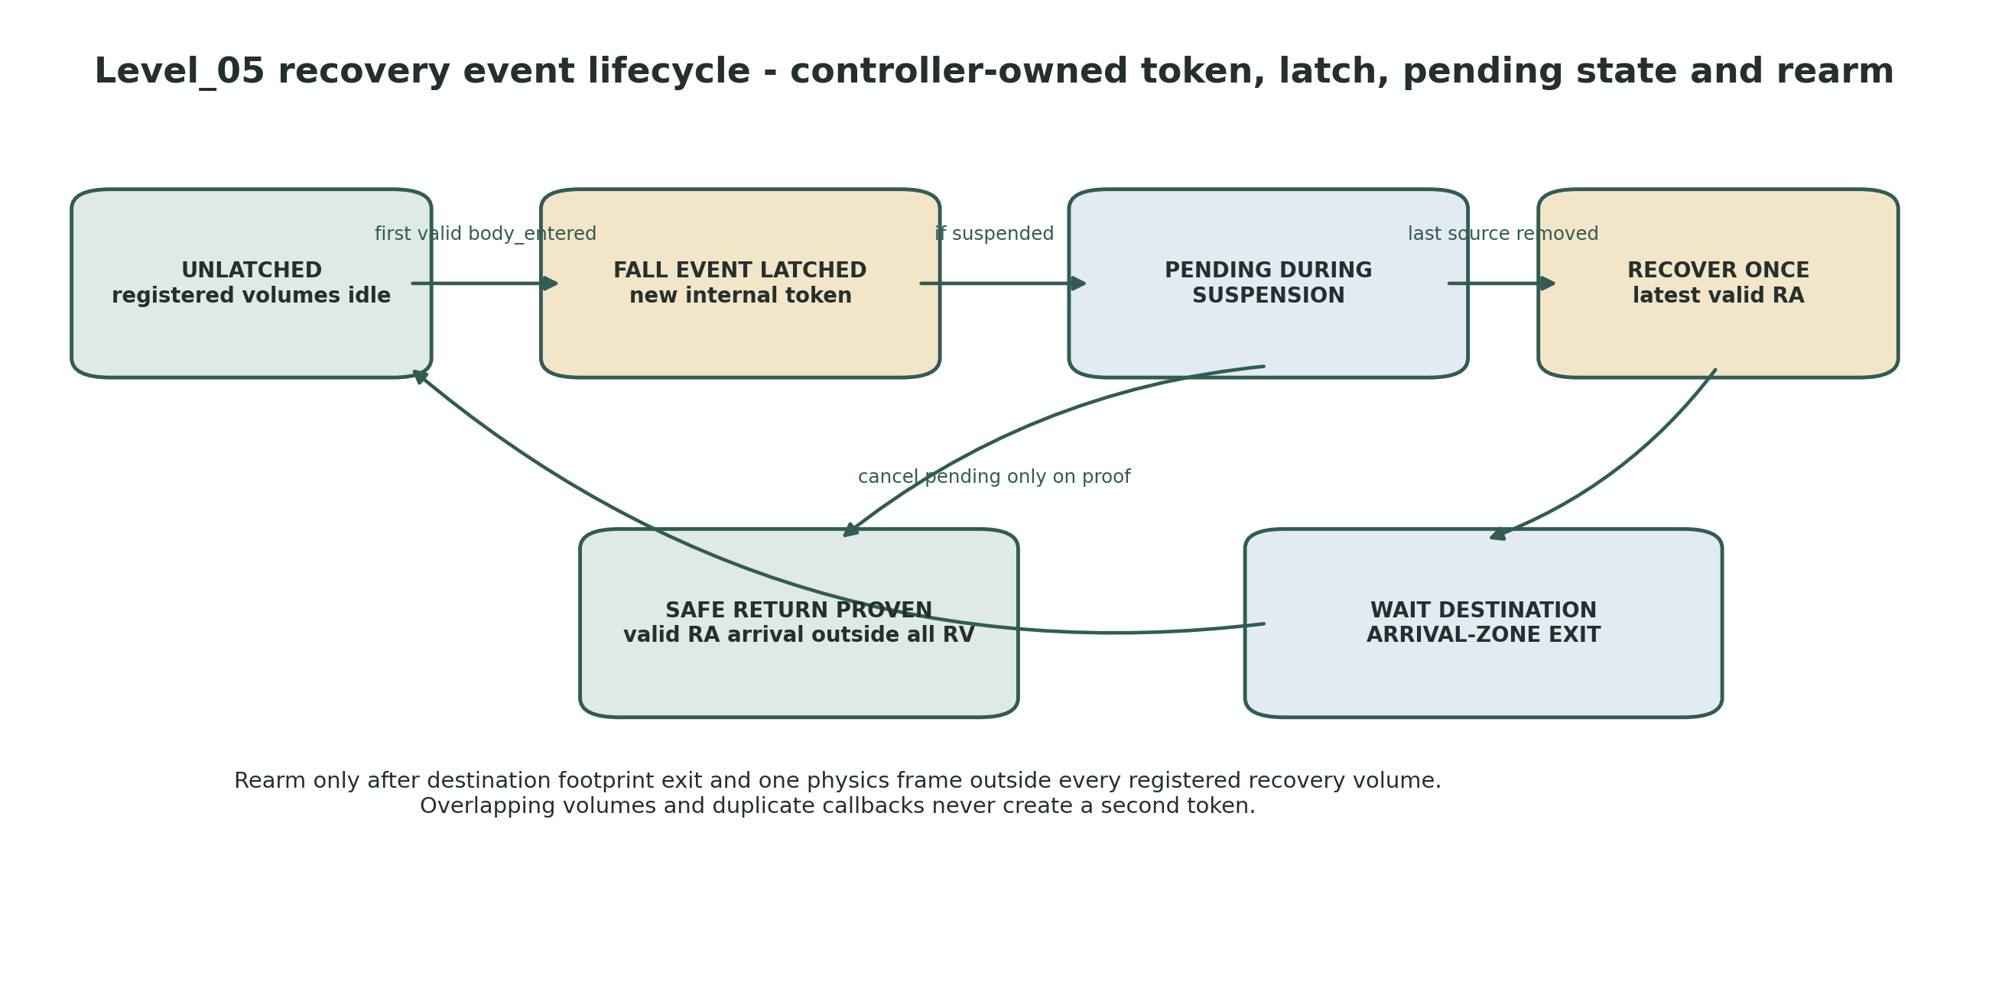
Figure 9. Controller-owned fall token, pending suspension and destination-footprint rearm.
Each Level05RecoveryVolume is a dumb Area3D source with a unique volume_id and one CollisionShape3D. Level05RecoveryController explicitly registers every volume by exact NodePath and binds its own private handlers. Volumes own neither destination nor token.
RecoveryController API | Contract
register_volume(volume: Area3D, expected_id: StringName) | Private startup registration; validates exact path, unique ID and bound source.
register_anchor(zone: Node, expected_id: StringName) | Private startup registration; validates exact path and floor transform.
add_suspension_source(source: StringName) | Idempotently add shard_reward or main_text.
remove_suspension_source(source: StringName) | Remove owned source; after last removal reevaluate current pending token once.
get_latest_valid_anchor_id() -> StringName | Read-only.
has_pending_recovery() -> bool | Read-only.
debug_get_fall_event_token() -> int | Harness only.
request_anchor_gate_reevaluation() | Ask registered RA zones to enable/reevaluate based on Progress predicates.
perform_recovery_for_current_token() | Private; chooses destination, teleports once, zeroes velocity and starts destination-exit rearm.

16.3 Exact fall-event lifecycle
1. On registered body_entered, bound handler first verifies the exact configured Player and expected source object/volume_id.
2. If unlatched, increment fall_event_generation, assign current fall_event_token, set recovery_latched=true and record exact source volume.
3. Additional entries from the same or overlapping registered volumes update active overlap set but never create a second token.
4. If effective suspension is active, retain exact pending source volume + current token. Exiting the originating volume does not clear the event.
5. A pending event can be cancelled before unlock only by a proven safe return: grounded arrival in a currently gate-valid registered RA zone while outside every recovery volume.
6. After the last suspension source is removed, wait one physics frame. If the token is still pending and no safe-return proof exists, recover once even if Player left the source volume or continued below Y=-12.
7. After teleport, set Player.velocity=Vector3.ZERO and keep the event latched until Player exits the destination ArrivalZone and one physics frame confirms no registered recovery-volume overlap.
8. Unknown IDs, mismatched bound source, duplicate callback, stale token and out-of-order rearm events are rejected.

16.4 Exact recovery-volume registry
volume_id | Shape | Exact transform | Exact size | Controller-owned destination rule
RV_FALL_GLOBAL | Box | pos (0,-8,0), rot (0,0,0) | size (100,8,116) | RA_LATEST_VALID
RV_PERIM_N | Box | pos (0,3,56), rot (0,0,0) | size (100,12,8) | RA_LATEST_VALID
RV_PERIM_S | Box | pos (0,3,-56), rot (0,0,0) | size (100,12,8) | RA_LATEST_VALID
RV_PERIM_W | Box | pos (-49,3,0), rot (0,0,0) | size (8,12,120) | RA_LATEST_VALID
RV_PERIM_E | Box | pos (49,3,0), rot (0,0,0) | size (8,12,120) | RA_LATEST_VALID
RV_BASIN_DISK | Cylinder | pos (-9,-0.5,0), rot (0,0,0) | radius 7.50, height 5.00 | RA_LATEST_VALID
RV_OUTLOOK_S | Box | pos (-7,2,-21), rot (0,0,0) | size (30,10,5) | RA8 if valid, else latest

16.5 Recovery-anchor transform and state-gate contract
Anchor root / anchor_id | Exact root + FloorAnchor global floor position | Earliest accepted predicate
RA0_Arrival | Vector3(-9.000,2.400,-46.440) | L05_INIT+
RA1_DewComplete | Vector3(18.460,2.680,-29.650) | All three Dew IDs complete / reveal requested+
RA2_Shard10Ledge | Vector3(23.360,2.760,-20.180) | SHARD_10_AVAILABLE+
RA3_LittleReactions | Vector3(25.370,2.620,0.000) | SHARD_10_REWARD_COMPLETE or REACTIONS_ACTIVE+
RA4_Shard11Stone | Vector3(5.120,2.220,26.420) | SHARD_11_AVAILABLE+
RA5_MosaicEntry | Vector3(-20.000,1.480,20.570) | SHARD_11_REWARD_COMPLETE or MOSAIC_ACTIVE+
RA6_Shard12Terrace | Vector3(-24.650,0.820,0.000) | SHARD_12_AVAILABLE+
RA7_QuietAssembly | Vector3(-20.108,0.720,-9.319) | ALL_REWARDS_COMPLETE+
RA8_MainTextGate | Vector3(-11.344,0.680,-13.295) | ALL_REWARDS_COMPLETE or MAIN_TEXT+
RA9_PortalApproach | Vector3(-6.742,0.740,-12.802) | EXIT / portal activation+

Every RAx root owns the approved scene-local coordinate. FloorAnchor.transform is identity. ArrivalZone is centered locally at Vector3(0,1.25,0), with cylinder radius 2.25 m and height 2.50 m. get_floor_anchor_global_transform() is the sole teleport transform. Startup validation compares global floor position to the approved coordinate with approximate float comparison.

16.6 Level05RecoveryAnchorZone contract
Export / API | Contract
anchor_id: StringName | Explicit canonical RA0-RA9 ID.
player_path: NodePath | ../../../../PlayerRoot/Player for every instance.
floor_anchor_path: NodePath | FloorAnchor.
arrival_zone_path: NodePath | ArrivalZone.
grounded_dwell_seconds: float | 0.20 s exact.
set_accepting(bool) | Controller-owned gate; on enable waits physics frame and reevaluates overlap.
request_current_overlap_reevaluation() | One-shot; no exit/re-entry requirement.
get_floor_anchor_global_transform() -> Transform3D | Exact teleport transform.
is_player_inside_arrival_zone() -> bool | Rearm and safe-return proof.
recovery_anchor_reached(anchor_id) | After configured Player grounded continuously 0.20 s.
recovery_anchor_departed(anchor_id) | Exact Player leaves ArrivalZone.

16.7 Recovery suspension and control-lock separation
Source / owner | Lifecycle
&"shard_reward" | Add on slot shard_collection_started; remove on matching shard_collected. Do not read shared reward private state.
&"main_text" | FinaleController adds before accepted show_finale_text(); removes on actual closed or owned error cleanup.
Effective suspension | active_sources.size() > 0. Teleport never occurs while true.
Shared reward control lock | Owned and released by ShardRewardSequenceController.
Main-text control lock | Owned and released by Level05FinaleController.
Portal transition lock | Owned by shared LevelPortal.
Environment and puzzle presentation | Never lock Player.

17. File ownership and future changed-file boundaries

17.1 Expected future files - reference only
Action | Path | Ownership / purpose
MODIFY | scenes/levels/Level_05.tscn | Replace placeholder composition and set exact parent overrides.
CREATE | scenes/levels/level_05/blocks/Block_05_00_OuterThreshold.tscn ... Block_05_09_PortalOutlook.tscn | Environment-only blocks.
CREATE | scenes/levels/level_05/gameplay/DewScriptPuzzle.tscn | Dew local puzzle.
CREATE | scenes/levels/level_05/gameplay/LittleReactionsPuzzle.tscn | Reaction local puzzle.
CREATE | scenes/levels/level_05/gameplay/OrdinaryMosaicPuzzle.tscn | Mosaic local puzzle.
CREATE | scenes/levels/level_05/gameplay/Level05PresenceFootprint.tscn | Reusable grounded dwell sensor.
CREATE | scenes/levels/level_05/gameplay/Level05ShardSlot.tscn | One-shard hidden/reveal adapter.
CREATE | scenes/levels/level_05/gameplay/Level05RecoveryAnchorZone.tscn | Exact floor anchor + arrival sensor.
CREATE | scenes/levels/level_05/gameplay/Level05RecoveryVolume.tscn | Dumb authored fall/OOB Area3D.
CREATE | scripts/levels/level_05/level_05_progress_controller.gd | Sole macro owner.
CREATE | scripts/levels/level_05/dew_script_controller.gd | Dew unique-ID state.
CREATE | scripts/levels/level_05/little_reactions_controller.gd | Reaction unique-ID state.
CREATE | scripts/levels/level_05/ordinary_mosaic_controller.gd | Mosaic unique-ID state.
CREATE | scripts/levels/level_05/level_05_presence_footprint.gd | Grounded overlap/dwell generation.
CREATE | scripts/levels/level_05/level_05_shard_slot.gd | Availability and child signal adapter.
CREATE | scripts/levels/level_05/level_05_environment_state_controller.gd | E0-E4 + Quiet Assembly presentation.
CREATE | scripts/levels/level_05/level_05_finale_controller.gd | FinalTextGate + fail-closed exact text.
CREATE | scripts/levels/level_05/level_05_portal_adapter.gd | One shared activation request + accent.
CREATE | scripts/levels/level_05/level_05_recovery_controller.gd | Volume events, tokens, anchors, suspension and rearm.
CREATE | scripts/levels/level_05/level_05_recovery_anchor_zone.gd | Arrival sensing and floor transform.
CREATE | scripts/levels/level_05/level_05_recovery_volume.gd | Explicit volume_id only.
OPTIONAL CREATE | scripts/levels/level_05/*_presentation.gd | Small local VFX interfaces only if art production requires them.

17.2 Files forbidden to touch in this documentation stage
- Any repository .tscn, .gd, .tres, shader, GLB, imported asset or project.godot file.
- Any branch, commit, pull request, issue, release or runtime test branch.
- Level_01-Level_04 and Level_06 runtime files.
- Art Production Bible, Greybox Development Reference, Codex decomposition or implementation summary.
- Shared Player, SoulShard, SoulOrb_Follow, reward UI/controller, LevelFinaleOverlay or LevelPortal unless a later named P0 gate fails and Producer separately approves one minimal prerequisite.
NO PROJECT SETTING CHANGE
Level_05 requires no new input action, autoload, physics layer, rendering setting or global singleton. project.godot remains unchanged.

18. Test harness, validation and acceptance matrices

18.1 Unit-like / headless checks
ID | Check | Expected evidence
UT-01 | Initial state | Clean construction is L05_INIT/E0; three slots packed hidden; portal inactive.
UT-02 | Deferred init | Successful startup validation advances once to DEW_ACTIVE.
UT-03 | Future target rejection | Reaction/Mosaic target events before active state are rejected.
UT-04 | All Dew permutations | All 6 permutations produce 3 unique IDs, one logical terminal and one presentation terminal.
UT-05 | Dew duplicate callbacks | Repeated same ID and same-frame callbacks do not overcount.
UT-06 | Shard_10 gating | Only actual slot shard_available enters SHARD_10_AVAILABLE.
UT-07 | Shard_10 progression | Only slot shard_collected(Shard_10) commits reward and starts REACTIONS_ACTIVE.
UT-08 | E1 failure | Missing E1 presentation callback does not delay REACTIONS_ACTIVE.
UT-09 | All Reaction permutations | All 6 produce 3 unique IDs and one terminal.
UT-10 | Reaction motion race | Real final motion callback racing 1.30 s fallback emits one presentation terminal.
UT-11 | Shard_11 progression | Wrong/duplicate shard IDs ignored; expected collected advances.
UT-12 | E2 failure | MOSAIC_ACTIVE continues when E2 presentation fails.
UT-13 | All Mosaic permutations | All 6 produce 3 unique IDs and one terminal.
UT-14 | Mosaic layer race | Real callback racing fallback emits once.
UT-15 | Shard_12 progression | Actual collected enters ALL_REWARDS_COMPLETE and arms finale immediately.
UT-16 | Quiet Assembly failure | Missing E3/Quiet Assembly callback cannot block gate/main text.
UT-17 | Main text fail-closed | Missing overlay/API/false return leaves portal dormant and releases only owned lock.
UT-18 | Duplicate main close | One EXIT and one portal activation request.
UT-19 | Portal diagnostic timeout | Never emits success, repeats activate or loads scene.
UT-20 | Slot pre-overlap | Each hidden shard becomes interactable once without exit/re-entry after verified availability.
UT-21 | SoulOrb continuity | Exactly one visible SoulOrb_Follow; normal reward return path used once per shard.
UT-22 | Recovery registry | Exactly seven explicit volume paths and ten anchor paths; IDs unique and path/source binding exact.
UT-23 | One token per fall | First valid entry creates one internal token; duplicate and overlapping entries do not.
UT-24 | Pending across source exit | Suspended fall remains pending after leaving origin/continuing below Y=-12.
UT-25 | Safe return proof | Valid RA arrival outside every RV clears pending before unlock.
UT-26 | Pending applies once | No safe-return proof -> one recovery after last source removal.
UT-27 | Rearm | No new token until destination ArrivalZone exit + one physics frame outside all RVs.
UT-28 | Unknown/stale event rejection | Unknown volume ID, mismatched bound source and stale token do nothing.
UT-29 | RA transform convention | All FloorAnchor local transforms identity; global positions approximately equal approved values.
UT-30 | RA gates | Every anchor ignored before earliest predicate and accepted at/after predicate.
UT-31 | Presence Player binding | All 9 player_path values resolve from actual footprint owner.
UT-32 | Non-Player rejection | Other CharacterBody3D cannot satisfy dwell.
UT-33 | Airborne dwell | Airborne overlap contributes zero; landing while still inside may begin dwell.
UT-34 | Current-overlap activation | Player already inside a footprint/RA/gate is reevaluated without exit/re-entry.
UT-35 | Reload | Fresh scene reconstructs L05_INIT/E0 with no stale state.

18.2 Static scene and API validation
ST-01 - Godot headless parse and scene load succeed with no new parse errors.
ST-02 - Every exported NodePath resolves from its real owner to the expected type, including all corrected four-parent puzzle paths and all nine five-parent footprint Player paths.
ST-03 - Level_05 root is identity; exact P00-P24, target, shard, gate, portal, RV and RA coordinates use approximate comparisons.
ST-04 - Exactly three Level05ShardSlot instances exist; each contains exactly one shared SoulShard with exact ID/text and packed disabled state.
ST-05 - Exactly one visible shared SoulOrb_Follow exists; target/orientation paths are exact; a visible soul_orb_visual resolves.
ST-06 - Canopy/route-context concepts do not leak into Level_05. There is no branch choice, route context or anchor context enum.
ST-07 - Every recovery volume is explicitly registered; no root scan, node-name parsing, nearest volume or per-frame world-position scan.
ST-08 - Every RA root owns exact floor coordinate; FloorAnchor identity; ArrivalZone local center (0,1.25,0), r=2.25, h=2.50.
ST-09 - PortalFloorAnchor owns P24; LevelPortal local transform is approximately identity; target Level_06; AUTO_ENTER; no confirmation.
ST-10 - Environment-mutated resources are local/deep duplicated; EnvironmentController has no PortalAccentVFX path or method.
ST-11 - No LevelManager, PoemRewardUI, GameState, save, new autoload or project.godot change remains in the Level_05 flow.

18.3 Manual P0/P1 integration matrix
ID | Setup / action | Expected evidence
P0-01 | Clean full route | Dew -> Shard_10 -> Reactions -> Shard_11 -> Mosaic -> Shard_12 -> text -> Level_06; exact copy; one transition.
P0-02 | Dew permutations | All 6 orders; one reveal; persistence on leave/re-enter.
P0-03 | Reaction permutations | All 6 orders; no waiting for random motion; one reveal.
P0-04 | Mosaic permutations | All 6 orders; no camera facing check; one reveal.
P0-05 | Future pocket early | Enter future footprint and remain; no early ID; activation reevaluates without re-entry.
P0-06 | Presence Player binding | Verify all nine exact paths; non-Player rejected; airborne dwell rejected.
P0-07 | Dew presentation disabled | Final trace fallback still reveals Shard_10 once.
P0-08 | Reaction presentation disabled | 1.30 s fallback still reveals Shard_11 once.
P0-09 | Mosaic presentation disabled | Fallback still reveals Shard_12 once.
P0-10 | Shard pre-overlap x3 | Stand in each future radius; no early interaction; available once without re-entry.
P0-11 | Duplicate shard lifecycle | Repeat started/collected callbacks; one macro advancement per ID.
P0-12 | Normal reward return x3 | Exactly one visible SoulOrb_Follow and one return/absorb pulse per reward.
P0-13 | E1 callback missing | REACTIONS_ACTIVE begins.
P0-14 | E2 callback missing | MOSAIC_ACTIVE begins.
P0-15 | E3/Quiet Assembly missing | FinalTextGate remains eligible and main text can start.
P0-16 | FinalTextGate early overlap | Remain inside before Shard_12 reward; exact text starts after eligibility without re-entry.
P0-17 | Main text UI failure | Portal dormant; configuration error; only owned lock/suspension released.
P0-18 | Duplicate text close | One EXIT and one activate request.
P0-19 | Portal anchor audit | P24 anchor and shared portal root remain coincident; shared internal child transforms unchanged.
P0-20 | Portal stationary overlap | No early load; one Level_06 transition after actual active, without re-entry.
P0-21 | Portal timeout | Blocker diagnostic only; no fabricated success or local scene load.
P0-22 | Portal rapid enter/exit | At most one transition; shared latch owns result.
P0-23 | All recovery volumes | Validate exact transforms/shapes/sizes and explicit registration.
P0-24 | Overlapping recovery volumes | One token and one recovery only.
P0-25 | Duplicate body_entered | No second token or teleport.
P0-26 | Fall during reward | Pending survives source exit and continued fall below Y=-12; one unlock recovery.
P0-27 | Fall during main text | Same contract; overlay not interrupted.
P0-28 | Safe return before unlock | Reach valid RA outside all RV; pending clears; no teleport.
P0-29 | Destination rearm | Remain in destination footprint: no repeat; exit then new fall creates next token.
P0-30 | Unknown/mismatched/stale events | No state mutation.
P0-31 | RA0-RA9 before gate | Grounded 0.20 s does not change latest valid anchor.
P0-32 | RA0-RA9 at/after gate | Each updates latest valid anchor once.
P0-33 | RA current-overlap | Stand inside before gate opens; accepted after enable without re-entry.
P0-34 | RV_OUTLOOK_S before RA8 | Uses latest valid, never forward.
P0-35 | RV_OUTLOOK_S after RA8 | May use RA8 exactly once.
P0-36 | Spawn | Repeated loads: grounded, non-overlapping, stable floor snap; floor marker unchanged.
P0-37 | Stale step motion | Recovery leaves no residual step climb/velocity; otherwise STOP for Player safe-teleport API.
P0-38 | Seed Basin coverage | Exact r<=7.5 cylinder coverage, no overshoot into legal rim.
P0-39 | Full reload | Every macro state reloads to L05_INIT/E0; no stale shard/UI/portal.
P0-40 | Exact copy | Three rewards and main text character-for-character.
P1-01 | Blind first play | 5:30-7:00; no UI arrows required.
P1-02 | Repeat play | 3:15-4:15.
P1-03 | Camera QA | CP0-CP9 at 16:9; required landmarks visible, prohibited occlusions absent.
P1-04 | Accessibility | Muted/reduced-color play remains fully readable.
P1-05 | Performance | Stable 60 FPS target; bounded particles/material copies; no per-frame scans.

19. Risks, simplifications and mandatory STOP conditions
Risk | Severity | Mitigation
Linear-order event leak activates future puzzle | High | Progress validates exact state; footprints packed non-accepting; current-overlap reevaluation only after activation.
Presentation callback softlocks reveal | High | Logical completion separate; bounded first-terminal-wins fallback.
Hidden shard collectable through pre-overlap | High | Packed disabled state + effective verification + P0; conditional minimal shared API only after failure.
Recovery loses fall after source exit | High | Controller-owned token remains pending until proven safe RA return or recovery.
Recovery duplicates across overlapping volumes | High | One latch/token and active overlap set; bound source validation.
Recovery teleports forward | High | Latest valid authored RA only; RV_OUTLOOK_S override checks RA8 validity.
Portal early overlap softlocks | High | Mandatory P0; conditional reevaluate API; no local scene-load workaround.
Main text skipped on UI failure | High | Fail-closed overlay contract; portal dormant.
Environment reads as collecting/capturing memories | High | E0 alive; persistent traces; no trophy escalation or global value meter.
Little Reactions anthropomorphizes Alena | Medium | Autonomous plant-like motions; emergency Passing Gestures only after Producer approval.
Shared changes leak across levels | High | No shared edit without failed named P0 evidence and separate approval.

19.1 Approved simplification direction
Blocker | Allowed simplification
Dew surfaces expensive | Keep three broad triggers and simple persistent curve meshes/decals; no refraction.
Reaction motions anthropomorphic/expensive | Use autonomous Passing Gestures at same IDs/coordinates; completion semantics unchanged; Producer approval required.
Mosaic technology expensive | Toggle three pre-authored layer groups; no runtime painting or camera scoring.
Macro-garden asset cost high | Retain exact route using three modular families only: stone/moss, grass/seed, dew/glow.
Seed Basin boundary expensive | Primitive retaining ring + non-climbable collision belt; exact recovery cylinder remains.
Scope pressure | Cut decorative VFX/camera emphasis/microflora first. Do not cut shard, exact copy, recovery, finale or portal contracts.

19.2 Mandatory STOP conditions
- Any canonical ID, exact text, P00-P24 coordinate, RV/RA registry value or canonical macro label conflicts with approved sources.
- Any active PR or main change modifies a shared contract named in the preflight refresh rule.
- Any Level05PresenceFootprint cannot bind the exact Player path or requires node/group/any-CharacterBody fallback.
- SoulShard hidden/pre-overlap test fails without private-field access. Stop for separately approved minimal public availability/overlap-refresh API.
- LevelPortal stationary early-overlap test fails. Stop for separately approved reevaluate_auto_enter_overlap(); scene loading remains shared.
- Player recovery leaves stale step-climb or motion state after velocity reset. Stop for separately approved public safe-teleport API.
- LevelFinaleOverlay cannot show the exact main text at supported viewports. Stop for Producer decision on local wrapper or narrow responsive fix.
- Any environment transition mutates a resource shared with another level or EnvironmentController gains PortalAccentVFX ownership.
- Any recovery solution needs nearest-anchor guessing, node-name parsing, per-frame world-position scan or undefined external fall token.
- Any proposed solution requires GameState, save, autoload, LevelManager expansion, project-wide puzzle framework or project.godot change.
- Any route requires a mandatory jump, precision alignment, hidden-object search, timer, response, sound cue or camera-facing test.

20. Producer decisions and next-gate requirements
ID | Decision | Status | Effect
PD-T01 | Approve Level05ProgressController as sole macro owner and exact twelve-state model. | APPROVE / ADJUST | Blocks future technical decomposition.
PD-T02 | Approve three independent local puzzle controllers and nine explicit PresenceFootprints. | APPROVE / ADJUST | No future-event leakage or identity inference.
PD-T03 | Approve three Level05ShardSlot instances and progression only on slot shard_collected. | APPROVE / ADJUST | Separates completion, availability and collection.
PD-T04 | Approve mandatory shared SoulOrb_Follow continuity and normal reward return. | APPROVE / ADJUST | Emergency no-orb completion is not expected flow.
PD-T05 | Approve E0-E4 EnvironmentStateController semantics and non-blocking transitions. | APPROVE / ADJUST | No reward callback gates next puzzle or finale.
PD-T06 | Approve LevelFinaleOverlay as default fail-closed exact-text UI. | APPROVE / ADJUST | UI fit must be verified later.
PD-T07 | Approve shared LevelPortal as exclusive activation/load owner and adapter boundary. | APPROVE / ADJUST | No local scene transition.
PD-T08 | Approve authored recovery-volume event architecture and RA safe-return proof rule. | APPROVE / ADJUST | Pending fall persists across source exit; cancel only on valid RA proof.
PD-T09 | Approve conditional shared-prerequisite process for SoulShard, Player and LevelPortal. | APPROVE / ADJUST | Only after named P0 failures with evidence.
PD-T10 | Confirm Player root Y remains a later runtime evidence requirement, not a blocker for this document. | APPROVE / ADJUST | Floor anchors remain exact.
PD-T11 | Confirm next authorized gate after technical acceptance. | OPEN | Recommended: Art Production Bible only; greybox/Codex/runtime remain unauthorized.

20.1 Gate statement
NO IMPLEMENTATION AUTHORITY
Producer acceptance of this DOCX approves architecture source-of-truth only. It does not authorize implementation preflight, Codex decomposition, greybox work, runtime scenes/scripts, Blender/GLB assets, a branch, commit or PR. Recommended next gate: Level_05 Art Production Bible only.

20.2 Non-authorizing future decomposition guidance
For later planning only, the architecture naturally decomposes into small slices: fresh preflight; root scaffold/static validation; generic presence sensor; Dew; Shard_10; Reactions; Shard_11; Mosaic; Shard_12; environment/Quiet Assembly; finale; recovery; portal; integration QA. This list is guidance for a future approved Task Generator and grants no authority to begin any slice.

Appendix A. Canonical constants and enums
const PUZZLE_DEW: StringName = &"DEW_SCRIPT"
const PUZZLE_REACTIONS: StringName = &"LITTLE_REACTIONS"
const PUZZLE_MOSAIC: StringName = &"ORDINARY_MOSAIC"
const SHARD_10: StringName = &"Shard_10"
const SHARD_11: StringName = &"Shard_11"
const SHARD_12: StringName = &"Shard_12"
const MAIN_TEXT_ID: StringName = &"LEVEL_05_MAIN_TEXT"
const PORTAL_TARGET := "res://scenes/levels/Level_06.tscn"
enum MacroState {
L05_INIT,
DEW_ACTIVE,
SHARD_10_AVAILABLE,
SHARD_10_REWARD_COMPLETE,
REACTIONS_ACTIVE,
SHARD_11_AVAILABLE,
SHARD_11_REWARD_COMPLETE,
MOSAIC_ACTIVE,
SHARD_12_AVAILABLE,
ALL_REWARDS_COMPLETE,
MAIN_TEXT,
EXIT,
}
enum EnvironmentPhase {
E0_INITIAL,
E1_AFTER_SHARD_10,
E2_AFTER_SHARD_11,
E3_AFTER_SHARD_12,
E4_AFTER_MAIN_TEXT,
}
enum PuzzleState { LOCKED, ACTIVE_0, ACTIVE_1, ACTIVE_2, COMPLETE }
enum ShardSlotState { HIDDEN, REVEALING, ENABLE_PENDING, AVAILABLE, COLLECTION_STARTED, COLLECTED }

Appendix B. Controller export reference
Component | Export family | Validation rule
Progress | Three puzzle paths, three slot paths, environment/finale/adapter/recovery paths | Explicit parent overrides; fail closed.
Puzzle controllers | puzzle_id, expected IDs, footprint root, presentation/player paths, hint and terminal timings | No path/array order authority.
PresenceFootprint | target_id, player_path, dwell_seconds, grounded_required | Exact Player; current-overlap reevaluation.
ShardSlot | shard_id, reward_text, child/player/VFX paths, reveal timings | Packed hidden and verified collectability.
Environment | WorldEnvironment, lighting/guidance/Quiet Assembly paths, E0-E4 tune exports | Deep duplicate resources; no PortalAccentVFX.
Finale | player, gate, overlay, recovery paths, exact text | No readable-text timer fallback.
PortalAdapter | portal and accent paths, diagnostic timeout | Timeout is blocker only.
RecoveryController | player/progress, 7 volume paths, 10 anchor paths, source keys | Internal token/latch; no external request token.
RecoveryAnchorZone | anchor_id, player/floor/arrival paths, 0.20 s dwell | Exact root coordinate and identity FloorAnchor.
RecoveryVolume | volume_id only | No destination, token or Player logic.

Appendix C. Validation checklist
☐ Source versions match Narrative v1.1, Visual Master Concept and Gameplay v1.2.
☐ Audited main commit recorded as a9380f7afce1c0bb0727ccaf6e3f0e76a13df78d and open PR count recorded.
☐ Exact Shard_10/11/12 and main text copied without decorative runtime quotes.
☐ Level05ProgressController is sole macro owner; exact twelve labels preserved.
☐ Three puzzle controllers each track exactly three unique IDs and one terminal.
☐ All nine footprints bind ../../../../../PlayerRoot/Player and use public is_on_floor().
☐ Each canonical shard has one floor anchor, one slot and one shared SoulShard child.
☐ Packed shard children are disabled before first frame; macro advances only on slot shard_collected.
☐ Exactly one visible SoulOrb_Follow uses target ../Player and orientation ../Player/CharacterVisualRoot.
☐ Environment transitions are non-blocking, resources local and PortalAccentVFX absent from EnvironmentController.
☐ Quiet Assembly is non-interactive and cannot delay main text.
☐ Main text is fail-closed and actual closed is mandatory.
☐ PortalFloorAnchor owns P24; LevelPortal identity-local; shared portal owns loading.
☐ RecoveryController explicitly registers 7 volumes and 10 anchors and internally owns token/latch/pending/rearm.
☐ RA root owns exact coordinate; FloorAnchor identity; ArrivalZone local center (0,1.25,0).
☐ No LevelManager, PoemRewardUI, GameState, save, autoload, project-wide puzzle framework or project.godot change.
☐ All named P0 stop-condition tests remain required for future evidence.
☐ Producer explicitly authorizes the next gate before any implementation preflight.

Appendix D. Source traceability
Design concern | Source authority | Architecture location
Exact copy / emotional safety | Narrative v1.1 §§4-6, final locked table | Sections 4, 12, 14, 19-20
Visual hierarchy / inward spiral / motif families | Visual Master Concept §§1-10 | Sections 3-4, 9-13, 19
Coordinates / route / timings / recovery | Gameplay v1.2 §§3-5, 9-14 | Sections 4, 7-18
Canonical macro states | Gameplay v1.2 §9 | Sections 5, 8 and Appendix A
Shared API facts | current main audited files | Sections 1, 5-7, 12, 14-16
No implementation authority | All three source scope statements + task instruction | Sections 17 and 20

FINAL HANDOFF STATUS
This document is complete as a Level_05 technical-architecture candidate for Producer review. No Godot scenes, scripts, resources, assets, branches, commits or pull requests were created or modified while producing it.

