FIFTEEN SHARDS OF LIGHT
Level_05 — «То, что остается»
VISUAL MASTER CONCEPT PACKAGE
Visual development lead • Environment concept design • Blender art direction
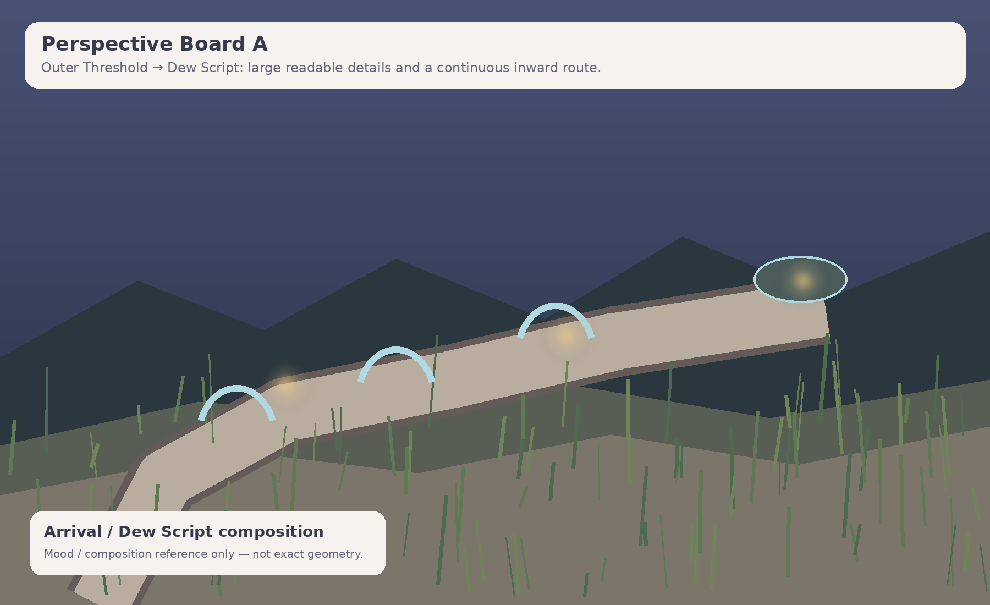
Cover mood/composition reference. Non-authoritative for exact geometry, coordinates and gameplay implementation.
Control | Value
Project | Fifteen Shards of Light
Repository | MindDevastation/fifteen-shards-of-light
Level | Level_05 only
Primary design authority | Level_05_Narrative_and_Level_Scenario_Package_v1.1.docx
Document status | VISUAL MASTER CONCEPT CANDIDATE — Producer approval required
Mode | Documentation only — no runtime changes, Blender production, GLB hierarchy, NodePaths or state machines
Repository preflight | Current Level_05.tscn remains a 12×12 one-shard placeholder; direct fetch blob SHA 43d29b9e8b486e56584e89169675b12ea2d7bddd. Portal target remains Level_06.

EMOTIONAL SAFETY CONTRACT
Героиня не сломана, и ее никто не чинит. Свет, искренность, улыбка и маленькие речевые детали уже принадлежат ей. Уровень показывает, что именно осталось в памяти автора, но не превращает внимание в наблюдение, каталог, доказательство близости или эмоциональный долг.

0. Document control, authority split and scope

0.1 Authority hierarchy
Authority layer | Controls
Textual authority | Approved Level_05 Narrative and Level Scenario Package v1.1 controls title, exact copy, three-shard model, emotional function, sequential route, mechanic intent and forbidden readings.
Diagram authority | Top-down map, sightline board, puzzle diagrams, state boards and asset-budget board in this package define visual composition intent and approximate relative proportions.
Mood/composition references | Stylized perspective boards communicate atmosphere, scale and camera energy only. They do not define exact geometry, asset count, gameplay coordinates or runtime architecture.
Repository factual authority | Current repository files describe placeholders and available integration constraints only. The existing one-shard Level_05 scene is not visual canon.

0.2 Scope boundary
- Defines visual thesis, shape language, landmarks, top-down composition, sightlines, puzzle readability, environment states, palette/material/fog/light rules and a constrained asset-family proposal.
- Does not define final Godot architecture, NodePaths, state machines, exact gameplay coordinates, collision ownership, production GLB hierarchy or implementation slices.
- Does not authorize Blender production, final materials, runtime assets, branches, commits or pull requests.

0.3 Continuity without visual copying
Previous level | Continuity retained | Visual language deliberately not copied
Level_02 — Живой свет | Warm-natural fantasy, readable landmarks, emotionally safe state change. | No central arena, light channels, portal socket, optical alignment or ancient mechanism composition.
Level_03 — После наших разговоров | Broad safe traversal, subtle amber/ivory accents, world already alive. | No airy S-route, wind arches, spark-following, open meadow or wind-ribbon identity.
Level_04 — Ты сама | Natural material coherence, persistent completed-state motifs, calm portal transition. | No rainlit terraces, shoreline/ripple mechanic, branch choice, braided crossing or mixed-weather synthesis.

0.4 Current repository preflight
Direct repository inspection confirms that Level_05.tscn is still a flat 12×12 legacy placeholder with one SoulShard, legacy LevelManager/PoemRewardUI and a portal targeting Level_06. Level_06 is also a one-shard placeholder. These facts constrain later integration work but do not override the approved Level_05 narrative package. No runtime files were modified during this visual-development stage.

1. Visual thesis and emotional reading

1.1 Visual thesis
Level_05 is a close-up blue-hour garden built around one continuous inward spiral. After the broader weather and branch structure of Level_04, the player’s attention moves closer to the ground: dew on large leaves, seed heads, moss, low stone and small autonomous movements. The level does not ask the player to find hidden proof. It makes three already-visible details easy to notice and lets them remain as quiet traces.
CENTRAL VISUAL IDEA
A small detail is not valuable because the player discovered or preserved it. It was already part of the living world. The level only gives the player enough space and clarity to notice why it remained in the author’s memory.

1.2 Emotional arc
Beat | Emotional reading | Visual expression
Arrival | The scale shifts from broad weather to close attention. | Tall grass and large dew forms frame a readable spiral; central seed basin appears only in fragments.
Dew Script / Shard_10 | One particular word can remain after a whole conversation. | Three broad dew arcs leave simple curved traces; no letters, code or hidden message.
Little Reactions / Shard_11 | A brief smile can remain important without needing to be repeated. | Three autonomous seed/grass motions happen once and persist as minimal background behavior.
Ordinary Mosaic / Shard_12 | Sincerity is felt through an ordinary shared composition, not a rare treasure. | Three broad view pads add foreground, midground and background layers without camera alignment checks.
Quiet Assembly | The three memories coexist and clarify the depth of feeling. | Dew, motions and layers become visible together; no fourth puzzle and no grand transformation.
Main text / Portal | Level_05 ends on depth, while admiration remains for Level_06. | Horizon opens modestly; portal activates as a transition, not a climax.

1.3 Exact player-facing copy anchor
ID | Exact locked text
Shard_10 | Я до сих пор улыбаюсь, когда вспоминаю твое «понимяу».
Shard_11 | Я до сих пор помню, как ты на несколько секунд включила камеру и улыбнулась.
Shard_12 | Мне дорога твоя искренность в наших разговорах.
Main text | Я помню твое «понимяу», ту короткую улыбку в камеру и то, как искренне ты говоришь со мной. В тот момент это могло казаться мелочами, но именно они возвращаются в память снова и снова. Из них постепенно сложилось понимание: мое чувство к тебе глубже, чем один легкий разговор или яркий момент.

2. Shape language, landmark hierarchy and environmental storytelling

2.1 Shape language
- Broad inward crescents and nested terraces: continuous route rhythm without forming a circular hub.
- Cup, droplet and seed silhouettes: delicate but readable at ordinary gameplay-camera distance.
- Low, soft verticals: grass and seed heads create intimacy without walls, cages or monumental architecture.
- Layered depth instead of object density: foreground, midground and background carry Ordinary Mosaic.

2.2 Landmark hierarchy
Priority | Landmark | Visual role
Primary orientation | Central Seed Basin | Visible in fragments throughout the spiral. It keeps orientation but cannot be reached as a repeat hub or early shortcut.
Primary local | Next Pocket Silhouette | Dew leaf, seed cluster or crescent terrace is always the strongest nearby navigation cue.
Secondary | Shard Rest Place | A quiet, dry place that frames the exact text without pedestal/trophy staging.
Final | Portal Outlook | A restrained opening toward Level_06. The horizon broadens only at the end.

2.3 Environmental storytelling locks
- The garden is alive before any shard. Glints, grass sway and seed movements already exist in weak form.
- Completion preserves a trace; it does not “capture” a memory or add value to an empty world.
- No element represents Alena as a plant, seed, spark, statue or collectible object.
- The central seed basin is a spatial landmark, not a symbolic container for “parts of her”.
- The player’s attention is guided, never tested as proof of how well they know her.

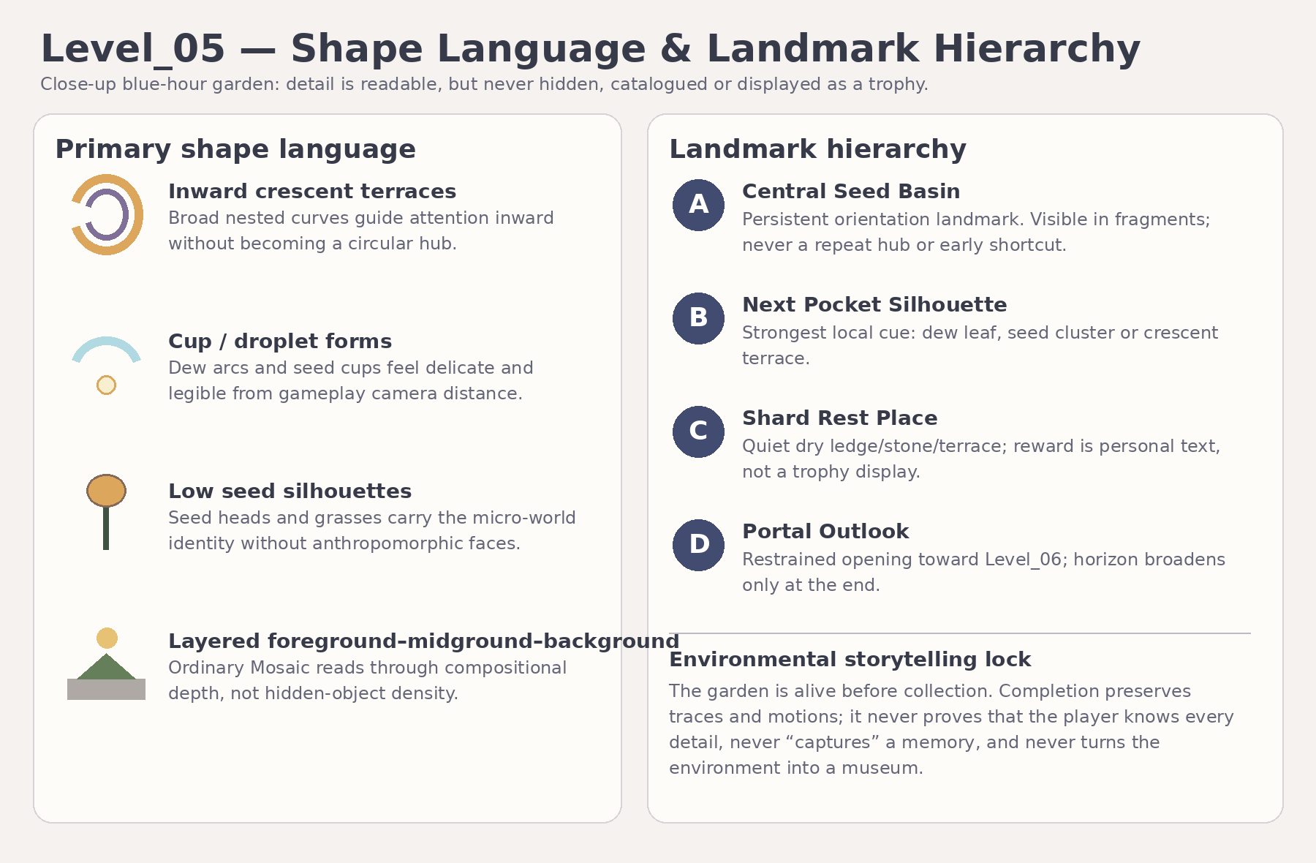
Figure 1. Shape language, landmark hierarchy and environmental storytelling lock. Diagram = visual-intent authority.

3. Top-down composition with approximate relative proportions

3.1 Spatial thesis
The level is one continuous inward spiral with three sequential detail pockets. The player never returns to a central hub, never chooses branches and never backtracks for mandatory content. A low central seed basin acts as a stable orientation reference while retaining edges and plant masses prevent a direct shortcut to the inner terrace.
Zone | Approximate visual proportion | Composition rule
Whole-level envelope | Approx. 82–94 m wide × 92–108 m long; estimated centerline 155–180 m. | Visual-planning range only; exact coordinates and route metrics belong to Gameplay Design.
Outer Threshold | 10–12 m safe terrace | One readable forward route; central basin is glimpsed, not entered.
Dew Script Walk | 5–6 m broad curved path; three visible arcs | All mandatory arcs visible locally; no precision alignment or thin-beam language.
Shard_10 Rest Ledge | 8–10 m dry pocket | Safe, open reward space with view back to persistent traces.
Moss Bend | Short 12–16 m connective curve | No task; resets pace before the second mechanic.
Little Reactions Pocket | 14–18 m elongated pocket | Three autonomous stations visible along one route; no chase or timing.
Shard_11 Rest Stone | 8–10 m broad pad | Quiet transition, not a trophy display.
Inner Spiral Descent | 5–6 m path; visual slope target ≤8° | Broad readable descent; no mandatory jumps or slippery surfaces.
Ordinary Mosaic Terrace | 16–20 m crescent terrace | Three broad view pads and one shared layered field.
Shard_12 / Quiet Assembly | 10–14 m inner dry terrace | Third reward followed by forward-only non-interactive synthesis.
Portal Outlook | 12–16 m open transition space | Main text and restrained portal direction toward Level_06.

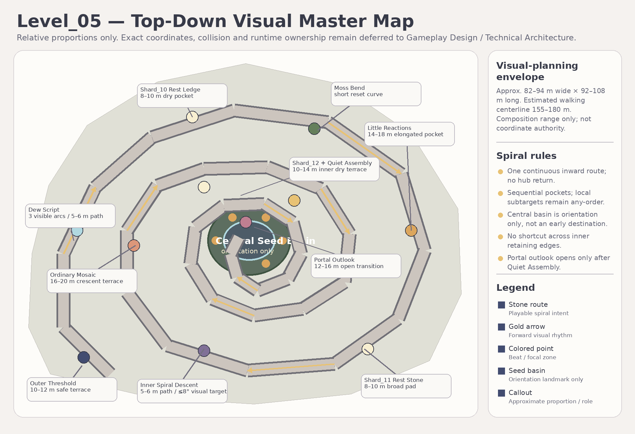
Figure 2. Top-down visual master map. Relative proportions only; not coordinate or collision authority.

4. Player sightlines and visual route

4.1 Diegetic navigation contract
Every route beat should be readable through three simultaneous cues: one next-pocket silhouette, one partial glimpse of the central seed basin, and one local motion/glint cue. The level must not require UI arrows, minimap reading, exact camera alignment or a 360-degree search.
Route beat | Required reading
Outer Threshold | Only the Dew Script entrance has primary contrast; later pockets are visible as distant motif silhouettes, not alternate routes.
Dew Script | Three arcs can be understood from the local entrance. Persistent traces remain behind after completion.
After Shard_10 | Next pocket silhouette becomes clearer; completed traces stay alive without becoming brighter trophies.
Little Reactions | All three stations sit on one camera-readable path. Motions are autonomous and locally distinct.
After Shard_11 | Low glints clarify the inner descent and show the three view-pad silhouettes below.
Ordinary Mosaic | The central composition field is visible from the first pad; exact viewing direction is irrelevant.
After Shard_12 | Quiet Assembly becomes the only strongest forward cue. All earlier motifs remain in peripheral view.
Portal Outlook | Horizon and Level_06 direction open only at the end; no grand destination portal dominates the level from spawn.

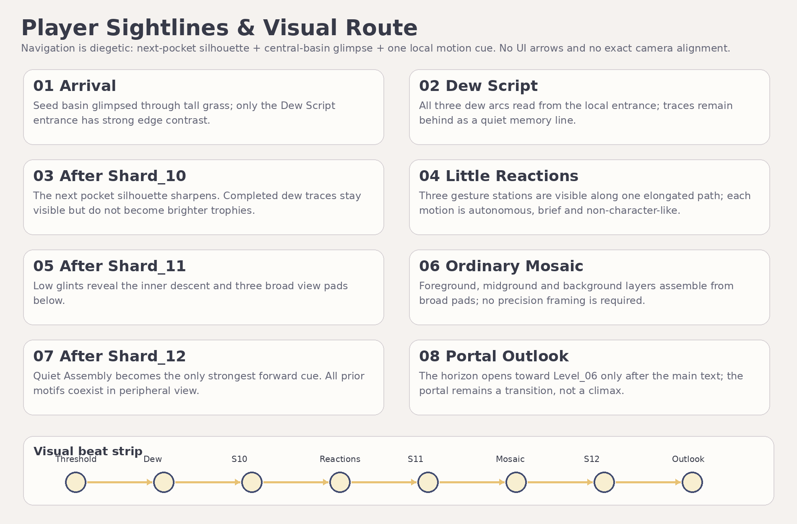
Figure 3. Player sightlines and visual route. Diagram = navigation-intent authority.

5. Puzzle visual concepts
The three mechanics use distinct visual verbs and feedback. They share broad triggers, persistent completion and non-punitive hints, but they must not collapse into three versions of the same collectible walk.

5.1 Dew Script — locked visual form
Aspect | Visual solution
Readable rule | Three large dew arcs stand directly on a broad curved path and are visible from the local entrance.
Feedback | Each arc leaves one persistent curved trace on a large leaf/stone surface. The trace is abstract and never resembles letters, handwriting or a hidden code.
Guidance | The first arc sits on the mandatory route; after prolonged inactivity an unvisited arc receives a slow rising glint.
Safety | No reset, wrong order, timer, audio dependency, thin beam, exact alignment or pixel-sized target.
Narrative fit | One clear trace supports the memory of “понимяу” without turning the puzzle into word collection.

5.2 Little Reactions — locked primary form
Aspect | Visual solution
Readable rule | Three gesture stations occupy one elongated pocket path and are visible from entry or one natural camera turn.
Gesture set | Seed turn, pollen puff and folding glow. Each is brief, autonomous and plant-like rather than character-like.
Feedback | The first visit records one persistent small route mark; completed stations keep only minimal background motion.
Guidance | Nearest unvisited station receives a low vertical mote cue after inactivity.
Safety | No chase, timing, waiting for a random event, facial features, eyes, wings, mascot behavior or required sound.
Narrative fit | The environment prepares the idea of a brief smile but never depicts Alena or implies that the player caused the reaction.

5.3 Ordinary Mosaic — locked visual form
Aspect | Visual solution
Readable rule | Three broad view pads are visible from the terrace entrance and may be visited in any local order.
Feedback | Each pad adds one persistent layer to one shared field: matte stone, grass motion, warm mote path.
Camera rule | No exact facing angle, composition score, screenshot or lens mechanic. Presence is enough.
Guidance | An unvisited pad receives an edge outline and restrained path motes after inactivity.
Safety | No hidden objects, rare treasure, collectible icons, proof-of-attention quiz or surveillance framing.
Narrative fit | Ordinary layers support the value of sincerity without presenting it as evidence of Alena’s feelings.

5.4 Quiet Assembly
Quiet Assembly is strictly non-interactive. After the Shard_12 reward, the player walks through a short composition where dew traces, restrained gestures and mosaic layers coexist. Missing optional presentation callbacks may never block main text or portal activation in later technical design.

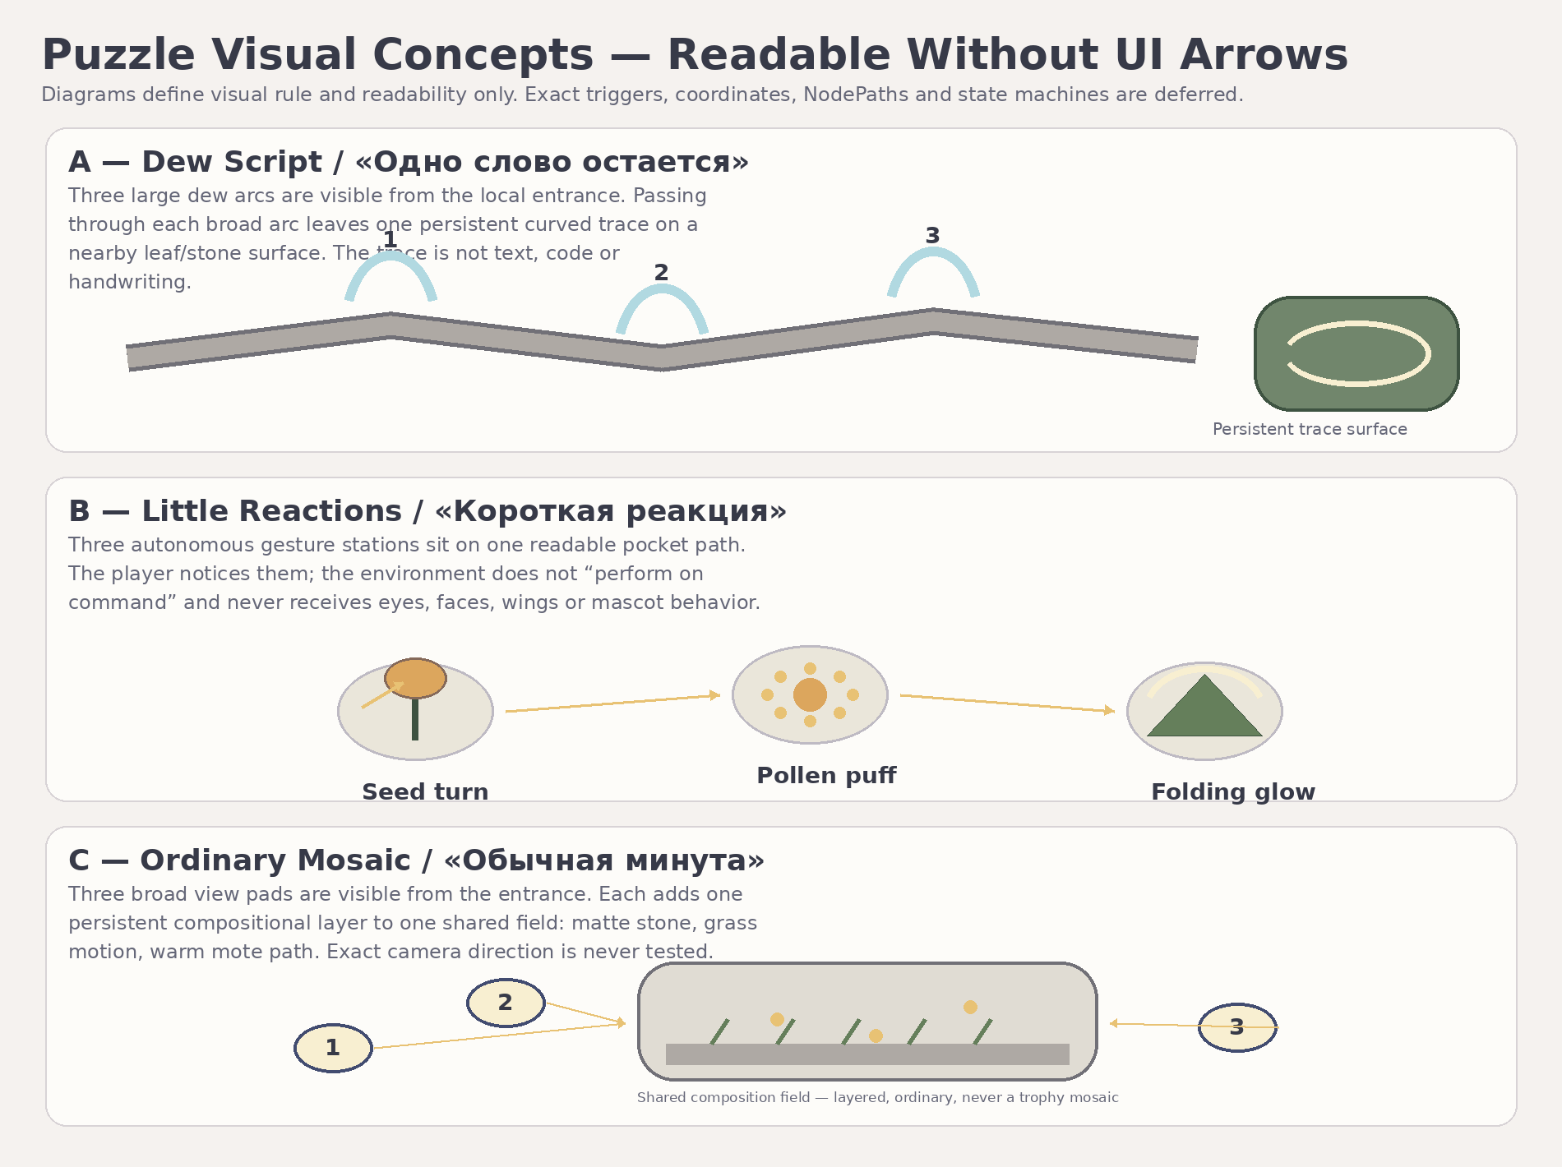
Figure 4. Puzzle visual concepts. Diagrams define readability intent, not runtime implementation.

6. Environment state boards
State changes increase local clarity and preserve completed traces. They do not raise the “value” of the garden, transform it from dead to alive or imply that collecting details gives the author ownership of them.
State | Locked visual behavior | Emotional reading
E0 Initial | Visible natural color at approximately 75–85% of final richness. Dew glints, seed movement and mosaic layers exist faintly from the beginning. | The world is already alive; attention is invited, not demanded.
E1 After Shard_10 | Dew traces persist. Only the next-pocket silhouette and route edge gain slightly clearer glints. | A remembered word becomes legible without global reward escalation.
E2 After Shard_11 | Gesture stations retain minimal background motion. Inner descent and view pads gain low readable glints. | A brief reaction remains in memory without becoming a repeated performance.
E3 After Shard_12 / Synthesis | All three motif families coexist. Quiet Assembly becomes primary; portal remains inactive. | Three details become one understanding of deeper feeling.
E4 After Main Text / Exit | Portal activates calmly; the horizon toward Level_06 opens modestly. Garden state remains stable. | Continuation, not climax. Admiration remains reserved for Level_06.

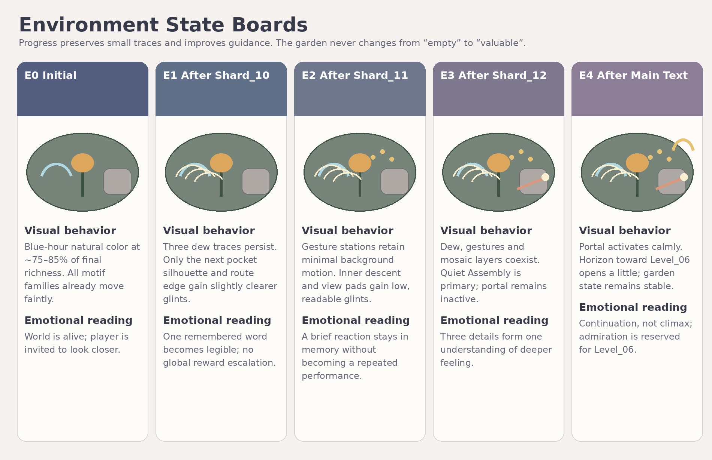
Figure 5. Environment state boards. State language is visual intent; exact timings remain deferred.

7. Palette, materials, fog, light, motion and focal-point rules

7.1 Palette direction
- Blue-hour indigo and cloud blue form the global frame; the level stays luminous and readable, never horror-dark or melancholy-black.
- Velvet moss, wet matte stone and dry seed amber provide the natural base.
- Dew ivory and restrained rose are local accents only. Warm glints never wash the whole level into gold.

7.2 Material direction
Material family | Direction
M_L05_Stone_Matte | Low-contrast stone with selective damp darkening; no visual or gameplay implication of slippery surfaces.
M_L05_Moss_Velvet | Broad readable clumps and soft roughness; avoid noisy micro-detail that competes with path readability.
M_L05_Seed_Dry | Warm dry seed pods and stems with restrained roughness; no toy-plastic or candy appearance.
M_L05_Dew_Translucent | Small controlled translucent highlights; no mandatory full-scene refraction or glass-heavy assets.
M_L05_Mote_Emissive | Sparse ivory/amber motes with conservative bloom and clear separation from shard/portal light.
M_L05_Background_Matte | Low-detail cool hill/sky silhouettes that support depth without becoming a grand vista.

7.3 Fog, lighting and natural motion
- Use light atmospheric haze only. Mandatory route and next-pocket silhouette remain readable at all times.
- Use broad cool sky fill plus restrained warm local glints. No sacred beams, spotlight worship framing or Level_02 light-channel semantics.
- Natural motion stays small: grass sway, seed turn, dew glint, pollen/mote drift. Simulation-heavy vegetation is optional/cut.
- Bloom is capped so dew, Soul Shards and portal remain distinct.

7.4 Focal-point hierarchy
- Primary navigation: next pocket silhouette.
- Secondary orientation: partial central seed-basin glimpse.
- Local interaction: one broad glint/motion cue.
- Reward moment: shard and exact text, not a monumental prop composition.

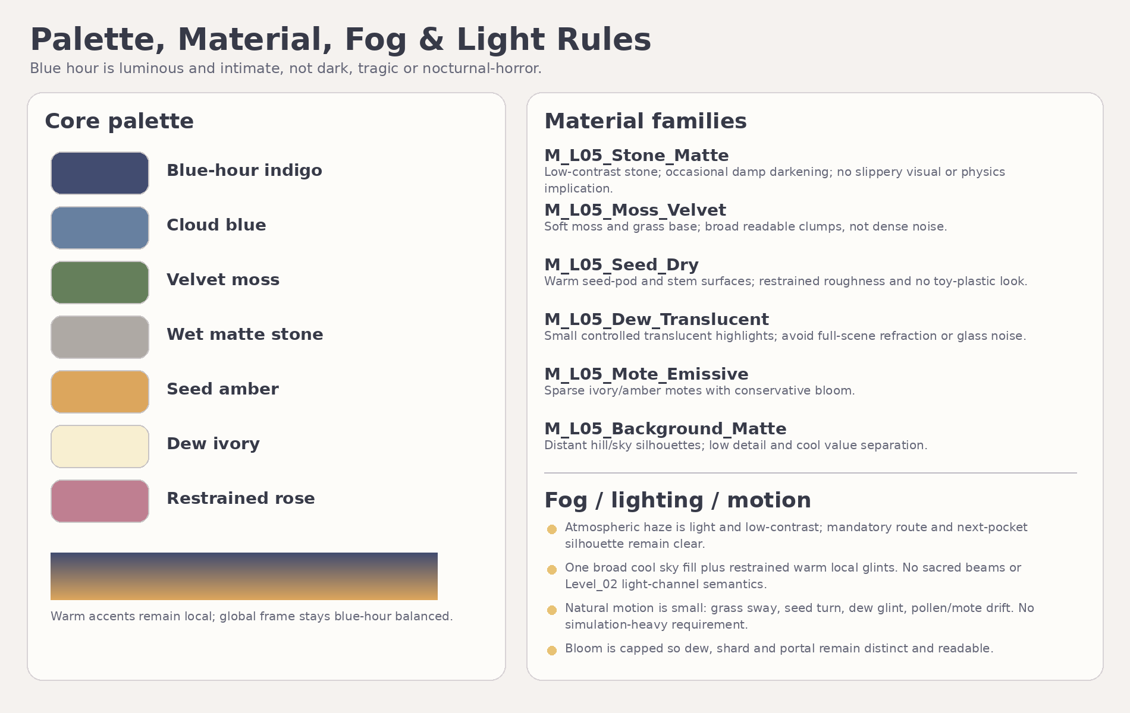
Figure 6. Palette, material, fog and light rules. Final shader implementation is deferred.

8. Perspective and composition boards
The following stylized boards are mood/composition references. They establish atmosphere, scale, depth and route framing only. Text and diagrams remain authoritative for gameplay layout, proportions and production scope.

Figure 7A. Outer Threshold → Dew Script: close scale, readable large details and one continuous inward route. Mood reference only.

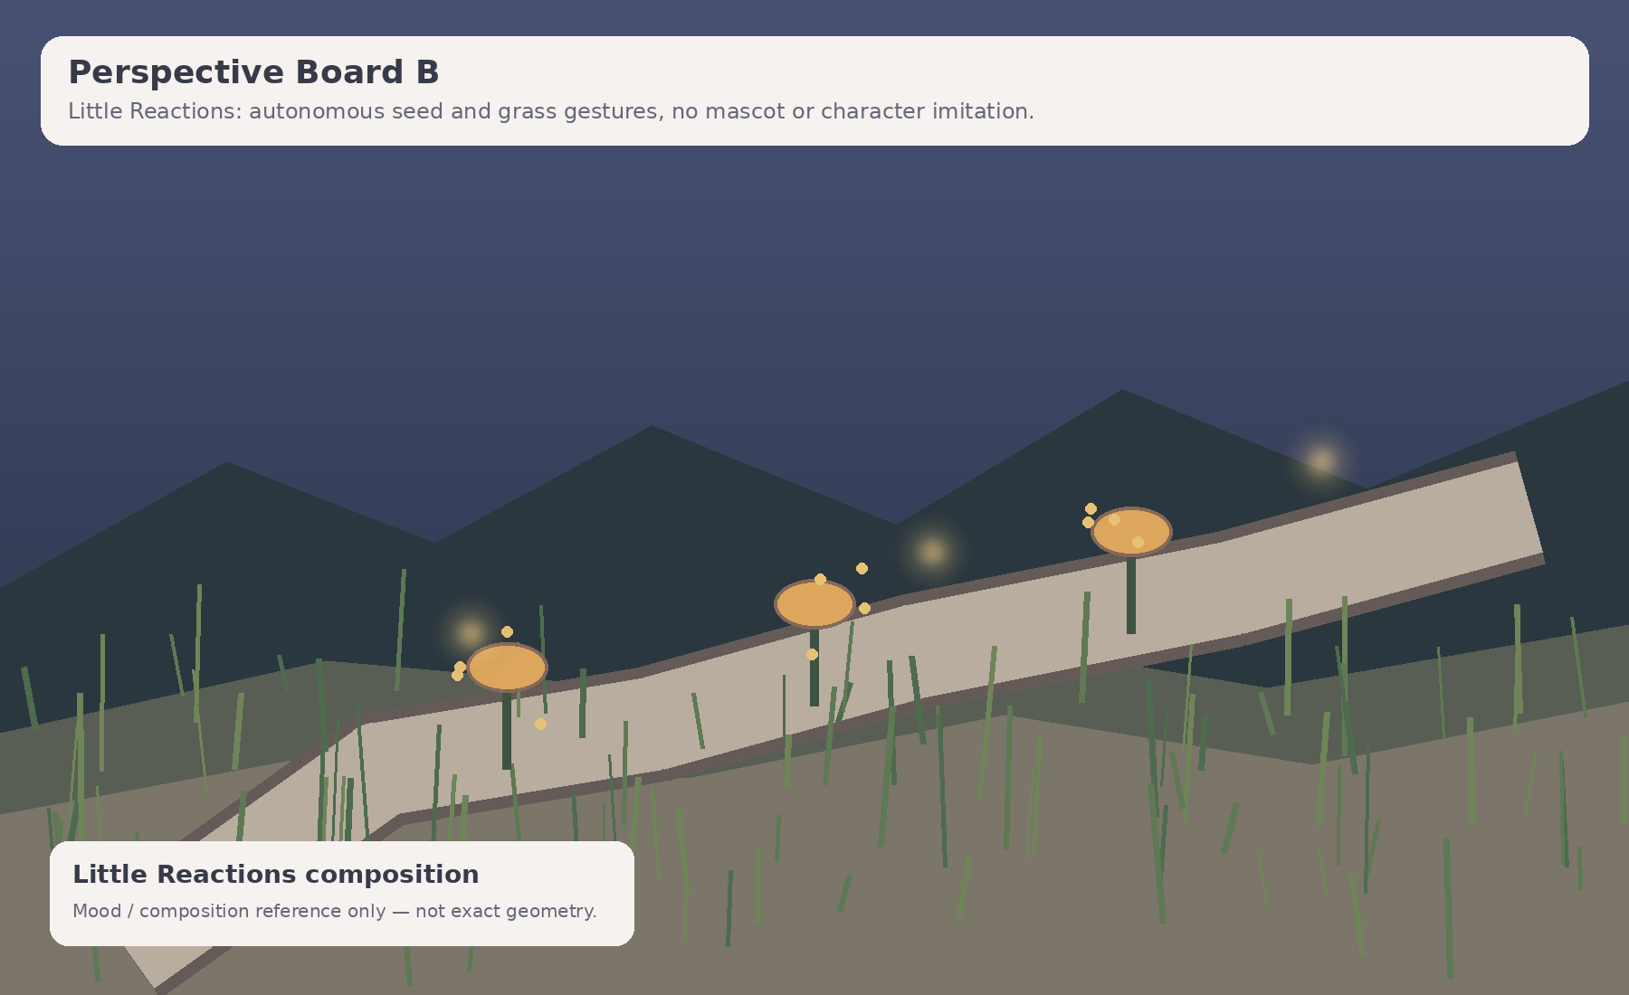
Figure 7B. Little Reactions: autonomous seed/grass gestures with no mascot or character imitation. Mood reference only.

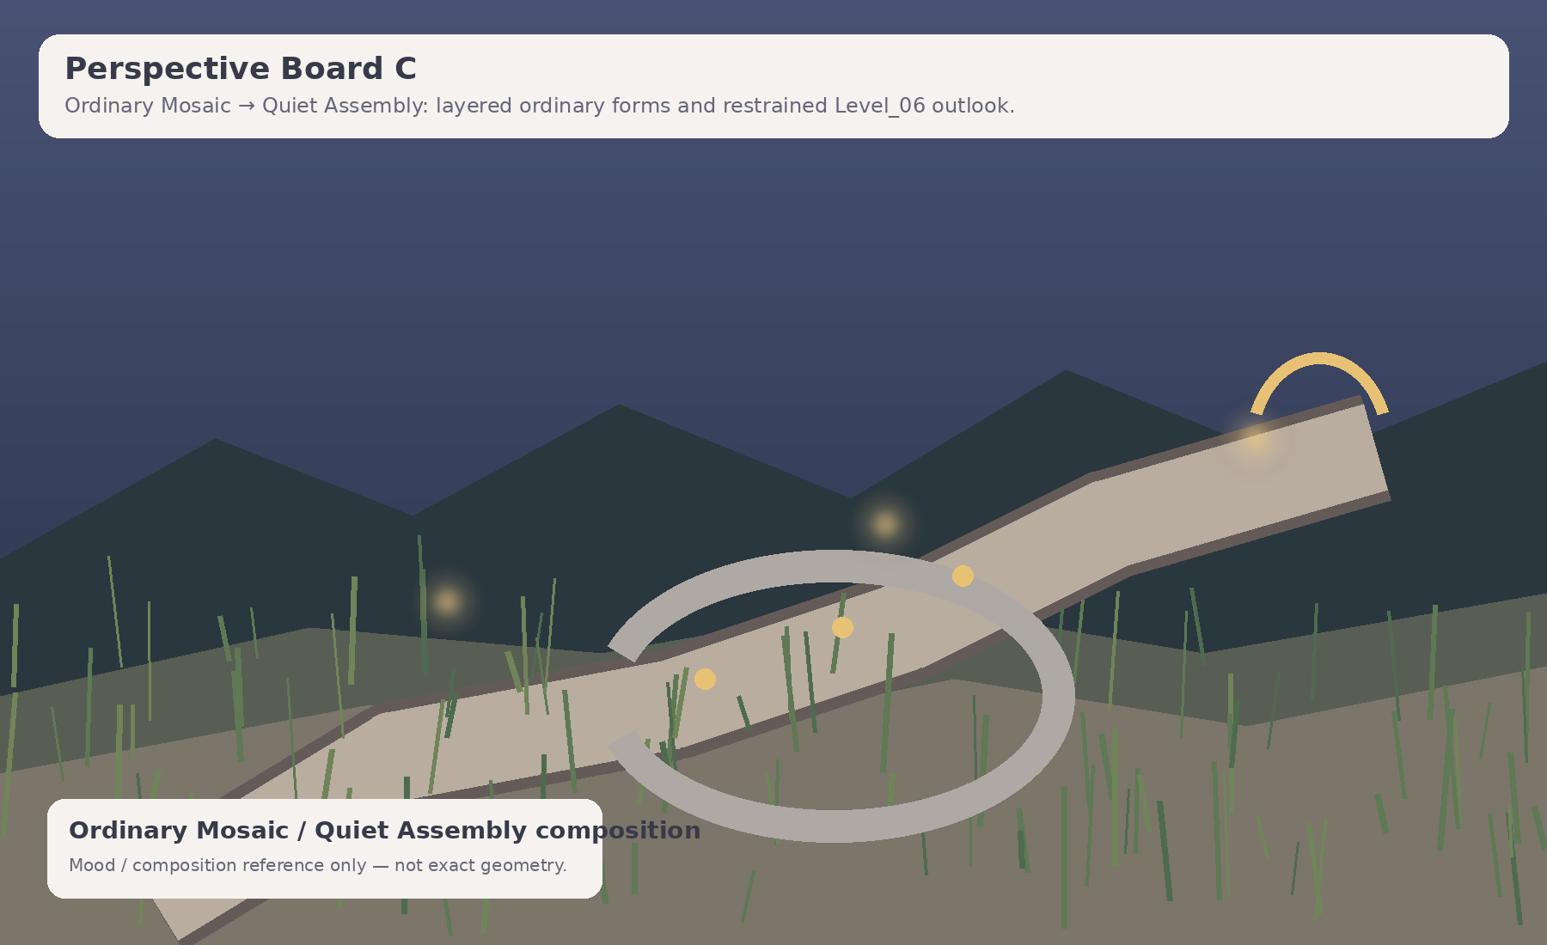
Figure 7C. Ordinary Mosaic → Quiet Assembly: layered ordinary forms and a restrained Level_06 outlook. Mood reference only.

9. Hero asset budget and modular kit proposal

9.1 Asset-family budget
The recommended budget is exactly three later modular families. Central Seed Basin, shard rest places, Ordinary Mosaic field and Portal Outlook are compositions built from these kits, not separate hero families.
Family | Scope | Budget / rule
Terrace / Stone–Moss Kit | Straight and curved terrace floor, shallow ramp, transition cap, edge, retaining stone, moss seam and dry rest ledge. | Medium modules ~1.5–8k triangles. Shared 1K texture families; selective 2K only for large repeated surfaces.
Grass / Seed Microflora Kit | Tall grass clusters, seed heads, dry pods, stems, low shrubs and restrained autonomous gesture variants. | Small props ~0.2–3k triangles. Atlas/shared materials; collision only if a major approved blocker requires it.
Dew / Glow Surface Kit | Dew arcs, trace surfaces, sparse motes, glint strips and small translucent accents. | Mostly low-poly planes/curves or later Godot VFX. Conservative transparency, overdraw and bloom.

9.2 Focal compositions — not new families
- Central Seed Basin: assembled orientation composition; not a hub and not a unique hero family.
- Three shard rest places: quiet arrangements of shared terrace and microflora modules; no pedestal family.
- Ordinary Mosaic field: layered placement of shared stone, grass and mote elements; no bespoke memory monument.
- Portal Outlook: later shared LevelPortal integration within a terrace/outlook composition; no monumental gate family.

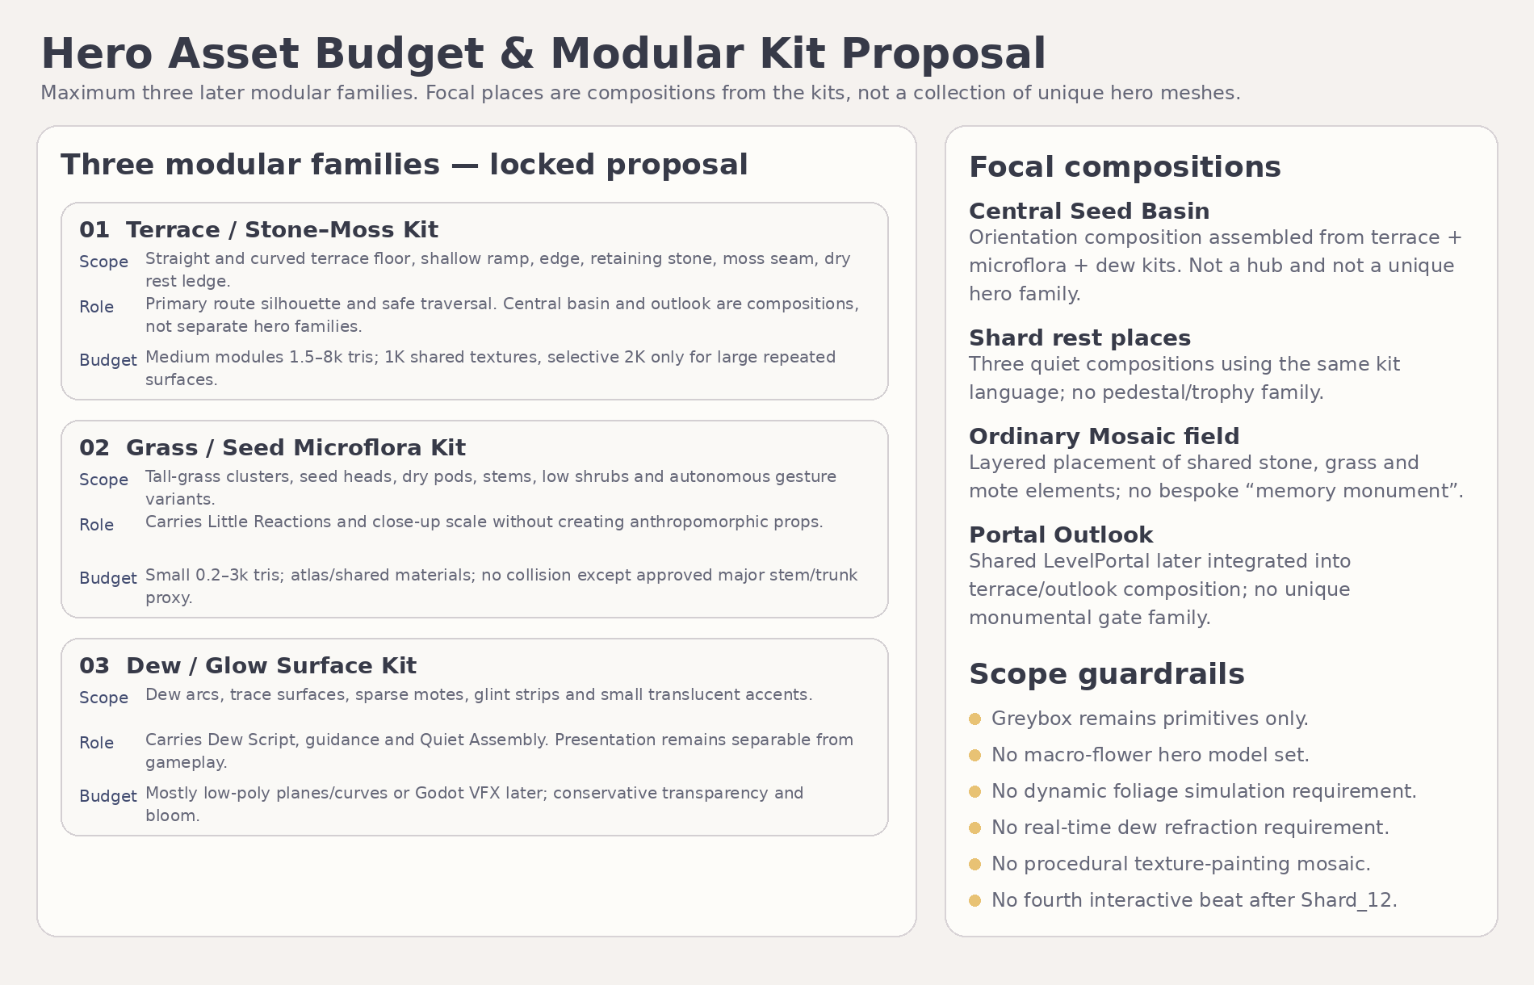
Figure 8. Three-family modular budget and focal-composition guardrails.

9.3 Scope guardrails
- Greybox requires primitives only.
- No macro-flower hero set, foliage simulation, real-time dew refraction or procedural texture-painting mosaic.
- No fourth interaction after Shard_12.
- Silhouette, route readability and broad interaction scale outrank surface-detail density.

10. Forbidden visual directions
Forbidden direction | Reason / correction
Museum, archive, display cases or memory gallery | Would turn personal details into collected evidence or trophies. Keep all traces integrated into the living garden.
Surveillance, camera lens, recording interface, diary/log wall | The camera-smile memory must never become observation or monitoring imagery.
Hidden-object or pixel-hunting composition | Mandatory details are broad, locally visible and hinted non-punitively.
Literal letters, words or secret code in Dew Script | Dew traces remain abstract curves; the exact word appears only in player-facing text.
Anthropomorphic plants or reaction mascots | Little Reactions are autonomous environmental motions, not representations of Alena.
Toy-box, candy garden or excessive hearts | The tone is warm and magical but adult, restrained and emotionally specific.
Grand “perfect portrait” or final ideal image | Level_05 recognizes three memories; it does not claim total knowledge or assemble an idealized person.
Shrine, altar, throne or confession stage at the portal | Portal Outlook is a transition to Level_06, not the emotional climax of the game.
Rainlit terraces, ripple shoreline or braided branch reprise | These belong to Level_04 and must not be copied.
Wind arches, spark chase or breathing meadow reprise | These belong to Level_03 and must not be copied.
Central light arena or optical mechanism | These belong to Level_02 and conflict with the close-up natural micro-world.

11. Producer approval table — locks required before Gameplay Design
Item | Current proposal | Required state
Title and exact copy | «То, что остается»; exact Shard_10/11/12 and main text from Narrative Package v1.1. | ALREADY LOCKED — preserve character-for-character
Macro route | One continuous inward spiral; Dew Script → Shard_10 → Little Reactions → Shard_11 → Ordinary Mosaic → Shard_12 → Quiet Assembly → Main Text → Level_06 portal. | LOCK visual topology
Whole-level visual envelope | Approx. 82–94 m wide × 92–108 m long; estimated visual centerline 155–180 m. | LOCK as visual-planning range only
Central Seed Basin | Persistent orientation landmark, inaccessible as early hub/shortcut; later part of Quiet Assembly composition. | LOCK role and reading
Dew Script visual rule | Three large arcs, abstract persistent traces, no literal text/code. | LOCK
Little Reactions visual rule | Seed turn + pollen puff + folding glow; autonomous, non-anthropomorphic. Passing Gestures only as emergency fallback. | LOCK
Ordinary Mosaic visual rule | Three broad view pads add ordinary foreground/midground/background layers; no camera alignment. | LOCK
Environment progression | Local clarity and persistent traces only; garden alive from E0; portal inactive until main text closes. | LOCK
Palette / atmosphere | Luminous blue hour, cool global frame, local amber/ivory glints, no rain and no dark-horror grading. | LOCK
Asset-family budget | Exactly three later modular families; focal places are compositions, not extra hero families. | LOCK
Deferred items | Exact coordinates/dimensions, trigger volumes, collision, camera QA coordinates, VFX timings, final silhouettes and shader implementation. | DEFER to Gameplay / Technical / Art Production stages

12. Final visual-development verdict and handoff
ART-DIRECTION VERDICT
Level_05 has a coherent, differentiated and MVP-safe visual identity: a luminous blue-hour close-up garden, one continuous inward spiral and three distinct detail-reading beats. The concept continues Level_04’s handoff about small things remaining in memory without copying its rainlit terrace language, and it prepares Level_06 without stealing its admiration payoff.

12.1 What passes to Producer
- Approve the visual thesis, spiral topology, central-basin role, puzzle visual rules, environment states, palette and three-family modular budget.
- Confirm that Little Reactions remains the primary visual form and Passing Gestures remains emergency fallback only.

12.2 What passes to Gameplay Design
- Convert the approximate composition into exact coordinates, route widths, slopes, clearances, recovery rules and camera QA points without changing the sequential emotional order.
- Preserve broad triggers, visible local subtargets, persistent progress, no wrong order inside a pocket and no additional task in Quiet Assembly.

12.3 What passes to later Art / Blender planning
- Use exactly three modular families and build all focal places as compositions from them.
- Treat text and diagrams as authority; perspective boards are mood/composition reference only.
- Do not begin Blender production until Gameplay Design and Technical Architecture are approved.

12.4 Documentation completion statement
This package is the single Visual Master Concept deliverable for the current Level_05 stage. No Godot scenes/scripts, runtime assets, Blender files, GLBs, materials, branches, commits or pull requests were created or modified.

Appendix A. Canonical authority summary
Domain | Locked / deferred result
Narrative authority | Level_05_Narrative_and_Level_Scenario_Package_v1.1.docx.
Player-facing title | То, что остается.
Shard model | Exactly Shard_10, Shard_11 and Shard_12 in fixed narrative order.
Visual world | Close-up blue-hour garden / Сад близкого взгляда.
Route | One continuous inward spiral; no hub, branches, mandatory backtracking or shortcut to center.
Mechanics | Dew Script; Little Reactions; Ordinary Mosaic; Quiet Assembly non-interactive.
Portal target | Level_06 direction retained; exact runtime implementation deferred.
Authority split | Text and diagrams authoritative; stylized/AI mood boards non-authoritative.

