FIFTEEN SHARDS OF LIGHT

Level_06 — «Ты восхищаешь меня»

ART PRODUCTION BIBLE — VERSION 1.1
  - Environment production design • Blender technical art • Godot art integration
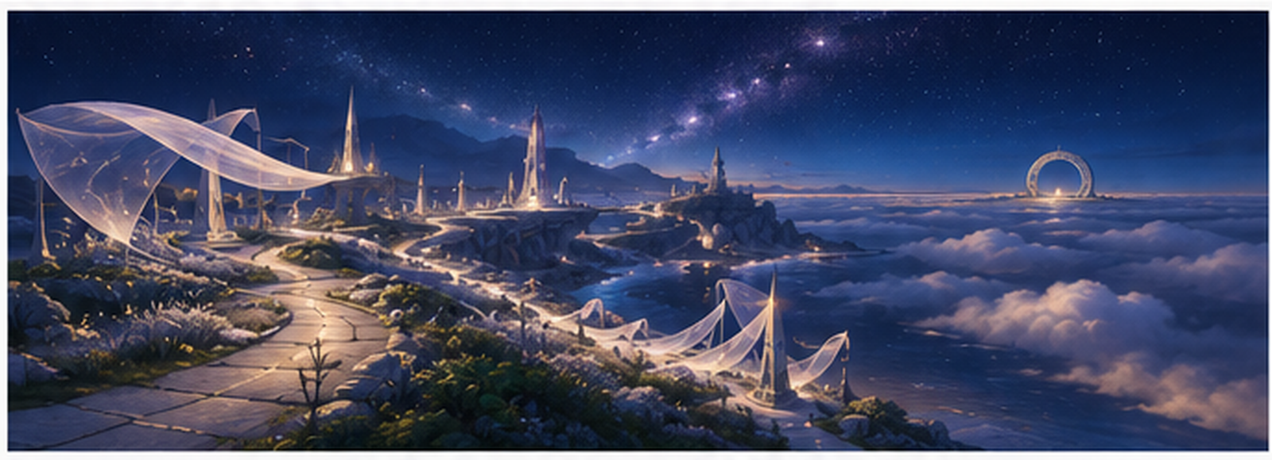
Cover mood/composition reference from the approved Visual Master Concept. Non-authoritative for exact geometry and runtime topology.
Control | Value
Repository | MindDevastation/fifteen-shards-of-light
Target scene | res://scenes/levels/Level_06.tscn
Document status | VERSION 1.1 ART-PRODUCTION DESIGN CANDIDATE — repeat Producer review required
Mode | Documentation only — no Blender, GLB, texture, material, wrapper or runtime creation
Audited source snapshot | Fresh Art Bible Gate preflight, 28 June 2026: default branch main confirmed; 0 open PRs verified; approved source snapshot SHA 56410298d9a2f4783e9512a84653b03e73ee3e50. Re-resolve head SHA before ART-A01.
Engine baseline | Godot 4.6 / Forward Plus / Jolt Physics / GDScript
Primary inputs | Narrative v1.1; Visual Master; Gameplay Spec v1.3; Technical Architecture v1.2.2

EMOTIONAL SAFETY CONTRACT
Героиня не сломана, и ее никто не чинит. Ее свет, красота, живость и способность увлекаться уже принадлежат ей. Art production может визуализировать ясность реакции автора, но не восстановление ценности, право на доступ, ответ, благодарность или взаимность. Мир жив уже в E0.

0. Document control, source hierarchy and scope

0.1 Approved source hierarchy
Priority | Approved source | Controls for this Art Production Bible
1 | Level_06 Narrative and Level Scenario Package v1.1 | Title, exact copy, three-shard order, emotional meaning, FinalScene boundary and forbidden readings.
2 | Level_06 Visual Master Concept Package | High silver meadow identity, ascending crescent, three modular families, visual hierarchy and E0–E4 intent.
3 | Level_06 Gameplay Map and Complete Level Design Specification v1.3 | Exact P00–P30 coordinates, zone footprints, corridor dimensions, puzzle volumes, recovery geometry, pacing and acceptance.
4 | Level_06 Technical Architecture and State Model v1.2.2 | Node ownership, exact gameplay anchors, root/subscene boundaries, generation and recovery/portal authority.
5 | Current repository main | Factual placeholder and shared API constraints only; placeholder is not art canon.

0.2 Version 1.1 Change Log
Correction | Version 1.1 result
Axis contract | Separated Godot camera/look forward (-Z) from canonical asset model front (+Z); Blender model front remains -Y; placement wrappers own route/panel orientation.
Boundary / recovery | Restored the exact 6.00 + 1.50 + 1.50 m corridor cross-section, 0.75 × 0.55 m jumpable lip, dangerous B0–B5 crossing freedom, Q0–Q5 coverage and RA anchor classification.
Wrapper collision ownership | Removed collision children from art wrappers. Raw GLB and wrappers are visual-only; conditional `_COL.glb` is instanced by a separate LevelGeometry collision owner after ART-A08.
Registry deduplication | Removed L06_PortalApproach_Inlay_A and retained one canonical L06_LastLight_Guidance_Inlay_A.
Three-family / MVP audit | Reduced the canonical art registry from 46 to 30 assets; removed six ramp variants and multiple one-off platform/secondary variants; added family, criticality, reuse and justification fields plus a Minimum Viable Art Set.
Portal ownership | Selected PortalAccent option A: Level_06 uses shared LevelPortal.activate() only; no M_L06_Portal_Accent or local portal visual controller.
Replacement acceptance | Added exact greybox-to-visual mapping, pre/post dangerous-B tests and independent visual/collision rollback proofs.
Document control / QA | Updated Version 1.1 status, fresh gate preflight, footers, figures, comments/tracked-change cleanup and full render QA requirements.

0.3 Scope boundary
- Defines Boundary Map, layer split, complete art asset registry, dimensions, origins, variants, material/VFX families, collision policy, wrapper-first workflow, priorities, acceptance gates and post-greybox integration slices.
- Does not modify Level_06.tscn, shared scenes/scripts, project.godot, FinalScene, branch history or runtime code.
- Does not create .blend, .glb, textures, final materials, Godot wrappers, VFX scenes or greybox implementation.
- Exact gameplay coordinates, IDs, Areas, anchors, pivots, NodePaths, portal/recovery ownership and state machines remain controlled by Gameplay/Technical sources.

0.4 Art production verdict
ART PRODUCTION VERDICT
The approved Level_06 design is producible with exactly three modular art families. The safe approach is primitive-only GB-P0, then wrapper-first visual replacement while accepted collision remains intact. Collision-proxy replacement is a separate conditional gate. Focal locations are compositions, not additional hero families.

0.5 Fresh Art Bible Gate preflight
Object | Fresh preflight result | Art consequence
Repository/default branch | MindDevastation/fifteen-shards-of-light; default branch `main` confirmed by fresh connector preflight. | Production source remains current main; no branch or repository write is authorized.
Open pull requests | 0 open PRs verified on 28 June 2026. | No active shared-contract diff competes with this revision.
Approved source SHA | 56410298d9a2f4783e9512a84653b03e73ee3e50 from Technical Architecture v1.2.2. | Use as this document’s compatibility baseline; re-resolve exact head SHA before ART-A01 or any runtime work.
Level_06.tscn | Flat 12×12 one-shard legacy placeholder, portal to Level_07. | Not art canon; later implementation must use approved Level_06 contracts.
Shared LevelPortal / SoulOrb | Existing shared owners remain authoritative. | No private child/material access, no second portal, no Level_06 orb asset.
Drift stop rule | Any change to Player, camera, shard/reward UI, SoulOrb, LevelPortal, FinalScene or Level_06 source contracts pauses production. | Reconcile the Bible before Blender or runtime integration.

0.6 Document map
Section | Purpose
1 | Production principles
2 | Boundary Map
3 | Layer split / ownership
4 | Coordinate, naming and export contract
5 | Complete asset registry
6 | Budgets and material/VFX families
7 | Production sheets
8 | Collision matrix
9 | Pivot/origin contracts
10 | Wrapper workflow
11 | Immediate greybox handoff
12 | Post-greybox slices
13 | Priority
14 | Export checklist
15 | Acceptance gates
16 | Risks
17 | Handoff

1. Locked production principles
- One continuous ascending crescent. No hub, branch network, inward spiral, tower, teleport, closing gate or hidden route mutation.
- Exactly three later modular families: Grass Ridge / Silver Wake Kit; Veil / Open Frame Kit; Stone Shelf / Light Amphitheater Kit.
- Focal spaces — three shard shelves, Quiet Horizon and portal approach — are kit compositions, not new hero families.
- World motion exists from E0. VFX clarifies progression; it does not create life, beauty or wholeness.
- GameplayRoot owns all authoritative IDs, triggers, Areas, pivots, markers, shard anchors, FinalTextGate, PortalFloorAnchor, LevelPortal and recovery nodes.
- Raw GLB and art wrappers never own gameplay state and never expose imported child names as gameplay contracts.
- Hard physical boundaries are separate from visible rims. Recovery/service volumes are separate from both.
- No invisible catch floor, no geometry bridging gaps, no hidden playable space below visible route.
- Positive scale only. Any true mirror/handed geometry is applied in Blender and exported as a separate explicit asset.
- Portal accent option A is locked: Level_06 uses shared LevelPortal.activate() and does not create a local portal material/controller or access shared portal private children.
- Raw GLB and environment wrappers are always visual-only. Conditional collision assets, if approved, are separate LevelGeometry-owned instances and separate commits.
- Art registry production scope is classified as MANDATORY MVP / OPTIONAL / CUT-FIRST and audited against exactly three approved modular families.
- GB-P0 is primitives only. All final geometry, final materials, wrappers and polished VFX are deferred until greybox acceptance.

2. Boundary Map
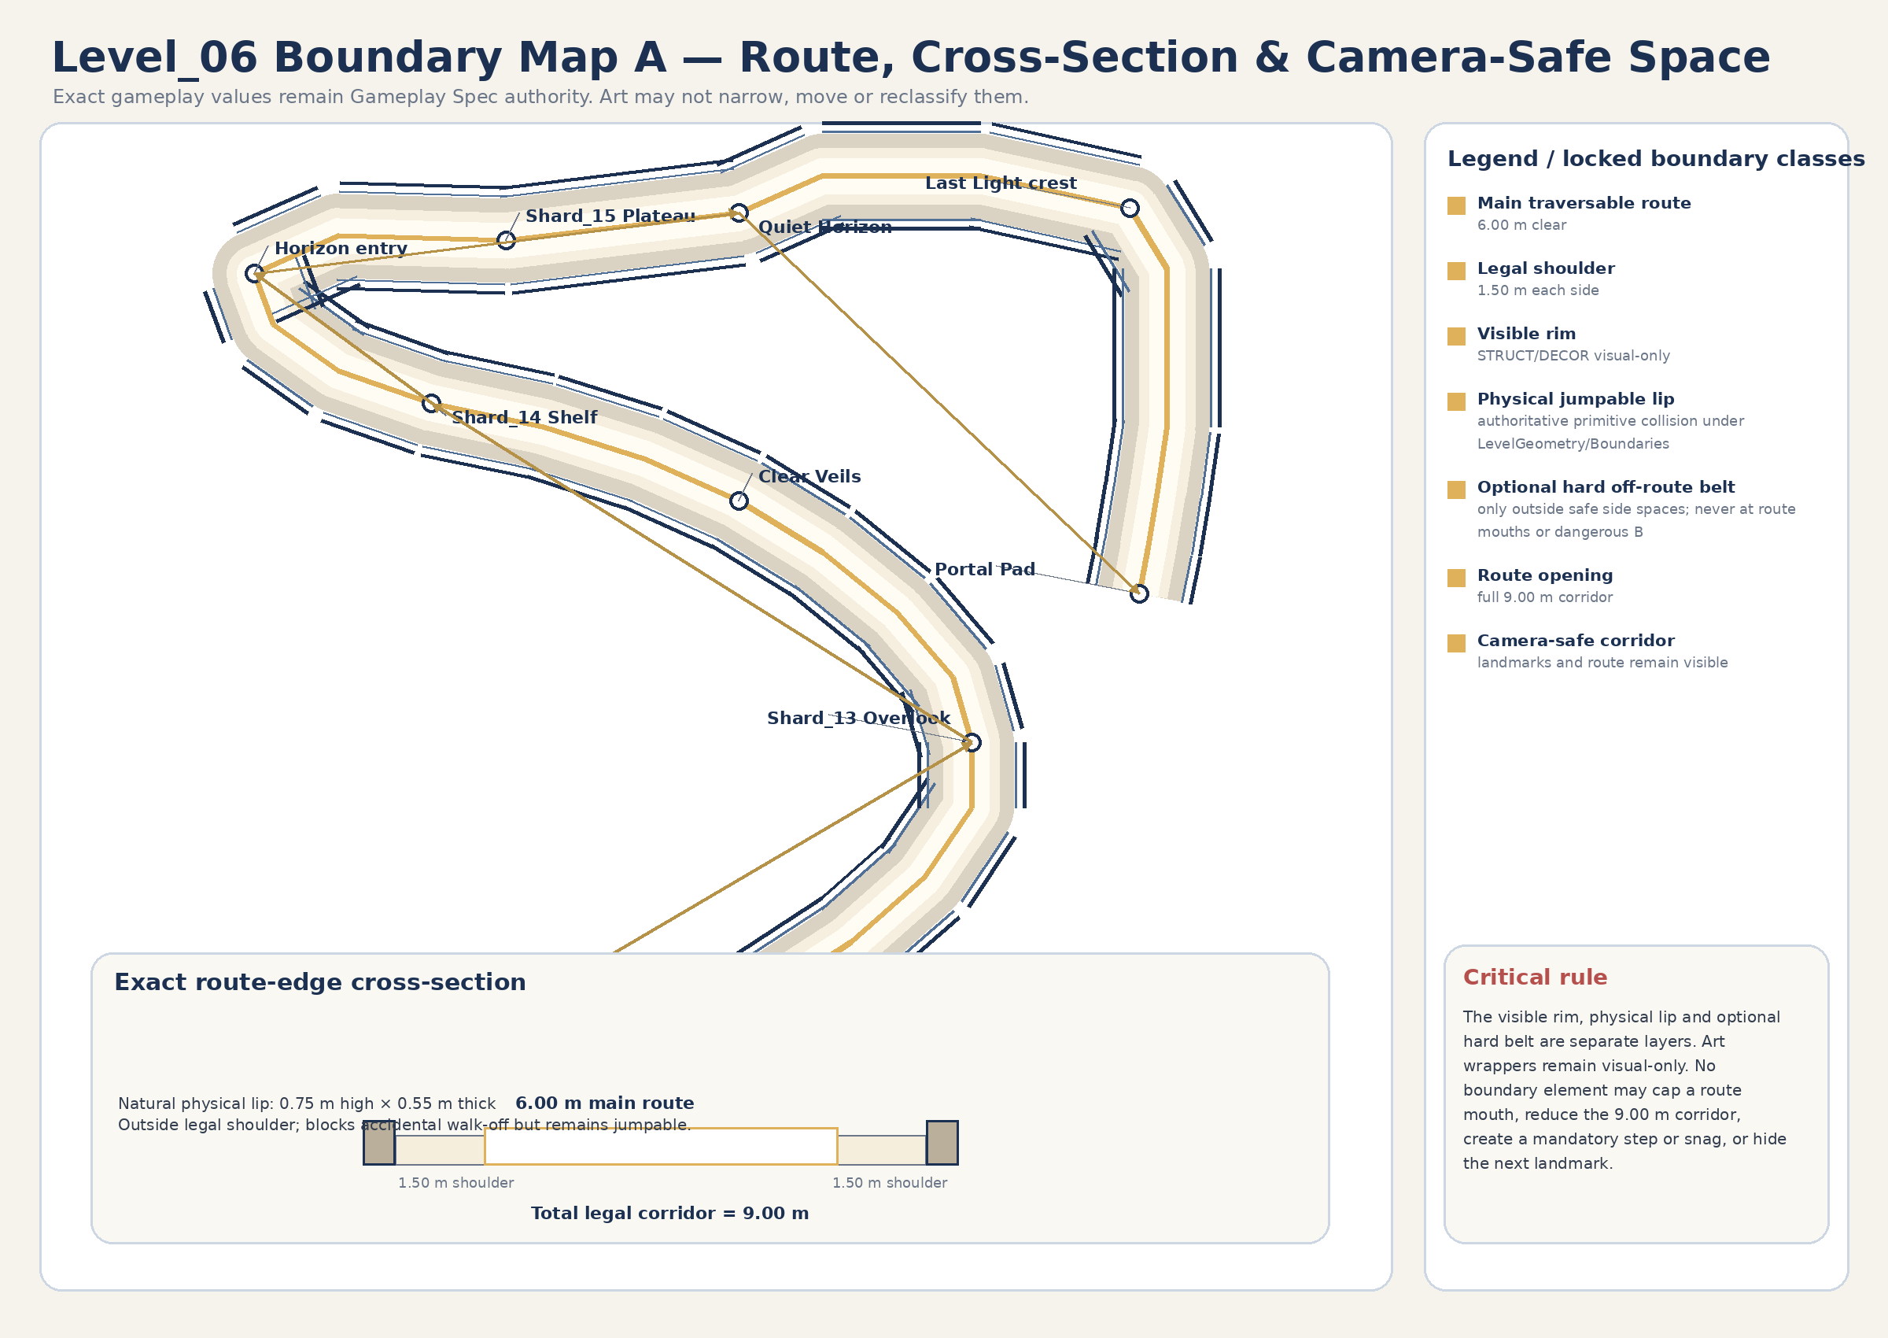
Figure 1A. Exact route/playable/boundary/camera map. Text and map geometry are art-production authority; exact P00–P30 values remain Gameplay Spec authority.
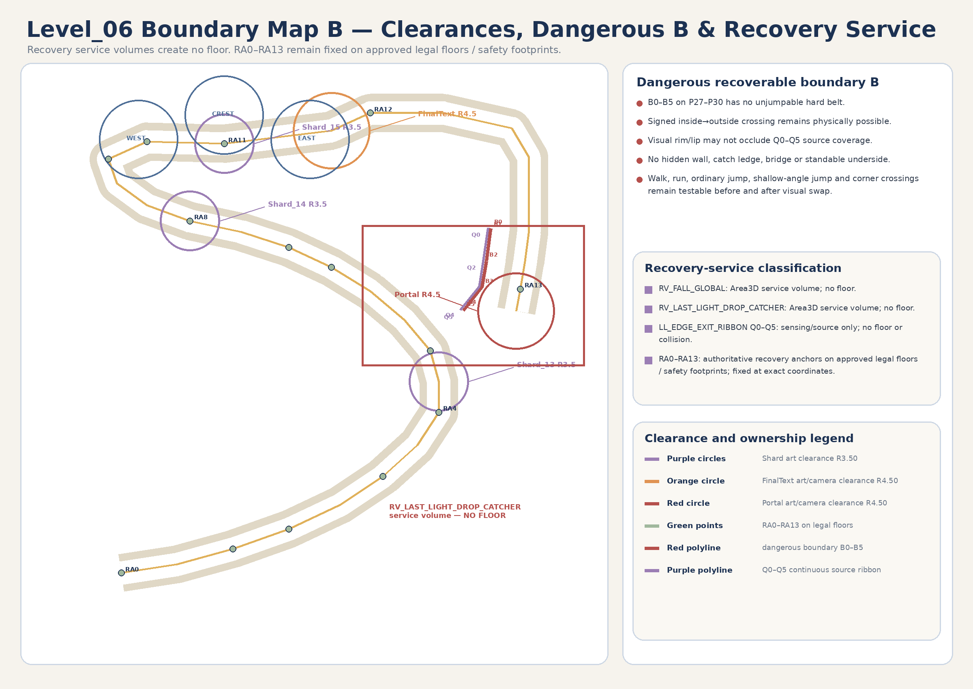
Figure 1B. Gameplay clearances, recovery/service geometry and portal map. Art must not move or occlude authoritative gameplay nodes.

2.1 Boundary classes
Boundary class | Exact contract | Owner | Art-production rule
Playable surface | P00–P30 and Z00–Z11 approved floors; mandatory playable collision inside X −30..+30 / Z −58..+58. | WorldRoot/LevelGeometry | Visual replacement conforms to accepted blocks; collision and exact transforms remain unchanged.
Main traversable route | 6.00 m clear width. | WorldRoot/LevelGeometry | No visual, collision, grass or VFX reduces it.
Legal shoulders | 1.50 m each side; total legal corridor 9.00 m. | WorldRoot/LevelGeometry | Legal, walkable support; no blockers or dense snagging decor.
Visible rim | Natural stone/grass edge explaining the boundary. | STRUCT / DECOR visual wrappers | Visual-only; may stop at route openings; never owns collision.
Exact physical jumpable lip | Outside each legal shoulder: natural lip 0.75 m high × 0.55 m thick. Prevents accidental exit but remains crossable by deliberate ordinary jump. | WorldRoot/LevelGeometry/Boundaries primitive StaticBody3D or approved block-local collision root | Separate from visible rim and wrappers. Seams create no mandatory step, gap or snag.
Optional hard off-route belt | Additional off-route blocker may exist only beyond the physical lip where approved and outside legal side spaces. | WorldRoot/LevelGeometry/Boundaries | Never crosses route openings, camera corridors, legal shoulders, recovery exclusions or dangerous B0–B5.
Route openings | Full 9.00 m legal corridor at every zone/route mouth. | WorldRoot/LevelGeometry/Boundaries | Visible rim, lip and optional belt terminate cleanly; no route cap.
Dangerous recoverable boundary B | B0–B5 along P27–P30 remains physically crossable. Signed inside→outside crossing must remain possible. | WorldRoot/LevelGeometry + GameplayRoot/RecoveryRoot sensing | Unjumpable belt forbidden; no hidden wall, catch ledge, bridge or standable underside; Q0–Q5 coverage unobstructed.
Camera-safe area | Legal corridor plus approved sightlines from P00/P08/P15/P18/P21 and Last Light. | Art composition; gameplay-camera QA | No opaque foreground wall, grass curtain or VFX hides the next landmark.
Wake/Veil puzzle clearance | Exact 9.20 m across × 6.00 m along footprints with authored floor under 100%. | GameplayRoot/PuzzleRoot + WorldRoot/LevelGeometry | No blocking art/collision or opaque VFX.
Constellation clearance | Gameplay R4.60 each; continuous support to R5.00. | GameplayRoot/PuzzleRoot + Z07 floor | No raised lip, hole, dense prop or collision in target footprints.
Shard clearance | Art/camera R3.50 around Shard_13/14/15 roots. | GameplayRoot/ShardRoot | One L06_Shard_Surround_A reused x3; visual-only.
Main-text clearance | Art/camera R4.50 around FinalTextGate. | GameplayRoot/FinaleRoot | No altar, monument or blocking frame.
Portal clearance | Art/camera R4.50 around PortalFloorAnchor. | GameplayRoot/FinaleRoot / shared LevelPortal | No second portal, no local portal accent controller, no early dominant glow.
Recovery service volumes / ribbon | RV_FALL_GLOBAL, RV_LAST_LIGHT_DROP_CATCHER and LL_EDGE_EXIT_RIBBON Q0–Q5. | GameplayRoot/RecoveryRoot | No floor, collision, route, catch ledge or standable geometry.
Recovery anchors | RA0–RA13 exact markers on approved legal floors / safety footprints. | GameplayRoot/RecoveryRoot | 0.00 m movement. They are not service volumes and are not subject to the “no floor” classification.

2.2 Zone boundary schedule
Zone | Approved footprint | Centerline | Required openings / clearances | Safety relation
Z00 Lower Cloud Terrace | Ellipse 16×14 m; floor Y0.80 | P00–P01 | 9 m exit; 6 m main + 1.5 m shoulders; jumpable lip stops at mouth | RA0 on legal floor
Z01 Silver Wake corridor | Swept P01–P07; 9 m legal corridor | P01–P07 | Three 9.20×6.00 trigger footprints; full floor support | RA1–RA3 on legal floors
Z02 Shard_13 Overlook | Ellipse 12×11 m; floor Y3.45 | P08 | Shard R3.50; open back/forward sightlines | RA4 on legal floor
Z03 Ridge Rest | Swept P08–P11; 9 m corridor | P08–P11 | No puzzle; cross-section preserved | RA5 on legal floor
Z04 Clear Veils lane | Swept P11–P15; 9 m corridor | P11–P15 | Three 9.20×6.00 footprints; transparent route | RA6–RA8 on legal floors
Z05 Shard_14 Shelf | Ellipse 12×10 m; floor Y6.35 | P15 | Shard R3.50; upper zones visible | RA8 on legal floor
Z06 Open Sky Approach | Swept P15–P18; 9 m corridor | P15–P18 | All upper zones visible; no narrowing | RA9 on legal floor
Z07 Horizon Amphitheater | Exact offset hull; X−25..5, Z42.5..58 | P18–P20 | All R4.60 zones supported to R5.00 | RA9–RA11 on legal floor
Z08 Shard_15 Plateau | Ellipse 16×12 m; floor Y8.20 | P20 | Shard R3.50 | RA11 on legal floor
Z09 Quiet Horizon | Ellipse 18×14 m; floor Y8.60 | P21 | FinalText R4.50; portal dormant | RA12 valid after close on legal floor
Z10 Last Light Walk | Swept P21–P29; 9 m corridor; 65.17 m | P21–P29 | Exact lip except dangerous B0–B5; B remains jumpable; Q0–Q5 clear | RA12–RA13 on legal floor
Z11 Portal Pad | Rotated ellipse 12×10 m; floor Y11.00 | P30 | Portal R4.50; shared AUTO_ENTER owner | RA13 on approved portal approach floor

3. Layer split and node ownership
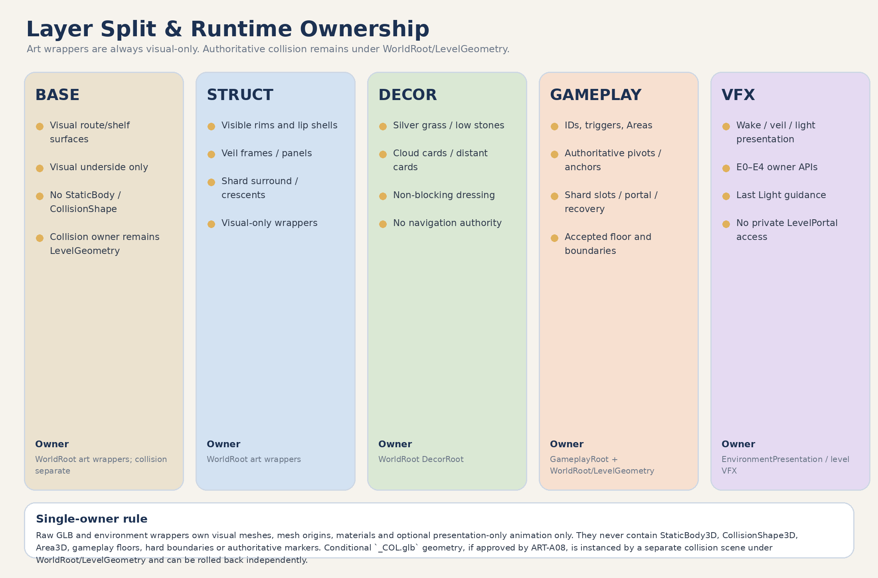
Figure 2. BASE / STRUCT / DECOR / GAMEPLAY / VFX split and single-owner rules.

3.1 Authoritative ownership matrix
Authority | Exact owner | Art contract
Route geometry / exact coordinates | Gameplay Spec + WorldRoot/LevelGeometry | 0.00 m movement; visual block maps to accepted greybox block/footprint.
Accepted floor / grounding / support | WorldRoot/LevelGeometry | Never moved into or replaced by an art wrapper during visual swap.
Physical jumpable lip / optional hard belt | WorldRoot/LevelGeometry/Boundaries or approved block-local StaticBody3D root | Primitive baseline; dangerous B0–B5 has no unjumpable hard belt.
Puzzle IDs / trigger footprints | GameplayRoot/PuzzleRoot | GLB/wrapper contains no Areas, IDs or target state.
Authoritative pivots / targets / markers | Gameplay scenes | Mesh origins documented; gameplay pivots remain parent-owned.
Shard slots / anchors | GameplayRoot/ShardRoot | Low visual surround only; exact roots unchanged.
FinalTextGate / PortalFloorAnchor / LevelPortal | GameplayRoot/FinaleRoot + shared LevelPortal | No duplicate portal or private-child/material access.
Recovery Areas / ribbon | GameplayRoot/RecoveryRoot | Service only; no floor or art collision.
Recovery anchors RA0–RA13 | GameplayRoot/RecoveryRoot | Fixed on legal floors/safety footprints; 0.00 m movement.
Environment E0–E4 state owner | WorldRoot/EnvironmentPresentation | Wrapper-level presentation API only.
Raw visual GLB | assets/environment/level_06/** | Visual mesh/material only; no collision or gameplay state.
Environment wrapper | scenes/environment/level_06/** | Sole visual instance owner; always visual-only.
Conditional collision scene | scenes/levels/level_06/geometry/collision/** under WorldRoot/LevelGeometry | Separate `_COL.glb` instance, separate gate/commit/rollback; never child of art wrapper.
Level-owned VFX scene | scenes/levels/level_06/vfx/** | Presentation only; controls wrapper API; no duplicate geometry.
SoulOrb_Follow | Shared existing scene under SoulOrbRoot | Reuse; no Level_06 orb asset/family.

4. Blender, GLB and Godot coordinate / transform contract

4.1 Coordinate and dimension-axis conventions
Domain | Locked convention
Godot camera/look forward | -Z. This is a camera/view convention only and must not be reused as the model-front definition.
Canonical asset model front in Godot | +Z. Every oriented art asset uses local +Z as its documented model front / panel normal / opening reference.
Canonical asset model front in Blender | -Y. Standard glTF/GLB conversion maps Blender model front -Y to Godot model front +Z.
Blender source axes / unit | +Z up; 1 Blender unit = 1 meter.
Standard conversion | Use standard glTF/GLB conversion. No manual axis bake or import-basis rewrite to imitate Godot.
Route travel / panel normal | Set by the wrapper placement transform: wrapper +Z is yaw/pitch-aligned to approved route travel, panel normal or opening direction.
Blender rectangular dimensions | local X width × local Y depth/forward × local Z height.
Godot imported rectangular dimensions | local X width × local Z depth/forward × local Y height.
Circular dimensions | diameter/radius × height; reference opening/model-front axis still uses Godot +Z / Blender -Y where relevant.
Origin workflow | Set required origin first; exported root at world origin; apply rotation/scale; final location 0/0/0, rotation 0/0/0, scale 1/1/1.
Scale / mirrors | Positive scale only. True mirror/handed geometry is applied in Blender and exported as an explicit canonical asset.
Test-import proof | Godot import sandbox displays +Z model-front arrow, dimensions, floor datum, pivot and normals; camera -Z is checked separately.

4.1A Asset-type orientation and test-import matrix
Asset type | Blender model front | Godot model front | Pivot / origin | Direction after placement | Required test-import proof
Route surface / inlay | Blender -Y | Godot +Z | Bottom/floor center | Wrapper +Z aligns to approved route travel; pitch follows accepted floor plane | Front-arrow, 9 m width, floor datum and seam test
Curve module | Blender -Y at start tangent | Godot +Z at start tangent | Arc center | Wrapper transform aligns start tangent to route travel | Start/end tangent arrows and radius test
Veil panel / frame / card | Blender -Y panel normal | Godot +Z panel normal | Bottom center or documented card center | Wrapper +Z faces approved crossing direction or target camera | Normal arrow, culling, transparency and bottom-datum test
Crescent / arc insert | Blender -Y opening reference | Godot +Z opening reference | Arc center | Wrapper +Z points toward approved opening direction | Opening arrow, radius/arc and floor-offset test
Spire / shard surround / light group | Blender -Y reference face | Godot +Z reference face | Bottom center / upper-plane center | Wrapper yaw sets intended presentation; no gameplay pivot in GLB | Reference-face arrow, height and pivot test
Cloud / mountain card | Blender -Y card normal | Godot +Z card normal | Center or bottom center | Wrapper +Z faces approved camera sector, never route authority | Front/back culling and horizon placement test

4.2 Naming, collision and exact-path conventions
- Canonical asset format: L06_<FamilyOrRole>_<Descriptor>_A. `_A/_B` is used only for real geometry or silhouette variation, never puzzle/shard identity alone.
- One canonical geometry asset has one .blend source, one raw .glb path, one wrapper path and one runtime visual instance owner.
- Intentional reuse is written as reuse xN and references the same wrapper; reuse is not a new asset.
- Collision GLB suffix is `_COL.glb` only. Every custom collision export is `CONDITIONAL - ART-A08 ONLY`.
- Custom collision is not created before greybox acceptance and proven necessity. Godot primitive collision is the baseline.
- Environment wrappers live under scenes/environment/level_06/**. Level-owned presentation/VFX scenes live under scenes/levels/level_06/vfx/**.

4.3 Registry uniqueness contract
Audit item | Mandatory rule
Canonical asset names | Unique across BASE, STRUCT, DECOR and GAMEPLAY-VISUAL.
Blender source / raw GLB / wrapper paths | One unique exact path each per canonical visual geometry asset.
Conditional collision paths | Only `_COL.glb`, exact unique path, separate collision scene and ART-A08 gate.
Semantic duplicates | Prohibited. Same purpose/geometry/runtime owner is merged; Last Light uses one canonical inlay.
_A/_B suffix | Only real silhouette/geometry variation. Secondary cosmetic variants are removed from MVP by default.
Runtime visual owner | Exactly one wrapper instance owner for each canonical visual mesh.
Intentional reuse | Explicit reuse xN of the same wrapper; never a new asset.
Approved family value | Exactly one of the three approved modular families or Shared-support / non-family utility.
Production criticality | Every asset is MANDATORY MVP, OPTIONAL or CUT-FIRST.
Automated/manual audit | Names/paths/family counts checked automatically; semantic purpose, one-off justification and runtime ownership checked manually.

4.4 Pre-production registry audit result
Audit metric | Version 1.1 candidate result | Gate
Canonical geometry entries | 30 unique BASE / STRUCT / DECOR / GAMEPLAY-VISUAL entries | PASS — reduced v1.1 candidate registry
Mandatory / optional / cut-first | 20 / 6 / 4 | PASS — Minimum Viable Art Set defined
Approved modular families | Exactly 3; utilities explicitly classified | PASS — no focal-location family
Canonical Blender / raw GLB / wrapper paths | 30 unique exact paths in each category | PASS — candidate registry
Conditional collision assets | 6 unique `_COL.glb` paths, each with separate collision scene owner | CONDITIONAL — ART-A08 ONLY
VFX delivery entries | 11 exact level-owned scenes; no local portal accent | PASS — shared portal option A
Semantic duplicate review | One L06_LastLight_Guidance_Inlay_A; no PortalApproach duplicate | PASS — manual audit
Runtime owner review | One visual wrapper owner per mesh-backed asset; collision owner separate | PASS — single-owner contract

4.5 Production-start drift rule
FRESH PREFLIGHT REQUIRED
Before ART-A01 or any later runtime integration, recheck main SHA and open PRs affecting Player, Camera, SoulShard, reward/finale UI, SoulOrb_Follow, LevelPortal, FinalScene and Level_06 source contracts. A changed shared contract pauses production until the Bible is reconciled.

5. Complete asset registry
REGISTRY STATUS
This registry contains exactly three modular families and no additional hero families. All paths are future production contracts only; no file is created by this documentation stage.

5.1 BASE registry
Canonical asset | Purpose / dimensions | Origin / pivot / orientation | Variant strategy | Material families | Collision / LOD | Greybox / art priority | Approved modular family | Production criticality | Reuse count | One-off justification
L06_Path_Surface_Straight_A | Reusable planar visual route skin; 9.0×8.0×0.25 m | Bottom center; Blender -Y / Godot +Z; wrapper +Z = route travel | One geometry reused on straight and sloped planar segments | M_L06_Stone_Pale; M_L06_Soil_Dry | Visual-only; accepted primitive collision; 2–6k, LOD1 50% | GB-P0 dimensions only / ART-P1 | Stone Shelf / Light Amphitheater Kit | MANDATORY MVP | 18+ | Consolidates all six former ramp-rise assets; wrapper tilt follows accepted floor plane.
L06_Path_Surface_Curve_R12_A | 30° visual route skin; 9 m lane, R12, 0.25 m high | Arc center; Blender -Y / Godot +Z at start tangent | One reusable curve; positive rotations | M_L06_Stone_Pale; M_L06_Soil_Dry | Visual-only; conditional separate collision; 3–8k, LOD1 50% | GB-P0 dimensions only / ART-P1 | Stone Shelf / Light Amphitheater Kit | MANDATORY MVP | 4+ | Real radius variation required for route fit.
L06_Path_Surface_Curve_R18_A | 30° broad visual route skin; 9 m lane, R18, 0.25 m high | Arc center; Blender -Y / Godot +Z at start tangent | One reusable curve; positive rotations | M_L06_Stone_Pale; M_L06_Soil_Dry | Visual-only; conditional separate collision; 4–10k, LOD1 45% | GB-P0 dimensions only / ART-P1 | Stone Shelf / Light Amphitheater Kit | MANDATORY MVP | 4+ | Real radius variation required for route fit.
L06_Path_Transition_Cap_A | Zone-mouth visual transition; 9.0×3.0×0.25 m | Bottom center; Blender -Y / Godot +Z; wrapper +Z = route travel | One reusable geometry | M_L06_Stone_Pale; M_L06_Soil_Dry | Visual-only; conditional separate collision; 1–3k | GB-P0 dimensions only / ART-P1 | Stone Shelf / Light Amphitheater Kit | MANDATORY MVP | 6+ | Reusable seam/fit module, not a focal-location hero.
L06_Stone_Shelf_Surface_A | Reusable elliptical visual shelf skin; base 12×10×0.25 m | Center at upper plane; Blender -Y / Godot +Z reference | Positive-scale footprint adaptation over accepted collision | M_L06_Stone_Pale; M_L06_Soil_Dry | Visual-only; conditional separate collision; 4–10k, LOD1 50% | GB-P0 footprint only / ART-P1 | Stone Shelf / Light Amphitheater Kit | MANDATORY MVP | 6 | Builds Z00/Z02/Z05/Z08/Z09/Z11 as kit compositions; no one-off platform families.
L06_Amphitheater_Surface_A | Optional exact Z07 offset-hull visual skin; 30×15.5×0.25 m envelope | Floor datum; Blender -Y / Godot +Z faces approved entry | One explicit geometry only after failed generic-kit fit review | M_L06_Stone_Pale; M_L06_Soil_Dry | Visual-only; conditional separate collision; 8–20k, LOD1 45% | GB-P0 exact hull only / ART-P2 | Stone Shelf / Light Amphitheater Kit | OPTIONAL | 1 | Allowed only after accepted greybox proves reusable shelf/curve composition cannot satisfy exact hull/silhouette.
L06_Path_Underside_A | Visual underside directly beneath visible walkable geometry; 9×8×1.5 m | Top center; Blender -Y / Godot +Z route reference | One reusable geometry | M_L06_Stone_Edge | Visual-only; no floor; 2–6k, LOD1 40% | No GB-P0 asset / ART-P3 | Stone Shelf / Light Amphitheater Kit | CUT-FIRST | 8+ | Pure depth dressing; never bridges gaps or becomes standable.

5.1B Exact production paths
Canonical asset | Blender source path | Raw visual GLB path | Conditional collision GLB | Separate collision scene owner | Godot visual wrapper path
L06_Path_Surface_Straight_A | assets/blender/level_06/base/L06_Path_Surface_Straight_A.blend | assets/environment/level_06/base/L06_Path_Surface_Straight_A.glb | CONDITIONAL - ART-A08 ONLY: assets/environment/level_06/collision/L06_Path_Surface_Straight_A_COL.glb | CONDITIONAL - ART-A08 ONLY: scenes/levels/level_06/geometry/collision/L06_Path_Surface_Straight_A_COL.tscn | scenes/environment/level_06/base/L06_Path_Surface_Straight_A.tscn
L06_Path_Surface_Curve_R12_A | assets/blender/level_06/base/L06_Path_Surface_Curve_R12_A.blend | assets/environment/level_06/base/L06_Path_Surface_Curve_R12_A.glb | CONDITIONAL - ART-A08 ONLY: assets/environment/level_06/collision/L06_Path_Surface_Curve_R12_A_COL.glb | CONDITIONAL - ART-A08 ONLY: scenes/levels/level_06/geometry/collision/L06_Path_Surface_Curve_R12_A_COL.tscn | scenes/environment/level_06/base/L06_Path_Surface_Curve_R12_A.tscn
L06_Path_Surface_Curve_R18_A | assets/blender/level_06/base/L06_Path_Surface_Curve_R18_A.blend | assets/environment/level_06/base/L06_Path_Surface_Curve_R18_A.glb | CONDITIONAL - ART-A08 ONLY: assets/environment/level_06/collision/L06_Path_Surface_Curve_R18_A_COL.glb | CONDITIONAL - ART-A08 ONLY: scenes/levels/level_06/geometry/collision/L06_Path_Surface_Curve_R18_A_COL.tscn | scenes/environment/level_06/base/L06_Path_Surface_Curve_R18_A.tscn
L06_Path_Transition_Cap_A | assets/blender/level_06/base/L06_Path_Transition_Cap_A.blend | assets/environment/level_06/base/L06_Path_Transition_Cap_A.glb | CONDITIONAL - ART-A08 ONLY: assets/environment/level_06/collision/L06_Path_Transition_Cap_A_COL.glb | CONDITIONAL - ART-A08 ONLY: scenes/levels/level_06/geometry/collision/L06_Path_Transition_Cap_A_COL.tscn | scenes/environment/level_06/base/L06_Path_Transition_Cap_A.tscn
L06_Stone_Shelf_Surface_A | assets/blender/level_06/base/L06_Stone_Shelf_Surface_A.blend | assets/environment/level_06/base/L06_Stone_Shelf_Surface_A.glb | CONDITIONAL - ART-A08 ONLY: assets/environment/level_06/collision/L06_Stone_Shelf_Surface_A_COL.glb | CONDITIONAL - ART-A08 ONLY: scenes/levels/level_06/geometry/collision/L06_Stone_Shelf_Surface_A_COL.tscn | scenes/environment/level_06/base/L06_Stone_Shelf_Surface_A.tscn
L06_Amphitheater_Surface_A | assets/blender/level_06/base/L06_Amphitheater_Surface_A.blend | assets/environment/level_06/base/L06_Amphitheater_Surface_A.glb | CONDITIONAL - ART-A08 ONLY: assets/environment/level_06/collision/L06_Amphitheater_Surface_A_COL.glb | CONDITIONAL - ART-A08 ONLY: scenes/levels/level_06/geometry/collision/L06_Amphitheater_Surface_A_COL.tscn | scenes/environment/level_06/base/L06_Amphitheater_Surface_A.tscn
L06_Path_Underside_A | assets/blender/level_06/base/L06_Path_Underside_A.blend | assets/environment/level_06/base/L06_Path_Underside_A.glb | N/A - accepted Godot primitive or no collision | N/A | scenes/environment/level_06/base/L06_Path_Underside_A.tscn

5.2 STRUCT registry
Canonical asset | Purpose / dimensions | Origin / pivot / orientation | Variant strategy | Material families | Collision / LOD | Greybox / art priority | Approved modular family | Production criticality | Reuse count | One-off justification
L06_Stone_Rim_Straight_A | Visual shell for visible rim / exact jumpable lip; 0.55×6.0×0.75 m | Bottom center; Blender -Y / Godot +Z along run | One reusable straight shell | M_L06_Stone_Edge | Visual-only; physical lip collision stays LevelGeometry; 1–4k | GB-P0 lip primitive / ART-P1 | Stone Shelf / Light Amphitheater Kit | MANDATORY MVP | 16+ | Matches exact physical lip without owning it.
L06_Stone_Rim_Curve_R12_A | Curved visual lip shell; 0.55 m thick, R12, 30°, 0.75 m high | Arc center; Godot +Z at start tangent | One R12 curve | M_L06_Stone_Edge | Visual-only; no wrapper collision; 2–6k | GB-P0 lip primitive / ART-P1 | Stone Shelf / Light Amphitheater Kit | MANDATORY MVP | 4+ | Real radius variation required.
L06_Stone_Rim_Curve_R18_A | Curved visual lip shell; 0.55 m thick, R18, 30°, 0.75 m high | Arc center; Godot +Z at start tangent | One R18 curve | M_L06_Stone_Edge | Visual-only; no wrapper collision; 3–7k | GB-P0 lip primitive / ART-P1 | Stone Shelf / Light Amphitheater Kit | MANDATORY MVP | 4+ | Real radius variation required.
L06_Veil_Frame_A | Reusable Clear Veils frame; 9.2×1.0×5.8 m | Bottom center; Blender -Y / Godot +Z panel normal | One geometry reused x3 | M_L06_Veil_Frame | Visual-only; 3–10k, LOD1 50% | GB-P0 silhouette only / ART-P1 | Veil / Open Frame Kit | MANDATORY MVP | 3 | Primary concept silhouette.
L06_Veil_Panel_A | Transparent non-blocking veil; 9.2×0.25×5.4 m | Bottom center; Blender -Y / Godot +Z panel normal | One geometry reused x3 | M_L06_Veil_Translucent | Visual-only; 1–3k | GB-P0 plane only / ART-P1 | Veil / Open Frame Kit | MANDATORY MVP | 3 | Primary concept surface; no blocking collision.
L06_Shard_Surround_A | Low reusable shard framing; diameter 3.0 m × 0.35 m | Upper-plane center; +Z reference face | One geometry reused x3 | M_L06_Stone_Pale; M_L06_Mote_Emissive | Visual-only; 2–5k | GB-P0 low cue only / ART-P1 | Stone Shelf / Light Amphitheater Kit | MANDATORY MVP | 3 | Single canonical surround for all shard anchors; no hero family.
L06_Constellation_Crescent_Insert_A | Target-zone crescent; outer R4.60, inner R3.70, 115°, H0.12 | Arc center; Blender -Y / Godot +Z opening reference | One geometry reused x3 with positive rotation | M_L06_Stone_Pale; M_L06_LightGroup_Emissive | Visual-only; 1–3k | GB-P0 decal cue / ART-P1 | Stone Shelf / Light Amphitheater Kit | MANDATORY MVP | 3 | Core readable target shell.
L06_Horizon_Marker_Spire_A | Thin optional orientation marker; 1.2×1.2×5.5 m | Bottom center; Blender -Y / Godot +Z face | One reusable geometry | M_L06_Stone_Edge; M_L06_Mote_Emissive | Visual-only; 2–6k, LOD1 50% | No initial asset / ART-P2 | Stone Shelf / Light Amphitheater Kit | OPTIONAL | 3–5 | Only if sightline QA needs a restrained repeated marker.

5.2B Exact production paths
Canonical asset | Blender source path | Raw visual GLB path | Conditional collision GLB | Separate collision scene owner | Godot visual wrapper path
L06_Stone_Rim_Straight_A | assets/blender/level_06/struct/L06_Stone_Rim_Straight_A.blend | assets/environment/level_06/struct/L06_Stone_Rim_Straight_A.glb | N/A - accepted Godot primitive or no collision | N/A | scenes/environment/level_06/struct/L06_Stone_Rim_Straight_A.tscn
L06_Stone_Rim_Curve_R12_A | assets/blender/level_06/struct/L06_Stone_Rim_Curve_R12_A.blend | assets/environment/level_06/struct/L06_Stone_Rim_Curve_R12_A.glb | N/A - accepted Godot primitive or no collision | N/A | scenes/environment/level_06/struct/L06_Stone_Rim_Curve_R12_A.tscn
L06_Stone_Rim_Curve_R18_A | assets/blender/level_06/struct/L06_Stone_Rim_Curve_R18_A.blend | assets/environment/level_06/struct/L06_Stone_Rim_Curve_R18_A.glb | N/A - accepted Godot primitive or no collision | N/A | scenes/environment/level_06/struct/L06_Stone_Rim_Curve_R18_A.tscn
L06_Veil_Frame_A | assets/blender/level_06/struct/L06_Veil_Frame_A.blend | assets/environment/level_06/struct/L06_Veil_Frame_A.glb | N/A - accepted Godot primitive or no collision | N/A | scenes/environment/level_06/struct/L06_Veil_Frame_A.tscn
L06_Veil_Panel_A | assets/blender/level_06/struct/L06_Veil_Panel_A.blend | assets/environment/level_06/struct/L06_Veil_Panel_A.glb | N/A - accepted Godot primitive or no collision | N/A | scenes/environment/level_06/struct/L06_Veil_Panel_A.tscn
L06_Shard_Surround_A | assets/blender/level_06/struct/L06_Shard_Surround_A.blend | assets/environment/level_06/struct/L06_Shard_Surround_A.glb | N/A - accepted Godot primitive or no collision | N/A | scenes/environment/level_06/struct/L06_Shard_Surround_A.tscn
L06_Constellation_Crescent_Insert_A | assets/blender/level_06/struct/L06_Constellation_Crescent_Insert_A.blend | assets/environment/level_06/struct/L06_Constellation_Crescent_Insert_A.glb | N/A - accepted Godot primitive or no collision | N/A | scenes/environment/level_06/struct/L06_Constellation_Crescent_Insert_A.tscn
L06_Horizon_Marker_Spire_A | assets/blender/level_06/struct/L06_Horizon_Marker_Spire_A.blend | assets/environment/level_06/struct/L06_Horizon_Marker_Spire_A.glb | N/A - accepted Godot primitive or no collision | N/A | scenes/environment/level_06/struct/L06_Horizon_Marker_Spire_A.tscn

5.3 DECOR registry
Canonical asset | Purpose / dimensions | Origin / pivot / orientation | Variant strategy | Material families | Collision / LOD | Greybox / art priority | Approved modular family | Production criticality | Reuse count | One-off justification
L06_Grass_Silver_Low_A | Low silver grass cluster; 1.6×1.6×0.6 m | Ground center; +Z reference | One atlas geometry | M_L06_Grass_Silver | Visual-only; 0.2–1.2k | No initial asset / ART-P2 | Grass Ridge / Silver Wake Kit | MANDATORY MVP | 40+ | Primary world identity and E0 motion.
L06_Grass_Silver_Tall_A | Tall silver grass cluster; 1.4×1.4×1.2 m | Ground center; +Z reference | One geometry | M_L06_Grass_Silver | Visual-only; 0.4–1.8k | No initial asset / ART-P2 | Grass Ridge / Silver Wake Kit | OPTIONAL | 20+ | Secondary silhouette variation only.
L06_Grass_Ridge_Strip_A | Long low ridge strip; 0.8×6.0×1.0 m | Bottom center; +Z aligns route travel | One reusable strip | M_L06_Grass_Silver | Visual-only; 0.8–2.5k, LOD1 45% | No initial asset / ART-P2 | Grass Ridge / Silver Wake Kit | MANDATORY MVP | 12+ | Efficient route-edge identity.
L06_Stone_PebbleCluster_A | Low dry-stone cluster; 2×1.5×0.7 m | Ground center; +Z reference | One geometry | M_L06_Stone_Edge | Visual-only; 0.3–1.2k | No initial asset / ART-P3 | Stone Shelf / Light Amphitheater Kit | OPTIONAL | 8+ | Minor texture breakup outside clearances.
L06_PearlFlower_Cluster_A | Restrained pearl flowers; 1.2×1.2×0.6 m | Ground center; +Z reference | One geometry | M_L06_Grass_Silver; M_L06_Mote_Emissive | Visual-only; 0.2–0.8k | No initial asset / ART-P3 | Grass Ridge / Silver Wake Kit | CUT-FIRST | 10+ | Nonessential decoration.
L06_Cloud_Card_A | Cloud-sea card; 12×0.1×5 m | Center; Blender -Y / Godot +Z card normal | One geometry reused; positive scale only | M_L06_Cloud_Card | Visual-only; 0.1–0.4k | No initial asset / ART-P2 | Shared-support / non-family utility | OPTIONAL | 6+ | Low-cost cloud depth; no volumetric dependency.
L06_Distant_Mountain_Card_A | Far mountain card; 24×0.1×8 m | Bottom center; Blender -Y / Godot +Z card normal | One geometry | M_L06_Distant_Silhouette | Visual-only; 0.1–0.5k | No initial asset / ART-P3 | Shared-support / non-family utility | CUT-FIRST | 2+ | Background only; remove if sky/cloud depth is sufficient.
L06_Veil_Ribbon_Decor_A | Non-interactive ribbon; 0.5×3×2.5 m | Bottom start; Blender -Y / Godot +Z flow reference | One geometry | M_L06_Veil_Translucent | Visual-only; 0.2–0.8k | No initial asset / ART-P3 | Veil / Open Frame Kit | CUT-FIRST | 6+ | Minor dressing; not required for mechanic readability.

5.3B Exact production paths
Canonical asset | Blender source path | Raw visual GLB path | Conditional collision GLB | Separate collision scene owner | Godot visual wrapper path
L06_Grass_Silver_Low_A | assets/blender/level_06/decor/L06_Grass_Silver_Low_A.blend | assets/environment/level_06/decor/L06_Grass_Silver_Low_A.glb | N/A - accepted Godot primitive or no collision | N/A | scenes/environment/level_06/decor/L06_Grass_Silver_Low_A.tscn
L06_Grass_Silver_Tall_A | assets/blender/level_06/decor/L06_Grass_Silver_Tall_A.blend | assets/environment/level_06/decor/L06_Grass_Silver_Tall_A.glb | N/A - accepted Godot primitive or no collision | N/A | scenes/environment/level_06/decor/L06_Grass_Silver_Tall_A.tscn
L06_Grass_Ridge_Strip_A | assets/blender/level_06/decor/L06_Grass_Ridge_Strip_A.blend | assets/environment/level_06/decor/L06_Grass_Ridge_Strip_A.glb | N/A - accepted Godot primitive or no collision | N/A | scenes/environment/level_06/decor/L06_Grass_Ridge_Strip_A.tscn
L06_Stone_PebbleCluster_A | assets/blender/level_06/decor/L06_Stone_PebbleCluster_A.blend | assets/environment/level_06/decor/L06_Stone_PebbleCluster_A.glb | N/A - accepted Godot primitive or no collision | N/A | scenes/environment/level_06/decor/L06_Stone_PebbleCluster_A.tscn
L06_PearlFlower_Cluster_A | assets/blender/level_06/decor/L06_PearlFlower_Cluster_A.blend | assets/environment/level_06/decor/L06_PearlFlower_Cluster_A.glb | N/A - accepted Godot primitive or no collision | N/A | scenes/environment/level_06/decor/L06_PearlFlower_Cluster_A.tscn
L06_Cloud_Card_A | assets/blender/level_06/decor/L06_Cloud_Card_A.blend | assets/environment/level_06/decor/L06_Cloud_Card_A.glb | N/A - accepted Godot primitive or no collision | N/A | scenes/environment/level_06/decor/L06_Cloud_Card_A.tscn
L06_Distant_Mountain_Card_A | assets/blender/level_06/decor/L06_Distant_Mountain_Card_A.blend | assets/environment/level_06/decor/L06_Distant_Mountain_Card_A.glb | N/A - accepted Godot primitive or no collision | N/A | scenes/environment/level_06/decor/L06_Distant_Mountain_Card_A.tscn
L06_Veil_Ribbon_Decor_A | assets/blender/level_06/decor/L06_Veil_Ribbon_Decor_A.blend | assets/environment/level_06/decor/L06_Veil_Ribbon_Decor_A.glb | N/A - accepted Godot primitive or no collision | N/A | scenes/environment/level_06/decor/L06_Veil_Ribbon_Decor_A.tscn

5.4 GAMEPLAY-VISUAL registry
Canonical asset | Purpose / dimensions | Origin / pivot / orientation | Variant strategy | Material families | Collision / LOD | Greybox / art priority | Approved modular family | Production criticality | Reuse count | One-off justification
L06_Wake_Band_Visual_A | Silver-grass reaction band; 9.2×6.0×0.45 m | Floor center; Blender -Y / Godot +Z = route travel | One geometry reused x3 | M_L06_Grass_Silver; M_L06_Grass_Wake_Emissive | Visual-only; 1–4k | GB-P0 band proxy / ART-P1 | Grass Ridge / Silver Wake Kit | MANDATORY MVP | 3 | Core puzzle feedback.
L06_Wake_Persistent_Strip_A | Persistent wake strip; 1.0×6.0×0.08 m | Floor center; Blender -Y / Godot +Z = route travel | One geometry reused x3 | M_L06_Grass_Wake_Emissive | Visual-only; 0.3–1k | GB-P0 line cue / ART-P1 | Grass Ridge / Silver Wake Kit | MANDATORY MVP | 3 | Persistent 1/3–3/3 result.
L06_Veil_Current_Channel_A | Silver current visual; 8×0.3×4.6 m | Bottom center; Blender -Y / Godot +Z panel normal | One geometry reused x3 | M_L06_LightGroup_Emissive; M_L06_Veil_Translucent | Visual-only; 0.5–1.5k | GB-P0 line cue / ART-P1 | Veil / Open Frame Kit | MANDATORY MVP | 3 | Core Clear Veils feedback.
L06_Constellation_LightGroup_A | Independent light group; diameter 2.4 m × H3.5 envelope | Bottom center; +Z reference | One geometry reused x3; target heights owner-controlled | M_L06_LightGroup_Emissive; M_L06_Mote_Emissive | Visual-only; 0.5–2k | GB-P0 point cue / ART-P1 | Stone Shelf / Light Amphitheater Kit | MANDATORY MVP | 3 | Core any-order feedback.
L06_Constellation_Horizon_Ribbon_A | Shared 3/3 pulse; 18×0.25×0.5 m | Center; Blender -Y / Godot +Z panel normal | One geometry | M_L06_LightGroup_Emissive | Visual-only; 0.3–1.2k | GB-P0 line cue / ART-P1 | Stone Shelf / Light Amphitheater Kit | MANDATORY MVP | 1 | Approved terminal visual; abstract only.
L06_FinalText_FloorCue_A | Subtle main-text cue; diameter 8.5 m × H0.06 | Floor center; +Z reference | One geometry | M_L06_Stone_Pale_Tintable; M_L06_Mote_Emissive | Visual-only; 0.5–1.5k | Optional GB decal / ART-P2 | Stone Shelf / Light Amphitheater Kit | OPTIONAL | 1 | Only if Quiet Horizon composition does not already read clearly.
L06_LastLight_Guidance_Inlay_A | Canonical post-text route inlay; 0.8×6.0×0.06 m | Floor center; Blender -Y / Godot +Z = route travel | One geometry reused along P21–P30 | M_L06_LightGroup_Emissive | Visual-only; 0.3–1k | GB-P0 line cue / ART-P1 | Stone Shelf / Light Amphitheater Kit | MANDATORY MVP | 10+ | Sole Last Light/portal-approach guidance asset; semantic duplicate removed.

5.4B Exact production paths
Canonical asset | Blender source path | Raw visual GLB path | Conditional collision GLB | Separate collision scene owner | Godot visual wrapper path
L06_Wake_Band_Visual_A | assets/blender/level_06/gameplay/L06_Wake_Band_Visual_A.blend | assets/environment/level_06/gameplay/L06_Wake_Band_Visual_A.glb | N/A - accepted Godot primitive or no collision | N/A | scenes/environment/level_06/gameplay/L06_Wake_Band_Visual_A.tscn
L06_Wake_Persistent_Strip_A | assets/blender/level_06/gameplay/L06_Wake_Persistent_Strip_A.blend | assets/environment/level_06/gameplay/L06_Wake_Persistent_Strip_A.glb | N/A - accepted Godot primitive or no collision | N/A | scenes/environment/level_06/gameplay/L06_Wake_Persistent_Strip_A.tscn
L06_Veil_Current_Channel_A | assets/blender/level_06/gameplay/L06_Veil_Current_Channel_A.blend | assets/environment/level_06/gameplay/L06_Veil_Current_Channel_A.glb | N/A - accepted Godot primitive or no collision | N/A | scenes/environment/level_06/gameplay/L06_Veil_Current_Channel_A.tscn
L06_Constellation_LightGroup_A | assets/blender/level_06/gameplay/L06_Constellation_LightGroup_A.blend | assets/environment/level_06/gameplay/L06_Constellation_LightGroup_A.glb | N/A - accepted Godot primitive or no collision | N/A | scenes/environment/level_06/gameplay/L06_Constellation_LightGroup_A.tscn
L06_Constellation_Horizon_Ribbon_A | assets/blender/level_06/gameplay/L06_Constellation_Horizon_Ribbon_A.blend | assets/environment/level_06/gameplay/L06_Constellation_Horizon_Ribbon_A.glb | N/A - accepted Godot primitive or no collision | N/A | scenes/environment/level_06/gameplay/L06_Constellation_Horizon_Ribbon_A.tscn
L06_FinalText_FloorCue_A | assets/blender/level_06/gameplay/L06_FinalText_FloorCue_A.blend | assets/environment/level_06/gameplay/L06_FinalText_FloorCue_A.glb | N/A - accepted Godot primitive or no collision | N/A | scenes/environment/level_06/gameplay/L06_FinalText_FloorCue_A.tscn
L06_LastLight_Guidance_Inlay_A | assets/blender/level_06/gameplay/L06_LastLight_Guidance_Inlay_A.blend | assets/environment/level_06/gameplay/L06_LastLight_Guidance_Inlay_A.glb | N/A - accepted Godot primitive or no collision | N/A | scenes/environment/level_06/gameplay/L06_LastLight_Guidance_Inlay_A.tscn

5.5 VFX registry
VFX ID | Delivery type | Canonical geometry / wrapper | Blender source | Raw GLB | Godot VFX scene path | Runtime ownership contract
L06_VFX_GrassAmbient | Godot-only | N/A | N/A | N/A | scenes/levels/level_06/vfx/L06_VFX_GrassAmbient.tscn | EnvironmentPresentation owns parameters; no geometry source.
L06_VFX_WakeBandPulse | Existing registered visual asset + Godot presentation | Reuse L06_Wake_Band_Visual_A wrapper | N/A | N/A | scenes/levels/level_06/vfx/L06_VFX_WakeBandPulse.tscn | Controls existing wrapper API; no second GLB.
L06_VFX_WakePersistent | Existing registered visual asset + Godot presentation | Reuse L06_Wake_Persistent_Strip_A wrapper | N/A | N/A | scenes/levels/level_06/vfx/L06_VFX_WakePersistent.tscn | Controls existing wrapper API.
L06_VFX_VeilBaseMotion | Existing registered visual asset + Godot presentation | Reuse L06_Veil_Panel_A wrapper | N/A | N/A | scenes/levels/level_06/vfx/L06_VFX_VeilBaseMotion.tscn | E0 motion; no duplicate geometry.
L06_VFX_VeilCurrentPulse | Existing registered visual asset + Godot presentation | Reuse L06_Veil_Current_Channel_A wrapper | N/A | N/A | scenes/levels/level_06/vfx/L06_VFX_VeilCurrentPulse.tscn | Controls existing channel wrapper.
L06_VFX_VeilEdgeMotes | Godot-only | N/A | N/A | N/A | scenes/levels/level_06/vfx/L06_VFX_VeilEdgeMotes.tscn | Hint/presentation only.
L06_VFX_ConstellationGroupRise | Existing registered visual asset + Godot presentation | Reuse L06_Constellation_LightGroup_A wrapper | N/A | N/A | scenes/levels/level_06/vfx/L06_VFX_ConstellationGroupRise.tscn | One existing wrapper per group.
L06_VFX_ConstellationHorizonPulse | Existing registered visual asset + Godot presentation | Reuse L06_Constellation_Horizon_Ribbon_A wrapper | N/A | N/A | scenes/levels/level_06/vfx/L06_VFX_ConstellationHorizonPulse.tscn | No duplicate geometry.
L06_VFX_QuietHorizonSynthesis | Godot-only | N/A | N/A | N/A | scenes/levels/level_06/vfx/L06_VFX_QuietHorizonSynthesis.tscn | Coordinates local presentation only.
L06_VFX_LastLightGuidance | Existing registered visual asset + Godot presentation | Reuse L06_LastLight_Guidance_Inlay_A wrapper | N/A | N/A | scenes/levels/level_06/vfx/L06_VFX_LastLightGuidance.tscn | Activates sole guidance wrapper after main-text close.
L06_VFX_CloudDrift | Existing registered visual asset + Godot presentation | Reuse L06_Cloud_Card_A wrapper | N/A | N/A | scenes/levels/level_06/vfx/L06_VFX_CloudDrift.tscn | Optional; material offset on existing card.

5.5A Mesh-backed VFX runtime ownership
- The registered environment wrapper contains the sole runtime geometry instance.
- The level-owned presentation controller/VFX scene receives a wrapper-level reference or API and never creates a second raw-GLB instance.
- No second .blend, .glb or wrapper is created under /vfx/.
- Gameplay logic depends only on wrapper-level/presentation API and never imported GLB child names.
- If a presentation scene would need its own geometry instance, it must become a new canonical asset and pass registry uniqueness review before production.

Portal visual ownership — Option A locked
Contract | Locked result
Portal activation | Level_06 calls only the public shared LevelPortal.activate() flow through approved runtime architecture.
Local portal accent | Not created. M_L06_Portal_Accent and L06_VFX_PortalAccent are removed.
Private shared content | No Level_06 scene or VFX accesses private LevelPortal child names, materials or AnimationPlayer tracks.
Visual hierarchy | Shared portal remains dormant/subordinate until main-text close; Last Light guidance provides level-local approach emphasis.

6. Asset budgets, LOD and material-slot guardrails
Asset class | Triangle target | Texture target | Material slots | Collision / LOD rule
Mandatory route/shelf visual modules | 2k–10k each; optional amphitheater up to 20k | 1K shared; 2K only if justified | 1–3 | Visual-only; accepted primitive collision remains. LOD1 45–55% for repeated modules.
Veil / semi-hero repeated modules | 1k–10k | 1K shared; 2K only if silhouette requires | 1–3 | Visual-only; reused x3; no cloth-physics dependency.
Gameplay-visual shells | 0.3k–4k | 512–1K shared/emissive masks | 1–2 | Visual-only; no collision; no LOD unless heavily repeated.
Grass / small decor | 0.2k–2.5k | 512–1K atlas | 1 | No collision; MultiMesh/LOD/billboard preferred.
Cloud / distant cards | 0.1k–0.5k | 1K–2K shared cards | 1 | Optional or cut-first; no volumetric system dependency.
Conditional collision geometry | As simple as acceptance allows | No textures/material dependency | 0–1 debug material | ART-A08 only; separate `_COL.glb` and LevelGeometry collision scene; never art-wrapper child.

6.1 Minimum Viable Art Set
Scope | Minimum Viable Art Set contract
Stone Shelf / Light Amphitheater Kit | Path straight/R12/R18, transition cap, reusable shelf surface, rim straight/R12/R18, shard surround, crescent insert, Last Light inlay.
Grass Ridge / Silver Wake Kit | Low grass, ridge strip, Wake band and persistent strip.
Veil / Open Frame Kit | Veil frame, veil panel and current channel.
Shared-support utility | Constellation light group / horizon ribbon, using shared materials and level-owned presentation; no additional hero family.
Explicitly outside MVP | Bespoke amphitheater surface, path underside, tall grass, pebble/flower variants, cloud/mountain cards, ribbon decor and FinalText floor cue unless acceptance proves need.

Material-slot guardrails
- Prefer one shared atlas/material family over unique material per asset.
- No 4K textures. No complex large-surface transparency. No baked lighting that conflicts with E0–E4 state changes.
- Emission surfaces must be separable/maskable and must not require gameplay code to address imported children.
- Translucent veils must remain readable without severe overdraw or bloom clipping.

7. Material and VFX family plan
Material family | Purpose / contract
M_L06_Stone_Pale | Matte pale stone for visual route/shelf skins; shared tintable state variant allowed.
M_L06_Stone_Pale_Tintable | Local duplicated presentation variant only; never shared-resource mutation.
M_L06_Stone_Edge | Darker visual rim/underside shell; does not own physical lip collision.
M_L06_Soil_Dry | Restrained dry route inset; no collision meaning.
M_L06_Grass_Silver | Silver-blue grass atlas with E0 motion.
M_L06_Grass_Wake_Emissive | Local persistent Wake mask.
M_L06_Veil_Frame | Pearl/silver frame material.
M_L06_Veil_Translucent | Transparent pearl veil with controlled depth fade / overdraw.
M_L06_LightGroup_Emissive | Ivory/silver groups, horizon pulse and Last Light guidance.
M_L06_Mote_Emissive | Shared small-mote atlas/material.
M_L06_Cloud_Card | Optional cloud card below route.
M_L06_Distant_Silhouette | Optional/cut-first far horizon silhouette.

7.1 Environment-state compatibility
State | Art presentation rule | Must not happen
E0_INITIAL | Natural clear-night color; grass, veils, light groups and clouds already move faintly. | No grayscale, dormant or dead-world read.
E1_AFTER_SHARD_13 | Wakes persist; veil shelf silhouette/guidance becomes clearer. | No global saturation reward or lower-area shutdown.
E2_AFTER_SHARD_14 | Upper crescent zones gain local readability; prior motifs remain alive. | No hidden-world reveal behind veils.
E3_AFTER_SHARD_15 | All groups remain separate; Quiet Horizon becomes primary; shared portal stays dormant. | No triumph, letters, heart, acrostic or active portal.
E4_AFTER_MAIN_TEXT | Last Light guidance activates; shared LevelPortal.activate() remains the only portal visual/runtime activation path; landscape stays stable. | No local portal accent material/controller, private-child access, sunrise/fireworks or giant bloom.

8. Production sheets
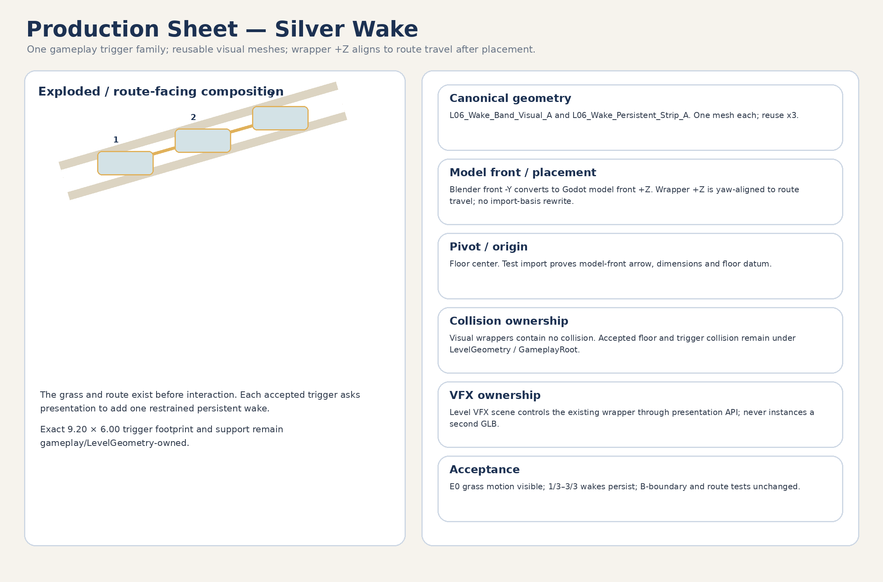
Figure 3. Silver Wake production sheet.
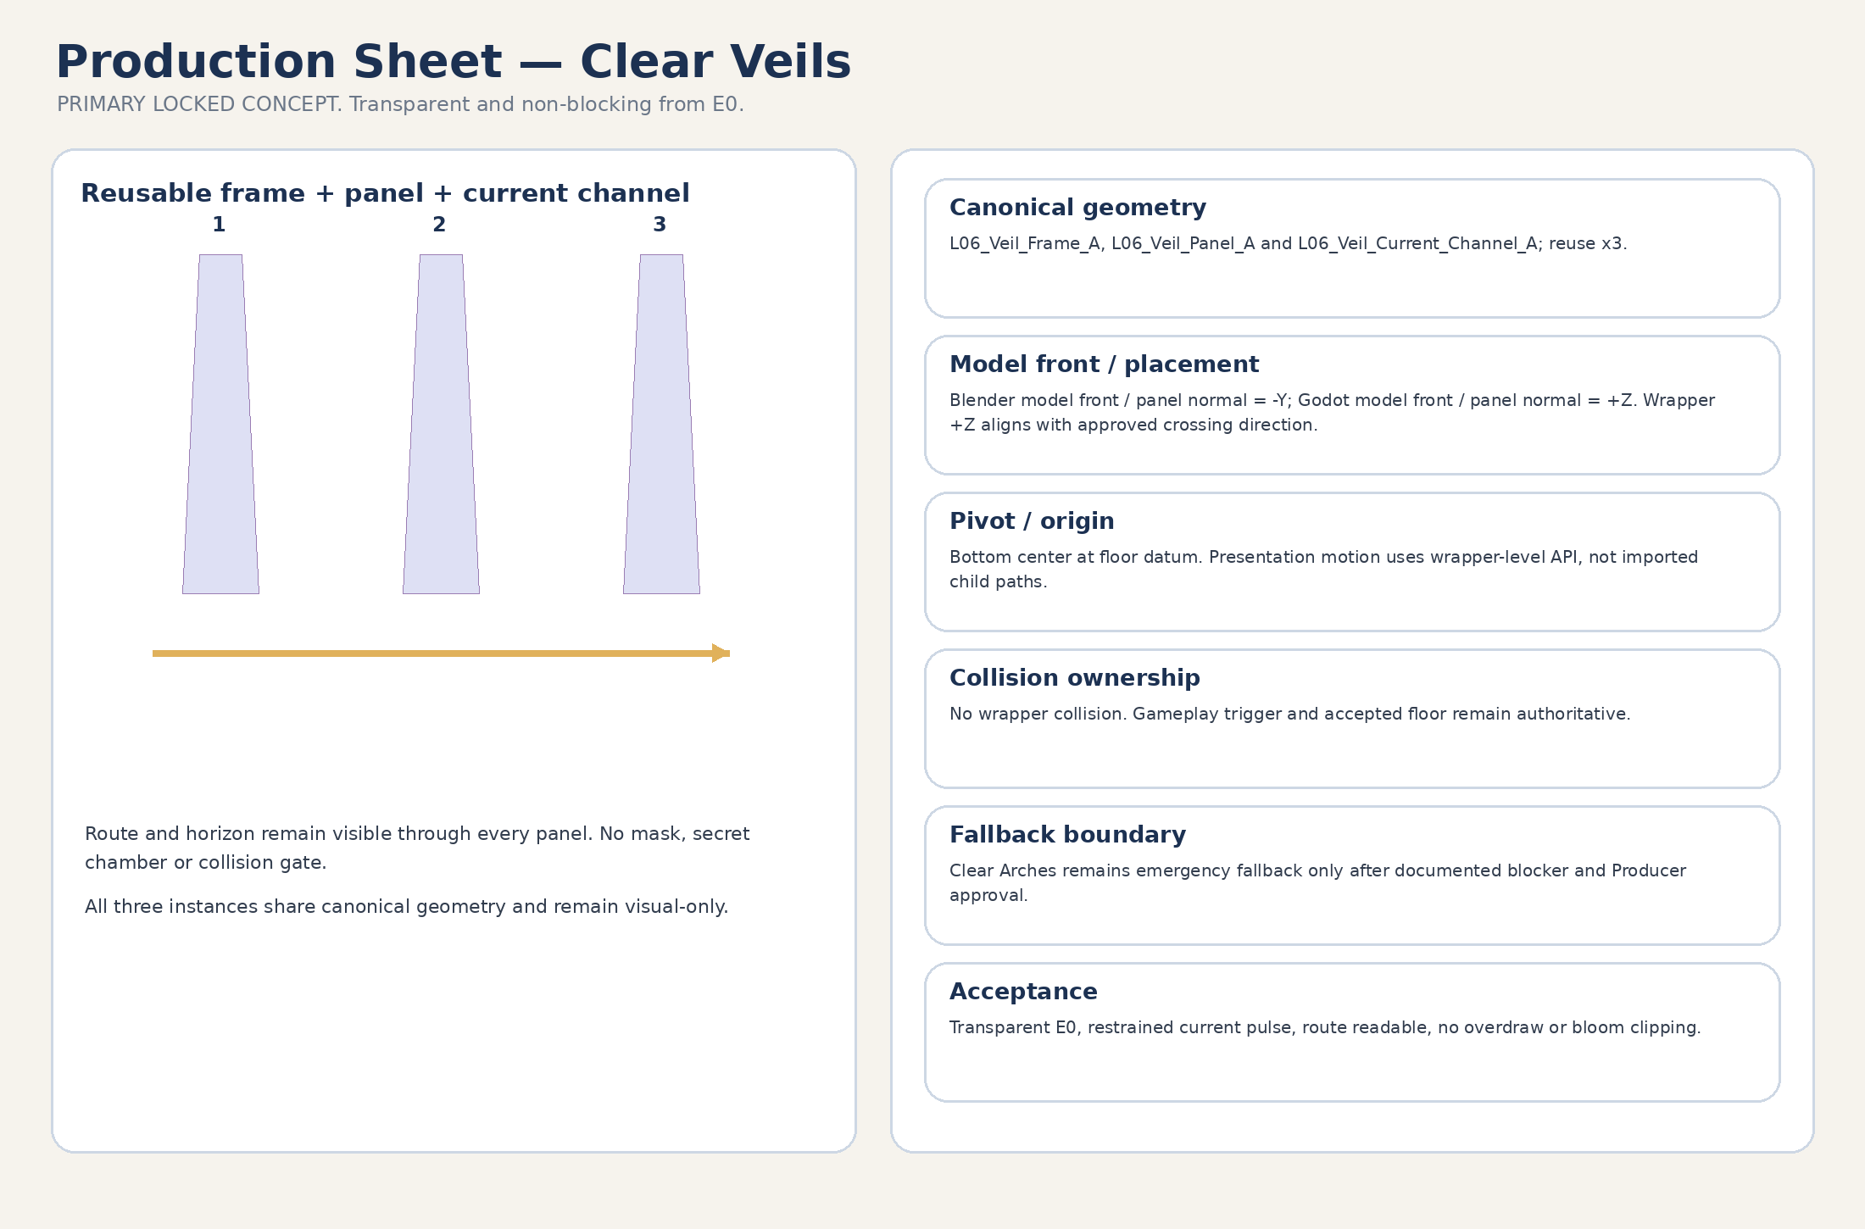
Figure 4. Clear Veils production sheet — PRIMARY LOCKED CONCEPT.
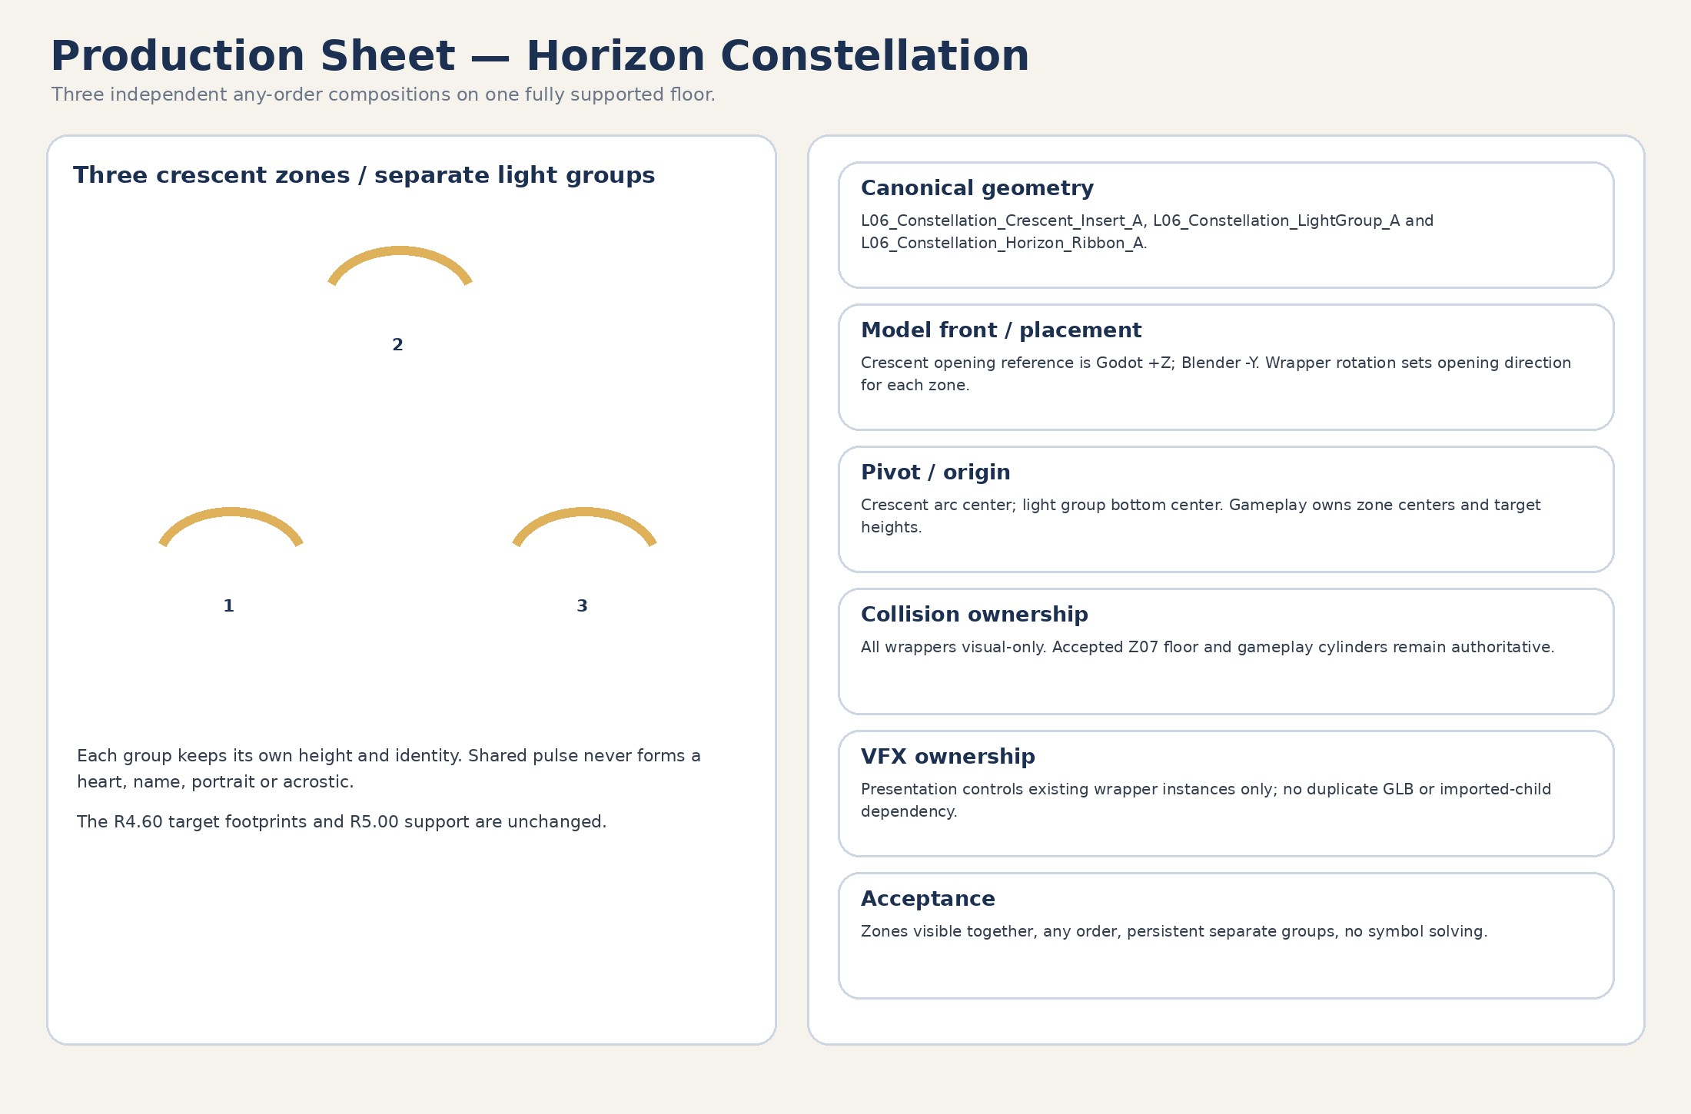
Figure 5. Horizon Constellation production sheet.
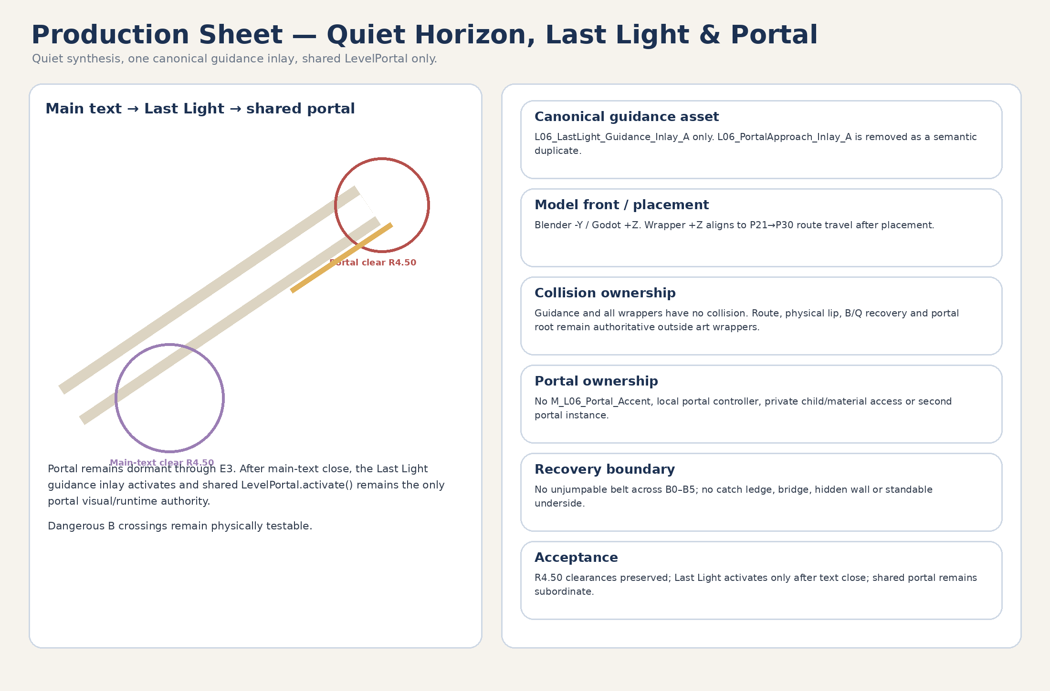
Figure 6. Quiet Horizon / Last Light / Portal production sheet.

9. Collision matrix
Object / class | Visual owner | Authoritative collision owner | Custom collision status | Acceptance rule
Route / shelf visual wrappers | Environment visual wrapper | WorldRoot/LevelGeometry primitive StaticBody3D | CONDITIONAL separate ART-A08 `_COL.glb` only | Visual-only swap first; wrapper never contains collision.
Conditional collision proxy | Separate collision scene under WorldRoot/LevelGeometry | WorldRoot/LevelGeometry | ART-A08 only | Independent path/commit/rollback; full traversal/recovery retest.
Visible rim shell | STRUCT wrapper | None | No wrapper collision | May visually cover the physical lip but never owns it.
Exact physical jumpable lip | No art-wrapper authority | WorldRoot/LevelGeometry/Boundaries primitive 0.75×0.55 m | Primitive may remain permanent | Outside shoulders; jumpable; seams snag-free.
Optional hard off-route belt | No art-wrapper authority | WorldRoot/LevelGeometry/Boundaries | Godot primitive preferred | Forbidden at route openings, legal side spaces and dangerous B0–B5.
Dangerous B0–B5 | Visual rim/lip shell only where it does not block crossing/Q | WorldRoot/LevelGeometry + Recovery sensing | No unjumpable belt | Walk/run/jump/shallow/corner crossings must remain possible.
Path underside | BASE visual wrapper | None | Never collision/floor | Only below visible floor; no gap bridge/catch ledge.
Wake / Veil visuals | GAMEPLAY-VISUAL / STRUCT wrappers | Gameplay triggers + accepted floor | No collision | 9.20×6.00 support unchanged.
Constellation visuals | GAMEPLAY-VISUAL wrappers | Gameplay cylinders + Z07 floor | No collision | R4.60/R5.00 clear.
Shard surround | STRUCT wrapper | Gameplay shard slot | No collision | R3.50 clear; reused x3.
FinalText cue | GAMEPLAY-VISUAL wrapper | FinalTextGate Area3D | No collision | R4.50 clear.
Last Light guidance | GAMEPLAY-VISUAL wrapper | Accepted route collision | No collision | Does not alter B/Q or P21–P30.
Shared LevelPortal | Shared existing scene | Shared LevelPortal | No Level_06 collision/visual override | R4.50 clear; public activate only.
Recovery service Areas / ribbon | GameplayRoot/RecoveryRoot | Area3D/sensing only | No art collision/floor | RV_FALL_GLOBAL, catcher and Q ribbon remain empty of standable art.
Recovery anchors RA0–RA13 | GameplayRoot/RecoveryRoot | Approved legal floors/safety footprints | N/A | Fixed 0.00 m; not “no-floor” service volumes.

10. Pivot, origin and marker contracts
Item | Mesh origin / model-front reference | Authoritative owner | Placement / proof rule
Path surfaces / Last Light inlay | Bottom/floor center; Blender -Y → Godot +Z model front | WorldRoot placement / gameplay route | Wrapper +Z aligns to approved route travel; test-import front arrow required.
Curve surfaces / curved rims | Arc center; -Y/+Z start-tangent reference | WorldRoot placement | Positive rotations; imported start tangent verified.
Shelf surfaces | Center at upper floor plane; +Z reference | WorldRoot/LevelGeometry placement | Conforms to accepted floor footprint; visual only.
Veil frame/panel/current | Bottom center; Blender -Y → Godot +Z panel normal | GameplayRoot owns pass-through Area | Wrapper +Z aligns crossing direction; no gameplay pivot in GLB.
Constellation crescent | Arc center; Blender -Y → Godot +Z opening reference | GameplayRoot owns zone center | Three positive-rotation instances.
Light group / horizon ribbon | Bottom center or documented center; +Z reference | Presentation owner controls target height/state | No imported-child NodePath.
Shard surround | Center at upper plane; +Z reference | GameplayRoot/ShardRoot | Reuse x3; visual-only.
FinalText cue | Floor center; +Z reference | GameplayRoot/FinaleRoot/FinalTextGate | 0.00 m movement.
Portal pad composition | Generic shelf/edge kit; +Z reference | PortalFloorAnchor / shared LevelPortal | No unique portal pivot, material override or local controller.
Cloud / mountain cards | Center/bottom center; Blender -Y → Godot +Z card normal | EnvironmentPresentation placement | Wrapper +Z faces camera sector; non-authoritative.
ArtAlignment markers | Optional ArtAlignment_* only | Art wrapper | Removable, non-authoritative, never gameplay NodePath.

10.1 Locked art tolerance
- Gameplay anchors, trigger centers/volumes, Area3D nodes, pivots, shard roots, FinalTextGate, PortalFloorAnchor, LevelPortal, recovery anchors/Areas/ribbon and NodePaths: 0.00 m movement.
- Free non-authoritative dressing has no universal displacement tolerance. It passes only if route width, shoulders, puzzle/shard/portal clearances, camera sightlines, route openings, boundary rules and seams remain compliant.
- Block/module seams remain <=0.10 m and may not create steps above 0.15 m, gaps, snag points or visible light leaks.

10.2 SoulOrb_Follow decision
SHARED ASSET REUSE
Reuse res://scenes/core/SoulOrb_Follow.tscn. Do not create a Level_06 orb mesh, wrapper or fourth family. Target/orientation ownership remains in Technical Architecture. Art keeps Player/camera clearance around the existing follow visual and prevents clipping through veils, grass, shelves and portal framing.

11. Wrapper-first Blender → GLB → Godot workflow
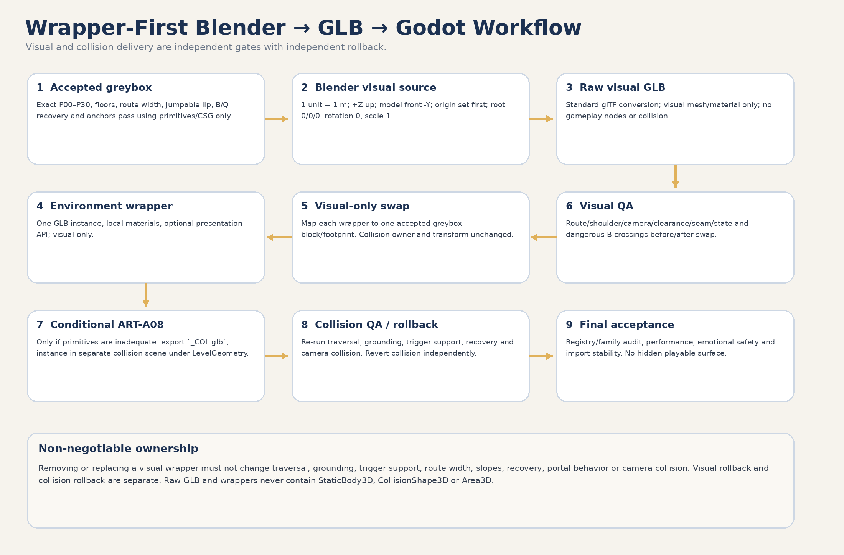
Figure 7. Wrapper-first production and two-stage primitive replacement gates.

11.1 Wrapper content contract
Wrapper may contain | Wrapper must not contain
One raw visual-GLB instance | StaticBody3D, CollisionShape3D or Area3D
Local duplicated material overrides | Gameplay floor, physical lip, hard boundary or recovery collision
Optional presentation-only AnimationPlayer / wrapper-level API | Gameplay IDs, state, triggers, targets, spawn points or shard anchors
ArtAlignment_* non-authoritative markers | Authoritative pivots or NodePaths into imported GLB children
LOD / visibility helpers with no authority | Scene loading, portal ownership, recovery authority or second GLB instance

11.2 Safe primitive replacement
GATE 1 — VISUAL-ONLY SWAP | Replace only the visible primitive/mesh. Each visual block maps to one accepted greybox block/footprint. Preserve collision owner, transform, route width, slopes, support, triggers, B/Q recovery, anchors and NodePaths. Run camera, seams, clearances, state and dangerous-B crossing QA. Visual rollback must not touch collision.

GATE 2 — COLLISION-PROXY SWAP | Separate conditional operation only after ART-A08 justification. Instance exact `_COL.glb` through a separate collision scene under WorldRoot/LevelGeometry or /Boundaries, never inside the art wrapper. Re-run traversal, seams, steps, slopes, grounding, trigger support, recovery, camera collision and portal tests. Collision rollback is independent from visual rollback.

12. IMMEDIATE GREYBOX HANDOFF
DO NOT MIX FINAL ART INTO THE INITIAL LEVEL_06 GREYBOX PR
The immediate handoff may consume dimensions, exact footprints, proxy shapes, boundary classes, collision ownership, clearances, pivot contracts and acceptance criteria only. It may not create or include .blend, .glb, final textures/materials, environment wrappers or polished VFX.

Allowed GB-P0 input | Not allowed in initial greybox PR
P00–P30, Z00–Z11 and floor elevations as primitives/CSG | Any production .blend, raw GLB or environment wrapper
6.00 m route + 1.50 m shoulders + exact 0.75×0.55 m jumpable lip | Final visual geometry or materials
Optional hard belts only where allowed; dangerous B0–B5 remains crossable | Unjumpable B belt, hidden wall, catch ledge or standable underside
Primitive Wake/Veil/Constellation proxies and support floors | Polished puzzle visual shells / VFX
RV_FALL_GLOBAL, catcher, Q ribbon debug and RA0–RA13 | Custom collision GLB or art-owned recovery geometry
Shard/MainText/portal clearances and zero-movement anchors | Portal accent controller or private shared portal access
Automated primitive-only proof and debug overlays | Decor, cloud cards or focal hero compositions
Exact accepted-block IDs for later visual mapping | Any assumption that visual and collision swap together

12.1 Greybox acceptance preconditions before art swap
- Exact P00–P30 coordinates, Z00–Z11 footprints, 221.63 m route length and maximum 3.96° slope pass using primitives/CSG only; no .blend, GLB, wrapper or final material is required.
- Walk, run, ordinary jump, shallow-angle jump and corner crossings across dangerous B0–B5 pass before any art swap.
- Every future visual wrapper has an exact accepted greybox block/footprint mapping and can be removed without changing traversal or recovery.
- Registry names/paths/family values are machine-auditable; semantic duplicates and one-off justification are manually audited.
- Exact cross-section passes: 6.00 m main route + 1.50 m legal shoulder each side + 0.75 m high × 0.55 m thick jumpable lip outside the shoulder; all route mouths remain open.
- Wake/Veil trigger floor coverage is 100%; airborne and held-overlap tests pass.
- All three Constellation R4.60 footprints are supported within Z07 with 0.40 m reserve.
- Shard R3.5, FinalText R4.5 and portal R4.5 clearances pass.
- RV_FALL_GLOBAL, LL_EDGE_EXIT_RIBBON Q0–Q5 and RV_LAST_LIGHT_DROP_CATCHER create no floor; RA0–RA13 remain fixed on approved legal floors/safety footprints; all recovery tests pass.
- Stationary portal early-overlap and FinalScene handoff prerequisite tests pass or create a formal STOP.
- Camera/sightline review confirms the continuous ascending crescent and no hidden required target.

13. POST-GREYBOX ART INTEGRATION SLICES
EXECUTION RULE
These slices are deferred until the initial Level_06 greybox is accepted. Do not execute them in the initial greybox PR.

Slice | Name | Scope
ART-A01 | Registry lock / import sandbox | Fresh SHA/PR preflight; automated name/path/family audit; model-front test-import scene; no runtime integration.
ART-A02 | Mandatory BASE visual set | Produce path surfaces, transition cap and reusable shelf skin; visual-only mapping to accepted blocks; collision unchanged.
ART-A03 | Visible rims / focal compositions | Add visual lip/rim shells and compose shard shelves, Quiet Horizon and portal approach from approved kits; dangerous B remains crossable.
ART-A04 | Silver Wake kit | Integrate band/strip wrappers and presentation API; no trigger/floor ownership changes.
ART-A05 | Clear Veils kit | Integrate frame/panel/current wrappers; PRIMARY concept; visual-only.
ART-A06 | Horizon Constellation kit | Integrate crescents, light groups and horizon ribbon; no zone/floor ownership changes.
ART-A07 | Optional / cut-first dressing | Only after MVP readability: tall grass, stones, cards and minor decor; cut-first list remains removable.
ART-A08 | Conditional collision proxy | Only if primitive collision is proven inadequate; separate `_COL.glb`, separate collision scene, separate commit/rollback, full P0 re-test.
ART-A09 | Materials / E0–E4 VFX | Local material instances and wrapper-level presentation; no PortalAccent; shared LevelPortal.activate() only.
ART-A10 | Final art acceptance | Registry/family/MVAS audit, import orientation, performance, traversal, B recovery, camera and emotional-safety gate.

14. Production priority
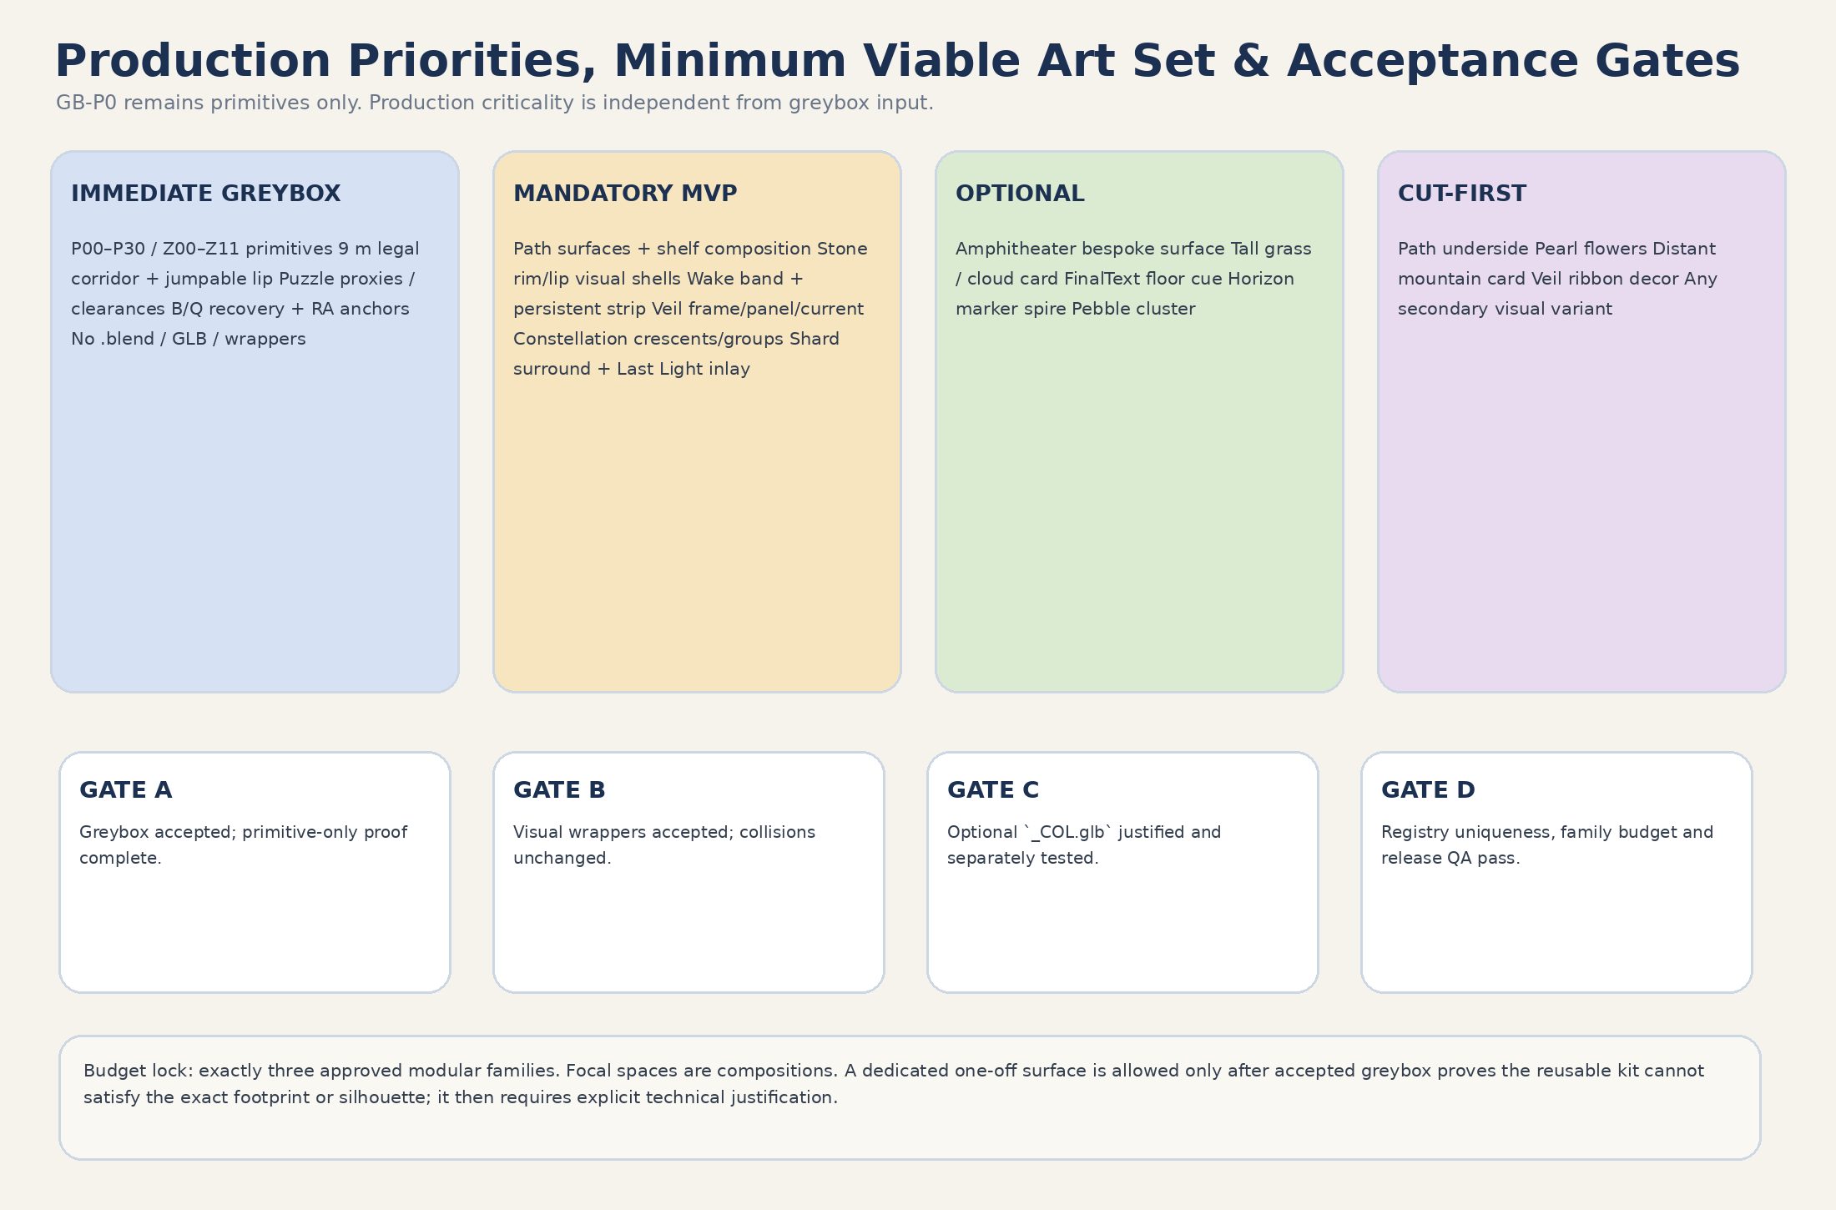
Figure 8. Separation of GB-P0 inputs, post-greybox priorities and acceptance gates.

15. Blender / GLB / Godot export checklist
- 1 Blender unit = 1 meter.
- Blender +Z up; canonical asset model front -Y. Godot camera/look forward is -Z, while imported canonical asset model front is +Z.
- Required origin set before transform application.
- Export root at world origin; location 0/0/0, rotation 0/0/0, scale 1/1/1.
- Positive scale only; true mirrors applied in Blender and exported explicitly.
- Canonical name and exact unique source/raw/wrapper paths match registry.
- No hidden/unused objects, cameras, lights, gameplay scripts, Areas, IDs or authoritative markers in raw GLB.
- Minimal material slots; emission surfaces separable or maskable.
- Normals/tangents clean; transparency and double-sided use justified.
- Collision absent unless the row explicitly allows `CONDITIONAL - ART-A08 ONLY` `_COL.glb`.
- Custom collision export never precedes accepted greybox and proven necessity.
- Wrapper contains one raw visual-GLB instance, local duplicated materials, optional presentation API and ArtAlignment_* markers only; no collision/Area/gameplay node.
- Level-owned VFX scene never instances a duplicate raw GLB/wrapper.
- Godot test import verifies camera -Z separately from model front +Z, plus dimensions, origin, floor datum, normals, materials and LOD. Conditional collision is tested in its separate owner scene.
- Visual-only swap tested before any collision-proxy swap; dangerous B crossings pass before and after; rollback paths remain independent.
- No catch floor, hidden floor, hidden wall, catch ledge, standable underside or geometry bridging gaps.
- No import warnings, missing textures, external absolute paths or duplicate resource UIDs.
- For every oriented asset, the export record states Blender model front -Y, Godot model front +Z, pivot/origin, wrapper placement direction and test-import proof.
- Route travel/panel normal is set only by wrapper placement transform; import basis is never manually rewritten.
- Raw GLB and visual wrapper contain no StaticBody3D, CollisionShape3D, Area3D, gameplay floor or hard boundary.
- Conditional `_COL.glb` uses a unique exact path and separate LevelGeometry collision scene; visual-wrapper path is independent.
- Registry uniqueness, approved-family values, criticality, reuse count and one-off justifications pass automated/manual audit.

16. Art acceptance gates
Gate | Acceptance criterion
A-01 Exact mapping / zero movement | Every final visual block maps to an accepted greybox block/footprint. Gameplay coordinates, anchors, Areas, pivots, PortalFloorAnchor, recovery nodes and NodePaths move 0.00 m.
A-02 Route cross-section | 6.00 m route + 1.50 m shoulders each side + 0.75×0.55 m jumpable lip remain exact; seams create no mandatory step, snag or gap; route mouths preserve 9.00 m.
A-03 Camera / sightlines | P00/P08/P15/P18/P21 and Last Light landmarks remain readable; no foreground wall or opaque VFX.
A-04 Puzzle / reward clearances | Wake/Veil 9.20×6.00 support, Constellation R4.60/R5.00, shard R3.50 and FinalText R4.50 remain unobstructed.
A-05 Boundaries / dangerous B | Physical lip and optional belt stay LevelGeometry-owned. No unjumpable belt on B0–B5; Q0–Q5 coverage clear; walk/run/ordinary/shallow/corner crossings pass before and after visual swap.
A-06 Portal ownership | Portal R4.50 clear; shared LevelPortal not duplicated; no M_L06_Portal_Accent, local portal controller or private child/material access.
A-07 Recovery safety | RV_FALL_GLOBAL, catcher and Q ribbon contain no floor/standable art; RA0–RA13 remain fixed on approved legal floors; no catch ledge/bridge/underside.
A-08 Registry / family / MVAS | 30 canonical assets; names/source/raw/wrapper paths unique; exactly three approved families; mandatory/optional/cut-first and reuse/one-off justification complete; automated + manual audit pass.
A-09 Material / state | E0 alive; E1–E4 cumulative; no shared-resource mutation, dead-world read, hidden true-self reveal or confession symbol.
A-10 Wrapper / VFX ownership | Wrappers are visual-only and sole mesh instance owners; VFX uses wrapper API; no duplicate GLB; shared portal public activation only.
A-11 Axis / import | Godot camera forward -Z remains separate from model front +Z; Blender model front -Y converts normally; test-import proves front, dimensions, origin, normals and floor datum.
A-12 Performance | Triangle/LOD/material/overdraw/bloom budgets pass at gameplay camera; optional/cut-first assets removable.
A-13 Emotional safety | No altar, crown, ring, heart/acrostic, proof trial, beauty-access pressure or productivity obligation.
A-14 Primitive-only greybox | Initial GB-P0 is fully playable using primitives/CSG with no .blend, GLB, wrapper or final material.
A-15 Independent replacement / rollback | Visual-only and collision-proxy swaps use separate gates/commits. Removing visual wrapper changes no collision; collision rollback preserves accepted visual.

17. Production risks and corrections
ID | Risk | Severity | Mitigation
R-01 | Veils imply mask / hidden “true self” | HIGH | Transparent/non-blocking E0; route visible; Clear Arches only formal fallback.
R-02 | Last level becomes ceremonial shrine | CRITICAL | Kit-built natural ledges; shared portal subordinate; no local accent controller.
R-03 | Art narrows exact corridor / lip creates snag | CRITICAL | Cross-section A-02, route-mouth review and seam tests.
R-04 | Visible rim disagrees with physical lip / hard belt | HIGH | Visual wrapper and LevelGeometry collision reviewed as separate layers.
R-05 | Dangerous B becomes unjumpable or Q is occluded | CRITICAL | No hard belt B0–B5; pre/post visual walk/run/jump/shallow/corner tests.
R-06 | Visual wrapper silently owns/replaces collision | CRITICAL | Wrapper visual-only contract; separate ART-A08 scene/commit/rollback.
R-07 | Axis confusion rotates models 180° | HIGH | Camera -Z vs model +Z separated; front-arrow import proof.
R-08 | Mesh-backed VFX duplicates geometry | HIGH | One wrapper instance owner; presentation API only.
R-09 | Transparency/bloom destroys readability | HIGH | Overdraw/bloom caps and camera QA.
R-10 | Constellation forms confession symbol | CRITICAL | Separate abstract groups; no letters/heart/name.
R-11 | Cloud/decor scope exceeds MVP | HIGH | Criticality field and cut-first list.
R-12 | Registry fake variants / one-off platforms return | HIGH | 30-entry audit; generic shelf composition; Producer review for one-offs.
R-13 | Recovery service volumes treated as no-floor anchors | HIGH | Separate service no-floor contract from fixed RA legal-floor anchors.
R-14 | Shared portal private content accessed | CRITICAL | Option A: public LevelPortal.activate() only.
R-15 | Source/shared-contract drift | HIGH | Fresh preflight before ART-A01 and runtime integration.

18. Handoff boundary

18.1 What may pass to Greybox / implementation planning
- Exact dimensions and footprints from Gameplay Spec v1.3.
- Boundary classes, route openings, primitive collision policy and recovery exclusions.
- Gameplay-owned pivot/marker/anchor contracts and zero-movement rule.
- Immediate greybox acceptance criteria and visual debug requirements.
- No production paths as a requirement to create final assets in the initial PR.

18.2 What passes to Blender / Art only after greybox approval
- Canonical asset registry, exact future paths, material/VFX families and triangle/LOD budgets.
- Production sheets for Silver Wake, Clear Veils, Horizon Constellation and final approach.
- Wrapper-first integration and two-stage collision replacement workflow.
- Post-greybox ART-A01–A10 slices and final art acceptance gates.

Appendix A. Exact P00–P30 centerline — art must not move
Pt | X | Y floor | Z | Role
P00 | -22.00 | 0.80 | -51.00 | Spawn / Lower Cloud Terrace
P01 | -15.50 | 1.05 | -49.00 | Lower Terrace exit
P02 | -9.00 | 1.40 | -45.50 | Silver Wake Band 1
P03 | -2.50 | 1.80 | -41.00 | Silver Wake Band 2
P04 | 3.50 | 2.20 | -35.50 | Silver Wake Band 3
P05 | 8.50 | 2.55 | -29.00 | Silver Wake upper curve
P06 | 12.50 | 2.90 | -22.00 | Overlook approach
P07 | 15.00 | 3.25 | -14.50 | Shard_13 Overlook entry
P08 | 15.00 | 3.45 | -7.50 | Shard_13 shelf center
P09 | 14.00 | 3.75 | -0.50 | Ridge Rest lower
P10 | 11.00 | 4.15 | 6.50 | Ridge Rest upper
P11 | 7.00 | 4.55 | 13.00 | Clear Veils approach
P12 | 2.50 | 5.00 | 18.50 | Clear Veil 1
P13 | -2.50 | 5.45 | 23.00 | Clear Veil 2
P14 | -8.00 | 5.90 | 26.50 | Clear Veil 3
P15 | -14.00 | 6.35 | 29.00 | Shard_14 Shelf
P16 | -19.00 | 6.75 | 32.50 | Open Sky Approach lower
P17 | -22.50 | 7.15 | 37.50 | Open Sky Approach upper
P18 | -23.50 | 7.50 | 43.00 | Horizon Amphitheater entry
P19 | -19.00 | 7.80 | 47.00 | Amphitheater inner approach
P20 | -10.00 | 8.20 | 46.50 | Shard_15 central plateau
P21 | 2.50 | 8.60 | 49.50 | Quiet Horizon / Main Text Gate
P22 | 7.00 | 8.85 | 53.50 | Last Light Walk 1
P23 | 15.50 | 9.10 | 53.50 | Last Light Walk 2
P24 | 23.50 | 9.35 | 50.00 | Last Light outer crest
P25 | 25.50 | 9.60 | 43.50 | Last Light east rim
P26 | 25.50 | 9.85 | 35.00 | Last Light southbound rim 1
P27 | 25.50 | 10.10 | 26.50 | Last Light southbound rim 2
P28 | 25.00 | 10.35 | 19.50 | Last Light inner rim
P29 | 24.50 | 10.70 | 13.50 | Portal approach
P30 | 24.00 | 11.00 | 8.50 | PortalFloorAnchor

Appendix B. Puzzle, shard, finale and portal clearances
ID | Center Vector3 | Clearance / volume | Heading | Art rule
WAKE_BAND_1 | (-9.00, 3.90, -45.50) | 9.20 across × 5.50 high × 6.00 along | 58.39° | Exact footprint clear; gameplay-owned
WAKE_BAND_2 | (-2.50, 4.30, -41.00) | 9.20 across × 5.50 high × 6.00 along | 51.34° | Exact footprint clear; gameplay-owned
WAKE_BAND_3 | (3.50, 4.70, -35.50) | 9.20 across × 5.50 high × 6.00 along | 42.51° | Exact footprint clear; gameplay-owned
VEIL_LAYER_1 | (2.50, 7.50, 18.50) | 9.20 across × 5.50 high × 6.00 along | -43.53° | Exact footprint clear; gameplay-owned
VEIL_LAYER_2 | (-2.50, 7.95, 23.00) | 9.20 across × 5.50 high × 6.00 along | -52.70° | Exact footprint clear; gameplay-owned
VEIL_LAYER_3 | (-8.00, 8.40, 26.50) | 9.20 across × 5.50 high × 6.00 along | -62.45° | Exact footprint clear; gameplay-owned
CONSTELLATION_WEST | (-20.00, 9.25, 47.50) | R4.60 × H3.50; support to R5.00 | — | No tall/opaque art
CONSTELLATION_CREST | (-10.00, 9.95, 53.00) | R4.60 × H3.50; support to R5.00 | — | No tall/opaque art
CONSTELLATION_EAST | (0.00, 9.40, 47.50) | R4.60 × H3.50; support to R5.00 | — | No tall/opaque art
Shard_13 | (15.00, 4.45, -7.50) | R3.50 art/camera clear | — | L06_Shard_Surround_A reuse
Shard_14 | (-14.00, 7.35, 29.00) | R3.50 art/camera clear | — | Same reuse
Shard_15 | (-10.00, 9.20, 46.50) | R3.50 art/camera clear | — | Same reuse
FinalTextGate | (2.50, 10.35, 49.50) | Gameplay R4.25; art clear R4.50 | — | No altar/monument
PortalFloorAnchor | (24.00, 11.00, 8.50) | Art/camera clear R4.50 | 5.71° | Shared LevelPortal

Appendix C. Recovery and camera QA references
Recovery item | Exact contract | Art restriction
RV_FALL_GLOBAL | Box center (0,−9,0), size (76,12,132), top Y−3.00 | No floor or standable service geometry.
RV_LAST_LIGHT_DROP_CATCHER | Box center (19,7,12), size (26,7,32); X6..32 Y3.5..10.5 Z−4..28 | No catch platform, bridge or dense opaque dressing.
LL_EDGE_EXIT_RIBBON | Q0–Q5 swept R0.45, Y9.50..13.50; round joins/caps | Non-visual gameplay sensing authority; art edge must not interfere.
Dangerous boundary B | B0–B5 exact polyline P27–P30 edge | Visible rim may explain edge but cannot shift boundary.
Recovery anchors | RA0–RA13 exact positions/state gating | 0.00 m movement; no art-owned replacement markers.

Anchor | Position
RA0 | Vector3(-22.00, 1.80, -51.00)
RA1 | Vector3(-9.00, 2.40, -45.50)
RA2 | Vector3(-2.50, 2.80, -41.00)
RA3 | Vector3(8.50, 3.55, -29.00)
RA4 | Vector3(15.00, 4.25, -14.50)
RA5 | Vector3(14.00, 4.75, -0.50)
RA6 | Vector3(2.50, 6.00, 18.50)
RA7 | Vector3(-2.50, 6.45, 23.00)
RA8 | Vector3(-14.00, 7.35, 29.00)
RA9 | Vector3(-23.50, 8.50, 43.00)
RA10 | Vector3(-19.00, 8.80, 47.00)
RA11 | Vector3(-10.00, 9.20, 46.50)
RA12 | Vector3(7.00, 9.85, 53.50)
RA13 | Vector3(24.50, 11.70, 13.50)

Appendix D. Approved visual authority references
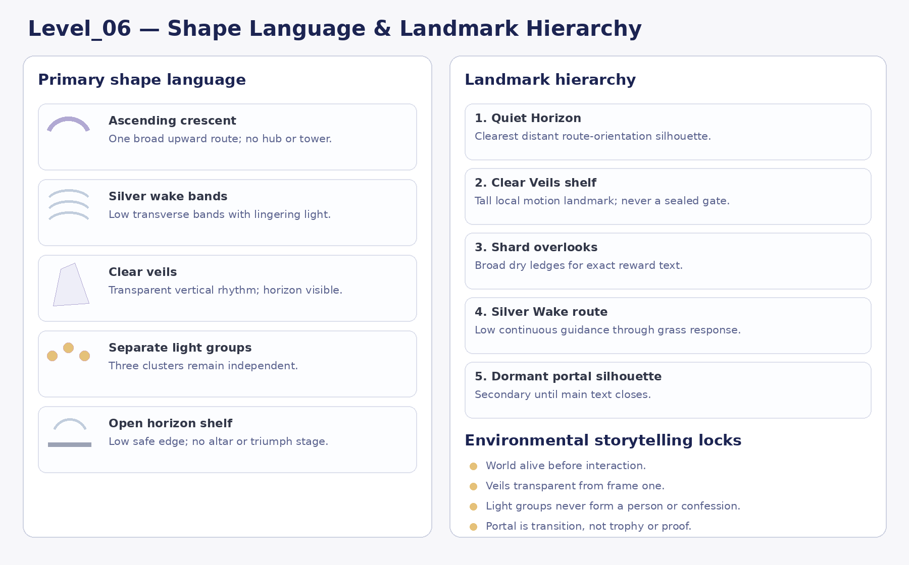
Approved Visual Master reference: Shape language and landmark hierarchy. Mood/diagram authority only as defined by source hierarchy.
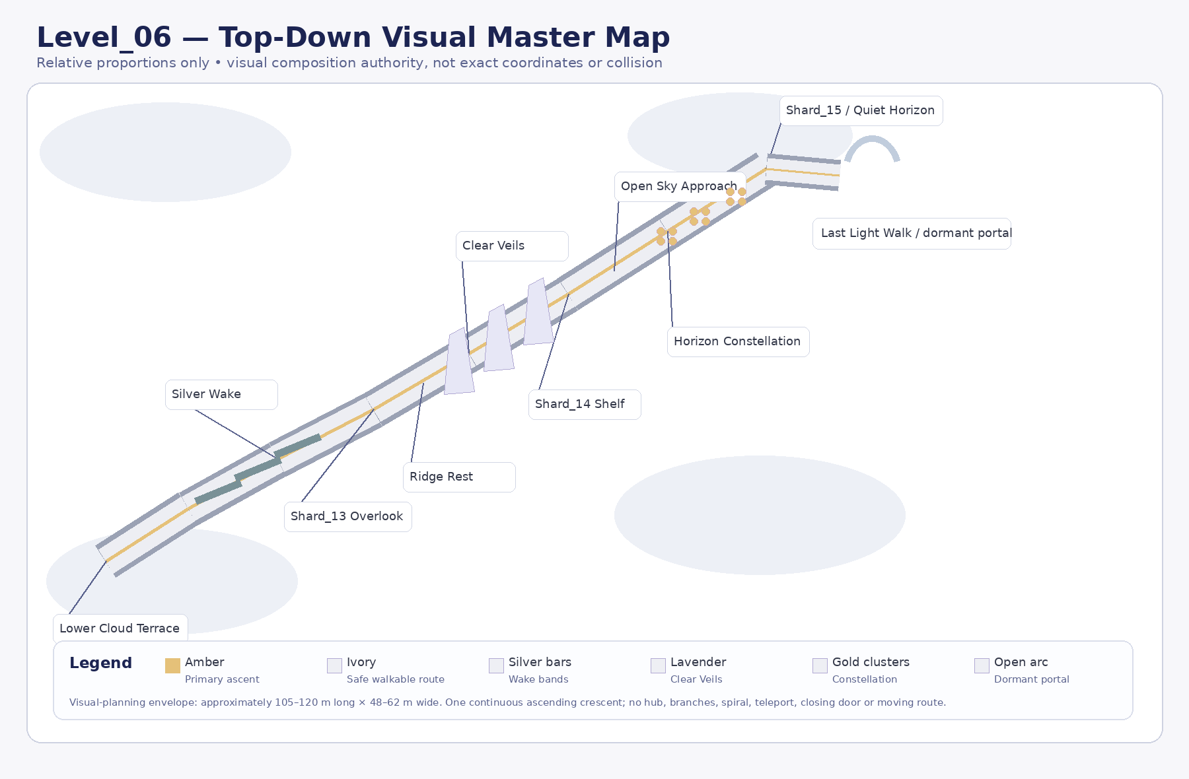
Approved Visual Master reference: Visual top-down master concept — approximate only. Mood/diagram authority only as defined by source hierarchy.
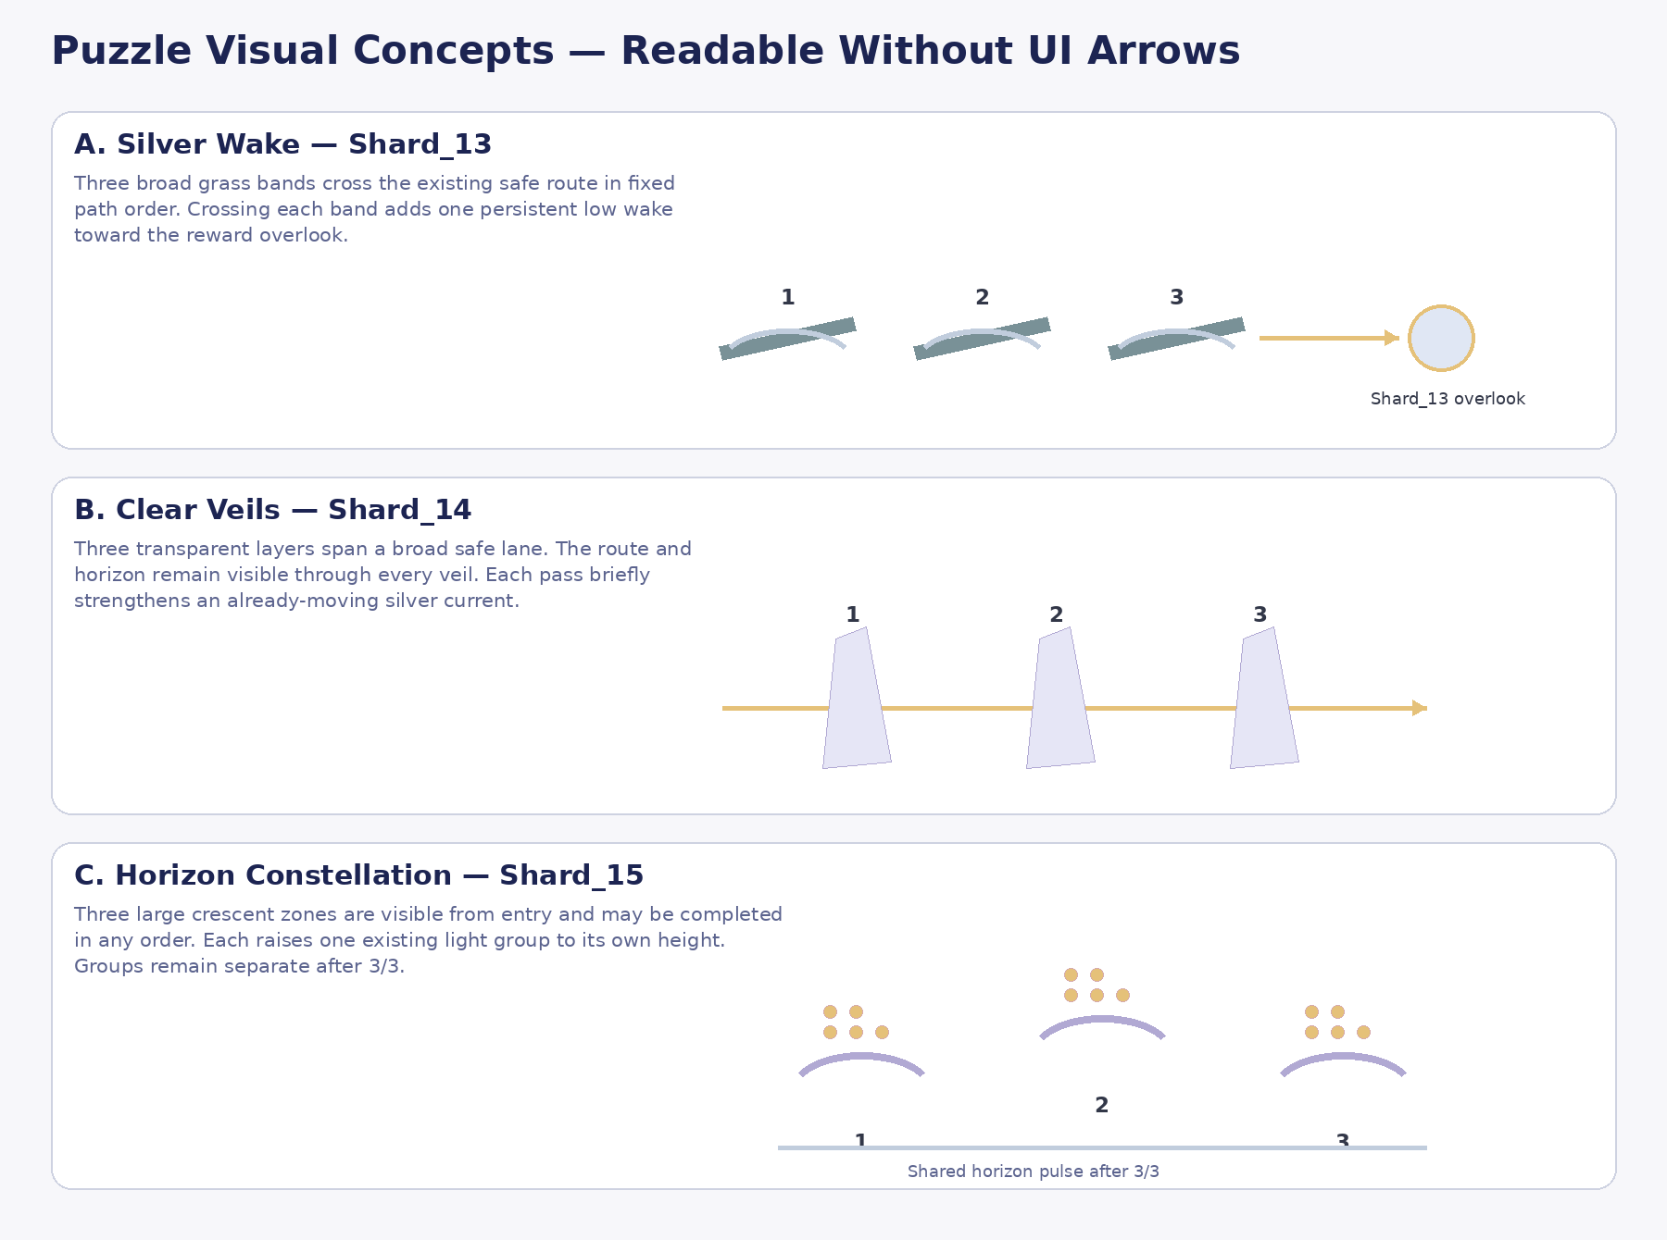
Approved Visual Master reference: Puzzle visual concepts. Mood/diagram authority only as defined by source hierarchy.
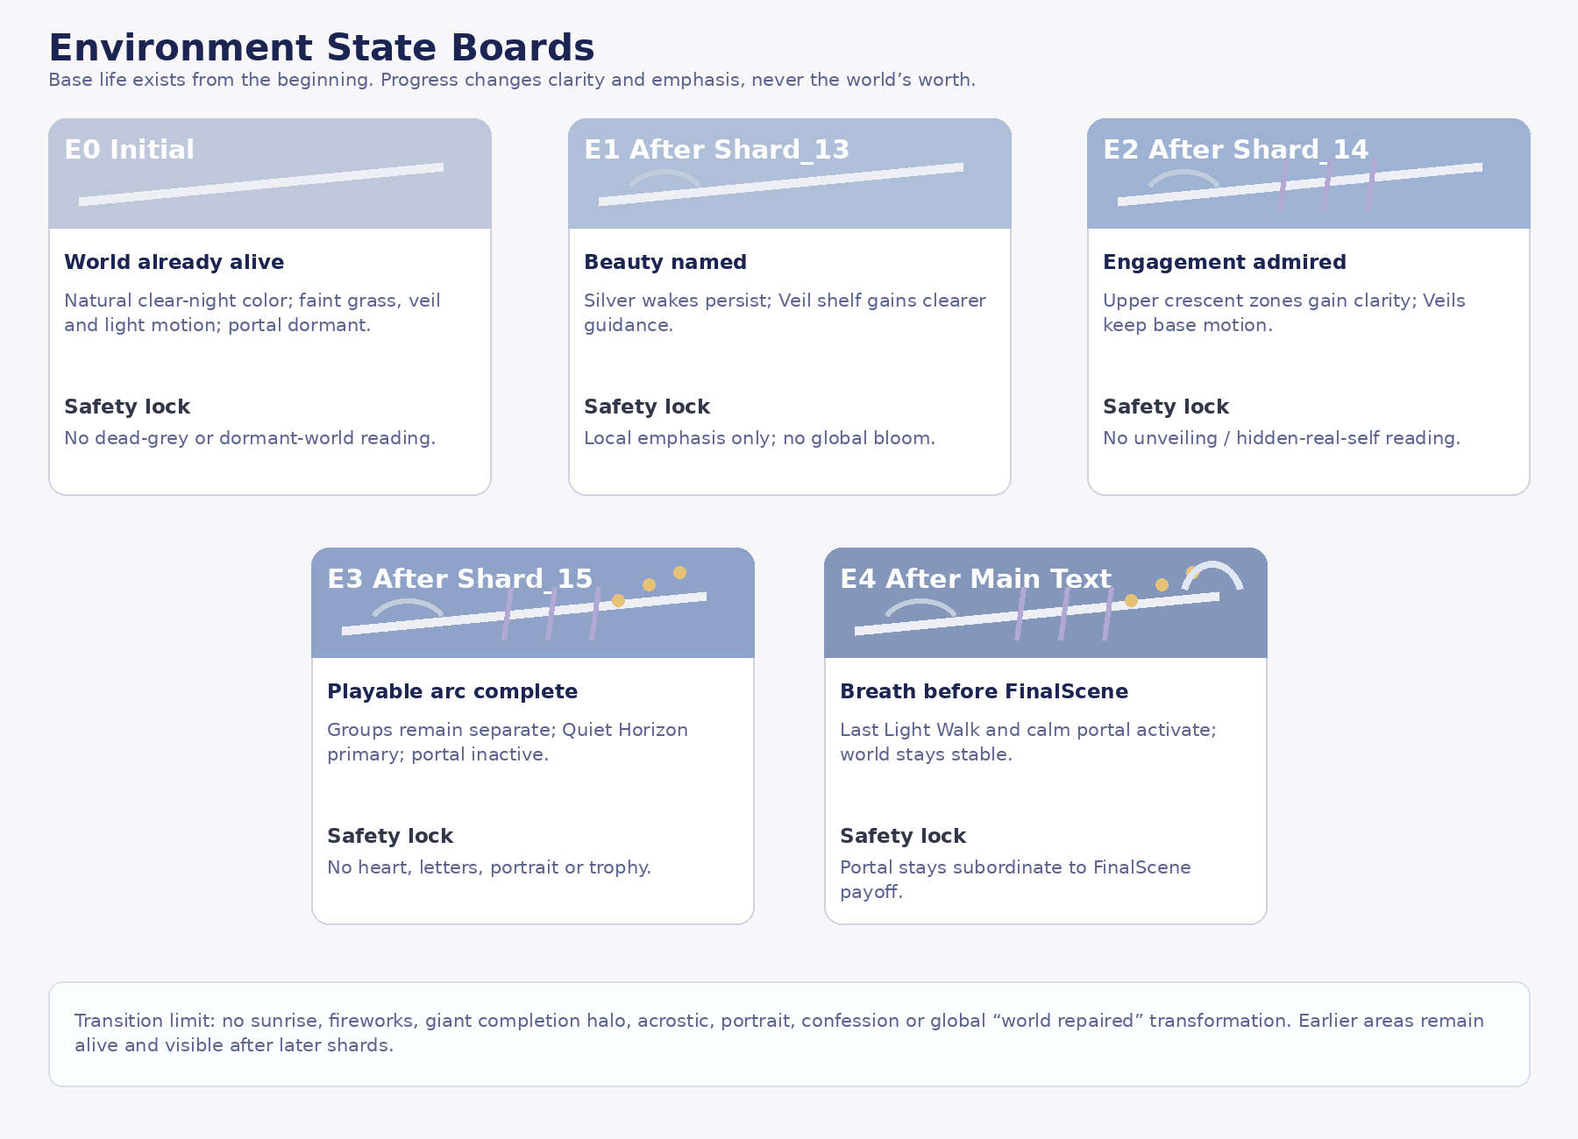
Approved Visual Master reference: Environment state board. Mood/diagram authority only as defined by source hierarchy.
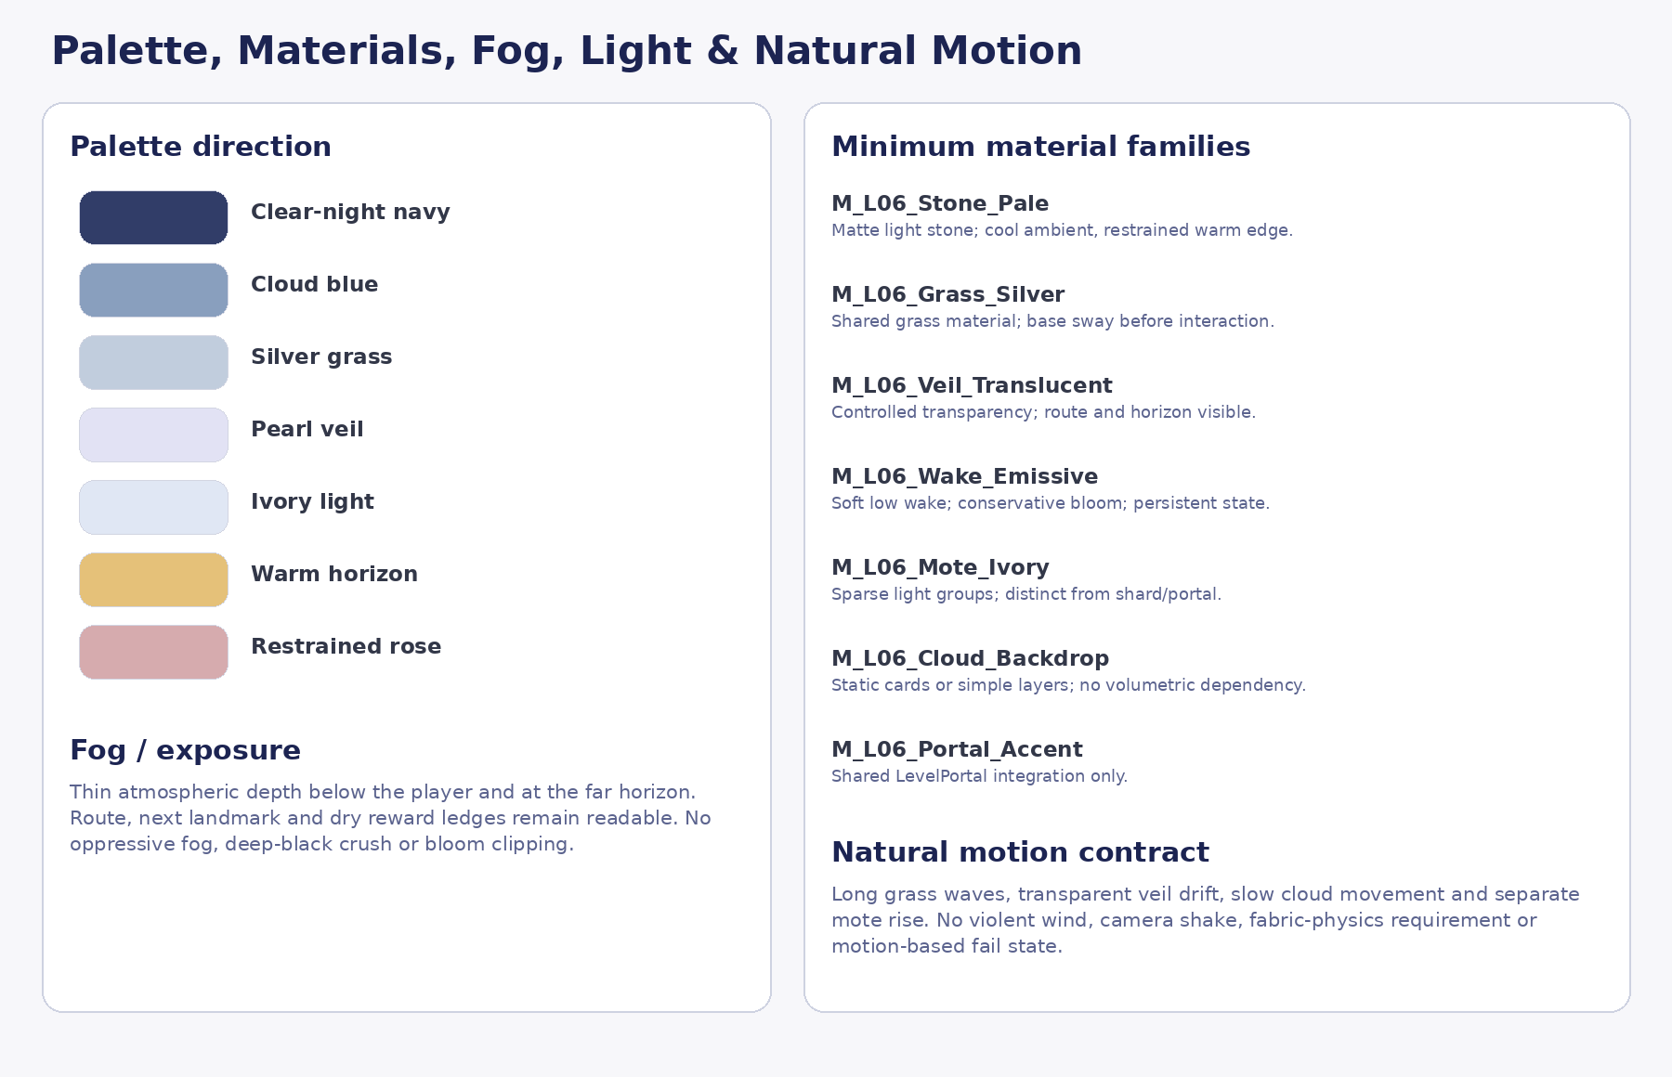
Approved Visual Master reference: Palette/material direction. Mood/diagram authority only as defined by source hierarchy.
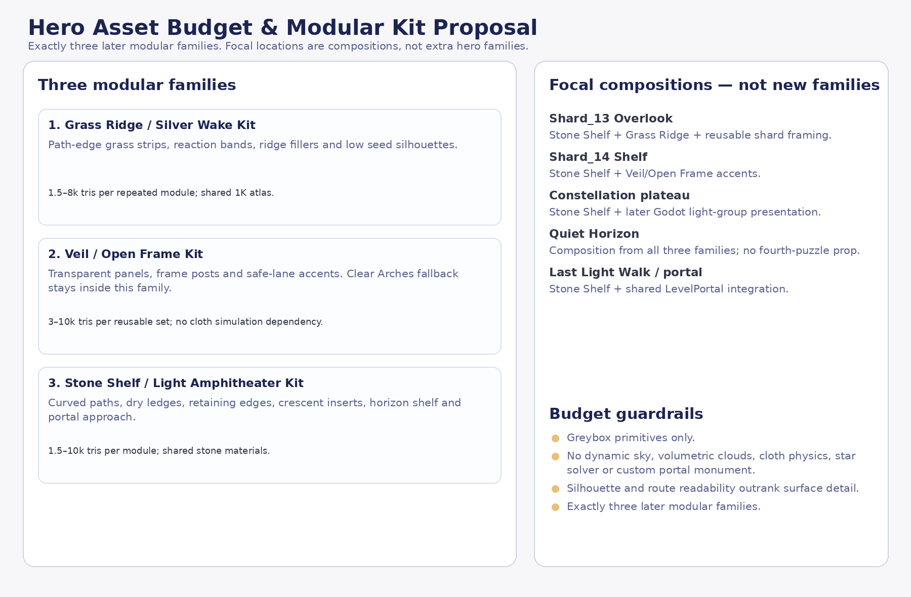
Approved Visual Master reference: Three-family modular budget. Mood/diagram authority only as defined by source hierarchy.

Document completion statement
DOCUMENTATION-ONLY COMPLETION — VERSION 1.1 CANDIDATE
This revised Art Production Bible applies the Producer Art Production Bible Gate corrections and remains documentation only. No Godot scenes/scripts, Blender files, GLBs, textures, materials, resources, project.godot, branches, commits or pull requests were created or modified. Fresh preflight and full render QA are recorded for repeat Producer review.

