FIFTEEN SHARDS OF LIGHT
Level_06
«Ты восхищаешь меня»
GAMEPLAY MAP AND COMPLETE LEVEL DESIGN SPECIFICATION
Version 1.3 - Final Last Light recovery-source technical revision
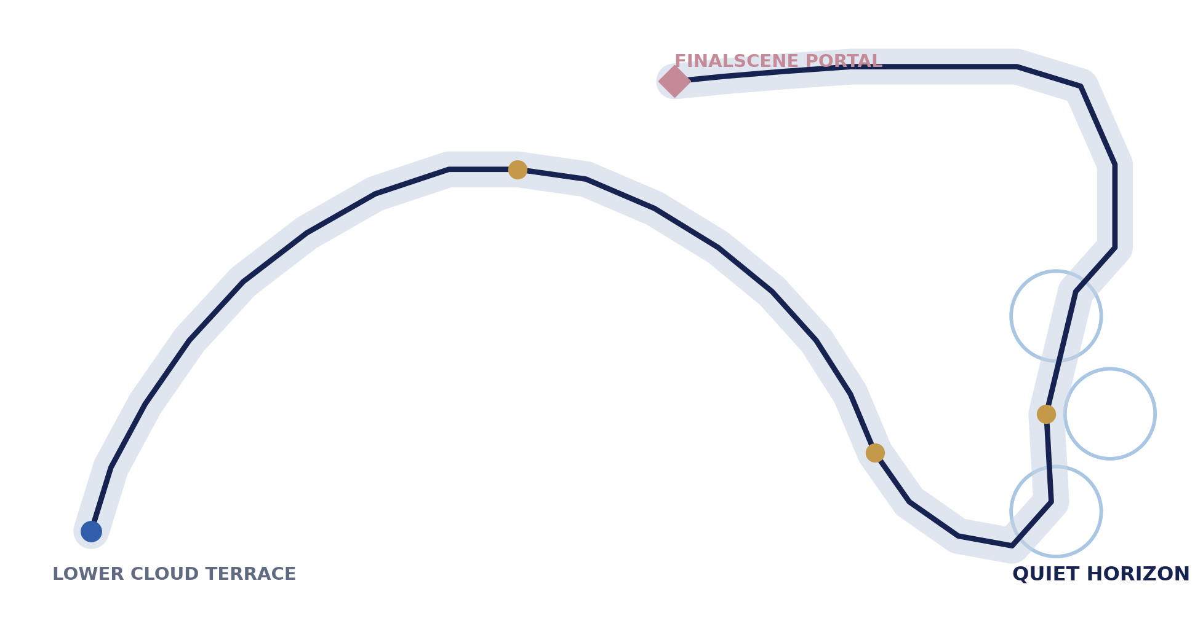
Cover route abstraction. Exact geometry, dimensions and coordinates are controlled by Sections 4-5.
Control | Value
Repository | MindDevastation/fifteen-shards-of-light
Target scene | res://scenes/levels/Level_06.tscn
Narrative authority | Level_06_Narrative_and_Level_Scenario_Package_v1.1.docx
Visual authority | Level_06_Visual_Master_Concept_Package.docx
Document mode | Documentation only - no Godot, asset, Blender, branch, commit or PR changes
Document status | READY FOR PRODUCER APPROVAL - v1.3 LAST LIGHT SOURCE CONTRACT CLOSED
Next gate | READY FOR GODOT TECHNICAL ARCHITECTURE AFTER PRODUCER APPROVAL

EMOTIONAL SAFETY CONTRACT
Героиня не сломана, и ее никто не чинит. Ее свет и ценность уже принадлежат ей. Игрок не заслуживает доступ, ответ или взаимность. Изменения среды показывают ясность реакции автора и навигационную читаемость, а не восстановление или повышение ценности Алены.

0. Document control, authority and decision language
Этот v1.3 документ заменяет Level_06 Gameplay Map and Complete Level Design Specification v1.2 в design-domain. Он сохраняет все утвержденные narrative, pacing, route и puzzle contracts и выполняет одну финальную техническую коррекцию: непрерывное source coverage опасной границы Last Light, persistent origin provenance и устранение shallow-angle bypass. Режим остается documentation only; никакие runtime-файлы или production assets не создавались и не изменялись.
Authority layer | Controls | State
Approved Narrative Package v1.1 | Title, exact copy, exactly three shards, narrative order, emotional boundaries and FinalScene handoff. | IMMUTABLE
Approved Visual Master Concept | High silver meadow, continuous ascending crescent, Clear Veils primary, composition and E0-E4 intent. | IMMUTABLE
This Gameplay Spec v1.3 | Exact coordinates, collision footprint, deterministic inputs, recovery, pacing evidence and acceptance. | PRODUCER REVIEW - FINAL TECHNICAL GATE
Current repository | Player speeds/jump, shared SoulShard, reward and LevelPortal compatibility facts. | VERIFIED CURRENT
Future Technical Architecture | Node ownership, signal topology, implementation and Godot runtime proof. | DEFERRED

Decision label | Meaning
VERIFIED CURRENT | Fact verified from current repository or approved source.
DESIGN LOCK | Canonical gameplay contract after Producer approval.
RUNTIME VALIDATION REQUIRED | Mandatory contract that static inspection cannot prove.
BLOCK | The next gate cannot proceed until the specified Producer or prerequisite decision is closed.
DEFERRED | Intentionally outside this document and not authorized.
RELEASE BLOCKER | Runtime may fail safely to avoid a softlock, but the build cannot pass production acceptance until the defect is fixed.

0.1 Version 1.3 Change Log
- Established continuous coverage of the dangerous Last Light boundary from P27 through the P30 portal-pad edge with one exact swept source ribbon.
- Removed the measured 1.21 m, 0.94 m and 0.80 m gaps between the former LL_EDGE_EXIT service boxes; corner joins now have positive geometric overlap independent of Player-body size.
- Replaced immediate-previous-grounded-sample logic with persistent LAST_LIGHT_ORIGIN_VALID provenance that survives airborne travel and is replaced only by proven grounded support, recovery, reload or transition lifecycle events.
- Removed the fixed horizontal velocity dot outward_normal >= 0.50 m/s gate; signed inside-to-outside crossing is authoritative and velocity is diagnostic only.
- Updated Figure 1, Figure 10, Section 14.2, failure/recovery matrices, Appendix A/B, A12-A14 and P0 Last Light tests with deterministic token-state expectations.
- Numerically verified continuous ribbon union, zero source gaps, 0.099 m minimum boundary reserve and 1.87 m minimum clearance from the early legal corridor.
- Completed full DOCX render QA, exact-copy verification, comment/tracked-change cleanup and unreadable-label / broken-table inspection.

0.2 Previous-version provenance
Version 1.2 applied the Producer pacing decision, closed Constellation floor containment, established the playable/service-envelope split, defined mandatory shard presentation and added a source-armed catcher. Version 1.3 preserves those decisions but replaces the discontinuous four-box source and one-frame floor sample with the continuous-ribbon and persistent-provenance contracts. Versions 1.0-1.2 remain revision provenance only.

1. Executive summary and design verdict
GAMEPLAY DESIGN GATE VERDICT - READY FOR PRODUCER APPROVAL
The v1.3 level preserves the approved route, pacing and puzzle design and closes the final Last Light recovery-source defect. One swept ribbon covers 100% of the dangerous P27-P30 boundary with round joins and positive reserve; LAST_LIGHT_ORIGIN_VALID persists through airborne travel; any signed inside-to-outside crossing can create a candidate without a fixed horizontal-speed threshold. Lower-route trajectories remain ignored without Last Light provenance. No content redesign, artificial padding, forced wait, fourth puzzle or extra playable scene is authorized.
DESIGN VERDICT - READY FOR PRODUCER APPROVAL. The approved Level_06 design remains unchanged. v1.3 closes only the Last Light recovery-source contract: one continuous swept ribbon covers the entire dangerous P27-P30 boundary, persistent provenance survives airborne travel, signed inside-to-outside crossing is authoritative, and lower-route entries remain false-positive safe.
Item | Canonical v1.3 result
Title | Ты восхищаешь меня
Macro-order | Spawn -> Silver Wake -> Shard_13 -> Ridge Rest -> Clear Veils -> Shard_14 -> Open Sky Approach -> Horizon Constellation -> Shard_15 -> Quiet Horizon -> Main Text -> Last Light Walk -> Portal -> FinalScene
Order model | HYBRID: macro route fixed; Constellation WEST / CREST / EAST any-order.
Envelope | Scene-local X -30.00..+30.00; Z -58.00..+58.00 limits mandatory playable collision, targets and compact anchors. Recovery/service volumes are governed separately.
Centerline | P00-P30; 221.63 m total; 65.17 m Last Light; max segment slope 3.96°.
Sequential targets | Wake/Veil 9.20 m across x 5.50 m high x 6.00 m along; first Player-body overlap; no grounded requirement or dwell.
Final-route safety | Relocated P22-P30 plus continuous LL_EDGE_EXIT_RIBBON, persistent Last Light origin provenance and token-gated RV_LAST_LIGHT_DROP_CATCHER; lower-route entries cannot arm recovery.
Exit | Shared LevelPortal, AUTO_ENTER, no confirmation, future target res://scenes/core/FinalScene.tscn.
Production status | Documentation complete; Producer pacing decision and v1.3 Last Light source correction applied; final Producer approval remains required before Technical Architecture.
Pacing validation | First play 2:00-4:00 (nominal ~3:00); repeat 1:10-2:00 (nominal ~1:30); Last Light 15.33 s walk / 10.43 s sprint.

1.1 Why progression is hybrid
Layer | Order | Narrative and pacing proof
Macro chapter | Strict linear | Shard_13 must establish beauty before Shard_14 names authentic engagement and Shard_15 synthesizes both.
Silver Wake | 1 -> 2 -> 3 | The route teaches one response becoming clearer. Sequential broad crossings add no puzzle tax.
Clear Veils | 1 -> 2 -> 3 | The already-existing current gains strength layer by layer; reordering would weaken the visual grammar.
Horizon Constellation | Any-order | Three independent reasons remain distinct and the final mechanic avoids a prescribed hierarchy or test-like sequence.
Exit | Strict linear | Main text must be accepted before portal activation; FinalScene exclusively owns the confession.

2. Repository preflight and compatibility facts
Ref | Verified current fact | Design consequence
R01 | Audited main SHA 56410298d9a2f4783e9512a84653b03e73ee3e50; Level_06 remains a flat one-shard placeholder. | Placeholder has factual compatibility value only and no design authority.
R02 | Player walk_speed = 4.25 m/s, run_speed = 6.25 m/s, jump_velocity = 4.025; ordinary jump is available. | Required crossing targets must accept airborne Player-body overlap.
R03 | Player collision is approximately 0.706 x 1.728 x 0.522 m and controls can be locked through the public current method. | Headroom, trigger height and recovery anchors account for the existing body envelope.
R04 | Shared SoulShard supports shard_id, exact reward_text, interaction, reward_sequence_requested and idempotent completion. | Exactly one currently available shard is used per beat; reward completion gates progression.
R05 | Current SoulShard charge baseline is 1.20 s plus 0.06 s terminal hold. | Pacing evidence includes a 1.26 s mandatory charge baseline.
R06 | ShardRewardOverlay formation and return provide a minimum current presentation baseline of approximately 4.62 s before user reading allowance. | Pacing evidence includes the current minimum animation baseline; exact player-facing text remains mandatory and missing dependencies are release-blocking.
R07 | Shared LevelPortal owns activation, interaction latch and scene transition. AUTO_ENTER begins only from an active-state body_entered event in static inspection. | Stationary early-overlap must be proven in Godot; incompatibility is a narrow shared prerequisite BLOCK.
R08 | Current Level_06 portal targets Level_07. | Future approved runtime slice must retarget to res://scenes/core/FinalScene.tscn.
R09 | Current ShardRewardSequenceController safe-completes a second shard request while another sequence is active, which can emit collected for a non-current shard. | Technical Architecture must intercept concurrent/non-current requests before the shared controller. No project-wide shared change is assumed without a separate prerequisite decision.

REPOSITORY BOUNDARY
No repository mutation is authorized. Values above are compatibility facts, not instructions to implement scripts or scenes in this stage.

3. Immutable narrative and visual contracts
SHARD_13 - EXACT LOCKED COPY
Ты очень красивая - и я правда восхищаюсь твоей красотой.

SHARD_14 - EXACT LOCKED COPY
Меня восхищает, как ты умеешь по-настоящему загораться тем, что тебе интересно.

SHARD_15 - EXACT LOCKED COPY
Ты удивительная - и своей красотой, и тем, как сильно умеешь загораться идеей.

MAIN TEXT - EXACT LOCKED COPY
Мне трудно свести мое восхищение тобой к одной причине. Меня волнует твоя красота, и мне очень дорого видеть, как увлеченно ты можешь заниматься тем, что тебя по-настоящему захватывает. Но даже эти слова не объясняют тебя целиком - и я не хочу делать вид, будто знаю о тебе все. Я просто точно знаю, что восхищаюсь тобой. Дальше мне осталось сказать только самое главное.

Immutable item | Required result
World | High silver meadow above a cloud sea in clear night. The world is alive from E0.
Route identity | One continuous ascending crescent; no hub, branch network, inward spiral or seventh playable scene.
Mechanics | Silver Wake; Clear Veils primary; Horizon Constellation; Quiet Horizon non-interactive.
Shard count/order | Exactly Shard_13 -> Shard_14 -> Shard_15.
FinalScene boundary | No acrostic, direct love confession, response prompt or EndingOverlay design inside Level_06.
Safety | No combat, damage, death, punishment, precision platforming, timer pressure or emotional debt.

4. Exact world footprint and coordinate system
Parameter | Exact contract
Origin / axes | Scene-local Godot coordinates. +X east, -X west, +Z north/up-route, -Z south/spawn; +Y vertical.
Gameplay envelope | X -30.00..+30.00; Z -58.00..+58.00 applies to mandatory playable collision, puzzle targets and compact gameplay anchors. Recovery/service volumes may extend only for fall coverage; they create no floor, standable geometry, route or gameplay acceptance outside the envelope.
Authored floor Y | P00-P30 Y values are floor elevations. Player recovery roots are normally floor Y + 1.00 m.
Legal route | 6.00 m clear traversable route plus 1.50 m legal shoulder each side = 9.00 m total safe corridor.
Mandatory slope | <= 8.00°; this layout maximum is <= 3.96°. Cross-slope <= 3.00°.
Mandatory steps/gaps | Step <= 0.15 m; no mandatory gap or jump.
Recovery/service bounds | A01 does not apply to RV_FALL_GLOBAL, RV_LAST_LIGHT_DROP_CATCHER or LL_EDGE_EXIT_RIBBON / LLR_SEG_* service geometry. They have separate coverage and false-positive acceptance criteria.

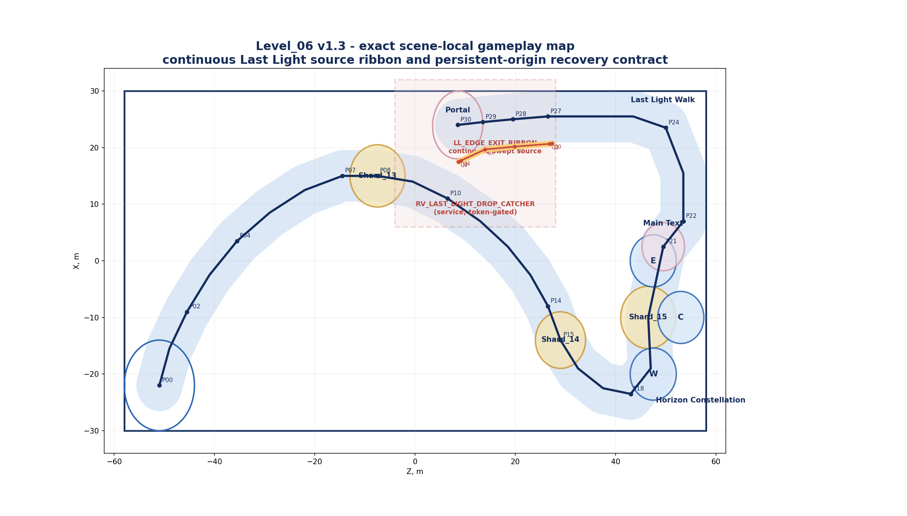
Figure 1. v1.3 exact top-down gameplay map: unchanged P00-P30 route, continuous LL_EDGE_EXIT_RIBBON, service-volume recovery and contained Z07 floor.

4.1 Exact zone and platform dimensions
ID | Zone | Exact footprint | Floor Y | Gameplay function
Z00 | Lower Cloud Terrace | Ellipse center (-22.00,-51.00); width 16.00 m on world X; depth 14.00 m on world Z; heading 0°. | Y 0.80 | Bounds X -30..-14, Z -58..-44.
Z01 | Silver Wake corridor | Swept P01-P07; 6.00 route + 1.50 shoulders; target sections have 0.10 m colliding lip each side. | Y 1.05..3.25 | Three ordered crossings.
Z02 | Shard_13 Overlook | Ellipse center (15.00,-7.50); width 12.00 X; depth 11.00 Z; heading 0°. | Y 3.45 | Shard root and reward-safe floor.
Z03 | Ridge Rest | Swept P08-P11; total legal corridor 9.00 m. | Y 3.45..4.55 | No task.
Z04 | Clear Veils lane | Swept P11-P15; total legal corridor 9.00 m; 0.10 m colliding lips at crossing sections. | Y 4.55..6.35 | Three transparent layers.
Z05 | Shard_14 Shelf | Ellipse center (-14.00,29.00); width 12.00 X; depth 10.00 Z. | Y 6.35 | No shrine framing.
Z06 | Open Sky Approach | Swept P15-P18; total legal corridor 9.00 m. | Y 6.35..7.50 | Three upper zones visible.
Z07 | Horizon Amphitheater | Rounded offset-hull floor: H = convex hull of WEST (-20.00,47.50), CREST (-10.00,53.00), EAST (0.00,47.50), then H ⊕ disk R5.00 in XZ. Exact bounds X -25.00..+5.00, Z 42.50..58.00. | Y 7.50..8.60 | One continuous wide floor; all three R4.60 zones contained with 0.40 m reserve.
Z08 | Shard_15 Plateau | Ellipse center (-10.00,46.50); width 16.00 X; depth 12.00 Z. | Y 8.20 | Central dry reward floor.
Z09 | Quiet Horizon / Main Text | Ellipse center (2.50,49.50); width 18.00 X; depth 14.00 Z. | Y 8.60 | FinalTextGate R4.25 has >=2.75 m fall-boundary setback.
Z10 | Last Light Walk | Swept P21-P29; 6.00 route + 1.50 shoulders = 9.00 m safe corridor. | Y 8.60..10.70 | 65.17 m from P21 to P30.
Z11 | Portal pad | Ellipse center (24.00,8.50); width 12.00 m across portal; depth 10.00 m along portal facing; heading 5.71°. | Y 11.00 | Rotated bounds contained; portal subordinate.

4.2 Exact route centerline P00-P30
Part 1 - P00 through P15
Pt | X | Y floor | Z | Segment | Cumulative | Heading | Slope | Role
P00 | -22.00 | 0.80 | -51.00 | 0.00 | 0.00 | — | 0.00° | Spawn / Lower Cloud Terrace
P01 | -15.50 | 1.05 | -49.00 | 6.81 | 6.81 | 72.90° | 2.11° | Lower Terrace exit
P02 | -9.00 | 1.40 | -45.50 | 7.39 | 14.20 | 61.70° | 2.71° | Silver Wake Band 1
P03 | -2.50 | 1.80 | -41.00 | 7.92 | 22.11 | 55.30° | 2.90° | Silver Wake Band 2
P04 | 3.50 | 2.20 | -35.50 | 8.15 | 30.26 | 47.49° | 2.81° | Silver Wake Band 3
P05 | 8.50 | 2.55 | -29.00 | 8.21 | 38.47 | 37.57° | 2.44° | Silver Wake upper curve
P06 | 12.50 | 2.90 | -22.00 | 8.07 | 46.54 | 29.74° | 2.49° | Overlook approach
P07 | 15.00 | 3.25 | -14.50 | 7.91 | 54.45 | 18.43° | 2.53° | Shard_13 Overlook entry
P08 | 15.00 | 3.45 | -7.50 | 7.00 | 61.46 | 0.00° | 1.64° | Shard_13 shelf center
P09 | 14.00 | 3.75 | -0.50 | 7.08 | 68.53 | -8.13° | 2.43° | Ridge Rest lower
P10 | 11.00 | 4.15 | 6.50 | 7.63 | 76.16 | -23.20° | 3.01° | Ridge Rest upper
P11 | 7.00 | 4.55 | 13.00 | 7.64 | 83.80 | -31.61° | 3.00° | Clear Veils approach
P12 | 2.50 | 5.00 | 18.50 | 7.12 | 90.92 | -39.29° | 3.62° | Clear Veil 1
P13 | -2.50 | 5.45 | 23.00 | 6.74 | 97.66 | -48.01° | 3.83° | Clear Veil 2
P14 | -8.00 | 5.90 | 26.50 | 6.53 | 104.20 | -57.53° | 3.95° | Clear Veil 3
P15 | -14.00 | 6.35 | 29.00 | 6.52 | 110.71 | -67.38° | 3.96° | Shard_14 Shelf

4.2 Exact route centerline P00-P30 - continued
Part 2 - P16 through P30
Pt | X | Y floor | Z | Segment | Cumulative | Heading | Slope | Role
P16 | -19.00 | 6.75 | 32.50 | 6.12 | 116.83 | -55.01° | 3.75° | Open Sky Approach lower
P17 | -22.50 | 7.15 | 37.50 | 6.12 | 122.95 | -34.99° | 3.75° | Open Sky Approach upper
P18 | -23.50 | 7.50 | 43.00 | 5.60 | 128.55 | -10.30° | 3.58° | Horizon Amphitheater entry
P19 | -19.00 | 7.80 | 47.00 | 6.03 | 134.58 | 48.37° | 2.85° | Amphitheater inner approach
P20 | -10.00 | 8.20 | 46.50 | 9.02 | 143.60 | 93.18° | 2.54° | Shard_15 central plateau
P21 | 2.50 | 8.60 | 49.50 | 12.86 | 156.46 | 76.50° | 1.78° | Quiet Horizon / Main Text Gate
P22 | 7.00 | 8.85 | 53.50 | 6.03 | 162.49 | 48.37° | 2.38° | Last Light Walk 1
P23 | 15.50 | 9.10 | 53.50 | 8.50 | 170.99 | 90.00° | 1.68° | Last Light Walk 2
P24 | 23.50 | 9.35 | 50.00 | 8.74 | 179.73 | 113.63° | 1.64° | Last Light outer crest
P25 | 25.50 | 9.60 | 43.50 | 6.81 | 186.53 | 162.90° | 2.11° | Last Light east rim
P26 | 25.50 | 9.85 | 35.00 | 8.50 | 195.03 | 180.00° | 1.68° | Last Light southbound rim 1
P27 | 25.50 | 10.10 | 26.50 | 8.50 | 203.54 | 180.00° | 1.68° | Last Light southbound rim 2
P28 | 25.00 | 10.35 | 19.50 | 7.02 | 210.56 | -175.91° | 2.04° | Last Light inner rim
P29 | 24.50 | 10.70 | 13.50 | 6.03 | 216.59 | -175.24° | 3.33° | Portal approach
P30 | 24.00 | 11.00 | 8.50 | 5.03 | 221.63 | -174.29° | 3.42° | PortalFloorAnchor

Recomputed v1.3 totals remain unchanged: P00-P30 = 221.63 m; P00-P21 = 156.46 m; P21-P30 = 65.17 m. Portal faces from P30 toward P29 at heading 5.71° clockwise from +Z.

4.3 Traversal, clearance and non-overlap proof
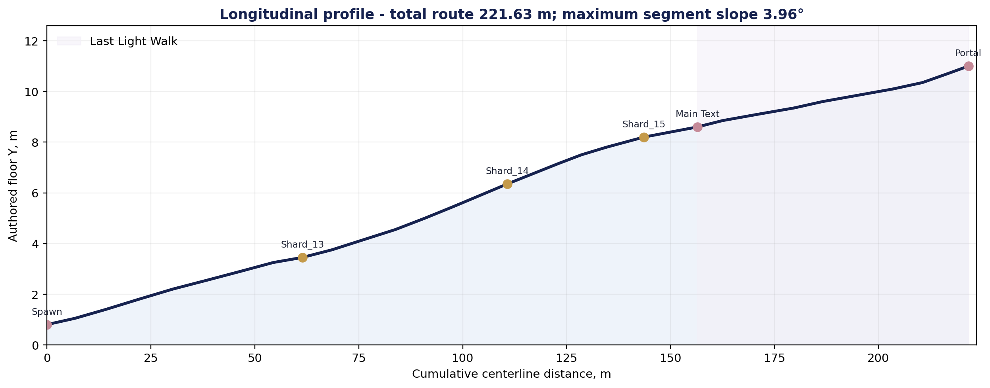
Figure 2. Recomputed v1.3 elevation profile. All authored segments remain far below the 8° mandatory maximum.
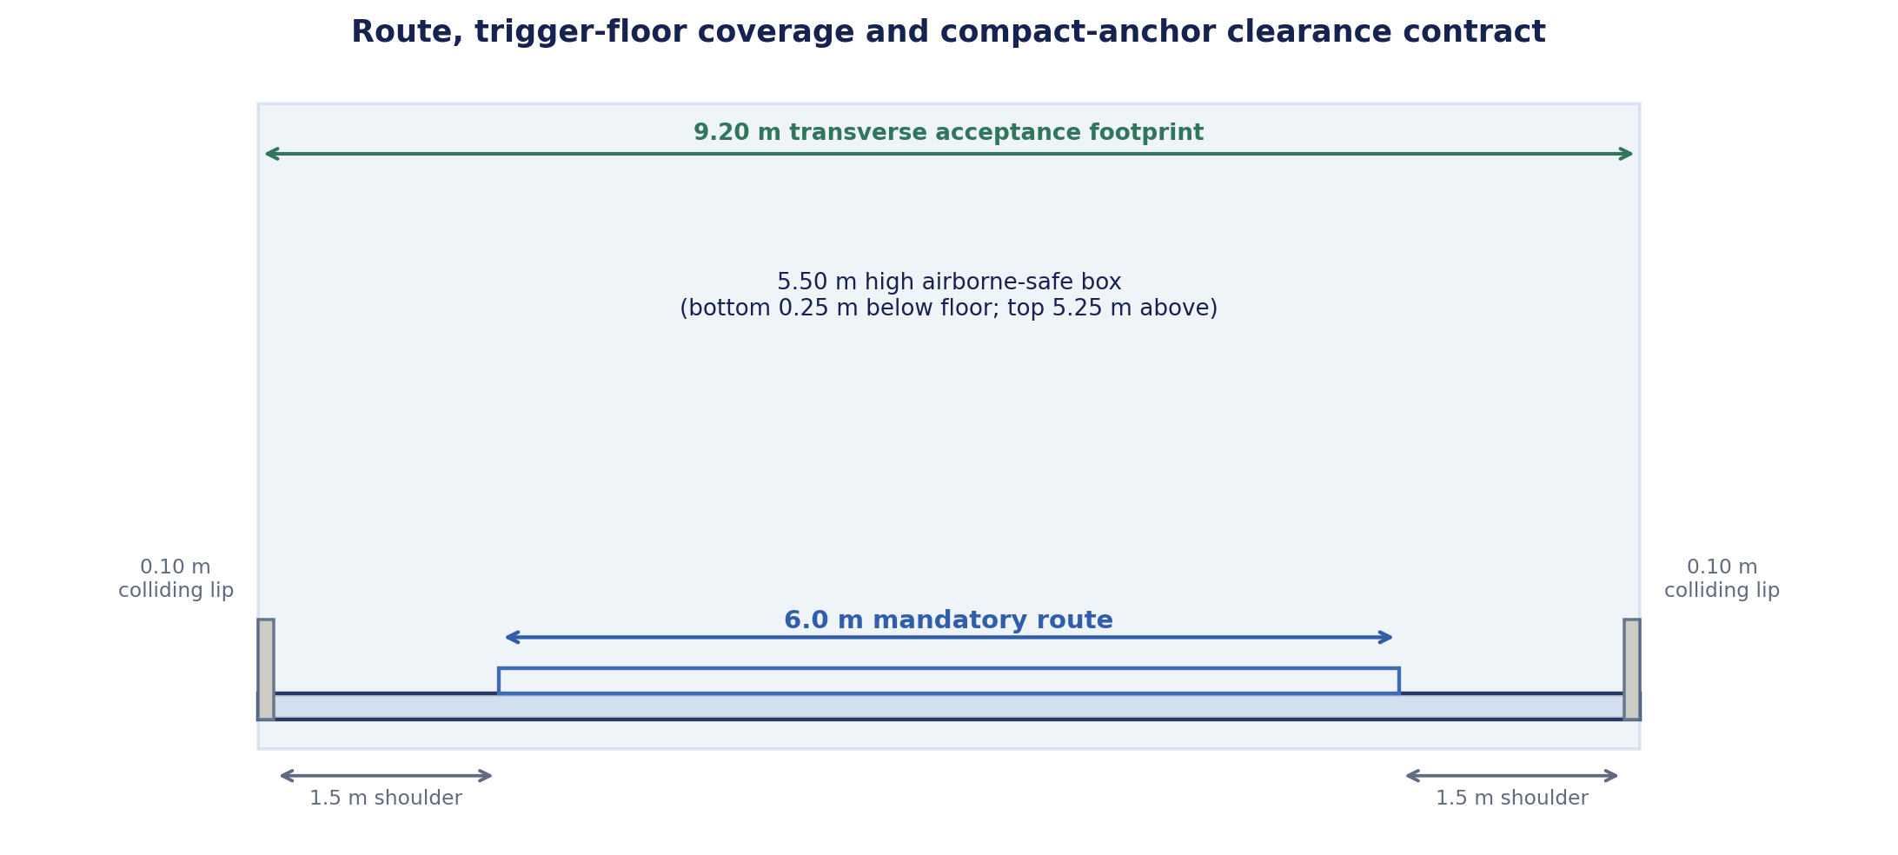
Figure 3. Route cross-section and explicit transverse trigger exception.
Contract | Exact rule | Proof / consequence
Compact-anchor setback | The 2.00 m minimum setback to a fall boundary applies to shard roots, FinalTextGate outer radius, portal InteractionArea and other compact interactable anchors. | Shard shelves and enlarged Quiet Horizon/portal pads satisfy it.
Wake/Veil exception | Transverse boxes may cover the full 9.00 m legal corridor plus 0.10 m colliding non-fall lip on each side: 9.20 m total. | They are not compact anchors and must catch any legal crossing.
Trigger-floor coverage | Every Wake/Veil XZ trigger footprint has authored collision floor under 100% of its footprint. No acceptance is permitted beyond that collision floor. | Prevents off-edge acceptance and resolves the old 2.00 m contradiction.
Remote non-adjacent route sections | For centerline segments separated by at least two intervening segments, minimum distance is 10.12 m. Subtracting two 4.50 m safe half-widths leaves 1.12 m. | No remote safe-corridor self-overlap; overlap between immediate curve-neighbor segments is intentional continuity.
Last Light versus early route | Minimum P22-P30 centerline distance to P00-P18 is 12.74 m. Subtracting two 4.50 m safe half-widths leaves 3.74 m XZ gap. | Safe corridor footprints do not overlap.
Portal pad versus early route | Conservative rotated-ellipse to buffered early-route distance is 2.45 m. | Portal pad legal floor does not overlap early route.
Deliberate edge jump | Static separation alone cannot prove no landing on lower route; RV_LAST_LIGHT_DROP_CATCHER is therefore mandatory during exit state. | No unsupported “no drop-down return” claim remains.
Envelope | All mandatory playable collision/target/compact-anchor bounds are within X +/-30 and Z +/-58. Recovery/service coverage is intentionally evaluated outside A01. | No playable-envelope exception exists; only non-playable service-volume bounds are evaluated separately.
Constellation floor containment | Let H = conv(WEST, CREST, EAST) and Z07 = H ⊕ D(5.00). Each target footprint is {center_i} ⊕ D(4.60). Since center_i belongs to H and D(4.60) is a subset of D(5.00), all three cylinders are subsets of Z07. | Z07 bounds X -25..5 and Z 42.5..58 are inside the gameplay envelope; each target has 0.40 m radial reserve.
Service-volume exception | RV_LAST_LIGHT_DROP_CATCHER reaches X +32 and RV_FALL_GLOBAL reaches X +/-38, Z +/-66 solely to cover falls. | They create no collision floor, route, target or acceptance outside the playable envelope; false-positive tests are mandatory.

5. Spawn, landmarks, sightlines and exit placement
Item | Exact placement | Required reading / proof
SpawnRoot | Vector3(-22.00, 1.80, -51.00) | Player root = floor +1.00 m; faces P01 at 72.90°.
Lower Cloud Terrace | World-aligned ellipse heading 0°; width 16.00 along X, depth 14.00 along Z. | X bounds -30..-14; Z bounds -58..-44. Exact containment passes.
First route read | P00 camera sees P01-P04, upper crescent silhouette and inactive distant portal as secondary. | Only one traversable forward route.
Shard_13 root | Vector3(15.00, 4.45, -7.50) | Broad overlook; >=2.00 m from fall boundary.
Shard_14 root | Vector3(-14.00, 7.35, 29.00) | Open shelf; upper three zones readable.
Shard_15 root | Vector3(-10.00, 9.20, 46.50) | Central plateau after 3/3 zones.
FinalTextGate | Vector3(2.50, 10.35, 49.50); cylinder R4.25 x H3.50 | Quiet Horizon platform width18/depth14 gives >=2.75 m minimum setback.
PortalFloorAnchor | Vector3(24.00, 11.00, 8.50) | Portal root on rotated 12 x 10 m pad.
Portal heading | 5.71° toward P29 | Faces back/up-route enough to remain readable but subordinate.
Portal target | res://scenes/core/FinalScene.tscn | Level_07 target is legacy drift.

Viewpoint | Must be visible | Must not dominate
P00 Arrival | One rising crescent, Wake bands, Quiet Horizon silhouette. | Dormant portal, shard VFX.
P08 Shard_13 | Persistent wakes below and transparent Veils ahead. | Constellation reward.
P15 Shard_14 | All three upper zones in one natural sweep. | Portal.
P18 Amphitheater entry | WEST / CREST / EAST zones and central plateau. | No hidden target or camera alignment.
P21 Quiet Horizon | All motifs coexist; main-text area calm. | Portal remains inactive.
P22-P29 Last Light | Active portal becomes the strongest single guide. | No alternate route or Level_07 detour.

6. Macro gameplay flow and beat-by-beat sequence
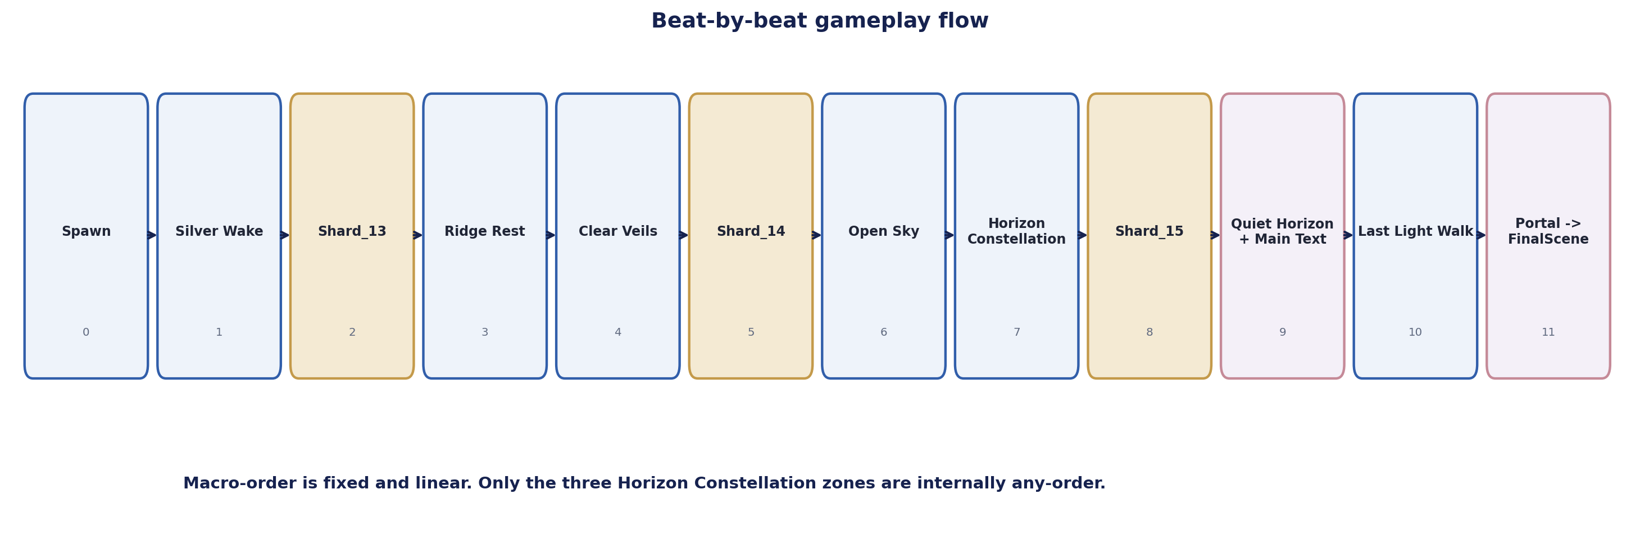
Figure 4. Fixed macro flow with internally free-order Horizon Constellation.
Beat | Zone | Gameplay | Emotional function
00 | Lower Cloud Terrace | Safe spawn; one crescent route and E0 world already alive. | Arrival / scale opens.
01 | Wake onboarding | First broad airborne-safe box teaches automatic crossing. | Presence records reaction, not life.
02 | Silver Wake | WAKE_BAND_1 -> 2 -> 3; persistent 1/3-3/3 wakes. | Beauty becomes explicit admiration.
03 | Shard_13 | Reveal, interact, exact reward, complete sequence. | Direct beauty compliment.
04 | Ridge Rest | Calm connector; no input rule. | Breath between reasons.
05 | Clear Veils | VEIL_LAYER_1 -> 2 -> 3; airborne-safe pass-through. | Existing interest gathers force.
06 | Shard_14 | Reveal, interact, exact reward, complete sequence. | Admiration for authentic engagement.
07 | Open Sky Approach | Three upper zones visible together. | Move from reasons to whole impression.
08 | Horizon Constellation | WEST / CREST / EAST any-order; grounded dwell per zone. | Independent reasons coexist.
09 | Shard_15 | Reveal, interact, exact reward; all 15 shards complete. | “Ты удивительная” payoff.
10 | Quiet Horizon | Non-interactive synthesis; no fourth puzzle. | Calm completion, no triumph.
11 | Main Text | Exact text opens once and must be accepted. | Handoff to “самое главное”.
12 | Last Light / Portal | Ordinary 65.17 m walk; portal activates calmly; transition to FinalScene. | Emotional breath, not a seventh level.

6.1 Evidence-based pacing model
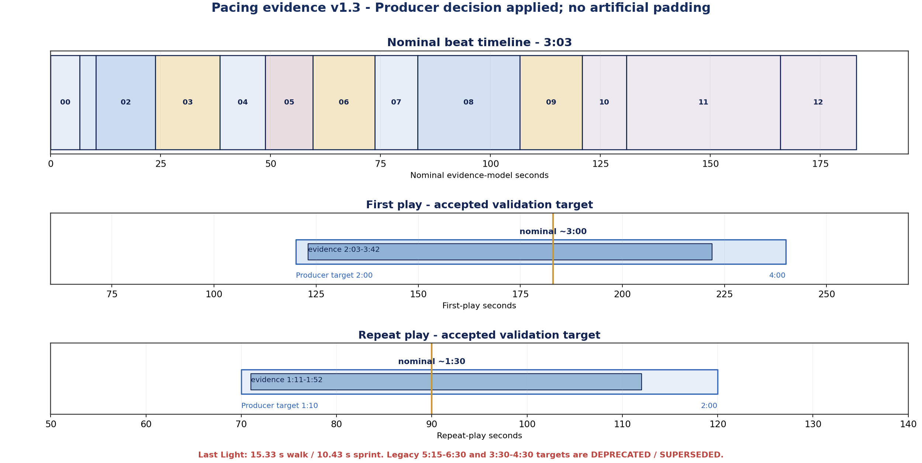
Figure 5. v1.3 pacing evidence: Producer validation targets accepted; legacy targets are deprecated and superseded.
Method: traversal uses current Player speeds (walk 4.25 m/s; run 6.25 m/s). Mandatory shard presentation uses current minimum baselines: reveal 1.20/1.25/1.35 s, SoulShard charge 1.26 s and reward overlay minimum 4.62 s. Reading and observation remain separate, voluntary allowances. Producer validates first play at 2:00-4:00, repeat at 1:10-2:00 and Last Light at about 15 s walk / about 10 s sprint.

Beat | Movement m | Walk s | Sprint s | Dwell s | Mandatory presentation s | Reading s | Observation / decision s | Nominal s | Expected bound s
00 Arrival | 6.81 | 1.60 | 1.09 | 0 | 0 | 0 | 3-8 | 6.6 | 4.1-9.6
01 Wake onboarding | 7.39 | 1.74 | 1.18 | 0 | 0 | 0 | 1-3 | 3.7 | 2.2-4.7
02 Silver Wake | 40.26 | 9.47 | 6.44 | 0 | 0 | 0 | 2-6 | 13.5 | 8.4-15.5
03 Shard_13 | 7.00 | 1.65 | 1.12 | 0 | 7.08 | 2-5 | 1-4 | 14.7 | 11.2-17.7
04 Ridge Rest | 22.35 | 5.26 | 3.58 | 0 | 0 | 0 | 3-7 | 10.3 | 6.6-12.3
05 Clear Veils | 26.91 | 6.33 | 4.31 | 0 | 0 concurrent | 0 | 2-7 | 10.8 | 6.3-13.3
06 Shard_14 | 0 | 0 | 0 | 0 | 7.13 | 3-6 | 1-4 | 14.1 | 11.1-17.1
07 Open Sky | 17.83 | 4.20 | 2.85 | 0 | 0 | 0 | 3-8 | 9.7 | 5.9-12.2
08 Constellation | 38.58-61.84 | 9.08-14.55 | 6.17-9.89 | 1.80 | 0; rise concurrent | 0 | 4-12 | 23.3 | 12.0-28.4
09 Shard_15 | 0 | 0 | 0 | 0 | 7.23 | 3-6 | 1-4 | 14.2 | 11.2-17.2
10 Quiet Horizon | 12.86 | 3.03 | 2.06 | 0 | 0 | 0 | 4-10 | 10.0 | 6.1-13.0
11 Main Text | 0 | 0 | 0 | 0 | 0 forced | 26-36 | 2-6 | 35.0 | 28-42
12 Last Light | 65.17 | 15.33 | 10.43 | 0 | 0; activation concurrent | 0 | 0-4 | 17.3 | 10.4-19.3

Aggregate | Evidence result
Required movement | 245.16-268.42 m depending on Constellation permutation; median model 264.11 m.
Pure traversal | Normal walk 57.69-63.16 s, median 62.14 s; sprint 39.23-42.95 s, median 42.26 s.
Mechanics without reading | Approximately 1:25 normal median or 1:06 sprint median, including 1.80 s dwell and 21.44 s shard presentation.
First play | Producer target 2:00-4:00, nominal about 3:00. Current evidence 2:03-3:42; PASS.
Repeat play | Producer target 1:10-2:00, nominal about 1:30. Current evidence 1:11-1:52; PASS.
Last Light Walk | 15.33 s at normal walk and 10.43 s at sprint. Both match the Producer decision; sprint remains allowed.
Constellation permutations | W-C-E 38.58 m; W-E-C 43.61 m; C-W-E 58.26 m; C-E-W 58.26 m; E-W-C 61.84 m; E-C-W 56.80 m. Centers unchanged; all values independently recomputed.
Deprecated targets | 5:15-6:30 first play and 3:30-4:30 repeat are DEPRECATED / SUPERSEDED BY PRODUCER DECISION and are not active acceptance criteria.

PRODUCER PACING DECISION - DESIGN LOCK
Validate first play at 2:00-4:00 with nominal about 3:00; repeat at 1:10-2:00 with nominal about 1:30; Last Light at about 15 s walking and about 10 s sprinting. Preserve evidence ranges 2:03-3:42 and 1:11-1:52. Do not add forced waits, a fourth puzzle, hidden collectibles, mandatory sightseeing, artificial slowing or a separate playable scene.

7. Abstract progression and persistence model
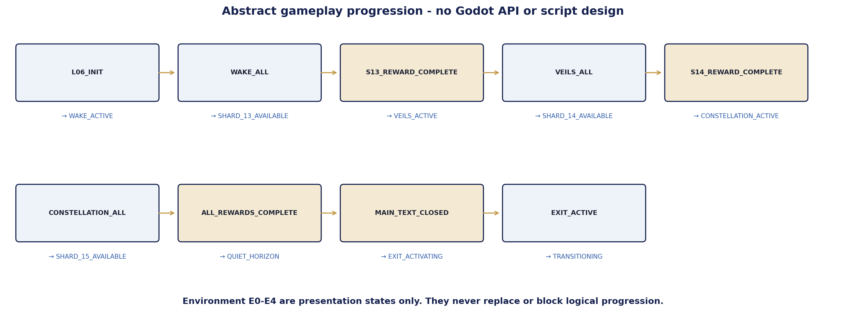
Figure 6. Monotonic logical state flow. E0-E4 remain presentation states, not alternate progression.
State | Entry condition | Canonical result
L06_INIT / WAKE_ACTIVE | Scene clean-load complete | Only WAKE_BAND_1 is current; E0.
WAKE_1 | WAKE_BAND_1 accepted | Current target becomes WAKE_BAND_2.
WAKE_2 | WAKE_BAND_2 accepted | Current target becomes WAKE_BAND_3.
SHARD_13_REVEALING / AVAILABLE | WAKE_BAND_3 accepted; reveal settles/fallback | Exactly one Shard_13 can be collected.
VEILS_ACTIVE | SHARD_13 reward sequence complete | Only VEIL_LAYER_1 is current; E1 cue.
VEIL_1 / VEIL_2 | Current ordered layer accepted | Next layer becomes current.
SHARD_14_REVEALING / AVAILABLE | VEIL_LAYER_3 accepted; settle/fallback | Exactly one Shard_14 can be collected.
CONSTELLATION_ACTIVE | SHARD_14 reward sequence complete | All three zones active, any-order; E2 cue.
CONSTELLATION_PARTIAL | One or two unique zones accepted | Completed groups persist; no reset.
SHARD_15_REVEALING / AVAILABLE | All three zones accepted; shared pulse/fallback | Exactly one Shard_15 can be collected.
ALL_REWARDS_COMPLETE | SHARD_15 reward sequence complete | E3, Quiet Horizon and FinalTextGate eligibility.
MAIN_TEXT | Eligible gate entered/overlapped | Main text opens exactly once; controls locked while visible.
MAIN_TEXT_CLOSED / EXIT_ACTIVATING | Accepted close | Last Light guidance and shared portal activation request.
EXIT_ACTIVE / TRANSITION | Shared activation completes | AUTO_ENTER to FinalScene; exactly one transition.

- All progress sets are unique-ID monotonic sets; no blind count += 1 authority.
- Local optional VFX callbacks may use bounded fallbacks but never synthesize shared LevelPortal success.
- A future target overlapping the Player is re-evaluated when it becomes current; exit/re-entry is never required.
- Missing environment callbacks cannot block gameplay, but missing exact main-text presentation fails closed.

8. Silver Wake - complete deterministic puzzle specification
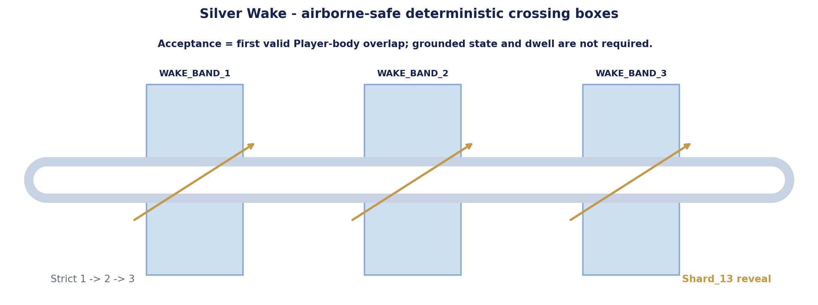
Figure 7. Silver Wake canonical airborne-safe crossing contract.
Field | Canonical v1.3 contract
Prerequisite | L06_INIT / WAKE_ACTIVE. Only current ordered target is eligible.
Input | First valid continuous overlap between the Player CharacterBody3D and the current target box. Grounded state is irrelevant.
Volume | Oriented box 9.20 m across route x 5.50 m high x 6.00 m along route. Bottom floor -0.25 m; top floor +5.25 m.
Dwell / crossing | 0.00 s dwell. Acceptance occurs on the first physics evaluation that confirms current-target overlap.
Airborne behavior | Walk, sprint, ordinary jump and jump-spam accept identically while the Player body intersects the box.
Strict order | WAKE_BAND_1 -> 2 -> 3. Future-target overlap is ignored until that target becomes current. If still overlapping at activation, it accepts on the next physics evaluation without exit/re-entry.
Duplicate handling | Each ID accepted exactly once. Repeated enter/exit, multiple overlap callbacks or re-evaluation after acceptance are ignored.
Feedback | Immediate local glint and persistent wake 1/3, 2/3, 3/3; audio optional.
Assistance | After 15 s without new accepted progress, only the current band receives a slow non-flashing glint.
Wrong input | No punishment, reset, door, damage or forced backtrack. Non-current targets simply do not advance progress.
Leave/re-enter | Accepted IDs persist. Incomplete current target remains available.
No-softlock proof | The box spans all legal crossing width, adds colliding lips, covers the ordinary jump body envelope and is 6 m long. At 6.25 m/s the Player remains in it for approximately 0.96 s, so normal movement cannot cross silently between physics evaluations.

8.1 Silver Wake exact target transforms
ID | Center | Heading | Local size A x H x L | Acceptance
WAKE_BAND_1 | Vector3(-9.00, 3.90, -45.50) | 58.39° | 9.20 x 5.50 x 6.00 | Player-body overlap; 0.00 s
WAKE_BAND_2 | Vector3(-2.50, 4.30, -41.00) | 51.34° | 9.20 x 5.50 x 6.00 | Player-body overlap; 0.00 s
WAKE_BAND_3 | Vector3(3.50, 4.70, -35.50) | 42.51° | 9.20 x 5.50 x 6.00 | Player-body overlap; 0.00 s

8.2 Shard_13 reveal and reward sequence
- WAKE_BAND_3 acceptance commits WAKE_COMPLETE exactly once.
- Shard_13 reveal begins at Vector3(15.00, 4.45, -7.50); authored reveal target 1.20 s with bounded local presentation fallback.
- Only Shard_13 is interactable. Shared shard charge and exact short reward run.
- Logical progression advances only after Shard_13 reward sequence completes, then E1 and VEILS_ACTIVE become eligible.

9. Clear Veils - complete deterministic puzzle specification
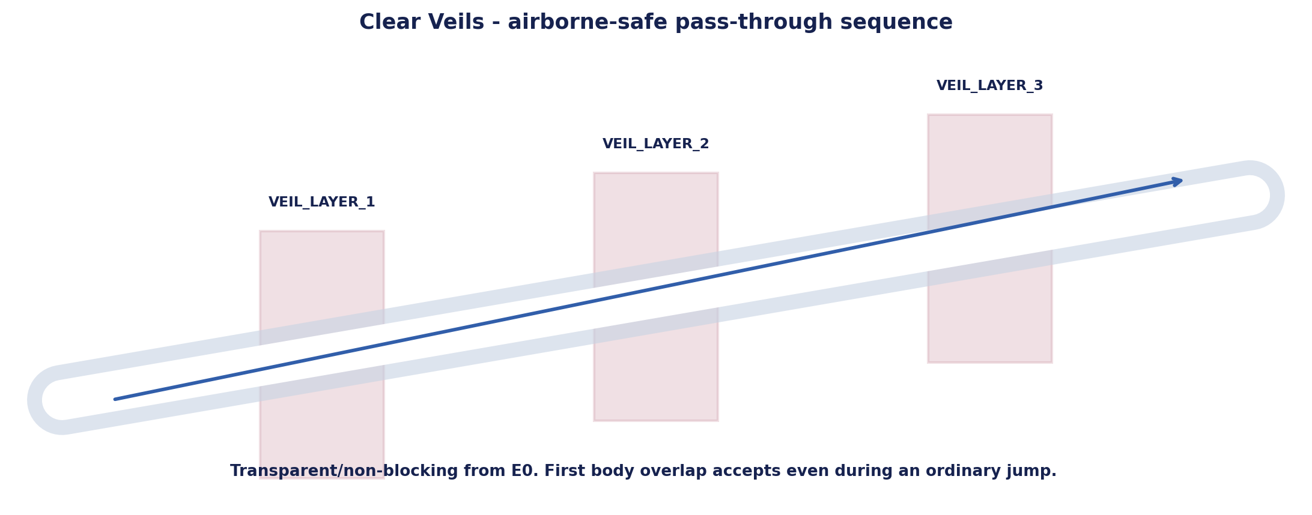
Figure 8. Clear Veils canonical airborne-safe pass-through contract.
Field | Canonical v1.3 contract
Prerequisite | SHARD_13_REWARD_COMPLETE / VEILS_ACTIVE. Only current ordered layer is eligible.
Input | First valid continuous Player-body overlap with the current transparent veil box; grounded state is irrelevant.
Volume | Oriented box 9.20 m across x 5.50 m high x 6.00 m along; bottom floor -0.25 m, top floor +5.25 m. Veil visual never blocks collision route.
Dwell / crossing | 0.00 s. Acceptance is immediate on first current-target overlap.
Airborne behavior | Airborne passage, boundary jumping and repeated airborne enter/exit are accepted once exactly like grounded passage.
Strict order | VEIL_LAYER_1 -> 2 -> 3. A future layer does not advance early; if it becomes current while Player remains inside, next-physics acceptance occurs without re-entry.
Feedback | Existing motion briefly strengthens and sends a restrained vertical pulse; route motif persists 1/3-3/3.
Presentation fallback | Missing parting/current callback may fall back after 2.50 s, but logical acceptance and next-target eligibility do not wait for it. Third-layer reveal may wait for settle or the bounded fallback.
Assistance | After 15 s without progress, current unvisited layer receives edge motes.
Wrong input / duplicates | No collision blocking, reset or penalty. Non-current overlap is ignored; accepted ID and callback duplicates are ignored.
Leave/re-enter | Accepted layers persist; current layer remains available.
No-softlock proof | Full corridor width, colliding lips, 5.50 m vertical coverage and 6.00 m along-route length prevent ordinary walk/run/jump from bypassing the required current layer.

9.1 Clear Veils exact target transforms
ID | Center | Heading | Local size A x H x L | Acceptance
VEIL_LAYER_1 | Vector3(2.50, 7.50, 18.50) | -43.53° | 9.20 x 5.50 x 6.00 | Player-body overlap; 0.00 s
VEIL_LAYER_2 | Vector3(-2.50, 7.95, 23.00) | -52.70° | 9.20 x 5.50 x 6.00 | Player-body overlap; 0.00 s
VEIL_LAYER_3 | Vector3(-8.00, 8.40, 26.50) | -62.45° | 9.20 x 5.50 x 6.00 | Player-body overlap; 0.00 s

9.2 Shard_14 reveal and reward sequence
- VEIL_LAYER_3 acceptance commits VEILS_COMPLETE once; presentation settles or bounded fallback completes.
- Shard_14 reveal begins at Vector3(-14.00, 7.35, 29.00); authored reveal target 1.25 s.
- Shared collection and exact Shard_14 reward run; duplicate request cannot create a second reward.
- After complete reward sequence, E2 and CONSTELLATION_ACTIVE become eligible.
CLEAR ARCHES STATUS EMERGENCY FALLBACK ONLY
Clear Veils remains the primary locked concept. Clear Arches is not an implementation option inside this spec; it requires a documented visual/gameplay blocker and separate Producer approval.

10. Horizon Constellation - complete deterministic puzzle specification
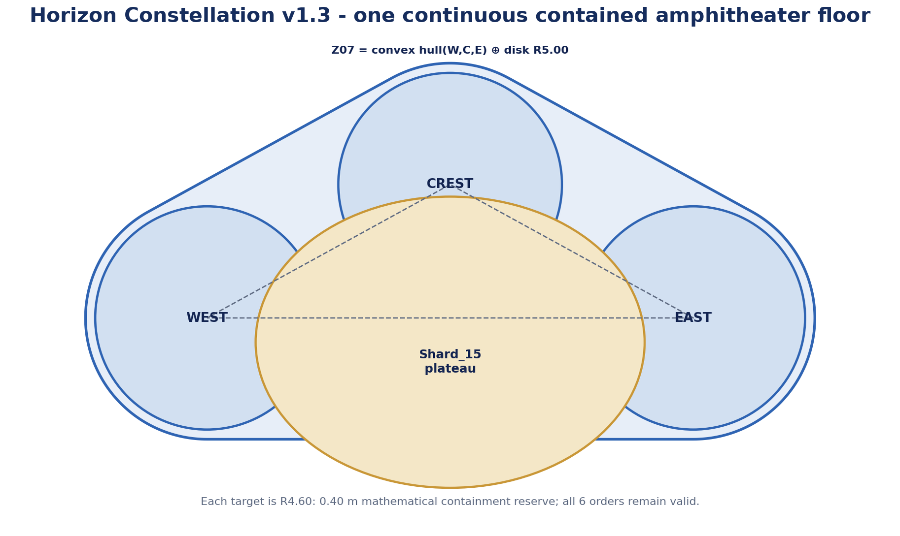
Figure 9. Horizon Constellation v1.3: all three R4.60 zones lie on one exact offset-hull amphitheater floor and remain completable in any order.
Field | Canonical v1.3 contract
Prerequisite | SHARD_14_REWARD_COMPLETE / CONSTELLATION_ACTIVE. All three unique zones eligible together.
Input | Grounded Player-body presence inside a zone cylinder for accumulated 0.60 s. No camera direction, E input or audio cue required.
Volume | Cylinder radius 4.60 m, height 3.50 m; each full XZ footprint is contained by the single Z07 offset-hull floor with 0.40 m reserve.
Airborne behavior | Airborne overlap alone does not advance. Landing while still inside begins/resumes dwell without exit/re-entry. Jumping pauses, not resets, dwell while airborne; leaving the volume resets only incomplete dwell.
Order | WEST, CREST and EAST in any order. Each unique ID accepted once.
Feedback | Accepted group rises to its own height and persists. After 3/3, one horizontal pulse appears; groups remain separate.
Assistance | At 20 s without progress, nearest unvisited zone gains low path motes; at 35 s, all remaining zones gain restrained ground crescents.
Wrong input / duplicate | No penalty or reset. Duplicate overlap, dwell completion or animation completion is ignored.
Leave/re-enter | Completed zones persist. Incomplete dwell resets only on actual volume exit; jumping in place does not erase it.
No-softlock proof | All zones are visible from entry, broad, on one safe floor and independent; missing rise callback uses 1.40 s bounded local fallback.

10.1 Horizon Constellation exact target transforms
ID | Center | Volume | Grounded dwell | Light-group target
CONSTELLATION_WEST | Vector3(-20.00, 9.25, 47.50) | R4.60 x H3.50; Z07 reserve 0.40 m | 0.60 s | Low / west independent height
CONSTELLATION_CREST | Vector3(-10.00, 9.95, 53.00) | R4.60 x H3.50; Z07 reserve 0.40 m | 0.60 s | Highest / crest independent height
CONSTELLATION_EAST | Vector3(0.00, 9.40, 47.50) | R4.60 x H3.50; Z07 reserve 0.40 m | 0.60 s | Mid / east independent height

Exact containment proof: H = conv{(-20.00,47.50), (-10.00,53.00), (0.00,47.50)} in XZ and Z07 = H ⊕ D5.00. Each target is {center_i} ⊕ D4.60; therefore each target is a subset of Z07 with 0.40 m reserve. Z07 bounds are X -25.00..+5.00 and Z 42.50..58.00, entirely inside the gameplay envelope. Zone centers, all six decision-route distances and pacing values remain unchanged.

10.2 Shard_15 reveal and reward sequence
- Third unique zone acceptance commits CONSTELLATION_COMPLETE; shared pulse settles or 1.40 s fallback.
- Shard_15 reveal begins at Vector3(-10.00, 9.20, 46.50); authored reveal target 1.35 s.
- Shared collection and exact Shard_15 reward run.
- Only completed reward sequence commits ALL_REWARDS_COMPLETE, E3 and Quiet Horizon eligibility.

11. Shard, reward and environment progression contracts
Shard | Prerequisite | Reveal / availability | Reward-complete transition | Environment effect
Shard_13 | All Wake IDs accepted | 1.20 s reveal or bounded local fallback; one active root. | SHARD_13_REWARD_COMPLETE -> VEILS_ACTIVE | E1: wakes persist; Veils shelf becomes clearer.
Shard_14 | All Veil IDs accepted | 1.25 s reveal after settle/fallback; one active root. | SHARD_14_REWARD_COMPLETE -> CONSTELLATION_ACTIVE | E2: upper crescents become clearer.
Shard_15 | All Constellation IDs accepted | 1.35 s reveal after shared pulse/fallback; one active root. | SHARD_15_REWARD_COMPLETE -> ALL_REWARDS_COMPLETE | E3: motifs coexist; Quiet Horizon primary; portal dormant.

Environment state | Presentation only | Failure rule
E0 Initial | Grass, Veils and light groups already move; route readable; portal inactive. | Missing ambience never blocks gameplay.
E1 | Wake persists and next shelf silhouette strengthens. | Callback may time out locally.
E2 | Constellation zones gain readable low contrast; prior motifs continue. | Callback may time out locally.
E3 | All motifs coexist; Quiet Horizon reads as next destination. | Portal remains inactive until main-text close.
E4 | After main-text close, Last Light guidance and portal activation begin calmly. | Shared portal failure remains fail-closed.

11.1 Mandatory shard presentation and concurrent-request prerequisite
- Shard_13-15 exact reward texts are mandatory narrative content. The canonical ShardRewardOverlay must display each exact string character-for-character and keep it visible until Player confirmation.
- Missing ShardRewardOverlay, active Camera3D or another mandatory presentation dependency may use shared safe logical completion only to prevent permanent Player/control lock. The defect must emit a hard diagnostic and is RELEASE BLOCKING.
- Generic PoemRewardUI, empty reward_text, fallback "..." or any non-canonical text is not an acceptable production fallback. Production acceptance requires all three exact texts to appear and remain until confirmation.
- Only the canonical current shard may be registered with or allowed to request the shared reward controller. Hidden, non-current and completed shards are blocked by a Level_06-local gate before the shared controller.
- A concurrent second-shard request is intercepted before ShardRewardSequenceController: it does not call complete_collection_sequence, does not emit collected and does not change macro-state. Test builds emit a hard diagnostic.
- Duplicate request from the same current shard is idempotent. A delayed callback from a previous shard is rejected by shard ID plus active-sequence generation and cannot advance state.
- The current shared controller behavior is incompatible with an unguarded concurrent request. A project-wide shared-controller change is not assumed; if local gating cannot satisfy the contract, Technical Architecture must request a narrow prerequisite decision.
- Progress records a shard only after its canonical reward sequence completes; presentation-safe completion may preserve runtime continuity but cannot make a defective build release-acceptable.

12. Main-text gate, Quiet Horizon and exit contract
Stage | Canonical behavior
Quiet Horizon | After ALL_REWARDS_COMPLETE, E3 synthesis runs without interaction. No fourth puzzle, collectible or triumph sequence.
Eligibility | FinalTextGate becomes eligible only after all three unique reward completions. If Player is already inside, eligibility is evaluated on the next physics step; no exit/re-entry.
Main text | Exact Section 3 text opens once. Controls lock only while overlay is visible. Missing canonical text/overlay is BLOCK and cannot be treated as success.
Close | Only accepted close commits MAIN_TEXT_CLOSED. Duplicate close signals are ignored.
Exit activation | After close, E4 and Last Light guidance begin and Level_06 requests shared LevelPortal activation. Local code does not synthesize activation_completed.
Last Light | P21-P30, 65.17 m, ordinary traversal, no new rule/text/timer. Producer validation: 15.33 s normal walk, 10.43 s sprint.
Portal | LevelPortal root P30, AUTO_ENTER, require_entry_confirmation = false, future target FinalScene.
Transition failure | Fail closed. No Level_06-local change_scene_to_file, timeout-success or portal bypass.

12.1 Stationary early-overlap prerequisite
MANDATORY RUNTIME CONTRACT RUNTIME VALIDATION REQUIRED
If the Player enters the future portal InteractionArea while it is inactive and remains inside through activation: no early transition occurs; after activation exactly one transition occurs without exit/re-entry. Rapid boundary spam and duplicate activation completion cannot cause a second transition. Static inspection does not prove this. If the shared portal fails the Godot runtime test, Technical Architecture must stop and request an approved narrow shared prerequisite; Level_06-local scene loading remains forbidden.

13. Progress preservation, leave/re-enter and reload policy
Situation | Required behavior
Leave puzzle zone | All accepted unique IDs and completed shard rewards persist. No local reset.
Return to current target | Current unaccepted target remains eligible; assistance timer may restart only from most recent progress.
Future target overlap | Ignored while not current. If still overlapping when it becomes current, next-physics acceptance occurs without re-entry.
Reward/main-text lock | Movement controls locked; logical state and pending recovery retained.
Scene full reload | Clean reset to L06_INIT, E0 and SpawnRoot; no accepted target IDs, collected shards, open UI, active portal or pending recovery.
Partial checkpoint/save | Not approved. No mid-level persistence contract.

- Unique IDs are immutable strings and accepted once.
- Logical progression is monotonic within a run and cannot decrement.
- Visual callbacks never become the sole authority for logical completion.

14. Fall recovery and no-softlock policy
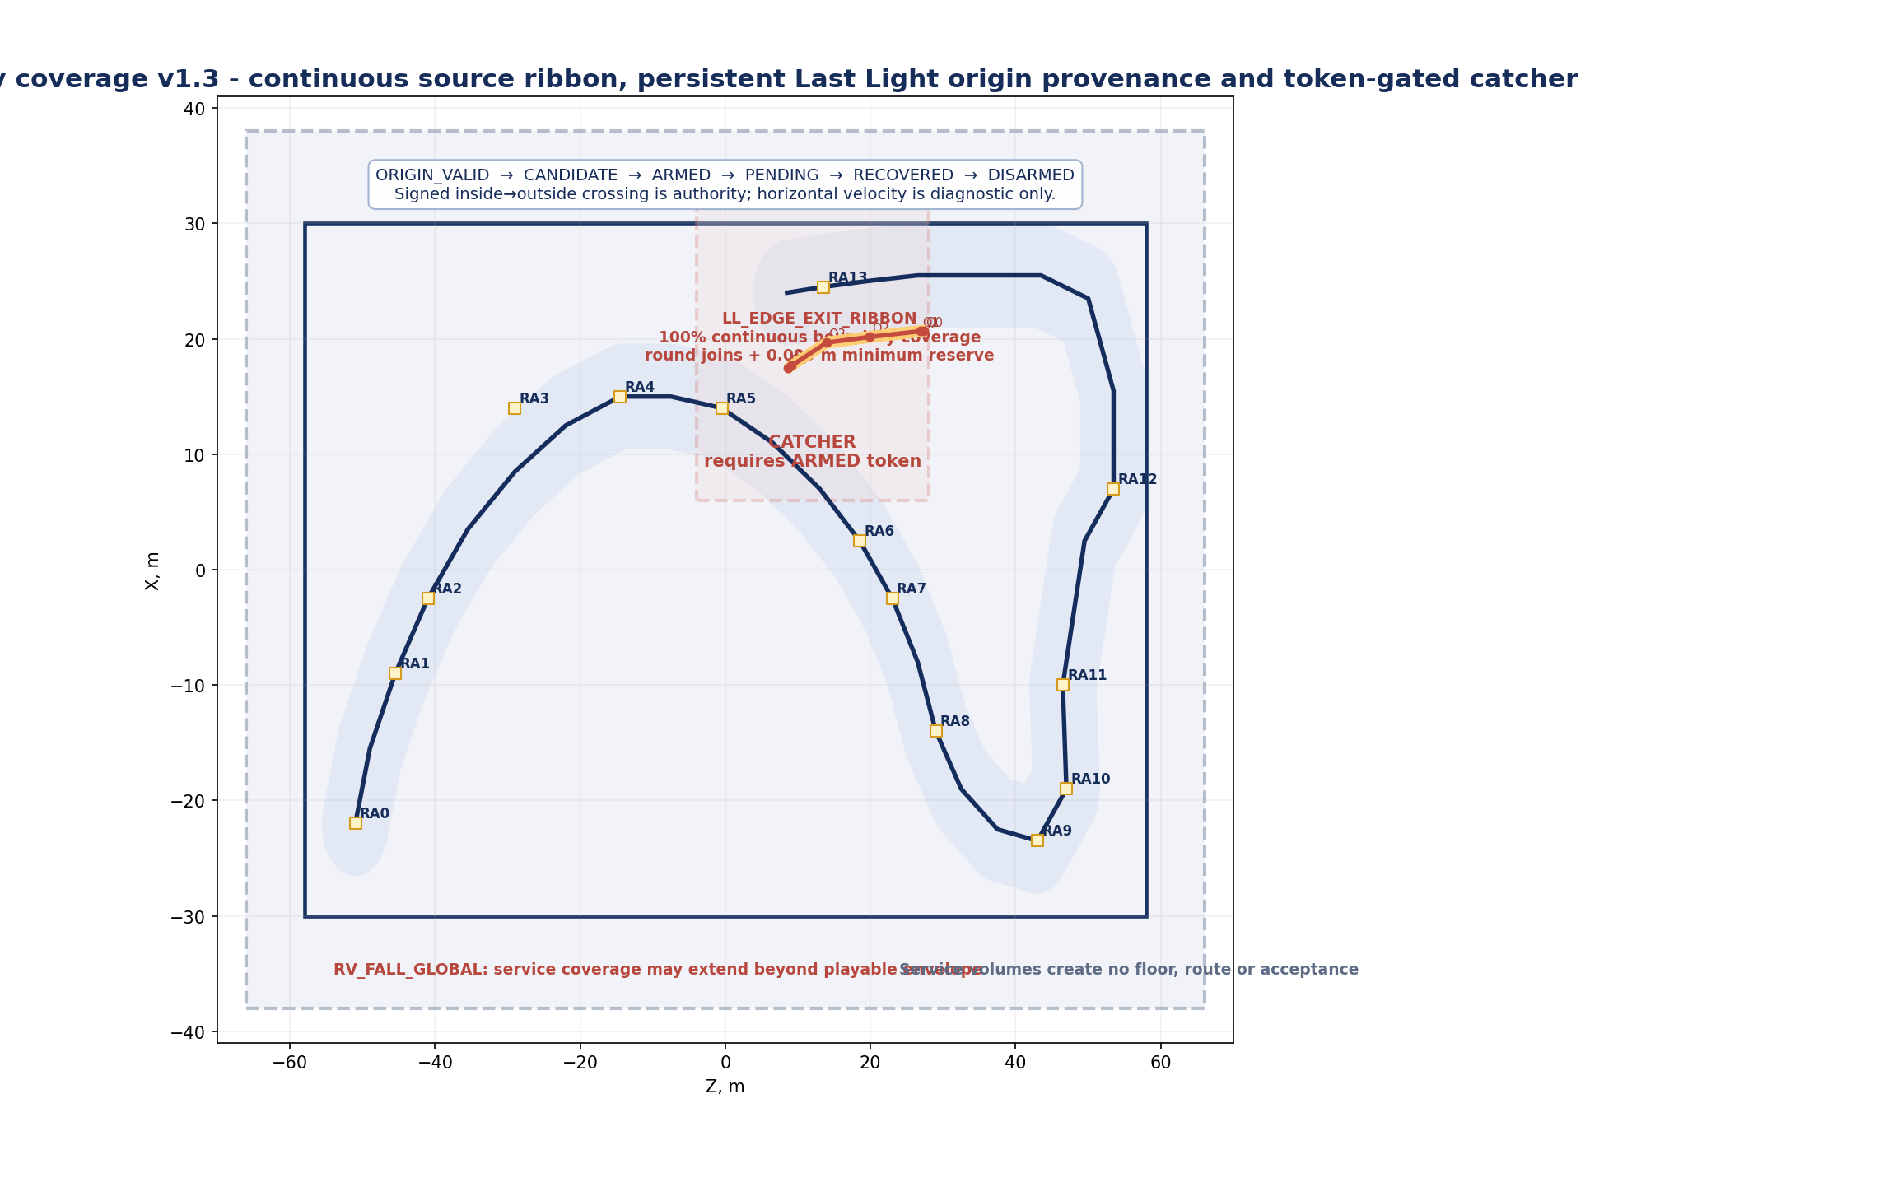
Figure 10. v1.3 recovery coverage: continuous swept source ribbon, persistent Last Light origin provenance, token-gated catcher and shared local/global event lifecycle.

14.1 Global below-world recovery
Field | Contract
ID | RV_FALL_GLOBAL
Shape | Box center Vector3(0.00, -9.00, 0.00), size Vector3(76.00, 12.00, 132.00); top threshold Y = -3.00. This is a recovery/service volume and may extend beyond the playable envelope.
Trigger | First valid Player-body entry creates one latched pending fall event.
Control lock | If reward/main-text/portal lock is active, pending event survives until unlock; no repeat body_entered required.
Cancellation | Only proven grounded return to legal playable collision before unlock cancels pending recovery.
Teleport | Exactly once to RA_LATEST_VALID; velocity zeroed through verified public behavior or Technical Architecture-approved equivalent.
Re-arm | No second recovery until Player exits destination safety footprint.
Interaction with local event | If a Last Light token reaches RV_FALL_GLOBAL, local and global recovery reuse the same event token. Exactly one recovery occurs; source provenance, candidate/armed/pending state and global entry cannot double-teleport.

14.2 Last Light drop catcher - canonical safety solution
Field | Exact contract
ID | RV_LAST_LIGHT_DROP_CATCHER + LL_EDGE_EXIT_RIBBON
Catcher shape / bounds | Axis-aligned service box center Vector3(19.00, 7.00, 12.00), size Vector3(26.00, 7.00, 32.00); bounds X 6..32, Y 3.50..10.50, Z -4..28.
Service classification | The catcher and source ribbon may extend beyond the playable envelope only for fall coverage. They create no floor, route, standable geometry or gameplay acceptance and are excluded from A01.
Dangerous legal-floor boundary B | XZ polyline with tangent end extensions: B0 (21.047,27.319), B1/P27 (21.011,26.821), B2/P28 (20.513,19.847), B3/P29 (20.019,13.911), B4/P30-pad edge (18.030,9.097), B5 (17.839,8.635). Inside is the Last Light/portal legal-floor side; outside is the catcher side.
Source ID / shape | LL_EDGE_EXIT_RIBBON. One XZ swept ribbon S ⊕ D0.45, vertically extruded through Y 9.50..13.50. Round joins and round end caps are mandatory; it is one logical source, not four independent boxes.
Ribbon vertices Q0-Q5 | Q0 (20.698,27.344), Q1 (20.662,26.846), Q2 (20.164,19.874), Q3 (19.670,13.943), Q4 (17.682,9.132), Q5 (17.491,8.670), all in (X,Z). Q0/Q5 provide 0.50 m tangent endpoint reserve.
LLR_SEG_P27_CAP | Q0->Q1; length 0.500 m; heading -175.91 degrees.
LLR_SEG_P27_P28 | Q1->Q2; length 6.989 m; heading -175.91 degrees.
LLR_SEG_P28_P29 | Q2->Q3; length 5.952 m; heading -175.24 degrees.
LLR_SEG_P29_P30 | Q3->Q4; length 5.206 m; heading -157.54 degrees; exact widening transition toward the 6.00 m portal-pad half-width.
LLR_SEG_P30_CAP | Q4->Q5; length 0.500 m; heading -157.54 degrees.
Ribbon bounds | XZ bounds X 17.041..21.148 and Z 8.220..27.794 after the R0.45 sweep; Y 9.50..13.50. These bounds do not create playable-envelope authority.
Continuous-coverage proof | Maximum Hausdorff distance from dangerous boundary B to ribbon centerline S is 0.351 m. Ribbon radius is 0.450 m, therefore every boundary point is covered with at least 0.099 m reserve. Adjacent segments share the complete R0.45 corner disk, so union gaps are exactly 0.000 m and do not rely on Player collision size.
Lower-route separation proof | Minimum centerline distance from S to P00-P18 is 6.820 m. Subtract early-route safe half-width 4.500 m and ribbon radius 0.450 m: minimum positive separation = 1.870 m. The source ribbon does not enter Ridge Rest, Clear Veils, Open Sky or other lower legal floor.
Activation state | Source and catcher evaluation begins only at MAIN_TEXT_CLOSED / EXIT_ACTIVATING and later. Before that they are logically inactive.
Persistent origin provenance | LAST_LIGHT_ORIGIN_VALID is set when the last proven grounded support is authored Last Light or portal legal floor. It persists through jump/ascent/fall. Grounded landing on another legal floor replaces it with lower-floor provenance. Safe grounded return cancels the event and starts a new Last Light origin epoch. Recovery teleport, scene reload and transition start clear it.
Source candidate | Create SOURCE_CANDIDATE when MAIN_TEXT_CLOSED+, LAST_LIGHT_ORIGIN_VALID is true, and the Player motion segment makes a signed inside->outside crossing of boundary B within LL_EDGE_EXIT_RIBBON. Grounded state is not required. Horizontal velocity dot outward_normal is diagnostic only and never an acceptance threshold; signed crossing is authority.
Arming condition | Promote CANDIDATE to ARMED only while outside Last Light/portal legal floor and either velocity.y <= -0.25 m/s or Player root is at least 0.20 m below the local source floor plane. A candidate may be created during ascent and waits for descent/below-plane arming.
Catcher condition | Promote ARMED to PENDING only when Player-body overlaps RV_LAST_LIGHT_DROP_CATCHER, remains outside legal Last Light/portal floor and is descending. Commit recovery before any lower legal-floor landing.
Lower-route exclusion | Ridge Rest, Clear Veils, Open Sky and all lower/side trajectories have NO LAST_LIGHT ORIGIN after proven grounded support there. Entering the ribbon/catcher from below or side is IGNORED. Grounded backtracking, jump and run-jump on lower legal floors cannot create a candidate.
Safe return anchor | Use RA12 before EXIT_ACTIVE; use RA13 after EXIT_ACTIVE and before transition starts.
Cancellation / disarm | Grounded return to proven Last Light/portal legal floor before teleport cancels CANDIDATE/ARMED/PENDING and re-establishes a fresh origin epoch. Recovery commits once, clears origin, teleports, then DISARMS; a new token requires post-recovery grounded Last Light provenance and a later new signed crossing.
Duplicate behavior | One event token per departure. Duplicate ribbon callbacks, corner crossings, catcher overlaps, boundary spam and RV_FALL_GLOBAL entry reuse the same token and cannot create a second teleport.
Coverage result | All grounded, airborne, shallow-angle and corner exits along P27-P30 are source-qualified by geometry and provenance, then intercepted before early-route landing. Lower-route presence in catcher bounds remains insufficient without LAST_LIGHT_ORIGIN_VALID and signed inside->outside crossing.

14.3 Canonical-state recovery anchors
Anchor | Position | Earliest valid canonical state | Use
RA0 | Vector3(-22.00, 1.80, -51.00) | L06_INIT+ | Spawn safety footprint.
RA1 | Vector3(-9.00, 2.40, -45.50) | WAKE_BAND_1 accepted+ | After first Wake.
RA2 | Vector3(-2.50, 2.80, -41.00) | WAKE_BAND_2 accepted+ | After second Wake.
RA3 | Vector3(8.50, 3.55, -29.00) | WAKE_COMPLETE / SHARD_13_REVEALING+ | Upper Wake curve.
RA4 | Vector3(15.00, 4.25, -14.50) | SHARD_13_AVAILABLE+ | Overlook entry, outside shard root.
RA5 | Vector3(14.00, 4.75, -0.50) | SHARD_13_REWARD_COMPLETE / VEILS_ACTIVE+ | Ridge Rest lower.
RA6 | Vector3(2.50, 6.00, 18.50) | VEIL_LAYER_1 accepted+ | Veil lane 1.
RA7 | Vector3(-2.50, 6.45, 23.00) | VEIL_LAYER_2 accepted+ | Veil lane 2.
RA8 | Vector3(-14.00, 7.35, 29.00) | VEILS_COMPLETE / SHARD_14_AVAILABLE+ | Shard_14 shelf.
RA9 | Vector3(-23.50, 8.50, 43.00) | SHARD_14_REWARD_COMPLETE / CONSTELLATION_ACTIVE+ | Amphitheater entry; no forward skip.
RA10 | Vector3(-19.00, 8.80, 47.00) | CONSTELLATION_PARTIAL+ | Inner approach; completed zones persist.
RA11 | Vector3(-10.00, 9.20, 46.50) | SHARD_15_AVAILABLE / ALL_REWARDS_COMPLETE+ | Central plateau.
RA12 | Vector3(7.00, 9.85, 53.50) | MAIN_TEXT_CLOSED / EXIT_ACTIVATING+ | Last Light safe start.
RA13 | Vector3(24.50, 11.70, 13.50) | EXIT_ACTIVE / portal activation+ | Portal approach outside InteractionArea.

A future anchor never becomes RA_LATEST_VALID before its canonical state. Grounded presence near a future anchor is ignored. Recovery cannot teleport the Player forward through narrative progression.

15. Failure and softlock matrix
Failure / abuse | Condition | Deterministic result | No-softlock guarantee
Airborne Wake crossing | Player jumps/runs through current band. | Player-body overlap accepts once; no grounded gate. | No backtrack, no reset.
Wake wrong-order overlap | Player overlaps future band. | Ignored until current; if still inside after promotion, next-physics acceptance. | Strict order preserved.
Airborne Veil crossing | Player passes through current Veil in air. | Accept once; visual parting is optional presentation. | No collision door.
Repeated airborne enter/exit | Boundary spam generates callbacks. | Unique ID latch commits once. | No duplicate progress.
Constellation jump | Player jumps while dwell active. | Dwell pauses in air and resumes on landing inside. | No accidental airborne acceptance.
Constellation floor defect | Any R4.60 target footprint lacks authored floor. | P0 containment failure; level cannot pass acceptance. | No narrow ledge or off-floor dwell.
Missing Wake/Veil VFX callback | Presentation never completes. | Bounded local fallback; logical progress preserved. | No synthetic portal signal.
Missing ShardRewardOverlay | Shared safe completion may unlock/complete logically. | Hard diagnostic and RELEASE BLOCKER; exact text was not shown. | No permanent control lock, no release acceptance.
Missing active Camera3D | Reward projection cannot run. | Shared safe completion may prevent softlock; hard diagnostic and RELEASE BLOCKER. | Build cannot pass P0.
Empty/generic reward text | reward_text empty or PoemRewardUI/fallback appears. | Reject as canonical presentation; release-blocking exact-copy failure. | No silent narrative loss.
Concurrent non-current shard request | Shard_14/15 requests while prior sequence active. | Level_06-local gate intercepts before shared controller; no complete_collection_sequence, collected or macro advance; hard diagnostic. | Shared unsafe branch is never reached.
Duplicate/stale reward callback | Same request repeats or previous shard callback arrives late. | Current shard ID + sequence generation accepts only the active event once. | Monotonic state unchanged.
Missing main-text overlay/copy | Canonical presentation unavailable. | Fail closed; portal remains inactive; diagnostic BLOCK. | No silent skip.
Main-text duplicate close | Close emitted more than once. | First accepted close only. | One portal activation request.
Portal stationary early overlap | Player remains inside inactive area through activation. | Runtime contract requires one transition without re-entry. | Shared prerequisite BLOCK if failed.
Portal transition failure | Scene load fails. | Shared LevelPortal remains active/fail-closed and reports failure. | No local bypass.
Last Light edge departure | Player exits any sampled point on P27-P30 dangerous side, including airborne/shallow-angle/corner trajectories. | LAST_LIGHT_ORIGIN_VALID -> signed crossing -> CANDIDATE -> ARMED on descent -> PENDING in catcher -> RA12/RA13 once. | Continuous ribbon has zero gaps; no lower-route landing.
Lower-route presence in catcher | Player backtracks, jumps, run-jumps or enters from below/side after MAIN_TEXT_CLOSED. | NO LAST_LIGHT ORIGIN -> IGNORED; no candidate, armed event or teleport. | No false-positive recovery.
Global fall during UI lock | Player falls below -3 while controls locked. | Pending event waits and executes once after unlock if still illegal. | No repeat entry required.
Reload mid-state | Full scene reload. | Clean L06_INIT/E0 reset. | No stale UI/progress.

16. Accessibility and comfort rules
Domain | Required rule
Movement | No mandatory jump, precision edge, gap, moving platform, combat or timer. Walk and sprint both valid.
Targets | Required triggers broad and visible. Wake/Veil accept airborne passage; Constellation zones are R4.60.
Navigation | Every beat has distant landmark + local motion cue + broad route frame. No minimap or 360° search.
Vision | No color-only information. Shape, persistence and motion distinguish progress; bloom must preserve silhouettes.
Audio | All rules, completion and assistance readable while muted.
Motion | No camera shake, forced camera, fast flashing or rapid full-screen pulse.
UI | Exact text supports 1280x720, clear contrast and confirmation without time pressure.
Recovery | Falls preserve progress and return to canonical safe state without punishment.
Emotional safety | No ownership, idealization, proof-of-worth, response demand or hidden “true self” reading.

17. Acceptance criteria
ID | Area | Acceptance criterion | Priority
A01 | Playable envelope | Every mandatory playable platform, collision floor, puzzle target and compact gameplay anchor is within X -30..30 and Z -58..58. Recovery/service volumes are explicitly excluded and tested separately. | P0
A02 | Route geometry | P00-P30 coordinates match Section 4.2; total 221.63 m; max slope <=3.96 degrees. | P0
A03 | Corridor | Mandatory legal corridor is 9.00 m; Wake/Veil target sections add only 0.10 m colliding lips each side. | P0
A04 | Target floor coverage | 100% of each Wake/Veil 9.20 x 6.00 footprint and each Constellation R4.60 footprint has authored collision floor. | P0
A05 | Airborne Wake | Walk, sprint, ordinary jump, jump-spam and boundary jump accept current Wake exactly once without backtrack. | P0
A06 | Airborne Veils | Airborne passage and repeated enter/exit accept current Veil exactly once without backtrack. | P0
A07 | Strict sequence | Wake and Veil IDs advance only 1 -> 2 -> 3; future overlap never advances early. | P0
A08 | Constellation containment / airborne | WEST, CREST and EAST are mathematically contained by Z07 with 0.40 m reserve; airborne overlap does not progress and landing resumes dwell without re-entry. | P0
A09 | Shard flow | Exactly three shard rewards complete in narrative order and all three exact texts appear character-for-character until confirmation. | P0
A10 | Main text | Exact main text opens once after three reward completions; missing presentation fails closed. | P0
A11 | Final route separation | P22-P30 safe footprint and portal pad do not overlap early legal route in XZ. | P0
A12 | Continuous-source drop prevention | LL_EDGE_EXIT_RIBBON covers 100% of the P27-P30 dangerous boundary with 0.000 m gaps and >=0.099 m reserve. Any grounded, airborne, shallow-angle or corner inside->outside crossing with LAST_LIGHT_ORIGIN_VALID creates CANDIDATE and is recovered before early legal-route landing. | P0
A13 | Lower-route false positives | Lower-route traversal never creates Last Light provenance. Backtracking, jump and run-jump on Ridge Rest/lower zones plus catcher entry from below/side remain NO LAST_LIGHT ORIGIN -> IGNORED. | P0
A14 | Recovery anchors | RA12/RA13 selection follows canonical state. Local/global paths share one token; safe return cancels; one recovery ends DISARMED; a later independent departure may create one new token without forward skip. | P0
A15 | Stationary portal overlap | Inactive overlap gives no early transition; activation while stationary gives exactly one transition without re-entry. | P0 runtime
A16 | Pacing decision | First play validates 2:00-4:00 (nominal ~3:00), repeat 1:10-2:00 (nominal ~1:30), Last Light 15.33 s walk / 10.43 s sprint. Evidence ranges 2:03-3:42 and 1:11-1:52 pass. | P0
A17 | Reload | Any full reload returns clean L06_INIT/E0 with no stale state. | P0
A18 | FinalScene boundary | No acrostic, confession, response prompt or Level_07 player-facing detour. | P0
A19 | Service-volume exception | RV_FALL_GLOBAL and RV_LAST_LIGHT_DROP_CATCHER cover required fall trajectories outside the playable envelope without floor, route, target or false-positive acceptance. | P0
A20 | Missing reward overlay | Missing ShardRewardOverlay safely avoids permanent lock but emits hard diagnostic and fails release acceptance. | P0 release
A21 | Missing active camera | Missing active Camera3D safely avoids permanent lock but emits hard diagnostic and fails release acceptance. | P0 release
A22 | Concurrent shard request | Non-current/concurrent request is blocked before shared controller; no collected signal or macro-state change. | P0
A23 | Delayed stale callback | Callback from previous shard/generation is ignored; accepted IDs and macro-state change only once. | P0
A24 | Comfort | No damage, death, punishment, precision platforming, forced wait or emotional debt. | P0

18. Manual playtest matrix
Part 1 - T01 through T19
Test | Scenario | Procedure | Expected result | Priority
T01 | Exact spawn containment | Inspect/calculate Z00 bounds and all mandatory footprints. | All within envelope; no A01 exception. | P0
T02 | Route metrics recompute | Export P00-P30 and independently calculate length/slope/headings. | Matches Section 4.2 within rounding. | P0
T03 | Trigger-floor coverage | Visualize each Wake/Veil box projected to floor collision. | 100% floor coverage; only 0.10 m lips outside legal shoulder. | P0
T04 | Wake normal jump | Jump normally through each current band. | Exactly one acceptance per band; no backtrack. | P0
T05 | Wake run-jump | Sprint-jump through each current band. | Exactly one acceptance; strict order preserved. | P0
T06 | Wake boundary jump | Jump repeatedly at entry/exit boundaries. | No miss and no duplicate. | P0
T07 | Wake jump-spam all bands | Spam jump from P01 through P05. | 1 -> 2 -> 3 exactly once; Shard_13 reveals. | P0
T08 | Veil airborne each | Pass each current Veil while airborne. | Exactly one acceptance per layer; no backtrack. | P0
T09 | Veil airborne enter/exit spam | Oscillate/jump across each boundary repeatedly. | One unique acceptance only. | P0
T10 | Wrong-order overlap | Reach/overlap future Wake/Veil before current completion. | No early progress; accepts after promotion if still inside. | P0
T11 | Constellation airborne only | Jump through zone without landing. | No progress. | P0
T12 | Constellation land inside | Enter airborne and land/stay 0.60 s. | Dwell begins without exit/re-entry; accepts once. | P0
T13 | Constellation jump during dwell | Jump before 0.60 s, land inside. | Dwell pauses/resumes; no reset until exit. | P0
T14 | All six zone orders | Complete all permutations of W/C/E. | All six orders complete on the one Z07 floor; measured movement distances are 38.58 / 43.61 / 58.26 / 58.26 / 61.84 / 56.80 m and yield the same Shard_15 result. | P0
T15 | Shard completion duplicate callbacks | Emit accepted completion/reward-complete twice for each canonical current shard. | One reward-complete state advance; concurrent non-current requests are tested separately. | P0
T16 | Main text stationary eligibility | Stand inside FinalTextGate before eligibility. | Opens once when eligible without re-entry. | P0
T17 | Main text failure | Remove/disable canonical overlay in test build. | Portal remains inactive; diagnostic BLOCK. | P0
T18 | Portal inactive overlap | Stand inside portal area before activation. | No transition. | P0
T19 | Portal stationary activation | Remain inside through activation. | Exactly one FinalScene transition without re-entry. | P0

18. Manual playtest matrix - continued
Part 2 - T20 through T56
Test | Scenario | Procedure | Expected result | Priority
T20 | Portal boundary spam | Rapidly enter/exit around activation and duplicate activation callback. | At most one transition. | P0
T21 | Dangerous-boundary debug sweep | Sample boundary B from P27 to P30 at spacing <=0.25 m; visualize B, S and R0.45 union. | Every sample lies inside LL_EDGE_EXIT_RIBBON; union gap = 0.000 m; reserve >=0.099 m. | P0
T22 | Walk-off every sampled point | From grounded Last Light floor, walk outward at every T21 sample. | ORIGIN_VALID -> CANDIDATE -> ARMED -> PENDING -> RECOVERED -> DISARMED; one RA12/RA13 teleport before lower landing. | P0
T23 | Run-jump every sampled point | Sprint-jump outward at every T21 sample. | Same deterministic lifecycle exactly once; airborne crossing cannot bypass source. | P0
T24 | Jump begins 1 m before edge | Start ordinary jump 1.00 m inside floor and cross ribbon airborne. | Origin persists airborne; CANDIDATE at signed crossing, then ARMED/PENDING/RECOVERED once. | P0
T25 | Jump begins 2 m before edge | Start ordinary jump 2.00 m inside floor and cross ribbon airborne. | Persistent origin remains valid across multiple physics samples; full lifecycle once. | P0
T26 | Earliest run-jump from safe corridor | Start maximum-early ordinary run-jump from the deepest legal point that can clear the edge. | Any eventual signed crossing creates CANDIDATE; no previous-grounded-sample dependency. | P0
T27 | Shallow-angle exit | Cross outward with measured horizontal outward component below 0.50 m/s. | Signed crossing is accepted; velocity threshold cannot suppress CANDIDATE; full recovery lifecycle once. | P0
T28 | Corner crossing | Cross through each Q1/Q2/Q3/Q4 round join and tangent directions on both sides. | Shared R0.45 corner disk gives one CANDIDATE and one token; no gap or duplicate. | P0
T29 | Former midpoint gaps | Exit through old gap midpoints P27/P28, P28/P29 and P29/P30. | Each point is inside continuous ribbon and follows ORIGIN_VALID -> CANDIDATE -> ARMED -> PENDING -> RECOVERED -> DISARMED. | P0
T30 | Safe return before catcher commit | Cross outward, then regain proven grounded Last Light/portal floor before PENDING commit. | CANDIDATE/ARMED cancels; no teleport; fresh grounded origin epoch becomes valid. | P0
T31 | Lower-route landing prevention | Use worst-case source-qualified trajectories aimed at Ridge Rest/early route. | PENDING/RECOVERED occurs before legal lower-floor contact; landing is impossible. | P0
T32 | Same trajectories from lower route | Reproduce T22-T29 trajectories from below/side or after grounded Ridge Rest support. | NO LAST_LIGHT ORIGIN -> IGNORED; no candidate, armed state or teleport. | P0
T33 | Repeat fall after recovery | Complete one recovery, re-establish grounded Last Light origin, then cross again. | First token ends DISARMED; second departure creates a distinct token and one new recovery. | P0
T34 | Backtrack after MAIN_TEXT_CLOSED | Walk normally from Last Light back to Ridge Rest and remain grounded. | Lower-floor provenance replaces Last Light origin; no recovery. | P0
T35 | Ridge Rest jump/run-jump | Jump and run-jump on legal Ridge Rest inside catcher XZ/Y projection. | NO LAST_LIGHT ORIGIN -> IGNORED. | P0
T36 | Enter catcher below/side | Approach catcher/ribbon from lower legal route and non-Last-Light side. | NO LAST_LIGHT ORIGIN -> IGNORED. | P0
T37 | Global fall during reward | Force fall below -3 while reward overlay locks controls. | Pending recovery executes once after unlock if still illegal. | P0
T38 | Global fall during main text | Force fall below -3 while main text open. | Pending event preserved; no duplicate UI. | P0
T39 | Recovery no-forward skip | Fall at every canonical state. | Returns latest valid anchor only. | P0
T40 | Reload every state | Reload during every puzzle/reward/text/portal state. | Always clean L06_INIT/E0. | P0
T41 | Pacing pure traversal / permutations | Time P00-P30 and all six Constellation orders at 4.25/6.25 m/s. | Matches Section 6.1 traversal and permutation distances within rounding. | P0
T42 | Pacing full first play | Natural reading plus bounded observation; no intentional idle. | 2:00-4:00 target, nominal ~3:00; evidence 2:03-3:42 passes. | P0
T43 | Pacing repeat play | Known route and prompt confirmations; no intentional idle. | 1:10-2:00 target, nominal ~1:30; evidence 1:11-1:52 passes. | P0
T44 | Three-zone floor containment | Debug-draw Z07 offset hull and all three R4.60 cylinders; sample boundary collision. | Each circle fully supported with 0.40 m reserve; Z07 bounds inside envelope. | P0
T45 | Recovery service-volume envelope exception | Debug-draw gameplay envelope, RV_FALL_GLOBAL, catcher and ribbon. | Service volumes extend only as documented and create no floor/target/acceptance. | P0
T46 | Missing ShardRewardOverlay | Remove overlay in test build and collect current shard. | Player not permanently locked; hard diagnostic; release acceptance fails. | P0 release
T47 | Missing active Camera3D | Disable active camera when reward request begins. | Safe completion prevents softlock; hard diagnostic; release acceptance fails. | P0 release
T48 | Empty reward_text | Set current canonical shard reward_text empty. | No generic production fallback; exact-copy P0 fails and build is release-blocked. | P0 release
T49 | Generic fallback instead of canonical overlay | Route reward to PoemRewardUI or "..." fallback. | Rejected as production flow; hard diagnostic and release failure. | P0 release
T50 | Exact-copy character comparison | Capture displayed Shard_13, Shard_14 and Shard_15 text. | Each matches approved string character-for-character and remains until confirmation. | P0
T51 | Shard_14 request during Shard_13 reward | Force Shard_14 request while Shard_13 sequence is active. | Local gate intercepts; no Shard_14 collected/macro change; hard diagnostic. | P0
T52 | Shard_15 request during Shard_14 reward | Force Shard_15 request while Shard_14 sequence is active. | Local gate intercepts; no Shard_15 collected/macro advance. | P0
T53 | Duplicate request from same shard | Emit same current shard request twice in one generation. | One active sequence and one completion; second request ignored. | P0
T54 | Delayed stale reward callback | Deliver previous-shard completion after next shard becomes current. | Rejected by shard ID/generation; state changes once. | P0
T55 | Muted audio | Audio 0. | All progress, hints and completion readable. | P1
T56 | 720p / low graphics | 1280x720 and minimum supported quality. | Targets, exact text, route and portal distinguishable. | P1

19. Risk matrix and mitigation
ID | Risk | Severity | Mitigation | Verification
R-01 | Admiration copy overwhelms or idealizes | HIGH | Preserve exact approved copy; add no ownership, comparison or perfection language. | Exact-copy audit.
R-02 | Beauty beat implies image access | HIGH | No camera/photo/alignment mechanic or request. | Design review.
R-03 | Veils imply mask/hidden true self | HIGH | Transparent, non-blocking from E0; Clear Arches only by separate approval. | Visual review.
R-04 | Level steals FinalScene confession | CRITICAL | No acrostic/love phrase/answer prompt; portal transition only. | Narrative audit.
R-05 | Airborne target bypass | CRITICAL | 9.20 x 5.50 x 6.00 Player-body boxes, no grounded gate, strict unique latch. | T04-T10.
R-06 | Final-route edge departure bypasses discontinuous source or lands on Ridge Rest. | CRITICAL | One swept LL_EDGE_EXIT_RIBBON, persistent Last Light provenance, signed crossing authority and token-gated catcher. | T21-T33.
R-07 | Trigger clearance contradiction | HIGH | 2.00 m rule limited to compact anchors; transverse exception has full collision floor. | T03.
R-08 | Constellation CREST lacks floor | CRITICAL | Z07 offset hull H ⊕ D5.00 contains every R4.60 zone with 0.40 m reserve. | T14, T37.
R-09 | Mandatory shard text silently absent | CRITICAL | Safe logical completion prevents softlock, but missing overlay/camera/text is diagnostic and release-blocking. | T39-T43.
R-10 | Concurrent request reaches unsafe shared branch | CRITICAL | Only current shard reaches controller; local pre-controller gate intercepts and diagnoses second request. | T44-T47.
R-11 | Main text silently skipped | CRITICAL | Mandatory fail-closed gate. | T16-T17.
R-12 | Pacing drifts outside Producer validation | HIGH | Use evidence-based targets 2:00-4:00 and 1:10-2:00; no padding or content redesign. | T34-T36 / D16.
R-13 | Stationary portal overlap unsupported | CRITICAL | Godot runtime P0 proof; narrow shared prerequisite if failed. | T18-T20.
R-14 | Recovery advances, loops, misses shallow/corner exit or false-triggers from lower route. | HIGH | Persistent provenance, zero-gap ribbon, no 0.50 m/s gate, one-token lifecycle, floor-return cancellation and lower-route exclusion. | T21-T39, T45.
R-15 | Last Light reads as seventh level | MEDIUM | No mechanic/text; 15.33 s walk / 10.43 s sprint; portal subordinate. | T35-T36.

20. Producer decision table
ID | Decision | v1.3 value | State | Producer action
D01 | Title and exact copy | Preserve approved source character-for-character. | LOCKED SOURCE | APPROVE
D02 | Order model | Macro linear; Constellation internal any-order. | DESIGN LOCK | APPROVE
D03 | Envelope / spawn | 60 x 116 m playable envelope; recovery/service volumes separately governed. | DESIGN LOCK | APPROVE
D04 | Centerline | P00-P30, 221.63 m; unchanged after v1.3 recomputation. | DESIGN LOCK | APPROVE
D05 | Clearance | 9.00 m legal corridor; compact-anchor 2.00 m rule; trigger exception with floor coverage. | DESIGN LOCK | APPROVE
D06 | Silver Wake | Ordered airborne-safe Player-body boxes; 0.00 s dwell. | DESIGN LOCK | APPROVE
D07 | Clear Veils | Primary concept; ordered airborne-safe boxes; 0.00 s dwell. | DESIGN LOCK | APPROVE
D08 | Constellation | Three R4.60 zones any-order; grounded 0.60 s; Z07 = conv(W,C,E) ⊕ D5.00. | DESIGN LOCK | APPROVE
D09 | Final-route geometry | Relocated route and rotated portal pad with proven XZ non-overlap. | DESIGN LOCK | APPROVE
D10 | Continuous Last Light source and local drop catcher | LL_EDGE_EXIT_RIBBON (Q0-Q5, R0.45, zero gaps) + LAST_LIGHT_ORIGIN_VALID + RV_LAST_LIGHT_DROP_CATCHER -> RA12/RA13. | DESIGN LOCK | APPROVE
D11 | Main text | Exact once-only fail-closed gate. | DESIGN LOCK | APPROVE
D12 | Portal | AUTO_ENTER to FinalScene; stationary early-overlap mandatory. | RUNTIME VALIDATION REQUIRED | APPROVE CONTRACT
D13 | Reload | Clean full-scene reset; no partial checkpoint. | DESIGN LOCK | APPROVE
D14 | Clear Arches | Not selected; emergency fallback requires separate blocker/approval. | HOLD | HOLD
D15 | Implementation / Blender | Not designed or authorized. | DEFERRED | HOLD
D16 | Pacing validation | First 2:00-4:00 nominal ~3:00; repeat 1:10-2:00 nominal ~1:30; Last Light ~15 s walk / ~10 s sprint. Legacy targets deprecated. | PRODUCER DECISION APPLIED / DESIGN LOCK | APPROVE
D17 | Shard reward presentation | Safe completion may avoid softlock, but missing canonical overlay/camera/exact text is release-blocking. | DESIGN LOCK / RELEASE POLICY | APPROVE
D18 | Concurrent shard request | Level_06-local pre-controller gate required; unsafe shared second-request branch must not be reached. | TECHNICAL PREREQUISITE | APPROVE CONTRACT
D19 | Service-volume envelope | Playable A01 excludes recovery/service volumes; separate coverage/false-positive tests govern them. | DESIGN LOCK | APPROVE

21. Deferred work and production gate
Deferred stage | May define after approval | Not authorized by this document
Godot Technical Architecture | State ownership, trigger evaluation, catcher logic, signals, shared prerequisite and automated tests. | No scripts/scenes modified now.
Greybox planning | Primitive modules, collision build order, debug visualization and development slices. | No branch, commit or PR.
Art / Blender | Three modular families, LOD/collision/material budgets and exact asset interfaces. | No Blender/GLB/runtime assets.
FinalScene package | Acrostic, direct confession, response-space wording and ending presentation. | No FinalScene creative design here.

FINAL DOCUMENT STATUS - READY FOR PRODUCER APPROVAL
Version 1.3 preserves all approved narrative, pacing, route, puzzle, presentation and portal contracts and closes the final Last Light recovery-source issue. The dangerous P27-P30 boundary now has one mathematically continuous swept source ribbon with zero gaps; persistent Last Light origin provenance survives airborne travel; signed crossing replaces the fixed 0.50 m/s velocity gate; lower-route trajectories remain ignored. The document remains documentation only and authorizes no runtime or asset work. After explicit Producer approval, the next gate is READY FOR GODOT TECHNICAL ARCHITECTURE.

Appendix A. Exact gameplay volume registry
ID | Shape | Center | Size | Heading | Activation gate
WAKE_BAND_1 | Oriented box | Vector3(-9.00, 3.90, -45.50) | A9.20 x H5.50 x L6.00 | 58.39 degrees | WAKE_ACTIVE
WAKE_BAND_2 | Oriented box | Vector3(-2.50, 4.30, -41.00) | A9.20 x H5.50 x L6.00 | 51.34 degrees | WAKE_BAND_1+
WAKE_BAND_3 | Oriented box | Vector3(3.50, 4.70, -35.50) | A9.20 x H5.50 x L6.00 | 42.51 degrees | WAKE_BAND_2+
VEIL_LAYER_1 | Oriented box | Vector3(2.50, 7.50, 18.50) | A9.20 x H5.50 x L6.00 | -43.53 degrees | VEILS_ACTIVE
VEIL_LAYER_2 | Oriented box | Vector3(-2.50, 7.95, 23.00) | A9.20 x H5.50 x L6.00 | -52.70 degrees | VEIL_LAYER_1+
VEIL_LAYER_3 | Oriented box | Vector3(-8.00, 8.40, 26.50) | A9.20 x H5.50 x L6.00 | -62.45 degrees | VEIL_LAYER_2+
CONSTELLATION_WEST | Cylinder | Vector3(-20.00, 9.25, 47.50) | R4.60 x H3.50 | - | CONSTELLATION_ACTIVE
CONSTELLATION_CREST | Cylinder | Vector3(-10.00, 9.95, 53.00) | R4.60 x H3.50 | - | CONSTELLATION_ACTIVE
CONSTELLATION_EAST | Cylinder | Vector3(0.00, 9.40, 47.50) | R4.60 x H3.50 | - | CONSTELLATION_ACTIVE
FinalTextGate | Cylinder | Vector3(2.50, 10.35, 49.50) | R4.25 x H3.50 | - | ALL_REWARDS_COMPLETE
LL_EDGE_EXIT_RIBBON | Swept service ribbon | XZ Q0-Q5; Y 11.50 center | R0.45 sweep x H4.00; bounds X17.041..21.148 / Z8.220..27.794 | polyline | MAIN_TEXT_CLOSED+
LLR_SEG_P27_CAP | Ribbon centerline segment | XZ (20.680,27.095); Y 11.50 | L0.500 within parent R0.45 sweep x H4.00 | -175.91 degrees | MAIN_TEXT_CLOSED+
LLR_SEG_P27_P28 | Ribbon centerline segment | XZ (20.413,23.360); Y 11.50 | L6.989 within parent R0.45 sweep x H4.00 | -175.91 degrees | MAIN_TEXT_CLOSED+
LLR_SEG_P28_P29 | Ribbon centerline segment | XZ (19.917,16.908); Y 11.50 | L5.952 within parent R0.45 sweep x H4.00 | -175.24 degrees | MAIN_TEXT_CLOSED+
LLR_SEG_P29_P30 | Ribbon centerline segment | XZ (18.676,11.537); Y 11.50 | L5.206 within parent R0.45 sweep x H4.00 | -157.54 degrees | MAIN_TEXT_CLOSED+
LLR_SEG_P30_CAP | Ribbon centerline segment | XZ (17.586,8.901); Y 11.50 | L0.500 within parent R0.45 sweep x H4.00 | -157.54 degrees | MAIN_TEXT_CLOSED+
RV_LAST_LIGHT_DROP_CATCHER | Service box | Vector3(19.00, 7.00, 12.00) | 26.00 x 7.00 x 32.00 | 0 degrees | ARMED token + MAIN_TEXT_CLOSED+
RV_FALL_GLOBAL | Service box | Vector3(0.00, -9.00, 0.00) | 76.00 x 12.00 x 132.00 | 0 degrees | Always authored

Appendix A trigger dimensions use A = across-route local axis, H = world vertical height and L = along-route local axis. Every gameplay target has collision floor under its entire XZ footprint. LL_EDGE_EXIT_RIBBON / LLR_SEG_* and RV_* are non-playable service geometry: A01 does not apply to their outer bounds, and they create no floor, route or gameplay acceptance. Ribbon segment rows describe one continuous logical source, not independent trigger boxes.

Appendix B. Canonical IDs and deprecated values
Domain | Canonical v1.3 | Forbidden / deprecated
Shard IDs | Shard_13, Shard_14, Shard_15 | Generic SoulShard or empty shard_id.
Wake IDs | WAKE_BAND_1-3 | Grounded 0.20 s dwell; 9.20 x 2.50 x 2.40 boxes.
Veil IDs | VEIL_LAYER_1-3 | Grounded 0.15 s dwell; 9.20 x 3.60 x 2.20 boxes.
Constellation IDs / floor | WEST / CREST / EAST on Z07 = conv(W,C,E) ⊕ D5.00; every target R4.60 | Old 30 x 18 ellipse that leaves CREST outside floor; blind counter; airborne acceptance.
Spawn | Vector3(-22.00, 1.80, -51.00); ellipse center Z -51.00 | Old center Z -51.50.
Portal | Vector3(24.00, 11.00, 8.50), heading 5.71 degrees | Old Vector3(16.00, 11.00, 2.50) or Level_07 route.
Recovery | LL_EDGE_EXIT_RIBBON Q0-Q5, R0.45 swept source + LAST_LIGHT_ORIGIN_VALID + RV_LAST_LIGHT_DROP_CATCHER + RV_FALL_GLOBAL; RA12/RA13; one token lifecycle. | Four discontinuous LL_EDGE_EXIT_P27-P30 boxes; immediate previous-grounded-sample gate; horizontal dot >=0.50 m/s; state-only catcher.
Envelope | Playable X -30..30 / Z -58..58; service volumes separately governed | Applying A01 to recovery/service coverage or creating floor outside envelope.
Pacing | First 2:00-4:00 nominal ~3:00; repeat 1:10-2:00 nominal ~1:30; evidence 2:03-3:42 / 1:11-1:52 | 5:15-6:30 and 3:30-4:30 - DEPRECATED / SUPERSEDED.
Shard presentation | Canonical ShardRewardOverlay + exact text until confirmation; missing dependency is release-blocking | Generic PoemRewardUI, empty text or "..." as production fallback.
Concurrent request | Only current shard reaches shared controller; stale/concurrent requests blocked locally | Allowing shared controller to safe-complete a non-current second shard.
Portal ownership | Shared LevelPortal only | Level_06-local scene load or synthetic activation success.

