FIFTEEN SHARDS OF LIGHT

Level_06 — «Ты восхищаешь меня»
VISUAL MASTER CONCEPT PACKAGE
Visual development lead • Environment concept design • Blender art direction
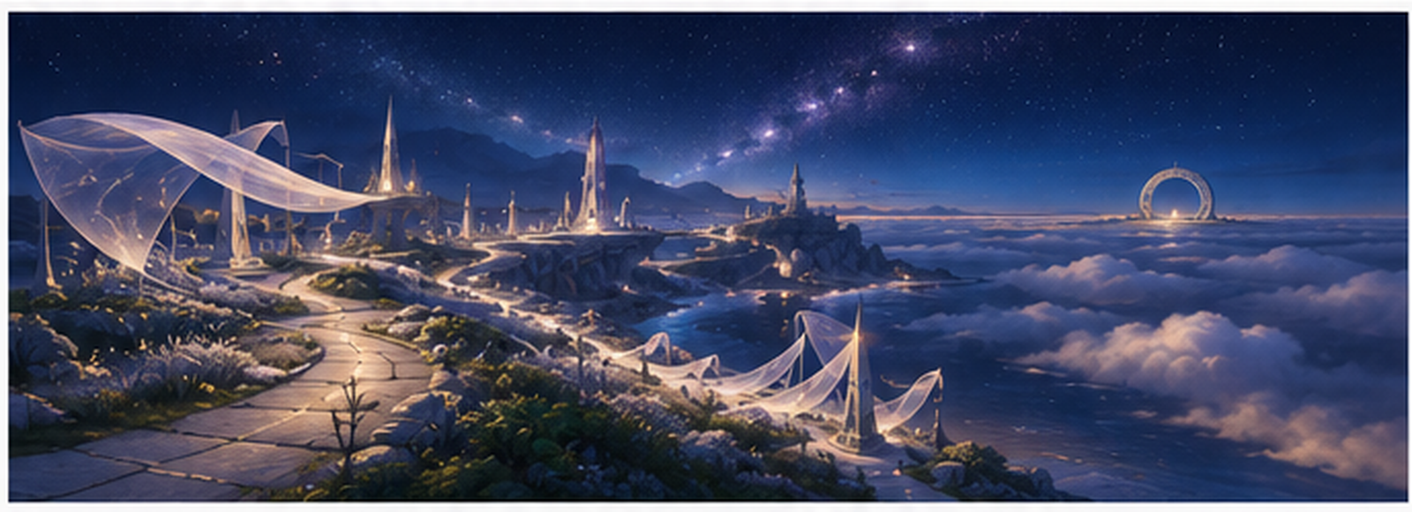
Cover mood/composition reference. Non-authoritative for exact geometry, proportions, route topology and gameplay implementation.
Control | Value
Project | Fifteen Shards of Light
Repository | MindDevastation/fifteen-shards-of-light
Level | Level_06 only
Primary design authority | Level_06_Narrative_and_Level_Scenario_Package_v1.1.docx
Document status | VISUAL MASTER CONCEPT CANDIDATE — Producer approval required
Mode | Documentation only — no runtime changes, Blender production, GLB hierarchy, NodePaths or state machines
Repository snapshot | Narrative audit: main SHA 56410298d9a2f4783e9512a84653b03e73ee3e50; Level_06 remains a 12×12 legacy one-shard placeholder; current Level_07 portal target is legacy drift.

EMOTIONAL SAFETY CONTRACT
Героиня не сломана, и ее никто не чинит. Красота, увлеченность, живость и свет уже принадлежат ей. Уровень выражает восхищение автора, но не превращает его в право на доступ, полное знание, ответ, благодарность или эмоциональный долг.

0. Document control, authority split and scope

0.1 Authority hierarchy
Authority layer | Controls
Textual authority | Approved Level_06 Narrative and Level Scenario Package v1.1 controls the title, exact player-facing copy, three-shard model, emotional function, route order, mechanic intent, FinalScene boundary and forbidden readings.
Diagram authority | Top-down map, sightline board, puzzle diagrams, environment-state board and modular-budget board in this package define visual-composition intent and approximate relative proportions.
Mood/composition references | Stylized and AI-derived perspective boards communicate atmosphere, scale and camera energy only. They do not define exact geometry, gameplay coordinates, asset count or runtime architecture.
Repository factual authority | The current Level_06 scene describes placeholder drift and available integration constraints only. The flat one-shard scene and Level_07 portal target are not visual canon.

0.2 Scope boundary
- Defines visual thesis, emotional reading, shape language, landmarks, top-down composition, sightlines, puzzle readability, environment states, palette/material/fog/light rules and a constrained modular-family proposal.
- Does not define final Godot architecture, NodePaths, state machines, exact coordinates, collision ownership, production GLB hierarchy or implementation slices.
- Does not authorize Blender production, final materials, runtime assets, FinalScene content, branches, commits or pull requests.

0.3 Continuity without visual copying
Previous level | Continuity retained | Visual language deliberately not copied
Level_02 — Живой свет | Warm-natural fantasy, readable landmarks, emotionally safe environmental change. | No central arena, spokes, optical alignment, light mechanism or portal socket composition.
Level_03 — После наших разговоров | Broad safe traversal, world alive from the beginning, restrained amber/ivory accents. | No airy S-route, wind arches, spark-following, breathing meadow or conversation-grove identity.
Level_04 — Ты сама | Natural coexistence, persistent completed states and calm portal transition. | No rainlit terraces, branch choice, braided crossing, ripple conversation or weather synthesis.
Level_05 — То, что остается | Specific personal memory, persistent motifs and a non-interactive synthesis before exit. | No close-up blue-hour micro-world, inward spiral, dew script, seed reactions or mosaic view pads.

0.4 Current repository preflight
Direct repository inspection confirms that Level_06.tscn is still a flat 12×12 legacy placeholder with one SoulShard, legacy LevelManager/PoemRewardUI, shared Player/camera/light and a portal targeting Level_07. These facts constrain later integration work but do not override the approved Level_06 narrative package. No runtime files were modified during this visual-development stage.

1. Visual thesis and emotional reading

1.1 Visual thesis
Level_06 is a high silver meadow above a sea of clouds, organized as one continuous ascending crescent. After Level_05’s close-up inward spiral, the visual scale opens outward and upward. The player does not repair the night, ignite dead stars or earn access to a final truth. They move through a world that is already beautiful and alive while three distinct forms of admiration become increasingly clear: beauty, the ability to become deeply engaged by an idea, and the whole impression that Alena is amazing.

CENTRAL VISUAL IDEA
The landscape expands because the author’s understanding becomes clearer, not because Alena or the world is incomplete. The final playable chapter names admiration directly, then stops before the acrostic and love confession owned by FinalScene.

1.2 Emotional arc
Beat | Emotional reading | Visual expression
Arrival | Wonder becomes spacious after the intimate detail scale of Level_05. | A broad lower terrace reveals one upward crescent, cloud sea and distant inactive portal silhouette.
Silver Wake / Shard_13 | The author directly names Alena’s beauty as his own reaction. | Existing silver grass motion receives three persistent low wakes along the route.
Clear Veils / Shard_14 | Admiration moves from appearance to how genuinely she can ignite around an idea. | Three transparent layers briefly carry a stronger existing current upward without hiding or revealing a “true” world.
Horizon Constellation / Shard_15 | Separate reasons support one whole impression: she is amazing. | Three independent light groups rise and remain separate; no symbolic portrait or confession forms.
Quiet Horizon | The playable admiration arc is complete without triumph. | All motifs coexist in one calm panorama; the portal remains dormant.
Main text / Last Light Walk | The author is ready to say the most important thing in FinalScene. | After text close, one ordinary 15–25 second path leads to a calm portal transition.

1.3 Exact player-facing copy anchor
ID | Exact locked text
Shard_13 | Ты очень красивая - и я правда восхищаюсь твоей красотой.
Shard_14 | Меня восхищает, как ты умеешь по-настоящему загораться тем, что тебе интересно.
Shard_15 | Ты удивительная - и своей красотой, и тем, как сильно умеешь загораться идеей.
Main text | Мне трудно свести мое восхищение тобой к одной причине. Меня волнует твоя красота, и мне очень дорого видеть, как увлеченно ты можешь заниматься тем, что тебя по-настоящему захватывает. Но даже эти слова не объясняют тебя целиком - и я не хочу делать вид, будто знаю о тебе все. Я просто точно знаю, что восхищаюсь тобой. Дальше мне осталось сказать только самое главное.

2. Shape language, landmark hierarchy and environmental storytelling
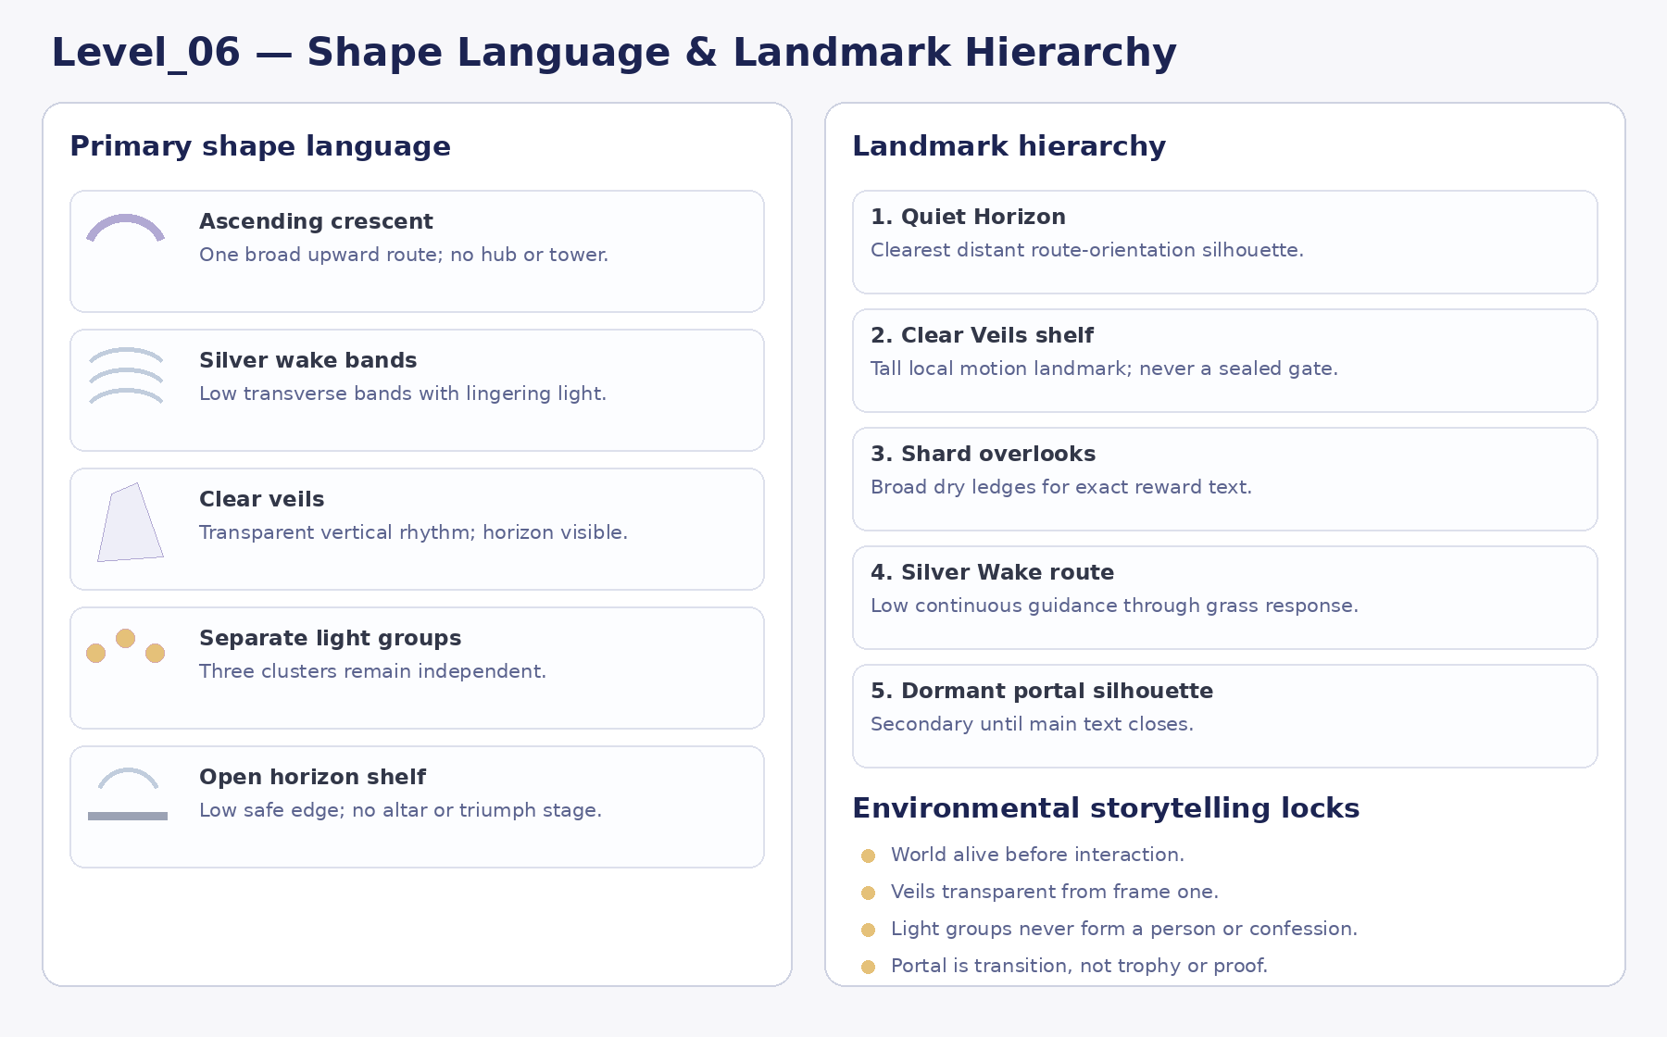
Figure 1. Shape language, landmark hierarchy and environmental storytelling lock. Diagram = visual-intent authority.

2.1 Shape language
- Ascending crescents and open horizon shelves: one clear upward route without tower, hub or spiral.
- Long soft horizontal and diagonal lines: silver wakes, cloud bands and horizon rhythm create calm forward momentum.
- Transparent verticals: veils or open frames provide height without gate, prison, mask or hidden-chamber language.
- Separate luminous clusters: constellation groups stay independent and never form a heart, name, acrostic or portrait.
- Low stone edges and broad dry ledges: safety and readability take priority over dramatic cliffs.

2.2 Landmark hierarchy
Priority | Landmark | Visual role
Primary orientation | Quiet Horizon / upper amphitheater | Clearest distant landscape silhouette and route-orientation landmark. It promises openness, not reward or worship.
Primary local | Clear Veils shelf | Tallest local motion rhythm. It communicates the middle beat without becoming a gate or hidden-world reveal.
Secondary | Shard overlooks and plateau | Broad dry reward spaces that support exact text without trophy staging.
Route support | Silver Wake bands and stone-edge cadence | Low guidance for the continuous ascent.
Final secondary | Dormant portal silhouette | Visible as a distant transition reference but inactive and compositionally subordinate until main text closes.

2.3 Environmental storytelling locks
- The grass, veils and light groups are visibly alive before the player interacts.
- Progress clarifies the author’s reaction; it does not increase Alena’s value or repair the environment.
- Veils remain transparent from the beginning. No mechanic grants access to a hidden “real” Alena.
- The three light groups remain distinct after completion. They do not assemble a person from parts.
- The final portal is a route transition to FinalScene, not an altar, crown, ring, gate to her heart or proof of worth.

3. Top-down composition with approximate relative proportions

3.1 Spatial thesis
The level is one continuous ascending crescent from Lower Cloud Terrace to Quiet Horizon, followed by a short forward-only Last Light Walk. It is not a circular tower, hub, branch network, S-route or inward spiral. The route should feel like a single long exhale that opens the sky without becoming a ceremonial final staircase.
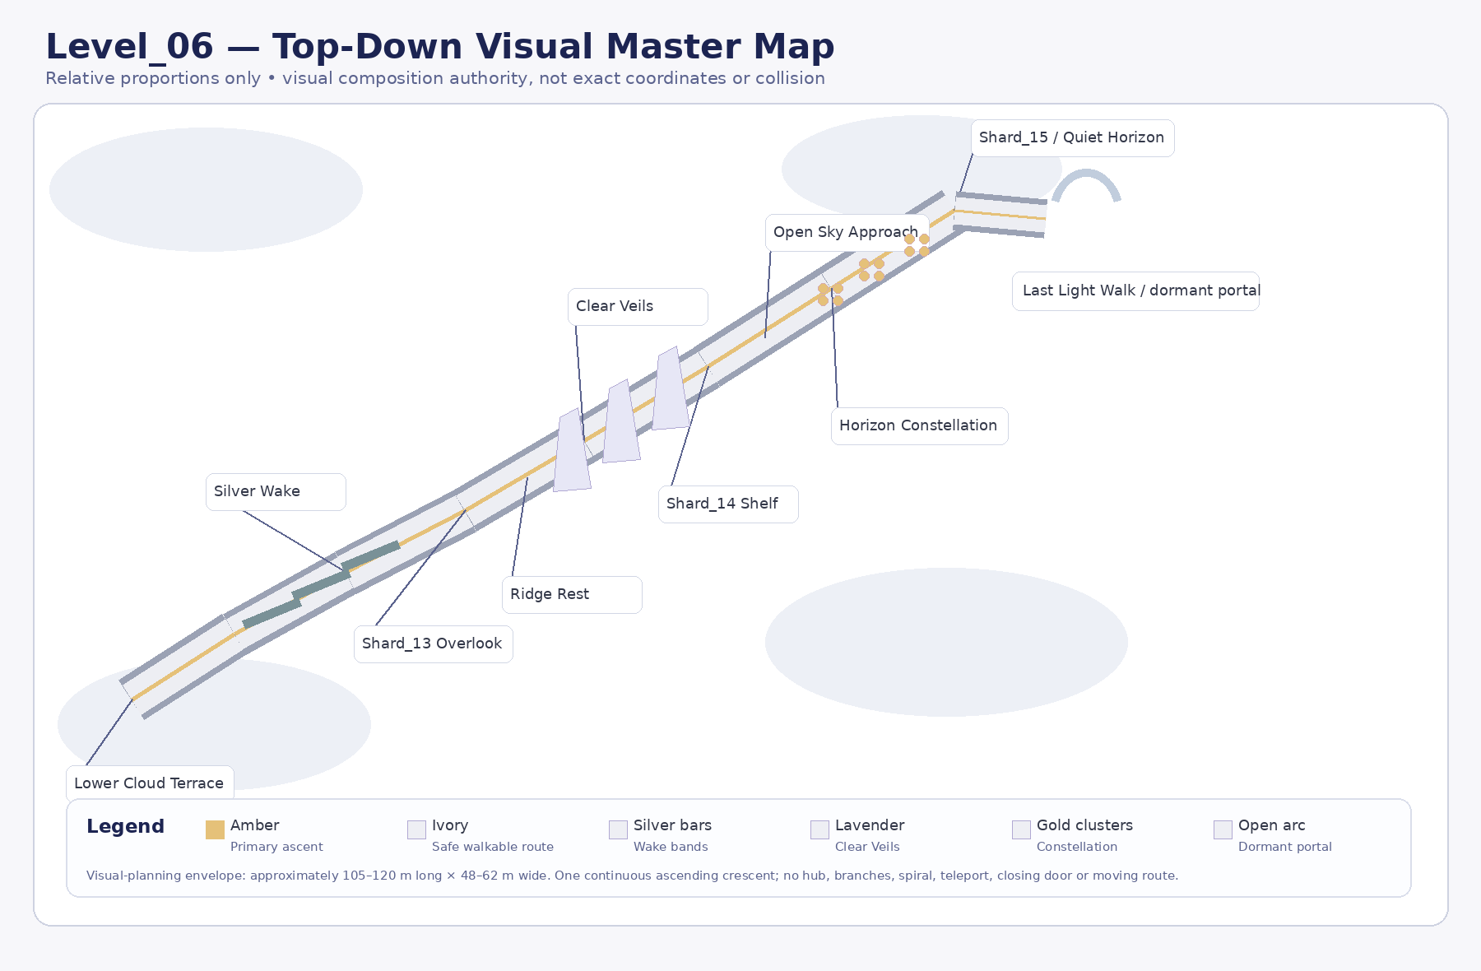
Figure 2. Top-down visual master map. Relative proportions only; not coordinate, collision or runtime authority.
Zone | Approximate visual proportion | Composition rule
Whole-level envelope | Approx. 105–120 m long × 48–62 m wide; broad continuous rise. | Visual-planning range only. Exact gameplay coordinates belong to Gameplay Design.
Lower Cloud Terrace | 12–16 m safe crescent pad. | One forward route; distant amphitheater and dormant portal secondary.
Silver Wake path | 5–7 m broad rising curve; 3 transverse grass bands. | Bands sit directly on the safe route; no narrow bridge or moving platform.
Shard_13 Overlook | 10–12 m broad dry shelf. | Safe text space with a view back over persistent wakes.
Ridge Rest | 20–30 m calm connector. | No task; clear pacing reset.
Clear Veils lane | Approx. 6 m broad lane; three spaced transparent layers. | Horizon and route visible through all layers; no door or maze reading.
Shard_14 Shelf | 10–12 m open landing. | Frames upper light groups without shrine composition.
Open Sky Approach | 5–7 m gradual rise. | All three constellation zones readable together from entry.
Horizon amphitheater | 24–30 m wide shallow arc. | Three broad any-order crescent zones around a central dry plateau.
Shard_15 / Quiet Horizon | 14–18 m plateau. | All motifs visible; no fourth puzzle, letters or acrostic.
Last Light Walk / portal | 5–6 m gentle forward path; 15–25 sec. | No text, choice, timer or ceremony; future target FinalScene.

4. Player sightlines and visual route

4.1 Diegetic navigation contract
Every beat should be readable through three simultaneous cues: one distant upward landmark, one local motion/emissive cue and one broad safe route frame. The level must not require UI arrows, minimap reading, exact camera alignment or a 360-degree search.
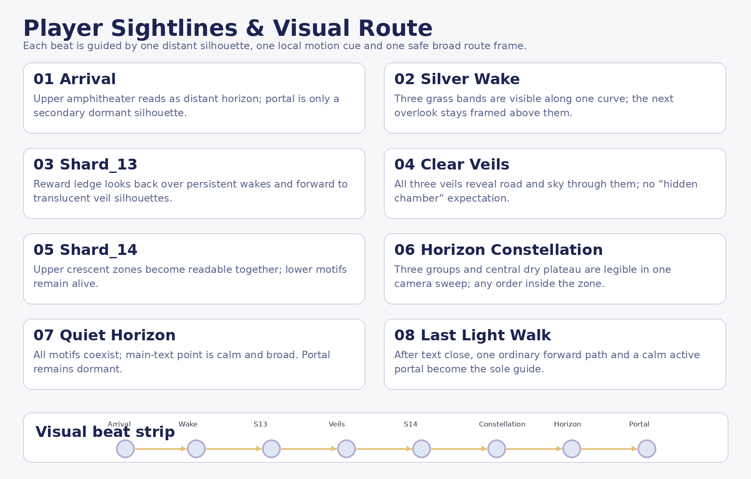
Figure 3. Player sightlines and visual route. Diagram = navigation-intent authority.
Route beat | Required reading
Lower Cloud Terrace | Only one route ascends. Quiet Horizon is the main distant landscape silhouette; portal is secondary and dormant.
Silver Wake | All three bands lie sequentially along the route; the overlook remains visible above them.
Shard_13 Overlook | Persistent wakes remain below; translucent veil silhouettes clearly indicate the next space.
Clear Veils | Road and horizon remain visible through every layer. No “enter the secret chamber” implication.
Shard_14 Shelf | All three upper crescent zones can be read in one natural camera sweep.
Horizon Constellation | The central dry plateau and three separate groups stay visually distinct; internal order is free.
Quiet Horizon | Main-text position is calm and broad. Portal remains inactive before and during text.
Last Light Walk | After text closes, the active portal becomes the only strongest guide; no alternate route or seventh-level detour.

4.2 Composition-board rule
Perspective boards may exaggerate atmosphere and scale, but they must preserve the one-route crescent, safe broad traversal, transparent veils, distinct light groups and dormant portal. Any board that resembles a shrine, tower ascent, final confession stage or circular challenge arena is rejected as non-canonical.
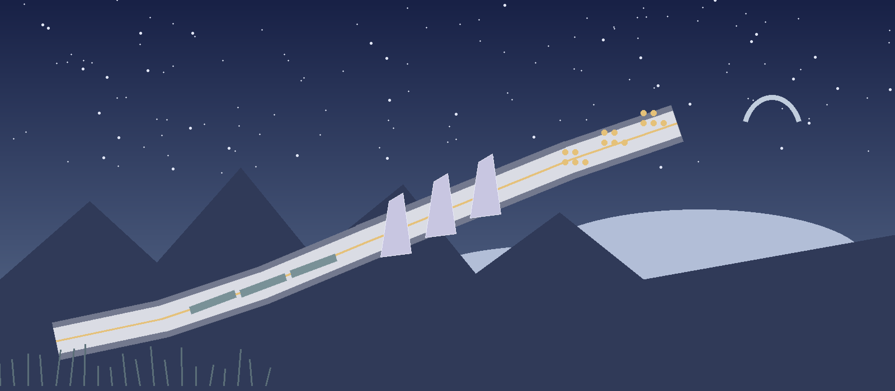
Figure 3A. Stylized mood/composition reference. Non-authoritative. Use only for clear-night atmosphere, cloud-sea depth and broad ascending route energy; ignore any implied exact geometry.

5. Puzzle visual concepts
The three mechanics share broad triggers, persistent progress and non-punitive guidance, but must have visibly different verbs and feedback. None may become a proof trial, difficulty spike or symbolic access to Alena’s inner self.
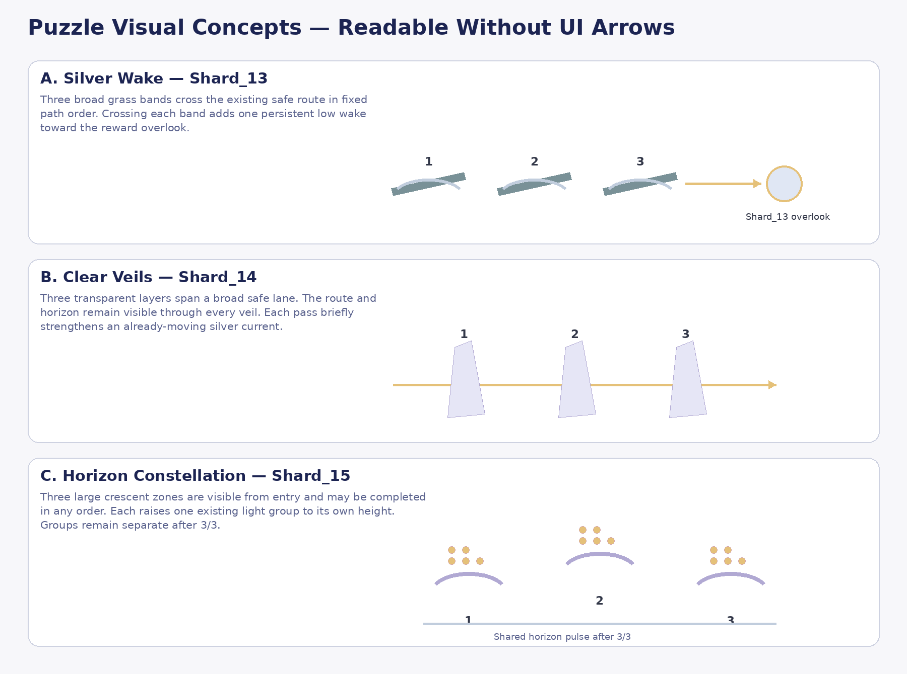
Figure 4. Puzzle visual concepts. Diagrams define rule readability, not runtime implementation.

5.1 Silver Wake — locked visual form
Aspect | Visual solution
Readable rule | Three wide grass bands cross the existing route in fixed path order. The first band teaches the rule automatically.
Feedback | Each band adds one persistent low silver wake; base grass motion remains visible before and after.
Guidance | A missed next band receives a slow local glint after prolonged inactivity.
Safety | No timing, jump, moving platform, audio dependency, thin target or failure reset.
Narrative fit | The player does not make the landscape beautiful. The wake visualizes the author’s response to beauty.

5.2 Clear Veils — PRIMARY LOCKED CONCEPT
Aspect | Visual solution
Readable rule | Three transparent veils span a broad safe lane. The route and horizon are visible through all layers.
Feedback | Passing each layer briefly strengthens an already-moving silver current and sends a restrained vertical pulse upward.
Guidance | An unvisited veil receives subtle edge motes. Parting begins before contact and never blocks the route.
Safety | No door, maze, stealth, hidden room, mask-removal or collision-dependent softlock.
Narrative fit | The existing impulse grows layer by layer; the player does not reveal, start or fix Alena.

Emergency fallback only: Clear Arches may replace Clear Veils after a documented visual/gameplay blocker related to mask/unveiling reading, readability or MVP cost. The pass-through verb, ascending current and Shard_14 emotional function remain unchanged.

5.3 Horizon Constellation — locked visual form
Aspect | Visual solution
Readable rule | Three large crescent zones are visible from entry and may be completed in any order.
Feedback | Each raises one pre-existing light group to its own height; all groups remain separate.
Guidance | An unvisited zone receives low path motes after inactivity; no exact viewing direction.
Safety | No star matching, line drawing, symbol solving, audio sync, camera alignment or reset.
Narrative fit | Separate reasons support one whole feeling without reducing Alena to a list of parts.

5.4 Quiet Horizon and Last Light Walk
Quiet Horizon is strictly non-interactive synthesis. Last Light Walk is a short controlled bridge inside the same scene. There is no fourth puzzle, no acrostic reveal, no ending choice and no separate seventh playable chapter.

6. Environment state boards
State changes increase local clarity and guidance while preserving every earlier motif. They do not convert a dead meadow into a living one and do not imply completion of Alena or entitlement to FinalScene.
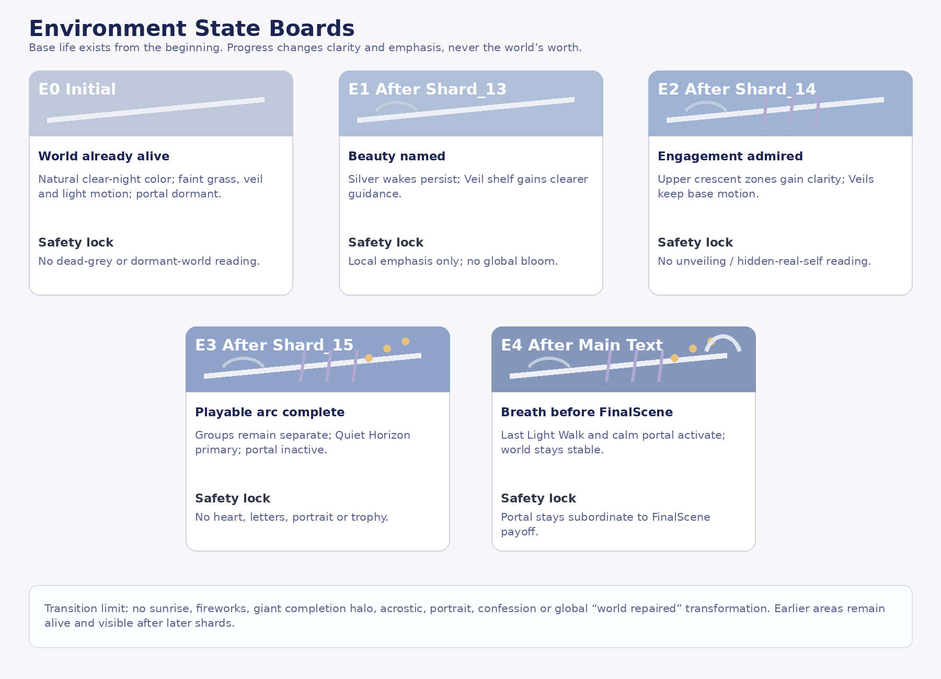
Figure 5. Environment states tied to shards and key events. Diagram = visual-state authority.
State | Locked visual behavior | Emotional reading
E0 Initial | Clear-night natural color, faint grass/veil/light motion, readable route, dormant portal. | The world is already alive; admiration starts with noticing.
E1 After Shard_13 | Silver wakes persist; Clear Veils shelf gains clearer silhouette guidance. | Beauty is named without global reward escalation.
E2 After Shard_14 | Upper crescent zones gain stronger low contrast; veil base motion continues. | The author recognizes how she can genuinely ignite around an idea.
E3 After Shard_15 / Synthesis | All three groups remain distinct; Quiet Horizon becomes primary; portal inactive. | Playable admiration arc complete; confession still deferred.
E4 After Main Text / Exit | Last Light Walk guidance activates; shared portal glows calmly; landscape stays stable. | A breath before FinalScene, not a climax that replaces it.

6.1 Transition limits
- No sunrise, fireworks, rose explosion, giant completion halo or sky-wide bloom.
- No heart, name, acrostic, words or silhouette portrait in the constellation.
- No lower area shuts down or becomes inferior after a later shard.
- Portal activation is local and restrained; it does not dominate the horizon before main text closes.

7. Palette, materials, fog, light, natural motion and focal-point rules
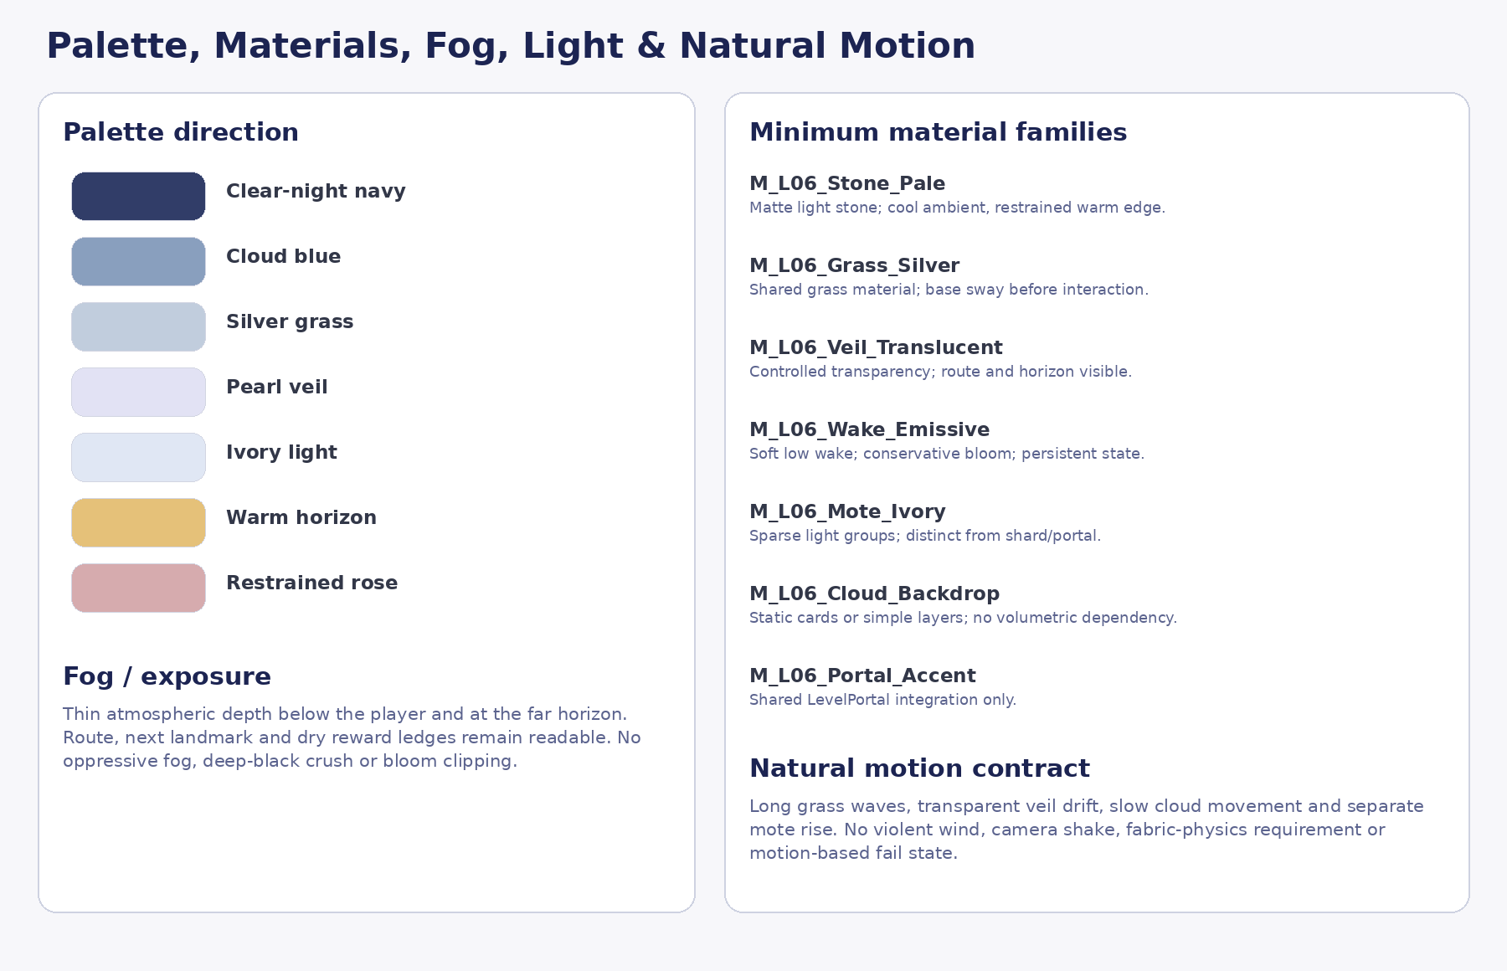
Figure 6. Palette and material-family direction. Final shader implementation is deferred.

7.1 Palette direction
- Clear-night navy and cloud blue form the global frame. The level remains readable and luminous, never horror-dark.
- Silver grass, pearl veil and ivory light carry the main identity. Warm gold is limited to horizon and guidance accents.
- Restrained rose may appear in small complementary highlights but never becomes romantic-card pink wash.
- SoulShard and portal colors must remain distinguishable from environmental motes and wakes.

7.2 Fog and lighting
- Use thin atmospheric depth below the playable height and at the far horizon. Mandatory route and next landmark remain visible.
- Primary illumination: cool moon/sky ambient. Secondary: thin warm horizon line and local ivory/silver response.
- No sacred spotlight, judgment beam, heroic sunrise, oppressive fog or crushed-black exposure.
- Bloom must preserve silhouette edges and avoid merging grass wakes, shards and portal into one overexposed system.

7.3 Natural motion
- Long gentle grass waves exist before player interaction.
- Veils drift transparently with a slow upward current; real cloth simulation is optional/cut.
- Clouds move slowly below the route using low-cost cards or simple layers; volumetric clouds are not mandatory.
- Light groups rise slowly and independently; no rapid flashing, camera shake or forced focus.

7.4 Focal-point hierarchy
Layer | Primary focal point
Long-range | Quiet Horizon / upper amphitheater landscape silhouette.
Mid-range | Clear Veils shelf or next shard ledge.
Local gameplay | One grass band, veil layer or crescent zone with restrained preglow.
Reward | SoulShard and exact text on a broad dry floor, not a monumental prop.
Exit | Active portal only after main text closes; FinalScene retains the emotional climax.

8. Hero asset budget and modular kit proposal

8.1 Asset-family budget
The recommended budget is exactly three later modular families. Shard overlooks, constellation plateau, Quiet Horizon and portal approach are compositions built from these kits, not separate hero families.
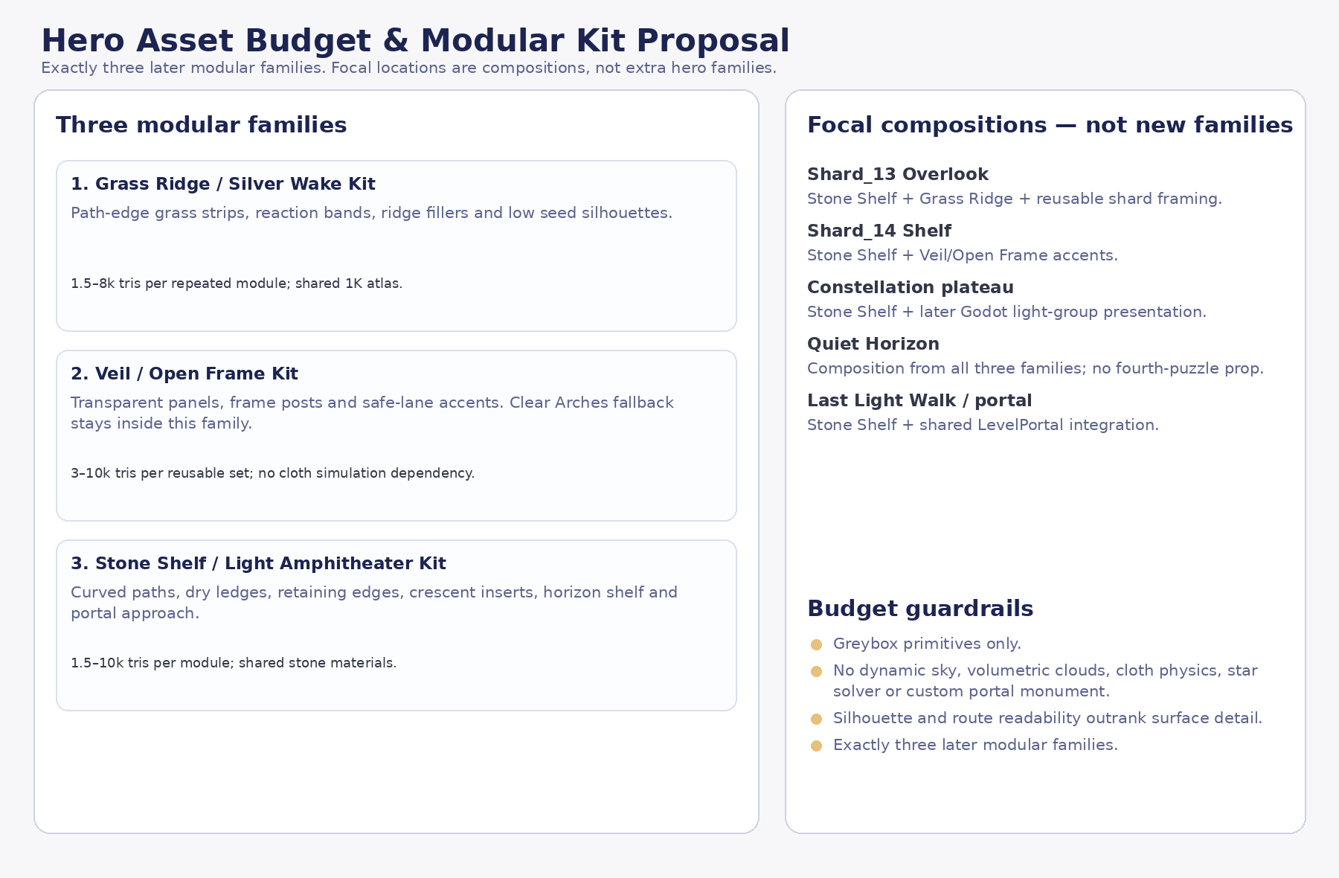
Figure 7. Three-family modular budget and focal-composition guardrails.
Family | Scope | Budget / rule
Grass Ridge / Silver Wake Kit | Path-edge grass strips, reaction bands, ridge fillers, low seed silhouettes. | Repeated medium modules ~1.5–8k triangles; shared 1K atlas; optional 2K only for justified major repeated surface.
Veil / Open Frame Kit | Transparent panels, light frame posts, safe-lane accents; emergency Clear Arches stays inside the same family budget. | Semi-hero repeated silhouettes ~3–10k triangles per reusable set; no fabric-simulation dependency.
Stone Shelf / Light Amphitheater Kit | Curved paths, dry ledges, retaining edges, crescent-zone floor inserts, horizon shelf and portal approach. | Medium modules ~1.5–10k triangles; shared materials; simple collision later only if approved.

8.2 Focal compositions — not additional families
- Shard_13 Overlook = Stone Shelf + Grass Ridge + restrained reusable shard surround.
- Shard_14 Shelf = Stone Shelf + Veil/Open Frame accents.
- Horizon Constellation plateau = Stone Shelf + later Godot light-group presentation; no bespoke constellation monument.
- Quiet Horizon = composition from all three families; no fourth-puzzle prop.
- Last Light Walk / portal approach = Stone Shelf + shared LevelPortal integration; no unique wedding arch or hero gate family.

8.3 Scope guardrails
- Greybox uses primitives only.
- No dynamic sky/time system, volumetric cloud sea, cloth physics, star solver or custom portal monument is required.
- Silhouette, route readability and broad trigger scale outrank surface-detail density.
- Clear Arches remains emergency fallback only and does not create a fourth modular family.

9. Forbidden visual directions
Forbidden direction | Reason / correction
Dead meadow, broken stars or world-repair sequence | Would imply the player restores value or wholeness. Keep base life and motion visible from E0.
Veils as masks or sealed “true self” | Keep them transparent and non-blocking from the beginning; no secret chamber or reveal of a real version.
Shrine, altar, throne, crown, ring or wedding arch | Would turn admiration into entitlement, ceremony or proof. Use broad natural ledges and shared portal integration.
Heart, name, acrostic or words in constellation | FinalScene exclusively owns acrostic and direct confession.
Final guardian, proof-of-love trial, sacrifice or difficulty spike | The last playable chapter must remain gentle and non-punitive.
Heroic sunrise, fireworks or giant rose-gold bloom | Would steal the emotional payoff from FinalScene.
Camera/photo mechanic around beauty | Would create visual-access pressure. Shard_13 is a direct compliment, not a request for imagery.
Productivity or performance symbolism for engagement | Shard_14 celebrates authentic interest, not constant productivity or entertainment for the author.
Circular arena, tower climb, spiral, hub or branches | Conflicts with the locked one-crescent route identity and repeats previous levels.
Seventh playable bridge scene | Last Light Walk remains a 15–25 second beat inside Level_06.

10. Producer approval table — locks required before Gameplay Design
Item | Current proposal | Required state
Title and exact copy | «Ты восхищаешь меня»; exact Shard_13/14/15 and main text from Narrative Package v1.1. | ALREADY LOCKED — preserve character-for-character
Macro route | One continuous ascending crescent: Silver Wake → Shard_13 → Clear Veils → Shard_14 → Horizon Constellation → Shard_15 → Quiet Horizon → Main Text → Last Light Walk → FinalScene portal. | LOCK visual topology
Whole-level visual envelope | Approx. 105–120 m long × 48–62 m wide. | LOCK as visual-planning range only
Silver Wake visual rule | Three broad sequential route bands; persistent low wakes; base grass alive from E0. | LOCK
Clear Veils visual rule | Transparent, non-blocking layers with visible path/horizon and pre-existing current. | LOCK PRIMARY CONCEPT
Clear Arches | Replacement only after a documented blocker involving mask/unveiling reading, readability or MVP cost. | EMERGENCY FALLBACK ONLY
Horizon Constellation visual rule | Three immediately visible broad any-order zones; separate groups persist; no symbols. | LOCK
Environment progression | Local clarity and preserved motifs; portal inactive until main text closes. | LOCK
Palette / atmosphere | Clear-night silver meadow, cloud sea, cool ambient and restrained warm horizon. | LOCK
Asset-family budget | Exactly three later modular families; focal locations are compositions. | LOCK
FinalScene boundary | No acrostic, direct love confession, response prompt, final poem/video/voiceover or EndingOverlay design in Level_06. | LOCK
Deferred items | Exact coordinates, route metrics, collision/recovery, camera QA points, VFX timings, final silhouettes, shaders and runtime integration. | DEFER to Gameplay / Technical / Art Production stages

11. Final visual-development verdict and handoff

ART-DIRECTION VERDICT
Level_06 has a coherent, differentiated and MVP-safe visual identity: a high silver meadow above clouds, one continuous ascending crescent and three distinct admiration beats. The concept expands naturally from Level_05’s close-up memory garden without copying it, completes the playable admiration arc and protects FinalScene’s exclusive authority over the acrostic and direct confession.

11.1 What passes to Producer
- Approve the visual thesis, crescent topology, landmark hierarchy, three puzzle visual forms, environment states, palette and three-family modular budget.
- Confirm Clear Veils as PRIMARY LOCKED CONCEPT and Clear Arches as emergency fallback only.
- Confirm the portal remains compositionally subordinate and inactive before main-text close.

11.2 What passes to Gameplay Design
- Convert approximate composition into exact coordinates, route width, slopes, clearances, recovery and camera QA without changing the fixed emotional order.
- Preserve broad visible triggers, persistent progress, any-order internal constellation zones and no fourth puzzle.
- Preserve the 15–25 second Last Light Walk inside Level_06 and direct future handoff to FinalScene.

11.3 What passes to later Art / Blender planning
- Use exactly three modular families and build reward spaces and finale approach as compositions from them.
- Treat text and diagrams as authority; mood boards remain non-authoritative.
- Do not begin Blender production until Gameplay Design and Technical Architecture are approved.

11.4 Documentation completion statement
This package is the single Visual Master Concept deliverable for the current Level_06 stage. No Godot scenes/scripts, runtime assets, Blender files, GLBs, materials, FinalScene content, branches, commits or pull requests were created or modified.

Appendix A. Canonical authority summary
Domain | Locked / deferred result
Narrative authority | Level_06_Narrative_and_Level_Scenario_Package_v1.1.docx.
Player-facing title | Ты восхищаешь меня.
Shard model | Exactly Shard_13, Shard_14 and Shard_15 in fixed narrative order.
Visual world | High silver meadow / clear-night cloud overlook.
Route | One continuous ascending crescent; no hub, branches, spiral, teleport or return to spawn.
Mechanics | Silver Wake; Clear Veils; Horizon Constellation; Quiet Horizon non-interactive; Last Light Walk.
Portal target | Future canonical target res://scenes/core/FinalScene.tscn; current Level_07 target is legacy drift.
FinalScene boundary | FinalScene exclusively owns acrostic, direct confession, response-space wording and polished ending presentation.
Authority split | Text and diagrams authoritative; stylized/AI mood boards non-authoritative.
Production status | Documentation only. Exact gameplay and technical parameters are deferred.

