FIFTEEN SHARDS OF LIGHT

Level_04 — «Ты сама»

ART PRODUCTION BIBLE v1.1
Environment production design • Blender technical art • Godot art integration
Status: ART-PRODUCTION DESIGN CANDIDATE — Producer approval required
Mode: Documentation only — no Blender files, GLBs, textures, materials, wrappers, runtime scenes or scripts
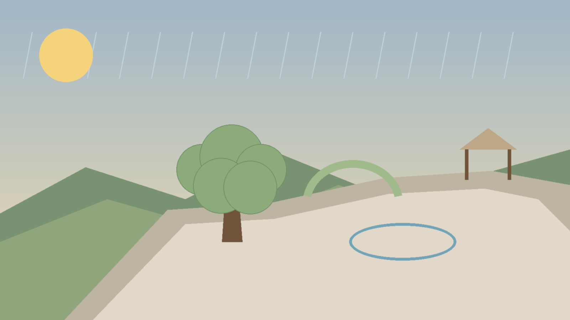
Cover mood reference only. Geometry and production authority remain in text, maps and registries.
Control | Value
Project | Fifteen Shards of Light
Repository | MindDevastation/fifteen-shards-of-light
Level | Level_04 only
Narrative authority | Level_04_Narrative_and_Level_Scenario_Package_v1.1.docx
Visual authority | Level_04_Visual_Master_Concept_Package_v1.2.docx
Gameplay authority | Level_04_Gameplay_Map_and_Level_Design_Spec_v1.2.docx
Technical authority | Level_04_Technical_Architecture_and_State_Model_v1.2.docx
Target scene | res://scenes/levels/Level_04.tscn
Engine baseline | Godot 4.6 / Forward Plus / Jolt Physics
Document output | Level_04_Art_Production_Bible_v1.1.docx

Emotional safety contract
The heroine is not broken and the garden is not healed by the player. Sunlight, cloud shadow, drizzle, still water, seriousness, laughter and quiet already belong to the world and to her. Art records attention and coexistence; it must not create emotional debt, savior framing or a demand for response.

0. Document control, source hierarchy and scope

0.1 Four-source authority hierarchy
Priority | Source | Controls
1 | Narrative / Scenario v1.1 | Title, exact copy, emotional function, branch equality and forbidden readings.
2 | Visual Master v1.2 | Composition intent, static split-level topology reading, landmark hierarchy, palette and three-family budget.
3 | Gameplay Spec v1.2 | Exact scene-local coordinates, dimensions, route metrics, clearances, recovery anchors and deterministic behavior.
4 | Technical Architecture v1.2 | Scene/node ownership, canonical gameplay pivots/markers, shared-system boundaries and future runtime composition.

0.2 Scope boundary
- This Bible defines Boundary Maps, layer ownership, asset registry, production sheets, material/VFX families, collision policy, pivot/origin contracts, wrapper-first integration, export checks and post-greybox art slices.
- It does not authorize a greybox PR, Blender production, GLB export, textures, final materials, Godot wrappers, runtime code, branch, commit or pull request.
- The current one-shard Level_04 placeholder is repository evidence only and is not art or gameplay canon.
- Diagrams and tables in this document are art-production authority after Producer approval. AI/stylized mood boards remain non-authoritative.

0.3 Production verdict
READY FOR PRODUCER REVIEW AS AN ART-PRODUCTION DESIGN CANDIDATE. The package preserves the approved static braided topology, exact gameplay coordinates, broad safe traversal, three modular families, ownership boundaries and emotional-safety rules. Initial runtime work must remain GB-P0 primitive-only. All final art is deferred until greybox acceptance.

0.4 Version 1.1 Change Log
ID | Correction | Version 1.1 locked result
V11-01 | Route-width normalization | Locked 5.5 m minimum mandatory route width; 6.0-7.0 m only at branch entrances/exits, major curves, shard alcoves/approaches and Final Pavilion approach; Braided Crossing lanes remain 5.5 m minimum with at least 3.4 m lower clear height.
V11-02 | Boundary ownership normalization | Replaced the non-canonical BoundaryRoot name with EnvironmentRoot/Boundaries or an explicitly approved block-local StaticBody3D collision root under the relevant EnvironmentRoot block.
V11-03 | Ripple contour source deduplication | Both RippleContour VFX presentation scenes reuse the single canonical STRUCT source and raw GLB for L04_Ripple_Contour_Ring_A. No duplicate /vfx geometry source exists.
V11-04 | Boundary Map QA | Re-exported Figures 1A and 1B with corrected ownership/width contracts, separated portal and recovery annotations, readable water note and uncluttered legend/leader layout.
V11-05 | VFX registry pagination QA | Moved the VFX registry to a fresh page, repeated its header and prevented row splitting so canonical IDs and exact paths remain intact at 100% zoom.

0.5 Audited repository snapshot
Repository datum | Locked value / requirement
Audited main commit | d84af4e4616d7e2a5375c776fe8be0d8c9cbaabf
Later-work preflight | Before any authorized Blender or runtime work, recheck current main and all active PRs for shared-contract drift affecting Player, SoulShard, reward flow, LevelFinaleOverlay, LevelPortal, recovery ownership, exact gameplay coordinates or path conventions.
This immutable snapshot is the factual repository baseline for this documentation revision only. It does not authorize implementation and must not be reused without a fresh preflight at a later production gate.

1. Locked production principles
- One coherent rainlit terraced garden; no hub, arena, shrine or moralized weather split.
- Exactly three later modular families: Canopy / Tree Modules, Shoreline / Ripple Markers, Open Pavilion Kit.
- Final Pavilion, Crossing Tree and branch zones are compositions from these families plus shared kits, not additional hero families.
- Gameplay owns all authoritative pivots, target IDs, presence areas, shard anchors, recovery anchors, FinalTextGate and PortalFloorAnchor.
- Raw GLB and art wrappers own visual meshes, documented origins, approved static collision, materials and presentation-only animation only.
- Positive scale only. Any genuinely handed mesh is authored and applied in Blender as an explicit variant.
- No invisible catch floor. SoftReturnVolume and authored OOB volumes remain the recovery authority.
- Visual-only replacement precedes any collision-proxy replacement.
- No final art file is GB-P0 content.

2. Boundary Map
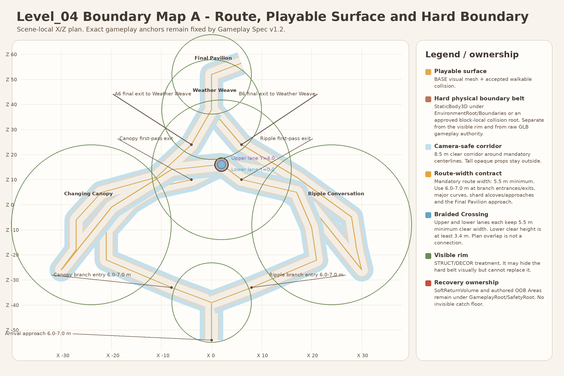
Figure 1A. Route, playable surface, hard boundary and camera-safe corridor. Exact anchors follow Gameplay Spec v1.2.
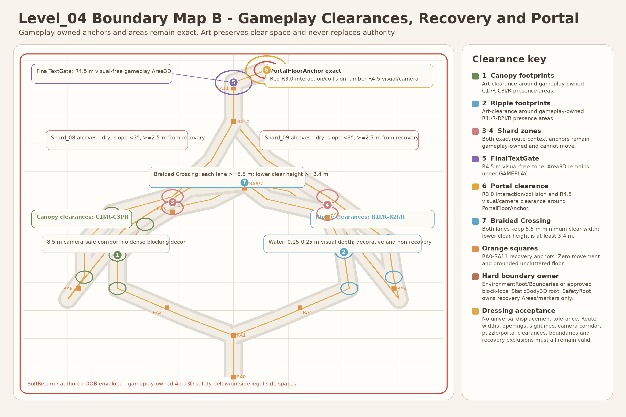
Figure 1B. Puzzle, shard, portal and recovery clearances. Gameplay nodes remain authoritative.

2.1 Boundary classes
Boundary class | Location / dimensions | Owner / collision | Visible | Production form
Playable surface | All mandatory terraces, ramps, shard floors, crossing lanes, Weather Weave and pavilion floor. | BASE visual mesh + accepted walkable collision. | Visible | Modular / block composition
Hard physical boundary belt | Natural blockers or simplified StaticBody3D belt around legal traversal. Must preserve route openings. | EnvironmentRoot/Boundaries or an explicitly approved block-local StaticBody3D collision root under the relevant EnvironmentRoot block. | Usually hidden by visible rim | Separate from visual rim; never raw GLB gameplay authority
Visible rim / edge | Rounded retaining stone, roots, low wall, shoreline edge and cliff dressing. | STRUCT/DECOR under EnvironmentRoot. | Visible | Modular
Route openings | Mandatory traversal openings. Route width is 5.5 m minimum. Use 6.0-7.0 m at branch entrances/exits, major curves, shard alcoves/approaches and the Final Pavilion approach. Braided Crossing upper and lower lanes remain 5.5 m minimum with at least 3.4 m lower clear height. | Geometry contract; no node authority. | Visible as open space | Part of base/structure layout
Camera-safe corridor | 8.5 m clear corridor around mandatory centerlines. | Art placement rule. | Not visible | N/A
Walkable shoulder | Minimum 1.25 m between route edge and dense dressing/recovery boundary. | BASE + dressing exclusion. | Not explicit | N/A
SoftReturn envelope | Area below/outside legal geometry; no overlap with legal side spaces, shallow water or overlooks. | GameplayRoot/SafetyRoot RecoveryVolumes. | Invisible | Godot Area3D only
Puzzle art-clearance | No dense blocking art around Canopy/Ripple presence footprints and readable target silhouettes. | Art exclusion around gameplay-owned areas. | Not visible | N/A
Shard clearance | Dry floor, slope <3 degrees, >=2.5 m from recovery boundary, unobstructed reward camera. | Art exclusion around gameplay-owned shard anchors. | Not visible | N/A
Portal clearance | R3.0 interaction/collision and R4.5 visual/camera clear around PortalFloorAnchor. | Gameplay anchor + art exclusion. | Not visible | N/A
Over/under separation | Upper lane floor Y=4.0; lower lane Y=0.0; no same-level connection; >=3.4 m clear height. | BASE/STRUCT geometry plus accepted collision. | Visible | Block composition

2.2 Zone boundary schedule
Zone | Exact layout authority | Boundary/opening rule | Gameplay/camera lock
Arrival | Center (0,0,-54), 12 x 10 m | One 6.0-7.0 m approach; no dense decor around spawn/recovery anchor. | RA0 exact; CP0 clear.
Crossing Tree | Center (0,0,-39), 18 x 16 m | Two equally readable 6.0-7.0 m branch openings; no circular selector architecture. | RA1 exact; CP1 equal prominence.
Changing Canopy | Visual region center (-21,2.5,-8), 30 x 42 m | Initial and remaining terraces physically separate; mandatory route width 5.5 m minimum, widened to 6.0-7.0 m at entries/exits, major curves and shard approaches. | C1I/R, C2I/R, C3I/R remain gameplay-owned.
Shard_08 zone | First (-11,2,7); remaining (-11,4,11) | Two facing, non-connecting alcoves; dry floor; no anchor migration. | 2.5 m recovery clearance minimum.
Ripple Conversation | Visual region center (23,-0.6,-8), 30 x 42 m | Initial and remaining shore lanes remain physically separate; mandatory route width 5.5 m minimum, widened to 6.0-7.0 m at entries/exits, major curves and shard approaches. | R1I/R, R2I/R exact.
Shard_09 zone | First (17,-0.3,5); remaining (17,-0.3,11) | Dry bank; two route-context anchors; no lane switch at shard. | 2.5 m recovery clearance minimum.
Braided Crossing | Center (2,2,14), 30 x 30 m | UC Y=4 / LC Y=0, no junction; each lane keeps 5.5 m minimum clear width and the lower lane keeps at least 3.4 m clear height. | RA6/RA7 exact; CP6/CP7.
Weather Weave | Center (0,1.8,38), 18 x 14 m | Non-interactive synthesis; pavilion sightline primary after both rewards. | RA10 exact; CP8.
Final Pavilion | Center (0,2,52), 16 x 14 m | Final approach 6.0-7.0 m; FinalTextGate R4.5; PortalFloorAnchor (6,2,56.5); open shelter. | RA11 / CP9 / portal clearances exact.

3. Layer split and node ownership
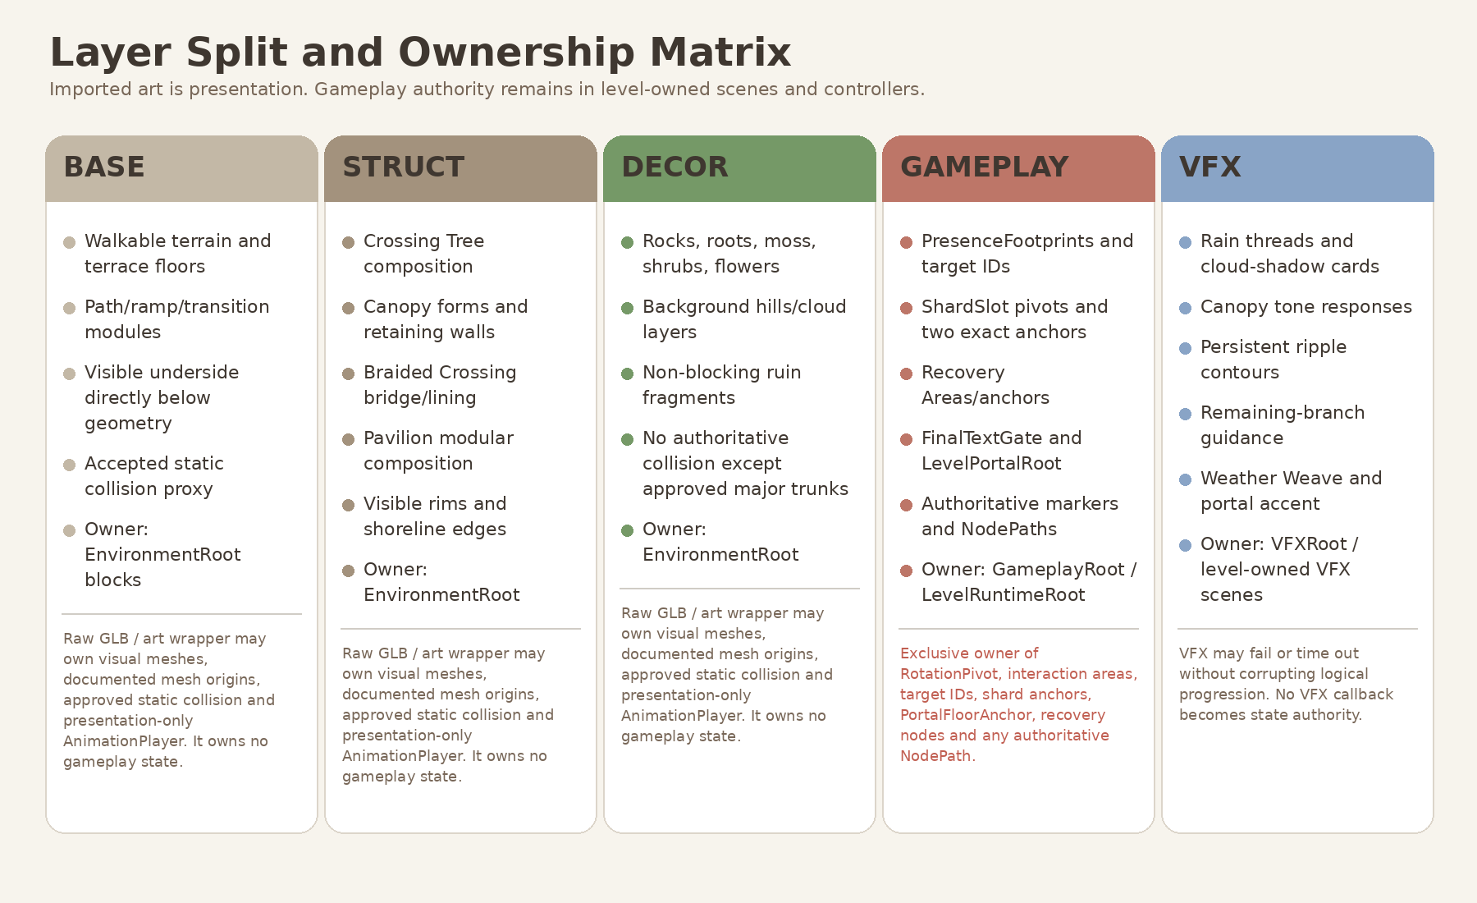
Figure 2. BASE / STRUCT / DECOR / GAMEPLAY / VFX ownership split.
Layer | Contents | Owner | Collision | Authority boundary
BASE | Terrain, path/ramp modules, terrace floors, visible underside immediately below walkable geometry. | EnvironmentRoot block scenes. | Approved walkable/static collision only. | No target IDs, triggers, shard anchors, recovery areas or state.
STRUCT | Tree trunks/crowns, canopy frames, retaining walls, bridge, underpass lining, pavilion pieces, visible rims. | EnvironmentRoot. | Simplified static collision where required. | No authoritative pivots/markers; ArtAlignment_* only.
DECOR | Foliage, rocks, roots, flowers, background hills/clouds, small ruins. | EnvironmentRoot. | None by default; major trunk proxy only if approved. | Never reduce route/camera/puzzle/portal clearances.
GAMEPLAY | PresenceFootprints, target IDs, shard slots/anchors, FinalTextGate, PortalFloorAnchor, recovery Areas/anchors. | GameplayRoot / LevelRuntimeRoot. | Area3D / Marker3D / gameplay collision. | Exclusive state and NodePath authority.
VFX | Rain, cloud shadow, branch feedback, contours, guidance, Weather Weave, portal accent. | VFXRoot / scenes/levels/level_04/vfx. | No collision. | May fail without changing logical progression.

4. Blender, GLB and Godot coordinate / transform contract

4.1 Coordinate conventions
Domain | Locked convention
Blender source | +Z up; project-authored forward = -Y; 1 Blender unit = 1 meter; do not manually axis-bake to imitate Godot.
Godot import | +Y up; -Z forward; use standard GLB/glTF conversion and verify scale/orientation/pivots in a dedicated import test scene.
Blender dimension notation | local X width x local Y depth/forward x local Z height.
Godot imported dimension reading | local X width x local Z depth/forward x local Y height.
Circular assets | Use explicit diameter or radius x height; do not force rectangular notation.
Transform finalization | Set required mesh origin first; place exported root at world origin; apply rotation and scale; final exported root location 0/0/0, rotation 0/0/0, scale 1/1/1.
Scale policy | Positive scale only. No negative-scale placement. A needed mirror is applied in Blender and exported as an explicit variant.
Gameplay anchors | Never baked into raw GLB as authoritative markers. They remain exact Godot-owned nodes.

4.2 Naming and path conventions
Canonical names use L04_<Family>_<Function>_<Variant>. The final suffix _A/_B denotes an actual geometry variant only, never branch identity. Trial/branch identity is written in the semantic name.
Asset type | Exact production path pattern
Blender source | assets/blender/level_04/<layer>/<CanonicalName>.blend
Raw GLB | assets/environment/level_04/<layer>/<CanonicalName>.glb
Optional collision GLB | assets/environment/level_04/collision/<CanonicalName>_COLLISION.glb or N/A - Godot primitive
Godot art wrapper | scenes/environment/level_04/<layer>/<CanonicalName>.tscn
Level-owned VFX scene | scenes/levels/level_04/vfx/<CanonicalName>.tscn

5. Complete asset registry
All actual art assets are post-greybox. “Greybox input” means proxy dimensions/reference only. It never makes a .blend, .glb, texture, production material or wrapper part of GB-P0.

5.1 BASE registry
Canonical asset | Purpose | Dimensions (Blender X x Y x Z) | Origin / forward | Variants | Materials | Collision | Triangles | LOD | Greybox input | Art priority
L04_Path_Module_Straight_A | Reusable straight path | 5.5 x 6.0 x 0.5 m | Bottom-center; -Y forward | One geometry, rotated only | M_L04_Stone_Wet; M_L04_Soil_Path | Godot primitive during greybox; optional simplified custom after gate | 1.5–4k | LOD1 recommended | GB-P0 proxy dimensions only | ART-P1
L04_Path_Module_Curve30_A | 30-degree gentle curve | 5.5 m width x 6.0 m arc depth x 0.5 m height | Bottom-center; tangent exits documented | One reusable positive-scale geometry | M_L04_Stone_Wet; M_L04_Soil_Path | Accepted greybox collision preserved initially | 2–5k | LOD1 recommended | GB-P0 proxy dimensions only | ART-P1
L04_Path_Module_Ramp_Rise020_A | Broad ramp, rise 0.20 m | 5.5 x 8.0 x 0.4 m envelope; rise 0.20 m | Lower-end bottom-center | One geometry | M_L04_Stone_Wet; M_L04_Soil_Path | Simple ramp proxy | 2–5k | LOD1 optional | GB-P0 proxy dimensions only | ART-P1
L04_Path_Module_Ramp_Rise040_A | Broad ramp, rise 0.40 m | 5.5 x 8.0 x 0.6 m envelope; rise 0.40 m | Lower-end bottom-center | One geometry | M_L04_Stone_Wet; M_L04_Soil_Path | Simple ramp proxy | 2–5k | LOD1 optional | GB-P0 proxy dimensions only | ART-P1
L04_Path_Transition_Cap_A | Path/terrace transition | 5.5 x 3.0 x 0.5 m | Bottom-center; -Y forward | One geometry | M_L04_Stone_Wet | Primitive box or simplified custom | 1–3k | No | GB-P0 proxy dimensions only | ART-P1
L04_Base_Arrival_Terrace_A | Arrival floor composition | 12 x 10 x 0.6 m | Bottom-center | One asset | M_L04_Stone_Wet; M_L04_Moss_Foliage | Accepted primitive collision | 3–8k | LOD1 optional | GB-P0 proxy dimensions only | ART-P1
L04_Base_CrossingTree_Clearing_A | Irregular choice clearing | 18 x 16 x 0.8 m | Bottom-center | One asset | M_L04_Stone_Wet; M_L04_Soil_Path | Accepted simplified custom | 5–10k | LOD1 recommended | GB-P0 proxy dimensions only | ART-P1
L04_Base_Canopy_Pocket_A | Reusable widened canopy pocket floor | 10 x 8 x 0.6 m | Bottom-center | One reusable geometry | M_L04_Stone_Wet; M_L04_Moss_Foliage | Primitive/simplified custom | 3–7k | LOD1 optional | GB-P0 proxy dimensions only | ART-P1
L04_Base_Ripple_Shore_A | Reusable curved dry-shore section | 12 x 8 x 0.5 m | Bottom-center; shoreline side +X documented | One geometry; rotation only | M_L04_Stone_Wet; M_L04_Soil_Path | Simplified custom; water excluded | 3–8k | LOD1 optional | GB-P0 proxy dimensions only | ART-P1
L04_Base_BraidedCrossing_Upper_A | Upper crossing deck floor | 5.5 x 14 x 0.6 m | Bottom-center; -Y forward | One asset | M_L04_Stone_Wet | Simplified custom; clear underpass | 4–9k | LOD1 recommended | GB-P0 proxy dimensions only | ART-P1
L04_Base_BraidedCrossing_Lower_A | Lower underpass floor | 5.5 x 14 x 0.5 m | Bottom-center; -Y forward | One asset | M_L04_Stone_Wet; M_L04_Soil_Path | Accepted primitive/simplified | 3–7k | LOD1 optional | GB-P0 proxy dimensions only | ART-P1
L04_Base_WeatherWeave_A | Final approach floor | 18 x 14 x 0.6 m | Bottom-center | One asset | M_L04_Stone_Wet; M_L04_Moss_Foliage | Accepted primitive collision | 4–9k | LOD1 optional | GB-P0 proxy dimensions only | ART-P1
L04_Base_FinalPavilion_A | Pavilion floor | 16 x 14 x 0.6 m | Bottom-center | One asset | M_L04_Stone_Wet; M_L04_Timber_Dark | Accepted primitive collision | 4–9k | LOD1 optional | GB-P0 proxy dimensions only | ART-P1
L04_Boundary_Rim_Straight_A | Visible retaining edge | 1.2 x 6.0 x 1.2 m | Bottom-center | One geometry | M_L04_Stone_Wet; M_L04_Moss_Foliage | Hard belt separate; optional simple rim collision | 1–3k | LOD1 optional | GB-P0 boundary dimensions only | ART-P2
L04_Boundary_Rim_Curve30_A | Visible curved retaining edge | 1.2 m width x 6.0 m arc depth x 1.2 m height | Bottom-center | One geometry | M_L04_Stone_Wet; M_L04_Moss_Foliage | Hard belt separate | 1–4k | LOD1 optional | GB-P0 boundary dimensions only | ART-P2
L04_Underside_Slab_A | Immediate underside under visible route | 5.5 x 6.0 x 0.3 m | Top-center | One geometry | M_L04_Stone_Wet | Optional anti-tunneling only; never bridges gaps | 0.8–2k | No | N/A - not required for GB-P0 | ART-P2

5.2 STRUCT registry
Canonical asset | Purpose | Dimensions | Origin / forward | Family / set | Materials | Collision | Triangles | LOD | Post-greybox priority
L04_Tree_Trunk_Core_A | Crossing Tree main trunk core | diameter 2.2–2.8 m x height 8–10 m | Base center; branch spread authored toward -Y | Canopy / Tree Modules | M_L04_Timber_Dark; M_L04_Moss_Foliage | Simple capsule/convex major trunk only | 8–18k | LOD1/LOD2 | ART-P1
L04_Tree_Branch_Spread_A | Reusable large branch spread | 8 x 4 x 3 m envelope | Socket origin at trunk connection; -Y along branch | Canopy / Tree Modules | M_L04_Timber_Dark | None | 5–12k | LOD1/LOD2 | ART-P1
L04_Canopy_Crown_Large_A | Large irregular crown | diameter 8–10 m x height 4–5 m | Bottom-center | Canopy / Tree Modules | M_L04_Canopy_Leaf | None | 4–10k | LOD1/LOD2 | ART-P1
L04_Canopy_Crown_Medium_A | Medium crown | diameter 5–7 m x height 3–4 m | Bottom-center | Canopy / Tree Modules | M_L04_Canopy_Leaf | None | 3–7k | LOD1/LOD2 | ART-P1
L04_Canopy_Crown_Small_A | Small crown / pocket dressing | diameter 3–4.5 m x height 2–3 m | Bottom-center | Canopy / Tree Modules | M_L04_Canopy_Leaf | None | 1.5–4k | LOD1 | ART-P2
L04_Canopy_Frame_A | Open canopy framing branch/leaf arch | 6 x 2 x 3.5 m envelope | Bottom-center; -Y through opening | Canopy / Tree Modules | M_L04_Timber_Dark; M_L04_Canopy_Leaf | None unless major trunk | 3–8k | LOD1 | ART-P1
L04_Ripple_Marker_A | Persistent shoreline marker base | diameter 2.4 m x height 0.35 m | Bottom-center | Shoreline / Ripple Markers | M_L04_Stone_Wet; M_L04_Ripple_Emissive | None; gameplay footprint separate | 1–3k | No | ART-P1
L04_Ripple_Contour_Ring_A | Mesh-backed persistent water contour | diameter 5.0 m x height 0.05 m | Center on water plane | Shoreline / Ripple Markers | M_L04_Ripple_Emissive | None | 0.3–1k | No | ART-P1
L04_Shoreline_Edge_A | Curved visual shoreline edge | 1.2 x 6.0 x 0.8 m | Bottom-center; water side +X documented | Shoreline / Ripple Markers | M_L04_Stone_Wet; M_L04_Moss_Foliage | Hard boundary separate | 1–4k | LOD1 optional | ART-P2
L04_DryBank_Alcove_A | Shard_09 visual alcove shell | 8 x 6 x 1.0 m envelope | Bottom-center; opening -Y | Shared kit composition | M_L04_Stone_Wet; M_L04_Moss_Foliage | Base collision separate | 3–8k | LOD1 optional | ART-P1
L04_ListeningLedge_Alcove_A | Shard_08 visual alcove shell | 8 x 6 x 1.2 m envelope | Bottom-center; opening -Y | Shared kit composition | M_L04_Stone_Wet; M_L04_Timber_Dark | Base collision separate | 3–8k | LOD1 optional | ART-P1
L04_BraidedCrossing_Bridge_A | Upper bridge structure | 7 x 10 x 1.0 m envelope | Bottom-center; -Y forward | One asset | M_L04_Stone_Wet; M_L04_Timber_Dark | Simplified custom; floor collision may remain greybox | 6–14k | LOD1 | ART-P1
L04_BraidedCrossing_Underpass_Lining_A | Lower route lining / support | 8 x 10 x 4.0 m envelope | Bottom-center | One asset | M_L04_Stone_Wet; M_L04_Moss_Foliage | Static supports only; preserve 5.5 x 3.4 clearance | 5–12k | LOD1 | ART-P1
L04_Pavilion_Post_A | Reusable open pavilion post | 0.45 x 0.45 x 3.8 m | Base center | Open Pavilion Kit | M_L04_Timber_Dark | Simple box/capsule if camera/player relevant | 0.8–2k | LOD1 optional | ART-P1
L04_Pavilion_Roof_Segment_A | Reusable roof segment | 4.5 x 3.0 x 0.45 m | Connection edge center; -Y outward | Open Pavilion Kit | M_L04_Pavilion_Roof; M_L04_Timber_Dark | None | 2–6k | LOD1 | ART-P1
L04_Pavilion_Eave_A | Edge/eave segment | 0.8 x 3.0 x 0.55 m | Connection edge center | Open Pavilion Kit | M_L04_Pavilion_Roof | None | 0.8–2k | LOD1 optional | ART-P2
L04_Pavilion_LowRail_A | Low open rail segment | 0.25 x 2.5 x 0.9 m | Bottom-center | Open Pavilion Kit | M_L04_Timber_Dark | Simple box if blocking | 0.6–1.5k | No | ART-P2
L04_Retaining_Wall_A | General low retaining wall | 0.9 x 4.0 x 1.2 m | Bottom-center | Shared structure kit | M_L04_Stone_Wet; M_L04_Moss_Foliage | Hard belt separate or simple box | 1–4k | LOD1 optional | ART-P2
L04_Ruin_Arch_Half_A | Small open ruin fragment | 3.5 x 1.0 x 3.0 m | Bottom-center | Shared structure kit | M_L04_Stone_Wet | Simple custom only if blocking | 2–6k | LOD1 | ART-P3
L04_Ruin_Column_Low_A | Low rounded ruin marker | diameter 0.9 m x height 1.8 m | Base center | Shared structure kit | M_L04_Stone_Wet | Simple capsule/box if needed | 0.8–2k | LOD1 optional | ART-P3

5.3 DECOR registry
Canonical asset | Purpose | Dimensions | Material | Collision | Triangles | Priority
L04_Grass_Tuft_A | Low route-edge grass | 0.6 x 0.4 x 0.5 m | M_L04_Moss_Foliage | None | 100–500 | ART-P3
L04_Shrub_Cluster_A | Soft shrub cluster | 1.5 x 1.2 x 1.1 m | M_L04_Moss_Foliage | None | 0.5–1.8k | ART-P3
L04_Flower_Cluster_A | Small warm/cool flowers | 0.8 x 0.6 x 0.45 m | M_L04_Flower_Accent | None | 200–800 | ART-P3
L04_HangingLeaves_A | Hanging leaf strip | 2.5 x 0.5 x 2.0 m | M_L04_Canopy_Leaf | None | 0.5–2k | ART-P3
L04_Moss_Clump_A | Stone seam moss | 1.0 x 0.5 x 0.2 m | M_L04_Moss_Foliage | None | 100–500 | ART-P3
L04_Root_Cluster_A | Rounded root dressing | 2.5 x 1.0 x 0.8 m | M_L04_Timber_Dark | None unless major blocker | 1–3k | ART-P3
L04_Pebble_Cluster_A | Wet pebble cluster | 1.2 x 0.8 x 0.35 m | M_L04_Stone_Wet | None | 0.3–1k | ART-P3
L04_DripStone_A | Small drip focal stone | 0.8 x 0.6 x 0.9 m | M_L04_Stone_Wet | None | 0.5–1.5k | ART-P3
L04_Background_Hill_A | Distant garden silhouette | 30 x 8 x 12 m envelope | M_L04_Background_Matte | None | 1–5k | ART-P3
L04_Background_CloudLayer_A | Distant cloud card/mesh | 40 x 1 x 16 m envelope | M_L04_CloudCard | None | 0.1–1k | ART-P3

5.4 Exact production paths
Canonical asset | Blender source path | Raw GLB path | Collision GLB / primitive | Godot wrapper path
L04_Path_Module_Straight_A | assets/blender/level_04/base/L04_Path_Module_Straight_A.blend | assets/environment/level_04/base/L04_Path_Module_Straight_A.glb | assets/environment/level_04/collision/L04_Path_Module_Straight_A_COLLISION.glb | scenes/environment/level_04/base/L04_Path_Module_Straight_A.tscn
L04_Path_Module_Curve30_A | assets/blender/level_04/base/L04_Path_Module_Curve30_A.blend | assets/environment/level_04/base/L04_Path_Module_Curve30_A.glb | assets/environment/level_04/collision/L04_Path_Module_Curve30_A_COLLISION.glb | scenes/environment/level_04/base/L04_Path_Module_Curve30_A.tscn
L04_Path_Module_Ramp_Rise020_A | assets/blender/level_04/base/L04_Path_Module_Ramp_Rise020_A.blend | assets/environment/level_04/base/L04_Path_Module_Ramp_Rise020_A.glb | assets/environment/level_04/collision/L04_Path_Module_Ramp_Rise020_A_COLLISION.glb | scenes/environment/level_04/base/L04_Path_Module_Ramp_Rise020_A.tscn
L04_Path_Module_Ramp_Rise040_A | assets/blender/level_04/base/L04_Path_Module_Ramp_Rise040_A.blend | assets/environment/level_04/base/L04_Path_Module_Ramp_Rise040_A.glb | assets/environment/level_04/collision/L04_Path_Module_Ramp_Rise040_A_COLLISION.glb | scenes/environment/level_04/base/L04_Path_Module_Ramp_Rise040_A.tscn
L04_Path_Transition_Cap_A | assets/blender/level_04/base/L04_Path_Transition_Cap_A.blend | assets/environment/level_04/base/L04_Path_Transition_Cap_A.glb | assets/environment/level_04/collision/L04_Path_Transition_Cap_A_COLLISION.glb | scenes/environment/level_04/base/L04_Path_Transition_Cap_A.tscn
L04_Base_Arrival_Terrace_A | assets/blender/level_04/base/L04_Base_Arrival_Terrace_A.blend | assets/environment/level_04/base/L04_Base_Arrival_Terrace_A.glb | assets/environment/level_04/collision/L04_Base_Arrival_Terrace_A_COLLISION.glb | scenes/environment/level_04/base/L04_Base_Arrival_Terrace_A.tscn
L04_Base_CrossingTree_Clearing_A | assets/blender/level_04/base/L04_Base_CrossingTree_Clearing_A.blend | assets/environment/level_04/base/L04_Base_CrossingTree_Clearing_A.glb | assets/environment/level_04/collision/L04_Base_CrossingTree_Clearing_A_COLLISION.glb | scenes/environment/level_04/base/L04_Base_CrossingTree_Clearing_A.tscn
L04_Base_Canopy_Pocket_A | assets/blender/level_04/base/L04_Base_Canopy_Pocket_A.blend | assets/environment/level_04/base/L04_Base_Canopy_Pocket_A.glb | assets/environment/level_04/collision/L04_Base_Canopy_Pocket_A_COLLISION.glb | scenes/environment/level_04/base/L04_Base_Canopy_Pocket_A.tscn
L04_Base_Ripple_Shore_A | assets/blender/level_04/base/L04_Base_Ripple_Shore_A.blend | assets/environment/level_04/base/L04_Base_Ripple_Shore_A.glb | assets/environment/level_04/collision/L04_Base_Ripple_Shore_A_COLLISION.glb | scenes/environment/level_04/base/L04_Base_Ripple_Shore_A.tscn
L04_Base_BraidedCrossing_Upper_A | assets/blender/level_04/base/L04_Base_BraidedCrossing_Upper_A.blend | assets/environment/level_04/base/L04_Base_BraidedCrossing_Upper_A.glb | assets/environment/level_04/collision/L04_Base_BraidedCrossing_Upper_A_COLLISION.glb | scenes/environment/level_04/base/L04_Base_BraidedCrossing_Upper_A.tscn
L04_Base_BraidedCrossing_Lower_A | assets/blender/level_04/base/L04_Base_BraidedCrossing_Lower_A.blend | assets/environment/level_04/base/L04_Base_BraidedCrossing_Lower_A.glb | assets/environment/level_04/collision/L04_Base_BraidedCrossing_Lower_A_COLLISION.glb | scenes/environment/level_04/base/L04_Base_BraidedCrossing_Lower_A.tscn
L04_Base_WeatherWeave_A | assets/blender/level_04/base/L04_Base_WeatherWeave_A.blend | assets/environment/level_04/base/L04_Base_WeatherWeave_A.glb | assets/environment/level_04/collision/L04_Base_WeatherWeave_A_COLLISION.glb | scenes/environment/level_04/base/L04_Base_WeatherWeave_A.tscn
L04_Base_FinalPavilion_A | assets/blender/level_04/base/L04_Base_FinalPavilion_A.blend | assets/environment/level_04/base/L04_Base_FinalPavilion_A.glb | assets/environment/level_04/collision/L04_Base_FinalPavilion_A_COLLISION.glb | scenes/environment/level_04/base/L04_Base_FinalPavilion_A.tscn
L04_Boundary_Rim_Straight_A | assets/blender/level_04/base/L04_Boundary_Rim_Straight_A.blend | assets/environment/level_04/base/L04_Boundary_Rim_Straight_A.glb | N/A - Godot primitive | scenes/environment/level_04/base/L04_Boundary_Rim_Straight_A.tscn
L04_Boundary_Rim_Curve30_A | assets/blender/level_04/base/L04_Boundary_Rim_Curve30_A.blend | assets/environment/level_04/base/L04_Boundary_Rim_Curve30_A.glb | N/A - Godot primitive | scenes/environment/level_04/base/L04_Boundary_Rim_Curve30_A.tscn
L04_Underside_Slab_A | assets/blender/level_04/base/L04_Underside_Slab_A.blend | assets/environment/level_04/base/L04_Underside_Slab_A.glb | N/A - Godot primitive | scenes/environment/level_04/base/L04_Underside_Slab_A.tscn
L04_Tree_Trunk_Core_A | assets/blender/level_04/struct/L04_Tree_Trunk_Core_A.blend | assets/environment/level_04/struct/L04_Tree_Trunk_Core_A.glb | assets/environment/level_04/collision/L04_Tree_Trunk_Core_A_COLLISION.glb | scenes/environment/level_04/struct/L04_Tree_Trunk_Core_A.tscn
L04_Tree_Branch_Spread_A | assets/blender/level_04/struct/L04_Tree_Branch_Spread_A.blend | assets/environment/level_04/struct/L04_Tree_Branch_Spread_A.glb | N/A - Godot primitive / none | scenes/environment/level_04/struct/L04_Tree_Branch_Spread_A.tscn
L04_Canopy_Crown_Large_A | assets/blender/level_04/struct/L04_Canopy_Crown_Large_A.blend | assets/environment/level_04/struct/L04_Canopy_Crown_Large_A.glb | N/A - Godot primitive / none | scenes/environment/level_04/struct/L04_Canopy_Crown_Large_A.tscn
L04_Canopy_Crown_Medium_A | assets/blender/level_04/struct/L04_Canopy_Crown_Medium_A.blend | assets/environment/level_04/struct/L04_Canopy_Crown_Medium_A.glb | N/A - Godot primitive / none | scenes/environment/level_04/struct/L04_Canopy_Crown_Medium_A.tscn
L04_Canopy_Crown_Small_A | assets/blender/level_04/struct/L04_Canopy_Crown_Small_A.blend | assets/environment/level_04/struct/L04_Canopy_Crown_Small_A.glb | N/A - Godot primitive / none | scenes/environment/level_04/struct/L04_Canopy_Crown_Small_A.tscn
L04_Canopy_Frame_A | assets/blender/level_04/struct/L04_Canopy_Frame_A.blend | assets/environment/level_04/struct/L04_Canopy_Frame_A.glb | N/A - Godot primitive / none | scenes/environment/level_04/struct/L04_Canopy_Frame_A.tscn
L04_Ripple_Marker_A | assets/blender/level_04/struct/L04_Ripple_Marker_A.blend | assets/environment/level_04/struct/L04_Ripple_Marker_A.glb | N/A - Godot primitive / none | scenes/environment/level_04/struct/L04_Ripple_Marker_A.tscn
L04_Ripple_Contour_Ring_A | assets/blender/level_04/struct/L04_Ripple_Contour_Ring_A.blend | assets/environment/level_04/struct/L04_Ripple_Contour_Ring_A.glb | N/A - Godot primitive / none | scenes/environment/level_04/struct/L04_Ripple_Contour_Ring_A.tscn
L04_Shoreline_Edge_A | assets/blender/level_04/struct/L04_Shoreline_Edge_A.blend | assets/environment/level_04/struct/L04_Shoreline_Edge_A.glb | N/A - Godot primitive / none | scenes/environment/level_04/struct/L04_Shoreline_Edge_A.tscn
L04_DryBank_Alcove_A | assets/blender/level_04/struct/L04_DryBank_Alcove_A.blend | assets/environment/level_04/struct/L04_DryBank_Alcove_A.glb | N/A - Godot primitive / none | scenes/environment/level_04/struct/L04_DryBank_Alcove_A.tscn
L04_ListeningLedge_Alcove_A | assets/blender/level_04/struct/L04_ListeningLedge_Alcove_A.blend | assets/environment/level_04/struct/L04_ListeningLedge_Alcove_A.glb | N/A - Godot primitive / none | scenes/environment/level_04/struct/L04_ListeningLedge_Alcove_A.tscn
L04_BraidedCrossing_Bridge_A | assets/blender/level_04/struct/L04_BraidedCrossing_Bridge_A.blend | assets/environment/level_04/struct/L04_BraidedCrossing_Bridge_A.glb | assets/environment/level_04/collision/L04_BraidedCrossing_Bridge_A_COLLISION.glb | scenes/environment/level_04/struct/L04_BraidedCrossing_Bridge_A.tscn
L04_BraidedCrossing_Underpass_Lining_A | assets/blender/level_04/struct/L04_BraidedCrossing_Underpass_Lining_A.blend | assets/environment/level_04/struct/L04_BraidedCrossing_Underpass_Lining_A.glb | assets/environment/level_04/collision/L04_BraidedCrossing_Underpass_Lining_A_COLLISION.glb | scenes/environment/level_04/struct/L04_BraidedCrossing_Underpass_Lining_A.tscn
L04_Pavilion_Post_A | assets/blender/level_04/struct/L04_Pavilion_Post_A.blend | assets/environment/level_04/struct/L04_Pavilion_Post_A.glb | assets/environment/level_04/collision/L04_Pavilion_Post_A_COLLISION.glb | scenes/environment/level_04/struct/L04_Pavilion_Post_A.tscn
L04_Pavilion_Roof_Segment_A | assets/blender/level_04/struct/L04_Pavilion_Roof_Segment_A.blend | assets/environment/level_04/struct/L04_Pavilion_Roof_Segment_A.glb | N/A - Godot primitive / none | scenes/environment/level_04/struct/L04_Pavilion_Roof_Segment_A.tscn
L04_Pavilion_Eave_A | assets/blender/level_04/struct/L04_Pavilion_Eave_A.blend | assets/environment/level_04/struct/L04_Pavilion_Eave_A.glb | N/A - Godot primitive / none | scenes/environment/level_04/struct/L04_Pavilion_Eave_A.tscn
L04_Pavilion_LowRail_A | assets/blender/level_04/struct/L04_Pavilion_LowRail_A.blend | assets/environment/level_04/struct/L04_Pavilion_LowRail_A.glb | N/A - Godot primitive / none | scenes/environment/level_04/struct/L04_Pavilion_LowRail_A.tscn
L04_Retaining_Wall_A | assets/blender/level_04/struct/L04_Retaining_Wall_A.blend | assets/environment/level_04/struct/L04_Retaining_Wall_A.glb | assets/environment/level_04/collision/L04_Retaining_Wall_A_COLLISION.glb | scenes/environment/level_04/struct/L04_Retaining_Wall_A.tscn
L04_Ruin_Arch_Half_A | assets/blender/level_04/struct/L04_Ruin_Arch_Half_A.blend | assets/environment/level_04/struct/L04_Ruin_Arch_Half_A.glb | N/A - Godot primitive / none | scenes/environment/level_04/struct/L04_Ruin_Arch_Half_A.tscn
L04_Ruin_Column_Low_A | assets/blender/level_04/struct/L04_Ruin_Column_Low_A.blend | assets/environment/level_04/struct/L04_Ruin_Column_Low_A.glb | N/A - Godot primitive / none | scenes/environment/level_04/struct/L04_Ruin_Column_Low_A.tscn
L04_Grass_Tuft_A | assets/blender/level_04/decor/L04_Grass_Tuft_A.blend | assets/environment/level_04/decor/L04_Grass_Tuft_A.glb | N/A - no collision | scenes/environment/level_04/decor/L04_Grass_Tuft_A.tscn
L04_Shrub_Cluster_A | assets/blender/level_04/decor/L04_Shrub_Cluster_A.blend | assets/environment/level_04/decor/L04_Shrub_Cluster_A.glb | N/A - no collision | scenes/environment/level_04/decor/L04_Shrub_Cluster_A.tscn
L04_Flower_Cluster_A | assets/blender/level_04/decor/L04_Flower_Cluster_A.blend | assets/environment/level_04/decor/L04_Flower_Cluster_A.glb | N/A - no collision | scenes/environment/level_04/decor/L04_Flower_Cluster_A.tscn
L04_HangingLeaves_A | assets/blender/level_04/decor/L04_HangingLeaves_A.blend | assets/environment/level_04/decor/L04_HangingLeaves_A.glb | N/A - no collision | scenes/environment/level_04/decor/L04_HangingLeaves_A.tscn
L04_Moss_Clump_A | assets/blender/level_04/decor/L04_Moss_Clump_A.blend | assets/environment/level_04/decor/L04_Moss_Clump_A.glb | N/A - no collision | scenes/environment/level_04/decor/L04_Moss_Clump_A.tscn
L04_Root_Cluster_A | assets/blender/level_04/decor/L04_Root_Cluster_A.blend | assets/environment/level_04/decor/L04_Root_Cluster_A.glb | N/A - no collision | scenes/environment/level_04/decor/L04_Root_Cluster_A.tscn
L04_Pebble_Cluster_A | assets/blender/level_04/decor/L04_Pebble_Cluster_A.blend | assets/environment/level_04/decor/L04_Pebble_Cluster_A.glb | N/A - no collision | scenes/environment/level_04/decor/L04_Pebble_Cluster_A.tscn
L04_DripStone_A | assets/blender/level_04/decor/L04_DripStone_A.blend | assets/environment/level_04/decor/L04_DripStone_A.glb | N/A - no collision | scenes/environment/level_04/decor/L04_DripStone_A.tscn
L04_Background_Hill_A | assets/blender/level_04/decor/L04_Background_Hill_A.blend | assets/environment/level_04/decor/L04_Background_Hill_A.glb | N/A - no collision | scenes/environment/level_04/decor/L04_Background_Hill_A.tscn
L04_Background_CloudLayer_A | assets/blender/level_04/decor/L04_Background_CloudLayer_A.blend | assets/environment/level_04/decor/L04_Background_CloudLayer_A.glb | N/A - no collision | scenes/environment/level_04/decor/L04_Background_CloudLayer_A.tscn

5.5 VFX registry
VFX scene | Delivery type | Blender source | Raw GLB | Collision | Godot VFX scene path | Purpose
L04_VFX_RainThreads | Godot-only | N/A | N/A | N/A | scenes/levels/level_04/vfx/L04_VFX_RainThreads.tscn | Sparse drizzle from E0 through exit.
L04_VFX_CloudShadow | Godot-only | N/A | N/A | N/A | scenes/levels/level_04/vfx/L04_VFX_CloudShadow.tscn | Slow cloud-shadow drift; no gameplay authority.
L04_VFX_CanopyTone_1 | Mesh-backed Godot VFX | assets/blender/level_04/vfx/L04_VFX_CanopyTone_1.blend | assets/environment/level_04/vfx/L04_VFX_CanopyTone_1.glb | N/A | scenes/levels/level_04/vfx/L04_VFX_CanopyTone_1.tscn | Sunlit leaf response.
L04_VFX_CanopyTone_2 | Godot-only | N/A | N/A | N/A | scenes/levels/level_04/vfx/L04_VFX_CanopyTone_2.tscn | Cool shadow response.
L04_VFX_CanopyTone_3 | Godot-only | N/A | N/A | N/A | scenes/levels/level_04/vfx/L04_VFX_CanopyTone_3.tscn | Droplet / leaf response.
L04_VFX_RippleContour_1 | Existing registered visual asset + Godot presentation | assets/blender/level_04/struct/L04_Ripple_Contour_Ring_A.blend | assets/environment/level_04/struct/L04_Ripple_Contour_Ring_A.glb | N/A | scenes/levels/level_04/vfx/L04_VFX_RippleContour_1.tscn | Persistent contour A; scene instance reuses the canonical registered STRUCT mesh.
L04_VFX_RippleContour_2 | Existing registered visual asset + Godot presentation | assets/blender/level_04/struct/L04_Ripple_Contour_Ring_A.blend | assets/environment/level_04/struct/L04_Ripple_Contour_Ring_A.glb | N/A | scenes/levels/level_04/vfx/L04_VFX_RippleContour_2.tscn | Persistent contour B; separate presentation scene reuses the same canonical registered STRUCT mesh. No geometry variant.
L04_VFX_CanopyGuidance | Godot-only | N/A | N/A | N/A | scenes/levels/level_04/vfx/L04_VFX_CanopyGuidance.tscn | Remaining-branch leaf-mote / ground-wave guidance.
L04_VFX_RippleGuidance | Godot-only | N/A | N/A | N/A | scenes/levels/level_04/vfx/L04_VFX_RippleGuidance.tscn | Remaining-branch drip/ring guidance.
L04_VFX_WeatherWeave | Godot-only | N/A | N/A | N/A | scenes/levels/level_04/vfx/L04_VFX_WeatherWeave.tscn | Non-interactive synthesis; bounded fallback.
L04_VFX_PortalAccent | Existing registered visual asset + Godot presentation | N/A - shared LevelPortal visual | N/A - shared LevelPortal asset | N/A | scenes/levels/level_04/vfx/L04_VFX_PortalAccent.tscn | Adapter-owned local accent only.
L04_VFX_ShardReveal_08 | Existing registered visual asset + Godot presentation | N/A - shared SoulShard visual | N/A | N/A | scenes/levels/level_04/vfx/L04_VFX_ShardReveal_08.tscn | Local reveal presentation; slot owns logical reveal.
L04_VFX_ShardReveal_09 | Existing registered visual asset + Godot presentation | N/A - shared SoulShard visual | N/A | N/A | scenes/levels/level_04/vfx/L04_VFX_ShardReveal_09.tscn | Local reveal presentation; slot owns logical reveal.
Registry audit confirmation: every canonical geometry asset has one canonical Blender source path, one canonical raw GLB path and one canonical Godot wrapper path. L04_VFX_RippleContour_1.tscn and L04_VFX_RippleContour_2.tscn are separate presentation scenes that intentionally reuse the single registered geometry asset L04_Ripple_Contour_Ring_A; no second source mesh, GLB or implicit geometry variant exists.

6. Asset budgets, LOD and material-slot guardrails
Class | Triangle target | Texture target | Material slots | Collision | LOD
Semi-hero family module | 4k–18k per component; composition budget reviewed separately | 1K–2K; 2K only when justified | 1–3 | Simple proxy for major blocking forms only | LOD1 required; LOD2 for large distant silhouettes
Medium structure | 2k–10k | 1K–2K | 1–2 | Primitive or simplified custom | LOD1 recommended
Small prop | 300–3k | 512–1K atlas/shared | 1 | Only if gameplay/camera relevant | Usually none
Foliage | 100–2k | Shared atlas | 1 | None; capsule/box only for major trunk | LOD or billboard for large instances
VFX mesh | 100–3k | Shared small textures / procedural | 1 | None | Not normally required

Silhouette and navigation readability override triangle ambition. No 4K textures. Avoid unique material instances unless runtime parameters require a local duplicate.

7. Material and VFX family plan
Material family | Primary use | Maps / method | Rule
M_L04_Stone_Wet | BASE/STRUCT | Base Color, Normal, Roughness, optional AO | Wet-looking darkened stone; gameplay physics remain non-slippery.
M_L04_Stone_Tintable | Shared shader variant of M_L04_Stone_Wet | Same maps + tint parameters | Environment-state compatible; not a separate art family.
M_L04_Soil_Path | BASE | Base Color, Normal, Roughness | Soft dry/wet path transitions.
M_L04_Moss_Foliage | DECOR/STRUCT | Base Color, Normal, Roughness, alpha clip only if necessary | Shared moss/grass/shrub family.
M_L04_Canopy_Leaf | Canopy family | Base Color, Normal, Roughness, restrained subsurface/alpha clip | No complex transparent layers on large surfaces.
M_L04_Timber_Dark | Tree/Pavilion | Base Color, Normal, Roughness | Dark warm timber; no glossy varnish.
M_L04_Pavilion_Roof | Pavilion kit | Base Color, Normal, Roughness | Muted roof material integrated with garden.
M_L04_Water_Shallow | Ripple region | Base Color, Normal, Roughness, simple depth/fresnel | Simple plane; dynamic simulation optional/cut.
M_L04_Ripple_Emissive | Ripple markers/contours | Emission mask, alpha/additive as approved | Persistent readable contour without over-bloom.
M_L04_Glow_IvoryAmber | Shard/portal accents | Emission mask | Shared warm accent; not full-screen gold.
M_L04_Rain_Additive | Rain threads | Small procedural/atlas | Sparse drizzle only.
M_L04_CloudShadow_Decal | Cloud shadow | Opacity/decal mask | Slow moving local presentation.
M_L04_Flower_Accent | Flowers | Shared atlas | Restrained rose/ivory accents.
M_L04_Background_Matte | Distant hills | Base Color, Roughness | Low-detail atmospheric silhouettes.
M_L04_CloudCard | Background clouds | Alpha / soft card | No dense opaque fog wall.

7.1 Environment-state compatibility
- E0 keeps natural color at approximately 0.80–0.85 richness; nothing is grayscale or dormant.
- E1 changes only remaining-branch local guidance. Completed branch materials and motion stay alive.
- E2 makes Weather Weave/pavilion guidance primary while portal remains inactive.
- E3 preserves weather; portal accent is owned by the portal adapter, not EnvironmentStateController.
- All runtime-mutated materials and Environment resources must be local/deep duplicated before parameter changes.

8. Production sheets
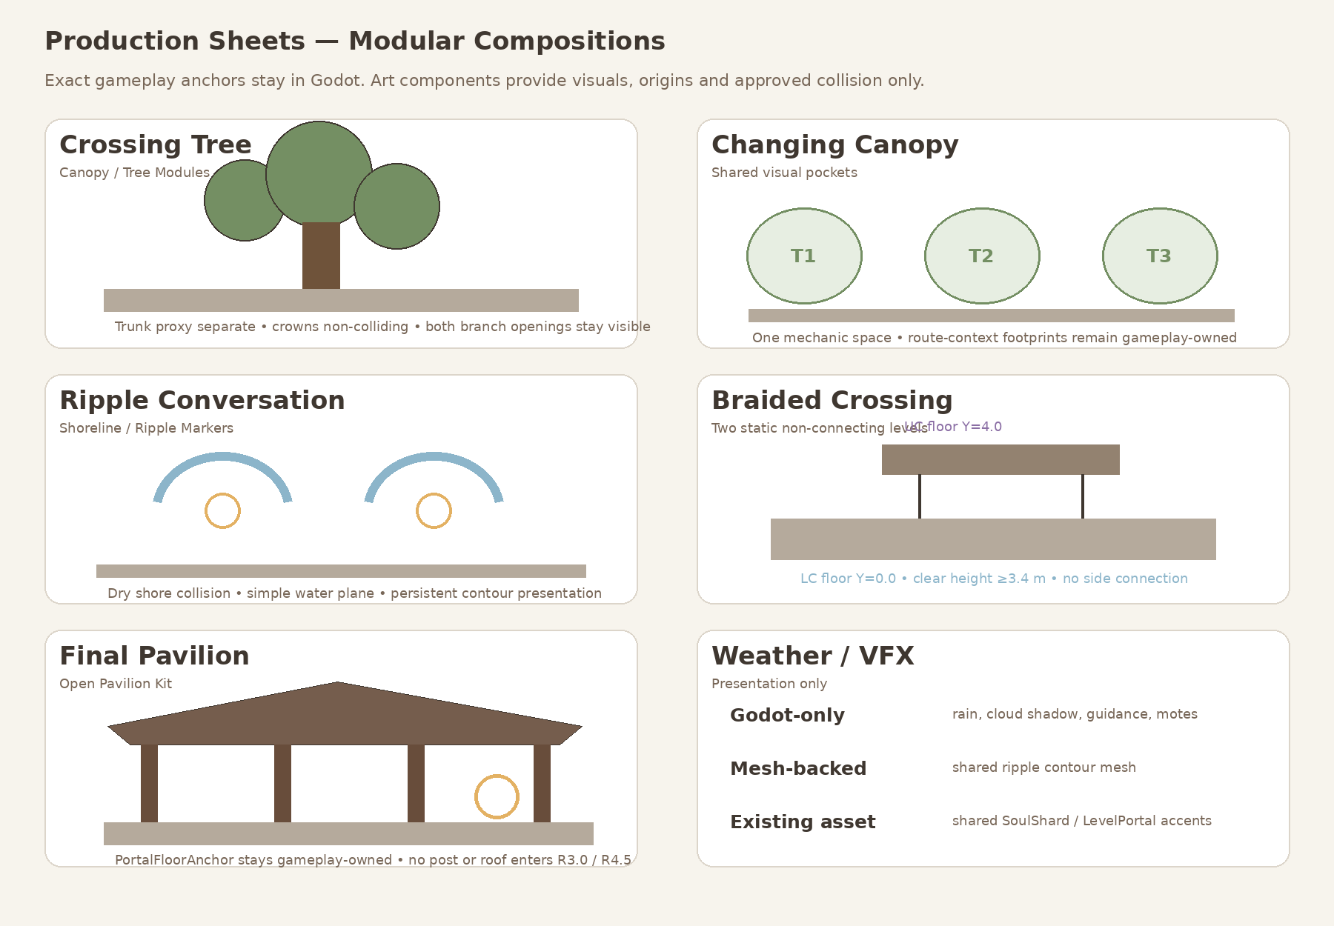
Figure 3. Modular production sheets for the three families and major compositions.

8.1 Crossing Tree composition
- Composition from Tree_Trunk_Core_A, Tree_Branch_Spread_A and 2–3 canopy crowns.
- The old tree is an orientation landmark, not a trial selector or shrine.
- Gameplay branch entrances and equal sightlines remain exact; tree art may not hide both openings from CP0/CP1.
- Trunk collision is a separate simple proxy. Canopy meshes have no collision.

8.2 Changing Canopy composition
- Three shared visual pockets map to gameplay IDs CANOPY_TONE_1..3 but imported art does not own those IDs.
- Initial and remaining terraces use the same mechanic-space visuals from opposite route contexts.
- Canopy crowns/frames must not imply a physical connection between the two terraces.
- ArtAlignment_Tone_1..3 markers are optional and non-authoritative; gameplay markers remain in the puzzle scene.

8.3 Ripple Conversation composition
- Use one simple shallow water plane, two Ripple_Marker_A instances and shared contour mesh/presentation.
- Both markers are readable together from branch entry; color is never the sole distinction.
- Dry shore collision is authoritative for traversal; water is non-hazardous and not a recovery trigger.
- Persistent contours remain through E1–E3 and never read as healing or damage repair.

8.4 Braided Crossing composition
- Upper deck and lower underpass are separate BASE surfaces.
- No side stair, climbable retaining edge or apparent same-level junction may be introduced by art.
- Maintain 5.5 m clear width and at least 3.4 m lower clear height after every visual/collision swap.
- Camera collision and bridge underside are tested independently.

8.5 Final Pavilion composition
- Built from Open Pavilion Kit components; not a unique monument or fourth hero family.
- The pavilion remains open, asymmetrical and integrated into terrace materials.
- PortalFloorAnchor and shared LevelPortal stay gameplay-owned. Art frames but does not reposition or resize them.
- No post, roof edge, rail or foliage enters the R3.0/R4.5 portal clearance zones.

9. Collision matrix
Object class | Collision type | Owner | Production rule | Acceptance
Mandatory floors / ramps | StaticBody3D collision | BASE block / EnvironmentRoot | Accepted greybox primitive first; custom proxy only after separate gate | No visual+collision silent swap.
Hard boundary belt | StaticBody3D | EnvironmentRoot/Boundaries or approved block-local collision root | Separate simplified belt or approved block-local collision | SafetyRoot does not own it.
Visible rim / retaining wall | Optional simple collision | STRUCT/DECOR | Only if visually reachable/blocking | Must not narrow route opening.
Crossing Tree trunk | Capsule/convex proxy | STRUCT wrapper | Only major trunk; canopy none | Preserve branch sightlines.
Braided Crossing upper/lower | StaticBody3D | BASE/STRUCT block | Separate floor and support proxies | No lane-switch collision seam.
Shallow water | None or floor collision identical to dry route if traversable | BASE block | No hazard / slowdown / recovery | Visual water owns no gameplay.
Small foliage/rocks | None | DECOR | No collision by default | Avoid snagging.
Pavilion posts/rails | Simple box/capsule if blocking | STRUCT wrapper | Keep portal/gate clearances | No camera trap.
Presence footprints / targets | Area3D | GameplayRoot/PuzzleRoot | Gameplay-owned | Never embedded in GLB.
Shard interaction | Shared SoulShard collision | GameplayRoot/ShardRoot | Shared system | Art shell does not own.
SoftReturn / OOB | Area3D | GameplayRoot/SafetyRoot | Explicit registered volumes only | No invisible catch floor.
Recovery anchors | Marker3D + Area3D sensor | GameplayRoot/SafetyRoot | Exact zero-movement anchors | Art keeps grounded uncluttered floor.
Portal | Shared LevelPortal interaction/collision | GameplayRoot/PortalRoot | Shared owner | Art wrapper does not modify internal children.

10. Pivot, origin and marker contracts
Subject | Pivot / marker | Owner | Contract
All raw GLB assets | Documented mesh origin only | Art source/wrapper | No gameplay authority. Root exports at 0/0/0, rot 0/0/0, scale 1/1/1.
Path/ramp modules | Bottom-center; forward -Y | Art source | Allows predictable snapping; seams <=0.10 m.
Tree branch spread | Connection socket origin | Art source | Socket is non-authoritative ArtAlignment_BranchSocket.
Canopy crowns | Bottom-center | Art source | No gameplay pivot.
Ripple marker/contour | Geometric center on floor/water plane | Art source | Gameplay footprint/ID remains separate.
Pavilion modules | Connection edge or base center | Art source | No PortalFloorAnchor ownership.
Changing Canopy targets | Exact target centers and footprints | Gameplay scene | Zero movement; art fits around them.
Ripple markers | Exact target centers and footprints | Gameplay scene | Zero movement; art fits around them.
Shard_08/09 anchors | FirstPassAnchor and RemainingPassAnchor | Gameplay ShardSlot | Zero movement; raw GLB has no authoritative anchor.
FinalTextGate | Center (0,2,52), R4.5 | Gameplay scene | Zero movement.
PortalFloorAnchor | (6,2,56.5) | GameplayRoot/PortalRoot | Zero movement; shared LevelPortal identity child.
Recovery anchors RA0–RA11 | Exact Gameplay Spec coordinates | GameplayRoot/SafetyRoot | Zero movement; FloorAnchor identity-local.
Art alignment markers | ArtAlignment_* only | Art wrapper | Optional, non-authoritative, safe to remove/rebuild.

10.1 Locked art tolerance
- Gameplay anchors, triggers, Area3D nodes, pivots, shard anchors, LevelPortalRoot/PortalFloorAnchor, recovery anchors and NodePaths: 0.00 m movement.
- Free non-authoritative dressing has no universal displacement tolerance. It passes only through route width, opening, puzzle, portal, camera, sightline, boundary and recovery acceptance.
- Construction seams remain <=0.10 m and may never reduce a locked clearance.

10.2 SoulOrb_Follow decision
Reuse exactly one existing shared SoulOrb_Follow under PlayerRoot. Do not create a Level_04 orb asset and do not count it as a fourth semi-hero family. Target and orientation ownership remain in Technical Architecture. Art must preserve Player/camera clearance and prevent clipping around the existing shared orb visual.

11. Wrapper-first Blender → GLB → Godot workflow
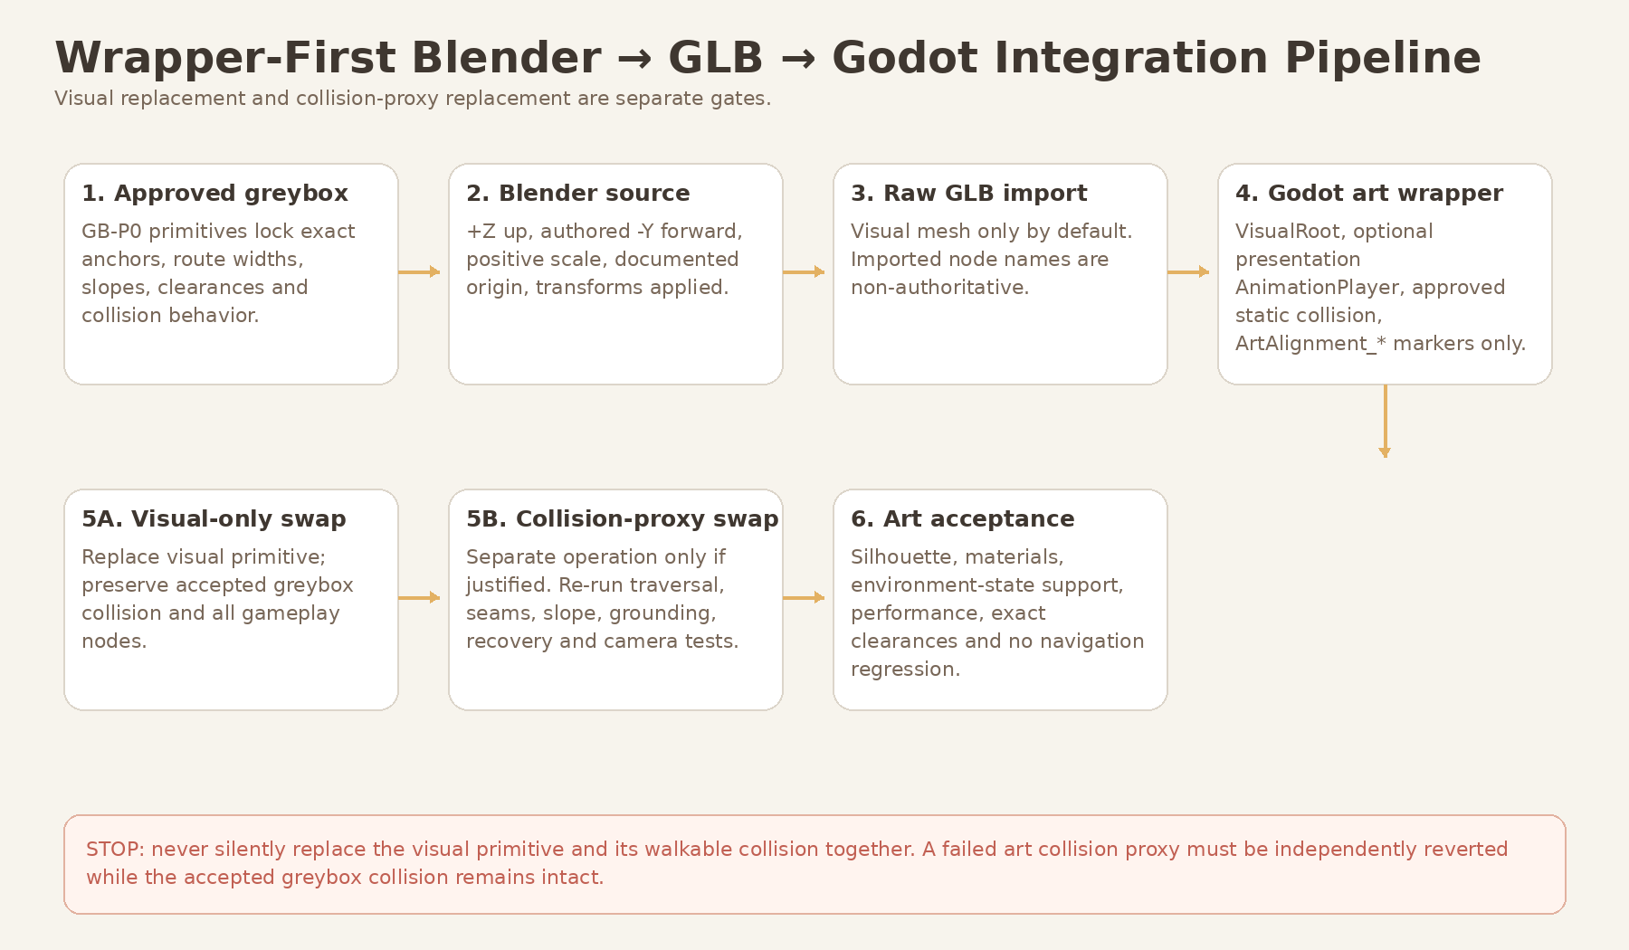
Figure 4. Wrapper-first integration and split visual/collision replacement gates.
Step | Contract
Source setup | Create one .blend per canonical asset/set. +Z up, -Y authored forward, metric scale, positive scale only.
Origin + transforms | Set origin first, place export root at world origin, apply rotation/scale, final root transform identity.
GLB export | Export visual mesh with minimal materials. Collision GLB only when justified and separately named.
Import test | Open dedicated Godot import test scene; verify +Y up, -Z forward, dimensions, normals, materials, pivots, scale and warnings.
Wrapper creation | Create wrapper under scenes/environment/level_04/** with VisualRoot, optional presentation AnimationPlayer, approved static collision and ArtAlignment_* markers.
Visual-only swap | Replace only the greybox visual primitive. Preserve accepted greybox collision, gameplay nodes and exact anchors.
Collision-proxy swap | Separate operation. Rerun traversal, seam, step, slope, grounding, recovery and camera collision tests. Revert collision independently if failed.
Acceptance | Run art gates, performance, environment-state and both-route QA before merging.

11.1 Wrapper content contract
- VisualRoot (Node3D) with imported GLB instance.
- Optional presentation-only AnimationPlayer.
- Approved static collision child owned by wrapper/block, never gameplay state.
- Optional ArtAlignment_* markers only.
- No gameplay scripts on raw GLB or imported nodes.
- Gameplay script attaches to parent gameplay scene/controller, not art wrapper.
- No fragile dependency on imported child names when a wrapper-level reference can be used.

12. IMMEDIATE GREYBOX HANDOFF
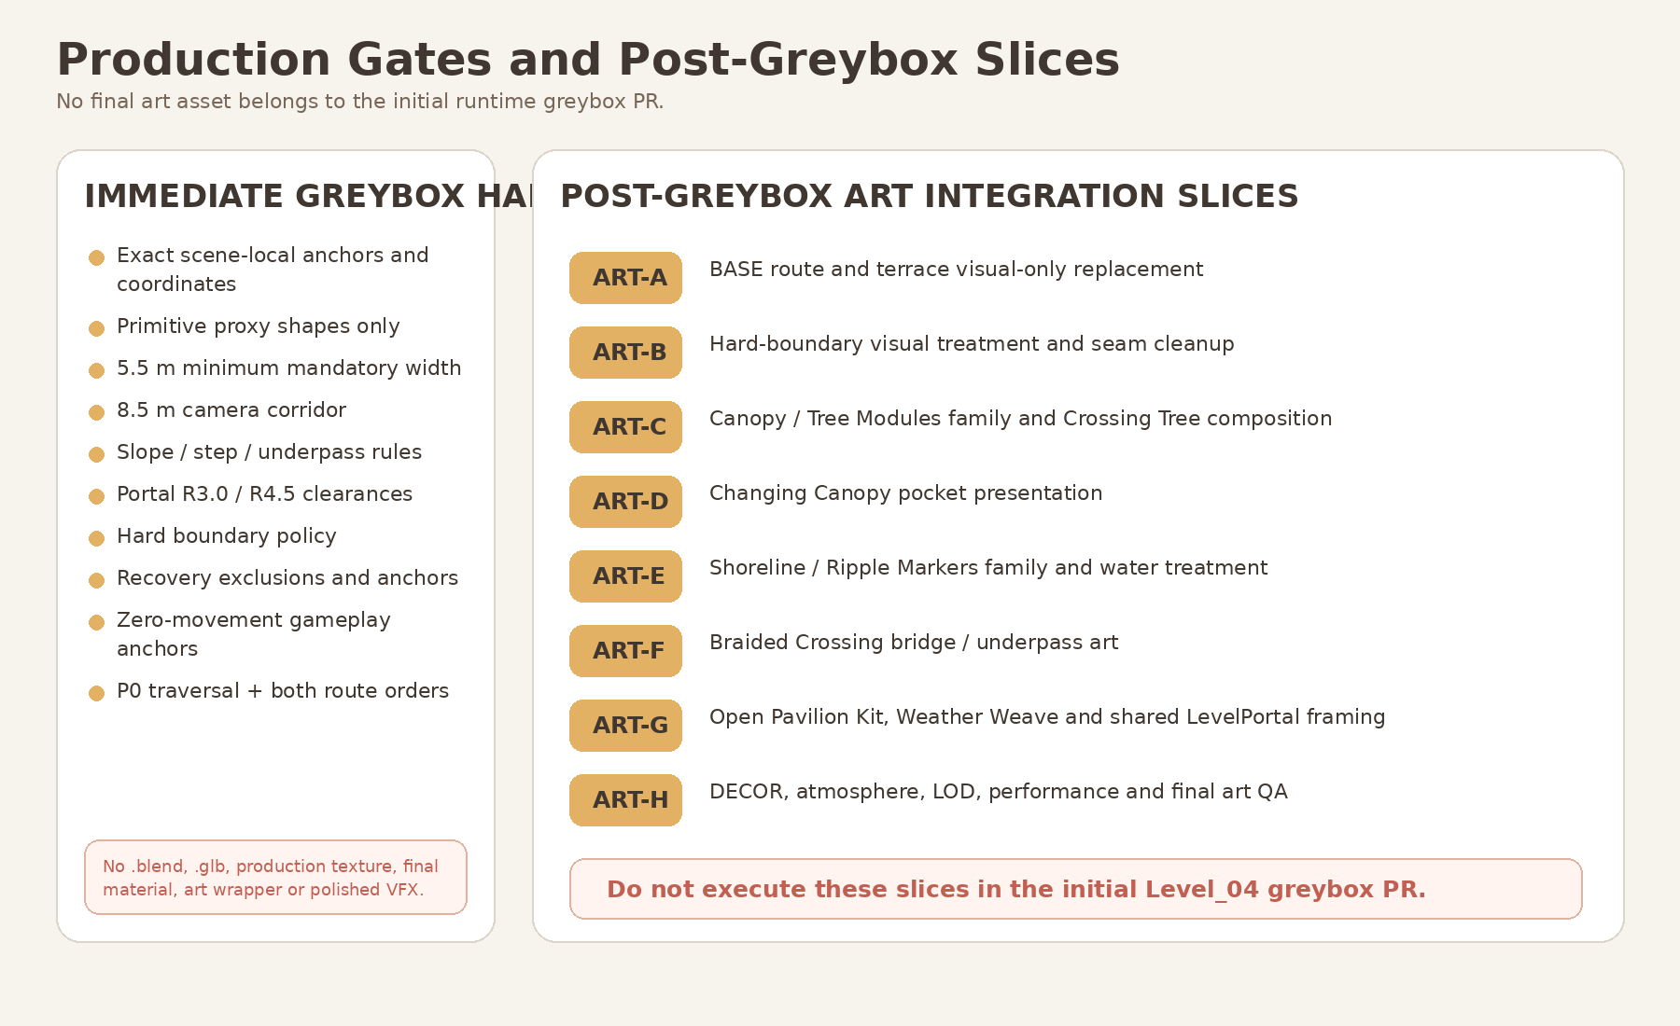
Figure 5. Immediate greybox scope and deferred post-greybox art slices.
The initial Level_04 greybox reference may consume only exact dimensions, coordinates, proxy shapes, collision policy, layer boundaries, pivot/anchor contracts, clearances and acceptance criteria. It may not consume or create final art files.
Greybox input | Locked value
Whole envelope | 76 x 120 m exact gameplay envelope; Level_04 root identity.
Mandatory width | 5.5 m minimum; 6.0-7.0 m at branch entrances/exits, major curves, shard alcoves/approaches and the Final Pavilion approach. Braided Crossing upper/lower lanes remain 5.5 m minimum.
Camera corridor | 8.5 m clear around mandatory centerlines.
Shoulder | 1.25 m minimum to dense dressing/recovery boundary.
Slope / step | Preferred <=8°, isolated <=10° over <=4 m; step <=0.15 m; cross-slope <=3°.
Braided Crossing | UC Y=4.0 / LC Y=0.0; width >=5.5 m; lower clear height >=3.4 m; no connection.
Portal | PortalFloorAnchor (6,2,56.5); R3.0 interaction/collision; R4.5 visual/camera.
Gameplay anchors | All exact coordinates and NodePaths: 0.00 m movement.
Fall safety | Explicit SoftReturn/OOB Areas only; no catch floor.
Art in initial PR | None. Primitives and debug materials only.

12.1 Greybox acceptance preconditions before art swap
- Both Sequence A and B complete on the same static terrain.
- No first-pass branch can reach Weather Weave early.
- No lane switch at shard zones or Braided Crossing.
- All route widths, slopes, steps and underpass clearance pass.
- CP0–CP9 sightlines pass with primitives.
- Shard, gate, portal and recovery pre-overlap tests pass.
- No false recovery in legal side spaces or shallow water.
- Stable 60 FPS baseline and no parse/import errors.

13. POST-GREYBOX ART INTEGRATION SLICES
Do not execute these slices in the initial Level_04 greybox PR.
Slice | Scope | Acceptance focus
ART-A | BASE visual-only swap | Path/terrace modules and visible underside. Preserve accepted collision.
ART-B | Boundary visual treatment | Visible rims, retaining walls, shoreline edges. Hard belt remains separate.
ART-C | Canopy / Tree Modules | Crossing Tree composition, crowns and branch frames; CP0/CP1 sightline QA.
ART-D | Changing Canopy presentation | Three pocket visuals, local tone VFX and guidance; gameplay footprints unchanged.
ART-E | Shoreline / Ripple Markers | Dry shore visuals, simple water, two markers and persistent contours.
ART-F | Braided Crossing art | Bridge/underpass structure, camera collision and clear-height verification.
ART-G | Open Pavilion / finale framing | Pavilion kit, Weather Weave, portal framing; exact gate/portal clearances unchanged.
ART-H | DECOR / optimization / final QA | Foliage, background, LOD, material consolidation, performance and full route re-test.

14. Production priority
Priority | Contents | Start gate
GB-P0 | Primitive dimensions, exact anchors, collision policy, clearances and acceptance only. | Immediate documentation handoff; no art assets.
ART-P1 | BASE route surfaces; three semi-hero families; Braided Crossing; core pavilion composition. | After greybox Producer acceptance.
ART-P2 | Visible boundaries, retaining walls, shoreline edges, guidance and state-support assets. | After ART-P1 route/collision stability.
ART-P3 | Foliage, small ruins, flowers, roots, background and polish. | After gameplay readability and performance baseline remain stable.

15. Blender / GLB / Godot export checklist
- Canonical name and exact source/export/wrapper paths used.
- 1 Blender unit = 1 meter.
- Blender +Z up; project-authored forward -Y.
- Origin documented and set before transform application.
- Export root at world origin.
- Final location 0/0/0, rotation 0/0/0, scale 1/1/1.
- Positive scale only; no unapplied mirror.
- No hidden/unused objects or accidental cameras/lights.
- No unapplied modifier that changes export unpredictably.
- Minimal material slots and exact M_L04_* names.
- Visual and collision exports separated when collision GLB exists.
- No gameplay scripts, IDs, Area3D or authoritative markers in raw GLB.
- Godot import verifies +Y up / -Z forward, dimensions, normals and pivots.
- Wrapper created with VisualRoot and ArtAlignment_* markers only.
- No warnings in Godot import or headless scene load.

16. Art acceptance gates
Gate | Exact acceptance
A-01 Geometry fidelity | All gameplay anchors/triggers/pivots/NodePaths remain at zero movement. Free dressing has no universal tolerance.
A-02 Route integrity | Mandatory routes remain at least 5.5 m wide; branch entrances/exits, major curves, shard alcoves/approaches and Final Pavilion approach remain 6.0-7.0 m; both Braided Crossing lanes remain at least 5.5 m; lower clear height remains at least 3.4 m; 1.25 m shoulder and 8.5 m camera corridor are preserved.
A-03 Static topology | No art-created shortcut, lane switch, climbable bypass or premature Weather Weave/Pavilion access.
A-04 Boundary ownership | Hard StaticBody belt is owned by EnvironmentRoot/Boundaries or an approved block-local StaticBody3D root under the relevant EnvironmentRoot block; visible rim is STRUCT/DECOR; SafetyRoot owns recovery Areas/anchors only.
A-05 Collision stability | No invisible catch floor; visual-only swap passes before collision-proxy swap; failed proxy reverts independently.
A-06 Puzzle readability | All three Canopy pockets and both Ripple markers readable without UI arrows and not hidden by art/VFX.
A-07 Shard safety | Both route-context shard floors are dry, uncluttered, slope <3° and >=2.5 m from recovery boundary.
A-08 Portal/finale | FinalTextGate and R3/R4.5 portal clearances remain empty; pavilion does not read as shrine or trophy.
A-09 Environment states | E0–E3 preserve coexistence; no weather clearing, healing, good/bad branch ranking or VFX state authority.
A-10 Materials | Exact M_L04_* families; no 4K or excessive unique materials; local duplicates for runtime parameters.
A-11 Import stability | All GLBs test-import cleanly; wrapper paths resolve; no fragile imported-name dependency.
A-12 Performance | Target stable 60 FPS with rain/contours/guidance; bounded particles, LOD and shared materials.
A-13 Emotional safety | No savior framing, emotional debt, response demand, tears/trauma symbolism, altar or ceremony framing.
A-14 Full route QA | Sequence A/B, CP0–CP9, RA0–RA11, recovery, early overlap and finale tests rerun after each relevant slice.

17. Production risks and corrections
Risk | Severity | Correction
R-01 Art narrows routes | High | Use centerline overlays and clearance volumes during placement; reject any asset that reduces locked width.
R-02 Canopy hides targets or choices | High | Run CP0–CP3 tests; use open crowns and silhouette gaps.
R-03 Water scope grows | High | Keep simple plane + contour meshes; cut simulation/reflections before gameplay scope changes.
R-04 Bridge creates shortcut | High | Separate upper/lower collision and camera test; no climbable supports or side stair.
R-05 Pavilion becomes shrine | High | Use low open asymmetrical modular composition; keep portal side-forward and restrained.
R-06 Weather becomes moralized | High | Keep sun/shadow/drizzle/water in all states; local guidance only after first reward.
R-07 Wrapper acquires gameplay authority | High | Reject gameplay scripts/Area3D/target IDs inside art wrappers or imported GLB.
R-08 Negative scale/mirror bugs | Medium | Positive scale only; explicit Blender-applied variant if a handed form is essential.
R-09 Visual and collision swapped together | High | Enforce two separate gates; preserve accepted greybox collision for visual-only swap.
R-10 Material proliferation | Medium | Use exact M_L04_* families and atlases; review slot counts at import.
R-11 Excess hero assets | Medium | Maintain exactly three modular families; build landmarks as compositions.
R-12 VFX blocks progression | High | VFX is presentation-only with bounded fallback; logic remains in gameplay controllers.

18. Handoff boundary

18.1 What may pass to Greybox / Codex planning
- Exact coordinates and gameplay envelope.
- Proxy dimensions and route centerlines.
- Clearances, boundary ownership and collision policy.
- Zero-movement pivot/anchor contracts.
- Primitive-only layer tree and acceptance gates.
- No asset implementation prompt or final art slice execution until Producer approval.

18.2 What passes to Blender / Art after greybox approval
- Canonical asset registry and exact paths.
- Dimension/origin/forward/positive-scale contracts.
- Material/VFX families and budget guardrails.
- Production sheets and wrapper-first pipeline.
- Post-greybox slices ART-A through ART-H.
- Export checklist and art acceptance gates.

Appendix A. Exact gameplay anchors — art must not move
Anchor | Exact scene-local floor coordinate
O / SpawnFloorAnchor | (0.00, 0.00, -54.00)
T / Crossing Tree | (0.00, 0.00, -39.00)
C1I | (-21.00, 1.00, -22.00)
C2I | (-21.00, 1.30, -10.00)
C3I | (-16.00, 1.70, 1.00)
C1R | (-27.00, 4.00, -18.00)
C2R | (-27.00, 4.00, -6.00)
C3R | (-22.00, 4.00, 5.00)
R1I | (21.00, -0.40, -22.00)
R2I | (20.00, -0.50, -9.00)
R1R | (29.00, -1.00, -18.00)
R2R | (28.00, -0.80, -5.00)
Shard_08 FIRST_PASS | (-11.00, 2.00, 7.00)
Shard_08 REMAINING_PASS | (-11.00, 4.00, 11.00)
Shard_09 FIRST_PASS | (17.00, -0.30, 5.00)
Shard_09 REMAINING_PASS | (17.00, -0.30, 11.00)
UC | (2.00, 4.00, 16.00)
LC | (2.00, 0.00, 16.00)
W / Weather Weave | (0.00, 1.80, 38.00)
P / FinalTextGate center | (0.00, 2.00, 52.00)
PR / PortalFloorAnchor | (6.00, 2.00, 56.50)

Appendix B. Recovery and camera QA references
Recovery anchor | Exact floor coordinate
RA0 Arrival | (0,0,-54)
RA1 Crossing Tree | (0,0,-39)
RA2 Canopy Initial | (-12,0.8,-29)
RA3 Canopy First Pass | (-11,2,5.5)
RA4 Ripple Initial | (12,-0.2,-29)
RA5 Ripple First Pass | (17,-0.3,3.5)
RA6 Upper Crossing | (2,4,14)
RA7 Lower Crossing | (2,0,14)
RA8 Canopy Remaining | (-28,4,-22)
RA9 Ripple Remaining | (29,-1,-22)
RA10 Weather Weave | (0,1.8,38)
RA11 Final Pavilion | (0,2,50)

Camera QA remains CP0–CP9 from Gameplay Spec v1.2. Art review must reproduce the required reading at Arrival, Crossing Tree, both initial/remaining branch views, both crossing levels, Weather Weave and Final Pavilion.

Appendix C. Visual authority references
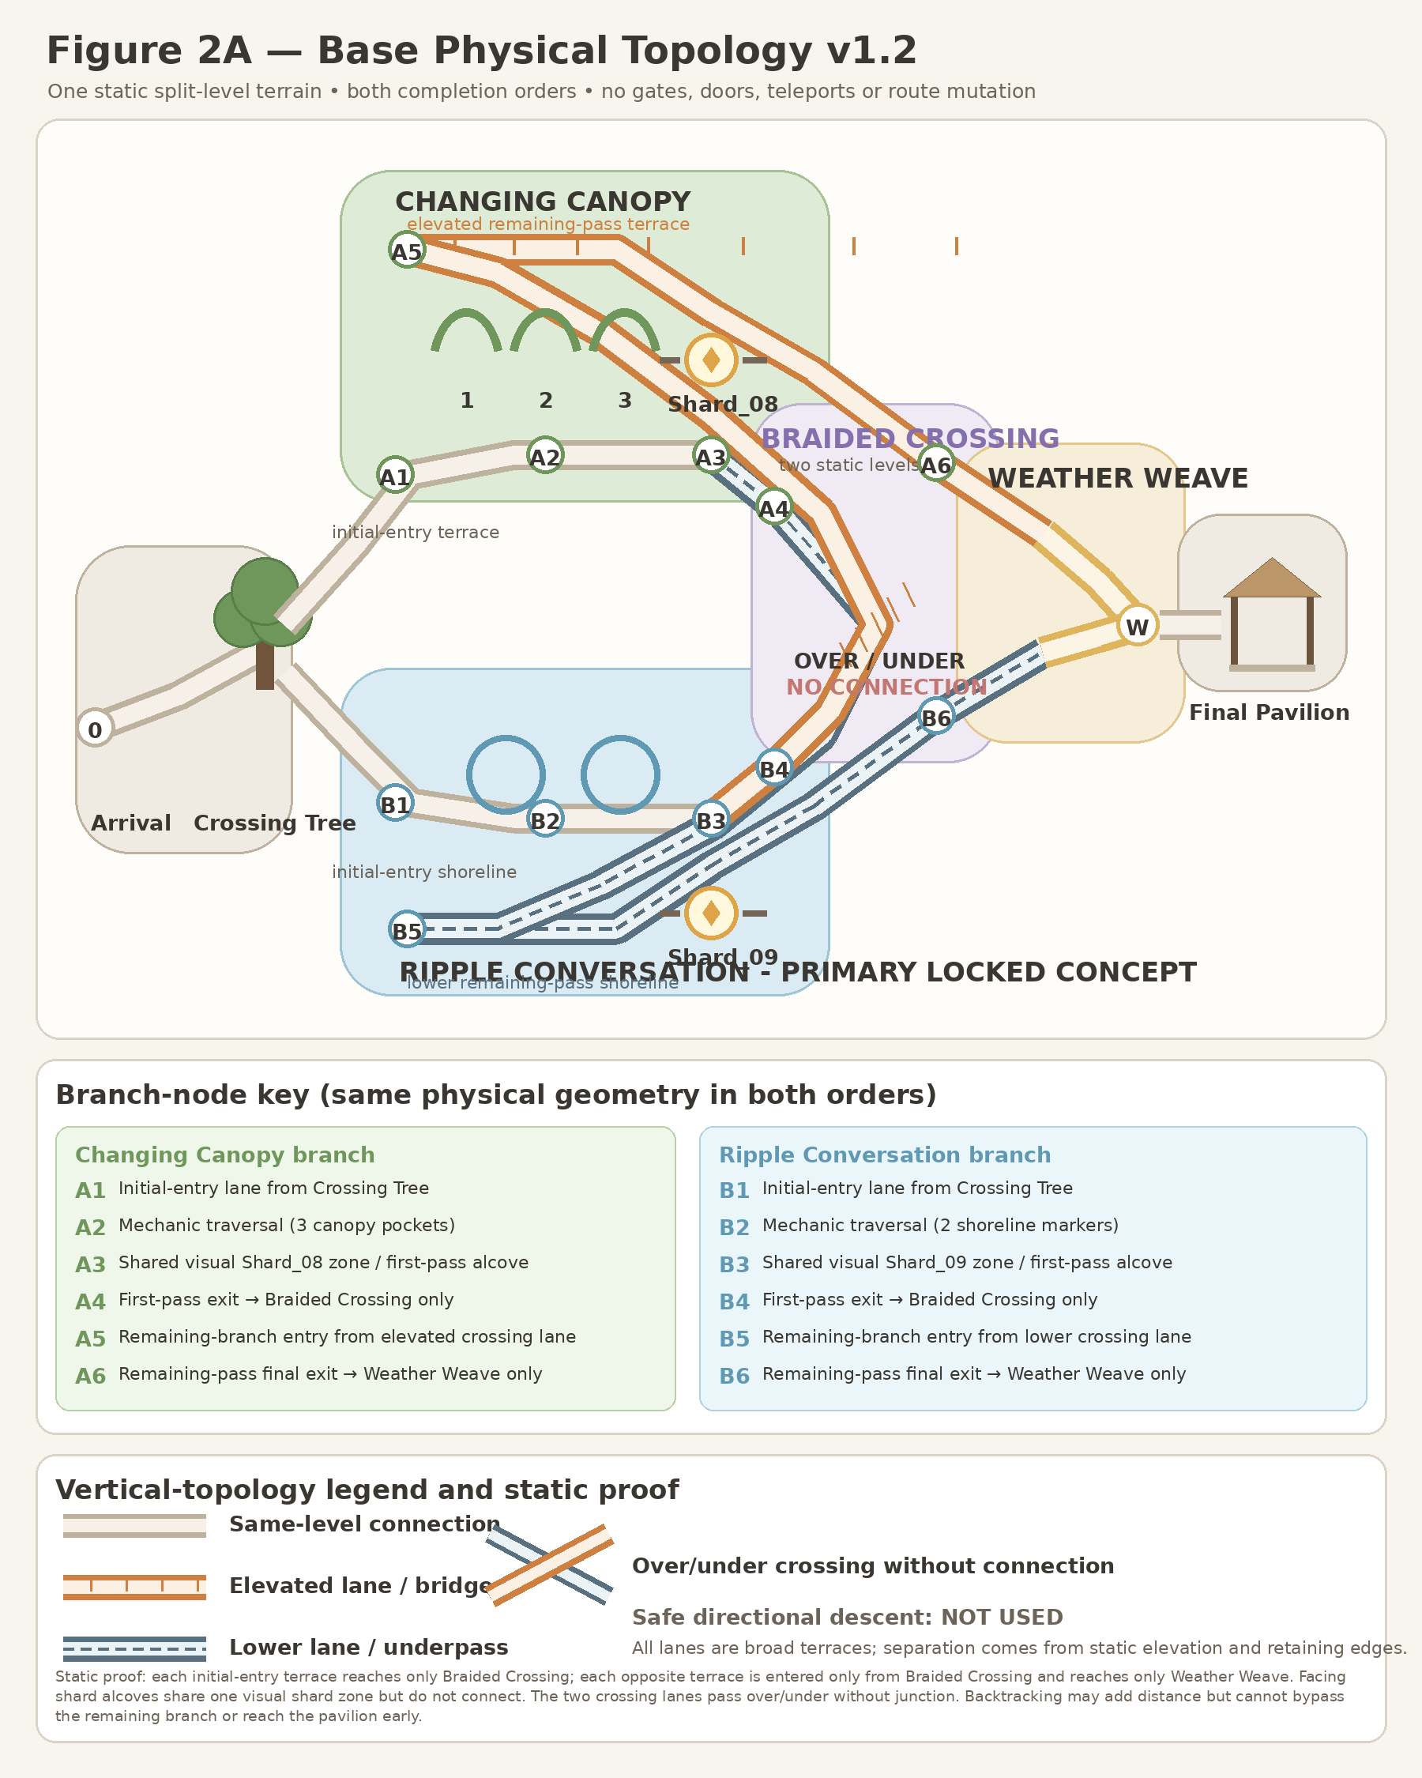
Approved static topology reference from Visual Master v1.2. Mood/diagram reference only; exact production contract is defined in this Bible.
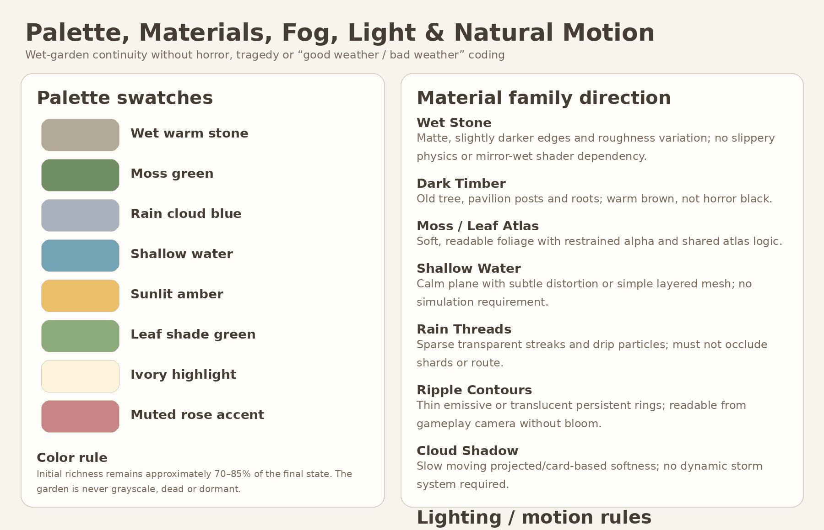
Approved palette/material direction reference. Mood/diagram reference only; exact production contract is defined in this Bible.
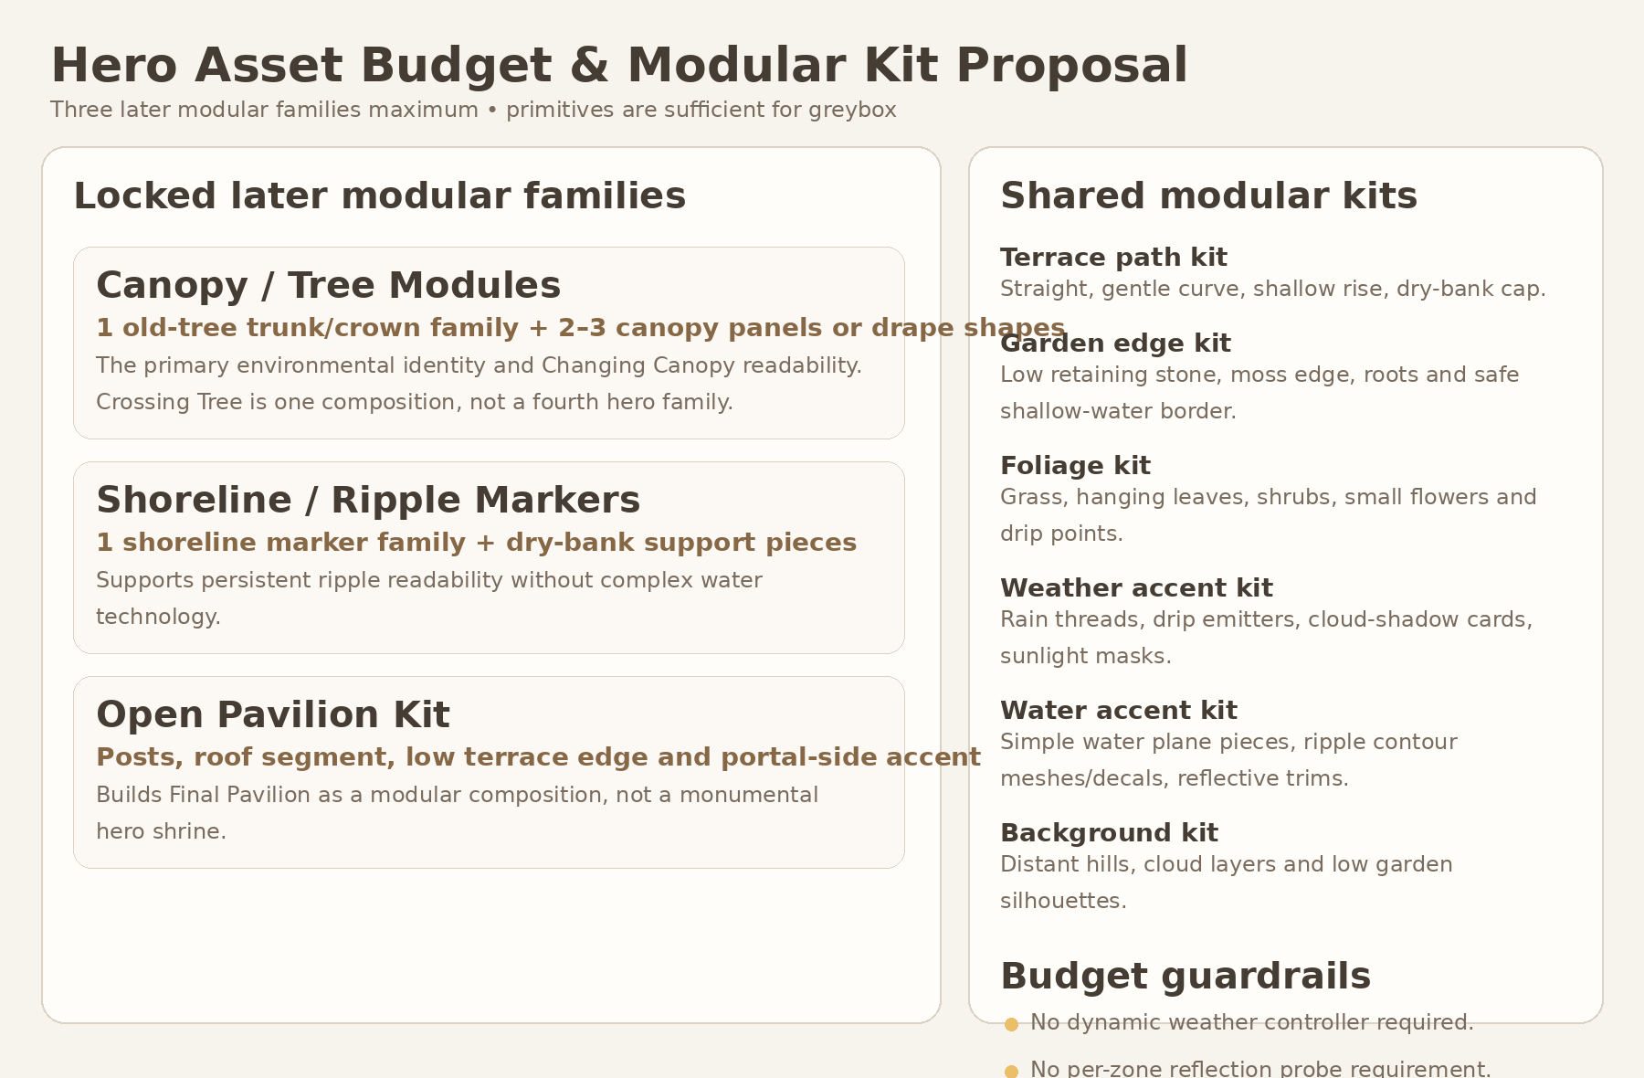
Approved three-family budget reference. Mood/diagram reference only; exact production contract is defined in this Bible.

Document completion statement
This self-contained Level_04 Art Production Bible defines the production boundary for Blender art, GLB import, Godot wrappers and post-greybox integration. It creates no runtime assets and authorizes no implementation. Producer approval and greybox acceptance are mandatory before ART-A begins.

