FIFTEEN SHARDS OF LIGHT

Level_04
Gameplay Map and Complete Level Design Specification v1.2
  - «Ты сама»

FINAL LEVEL DESIGN VERDICT
READY FOR GODOT TECHNICAL ARCHITECTURE AFTER PRODUCER APPROVAL. This document defines playable space, deterministic puzzle behavior, progression, recovery and acceptance contracts only. It does not authorize runtime implementation, a greybox PR, Blender production or Codex implementation decomposition.

Control | Value
Project | Fifteen Shards of Light
Repository | MindDevastation/fifteen-shards-of-light
Target scene | res://scenes/levels/Level_04.tscn
Version | 1.2
Mode | Documentation only - no Godot scenes/scripts, branch, PR, Blender files or GLB assets
Narrative authority | Level_04_Narrative_and_Level_Scenario_Package_v1.1.docx
Visual authority | Level_04_Visual_Master_Concept_Package_v1.2.docx
Portal target | res://scenes/levels/Level_05.tscn

Contents
- Source hierarchy and repository snapshot
- Final order model and topology proof
- Exact world layout, dimensions and coordinates
- Route geometry, slopes, clearances and fall safety
- Beat-by-beat playable flow and pacing
- Changing Canopy and Shard_08 specification
- Ripple Conversation and Shard_09 specification
- Order-independent progression and environment states
- Weather Weave, main-text gate and portal exit
- Progress preservation, duplicates and reload policy
- Accessibility and guidance
- Failure / softlock matrix
- Acceptance criteria and manual playtest matrix
- Simplification fallback and handoff
- Producer decision table

0. Version 1.2 Change Log
ID | Version 1.2 correction
V12-01 | Removed all reward-order authority. first_branch_candidate is fixed only by the first accepted branch-mechanic logical terminal event and is immutable.
V12-02 | Standardized the canonical Level_04 gameplay progression states across reveal authority, environment mapping, failures, acceptance criteria and diagrams.
V12-03 | Corrected the coordinate frame: all values are Level_04 scene-local, root transform is identity, origin is Vector3(0,0,0), and Crossing Tree remains at Vector3(0,0,-39).
V12-04 | Clarified authority hierarchy: Narrative controls copy, Visual Master controls composition intent, Gameplay Spec controls exact layout/behavior, repository controls factual compatibility only.
V12-05 | Carried forward the portal early-overlap requirement as a Technical Architecture runtime-validation blocker rather than a proven shared behavior.
V12-06 | Updated first/remaining shard rules, early-crossing matrix, failure cases and P0 tests to the immutable candidate contract.
V12-07 | Preserved all v1.1 coordinates, route parity, CP0-CP9, recovery, reload, clearances, puzzle rules and canonical texts.
V12-08 | Completed full DOCX render QA for maps, tables, progression diagrams and P0/P1 matrices.

Executive summary
Level_04 is specified as one coherent rainlit terraced garden with a static braided figure-eight topology. The player makes one initial choice at the Crossing Tree, completes either Changing Canopy or Ripple Conversation first, uses one split-level Braided Crossing to enter the remaining branch, then reaches the shared Weather Weave and Final Pavilion.
The playable envelope is 76 x 120 m. Both valid sequences use the same static terrain, differ in route length by approximately 4.0 m (1.7%), contain no mandatory gaps, jumps, damage, death, timer pressure, moving route or one-way descent, and converge on the same finale.
ORDER MODEL
Hybrid order. The two branches are freely selectable at the Crossing Tree and narratively equal. Inside each branch, local targets are persistent and may be visited in any order. After the first unique shard reward, the static crossing leads toward the remaining branch. After the second unique reward, both orders converge on the same non-interactive Weather Weave, main text and Level_05 portal.

1. Source hierarchy and repository snapshot
Priority | Source | Authority after approval
1 | Narrative Package v1.1 | Controls narrative function, exact Shard_08 / Shard_09 copy, exact main text and emotional-safety constraints.
2 | Visual Master Concept v1.2 | Controls approved visual composition intent, topology reading, landmarks, atmosphere and visual hierarchy.
3 | Gameplay Spec v1.2 | Controls exact gameplay floor anchors, route dimensions, deterministic behavior, progression states, recovery and acceptance contracts.
4 | Current repository main | Controls factual shared compatibility, available systems and placeholder drift only; it cannot override approved Gameplay Design inside this domain.

Repository datum | Design implication
Current Level_04 SHA | a62ee67ce823a27e82e615a1f2bdb53d45e580b8
Current scene | Flat 12 x 12 placeholder, one SoulShard, legacy one-shard LevelManager and PoemRewardUI.
Current portal target | res://scenes/levels/Level_05.tscn - retained.
Shared SoulShard direction | Canonical future Level_04 uses Shard_08 and Shard_09 with exact per-shard reward copy.
Shared portal factual baseline | LevelPortal supports AUTO_ENTER, optional confirmation and owns scene transition. A Player already overlapping before activation is not treated as proven to auto-transition without runtime validation.
Runtime status | No repository write or runtime change is authorized by this document.

LEGACY PLACEHOLDER RULE
The current Floor, one SoulShard, legacy LevelManager and generic PoemRewardUI are factual placeholder evidence only. They do not constrain shard count, narrative order, route topology, gameplay map or final Level_04 composition.

2. Final order model and topology proof
Layer | Model | Locked result
Initial order | FREE | Player chooses Changing Canopy or Ripple Conversation at one Crossing Tree choice point.
Branch-local targets | FREE | Three Canopy zones and two Ripple markers are persistent and any-order.
Branch completion | ORDER-INDEPENDENT | first_branch_candidate is fixed solely by the first accepted branch-mechanic logical terminal event. It is immutable regardless of later shard collection or reward order.
Inter-branch route | STATIC | Braided Crossing contains two non-connecting levels; no gate, teleport, moving path or route mutation.
Final order | LINEAR AFTER BOTH | Weather Weave -> Main Text -> Portal Level_05.

2.1 Static topology proof
- Each branch has an initial-entry terrace from Crossing Tree and a physically separate remaining-pass terrace entered from Braided Crossing.
- Each branch has one shared visual shard zone with two facing, non-connecting reveal alcoves. Only one canonical shard ID exists; the active reveal floor anchor depends on route context.
- First-pass exits A4 and B4 connect only to Braided Crossing.
- Remaining-pass final exits A6 and B6 connect only to Weather Weave.
- Upper crossing floor Y=4.0 m and lower underpass floor Y=0.0 m cross in plan but have no junction, side stair or climbable shortcut.
- Backtracking may add distance but cannot create a direct Arrival/Tree-to-Pavilion bypass.
Paper-route parity: Sequence A = 237.0 m; Sequence B = 241.0 m. Difference = 4.0 m (1.7%). This is within the 5% parity target and supports equal narrative value.
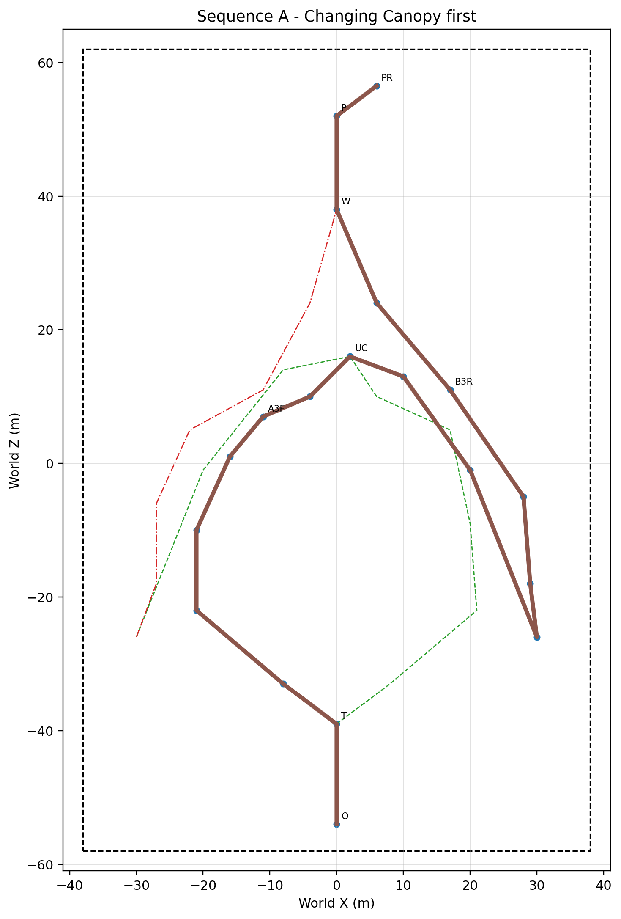
Figure 1. Sequence A - Changing Canopy first.
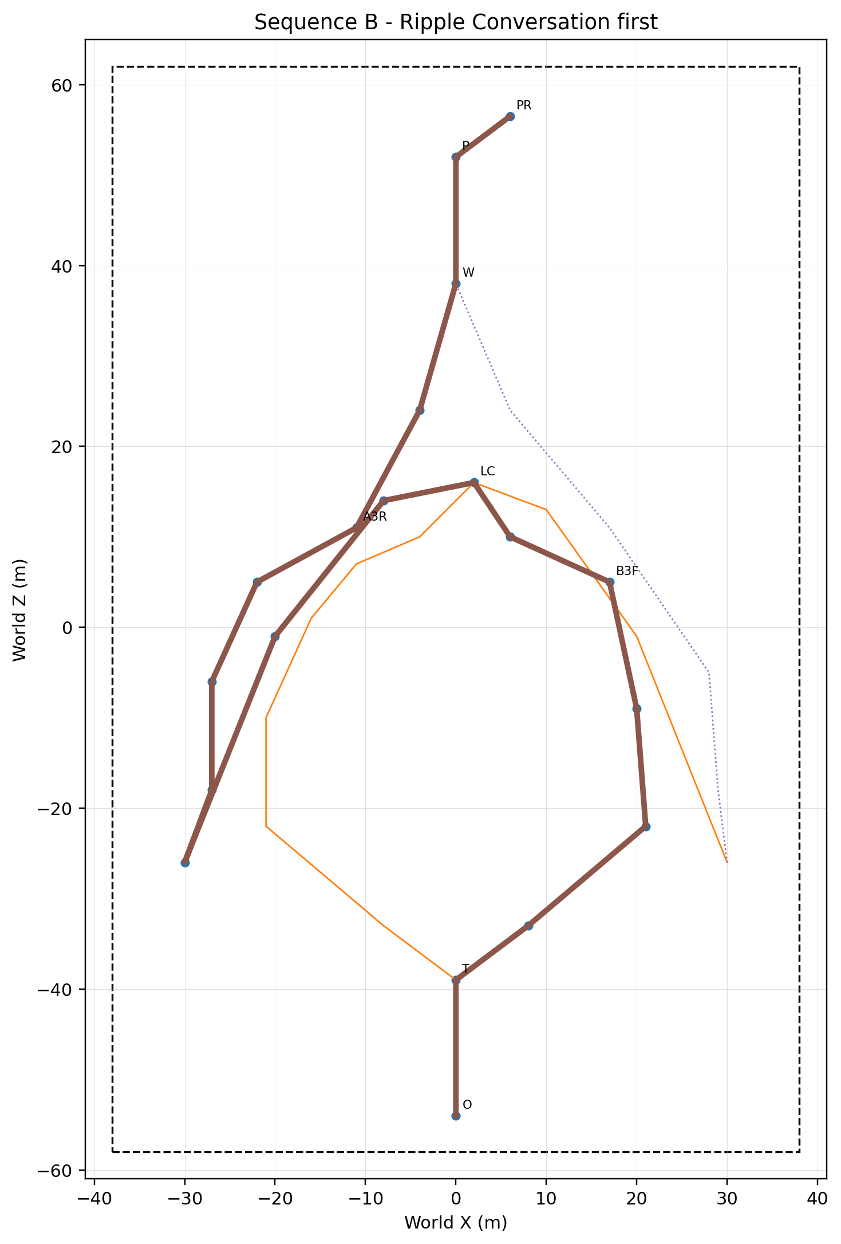
Figure 2. Sequence B - Ripple Conversation first.

3. Exact world layout, dimensions and coordinates
Convention | Definition
Scene-local coordinate frame | All coordinates are Level_04 scene-local. Level_04 root transform is identity. Scene-local origin is Vector3(0, 0, 0). Crossing Tree anchor remains Vector3(0, 0, -39). No secondary local re-origin is permitted.
Forward | +Z from Arrival toward Final Pavilion.
Right | +X when the player faces +Z.
Floor coordinates | Y values are exact authored floor anchors, not assumed Player-root heights.
Gameplay-anchor authority | All authoritative gameplay floor anchors are exact and may not move without Producer-approved design revision.
Player runtime root Y | Derived later from actual shared CharacterBody grounding/floor-snap semantics while the floor anchor remains exact.
Decorative placement | No universal decorative displacement allowance. Acceptance is controlled by route width, camera corridor, target visibility, shard/portal clearance, sightlines and recovery exclusions.
Construction / seam tolerance | <=0.10 m only for mesh seams, collision joins and construction alignment; it may not move gameplay anchors or reduce required clearances.

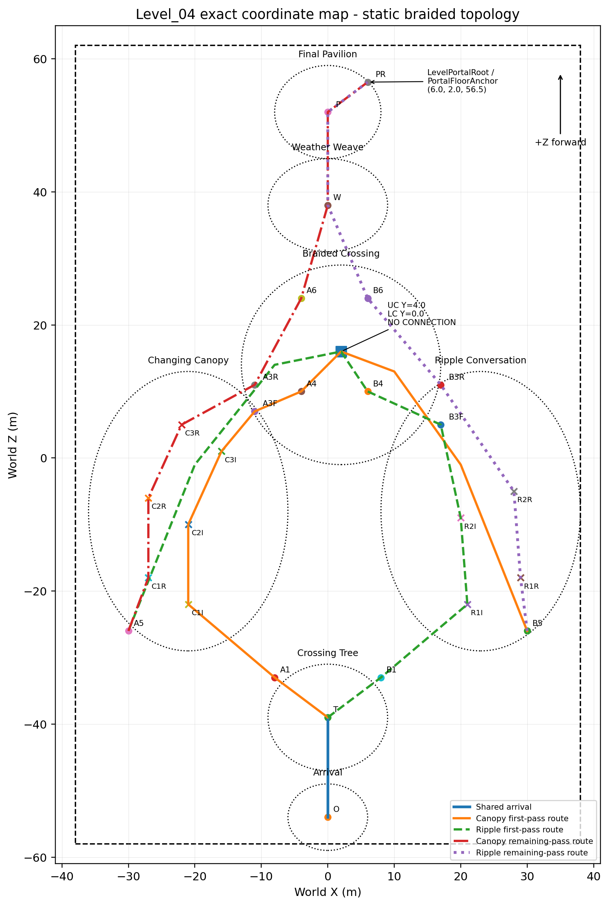
Figure 3. Exact static coordinate map. Labels are keyed to the coordinate tables below.
Zone | Position | Plan size | Floor Y | Function
Whole gameplay envelope | X -38..+38 | Z -58..+62 | 76 x 120 m | Visual concept target 105-125 m long x 65-80 m wide.
Arrival / After-Rain Terrace | Center (0,0,-54) | 12 x 10 m | Y 0.0 | Safe spawn and first combined-weather view.
Crossing Tree | Center (0,0,-39) | 18 x 16 m | Y 0.0 | One initial branch choice only.
Changing Canopy visual region | Center (-21,2.5,-8) | 30 x 42 m | Y 0.5-4.0 | Three visual pockets shared by two separate traversal terraces.
Ripple Conversation visual region | Center (23,-0.6,-8) | 30 x 42 m | Y -1.0..0.0 | Curved shoreline with two shared visual marker zones.
Braided Crossing | Center (2,2.0,14) | 30 x 30 m | Y 0.0 / 4.0 | Two static levels, no connection.
Weather Weave | Center (0,1.8,38) | 18 x 14 m | Y 1.8 | Non-interactive synthesis.
Final Pavilion | Center (0,2.0,52) | 16 x 14 m | Y 2.0 | Main-text rest point and side-forward exit.

Anchor | X | Floor Y | Z
O | 0.00 | 0.00 | -54.00
T | 0.00 | 0.00 | -39.00
A1 | -8.00 | 0.50 | -33.00
C1I | -21.00 | 1.00 | -22.00
C2I | -21.00 | 1.30 | -10.00
C3I | -16.00 | 1.70 | 1.00
A3F | -11.00 | 2.00 | 7.00
A4 | -4.00 | 3.00 | 10.00
UC | 2.00 | 4.00 | 16.00
U1 | 10.00 | 3.30 | 13.00
U2 | 20.00 | 1.00 | -1.00
B5 | 30.00 | -1.00 | -26.00
R1R | 29.00 | -1.00 | -18.00
R2R | 28.00 | -0.80 | -5.00
B3R | 17.00 | -0.30 | 11.00
B6 | 6.00 | 0.80 | 24.00
B1 | 8.00 | -0.20 | -33.00
R1I | 21.00 | -0.40 | -22.00
R2I | 20.00 | -0.50 | -9.00
B3F | 17.00 | -0.30 | 5.00
B4 | 6.00 | 0.00 | 10.00
LC | 2.00 | 0.00 | 16.00
L1 | -8.00 | 0.60 | 14.00
L2 | -20.00 | 2.30 | -1.00
A5 | -30.00 | 4.00 | -26.00
C1R | -27.00 | 4.00 | -18.00
C2R | -27.00 | 4.00 | -6.00
C3R | -22.00 | 4.00 | 5.00
A3R | -11.00 | 4.00 | 11.00
A6 | -4.00 | 3.00 | 24.00
W | 0.00 | 1.80 | 38.00
P | 0.00 | 2.00 | 52.00
PR | 6.00 | 2.00 | 56.50

3.1 Shard reveal floor anchors
Each branch has one canonical shard ID and two exact route-context floor anchors inside one shared visual shard zone. Only one anchor per shard may ever become active. first_branch_candidate is fixed by the first accepted branch-mechanic logical terminal event; collection and reward order have no candidate authority. A revealed shard never migrates between anchors.
Anchor | Floor position | Authority / use
Shard_08 first-pass floor anchor | Vector3(-11.00, 2.00, 7.00) | Eligible only when Changing Canopy wins first_branch_candidate and reaches 3/3.
Shard_08 remaining-pass floor anchor | Vector3(-11.00, 4.00, 11.00) | Eligible only when Changing Canopy is remaining_branch and the player reaches its remaining-pass shard zone.
Shard_09 first-pass floor anchor | Vector3(17.00, -0.30, 5.00) | Eligible only when Ripple Conversation wins first_branch_candidate and reaches 2/2.
Shard_09 remaining-pass floor anchor | Vector3(17.00, -0.30, 11.00) | Eligible only when Ripple Conversation is remaining_branch and the player reaches its remaining-pass shard zone.

3.1.1 First-branch candidate and reveal authority
Canonical gameplay progression state | Deterministic contract
CANDIDATE_UNSET | No branch mechanic has reached a logical terminal event. Both branches may retain partial target progress; no shard reveal authority exists.
FIRST_CANDIDATE_CANOPY | The first accepted terminal event is Changing Canopy 3/3. Candidate is immutable. Only Shard_08 may gain first-pass reveal authority.
FIRST_CANDIDATE_RIPPLE | The first accepted terminal event is Ripple Conversation 2/2. Candidate is immutable. Only Shard_09 may gain first-pass reveal authority.
FIRST_SHARD_AVAILABLE | The candidate shard reveal has completed at its exact first-pass anchor. The opposite shard remains deferred even if its mechanic is complete.
FIRST_REWARD_COMPLETE | The candidate shard reward sequence completes. It does not select or change the candidate; it fixes the opposite branch as remaining_branch.
REMAINING_DEFERRED | The remaining mechanic may be partial or complete. Its shard stays hidden until remaining-pass shard-zone authority is satisfied.
SECOND_SHARD_AVAILABLE | The remaining branch mechanic is complete and the player has reached its exact remaining-pass shard zone. Exactly one second-shard anchor reveals.
BOTH_REWARDS_COMPLETE | The second unique reward sequence completes. Weather Weave and FinalTextGate may arm; no alternate shard anchor remains active.
MAIN_TEXT | The player enters the armed FinalTextGate. Exact main text opens once; portal remains dormant.
EXIT | Main text closes. Shared LevelPortal activation may begin; Level_04-local scene loading remains forbidden.
Same-frame branch-terminal callbacks use first accepted event wins. Candidate assignment is immutable and idempotent. Target completion, reveal requests and reward completion are independently idempotent. The opposite branch may become fully mechanically complete before FIRST_REWARD_COMPLETE, but its shard remains in REMAINING_DEFERRED and cannot reveal at a first-pass anchor.

3.2 Portal and spawn placement
Object | Locked value | Contract
SpawnFloorAnchor | Vector3(0.00, 0.00, -54.00) | Facing +Z. Technical Architecture validates Player-root-to-floor semantics.
FinalTextGate center | Vector3(0.00, 2.00, 52.00) | Broad presence radius 4.5 m; armed only after both rewards.
LevelPortalRoot / PortalFloorAnchor | Vector3(6.00, 2.00, 56.50) | Gameplay Design locks root/floor position only; shared child offsets remain authoritative.
Portal interaction / collision clearance | 3.0 m clear radius | No blocker intrudes into the shared interaction/entry envelope.
Portal visual / camera clearance | 4.5 m clear radius | No column, roof edge, dense foliage or camera blocker obscures portal formation and approach.
Portal target | res://scenes/levels/Level_05.tscn | Scene loading remains owned by shared LevelPortal.

PLAYER ROOT-TO-FLOOR CARRY-OVER
The current Player collision shape is vertically offset from the CharacterBody root. Technical Architecture must validate root-to-floor semantics, grounding and floor snap. Spawn root height must not be derived by simply adding half the collider height to the floor anchor.

3.3 Exact Camera QA points
Point | Exact player floor position | Viewing target | Required reading | Occlusion / state contract
CP0 Arrival | Player floor position Vector3(0.00, 0.00, -52.00) | Look at Vector3(0.00, 2.00, -39.00) | Crossing Tree primary; both branch entrances; distant pavilion silhouette | No tree trunk/foliage may hide both choices. Environment E0; gameplay CANDIDATE_UNSET.
CP1 Crossing Tree | Vector3(0.00, 0.00, -37.00) | Vector3(0.00, 1.50, -25.00) | Equal Canopy/Ripple prominence; pavilion secondary | No branch may be visually ranked or reduced to a hidden side path. Environment E0; gameplay CANDIDATE_UNSET.
CP2 Canopy initial | Vector3(-18.00, 1.50, -14.00) | Vector3(-19.00, 2.20, -3.00) | Three canopy pockets progressively readable; first-pass shard zone context | No severe canopy occlusion of the next unvisited pocket. Environment E0; gameplay CANDIDATE_UNSET or FIRST_CANDIDATE_CANOPY.
CP3 Canopy remaining | Vector3(-26.00, 4.00, -10.00) | Vector3(-19.00, 2.70, 2.00) | Remaining-terrace footprints and remaining-pass shard zone | No mistaken walkable connection to initial terrace. FIRST_REWARD_COMPLETE / REMAINING_DEFERRED with Canopy as remaining_branch.
CP4 Ripple initial | Vector3(18.00, -0.40, -17.00) | Vector3(23.00, -0.50, -7.00) | Both shoreline markers and dry first-pass shard bank | No foliage or reflection hides both marker contours. Environment E0; gameplay CANDIDATE_UNSET or FIRST_CANDIDATE_RIPPLE.
CP5 Ripple remaining | Vector3(28.00, -0.90, -14.00) | Vector3(23.00, -0.50, -6.00) | Remaining footprints, contours and remaining-pass dry bank | No apparent shortcut to initial shoreline terrace. FIRST_REWARD_COMPLETE / REMAINING_DEFERRED with Ripple as remaining_branch.
CP6 Crossing upper | Vector3(5.00, 4.00, 11.00) | Vector3(2.00, 2.00, 16.00) | Upper lane continuity and visible lower underpass separation | No false side stair, drop shortcut or same-level junction. Any gameplay state before BOTH_REWARDS_COMPLETE.
CP7 Crossing lower | Vector3(3.00, 0.00, 13.00) | Vector3(2.00, 2.00, 16.00) | Lower-lane clearance and bridge underside | No camera clipping; upper lane must not read as reachable from below. Any gameplay state before BOTH_REWARDS_COMPLETE.
CP8 Weather Weave | Vector3(0.00, 1.80, 40.00) | Vector3(0.00, 2.00, 52.00) | Pavilion primary; combined canopy/ripple/drizzle/sun motifs | No portal guidance before main text. Environment E2; gameplay BOTH_REWARDS_COMPLETE.
CP9 Final Pavilion | Vector3(-2.00, 2.00, 50.00) | Vector3(6.00, 2.00, 56.50) | Open shelter, horizon and side-forward portal root | No shrine/throne framing; portal visual clear radius 4.5 m. Gameplay MAIN_TEXT or EXIT; environment E2/E3.

4. Route geometry, slopes, clearances and fall safety
Parameter | Locked rule
Mandatory path width | 5.5 m minimum; 6.0-7.0 m at branch entries, curves, shard alcoves and pavilion approach.
Walkable shoulder | 1.25 m minimum between route edge and dense dressing / recovery volume.
Safe camera corridor | 8.5 m clear corridor around mandatory centerlines; tall opaque props outside it.
Preferred slope | <=8 degrees. Sequence A paper maximum = 7.6 degrees; Sequence B = 5.1 degrees.
Absolute isolated slope | 10 degrees maximum over <=4 m only; not used in the proposed centerline.
Cross-slope | <=3 degrees on mandatory traversal and puzzle footprints.
Mandatory step | <=0.15 m. Larger elevation changes use broad continuous ramps.
Mandatory gap | None.
Lower underpass clear width | 5.5 m minimum.
Lower underpass clear height | 3.4 m minimum to underside of bridge; proposed floor separation = 4.0 m.
Water | 0.15-0.25 m visual depth; non-hazardous, non-slippery and not required for traversal.
Shard safety | Dry, <3-degree floor, >=2.5 m from recovery boundary.
Pavilion portal clearance | 3.0 m interaction/collision clear radius plus 4.5 m visual/camera clear radius around PortalFloorAnchor; no column, roof edge or dense foliage may block formation/approach.

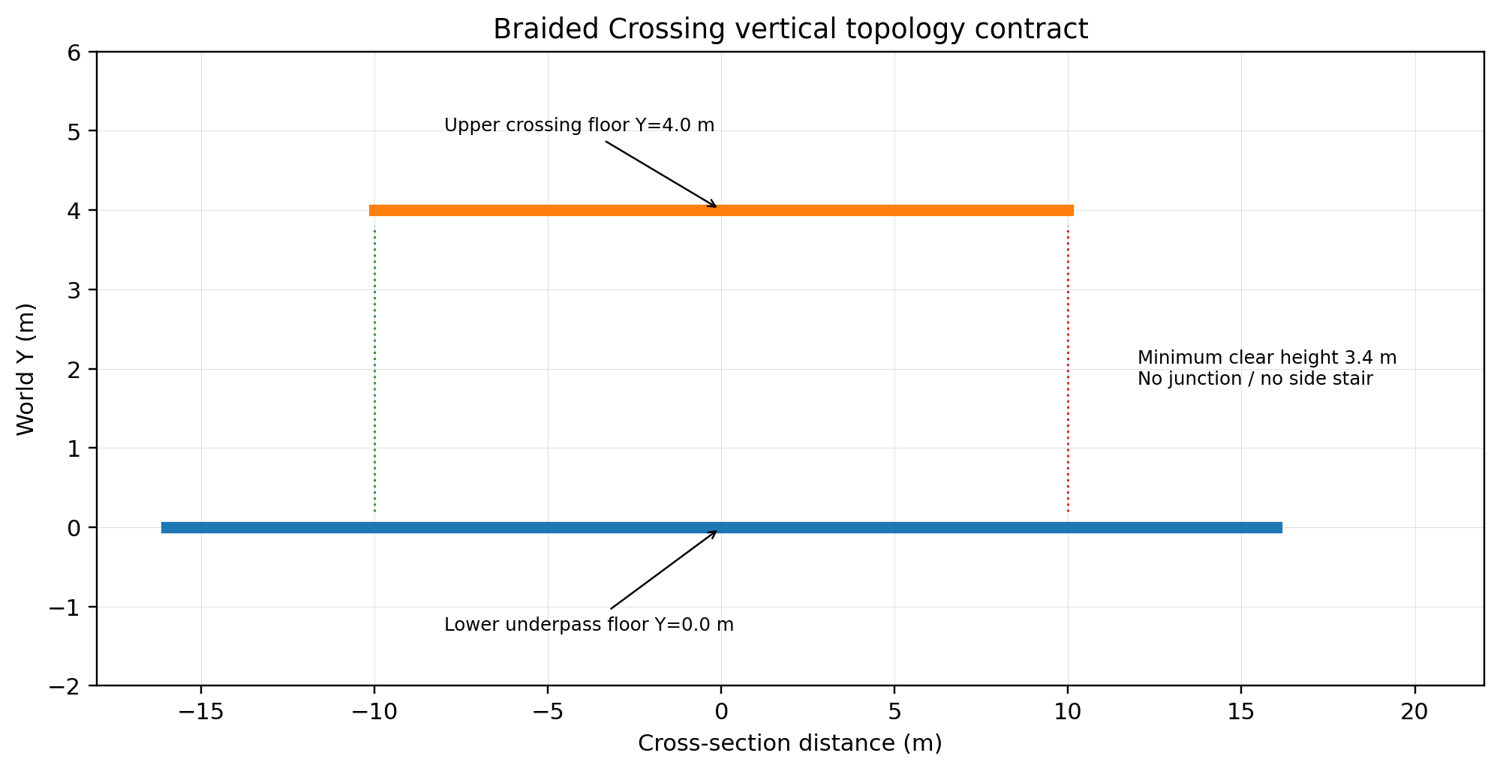
Figure 4. Braided Crossing vertical section. Plan overlap is not a walkable connection.

4.1 Fall recovery policy
Falls are handled only by explicit SoftReturnVolume below the playable world and explicit authored out-of-bounds recovery volumes. Standing still, moving slowly, touching a normal blocker, walking in shallow water or pausing during a puzzle never triggers recovery.
Recovery anchor | Floor position | Activation
RA0 Arrival | Vector3(0.00, 0.00, -54.00) | Becomes latest valid anchor after grounded arrival.
RA1 Crossing Tree | Vector3(0.00, 0.00, -39.00) | Becomes latest valid anchor after grounded arrival.
RA2 Canopy initial | Vector3(-12.00, 0.80, -29.00) | Becomes latest valid anchor after grounded arrival.
RA3 Canopy first-pass shard zone | Vector3(-11.00, 2.00, 5.50) | Becomes latest valid anchor after grounded arrival.
RA4 Ripple initial | Vector3(12.00, -0.20, -29.00) | Becomes latest valid anchor after grounded arrival.
RA5 Ripple first-pass shard zone | Vector3(17.00, -0.30, 3.50) | Becomes latest valid anchor after grounded arrival.
RA6 Upper crossing | Vector3(2.00, 4.00, 14.00) | Becomes latest valid anchor after grounded arrival.
RA7 Lower crossing | Vector3(2.00, 0.00, 14.00) | Becomes latest valid anchor after grounded arrival.
RA8 Canopy remaining | Vector3(-28.00, 4.00, -22.00) | Becomes latest valid anchor after grounded arrival.
RA9 Ripple remaining | Vector3(29.00, -1.00, -22.00) | Becomes latest valid anchor after grounded arrival.
RA10 Weather Weave | Vector3(0.00, 1.80, 38.00) | Becomes latest valid anchor after grounded arrival.
RA11 Final Pavilion | Vector3(0.00, 2.00, 50.00) | Becomes latest valid anchor after grounded arrival.

- One teleport maximum per fall event; recovery volume is disarmed until the player leaves the destination safety zone.
- Recovery sets Player.velocity = Vector3.ZERO, or invokes an equivalent proven public Player API that produces the same complete velocity reset. Private movement state is not required.
- Unique target, shard, branch and environment progress is preserved.
- Recovery is deferred while a shard reward or main-text control lock is active.
- Recovery volumes may not overlap legal side spaces, shard alcoves, pavilion overlooks, shallow-water observation areas or both Braided Crossing lanes.
- Optional generic stuck detection is outside the MVP and requires a separate definition and approval.

5. Beat-by-beat playable flow and pacing
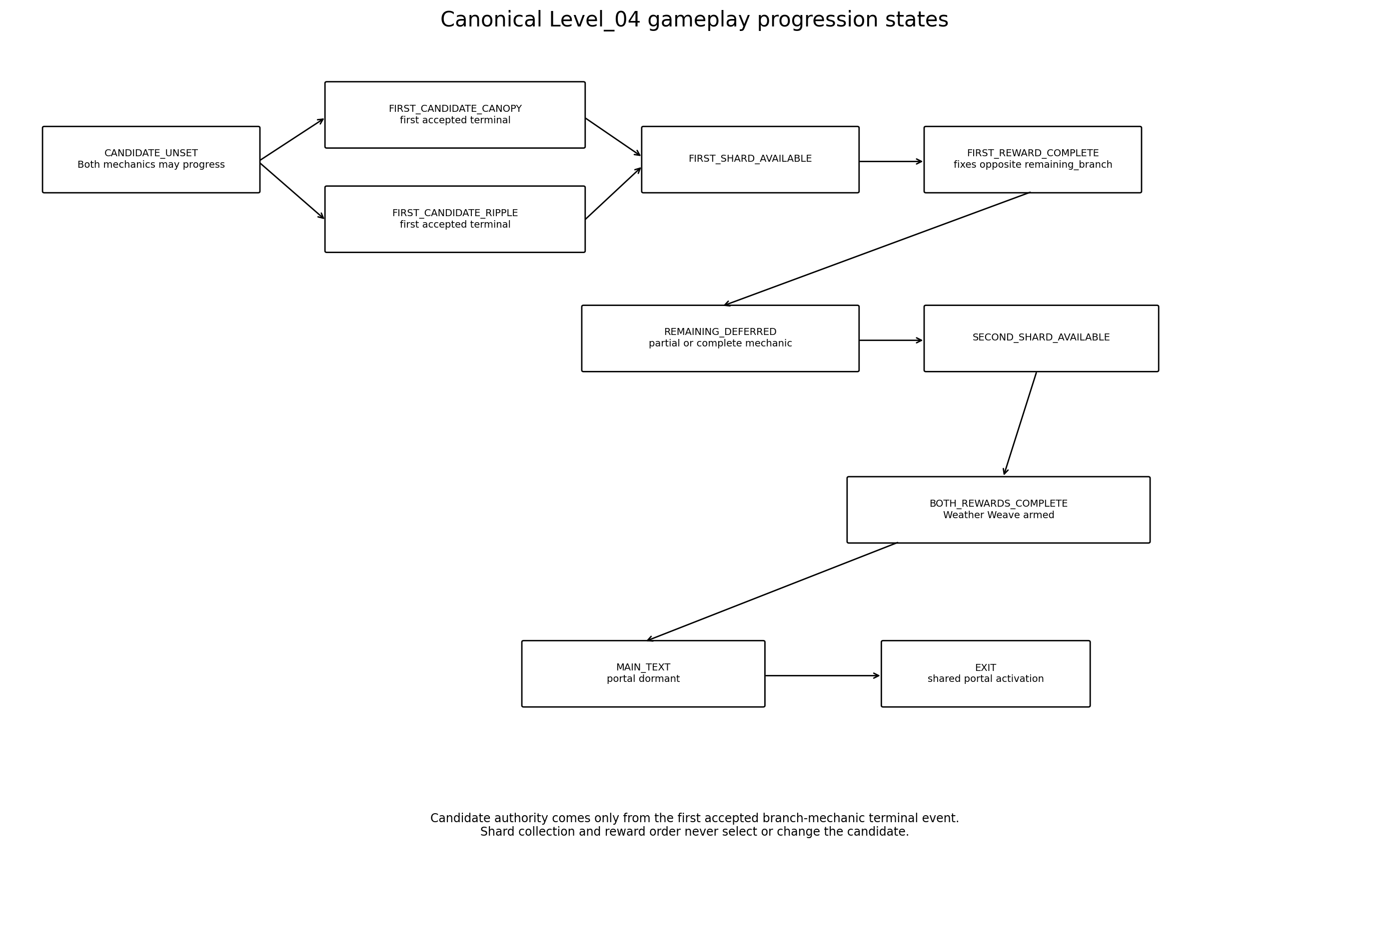
Figure 5. Canonical Level_04 gameplay progression states and immutable first-candidate authority.

5.1 Beat table
ID | Beat | Budget | Location | Goal | Landmark | Action | Narrative | Environment | Confusion | Fallback
B00 | Arrival | 0:00-0:25 | Arrival terrace | Orient and move | Crossing Tree; both branch silhouettes; distant pavilion | Walk / camera | Coexistence without good/bad state | Natural sun, shadow, drizzle and water already visible | Player turns away | Tree remains dominant; route edges frame return
B01 | Crossing Tree choice | 0:25-0:45 | Tree clearing | Choose first branch | Canopy entrance and shoreline entrance equally legible | Walk | Agency without moral test | No branch dims or closes | Cannot decide | After 15 s both entrances pulse once, equally
B02A | First branch - Canopy | 0:45-1:40 | Canopy initial terrace | Visit 3 unique pockets | Large canopy forms | Broad proximity | Conversation changes tone | Persistent 1/3-3/3 branch motif | Misses pocket | Leaf-mote escalation after 20 s
B02B | First branch - Ripple | 0:45-1:35 | Ripple initial shoreline | Visit 2 unique markers | Both shoreline markers visible | Broad proximity | Pauses leave traces | Persistent water contours | Misses marker | Drip/mote escalation after 20 s
B03 | First shard reveal | 1:35-1:55 | First-pass shard alcove | Collect Shard_08 or Shard_09 | Route-context shard anchor | E / existing shard collection | First equal emotional observation | Short reveal then reward sequence | Leaves before collect | Shard remains available
B04 | After first reward | 1:55-2:20 | Completed branch exit | Read remaining route | Braided Crossing | Walk | First beat does not outrank second | Completed branch persists; remaining branch guidance strengthens | Backtracks | No bypass; guidance keeps pointing forward
B05 | Braided Crossing | 2:20-2:50 | Split-level connector | Reach remaining-pass entry | Over/under terraces | Walk | One continuous garden | Both motif families overlap | Tries to switch levels | Retaining edges and no junction
B06A | Remaining Canopy | 2:50-3:45 | Elevated remaining terrace | Complete any unfinished 3 pockets | Canopy pockets from opposite side | Broad proximity | Seriousness is equally valued | Persistent motif and first branch state remain | Targets partially done | Unique IDs preserve prior completion
B06B | Remaining Ripple | 2:50-3:40 | Lower remaining shoreline | Complete any unfinished 2 markers | Ripple markers from opposite side | Broad proximity | Quiet pauses remain meaningful | Persistent contours and first branch state remain | Targets partially done | Unique IDs preserve prior completion
B07 | Second shard reveal | 3:40-4:10 | Remaining-pass shard alcove | Collect second unique shard | Shard floor anchor | E / reward sequence | Both observations coexist | Weather Weave becomes armed after reward completes | Duplicate callback | Ignored by unique ID
B08 | Weather Weave | 4:10-4:40 | Shared final approach | Walk to pavilion | Pavilion becomes primary | Walk | Synthesis, not third puzzle | Leaf-shadow, ripples, drizzle and sun framed together | VFX callback missing | Bounded fallback continues
B09 | Main text | 4:40-5:25 | Final Pavilion | Enter broad text gate and read | Open shelter and horizon | Presence / overlay | Author misses Alena herself | Portal remains dormant | Gate entered early | Re-evaluate after both rewards
B10 | Portal formation | 5:25-5:45 | Pavilion side-forward | Wait for calm activation | Portal root | No input required | Continuation, not trophy | Local restrained activation | Player overlaps early | One transition after activation; no re-entry required
B11 | Exit | 5:45-6:30 | Portal | Transition to Level_05 | Stable portal | AUTO_ENTER | Move toward small details chapter | Weather remains unchanged | Rapid enter/exit | Portal owns one scene transition

5.2 Pacing budget
Segment | Target | Interpretation
Arrival + choice | 0:35-0:50 | One clear choice; no 360-degree search.
First branch + reward | 1:10-1:35 | Canopy and Ripple must both fit this budget.
Braided Crossing | 0:25-0:35 | Connector, not a new puzzle.
Remaining branch + reward | 1:10-1:35 | Persistent partial progress may shorten this segment.
Weather Weave + main text + portal | 1:05-1:35 | Only main text intentionally blocks movement.
Normal first completion | 5:00-6:30 | Scope alarm if traversal without reading exceeds 7:00.
Correct repeat completion | 3:00-4:00 | Both sequence orders within ±10% total time.

6. Changing Canopy and Shard_08 specification
LOCKED SHARD_08 TEXT
«Ты можешь рассмешить меня, а через минуту сказать что-то так серьёзно, что я просто слушаю.»

Field | Specification
Canonical ID | Shard_08
Mechanic completion | All three unique canopy target IDs complete. This may happen before or after first_branch_candidate is assigned.
First-branch authority | If Canopy produces the first accepted branch-mechanic terminal event, gameplay enters FIRST_CANDIDATE_CANOPY. Candidate is immutable; only the first-pass Shard_08 anchor may reveal.
Deferred authority | If Ripple owns first_branch_candidate, Canopy may retain 3/3 in REMAINING_DEFERRED. Shard_08 may reveal only after FIRST_REWARD_COMPLETE and exact remaining-pass shard-zone authority.
Input | Grounded player enters and remains inside a broad pocket footprint for 0.45 s. No E timing.
Order | Any order; C1, C2 and C3 are persistent unique states.
Dual-terrace rule | Each visual pocket has an initial and remaining footprint mapped to one unique completion.
Reveal | Exactly one route-context anchor becomes active. Reveal duration target 0.8-1.1 s; anchor cannot change after reveal starts.
Reward sequence | Exact short text once; duplicate callbacks ignored. If this is the candidate reward, FIRST_REWARD_COMPLETE fixes Ripple as remaining_branch without selecting or changing the candidate.
Leave / re-enter | No reset. Partial/full progress persists through early crossing, backtracking and recovery.

Unique target | Visual pocket | Trigger footprints | Feedback
CANOPY_TONE_1 | Pocket center (-24,2.5,-20) | C1I (-21,1.0,-22) / C1R (-27,4.0,-18) | Sunlit leaf movement; equal-value warm response.
CANOPY_TONE_2 | Pocket center (-24,2.7,-8) | C2I (-21,1.3,-10) / C2R (-27,4.0,-6) | Cool cloud-shadow drift; no negative coding.
CANOPY_TONE_3 | Pocket center (-19,2.9,3) | C3I (-16,1.7,1) / C3R (-22,4.0,5) | Droplet and leaf response; no healing/bloom effect.

Rule | Contract
Branch-local mechanic progression | Local target count 0/3 -> 1/3 -> 2/3 -> 3/3. At 3/3 it emits a terminal event: it becomes FIRST_CANDIDATE_CANOPY if CANDIDATE_UNSET, otherwise it remains complete under REMAINING_DEFERRED. These are local substates, not alternate Level_04 progression-state names.
Candidate race | If Canopy and Ripple terminal callbacks occur in the same frame, the first accepted callback fixes first_branch_candidate; later candidate callbacks are ignored.
Wrong input | None. Entering a completed footprint gives a quiet completed-state response only.
Assistance 1 | 20 s without new completion: nearest unvisited pocket receives rising leaf motes.
Assistance 2 | 35 s without new completion: ground-light wave repeats every 6 s toward nearest unvisited pocket.
Early crossing | Either terrace may record unique target progress before FIRST_REWARD_COMPLETE; progress never resets and cannot override the immutable first_branch_candidate.
Reveal exclusivity | Only one Shard_08 anchor can activate. No duplicate instance and no anchor migration after reveal begins.
Presentation fallback | If VFX callback races fallback timeout, first terminal event wins and the reveal/reward state advances once.
No-softlock contract | No ordered sequence, timer, reset, hidden target, sound dependency, jump or state-correction interpretation.

7. Ripple Conversation and Shard_09 specification
LOCKED SHARD_09 TEXT
«Мне дороги и наши разговоры, в которых пауз больше, чем слов.»

Field | Specification
Canonical ID | Shard_09
Mechanic completion | Both unique shoreline marker IDs complete. This may happen before or after first_branch_candidate is assigned.
First-branch authority | If Ripple produces the first accepted branch-mechanic terminal event, gameplay enters FIRST_CANDIDATE_RIPPLE. Candidate is immutable; only the first-pass Shard_09 anchor may reveal.
Deferred authority | If Canopy owns first_branch_candidate, Ripple may retain 2/2 in REMAINING_DEFERRED. Shard_09 may reveal only after FIRST_REWARD_COMPLETE and exact remaining-pass shard-zone authority.
Input | Grounded player enters a broad dry-shore footprint and remains 0.45 s. No waiting puzzle or precise placement.
Order | Any order; R1 and R2 are persistent unique states.
Dual-terrace rule | Each visual marker has an initial and remaining footprint mapped to one unique completion.
Reveal | Exactly one route-context anchor becomes active. Reveal target 0.8-1.1 s; anchor cannot change after reveal starts.
Reward sequence | Exact short text once; duplicate callbacks ignored. If this is the candidate reward, FIRST_REWARD_COMPLETE fixes Canopy as remaining_branch without selecting or changing the candidate.
Water rule | Water is visual only: non-hazardous, non-slippery and not required for traversal.

Unique target | Visual marker | Trigger footprints | Feedback
RIPPLE_MARKER_1 | Visual center (25,-0.7,-20) | R1I (21,-0.4,-22) / R1R (29,-1.0,-18) | Persistent contour A on already-living water.
RIPPLE_MARKER_2 | Visual center (24,-0.65,-7) | R2I (20,-0.5,-9) / R2R (28,-0.8,-5) | Persistent contour B; both remain visible together.

Rule | Contract
Branch-local mechanic progression | Local target count 0/2 -> 1/2 -> 2/2. At 2/2 it emits a terminal event: it becomes FIRST_CANDIDATE_RIPPLE if CANDIDATE_UNSET, otherwise it remains complete under REMAINING_DEFERRED. These are local substates, not alternate Level_04 progression-state names.
Candidate race | If Ripple and Canopy terminal callbacks occur in the same frame, the first accepted callback fixes first_branch_candidate; later candidate callbacks are ignored.
Wrong input | None. Completed markers do not increment again and do not remove contours.
Assistance 1 | 20 s without new completion: nearest unvisited marker gains a restrained vertical drip/mote cue.
Assistance 2 | 35 s: a soft ring repeats at the nearest unvisited marker every 6 s.
Early crossing | Either terrace may record unique marker progress before FIRST_REWARD_COMPLETE; progress never resets and cannot override the immutable first_branch_candidate.
Reveal exclusivity | Only one Shard_09 anchor can activate. No duplicate instance and no anchor migration after reveal begins.
Race protection | Duplicate footprint callbacks and presentation completion racing fallback timeout are idempotent; first terminal event wins.
No-softlock contract | No response-demand metaphor, waiting duration, ordered exchange, audio recognition or water-technology dependency.

8. Order-independent progression and environment states
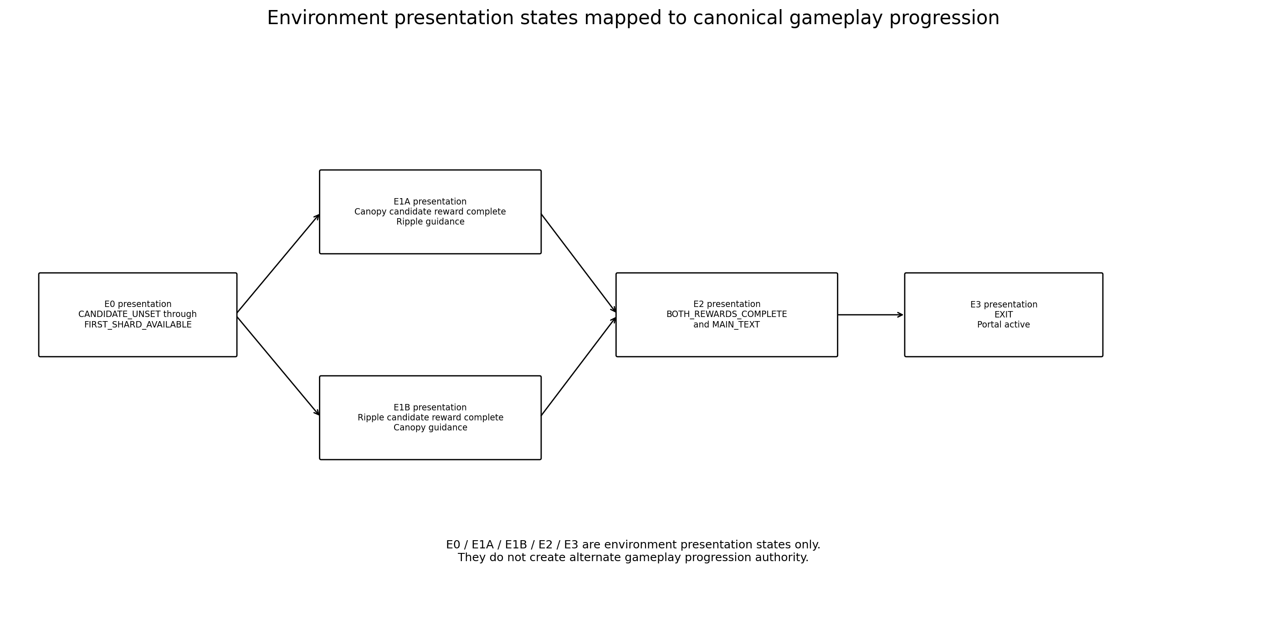
Figure 6. Environment presentation states E0-E3. These labels are not gameplay progression-state names.
Canonical gameplay progression state | Environment presentation state | Persistent visual / authority result
CANDIDATE_UNSET | E0 | Both branches alive; both may record target progress; all shards and finale gates fail-closed.
FIRST_CANDIDATE_CANOPY | E0 | Only Shard_08 first-pass reveal authority exists; Ripple completion, if any, is deferred.
FIRST_CANDIDATE_RIPPLE | E0 | Only Shard_09 first-pass reveal authority exists; Canopy completion, if any, is deferred.
FIRST_SHARD_AVAILABLE | E0 | Guidance prioritizes the candidate shard; crossing remains physically open.
FIRST_REWARD_COMPLETE | E1A or E1B | Candidate remains immutable. Opposite branch becomes remaining_branch; only its guidance strengthens.
REMAINING_DEFERRED | E1A or E1B | Second shard remains hidden until exact remaining-pass zone authority is satisfied.
SECOND_SHARD_AVAILABLE | E1A or E1B | Exactly one remaining-pass anchor reveals; completed first branch stays alive.
BOTH_REWARDS_COMPLETE | E2 | Weather Weave and pavilion guidance become primary; portal remains dormant.
MAIN_TEXT | E2 | Exact main text once; portal remains dormant through the overlay.
EXIT | E3 | Shared LevelPortal activates; weather does not clear or rank branches.
Canonical gameplay progression uses only the ten states defined in Section 3.1.1. E0, E1A, E1B, E2 and E3 are environment presentation labels mapped onto those states; they do not create alternate progression authority.

8.1 Order-independent progression contract
- Progress is keyed to unique mechanic-target IDs and canonical shard IDs Shard_08 / Shard_09; a blind counter is never sufficient.
- first_branch_candidate is fixed solely by the first accepted branch-mechanic logical terminal event. Before any terminal event, either branch may still become candidate. After assignment, candidate is immutable regardless of shard collection or reward order. FIRST_REWARD_COMPLETE only fixes the opposite branch as remaining_branch.
- The deferred second shard may reveal only at its exact remaining-pass anchor. After its unique reward, gameplay enters BOTH_REWARDS_COMPLETE and the common E2 environment presentation starts regardless of shard ID or route order.
- Completed branch visuals never dim, close, dry, clear or lose value.
- Only the remaining branch receives stronger local guidance after the first reward.
- Duplicate reward callbacks, duplicated collection signals and replayed presentation callbacks are ignored.
- Both Sequence A and Sequence B reach identical Weather Weave, exact main text, portal state and Level_05 target.

8.2 Early Braided Crossing contract
Situation | Locked behavior
CANDIDATE_UNSET | Early traversal is allowed. Targets on either terrace may record unique progress. No shard reveals; Weather Weave and FinalTextGate remain fail-closed.
FIRST_CANDIDATE_* or FIRST_SHARD_AVAILABLE | Crossing is allowed before collection. Candidate is immutable; its first-pass shard remains the sole available reward. Guidance continues toward it and every route has a physical return.
Both mechanics complete before FIRST_REWARD_COMPLETE | First accepted terminal event still owns candidate authority. Opposite mechanic is complete in REMAINING_DEFERRED; only the candidate first-pass shard can reveal.
FIRST_REWARD_COMPLETE with remaining mechanic complete | remaining_branch is fixed as candidate opposite. On arrival at its exact remaining-pass shard zone, gameplay advances to SECOND_SHARD_AVAILABLE without replaying the mechanic.
Recovery and backtracking | Recovery anchors must never trap the player on a side without a return route. Repeated crossing/backtracking preserves all progress and reveal authority.

9. Weather Weave, main-text gate and portal exit

9.1 Weather Weave
Field | Contract
Input | Walk toward the visible Final Pavilion. No new interaction or puzzle.
Prerequisite | Both unique shard reward sequences complete.
Presentation | Leaf-shadow flecks, persistent ripples, drizzle and sunlight share the same approach.
Duration | 20-30 s normal traversal; optional synthesis presentation bounded to <=2.0 s.
Fallback | Missing optional motif callback cannot delay FinalTextGate arming beyond 2.5 s.
Narrative role | Synthesis of two already valuable observations, not repair or emotional proof.

LOCKED MAIN TEXT
«Сначала я думал, что жду наших разговоров ради твоего голоса и смеха. Потом понял, что мне дороги и те минуты, когда ты серьёзна, говоришь прямо или между нами просто становится тихо. Я скучаю не только по лёгким разговорам. Я скучаю по тебе - и поэтому в памяти остаются даже маленькие вещи.»

Field | Locked behavior
FinalTextGate | Center Vector3(0.00, 2.00, 52.00), broad radius 4.5 m.
Gate prerequisite | Both unique reward sequences complete. If player is already inside, gate re-evaluates automatically.
Main text | Shows exactly once. Control lock only while the existing overlay requires it.
Portal floor anchor | LevelPortalRoot / PortalFloorAnchor = Vector3(6.00, 2.00, 56.50).
Target | target_scene_path = res://scenes/levels/Level_05.tscn
Entry behavior | entry_mode = LevelPortal.EntryMode.AUTO_ENTER; require_entry_confirmation = false.
Activation timing | Portal activation begins only after main text closes.
Scene ownership | Level_04-local orchestration never changes scene directly; shared LevelPortal owns scene loading.
Shared geometry | Gameplay Design locks root/floor position, not internal visual or interaction child coordinates.
Early overlap | Gameplay requirement: if the player overlaps the future portal area during formation and remains inside, exactly one Level_05 transition occurs after activation with no exit/re-entry. Current shared LevelPortal pre-existing-overlap behavior is not treated as proven. Technical Architecture must runtime-validate it; if unsupported, hard-stop for a separately approved narrow shared prerequisite. Level_04-local scene loading remains forbidden.

10. Progress preservation, duplicate events and reload policy
Domain | Contract
Canopy targets | Three unique IDs, persistent across leave/re-enter, terrace change, crossing and recovery.
Ripple markers | Two unique IDs, persistent contours and duplicate protection.
Shard collection | Shard_08 and Shard_09 accepted once each; reward completion keyed to unique ID.
First-reward response | Runs once at FIRST_REWARD_COMPLETE. It cannot select or change first_branch_candidate; it only fixes the immutable candidate opposite as remaining_branch.
Second-reward response | Runs once at BOTH_REWARDS_COMPLETE. Environment presentation E2 and Weather Weave are common for both orders.
Main text | Opens and closes once; duplicate close callbacks ignored.
Portal activation | Activation requested once; duplicate completion callbacks produce no second transition.
Fall recovery | Preserves all current-scene progress and environment state.

10.1 Reload policy
MVP FULL-SCENE RELOAD
A full Level_04 scene reload resets the chapter coherently to E0 at Arrival. The current project has no approved partial Level_04 checkpoint/save contract. No stale branch, contour, shard, overlay or portal state may survive a clean reload.

- Normal traversal mistakes use SoftReturnVolume recovery and do not reload the scene.
- If a future save system restores Level_04, it must restore unique target IDs, shard IDs, route context and environment state atomically before control resumes.
- Partial restoration is outside this stage and requires separate approval.

11. Accessibility and guidance
Area | Rule
Navigation | Crossing Tree silhouette, branch materials, terrain height, persistent effects, Braided Crossing framing and pavilion sightline. No UI arrow required.
Order equality | Both entrances receive equal initial emphasis; no sun=good / rain=bad framing.
Audio independence | Every mandatory target and route is readable without sound.
Color independence | Targets differ through position, silhouette, motion and persistent geometry, not color alone.
Motor accessibility | No jump, timer, quick input or precise shore placement. Broad 0.45 s presence footprints.
Cognitive accessibility | 3 any-order Canopy targets, 2 any-order Ripple targets, persistent progress, no wrong answers.
Motion sensitivity | No camera shake, lightning flash, rapid weather transition or large bloom pulse.
Text safety | Player is on broad dry floor; environment never moves the character while reading.

Beat | Base | Assistance 1 | Assistance 2
Crossing Tree | 0-15 s: equal static readability | 15-30 s: both entrances pulse once | No forced choice or ranking.
Canopy | 0-20 s: normal pocket motion | 20-35 s: nearest unvisited leaf motes | >35 s: ground wave every 6 s.
Ripple | 0-20 s: normal marker ring | 20-35 s: nearest unvisited drip/mote | >35 s: ring every 6 s.
After first reward | Immediate remaining-route contrast | 20 s: connector motif pulse | Completed branch remains equally alive.
Weather Weave | Pavilion primary sightline | 25 s: stronger pavilion silhouette pulse | Repeated synthesis flecks; portal remains dormant.

12. Failure and softlock matrix
Risk | Prevention | Fallback | Acceptance
Player partially completes both branches before first shard | While no mechanic terminal event exists, gameplay remains CANDIDATE_UNSET and all target progress persists. | The first accepted branch-mechanic terminal event fixes FIRST_CANDIDATE_CANOPY or FIRST_CANDIDATE_RIPPLE. The candidate is immutable; reward order has no authority. | No shard reveals before a terminal event; after assignment, candidate never changes.
Player abandons first branch and returns to Tree | No gate or reset. Before any terminal event, either branch may still become candidate. | After FIRST_CANDIDATE_CANOPY or FIRST_CANDIDATE_RIPPLE is assigned, backtracking cannot change it regardless of collection or reward order. | No softlock; extra distance only; candidate remains immutable.
Canopy duplicate footprint callbacks | Unique target ID accepts first completion only. | Further callbacks produce completed-state feedback. | Progress never exceeds 3.
Ripple duplicate marker callbacks | Unique target ID accepts first completion only. | Persistent contour remains. | Progress never exceeds 2.
Canopy / Ripple presentation callback races fallback timeout | Logical state transition is idempotent. | First terminal event wins; late event ignored. | One reveal only.
Player leaves Canopy / Ripple halfway | Progress persistent. | Hints resume on return. | No reset.
Player reaches wrong shard alcove | Only route-context reveal anchor becomes available. | Inactive alcove remains visual-only. | No duplicate shard instance.
Player backtracks after first reward instead of crossing | Completed branch remains open; no bypass. | Remaining-branch guidance continues toward crossing. | Can still complete, but not reach Weather Weave early.
Player tries to switch Braided Crossing levels | No junction, side stair or climbable retaining edge. | Out-of-bounds recovery if natural boundary is bypassed. | Cannot skip remaining branch.
Player stands still / moves slowly / touches blocker | No recovery trigger tied to inactivity or speed. | None required. | Player is never teleported.
Player falls below terrain | Explicit SoftReturnVolume only. | One teleport to latest valid anchor; velocity reset; state preserved. | No death, loop or repeated teleport.
Recovery occurs during reward/main text lock | Recovery request deferred. | Apply after lock closes only if still out of bounds. | No overlay interruption.
Player enters shallow water | Water is non-hazardous and outside recovery volumes. | Walk back to dry route; no damage or reset. | No false recovery.
Duplicate Shard_08 / Shard_09 signal | Unique ID already recorded -> ignore. | No second overlay or environment transition. | Exactly two unique rewards max.
Second reward presentation missing | Bounded fallback completes logical reward. | Weather Weave arms once. | No finale softlock.
Player enters FinalTextGate early | Gate records presence but remains unarmed. | After both rewards, gate re-evaluates automatically. | No exit/re-entry required.
Duplicate main-text close | First valid close advances. | Later closes ignored. | One portal activation.
Portal activation completion duplicates | First completion arms entry. | Later callbacks ignored. | One scene transition.
Rapid portal enter/exit around activation | Portal entry state owns transition. | No transition before active; after active, one valid overlap starts entry. | No double load.
Early overlap during formation | Entry remains disabled before portal ACTIVE. Gameplay contract requires overlap re-evaluation on activation. | Technical Architecture must runtime-validate shared behavior; if unsupported, hard-stop for a separately approved narrow shared prerequisite. | No early load; exactly one Level_05 transition after activation without re-entry.
Portal VFX fails | Bounded activation fallback. | Stable active state and shared transition still enabled. | No invisible permanent lock.
Scene reload during any partial state | Clean CANDIDATE_UNSET / E0 reconstruction. | All transient gameplay and presentation states cleared. | No mixed branch/environment state.
Both mechanics complete before either shard | First accepted terminal callback fixes FIRST_CANDIDATE_CANOPY or FIRST_CANDIDATE_RIPPLE; opposite mechanic enters REMAINING_DEFERRED. | Only candidate first-pass shard reaches FIRST_SHARD_AVAILABLE; second waits for FIRST_REWARD_COMPLETE plus remaining-pass authority. | Exactly one first-pass shard active; Weather Weave fail-closed.
First mechanic complete, shard uncollected, player enters crossing | FIRST_CANDIDATE_* or FIRST_SHARD_AVAILABLE permits physical crossing; candidate remains sole first-shard authority. | Guidance continues toward candidate shard; physical return remains available. | No SECOND_SHARD_AVAILABLE and no finale arming.
Remaining mechanic already complete when first reward finishes | FIRST_REWARD_COMPLETE fixes remaining_branch as immutable candidate opposite. | REMAINING_DEFERRED advances to SECOND_SHARD_AVAILABLE on exact remaining-pass zone arrival without replaying mechanic. | Exactly one reveal at remaining anchor.
Deferred second shard reaches remaining anchor | REMAINING_DEFERRED verifies remaining branch, mechanic completion and exact zone authority. | Advance once to SECOND_SHARD_AVAILABLE at the exact remaining-pass floor anchor. | No first-pass duplicate and no migration.
Duplicate first-branch candidate callbacks | Atomic first accepted terminal event transitions CANDIDATE_UNSET once. | Later candidate callbacks are ignored idempotently. | FIRST_CANDIDATE_CANOPY / RIPPLE never changes.
Player crosses early and backtracks repeatedly | All target and candidate states persist; routes remain bidirectional. | Guidance continues to currently available first shard. | No reset, trap or unintended reveal.
Two shard instances become active | Per-shard anchor exclusivity forbids second activation. | Disable/reject duplicate before interaction becomes available. | At most one active instance per canonical shard.
Anchor migration requested after reveal begins | Reveal state freezes active anchor. | Ignore later context/anchor requests. | World position remains unchanged through reward.

13. Acceptance criteria
Domain | Acceptance criterion
Layout | 76 x 120 m envelope; one Tree choice; one split-level crossing; no Arrival-to-Pavilion shortcut.
Traversal | 5.5 m minimum mandatory width; no gaps/jumps; slopes comply; underpass clear height >=3.4 m.
Order parity | Sequence A and B route length difference <=5%; same finale state and target.
Canopy | Exactly 3 visible persistent unique targets; either terrace footprint can satisfy its unique target.
Ripple | Exactly 2 visible persistent markers; any order; dry-ground shard reveal; water non-hazardous.
Shard copy | Shard_08 and Shard_09 exact canonical texts without paraphrase.
Progression | Canonical state set only: CANDIDATE_UNSET, FIRST_CANDIDATE_CANOPY, FIRST_CANDIDATE_RIPPLE, FIRST_SHARD_AVAILABLE, FIRST_REWARD_COMPLETE, REMAINING_DEFERRED, SECOND_SHARD_AVAILABLE, BOTH_REWARDS_COMPLETE, MAIN_TEXT, EXIT. first_branch_candidate is terminal-event-owned and immutable.
Weather Weave | Non-interactive; no third puzzle; optional VFX cannot block final gate.
Main text | Exact text, once, after both reward sequences and FinalTextGate presence.
Portal | Root floor anchor locked; AUTO_ENTER; no confirmation; shared portal owns Level_05 load; 3.0 m interaction clearance and 4.5 m visual/camera clearance.
Recovery | Explicit volumes only; one teleport per fall; velocity reset; state preservation.
Tone | No healing, weather clearing, mood ranking, shrine, emotional debt or response demand.
Runtime safety | All duplicate/race transitions are idempotent. Portal early-overlap behavior is a mandatory Technical Architecture runtime validation; unsupported shared behavior is a hard-stop prerequisite, never a weakened local workaround.
Duration | First 5:00-6:30; repeat 3:00-4:00; traversal-only scope alarm >7:00.
Reveal authority | No active duplicate shard instances; no anchor migration after reveal starts; same-frame candidate/reveal events are idempotent.
Early crossing | Allowed during CANDIDATE_UNSET through REMAINING_DEFERRED; target progress persists; Weather Weave / FinalTextGate fail-closed; physical return and recovery remain valid.
Camera QA | CP0-CP9 satisfy required landmarks, target readability, environment state and prohibited-occlusion contracts.

13.1 Manual playtest matrix
ID | Setup | Action | Expected
P0-01 | Fresh scene | Sequence A through Level_05 | All beats, exact texts and one portal transition.
P0-02 | Fresh scene | Sequence B through Level_05 | Identical finale state and one portal transition.
P0-03 | Canopy available | Test all 6 orders of C1/C2/C3 | Exactly 3 unique completions and one eligible reveal authority.
P0-04 | Ripple available | Test R1-R2 and R2-R1 | Exactly 2 unique completions and one eligible reveal authority.
P0-05 | Both mechanics near terminal | Complete both in same frame | First accepted mechanic terminal event fixes FIRST_CANDIDATE_CANOPY/RIPPLE; opposite is REMAINING_DEFERRED.
P0-06 | Both mechanics complete | Collect neither shard, cross and backtrack | Only candidate first-pass shard reaches FIRST_SHARD_AVAILABLE; no Weather Weave / FinalTextGate.
P0-07 | Candidate mechanic complete | Enter crossing before shard collection | Candidate remains immutable; progress preserved; guidance stays on candidate shard; return route valid.
P0-08 | Opposite mechanic already complete | Finish first reward, reach remaining-pass zone | On remaining-pass arrival, REMAINING_DEFERRED advances once to SECOND_SHARD_AVAILABLE.
P0-09 | First reward complete | Remaining mechanic partial, cross early | Existing progress persists; shard reveals only after final target + remaining-zone authority.
P0-10 | Candidate callbacks | Send duplicate candidate callbacks | CANDIDATE_UNSET transitions once; candidate remains immutable; no duplicate reveal.
P0-11 | Canopy / Ripple target | Fire initial and remaining footprint callbacks same frame | One unique completion only.
P0-12 | Reveal starts | Request alternate anchor before reveal ends | No migration; original world anchor remains.
P0-13 | Shard visibility audit | Inspect all route/order states | No more than one active instance per canonical shard.
P0-14 | Braided Crossing | Attempt all edge climbs and route switches | No UC/LC connection or pavilion bypass.
P0-15 | Fall volume | Fall repeatedly from each route family | One teleport per fall; Player.velocity = Vector3.ZERO or public equivalent; progress preserved.
P0-16 | Normal route | Stand still, move slowly, push blocker | No recovery.
P0-17 | Shallow water | Enter legal water-side observation areas | No damage, slowdown or recovery.
P0-18 | Duplicate shard | Emit same shard completion twice | Second ignored; no duplicate reward/state.
P0-19 | FinalTextGate early | Enter before second reward and remain | Text starts after both rewards without re-entry.
P0-20 | Main text | Send duplicate close events | One portal activation only.
P0-21 | Portal formation | Remain inside future portal area | Mandatory runtime validation: no early load; exactly one Level_05 transition after activation without re-entry. Unsupported shared behavior hard-stops Technical Architecture.
P0-22 | Portal | Rapid enter/exit and duplicate activation completion | At most one transition.
P0-23 | Presentation race | Race branch/shard VFX completion against fallback timeout | First terminal event wins; one reveal/reward.
P0-24 | Full reload | Reload during each major state | Clean CANDIDATE_UNSET / E0 reset; no stale candidate, anchor, shard or portal state.
P1-01 | Blind first-time play | Complete both orders with new testers | 5:00-6:30 typical; no UI arrows required.
P1-02 | Repeat play | Complete both orders optimally | 3:00-4:00; order difference <=10%.
P1-03 | Camera QA | Visit CP0-CP9 at 16:9 in listed states | All required landmarks/targets readable; no prohibited severe occlusion.
P1-04 | Accessibility | Play muted and with reduced color reliance | All mandatory information remains readable.

14. Simplification fallback and handoff
Blocker | Approved simplification
Canopy presentation too expensive | Keep the three presence zones and persistent branch motif; replace complex leaf/shadow reactions with simple local light, particles and material tint.
Ripple technology too expensive | Keep two dry-shore markers and persistent contour meshes/decals. Do not require dynamic water simulation.
Ripple metaphor proves unreadable or exchange-demand-like | Emergency fallback only: two broad rain-shelter alcoves at the same route positions. Requires Producer approval before replacement.
Split-level crossing art too expensive | Keep primitive retaining terraces and one simple bridge slab. Do not flatten into a hub or add a teleport.
Weather effects too expensive | Use looped rain particles, static water plane and simple shadow card. Logical states stay unchanged.
Scope pressure | Cut decorative VFX, camera emphasis and secondary foliage first. Do not cut a shard, branch parity, recovery, duplicate protection, main text or portal contract.

14.1 What passes to Godot Technical Architecture
- Exact floor anchors, route graph, dimensions, slopes, clearances and recovery anchors.
- Unique target semantics, dual-terrace footprint rules, branch/shard progression and environment state contracts.
- Order-parity and no-bypass proof for both valid sequences.
- Main-text and LevelPortal integration behavior, including early-overlap and duplicate contracts.
- Failure matrix and P0/P1 manual tests as architecture acceptance inputs.

14.2 Deferred beyond this document
- Final Godot node hierarchy, scripts, signals, APIs, NodePaths and implementation slices.
- Greybox scene creation, branch or PR.
- Blender meshes, GLB hierarchy, UVs, materials and final collision ownership.
- Art Production Bible, Greybox Development Reference or Codex implementation decomposition.

15. Producer decision table
ID | Decision | Requested status | Effect
PD-01 | 76 x 120 m exact envelope and coordinate map | APPROVE / ADJUST | Required before Technical Architecture.
PD-02 | Static split-level topology and route parity | APPROVE / ADJUST | No hub, gate, teleport or moving route.
PD-03 | Canopy input: 0.45 s broad grounded presence | APPROVE / ADJUST | No E or timing challenge.
PD-04 | Ripple input: 0.45 s dry-shore presence | APPROVE / ADJUST | Primary locked concept preserved.
PD-05 | Dual reveal anchors per canonical shard | APPROVE / ADJUST | One active anchor based on route context.
PD-06 | Fall recovery policy and anchor set | APPROVE / ADJUST | Explicit volumes only.
PD-07 | Clean full-scene reload reset | APPROVE / ADJUST | No partial checkpoint framework.
PD-08 | Portal root anchor and AUTO_ENTER contract | APPROVE / ADJUST | Target Level_05; shared portal owns load.
PD-09 | Pacing and route parity budgets | APPROVE / ADJUST | First 5:00-6:30, repeat 3:00-4:00.
PD-10 | Immutable terminal-event first_branch_candidate and deferred reveal authority | APPROVE / ADJUST | Prevents reward order or both first-pass shards from gaining authority.
PD-11 | Early Braided Crossing behavior | APPROVE / ADJUST | Allows exploration while keeping reveal/finale gates deterministic.
PD-12 | Exact CP0-CP9 Camera QA points | APPROVE / ADJUST | Locks visual-readability audit positions without moving gameplay anchors.

DOCUMENT COMPLETION STATUS
Level_04_Gameplay_Map_and_Level_Design_Spec_v1.2.docx is a revised playable-design candidate. After Producer approval it may authorize only the Godot Technical Architecture stage.

Appendix A. Canonical text and emotional-safety lock
Item | Exact locked copy
Shard_08 | Ты можешь рассмешить меня, а через минуту сказать что-то так серьёзно, что я просто слушаю.
Shard_09 | Мне дороги и наши разговоры, в которых пауз больше, чем слов.
Main text | Сначала я думал, что жду наших разговоров ради твоего голоса и смеха. Потом понял, что мне дороги и те минуты, когда ты серьёзна, говоришь прямо или между нами просто становится тихо. Я скучаю не только по лёгким разговорам. Я скучаю по тебе - и поэтому в памяти остаются даже маленькие вещи.

- The heroine is not broken and is not repaired.
- Sun, shadow, drizzle, water, laughter, seriousness, directness and silence are equally alive from the beginning.
- The level expresses the author's memory and feeling; it does not demand availability, laughter, response, gratitude or relationship status.
- No branch represents the good, true, healthy or preferred version of Alena.

