FIFTEEN SHARDS OF LIGHT

Level_04 — «Ты сама»

VISUAL MASTER CONCEPT PACKAGE v1.2
Visual development lead • Environment concept design • Blender art direction

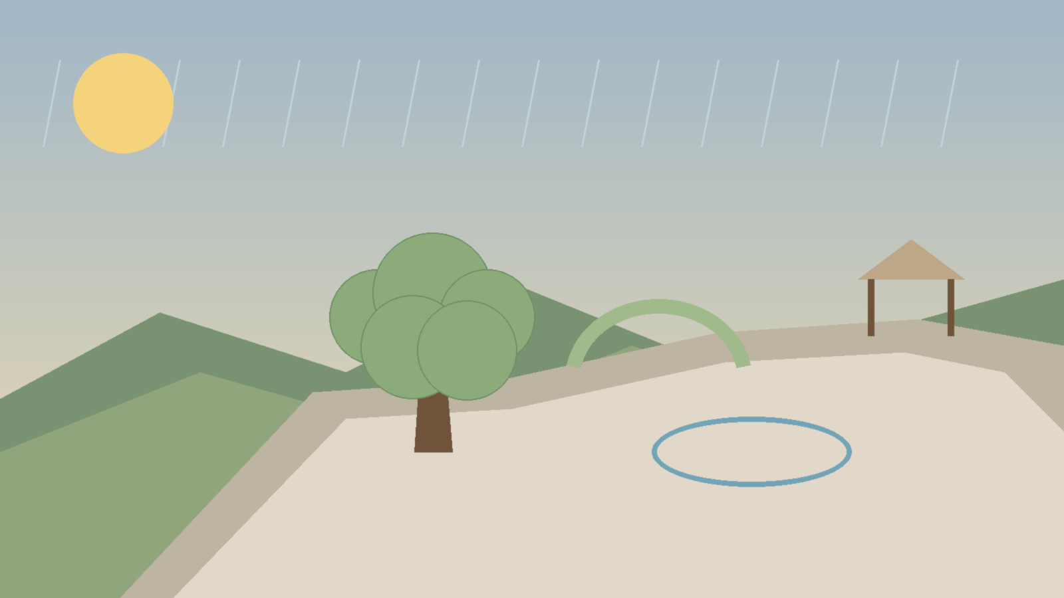
Cover mood/composition reference. Non-authoritative for geometry and gameplay layout.
Control | Value
Project | Fifteen Shards of Light
Repository | MindDevastation/fifteen-shards-of-light
Level | Level_04 only
Primary design authority | Level_04_Narrative_and_Level_Scenario_Package_v1.1.docx
Document status | VISUAL MASTER CONCEPT CANDIDATE v1.2 - Producer approval required
Mode | Documentation only — no runtime changes, Blender production, GLB hierarchy, NodePaths or state machines
Creative title | Ты сама

EMOTIONAL SAFETY CONTRACT
Героиня не сломана, и среда не нуждается в исцелении. Свет, серьёзность, прямота, тишина, смех и переменчивость уже принадлежат ей. Уровень показывает, что автору дорога сама Алёна, а не только лёгкость общения. Игра не требует ответа и не создаёт эмоционального долга.

0. Document control, authority split and scope

0.1 Authority hierarchy
Authority layer | What it controls
Textual authority | Approved Level_04 Narrative and Level Scenario Package v1.1 controls title, exact copy, emotional function, branch equality, route model, mechanic intent and forbidden readings.
Diagram authority | Top-down maps, route-order diagrams, silhouette boards and state boards in this package define visual composition intent and approximate relative proportions.
Mood/composition references | Stylized concept boards communicate atmosphere and camera energy only. They do not define exact geometry, object count or runtime coordinates.
Repository factual authority | Current repository files describe existing placeholders and integration constraints only. The old flat one-shard Level_04 placeholder is not visual canon.

0.2 Scope boundary
- This package defines visual thesis, shape language, landmarks, top-down composition, sightlines, puzzle readability, environment states, palette/material/fog/light rules and an art-budget proposal.
- It does not define final Godot scene architecture, NodePaths, state machines, exact coordinates, production GLB hierarchy, collision ownership or implementation slices.
- It does not authorize Blender production, final material authoring, runtime assets, branches or pull requests.

0.3 Continuity without copying
- Level_02 continuity: warm natural stone, moss, soft ancient-fantasy language and emotionally safe environmental change. Difference: no central arena, spokes or light-mechanism structure.
- Level_03 continuity: readable broad traversal, restrained amber/ivory glow and a world already alive. Difference: no airy wind-grove S-route, wind arches, spark chase or breathing meadow.
- Level_04 identity: wet terraced garden, one old Crossing Tree, braided order-independent route, changing canopy, persistent ripple contours and a calm open pavilion.

0.4 Version 1.2 Change Log
ID | Version 1.2 correction
V12-01 | Rebuilt Figures 2A–2C around one physically coherent static split-level topology shared by both completion orders.
V12-02 | Separated each branch into an initial-entry terrace, mechanic traversal, shared visual shard zone, first-pass exit to Braided Crossing, remaining-branch entry and remaining-pass final exit to Weather Weave.
V12-03 | Defined Braided Crossing as one connector zone with two static over/under lanes that cross without connection and route the first completed branch into the opposite remaining-pass lane.
V12-04 | Added a vertical-topology legend for same-level links, elevated lanes, lower underpasses and non-connecting over/under crossings; safe directional descent is explicitly not used.
V12-05 | Proved that no branch completed first can reach its Weather Weave exit, while the branch completed second reaches Weather Weave through its separate remaining-pass terrace.
V12-06 | Preserved Figure 3 and all approved narrative, puzzle, environment, palette and modular-budget decisions; completed full DOCX visual QA at 100% zoom.

1. Visual thesis and emotional reading

Visual thesis
Level_04 is a rainlit terraced garden where sunlight, cloud shadow, drizzle and still water coexist from the beginning. The player does not choose a “good” and a “bad” side. Instead, one initial choice lets them notice two equally valuable tones of the same relationship: the natural shift from laughter to seriousness, and conversations in which pauses carry presence rather than emptiness. The garden’s final synthesis does not clear the weather; it composes all existing states into one calm view.

Emotional arc
Beat | Emotional reading | Visual expression
Arrival | The person is not one stable mood and does not need to be simplified. | Sun, shadow, drizzle and still water are visible together before any progress.
Changing Canopy | A conversation may move from laughter to seriousness without either tone becoming wrong. | Three canopy pockets with distinct but equally warm reactions.
Ripple Conversation | Pauses do not need to be filled to remain meaningful. | Two persistent contours on already-living shallow water.
First reward | The first discovered tone does not outrank the other. | Completed branch remains alive; only remaining branch gains stronger local guidance.
Weather Weave | Both memories coexist as one understanding. | Leaf-shadow, ripple contours, drizzle and sun are composed in the final approach.
Main text and exit | The author misses Alena herself, not only pleasant conversations. | Pavilion remains a quiet shelter; portal activates calmly after text.

Exact player-facing copy anchor
ID | Exact text
Shard_08 | Ты можешь рассмешить меня, а через минуту сказать что-то так серьёзно, что я просто слушаю.
Shard_09 | Мне дороги и наши разговоры, в которых пауз больше, чем слов.
Main level text | Сначала я думал, что жду наших разговоров ради твоего голоса и смеха. Потом понял, что мне дороги и те минуты, когда ты серьёзна, говоришь прямо или между нами просто становится тихо. Я скучаю не только по лёгким разговорам. Я скучаю по тебе - и поэтому в памяти остаются даже маленькие вещи.

2. Shape language, landmark hierarchy and environmental storytelling
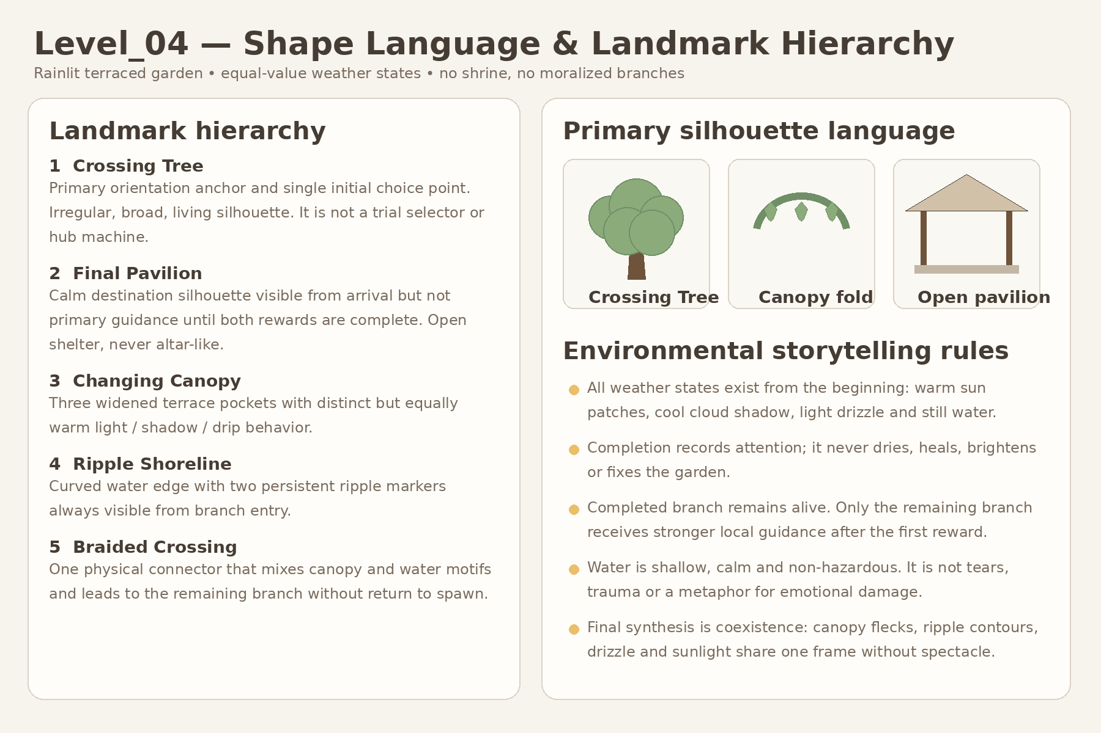
Figure 1. Shape language and landmark hierarchy. Diagram is authoritative for visual intent.

2.1 Shape language
- Irregular terraces, rounded retaining stones, low mossy edges and open views between levels.
- Large living silhouettes instead of monumental architecture: tree crown, canopy folds, water curve and pavilion roof line.
- Broad asymmetry. Repetition is rhythmic but never perfectly mirrored or arena-like.
- Visual transitions are braided: leaf, water, wet stone and rain motifs overlap rather than dividing the garden into moralized biomes.

2.2 Landmark hierarchy
Priority | Landmark | Visual role
Primary | Crossing Tree | Main orientation anchor and single initial choice point. Broad irregular crown, visible from Arrival and both branch entrances.
Primary | Final Pavilion | Calm destination silhouette and narrative rest point. Visible early, but not highlighted as immediate objective until both rewards finish.
Secondary | Changing Canopy pockets | Three widened readable environmental zones, each with distinct motion/light behavior.
Secondary | Ripple shoreline | One curved shoreline with two persistent markers visible from entry.
Connector | Braided Crossing | Single physical inter-branch connector blending both motif families and preventing return-to-hub reading.

2.3 Environmental storytelling rules
- Neither sunlight nor drizzle represents the “true” or “healthy” version of Alena.
- No branch closes, dims, dries or becomes invalid after the other is completed.
- Water is shallow, decorative and non-hazardous. It is not tears, trauma or a psychological diagnosis.
- The pavilion is an open shelter and transition point, not a shrine, altar, cage or romantic ceremony stage.

3. Top-down composition with approximate relative proportions

Spatial thesis
The level is one coherent rainlit terraced garden with a braided figure-eight rhythm, not a central hub with two trials. The Crossing Tree is used once. Each branch contains two physically separate traversal terraces around the same mechanic space and one shared visual shard zone: an initial-entry terrace that can exit only into Braided Crossing, and a remaining-pass terrace entered only from Braided Crossing that can exit only into Weather Weave. Both route orders use the same static terrain.
Approximate whole-level visual-planning envelope: approximately 105–125 m long × 65–80 m wide. This range supports the 5:00–6:30 first-completion target and is not exact coordinate authority.
Static pavilion-access rule: the Final Pavilion may be visible from Arrival as a distant secondary silhouette, but there is no direct walkable route from Arrival, Crossing Tree or either first-pass shard terrace. The pavilion approach is physically connected only to Weather Weave, which is reached from a remaining-pass final exit after the opposite branch has been traversed. No invisible wall, state gate, door, teleport, moving path or hidden dynamic geometry is used.
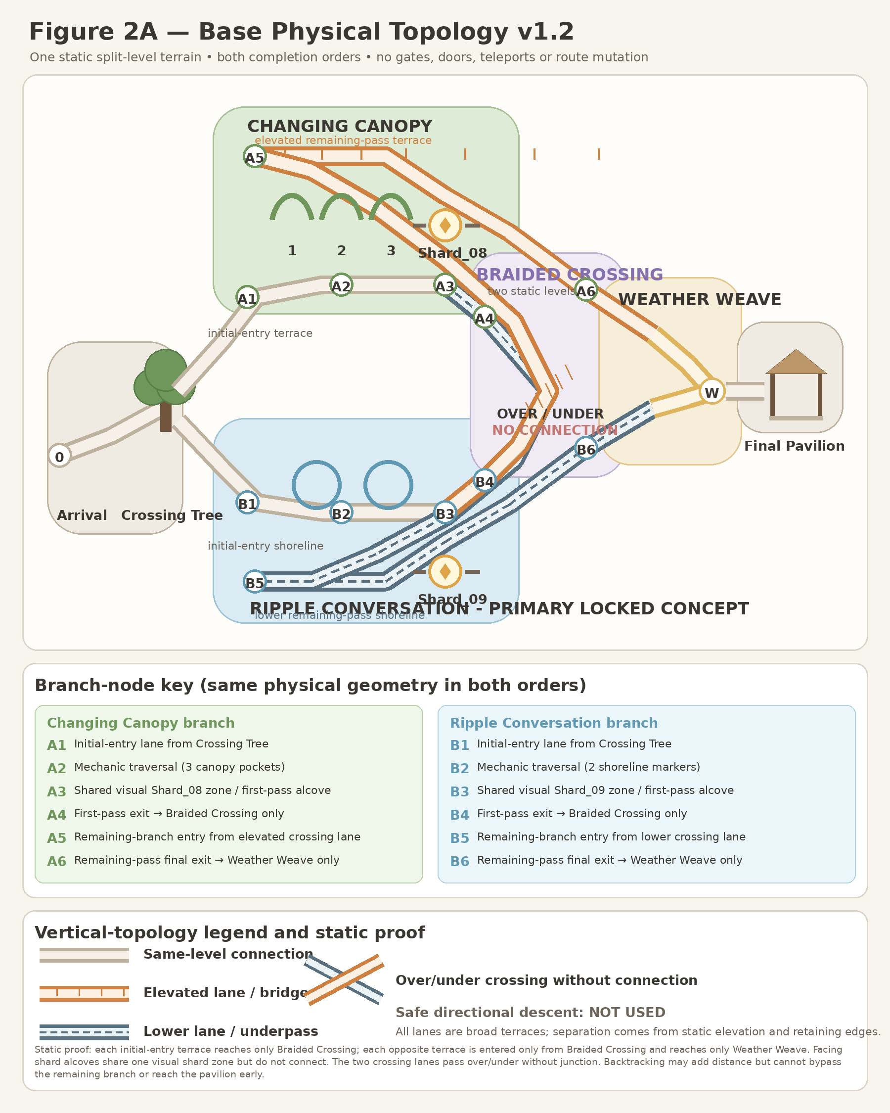
Figure 2A. Base physical topology v1.2. One static split-level terrain shows initial-entry lanes, shared mechanic/shard zones, first-pass exits, the two non-connecting Braided Crossing levels, remaining-branch entries, final exits and the Weather Weave approach. Exact runtime coordinates remain deferred to Gameplay Design.

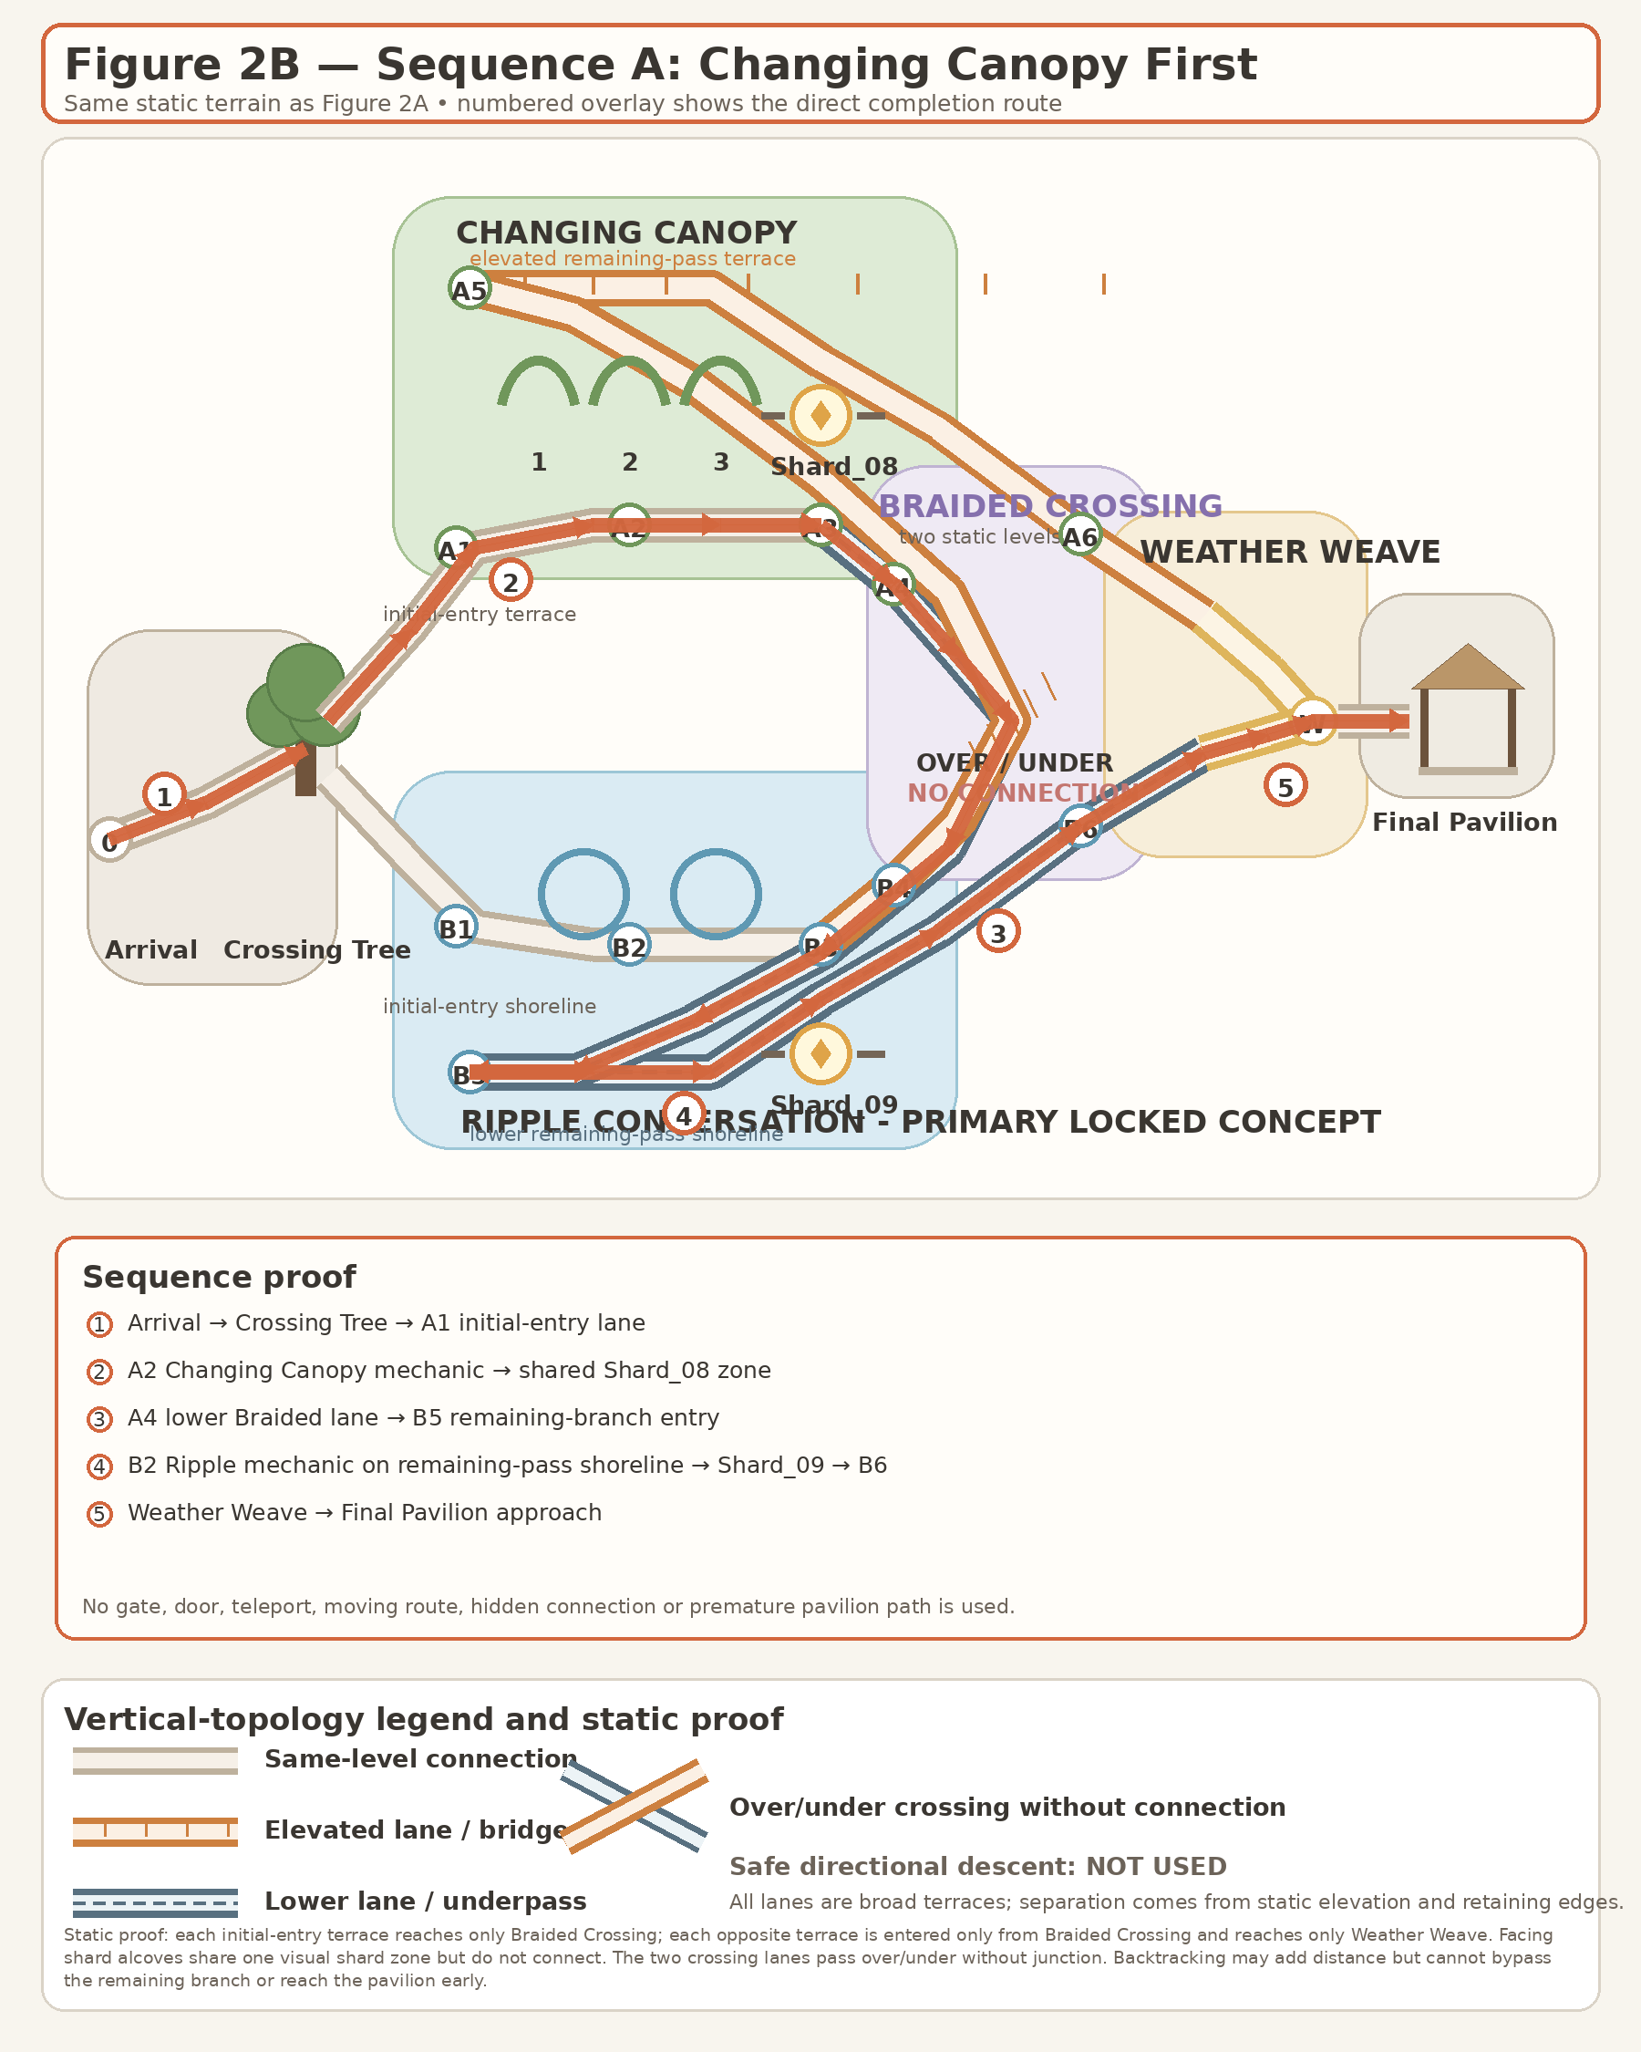
Figure 2B. Sequence A overlay - Changing Canopy first. The highlighted route uses the same static geometry as Figure 2A and cannot reach Weather Weave from the first-pass Canopy terrace.

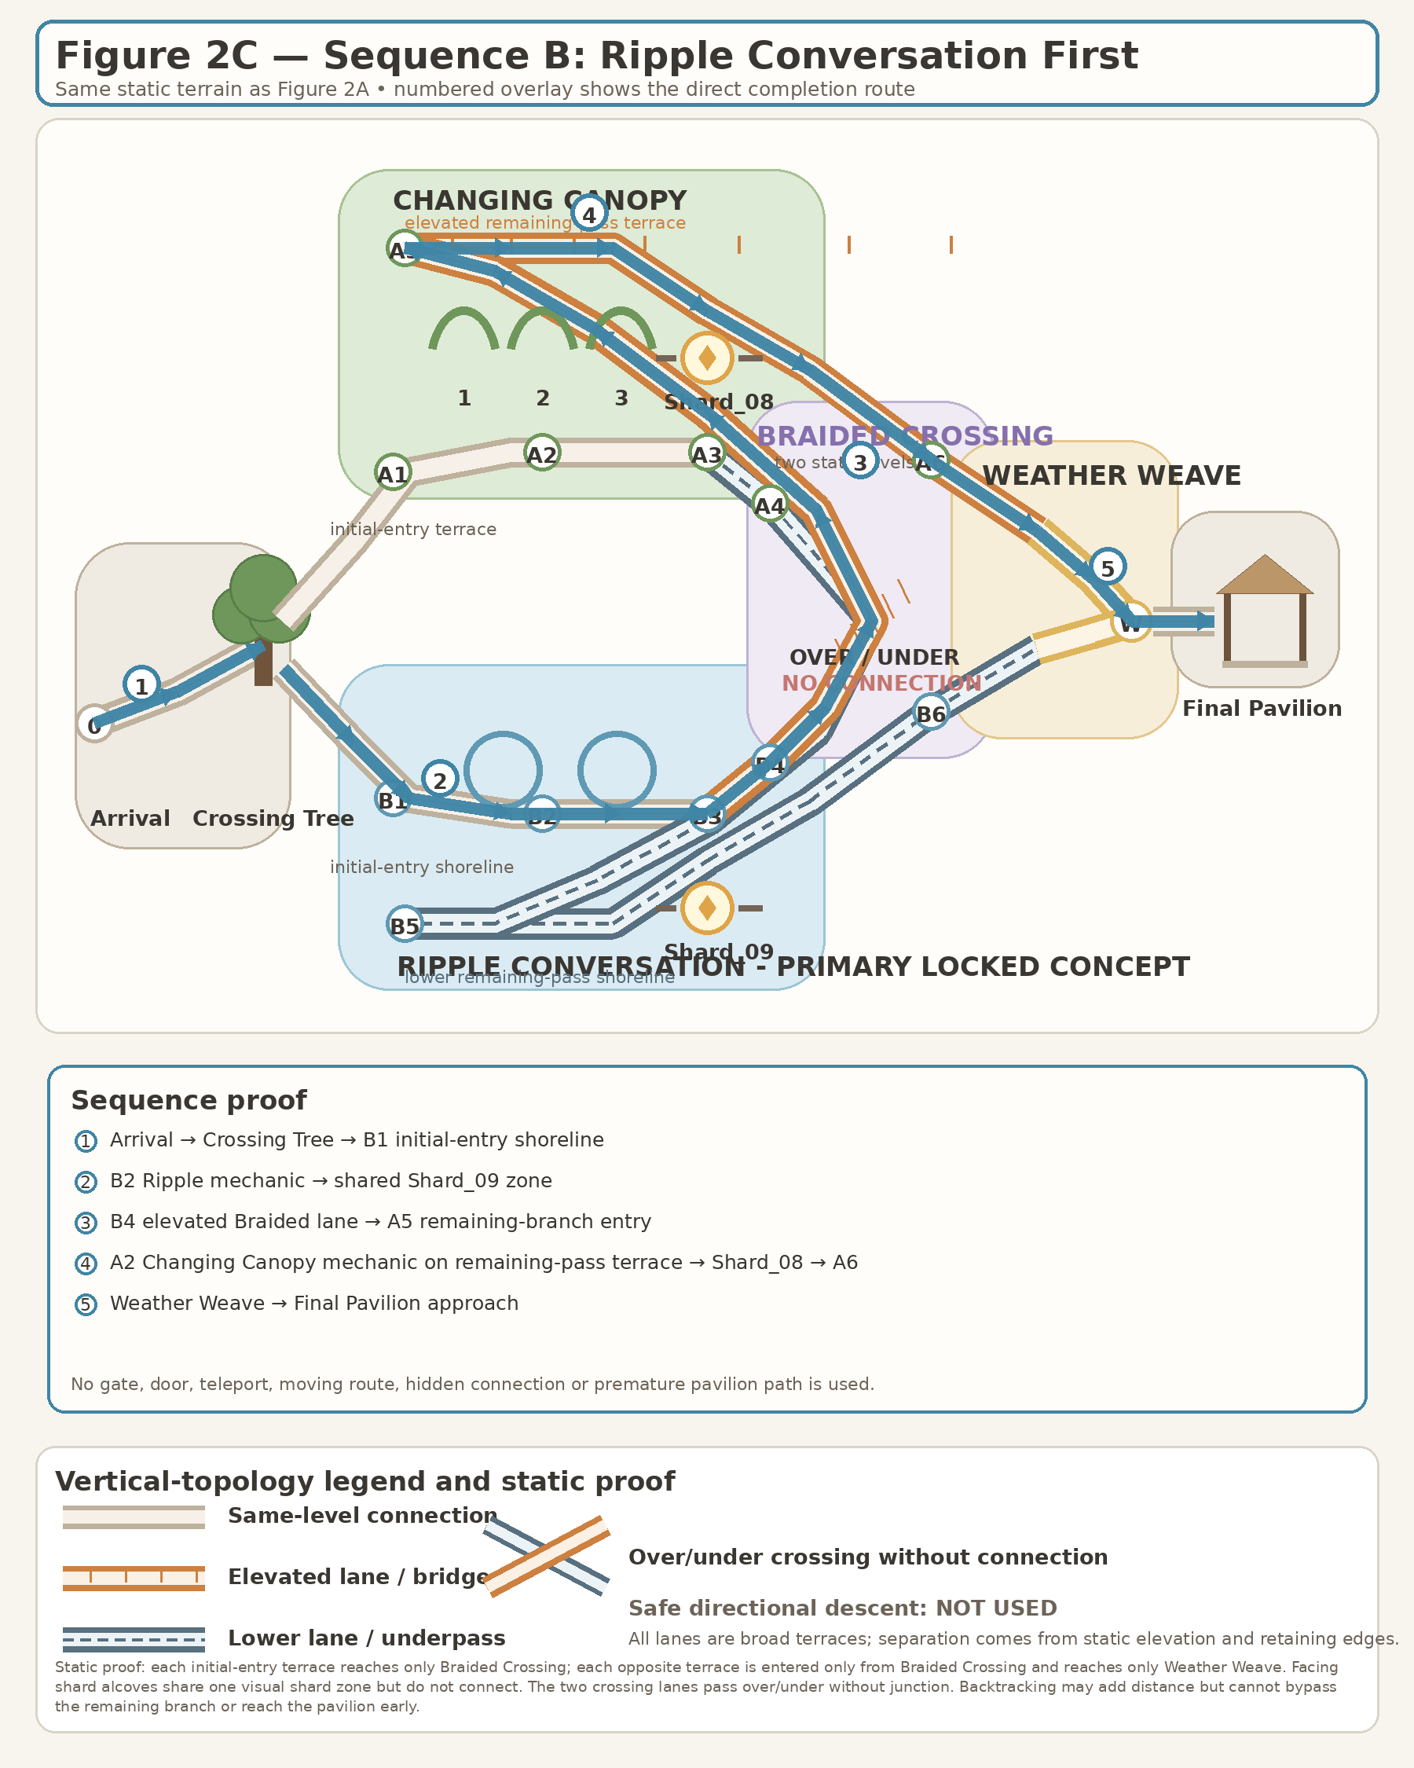
Figure 2C. Sequence B overlay - Ripple Conversation first. The highlighted route uses the same static geometry as Figure 2A and cannot reach Weather Weave from the first-pass Ripple shoreline.
Topology proof: each branch has an initial-entry lane from Crossing Tree, its mechanic space, a shared visual shard zone with physically separated facing alcoves, a first-pass exit that leads only into Braided Crossing, a remaining-branch entry reached only from the opposite crossing lane, and a separate remaining-pass final exit that leads only into Weather Weave. The Braided Crossing lanes pass over and under without a junction. A player cannot switch lanes at either shard, cannot reach the pavilion after only one reward, and cannot create a bypass by backtracking. Both valid sequences use the same static walkable terrain with broad safe traversal and no one-way drop, jump, precision movement, gate, teleport or moving route.
Zone | Approximate relative size | Visual composition rule
Arrival / After-Rain Terrace | 10–12 m wide safe pad | One clear approach. Tree, branch entrances and pavilion silhouette are readable without 360° wandering.
Crossing Tree | 14–18 m irregular clearing | One initial choice only. Avoid circular selector geometry, equal pedestals or challenge-signage symmetry.
Changing Canopy branch | 5–6 m broad terrace path; 3 widened pockets | All three zones visible progressively; no gaps, jumps or beam-puzzle staging.
Shard_08 Listening Ledge | 8–10 m rest pocket | Broad dry placement with clear view toward lower route; never under heavy rain occlusion or cliff-edge danger.
Braided Crossing | 5–6 m physical connector | One connector carrying both leaf and water motifs; no spawn return, teleport or closing door.
Ripple Conversation branch | 18–24 m curved shoreline | Both shoreline markers visible from entry; no maze or hidden water targets.
Shard_09 Dry Bank | 8–10 m dry platform | Shard remains above dry ground, not in water.
Final Pavilion | 12–16 m open shelter | Combined weather view, one-time main text and side-forward Level_05 portal.

4. Player sightlines and visual route
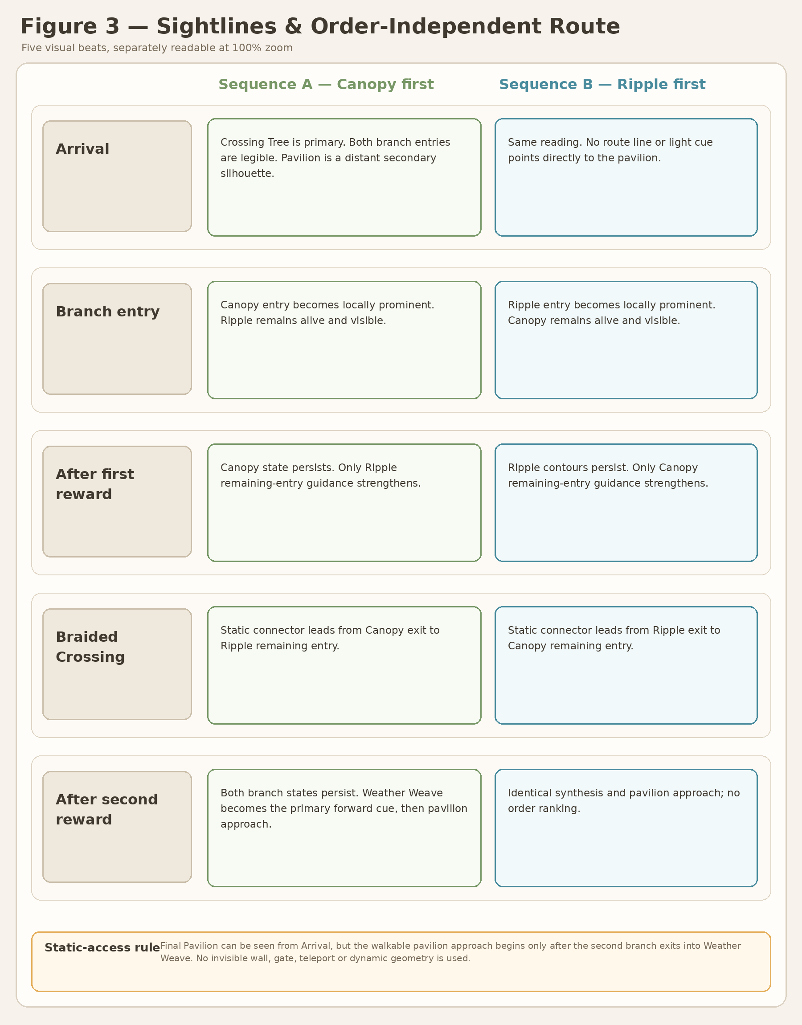
Figure 3. Player sightlines and order-independent route beats. Arrival, Branch entry, After first reward, Braided Crossing and After second reward remain separately readable at 100% zoom.

4.1 Visual-navigation contract
- No UI arrows are required. Route guidance comes from visible entrances, landmark silhouettes, persistent effects and local contrast.
- From Arrival, the Crossing Tree dominates; both branches are legible and the pavilion is a secondary distant silhouette. The static route provides no direct walkable pavilion approach from Arrival or Crossing Tree.
- At either branch entry, all required local targets are visible immediately or within one natural camera turn.
- After the first reward, the completed branch remains equally alive. Stronger guidance appears only on the remaining branch.
- Braided Crossing is unmistakably forward progress and never points back to spawn.
- After both complete rewards, Weather Weave becomes the primary guide and opens the natural physical continuation to the pavilion approach without adding a third task.

4.2 Required route parity
Sequence | Locked route
A | Changing Canopy → Shard_08 reward → Braided Crossing → Ripple Conversation → Shard_09 reward → Weather Weave → Main Text → Portal Level_05
B | Ripple Conversation → Shard_09 reward → Braided Crossing → Changing Canopy → Shard_08 reward → Weather Weave → Main Text → Portal Level_05

5. Puzzle visual concepts
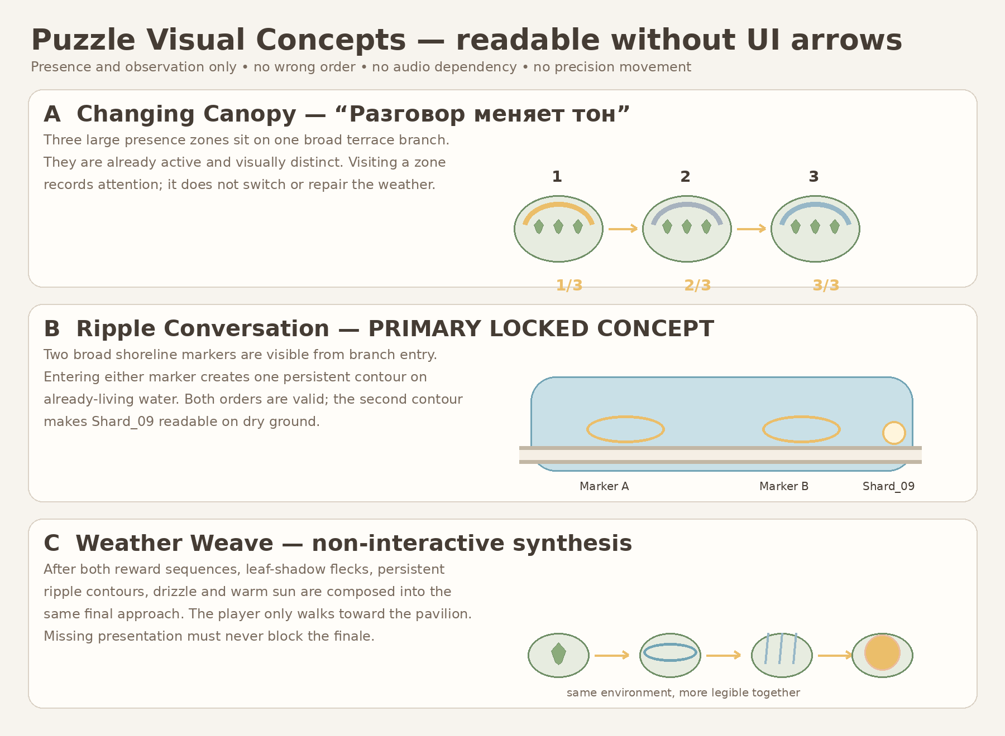
Figure 4. Puzzle readability concepts. Diagram defines visual rule, not runtime implementation.

5.1 Changing Canopy
Aspect | Visual solution
Rule readability | Three large terrace pockets are already visible through canopy silhouette, ground motif and local motion profile.
Feedback | Each visited pocket leaves one persistent segment in a branch-local motif. Leaves, shadow and droplets respond differently but with equal warmth.
No-arrow guidance | The nearest zone gives a broad ground-light wave when approached; after 20 seconds an unvisited zone receives gentle rising leaf motes.
Safety | No reset, wrong order, timer fail, audio dependency, gap or precision movement.
Meaning | The player notices existing tones; they do not switch or correct Alena’s state.

5.2 Ripple Conversation - PRIMARY LOCKED CONCEPT
Aspect | Visual solution
Rule readability | Two broad shoreline markers sit on one curved path and are visible together from branch entry.
Feedback | Entering a marker creates one persistent contour that remains visible on already-living water.
Completion | After both contours exist, Shard_09 appears on the dry bank.
No-arrow guidance | Nearest marker has a gentle water ring; after 20 seconds the unvisited marker gains a vertical drip/mote cue.
Safety | No waiting requirement, timing input, precision placement, reset or water hazard.
Meaning | Pauses leave traces without demanding reply or exchange.

5.3 Weather Weave
- Non-interactive synthesis only. The player walks toward the visible pavilion.
- Leaf-shadow flecks, ripple contours, drizzle and sun are framed in one approach.
- Optional visual presentation must have a bounded fallback; the finale cannot depend on it.
- Rain-shelter alcoves remain emergency fallback only and are not developed as an equal visual concept.

6. Environment state boards
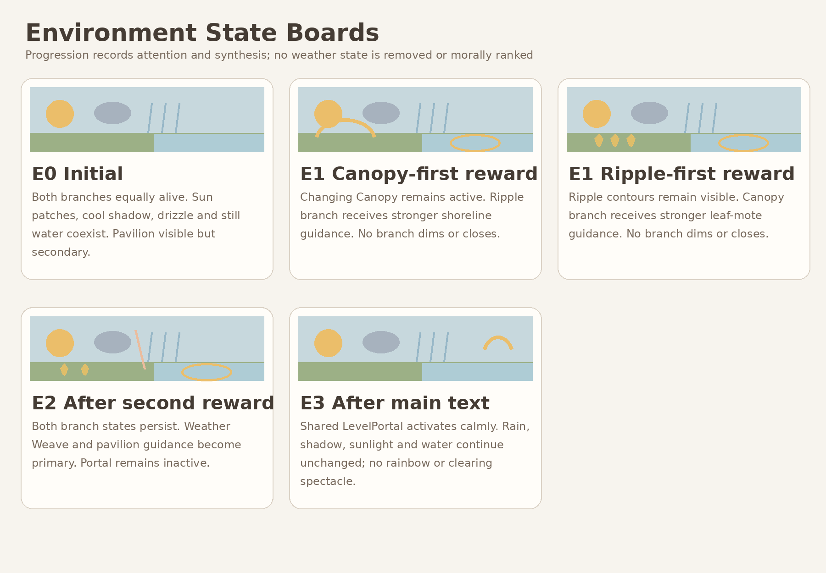
Figure 5. Initial, branch-order variants, synthesis and exit states.
State | Locked visual behavior | Narrative reading
E0 Initial | Both branches equally alive; visible natural color; sun, cloud shadow, drizzle and water coexist; pavilion visible but secondary. | No bad starting state and no canonical first shard.
E1A Canopy first | Canopy state persists. Ripple branch receives stronger local shoreline guidance only. | First reward does not rank the branches.
E1B Ripple first | Ripple contours persist. Canopy branch receives stronger leaf-mote guidance only. | Both route orders have equal value.
E2 After second reward | Both branch states remain. Weather Weave and pavilion guidance become primary; portal remains inactive. | Two observations become one understanding.
E3 After main text | Shared portal activates calmly. Rain, shadow, sun and water continue to coexist. | The environment is not “fixed”; the story simply continues.

7. Palette, material, fog, lighting and natural-motion rules
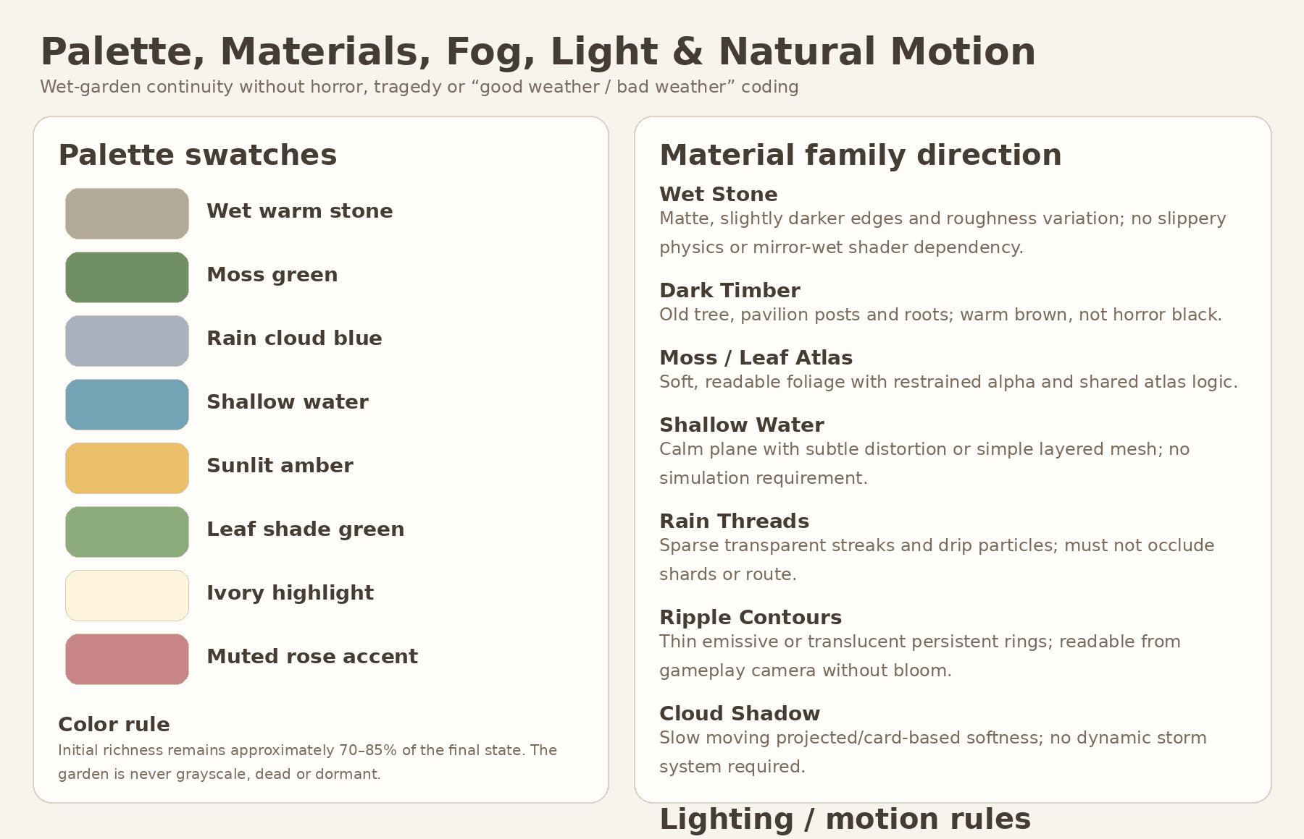
Figure 6. Palette and material direction. Final shader implementation is deferred.

7.1 Palette rule
- Initial natural color richness should remain approximately 70–85% of the final state. The garden is never grayscale, dead or dormant.
- Warm wet stone, moss green, shallow-water blue, cool cloud gray, sunlit amber, dark timber and restrained ivory/rose accents form the core palette.
- No branch receives a superior “correct” palette. Warm and cool states coexist within each view.

7.2 Fog and light
- Use light atmospheric depth only. Mandatory route, branch entrances and pavilion silhouette remain readable.
- Warm late-day sun and cool diffuse cloud fill coexist in every state.
- Avoid tragic sunset grading, oppressive storm contrast or horror-dark shadows.

7.3 Material direction
- Wet stone is visually darker and softly rough, but gameplay physics remain non-slippery.
- Water should be achievable with a simple shallow plane and layered ripple treatment; dynamic simulation is optional/cut.
- Rain threads, drip points, cloud-shadow cards and ripple contours must be separable presentation layers.
- Avoid unique materials for every prop, 4K textures, large complex transparency and baked lighting that blocks environment-state changes.

7.4 Natural motion
- Slow cloud-shadow drift, leaf sway, sparse drizzle, drip particles and persistent ripple contours.
- Movement exists before progress and continues after the portal activates.
- No thunder-stop, weather clear-out, rainbow reward, bloom explosion or giant heart symbol.

8. Perspective and composition mood boards
These boards are non-authoritative mood/composition references. They establish atmosphere, depth, route framing and emotional temperature only. Text and diagrams take precedence for geometry and gameplay layout.

Figure 7A. Arrival / Crossing Tree mood board — one coherent wet garden, open sky, equal branch value.
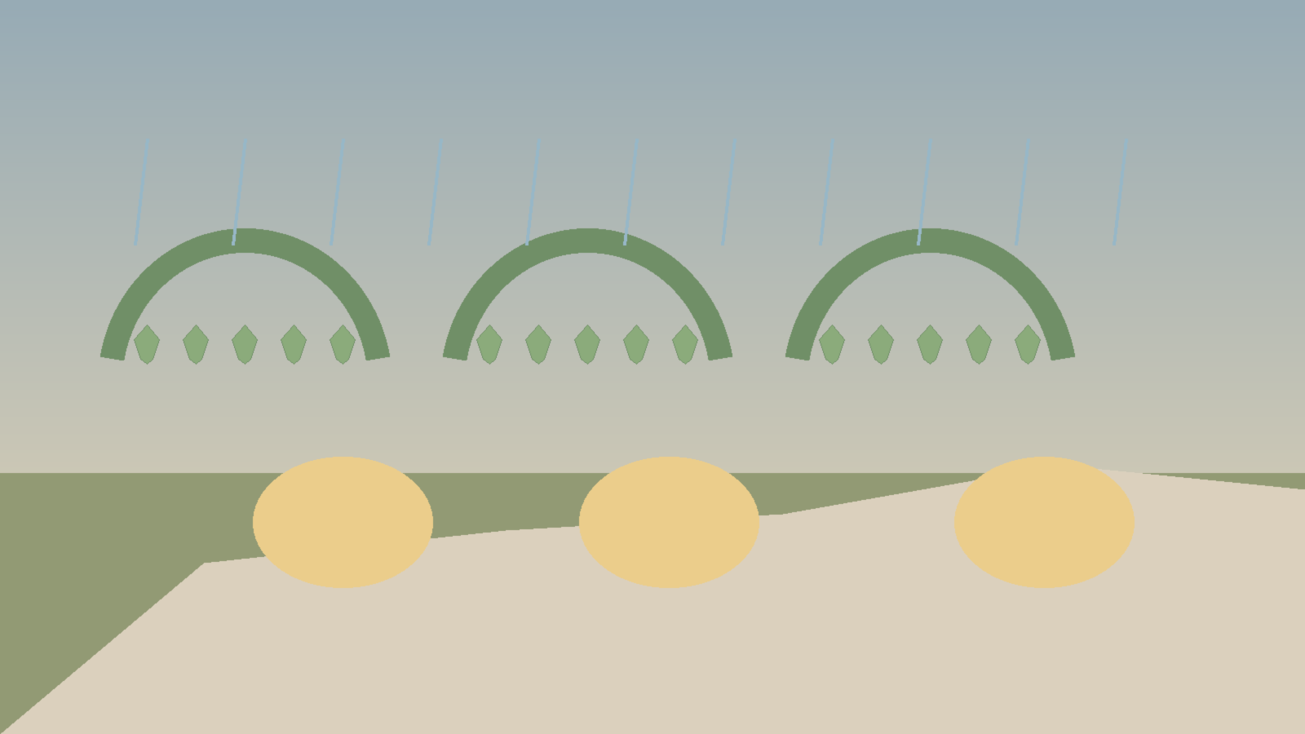
Figure 7B. Changing Canopy mood board — broad safe terrace, three readable pockets, mixed sun/shadow/drizzle.
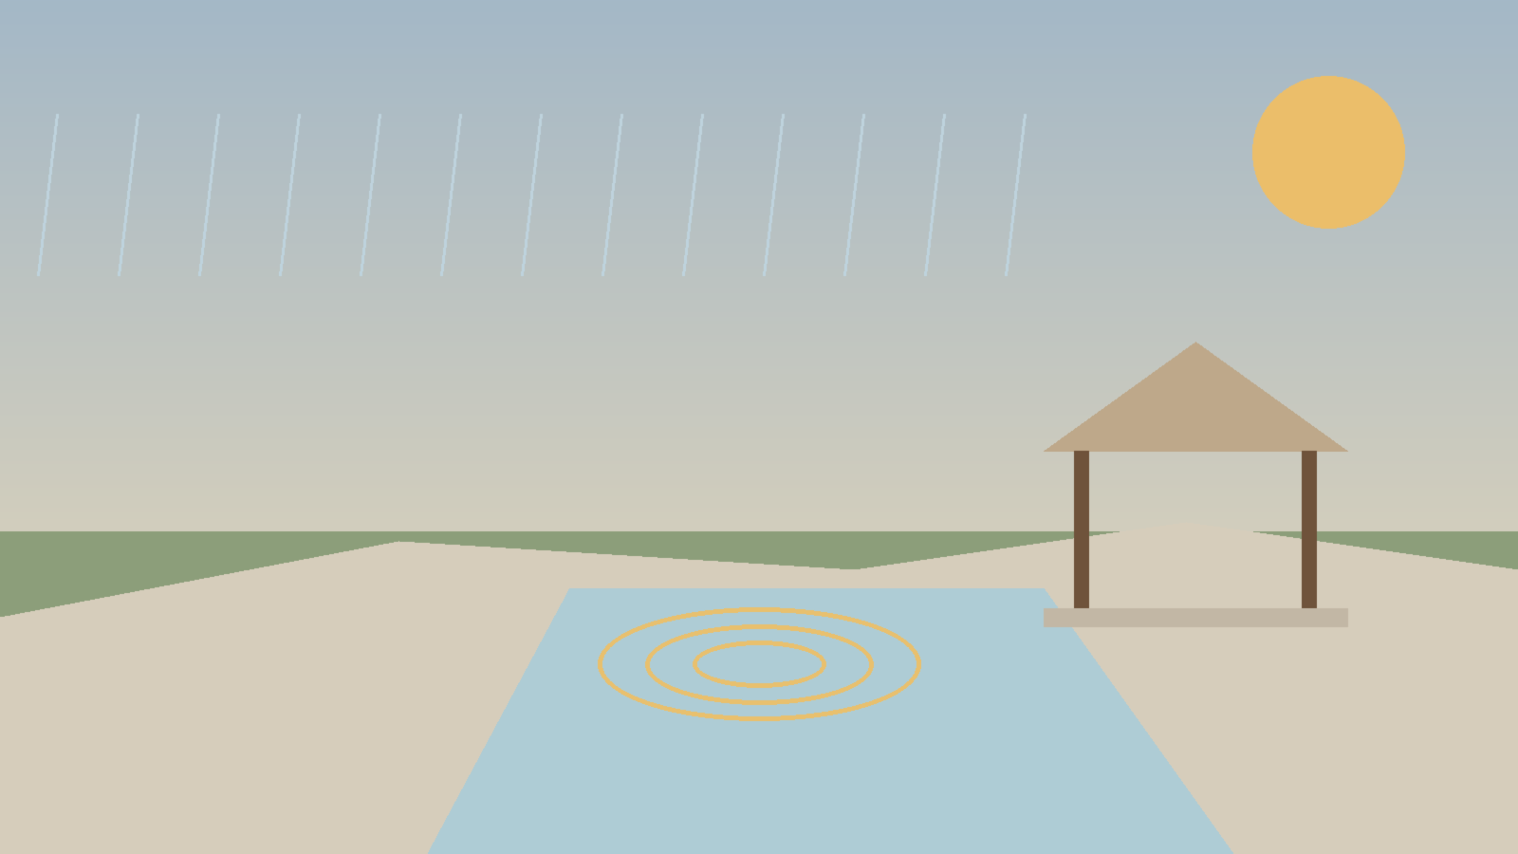
Figure 7C. Ripple shoreline and Final Pavilion mood board — persistent water traces, calm open shelter, no shrine framing.

9. Hero asset budget and modular kit proposal
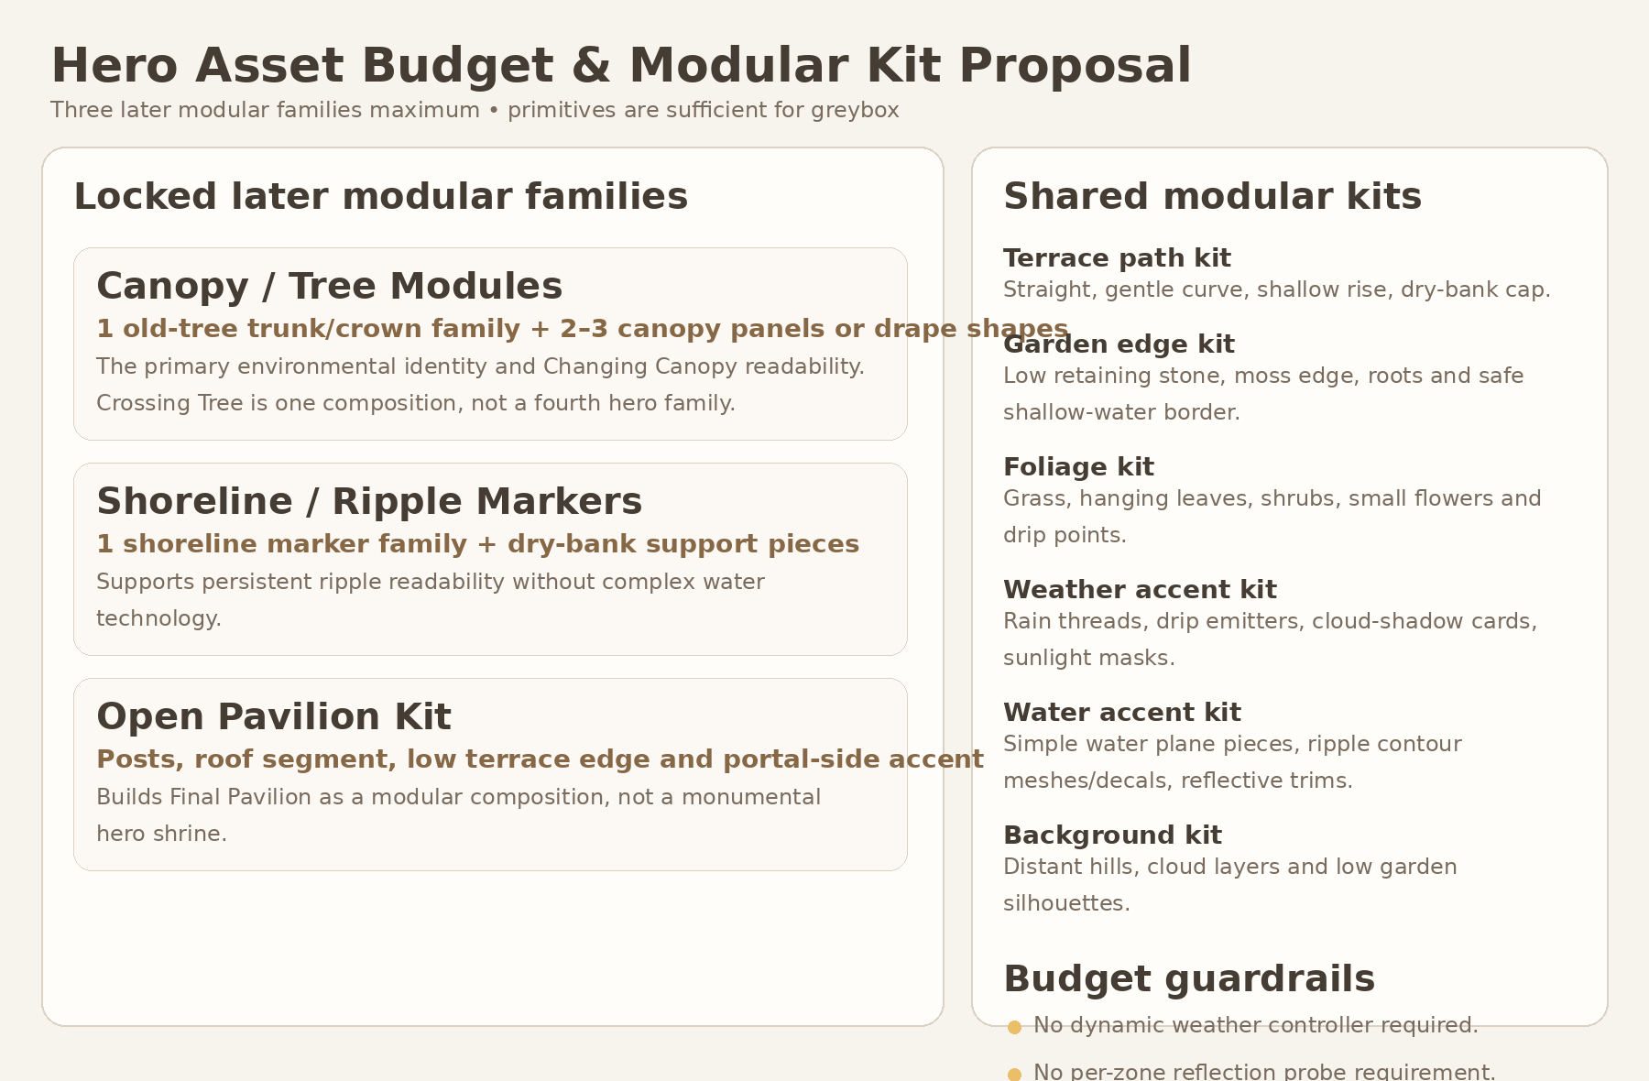
Figure 8. Three later modular families maximum and shared reusable kits.

9.1 Asset-family budget
Family | Scope | Budget rule
Canopy / Tree Modules | Crossing Tree composition, reusable trunk/crown pieces and 2–3 canopy shapes. | One family. Crossing Tree is a composition, not an additional hero family.
Shoreline / Ripple Markers | One marker family, dry-bank support and simple water-edge visual pieces. | No complex water-simulation hero asset.
Open Pavilion Kit | Posts, roof segment, low terrace edge and restrained portal-side accent. | Final Pavilion is a modular composition, not a monumental unique building.

9.2 Shared kits
- Terrace path kit: straight, gentle curve, shallow rise, transition cap and dry-bank edge.
- Garden edge kit: low retaining stones, roots, moss edge and shallow-water border.
- Foliage kit: grass, shrubs, small flowers, hanging leaves and drip points.
- Weather accent kit: rain threads, drip emitters, cloud-shadow cards and sunlight masks.
- Water accent kit: simple plane pieces, ripple contour meshes/decals and reflection trims.
- Background kit: distant hills, cloud layers and low garden silhouettes.

9.3 Scope guardrails
- Greybox requires primitives only.
- No monolithic Level_04 GLB.
- No dynamic weather controller, water simulation, per-zone reflection system, cloth simulation or reactive vegetation physics as mandatory scope.
- Prioritize silhouette, route readability and persistent feedback over detail density.

10. Forbidden visual directions
Forbidden direction | Reason / correction
Sunlit branch = good / true; rainy branch = difficult / damaged | Both branch environments must be equally alive and visually valuable from E0 through exit.
Player clears clouds, dries garden, calms storm or opens broken flowers | Progress records attention and synthesis; it does not heal or repair the environment.
Crossing Tree as a circular hub with two trial gates | Use one irregular choice clearing once, then forward-only braided routing.
Pavilion as shrine, altar, throne, wedding gazebo or reward chest | Keep it small, open, asymmetrical and integrated into terrace materials.
Water as tears, trauma or emotional damage | Water is calm spatial material and visual memory surface only.
Ripple mechanic as dialogue-response demand | Ripples are traces of one walk, not two people answering each other.
Storm horror, oppressive fog or tragic sunset | Use gentle post-rain atmosphere and readable late-day light.
Rainbow, heart burst, giant beam or weather-clearing spectacle | Finale is a quiet coexistence state with calm portal activation.
Wind arches, playful spark chase or breathing meadow reprise | These belong to Level_03 and must not be copied.
Large unique hero assets for every zone | Use three modular families and shared kits only.

11. Producer approval table — items to lock before Gameplay Design
Item | Current proposal | Approval state needed
Visual thesis | One coherent rainlit terraced garden; weather states coexist from the beginning. | LOCK before Gameplay Design
Route topology | One Crossing Tree choice → selected branch initial-entry lane → mechanic → shared shard zone → first-pass exit → one Braided Crossing over/under lane → opposite remaining-branch entry → same branch mechanic space → shared shard zone → remaining-pass final exit → Weather Weave → Pavilion. | LOCK
Order parity | Sequence A and Sequence B have identical narrative value, synthesis and exit state. | LOCK
Changing Canopy visual rule | Three broad persistent presence zones, any order, no correction/healing reading. | LOCK
Ripple Conversation visual rule | Two visible persistent shoreline markers, any order, Shard_09 on dry bank. Ripple Conversation - PRIMARY LOCKED CONCEPT. | LOCK
After-first-reward response | Completed branch stays alive; only remaining branch receives stronger local guidance. | LOCK
Weather Weave | Non-interactive final approach; no third puzzle. | LOCK
Final Pavilion reading | Quiet open shelter and route transition, not shrine/altar/ceremony. | LOCK
Palette / atmosphere | Warm wet stone + moss + shallow-water blue + cloud gray + amber sun; gentle drizzle. | LOCK
Asset-family budget | Exactly three later modular families; primitives only for greybox. | LOCK
Open later design item | Exact coordinates, precise VFX timing, final tree/pavilion silhouettes, camera polish and exact shader implementation. | DEFER

12. Final visual-development verdict and handoff

ART-DIRECTION VERDICT
Level_04 has a coherent and production-safe visual identity: a rainlit terraced garden with one initial choice, two equally valued branches, one physical braided connector and a calm shared finale. The concept preserves the approved narrative emphasis on Alena herself rather than only the ease of conversation, while avoiding savior framing, mood ranking and emotional debt.

What to pass to Producer
- Approve the visual thesis, route topology, branch equality, state-response rules, pavilion reading, palette direction and three-family art budget.
- Confirm that Ripple Conversation - PRIMARY LOCKED CONCEPT remains the sole primary concept and Rain-shelter Alcoves remain emergency fallback only.

What to pass to Gameplay Design
- Use the narrative authority and visual diagrams to define exact coordinates, traversal metrics, clearances, both route orders, fall safety and camera QA.
- Preserve broad triggers, persistent progression, no wrong order and no additional puzzle in Weather Weave.

What to pass to later Art / Blender planning
- Use three modular families maximum, plus shared terrace, garden-edge, foliage, weather, water and background kits.
- Treat diagrams as composition authority and mood boards as non-authoritative atmosphere reference.
- Do not begin Blender production until Gameplay Design and Technical Architecture are approved.

DOCUMENT COMPLETION STATEMENT
This DOCX is the self-contained Level_04 Visual Master Concept Package v1.2. It preserves the approved narrative and art direction while correcting Figures 2A–2C into one physically coherent static split-level topology. It introduces no runtime changes, exact NodePaths, state machines, production GLB hierarchy, Blender assets or implementation branch.

