

# AI-Powered Customer Service Chatbot Project Plan

## Project Scope: AI-Powered Customer Service Chatbot

* **Objective**: To create an AI chatbot that not only automates responses but also personalizes customer interactions based on past interactions and preferences.
* **Target Audience**: Customers seeking immediate, accurate responses and employees needing support in managing high-volume inquiries.
* **Expected Impact**: Reduction in response time, increased customer satisfaction scores, and decreased workload for human customer service agents.

## Defined Work Schedules & Locations

* **Detailed Schedules**: Bi-weekly sprints, with each sprint focusing on specific deliverables like chatbot learning algorithms, user interface design, or integration with existing systems.
* **Location Strategies**: Use of collaboration tools for remote work and designated days for on-site meetings to ensure team cohesion and effective communication.

## Project Oversight Activities

#### Project Governance:

* **Scrum Master**: Additional responsibilities include monitoring team dynamics and facilitating agile training sessions.
* **Product Owner**: Regularly liaises with customer service teams to understand evolving needs and integrates this feedback into the product backlog.
* **Development Team**: Specialization areas, such as natural language processing, user experience design, and data security.
* **Stakeholders**: Include representatives from IT, customer service, marketing, and legal departments for holistic project oversight.

### *Development Phase Major Activities*

#### Data Management:

* **Types and Sources:** Identify the necessary data types and sources.
* **Feature Engineering and Management:** Address feature engineering and management for data training/testing.

#### Fine-Tuning and Implementation:

* Refine the chatbot based on initial testing and feedback.

#### Maintenance and Ongoing Fine-Tuning:

* **Additional Data Requirements:** Consider the need for more or new data.
* **Continuous Improvement:** Regular updates and improvements.

#### Addressing Unforeseen Conflicts/Disasters:

* Develop strategies for managing unexpected challenges.

#### Implementing Customer Feedback:

* Continuously integrate customer feedback to enhance satisfaction.

## Work Stream Activities

#### High-Level User Stories:

* “As a customer, I want the chatbot to provide personalized recommendations based on my purchase history.”
* “As a service manager, I want the chatbot to generate reports on common customer issues.”

#### More Granular User Stories:

* “As a customer, I expect the chatbot to guide me through troubleshooting steps for common product issues.”
* “As a data analyst, I want to access chat logs for trend analysis and service improvement.”

## List of Deliverables

* **Technical Deliverables**: AI chatbot with advanced natural language understanding, seamless integration with customer databases.
* **Training Materials**: For customer service agents to understand chatbot functionalities and escalation procedures.
* **Performance Metrics**: Detailed KPIs for chatbot efficiency, accuracy, and customer satisfaction.

## Project Completion Criteria

* **Success Metrics**: Benchmarks for chatbot resolution rate, average handling time, and user satisfaction scores.
* **User Acceptance Testing**: Involving real users in the final testing phase to gather authentic feedback and make necessary adjustments before the full launch.

## Change Request Process

* **Change Management Framework**: Steps for evaluating the impact of changes, including potential risks and benefits.
* **Stakeholder Involvement**: Ensuring all relevant parties are involved in the decision-making process for changes.

## Charges/Budget

* **Phase-wise Budget Breakdown**: Detailed costs associated with development, testing, deployment, and maintenance phases.
* **Contingency Funds**: Allocation for unexpected expenses or project scope changes.

## Additional Considerations

* **Ethical and Privacy Considerations**: Ensuring the chatbot adheres to data protection laws and ethical guidelines in customer interactions.
* **Scalability and Future Expansion**: Planning for future enhancements, like integrating the chatbot with other communication channels or expanding its capabilities with AI advancements.

Time Line

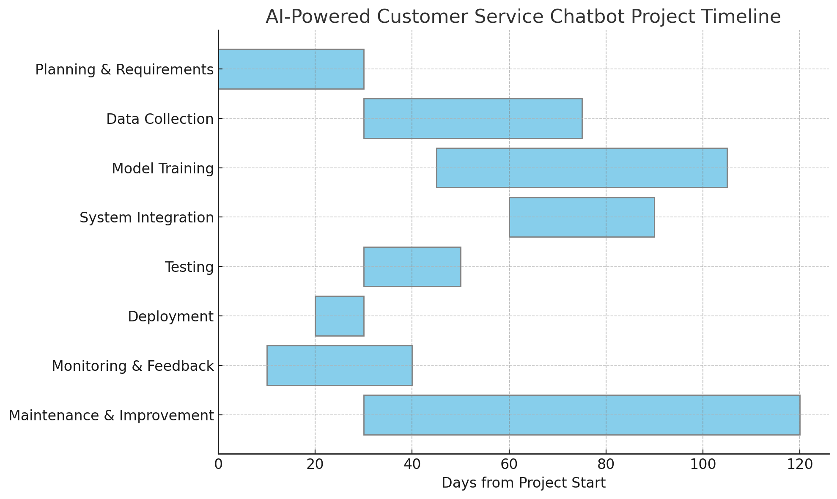Project Workflow Flowchart

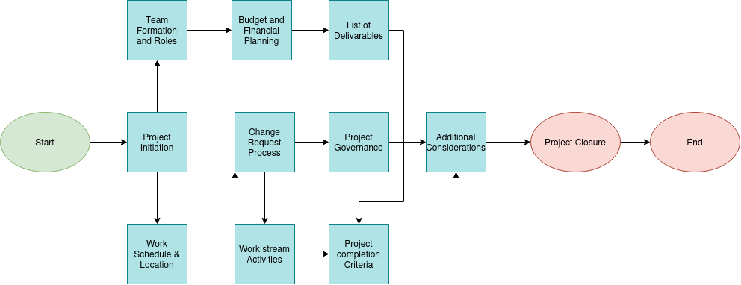

Chatbot Logic Flowchart

