BRIDGEWORKS
CEEFM Kft
Digital Growth Handover

Prepared for Victor, CEEFM Kft
Prepared by BridgeWorks
May 29, 2026

Purpose of This Document
This is the complete handover for the BridgeWorks digital growth work on CEEFM.
It does three things:
- Records everything that was built, so you keep full value of the work.
- Lists every account, asset, and file, so nothing is lost in the transition.
- Hands you a clear set of next steps, so you or your next provider can carry the work forward without starting over.
Everything described here belongs to CEEFM. All files, accounts, and assets are yours.
1. Where Things Stand
In nine weeks, CEEFM moved from an invisible single-page brochure to a structured, search-ready platform with a measurable AI visibility score.
Metric | Start (March) | Latest verified | Change
AI visibility score (GEO) | 16/100 | 74/100 | +58 points
Indexed pages | 1 | 4, plus pages built in May | structural
Schema types live | 0 | 3 (ProfessionalService, ContactPage, BreadcrumbList) | new
Wikidata entity | none | Q139592822 published | new
LinkedIn followers | 0 | 146 | new
LinkedIn posts | 0 | 28 published or written | new
Legal and entity signals | incomplete | complete and verified | fixed

The AI visibility score measures how often AI tools such as ChatGPT, Perplexity, and Google AI surface CEEFM when someone asks about Budapest facility management. It is scored across six categories: schema, entity signals, content depth, technical SEO, AI crawler access, and citability. The 74/100 figure is the last full audit on file, taken at the end of April. The May plan targeted 80+. A May re-audit was scheduled but is not in the handover records, so the verified number is reported here.
The foundation (Phase 1) is substantially complete. The conversion phase (Phase 2: paid ads and outreach) was fully prepared but not activated before the engagement closed.
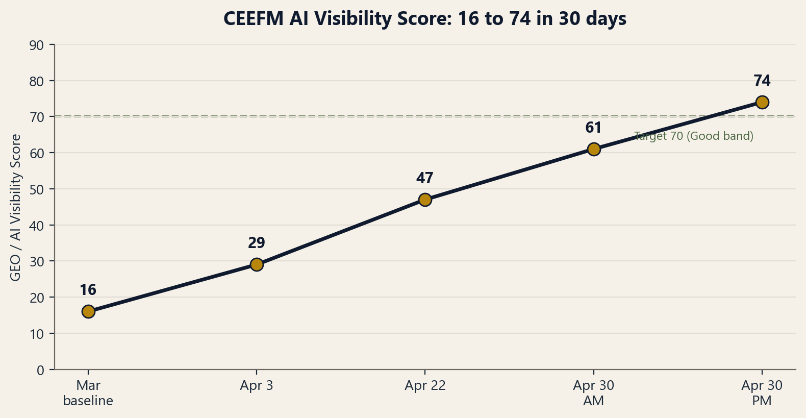
2. What Was Delivered
2.1 Website technical rebuild
Item | Before | After
Schema markup | None | ProfessionalService + FAQPage JSON-LD
Security headers | None | HSTS, X-Frame-Options, X-Content-Type-Options, Referrer-Policy, Permissions-Policy (via .htaccess)
Stat counters | JavaScript, not crawlable | Server-rendered HTML
Legal imprint | Missing | Full Hungarian imprint in footer
Founding year | Wrong or missing | Corrected to 2010
AI crawler files | None | llms.txt and /llms-full.txt published
Site structure | Single page | Split into hospitality and residential service pages plus case study pages
SolaCare | Not present | Added as a service tile with outbound link

The Hungarian legal imprint now live in the footer:
- Cégjegyzékszám: 13-09-227045
- Adószám: 22734015-2-13
- Registered seat: 2724 Újlengyel, Petőfi Sándor utca 48
2.2 AI visibility (GEO score progression)
Audit date | Score | Change
March (baseline) | 16/100 | —
April 3 | 29/100 | +13
April 22 | 47/100 | +18
April 30 (morning) | 61/100 | +14
April 30 (evening) | 74/100 | +13

The single biggest lift came from publishing a Wikidata entity (Q139592822), which is the ground-truth record that AI systems read to recognize a business. That one move added 40 points to the brand authority category alone. The remaining gap to 80+ is citability, which improves as more case study pages with hard numbers go live.
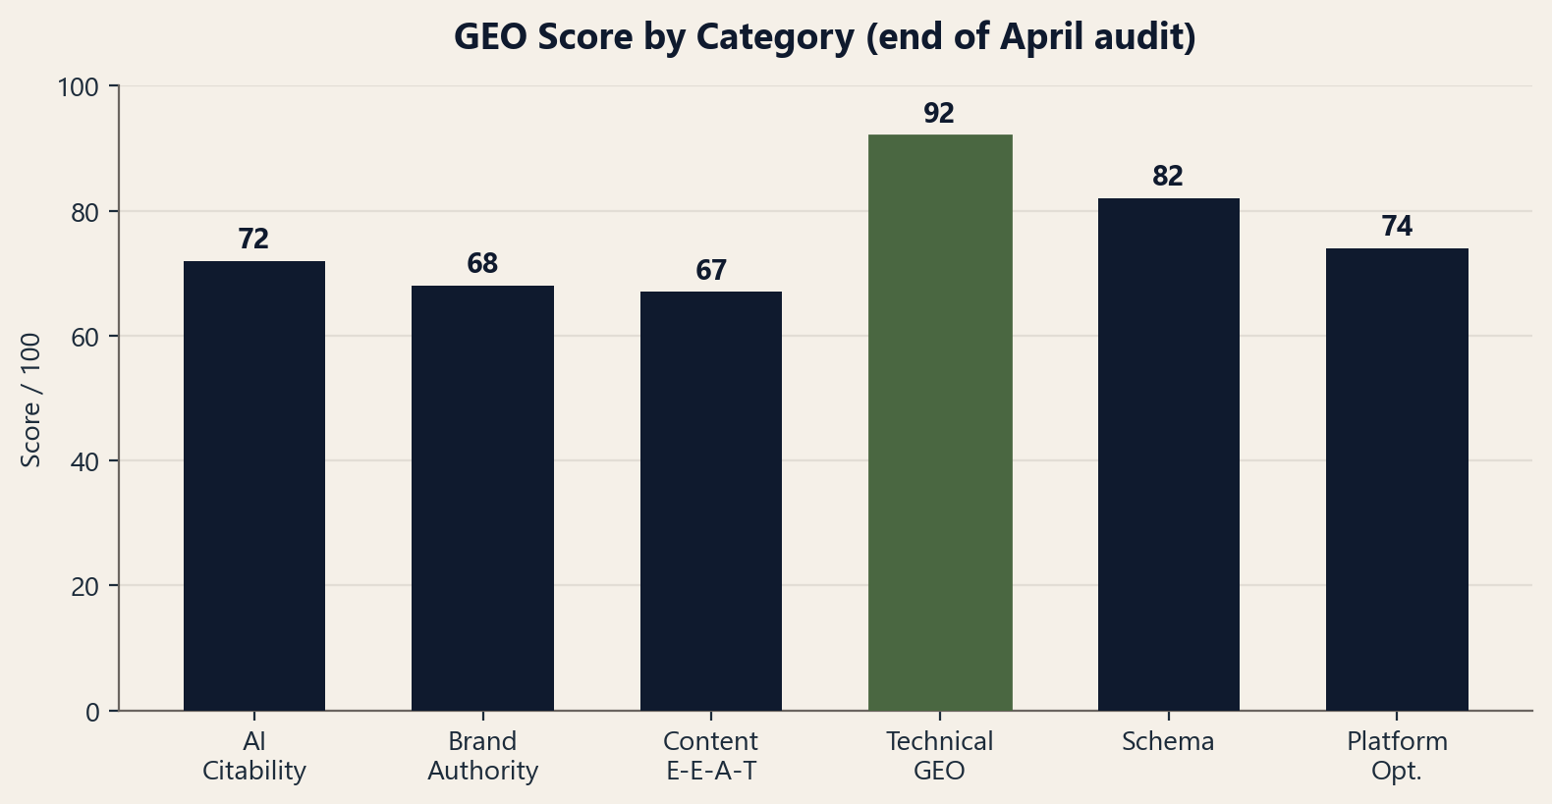
2.3 Content published
28 LinkedIn posts, all bilingual (English and Hungarian with correct diacritics).
- April: 12 strategic posts published (April 1 to 24).
- May: a 16-post calendar written and delivered. Weeks 6 to 8 published. Week 9 posts written and ready.
Topics covered spring and summer maintenance, hotel and aparthotel operations, eco-cleaning, energy costs, supervision and training, vendor consolidation economics, hospitality versus residential FM, and anonymized case results.
2.4 Accounts and platforms set up
- Google Search Console: verified, sitemap submitted.
- Bing Webmaster Tools: verified, IndexNow key in place, sitemap submitted.
- Google Business Profile: claimed. Verification postcard received. PIN entry pending (your action, see Section 5).
- LinkedIn company page: optimized (description, services, banner, founding posts).
2.5 Strategy and content assets prepared
These are complete, written, and ready to use:
- Aparthotel Operating Standard V1 draft (14 categories with measurable thresholds).
- Cold outreach sequence, English and Hungarian (3 emails).
- Wave 1 prospect list (22 Budapest hospitality and residential targets).
- Google Ads campaign plan with responsive search ad copy (EN and HU) and a video ad script.
- SEO keyword research (top 20 terms).
- Google Business Profile business description (EN and HU).
- LinkedIn company page optimization guide.
- Referral partner outreach queue and automation notes.
- Brand visual ad samples (4 ad concepts, 4 final HU and EN videos, voiceover audio).
3. Asset and File Inventory
All files live in the CEEFM project folder. Key locations:
Reports
- Monthly performance report, April 2026 (with delivery and analytics appendices, PDF).
- May 2026 action plan (PDF).
- GEO audit reports (March baseline through May 13 re-audit).
- Marketing audit.
Content
- April content calendar (EN and HU) plus 12 post images.
- May content calendar (EN and HU) plus post images.
- Calendar files in ICS and CSV format for scheduling.
Deliverables
- Aparthotel Operating Standard V1 draft.
- Outreach packet (cold sequence, prospect list, referral queue, automation).
- Google Ads campaign plan, RSA copy, and video script.
- SEO keyword research.
- GBP business description.
- LinkedIn company page optimization.
- 16-week campaign roadmap.
Brand visuals
- Ad samples, final videos, and voiceover audio.
A full file tree can be exported on request.
4. What Was Not Completed
The engagement closed at Week 9, before Phase 2 (acquisition) ran. The following was prepared but not activated:
- Google Ads: campaign planned and ad copy written. Not launched. Budget was never signed off.
- Cold outreach: sequence and prospect list ready. Not sent. Was waiting on Gmail send authorization.
- Google Business Profile: claimed, postcard received, but the verification PIN was not entered.
- Aparthotel Operating Standard: drafted, not yet published (was planned for June).
- GEO target: reached 68 of the 70 target. The last points come from more case study content.
- TikTok and Facebook Business pages: planned, setup not completed.
- June content calendar: not produced (engagement ended).
None of this is lost work. Each item is documented and ready for you or a future provider to pick up.
5. Your Immediate Action Items
These are short tasks that protect the value already built. They need you specifically.
- Enter the Google Business Profile PIN. The postcard arrived. Entering the PIN completes verification and unlocks your profile in Google Maps and local search. This is the single highest-value 10-minute task.
- Keep the website live and unchanged. The schema, imprint, and technical fixes are what hold the visibility score. Do not let a future site edit strip them out.
- Decide who maintains the LinkedIn page. Even one post a week keeps the page active. The May calendar shows the format that worked.
6. Recommended Next Steps
If you continue the work, in-house or with another provider, this is the order that makes sense:
Finish the foundation (1 to 2 weeks)
- Complete GBP verification and add 10+ photos.
- Add the TikTok and Facebook Business pages for entity signals and recruiting.
- Publish 2 to 3 more case study pages with hard numbers to push GEO past 70.
Run acquisition (when ready)
- Activate Google Ads using the prepared plan and copy. A 150,000 HUF per month test was proposed.
- Send the cold outreach sequence to the Wave 1 list.
- Publish the Aparthotel Operating Standard as a lead magnet.
Compound
- Maintain a weekly content cadence.
- Track which enquiries come from which channel.
Any competent digital provider can execute these from the documents in your folder. The strategy and the assets are done. What remains is activation.
7. Closing Note
It was a pleasure building this with you, Victor.
In nine weeks CEEFM went from invisible to measurable. The technical foundation is solid, the entity signals are truthful and complete, and the content engine is documented and repeatable. Everything is yours to keep and carry forward.
If you need anything explained, a file located, or a warm introduction to a provider who can continue the acquisition phase, reach out any time.
Wishing CEEFM strong growth ahead.
Emmanuel Ehigbai
BridgeWorks
office@bridgeworks.agency
Prepared by BridgeWorks for CEEFM Kft | May 29, 2026

