Nicholas Heredia

Mark Bely

04/03/2019

COMP 251

Project #3 Jester Algorithm Manual

Apologies to the client reading this algorithm. Given the long hours the code was worked on, the code may be disorganized, but it does work, provided the user follows the instructions. For the luck of the user, i.e. the lovely instructor, intensive time waiting is needed. This report was written partly sleep deprived but was organized with the effort to follow the usage of the program as much as possible, giving the author some semblance of what it is like to write a user manual for nay program they decide to publish or release into the hostile, unforgiving world. The algorithm can handle any uploaded data set, so long as the unrated cells are of an integer number, the rows are jokes, and the columns are movies, and aren’t labelled. Additionally, the algorithm features mean normalization which occurs on line 39. And the algorithm runs LESS than 15 minutes.

When opening the Matlab script and running it, there are the script windows and the prompt windows which depending on the default layout of your Matlab program exists below your script. These are where the script takes in user input.

The very first thing the user will see upon activation of the program is a prompt asking for alpha and lambda. Default values are already present in case the user needs help. Next decision is whether the default excel file is desired or another excel file is desired. If a nondefault excel file is chosen, make sure the file is located in the same folder with the .m files. Note all .m files are needed for the algorithm to work.

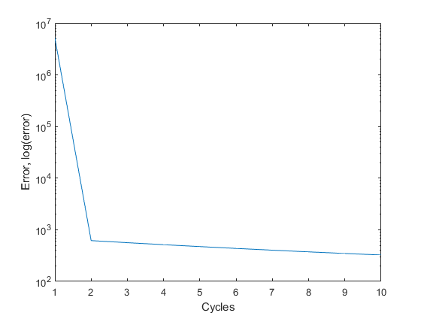The user must enter what the default answer is for ‘no ratings’. This is to help the algorithm figure out the r matrix for rated and unrated cells. Once ‘enter’ is pressed, the file will enter a learning period. Fear not, provided a reasonable alpha and lambda are picked, the program should run for no longer than ten minutes at the most. Unfortunately, there are instances where the error you see in the prompt window will decrease. The program has a handle on that and will exit the loop should that happen. Sadly, there is no option to ‘retry’ the learning phase, so we must move on. The errors will be saved in a text file. You should see a plot similar to the one below.

Figure(1) Log Plot of the Error curve for the recommender project.

Now comes the fun part. You will be asked how many jokes you want suggested to you. Bear in mind the total number of jokes is 100. Five should be a good number. Word of warning, some of the jokes in the data set are racy, sensitive, sexual, or dated to the Bill Clinton Administration. If they come up, bear in mind this is a Recommendation System.

The first five jokes in the data set which should be included in the zip file should be opened alongside the Matlab file. Rate the jokes from not funny, (-10) to hilarious (10). After the fifth joke, the algorithm will begin working to suggest the best number of jokes you desired. At which point, it prints the joke ID and saves the suggested jokes to a text file in the folder with the Matlab files.