DRVA4955

Pinout top view

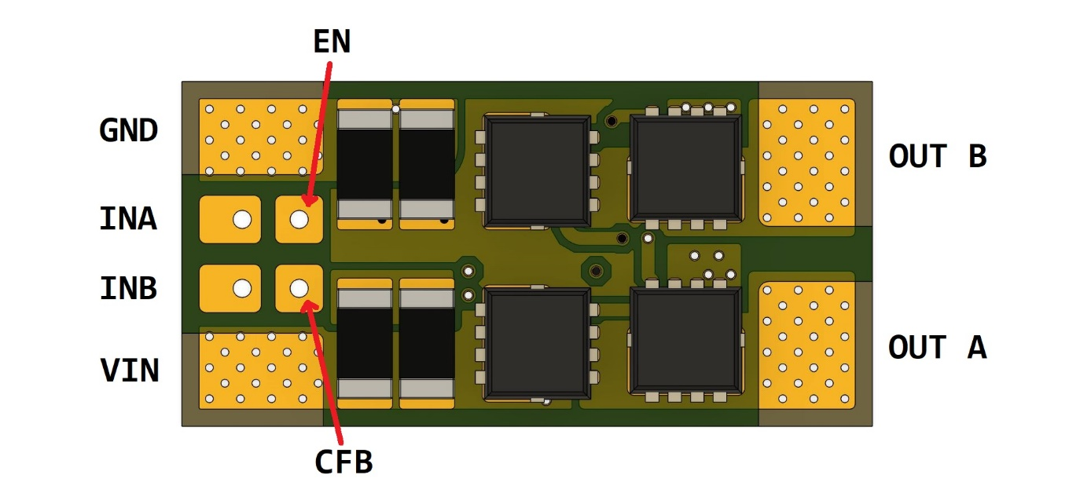

Pinout bottom view

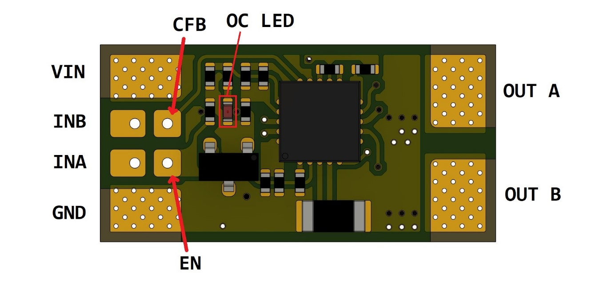

|  |  |
| --- | --- |
| VIN | DC Power positive input |
| GND | DC Power negative input (ground) |
| OUT A | Driver output A |
| OUT B | Driver output B |
| IN A | Driver control input A |
| IN B | Driver control input B |
| EN | Driver ENABLE / SLEEP |
| CFB | Current feedback |
| OC LED | Overcurrent indicator |

Electrical characterisitics

|  |  |  |  |
| --- | --- | --- | --- |
| Property | Condition | Value | Units |
| Vin max |  | 30 | V |
| Vin min |  | 6 | V |
| Iout peak | T<10us | 168 | A |
| Iout limit |  | 25 | A |
| Max operating temperature (mosfets) |  | 150 | *C |
| Max operating temperature (board) |  | 120 | *C |
| Thermal shutdown temperature |  | 165 | *C |
| V input LOW |  | <= 0.8 | V |
| V input HIGH |  | >= 2.0 | V |
| V input LOW (enable) |  | <= 0.4 | V |
| CFB max |  | 2.5 | V |

Control description

|  |  |  |  |  |  |
| --- | --- | --- | --- | --- | --- |
| EN | INA | INB | OUTA | OUTB | Function |
| 1 | 0 | 0 | Z | Z | Coast |
| 1 | 0 | 1 | L | H | Reverse |
| 1 | 1 | 0 | H | L | Forward |
| 1 | 1 | 1 | L | L | Brake (Slow decay) |
| 0 | X | X | Z | Z | Sleep (Standby) |

Enable pin has internal 10K ohm pull-up to 5V, can be left disconnected if not used.

Current feedback formula: I = VCFB * 10