M2X10A

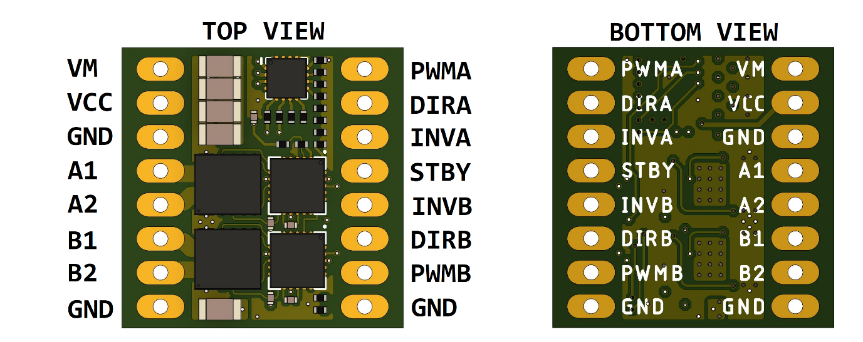

Driver pinout

|  |  |
| --- | --- |
| VM | Motor positive power input |
| VCC | Control logic positive power input |
| GND | Ground |
| A1 | Channel A output 1 |
| A2 | Channel A output 2 |
| B1 | Channel B output 1 |
| B2 | Channel B output 2 |
| PWMA | Channel A PWM input |
| PWMB | Channel B PWM input |
| DIRA | Channel A direction control |
| DIRB | Channel B direction control |
| INVA | Channel A output inversion control |
| INVB | Channel B output inversion control |
| STBY | Driver standby (active low) |

* Only one GND pin is required to be connected, but it is recommended to connect all GND pins to improve thermal performance.

Electrical and thermal characteristics

|  |  |  |  |
| --- | --- | --- | --- |
| Property | Condition | Value | Units |
| VM max |  | 30 | V |
| VM min |  | 6 | V |
| Peak (Pulsed) current (for each channel) | T < 10us | 80 | A |
| Continuous current (for each channel) | +25 °C  +70 °C | 13  10 | A |
| Max operating temperature (mosfets) |  | 150 | °C |
| Max operating temperature (board) |  | 120 | °C |
| Control circuit max operating temperature |  | 85 | °C |
| VCC max |  | 5.5 | V |
| VCC min |  | 1.8 | V |
| V input LOW | <= 0.2 * VCC | | V |
| V input HIGH | >= 0.8 * VCC | | V |

1. Current limits are for individual channels, both channels can be active simultaneously at the specified limit, but the combined power will generate more heat, please ensure not to exceed maximum operating temperature.
2. IMPORTANT – The driver does not limit the output current, the user must ensure that the maximum operating current is not exceeded, otherwise the driver can be damaged.

Control description

|  |  |  |  |  |  |  |
| --- | --- | --- | --- | --- | --- | --- |
| STBY | PWMA | DIRA | INVA | A1 | A2 | Function |
| 1 | 0 | - | 0 | Z | Z | Coast |
| 1 | 0 | - | 1 | L | L | Brake (Slow decay) |
| 1 | 1 | 0 | - | H | L | Forward |
| 1 | 1 | 1 | - | L | H | Reverse |
| 0 | - | - | - | Z | Z | Sleep (Standby) |

* Channel B control logic is identical to Channel A.
* All input pins have a 30K pull-down resistor to ground.
* The INVA and INVB pins control the inactive part of the PWM cycle, for applications like robotics it is recommended to use slow decay braking (INV set HIGH), this provides improved control.
* To reduce microcontroller pin usage, INV pins can be left unconnected or tied to VCC. STBY pin can be tied directly to VCC, for sumo robots can be connected to the start module.