Assignment 01

First Steps
Prepare the Android development environment and create your first test app to check all involved components

Download the Android development IDE Android Studio from
http://developer.android.com/sdk/installing/studio.html

Create first app and run it on your device or in the emulator
Create a first sample App using the default values and get familiar with the structure of the IDE.
Identify the IDE modules that let you inspect logs generated on the device (LogCat).
For running the App in the emulator, first create a new emulator configuration. Afterwards start the emulator and run the App in it.
If you have your own Android device, try running the App on it. You will probably have to install a driver on Windows machines; Linux and Mac should display your device as a startup target directly. It might also be necessary to bring your device into developer mode.

Note: Have a look at the Android tools reference for more information (http://developer.android.com/tools/workflow/index.html).

Guess my Number

As your first assignment, you will build an App that thinks of a random number between 1 and 100 and lets the player guess what this number is while giving feedback if a guess is higher or lower than the solution.
The player will have 5 tries to get the number right.

1.) Modify the main layout
The default activity layout should consist of two text elements (one for inputting the guess and the other for feedback), one ImageView (This should show an image that fits the game) and two buttons (one for restarting the game and one for guessing).
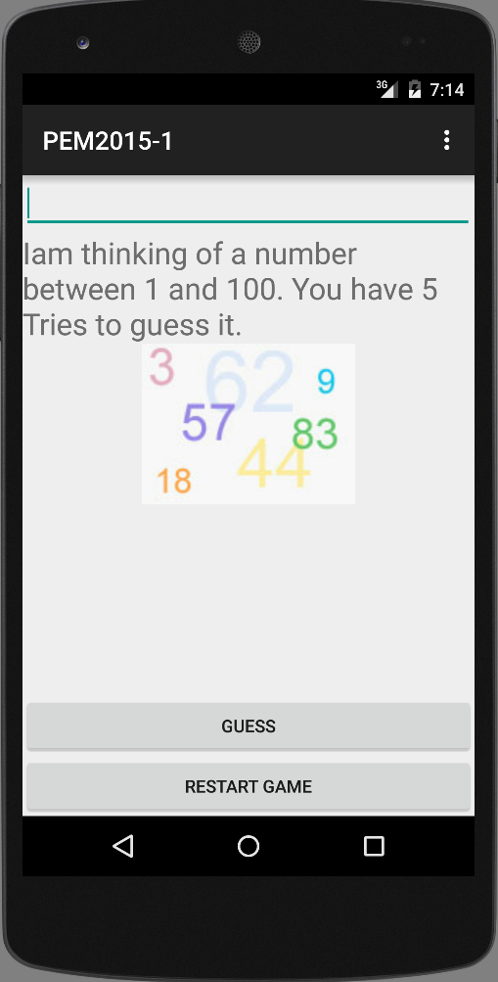
Afterwards, wire all elements up to the activity in order to change the text programmatically and react to button events.

2.) Create a new class for game operations
The new class should contain a method that creates a random number,
methods for handling guesses and the game rules(5 tries, Gameover or Success) and a method that handles a restart.

2.) Handle Errors
Handle Errors that could interrupt your program (e.g. false inputs) and give the user feedback. (You can use Toasts)
http://developer.android.com/guide/topics/ui/notifiers/toasts.html

Master Students: Insert more Images to give Feedback about the guessed number
This applies to master students only!
The Images should show the user if his guess is higher or lower than the solution. Use only one component to achieve this.
Also the Image should change for a Gameover and a Success.

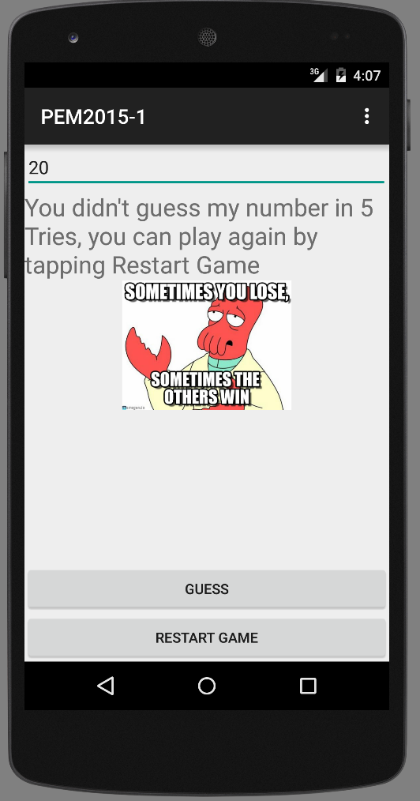

Submission
Please zip (rar is not zip!) up your complete Android project and hand it in via Uniworx. Projects that do not compile due to errors will not be accepted.

