**With this guide and the sections provided in this file you’ll be able to customize the portal.Using this guide you can easily configure your custom branding based on given components/Elements color/background-color from excel sheet**

**-->For changing the background image put images in the assets folder.**

**-->For changing the text label color replace the css of elements/components inside custom.css**

**Look at the below sections provided to see which number matches which element you can change, reference from excel sheet**

**Public Pages(Login Page)**

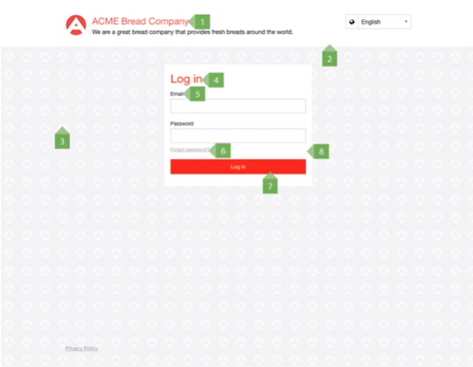

**Public Pages(Forgot password page)**

Customization of Forgot password text label put the color inside custom.css.

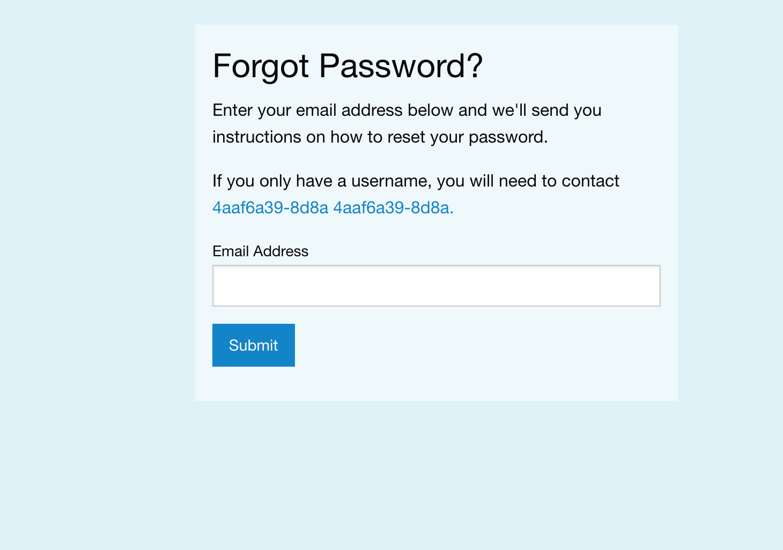

**Trainee App Page**

**The Trainee App consists of the trainee dashboard and the trainee player. The blue labels will identify the specifics of what will be customizable within your Mindflash account.**

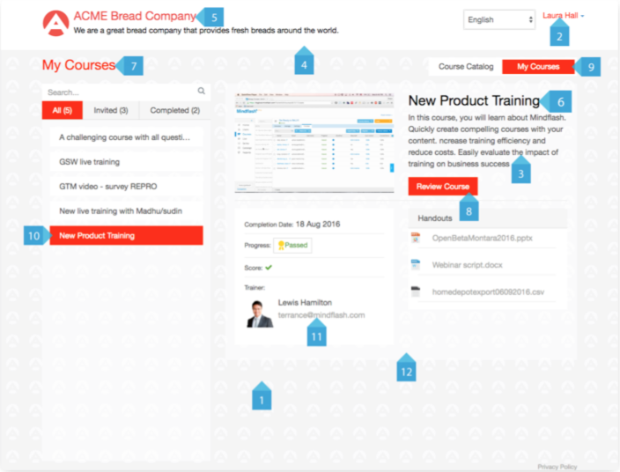

**Course Access Page**

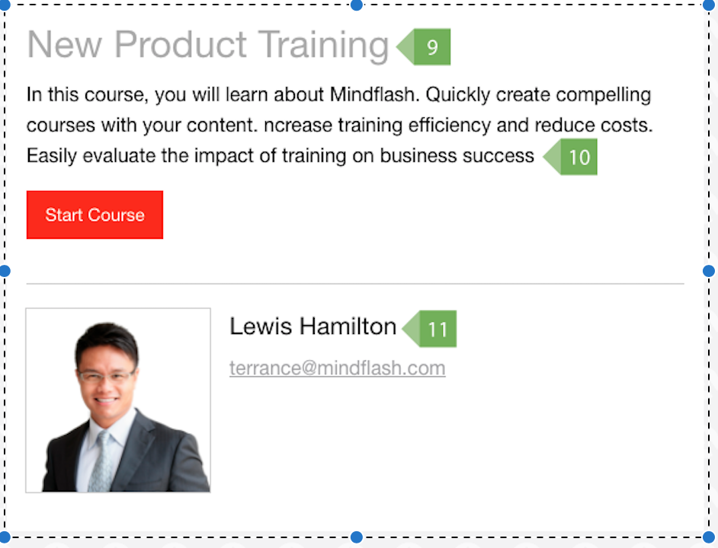

**Favicon Icon**

**For customization of favicon need to put favicon.ico file within the favicon folder.**

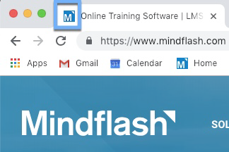

**If you have any questions please contact your Customer Success Manager directly or email us at** [**help@mindflash.com**](mailto:help@mindflash.com)**.**