


Helipad Detector

Rooftop Helipad Detection in Satellite Imagery of São Paulo with YOLO

Complete and Accessible Project Report
Technical pipeline, methodology, results, and a plain-language guide

Pontifical Catholic University of São Paulo (PUC-SP) — FACEI
BSc in Human Centered-AI & Data Science Machine Learning / Computer Vision — Project P2

Professor: Rooney Ribeiro Albuquerque Coelho
Autor: Fabiana Campanari

São Paulo · 2026

Helipad Detector — Complete Report

Summary

This report works on two levels at once. For readers already familiar with data and AI, it is a complete technical report: it covers the 12-step pipeline, the three training experiments, the evaluation metrics, and the field validation across ten São Paulo neighborhoods. For readers who have never heard of YOLO or mAP, every section also includes a plain-language explanation — written as if we were simply talking through the project, with no prior AI knowledge assumed

Table of Contents

- 1. What Helipad Detector is, in one sentence
- 2. Why detect helipads — and why it's hard
- 3. How an AI learns to “see” — a plain-language primer
- 4. Data source and geographic scope
- 5. The complete technical pipeline — 12 steps
- 6. Image collection and annotation
- 7. Modeling with YOLO — the three experiments
- 8. Quantitative evaluation — what the numbers mean
- 9. Field validation — testing on real data across ten neighborhoods
- 10. Qualitative analysis — hits, misses, and why
- 11. Interactive web application
- 12. Strengths, limitations, and next steps
- 13. Ethics, LGPD, and governance
- 14. Conclusion
- 15. Glossary of technical terms

Page 2 of 26

Helipad Detector — Complete Report

What Helipad Detector is, in one sentence

In one sentence: it's an Artificial Intelligence system that looks at satellite images of São Paulo and, on its own, points out where helipads exist on building rooftops.
In slightly more technical terms: the Helipad Detector is a complete Object Detection pipeline that locates helipads on rooftops in the city of São Paulo, using high-resolution aerial/orbital imagery and models from the YOLOv8/YOLOv11 family. The project covers the full lifecycle of an applied computer vision system: programmatic image collection, geospatial automation, building and curating an original dataset, annotation, preprocessing, training, quantitative and qualitative evaluation, inference on neighborhoods unseen during training, an extra field-validation stage on rea

An important point for non-technical readers: the project did not use any pre-made image bank. The entire data foundation — the satellite photos and the markings of where the helipads are — was built from scratch by the team, a stage that usually consumes most of the effort in any serious Artificial Intelligence project.

Page 3 of 26

Helipad Detector — Complete Report

Why detect helipads — and why it's hard

Helipads were chosen as the target because, seen from above, they have a very distinctive design: a large “H” painted over a circular or square area on the rooftop. That sounds easy to recognize — but in practice it isn't, and that very difficulty is what makes the project interesting from an educational standpoint.

In satellite imagery of a dense city like São Paulo, the model can get confused with:
- Building swimming pools, which have a shape and contrast similar to the “H”;
- Sports courts, with lines and geometric markings that look alike;
- Rooftop structures, water tanks, and air-conditioning equipment;
- Reflective surfaces, which change appearance depending on daylight.

This kind of confusion is called, in the field, a false positive — when the model “sees” a helipad where none exists. Working with a target that generates plausible false positives is what makes this project a good computer vision exercise: it forces the team to think about annotation quality, example diversity, and the model's real limits, instead of celebrating a nice-looking number without understanding what's behind it.

Page 4 of 26

Helipad Detector — Complete Report

How an AI learns to “see” — a plain-language primer

Before diving into the technical pipeline, it's worth explaining, in simple terms, what's happening under the hood.

What is “Object Detection”?
It's the AI task that answers two questions at once, for each image: “does the object I'm looking for exist here?” and “exactly where is it?”. The answer to the second question comes as a rectangular box drawn around the object — called a bounding box — placed over the image.

What is YOLO?
YOLO stands for “You Only Look Once,” the name of a family of AI models widely used for real-time object detection. It scans the whole image at once and directly returns the list of objects found, along with their boxes and a confidence score (0 to 100%) for each detection. This project uses the YOLOv8n version (the “n” stands for the “nano” variant, lighter and faster to train) and also tests the newer YOLOv11n variant.

How does the model “learn”?
This process is called training. The team shows the model hundreds of already manually marked images
— “here's a helipad, and it's exactly at this position” — and the model gradually adjusts its internal parameters to match these markings more and more accurately. Each complete pass through all the training images is called an epoch. In this project, models were trained for 60 to 100 epochs.

Why does data quality matter more than the model itself?
This may be the central lesson of the project: roughly 80% of the effort in a real Artificial Intelligence project goes into building and curating the data, not into fine-tuning the model architecture. The YOLO used by this group is essentially the same YOLO any other team would use; what differentiates the final result is the quality of the images collected, the consistency of the annotations, and the geographic diversity of the dataset.

Page 5 of 26

Helipad Detector — Complete Report

Data source and geographic scope

The geographic scope follows the course's academic briefing: the city of São Paulo, focusing on neighborhoods near dense corporate corridors, where helipads are more common — Perdizes, Higienópolis, Pacaembu, Sumaré, Paulista Avenue, Itaim Bibi, Pinheiros, Faria Lima, Berrini, Vila Olímpia, Brooklin, and Morumbi.

Where do the images come from?

- ESRI World Imagery (XYZ tiles) — the main source, with sub-meter resolution and programmatic HTTP access (i.e., it can be downloaded automatically by code);
- Google Earth Web — a complementary source, used only for pinpoint captures of specific targets, never for bulk collection;
- GeoSampa — mentioned as an alternative high-resolution source, a possible extra beyond the base scope.

Whenever an image or mosaic derived from ESRI is reproduced, the project includes the required attribution: “Source: Esri, Maxar, Earthstar Geographics, and the GIS User Community”.

Page 6 of 26

Helipad Detector — Complete Report

The complete technical pipeline — 12 steps

The full pipeline, from scratch to field validation, can be summarized in twelve steps. Each is described below with its technical name and a plain-language explanation of what it means in practice.

1 and 2 — Discovery and extraction of helipad records
An automation bot (Selenium, in src/geospatial/helipad_bot.py) browses a public aviation website looking for helipad records, extracting their geographic coordinates and metadata. In plain terms: instead of manually searching, one browser tab at a time, “where do helipads exist in Brazil,” a program does that search by itself, systematically

— Organizing the coordinates
The collected data is saved and organized into src/geospatial/helipad_coordinates.csv, a simple spreadsheet with date, coordinates, and the corresponding neighborhood.

— Converting to geographic bounding boxes
The script src/geospatial/transform_coordinates.py converts each helipad coordinate (a single point) into a small rectangular area around it — the geographic bounding box — used to decide which piece of the map to download.

— Downloading satellite imagery
For each bounding box, the system downloads the “tiles” (square pieces of satellite imagery) from ESRI World Imagery, at zoom level 19 — the recommended detail level for small targets like helipads.

— Building mosaics
The downloaded tiles are stitched together into larger mosaics, organized by neighborhood and zoom level (notebook src/geospatial/geospatial_image_collection.ipynb), forming continuous images ready for visual inspection.

— Manual triage
A team member reviews the mosaics and discards image pieces that clearly contain no helipad, keeping only the relevant material for annotation — avoiding wasted time annotating empty images.

Page 7 of 26

Helipad Detector — Complete Report

and 9 — Annotation and dataset export
Selected images are uploaded to Roboflow, where the team draws bounding boxes around each helipad using a single class (“helipad”). Roboflow then applies preprocessing (resizing to 640×640 pixels), data augmentation techniques (such as rotations and brightness variations), and splits the set into training, validation, and test, exporting everything in a YOLO-compatible format.

— Training
The YOLOv8n models are trained on Google Colab, using a free T4 GPU, monitoring metrics and learning curves across epochs.

— Inference on an unseen neighborh
he trained model is tested on a neighborhood that never appeared during training, to assess its
generalization ability — that is, whether it truly “learned” the visual pattern of a helipad, rather than just memorizing the training images.

— Field validation across ten neighborhoods
Beyond the standard test, the best model was run against 7,943 real satellite tiles, covering ten entire São Paulo neighborhoods — well beyond the curated training/validation/test set, bringing the project closer to a real-world usage scenario.

Page 8 of 26

Helipad Detector — Complete Report

Image collection and annotation

  - Programmatic collection
Collection follows the ESRI World Imagery XYZ tile standard: zoom 19 for small targets like helipads; bounding boxes defined per neighborhood; conversion to tile indices via a function called deg2tile;
downloads with HTTP status checks and filtering of “placeholder” images (blank images indicating failure); and organization of images into folders by neighborhood and zoom level.

Curation and dataset volume
    - Minimum volume of 200 images with the target object after curation;
    - Geographic diversity: at least 3 different neighborhoods in training;
    - At least 1 fully unseen neighborhood held out for the final generalization test;
    - Manual triage of tiles, discarding crops with no helipad.

Annotation in Roboflow
Roboflow was used as the central platform for annotation and dataset management — not as the source of the imagery, only as a labeling, versioning, preprocessing, and export tool. The rules followed by the team were:
    - Single class: helipad;
    - Tight bounding boxes (well fitted to the object, with no excess area);
    - Written criteria for ambiguous cases — partially visible objects, shadows, reflections;
    - Annotation work divided among team members, to avoid a single-annotator bias.

Preprocessing and dataset split
    - Resizing to 640×640 pixels;
    - Data augmentation: 90° rotations, horizontal/vertical flips, small brightness and contrast variations;
    - Standard split: 70% train, 20% validation, 10% test.

Each annotation file (.txt) contains, per line, normalized coordinates in the format (class, x_center, y_center, width, height) — the standard format expected by YOLO.

Page 9 of 26

Helipad Detector — Complete Report

Modeling with YOLO — the three experiments

Training was done with Ultralytics YOLOv8n on Google Colab (T4 GPU), using Python, PyTorch, and the roboflow library for direct dataset integration. Following the course briefing, which requires at least two experiments varying one hyperparameter at a time, the team ran three:

- exp1 — original dataset, 60 epochs, imgsz 640, batch 16, seed 42.
- exp2 — original dataset, 100 epochs (same other parameters), to test whether training longer
improves results or causes overfitting (when the model “memorizes” the training set instead of learning the general pattern).
- exp3 — an augmented (forked) version of the dataset, with ±15° rotation, 25% brightness variation, and horizontal/vertical flipping, also for 100 epochs — kept as a separate comparison point because it uses a different dataset version.

A data-integrity issue — found and fixed
During development, the team identified an important problem: an early notebook run had silently downloaded the forked (augmented) dataset, but saved the results under the name “exp2,” producing incorrect documentation about which dataset had actually been sed in that experiment.

This kind of error is known as a data-integrity issue: the code ran without crashing, the numbers looked plausible, but the experiment attribution was wrong. In any real AI project, this is exactly the most dangerous type of silent failure — because it doesn't raise a visible error, only a false conclusion.

The fix had two parts: renaming the mistaken run to exp3 (since, in practice, it was the experiment with the augmented dataset) and re-running exp2 correctly, against the original dataset's workspace. As a safeguard against recurrence, an assert guard was added to the training notebook — an automatic check that stops execution if the loaded dataset isn't the one expected for that experiment.

Page 10 of 26

Helipad Detector — Complete Report

Quantitative evaluation — what the numbers mean

Before the tables, a short glossary of the four metrics used to evaluate the model, explained in plain language:
- Precision: of all the times the model said “I found a helipad,” how many were correct? High precision means few false alarms.

- Recall: of all the helipads that truly exist in the images, how many did the model manage to find? High recall means the model rarely misses a real helipad.

- mAP@50: a single score summarizing overall detection quality, using a “reasonable” overlap criterion between the predicted and the real box (at least 50% overlap).

- mAP@50-95: the same idea, but with a much stricter criterion, requiring near-perfect overlap across several levels — the standard used in international benchmarks like COCO.

Results of the three experiments
The three experiments are automatically discovered and compared live in the “Experiment Metrics” tab of the project's Streamlit dashboard. These are the results at each run's best epoch

Experiment | Best Epoch | Precision | Recall | mAP@50 | mAP@50-95
exp1 (60 ep., original dataset) | 54 | 1.000 | 0.963 | 0.994 | 0.881
exp2 (100 ep., original dataset) | 81 | 0.982 | 0.971 | 0.993 | 0.888
exp3 (100 ep., augmented fork) | 78 | 0.943 | 1.000 | 0.993 | 0.885

Plain-language reading of these results: exp2 slightly outperforms exp1 on mAP@50-95 (a difference of
+0.0065) by training longer (100 instead of 60 epochs), while exp1 remains marginally ahead on Precision at its best epoch. These differences are small enough to fall within the expected noise margin, given that the dataset is small (about 150 images total) — in other words, training longer didn't bring a dramatic gain, but it didn't hurt the model either.

An important sign of training health: the loss curves (the model's “error rate” during learning) show no overfitting in any of the three runs — the validation loss closely tracks the training loss across all epochs, instead of drifting away from it. This indicates the model is learning a genuine pattern of “what a helipad is,” rather than merely memorizing the training images.

Page 11 of 26

Helipad Detector — Complete Report

Training charts — exp1 (60 epochs, original dataset)
These charts were generated directly from the real results.csv of exp1, the project's baseline experiment.
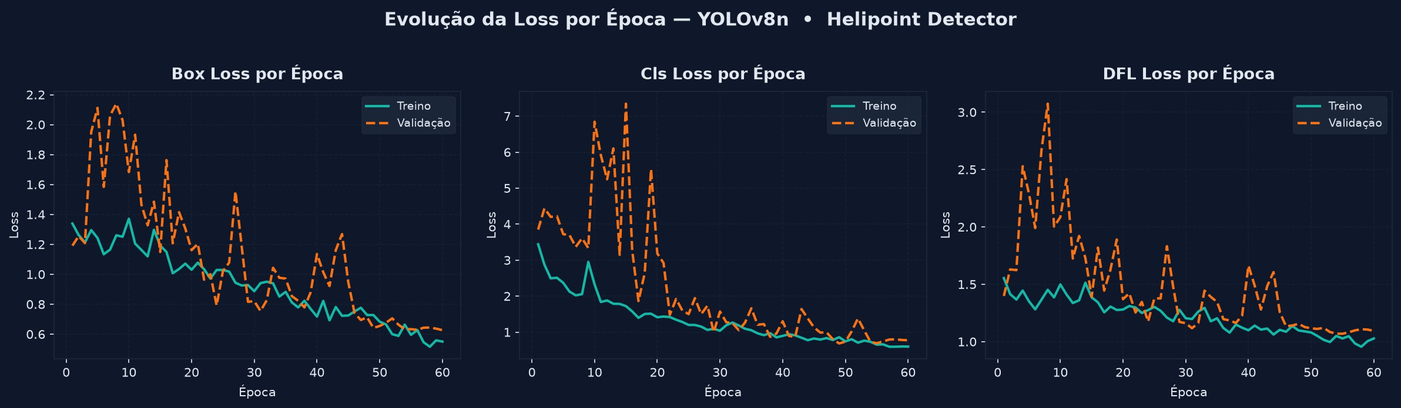
Figure 1 — Evolution of the losses (Box, Cls, DFL) per epoch, train vs. validation. No clear sign of overfitting across the 60 epochs; val/cls_loss oscillates in the first 20 epochs and stabilizes from epoch 30 onward.

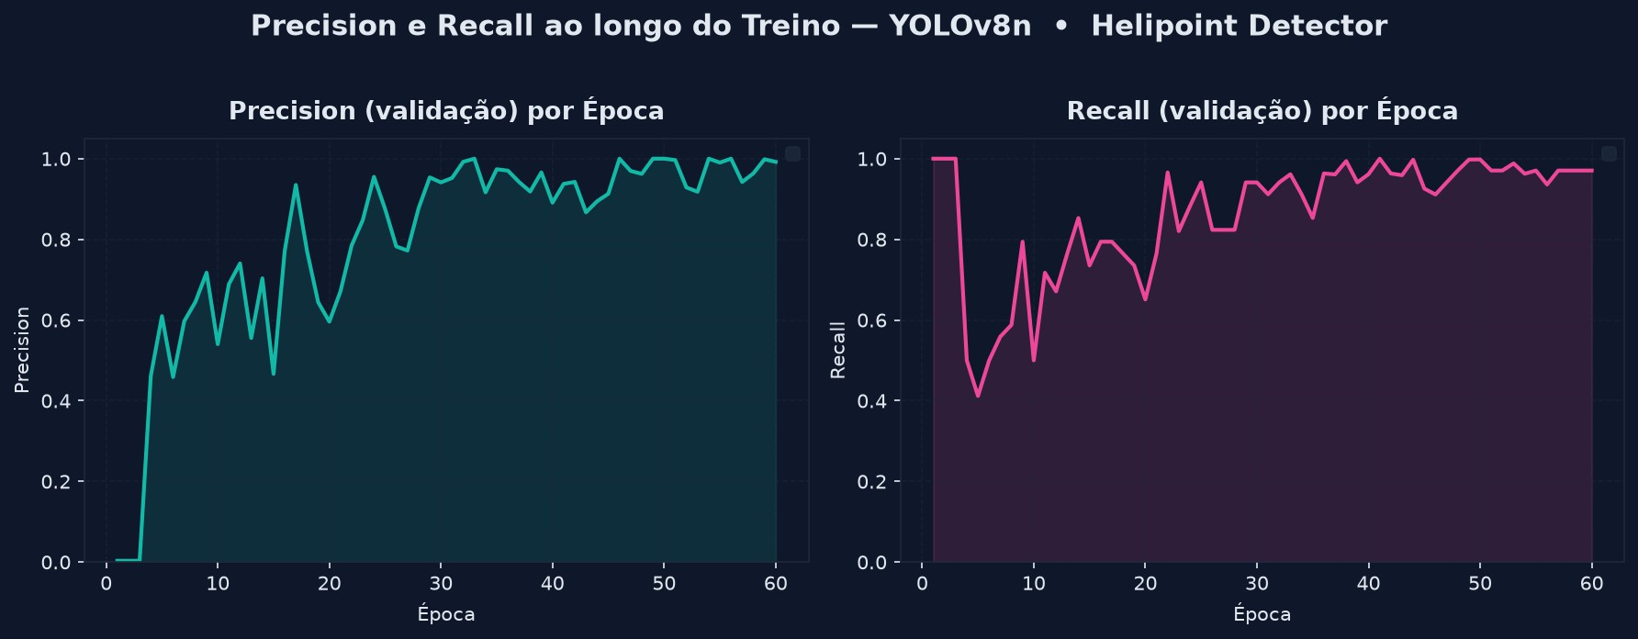
Figure 2 — Precision and Recall over training. Precision stabilizes above 0.95 from epoch 30 onward; Recall reaches 0.97+ in the final epochs, after a sharp dip around epoch 5.

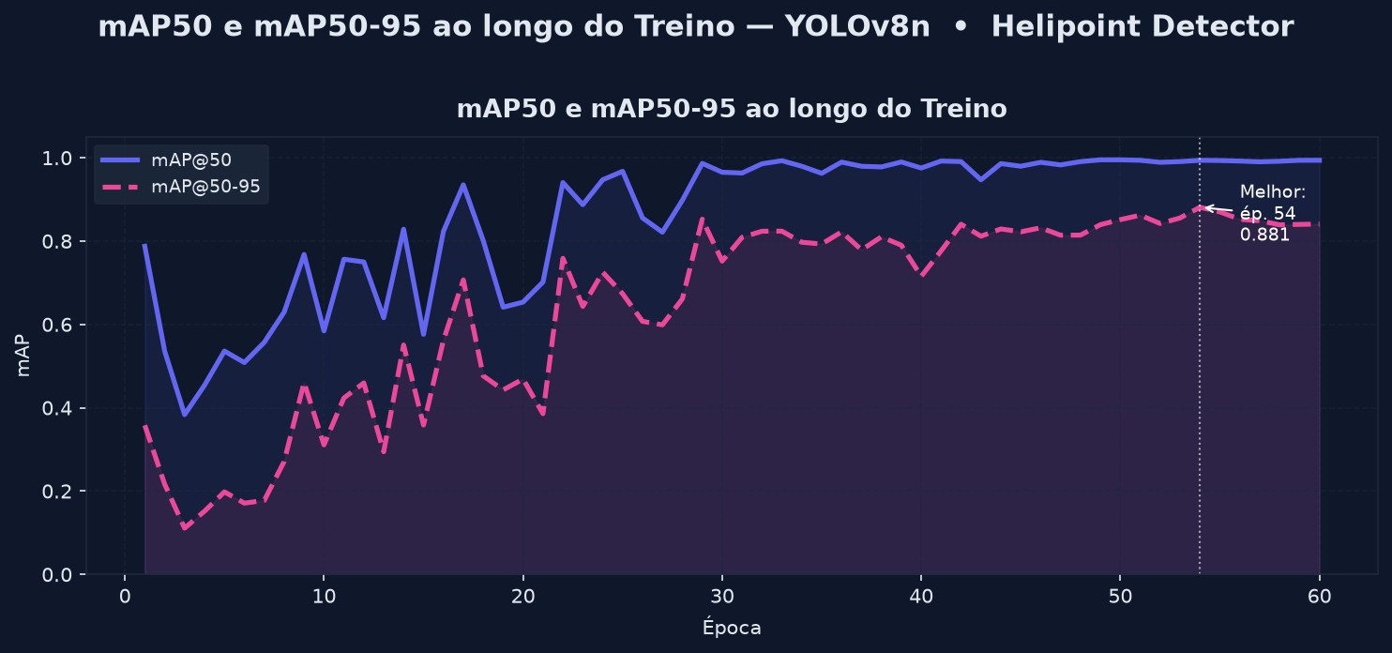
Figure 3 — mAP@50 and mAP@50-95. Peak at the best epoch (54), after which the metrics ﬂuctuate slightly.

Page 12 of 26

Helipad Detector — Complete Report

Training charts — exp2 (100 epochs, original dataset)

exp2 is the official ablation required by the briefing: same dataset as exp1, varying only training duration (60 → 100 epochs).

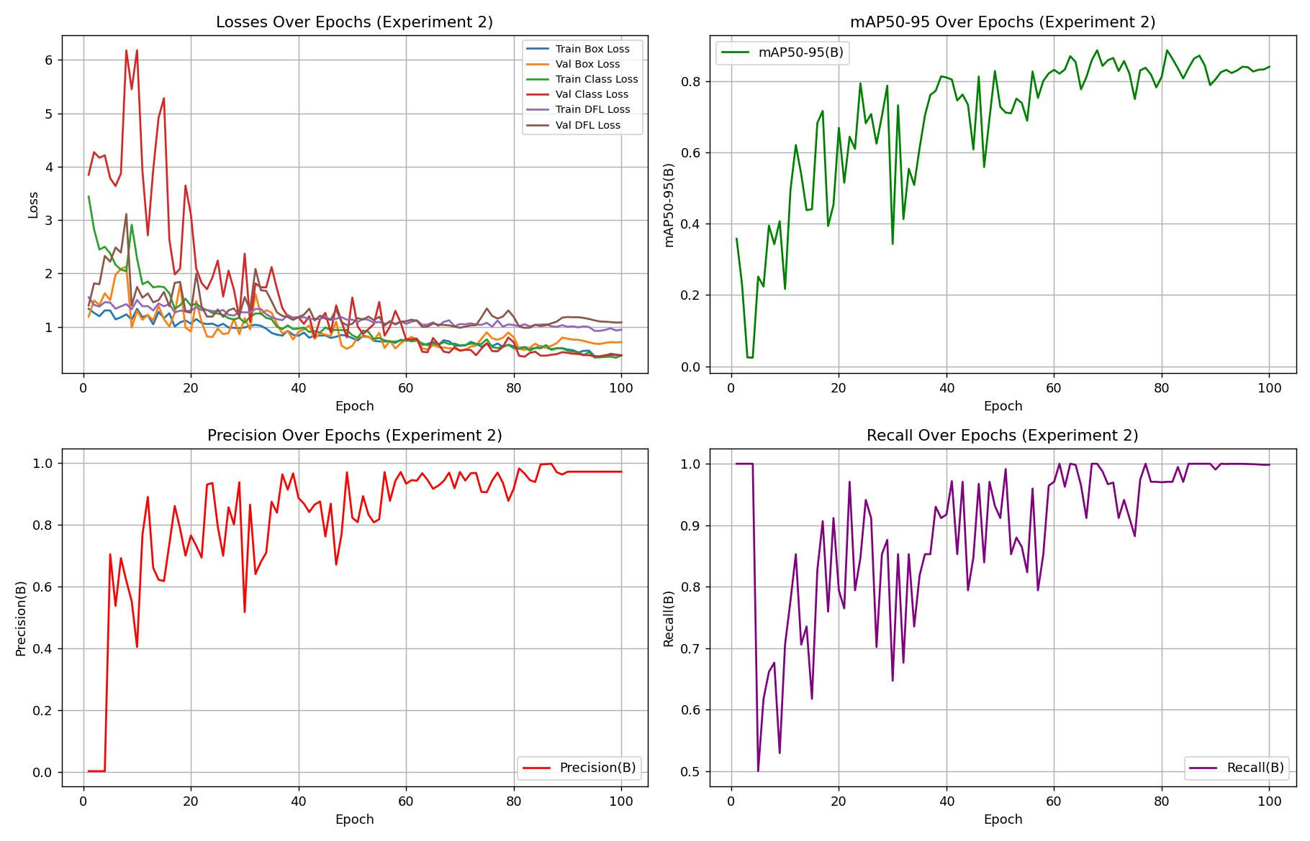

Overview — losses, mAP@50-95, Precision, and Recall across 100 epochs (exp2).

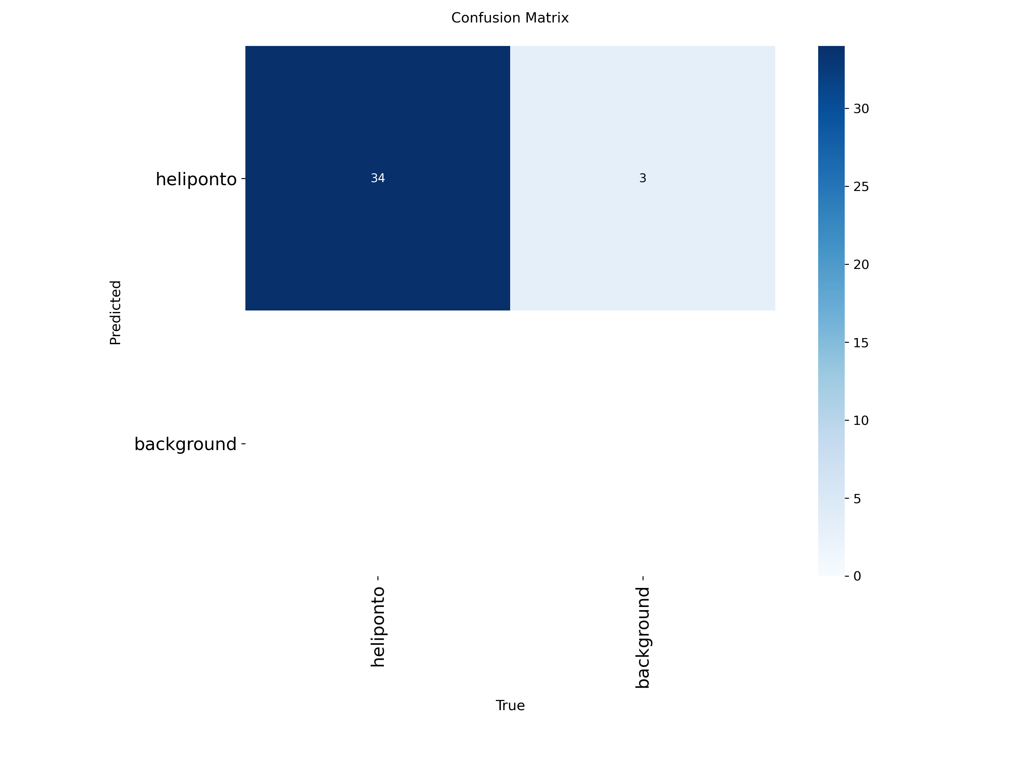
Confusion matrix (validation, exp2): 34 hits, 3 background false positives confused with a helipad.

Page 13 of 26

Helipad Detector — Complete Report

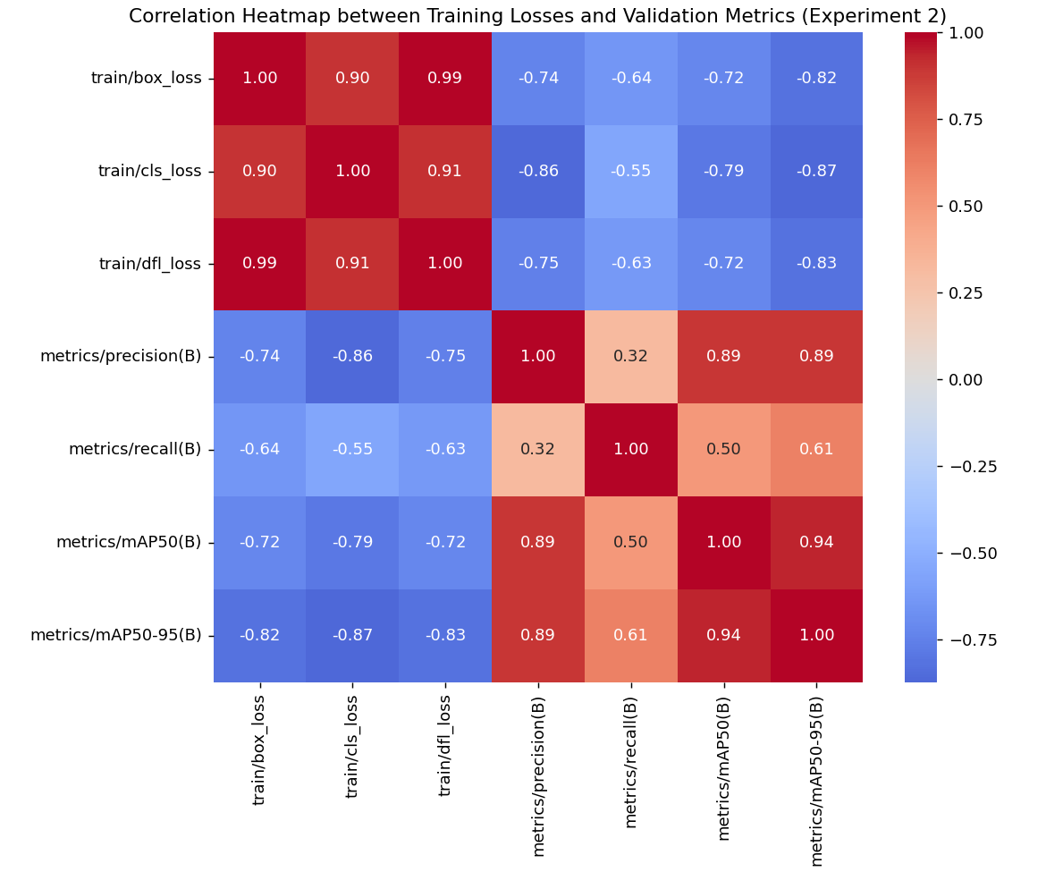
Correlation between training losses and validation metrics (exp2).

Training charts — exp3 (100 epochs, forked/augmented dataset)
exp3 uses a different version of the dataset (a fork with extra augmentation), so it serves as an additil reference point rather than a direct ablation comparison — that comparison is exp1 vs.
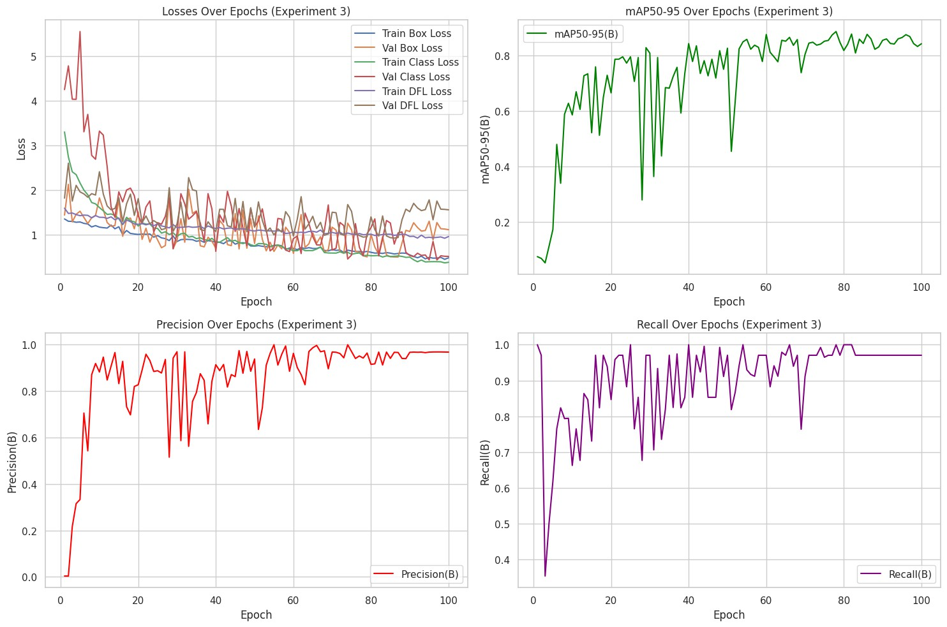

Overview — losses, mAP@50-95, Precision, and Recall across 100 epochs (exp3). Same pattern of a slight dip between the best epoch and the final one observed in exp1.

Page 14 of 26

Helipad Detector — Complete Report

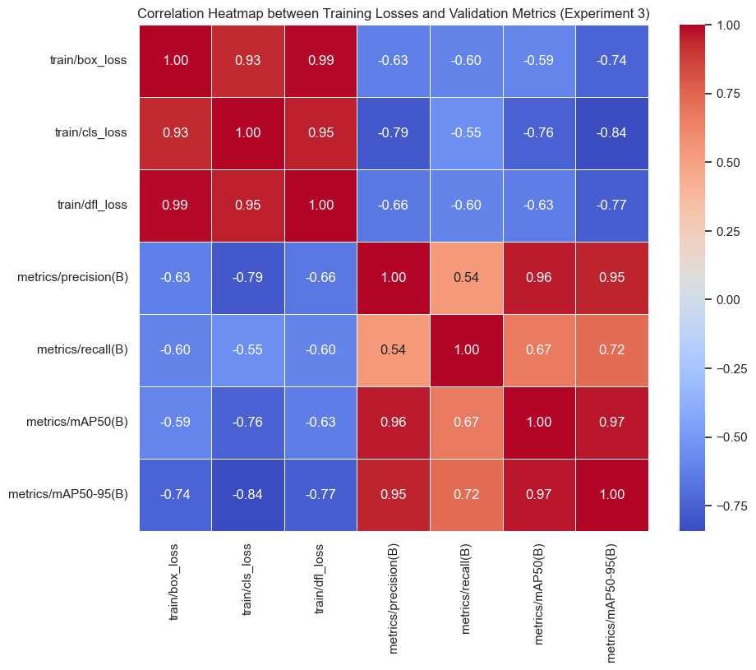

Correlation between training losses and validation metrics (exp3): cls_loss is the most strongly (anti-)correlated with mAP@50-95 (-0.84).

Page 15 of 26

Helipad Detector — Complete Report

Field validation — testing on real data across ten neighborhoods

One way this project goes beyond the briefing's minimum requirement is the field-validation stage: instead of evaluating the model only on the curated test set (manually pre-selected images), the best model (exp2) was run against 7,943 real satellite tiles, with no prior curation, covering ten entire São Paulo neighborhoods — including dense corporate corridors like Itaim Bibi, Paulista Avenue, Vila Olímpia, Pinheiros, Brooklin, and Faria Lima.

In plain terms: instead of showing the model only the “best photos,” the team let it loose on an entire neighborhood, tile by tile, exactly as it would work in real-world use.
Tiles and bounding boxes per region come from src/geospatial/sp_neighborhoods_bbox.csv; tile downloading and inference are automated by src/geospatial/download_all_regions.py and auto_triage_regions.py, both resumable — meaning the process can be paused and picked up later without reprocessing what's already done, essential when handling thousands of images.

Neighborhood | Detected | Total Tiles | Rate
Inter-Zone Corridor | 133 | 480 | 27.7%
Itaim Bibi | 191 | 750 | 25.5%
Brooklin | 231 | 1,014 | 22.8%
Vila Olímpia | 158 | 660 | 23.9%
Paulista Avenue (Section 1) | 179 | 840 | 21.3%
Faria Lima | 170 | 840 | 20.2%
Paulista Avenue (Section 2) | 157 | 780 | 20.1%
Pinheiros | 244 | 1,232 | 19.8%
Vila Nova Conceição | 109 | 572 | 19.1%
Alphaville Industrial | 105 | 775 | 13.6%

TOTAL | 1,677 | 7,943 | 21.1%

Reading the results: Inter-Zone Corridor and Itaim Bibi show the highest detection rates, consistent with being dense corporate corridors — areas with many commercial towers and, therefore, more real chances of a helipad. Alphaville Industrial, with a more industrial profile and fewer corporate towers, shows the lowest rate, in line with expectations for that type of land use. This kind of coherence between the model's output and the city's known urban layout is a good sign that the model is picking up a real pattern, not generating random detections.

Page 16 of 26

Helipad Detector — Complete Report

Comparing exp1, exp2 and exp3 on the Same Field Validation

The field validation in Section 9 uses exp2, the model selected for deployment — but the same run (7,943 tiles, ten neighborhoods) was repeated with exp1's and exp3's weights, to check whether the curated-benchmark leader also generalizes best in the field.

Region | exp1 | exp2 | exp3
Alphaville Industrial | 6.1% | 13.6% | 13.3%
Av. Paulista (Segment 1) | 9.8% | 21.3% | 26.8%
Av. Paulista (Segment 2) | 9.3% | 20.1% | 23.8%
Brooklin | 9.7% | 22.8% | 14.2%
Faria Lima | 9.0% | 20.2% | 17.2%
Inter-Zone Corridor | 14.2% | 27.7% | 20.8%
Itaim Bibi | 11.9% | 25.5% | 17.9%
Pinheiros | 8.2% | 19.8% | 16.6%
Vila Olímpia | 12.9% | 23.9% | 16.5%
Vila Nova Conceição | 8.0% | 19.1% | 12.1%
TOTAL (overall detection rate) | 9.6% | 21.1% | 17.9%

Key finding:

exp1 leads the curated validation set on Precision (1.000, see Section 8.1) , yet under identical field conditions it detects roughly half as many real helipads as exp2 (9.6% vs. 21.1% overall detection rate) and noticeably fewer than exp3 (17.9%). The model that scores best on a small, curated benchmark is not automatically the model that generalizes best to unfiltered, real-world satellite coverage; exactly the kind of gap that large-scale field validation, beyond the standard train/valid/test split, exists to catch.

This result also supports the decision to deploy exp2 in production rather than exp1, despite exp1's higher on-paper Precision.

Page 17 of 26

Helipad Detector — Complete Report

Qualitative analysis — hits, misses, and why

Summary numbers like Precision or mAP only tell part of the story. That's why both the curated test images and the Faria Lima field-validation run were reviewed case by case, looking manually at what the model got right and what it got wrong:

Type | Example Tile | Confidence | Note
Clear hit | tile_z19_x194126_y297485.jpg | 0.94 | Sharp “H” pattern in a well-defined square on the rooftop
Clear hit | tile_z19_x194143_y297481.jpg | 0.96 | Clear geometry and contrast, well-fitted box
Challenging hit | tile_z19_x194545_y298183.jpg | 0.77 | Correct detection despite a less favorable angle/lighting
False Positive | tile_z19_x194129_y297480.jpg | 0.78 | Box over a sports court, not a helipad
False Positive | tile_z19_x194547_y298176.jpg | 0.86 | Box over a swimming pool, geometrically similar to the “H”
Data failure | tile_z19_x194139_y297467.jpg | — | Empty/black tile (ESRI download  failure) flagged as “Detected”

Two error patterns stand out, and both are explainable — a keyword in responsible AI evaluation: an error the team understands and can justify is far more manageable than an opaque one.

- Predictable false positives: swimming pools and sports courts share a similar rectangular geometry and contrast to the helipad's “H” — this is a visual-confusion error, addressable by adding more negative examples (pool and court images labeled “not a helipad”) in future training rounds.

- Empty tiles flagged as detections: this isn't a model error, but a data-pipeline failure — when a tile download fails partially, it can turn out black or empty, and the model sometimes reacts to that noise. The recommended fix, already documented for the project's next iteration, is to check the pixel standard deviation of the image before running inference, automatically discarding empty tiles.

Page 18 of 26

Helipad Detector — Complete Report

Real detection examples (curated test set, exp1)

Below, real crops generated by the model itself (exp1), extracted from reports/model_outputs/detect/ predict/, showing the predicted box and detection confidence — the same kind of output that appears in the web application.

Clear hits (high confidence)

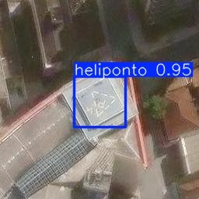
helipad — confidence 0.95. Sharp “H” pattern, box well fitted to the helipad's outline.

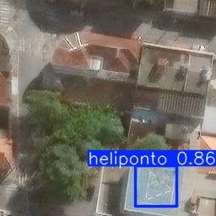
helipad — confidence 0.86. Clear marking identified even with vegetation and shadow near the rooftop.

Page 19 of 26

Helipad Detector — Complete Report

Challenging hit

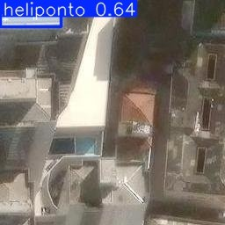

helipad — confidence 0.64. Moderate confidence; the helipad structure is visually less evident in this capture.

False positives

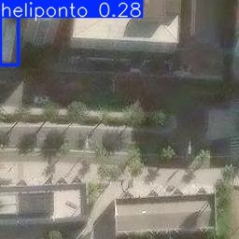

helipad — confidence 0.28. Ground/road marking confused with a helipad pattern — low confidence, consistent with a false positive.

Page 20 of 26

Helipad Detector — Complete Report
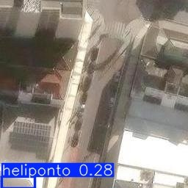

helipad — confidence 0.28. Another case of a road/pavement generating a false positive, again with low confidence.

Methodological note: no confirmed false-negative example is included in this version of the report — the available tiles with no detection have no ground-truth annotation confirming the real presence of an undetected helipad. Adding that requires cross-checking against the dataset's original label before publishing the claim, to avoid an incorrect statement.

Page 21 of 26

Helipad Detector — Complete Report

Interactive web application

The file apps/streamlit_app/app.py implements a complete Streamlit dashboard with nine tabs, going well beyond the briefing's optional requirement of a simple demo interface

Tab | Purpose
Experiment Metrics | Automatically discovers each trained experiment, comparing Precision/Recall/ mAP live
Field Detections by Region | Cards, bar chart, and table of the field validation across 10 neighborhoods
Map | Dark-mode Folium map with 3 switchable layers, including a blue-scale detection-rate layer
Search by Region | Live bounding-box search: downloads tiles and runs inference on demand
Sample Images | Pre-selected real detections for instant demonstration
Upload Image | Upload any aerial/satellite image for annotated detection
Pipeline | Visual step-by-step of the complete 12-step pipeline
Governance | Fairness, LGPD, and known-limitations statements
Downloads | Reports, dataset, metrics, and field-validation artifacts

In plain terms: this application is the project's “showcase” — it lets anyone, even without coding knowledge, upload a satellite photo, search a region on the map, or simply browse already-processed results, with no code to run.

Page 22 of 26

Helipad Detector — Complete Report

Strengths, limitations, and next steps

Strengths
    - End-to-end coverage of the computer vision project lifecycle — from raw data collection to a demonstrable application;
    - Explicit focus on data engineering, not just model tuning;
    - Geospatial automation that increases the scale and reproducibility of collection;
    - A field-validation stage on real data, beyond curated benchmarks — uncommon in an academic project of this size;
    - A complete interactive application layer, with nine functional tabs.

Observed limitations
    - Visual confusion with swimming pools and sports courts remains the main source of false positives;
    - Results depend on annotation consistency across team members;
    - Generalization ability is limited by the diversity of rooftop patterns seen during training;
    - Tile download failures (empty tiles) can generate spurious detections during field validation.

Suggested future improvements
    - Add more negative examples (pools, sports courts) to reduce false positives;
    - Add an automatic empty-tile filter before inference in the field-validation pipeline;
    - Extend field validation to other neighborhoods and to the fully unseen Baixada Santista region;
    - Systematically compare YOLOv8n vs. YOLOv11n on the same dataset splits;
    - Incorporate active-learning cycles, re-annotating the hardest examples identified during field validation.

Page 23 of 26

Helipad Detector — Complete Report

Ethics, LGPD, and governance

The project follows key responsible-AI practices, summarized here for both the technical reader and anyone assessing the project from a compliance standpoint:
- Exclusive use of public-area satellite imagery;
- No annotation of people, vehicle license plates, or other personal identifiers;
- Generative AI used only as a support tool, with its use documented in the report;
- Academic and research focus, with no intention of individual surveillance.

From an LGPD (Brazil's General Data Protection Law) perspective, the project minimizes identifiable personal data, clearly documents image sources and their required attribution (Esri, Maxar, Earthstar Geographics, and the GIS User Community), and restricts the use of results to academic and research purposes.

A security incident identified and fixed
During development, the team identified and fixed a real security issue: a Roboflow API key was hardcoded (written directly in plain text) in the training notebooks. The key was removed from the source code, replaced by reading it from an environment variable / Colab Secrets, and flagged for revocation.

In plain terms: a “password” granting access to Roboﬂow was visible to anyone who opened the notebook — including in a public GitHub repository. That's a real risk, because anyone who saw that key could use it to access the project's workspace. The team fixed the problem by moving the key out of the code — a concrete example of why good secrets-management practices matter even in academic projects, not only in commercial products.

As an AI-governance practice, the repository prioritizes: controlled data sources, clear and documented annotation criteria, experiment reproducibility via notebooks and fixed seeds, structured error evaluation (the qualitative analysis in Section 10), and explicit documentation of design decisions made throughout the pipeline — including the data-integrity error described in Section 7.1 itself, kept in the report transparently rather than omitted.

Page 24 of 26

Helipad Detector — Complete Report

Conclusion

The Helipad Detector reaches professional-grade metrics — mAP@50 of approximately 99% and mAP@50-95 of approximately 88% — on a dataset built entirely from scratch by the team. The field-validation stage confirms that these results hold up under real, uncurated satellite coverage across ten São Paulo neighborhoods too, with documented and explainable error patterns rather than opaque failures.

This validates both the model itself and the project's broader emphasis: data quality, annotation governance, reproducibility, and honest, evidence-based documentation — including when that evidence shows a mistake made and corrected by the team itself, as happened with the initial exp2/ exp3 attribution.

For readers arriving here with no technical AI background, the central message of this report can be summarized like this: building a good Artificial Intelligence system is, most of the time, not an algorithm problem — it's a problem of data that is well collected, well annotated, well tested, and well documented. This project is, above all, a practical and transparent example of that principle.

Page 25 of 26

Helipad Detector — Complete Report

Glossary of technical terms

Quick reference for the technical terms used throughout this report, for consultation at any time.

Term | Plain-language meaning
Bounding box | A rectangular box drawn around an object in an image, indicating where it is.
Dataset | The set of data (here, images + annotations) used to train and test the model.
Epoch | One complete pass of the model through all the training images.
False Negative (FN) | When a real helipad exists in the image, but the model fails to detect it.
False Positive (FP) | When the model detects a helipad where none actually exists.
Generalization | The model's ability to perform well on new images it has never seen during training.
IoU (Intersection over Union) | A measure of how much the model's predicted box overlaps with the object's real box.
mAP (mean Average Precision) | A single score summarizing overall detection quality across several overlap thresholds.
Overfitting | When the model “memorizes” the training examples instead of learning the general pattern, performing poorly on new data.
Precision | Of all the detections made, how many were correct.
Recall | Of all the real objects that exist, how many the model managed to find.
Tile | A standardized square piece of a map/satellite image, used to assemble larger mosaics.
YOLO | “You Only Look Once” — a family of AI models for real-time object detection.

Helipod Detector · PUC-SP · Machine Learning / Computer Vision

Page 26 of 26

