HELIPAD DETECTOR
Rooftop Helipad Detection with Computer Vision, Satellite Imagery and YOLO
Data Analysis Report and Executive Summary
PUC-SP · Machine Learning and Computer Vision · 2026

1. Executive Summary
The Helipad Detector project is a computer vision solution for detecting rooftop helipads in the city of Sao Paulo from high-resolution satellite imagery, covering data collection and preparation, training, evaluation, and model analysis.
The project's value lies both in the trained model and in building a structured pipeline capable of turning raw geographic coordinates into an annotated, reusable dataset -- demonstrating command of data engineering, image curation, annotation, and performance evaluation.
The exp1 model (60 epochs) delivered strong results relative to the training set size. A second, controlled experiment (100 epochs, same dataset) is in progress to validate whether training longer improves results -- see Section 16.

2. Introduction
Automatic object detection in satellite imagery is a relevant application in complex urban settings. This project focuses on identifying helipads on building rooftops -- structures with operational and urban relevance whose manual detection at scale is slow and hard to maintain.
The task presents considerable visual difficulty: helipads vary in shape, color, wear, contrast, shadow, and occlusion, and patterns on pools, courts, or terraces can be confused with the helipad's characteristic marking.

3. Problem Definition
The central challenge is automatically detecting rooftop helipads from satellite imagery, dealing with urban density, architectural diversity, and similar visual patterns -- plus variations in scale, orientation, lighting, and visual noise that increase false positives and negatives.

4. Objectives
- Build an original helipad dataset for Sao Paulo.
- Collect and organize geographic coordinates of targets.
- Obtain high-resolution satellite imagery.
- Manually annotate the objects.
- Train and evaluate an object detection model (YOLO).
- Verify generalization capability on areas not seen during training.
Demonstrate that careful data curation is decisive for AI system success -- the work functions simultaneously as a technical experiment, academic case study, and AI engineering portfolio piece.

5. Context and Background
The project relies on FlightMarket, Selenium, ESRI World Imagery, Roboflow, Jupyter, Google Colab, Ultralytics YOLO, and PyTorch, structured for reproducibility and a clear separation between discovery, preparation, annotation, training, and analysis.

6. Solution Architecture
The architecture is organized into sequential, complementary modules: geospatial discovery, image collection, data processing, annotation, training, evaluation, and results presentation -- facilitating future evolution (including web applications and MLOps flows).

7. Data Pipeline
Helipad coordinates are collected from external sources, converted into geographic bounding boxes, used to download satellite tiles (ESRI World Imagery), organized by neighborhood, manually curated, annotated, resized, augmented, and split into train/validation/test.
Automation: src/geospatial/helipad_bot.py (discovery) -> transform_coordinates.py (conversion) -> geospatial_image_collection.ipynb (tiles/mosaics).

8. AI Components
The AI core is a single-class object detector (helipad), based on the YOLO family -- a balance of speed and performance, requiring both classification and localization via bounding boxes.
Evaluated with classic detection metrics: precision, recall, mAP@50, and mAP@50-95.

9. Dashboard and Analytics Layer
Unlike earlier versions of this report, this layer is now a real, functional Streamlit app (apps/streamlit_app/app.py), not just static notebooks. It includes:
- Image upload with real-time detection (YOLO).
- Region search via satellite tiles.
- Sample image gallery for quick testing of the detector.
- Interactive map (Folium) with two real, clearly labeled layers: Sao Paulo neighborhoods used in training, and the auxiliary discovery dataset from other states.
- Density visualization (Kepler.gl) of the discovery dataset.
- Metrics panel automatically comparing experiments, reading the real results.csv files.
- Downloads tab for reports and the raw dataset.

10. Security and Governance
During development, the project identified and fixed a real security issue: a Roboflow API key was hardcoded in plain text in the training notebooks. The key was removed from the code (replaced with an environment variable / Colab Secrets read) and flagged for revocation -- a concrete example of why good secrets-management practices matter even in academic projects.
From a responsible-AI standpoint, the project defines annotation criteria, data curation, train/validation/test separation, and evaluation on unseen regions, reducing hidden biases. The qualitative analysis (Section 12) complements the numeric metrics, preventing evaluation from being limited to aggregate numbers.
Use is restricted to public-area imagery, with no annotation of people, license plates, or other personal identifiers, in line with Brazil's LGPD (data protection law).

11. Scalability and Performance
Automating geospatial discovery and data preparation reduces manual work and eases expansion to new neighborhoods. A broader production scenario would require orchestration, monitoring, model versioning, and formal experiment management -- today the project has a solid foundation, but is still academic in operational maturity.

12. Key Metrics
Real results from experiment 1 (YOLOv8n, 60 epochs, original Sao Paulo dataset -- 116 training images):
Metric | Best Epoch (54) | Final Epoch (60)
Precision | 1.000 | 0.992
Recall | 0.963 | 0.971
mAP@50 | 0.994 | 0.994
mAP@50-95 | 0.881 | 0.841

Experiment 2 (same dataset, 100 epochs -- the controlled ablation required by the briefing) is in progress. This report does not present exp2 numbers until the real results.csv is available, to avoid publishing incorrect or fabricated data.

13. Generated Charts (exp1)

Figure 1 - Loss Evolution by Epoch
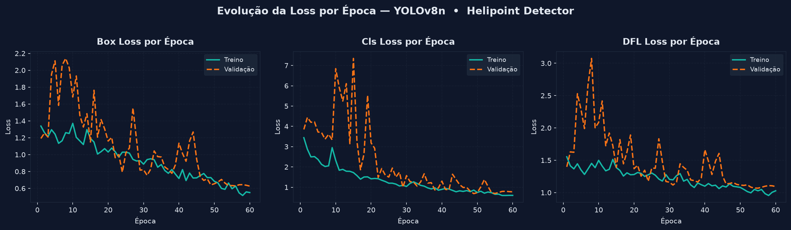
Box, Cls, and DFL loss decrease consistently for both training and validation, with no clear overfitting sign across the 60 epochs; val/cls_loss oscillates in the first 20 epochs and stabilizes from epoch 30 onward.

Figure 2 - Precision and Recall Over Training
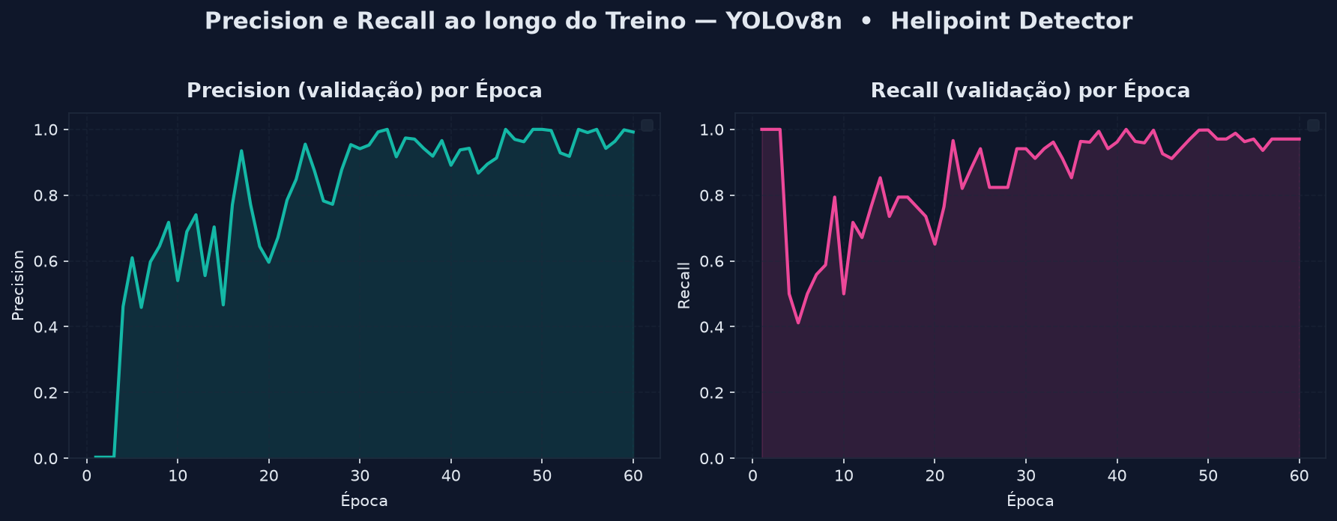
Precision stabilizes above 0.95 from epoch 30 onward; Recall reaches 0.97+ in the final epochs, after a sharp dip around epoch 5.

Figure 3 - mAP@50 and mAP@50-95
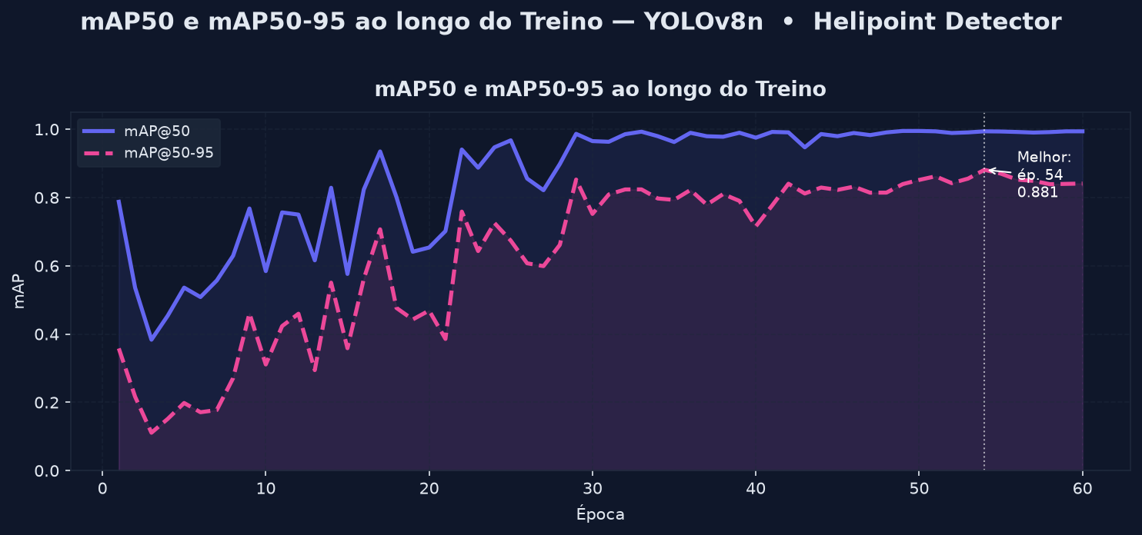
mAP@50 = 0.994 and mAP@50-95 = 0.881 at the best epoch (54) -- a peak after which metrics fluctuate slightly.

13.1 Generated Charts (exp2 — official ablation, 100 epochs)
Confirmed real numbers: best epoch 81 (Precision 0.982, Recall 0.971, mAP@50 0.993, mAP@50-95 0.888), final epoch 100 (Precision 0.971, Recall 0.998, mAP@50 0.991, mAP@50-95 0.841).
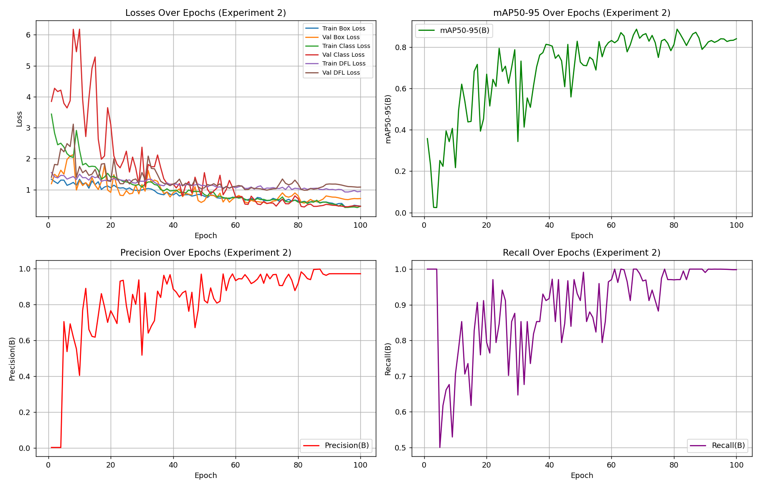
Losses, mAP@50-95, Precision, and Recall across 100 epochs -- exp2 (same dataset as exp1, only training duration differs).
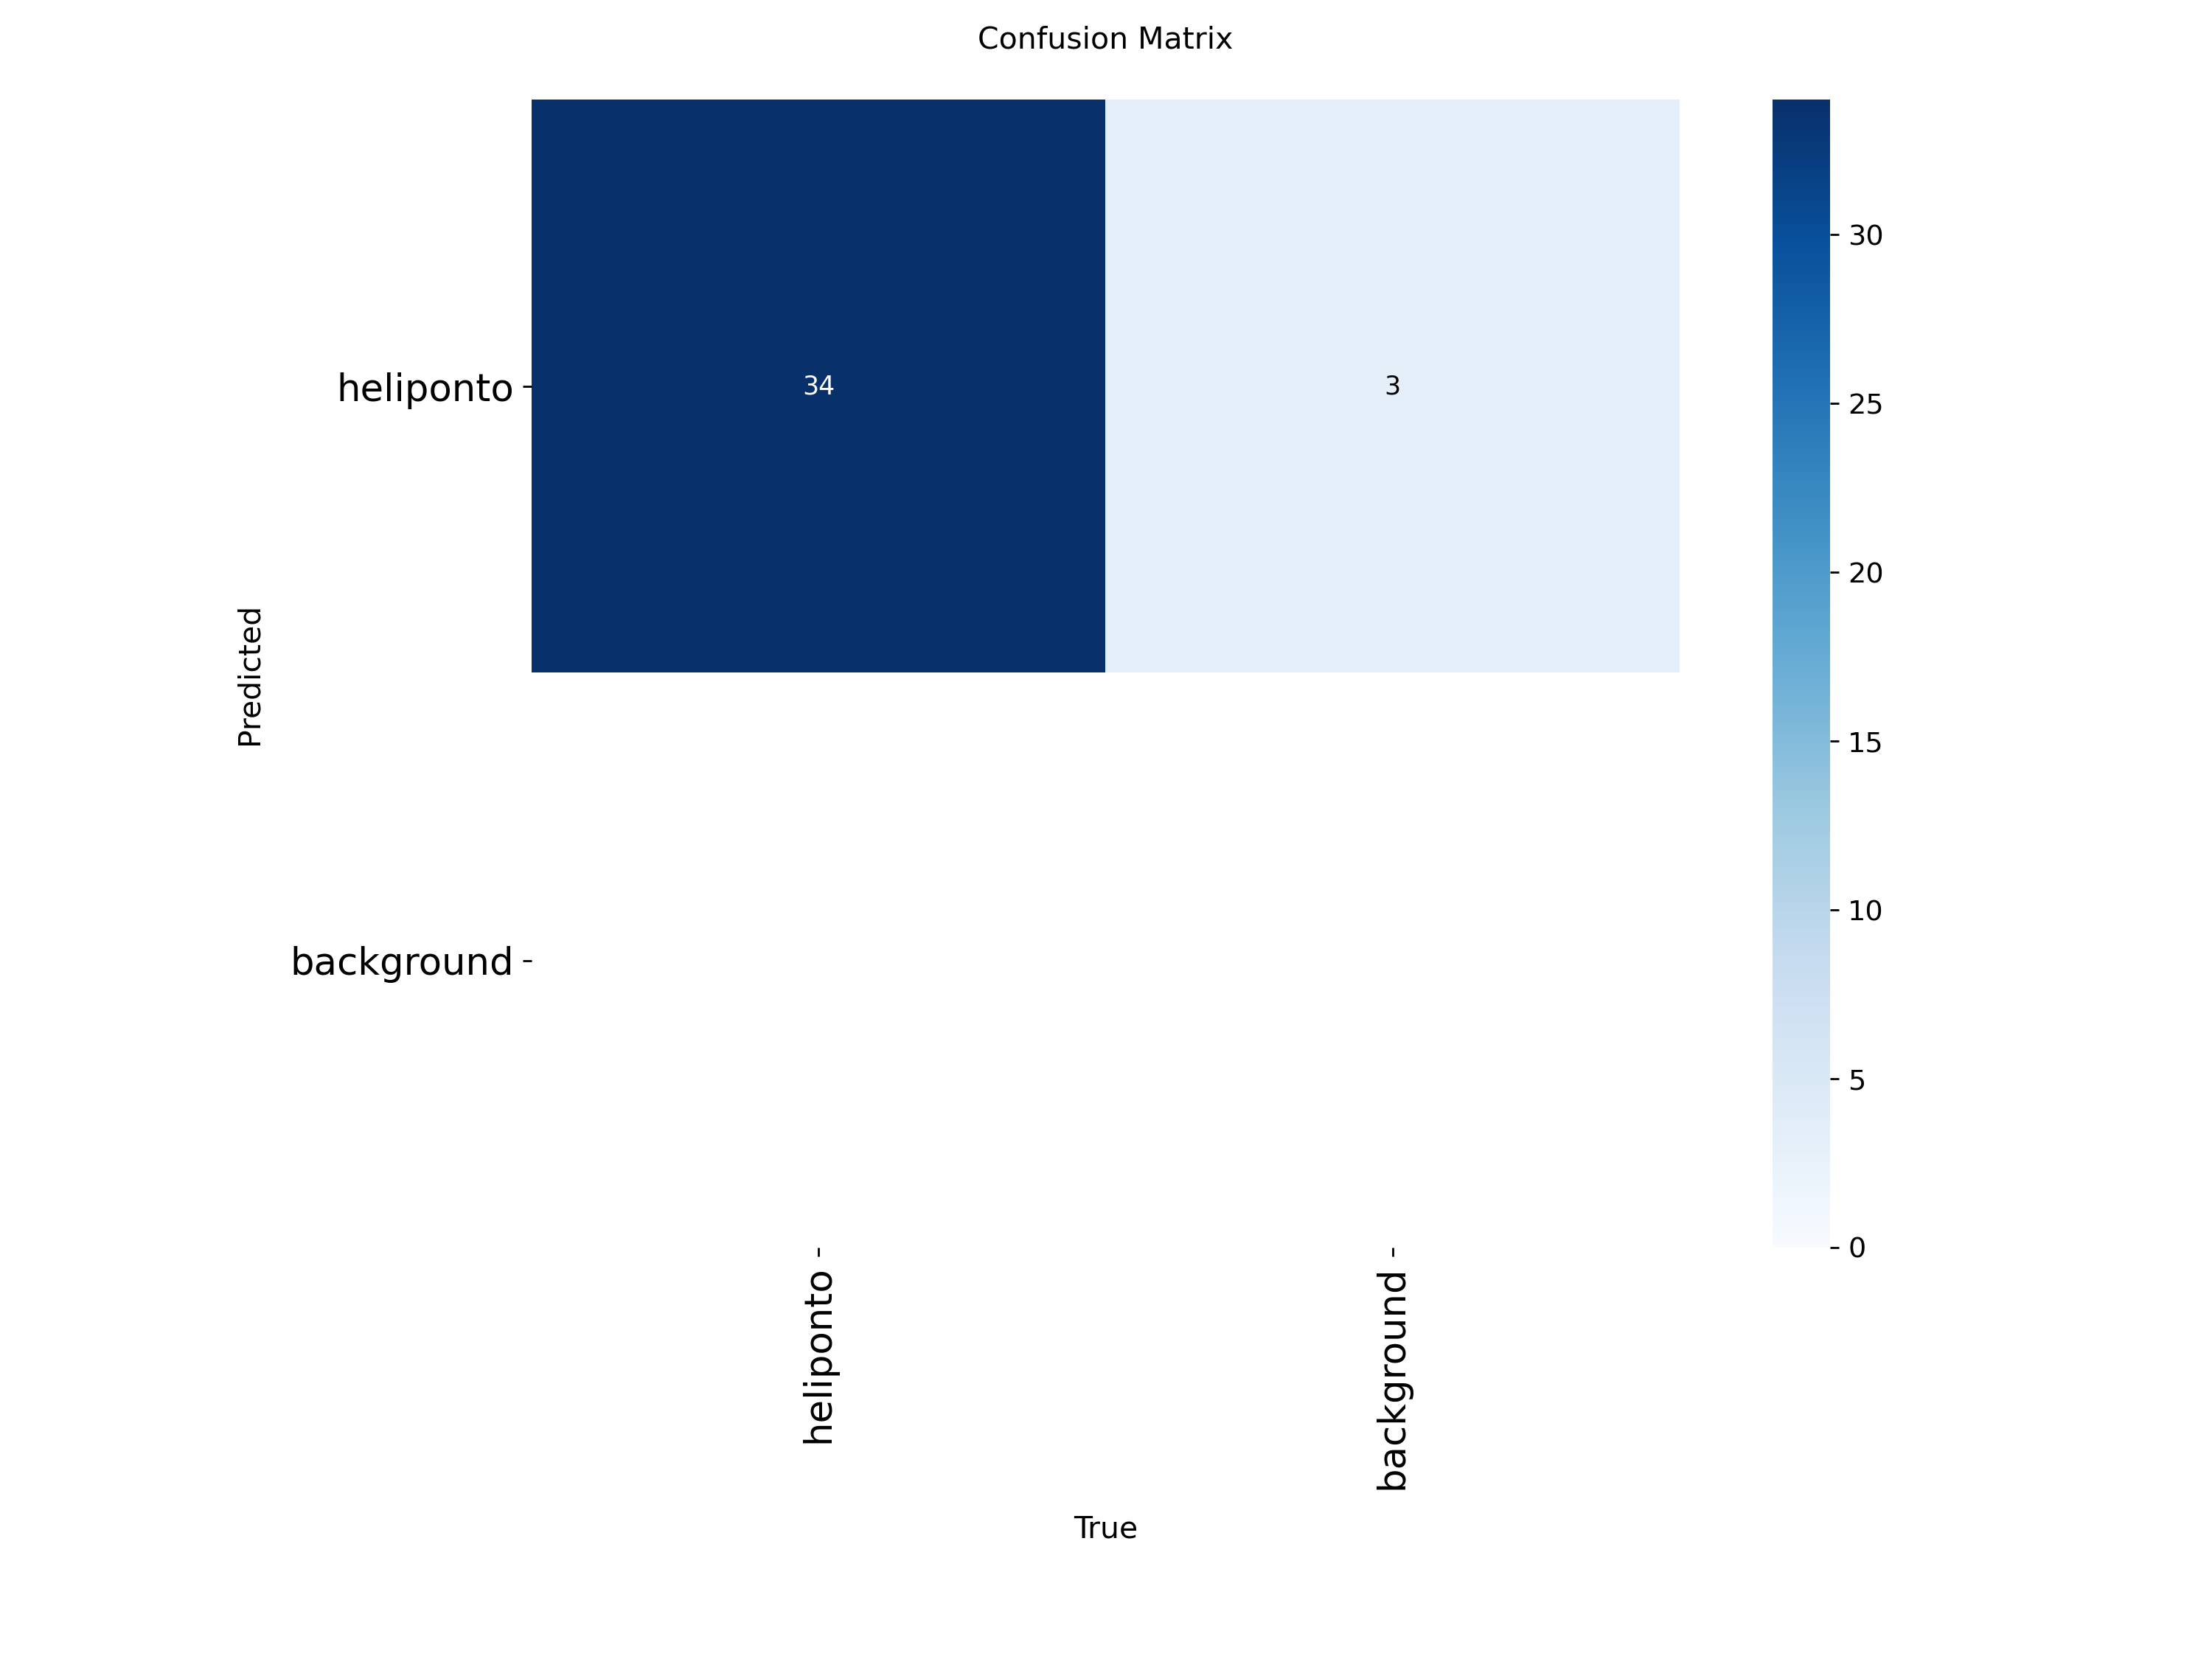
Confusion matrix (validation): 34 hits, 3 background false positives confused with helipad.
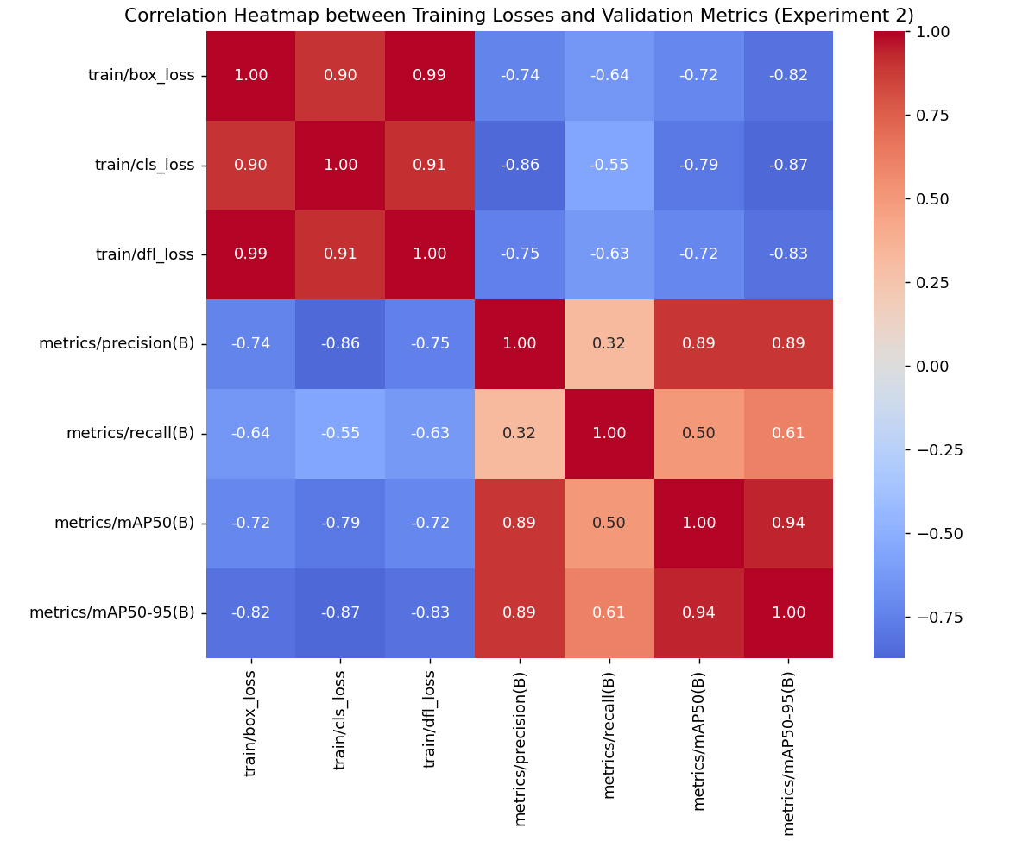
Correlation between training losses and validation metrics.

13.2 Generated Charts (exp3 — fork dataset, reference point)
exp3 uses a different dataset (fork with extra augmentation), so it serves as a reference point, not a direct ablation comparison -- that is exp1 vs exp2 above. Confirmed real numbers: best epoch 78 (Precision 0.943, Recall 1.000, mAP@50 0.993, mAP@50-95 0.885), final epoch 100 (Precision 0.968, Recall 0.971, mAP@50 0.952, mAP@50-95 0.842).
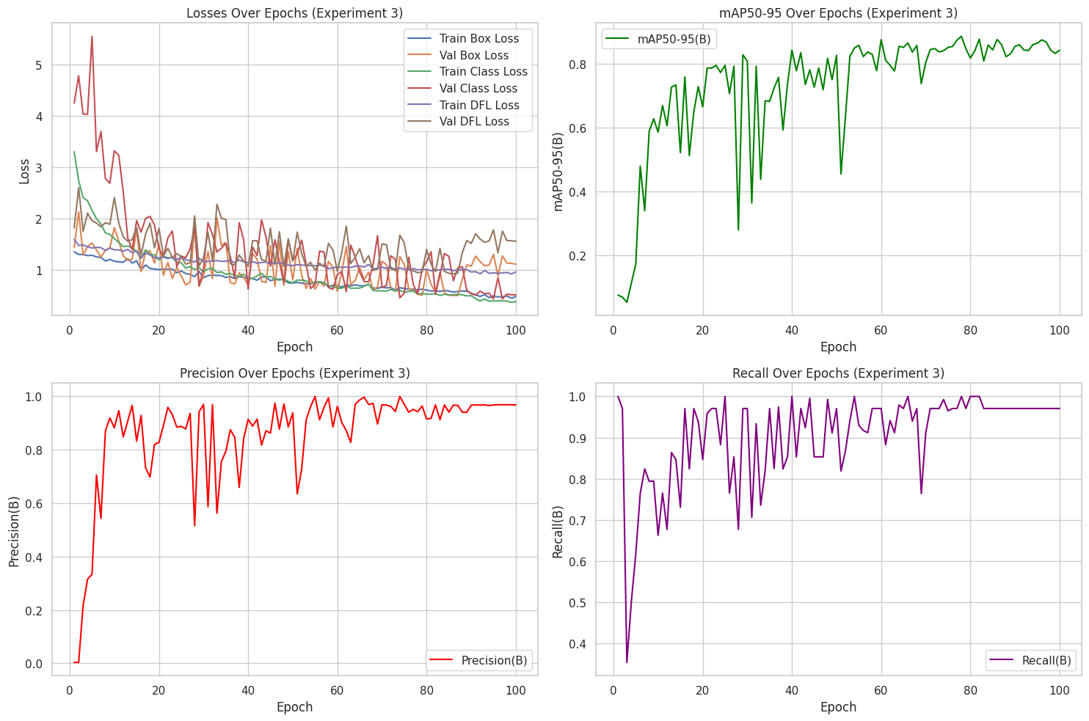
Overview: losses, mAP@50-95, Precision, and Recall across 100 epochs -- the same mild dip pattern between best and final epoch seen in exp1.
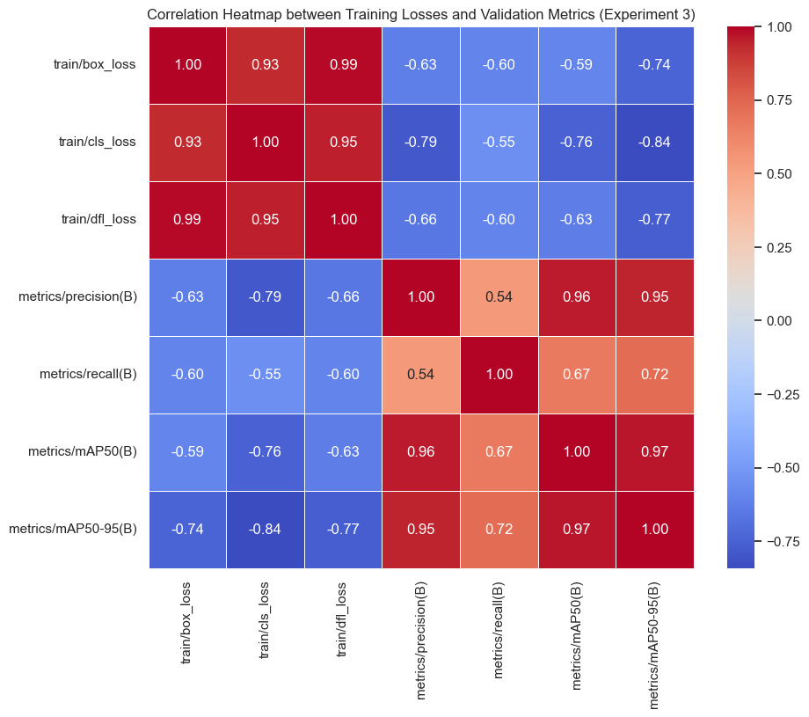
Correlation between training losses and validation metrics: cls_loss is the most strongly (anti-)correlated with mAP@50-95 (-0.84).

14. Qualitative Analysis
Real model predictions (exp1), taken from reports/model_outputs/detect/predict/:

Clear hits (high confidence)
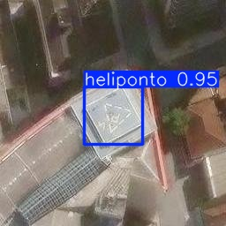
helipad -- 0.95
Sharp "H" pattern, bounding box tightly fitted to the helipad outline.
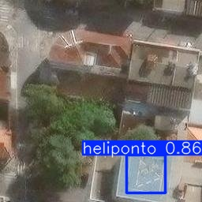
helipad -- 0.86
Clear marking identified even with vegetation and shadow near the rooftop.

Challenging hit
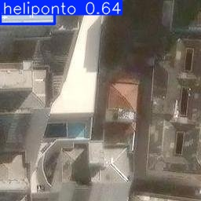
helipad -- 0.64
Moderate confidence; the helipad structure is visually less obvious in this capture.

False positives
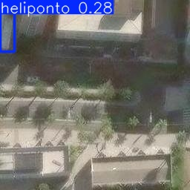
helipad -- 0.28
Ground/road marking mistaken for a helipad pattern -- low confidence, consistent with a false positive.
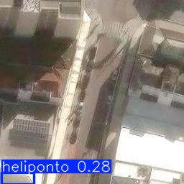
helipad -- 0.28
Another road/pavement case producing a false positive, again at low confidence.
Note: no confirmed false-negative example is included in this version -- the available no-detection tiles have no ground-truth annotation confirming an actual missed helipad. Adding one requires cross-checking against the original dataset label before publishing the claim.

15. Limitations
- Dataset size and geographic scope are still limited relative to the real diversity of urban helipads.
- Academic architectural maturity -- lacking continuous monitoring, formal versioning, and advanced operational governance.
- Inherent visual ambiguity: certain urban structures keep producing errors even in well-trained models.

16. Future Improvements -- already in progress
- Controlled experiment 2 (100 epochs) running to complete the comparison required by the briefing.
- Geographic split of the discovery dataset (SP vs. other states) via reverse geocoding (script ready, local run pending).
- Expanding Sao Paulo coverage with the Faria Lima region, whose bounding box was added but has not yet gone through image collection/curation.
- Systematic comparison between YOLOv8n and YOLOv11n (a YOLOv11n model already trained via hosted Roboflow exists as an additional reference).

17. Results and Key Outcomes
The project built a functional end-to-end solution: data collection, dataset, annotation, training, evaluation, and a real interactive dashboard -- not just isolated notebooks. It demonstrated very strong performance (exp1) even with a relatively small base, conditioned on curation quality.

18. Data Analysis and Insights
Data quality has a decisive influence on performance -- success does not stem only from choosing YOLO, but from the careful construction of the training set. Generalization to unseen areas remains the central evaluation criterion, and model errors concentrate in visually ambiguous situations.

19. Decision Support and Recommendations
- Prioritize evolving the data pipeline (curation, visual diversity, quality control) over architecture changes.
- Keep combining quantitative metrics with qualitative analysis.
- Preserve evaluation on unseen neighborhoods as a permanent practice.
- Formalize secrets management (API keys) from the start of any new experiment, given the real incident identified in Section 10.

20. Conclusion
Helipad Detector successfully demonstrates building a complete AI solution for helipad detection, showing command of data collection, geospatial engineering, curation, annotation, training, evaluation, and -- now -- a real, functional presentation layer (Streamlit dashboard with a two-layer geospatial map).

21. Next Steps
- Complete and document the real experiment 2 (same dataset, 100 epochs) to close the briefing's official comparison.
- Run the geographic state split of the discovery dataset.
- Collect and curate images for the Faria Lima region.
- Evolve the dashboard with active-learning cycles and re-annotation of hard cases.

