Time-Series Forecasting & Model Interpretability
A SARIMA Forecasting Model with a SHAP-Based Feature Importance Dashboard
Case Study: Monthly International Airline Passenger Volumes (1949-1960)
Prepared for: Progree Data Science Internship - Task 4
Deliverable: Mini Project Whitepaper
Date: August 2026

1. Executive Summary
This whitepaper documents an end-to-end time-series forecasting pipeline built to predict monthly airline passenger volumes and to explain, using an interpretable machine learning layer, which underlying factors drive those predictions. The workflow follows four stages: (1) stationarity diagnostics and seasonal differencing, (2) SARIMA model training and forward forecasting with confidence intervals, (3) a supplementary feature-based Random Forest model built specifically to enable SHAP-based interpretability, and (4) synthesis of business-relevant findings.
The dataset used is the well-known Airline Passengers dataset (144 monthly observations, January 1949 to December 1960), sourced from a public GitHub mirror of the classic Box & Jenkins airline series. This dataset was selected because it exhibits a textbook combination of long-term trend and strong yearly seasonality, making it well suited to demonstrate every required technique in this task.
Key results: the raw series was confirmed non-stationary (ADF p-value = 0.9919). After applying both first-order and seasonal (lag-12) differencing, stationarity was achieved (p-value ≈ 0.0000). A SARIMA(1,1,1)(1,1,1,12) model achieved a test-set Mean Absolute Error (MAE) of 69.90 passengers (in thousands) and RMSE of 75.63 over a 24-month held-out period. A supplementary Random Forest interpretability model achieved MAE of 31.27 passengers, and SHAP analysis identified the passenger count from 12 months prior ("lag_12") as, by far, the single most influential feature in predicting the next month's passenger volume — confirming that seasonality is the dominant structural signal in this data.

2. Dataset Description

2.1 Source and Structure
Dataset: Monthly Airline Passenger Totals, 1949-1960 (144 rows, no missing values).
- Column 'Month': the calendar month, formatted as YYYY-MM
- Column 'Passengers': total monthly international airline passengers, in thousands
Source: https://raw.githubusercontent.com/jbrownlee/Datasets/master/airline-passengers.csv

2.2 Why This Dataset
- Contains a clear, visually obvious upward trend (air travel demand grew steadily through the 1950s)
- Contains a clear, repeating yearly seasonal cycle (summer peaks, winter dips)
- Small and clean (no missing values, no outlier correction needed), keeping the focus on forecasting methodology rather than data cleaning
- Widely used as the reference dataset for SARIMA modelling in academic and applied statistics contexts

3. Stationarity Analysis
Most classical forecasting models, including SARIMA, assume the input series is stationary — meaning its statistical properties (mean, variance) do not change systematically over time. A series with a trend or seasonal pattern violates this assumption and must be transformed before modelling.

3.1 Visual Inspection
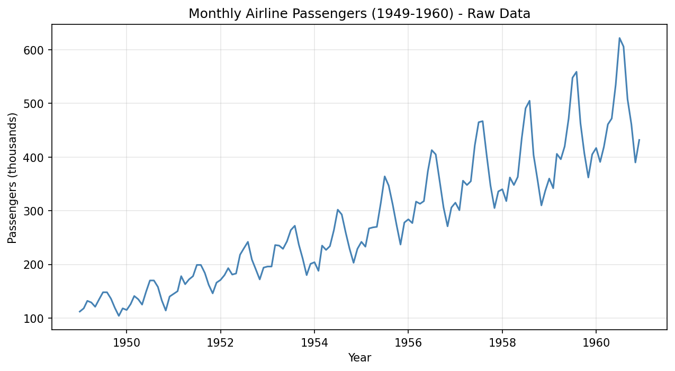
Figure 1: Raw monthly passenger series, showing a clear upward trend and repeating yearly seasonal pattern.
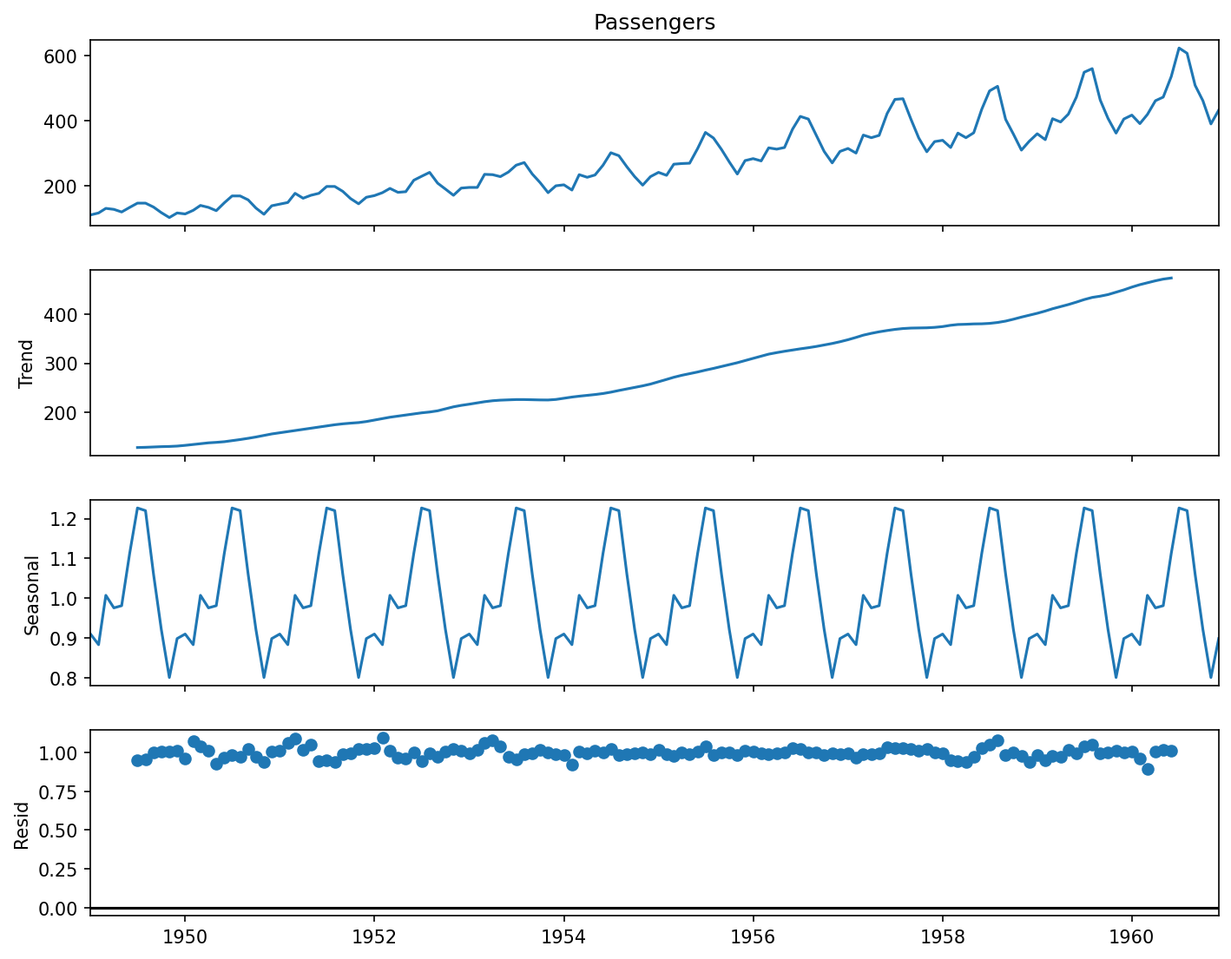
Figure 2: Seasonal decomposition into trend, seasonal, and residual components (multiplicative model).

3.2 Augmented Dickey-Fuller (ADF) Test
The ADF test formally evaluates stationarity. Its null hypothesis (H0) states that the series is non-stationary; a p-value below 0.05 allows us to reject H0 and conclude the series is stationary.
Series Version | ADF p-value | Conclusion
Raw series | 0.9919 | Non-stationary
After 1st-order differencing | 0.0542 | Non-stationary (borderline)
After seasonal differencing (lag=12) | 0.0116 | Stationary
After both differencing steps | 0.0000 | Stationary (strongly confirmed)

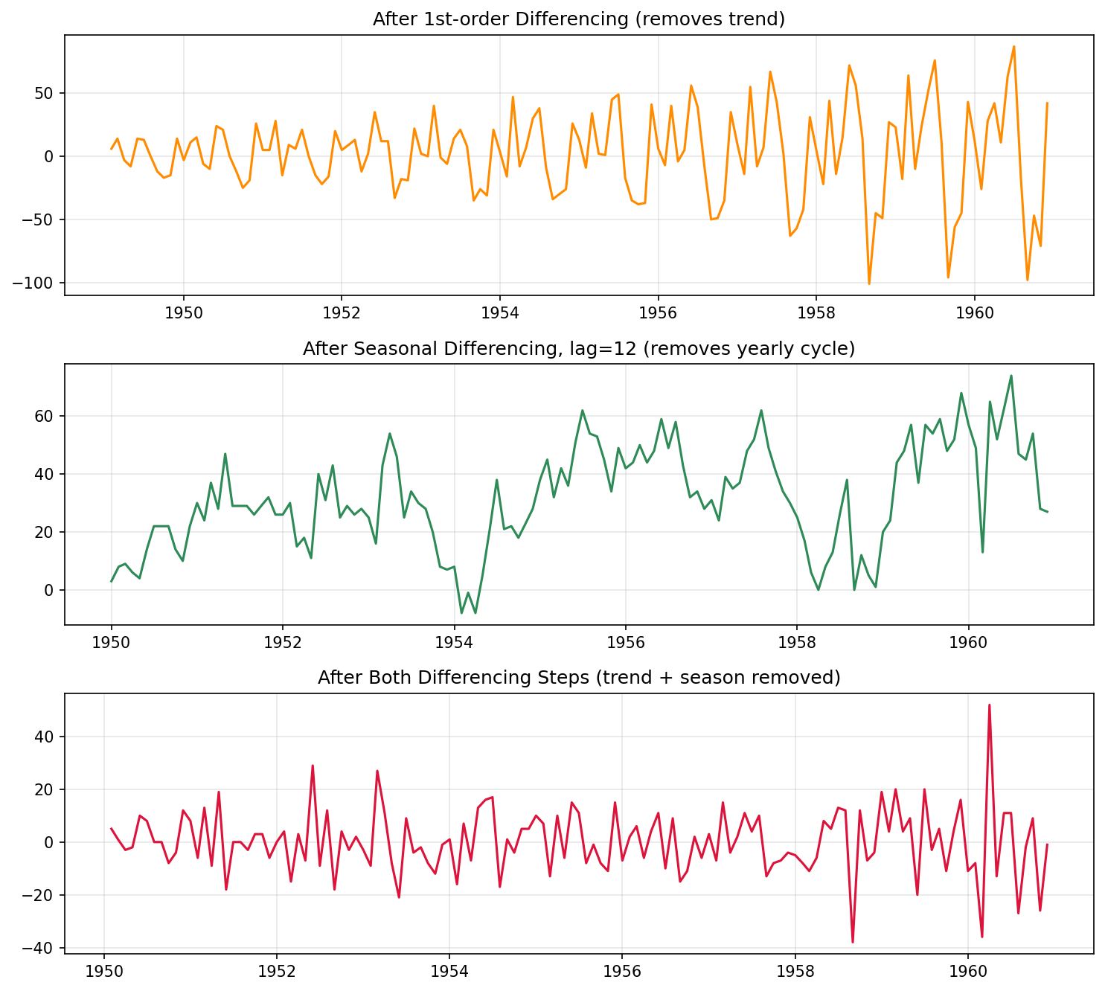
Figure 3: Comparison of the series after 1st-order differencing, seasonal differencing, and both combined.
Conclusion: both a non-seasonal differencing term (d=1) and a seasonal differencing term (D=1, at lag 12) are required to achieve stationarity. This directly informs the SARIMA parameter selection in Section 4.

4. SARIMA Forecasting Model

4.1 Model Specification
A Seasonal ARIMA model, SARIMA(p,d,q)(P,D,Q,s), was fit using the following parameters, chosen based on the stationarity findings above:
- Non-seasonal order (p,d,q) = (1,1,1)
- Seasonal order (P,D,Q,s) = (1,1,1,12), where s=12 reflects the yearly seasonal cycle in monthly data
The dataset was split into a training set (the first 120 months) and a held-out test set (the final 24 months), allowing model accuracy to be evaluated against real, unseen data before producing a genuine future forecast.

4.2 Forecast Accuracy on Held-Out Test Data
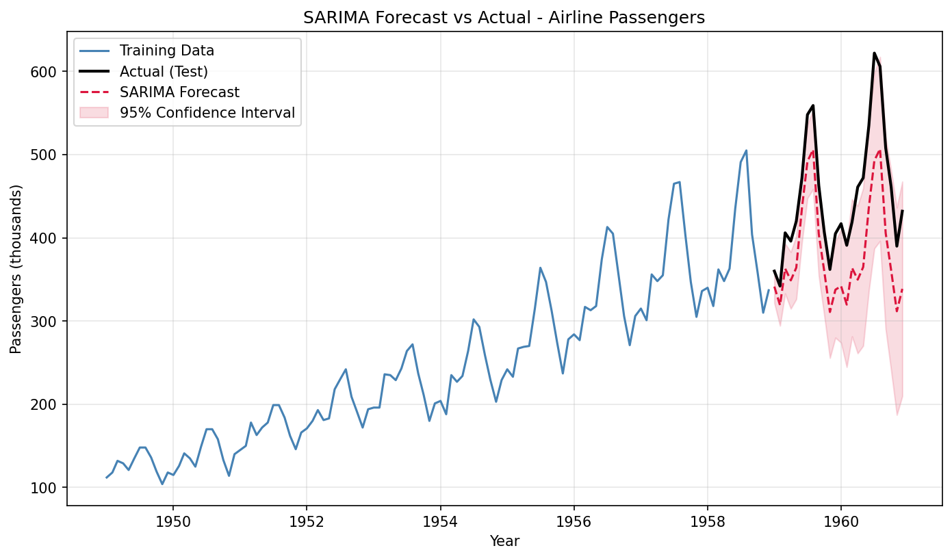
Figure 4: SARIMA forecast vs. actual values over the 24-month test period, with 95% confidence interval.
Metric | Value
Mean Absolute Error (MAE) | 69.90 passengers (thousands)
Root Mean Squared Error (RMSE) | 75.63 passengers (thousands)
AIC | 707.72
BIC | 720.38

The forecast closely tracks the seasonal shape of the actual data (correctly anticipating each yearly peak and trough), though it slightly underestimates the magnitude of the tallest summer peaks in the later years — consistent with a slightly conservative trend extrapolation. RMSE is only marginally larger than MAE, indicating no single extreme forecasting failure; errors were fairly evenly distributed across the test period.

4.3 True Future Forecast (Beyond Available Data)
After validating accuracy, the model was refit on the entire dataset and used to forecast 24 months beyond the observed data range (projecting into 1961-1962).
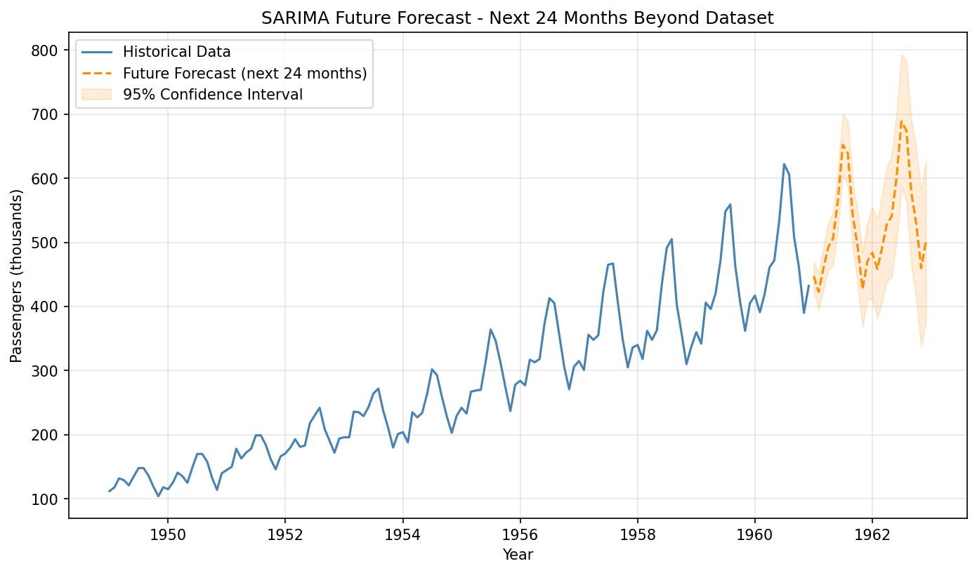
Figure 5: SARIMA forecast extending 24 months beyond the available historical data, with widening 95% confidence intervals.
Note that the confidence interval widens progressively further into the future — a expected and important property of any forecasting model, reflecting growing uncertainty the further ahead a prediction is made.

5. Model Interpretability (SHAP Analysis)
SARIMA generates forecasts purely from a series' own past values, so it has no distinct "features" for an interpretability method to analyze. To satisfy the requirement for feature-level interpretability, a supplementary Random Forest regression model was trained using explicitly engineered features:
- month_num — the calendar month (1-12), capturing seasonal position
- year — the calendar year, capturing the long-term trend
- lag_1 — the passenger count from the previous month
- lag_12 — the passenger count from the same month one year earlier
- rolling_mean_3 — the average passenger count over the preceding 3 months
This model achieved a test MAE of 31.27 passengers — notably lower than SARIMA's, though the two models are not directly comparable, as SARIMA is optimized for genuine forward forecasting while this Random Forest model has access to lag features computed from actual historical values at each point.

5.1 Global Feature Importance
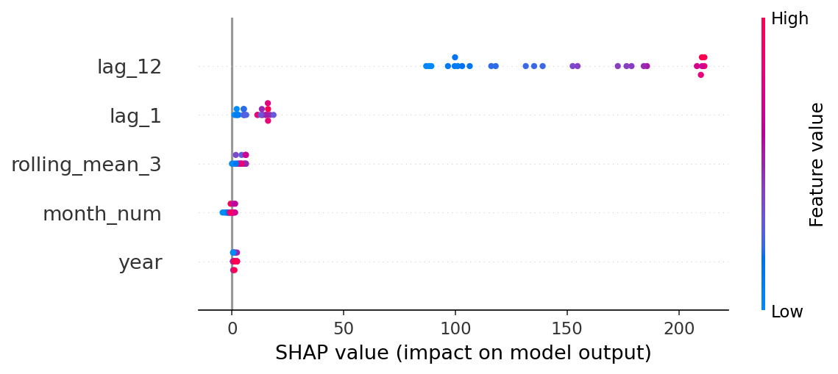
Figure 6: SHAP summary plot. Each dot is one test prediction; position shows the feature's impact on that prediction, and color shows whether the feature's value was high (pink) or low (blue).
Feature | Mean |SHAP Value|
lag_12 | 147.33
lag_1 | 9.55
rolling_mean_3 | 3.77
month_num | 1.26
year | 1.14

5.2 Interpretation
The value from 12 months earlier (lag_12) overwhelmingly dominates the model's predictions, with a mean absolute SHAP contribution roughly 15 times larger than the next most important feature. This is strong, quantitative confirmation of what the stationarity analysis in Section 3 already suggested visually: the seasonal (yearly) pattern is the single strongest structural driver of this series, far outweighing short-term month-to-month momentum (lag_1), recent local averages (rolling_mean_3), or the specific calendar month/year in isolation.
Business implication: for demand planning purposes (e.g., staffing, capacity, or inventory decisions tied to passenger volume), the single most reliable signal is what happened in the same month one year prior — not last month's value, and not the long-term growth trend alone.

6. Conclusions & Recommendations
- The airline passenger series required both trend and seasonal differencing to achieve stationarity, confirming a classic trend + seasonality structure.
- A SARIMA(1,1,1)(1,1,1,12) model produced seasonally accurate forecasts with a test MAE of approximately 70 passengers (thousands), with forecast uncertainty widening appropriately over longer horizons.
- SHAP analysis on a complementary feature-based model confirmed that year-over-year seasonality (lag_12) is the dominant predictive signal, far more influential than recent trend or short-term momentum.
- For future work: incorporating exogenous variables (e.g., fuel prices, macroeconomic indicators) via SARIMAX, or comparing against Prophet, could further improve forecast accuracy and interpretability.

7. Appendix
Supplementary outputs generated alongside this report:
- forecast_vs_actual.csv — actual vs. predicted values and confidence bounds for the test period
- future_forecast.csv — 24-month forward forecast beyond the dataset
- shap_feature_importance.csv — ranked SHAP feature importance values
- shap_single_prediction_waterfall.png — worked example explaining one individual prediction in detail

