iPipeline Velocity Platform

Frequently Asked Questions
&
Troubleshooting Guide

16 September 2013

Table of Contents
General FAQ 3
Why do I get a warning regarding a Pop-up blocked? 3
This website wants to run the following add-on: MSXML 5.0 from Microsoft Corporation. 3
How do I configure Adobe Reader to display the PDF in the browser? 3
Connected Specific FAQ 4
Which Database Solutions Are Supported? 4
Which Operating Systems Are Supported? 4
Are Web Farms / Load Balanced Servers Supported? 4
Is a Multi-Tier Environment Supported? 4
Is HTTPS Supported? 4
Is Single Sign-On (SSO) Supported? 4
Windows Server 2008 (IIS 7) Parser Error Message: is not a valid Win32 application 4
Disconnected Specific FAQ 5
What Are the ‘SQL Server’ Programs In My Start Menu? 5
How Do I Uninstall the Disconnected Software? 5
Which Operating Systems Are Supported? 5
Are Multiple-Instance Installations Supported? 5
How Do I Run Internet Update Manually? 5
Disconnected Troubleshooting 6
SQL Server Setup Error Message Encountered During Installation 6
ERROR: (CreateDatabase) Login failed for user ‘sa’ 6
An Error is Encountered During the Internet Update Process 6
An Error is Encountered Within the Disconnected Application 7
You get a pop-up that “You must be connected to the internet in order to synchronize” 7
Application doesn’t start - receiving message pop-up window 7
A “setupThePage” Error is Encountered in pop-up window 10
Blank Window during View Form or Running an Illustration 10
How to determine if your computer is running a 32-bit or 64-bit version of Windows 12
How to determine if you have Administrative rights on your computer 13
How to determine your version of Internet Explorer 15

General FAQ

Why do I get a warning regarding a Pop-up blocked?
Since the iPipeline Velocity Platform utilizes pop-up windows, any pop-up blockers should be configured to allow pop-ups from the iPipeline application.

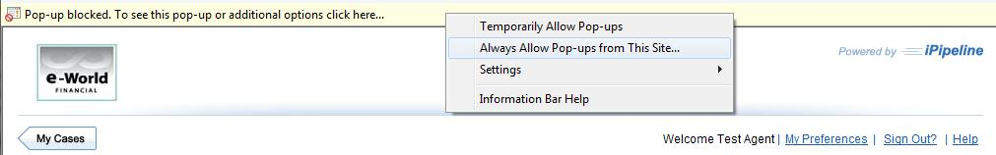

Right click on the yellow bar. Select Always allow Pop-ups from This Site…

Select ‘Yes’ to the confirmation window. The screen will redraw and the yellow bar is removed from your browser window. This will only need to be configured once initially.

This website wants to run the following add-on: MSXML 5.0 from Microsoft Corporation.
You may receive a warning stating: “This website wants to run the following add-on: MSXML 5.0 from Microsoft Corporation. If you trust the website and the add-on and want to allow it to run, click here…”

This warning is generated by the tighter security in recent versions of Internet Explorer. You should right click on the yellow warning and allow the add-on to be installed.

How do I configure Adobe Reader to display the PDF in the browser?
- Launch Adobe Reader
- Select Edit → Preferences
- Select Internet from the listing on the left.
- Review the checkbox at the top of this screen titled “Display PDF in browser”.
- If unchecked, check the box and select OK. If prompted to reboot, proceed.
- If this box was already checked, uncheck the box and select OK. Do not reboot at this time.
- Return to Edit → Preferences → Internet to re-check the box and select OK.
- If prompted to reboot, proceed.

Connected Specific FAQ

Which Database Solutions Are Supported?
Microsoft SQL Server 2005 and 2008 are the only currently supported database solutions.

Which Operating Systems Are Supported?
The iPipeline Velocity Platform will run on both Windows Server 2003 and Windows Server 2008.

Are Web Farms / Load Balanced Servers Supported?
Yes, the application can be run in a load-balanced server configuration. The application files can also reside on a common file share.

Is a Multi-Tier Environment Supported?
The application can be installed as 1-tier, 2-tier or 3-tier. The database and application web services can be on separate servers.

Is HTTPS Supported?
Yes, with a valid SSL Certificate installed, you can configure our software to use the https protocol.

Is Single Sign-On (SSO) Supported?
Yes, our application can be accessed via a pre-authenticated portal using various methods including SAML.

Windows Server 2008 (IIS 7) Parser Error Message: is not a valid Win32 application
This is due to a 64-bit OS and can be fixed with the following steps

- Inside IIS (7) click on Application Pools.

- Find the Application Pool that is configured for your web application in the list.

- Select it, and then click Advanced Settings on the right.

- Second setting in the list: Enable 32-Bit Applications - must be set to True.

Disconnected Specific FAQ

What Are the ‘SQL Server’ Programs In My Start Menu?
After installing the iPipeline Disconnected system, you may see the ‘SQL Server Surface Area Configuration’ and ‘SQL Server Error and Usage Reporting’ programs in your Start Menu. These are part of the SQL Server Express install which is used by the iPipeline Disconnected system. There is no need to run these programs and they can be hidden by right-clicking on the item in the Start menu and selecting the ‘Remove from this list’ option.

How Do I Uninstall the Disconnected Software?
The Disconnected software can be removed by selecting the Uninstall option from Add/Remove programs console.

Which Operating Systems Are Supported?
The Disconnected software supports installs on Windows XP, Windows Vista, Windows 7 and Windows 8. Please refer to the separate document outlining the Disconnected System Requirements for specific versions that are supported.

Are Multiple-Instance Installations Supported?
iPipeline only supports multiple instances of our Disconnected solution installed on the same machine with version 8.1 or higher.

How Do I Run Internet Update Manually?
The Internet Update process will run automatically each day. If there is a need to perform an additional update in the same day, you may perform the following steps:

1. Navigate to the following folder

- For 32 bit operating systems:
C:\Program Files\iPipeline\<company>\CossEnterpriseSuite\Exes

- For 64 bit operating systems:
C:\Program Files (x86)\iPipeline\<company>\CossEnterpriseSuite\Exes

2. In the Exes folder, double click on IU-Launch.exe

3. In the pop-up window, click on Update

4. When the update has finished, click on Close

Disconnected Troubleshooting

SQL Server Setup Error Message Encountered During Installation
One of the first steps of the Disconnected installation is to install SQL Server Express. Our installation runs the Microsoft provided installation and creates a new instance named cossnet8082. If any errors are encountered during the installation of SQL Server, our installation will detect that the SQL Server Express service didn’t start and will exit without installing our application. Before attempting the installation again the reason for the SQL Server installation failure should be determined and addressed.

To assist with troubleshooting the SQL installation failure, the Microsoft installation will create a summary.txt file in the following location which varies based on the OS and version of SQL Server Express:

SQL Server 2005 Express on a 32 bit Operating System
C:\Program Files\Microsoft SQL Server\90\Setup Bootstrap\LOG\summary.txt

SQL Server 2008 Express on a 64 bit Operating System
C:\Program Files (x86)\Microsoft SQL Server\100\Setup Bootstrap\LOG\summary.txt

After reviewing this log and addressing any issues, run the Disconnected installation again which will automatically detect the previously failed installation and take steps to clean up any remnants before proceeding with the installation.

Note: For a detailed explanation of how to view and read SQL Server Setup Log Files, refer to the following documentation: http://msdn.microsoft.com/en-us/library/ms143702(v=sql.105).aspx

ERROR: (CreateDatabase) Login failed for user ‘sa’
If the account name and the machine name are the same, this will prevent SQL Server 2008 from successfully creating the system admin (sa) login. To resolve:

- Uninstall SQL Server 2008 from the Control Panel
- Rename the machine
- Reboot and then reinstall

An Error is Encountered During the Internet Update Process
If an error occurs during the Internet Update process, a pop-up message will indicate what the error was. Further details on the error can be found within the log file that is located in the following location:

[install location]\CossEnterpriseSuite\Exes\InternetUpdate.log

This file is a cumulative log with details of each action taken during the update process. Scrolling to the bottom of the file will take you to where the error most likely occurred. Please provide this file when escalating the issue.

An Error is Encountered Within the Disconnected Application
If an error occurs while running the Disconnected application, the log that contains the error message is located within the following folder:

[install location]\CossEnterpriseSuite\Logs

The log file is named CossEnterpriseSuite_<DATE>.Log

Scrolling to the bottom of the file will take you to where the error most likely occurred. Please provide this file when escalating the issue.

Debug Logging
Sometimes it will be necessary to enable Debug logging to troubleshoot an issue. When enabled, this will generate a verbose log file in the same CossEnterpriseSuite\Logs folder named Debug_[DATE].Log.

This can be enabled with the following steps:

- Enable a key within the application’s master configuration file
  - Open the following file in Notepad:
[install location]\CossEnterpriseSuite\Config\CossEnterpriseSuiteConfig.config
  - Near the top of this XML config file you will need to enable the "DEBUG_FILE_NAME" key by removing the comment tags “<!—“ from the beginning and “-->” from the end of that line
- Reset the Apache2.2 service
  - Open the Services console with the run command of ‘services.msc’
  - Select the Apache2.2 service
  - Click on the ‘Restart’ option in the left panel

Once this logging is enabled, duplicate the error message and provide the resulting log file to the support team.

When finished with the troubleshooting, this logging should be disabled by adding the comment tags back to the beginning and end of the line in the config file.

You get a pop-up that “You must be connected to the internet in order to synchronize”
- Check to ensure that you are connected to the internet.
- Check for existing firewall(s). If found, ensure that they are not blocking Apache HTTP Server or InternetUpdate.exe.

If none of these resolve the issue, escalate.

Application doesn’t start - receiving message pop-up window
When you launch the application via the desktop shortcut the AppLaunch.exe will check to determine if the essential services of Apache HTTP Server and SQL Server Express are running. If they are not running, it will attempt to start them and you will see the following message window.

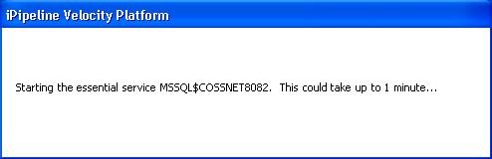

If the service is unable to successfully start, you will receive the following message.

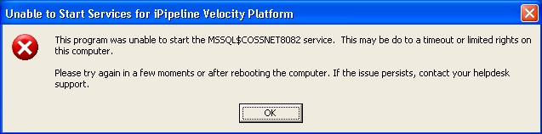

MSSQL$COSSNET8082
This service is for SQL Server Express. This error will occur if you haven’t rebooted since the initial install. If you have rebooted, a possible reason for that service failing to start is that the NetLib Encryptionizer service didn’t start successfully upon boot-up. The SQL Server Express service requires this to be running to start successfully. You can check on the status of this service by typing ‘sc query nlemsql’ (nlemslq64 for 64 bit systems) in a command window. You can quickly open a command window by typing ‘cmd’ in the run field.

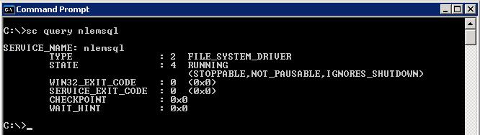
If this service doesn’t have the STATE of RUNNING then review the System & Application Event logs to determine the reason for start-up failure. A corrupt Netlib install can usually be resolved by running the repair utility of NetLib-Reinstall.exe which will uninstall and reinstall the NetLib Encryptionizer software (A restart will be required after this program completes). Contact your Helpdesk support to obtain the NetLib-Reinstall.exe program.

SQL Server: request failed or the service did not respond in a timely fashion
By default, the Service Control Manager will wait 30,000 milliseconds (30 seconds) for a service to respond. However, certain configurations, technical restrictions, or performance issues may result in the service taking longer than 30 seconds to start and report ready to the Service Control Manager.

- Go to Start > Run > and type regedit
- Navigate to: HKEY_LOCAL_MACHINE\SYSTEM\CurrentControlSet\Control
- With the control folder selected, right click in the pane on the right and select new DWORD Value
- Name the new DWORD: ServicesPipeTimeout
- Right-click ServicesPipeTimeout, and then click Modify
- Click Decimal, type ’180000′, and then click OK
- Restart the computer

By editing or creating the ServicesPipeTimeout DWORD value, the Service Control Manager timeout period can be overridden, thereby giving the service more time to start up and report ready to the Service.

If NetLib or a timeout isn’t the reason for the failure of the service, then the problem is most likely a corrupted database file and the only resolution is to uninstall/reinstall the application.

Apache2.2
This service is what allows the website application to run disconnected from the internet. If this is failing to start, then the best fix is to download and run the Apache-Reinstall.exe which will uninstall and reinstall the Apache software. Contact your Helpdesk support to obtain the Apache-Reinstall.exe program.

A “setupThePage” Error is Encountered in pop-up window
This is an issue with Windows 7 and IE10 where the Disconnected application doesn’t properly enter compatibility mode. To force the browser into compatibility mode, it is necessary to add 127.0.0.1 to the list of websites in the Compatibility View settings with the following steps:

- Select ‘Compatablity View settings’ in the Tools drop-down menu in Internet Explorer. Note: If you don’t see the menu bar, press the Alt key to reveal it.

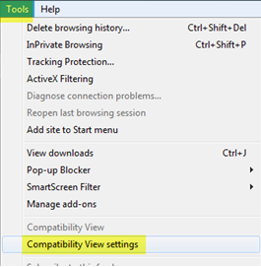

- In the resulting pop-up window, enter ‘127.0.0.1’ in the “Add this website” field and select the “Add” button.
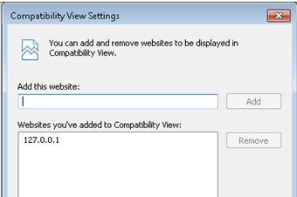

Blank Window during View Form or Running an Illustration
If you are experiencing a blank window or a brief flashing window that then closes when trying to generate a PDF from the application, this may be a result of a setting in Internet Explorer that prevents encrypted pages from being copied to your hard-drive.

This can be modified with the following steps:

- Open Internet Explorer
- Select Tools -> Internet Options
- Select Advanced tab as shown below.
- Uncheck “Do not save encrypted pages to disk”
- Select Apply.

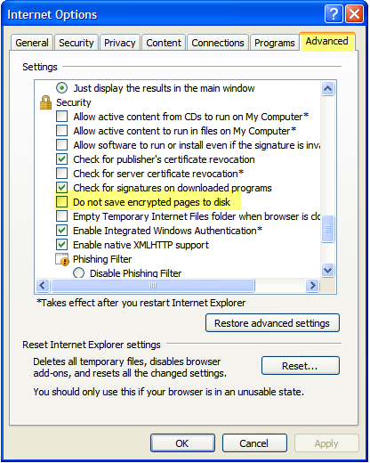

How to determine if your computer is running a 32-bit or 64-bit version of Windows

Windows XP Professional
- Click Start, click Run, type sysdm.cpl, and then click OK.
- Click the General tab. The operating system appears as follows:
  - For a 64-bit version operating system:
Microsoft Windows XP Professional x64 Edition Version < Year> appears under System.
  - For a 32-bit version operating system:
Microsoft Windows XP Professional Version < Year> appears under System.

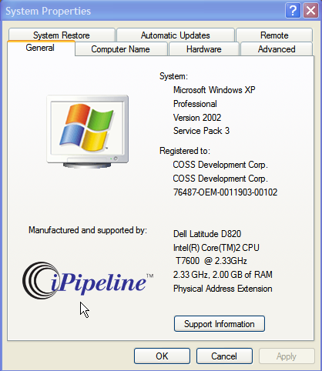

Windows Vista

Click Start, type system in the Start Search box, and then click system in the Programs list.

The operating system appears as follows:

For a 64-bit version operating system: 64-bit Operating System appears for the System type under System.

For a 32-bit version operating system: 32-bit Operating System appears for the System type under System.

How to determine if you have Administrative rights on your computer
- Open an Explorer session.

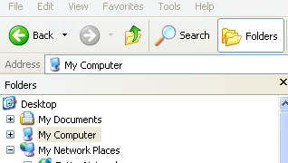

- Right click My Computer and select Manage. The following screen will appear.

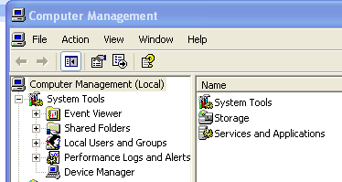

- Expand Local Users and Groups by clicking the plus (+) sign.

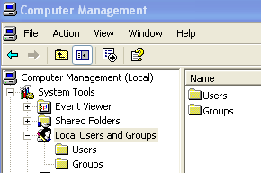

- Single-click Groups.

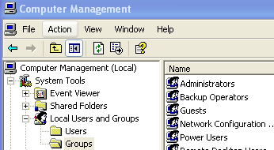

- Double-click Administrators in the right hand window.
- This screen will appear. If your userid/username is listed, then you have Administrative rights to this computer.

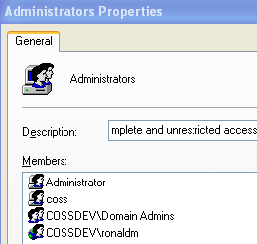

How to determine your version of Internet Explorer
- Launch Internet Explorer
- Select Help -> About Internet Explorer as shown:

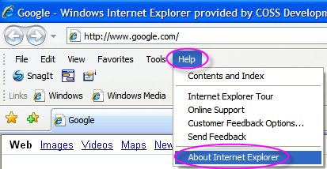

- The screen shown below will tell you the version:

