Dashboard Integration Steps
1. Open ngrok for Public Tunnel
Action | Open ngrok to expose the local server endpoint for webhook testing.

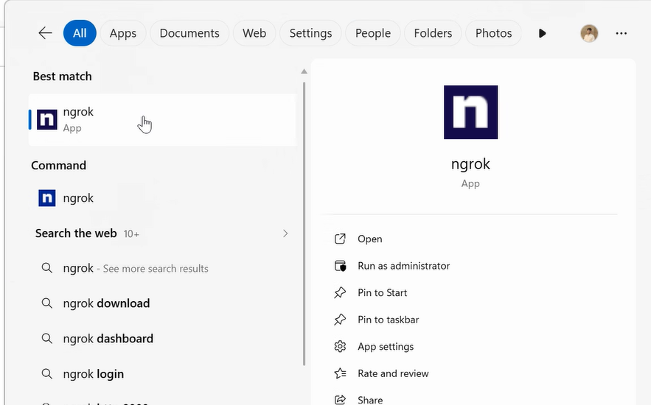

2. Configure ngrok Authentication
Action | Add the ngrok authentication token. The sensitive token is masked in the screenshot. The token to be entered here is -3FA3na76qt4Z1Ma3lB6zEst71th_7JEg1bDnywv4Sopzfg3b8

3. Confirm ngrok Authentication Saved
Action | Verify that ngrok confirms the auth token has been saved to the local configuration file.

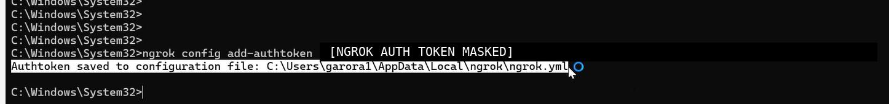

4. Open VerdictOS Dashboard
Action | Run the .bat file to access the dashboard.

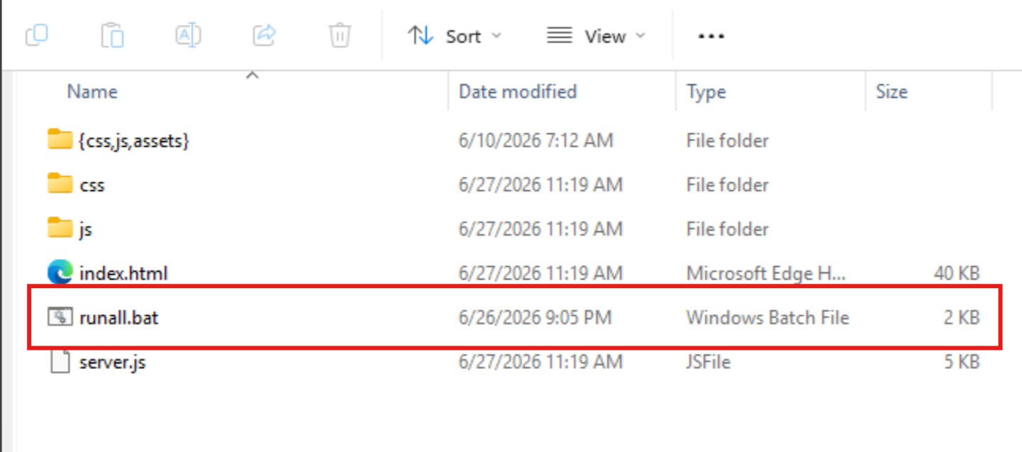

5. Validate Dashboard Standby State
Action | Confirm that all specialist agents are visible and in standby state before triggering the process.

