 | | Solution Design Document

VerdictOS – Agentic Courtroom for Enterprise Decisions

Table of Contents

| Solution Design Document 0
Table of Contents 0
I. Introduction 1
I.1 Purpose of the document 1
I.2 Objectives 1
I.3 Process key contact 1
I.4 Minimum Pre-requisites for automation 2
II. As-Is process description 3
II.1 Process Overview 3
II.2. Applications used in the process 4
II.3 As-Is Process map 5
II.5 Detailed As-Is Process Actions 5
III. Other Observations 14

Introduction

I.1 Purpose of the document
The Process Definition Document outlines the business process chosen for automation using UiPath Robotic Process Automation (RPA) technology.
The document describes the sequence of actions performed as part of the business process, the conditions and rules of the process prior to automation and how they are envisioned to work after automating it, partly or entirely. This specifications document serves as a base for developers, providing them with the details required for applying robotic process automation to the selected business process.

I.2 Objectives
The business objectives and benefits expected by the Business Process Owner after automation of the selected business process are:
- Reduce end-to-end case processing time by 70–80%.
- Improve decision accuracy and consistency using multi-agent review.
- Provide better monitoring, audit trail, and case traceability through Data Fabric and dashboards.
- Reduce manual reviewer effort by automating extraction, routing, notifications, and ServiceNow updates.

I.3 Process key contact
The specifications document includes concise and complete requirements of the business process and it is built based on the inputs provided by the process Subject Matter Expert (SME)/ Process Owner.
The Process Owner is expected to review it and provide signoff for accuracy and completion of the actions, context, impact and a set of process exceptions. The details are to be included in the table below.
Role | Name | Contact details  (email, phone number) | Notes
 | VerdictOS Team

I.4 Minimum Pre-requisites for automation
- UiPath Automation Cloud account with access to the hackathon tenant/folder.
- UiPath Studio Web access for Agentic Process and RPA Workflow editing.
- UiPath Orchestrator access with robot/serverless execution configured for debugging or publishing.
- Data Fabric unit allocated and the required Data Fabric entity created in the target tenant/folder.
- ServiceNow test instance or mocked/demo incident source with invoice attachment.
- Slack workspace/app/webhook or configured notification connector.
- Node.js installed locally for the demo dashboard/webhook service.
- ngrok installed and configured, if local webhook/dashboard needs to be exposed publicly during demo.
- For Node.js and ngrok initialization refer to document - VerdictOS_DashboardIntegrationStep

As-Is process description

II.1 Process Overview
General information about the process selected for RPA prior to automation.
# | Item | Description
1 | Process full name | VerdictOS – Agentic Risk Review and Decision Automation
2 | Process Area | Finance Operations / Invoice Validation / Risk Review
3 | Department | Finance, Compliance, Legal and Procurement Support
4 | Process short description  (operation, activity, outcome) | VerdictOS is an agentic automation solution that reviews invoice-related incidents by combining AI extraction, business context enrichment, vendor history, multi-agent risk evaluation, human-in-the-loop validation, and final decision logging.
5 | Role(s) required for performing the process | Finance Reviewer, Compliance/Legal Reviewer, UiPath Bot, AI Agents, Human Validator, Process Owner
6 | Process schedule and frequency | Event-driven; triggered whenever a ServiceNow incident/invoice request is created
7 | # of items processed /reference period | Varied
8 | Process execution time | Varied
9 | Peak period (s) | Month-end, quarter-end, financial closing periods, and high invoice submission cycles
10 | Transaction Volume During Peak period | Varied
11 | Total # of FTEs supporting this activity | 2–3 business FTEs with automation and AI agent support
12 | Expected increase of volume in the next reference period | Moderate increase expected as adoption expands across more invoice and vendor risk review scenarios
13 | Level of exception rate | Low
14 | Input data | ServiceNow Incident Ticket, Attachment.
15 | Output data | Extracted attachment data, Slack notification, final record in Data Fabric, ServiceNow ,Final risk evaluation in Dashboard.

II.2. Applications used in the process
The table includes a comprehensive list of all the applications that are used as part of the process to be automated to perform the given actions in the flow.
# | Application name & version | System Language | Environment/  Access method | Comments
1 | ServiceNow | EN | Web / API | Incident creation and invoice attachment source; acts as the main process trigger
2 | Document Understanding / AI Extraction | EN | API / UiPath AI capability | Extracts structured data from invoice attachment
3 | Data Fabric | EN | API / Database | Fetches vendor history and stores final transaction details
4 | AI Agent Layer | EN | API | Finance, Cyber, Legal, Human Intent, Precedent and Reputation agents perform analysis
5 | UiPath Action Center | EN | Web / Orchestrator | Used for human validation, approval or rejection
6 | Slack | EN | Web / API | Sends notification to stakeholders
7 | UiPath Orchestrator | EN | API | Triggers, manages and monitors  the automation process
8 | ngrok | EN | API | Dashboard integration.

II.3 As-Is Process map

High Level As-Is Process Map:
This chapter depicts the As-Is business process at a High Level to enable developers to have a high-level understanding of the current process.
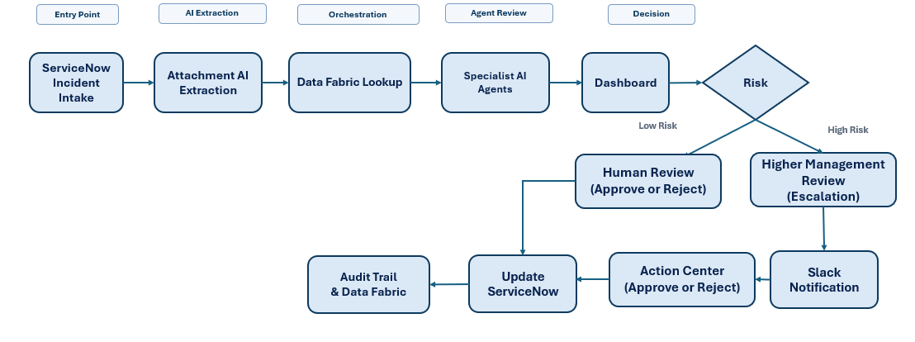

II.5 Detailed As-Is Process Actions
The following actions describe the detailed as-is execution flow for the VerdictOS invoice validation process, including ServiceNow triggering, invoice extraction, multi-agent risk review, human validation, dashboard update, Slack notification and audit storage.
1. Start Local Demo Trigger / Webhook Service
Description  Start the local demo trigger / webhook service from CMD.(refer to the document - VerdictOS_DashboardIntegrationSteps.docx) | Est. time: 30 sec.  Action: Manual / Command Execution

2. ServiceNow Incident Creation
Description  Generate ServiceNow incident ticket and attach related document.  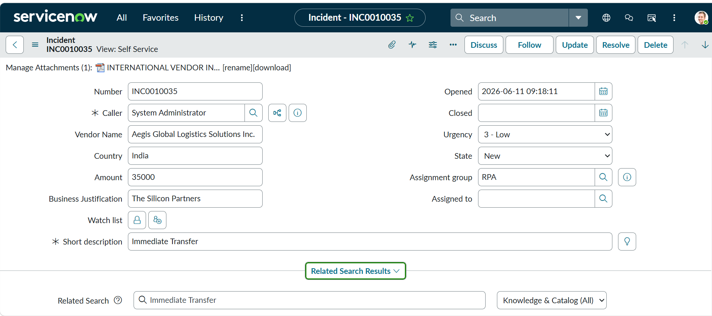 | Est. time: 20 sec.  Action: System Trigger

3. Receive ServiceNow Reference Details
Description  Bot receives the Incident Number and Incident ID from ServiceNow. | Est. time: 5 sec.  Action: Bot Action

4. Fetch Complete Incident Details
Description  Bot connects to ServiceNow and fetches complete incident details. | Est. time: 15 sec.  Action: API / Bot Action

5. Download Attachment
Description  Bot identifies and downloads the attachment from the ServiceNow incident. | Est. time: 20 sec.  Action: API / Bot Action

6. Extract Details
Description  AI extraction reads the PDF and extracts structured details for documents like Invoices (Vendor Name, Invoice Number, Amount, Currency, Billing Company and Bank Details) | Est. time: 60 sec.  Action: AI Extraction

7. Prepare Document Details
Description  Bot prepares Document Details from the extracted invoice information. | Est. time: 5 sec.  Action: Bot Action

8. Fetch Vendor Transaction History
Description  Bot queries UiPath Data Fabric using Vendor Name to fetch previous vendor transaction history.  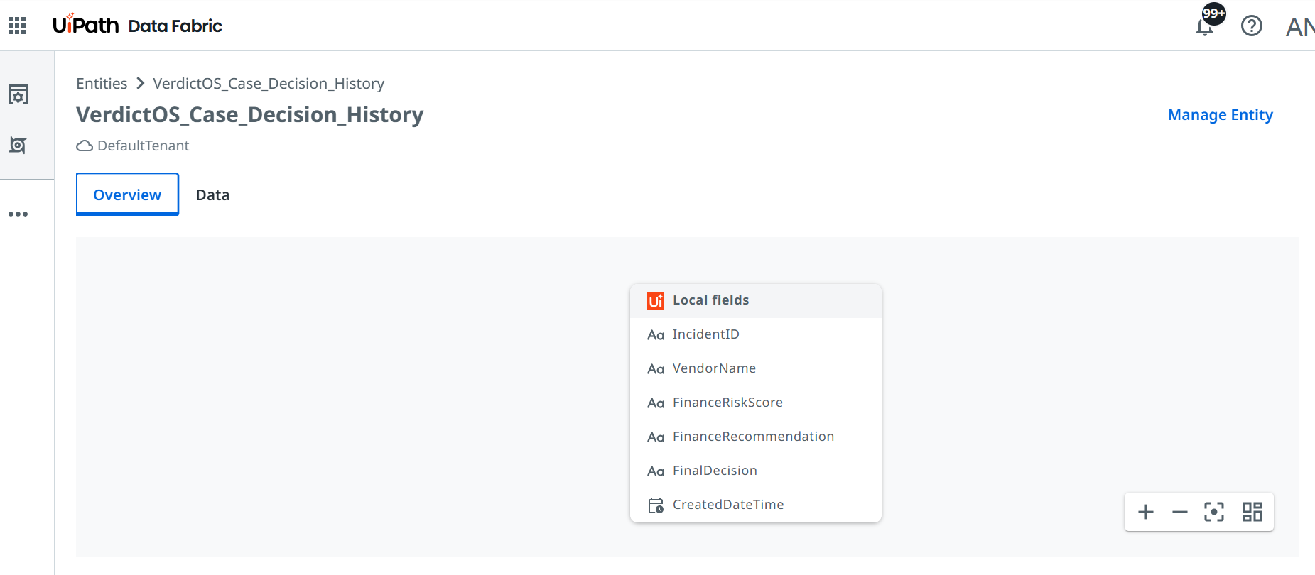 |  | Est. time: 10 sec.  Action: Data Fabric Query

9. Reset the data in Verdict Os Dashboard
Description  Bot reset the dashboard for new transaction.  A – From ngrok -  B – From Comand Prompt -  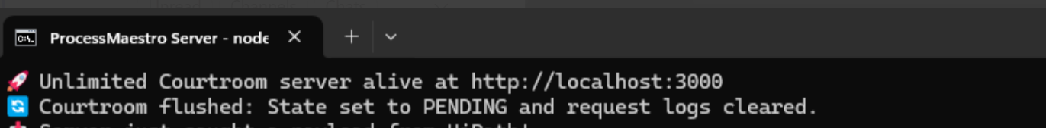 | Est. time: 5 sec.  Action: Bot

10. Activate Specialist Agents
Description  Bot activates specialist agents: Finance Agent, Cyber Agent, Legal Agent, Human Intent Agent, Reputation Agent and Precedent Agent. | Est. time: 10 sec.  Action: Agent Orchestration

11. Finance Agent Review
Description  Finance Agent reviews invoice completeness, amount, currency, payment details and finance control risk. (Taking Context file from storage bucket) | Est. time: 20 sec.  Action: AI Agent Review

12. Cyber Agent Review
Description  Cyber Agent reviews suspicious payment signals, bank detail risk and possible fraud indicators. (Taking Context file from storage bucket) | Est. time: 20 sec.  Action: AI Agent Review

13. Legal Agent Review
Description  Legal Agent reviews compliance, policy and legal risk. (Taking Context file from storage bucket) | Est. time: 20 sec.  Action: AI Agent Review

14. Human Intent Agent Review
Description  Human Intent Agent reviews requester intent, urgency and business justification from the ServiceNow incident. (Context by analyzing document text) | Est. time: 20 sec.  Action: AI Agent Review

15. Reputation Agent Review
Description  Reputation Agent reviews vendor trust and reputation risk indicators. (Context from Generative Web Search tool) | Est. time: 20 sec.  Action: AI Agent Review

16. Precedent Agent Review
Description  Precedent Agent compares the current vendor case with previous vendor history from Data Fabric. | Est. time: 20 sec.  Action: AI Agent Review

17. Generate Agent Outputs
Description  Each agent returns its finding, recommendation, confidence score and risk score. | Est. time: 5 sec.  Action: AI Agent Output

18. Collect Specialist Agent Outputs
Description  Bot collects all specialist agent outputs. | Est. time: 5 sec.  Action: Bot Action

19. Consolidate Through Debate Agent
Description  Debate Agent consolidates all agent recommendations and identifies the final risk position. | Est. time: 20 sec.  Action: AI Decisioning

25. Update VerdictOS Dashboard
Description  Bot updates the VerdictOS dashboard by sending the Payload with details, agent outputs, risk score and final decision summary.  A - ngrok  B - CMD  C – Data receiving on Dashboard -  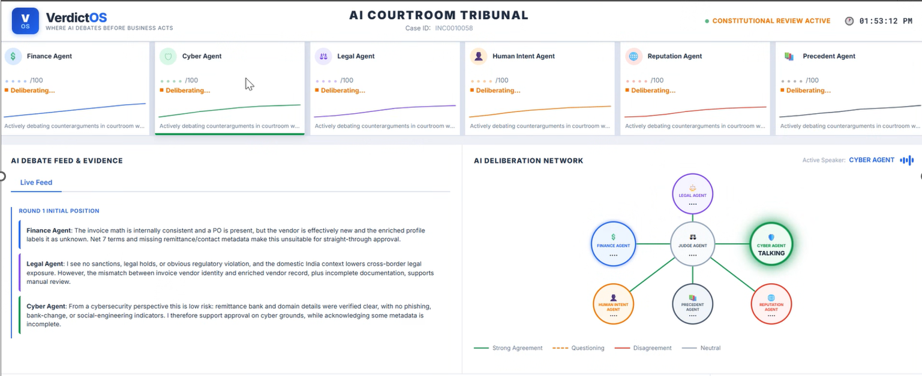 | Est. time: 15 sec.  Action: Dashboard Update

27. Human Review
Description  Human reviewer reviews the, agent recommendations and final recommendation and based on that click the final button(APPROVE, ESCALATE, REJECT)  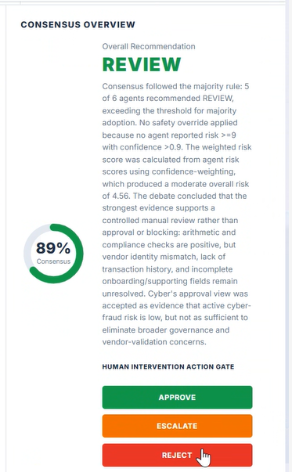 | Est. time: 3-10 min.  Action: Human Action

26 (A). Human Approval / Rejection
Description  Human reviewer approve or rejects the recommendation.  A – Approve – If Approve  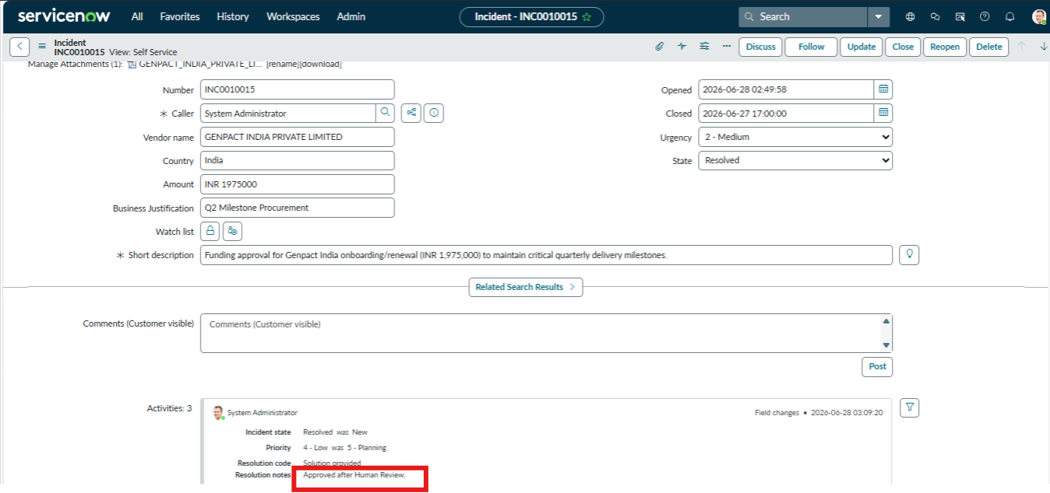  B – Reject -  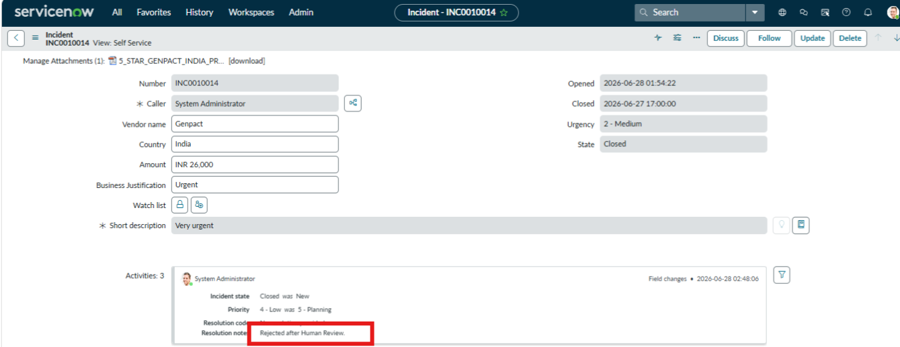 | Est. time: 30 sec.  Action: Human Action

26 (B). Create Action Center Task
Description  If human click on the Escalation button in dashboard, the bot creates an Action Center task for Upper Management review. Notification will be sent to management through Slack containing the Action Task Link.  A – Slack  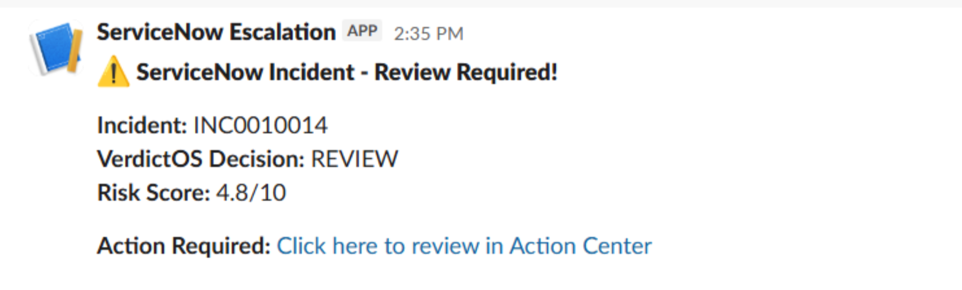  B – Action Center  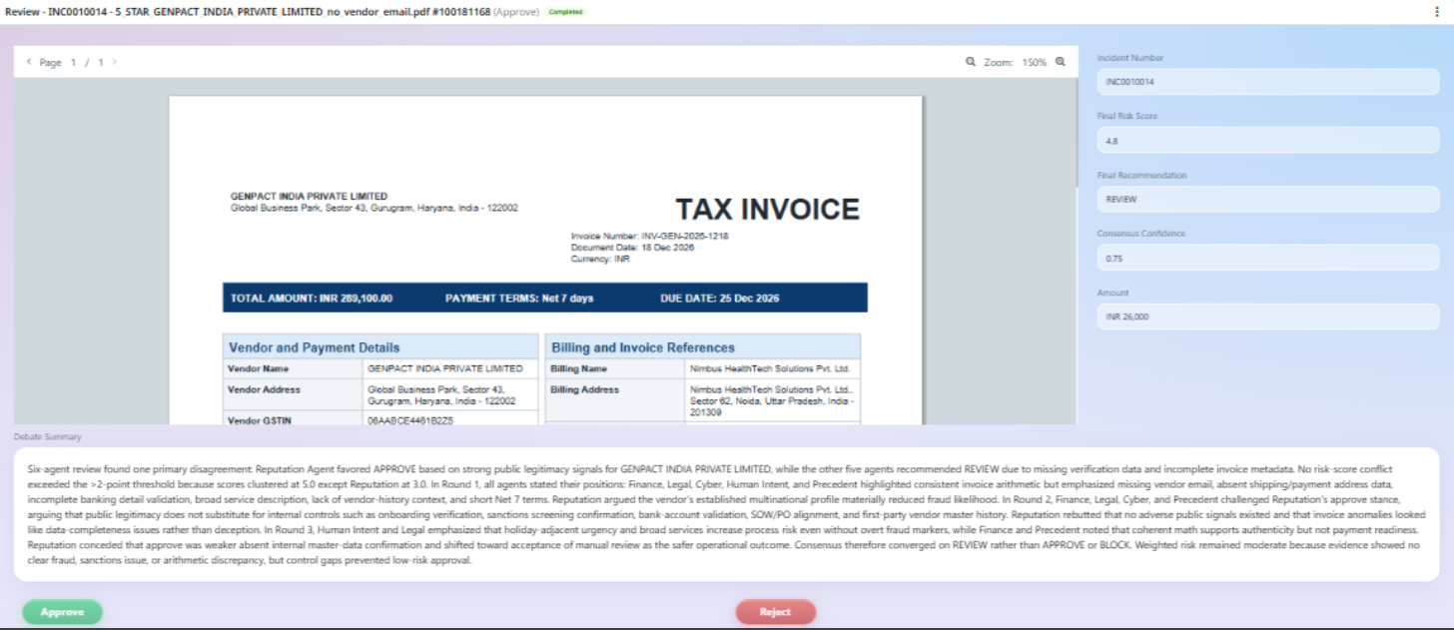 | Est. time: 20 sec.  Action: Human-in-the-Loop Routing

29. Final step of Agent
Description  Agent will mark the service now ticket as resolved after getting input as Approve or Reject from human. | Est. time: 5 sec.  Action: ServiceNow

30. Store Final Transaction
Description  Bot stores the final transaction and decision in UiPath Data Fabric for audit tracking and future Precedent Agent use. | Est. time: 10 sec.  Action: Data Fabric Writeback

32. Process End
Description  Process ends with final outcome as Approved or Rejected. | Est. time: 2 sec.  Action: Process Completion

Other Observations
Key Observations
# | Observation Area | Observation / Requirement | Impact / Monitoring Requirement
1 | Production Trigger | The CMD/webhook service is considered a demo execution method only. In production, the process should be triggered through ServiceNow and UiPath Orchestrator integration. | Avoid dependency on local manual trigger and ensure the automation can run in a controlled production setup.
2 | Source of Truth | ServiceNow should remain the primary source for Incident Number, Incident ID, requester details and invoice validation request data. | All downstream logs, dashboard updates and notifications should reference the ServiceNow incident.
3 | Invoice Attachment Quality | Invoice PDF quality directly impacts extraction accuracy. Poor scans, unreadable PDFs or missing invoice pages may require manual validation. | Track extraction failures and route low-confidence invoices to Action Center.
4 | AI Recommendation Usage | Finance, Cyber, Legal, Human Intent, Reputation and Precedent Agents provide recommendations and risk signals, not unconditional business approval. | Final approval logic must respect business policy and human validation requirements.
5 | Human-in-the-loop Review | Human review should be required only for high-risk, exception, low-confidence or Review Required cases. | Action Center should capture reviewer decision, comments and timestamp for auditability.
6 | Data Fabric Precedent Records | Only records with UseForPrecedent = True should be used for precedent comparison by the Precedent Agent. | Improves precedent quality and prevents unsuitable records from influencing future recommendations.
7 | Audit Trail | Final transaction details and decision output should be stored in UiPath Data Fabric after every completed process run. | Audit record should include Incident ID, Vendor Name, Invoice Number, Amount, Currency, Final Decision, Final Reason, Created Date Time and UseForPrecedent flag.
8 | Dashboard Monitoring | VerdictOS dashboard should show invoice details, agent-wise outputs, risk score, final recommendation and process status. | Supports real-time business monitoring and easier review of pending/high-risk cases.
9 | Notification Control | Slack notification should be sent only after final recommendation or final decision is available. | Notification should include Incident Number, Vendor Name, Invoice Amount, Final Recommendation and status.
10 | Access and Security | Service accounts, API keys and application credentials should be managed securely and should not be hardcoded in the workflow. | Use credential assets/secure storage and restrict access based on least privilege.
11 | Exception and Retry Logic | Temporary application/API failures should be retried before marking a case as failed or requiring manual review. | Retry count, error reason and final exception status should be logged for support review.
12 | Model / Prompt Governance | Agent prompts, scoring thresholds and business rules should be controlled through approved configuration and change management. | Prevents uncontrolled changes to risk scoring and recommendation behavior.
13 | Data Privacy | Invoice and vendor information may contain sensitive financial and banking details. | Restrict access, avoid unnecessary data exposure in Slack, and store only required fields for audit and precedent use.
14 | Business Sign-off | Final To-Be flow, exception rules, approval matrix and dashboard fields should be validated with the business owner before production release. | Ensures automation output aligns with finance, compliance, legal and audit expectations.

