Chapter 2

Chapter 2: Literature Review

2.1 Introduction
In the rapidly evolving landscape of healthcare technology, the intersection of Artificial Intelligence (AI) and psychology—often termed Affective Computing—has emerged as a transformative field. Mental health disorders, particularly stress, anxiety, and burnout, have escalated into a global health crisis, yet they often remain under-diagnosed due to their subjective nature and the stigma associated with seeking professional help. Unlike physiological ailments that present tangible symptoms, mental health struggles are frequently silent, manifesting in subtle behavioral changes that are difficult to quantify without continuous observation.
This chapter provides a comprehensive and critical review of the existing literature surrounding Affective Computing, with a specific focus on Multimodal Emotion Recognition (MER) via facial expression analysis and speech signal processing. It aims to contextualize the MindSense AI project within the current body of knowledge by examining state-of-the-art methodologies, analyzing the architecture of existing mental health monitoring systems, and identifying the significant technological gaps that persist.

While numerous studies have demonstrated the efficacy of AI in detecting emotions in controlled environments, there remains a disconnect between laboratory accuracy and real-world applicability. This review highlights the progression from simple unimodal detection to complex multimodal fusion and ultimately argues for the necessity of the proposed system: a privacy-centric, real-time intervention tool that moves beyond passive monitoring to active psychological support.

2.2 Background
Before analyzing specific studies, it is essential to define the core concepts and technologies that underpin this project.
2.2.1 Affective Computing
Affective computing is the study and development of systems and devices that can recognize, interpret, process, and simulate human affects. It is an interdisciplinary field spanning computer science, psychology, and cognitive science. The core premise is that machines can be taught to detect emotional states through physiological and behavioral cues.
2.2.2 Facial Emotion Recognition (FER)
The face is the most visible indicator of human emotion. Research in FER often relies on the psychological theory of Paul Ekman, which classifies human emotions into universal categories: Happiness, Sadness, Anger, Fear, Disgust, and Surprise. Modern FER systems utilize Deep Learning, specifically Convolutional Neural Networks (CNNs), to map facial landmarks and texture changes to these emotional states.
2.2.3 Speech Emotion Recognition (SER)
While the face reveals what a person feels, the voice often reveals how intensely they feel it. SER focuses on extracting acoustic features such as:
• Pitch and Tone: High pitch often correlates with stress or panic.
• Energy/Loudness: Low energy may indicate sadness or drowsiness.
• Speech Rate: Rapid speech can signal anxiety.
These features are processed to determine the underlying emotional arousal of the speaker without needing to record or analyze the actual words spoken.
2.2.4 Multimodal Fusion
Single-modality systems (Face-only or Voice-only) often suffer from ambiguity. For example, a person might smile out of politeness while feeling stressed. Multimodal Fusion combines data from multiple sensors (Camera + Microphone) to achieve higher accuracy and robustness in emotion detection.

2.3 Review of Relevant Work
To understand the current state of the art, we have categorized relevant literature into three distinct domains: Multimodal Stress Detection algorithms, Real-time Voice Analysis applications, and the architecture of AI-driven Mental Health Systems.

2.3.1 Advances in Multimodal Stress and Emotion Detection
The integration of visual and auditory data has long been recognized as the most robust method for emulating human-like perception. Recent research has focused heavily on improving the accuracy of these fusion models.

A pivotal study by Li et al. (2021) introduced the "MUSER" framework (Multimodal Stress Detection using Emotion Recognition). Their research investigated the deep semantic link between acute stress and basic emotional states. By utilizing the MuSE dataset, they trained a Transformer-based model capable of fusing acoustic features with linguistic data.

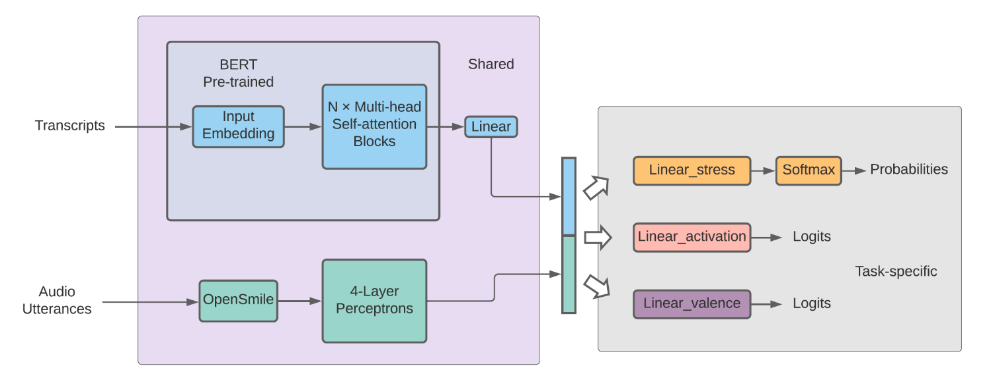
Figure 2.1 The Multimodal Fusion Architecture for MUSER proposed by Li et al. (2021), illustrating the processing of transcripts (via BERT) and audio utterances (via OpenSmile) into a shared fusion layer.

- Significance: Their findings were groundbreaking in demonstrating that "Emotion Recognition" serves as a critical auxiliary task for "Stress Detection." They proved that stress is not an isolated phenomenon but is deeply entangled with specific emotional patterns, such as fear or anger.
- Limitation: However, the system's primary focus was on maximizing classification accuracy within a static dataset environment. It lacked a mechanism for real-time deployment or user feedback, rendering it a powerful analytical tool rather than a practical health companion.

in a more recent systematic review, Ahmed et al. (2024) analyzed the landscape of Multimodal Emotion Recognition (MER) techniques. Their comprehensive survey highlighted that while modern Deep Learning architectures—specifically Convolutional Neural Networks (CNNs) fused with Long Short-Term Memory (LSTM) networks—can achieve recognition accuracies exceeding 85%, they come with a significant trade-off.
- Critical Insight: The authors noted that the high computational cost of these complex models makes them difficult to deploy on personal consumer devices (like smartphones or laptops) without experiencing significant latency. This creates a barrier for real-time monitoring applications that require instant responsiveness.

2.3.2 Voice Analysis for Real-Time Biofeedback
While facial expressions are overt, the human voice often acts as a subconscious "leakage channel" for emotion, revealing stress through prosodic features even when a subject attempts to hide it.

Arushi et al. (2021) explored this domain by developing a real-time stress detection model specifically designed for public speaking training. Their system focused on extracting low-level acoustic features, including Pitch, Amplitude Envelope, and Mel-Frequency Cepstral Coefficients (MFCCs).

- Significance: The study empirically validated that MFCCs are among the most reliable indicators of physiological arousal and "nervousness." Furthermore, they successfully integrated this detection logic into a Virtual Reality (VR) game to provide users with immediate feedback.
- Relevance to Our Work: This study is directly relevant to MindSense AI as it provides a precedent for the "Feedback Loop." It demonstrates that audio features alone are sufficient to trigger a system intervention, a concept we expand upon by combining it with visual data for higher reliability
2.3.3 Architecture of AI-Driven Mental Health Systems
Beyond algorithms, the architectural design of monitoring systems is crucial for user adoption.
A 2025 study published in the International Journal for Multidisciplinary Research (IJFMR) explored the theoretical framework of "AI-driven mental health monitoring systems." The researchers proposed a network of IoT devices and mobile sensors to track user well-being continuously.
- Key Finding: The study concluded that the single largest barrier to the mass adoption of such systems is not technical accuracy, but Privacy and Trust. Users are increasingly hesitant to engage with health applications that upload sensitive biometric data to the cloud.
- Identified Gap: The authors emphasized an urgent need for "Edge Computing" solutions—systems where data processing happens locally on the device. This specific recommendation validates the core architectural choice of our project to prioritize on-device processing over cloud dependence.

2.4 Relationship between the Relevant Work and Our Own Work
While the existing literature provides robust mathematical models for detecting emotions (Li et al., 2021) and demonstrates the viability of voice-based feedback (Arushi et al., 2021), there remains a distinct gap in integrating these isolated technologies into a cohesive, user-centric support system. Most current research remains academic, focusing on the accuracy of classification rather than the utility of the application for the end-user
MindSense AI builds upon these foundational studies but introduces three critical differentiators that address the limitations identified in the review:
- Transition from Passive Detection to Active Intervention The majority of reviewed works, including the MUSER framework, stop at the "Reporting" stage—simply logging stress levels for future analysis. Our system fundamentally shifts this paradigm by closing the loop with Smart Interventions. We argue that detection without action is insufficient for mental wellness. MindSense AI does not just observe the user; it acts as an intelligent agent, triggering real-time, context-aware recommendations (such as breathing exercises or focus prompts) immediately upon detecting a negative state.
- Privacy-First Architecture (On-Device Processing) As highlighted by the IJFMR (2025) study, the reliance on cloud processing is a major privacy flaw in existing systems. Our project directly addresses this by implementing a Local Processing architecture. Unlike systems that stream video to a server, MindSense AI performs all inference of facial expressions and voice tones directly on the user's mobile device. This ensures that sensitive biometric data never leaves the user's control, solving the "Trust Gap" identified in the literature.

- Multimodal Robustness for Real-World Contexts Many commercial applications currently on the market rely on a single modality—either tracking the face or the voice—which often leads to false positives in uncontrolled environments. By fusing visual and audio data, our system achieves a higher level of contextual awareness. For example, a face-only system might misinterpret a user's "concentration" as "anger" due to furrowed brows. However, by cross-referencing this with a calm voice pitch, our system can correctly identify the state as "Focused" rather than "Stressed," significantly reducing false alarms.

Table 2.1: Comparison with Existing Solutions
Feature | Typical Existing Research | Our Proposed System
Primary Goal | Classification and Data Logging | Real-time Intervention and Support
Modality | Single (Face OR Voice) | Multimodal (Face + Voice)
Action Taken | Passive Reporting (Graphs) | Smart Alerts and Exercises
Privacy | Cloud Processing | Local/On-Device Processing

2.5 Summary
In this chapter, we have established the theoretical foundations of the project by reviewing the key principles of Affective Computing. We analyzed the state-of-the-art in facial and speech emotion recognition, examining pivotal studies such as Li et al. (2021) regarding the correlation between emotion and stress, and Arushi et al. (2021) regarding the use of voice analysis for real-time feedback.
Our critical review of the literature concludes that while accurate detection algorithms currently exist, there is a significant lack of holistic systems that combine passive multimodal monitoring with immediate therapeutic aid. Furthermore, the review identified a critical need for privacy-preserving architectures in mental health technology.
MindSense AI aims to bridge these specific gaps. By creating a privacy-centric mobile application that not only detects the user's mental state with high accuracy but also actively assists them in managing it, we propose a solution that is both technologically advanced and ethically sound.
The following chapter (Chapter 3: System Analysis) will build upon these findings to define the specific functional requirements of the system, analyze the limitations of existing commercial apps in depth, and present the detailed architectural design and UML diagrams that will guide the implementation phase.
References
- Li, Y., et al. (2021). "MUSER: MUltimodal Stress Detection using Emotion Recognition as an Auxiliary Task". Proceedings of the NAACL

- Arushi, et al. (2021). "Real-time Stress Detection Model and Voice Analysis: An Integrated VR-based Game for Training Public Speaking Skills". IEEE Conference on Games (CoG).

- Ahmed, T., et al. (2024). "A Systematic Review on Multimodal Emotion Recognition: Techniques, Challenges, and Future Directions". IEEE Access.

- IJFMR (2025). "A study on AI driven mental health monitoring system". International Journal for Multidisciplinary Research.

