Does Annual Household Income Play a Role in Minority’s Political Party Identification?

**The survey**

The survey chosen for this research question is a survey conducted in **2010**, after the general election that year. The survey targeted **five ethnic minorities** instead of the general population, but many items are shared between this survey, and the British Election Study (BES) survey which has been running in Britain since 1963. This was a first distinct and separate survey probing into ethnic minorities in the UK. The five ethnic minorities included in the survey consisted of people of **Indian, Pakistani, Bangladeshi, Black Caribbean, and Black African background**.

A sample consists of **2787 adults aged 18+ from England, Scotland, and Wales**. These participants were all interviewed between **May 4th and August 31st 2010**. The survey consisted of face-to-face computer assisted **personal interviews** and a **mail-back paper questionnaire**. There were 200 interviewers conducting this survey with various ethnic backgrounds and coming from a diverse range of backgrounds. Survey takers were incentivised to participate with a £20 cash gift. Questions in the survey probed various aspects of individual’s political identification ranging from questions about **whether they were on electoral register, their feelings toward different political parties, their opinions on prominent figures from these parties, their personal finance and tax situations, their choice of media source for election information etc.**

**Research question**

The research question is: "**Does Annual Household Income Play a Role in Minority’s Political Party Identification?**"

Requirements:

* **Try to explain why this research questions might be of interest and to whom.**

Political parties and campaign strategists can use this information to understand better which groups of people agree with their policies, especially for their campaigns and messages. Sociologists and political scientists can study how things like income affect the political behaviour of minorities. Policymakers can learn how income changes political views and use this to create policies that help low- or high-income families in minority groups better.

* **Locate relevant data file and accompanying documentation in the “stata” folder.**
* **Identify variables of interest and specify their type.**

Dependent variable: Annual Household Income, zqinc (ordinal)

Independent variable: Party Identification, bq9_1 (nominal)

* **In case a variable is ordinal or nominal, list the possible categories and their meaning.**

**Variable =** bq9_1 **Variable label =** Party Identification

Value = 1 Label = None/No (No preference)

Value = 2 Label = Labour

Value = 3 Label = Conservatives

Value = 4 Label = Liberal Democrats

Value = 5 Label = Scottish National Party (SNP)

Value = 12 Label = Respect

**Variable =** zqinc **Variable label =** Annual Household Income

Value = 1 Label = 0 - 5000

Value = 2 Label = 5001 - 10000

Value = 3 Label = 10001- 15000

Value = 4 Label = 15001 - 20000

Value = 5 Label = 20001 - 25000

Value = 6 Label = 25001 - 30000

Value = 7 Label = 30001 - 35000

Value = 8 Label = 35001 - 40000

Value = 9 Label = 41000 - 45000

Value = 10 Label = 45001 - 50000

Value = 11 Label = 50001 - 60000

Value = 12 Label = 60001 - 70000

Value = 13 Label = 70001 - 80000

Value = 14 Label = 80001 or more

* **Perform any necessary transformations of data format type.**

**Filtered Data Process:**

1.- Ethnicity filter: The dataset we are using comes from the British Election Study (BES) 2010 whose target audience was five ethnic minorities (Indian, Pakistani, Bangladeshi, Black Caribbean, and Black African) within the UK. Therefore, we have decided to filter out records where their ethnicities do not come from the specified list. Ethnicity categories which fall in the minority group but has less than 3 records been omitted as well.

Each record has a valid value in the Ethnicity (nominal) field, as shown in the following list:

**Variable =** zq101 **Variable label =** Ethnicity

Value = 3 Label = Mixed White and Black Caribbean

Value = 4 Label = Mixed White and Black African

Value = 7 Label = Asian or Asian British - Indian

Value = 8 Label = Asian or Asian British - Pakistani

Value = 9 Label = Asian or Asian British - Bangladeshi

Value = 11 Label = Black or Black British - Caribbean

Value = 12 Label = Black or Black British - African

2.- Income/Party Category filtering:

Both Party Identification and Annual Household income questions possess categories to specifically cover scenarios where people do not want to share that information (refused, don’t know, and not stated). Our priority is to decide whether to include people’s records who fall in any of these categories. Our research question: “**Does Annual Household Income Play a Role in Minority’s Political Party Identification?**", then we think that any people that didn’t provide transparent information in these two questions, then they are not helping our case. For instance, if a family head answered that they would rather not share their political party preference, then no matter their income, it would not help us determine the relationship between income and party identification, since we don’t know their political preference, and vice versa. Therefore, we have decided to omit these family records from the dataset.

Political groups who have less than 3 records within our dataset were omitted since we don’t have enough data to conduct a reliable test for those groups.

After these data filtering steps, we end with 1543 (55.36% of the unfiltered dataset) valuable records to help us answer our research question.

**Data Transformation Analysis:**

The above histograms showcase how income is distributed for each political party. It is notorious how each of them presents a symptom of positive skewness, suggesting that the distributions are not normal. We will conduct a normality test and if the tests failed on validating normality, instead of transforming the data, we will leverage non-parametric tests.

* **Define the analysis required to answer the RQ and explain why you have chosen this particular analysis**.

Political Party Identification is evidently a nominal variable; however the Annual Household Income variable was modelled as an ordinal variable, based on the family income, it is assigned a category which means that their income is targeted by a value range. We are thinking that if annual income does not play an important role in political party identification, then if we grouped income by each political party, then these group’s distributions should be similar, and the groups consistency should hold. If there are groups which rejects these assumptions, then we would have enough evidence to conclude that income influence in the decision of selecting a political party group. For example, let’s say that political group A’s income distribution is far from group B, then there is a sign that income distribution is not the same, and it could be a decisive factor for political party selection (causality is out of the scope of this work).

Since we have a single factor (political party identification) with many levels (more than 2), a **ONE WAY ANOVA** or a **non-parametric independent samples** are both appropriate methods to compare and validate group differences. The final method will be selected if the assumptions of ANOVA are met (if not we will use the non-parametric test).

* **List all assumptions and how you addressed them.**

**1.- Assumption 1: Not significant outliers**

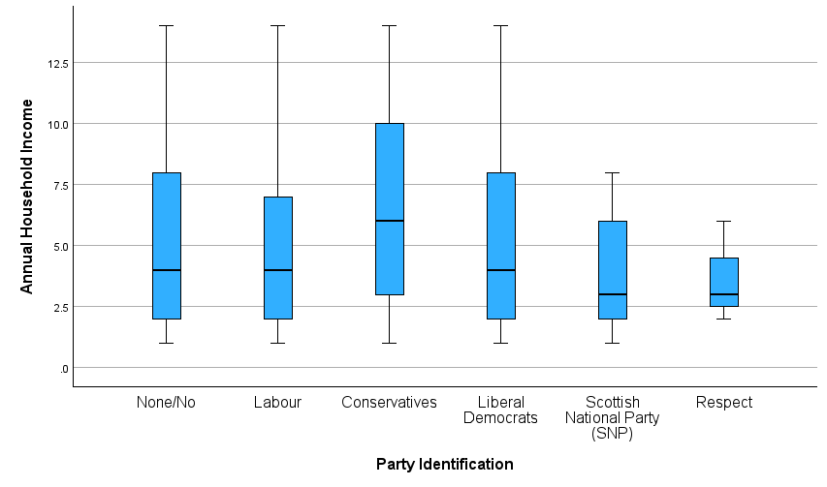

Previous boxplots show no sign of significant outliers.

**2.- Assumption 2: All observations are independent**

This means that each participant's data (their income and political identification) is independent of others' responses. No individual or group should influence the responses of others.

**3.- Assumption 3: Normality distribution for each group**

The above plot depicts the annual household income distribution by each political party group. The Shapiro test columns tell us that 4 groups are significantly not normal, and the other two groups are.

**4.- Assumption 4: Homogeneity of variance**

We have significant proof that there is not homogeneity of variance within the groups.

Since some groups are not normal and we have heterogeneity of variance, we have decided to use a non-parametric independent samples test.

* **List the null and alternative hypothesis.**

**Null hypothesis (H0)**: Variable Annual Household Income, grouped by political party, appears to be consistent within all the groups. Showing almost identical distribution for each category.

**Alternative Hypothesis (H1)**: There is significant evidence to support the claim that at least one group’s distribution is different from the rest, i.e. income is not distributed equally for each political party when grouped by this variable.

* **Provide the results of your analysis and answer the research question.**

A non-parametric independent samples Kruskal-Wallis Test was conducted to determine the influence of Annual Household Income across Political Party Identification. Families were classified based on their income into 14 classes and subdivided in political views: None/No (n = 176), Labour (n = 1053), Conservatives (n=150), Liberal Democrats (n=154), SNP (N=6), and Respect (n=4). Data is presented as median ± standard deviation. The test results (Test Statistic=19.776, p = .001) show that the Null Hypothesis: “The distribution of Annual Household Income is the same across categories of Party Identification” is rejected, therefore there is at least one group comparison that is statistically different.

**The following chart shows the pairwise comparisons for each group and their test results:**

We have 3 group comparisons that are statistically significant different: Labour-Conservatives (Test Statist=-163.857 p <.001), None/No-Conservatives (Test Statist=-131.725 p = .007), and Liberal Democrats-Conservatives (Test Statist=121.202 p = .017). Income grouped by None/No has a median of 4 and a standard deviation of 3.969, income grouped by Conservatives has a median of 6 and a standard deviation of 4.048, income grouped by Labour has median of 4 and standard deviation of 3.48, and income grouped by Liberal Democrats has a median of 4 and a standard deviation of 3.634.

Decoding the categorical values of the party identification categories we have category 6 lies in the range of 25,001 – 30,000, and category 4 in 15,0001 – 20,000.

* **Try to explain the impact of the result within the context of the data.**

The analysis shows that **Annual Household Income has a big effect on which political party ethnic minorities in the UK support**. People who earn more money, in the range of £25,001 to £30,000, are more likely to support the **Conservative Party**. On the other hand, people with lower incomes, around £15,001 to £20,000, usually support **Labour** or do not have a clear political preference. This means that income plays an important role in how minorities decide which party they like, and this pattern is similar to how income affects the general population.

For political parties, these results are very important. The **Conservative Party** can use this information to focus more on wealthier minority groups, offering messages about economic growth, lower taxes, and business opportunities, which may appeal to higher earners. Meanwhile, **Labour** and the **Liberal Democrats** might want to focus on helping lower-income people by talking more about social programs, healthcare, and reducing income inequality. They could attract more support from minorities who are struggling with financial problems.

The results also show that people with no political preference tend to have lower incomes. This might mean that these people feel left out of the political process or that no party really speaks to their problems. This is an opportunity for political parties to try to engage with this group by addressing their needs more clearly. If they can reach out to these voters, it could increase political participation among lower-income minority groups.

Overall, the study highlights that ethnic minorities are not all the same when it comes to politics. **Income differences within minority groups** are important and can lead to different political views. If political parties want to attract minority votes, they need to recognize that income plays a big role in shaping political opinions and offer policies that speak to both wealthier and lower-income people within these communities.