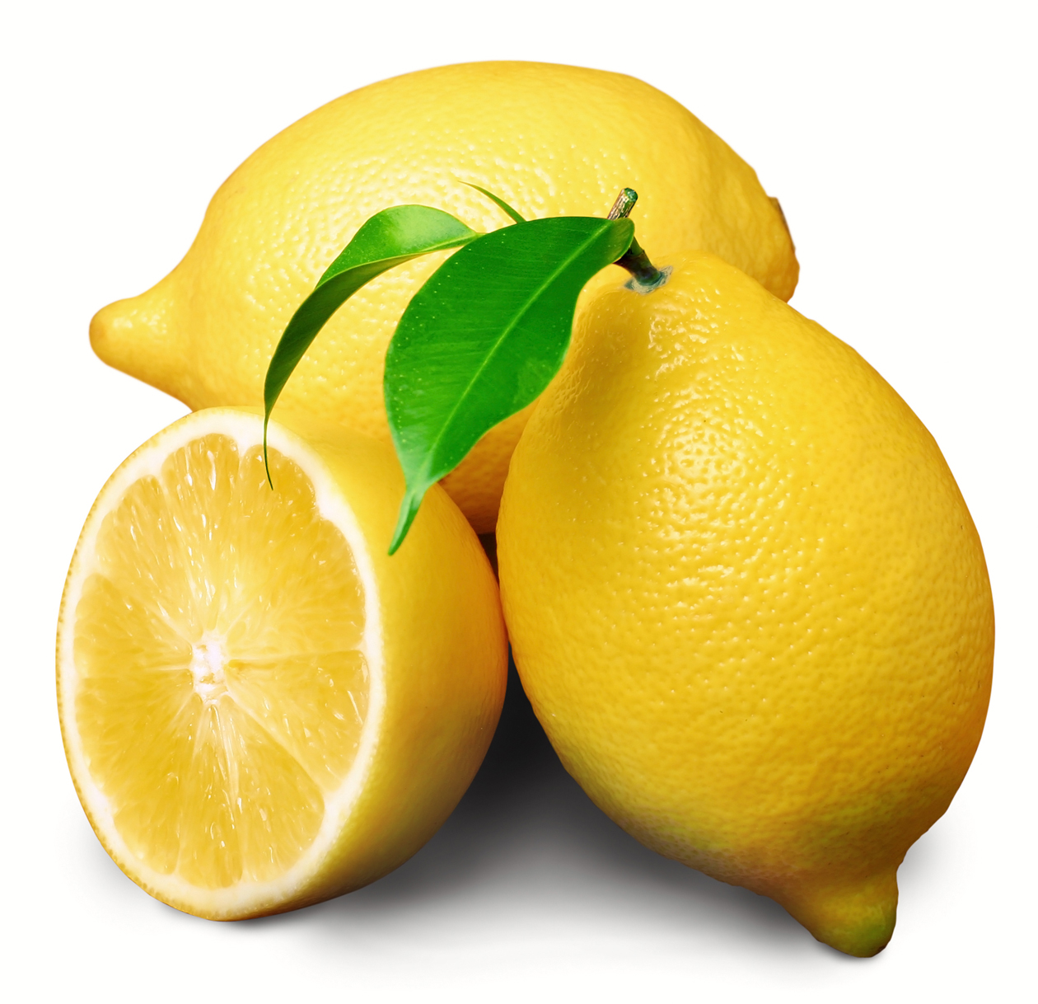
Lemonade Sale
- 1 glass for $0.35
- 2 glasses for $0.50
Thanks for your business!

