Confidential Data Processing on AWS
The Complete Handbook of the POC
Everything we built in session 1, why we built it that way, and how every part works in depth
Minelli-D · 2 October 2026 · Stockholm (eu-north-1) · synthetic data only · v1.1
ABOUT What this is. A study handbook of the whole project, to explore in the next days. It brings together the study guide, the data dictionary, the deployment paths, the spec, the two procedures, the code, the Terraform, every decision and everything we learned while deploying.
What it is not. It does not replace the other documents: it links to them. Each chapter says where the full detail lives.

Goal | Process sensitive data so that it is readable only inside a verified, short-lived, isolated environment, and nothing usable is left behind
Use case | Reconciliation of synthetic payslips: 100 employees, January–June 2026, simplified Italian rules, 29 planted errors
Technology | AWS Nitro Enclaves · AWS KMS with attestation · Amazon S3 · EC2 · Terraform · Python
Result | Session 1 deployed it in Stockholm, the job ran inside a real enclave, then everything was destroyed. Ongoing cost $0
Golden rule | Don't trust the place. Verify the code.

How to use this handbook
The handbook has nine parts. Each one can be read on its own, but the order follows the project: from the idea, to the decisions, to the code, to running it on AWS, to what we learned.
Part | Title | You will learn
I | The big picture | the problem, the architecture, the ten concepts, the threat model
II | The journey and every decision | what we did in session 1, in order, and all 27 decisions with their reasons
III | The use case: payslip reconciliation | the data, the formulas with worked examples, the planted errors and the scoring
IV | Security mechanisms in depth | envelope encryption, the key policy, attestation, S3 layers, the parent's disk, the network
V | Infrastructure as code | the two Terraform setups, file by file, and the Terraform concepts used
VI | The enclave application and the scripts | what runs where, the code walkthrough, and how it was tested
VII | Operating the POC | the procedures, the teardown, the AWS console tour, troubleshooting and costs
VIII | Lessons, production and the reusable pattern | what session 1 taught us, what changes for production, and how to reuse the pattern for any data source
IX | Exam, glossary and appendices | the SAA-C03 mapping, the glossary, the file inventory, the command cheat sheet and the self-check answers

A study plan for the next days
Day | Read | Then try
1 | Part I, and the diagrams in Part II | explain Schema 9 (the end-to-end pattern) out loud, step by step
2 | Part III and Part IV | recompute one payslip by hand; draw the key policy from memory
3 | Part V and Part VI | open infra/ and poc/enclave/ next to the text; run the 70 local tests
4 | Part VII | walk through the procedures without running them; list what each step proves
5 | Part VIII and Part IX | answer the self-check questions; sketch how you would adapt the pattern to another use case

REMEMBER Each chapter ends with a Remember box: one or two sentences to memorise. Read only those boxes, in order, and you have the whole project in two pages.

The documents this handbook links to
Document | Where | Use it for
Study guide v2 | confidential-processing-aws-study-guide-v2.docx | the concepts and the exam corner
Data dictionary | payslip-poc-data-dictionary.docx | every field of the dataset and every formula
Deployment paths | poc-deployment-paths-ec2-vs-eks.docx | why EC2 and not EKS, with costs
Specification | poc-tier1-spec.docx | the exact design that was deployed
Base procedure | poc/procedures/Base-phase-terraform.docx | running the base phase again
Lab procedure | poc/procedures/Lab-phase-terraform.docx | running the lab phase again
Decision log | poc/README.md | every decision, with its reason
Folder overview | README.md (root) | links to everything, key points

Conventions
Box | Meaning
REMEMBER | the sentence to memorise
EXAM NOTE | what this teaches for SAA-C03
TRAP | a mistake that is easy to make
LESSON | something that really happened in session 1
DECIDED | a decision we took
SELF-CHECK | a question to test yourself (answers in Appendix D)

Part I · The big picture
This part is the foundation. If you understand these five chapters, every other part is detail.

1. The problem and the idea

1.1 The goal
Process sensitive data, such as payslips, so that it is readable only inside an environment that is:
- Verified: only approved code can read the data, and it has to prove which code it is.
- Short-lived: the environment exists only while the job runs.
- Isolated: nobody outside it can read its memory, not even root on the machine that hosts it.
And when the job ends, nothing usable survives.

1.2 The first idea, and its weak point
Version 1 was a simple pipeline: pull the data, encrypt it, decrypt and process it inside a throwaway Kubernetes namespace, re-encrypt the result, store it in S3, send it back.
The weak point: once decrypted inside a pod, the data sits in memory as plaintext. A namespace organises resources; it is not a security boundary. Cluster admins, anyone with access to the node, memory dumps, logs and swap can all reach that plaintext.

1.3 Version 2: verify the hardware
Problem in version 1 | Fix in version 2 | AWS building block
Plaintext sits in pod memory | decrypt and process inside an isolated enclave | AWS Nitro Enclaves
Anyone with the right role can decrypt | release the key only to code that proves its identity | KMS key policy with attestation (PCR0)
Keys outlive the job | a fresh data key per job, discarded at the end | envelope encryption + crypto-shredding
Manual setup, forgotten resources | everything as code, destroyed after use | Terraform

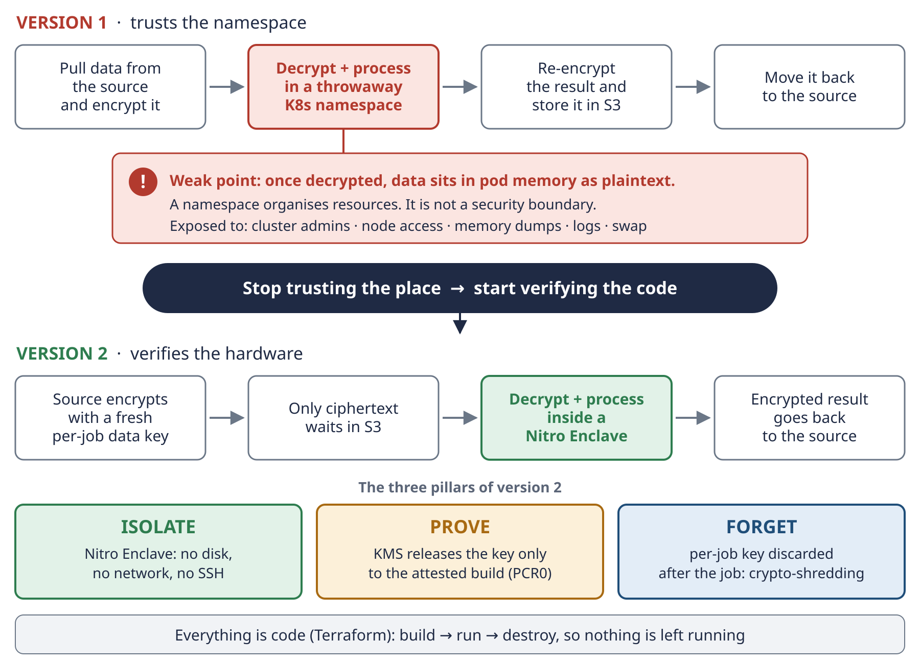
Schema 1 · From version 1 to version 2: the three pillars Isolate, Prove, Forget.
REMEMBER Isolate, Prove, Forget. The enclave isolates the processing, attestation proves which code runs, and the per-job key is forgotten at the end.

2. The architecture
Two pictures describe the architecture. Schema 2 is the general design from the study guide (with Kubernetes). Schema 6 is exactly what we deployed in the POC: one EC2 instance, no Kubernetes.
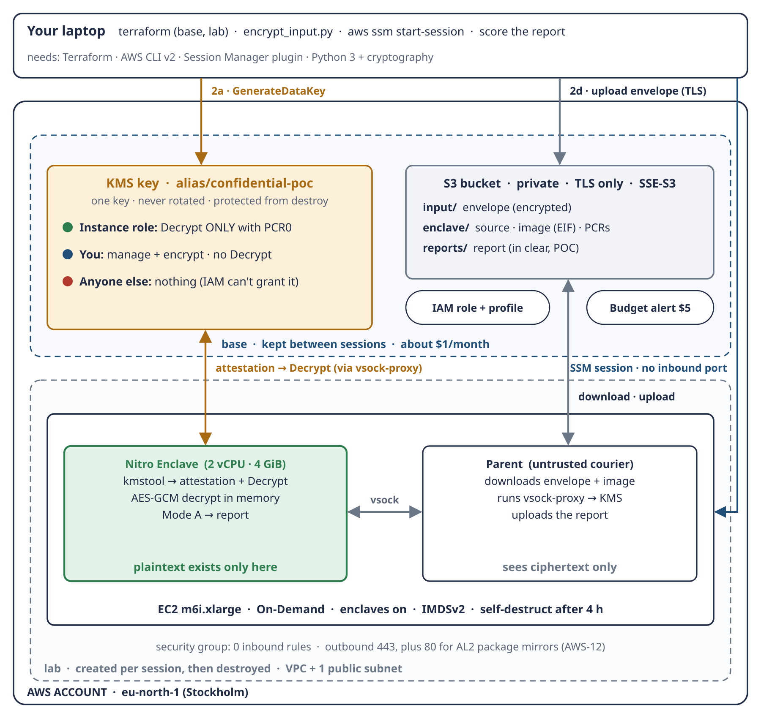
Schema 6 · The deployed POC: laptop, base setup (kept) and lab setup (per session).

2.1 The roles, in one table
Component | Its job | What it can read
Your laptop | data owner: creates and seals the data, runs Terraform, scores the report | the plaintext it created
AWS KMS | the gatekeeper: holds the key, checks the attestation | keys, never the data
Amazon S3 | the post office: stores envelopes, the image and reports | ciphertext (plus the POC report)
EC2 parent | the courier: moves bytes, runs the vsock-proxy | ciphertext only
Nitro Enclave | the only reader: decrypts in memory, runs the formulas | plaintext, only while the job runs
Cloud and node admins | operate the platform | nothing readable

2.2 The flow in eight words
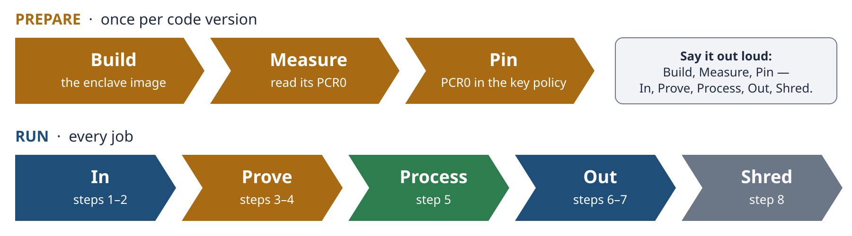
Schema 2b · Build, Measure, Pin, then In, Prove, Process, Out, Shred.
Word | What happens | In the POC
Build | build the enclave image from the code | lab step L4, build_enclave.sh
Measure | read its fingerprint, PCR0 | pcrs.json
Pin | write PCR0 into the key policy | lab step L5, Terraform
In | the sealed data arrives and is fetched | encrypt_input.py, run_job.py
Prove | the enclave proves its identity to KMS | kmstool with attestation
Process | decrypt in memory, run the formulas | enclave_app.py → reconcile.py
Out | the result leaves (sealed in production) | report to S3 reports/
Shred | keys and compute disappear | terminate the enclave, destroy the lab, delete the key

REMEMBER The parent is a courier, the enclave is the only reader, and KMS is the gatekeeper.

3. The ten concepts
The ten concepts answer three questions: why, where and how. They form one chain.
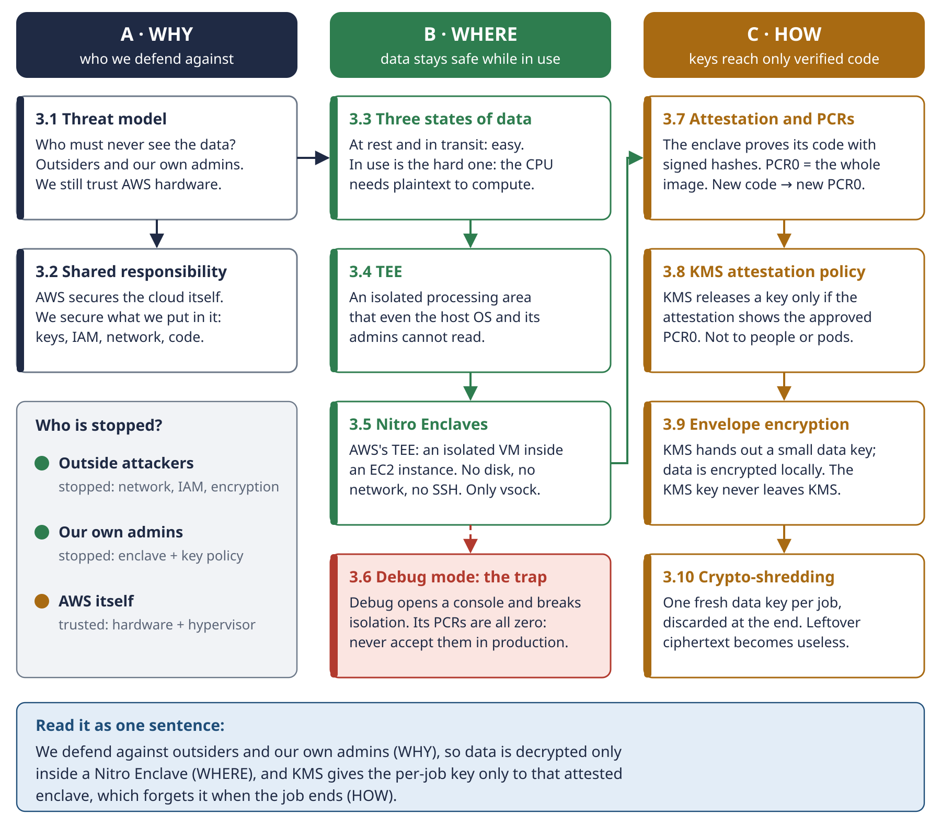
Schema 3 · The ten concepts as one chain: WHY → WHERE → HOW.
# | Concept | In one line | Where we used it
1 | Threat model | who must never see the data, and whom we trust | outsiders and our admins are stopped; AWS hardware is trusted
2 | Shared responsibility | AWS secures the cloud, we secure what we put in it | our key policy, IAM, network and code
3 | Three states of data | at rest and in transit are easy; in use is hard | the enclave protects data in use
4 | TEE | an isolated processing area the host cannot read | Nitro Enclaves is AWS's TEE
5 | Nitro Enclaves | an isolated VM inside EC2: no disk, no network, no SSH | the enclave in the lab
6 | Debug mode | breaks isolation; PCR0 becomes all zeros | refused by Terraform and by KMS
7 | Attestation and PCRs | signed hashes that prove which code runs | pcrs.json, the attestation document
8 | KMS attestation policy | KMS releases a key only to the approved PCR0 | statement 3 of our key policy
9 | Envelope encryption | a data key encrypts the data; KMS protects the data key | envelope.py, encrypt_input.py
10 | Crypto-shredding | destroy the key and the ciphertext becomes useless | deleting the KMS key at teardown

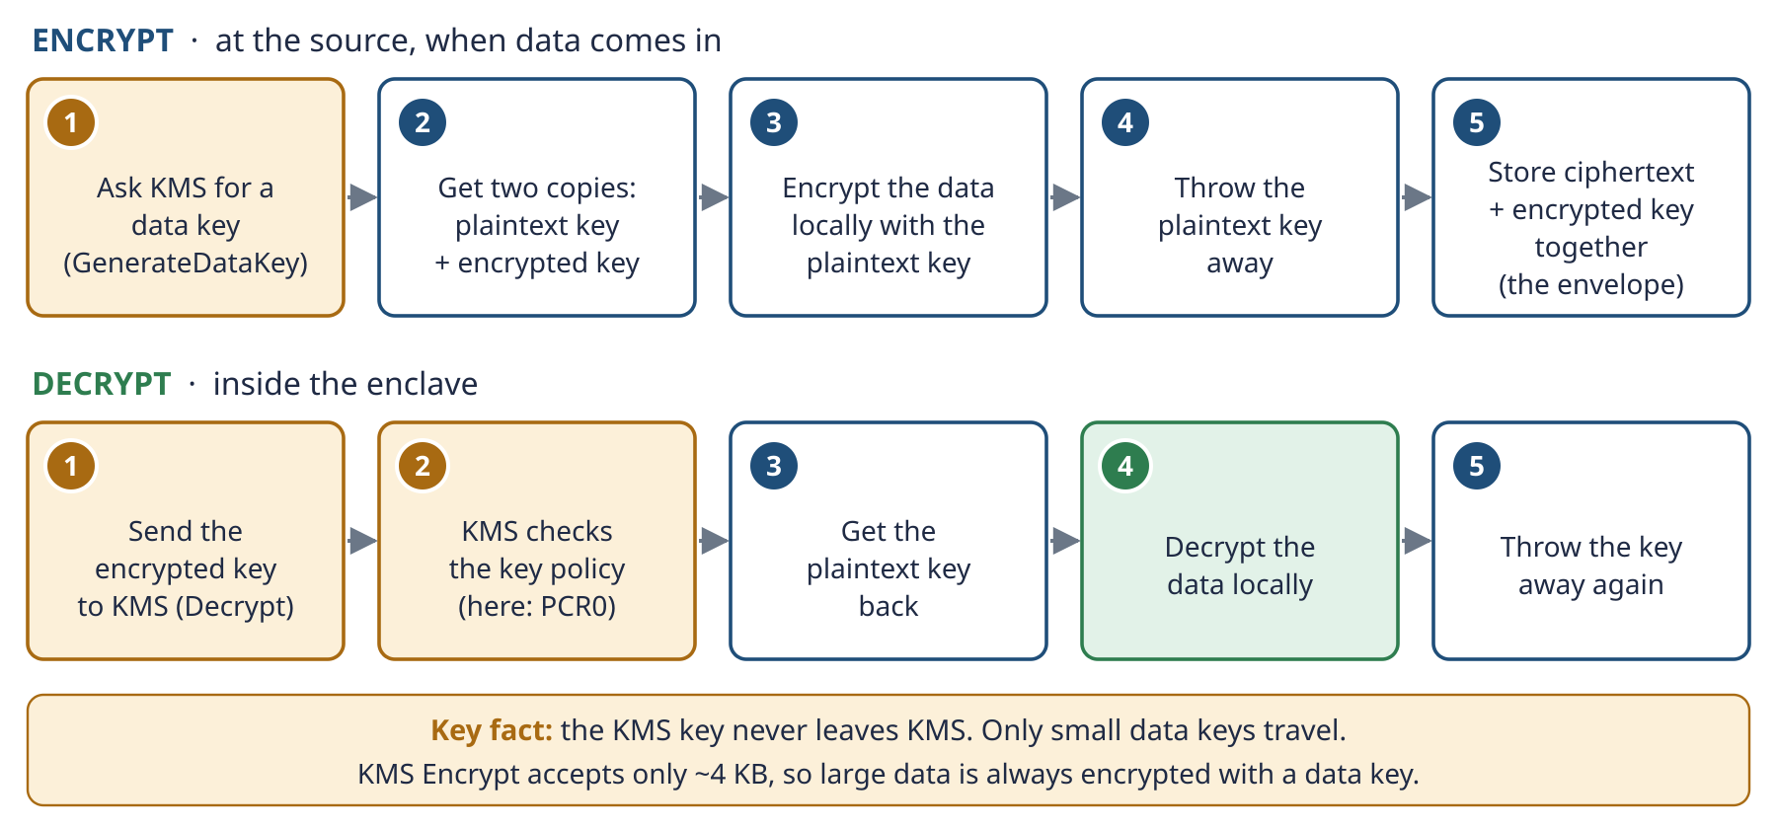
Schema 3b · Envelope encryption: big data never goes to KMS, only small data keys do.
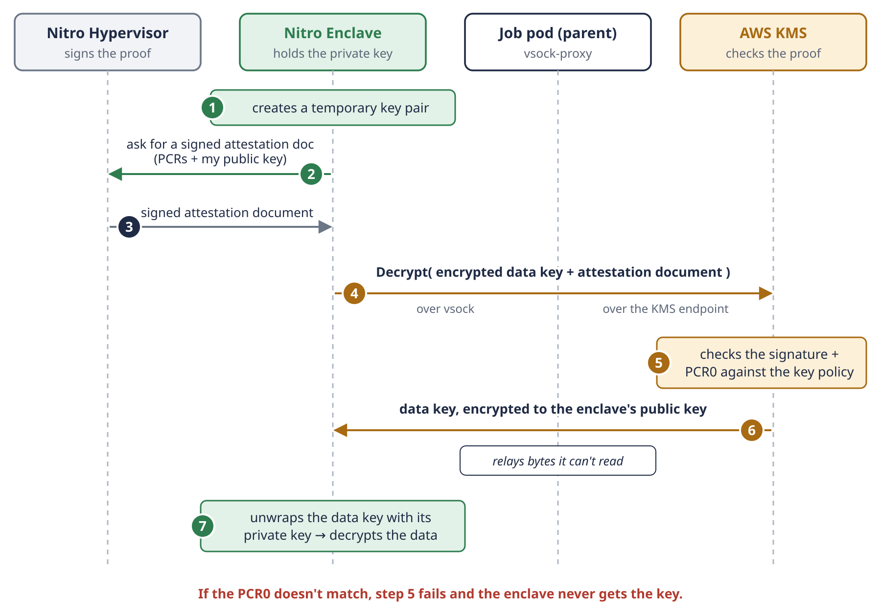
Schema 3c · The attestation handshake: the parent relays a key it cannot read.
REMEMBER WHY → WHERE → HOW. We defend against outsiders and our own admins (why), so data is decrypted only inside a Nitro Enclave (where), and KMS gives the per-job key only to that attested enclave, which forgets it at the end (how).

4. Inside and outside the enclave
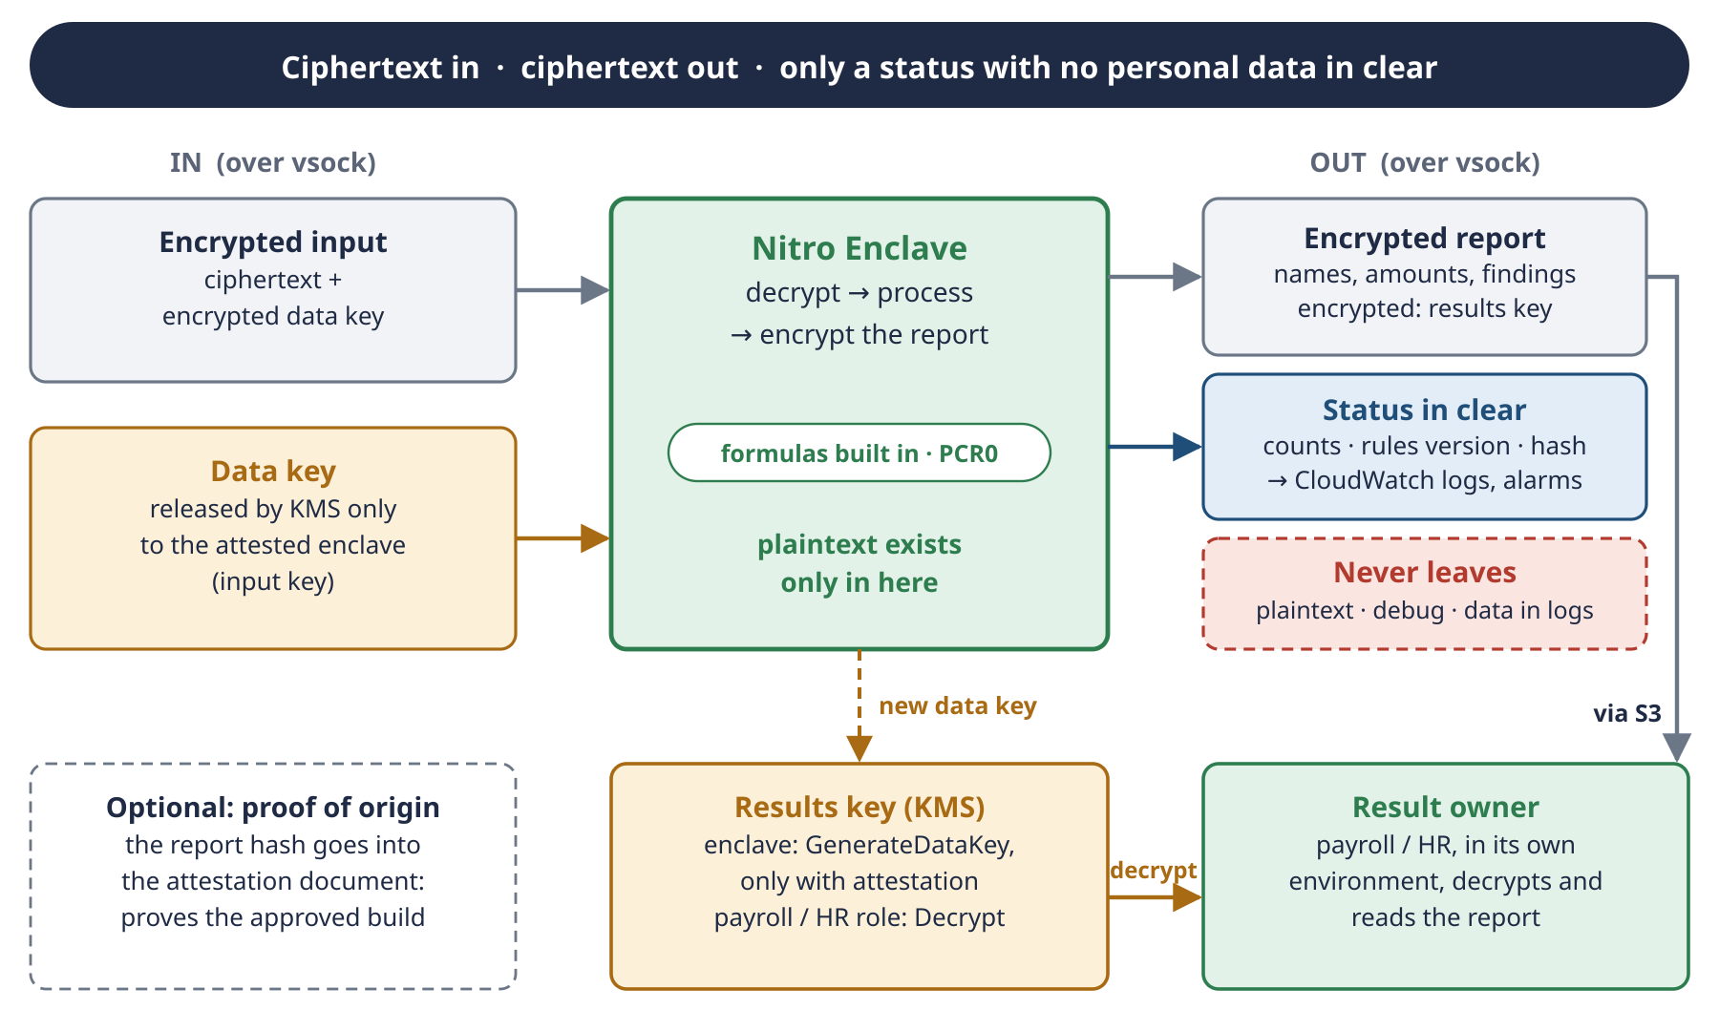
Schema 2c · Ciphertext in, ciphertext out; only a status with no personal data in clear.
The enclave's only door is vsock to the parent. Anything it hands out in plaintext is visible to the parent and to whoever controls the node. So the rule is: classify every output by one question: can it be linked to a person?
Output | Personal data? | Leaves as
Per-employee findings (payslip, line, amounts) | yes | sealed
Sick-leave or termination findings | yes, special category (health data under GDPR) | sealed
Next-month payslips (Mode B) | yes | sealed
Totals per small group | yes if the group is small (a group of 2 points at people) | clear only above a minimum group size
Job status: counts, rules version, report hash | no | in clear

TRAP Pseudonyms are not anonymity. An ID like E012 can be mapped back to a person by HR, so under GDPR it is still personal data.

DECIDED In the POC the report left in clear (AWS-8), because the data is synthetic. With real data, the report must leave sealed. One key is enough when the owner also reads the results; a separate results key is needed only when result readers must not read the inputs.

5. Threat model in practice
Here is every actor we thought about, and what each one can and cannot do in this design.
Actor | Can | Cannot | Why
Internet attacker | nothing directly | reach the instance, read S3 | zero inbound rules; private bucket; TLS only
Someone who steals your AWS credentials | read envelopes in S3, encrypt with the key | decrypt the data | no Decrypt for you in the key policy
Root on the EC2 parent | read the parent's disk and memory, call KMS with the role; read the report (AWS-8) and send any envelope to the enclave (gap F1) | read the enclave's memory, get the data key | Nitro isolation; attestation required (test B1)
Someone who changes the image in S3 | upload a different EIF | make KMS accept it | a different image has a different PCR0
Root on the parent before the build | change the code before it is measured, so that we pin a bad PCR0 (gap F2) | — | the image is built on the parent, and the build is not reproducible
The key admin | rewrite the policy or create a grant, and so give anyone Decrypt (gap F3) | do it silently | kms:Put* and kms:Create* in the admin statement; AWS-11 extends it to every IAM admin; CloudTrail logs every change
Debug-mode enclave | start and print to a console | get the key | PCR0 is all zeros
AWS itself | (trusted) | — | the root of trust is AWS's Nitro hardware: the honest limit of the design

EXAM NOTE Exam questions hide the threat model in one phrase, like “administrators must not be able to access the data”. That phrase points to Nitro Enclaves plus a KMS policy with attestation; encryption at rest alone does not stop administrators.

SELF-CHECK Why can't root on the parent instance decrypt the payslips, even though it has the same IAM role as the enclave?

Part II · The journey and every decision
This part tells what we did in session 1, in order, and lists every decision with its reason. It is the story behind the code.
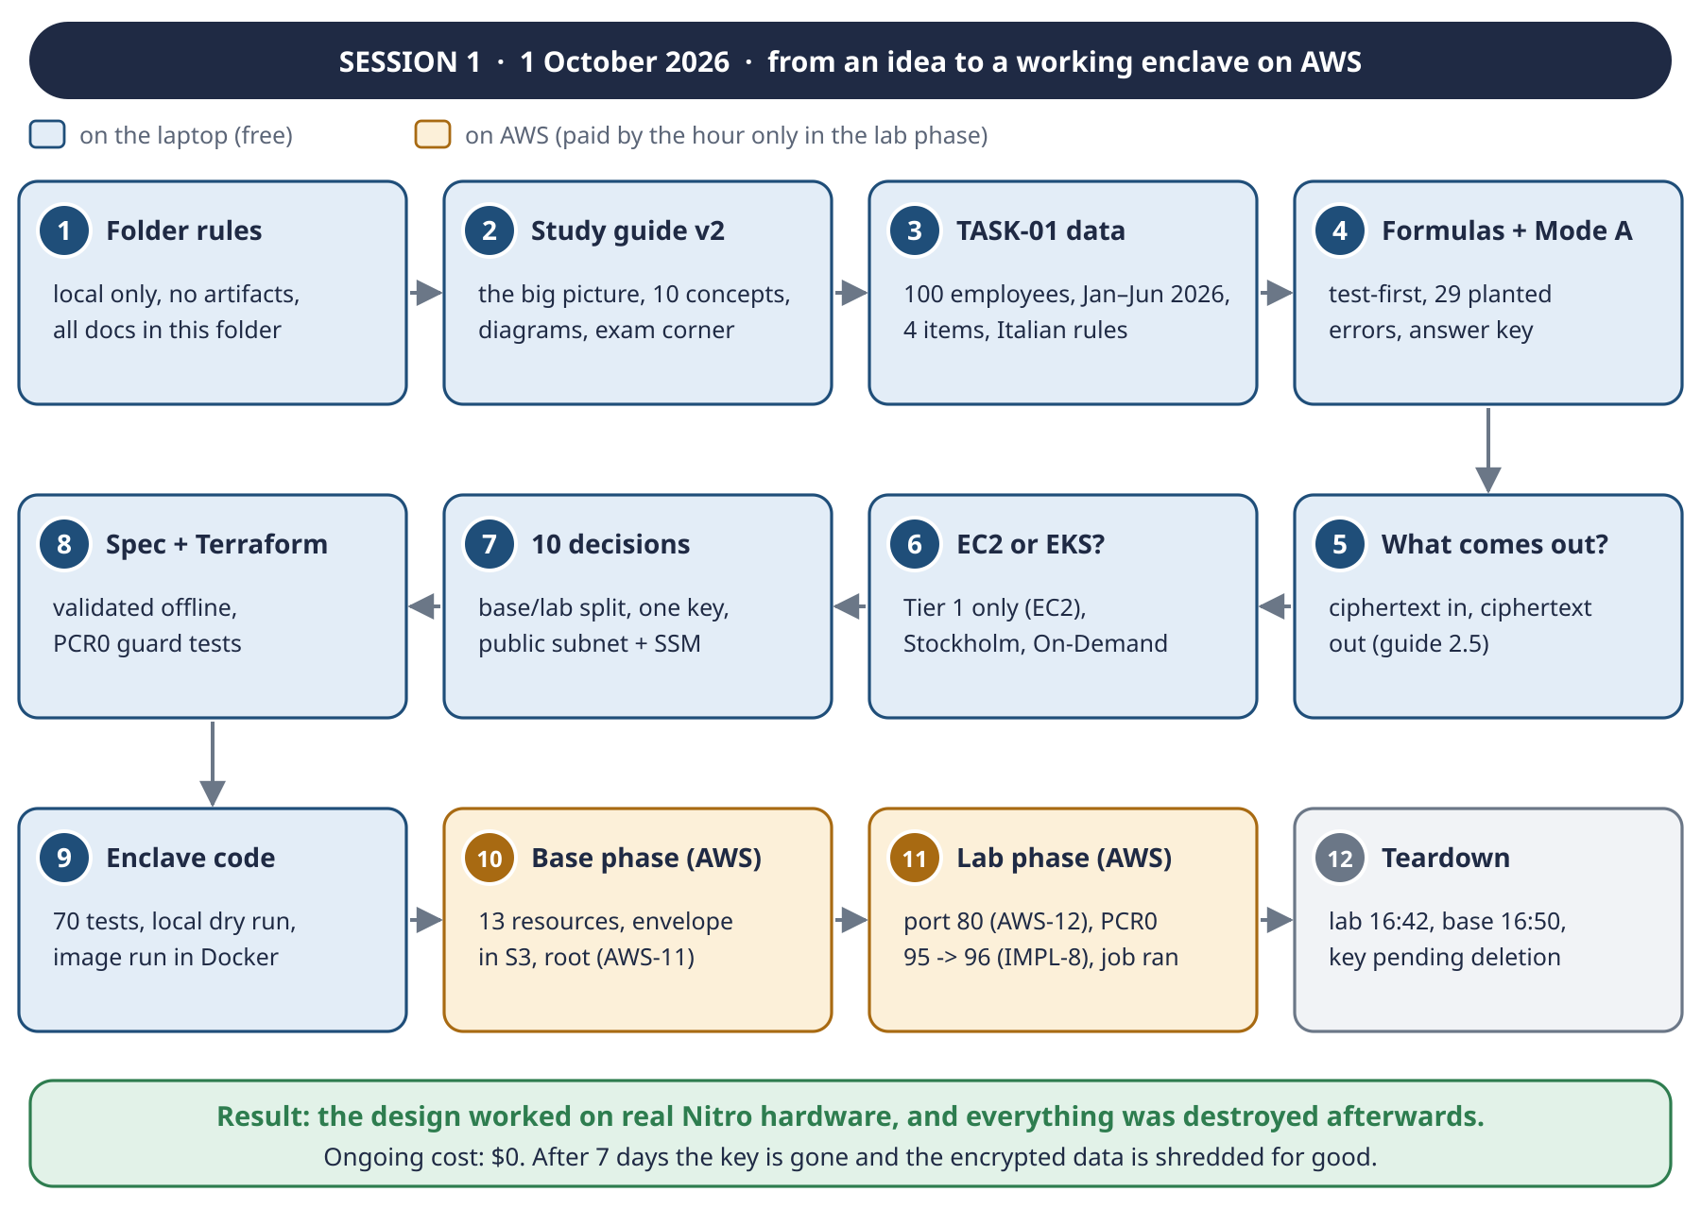
Schema 8 · Session 1, from the folder rules to the teardown.

6. What we did, step by step
# | Milestone | What happened | Output
1 | Folder rules | everything stays local; no artifacts, no cloud documents, no remote sessions; later also no Jira | memory rule, .gitignore
2 | Study guide v2 | the v1 guide reorganised into three parts, with diagrams for the big picture and memory aids | study guide v2
3 | TASK-01 defined | synthetic payslips, 100 employees, one semester; formulas for 4 items; how they run in the enclave | poc/README.md (DATA-1..7)
4 | Formulas and Mode A | simplified Italian rules, test-first; dataset generator with 29 planted errors and an answer key; data dictionary | poc/payslip/, data/, data dictionary
5 | What comes out? | can the result leave in clear? It depends on whether it can be linked to a person | guide section 2.5, Schema 2c
6 | EC2 or EKS? | EKS does not replace EC2; Tier 1 (one EC2 instance) proves the hard part | deployment paths document
7 | Ten decisions | Stockholm, base/lab split, one key, public subnet with SSM, ready-made parts, report in clear, m6i.xlarge, On-Demand | TASK-02
8 | Spec and Terraform | design approved section by section; Terraform written and validated offline, with tests for the PCR0 guard | spec, infra/
9 | Enclave code | envelope, encryption script, enclave app, parent runner, build scripts; 70 tests; the image built and run locally | poc/enclave/, procedures
10 | Base phase on AWS | 13 resources; the envelope uploaded; Terraform ran as the account root user | decision AWS-11
11 | Lab phase on AWS | port 80 needed by the kmstool build; a PCR0 copied with 95 characters; the job ran inside the enclave | decisions AWS-12, IMPL-8
12 | Teardown | lab destroyed at 16:42, base at 16:50 (after emptying the bucket); the key is pending deletion | $0 ongoing

LESSON What was not recorded. The job ran (you saw it work), but the status line, tests B1 and B2 and the score were not pasted, and the report was not downloaded before the bucket was deleted. The formal proof of tests A and B can be collected in the next run.

7. Every decision
All decisions were taken on 1 October 2026. The full table, always up to date, is poc/README.md.

7.1 Data and formulas (DATA)
ID | Decision | Why
DATA-1 | synthetic data only: 100 employees, January–June 2026, EUR | no real person; safe to test anywhere
DATA-2 | Italian payroll rules, simplified | realistic but quick
DATA-3 | four items: overtime, bank holidays, sick days, termination | the requested 3–4 items
DATA-4 | Mode A (check) first, then Mode B (next month), same formulas | Mode A can be tested
DATA-5 | ~5% planted errors plus a separate answer key | proves the check finds exactly the errors
DATA-6 | field names proposed by Claude, reviewed afterwards | unblocks the dataset
DATA-7 | formulas as code inside the enclave image; dataset declares rules_version | any formula change becomes a reviewed key-policy change

7.2 AWS deployment (AWS)
ID | Decision | Why
AWS-1 | Region eu-north-1 (Stockholm) | your choice
AWS-2 | Terraform split: base (kept) and lab (per session) | pay only while working
AWS-3 | one KMS key, never rotated, protected from destroy | each rotation adds $1/month; data stays decryptable across sessions
AWS-4 | Tier 1 only: EC2, no EKS | proves the hard part with the fewest moving parts
AWS-5 | Spot (replaced by AWS-10) | —
AWS-6 | public subnet, 0 inbound rules, SSM access, IMDSv2 | the key policy, not the network, protects the data
AWS-7 | ready-made parts; Docker only to build; image stored in S3 | less code of our own in the trusted part; Fargate cannot run enclaves
AWS-8 | no output encryption in the POC | synthetic data; the input stays fully protected
AWS-9 | m6i.xlarge; 2 vCPU + 4 GiB for the enclave | twice the memory of c6i, cheaper on Spot
AWS-10 | On-Demand | no capacity surprises
AWS-11 | Terraform runs as the account root user (known deviation) | your choice for the POC; Decrypt is still enclave-only
AWS-12 | outbound port 80 in the lab security group | the kmstool build fetches Amazon Linux 2 mirrors over HTTP

7.3 Implementation choices (IMPL)
ID | Choice | Why
IMPL-1 | kmstool from the SDK v0.4.5, commit checked | a moving branch would change PCR0
IMPL-2 | image: Amazon Linux 2023 + Python 3.9 + python3-cryptography | verified by building and running it locally
IMPL-3 | vsock port 5000, 8-byte length + JSON, max 64 MB; KMS through proxy port 8000 | simple framing, tested
IMPL-4 | status line without personal data; errors return only type + short message, credentials redacted | the parent is untrusted
IMPL-5 | report uploaded only if its SHA-256 matches the status line | catches a damaged or altered report
IMPL-6 | startup script writes /opt/poc/poc.env and pre-loads the code | scripts on the instance need no arguments
IMPL-7 | PCR0 kept in infra/base/pcr0.auto.tfvars | a later apply can't silently drop the enclave statement
IMPL-8 | PCR0 read from pcrs.json, never copied by hand | a hand-copied PCR0 lost one character

7.4 Design decisions from the documents
Decision | Where | Summary
D1–D10 | study guide, Part II | the deployment questions; D10 is about how results leave the enclave
Design sections 1–5 | spec | what Terraform creates, the key policy, inside the enclave, the session, safety nets
Three safety nets | spec section 8 | destroy, self-destruct after 4 hours, budget alert
No AMI | Part VII of this handbook | the image in S3 already gives a stable PCR0
Manual first session | Part VII of this handbook | only pinning PCR0 must stay human; the rest could be automated

8. Working rules
- Nothing personal is committed. No real names or emails, no AWS account IDs, bucket names or instance IDs, and no local paths.
- .docx documents, generated by scripts. Edit the scripts, not the .docx.
- Synthetic data only. State files, plan files, *.tfvars, the local encrypted copies and downloaded reports are git-ignored.
- Explained, then decided. Every step was explained before it was taken, and every decision was written down with its reason.
- You run AWS commands yourself, in your own terminal, and paste the results to check them.
REMEMBER A decision is only useful if its reason is written next to it. That is why every table here has a "why" column.

SELF-CHECK Which two decisions were added during the deployment itself, and what problem did each one solve?

Part III · The use case: payslip reconciliation
The POC needed a realistic job with real-looking data, real formulas and a result we can check. Payslip reconciliation fits: payroll data is sensitive (salaries, sick leave, dismissals), and the formulas are easy to verify by hand.
TRAP Simplified on purpose. Real Italian payroll depends on the national contract (CCNL), IRPEF brackets and deductions, INPS sick-pay rules and the separate taxation of TFR. These formulas are right for a POC, not for real payslips.

9. The dataset
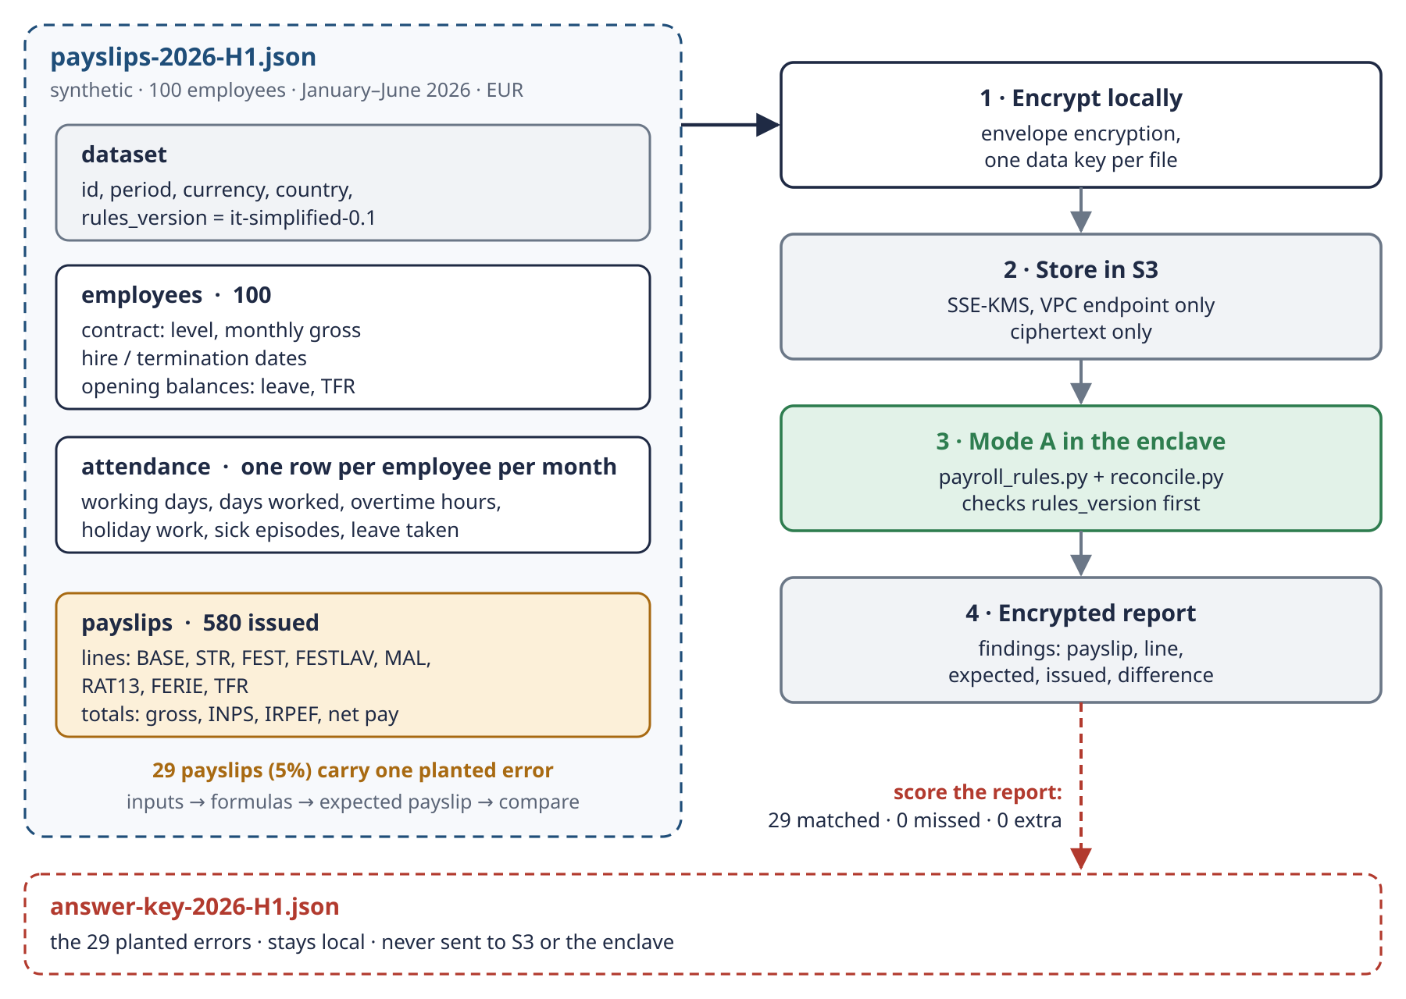
Schema 4 · The dataset, its path to the enclave, and the answer key that never leaves the laptop.

9.1 The four sections of payslips-2026-H1.json
Section | One entry per | Holds
dataset | file | id payslip-reconciliation-2026-H1, period, EUR, IT, `rules_version` = it-simplified-0.1, seed, synthetic: true
employees | person (100) | name, department, hire and termination dates, contract (level, monthly gross), opening balances (leave days, TFR fund)
attendance | person per month employed | working days, days worked, overtime hours, holiday work, sick episodes, leave taken
payslips | person per month employed (580) | the issued lines (BASE, STR, FEST, FESTLAV, MAL, RAT13, FERIE, TFR) and totals

9.2 The numbers
Item | Value
Employees | 100 (E001–E100)
Payslips | 580 (one per employee per month employed)
Terminated during the semester (6) | E026 7 Feb · E060 9 Feb · E043 19 Mar · E062 5 Jun · E095 7 Jun · E055 17 Jun
Hired during the semester (4) | E066 10 Feb · E014 5 Mar · E068 17 Apr · E078 17 Apr
Planted errors | 29 (5% of payslips), one per payslip
Net impact of the errors | +311.45 EUR (overpayments and underpayments together)
File sizes | plaintext JSON 579,366 bytes · envelope 773,025 bytes (base64 adds about a third)
Reproducible | the same seed (20260101) always produces identical files

10. The formulas

10.1 The parameters
Parameter | Value | Used for
hourly rate | monthly gross ÷ 173 | overtime, holiday work
daily rate | monthly gross ÷ 26 | holiday on a rest day, sick leave, unused leave
overtime premium | +25% | STR
holiday work premium | +50% | FESTLAV
sick leave | days 1–3 of each episode at 100%, from day 4 at 75% | MAL
leave accrual | 26 days per year (26 ÷ 12 per month) | FERIE
accrual month | a month counts if employed 15 days or more | RAT13, FERIE
TFR | base pay ÷ 13.5 | TFR
INPS (employee) | 9.19% of gross | totals
IRPEF | 23% flat of (gross − INPS), no deductions | totals
public holidays H1 2026 | 1 Jan, 6 Jan, 6 Apr, 25 Apr (Saturday), 1 May, 2 Jun | FEST, FESTLAV

10.2 The eight payslip lines
Code | Voce | Formula
BASE | Retribuzione base | monthly gross × days employed ÷ days in the month
STR | Straordinario | hours × hourly rate × 1.25
FEST | Festività in giorno di riposo | days × daily rate (a holiday on Saturday or Sunday)
FESTLAV | Lavoro festivo | hours × hourly rate × 1.50
MAL | Riduzione malattia | − (days from the 4th of each episode) × daily rate × 0.25
RAT13 | Rateo tredicesima | monthly gross × months accrued ÷ 12 (termination month)
FERIE | Ferie non godute | (opening leave + 26 ÷ 12 × months accrued − leave taken) × daily rate (termination month)
TFR | Trattamento di fine rapporto | opening TFR fund + base pay of 2026 ÷ 13.5 (termination month, not taxed here)

Totals: gross = every line except TFR · INPS = gross × 9.19% · IRPEF = (gross − INPS) × 23% · net = gross − INPS − IRPEF + TFR. Every line is rounded to the cent, half-up.

10.3 Worked example 1: overtime (from the tests)
Line | Calculation | Amount
BASE | 2,400 × 31 ÷ 31 | 2,400.00
STR | 10 h × (2,400 ÷ 173 = 13.8728) × 1.25 | 173.41
Gross | 2,400.00 + 173.41 | 2,573.41
INPS | 2,573.41 × 9.19% | − 236.50
IRPEF | (2,573.41 − 236.50) × 23% | − 537.49
Net pay |  | 1,799.42

10.4 Worked example 2: E001, April 2026 (from the dataset)
Anna Fabbri, warehouse, monthly gross €2,275.65, works 8 hours on Easter Monday, and 25 April falls on a Saturday.
Line | Calculation | Amount
BASE | full month: 2,275.65 × 30 ÷ 30 | 2,275.65
FEST | 1 day × (2,275.65 ÷ 26 = 87.525) | 87.53
FESTLAV | 8 h × (2,275.65 ÷ 173 = 13.1541) × 1.5 | 157.85
Gross | 2,275.65 + 87.53 + 157.85 | 2,521.03
INPS | 2,521.03 × 9.19% | − 231.68
IRPEF | (2,521.03 − 231.68) × 23% | − 526.55
Net pay |  | 1,762.80

10.5 Worked example 3: E026, termination on 7 February 2026
Stefano Bianchi, monthly gross €1,910.47, dismissed on 7 February, with 14 days of unused leave and €19,424.57 of TFR at the start of the year. In February he was also sick for one episode of 4 working days, starting on 2 February.
Line | Calculation | Amount
BASE | 1,910.47 × 7 days ÷ 28 | 477.62
MAL | 1 day beyond the 3rd × (1,910.47 ÷ 26 = 73.4796) × 0.25 | − 18.37
RAT13 | January counts (31 days), February does not (7 < 15): 1 × 1,910.47 ÷ 12 | 159.21
FERIE | (14 opening + 26 ÷ 12 × 1 accrued − 9 taken) = 7.17 days × 73.4796 | 526.60
TFR | 19,424.57 + (1,910.47 + 477.62) ÷ 13.5 | 19,601.47
Gross | 477.62 − 18.37 + 159.21 + 526.60 | 1,145.06
INPS | 1,145.06 × 9.19% | − 105.23
IRPEF | (1,145.06 − 105.23) × 23% | − 239.16
Net pay | 1,145.06 − 105.23 − 239.16 + 19,601.47 | 20,402.14

REMEMBER Two rates do almost everything: hourly = monthly ÷ 173, daily = monthly ÷ 26. Termination adds three lines: 13th-month accrual, unused leave, TFR.

11. Reconciliation (Mode A) and the planted errors

11.1 How Mode A works
- Check that the dataset declares the same rules_version as the code; otherwise refuse it.
- For each issued payslip, take the employee's attendance from January up to that month.
- Recompute the expected payslip with the formulas.
- Compare the issued lines with the expected lines, by code. Every difference is a finding: payslip, employee, month, line, expected, issued, difference.
- Summarise: payslips checked, payslips with differences, net impact.

11.2 The seven planted error types
Error type | What is wrong | Line | Count
OVERTIME_NO_PREMIUM | overtime paid at the plain rate, without +25% | STR | 4
OVERTIME_HOURS_SHORT | overtime paid for 2 hours fewer than recorded | STR | 8
HOLIDAY_REST_DAY_MISSING | 25 April not paid as an extra day | FEST | 3
HOLIDAY_WORK_LOW_PREMIUM | holiday work at +25% instead of +50% | FESTLAV | 5
SICK_REDUCTION_MISSING | sick days from the 4th paid at 100% | MAL | 7
TERMINATION_LEAVE_MISSING | unused leave not paid at termination | FERIE | 1
BASE_NOT_PRORATED | full salary in a partial month | BASE | 1
Total |  |  | 29

Example: payslip PS-2026-01-E012 pays overtime for 2 hours fewer than recorded. The STR line should be €64.07 but shows €27.46: a difference of −€36.61, which lowers the net pay by €25.61.

11.3 Why an answer key, and how the score works
A check that says "no differences found" proves nothing on its own. So the data carries known errors, and the list of those errors, the answer key, stays on the laptop. The enclave never sees it. After the run, score_report.py compares the findings with the answer key on the pair (payslip, line):
Result | Meaning
matched | a planted error that the enclave found
missed | a planted error that the enclave did not find
unexpected | a finding that is not in the answer key (a false alarm)

A perfect run is 29 matched, 0 missed, 0 unexpected, with exit code 0. Locally, this was proven three ways: the Python tests, the local dry run of the enclave logic, and the enclave image run in Docker.

11.4 Mode B (next step)
Mode B uses the same formulas to compute July 2026 from the six months of history plus July's events. Its output is new payslips, which are personal data, so in production they must leave the enclave sealed.

12. The code, walked through

12.1 payroll_rules.py: the formulas as pure functions
Pure means: no files, no network, no clock. Given the same input, the same output. That makes the formulas easy to test and safe to put in an enclave.
RULES_VERSION = 'it-simplified-0.1'
HOURLY_DIVISOR = Decimal('173') # monthly gross / 173 = hourly rate
OVERTIME_PREMIUM = Decimal('0.25')

def overtime_pay(monthly_gross, hours):
return _cents(_d(hours) * hourly_rate(monthly_gross) * (1 + OVERTIME_PREMIUM))

def sick_adjustment(monthly_gross, episode_days):
reduced_days = sum(max(0, d - SICK_FULL_PAY_DAYS) for d in episode_days)
return -_cents(reduced_days * daily_rate(monthly_gross) * SICK_REDUCTION)

compute_payslip(employee, attendance_ytd) builds the expected lines for the last month in the list, and adds the three termination lines when the employee leaves that month. Money uses Decimal, rounded half-up on every line.

12.2 reconcile.py: Mode A
if dataset['dataset']['rules_version'] != pr.RULES_VERSION:
raise ValueError(...) # data meant for other rules is refused
for p in dataset['payslips']:
expected = pr.compute_payslip(employees[p['employee_id']], ytd)
# compare issued vs expected line by line -> findings

12.3 generate_dataset.py: realistic data with known errors
- A seeded random generator, so the same seed always gives the same files.
- Employees with levels L1–L6, salaries, departments, hire dates, opening balances; 6 leavers and 4 joiners.
- Attendance with overtime, sick episodes, leave (never more than available), holiday work in sales and warehouse.
- Payslips computed with the same formulas, then 29 errors planted, one per payslip, with at least one of each type.
- A self-check in the tests: Mode A must find exactly the planted errors.

12.4 The tests for this part (47)
Test file | Tests | What it proves
test_payroll_rules.py | 14 | every formula against values computed by hand
test_reconcile.py | 6 | correct payslips give no findings; each kind of difference is found; other rules are refused
test_generate_dataset.py | 9 | shape, edge cases, reproducibility, ~5% errors, exact detection
test_envelope.py | 9 | the envelope format (Part IV)
test_encrypt_input.py | 7 | the encryption script with a fake AWS CLI (Part IV)
test_score_report.py | 2 | perfect score exits 0, a missed error exits 1

REMEMBER Formulas as pure functions, data with known errors, and an answer key that never leaves the laptop. That is what makes the result checkable.

SELF-CHECK Recompute the FEST line for an employee with a monthly gross of €2,600 in April 2026. Why is there no FEST line in May?

Part IV · Security mechanisms in depth
Six mechanisms work together. Each chapter explains one: what it is, how we used it, and what it does and does not protect.

13. Envelope encryption and the envelope format
In one line: the data is encrypted on the laptop with a small data key; KMS protects only that data key.

13.1 Why not just "KMS Encrypt" the file?
KMS Encrypt accepts only about 4 KB. Our JSON is 580 KB. So we ask KMS for a data key, encrypt the file locally with it, and keep only the encrypted copy of the data key next to the data. This is envelope encryption, and it is also the most common KMS exam question.

13.2 The six steps of encrypt_input.py
# | Where | What happens | Layer
2a | laptop → KMS | GenerateDataKey (AES-256): KMS returns a plaintext copy and an encrypted copy of the same key
2b | laptop | encrypt the JSON with AES-256-GCM, using the dataset id as aad | 1 · envelope
2c | laptop | wipe the plaintext data key (best effort in Python)
2d | laptop → S3 | upload the envelope over TLS (the bucket refuses non-TLS) | in transit
2e | S3 | S3 encrypts it again at rest (SSE-S3) | 2 · at rest
2f | both ends | refuse anything that is not an envelope, and any dataset not marked synthetic | safety check

13.3 The envelope, field by field
{ "format": "poc-envelope-v1",
"kms_key_id": "arn:aws:kms:eu-north-1:<account>:key/<id>",
"encrypted_data_key": "<base64>",
"algorithm": "AES-256-GCM",
"nonce": "<base64, 12 bytes>",
"aad": "payslip-reconciliation-2026-H1",
"ciphertext": "<base64>" }

Field | Meaning
format, algorithm | what this is and how it was sealed; anything else is refused
kms_key_id | which KMS key protects the data key
encrypted_data_key | the data key, encrypted under the KMS key: useless without KMS
nonce | 12 random bytes, fresh for every seal: AES-GCM must never reuse a nonce with the same key
aad | "additional authenticated data": not secret, but bound to the ciphertext. Change it and decryption fails
ciphertext | the encrypted JSON plus a 16-byte authentication tag

13.4 What AES-GCM gives us
- Confidentiality: without the data key, the ciphertext reveals nothing.
- Integrity: the authentication tag covers the ciphertext and the aad. Change one bit, and decryption raises InvalidTag. That is why the untrusted parent can carry the envelope: it can drop it, but not change it unnoticed.
def seal(plaintext, aad, data_key, encrypted_data_key, kms_key_id):
try:
nonce = os.urandom(12)
ciphertext = AESGCM(bytes(data_key)).encrypt(nonce, plaintext, aad.encode())
finally:
_wipe(data_key) # best effort

TRAP No encryption context. KMS supports an "encryption context" that would bind extra data to the data key, but the ready-made kmstool cannot pass one. So encrypt_input.py must not use it, or the enclave could never decrypt. A test checks this.

Schema 3b · Envelope encryption, encrypt and decrypt lanes.
REMEMBER Big data never goes to KMS; only a small data key does. The envelope travels everywhere; the key to open it is released only to the enclave.

14. The KMS key and its policy
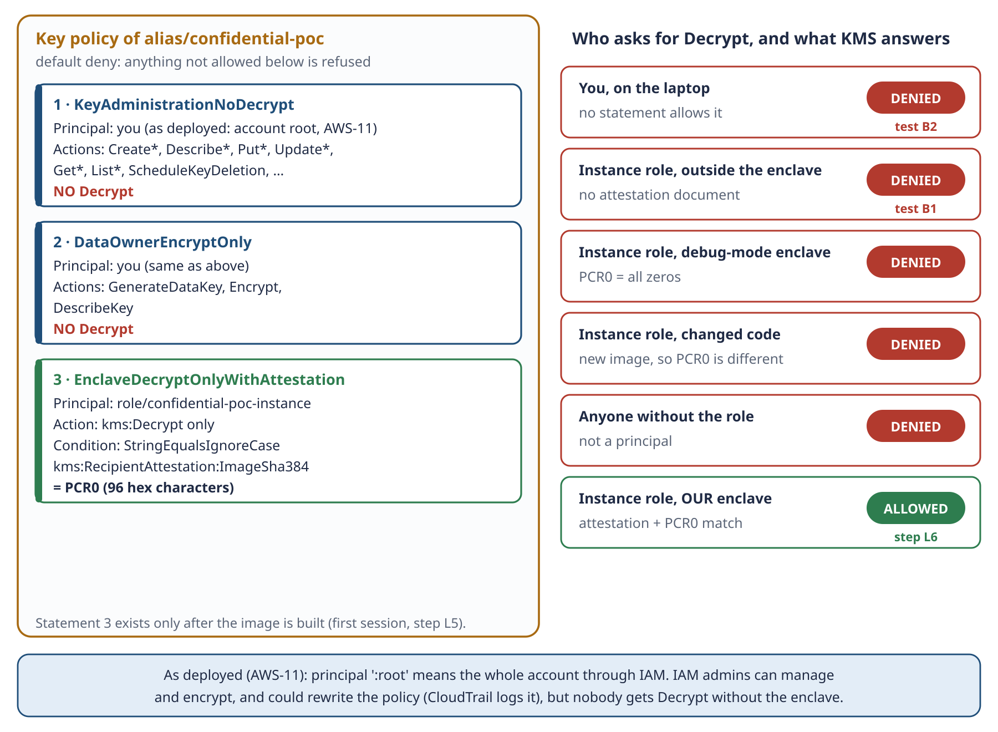
Schema 10 · The key policy, statement by statement, and what KMS answers to each caller.

14.1 Three kinds of KMS key
 | Customer managed | AWS managed | AWS owned
Example here | alias/confidential-poc | aws/ebs (the parent's disk) | used inside AWS services
Who creates it | you | AWS, on first use by a service | AWS
You control the policy | yes: needed for attestation | no | no
Rotation | your choice (off in the POC) | automatic, yearly | AWS's choice
Monthly fee | $1 (+$1 per rotation, up to two) | none | none
Can be deleted | yes, after 7–30 days | no | no

14.2 The third statement, as JSON
{ "Sid": "EnclaveDecryptOnlyWithAttestation",
"Effect": "Allow",
"Principal": { "AWS": "arn:aws:iam::<account>:role/confidential-poc-instance" },
"Action": "kms:Decrypt",
"Resource": "*",
"Condition": { "StringEqualsIgnoreCase": {
"kms:RecipientAttestation:ImageSha384": "<PCR0, 96 hex characters>" } } }

Read it as: *the instance role may decrypt only if the request carries an attestation document whose image hash equals this PCR0.* Without an attestation document the condition is false, so the statement does not apply, and nothing else allows Decrypt. KMS denies by default.

14.3 No account-root statement, as designed and as deployed
Most examples add a statement for arn:aws:iam::<account>:root, which lets IAM policies in the account grant use of the key. We designed it without that statement, so that only the key policy decides.
In session 1, Terraform ran as the account root user (AWS-11). Our first two statements name "the identity that runs Terraform", which became …:root. In a key policy that means the whole account, through IAM. The consequences:
- IAM admins in the account can manage the key and encrypt with it, and could rewrite the policy. CloudTrail would log it.
- Nobody can decrypt without the enclave: neither statement 1 nor 2 includes Decrypt, so IAM cannot grant it.
- In production: a dedicated IAM identity with MFA, the root user locked away.

14.4 Life of the key
State | When | Cost
Enabled | from the base apply until the teardown | $1/month, prorated hourly
PendingDeletion | after terraform destroy on base: a 7-day window (we chose the minimum) | free
Deleted | after the window | — the envelope can never be decrypted again (crypto-shredding)

During the window the deletion can be cancelled with aws kms cancel-key-deletion and aws kms enable-key. Terraform also refuses by itself to destroy the key: prevent_destroy = true, switched off only for the teardown.
EXAM NOTE Key policy first. A KMS key policy is the primary access control; IAM policies count only if the key policy lets the account delegate to IAM. Questions about "who can use this key" are answered by the key policy.

REMEMBER The key policy separates trusted people (the data owner) from the untrusted platform (the instance), and the platform only gets the key through attestation.

15. Nitro Enclaves and attestation

15.1 What an enclave really is
- A separate virtual machine carved out of the EC2 instance: 2 vCPUs and 4 GiB taken away from the parent by the allocator service (they appear as hugepages).
- No disk, no network, no SSH. The enclave image (EIF) is loaded into RAM. Its only channel is vsock, a local socket: the parent has CID 3, the enclave gets its own CID (for example 16).
- The Nitro Hypervisor isolates its memory, so even root on the parent cannot read it.
- It lives only while the parent runs; stopping or terminating the parent ends it, and its memory is wiped.

15.2 The attestation document
Inside the enclave there is a small device, the NSM (Nitro Security Module, /dev/nsm). Asked by the code, it returns an attestation document signed by AWS's Nitro hardware. It contains:
Field | Content
PCRs | the measurements of what is running (table below)
certificate + CA bundle | the chain up to the AWS Nitro root certificate, so KMS can check the signature
public_key | a temporary public key created by the enclave; KMS encrypts the answer to it
user_data, nonce, timestamp, module id | extra fields for freshness and identification

Register | Measures | Used in the POC
PCR0 | the whole enclave image (EIF) | yes: the key policy condition
PCR1 | the Linux kernel and boot ramdisk | no
PCR2 | the application | no
PCR3 | the IAM role of the parent instance | no (could bind the key to the role too)
PCR4 | the instance ID of the parent | no
PCR8 | the certificate that signed the image | no (production option: sign builds, pin PCR8)

15.3 How kmstool gets the key
- kmstool creates a temporary RSA key pair inside the enclave.
- It asks the NSM for an attestation document that includes the public key.
- It sends Decrypt(encrypted data key + attestation document) to KMS, through the parent's vsock-proxy on port 8000.
- KMS checks the signature chain and compares PCR0 with the key policy.
- KMS does not return the plaintext data key. It returns it encrypted to the enclave's public key ("ciphertext for recipient").
- kmstool decrypts it with the private key, which never left the enclave, and prints PLAINTEXT: <base64> to our app.
Schema 3c · The attestation handshake.

15.4 Why your laptop can never decrypt, even with the same Docker image
Lock | Your laptop | Parent instance | Our enclave
Identity in the key policy | no Decrypt at all | yes (instance role) | yes (same role)
Attestation signed by Nitro | no NSM: kmstool stops | no document | yes
PCR0 equal to the pinned one | no measurement | no | yes

A forged attestation document fails, because it cannot carry a valid AWS signature. And PCR0 is measured by the hardware when the enclave starts, not read from the image file.

15.5 Debug mode
nitro-cli run-enclave --debug-mode gives a console for troubleshooting, and breaks isolation. Its PCRs are all zeros, so KMS refuses it. Terraform refuses to pin a zero PCR0 (tested offline). Debug mode is only for checking that the app starts.
REMEMBER Credentials say who you are, attestation proves where you run, PCR0 proves what you run. KMS needs all three.

16. S3: the post office
Setting | What it does
Block Public Access (all four) | nothing in the bucket can ever be made public
Object ownership: bucket owner enforced | no ACLs; the account owns every object
Default encryption SSE-S3 | layer 2: everything is encrypted at rest, automatically
Bucket policy DenyInsecureTransport | refuses any request without TLS
Lifecycle: abort incomplete uploads after 1 day | no hidden cost from failed multipart uploads
Instance role permissions | read input/ and enclave/, write reports/ and enclave/, list the bucket

Folder | Content | Protection
input/ | the payslips envelope | layer 1 (envelope) + layer 2 (SSE-S3)
enclave/ | the code (src/), the image (EIF), pcrs.json | SSE-S3; integrity enforced by PCR0
reports/ | the report | SSE-S3 only (POC, decision AWS-8)

Why SSE-S3 and not our KMS key? If S3 used our key, the instance role would need ordinary Decrypt rights for S3, and the key policy would no longer be "Decrypt only for the enclave". The production design in the guide uses SSE-KMS with Bucket Keys, with a separate key.
REMEMBER Layer 1 protects the data from everyone except the enclave. Layer 2 only protects the disks inside AWS.

17. The parent's disk (EBS)
Every EC2 instance needs a disk to boot: Linux and the programs live there. On AWS that disk is an EBS volume. Ours was 30 GB gp3, encrypted, deleted on termination.
On the disk | Sensitive?
Amazon Linux, nitro-cli, Docker, the kmstool build, the EIF | no: code and tools
The downloaded envelope, /tmp/edk.bin | ciphertext only
/opt/poc/reports/report-…json | yes in real life (POC: synthetic, decision AWS-8)
The decrypted payslips | never there: they exist only in the enclave's memory

- Encryption at rest (the AWS managed key aws/ebs) protects against a stolen physical disk, not against root on the running instance. That is why only ciphertext may reach the parent.
- delete_on_termination = true: destroying the lab deletes the volume. To find forgotten volumes: aws ec2 describe-volumes --filters Name=status,Values=available.
- aws/ebs stays in your account after the teardown. It cannot be deleted, costs nothing, and does nothing until an encrypted volume needs it.
REMEMBER The enclave has no disk; the parent's disk only sees ciphertext. Encryption at rest protects disks, not running machines.

18. Network and access
Control | Setting | Why
Subnet | public, with a public IP | the first session needs internet to install and build
Security group in | zero rules | nobody can start a connection to the instance
Security group out | 443, plus 80 (AWS-12) | HTTPS for AWS and packages; HTTP for Amazon Linux 2 mirrors
Access | SSM Session Manager | no SSH, no open port; IAM-checked; logged
Metadata | IMDSv2 only, hop limit 1 | session tokens; containers on the host cannot reach the metadata service
KMS from the enclave | vsock-proxy with an allow-list | the enclave can reach only kms.eu-north-1.amazonaws.com

Security groups are stateful: replies to outbound connections come back automatically, and outbound rules never open anything inbound. "Outbound 80" means the instance may call out on HTTP; it does not let anyone call in.
How SSM works: the SSM agent on the instance keeps an outbound HTTPS connection to the Systems Manager service. When you run aws ssm start-session, your IAM identity is checked, and the shell is tunnelled through that connection. It needs the plugin on the laptop, the AmazonSSMManagedInstanceCore policy on the role, and outbound 443.
Why hop limit 1 matters: the metadata service gives out the role's temporary credentials. With a hop limit of 1, processes on the host can reach it, but containers behind Docker's network cannot. So a container cannot steal the role. A likely side effect: the Amazon Linux 2 build container could not learn its Region, so yum fell back to the generic amazonlinux.default.amazonaws.com mirror, over port 80. That led to decision AWS-12.
REMEMBER The network is an extra layer, not the main lock. Zero inbound, outbound only what is needed, SSM instead of SSH, IMDSv2 with hop limit 1.

SELF-CHECK Name three things the parent instance can do with the envelope, and two it cannot.

Part V · Infrastructure as code
Terraform describes the infrastructure as files, and makes AWS match them. Everything we deployed is in infra/: two separate setups with their own state.
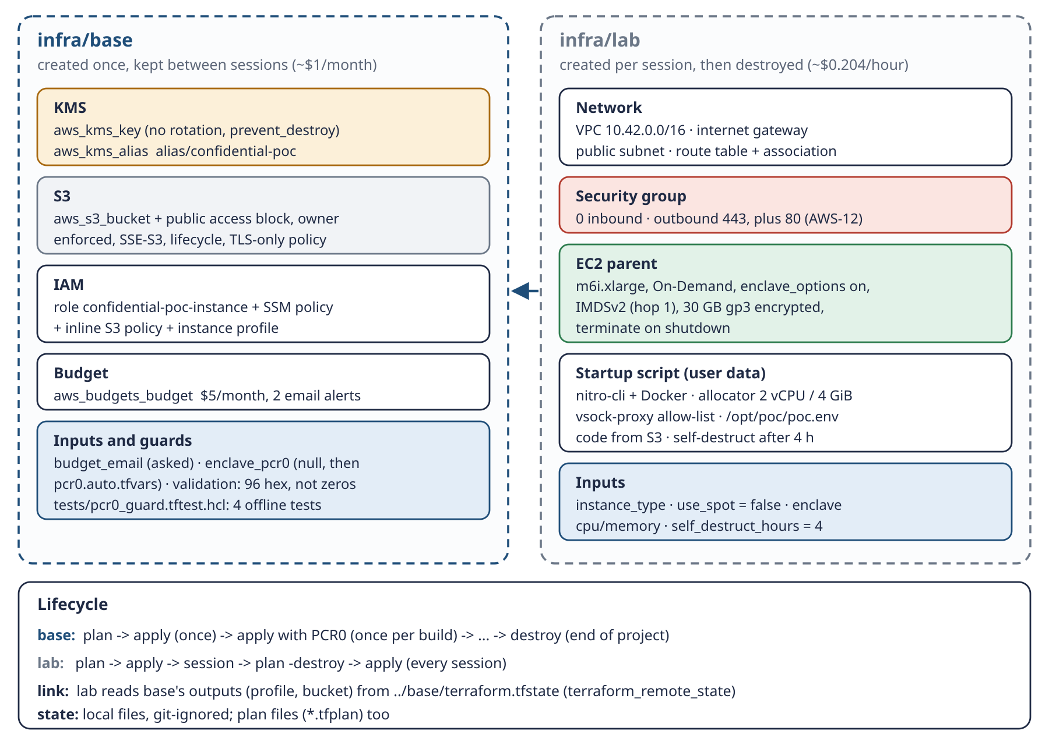
Schema 11 · The two Terraform setups, their contents, how lab reads base, and their lifecycles.

19. Why two setups
 | infra/base | infra/lab
Lifetime | created once, kept between sessions | created per session, then destroyed
Contents | identity + key + storage: things that must survive | network + compute: things billed by the hour
Resources | 13 | 7
Cost | ~$1/month | $0.204/hour while it exists
Destroy | only at the end of the project (the key is protected) | at the end of every session

TRAP Why the IAM role is in base, not lab. If a role named in a key policy is deleted and recreated, KMS no longer recognises it: the policy keeps an internal ID of the old role. The lab is destroyed every session, so the role lives in base. IAM roles are free.

20. infra/base, file by file
File | What it does
versions.tf | Terraform ≥ 1.6, AWS provider ~> 6.0 (6.67.0 used), Region, default tags on every resource (Project, Stack, ManagedBy)
variables.tf | region, name_prefix, budget_email (no default: asked at apply), budget_limit_usd (5), enclave_pcr0 (null, with the guard)
kms.tf | who runs Terraform, the key policy (3 statements, the third only with PCR0), the key, the alias
s3.tf | the bucket confidential-poc-<account>-eu-north-1 and its 6 settings
iam.tf | the instance role (trusted by EC2), SSM managed policy, inline S3 policy, instance profile; no KMS permission
budget.tf | $5/month, email at 80% actual and 100% forecast
outputs.tf | region, key ARN and alias, bucket, role ARN, profile name, pcr0_pinned
tests/pcr0_guard.tftest.hcl | 4 offline tests of the PCR0 guard, with a mock AWS provider

20.1 The PCR0 guard
variable "enclave_pcr0" {
type = string
default = null
validation {
condition = var.enclave_pcr0 == null || (
can(regex("^[0-9a-fA-F]{96}$", var.enclave_pcr0)) &&
lower(coalesce(var.enclave_pcr0, "x")) != join("", [for i in range(96) : "0"])
)
}
}

It allows "no PCR0 yet" (first apply), refuses anything that is not exactly 96 hex characters, and refuses the debug-mode value. In session 1 it caught a PCR0 that had lost one character in a copy-paste.

20.2 Who is "me"?
data "aws_caller_identity" "current" {}
data "aws_iam_session_context" "current" {
arn = data.aws_caller_identity.current.arn
}
locals { me = data.aws_iam_session_context.current.issuer_arn }

aws_iam_session_context turns a temporary session ARN into a stable one (the role ARN for an assumed role, the user ARN for an IAM user). For the root user it returns arn:aws:iam::<account>:root, which is what happened in session 1.

20.3 The third statement appears only with PCR0
dynamic "statement" {
for_each = var.enclave_pcr0 == null ? [] : [var.enclave_pcr0]
content {
sid = "EnclaveDecryptOnlyWithAttestation"
actions = ["kms:Decrypt"]
principals { type = "AWS", identifiers = [aws_iam_role.instance.arn] }
condition {
test = "StringEqualsIgnoreCase"
variable = "kms:RecipientAttestation:ImageSha384"
values = [statement.value]
}
}
}

20.4 The key itself
resource "aws_kms_key" "poc" {
enable_key_rotation = false # each rotation would add $1/month
deletion_window_in_days = 7
policy = data.aws_iam_policy_document.key.json
lifecycle { prevent_destroy = true }
}

21. infra/lab, file by file
File | What it does
versions.tf | provider + terraform_remote_state: reads base's outputs from ../base/terraform.tfstate
variables.tf | instance_type (m6i.xlarge), use_spot (false), enclave CPU (2) and memory (4096), self_destruct_hours (4), root_volume_gb (30)
network.tf | VPC 10.42.0.0/16, internet gateway, public subnet, route table, security group
ec2.tf | the parent instance
user-data.sh.tftpl | the startup script, filled in by Terraform
outputs.tf | instance ID, the ready-made SSM command, purchasing, self-destruct reminder, bucket

21.1 The security group
egress { from_port = 443, to_port = 443, protocol = "tcp", cidr_blocks = ["0.0.0.0/0"] }
# AWS-12: Amazon Linux 2 mirrors used by the kmstool build are fetched over HTTP
egress { from_port = 80, to_port = 80, protocol = "tcp", cidr_blocks = ["0.0.0.0/0"] }
# no ingress block at all: zero inbound rules

TRAP Changing a security group's description forces Terraform to replace it, and a group attached to a running instance can't simply be deleted. When we added port 80 we left the description unchanged on purpose, so the change was in place.

21.2 The instance
resource "aws_instance" "parent" {
ami = data.aws_ssm_parameter.al2023.insecure_value
instance_type = var.instance_type
iam_instance_profile = data.terraform_remote_state.base.outputs.instance_profile_name
instance_initiated_shutdown_behavior = "terminate" # safety net 2
enclave_options { enabled = true }
metadata_options { http_tokens = "required", http_put_response_hop_limit = 1 }
root_block_device { volume_type = "gp3", volume_size = 30, encrypted = true }
dynamic "instance_market_options" { for_each = var.use_spot ? [1] : [] ... }
user_data = templatefile("user-data.sh.tftpl", { ... })
user_data_replace_on_change = true
}

- The AMI is read from AWS's public parameter for the latest Amazon Linux 2023, so it is always current.
- Changing the startup script replaces the instance (user_data_replace_on_change). That is why the self-destruct hours must be chosen before apply.
- In the plan, instance_market_options and ingress show "(known after apply)". That is AWS filling in computed values, not a Spot request or an inbound rule.

21.3 The startup script, section by section
Section | Command | Why
Self-destruct | shutdown -h +240 | with "terminate on shutdown", the instance deletes itself after 4 hours
Packages | dnf install aws-nitro-enclaves-cli …-devel docker git jq | the ready-made parts
Allocator | cpu_count: 2, memory_mib: 4096 in allocator.yaml | sets aside the enclave's vCPUs and memory
Proxy allow-list | add kms.eu-north-1.amazonaws.com if missing | vsock-proxy forwards only to listed hosts
Services | systemctl enable --now nitro-enclaves-allocator docker | start them now and at boot
Settings | write /opt/poc/poc.env (bucket, region, sizes) | scripts on the instance need no arguments
Code | aws s3 sync s3://<bucket>/enclave/src/ /opt/poc/src/ | the code is ready when you connect
Marker | /var/log/confidential-poc-ready | tells you the script has finished

21.4 Where the 4-hour rule lives
File | Line | Role
variables.tf | self_destruct_hours = 4 | the number you change
ec2.tf | self_destruct_minutes = var.self_destruct_hours * 60 | passes 240 to the script
user-data.sh.tftpl | shutdown -h +240 | schedules the shutdown at boot
ec2.tf | instance_initiated_shutdown_behavior = "terminate" | shutdown means delete, not stop

22. The Terraform concepts used
Concept | Where | What it does
Version constraints + lock file | versions.tf, .terraform.lock.hcl | everyone gets the same provider version
default_tags | provider block | tags every resource: easy to find leftovers
Data sources | caller identity, session context, AMI parameter, AZs | read facts from AWS without creating anything
locals | kms.tf | a named value (me)
dynamic blocks | key policy, market options | a block that exists only under a condition
lifecycle prevent_destroy | the key | Terraform refuses to destroy it
variable validation | enclave_pcr0 | refuses bad input before any API call
templatefile | user data | fills ${...} values into a script
terraform_remote_state | lab | reads another setup's outputs
plan -out / apply plan | every change | apply runs exactly the plan you read
plan -destroy | teardown | shows what will be deleted, before deleting it
-chdir | every command | runs Terraform in a folder without cd
*.auto.tfvars, TF_VAR_* | PCR0, budget email | values loaded automatically, kept out of the code
terraform test, mock_provider, expect_failures | tests/ | tests without an AWS account
State files | terraform.tfstate | Terraform's memory of what exists: local, git-ignored, never edit by hand

23. Testing Terraform without AWS
Test | Expects
first apply without PCR0 | allowed; pcr0_pinned = false
PCR0 of all zeros (debug mode) | refused
malformed PCR0 | refused
a real 96-character hash | accepted; pcr0_pinned = true

Mutation check: we removed the "not all zeros" part of the guard in a copy, and the zero test failed. That proves the test really protects against debug-mode keys. fmt, validate and the rendered startup script (checked with shellcheck) complete the offline checks. What only AWS can test: the real API calls, which is what the procedures do.
REMEMBER base = identity + key + storage; lab = network + compute. Read every plan before apply, and let the guard refuse bad PCR0 values.

SELF-CHECK If you run terraform apply on base without pcr0.auto.tfvars, what happens to statement 3, and why is that dangerous?

Part VI · The enclave application and the scripts
This part follows the code: what runs where, how the enclave image is built, what the enclave app does, how the parent drives it, and how all of it was tested before touching AWS.

24. What runs where
File | Runs on | Job
poc/payslip/encrypt_input.py | laptop | envelope-encrypt the payslips and upload them
poc/enclave/upload_enclave_src.sh | laptop | upload the code to S3 enclave/src/
poc/enclave/build_enclave.sh + Dockerfile | parent (once) | build kmstool, the Docker image and the enclave image; output PCR0
poc/enclave/run_job.sh + run_job.py | parent (every job) | start the proxy and the enclave, feed it, upload the report
poc/enclave/enclave_app.py + vsock_proto.py | enclave | get the key with attestation, decrypt, run Mode A, reply
payroll_rules.py, reconcile.py, envelope.py | enclave (inside the image) | the formulas, Mode A, the envelope format
poc/payslip/score_report.py | laptop | score the report against the answer key

25. The enclave image, and why it is stored in S3

25.1 The Dockerfile
FROM amazonlinux:2023
RUN dnf install -y python3 python3-cryptography && dnf clean all
WORKDIR /app
COPY enclave/kmstool_enclave_cli enclave/libnsm.so ./
COPY payslip/payroll_rules.py payslip/reconcile.py payslip/envelope.py ./
COPY enclave/vsock_proto.py enclave/enclave_app.py ./
ENV LD_LIBRARY_PATH=/app KMSTOOL=/app/kmstool_enclave_cli PYTHONUNBUFFERED=1
CMD ["python3", "/app/enclave_app.py"]

Everything in this image is measured by PCR0. Change one line or one formula, rebuild, and the key refuses the new image until PCR0 is updated.

25.2 build_enclave.sh in five stages
Stage | What happens
1/5 | sync the code from S3 to /opt/poc/src/
2/5 | clone the AWS Nitro Enclaves SDK at v0.4.5, check the pinned commit cd61b618…, build kmstool (the slow part, inside an Amazon Linux 2 container: this is where port 80 was needed)
3/5 | docker build the image payslip-enclave:v1
4/5 | nitro-cli build-enclave → payslip-enclave.eif and pcrs.json (PCR0, PCR1, PCR2)
5/5 | upload the EIF and pcrs.json to S3 enclave/, print PCR0=…

25.3 Why the image goes to S3
- The instance is temporary. Destroying the lab deletes its disk. The image must live somewhere that survives: the base bucket.
- PCR0 must stay stable. Every rebuild can produce a different PCR0 (package updates, timestamps, base image changes). Storing the built image keeps the same bytes, so the same PCR0, so the key policy never has to change (decision AWS-3).
- Speed. The build takes 10–20 minutes; later sessions skip it and take about 20 minutes in total.
- Audit. pcrs.json sits next to the image and records exactly which build is trusted.
- It is safe to store. The image is code, not secrets. If someone replaced it in S3, the new image would have a different PCR0, and KMS would refuse it. Integrity is enforced by attestation, not by the storage.
Option | PCR0 | Cost and effort | Verdict
Rebuild every session | changes every time; re-pin every session | 10–20 minutes each time | no
Store the image in S3 | stable | cents of storage | chosen (POC)
Custom AMI (Packer, Image Builder) | stable if the image is baked in | snapshot ~$1–1.5/month + a build pipeline; saves 1–2 minutes of boot | production ("golden AMI")
Container registry (ECR) | stable | small | Tier 2: the pod image lives there

REMEMBER Build once, store in S3, PCR0 never changes. An altered image is useless: new PCR0, KMS says no.

25.4 Why the first session is partly manual
Only pinning PCR0 must stay human. Writing PCR0 into the key policy decides which code may read the data. The instance must never be able to do it, or it could give itself the key. In production, CI does it through a reviewed change. Building the image is manual only because it happens once and we wanted to watch it. A proposed auto_run option would make later sessions fully automatic: apply, the instance runs the job by itself, the report appears in S3, destroy.
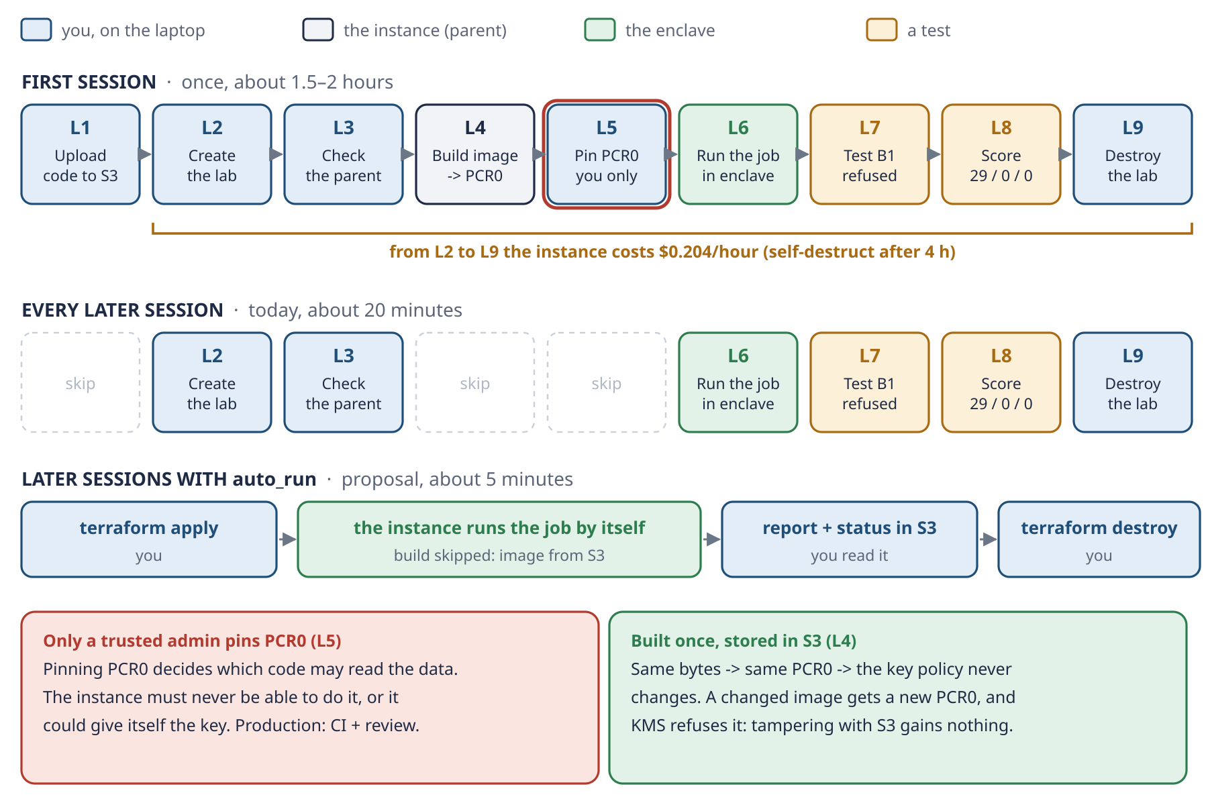
Schema 7 · The lab path: first session, later sessions, and later sessions with auto_run.

26. enclave_app.py: the only reader
It listens on vsock port 5000. For each request {credentials, region, envelope} it runs handle():
- Check that the input is a valid envelope.
- Call kmstool to decrypt the data key, with attestation, through the parent's proxy.
- Open the envelope (AES-GCM, checking the aad) in memory.
- Run Mode A (reconcile.py), which first checks rules_version.
- Reply with {status, report}. The status holds only counts, the rules version and the report's SHA-256.
- On any error, reply only with the error type and a short, safe message, with the credentials redacted.
cmd = [KMSTOOL, "decrypt", "--region", region, "--proxy-port", "8000",
"--aws-access-key-id", creds["access_key_id"],
"--aws-secret-access-key", creds["secret_access_key"],
"--aws-session-token", creds["session_token"],
"--ciphertext", base64(encrypted_data_key)]
# kmstool prints: PLAINTEXT: <base64 data key>

Status field | Example
ok | true
rules_version | it-simplified-0.1
payslips_checked | 580
payslips_with_differences | 29
net_difference | 311.45
report_sha256 | the fingerprint of the report

The app keeps serving until the parent terminates the enclave; then its memory, with the plaintext, is wiped.

27. vsock_proto.py: talking over vsock
Each message is an 8-byte length followed by JSON. The receiver reads exactly that many bytes, and refuses anything above 64 MB, which protects the enclave's memory. The same code works on any stream socket, which is why the tests can use an ordinary socket pair.

28. The parent: run_job.sh and run_job.py
Step | What the parent does
1 | sync the code, download the image if it is not already there
2 | start vsock-proxy 8000 → kms.eu-north-1.amazonaws.com:443 in the background
3 | nitro-cli run-enclave with 2 vCPUs and 4096 MiB (add --debug-mode only to check start-up)
4 | download the envelope; check it is an envelope
5 | get the role's temporary credentials from IMDSv2 (token first, then credentials)
6 | find the enclave's CID with nitro-cli describe-enclaves; connect over vsock, retrying while it boots
7 | send {credentials, region, envelope}, wait for {status, report}, print the status
8 | if the report's SHA-256 matches the status, save it and upload it to reports/
9 | on exit, always: terminate the enclave and stop the proxy

REMEMBER Credentials alone are not enough. The parent passes the same credentials it has itself; only the enclave can add the attestation that KMS demands.

29. The laptop scripts
- encrypt_input.py: steps 2a–2f (Part IV). Refuses datasets not marked synthetic. Saves the encrypted data key locally for test B2.
- upload_enclave_src.sh: one aws s3 sync with filters: only the 3 formula files and the enclave folder; no tests, no binaries, no data. --delete keeps S3 identical to your code.
- score_report.py: the score (Part III), exit code 0 only when perfect.

30. How it was tested before AWS
Check | Result
70 Python tests | 47 payslip + 23 enclave (vsock framing 4, enclave app 11, parent runner 8), all passing
Local dry run | the real enclave logic with a local test key: 29 matched, 0 missed, 0 unexpected
Enclave image in Docker on the laptop, no network | Python 3.9.25; 580 payslips checked, 29 with differences, net 311.45; the real KMS path (placeholder kmstool) failed safely
shellcheck | the three scripts and the rendered startup script: no findings
Terraform | fmt, validate, 4 offline tests, a mutation check
Test-first | every module: the tests were written first and seen failing before the code

What could only be tested on AWS: the Nitro hardware, the attestation and KMS's decision. That is exactly what the lab phase is for.
REMEMBER Test everything you can for free on the laptop. Spend money only on what only AWS can prove: the attestation.

SELF-CHECK Why does run_job.py check the report's SHA-256 before uploading it, if the enclave computed both?

Part VII · Operating the POC
The two procedures (poc/procedures/) have every command, what to watch and the troubleshooting. This part condenses them, adds the teardown and the console tour, and collects every problem met in session 1.

31. The base phase
Step | Command (from the project folder) | Watch for
0 · Terraform | download 1.16.4, check SHA-256, sudo install | checksum OK
1.1 · Who am I | aws sts get-caller-identity | this ARN becomes the key admin (…:root in session 1)
1.2 · Offline tests | terraform -chdir=infra/base init then test | 4 passed
1.3 · Plan, apply | plan -out=base.tfplan then apply base.tfplan | 13 to add; no Decrypt anywhere; rotation off
2 · Encrypt + upload | python3 poc/payslip/encrypt_input.py --bucket <bucket> | the aad, the paths, "uploaded to"
2.1 · Checks | grep -c a name; aws s3 ls input/; head-object | 0 · the envelope · "AES256"
3 · Test B2 | aws kms decrypt --ciphertext-blob fileb://data/encrypted/…datakey.bin | AccessDeniedException

32. The lab phase
Step | Where | Command | Watch for
L0 | laptop | install the Session Manager plugin; run the 70 tests | a version; all OK
L1 | laptop | bash poc/enclave/upload_enclave_src.sh <bucket> | 10 files, no tests, no data
L2 | laptop | terraform -chdir=infra/lab plan -out=lab.tfplan, apply lab.tfplan | 7 to add; no ingress; 443 + 80 out; On-Demand
L3 | instance | aws ssm start-session --target <id>, then 8 checks | ready file, poc.env, 2 / 4096, services, code, timer
L4 | instance | sudo bash /opt/poc/src/enclave/build_enclave.sh | pinned commit OK; PCR0=…
L5 | laptop | read PCR0 from pcrs.json → pcr0.auto.tfvars; plan; apply | 96 characters; 1 to change; pcr0_pinned: true
L6 | instance | sudo bash /opt/poc/src/enclave/run_job.sh | Flags NONE; ok, 580, 29, 311.45; report uploaded
L7 | instance | extract the encrypted data key, aws kms decrypt | AccessDeniedException (test B1)
L8 | laptop | download reports/, score_report.py | 29 / 0 / 0, exit 0
L9 | laptop | plan -destroy -out=destroy.tfplan, apply destroy.tfplan | 7 to destroy; no instance left

32.1 The B1 test, line by line
. /opt/poc/poc.env # load BUCKET and REGION
aws s3 cp "s3://$BUCKET/input/payslips-2026-H1.envelope.json" /tmp/env.json \
--region "$REGION" # the envelope (ciphertext)
jq -r .encrypted_data_key /tmp/env.json | base64 -d > /tmp/edk.bin
aws kms decrypt --ciphertext-blob fileb:///tmp/edk.bin --region "$REGION"
# same role, no attestation: AccessDenied

REMEMBER B1 proves where the key can be used, the score proves what the enclave did with the data, and the destroy proves nothing is left behind.

33. Teardown: the end of the project
Base is kept between sessions by design. Removing it ends the project, so it takes deliberate steps:
- Make sure the lab is gone: terraform -chdir=infra/lab state list must print nothing.
- Keep what you want: download reports/ and enclave/pcrs.json, and note the key ARN (terraform -chdir=infra/base output -raw key_arn).
- Empty the bucket: aws s3 rm s3://<bucket> --recursive. Terraform cannot delete a bucket that still has objects.
- Allow the key to be destroyed: in infra/base/kms.tf, set prevent_destroy = false.
- terraform -chdir=infra/base plan -destroy -out=destroy-base.tfplan: expect 13 to destroy. Then apply it.
- Check: the key is PendingDeletion with a date 7 days ahead; the bucket and the role no longer exist; no instance is left.
- Set prevent_destroy = true again in the code.
LESSON What happened in session 1. The lab was destroyed at 16:41–16:42. The base destroy ran twice: the last run removed only the bucket, so the first one most likely stopped on a non-empty bucket. At 16:50 base was empty. The report had not been downloaded, so it was deleted with the bucket.

Until about 8 October 2026 the key can still be saved: aws kms cancel-key-deletion --key-id <arn> then aws kms enable-key --key-id <arn>. After that, every envelope encrypted under it, in S3 and in data/encrypted/, can never be decrypted again. That is crypto-shredding, applied to the POC itself.

34. A tour of the AWS console
Things worth looking at while a session is running (Region: Stockholm). After the teardown, CloudTrail's event history still shows the last 90 days.
Console | Where | What it shows you
CloudTrail | Event history, event source kms.amazonaws.com | the successful Decrypt by confidential-poc-instance (its details should include the attestation and the image digest = PCR0), next to the denied calls of B1 and B2
KMS | Customer managed keys → the key → Key policy | the 3 statements; rotation disabled; later "Pending deletion"
S3 | the bucket → input/, enclave/, reports/ | the envelope, the image and pcrs.json, the report; SSE-S3 in each object's properties
EC2 | Instances → the parent | type, role, security group (no inbound), IMDSv2, encrypted disk, CPU graph. The enclave itself is not visible here
IAM | Roles → confidential-poc-instance | SSM and S3 permissions only: no KMS permission
Systems Manager | Session Manager → Session history | every shell you opened
Billing | Cost Explorer, Budgets | the real cost (with up to a day of delay) and the $5 budget

35. Troubleshooting: every problem we met or prepared for
Symptom | Cause | Fix
terraform plan: InvalidClientTokenId | the shell has different (old) credentials | run AWS commands in the terminal where you are signed in
Could not connect to the endpoint URL (ssm…) | a short network problem on the laptop | retry
Lines typed with ! showed no output | ! works only in the Claude Code input box | in your own terminal, type commands without !
Plan shows …:root as principal | Terraform runs as the root user | accepted for the POC (AWS-11)
start-session: TargetNotConnected | the SSM agent has not registered yet | wait 1–2 minutes
No ready file on the instance | the startup script is still running or failed | sudo tail -50 /var/log/cloud-init-output.log
L4: yum timeout on port 80 | only outbound 443 was allowed | egress 80 (AWS-12), applied in place
L4: "does not point to the pinned commit" | the SDK tag moved | stop and review before changing the pin
L5: Invalid value for variable enclave_pcr0 | PCR0 lost a character in a copy-paste (95, not 96) | read it from pcrs.json (IMPL-8)
L6: insufficient memory | image bigger than 4096 MiB allows | raise enclave_memory_mib, recreate the lab
L6: KmsError, AccessDenied | PCR0 not pinned, mismatched, or debug mode | compare pcrs.json with the tfvars; check Flags; CloudTrail
L6: KmsError, connection | vsock-proxy not running or KMS not allow-listed | check /etc/nitro_enclaves/vsock-proxy.yaml
L6: InvalidTag | the envelope was changed or damaged | re-run encrypt_input.py
L6: no answer from the enclave | the app crashed at boot | debug mode + nitro-cli console
The instance vanished | the 4-hour self-destruct | terraform -chdir=infra/lab apply again
JSON: Extra data at char 11176 | a stray character typed at the end of the answer key | removed it; the file matches the generator again
Base destroy fails on the bucket | the bucket is not empty | aws s3 rm --recursive, then destroy again
B1 or B2 succeeds | the key policy is wrong | stop, destroy the lab, compare the live policy with the plan

36. Costs
Item | Price
KMS customer managed key | $1/month, prorated hourly; free while pending deletion; +$1/month per rotation (up to two)
KMS requests | first 20,000/month free
m6i.xlarge On-Demand, Stockholm | $0.204/hour (Spot from about $0.045/hour)
Public IPv4 address | $0.005/hour
EBS gp3 30 GB | a few cents per session; about $2.5/month if forgotten
S3, Budgets, IAM, VPC, internet gateway, security group | free or cents

Scenario | Cost
Base only, for a month | ~$1
A 3-hour lab session, On-Demand | ~$0.65
A lab forgotten for a month (without the self-destruct) | ~$155
Worst case with the self-destruct | ~$0.85 (4 hours)
Session 1 in total | well under $1 (estimate: about an hour of instance, two hours of key)
After the teardown | $0

REMEMBER Three safety nets for cost: destroy (you, every session), self-destruct (automatic, 4 hours), budget alert (email, $5).

SELF-CHECK Why must the bucket be emptied before terraform destroy, and what happens to the envelope after the key's 7-day window?

Part VIII · Lessons, production and the reusable pattern

37. What session 1 taught us

37.1 Terraform ran as the account root user (AWS-11)
Symptom | the key policy, read from the local state, named arn:aws:iam::<account>:root
Cause | the AWS CLI on the laptop was signed in as the root user
Fix | kept for the POC as a known deviation, after looking at the consequences

LESSON Check aws sts get-caller-identity before the first apply: that identity becomes the key admin. In production, use a dedicated IAM identity with MFA and lock the root user away.

37.2 The kmstool build needed port 80 (AWS-12)
Symptom | L4 stopped: yum timeout on http://amazonlinux.default.amazonaws.com/…
Cause | the Amazon Linux 2 build container fetches its mirror list over HTTP; the security group allowed only 443
Fix | a second egress rule for port 80, applied in place, without recreating the instance

LESSON The troubleshooting table had predicted it. Outbound 80 is not inbound; and with package managers, trust comes from the signature, not the channel.

37.3 A PCR0 with 95 characters (IMPL-8)
Symptom | Invalid value for variable enclave_pcr0
Cause | one character lost when copying PCR0 from the SSM window
Fix | read PCR0 directly from pcrs.json in S3 and check that it has 96 characters

LESSON The guard did its job: a truncated PCR0 would have locked the key against every enclave, failing silently later. Never copy PCR0 by hand.

37.4 A stray character in the answer key
Symptom | Extra data: line 368 column 1 (char 11176)
Cause | a k typed after the final }, probably an accidental keypress in an editor
Fix | removed it; the file is identical to the generator output again

LESSON Generated files are reproducible: regenerate or compare instead of guessing.

37.5 Commands with "!" in a normal terminal
Symptom | commands typed as ! cd … && terraform … showed no output in the chat
Cause | the ! prefix sends a command to Claude Code only when typed in its input box
Fix | run commands in your own terminal without !, and paste the output

LESSON Your terminal holds your AWS sign-in; that is also why commands run by the assistant's shell failed (InvalidClientTokenId).

37.6 The report was never scored
Symptom | no local reports/ folder; the bucket deleted at 16:50
Cause | the teardown happened before step L8
Fix | collect the formal proof in the next run

LESSON Download and score the report before destroying base. Paste the status line and the test results into the session log as you go.

38. From POC to production
POC choice | Production version
synthetic data, simplified payroll rules | real data, exact CCNL rules, a data protection review (GDPR)
report in clear (AWS-8) | output sealed inside the enclave (guide section 2.5); only a status in clear
public subnet, outbound 443 + 80 | private subnets, VPC endpoints for KMS, S3, SSM, STS; packages from a mirror or a pre-built AMI
root user runs Terraform (AWS-11) | a dedicated IAM identity with MFA; separate key admin and data owner; no account delegation
PCR0 pinned by hand, measured on the parent | a reproducible build on a trusted machine, built twice, with a release record; a reviewed change; optionally sign images and pin PCR8 (section 40.3)
one EC2 instance, started by hand | EKS with Jobs and scale to zero (Tier 2), or the auto_run option
local Terraform state | remote state in S3 with locking
budget alert only | CloudWatch alarms on unexpected Decrypt and AccessDenied, CloudTrail to a locked bucket
one Availability Zone | multi-AZ subnets; jobs that can be retried
rebuild changes PCR0 | reproducible builds: pinned base images, packages and tools

39. The reusable pattern
Strip away the payslips and the same eight stages work for any confidential processing job.
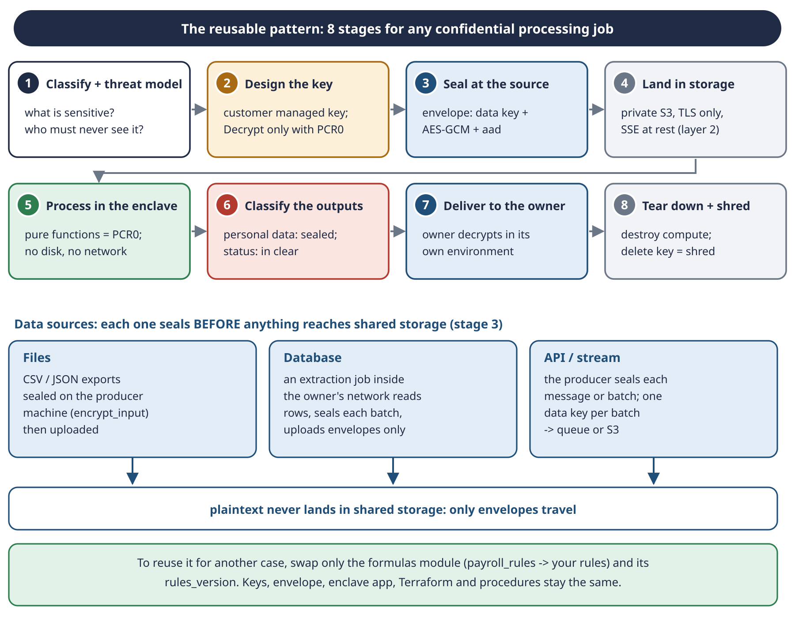
Schema 12 · The reusable pattern: eight stages, and how each kind of data source enters it.

39.1 The eight stages
# | Stage | Questions to answer | In this POC
1 | Classify + threat model | what is sensitive? who must never see it? whom do we trust? | payslips; outsiders and our admins; we trust AWS hardware
2 | Design the key | who manages it, who encrypts, who decrypts, under which condition? | owner encrypts, enclave decrypts with PCR0
3 | Seal at the source | where does plaintext exist before sealing, and for how long? | only on the laptop; envelope per file
4 | Land in storage | is storage private, TLS-only, encrypted at rest? | S3 with all four protections
5 | Process in the enclave | are the formulas pure? is the image reproducible? | Python formulas, PCR0 pinned
6 | Classify the outputs | can each output be linked to a person? | report (personal) vs status (not)
7 | Deliver to the owner | who decrypts the result, where? | the owner, on the laptop
8 | Tear down + shred | what is left behind? which key makes it useless? | destroy the lab; delete the key

39.2 Getting data in from different sources
The rule for every source is the same: seal before anything reaches shared storage. Plaintext lives only where it already lived, at the source.
Source | Recommended design | Watch out for
Files (exports, CSV, JSON) | a small sealing tool on the producer machine (like encrypt_input.py) creates the envelope; only the envelope is uploaded | temporary plaintext copies on the producer; delete them
Database | an extraction job runs inside the owner's trusted network: it reads rows, seals each batch with a fresh data key, uploads envelopes; no plaintext export file ever exists | the job's credentials must allow GenerateDataKey but not Decrypt; batch size vs memory
API or stream | the producer seals each message or batch (one data key per batch, cached for a short time) and sends envelopes to a queue or to S3 | many small messages: batch them to limit KMS requests and cost
Another cloud or a partner | the partner seals with your KMS key (via a role with Encrypt only) or with a public key you give them | never give them Decrypt

39.3 What you swap for a new use case
Keep as it is | Swap
the key design and the key policy | the formulas module (payroll_rules.py → your rules) and its rules_version
the envelope format and encrypt_input.py | the dataset schema and its generator (for tests)
enclave_app.py, vsock_proto.py, run_job.py | the processing call inside handle() (Mode A → your job)
Terraform base and lab | names, sizes (enclave_memory_mib if the data is bigger)
the procedures and safety nets | the success tests (your own "answer key")

39.4 A checklist for a new use case
- Write the threat model in three lines: what, from whom, whom we trust.
- Classify every input and every output: can it be linked to a person?
- Write the formulas as pure functions, test-first, with values computed by hand.
- Build a synthetic dataset with planted errors and an answer key.
- Decide who seals each source, and check they have Encrypt but not Decrypt.
- Reuse base and lab; pin PCR0 through a reviewed change.
- Prove the negative tests (B1, B2) before celebrating the positive one (A).
- Plan the teardown and the key deletion from day one.
REMEMBER Seal at the source, process only in the enclave, classify every output, shred at the end. Everything else is a detail of one use case.

40. What could come next

40.1 Next steps
Next step | What it adds | Effort
Run session 2 | collect the formal proof: status line, B1, B2, score 29 / 0 / 0 | about 2 hours with the procedures
auto_run option | sessions without SSM: apply → report → destroy | small: a few lines in the startup script
Mode B | compute July 2026 with the same formulas | small: new inputs, same rules
Sealed output | the report leaves the enclave encrypted (kmstool genkey); closes gap F1 | medium
Private networking | VPC endpoints, no internet | medium: pre-build packages or the image
Tier 2 (EKS) | Jobs, scale to zero, pod roles | large
CI pinning | reproducible build, built twice, release record, PCR0 pinned through reviewed changes; closes gap F2 (section 40.3) | medium

40.2 Gaps in the pattern, found after session 1
On 2 October 2026 we reviewed the pattern against the code. None of these gaps affected the POC: the data was synthetic, and the instance was new and reachable only by you. Each one matters as soon as the data is real. Trust leaks in three places: what leaves the enclave (F1), what gets pinned (F2) and who pins (F3). F4 and F5 are smaller.
# | Gap | What an attacker does | Fix
F1 | the parent receives the report in clear, and can ask for more | root on the parent sends any envelope from input/ to the enclave and reads the answer | seal the output inside the enclave (guide section 2.5); only a status leaves in clear
F2 | the pinned PCR0 was measured on the untrusted parent, and the build is not reproducible | a change made before the build is measured and pinned like the real code | pin every build input, build on a trusted machine, build twice and compare, keep a release record (40.3)
F3 | the key admin can rewrite the rules (kms:Put*, kms:Create*) | adds Decrypt for themselves, pins the PCR0 of a leaking image, or creates a grant | split duties, close the grant door, alarm on every policy or grant change
F4 | the report's hash does not prove where the report came from | a tampered parent changes the report and its hash together | the enclave signs the report with a key bound to its attestation
F5 | the enclave does not know which dataset it should process | the parent replays an older envelope | the job request names the expected dataset id, signed by the data owner

F1 · The parent reads the answer, and can ask for more. The report travels through vsock to the parent, which saves it and uploads it to S3 (AWS-8). And serve() in enclave_app.py answers any request on port 5000. Root on the parent can:
- copy any envelope from input/ (the instance role is allowed to read it);
- send it to the enclave over vsock;
- let the enclave do its honest job: a real attestation and the right PCR0, so KMS releases the key;
- read the report in clear.
KMS checks which code asks for the key, never who told that code to run. In Mode A the report lists the errors per employee; in Mode B it would be complete payslips, which is effectively the whole dataset. Fix: seal the output inside the enclave. The parent can still ask, but only ciphertext comes back, so asking is useless.
F2 · A perfect seal on the wrong box. PCR0 protects against changes after pinning: a modified image in S3 gets a different PCR0, and KMS refuses it. It does not protect against a change before pinning. build_enclave.sh builds the image on the parent, the machine we don't trust, and pcrs.json comes from there:
- someone with root on the parent before the build (or a poisoned base image or package) adds one line that sends the payslips out;
- nitro-cli build-enclave measures the bad image, so pcrs.json shows the bad PCR0;
- we pin it, following IMPL-8 correctly;
- KMS gives the key to the bad image. Every check passes.
The build is not reproducible either: FROM amazonlinux:2023 is a tag that moves, and dnf install takes the newest packages. The same source built on two days gives two PCR0 values. "Build once, store in S3" (AWS-7) keeps PCR0 stable, but nobody can rebuild the image and confirm that the pinned PCR0 comes from the code you reviewed. In session 1 the real risk was low: a new instance, no inbound ports, only you through SSM, about 40 minutes of life.
F3 · The key policy is just a document. Whoever can replace it decides who decrypts. Our admin statement (infra/base/kms.tf) is AWS's standard admin list, and it opens two doors:
- Front door, kms:Put*, which includes kms:PutKeyPolicy. Add Decrypt for yourself, or, more subtly, "update" PCR0 to an image that leaks. Our own workflow, terraform apply -var enclave_pcr0=…, is exactly this call: legitimate and dangerous at the same time.
- Side door, kms:Create*, which includes kms:CreateGrant. A grant can give Decrypt without changing the policy, carries no attestation condition, and shows only in ListGrants and CloudTrail.
This holds for a dedicated IAM admin too; AWS-11 (the root user) only widens it to every IAM identity the account allows. The power cannot be removed, because someone must pin the next PCR0 after a formula change. It can only be split and watched: the key admin doesn't approve PCR0, a second person reviews every policy change and a pipeline applies it; kms:Create* is dropped or grants are restricted (kms:GrantIsForAWSResource); an EventBridge rule raises an alarm on PutKeyPolicy and CreateGrant; a test checks that the policy has exactly three statements and that ListGrants is empty.
REMEMBER "The admin can't decrypt" really means "the admin can't decrypt without leaving a trace". The real security is the trace plus a second person.

TRAP On your own hardware (AMD SEV-SNP or Intel TDX instead of Nitro) the same five gaps apply. F2 and F3 get harder: the measurement also covers the VM firmware and kernel, and the policy admin becomes the admin of your own key broker, without CloudTrail. One gap is added: debug mode is a separate field in the report, not part of the measurement, so the key broker must refuse it explicitly.

40.3 Linking the pin to the source code
PCR0 is the fingerprint of the image bytes, not of the source code. What that means for our image:
Covered directly | our Python code: the Dockerfile copies payroll_rules.py, reconcile.py, envelope.py, vsock_proto.py and enclave_app.py into the image, so one changed character in a formula gives a new PCR0
Covered only as binaries | the parts that arrive pre-built: kmstool, the Python interpreter, the cryptography library, the base OS packages
Not covered | the recipe (Dockerfile, versions, build machine): only its result

Can the source be attached later? Yes, but only a reproducible build makes the attachment provable: anyone takes the tagged source, rebuilds it, and must obtain the pinned PCR0. Without it, as today, attaching the source later is only our word. The session-1 image can no longer be linked: its EIF was deleted with the bucket, and the build cannot be repeated byte for byte.
The release pipeline for a future version:
- Commit the source with a clean working tree, and tag it (enclave-vN).
- Write the commit id into the image (/app/BUILD_INFO), so PCR0 covers it too. The enclave puts it in its status line, so every report says which code produced it.
- Build on a trusted machine (laptop or CI) with every input pinned: base image by digest, package versions, kmstool commit. Never on the parent.
- Build a second time, independently. The two PCR0 values must match.
- Write the release record: commit, tag, base image digest, package versions, kmstool commit, PCR0/1/2 (and PCR8 if signed), date, who built it. Keep it in git next to the tag, and in S3 next to the image.
- Optionally sign the image (--signing-certificate, --private-key) and pin PCR8 as well: then KMS accepts only images you signed.
- Open a reviewed change with the new PCR0. A second person checks it against the release record and approves; the pipeline applies it.
- The parent only downloads the image and runs it.
REMEMBER PCR0 says the image did not change after pinning. Only a reproducible build from tagged source, on a trusted machine, says it is your code.

SELF-CHECK A new partner will send you salary data every night from their own database. Using the pattern, describe who seals the data, with which permissions, and what your enclave must refuse.

Part IX · Exam, glossary and appendices

41. SAA-C03: what this project teaches
Domain | Weight | What the project uses
Design Secure Architectures | 30% | KMS key policies and key types, envelope encryption, S3 encryption options and bucket policies, IAM roles, IMDSv2, SSM Session Manager, security groups, CloudTrail, separation of duties, Nitro Enclaves
Design Resilient Architectures | 26% | jobs that can be retried, S3 durability, decoupling through S3, infrastructure as code that can be recreated in minutes
Design High-Performing Architectures | 24% | choosing the instance family (m6i vs c6i), enclave sizing, S3 as the data layer
Design Cost-Optimized Architectures | 20% | On-Demand vs Spot, destroy after use, self-destruct, budgets, avoiding NAT gateways, KMS key and rotation costs

41.1 Patterns to recognise
If the question says… | Think…
administrators must not be able to read the data while it is processed | Nitro Enclaves + KMS key policy with attestation
audit trail of key usage, separation of duties | SSE-KMS with a customer managed key + CloudTrail
control the key policy (conditions, attestation) | a customer managed key, not an AWS managed key
encrypt a large file with KMS | envelope encryption: GenerateDataKey
S3 only over HTTPS | bucket policy denying aws:SecureTransport = false
shell access without SSH or open ports, with logging | SSM Session Manager
containers must not steal the instance role | IMDSv2 with hop limit 1
outbound traffic fails, inbound is not needed | add an outbound security-group rule; security groups are stateful
delete a key but keep a chance to undo | schedule key deletion with a 7–30 day waiting period
interruptible batch, lowest cost | Spot instances
private subnets must reach S3 without the internet | an S3 gateway VPC endpoint

41.2 Practice questions
Question 1. A healthcare company processes patient records on EC2. Even administrators with root access to the instances must not read the data during processing. What should the architect recommend?
A) Encrypt the EBS volumes with KMS.
B) Nitro Enclaves with a KMS key policy that requires attestation.
C) Enable S3 SSE-KMS.
D) Dedicated Instances.
Answer: B. EBS and S3 encryption protect data at rest, not in use. Dedicated Instances isolate hardware between customers, not from your own admins.
Question 2. A developer must encrypt 50 GB files with KMS, and the Encrypt API fails. What should they do?
A) Request a quota increase.
B) Use envelope encryption with GenerateDataKey.
C) Split the files into 4 KB parts.
D) Use SSE-C.
Answer: B. KMS Encrypt handles only small payloads; large data uses a data key.
Question 3. The people who administer a KMS key must not be able to decrypt with it. What is the right approach?
A) IAM policies only.
B) Separate administrative and usage permissions in the key policy.
C) Disable key rotation.
D) Use an AWS managed key.
Answer: B. Key policies support separation of duties; AWS managed keys don't accept custom policies.
Question 4. A nightly batch job can be restarted safely and must cost as little as possible. Which purchasing option fits?
A) On-Demand.
B) Reserved Instances.
C) Spot Instances.
D) Dedicated Hosts.
Answer: C. Interruptible and restartable means Spot. (Our POC chose On-Demand only to avoid surprises in a one-off lab.)
Question 5. An application in private subnets uploads large volumes to S3 and the NAT gateway bill is high. The most cost-effective fix?
A) A second NAT gateway.
B) An S3 gateway VPC endpoint.
C) An S3 interface endpoint.
D) Public subnets.
Answer: B. Gateway endpoints for S3 are free.
Question 6. Operators need a shell on EC2 instances. Security forbids inbound ports and requires every session to be logged. What should they use?
A) A bastion host with SSH.
B) AWS Systems Manager Session Manager.
C) EC2 Instance Connect over port 22.
D) A VPN.
Answer: B. Session Manager uses an outbound connection from the agent, checks IAM, and logs sessions; no inbound port is needed.
Question 7. Containers running on an EC2 host must not be able to obtain the instance role's credentials. Which setting helps?
A) Disable the metadata service entirely.
B) IMDSv2 required, with a hop limit of 1.
C) A larger instance type.
D) A NAT gateway.
Answer: B. With a hop limit of 1, the token cannot reach containers behind Docker's network. Disabling metadata would also break the host itself.
Question 8. An instance's security group allows only outbound 443. A package manager that uses HTTP fails. What is the minimal fix?
A) Add inbound port 80.
B) Add outbound port 80.
C) Add inbound and outbound port 80.
D) Replace the security group with a network ACL.
Answer: B. Security groups are stateful: replies to an allowed outbound connection come back automatically. This is exactly decision AWS-12.
Question 9. A KMS customer managed key must be deleted, but the team wants a chance to undo the decision. What does KMS offer?
A) Immediate deletion only.
B) Scheduled deletion with a 7–30 day waiting period, which can be cancelled.
C) Disabling the key forever.
D) Deleting the alias only.
Answer: B. During the waiting period the key is unusable, free, and can be restored with cancel-key-deletion.
Question 10. A key policy must contain a condition on the enclave's attestation. Which key type allows it?
A) An AWS managed key such as aws/s3.
B) An AWS owned key.
C) A customer managed key.
D) Any key type.
Answer: C. Only customer managed keys let you write the key policy.
Question 11. An EC2 root volume is created with encryption on and no key specified. Which key encrypts it?
A) None.
B) The account's default EBS key, the AWS managed key aws/ebs unless changed.
C) A random key that is discarded.
D) The instance's IAM role.
Answer: B. That is why aws/ebs appeared in the KMS console during the POC.

42. Glossary
Term | Meaning
AAD (aad) | additional authenticated data: not secret, but bound to the ciphertext by AES-GCM
AES-256-GCM | symmetric encryption that also checks integrity with an authentication tag
Allocator | the service that sets aside vCPUs and memory for enclaves on the parent
AMI | Amazon Machine Image: the disk image an instance boots from
Answer key | the list of planted errors, used only to score the report
Attestation document | a document signed by the Nitro hardware proving which image (PCRs) an enclave runs
AWS managed key | a KMS key created by AWS for a service (aws/ebs, aws/s3); its policy is not yours
base / lab | the kept Terraform setup / the per-session Terraform setup
CID | the vsock address of a VM: the parent is 3, the enclave gets its own
CloudTrail | the log of AWS API calls
Crypto-shredding | making data unrecoverable by destroying its key
Customer managed key | a KMS key you create, whose policy you write ($1/month)
Data key | a symmetric key from KMS used to encrypt data locally
Debug mode | enclave mode with a console; PCRs are all zeros, so KMS refuses it
EBS | Elastic Block Store: the instance's disk
EIF | Enclave Image File, built from a Docker image by nitro-cli
Envelope | our sealed input file: ciphertext + encrypted data key + nonce + aad
Envelope encryption | encrypt data with a data key, protect the data key with a KMS key
Gateway endpoint | a free VPC endpoint for S3 and DynamoDB
IMDSv2 | the token-based instance metadata service
Instance profile | the container that attaches an IAM role to an EC2 instance
Key policy | the resource policy that controls a KMS key
kmstool | AWS's ready-made tool that calls KMS with attestation from inside an enclave
Mode A / Mode B | check the issued payslips / compute the next month
Nitro Enclave | an isolated VM inside EC2 with no disk, no network, no SSH
NSM | Nitro Security Module: the device inside the enclave that issues attestation documents
Parent instance | the EC2 instance that hosts the enclave; untrusted courier
PCR | Platform Configuration Register: a hash measuring part of the enclave
PCR0 | the hash of the whole enclave image; pinned in the key policy
Pending deletion | the 7–30 day waiting state of a KMS key scheduled for deletion
plan file | a saved Terraform plan; apply runs exactly it
prevent_destroy | a Terraform setting that refuses to destroy a resource
Remote state | reading another Terraform setup's outputs (here from a local file)
Security group | a stateful firewall attached to an instance
Self-destruct | the scheduled shutdown that terminates the lab instance after 4 hours
SSE-S3 / SSE-KMS | S3 encryption at rest with S3-managed keys / with KMS keys
SSM Session Manager | shell access through an outbound agent connection, IAM-checked and logged
State file | Terraform's record of what exists
Status line | the enclave's answer without personal data: counts, rules version, report hash
TEE | Trusted Execution Environment
Threat model | who we defend against, and whom we trust
User data | the startup script an instance runs at first boot
vsock | the local socket between parent and enclave
vsock-proxy | forwards the enclave's KMS requests from vsock to an allow-listed host

Appendix A · Every file in the folder
Path | What it is
README.md | folder overview: links, key points, how to run
confidential-poc-handbook.docx | this handbook
confidential-processing-aws-study-guide.docx | study guide v1 (original, unchanged)
confidential-processing-aws-study-guide-v2.docx | study guide v2
payslip-poc-data-dictionary.docx | data dictionary, formulas, planted errors
poc-deployment-paths-ec2-vs-eks.docx | Tier 1 vs Tier 2
poc-tier1-spec.docx | the design specification
poc/README.md | all decisions (DATA, AWS, IMPL), status
poc/procedures/Base-phase-terraform.docx | base procedure
poc/procedures/Lab-phase-terraform.docx | lab procedure
poc/payslip/payroll_rules.py | the formulas
poc/payslip/reconcile.py | Mode A and the scoring function
poc/payslip/generate_dataset.py | synthetic dataset + planted errors + answer key
poc/payslip/envelope.py | the envelope format (seal, open, validate)
poc/payslip/encrypt_input.py | steps 2a–2f on the laptop
poc/payslip/score_report.py | test A on the laptop
poc/payslip/test_*.py | 47 tests
poc/enclave/enclave_app.py | the enclave application
poc/enclave/vsock_proto.py | message framing
poc/enclave/run_job.py, run_job.sh | the parent runner
poc/enclave/Dockerfile, build_enclave.sh | the enclave image build
poc/enclave/upload_enclave_src.sh | uploads the code to S3
poc/enclave/test_*.py | 23 tests
infra/base/*.tf, tests/pcr0_guard.tftest.hcl | the kept Terraform setup and its offline tests
infra/lab/*.tf, user-data.sh.tftpl | the per-session Terraform setup and the startup script
infra/*/terraform.tfstate*, *.tfplan | local state and plans (git-ignored); both states are empty after the teardown
data/payslips-2026-H1.json | the synthetic dataset (plaintext, local only)
data/answer-key-2026-H1.json | the planted errors (never sent anywhere)
data/encrypted/ | the envelope and the encrypted data key (git-ignored; unreadable after the key is deleted)
schemas/schema-*.svg, .png | the 16 diagrams (12 numbered schemas, some with a, b, c variants)
tools/docgen/ | generators for every .docx and diagram, handbook in handbook/ (git-ignored)
.gitignore | keeps state, plans, tfvars, encrypted copies, reports, tools and caches out of git

Appendix B · Command cheat sheet

Local
(cd poc/payslip && python3 -m unittest) # 47 tests
(cd poc/enclave && python3 -m unittest) # 23 tests
python3 poc/payslip/generate_dataset.py # regenerate data/ (same seed)
python3 poc/payslip/reconcile.py data/payslips-2026-H1.json \
--answer-key data/answer-key-2026-H1.json # 29 / 0 / 0
terraform -chdir=infra/base init && terraform -chdir=infra/base test # 4 offline tests
(cd tools/docgen && python3 schemas.py && node build_handbook.js) # regenerate

Base phase
aws sts get-caller-identity
terraform -chdir=infra/base plan -var budget_email=<email> -out=base.tfplan
terraform -chdir=infra/base apply base.tfplan
python3 poc/payslip/encrypt_input.py --bucket <bucket>
aws kms decrypt --region eu-north-1 \
--ciphertext-blob fileb://data/encrypted/payslips-2026-H1.datakey.bin # B2: denied

Lab phase
bash poc/enclave/upload_enclave_src.sh <bucket>
terraform -chdir=infra/lab plan -out=lab.tfplan
terraform -chdir=infra/lab apply lab.tfplan
aws ssm start-session --target <instance-id> --region eu-north-1
sudo bash /opt/poc/src/enclave/build_enclave.sh # first session
sudo bash /opt/poc/src/enclave/run_job.sh # every session
aws s3 cp s3://<bucket>/reports/ ./reports/ --recursive --region eu-north-1
python3 poc/payslip/score_report.py "$(ls -t reports/*.json | head -1)"
terraform -chdir=infra/lab plan -destroy -out=destroy.tfplan
terraform -chdir=infra/lab apply destroy.tfplan

Checks and teardown
aws ec2 describe-instances --region eu-north-1 \
--filters Name=tag:Project,Values=confidential-poc \
Name=instance-state-name,Values=pending,running,stopping,stopped \
--query "Reservations[].Instances[].InstanceId" # []
aws ec2 describe-volumes --region eu-north-1 --filters Name=status,Values=available
aws s3 rm s3://<bucket> --recursive --region eu-north-1 # before destroying base
aws kms describe-key --key-id <key-arn> --region eu-north-1 \
--query "KeyMetadata.[KeyState,DeletionDate]"
aws kms cancel-key-deletion --key-id <key-arn> --region eu-north-1 # undo (7 days)

Appendix C · Session log template
Copy this table for every session. Paste results as you go, before the teardown.
Item | Value
Date, start and end time
Identity (get-caller-identity)
Base plan summary / apply time
Envelope uploaded (size, time)
Test B2
instance_id, lab apply time
PCR0 (from pcrs.json, 96 characters)
Status line (L6)
Test B1 (L7)
Score (L8)
Lab destroyed (time, check)
Estimated cost
Surprises and lessons

Appendix D · Answers to the self-checks
Part | Answer
I | The key policy demands an attestation document showing our PCR0. Root on the parent has the role's credentials, but no attestation: only code inside the real enclave can obtain one from the Nitro hardware. So KMS answers AccessDenied (test B1).
II | AWS-12 (outbound port 80, because the kmstool build fetches Amazon Linux 2 mirrors over HTTP) and IMPL-8 (read PCR0 from pcrs.json, because a hand-copied value lost a character). AWS-11 was also recorded during deployment, as a deviation found in the state file.
III | 2,600 ÷ 26 = 100.00, so FEST = 100.00 in April (25 April is a Saturday). In May the only holiday, 1 May, is a Friday: a working day already paid in the monthly salary, so there is no rest-day holiday line.
IV | Can: download it, store it, forward it to the enclave (or drop or delay it). Cannot: read it (no data key without attestation) and change it unnoticed (AES-GCM fails with InvalidTag).
V | Statement 3 is removed, because enclave_pcr0 falls back to null. The enclave can no longer decrypt, and the next job fails with AccessDenied, with nothing pointing at the cause. pcr0.auto.tfvars prevents it (IMPL-7).
VI | It catches a report damaged or truncated on its way through the parent, and bugs. It is not protection against a malicious parent, which could change both report and hash; for that the enclave would have to sign or seal the report (production).
VII | Terraform refuses to delete a non-empty bucket. After the 7-day window the key is gone, so the envelope can never be decrypted again: crypto-shredding.
VIII | An extraction job inside the partner's network reads the rows and seals each batch with GenerateDataKey, through a role that has Encrypt but not Decrypt; only envelopes are uploaded. The enclave refuses anything that is not an envelope, envelopes that fail AES-GCM (InvalidTag), and data declaring another rules_version. The key policy denies Decrypt to everyone except the attested enclave.

REMEMBER The whole project in one breath: seal at the source, store only envelopes, let only the attested enclave open them, classify what comes out, and shred the key at the end.

