Confidential Data Processing on AWS
with Kubernetes and Terraform · Study Guide v2
Minelli-D · October 2026 · synthetic data only
ABOUT How to read it. This is the second version of the guide; where it says v1, it means the first, unpublished version. Part I explains the big picture with schemas and memory aids. Part II is the original build plan, written before the decisions were taken: what was actually built is in poc-tier1-spec.docx, and every decision is in poc/README.md. Part III is reference material for the exam. Section 2.5 explains how results leave the enclave.

How this guide is organised
Part | Sections | Use it to | Status
I · The big picture | 1 The idea · 2 The architecture · 3 Key concepts | understand and memorise the design | Ready to study
II · Build and deploy | 4 Decisions · 5 Build steps · 6 Terraform · 7 Budget · 8 Local prototype | see how the build was first planned | Original plan
III · Exam and reference | 9 Exam corner · 10 Glossary · 11 Sources | revise for SAA-C03 | Reference

Start with The project on one page, then read Part I in order. Every section in Part I has a schema and ends with a box to memorise.

The project on one page
If you only have five minutes, read this page. Everything else in the guide expands one of these lines.
Goal | Sensitive data is readable only inside a verified, short-lived, isolated environment. When the job ends, nothing usable is left.
Golden rule | Don't trust the place. Verify the code.
Three pillars | Isolate the processing: a Nitro Enclave.  Prove the code: attestation checked by the KMS key policy.  Forget the key: a per-job data key, discarded at the end (crypto-shredding).
The flow in 8 words | Build, Measure, Pin: once per code version. Then In, Prove, Process, Out, Shred: every job.
Who does what | The pod is a courier, the enclave is the only reader, KMS is the gatekeeper.
Where plaintext lives | At the source, which owns the data; inside the enclave while the job runs; at the result owner, after decrypting the report. Nowhere else.
What comes out | Ciphertext in, ciphertext out. Results leave encrypted with a separate results key. Only a status with no personal data leaves in clear (section 2.5).
Who is stopped | Outside attackers: yes. Our own cluster and node admins: yes. AWS itself: no, we trust its hardware and hypervisor.
How it's built | Terraform: create for a test session, destroy afterwards. Reproducible and cheap.
Exam value | Covers all four SAA-C03 domains: secure, resilient, high-performing and cost-optimised architectures.

REMEMBER If you remember one sentence: the pod is a courier, the enclave is the only reader, and KMS is the gatekeeper.

Part I · The big picture
Read this part first. It explains what the project does, how the pieces fit together, and the ten concepts you need. Each section has a schema and ends with a box to memorise.

1. The idea

1.1 The goal
Process sensitive data on Kubernetes so that it is readable only inside an environment that is:
- Verified: only approved code can read the data, and it must prove it.
- Short-lived: the environment exists only while the job runs.
- Isolated: nobody outside it can read its memory, not even root on the host.
And when the job ends, nothing usable survives.

1.2 Version 1 and its weak point
The first idea was a simple pipeline:
- Pull data from the source and encrypt it.
- Decrypt and process it inside a throwaway Kubernetes namespace.
- Re-encrypt the result and store it in S3.
- Move it back to the source.
The weak point is step 2. Once the data is decrypted inside a pod, it sits in memory as plaintext. A namespace organises resources: it is not a security boundary. Anyone with enough access can reach that plaintext:
- cluster admins;
- anyone with access to the node;
- memory dumps;
- logs;
- swap.

1.3 Version 2: verify the hardware
Version 2 stops trusting the namespace and starts verifying the hardware. Each weakness of version 1 gets a specific fix:
Problem in version 1 | Fix in version 2 | AWS building block
Plaintext sits in pod memory | Decrypt and process inside an isolated enclave | AWS Nitro Enclaves
Anyone with the right role can decrypt | Release the key only to code that proves its identity | KMS key policy with attestation (PCR0)
Keys outlive the job | Use a fresh data key per job and discard it at the end | Envelope encryption + crypto-shredding
Manual setup, forgotten resources | Describe everything as code, destroy it after use | Terraform

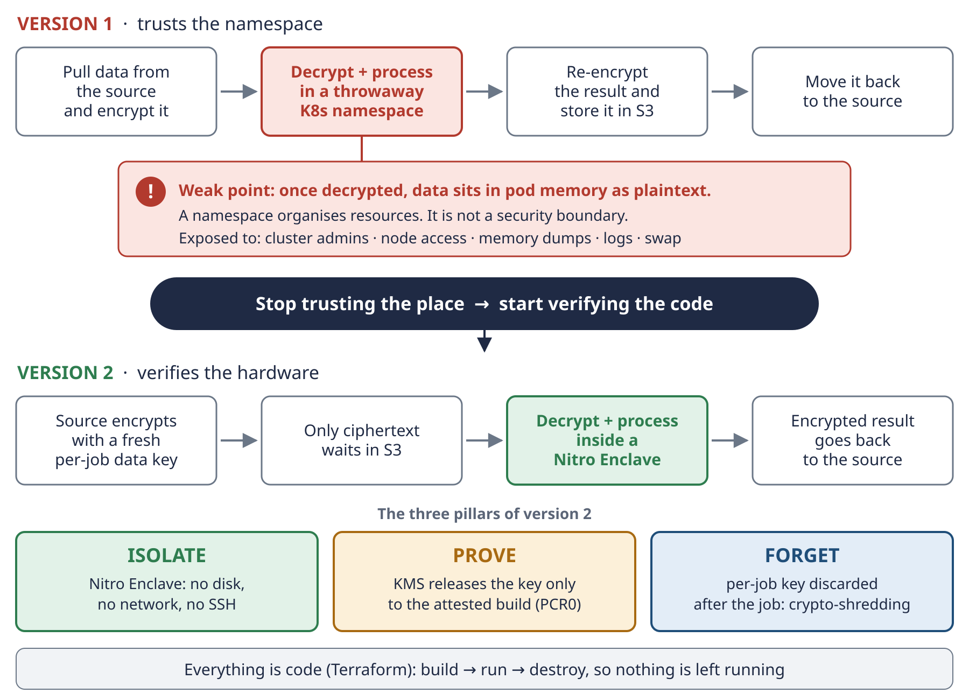
Schema 1 · From version 1 to version 2: same pipeline, but now the only place that can read the data is a verified enclave.

1.4 Two goals at once
- Build it: a working, cheap lab that proves the design.
- Study with it: prepare for the AWS Certified Solutions Architect – Associate (SAA-C03) exam. Almost every building block is core exam material: KMS, S3 encryption, VPC endpoints, IAM, EKS, EC2 purchasing options, CloudTrail and Budgets.
Exam notes appear where they are relevant. Part III maps the whole project to the exam domains.
REMEMBER Isolate, Prove, Forget. Version 1 trusted the namespace. Version 2 trusts nothing it can't verify: the enclave isolates the processing, attestation proves which code is running, and the per-job key is forgotten when the job ends.

2. The architecture

2.1 The main schema
Schema 2 shows every component and the numbered flow. Colours tell you what each component can see: green means plaintext, grey means ciphertext only, amber means keys.
How to read it. The only green box is the Nitro Enclave, so it is the only place inside AWS where plaintext exists. The job pod is the enclave's parent: it moves ciphertext in and out but can never read it. KMS is the gatekeeper: it releases key material only when the enclave proves, cryptographically, exactly which code it is running.
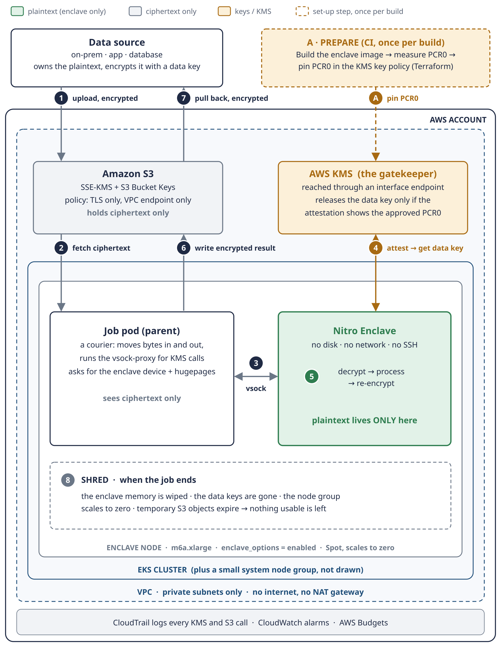
Schema 2 · Architecture. Step A happens once per code version. Steps 1 to 8 happen for every job.

2.2 The flow, step by step
Step | Phase | What happens | What travels
A | Prepare | CI builds the enclave image (EIF) and reads its PCR0. Terraform writes PCR0 into the KMS key policy. | Code and a hash, no data
1 | In | The source encrypts the data with a data key and uploads it to S3 over TLS. | Ciphertext
2 | In | The job pod downloads the ciphertext and its encrypted data key from S3, through the gateway endpoint. | Ciphertext
3 | Prove | The pod starts the enclave and passes it the ciphertext over vsock. | Ciphertext
4 | Prove | The enclave sends its attestation document to KMS. KMS checks PCR0 and returns the data key, encrypted so that only the enclave can open it. | Encrypted key
5 | Process | The enclave decrypts the data, processes it, and re-encrypts the result with a fresh data key. | Plaintext, inside the enclave only
6 | Out | The pod writes the encrypted result to S3. | Ciphertext
7 | Out | The source pulls the encrypted result back and decrypts it in its own environment. | Ciphertext
8 | Shred | The job ends: enclave memory is wiped, the data keys are gone, the node group scales to zero, temporary S3 objects expire. | Nothing usable is left

Note: the ASCII schema in v1 numbered the steps differently. v2 numbers them in the order they happen.

2.3 Who sees what
Component | Its job | What it can read
Data source | owns the data | Plaintext (it is the owner)
Result owner (payroll / HR) | receives the result | The report, after decrypting it with the results key
Amazon S3 | stores data at rest | Ciphertext only
Job pod (parent) | courier: moves bytes, runs the vsock-proxy | Ciphertext only
Nitro Enclave | decrypts and processes | Plaintext, only while the job runs
AWS KMS | gatekeeper | Keys, never your data
Cluster and node admins | operate the platform | Nothing readable
CloudTrail | audit | Who called what and when, never the data

2.4 Memorise the flow
Eight steps are hard to remember. Eight words are easy:
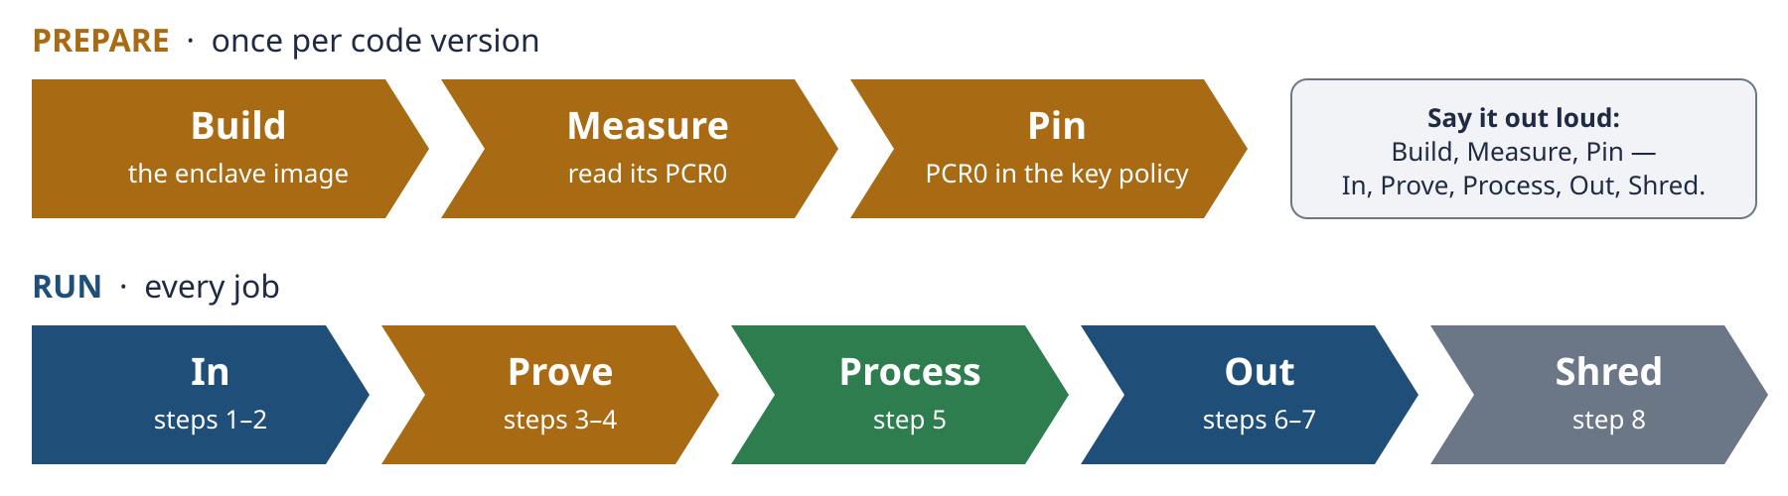
Schema 2b · The flow in eight words: Build, Measure, Pin, then In, Prove, Process, Out, Shred.
- Build, Measure, Pin (once per code version): build the enclave image, read its PCR0, pin PCR0 in the KMS key policy.
- In (steps 1–2): encrypted data arrives in S3 and the pod fetches it.
- Prove (steps 3–4): the enclave starts and proves its identity to KMS.
- Process (step 5): the enclave decrypts, processes and re-encrypts.
- Out (steps 6–7): the encrypted result goes to S3, then back to the source.
- Shred (step 8): keys and resources disappear.
REMEMBER Plaintext lives in one place only: the enclave. The pod is a courier. The enclave is the only reader. KMS is the gatekeeper.

2.5 Inside and outside: how results leave the enclave
Plaintext exists only inside the enclave, but the job must produce something useful for someone outside it. This section answers three questions: what can leave the enclave, in what form, and who can read it.

The rule: ciphertext in, ciphertext out
The enclave has no network and no disk. Its only door is vsock to the job pod. Anything the enclave hands over in plaintext is visible to the pod, and so to anyone who controls the node: admins, root, logs, memory dumps. That is exactly the weak point of version 1. So results leave the enclave encrypted, and become plaintext only at the destination, for the owner who is allowed to read them.
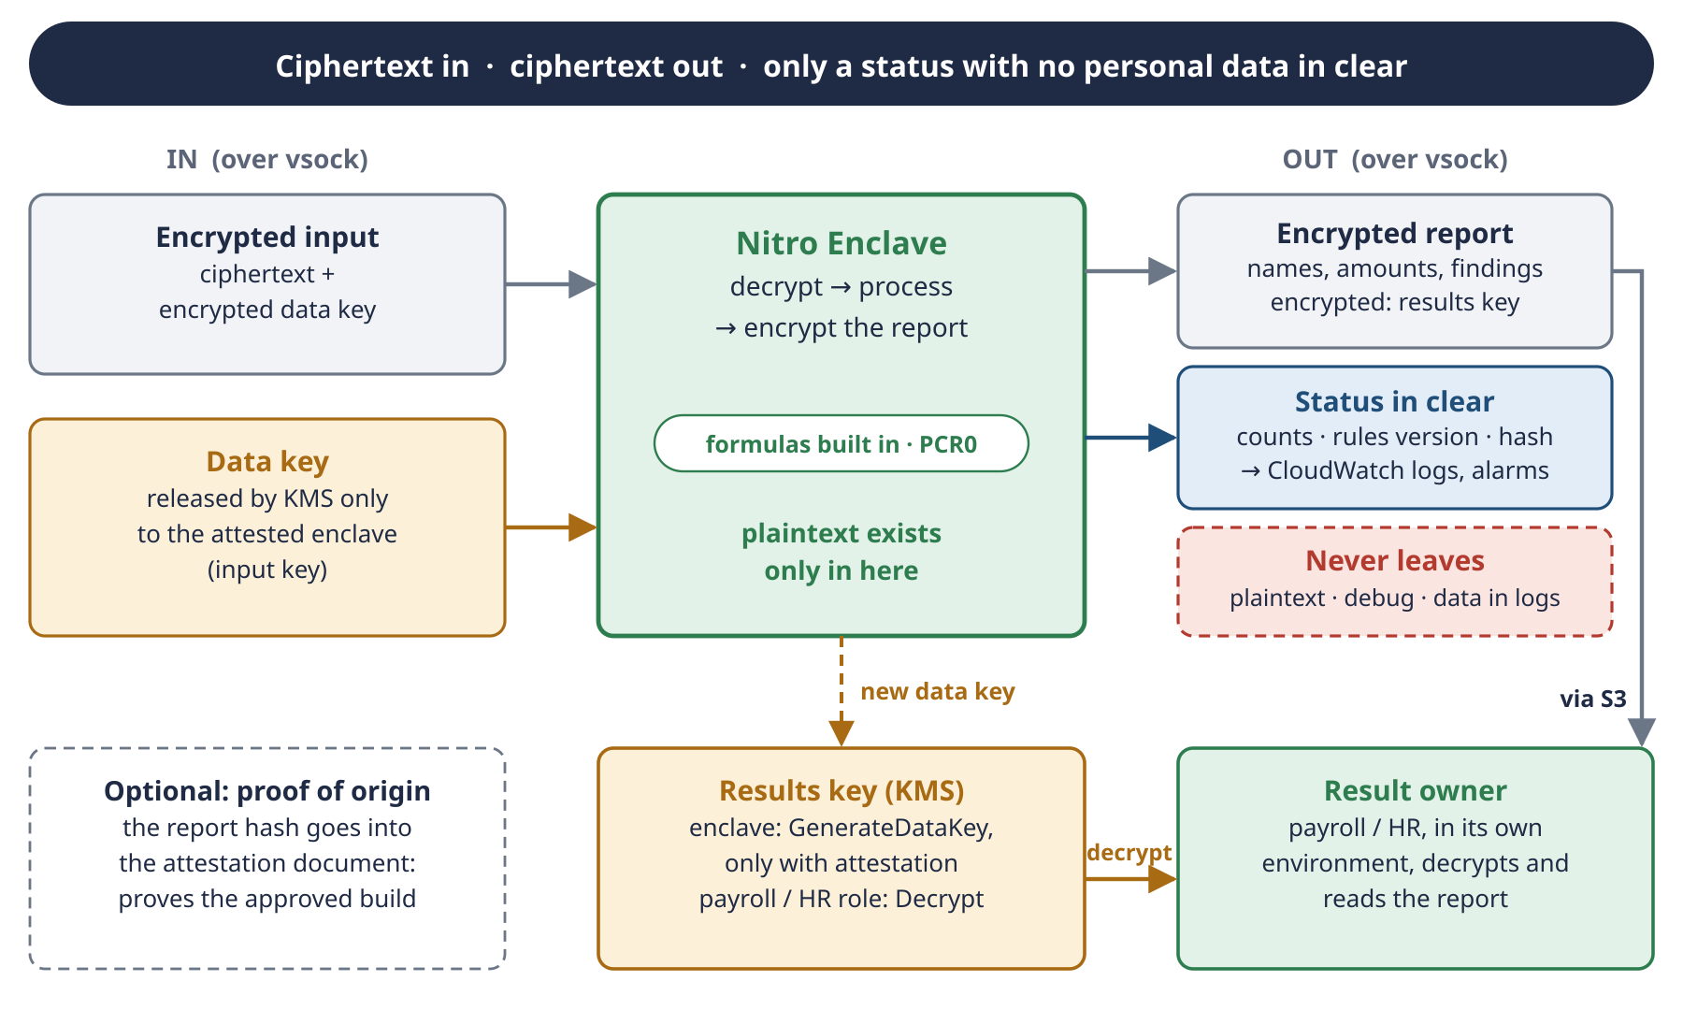
Schema 2c · What crosses the enclave boundary: ciphertext in, ciphertext out, and only a status with no personal data in clear.

First, classify the output
Not every output is sensitive, so look at what it contains before deciding. The question is not “is it the result of a formula?” but “can it be linked to a person?”
Output | Example from the payslip POC | Personal data? | Leaves as
Per-employee findings | PS-2026-01-E012, line STR, expected 64.07, issued 27.46 | Yes: the employee ID links salary amounts to a person | Encrypted
Findings on sick leave or termination | line MAL or FERIE for one employee | Yes, special category: sick leave is health data under GDPR | Encrypted
Next-month payslips (Mode B) | the July 2026 payslip of E001 | Yes: full salary data | Encrypted
Aggregates by group | differences per department | Only for small groups: a group of 2 people points at individuals | Clear only above a minimum group size (for example 5)
Job status | 580 checked, 29 with differences, rules it-simplified-0.1, report hash | No | Clear: logs and alarms

Pseudonymous IDs like E012 don't make data anonymous. The HR system can map E012 back to a person, so under GDPR it is still personal data.

One key or two?
In this design, the KMS key releases data keys to the instance only with attestation (3.8). Who else may decrypt the report decides how many keys you need:
- The owner of the data also reads the results (HR owns both the payslips and the report): one key is enough. The owner gets Decrypt in the key policy; the instance still gets it only with attestation. The owner can read its own inputs, which is fine.
- Results readers must not read the inputs (for example an auditor who sees only findings): use a separate results key, or the recipient's public key, as in the table below.
Option | How it works | Pros | Cons
A · Separate results key (proposal) | A second KMS key: the attested enclave can GenerateDataKey with it, only the payroll / HR role can Decrypt | Standard envelope encryption. CloudTrail logs every read. Access can be revoked. | One more key ($1/month)
B · Recipient's public key | The result owner's public key is built into the enclave image, and the enclave encrypts the report with it | No KMS needed for the output. PCR0 covers the key. | Changing the key needs a new build. The owner must guard its private key.

For the payslip case, one key is enough. In the Tier 1 POC we go one step further and skip output encryption entirely, because the data is synthetic (TASK-02, decision 8). Real data needs encrypted output.

Optional: proof of origin
The enclave can put the report's hash into the user data of its attestation document. The result owner can then check that this exact report was produced by the approved build (PCR0). It is useful for audits, but not needed for the POC.
REMEMBER Ciphertext in, ciphertext out. Classify every output: if it can be linked to a person, it leaves encrypted with the results key. Only a status with no personal data goes out in clear.

3. Key concepts
There are ten concepts. Don't learn them as a list. They answer three questions, why, where and how, and they form a single chain. Learn the chain in Schema 3, then read each concept below.
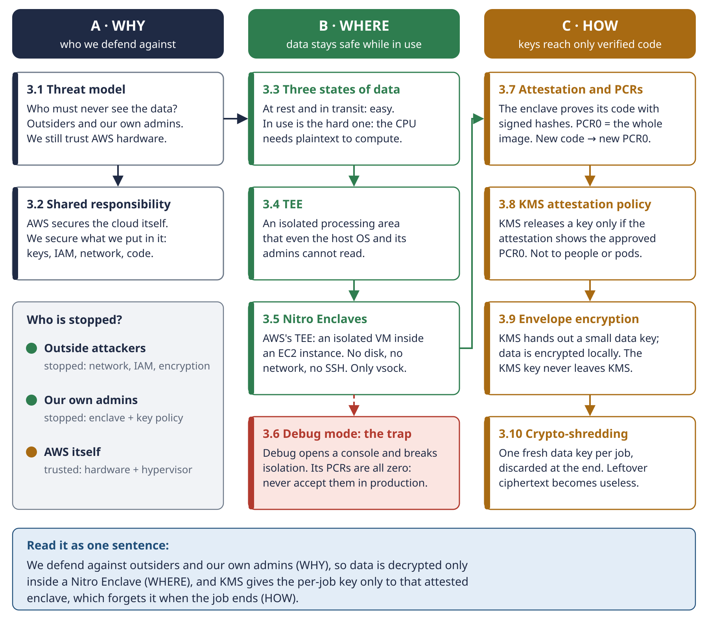
Schema 3 · The ten concepts as one chain: WHY → WHERE → HOW.

A · WHY: who we defend against

3.1 Threat model
In one line: a threat model answers “who am I defending against, and whom do I trust?”
Adversary | Stopped? | By what
External attackers | Yes | Private networking, IAM, encryption
Our own cluster and node admins | Yes | The enclave (root on the node can't read enclave memory) and the key policy (admins can't decrypt outside the enclave)
AWS itself | No, trusted | With Nitro, the root of trust is AWS's hardware and hypervisor

This is the honest limit of the design. If your threat model can't trust AWS, you need keys held outside AWS, or cryptographic techniques like homomorphic encryption, which are much slower.
The threat model decides everything else. If you didn't need protection from your own admins, plain EKS with SSE-KMS would be enough, and the enclave would be unnecessary cost and complexity.
EXAM NOTE Questions hide the threat model in one phrase, like “the company's administrators must not be able to access the data” or “the company must manage its own keys”. Spot that phrase first.

3.2 Shared responsibility
In one line: AWS is responsible for security OF the cloud. You are responsible for security IN the cloud.
AWS secures (of the cloud) | You secure (in the cloud)
Hardware, the Nitro System, the HSMs behind KMS | Key policies, IAM, network design, the enclave code and its PCRs

This project sits almost entirely on your side of the line, which makes it a good way to remember the model for the exam.

B · WHERE: data stays safe while in use

3.3 The three states of data
In one line: data is at rest, in transit or in use, and “in use” is the hard one to protect.
State | Meaning | Protection on AWS
At rest | stored on disk, in S3 or in a database | S3 SSE, EBS encryption: mature and easy
In transit | moving over a network | TLS: mature and easy
In use | loaded in memory while being processed | Hard: the CPU normally needs plaintext to compute. This is what confidential computing solves.

Confidential computing is the family of technologies that protect data in use, usually by isolating the memory where the processing happens. This project is a confidential computing project.

3.4 Trusted Execution Environment (TEE)
In one line: an isolated area of a processor or system whose code and data are protected from everything outside it, including the host OS and its administrators.
Examples are Intel TDX, AMD SEV-SNP and AWS Nitro Enclaves. A TEE usually offers remote attestation: a signed proof of what code is running inside it (see 3.7).

3.5 AWS Nitro Enclaves
In one line: an isolated virtual machine carved out of a parent EC2 instance, with no disk, no network and no interactive access.
- How it is isolated: the enclave takes some of the parent's vCPUs and memory. The Nitro Hypervisor isolates them, so even root on the parent can't read the enclave's memory.
- What it lacks: persistent storage, interactive access (no SSH) and external networking.
- Its only door: vsock, a local socket between the enclave and its parent.
- Cost: no extra charge. You pay only for the EC2 instance and the other services you use.
- Limits: up to four enclaves per parent instance. Enclaves stop when the parent stops. Not available on Outposts, Local Zones or Wavelength Zones.
- Which instances: Nitro-based types from AWS's supported list. In practice, Intel and AMD types from .xlarge (4 vCPUs) upwards and Graviton types from .large upwards. Most .metal sizes and the burstable T families aren't supported. The m6a.xlarge used in this guide is supported: in the M6a family only m6a.large and m6a.metal are excluded.
UPDATED IN V2 v1 listed t3, t3a, t4g, a1, c6g, c6gd, m6g, m6gd, r6g and r6gd as exceptions to the 4-vCPU rule. The current AWS user guide gives a per-family list instead, and Graviton families such as M6g, C6g and R6g are supported from .large upwards. Checked on 1 October 2026: always confirm in the AWS Nitro Enclaves user guide.

3.6 Debug mode: the trap
In one line: debug mode gives an enclave a console for troubleshooting, and breaks its isolation.
Because isolation is broken, a debug-mode enclave reports PCRs of all zeros in its attestation. A production key policy must never accept a zero PCR0. Many AWS samples use zeros for development, so this is a common mistake. Part II shows a Terraform validation that blocks it.
TRAP PCR0 = 000…000 means debug mode. Never put it in a production key policy.

C · HOW: keys reach only verified code

3.7 Attestation and PCRs
In one line: the enclave proves which code it runs with signed hashes called PCRs.
When you build an enclave image, the tooling computes measurements called Platform Configuration Registers (PCRs). They are SHA-384 hashes:
Register | Measures
PCR0 | the whole enclave image file (EIF)
PCR1 | the Linux kernel and boot ramdisk
PCR2 | the application
PCR8 | the certificate used to sign the image (only if the image is signed)

When the enclave runs, the Nitro Hypervisor produces a signed attestation document that contains these values. Anyone who trusts AWS's signing chain can verify exactly which code is running.
Change one line of code and rebuild, and PCR0 changes. That's the point: the measurement identifies one precise build.

3.8 KMS attestation-based key policies
In one line: KMS releases a key only when the attestation document shows the approved PCR0. Not to a person, not to a pod, not to an admin.
KMS understands Nitro attestation natively. There are two kinds of condition key:
- kms:RecipientAttestation:ImageSha384 matches the image hash, which is PCR0.
- kms:RecipientAttestation:PCR<n> matches one register, for example PCR8 for the signing certificate.
They control Decrypt, DeriveSharedSecret, GenerateDataKey, GenerateDataKeyPair and GenerateRandom. When the request carries an attestation document, KMS returns the key material encrypted to a public key that only the enclave holds. The parent pod passes the response along but can't read it. Schema 3c shows the full handshake.
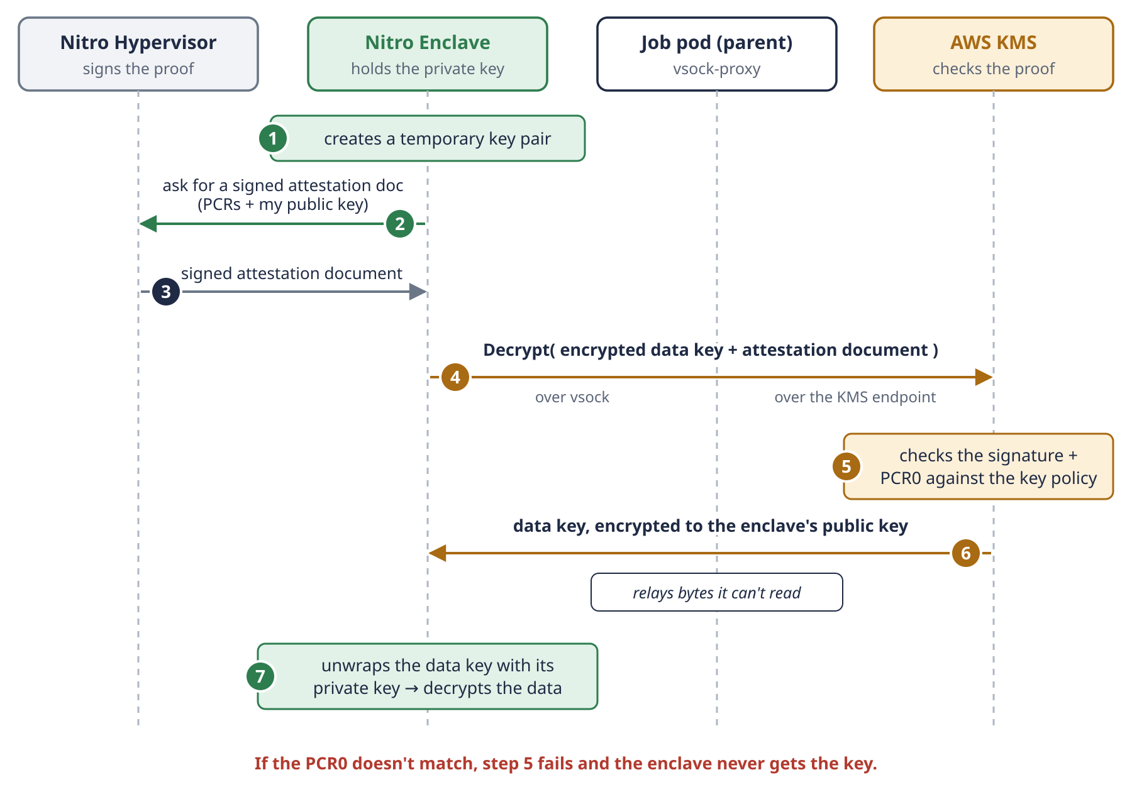
Schema 3c · The attestation handshake: the enclave gets a key that the pod relaying it can't read.

3.9 Envelope encryption
In one line: encrypt the data with a data key, then protect that data key with a KMS key.
KMS doesn't encrypt your large data directly: the Encrypt API accepts only about 4 KB. Instead:
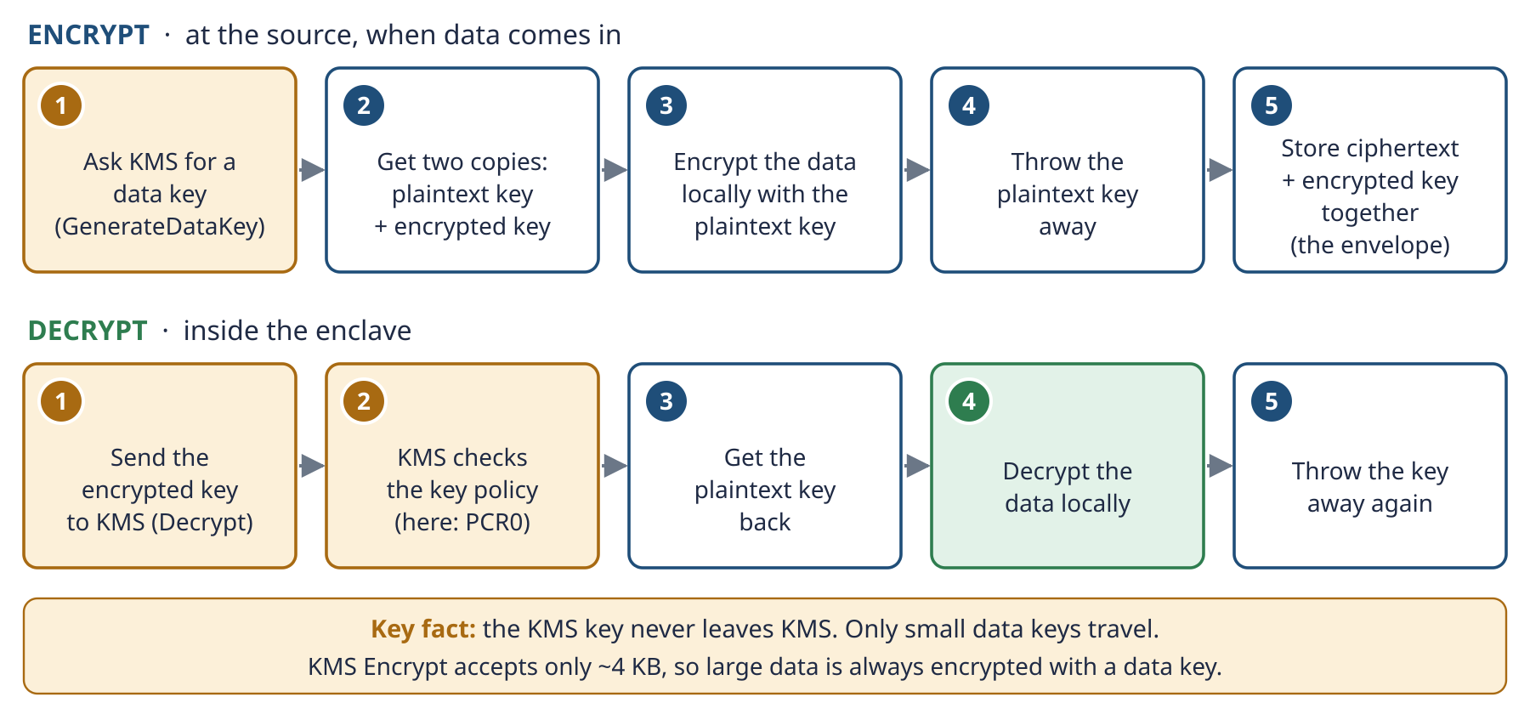
Schema 3b · Envelope encryption: big data never goes to KMS, only small data keys do.
- Ask KMS for a data key (GenerateDataKey). You get two copies of the same key: one in plaintext and one encrypted under your KMS key.
- Encrypt the data locally with the plaintext copy.
- Throw the plaintext copy away.
- Store the encrypted data key next to the encrypted data.
To decrypt, send the encrypted data key to KMS. If the key policy allows it, you get the plaintext key back and decrypt locally. In this project, “if the policy allows it” means “if the attestation shows the approved PCR0”.
EXAM NOTE The KMS key (formerly called a CMK) never leaves KMS. This is the most important KMS concept for the exam.

3.10 Crypto-shredding
In one line: make data unrecoverable by destroying the key instead of the data.
Each job uses a fresh data key, and that key is discarded when the job ends. Any leftover ciphertext, whether in logs, snapshots or a forgotten S3 object, becomes useless. This is how the design achieves “nothing left behind”, even though you can never prove that every byte was deleted.
REMEMBER WHY → WHERE → HOW. We defend against outsiders and our own admins (WHY), so data is decrypted only inside a Nitro Enclave (WHERE), and KMS gives the per-job key only to that attested enclave, which forgets it when the job ends (HOW).

Part II · Build and deploy (the original plan)
DECIDED The original plan, kept as it was. This part is the build plan as v1 proposed it, before the decisions were taken. Several points changed: the POC runs on one EC2 instance in Stockholm (eu-north-1), not on EKS in London. What was actually built is in poc-tier1-spec.docx, and every decision with its reason is in poc/README.md.

4. The decisions to make
These were the open choices before the deployment. The last column shows what v1 proposed; the final decisions are in poc/README.md.
# | Decision | Options | v1 proposal
D1 | Where to start | Local prototype · Tier 1 (one EC2) · Tier 2 (ephemeral EKS) | Local first, then Tier 1
D2 | AWS Region | eu-west-2 (London) or another | eu-west-2, used for the prices in section 7
D3 | Test data | Synthetic · anonymised · real | Synthetic only, until the design is proven
D4 | What the key policy pins | PCR0 (strict) · PCR8 signing certificate (flexible) · both | PCR0 for the lab
D5 | Pod identity | EKS Pod Identity · IRSA | Either, but never the node's instance role
D6 | CI and GitOps | GitLab CI · GitHub Actions · other | CI builds the EIF and opens a merge request that updates enclave_pcr0
D7 | Enclave node purchasing | Spot · On-Demand | Spot, scaling to zero
D8 | Terraform state | Local file · S3 backend | Not covered in v1: to decide
D9 | Monthly budget ceiling | Any amount | $10, alert at 80%
D10 | How results leave the enclave | One key with owner Decrypt · separate results key · recipient's public key | Not covered in v1. Payslips: one key (2.5). Tier 1 POC: no output encryption (synthetic data)

4.1 Proposed roadmap (from v1)
- Prototype locally with kind and LocalStack, a mock enclave and synthetic data. Cost: free.
- Build Tier 1 on AWS: one m6a.xlarge with enclaves enabled and a KMS key locked to PCR0. Decrypt a test file inside the enclave, and prove that the same Decrypt call from the parent instance fails.
- Add the CI step that builds the EIF and updates enclave_pcr0 through a reviewed Terraform plan.
- Move to Tier 2: ephemeral EKS with the device plugin, a Kubernetes Job and Spot nodes scaling to zero.
- Measure real costs and compare them with the estimates.

5. Build steps (v1 drill-down)
The ten build steps from v1, unchanged in substance. Use them as input for the discussion.
Step | Goal | Main services
1 · Threat model and data classification | decide what to protect, and from whom | Amazon Macie (optional)
2 · Network foundation | private VPC with no internet access | VPC, VPC endpoints
3 · KMS key and policy | a key only the attested enclave can use | AWS KMS
4 · Encrypted ingestion | data arrives already encrypted | S3, SSE-KMS, bucket policy
5 · EKS and enclave nodes | a cluster that can run enclaves | EKS, launch templates, device plugin
6 · Enclave image and PCR0 | lock the key to one build | nitro-cli, CI, Terraform
7 · Run a job | the eight-step flow from Part I | Kubernetes Job, vsock, KMS
8 · Tear down and crypto-shred | leave nothing behind | Job TTL, autoscaling, S3 lifecycle
9 · Audit and monitoring | prove who decrypted what | CloudTrail, CloudWatch, Budgets
10 · Return the result | send the result back safely | IAM role, S3

Step 1: Define the threat model and data classification
Before writing any Terraform, write down what data you process (for example, health records), who must never see it in plaintext (admins, other tenants, external attackers) and what you accept to trust (AWS hardware). This decides every later choice: see 3.1.

Step 2: Build the network foundation
Everything runs in a VPC with private subnets only, without internet access. Instead of a NAT gateway, AWS services are reached through VPC endpoints. There are two kinds:
Endpoint type | Services | How it works | Cost
Gateway | S3 and DynamoDB only | adds routes to your route tables | Free
Interface (PrivateLink) | most other services: KMS, STS, ECR, CloudWatch Logs… | an ENI with a private IP in your subnet | Per hour per AZ, plus per GB

For this project you need an S3 gateway endpoint, plus interface endpoints for KMS, STS (pod IAM credentials), ECR API and ECR DKR (to pull images), and the EKS-related endpoints your node bootstrap requires.
Why bother? Data never crosses the public internet, and the S3 bucket policy can require that requests come through your VPC endpoint (aws:SourceVpce), so a stolen credential used from outside the VPC is useless.
EXAM NOTE Gateway vs interface endpoints is a classic exam topic. Gateway: S3 and DynamoDB only, free. Interface: everything else, billed.

Step 3: Create the KMS key and its policy
Create one customer managed KMS key. Its key policy has at least three statements:
Statement | Who | Can do
Key administration | admin role | enable, disable, schedule deletion, put policy. No Decrypt.
Ingestion | source or ingestion role | GenerateDataKey, Encrypt
Processing | processing pod role, only when the attestation matches PCR0 (optionally PCR8) | Decrypt, GenerateDataKey

A second key, the results key, protects the output: the attested enclave can encrypt with it and only the result owner can decrypt it (see 2.5 and decision D10).
This is separation of duties: whoever manages the key can't use it. Enable automatic key rotation: it creates new key material yearly by default and keeps the old material to decrypt old data, so nothing breaks.
EXAM NOTE A key policy is the primary access control for a KMS key. IAM policies only work if the key policy allows the account to delegate to IAM. When a question asks “who can use this key”, think key policy first.

Step 4: Ingest the data encrypted
The source encrypts the data client-side with a data key before sending it (envelope encryption, 3.9), then uploads it over TLS to the S3 bucket. The bucket enforces SSE-KMS as default encryption, so even the encrypted blob is encrypted again at rest. Enable S3 Bucket Keys to cut KMS request costs.
The bucket policy denies any request without TLS (aws:SecureTransport = false), any request not coming through the VPC endpoint, and any PutObject without SSE-KMS. Block Public Access is on at account and bucket level. Versioning protects against accidental overwrites. A lifecycle rule expires intermediate objects after a short period.
EXAM NOTE Know the four S3 encryption options. SSE-S3: keys managed by S3. SSE-KMS: KMS keys, audit trail in CloudTrail, fine-grained control. SSE-C: you provide the key with every request. Client-side: you encrypt before upload. Audit of key usage or separation of duties → SSE-KMS. AWS must never see plaintext → client-side encryption.

Step 5: Prepare the EKS cluster and the enclave node group
Create an EKS cluster with two node groups. A small system node group runs cluster add-ons like CoreDNS. The enclave node group uses a launch template with enclave_options { enabled = true } and user data that installs the Nitro Enclaves CLI, starts the allocator service and reserves CPU and memory for enclaves. This group can scale to zero between jobs.
Then install the Nitro Enclaves Kubernetes device plugin as a DaemonSet. It lets pods create and terminate enclaves, and works with both Amazon EKS and self-managed nodes. Pod specs must request the enclave device and hugepages, and the hugepage size must match the memory allocated in the node user data.
Give the job pods their own IAM role through EKS Pod Identity or IRSA (IAM Roles for Service Accounts), never the node's instance role. That way, only the processing pod's role appears in the KMS key policy.
EXAM NOTE IRSA and Pod Identity show up in questions about least-privilege AWS access for pods. The wrong answer is usually “attach the policy to the node instance role”.

Step 6: Build the enclave image and lock the key to it
The processing code is packaged as a Docker image, then converted with nitro-cli build-enclave into an Enclave Image File (EIF). The build prints PCR0, PCR1 and PCR2. If you sign the EIF with a certificate, you also get PCR8.
This is where GitOps fits. The CI pipeline builds the EIF, extracts PCR0 and opens a merge request that updates the Terraform variable enclave_pcr0. The Terraform plan shows the KMS policy change, someone reviews it, and the apply locks the key to the new build. Every code change becomes a visible, audited change to who can decrypt.
Pinning PCR8 (the signing certificate) instead of, or alongside, PCR0 lets you release new builds without changing the policy each time, as long as they are signed with your certificate. It's a trade-off between convenience and strictness (decision D4).

Step 7: Run a job
A Kubernetes Job is scheduled on an enclave node. This is the RUN phase of Schema 2:
- The pod downloads the encrypted object and its encrypted data key from S3 through the gateway endpoint. It only ever holds ciphertext.
- The pod starts the enclave from the EIF, and they talk over vsock.
- The enclave generates a temporary key pair, asks the hypervisor for an attestation document that includes its public key, and sends a Decrypt request for the encrypted data key to KMS through a vsock proxy running in the pod. The enclave itself has no network.
- KMS validates the attestation signature, checks the PCRs against the key policy, and returns the data key encrypted to the enclave's public key. The pod relays bytes it can't read.
- The enclave decrypts the data and processes it entirely in its own memory.
- The enclave requests a fresh data key under the results key (GenerateDataKey, again with attestation), encrypts the result, and returns only ciphertext plus the encrypted data key to the pod (see 2.5).
- The pod writes the encrypted result to S3.

Step 8: Tear down and crypto-shred
When the job finishes, the enclave terminates and its memory is wiped. The plaintext data keys existed only in enclave memory, so they are gone. The Job object is cleaned up with ttlSecondsAfterFinished, and the enclave node group scales back to zero. Intermediate S3 objects expire through the lifecycle rule. Even if a copy survived somewhere, it is ciphertext whose key only the attested enclave can recover.

Step 9: Audit and monitoring
CloudTrail records every KMS API call, including the attestation details in the request, so you can prove which build decrypted what and when. Enable S3 data events for the bucket. Send logs to a separate, locked-down bucket, and consider Object Lock for tamper-proof retention. Set CloudWatch alarms on unexpected Decrypt calls or spikes of AccessDenied, which can mean someone is trying to use the key outside the enclave. An AWS Budgets alert protects you from cost surprises.
EXAM NOTE CloudTrail answers “who did what”. CloudWatch answers “what is happening now”. AWS Config answers “how is it configured, and has that changed”. Amazon Macie discovers sensitive data like PII in S3, which helps with classification in step 1.

Step 10: Move the result back to the source
The source system pulls the encrypted result through an authenticated, audited path (for example, a role it assumes with a narrowly scoped policy), then decrypts it in its own trusted environment with its Decrypt permission on the results key (2.5). Every hop stays encrypted, and every access is logged.

6. Terraform implementation (v1 draft code)

6.1 Module layout
confidential-processing/
├── main.tf # wires modules together
├── variables.tf # region, enclave_pcr0, budget_email...
├── outputs.tf
├── modules/
│ ├── network/ # VPC, private subnets, VPC endpoints
│ ├── kms/ # KMS key + attestation policy
│ ├── storage/ # S3 bucket, policy, lifecycle
│ ├── eks/ # cluster, system + enclave node groups
│ └── audit/ # CloudTrail, alarms, budget
└── enclave-userdata.sh # nitro-cli install + allocator config

6.2 Guarding the PCR0 variable
variable "enclave_pcr0" {
type = string
description = "SHA-384 image measurement (PCR0) of the approved enclave build"

validation {
condition = length(var.enclave_pcr0) == 96 && var.enclave_pcr0 != join("", [for i in range(96) : "0"])
error_message = "PCR0 must be a 96-character SHA-384 hex value and must not be the debug-mode zero value."
}
}

This stops a debug-mode policy from ever reaching production (see 3.6).

6.3 S3 gateway endpoint and KMS interface endpoint
resource "aws_vpc_endpoint" "s3" {
vpc_id = module.vpc.vpc_id
service_name = "com.amazonaws.${var.region}.s3"
vpc_endpoint_type = "Gateway"
route_table_ids = module.vpc.private_route_table_ids
}

resource "aws_vpc_endpoint" "kms" {
vpc_id = module.vpc.vpc_id
service_name = "com.amazonaws.${var.region}.kms"
vpc_endpoint_type = "Interface"
subnet_ids = module.vpc.private_subnets
security_group_ids = [aws_security_group.endpoints.id]
private_dns_enabled = true
}

6.4 KMS key with attestation-gated policy
data "aws_iam_policy_document" "key" {
statement {
sid = "KeyAdministration"
actions = ["kms:Create*", "kms:Describe*", "kms:Enable*", "kms:List*",
"kms:Put*", "kms:Update*", "kms:Revoke*", "kms:Disable*",
"kms:Get*", "kms:ScheduleKeyDeletion", "kms:CancelKeyDeletion",
"kms:TagResource", "kms:UntagResource"]
resources = ["*"]
principals {
type = "AWS"
identifiers = [var.key_admin_role_arn]
}
}

statement {
sid = "IngestionEncryptOnly"
actions = ["kms:GenerateDataKey", "kms:Encrypt"]
resources = ["*"]
principals {
type = "AWS"
identifiers = [var.ingestion_role_arn]
}
}

statement {
sid = "DecryptOnlyFromAttestedEnclave"
actions = ["kms:Decrypt", "kms:GenerateDataKey"]
resources = ["*"]
principals {
type = "AWS"
identifiers = [var.processing_pod_role_arn]
}
condition {
test = "StringEqualsIgnoreCase"
variable = "kms:RecipientAttestation:ImageSha384"
values = [var.enclave_pcr0]
}
}
}

resource "aws_kms_key" "processing" {
description = "Confidential processing key, enclave-only decrypt"
enable_key_rotation = true
policy = data.aws_iam_policy_document.key.json
}

Note what's missing: the admin role has no Decrypt, and the ingestion role can encrypt but not decrypt.

6.5 Enclave-enabled launch template and node group
resource "aws_launch_template" "enclave_node" {
name_prefix = "enclave-node-"
instance_type = "m6a.xlarge"
enclave_options { enabled = true }
user_data = base64encode(file("${path.root}/enclave-userdata.sh"))

metadata_options {
http_tokens = "required" # IMDSv2 only
http_put_response_hop_limit = 1
}
}

resource "aws_eks_node_group" "enclave" {
cluster_name = aws_eks_cluster.this.name
node_group_name = "enclave"
node_role_arn = aws_iam_role.node.arn
subnet_ids = module.vpc.private_subnets
capacity_type = "SPOT"
labels = { "aws-nitro-enclaves-k8s-dp" = "enabled" }

launch_template {
id = aws_launch_template.enclave_node.id
version = aws_launch_template.enclave_node.latest_version
}

scaling_config {
min_size = 0
desired_size = 0
max_size = 2
}
}

The label matches what the device plugin looks for, so it only runs on enclave nodes. IMDSv2 with a hop limit of 1 stops pods from stealing the node's credentials through the metadata service.

6.6 S3 bucket policy essentials
data "aws_iam_policy_document" "bucket" {
statement {
sid = "DenyInsecureTransport"
effect = "Deny"
actions = ["s3:*"]
resources = [aws_s3_bucket.data.arn, "${aws_s3_bucket.data.arn}/*"]
principals {
type = "*"
identifiers = ["*"]
}
condition {
test = "Bool"
variable = "aws:SecureTransport"
values = ["false"]
}
}

statement {
sid = "DenyOutsideVpcEndpoint"
effect = "Deny"
actions = ["s3:GetObject", "s3:PutObject"]
resources = ["${aws_s3_bucket.data.arn}/*"]
principals {
type = "*"
identifiers = ["*"]
}
condition {
test = "StringNotEquals"
variable = "aws:SourceVpce"
values = [aws_vpc_endpoint.s3.id]
}
}
}

In a real setup, add an exception for the source system's upload path, otherwise ingestion from outside the VPC will be blocked too.

6.7 Budget alarm
resource "aws_budgets_budget" "lab" {
name = "confidential-lab"
budget_type = "COST"
limit_amount = "10"
limit_unit = "USD"
time_unit = "MONTHLY"

notification {
comparison_operator = "GREATER_THAN"
threshold = 80
threshold_type = "PERCENTAGE"
notification_type = "ACTUAL"
subscriber_email_addresses = [var.budget_email]
}
}

7. Budget and cost optimisation

7.1 Unit prices (London, eu-west-2)
Item | Price | Source
Nitro Enclaves | No extra charge | AWS docs
m6a.xlarge On-Demand | $0.1998/hr | DoiT tracker
m6a.xlarge Spot | from ~$0.07/hr | DoiT tracker
EKS control plane (standard support) | $0.10/hr (~$73/month) | AWS / multiple guides
EKS control plane (extended support) | $0.60/hr (~$438/month) | AWS blog
KMS customer managed key | $1/month, prorated hourly | AWS KMS pricing
KMS symmetric requests | First 20,000/month free, then $0.03 per 10,000 | AWS KMS pricing
Public IPv4 address | $3.65/month each | Third-party 2026 guide

An m6a.xlarge in eu-west-2 has 4 vCPU and 16 GiB. The KMS free tier of 20,000 requests a month is calculated across all Regions. The instance prices come from a third-party tracker, so confirm them in the AWS Pricing Calculator.

7.2 Three budget tiers
Tier | What it is | Monthly cost | Good for
1 · Single-instance lab | One enclave-enabled EC2 instance, no EKS. Created with Terraform, destroyed after use. About 10 hours a month. | ~$2–4 | Proving the hardest part: KMS refusing the key to anything that isn't your enclave
2 · Ephemeral EKS | The whole cluster, built only for test sessions and destroyed afterwards. About 10 hours a month. | ~$4–6 | Testing the Kubernetes flow. Cluster creation is slow, so batch the testing.
3 · Always-on EKS | Control plane, an always-on system node, endpoints and any NAT, all month. | $100+ | Only a real service

Tier 1 detail: about $2 of On-Demand compute (under $1 on Spot), plus $1 for the KMS key and cents for S3. Tier 2: ten hours of control plane cost about $1, plus the node and KMS. Tier 3: about $73 a month for the control plane alone.

7.3 Hidden costs to watch
- NAT gateways bill per hour and per GB processed: one of the most common surprise costs on small accounts. Avoid them with VPC endpoints.
- Interface endpoints bill per hour per AZ. In a lab, deploy them in one AZ only and destroy them with the rest.
- Public IPv4 addresses cost money even when idle, so keep nodes private.
- EKS extended support costs six times the standard rate if an old cluster keeps running. Upgrade or destroy.
- CloudTrail data events (S3 object-level logging) are billed per event. The first management-event trail is free. Enable data events only on the sensitive bucket.

7.4 Cost-optimisation levers
- Use Spot for enclave nodes: jobs are short and can be retried. Around 60% cheaper than On-Demand.
- Scale the enclave node group to zero between jobs.
- Use the S3 gateway endpoint (free) instead of routing S3 traffic through NAT.
- Enable S3 Bucket Keys to reduce KMS requests.
- Use one KMS key with many data keys, not one KMS key per job: data keys are free apart from requests.
- For a steady production workload, compare Savings Plans with On-Demand.
EXAM NOTE The cost-optimised domain loves these patterns: Spot for interruptible batch, Savings Plans or Reserved Instances for steady state, gateway endpoints for S3 and DynamoDB, lifecycle rules to cheaper storage classes, S3 Bucket Keys for SSE-KMS-heavy workloads.

8. Local prototyping (free)
Nitro Enclaves can't run outside AWS, but most of the flow can be prototyped locally for free:
- Kubernetes: kind or minikube.
- S3: LocalStack or MinIO.
- KMS: LocalStack's KMS emulation, for the envelope-encryption logic.
- Enclave: a mock container that only receives ciphertext over a socket. It lets you build the job orchestration, Job TTLs, NetworkPolicies and the encrypt → process → re-encrypt cycle.
Then move to Tier 1 on AWS only to test real attestation. Keep test data synthetic: local mode offers no real protection.

Part III · Exam and reference

9. SAA-C03 exam corner

9.1 Mapping the project to the exam domains
The exam has four domains, and this project touches all of them:
Domain | Weight | What this project uses
Design Secure Architectures | 30% | KMS key policies, envelope encryption, S3 encryption options, bucket policies with aws:SecureTransport and aws:SourceVpce, VPC endpoints, IAM roles for pods, IMDSv2, CloudTrail, separation of duties
Design Resilient Architectures | 26% | Jobs that can be retried after a Spot interruption, multi-AZ subnets, S3 durability and versioning, processing decoupled through S3
Design High-Performing Architectures | 24% | Choosing instance families and sizes, EKS scaling, S3 as a scalable data layer
Design Cost-Optimized Architectures | 20% | Spot, scaling to zero, gateway endpoints, no NAT, S3 Bucket Keys, lifecycle rules, AWS Budgets

9.2 Patterns the exam likes
If the question says… | Think…
Data must be encrypted and the company needs an audit trail of key usage | SSE-KMS with a customer managed key + CloudTrail
The company must control its keys in a dedicated, single-tenant HSM | AWS CloudHSM, not KMS
EC2 instances in private subnets must reach S3 without the internet | S3 gateway VPC endpoint
Process highly sensitive data with no network access and no admin access | Nitro Enclaves
Pods need AWS permissions with least privilege | IRSA or EKS Pod Identity
Batch jobs tolerate interruption and cost must be minimised | Spot Instances
S3 must only be accessed over HTTPS | Bucket policy denying aws:SecureTransport = false
Reduce KMS request costs for a high-volume SSE-KMS bucket | S3 Bucket Keys

9.3 Practice questions
Question 1. A healthcare company processes patient records on EC2. Security requires that even system administrators with root access to the instances cannot read the data during processing. What should a solutions architect recommend?
A) Encrypt EBS volumes with KMS.
B) Use AWS Nitro Enclaves with a KMS key policy that requires attestation.
C) Enable S3 SSE-KMS.
D) Use Dedicated Instances.
Answer: B. EBS and S3 encryption protect data at rest, not in use. Dedicated Instances isolate hardware between customers, not from your own admins.
Question 2. An application in private subnets uploads large volumes of data to S3. The NAT gateway bill is high. What is the most cost-effective fix?
A) Add a second NAT gateway.
B) Create an S3 gateway VPC endpoint.
C) Create an S3 interface endpoint.
D) Move the instances to public subnets.
Answer: B. Gateway endpoints for S3 are free. Interface endpoints cost per hour and per GB. Public subnets weaken security.
Question 3. A company wants to encrypt 50 GB files with KMS. The developer reports that the Encrypt API fails. What should they do?
A) Request a KMS quota increase.
B) Use envelope encryption with GenerateDataKey.
C) Split the file into 4 KB parts.
D) Switch to SSE-C.
Answer: B. KMS Encrypt handles only small payloads. Large data uses a data key.
Question 4. A security team must ensure that the people who administer KMS keys cannot use them to decrypt data. What is the right approach?
A) Use IAM policies only.
B) Separate administrative and usage permissions in the key policy.
C) Disable key rotation.
D) Use an AWS managed key.
Answer: B. Key policies support separation of duties. AWS managed keys can't have custom policies.
Question 5. A nightly batch job on EKS takes two hours, can be restarted safely, and must cost as little as possible. Which purchasing option fits?
A) On-Demand.
B) Reserved Instances.
C) Spot Instances.
D) Dedicated Hosts.
Answer: C. Interruptible and restartable means Spot.

10. Glossary
Term | Meaning
Attestation document | A document signed by the Nitro Hypervisor proving which code (PCRs) an enclave runs
Bucket Key (S3) | A bucket-level key that reduces calls from S3 to KMS, lowering SSE-KMS costs
CloudHSM | Single-tenant hardware security modules fully managed by the customer
CloudTrail | Service that logs AWS API calls for audit
Confidential computing | Technologies that protect data while it's being processed
Crypto-shredding | Making data unrecoverable by destroying its encryption key
Customer managed key | A KMS key you create and control, including its key policy ($1/month)
Data key | A symmetric key generated by KMS to encrypt data locally
Debug mode | Enclave mode with a console; attestation shows all-zero PCRs
Device plugin | A Kubernetes extension that exposes hardware (here, the enclave device) to pods
EIF | Enclave Image File, the bootable image built from a Docker image by nitro-cli
EKS | Amazon Elastic Kubernetes Service, managed Kubernetes control plane
Envelope encryption | Encrypting data with a data key, then encrypting that key with a KMS key
Extended support (EKS) | Higher-cost support period for older Kubernetes versions ($0.60/hr)
Gateway endpoint | Free VPC endpoint for S3 and DynamoDB, implemented as route table entries
Hugepages | Large memory pages Linux reserves; required for enclave memory allocation
IMDSv2 | Session-based Instance Metadata Service that protects instance credentials
Interface endpoint | VPC endpoint (PrivateLink) with an ENI in your subnet, billed hourly
IRSA / Pod Identity | Mechanisms giving Kubernetes pods their own IAM role
Key policy | The resource policy that controls who can use and manage a KMS key
KMS | AWS Key Management Service, managed keys backed by HSMs
Launch template | EC2 configuration template (instance type, AMI, user data, enclave options)
NAT gateway | Managed service letting private instances reach the internet; billed hourly and per GB
Nitro Enclave | Isolated VM inside an EC2 instance with no storage, network or interactive access
Nitro Hypervisor | The lightweight AWS hypervisor that isolates instances and enclaves
PCR | Platform Configuration Register, a hash measuring part of the enclave image
PCR0 | Hash of the whole enclave image; used in kms:RecipientAttestation:ImageSha384
PCR8 | Hash of the signing certificate of the enclave image
Remote attestation | Proving to a remote party what code is running, using signed measurements
SSE-C / SSE-KMS / SSE-S3 | S3 server-side encryption with customer-provided, KMS or S3-managed keys
Separation of duties | Splitting powers so no single role can both manage and use a key
Spot Instance | Spare EC2 capacity at a large discount, interruptible with two minutes' notice
TEE | Trusted Execution Environment, isolated hardware-protected processing area
Threat model | Explicit statement of what you protect, from whom, and what you trust
vsock | Local socket channel between a parent instance and its enclave
VPC endpoint | Private connection from a VPC to an AWS service without the internet

11. Sources
- AWS Nitro Enclaves user guide, overview, requirements and pricing: https://docs.aws.amazon.com/enclaves/latest/user/nitro-enclave.html
- AWS Nitro Enclaves FAQs: https://aws.amazon.com/ec2/nitro/nitro-enclaves/faqs/
- Using Nitro Enclaves with Amazon EKS: https://docs.aws.amazon.com/enclaves/latest/user/kubernetes.html
- Nitro Enclaves Kubernetes device plugin: https://github.com/aws/aws-nitro-enclaves-k8s-device-plugin
- Cluster API Provider AWS, Nitro Enclaves: https://cluster-api-aws.sigs.k8s.io/topics/nitro-enclaves
- AWS KMS condition keys for Nitro Enclaves: https://docs.aws.amazon.com/kms/latest/developerguide/conditions-nitro-enclave.html
- Connect an enclave with AWS KMS: https://docs.aws.amazon.com/enclaves/latest/user/connect-enclave-kms.html
- AWS KMS pricing: https://aws.amazon.com/kms/pricing/
- Amazon EKS extended support pricing: https://aws.amazon.com/blogs/containers/amazon-eks-extended-support-for-kubernetes-versions-pricing/
- m6a.xlarge pricing in eu-west-2 (third-party): https://www.doit.com/compute/spot/eu-west-2/m6a.xlarge
Prices checked on 1 October 2026. Confirm them in the AWS Pricing Calculator before you spend. Schemas: SVG sources in the schemas/ folder next to this document.

