Payslip Reconciliation POC
Data dictionary, formulas and planted errors · v1.0
Minelli-D · October 2026 · TASK-01 · synthetic data only

1. What was built
Mode A (check) is working locally: the formulas recompute every issued payslip and report the differences. The dataset is ready to be encrypted and stored in S3.
File | What it is | Goes to S3? | Runs in the enclave?
data/payslips-2026-H1.json | the dataset: employees, monthly attendance, issued payslips | Yes, encrypted first (T4) | Decrypted only inside it
data/answer-key-2026-H1.json | the 29 planted errors: the test oracle | Never | Never
poc/payslip/payroll_rules.py | the simplified Italian formulas | No | Yes, built into the image
poc/payslip/reconcile.py | Mode A: recompute, compare, report | No | Yes, built into the image
poc/payslip/generate_dataset.py | creates the synthetic data and plants the errors | No | No
poc/payslip/test_*.py | 29 tests: formulas, reconciliation, dataset | No | No

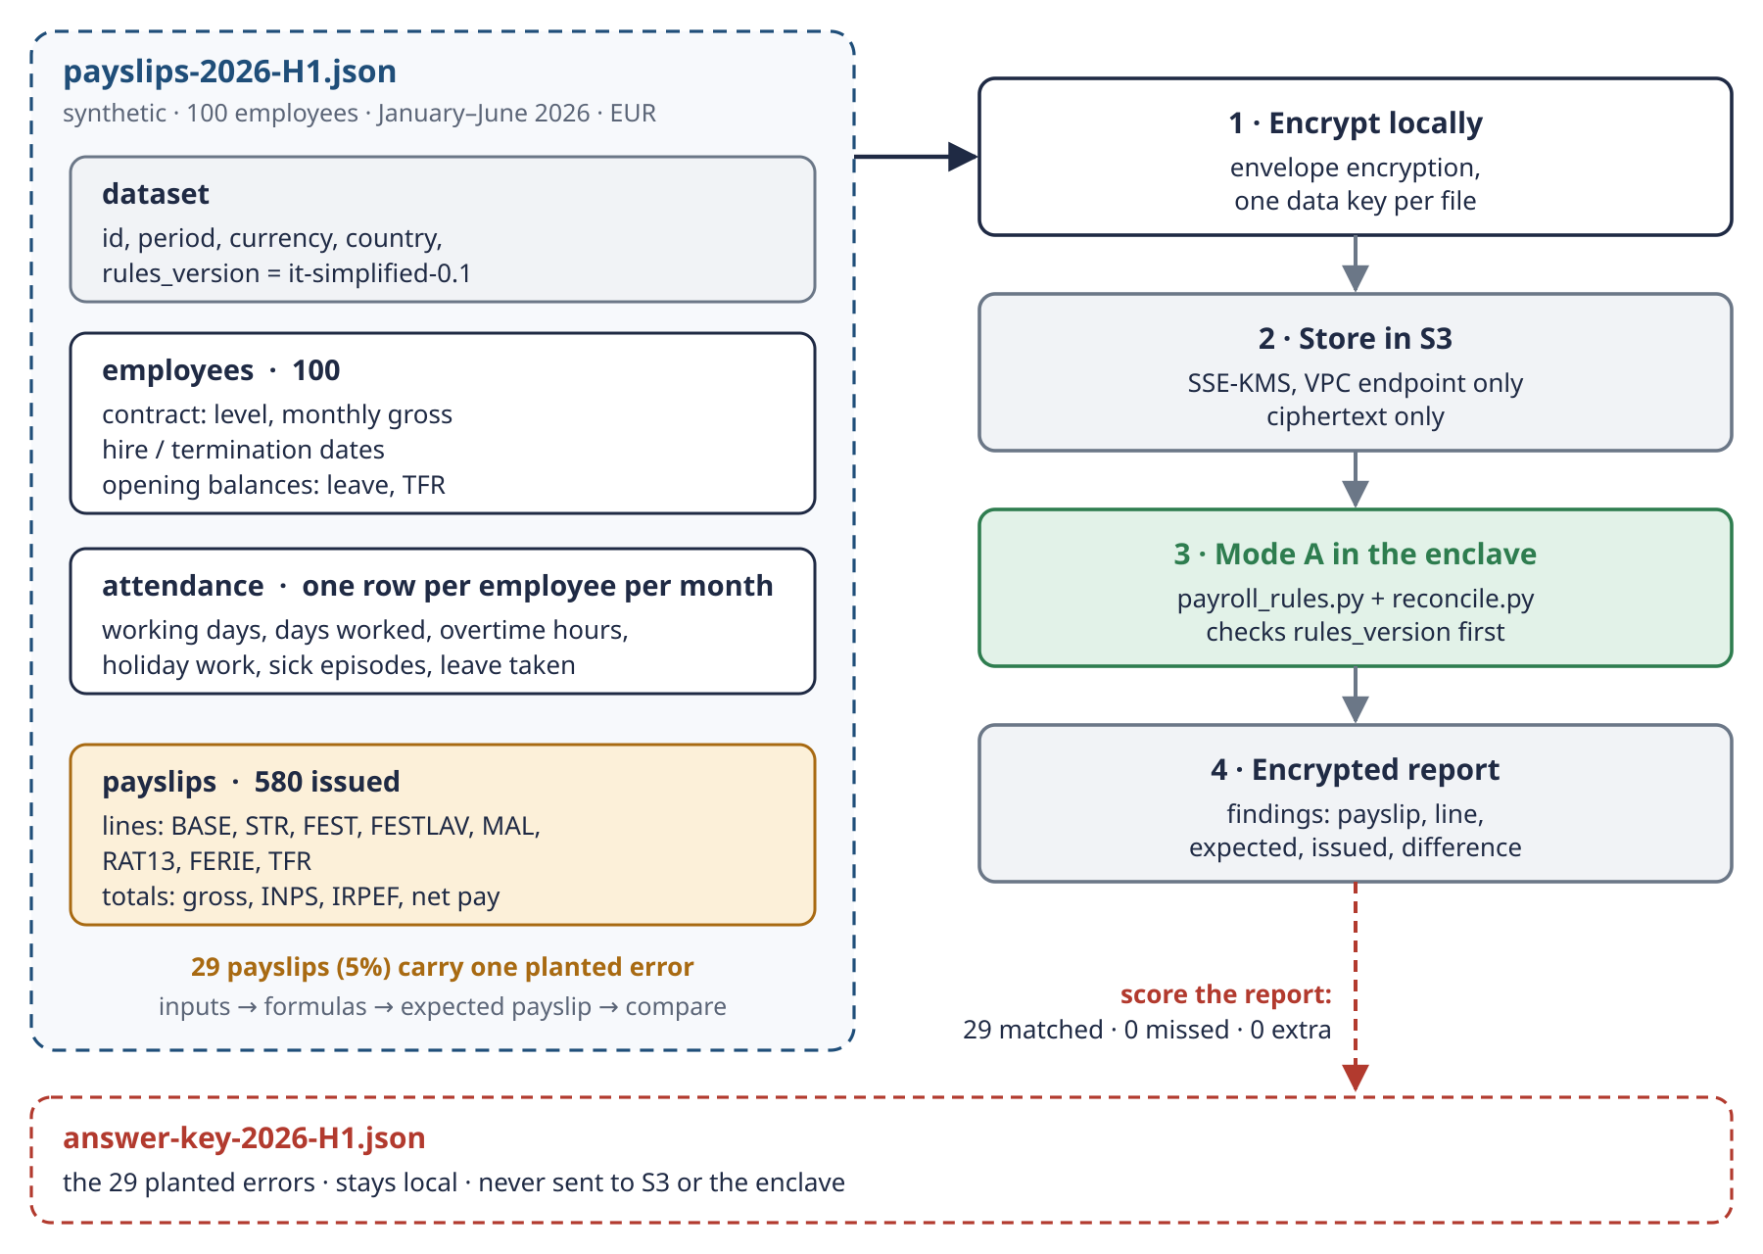
Schema 4 · The dataset, its path to the enclave, and the answer key that never leaves this folder.
Result of the first run
Employees | 100 (6 terminated and 4 hired during the semester)
Payslips checked | 580
Payslips with differences | 29 (5%)
Score against the answer key | 29 matched, 0 missed, 0 unexpected
Net impact of the errors | +311.45 EUR (overpayments and underpayments together)

2. Data dictionary
One JSON file with four sections. All amounts are in EUR, with two decimals. Dates are ISO (YYYY-MM-DD) and months are YYYY-MM.

2.1 dataset
Field | Type | Example | Meaning
id | text | payslip-reconciliation-2026-H1 | dataset name
synthetic | boolean | true | always true: no real person
period.from / period.to | month | 2026-01 / 2026-06 | the semester covered
currency / country | text | EUR / IT
rules_version | text | it-simplified-0.1 | which formulas the data expects; the enclave refuses a mismatch
seed | number | 20260101 | random seed: same seed, same file

2.2 calendar
Field | Type | Example | Meaning
public_holidays | list of dates | 2026-01-01, 2026-01-06, 2026-04-06, 2026-04-25, 2026-05-01, 2026-06-02 | Italian national holidays in the semester (Easter Sunday excluded: always a Sunday)

2.3 employees (one per person)
Field | Type | Example | Meaning
employee_id | text | E001 | key, E001 to E100
first_name / last_name | text | Anna / Fabbri | synthetic names
department | text | Magazzino | Amministrazione, Vendite, Magazzino, IT, Produzione, Risorse umane
hire_date | date | 2014-11-07 | start of employment
termination_date | date or null | 2026-02-07 | last day of employment, null if still employed
termination_reason | text or null | licenziamento | dimissioni, licenziamento, fine contratto a termine
contract.ccnl | text | Commercio (semplificato) | national contract, simplified
contract.level | text | L4 | L1 (highest) to L6
contract.contract_type | text | tempo indeterminato | permanent or fixed-term
contract.weekly_hours | number | 40 | all full-time in the POC
contract.monthly_gross | amount | 2275.65 | retribuzione lorda mensile
opening_balances.leave_days | number | 14.5 | unused leave days carried over from 2025
opening_balances.tfr_fund | amount | 15193.28 | TFR accrued up to 31 December 2025

2.4 attendance (one per employee per month employed)
Field | Type | Example | Meaning
employee_id / month | text / month | E002 / 2026-01 | key
working_days | number | 20 | Monday to Friday in the employment window, minus public holidays
days_worked | number | 17 | working_days minus sick days minus leave days
overtime_hours | number | 6.5 | hours of overtime (straordinario)
holiday_work[] | list | {date: 2026-05-01, hours: 8} | hours worked on a public holiday
sick_episodes[] | list | {start: 2026-01-13, days: 3} | one entry per sickness episode, days = working days
leave_days_taken | number | 2 | holiday leave (ferie) taken in the month

2.5 payslips (one per employee per month employed)
Field | Type | Example | Meaning
payslip_id | text | PS-2026-02-E026 | key: PS-month-employee
employee_id / month / pay_date | text / month / date | E026 / 2026-02 / 2026-02-27 | pay date is always the 27th
lines[].code | text | FERIE | line code (see section 3)
lines[].description | text | Ferie non godute | Italian label, as on a real cedolino
lines[].quantity / unit | number / text | 7.17 / days | days, hours or months behind the amount
lines[].rate | amount | 73.48 | unit rate, informative only
lines[].amount | amount | 526.60 | the amount paid: this is what gets reconciled
totals.gross | amount | 1145.06 | all lines except TFR
totals.inps_employee / irpef | amount | 105.23 / 239.16 | deductions (simplified)
totals.tfr | amount | 19601.47 | TFR paid (termination month only)
totals.net_pay | amount | 20402.14 | paid to the employee

2.6 answer key (separate file)
Field | Type | Example | Meaning
payslip_id / employee_id / month | text | PS-2026-01-E012 | which payslip carries the error
error_type / explanation | text | OVERTIME_HOURS_SHORT | see section 4
line | text | STR | the line that is wrong
expected_amount / issued_amount | amount | 64.07 / 27.46 | correct value vs the value on the payslip
difference | amount | -36.61 | issued minus expected
net_impact | amount | -25.61 | effect on the net pay

3. Payslip lines and formulas
TRAP Simplified on purpose. Real Italian payroll depends on the CCNL, IRPEF brackets and deductions, INPS sick-pay rules and the separate taxation of TFR. These formulas are right for a POC, not for real payslips.

Two rates are used everywhere: hourly rate = monthly gross ÷ 173 and daily rate = monthly gross ÷ 26. Every line is rounded to the cent.
Code | Voce (IT) | Item | Formula
BASE | Retribuzione base | Base pay | monthly gross × days employed ÷ days in the month
STR | Straordinario | Overtime | hours × hourly rate × 1.25
FEST | Festività in giorno di riposo | Holiday on a rest day | days × daily rate, for a public holiday on a Saturday or Sunday (in this semester only 25 April)
FESTLAV | Lavoro festivo | Holiday work | hours × hourly rate × 1.50
MAL | Riduzione malattia | Sick-leave reduction | − (days from the 4th of each episode) × daily rate × 0.25. Days 1–3 are paid in full
RAT13 | Rateo tredicesima | 13th-month accrual | monthly gross × months accrued in 2026 ÷ 12. Termination month only; a month counts with 15 or more days employed
FERIE | Ferie non godute | Unused leave | (opening leave + 26 ÷ 12 × months accrued − leave taken) × daily rate. Termination month only
TFR | Trattamento di fine rapporto | Severance (TFR) | opening TFR fund + base pay paid in 2026 ÷ 13.5. Termination month only, not taxed here

Totals: gross = all lines except TFR · INPS = gross × 9.19% · IRPEF = (gross − INPS) × 23%, flat and without deductions · net pay = gross − INPS − IRPEF + TFR.

Worked example
Monthly gross €2,400 and 10 overtime hours in January:
Line | Calculation | Amount
BASE | 2,400 × 31 ÷ 31 | 2,400.00
STR | 10 × (2,400 ÷ 173) × 1.25 | 173.41
Gross | 2,400.00 + 173.41 | 2,573.41
INPS | 2,573.41 × 9.19% | − 236.50
IRPEF | (2,573.41 − 236.50) × 23% | − 537.49
Net pay |  | 1,799.42

4. Planted errors
About 5% of the issued payslips carry exactly one error. The answer key lists them, and the enclave never sees it. The reconciliation passes only if it reports exactly these errors: none missed, none extra.
Error type | What is wrong | Line | Count
OVERTIME_NO_PREMIUM | overtime paid at the plain hourly rate, without +25% | STR | 4
OVERTIME_HOURS_SHORT | overtime paid for 2 hours fewer than recorded | STR | 8
HOLIDAY_REST_DAY_MISSING | 25 April (Saturday) not paid as an extra day | FEST | 3
HOLIDAY_WORK_LOW_PREMIUM | holiday work paid at +25% instead of +50% | FESTLAV | 5
SICK_REDUCTION_MISSING | sick days from the 4th paid at 100% instead of 75% | MAL | 7
TERMINATION_LEAVE_MISSING | unused leave not paid in the termination month | FERIE | 1
BASE_NOT_PRORATED | full salary paid in a partial month (hire or termination) | BASE | 1
Total |  |  | 29

Example from the answer key: payslip PS-2026-01-E012 pays overtime for 2 hours fewer than recorded. The STR line should be €64.07 but shows €27.46, a difference of −€36.61 that lowers the net pay by €25.61.

5. How to run it
cd poc/payslip
python3 -m unittest # 29 tests
python3 generate_dataset.py # writes the two files in data/
python3 reconcile.py ../../data/payslips-2026-H1.json \
--answer-key ../../data/answer-key-2026-H1.json

rules it-simplified-0.1: 580 payslips checked, 29 with differences,
net impact +311.45 EUR
answer key: 29 matched, 0 missed, 0 unexpected

Only the Python standard library is needed. The same seed always produces the same files, so a change to a rule or a field is easy to review.

6. What this means for the enclave (input for T5)
This is a first answer to “how do the formulas run inside the enclave?”, to discuss together:
- Formulas as code. payroll_rules.py and reconcile.py are built into the enclave image, so PCR0 measures them. Changing a formula means a new build, a new PCR0 and a reviewed key-policy change. It is the strictest option, and it is what this POC does.
- Version check. The dataset declares rules_version, and the code refuses data meant for other rules.
- Pure code. No network, no disk, no clock: the code only needs the input it is given, which fits an enclave that has no disk and no network.
- The answer key stays out. It is a test tool for this folder, never part of the data path.
- Encrypted output. The report carries employee IDs, amounts and sick-leave lines, so it is personal data: it leaves the enclave encrypted with a separate results key. Only the status line (counts, rules version, report hash) leaves in clear. See section 2.5 of the study guide.

7. What happened next
- Encryption: encrypt_input.py encrypts the JSON on the laptop with envelope encryption and uploads it to S3.
- Enclave: the formulas run as code inside the enclave image, so PCR0 measures them (decision DATA-7). Mode A ran inside a real Nitro Enclave on 1 October 2026.
- Ingestion and the full story: how other sources (files, databases, streams) are sealed before storage, and the journey of the whole project, are in the handbook.
- Not built yet: Mode B, which computes July 2026 with the same formulas.

