POC Deployment Paths
Tier 1 (EC2 only) vs Tier 2 (EKS) · Stockholm, eu-north-1 · v0.1
Minelli-D · October 2026 · synthetic data only
PROPOSAL To decide together. This document compares the two ways of deploying the POC, so we can choose how to start.
Decided: Tier 1 only (EC2, no EKS), On-Demand. Tier 2 stays documented here as a possible later step. Full design: poc-tier1-spec.docx.

Already decided
Region | Stockholm (eu-north-1)
Terraform split | a base setup kept between sessions (about $1/month) and a lab setup created per session, then destroyed
KMS key | one key, created once and reused; no automatic rotation
Data | synthetic payslips only (TASK-01)
Path | Tier 1 only: EC2, no EKS (decided 1 October 2026)
Purchasing | On-Demand (decided 1 October 2026, replacing Spot); Spot stays available as an option

1. The idea in one line
EKS doesn't replace EC2. An enclave always runs on an EC2 instance. With EKS, that instance becomes a Kubernetes worker node and the enclave still runs on it. Kubernetes only decides when and where the enclave starts.
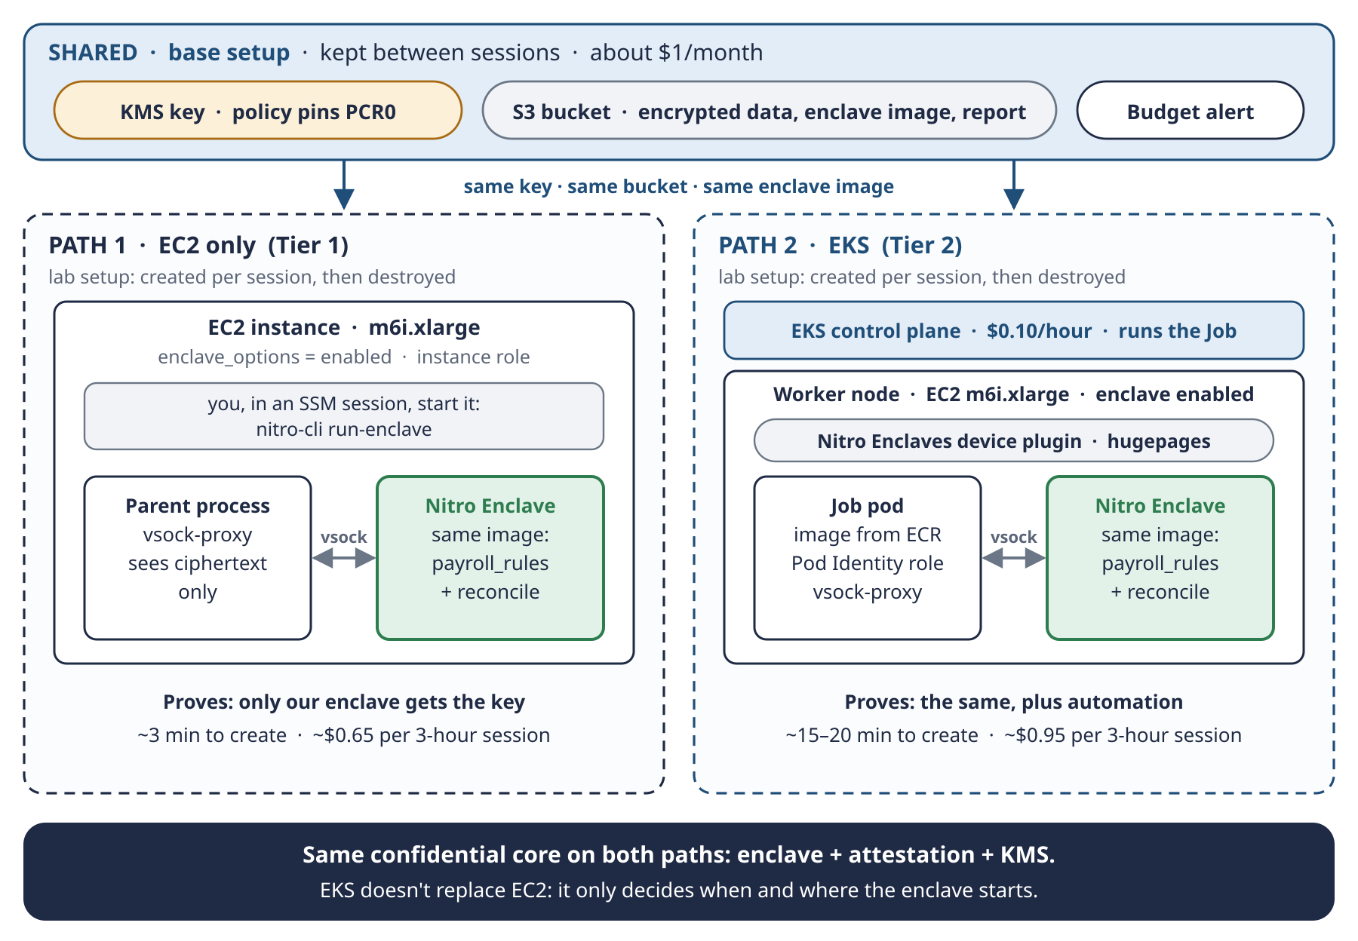
Schema 5 · Two paths, same confidential core. Both reuse the base setup; only the lab setup differs.
REMEMBER Same core, different driver. On both paths the enclave, the attestation and the KMS check are identical. On Tier 1 you start the enclave; on Tier 2 Kubernetes starts it.

2. What stays the same on both paths
Component | Role | Difference between the paths
KMS key (base) | releases the data key only to the enclave whose PCR0 matches | only the IAM role in the policy: the instance role on Tier 1, the pod role on Tier 2
S3 bucket (base) | holds the encrypted payslips, the enclave image and the encrypted report | none
Enclave image (EIF) | the code: payroll_rules.py + reconcile.py | none: same image, same PCR0
Data and formulas | payslips-2026-H1.json, rules it-simplified-0.1 | none
Security rule | ciphertext in, ciphertext out (guide, section 2.5) | none
Success tests | enclave finds the 29 errors; KMS refuses everyone else | Tier 2 adds the automation test

3. What changes
 | Tier 1 · EC2 only | Tier 2 · EKS
Who starts the enclave | you, with nitro-cli in an SSM session (no SSH, no open ports) | a Kubernetes Job, through the Nitro Enclaves device plugin
How the code arrives | the instance downloads the enclave image from S3 | the pod image in ECR contains the enclave image
AWS identity for KMS | the EC2 instance role | a Pod Identity role, never the node's role
Extra components | none | EKS control plane, node group with launch template, device plugin, hugepages, ECR repository, Pod Identity agent, Job manifest
Network | one subnet, no inbound rules | nodes must reach the EKS API, ECR, STS and S3
Scaling | manual: one instance | Jobs, node group scaling to zero
Time to create / destroy | ~3 min / ~2 min | ~15–20 min / ~10–15 min
What can go wrong | little: enclave memory settings, IAM | more: node bootstrap, networking, device-plugin labels, hugepages size, image pulls
Exam topics | EC2 purchasing, IAM roles, KMS, S3 encryption | all of Tier 1, plus EKS, IRSA / Pod Identity, scaling

4. Cost in Stockholm

4.1 Unit prices
Item | Price | Source
m6i.xlarge On-Demand (4 vCPU, 16 GiB) | $0.204/hour | DoiT tracker
m6i.xlarge Spot | from $0.045/hour | DoiT tracker
c6i.xlarge On-Demand (4 vCPU, 8 GiB), alternative | $0.182/hour | DoiT tracker
EKS control plane (standard support) | $0.10/hour | AWS EKS pricing
KMS customer managed key | $1/month, prorated hourly; free while scheduled for deletion; each rotation adds $1/month (up to two) | AWS KMS pricing
KMS requests | first 20,000/month free | AWS KMS pricing
Public IPv4 address | $0.005/hour | AWS VPC pricing

m6a.xlarge, the instance chosen in v1 of the guide, has no Stockholm price data in the tracker, so this document uses m6i.xlarge. It supports enclaves: in the M6i family only m6i.large and m6i.metal are excluded. Prices checked on 1 October 2026; confirm them in the AWS Pricing Calculator.

4.2 What a session costs
 | 3-hour session, On-Demand | 3-hour session, Spot | If forgotten for a month
Base setup only | — | — | ~$1
Tier 1 · EC2 only | ~$0.65 | ~$0.20 | ~$155
Tier 2 · EKS | ~$0.95 | ~$0.50 | ~$230

Sessions include the instance, a public IPv4 address and a small disk. Data transfer and S3 are cents.
TRAP The real risk isn't the session, it's forgetting to destroy. Two safeguards: a budget alert in the base setup, and terraform destroy on the lab setup at the end of every session.

5. The Terraform setups for each path
Setup | Lifetime | Tier 1 contents | Tier 2 contents
base | kept between sessions | KMS key (no rotation, protected from destroy), S3 bucket, budget alert | the same, plus an ECR repository for the pod image
lab | created per session, then destroyed | VPC with one subnet, security group with no inbound rules, instance role, EC2 instance with enclaves enabled | VPC with subnets, EKS cluster, node group with enclave launch template, Pod Identity role, device plugin, Job

Terraform state stays as local files in this folder, never committed to git.

6. A session, step by step

6.1 Tier 1 · EC2 only
- terraform apply the base setup (first time only).
- terraform apply the lab setup (about 3 minutes).
- On the instance, build the enclave image, read its PCR0 and store the image in S3 (first time only).
- Pin PCR0 in the key policy: terraform apply on base with enclave_pcr0 (first time only, free).
- Encrypt the payslip JSON locally with a data key and upload it to S3.
- Run the enclave: Mode A on the 580 payslips.
- Negative test: call the same Decrypt from the instance, outside the enclave. KMS must answer AccessDenied.
- Download the encrypted report, decrypt it, and check the score: 29 matched.
- terraform destroy the lab setup.

6.2 Tier 2 · EKS
- The base setup already exists. Add the ECR repository.
- Build the pod image (enclave image + vsock-proxy) and push it to ECR.
- terraform apply the lab setup (about 15–20 minutes).
- Install the device plugin, label the node and set hugepages.
- Add the pod role to the key policy. PCR0 stays the same.
- Run the Kubernetes Job.
- Negative test: a normal pod without the enclave asks for the key. KMS must answer AccessDenied.
- Read the report as in Tier 1.
- terraform destroy the lab setup (about 10–15 minutes), then check that nothing is left behind.

7. What each path proves
# | Success test | Tier 1 | Tier 2
A | The enclave decrypts the payslips, runs Mode A and finds the same 29 errors | Yes | Yes
B | The same Decrypt from outside the enclave is refused by KMS | Yes | Yes
C | The report leaves encrypted; only the status line is in clear | Yes | Yes
D | After terraform destroy, only the base setup remains | Yes | Yes
E | Kubernetes starts the job and scales the node back to zero | — | Yes

8. Recommendation
Start with Tier 1, then move to Tier 2.
- Tier 1 proves the hard part (tests A to D) with the fewest moving parts and the lowest cost.
- When something fails, there are few places to look: enclave settings, IAM or the key policy.
- Nothing is thrown away: the base setup, the enclave image, the data and the key policy logic all carry over to Tier 2.
- Tier 2 then adds only orchestration (test E), which is the platform part of the project.
DECIDED Decided on 1 October 2026: Tier 1 only, EC2 with no EKS, On-Demand (Spot was considered, then dropped to avoid capacity surprises).

9. Open points before writing Terraform
# | Question | Options | Proposal
1 | Instance type | m6i.xlarge (16 GiB) · c6i.xlarge (8 GiB) | m6i.xlarge: more memory for the enclave, about $0.02/hour more
2 | Lab network | public subnet with no inbound rules + SSM · private subnet + VPC endpoints | public subnet with no inbound rules for the POC; endpoints in Tier 2 or later
3 | Output key (D10) with one key | one key, input and output separated by encryption context · a second results key (+$1/month) | to discuss
4 | Purchasing | On-Demand · Spot | Decided: On-Demand (~$0.65 per 3-hour session). Spot stays available as the Terraform variable use_spot.

