POC Tier 1 · Design Specification
Confidential payslip processing on one EC2 instance with a Nitro Enclave · Stockholm · v1.0
Minelli-D · 1 October 2026 · TASK-02 · synthetic data only
PROPOSAL For your review. We approved design sections 1 to 5 in conversation on 1 October 2026; this is the written version.
Review it before we write the scripts and run the first session. Nothing is deployed yet.

At a glance
Goal | Prove on real AWS hardware that only our attested enclave can decrypt the payslips, and that it runs the reconciliation (Mode A) correctly.
Path | Tier 1: one EC2 instance (m6i.xlarge, On-Demand), no EKS
Region | Stockholm, eu-north-1
Cost | ~$1/month for the base setup, plus ~$0.65 per 3-hour session
Success tests | A (correct result) · B1 and B2 (KMS refuses everyone else) · C (report stored, POC version) · D (clean teardown)
Status | All code written and tested locally: 70 Python tests, 4 offline Terraform tests, the enclave image built and run locally. Nothing deployed yet. Step-by-step procedures in poc/procedures/.

1. Scope
In scope | Out of scope (and where it lives)
Terraform: base (kept) and lab (per session)  Envelope encryption of the payslip JSON on the laptop  Enclave image with kmstool + Mode A  One session runbook, with negative tests  Cost safety nets | EKS (paths doc, Tier 2)  Encrypted output (guide section 2.5; decision 8)  Private subnets + VPC endpoints (guide step 2)  CI pipeline and PCR8 signing (guide step 6)  Real data: synthetic only  Mode B, next month (TASK-01)

2. Decisions
# | Decision | Why
1 | Region eu-north-1 (Stockholm) | your choice
2 | Terraform split: base (kept) + lab (per session) | pay only while working
3 | One KMS key, created once, never rotated, protected from destroy | each rotation adds $1/month; data stays decryptable across sessions
4 | Tier 1 only: EC2, no EKS | proves the hard part with the fewest moving parts
5 | Spot: replaced by decision 10
6 | Public subnet, 0 inbound rules, SSM access, IMDSv2 | the first session needs outbound internet; the key policy, not the network, protects the data
7 | Ready-made parts: Amazon Linux 2023, nitro-cli, vsock-proxy, kmstool; Docker only to build | less of our own code in the trusted part
8 | No output encryption in the POC: the report goes to S3 in clear (SSE-S3 at rest) | synthetic data; the input stays fully protected
9 | m6i.xlarge: 2 vCPU + 4 GiB for the enclave | twice the memory of c6i.xlarge
10 | On-Demand (use_spot = false) | no capacity or enclave-on-Spot surprises; ~$0.45 more per session
11 | Terraform runs as the root user (known deviation, chosen after the base phase) | quickest for a personal POC; key policy principal becomes …:root (see section 4)
12 | Outbound port 80 in the lab security group (session 1) | the kmstool build fetches Amazon Linux 2 yum mirrors over HTTP; packages are GPG-signed; still zero inbound

3. Architecture
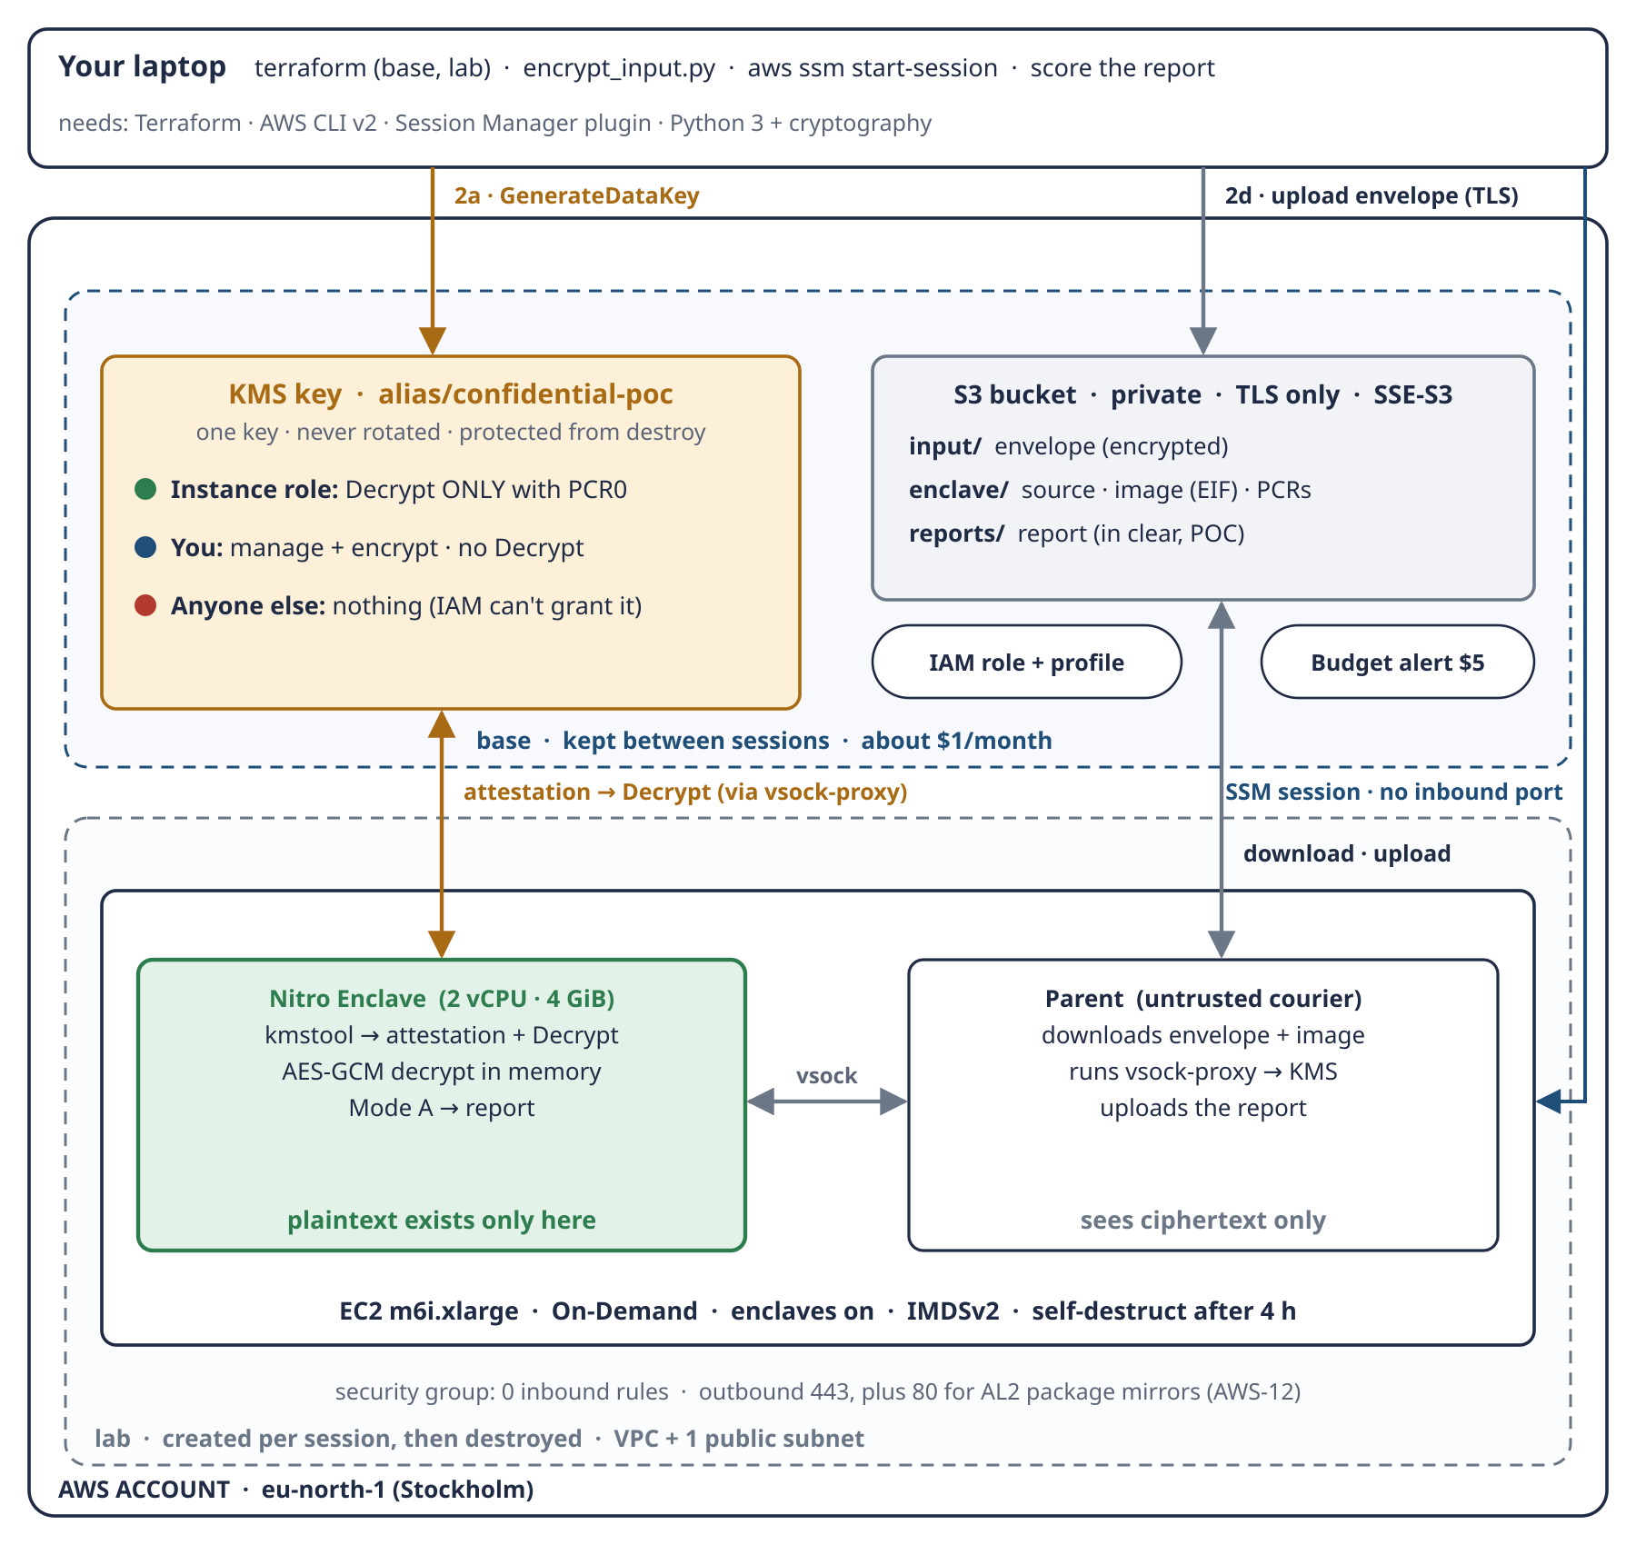
Schema 6 · Tier 1 POC: your laptop, the base setup (key, bucket, role, budget) and the lab setup (network, instance, enclave).
Setup | Lifetime | Contents
base | created once, kept (~$1/month) | KMS key + alias · S3 bucket (private, TLS only, SSE-S3, input/ enclave/ reports/) · IAM role + instance profile · budget alert $5/month
lab | created per session, then destroyed | VPC + 1 public subnet + internet gateway · security group (0 inbound, outbound 443 + 80) · EC2 m6i.xlarge with enclaves on, IMDSv2, 30 GiB encrypted disk, startup script, self-destruct after 4 hours

Three choices to memorise
- The IAM role lives in base, not lab. If a role named in a key policy is deleted and recreated, KMS no longer recognises it. IAM roles are free, so the role is kept.
- The bucket uses SSE-S3, not our KMS key. Our envelope (layer 1) is the real protection; SSE-S3 (layer 2) only protects the disks. Using our key for S3 too would mess up the key policy.
- Zero inbound rules. Nobody can connect in; we use SSM, which checks our IAM identity and is logged in CloudTrail.
REMEMBER base = identity + key + storage (things that must survive). lab = network + compute (things that cost money by the hour).

4. The key policy: who can do what
# | Who | May do | Condition | May NOT do
1 | You (the identity that runs Terraform) | manage the key: describe, put policy, tag, schedule deletion | none | Decrypt
2 | You as data owner | GenerateDataKey, Encrypt | none | Decrypt
3 | EC2 instance role | Decrypt only | attestation with PCR0 = our image | everything else
— | everyone else, including any IAM policy in the account | nothing

Three points to memorise
- Not even you can decrypt the payslips once they are encrypted. Only the enclave can. That gives two negative tests: B1 (the instance, outside the enclave) and B2 (your laptop).
- No "account root" statement. Only this key policy decides, and no IAM policy can grant Decrypt. The price: never delete the identity that runs Terraform. Terraform also checks that you can't lock yourself out.
- One person, two roles. In production, the key admin and the data owner are different people. Here you are both; you could rewrite the policy, but CloudTrail would log it.
TRAP As deployed (decision 11): Terraform ran as the account root user, so rows 1 and 2 name arn:aws:iam::<account>:root. In a key policy that means the whole account through IAM: any IAM admin can also manage the key and encrypt. Nobody gets Decrypt except the attested enclave, so the core guarantee and tests B1/B2 are unchanged. Production uses a dedicated IAM identity with MFA.

Statement 3 is added only once PCR0 exists (first session, step 7). Terraform refuses a PCR0 of all zeros, which is debug mode:
dynamic "statement" {
for_each = var.enclave_pcr0 == null ? [] : [var.enclave_pcr0]
content {
sid = "EnclaveDecryptOnlyWithAttestation"
actions = ["kms:Decrypt"]
principals { type = "AWS", identifiers = [aws_iam_role.instance.arn] }
condition {
test = "StringEqualsIgnoreCase"
variable = "kms:RecipientAttestation:ImageSha384"
values = [statement.value]
}
}
}

The instance role also has ordinary IAM permissions for S3 only: read input/ and enclave/, write reports/ and enclave/, plus SSM access. None of these touch the key.

5. Inside the enclave
Part of the enclave image (EIF) | Role
Amazon Linux 2023 + Python 3 + cryptography | runtime; AES-GCM decryption
kmstool_enclave_cli + libnsm.so (AWS, ready-made) | gets the attestation document from the Nitro hardware and calls KMS Decrypt
payroll_rules.py + reconcile.py (TASK-01, tested) | the formulas and Mode A
enclave_app.py + vsock_proto.py | listens on vsock, runs the job, replies {status, report}

PCR0 measures all of this. Change one formula, rebuild, and PCR0 changes: the key refuses the new image until the policy is updated. Pin the kmstool source to a fixed release, so a later rebuild produces the same image.

One run
- Parent: download the input envelope from S3.
- Parent: read the instance role's temporary credentials from IMDSv2.
- Parent: start vsock-proxy towards kms.eu-north-1.amazonaws.com.
- Parent → enclave over vsock: {credentials, envelope}.
- Enclave: kmstool asks the hardware for an attestation document (PCR0 + temporary public key) and calls KMS Decrypt through the proxy. KMS checks PCR0 and returns the data key encrypted for the enclave only.
- Enclave: decrypt the payslips in memory (AES-GCM, checking the aad).
- Enclave: run Mode A → report.
- Enclave → parent: report + status line.
- Parent: upload the report to S3 reports/.
- Parent: terminate the enclave; its memory is wiped.

The envelope (input file format)
{ "format": "poc-envelope-v1",
"kms_key_id": "arn:aws:kms:eu-north-1:<account>:key/<id>",
"encrypted_data_key": "<base64>",
"algorithm": "AES-256-GCM",
"nonce": "<base64, 12 bytes>",
"aad": "payslip-reconciliation-2026-H1",
"ciphertext": "<base64>" }

Three points to memorise
- Credentials alone are not enough. The parent has the same credentials, but KMS also demands the attestation document, which only the real enclave can produce.
- The parent relays bytes it can't read. KMS encrypts the data key to the enclave's temporary public key, and the proxy forwards only to allow-listed hosts.
- Debug mode is for start-up checks only. Its PCR0 is all zeros, so KMS refuses it.
REMEMBER S3 is the post office, the parent is the courier, the enclave is the only reader. The enclave never touches S3; the parent carries sealed envelopes it can't open. It can drop or delay them, but it can't read or change them unnoticed.

6. Protecting the data on its way into S3
# | Where | What happens | Layer
2a | laptop → KMS | encrypt_input.py asks for a data key (GenerateDataKey): a plaintext copy + an encrypted copy
2b | laptop | encrypt the JSON locally with the plaintext key (AES-256-GCM + aad). The plaintext JSON never leaves the laptop | 1 · envelope
2c | laptop | wipe the plaintext key from memory; keep only the encrypted key
2d | laptop → S3 | upload the envelope to input/ over TLS (the bucket refuses non-TLS) | in transit
2e | S3 | S3 encrypts the object again at rest (SSE-S3, automatic and free) | 2 · at rest
2f | both ends | the script refuses to upload anything that is not an envelope; the enclave refuses any input that is not one | safety check

KMS Encrypt alone would not work: it accepts only about 4 KB, and the JSON is 580 KB. That is why we use envelope encryption.
S3 folder | Content | Sensitive? | Protection
input/ | the payslips envelope | yes | layer 1 (envelope) + layer 2 (SSE-S3)
enclave/ | source, image (EIF), PCR values | no (code; PCR0 is not a secret) | SSE-S3
reports/ | the report | yes in real life, synthetic here | SSE-S3 only (decision 8)

REMEMBER Layer 1 protects the data from everyone except the enclave. Layer 2 only protects the disks inside AWS. With layer 2 alone, anyone allowed to read the bucket reads your data.

7. Session runbook

7.1 Prerequisites on your laptop
Tool | Status on 1 October 2026 | Note
Terraform ≥ 1.6 | to install | the code was validated with 1.16.4 and AWS provider 6.67.0
AWS CLI v2 + a profile with admin rights | installed (2.33.3) | this identity becomes the key admin: never delete it
Session Manager plugin | to install | needed for aws ssm start-session
Python 3 + cryptography | installed (46.0.5) | for encrypt_input.py

Tip: set the budget email once per shell instead of typing it every time, without storing it in any file: export TF_VAR_budget_email=<your email>.

7.2 First session (one-time setup, ~1.5–2 hours)
# Base phase (poc/procedures/Base-phase-terraform.docx)
terraform -chdir=infra/base init && terraform -chdir=infra/base apply
python3 poc/payslip/encrypt_input.py --bucket <bucket> # steps 2a-2f
aws kms decrypt --region eu-north-1 \
--ciphertext-blob fileb://data/encrypted/payslips-2026-H1.datakey.bin
# test B2: must be AccessDenied

# Lab phase, first session (poc/procedures/Lab-phase-terraform.docx)
bash poc/enclave/upload_enclave_src.sh <bucket> # L1
terraform -chdir=infra/lab init && terraform -chdir=infra/lab apply # L2
aws ssm start-session --target <instance-id> --region eu-north-1 # L3
sudo bash /opt/poc/src/enclave/build_enclave.sh # L4: prints PCR0
echo 'enclave_pcr0 = "<PCR0>"' > infra/base/pcr0.auto.tfvars # L5
terraform -chdir=infra/base apply # L5: 1 to change

7.3 Every session (~20 minutes)
terraform -chdir=infra/lab apply # L2
aws ssm start-session --target <instance-id> --region eu-north-1 # L3
sudo bash /opt/poc/src/enclave/run_job.sh # L6: tests A, C
aws kms decrypt --ciphertext-blob fileb:///tmp/edk.bin \
--region eu-north-1 # L7: test B1
aws s3 cp s3://<bucket>/reports/ ./reports/ --recursive
python3 poc/payslip/score_report.py "$(ls -t reports/*.json | head -1)"
# L8: 29 / 0 / 0 (test A)
terraform -chdir=infra/lab destroy # L9: test D

Every command, with what to watch and what to do if something fails, is in the two procedures: poc/procedures/Base-phase-terraform.docx and poc/procedures/Lab-phase-terraform.docx.

8. Safety nets, troubleshooting and testing

8.1 Three cost safety nets
# | Safety net | How
1 | terraform destroy on lab | at the end of every session, followed by the check in 7.3
2 | Self-destruct timer | the startup script runs shutdown -h +240; with "terminate on shutdown", the instance deletes itself after 4 hours. sudo shutdown -c cancels it
3 | Budget alert | $5/month: email at 80% actual and 100% forecast

After a self-destruct, what is left in lab costs nothing: the VPC, subnet, gateway and security group are free, and the public IP is released.

8.2 What can go wrong
Problem | What we'll see | Fix
No capacity for m6i.xlarge | apply fails | retry later, or change instance_type
Image too big for the enclave memory | run-enclave: insufficient memory | raise enclave_memory_mib (e.g. 6144) and re-create lab
KMS AccessDenied inside the enclave | the enclave reports it cannot decrypt | PCR0 mismatch (rebuilt image, debug mode, wrong variable): compare pcrs.json with the key policy; CloudTrail shows the refused call
vsock-proxy blocks KMS | connection refused | check that kms.eu-north-1.amazonaws.com is in /etc/nitro_enclaves/vsock-proxy.yaml (the startup script adds it)
Something needs port 80 | package or download fails (happened in session 1: kmstool build, yum timeout) | egress rule for port 80 in network.tf (decision 12, done)
Decryption fails ("InvalidTag") | the envelope was changed or damaged | re-run encrypt_input.py; this is AES-GCM doing its job

8.3 Testing: free first, AWS only for what needs AWS
Where | What | Status
laptop | 70 Python tests: payslip (formulas, reconciliation, dataset, envelope, encryption, scoring) 47 + enclave (vsock framing, enclave app, parent runner) 23 | passing
laptop | Terraform: fmt, validate (base + lab) | passing
laptop | Terraform offline test with a mock AWS provider: PCR0 guard (no PCR0 allowed on first apply, zeros refused, malformed refused, real hash accepted). A mutation check confirmed the zero test fails if the guard is removed | 4/4 passing
laptop | local dry run: the enclave logic with a local test key scores 29 / 0 / 0; the enclave Docker image built locally and run with no network: 580 checked, 29 with differences, KMS path fails safely | passing
AWS | tests A, B1, B2, C (POC), D | first session

Run the offline Terraform test with: terraform -chdir=infra/base init && terraform -chdir=infra/base test

9. Terraform layout
File | What it does
infra/base/versions.tf | Terraform ≥ 1.6, AWS provider ~> 6.0, Region, default tags (Project, Stack=base)
infra/base/variables.tf | region, name_prefix, budget_email (no default), budget_limit_usd, enclave_pcr0 (null by default, with the debug-mode guard)
infra/base/kms.tf | the key policy (3 rows, no root statement) + the key (no rotation, prevent_destroy) + alias
infra/base/s3.tf | bucket: public access blocked, owner enforced, SSE-S3, abort incomplete uploads, deny non-TLS
infra/base/iam.tf | instance role + profile: SSM managed policy, S3 permissions per folder, no KMS permissions
infra/base/budget.tf | $5/month with two email alerts
infra/base/outputs.tf | key ARN and alias, bucket, role, profile, pcr0_pinned
infra/base/tests/pcr0_guard.tftest.hcl | the offline test (mock provider)
infra/lab/versions.tf | provider + reads base outputs from ../base/terraform.tfstate
infra/lab/variables.tf | instance_type, use_spot (false), enclave CPU/memory, self_destruct_hours, root_volume_gb
infra/lab/network.tf | VPC, internet gateway, public subnet, route table, security group (0 inbound; 443 and 80 out, decision 12)
infra/lab/ec2.tf | the parent instance: AL2023, enclaves on, IMDSv2, encrypted gp3, terminate on shutdown, optional Spot
infra/lab/user-data.sh.tftpl | startup: self-destruct timer, install nitro-cli + Docker, allocator 2 vCPU / 4096 MiB, vsock-proxy allow-list
infra/lab/outputs.tf | instance ID, SSM command, purchasing, bucket

State files stay local and are git-ignored; base must never be destroyed (its key is protected by prevent_destroy).

10. Cost
Item | Cost
Base setup (KMS key; bucket, role and budget are free or cents) | ~$1/month
m6i.xlarge On-Demand in Stockholm | $0.204/hour (third-party tracker, checked 1 October 2026)
A 3-hour session (instance + public IP + disk) | ~$0.65
First session (~2 hours of build and tests) | ~$0.45
Worst case if you forget to destroy | ~$0.85: the self-destruct terminates the instance after 4 hours
KMS requests | free (20,000/month free tier)

11. Risks and limits
- Synthetic data only, and no output confidentiality in this POC (decision 8). Real data needs guide section 2.5.
- Trust in AWS: the root of trust is AWS's Nitro hardware and hypervisor (guide 3.1).
- Key lockout: with no root statement, deleting or re-creating the identity that runs Terraform leaves the key unmanageable. If you sign in with AWS SSO, note that a re-provisioned permission set re-creates its role. Recovery then needs AWS Support.
- Root user (decision 11): using the root user for daily work goes against AWS best practice, and its :root principal delegates key admin and encrypt to IAM. Acceptable for a personal POC with synthetic data.
- Public subnet: the instance has outbound internet access. That is fine for a POC with synthetic data; production uses private subnets with VPC endpoints.
- Reproducible builds: pin the kmstool source and the base images, or a rebuild will produce a different PCR0.
- Prices come from a third-party tracker; confirm them in the AWS Pricing Calculator.

12. Changes to other documents, and next steps
- Study guide, section 2.5: corrected. One key is enough when the data owner also reads the results; a separate key is needed only when result readers must not read the inputs.
- Deployment paths document: updated with Tier 1 only and On-Demand.
- TASK-02: all 10 decisions recorded.

Next steps
- You review this spec, the Terraform in infra/ and the code in poc/.
- Run the base phase with poc/procedures/Base-phase-terraform.docx (test B2).
- Run the lab phase with poc/procedures/Lab-phase-terraform.docx (tests A, B1, C, D), together.
- Write the journey document from the two session logs.

