POC Procedure · Base phase (Terraform)
Install Terraform, create the base setup, encrypt the payslips locally, push them to S3, prove nobody but the enclave can decrypt · v1.0
Minelli-D · 1 October 2026 · TASK-02 · Stockholm (eu-north-1)
This procedure
Goal | The base setup exists (KMS key, S3 bucket, IAM role, budget), the payslips are in S3 as an envelope, and test B2 proves that not even you can decrypt them.
Time | about 30–45 minutes
Cost | nothing billed by the hour: only the KMS key (~$1/month, prorated) and cents of S3. No EC2 instance in this phase.
Before | nothing: this is the first AWS step of the POC
After | the lab phase (EC2 + enclave), once the enclave scripts are written
Reference | poc-tier1-spec.docx (sections 3, 4, 6, 7) · poc/README.md (decisions)

TRAP Never run terraform destroy on base (Terraform refuses it anyway: the key has prevent_destroy). Never delete the IAM identity you use here: it is the only admin of the key. Never commit *.tfstate files (they are git-ignored).

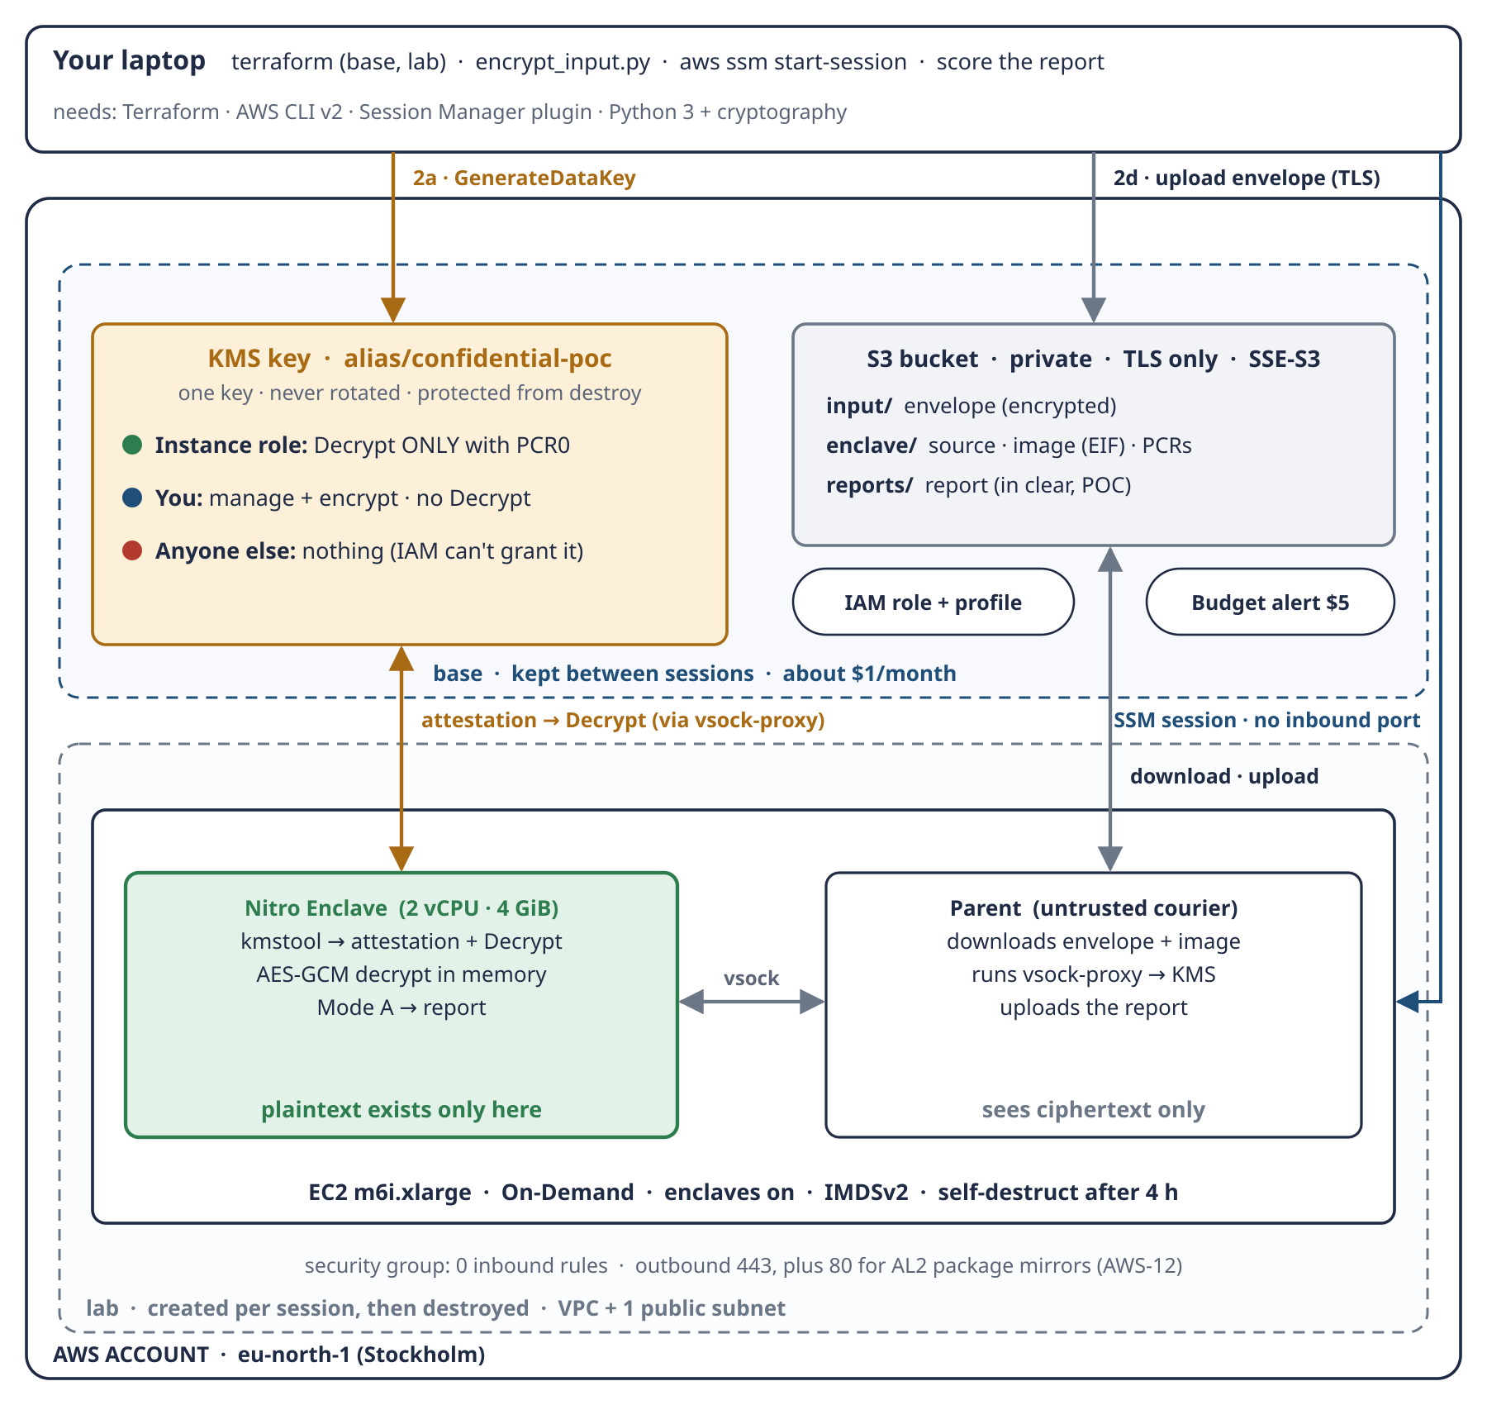
Schema 6 · This phase creates the upper part (base) and uses the laptop. The lower part (lab) comes in the next phase.

Step 0 · Install Terraform (once)
REMEMBER Terraform describes the infrastructure as code: base and lab are two folders of .tf files, and Terraform makes AWS match them. The checksum proves the binary really comes from HashiCorp.

cd /tmp
V=1.16.4
curl -LO https://releases.hashicorp.com/terraform/$V/terraform_${V}_linux_amd64.zip
curl -LO https://releases.hashicorp.com/terraform/$V/terraform_${V}_SHA256SUMS
grep linux_amd64.zip terraform_${V}_SHA256SUMS | sha256sum -c - # must print: OK
unzip terraform_${V}_linux_amd64.zip && sudo install terraform /usr/local/bin/
terraform version

What to watch
- terraform_1.16.4_linux_amd64.zip: OK from the checksum check. Anything else: stop, do not install.
- terraform version prints Terraform v1.16.4.
The Session Manager plugin is not needed in this phase; it comes with the lab phase.

Step 1 · Your identity and the base setup
REMEMBER base = identity + key + storage: the things that must survive between sessions. The identity that runs this step becomes the only admin of the key, and even it gets no Decrypt.

1.1 Set the shell and check who you are
cd Confidential-Data-Processing # your clone of this repository
export AWS_PROFILE=<your-profile> # skip if you use the default profile
export TF_VAR_budget_email=<your-email> # lives only in this shell, never in a file
aws sts get-caller-identity

What to watch
- The Arn printed here becomes the key admin. Write it in the session log (end of this document).
- If it contains assumed-role/AWSReservedSSO_… (AWS SSO): stop and discuss first. A re-provisioned permission set re-creates its role, which would leave the key without an admin.
- If it ends in :root, you are the account root user. For this POC that is accepted (decision AWS-11): the key policy then names …:root, which delegates key admin and encrypt to IAM in the account. Nobody gets Decrypt.

1.2 Initialise and run the offline tests
terraform -chdir=infra/base init
terraform -chdir=infra/base test # offline, mock AWS provider

What to watch
- init downloads the AWS provider (6.x) and creates .terraform.lock.hcl.
- test: Success! 4 passed, 0 failed (the PCR0 guard: debug-mode zeros and malformed values are refused).

1.3 Plan, read, apply
terraform -chdir=infra/base plan -out=base.tfplan
terraform -chdir=infra/base apply base.tfplan
terraform -chdir=infra/base output

Why plan -out: apply then runs exactly the plan you read, and nothing else.
What to watch
- The summary line: Plan: 13 to add, 0 to change, 0 to destroy, Region eu-north-1.
- In aws_kms_key.poc → policy: only the Sids KeyAdministrationNoDecrypt and DataOwnerEncryptOnly, with your ARN as principal.
- No EnclaveDecryptOnlyWithAttestation yet (there is no PCR0), no :root, no kms:Decrypt anywhere.
- enable_key_rotation = false, deletion_window_in_days = 7.
- The bucket: confidential-poc-<account>-eu-north-1. The budget: limit 5 USD, your email.
- After apply, output shows pcr0_pinned = false, plus bucket_name, key_arn, key_alias. Write them in the session log.

1.4 Optional: check the live key
KEY=$(terraform -chdir=infra/base output -raw key_arn)
aws kms get-key-policy --key-id "$KEY" --policy-name default \
--region eu-north-1 --output text
aws kms get-key-rotation-status --key-id "$KEY" --region eu-north-1
# KeyRotationEnabled: false

What to watch
- The live policy matches what you read in the plan.

Step 2 · Encrypt locally and push to S3
REMEMBER Layer 1 (envelope) protects the data from everyone except the enclave; layer 2 (SSE-S3) only protects the disks inside AWS. The plaintext JSON never leaves your laptop: KMS hands out a small data key, the file is encrypted locally, and only the envelope is uploaded.

# | What the script does | Layer
2a | asks KMS for a data key (GenerateDataKey): a plaintext copy + an encrypted copy
2b | encrypts the JSON locally with AES-256-GCM, bound to the dataset id (aad) | 1 · envelope
2c | wipes the plaintext data key
2d | uploads only the envelope to input/ over TLS | in transit
2e | S3 encrypts it again at rest (SSE-S3) | 2 · at rest
2f | refuses anything that is not an envelope, and any dataset not marked synthetic | safety check

(cd poc/payslip && python3 -m unittest) # 45 tests OK
BUCKET=$(terraform -chdir=infra/base output -raw bucket_name)
python3 poc/payslip/encrypt_input.py --bucket "$BUCKET"

What to watch
- The script prints the key it used, the aad payslip-reconciliation-2026-H1, the envelope path, the encrypted data key path and uploaded to: s3://…/input/payslips-2026-H1.envelope.json.

2.1 Check the result
grep -c "Fabbri" data/encrypted/payslips-2026-H1.envelope.json # 0: no names in clear
aws s3 ls "s3://$BUCKET/input/" --region eu-north-1 # the envelope is there
aws s3api head-object --bucket "$BUCKET" --key input/payslips-2026-H1.envelope.json \
--region eu-north-1 --query ServerSideEncryption # "AES256" = layer 2

What to watch
- 0 from grep: the envelope contains no employee name.
- The envelope in input/ (about 780 KB: base64 adds a third to the 580 KB JSON).
- "AES256": S3 encrypted it at rest.

Step 3 · Negative test B2: not even you can decrypt
REMEMBER This is the first real proof of the design. You created the key and the data, yet the key policy gives you no Decrypt. Only the attested enclave will ever get the data key.

aws kms decrypt --region eu-north-1 \
--ciphertext-blob fileb://data/encrypted/payslips-2026-H1.datakey.bin

What to watch
- Expected: AccessDeniedException … is not authorized to perform: kms:Decrypt … because no resource-based policy allows the kms:Decrypt action.
- If it succeeds: stop. It would mean the key policy is wrong. Do not continue to the lab phase.
- In the console, CloudTrail → Event history (eu-north-1, 5–15 minutes delay): a successful GenerateDataKey by you and a denied Decrypt by you. That is your audit trail.

If something goes wrong
Symptom | Likely cause | What to do
init cannot download the provider | no internet or a proxy | check the connection, run init again
plan: no valid credential sources | profile not set or expired session | export AWS_PROFILE=…; for SSO run aws sso login first
apply: MalformedPolicyDocumentException (invalid principal) | the identity ARN is not valid as a key-policy principal | stop, keep the error, and discuss it before retrying
apply: AccessDenied on budgets | your identity can't manage AWS Budgets | add Budgets permissions to your identity, or run with an admin profile
encrypt_input.py: AccessDenied on GenerateDataKey | a different identity than the one that ran Terraform | use the same AWS_PROFILE as in step 1
encrypt_input.py: refused (not synthetic) | wrong input file | use data/payslips-2026-H1.json
aws s3 cp AccessDenied | wrong bucket or profile | take the bucket from terraform output, same profile
Test B2 succeeds | the key policy grants Decrypt to you | stop: do not continue; compare the live policy with the plan

Only at the very end of the project: removing the base setup
Base is kept between sessions by design. When the whole project is over:
- empty the bucket: aws s3 rm "s3://$BUCKET" --recursive
- in infra/base/kms.tf, set prevent_destroy = false
- terraform -chdir=infra/base destroy: the key enters a 7-day pending deletion, during which it costs nothing and can still be cancelled

Checklist
 | Step | Expected
☐ | 0 · Terraform checksum | OK
☐ | 1.1 · Identity checked and noted | not an SSO role, or discussed first
☐ | 1.2 · Offline tests | 4 passed
☐ | 1.3 · Plan reviewed | 13 to add; 2 policy statements; no Decrypt; rotation off
☐ | 1.3 · Applied, outputs noted | pcr0_pinned = false
☐ | 2 · Local tests | 45 OK
☐ | 2 · Envelope uploaded | uploaded to s3://…/input/…
☐ | 2.1 · No names in clear | grep count 0
☐ | 2.1 · At-rest encryption | "AES256"
☐ | 3 · Test B2 | AccessDeniedException
☐ | 3 · CloudTrail | GenerateDataKey OK + Decrypt denied

Session log (fill in)
Item | Value
Date
Identity ARN (key admin)
Account ID
bucket_name
key_arn
Plan summary
Test B2 result
Notes, surprises, questions

