POC Procedure · Lab phase (Terraform)
Create the EC2 instance, build the enclave image, pin PCR0, run Mode A inside the enclave, prove the instance itself is refused, score the report, destroy the lab · v1.0
Minelli-D · 1 October 2026 · TASK-02 · Stockholm (eu-north-1)
This procedure
Goal | Tests A (the enclave finds exactly the 29 planted errors), B1 (the same instance is refused outside the enclave), C (report stored, POC version) and D (clean teardown).
Time | first session 1.5–2 hours (building kmstool and the image is the slow part) · later sessions ~20 minutes
Cost | m6i.xlarge On-Demand $0.204/hour while the lab exists: ~$0.45 for the first session, ~$0.10 later. The instance terminates itself after 4 hours.
Before | Base phase done (Base-phase-terraform.docx): base applied, envelope in input/, test B2 passed
After | write the results in the session log; they feed the journey document
Reference | poc-tier1-spec.docx (sections 5, 7, 8) · poc/README.md (decisions) · code in poc/enclave/

TRAP Always destroy the lab at the end (step L9): it costs money every hour it exists. Never use --debug-mode for the real run: its PCR0 is all zeros and KMS refuses it (Terraform also refuses to pin zeros). Never pin a PCR0 you did not build yourself in step L4.

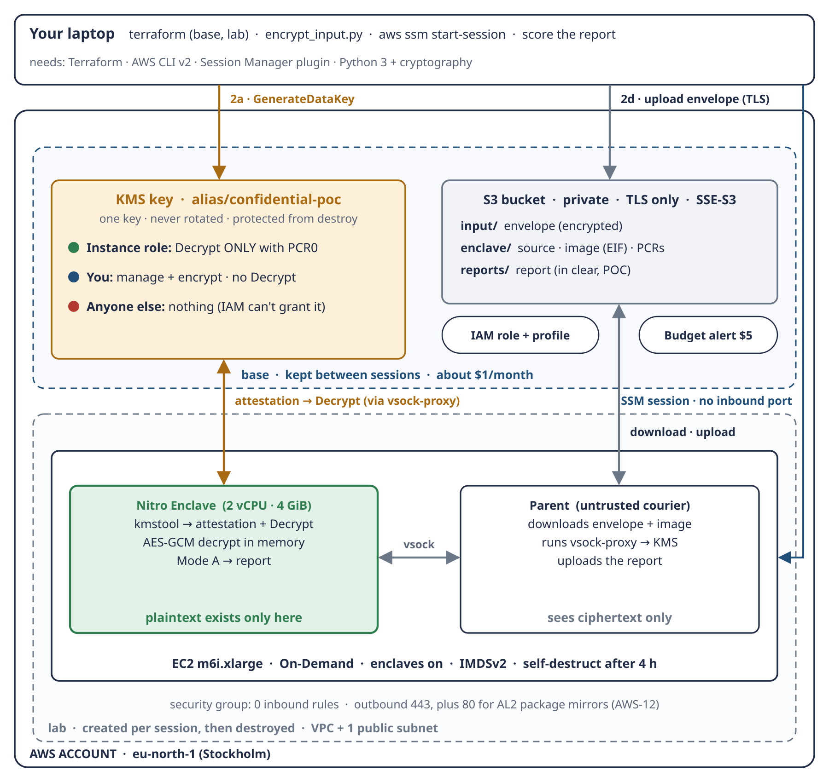
Schema 6 · This phase builds the lower part (lab): the EC2 instance, the parent and the enclave. The base part already exists.
Step | Where | First session | Later sessions
L0 · Prerequisites | laptop | yes | —
L1 · Upload the enclave source | laptop | yes | only if the code changed
L2 · Create the lab | laptop | yes | yes
L3 · Connect and check the parent | instance | yes | yes
L4 · Build the enclave image → PCR0 | instance | yes | only if the code changed
L5 · Pin PCR0 in the key policy | laptop | yes | only after a rebuild
L6 · Run the job (test A, C) | instance | yes | yes
L7 · Negative test B1 | instance | yes | yes
L8 · Score the report (test A) | laptop | yes | yes
L9 · Destroy the lab (test D) | laptop | yes | yes

L0 · Prerequisites (once)
laptop · install the Session Manager plugin, check the base phase, run the local tests
SSM=https://s3.amazonaws.com/session-manager-downloads/plugin/latest/ubuntu_64bit
curl -o /tmp/session-manager-plugin.deb "$SSM/session-manager-plugin.deb"
sudo dpkg -i /tmp/session-manager-plugin.deb
session-manager-plugin --version

cd Confidential-Data-Processing # your clone of this repository
export AWS_PROFILE=<your-profile> # the same identity as in the base phase
export TF_VAR_budget_email=<your-email>
terraform -chdir=infra/base output # pcr0_pinned = false on the first session
(cd poc/payslip && python3 -m unittest) # 47 tests OK
(cd poc/enclave && python3 -m unittest) # 23 tests OK (includes the local dry run)

What to watch
- The plugin prints a version number.
- Base outputs are there; pcr0_pinned = false on the first session, true later.
- 70 local tests OK. The enclave tests include the free dry run: the real enclave logic, with a local test key, finds exactly the 29 planted errors.
- data/answer-key-2026-H1.json must be valid JSON (no stray characters), or step L8 cannot score.

L1 · Upload the enclave source
REMEMBER Everything moves through S3: the laptop never talks to the instance directly. Only the code the image and the parent need is uploaded: no tests, no data, no answer key.

laptop · first session, and again only if you change the code
BUCKET=$(terraform -chdir=infra/base output -raw bucket_name)
bash poc/enclave/upload_enclave_src.sh "$BUCKET"
aws s3 ls "s3://$BUCKET/enclave/src/" --recursive --region eu-north-1

What to watch
- 10 files: payslip/ payroll_rules.py, reconcile.py, envelope.py; enclave/ Dockerfile, enclave_app.py, vsock_proto.py, run_job.py, run_job.sh, build_enclave.sh, upload_enclave_src.sh.
- No test_* files and no data files.
- Changing the code later means a new image and a new PCR0: repeat L4 and L5.

L2 · Create the lab
REMEMBER lab = network + compute: the things that cost money by the hour. From apply on, the instance costs $0.204/hour until L9, or until it self-destructs after 4 hours.

laptop · every session
terraform -chdir=infra/lab init
terraform -chdir=infra/lab plan -out=lab.tfplan
terraform -chdir=infra/lab apply lab.tfplan
terraform -chdir=infra/lab output

What to watch
- The summary line: Plan: 7 to add, 0 to change, 0 to destroy (VPC, internet gateway, subnet, route table, association, security group, instance).
- aws_instance.parent: instance_type = "m6i.xlarge", enclave_options { enabled = true }, http_tokens = "required", instance_initiated_shutdown_behavior = "terminate", no instance_market_options (On-Demand).
- aws_security_group.instance: two egress rules (443 and 80) and no ingress at all. Port 80 is for the Amazon Linux 2 package mirrors used by the kmstool build (decision AWS-12).
- Root volume: 30 GB gp3, encrypted = true.
- After apply, output gives instance_id, the ready-made ssm_session_command, purchasing = "on-demand" and the self-destruct reminder. Note the start time in the session log.

L3 · Connect and check the parent
REMEMBER No SSH and no open port. SSM opens the shell over an outbound connection from the instance, after checking your IAM identity, and CloudTrail logs it.

laptop → instance · wait 2–3 minutes after apply, for the startup script
aws ssm start-session --target <instance-id> --region eu-north-1

# now on the instance:
cat /var/log/confidential-poc-ready # the startup script has finished
cat /opt/poc/poc.env # BUCKET, REGION, enclave size
nitro-cli --version
grep -E "^(cpu_count|memory_mib)" /etc/nitro_enclaves/allocator.yaml # 2 and 4096
ls /opt/poc/src/enclave # the source code, synced from S3
shutdown --show # the self-destruct is scheduled

What to watch
- The ready file exists. If not: wait, or read sudo tail -50 /var/log/cloud-init-output.log.
- poc.env shows your bucket, REGION=eu-north-1, ENCLAVE_CPU_COUNT=2, ENCLAVE_MEMORY_MIB=4096.
- The allocator has set aside 2 vCPU and 4096 MiB for the enclave, taken away from this instance.
- shutdown --show reports a shutdown about 4 hours after boot.

L4 · Build the enclave image → PCR0
REMEMBER Docker only to build, and only once. nitro-cli turns the Docker image into an enclave image (EIF) and measures it. PCR0 is the fingerprint of this exact image. The EIF is stored in S3, so later sessions reuse it and PCR0 never changes.

instance · first session only, or after a code change. 10–20 minutes
sudo bash /opt/poc/src/enclave/build_enclave.sh

Stage | What happens
1/5 | syncs the source code from S3
2/5 | clones the AWS Nitro Enclaves SDK at v0.4.5, checks the pinned commit, builds kmstool (the slow part)
3/5 | builds the Docker image payslip-enclave:v1 (Amazon Linux 2023 + Python + our code + kmstool)
4/5 | nitro-cli build-enclave → payslip-enclave.eif + pcrs.json (PCR0, PCR1, PCR2)
5/5 | uploads the EIF and pcrs.json to s3://<bucket>/enclave/, prints PCR0=…

What to watch
- No "refused: … does not point to the pinned commit" message. If it appears: stop, the SDK tag has moved.
- pcrs.json shows PCR0, PCR1 and PCR2, each 96 hex characters, none of them all zeros.
- The last line prints PCR0=… and the exact command for the next step. Copy PCR0 into the session log.

L5 · Pin PCR0 in the key policy
REMEMBER The chicken and egg of PCR0: the image must exist before the key can name it. Now the key policy gets its third row: the instance role may Decrypt only with an attestation document showing this PCR0.

laptop · first session, and after every rebuild
B=s3://confidential-poc-<account>-eu-north-1
PCR0=$(aws s3 cp "$B/enclave/pcrs.json" - --region eu-north-1 \
| python3 -c "import json,sys; print(json.load(sys.stdin)['Measurements']['PCR0'])")
echo "${#PCR0} characters" # must say 96
echo "enclave_pcr0 = \"$PCR0\"" > infra/base/pcr0.auto.tfvars # git-ignored
terraform -chdir=infra/base plan -var budget_email=<your-email> -out=pin.tfplan
terraform -chdir=infra/base apply pin.tfplan
terraform -chdir=infra/base output pcr0_pinned # true

TRAP Never copy PCR0 by hand (decision IMPL-8). In session 1 a PCR0 copied from the SSM window lost one character (95 instead of 96); the Terraform guard refused it. Read it from pcrs.json as above.

Why a file: pcr0.auto.tfvars is loaded automatically by every later plan on base. Without it, a later apply would quietly remove the enclave statement, and the enclave could no longer decrypt.
What to watch
- The summary line: Plan: 0 to add, 1 to change, 0 to destroy, and the change is aws_kms_key.poc → policy. Anything destroyed: stop.
- A new statement EnclaveDecryptOnlyWithAttestation: principal = the instance role (…:role/confidential-poc-instance), action only kms:Decrypt, condition StringEqualsIgnoreCase on kms:RecipientAttestation:ImageSha384 = your PCR0.
- The other two statements are unchanged: still no Decrypt for you.

L6 · Run the job inside the enclave
REMEMBER S3 is the post office, the parent is the courier, the enclave is the only reader. The parent passes the envelope and the role's credentials over vsock. The enclave proves its identity to KMS (attestation), gets the data key, decrypts in memory, runs Mode A and returns the report.

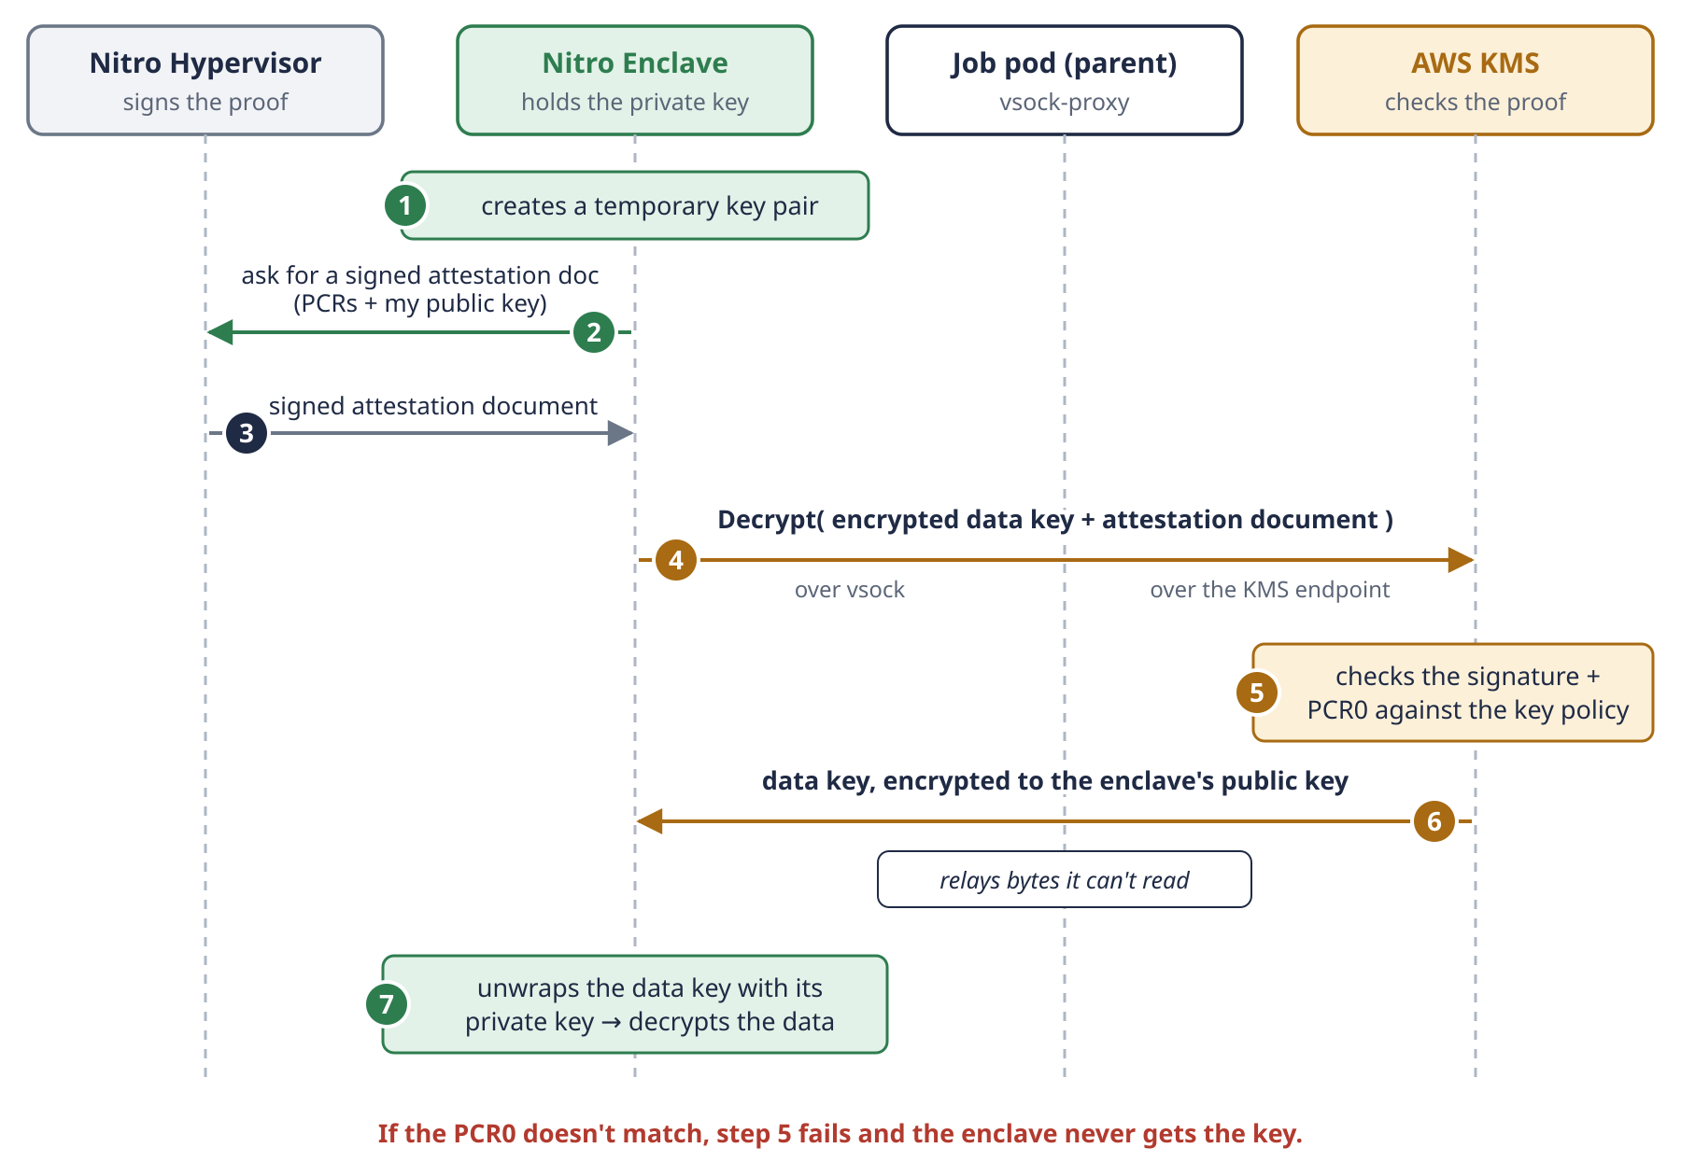
Schema 3c · What happens inside step L6 when the enclave asks KMS for the key.
instance · every session. 1–2 minutes
sudo bash /opt/poc/src/enclave/run_job.sh

What to watch
- run-enclave prints JSON with EnclaveCID, "CPUCount": 2 and "MemoryMiB": 4096; describe-enclaves shows "State": "RUNNING" and "Flags": "NONE" (not DEBUG_MODE).
- The status line: "ok": true, "payslips_checked": 580, "payslips_with_differences": 29, "net_difference": 311.45, plus report_sha256. No names, no amounts per person.
- report uploaded to s3://…/reports/report-payslip-reconciliation-2026-H1-<time>.json (test C, POC version: in clear, SSE-S3 at rest).
- At the end the script terminates the enclave (its memory is wiped) and stops the proxy.

L7 · Negative test B1: the instance itself is refused
REMEMBER Credentials alone are not enough. This test uses the same role and the same credentials the enclave just used successfully. Outside the enclave there is no attestation document, so KMS says no.

instance · every session
. /opt/poc/poc.env
aws s3 cp "s3://$BUCKET/input/payslips-2026-H1.envelope.json" /tmp/env.json \
--region "$REGION"
jq -r .encrypted_data_key /tmp/env.json | base64 -d > /tmp/edk.bin
aws kms decrypt --ciphertext-blob fileb:///tmp/edk.bin --region "$REGION"

What to watch
- Expected: AccessDeniedException … assumed-role/confidential-poc-instance/… is not authorized to perform: kms:Decrypt … because no resource-based policy allows the kms:Decrypt action.
- If it succeeds: stop and destroy the lab. The key policy would be wrong.
- Then leave the session: exit.

L8 · Score the report
REMEMBER Test A, the final check. The answer key never left your laptop; the enclave never saw it. A perfect score means the formulas found every planted error and nothing else.

laptop · every session
aws s3 cp "s3://$BUCKET/reports/" ./reports/ --recursive --region eu-north-1
python3 poc/payslip/score_report.py "$(ls -t reports/*.json | head -1)"

What to watch
- 29 matched, 0 missed, 0 unexpected and exit code 0 (echo $? prints 0).
- The local reports/ folder is git-ignored.

L9 · Destroy the lab
REMEMBER Three safety nets for cost: destroy, self-destruct, budget. This is the first one, and the one you always use. Base stays: the key, the bucket, the stored image and PCR0 are ready for the next session.

laptop · every session, at the end
terraform -chdir=infra/lab plan -destroy -out=destroy.tfplan
terraform -chdir=infra/lab apply destroy.tfplan
aws ec2 describe-instances --region eu-north-1 \
--filters Name=tag:Project,Values=confidential-poc \
Name=instance-state-name,Values=pending,running,stopping,stopped \
--query "Reservations[].Instances[].InstanceId"

What to watch
- Plan: 0 to add, 0 to change, 7 to destroy, and nothing from base in the list.
- The last command prints []: no instance left (test D).
- terraform -chdir=infra/base output still works: base is intact. Note the end time in the session log.

Debug mode: only to check that the app starts
If L6 fails before any status line (the enclave does not answer), start it in debug mode and read its console from a second SSM session. In debug mode PCR0 is all zeros, so KMS refuses the key: you will see a KmsError, which is the expected behaviour.
sudo bash /opt/poc/src/enclave/run_job.sh --debug-mode # session 1
ID=$(sudo nitro-cli describe-enclaves | jq -r '.[0].EnclaveID') # session 2
sudo nitro-cli console --enclave-id "$ID"

If something goes wrong
Symptom | Likely cause | What to do
apply: InsufficientInstanceCapacity | no m6i.xlarge free in that zone right now | retry in a few minutes, or set instance_type to another enclave-capable type
start-session: TargetNotConnected | the SSM agent has not registered yet | wait 1–2 minutes and retry
start-session: plugin not found | Session Manager plugin missing | step L0
No ready file in L3 | the startup script is still running, or failed | sudo tail -50 /var/log/cloud-init-output.log
L4: "does not point to the pinned commit" | the SDK tag moved | stop, discuss before changing the pin
L4: yum timeout on port 80 (amazonlinux.default.amazonaws.com) | outbound 80 blocked | egress rule 80 (decision AWS-12; already in network.tf)
L4: docker build fails | package download or disk | retry; df -h (30 GB disk)
L5: Invalid value for variable enclave_pcr0 | PCR0 truncated or mistyped | read it from pcrs.json (IMPL-8); it must have 96 characters
L6: run-enclave "insufficient memory" | image bigger than 4096 MiB allows | in lab, set enclave_memory_mib = 6144, re-create the lab
L6: run-enclave allocator errors | allocator service not running | sudo systemctl status nitro-enclaves-allocator
L6: status KmsError, AccessDenied | PCR0 not pinned, mismatched, or debug mode | compare jq -r .Measurements.PCR0 /opt/poc/pcrs.json with infra/base/pcr0.auto.tfvars; check Flags in describe-enclaves; CloudTrail shows the refused Decrypt
L6: status KmsError, connection | vsock-proxy not running, or KMS not allow-listed | grep kms /etc/nitro_enclaves/vsock-proxy.yaml
L6: status InvalidTag | the envelope was changed or damaged | redo base step 2 (encrypt_input.py)
L6: no answer from the enclave | the app crashed at boot | see Debug mode above
The instance vanished mid-session | the 4-hour self-destruct | terraform -chdir=infra/lab apply again (creates a new one)
L7 succeeds | the key policy is wrong | stop, destroy the lab, compare the live policy with the plan

Checklist
 | Step | Expected
☐ | L0 · Plugin + 70 local tests | OK
☐ | L1 · Source uploaded | 10 files, no tests, no data
☐ | L2 · Plan reviewed and applied | 7 to add; no ingress; egress 443 + 80; On-Demand
☐ | L3 · Parent ready | ready file; 2 vCPU / 4096 MiB; self-destruct scheduled
☐ | L4 · Image built | pinned commit OK; PCR0 noted
☐ | L5 · PCR0 pinned | 1 to change; pcr0_pinned = true
☐ | L6 · Job run | ok: true, 580 checked, 29 with differences; Flags NONE
☐ | L7 · Test B1 | AccessDeniedException
☐ | L8 · Score | 29 matched, 0 missed, 0 unexpected
☐ | L9 · Lab destroyed | 7 to destroy; no instance left

Session log (fill in)
Item | Value
Date, start and end time
instance_id
PCR0
Status line (L6)
Test B1 result (L7)
Score (L8)
Destroy verified (L9)
Estimated cost (hours × $0.204)
Notes, surprises, questions

