Validity of a Connectome-Constrained Simulated Drosophila as a Model Organism: Construct Fidelity, a Missing Afferent, and What the Failures Taught

PROJECT: NAF — Neural Assessment of Flies

15 September 2026

Abstract
Computational models of nervous systems are increasingly offered as substitutes for living animals, but the question of what such a model is valid for is rarely asked in the terms comparative psychology uses for animal models. We evaluate a connectome-constrained simulated Drosophila melanogaster against Willner’s (1984) framework of face, construct, and predictive validity. The artefact couples a 165,122-neuron leaky integrate-and-fire model of the male central nervous system to a biomechanical body, closing the sensorimotor loop in real time.
Construct validity is high in structure and low in dynamics: connectivity is measured rather than invented, sensory and motor channels terminate on identified neurons, and the plasticity mechanism is the anatomically correct one, but the neuron model is a gross simplification and only 534 of 165,122 neurons are read as motor output. A central finding concerns a threat to construct validity that was invisible from inside the simulation: associative learning was impossible because the afferents carrying noxious signals are peripheral and therefore absent from a central-brain volume. Two parameter-level explanations were tested and rejected, one of which reproduced the pathology it was meant to cure and was detected only by an unpunished control. Predictive validity was tested directly with a thermal escape paradigm.
We report the project’s methodological failures as findings in their own right, including an arousal experiment whose control condition produced the largest effect in the study. We argue that the artefact’s principal value is as a Replacement technology under the 3Rs, that Morgan’s Canon should govern interpretation of its behaviour, and that the live ethical obligation concerns representation rather than welfare.
Keywords: animal models, construct validity, Drosophila, connectomics, associative learning, research methods, comparative psychology

Validity of a Connectome-Constrained Simulated Drosophila as a Model Organism
Psychology has long relied on animal models, and has developed correspondingly careful criteria for judging them. Willner (1984) distinguished three: face validity, the resemblance of the model’s surface behaviour to the phenomenon modelled; construct validity, the correspondence of underlying mechanism; and predictive validity, whether the model responds to manipulations as the target does. A model may possess any one without the others, and the distinction matters because a model strong in face validity and weak in construct validity invites precisely the inferential errors that Morgan’s Canon was formulated to prevent.
Computational models of whole nervous systems raise these questions in an unusually sharp form. Electron-microscopy reconstruction has produced near-complete synaptic connectivity for the Drosophila brain (Dorkenwald et al., 2024; Scheffer et al., 2020; Schlegel et al., 2024), and such datasets can now be simulated at whole-brain scale (Shiu et al., 2024). Yet connectivity alone underdetermines function: Bargmann and Marder (2013) argued that the same wiring supports qualitatively different dynamics under different modulatory regimes, and Marder and Goaillard (2006) showed that biological circuits reach similar output from widely varying parameters. A simulation therefore embeds assumptions beyond its data, and its validity depends on which assumptions those are.
Drosophila is a well-established subject in comparative psychology. Its olfactory conditioning paradigm (Tully & Quinn, 1985) is among the most thoroughly characterised invertebrate learning preparations, the mushroom body is understood as the site of the association (Aso et al., 2014; Modi et al., 2020), and the direction of plasticity at the Kenyon cell to output-neuron synapse is established as depression rather than potentiation (Hige et al., 2015). This makes it an unusually favourable case: the mechanism a simulation ought to reproduce is known in advance, so construct validity can be assessed against something firmer than plausibility.
The Present Study
We evaluate one such artefact against Willner’s three criteria. Five questions were addressed, of which only the last was tested under a design specified before the data were seen.
1. Construct validity, structure: do sensory and motor channels terminate on identified neurons, and what proportion of the nervous system participates in the loop?
2. Construct validity, mechanism: is the learning rule the one Drosophila uses — plasticity at the Kenyon cell to output synapse, gated by dopamine, in the direction of depression?
3. Individual differences: do animals sharing one connectome develop distinguishable memories, as separate organisms should?
4. Predictive validity: exposed to a noxious substrate, do the animals escape, and by what route?
5. Face validity: does the artefact’s behaviour resemble that of a fly on measures that have published comparison values?
Questions 1 to 3 were exploratory: the measurements were made in the course of building the artefact and the analyses were chosen after seeing the system behave. Question 4 was confirmatory, with a directional hypothesis (animals exposed to a heated substrate will increase their height above it relative to an unexposed control), a control condition, randomised condition order, and an analysis plan fixed in advance. Question 5 remains unaddressed and is discussed as the principal limitation. We distinguish these explicitly because the distinction between confirmatory and exploratory analysis is the one most often lost in reporting, and because the majority of what follows falls on the exploratory side.
Method
Subjects
Subjects were simulated male Drosophila melanogaster. Each animal comprised a private instance of dynamic neural state (membrane potentials, conductances, adaptation and refractory variables, and a plastic synaptic overlay) together with a private biomechanical body in its own physics world. All animals read a single shared copy of the connectome, so they were genetically identical in the sense that matters here: the wiring diagram was the same, and only the state evolving over it differed.
Independence was established by three mechanisms. Each animal ran in a separate operating-system worker thread; each received a distinct pseudorandom seed for intrinsic noise and for its brain (seed 101 + identifier); and each began at a different position and orientation in the arena. Animals were therefore not replicates in the statistical sense of repeated measurements on one subject, but nor were they fully independent organisms, since they shared an arena and could sense one another. Sample size was limited to six by the memory required to hold each animal’s state, a constraint discussed under Limitations.
Materials and Apparatus
The nervous system was the male Drosophila central nervous system connectome, version 1.0 (brain and ventral nerve cord in one graph): 165,122 neurons and 10,511,038 weighted directed edges, annotated for cell type, class, superclass, hemisphere, predicted neurotransmitter, and soma position, following the nomenclature of Ito et al. (2014) and the cell typing of Schlegel et al. (2024). Neurons were modelled as leaky integrate-and-fire units following Shiu et al. (2024), with spike-frequency adaptation, short-term synaptic depression, and input scaled by neuron size.
The body was flybody (Vaxenburg et al., 2024), an articulated model with actuated legs, wings, proboscis, antennae, and abdomen, simulated in MuJoCo (Todorov et al., 2012). Vision used flyvis, a connectome-constrained optic-lobe model (Lappalainen et al., 2024) with 721 hexagonal input columns per eye. The apparatus was a circular or rectangular arena with configurable surfaces, furniture, illumination, humidity, airflow, and floor temperature.
Figure 1
Apparatus and the Four Integration Rates
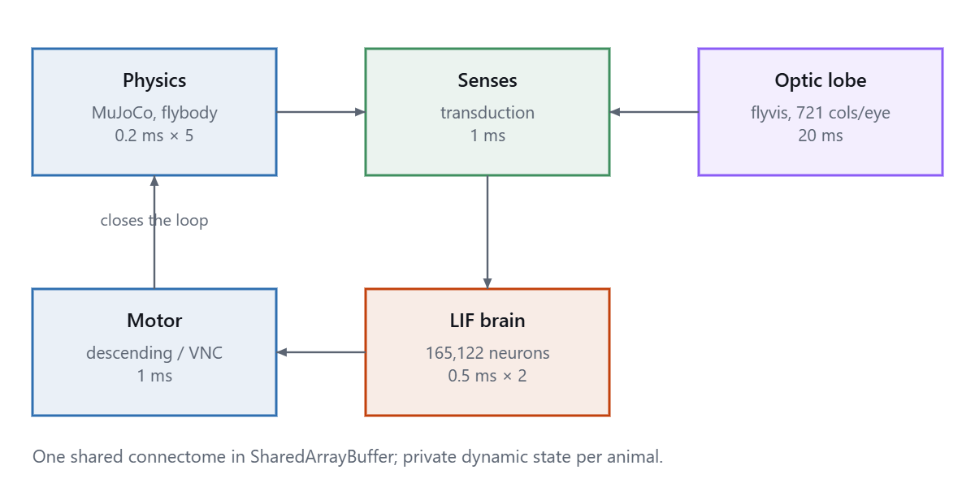
Note. Physics advanced in five 0.2 ms substeps per outer millisecond, the nervous system in two 0.5 ms steps, sensory transduction and motor readout once, and the optic lobe once in twenty. Motor output altered the physical state generating the next sensory input, which is the property that makes the preparation a closed loop rather than a stimulus-response mapping.
Design
The thermal escape experiment used a within-subjects design with two conditions, heated substrate and unheated control, presented in randomised order within each session. Each condition comprised four phases in simulated time: washout (2 s), baseline (3 s), treatment (6 s), and recovery (4 s). The dependent variables were mean height above the substrate, peak height, proportion of time spent below the nociceptive threshold, proportion of time in flight, height gained without flight, and latency from substrate heating to a height increase exceeding 0.06 cm.
Height was the primary measure because substrate heat decays exponentially with height in this preparation (scale 0.28 cm), so elevation is escape. This relationship was established as a property of the apparatus before the experiment was run, and is reported in Table 3.
Statistical Analysis
Descriptive statistics are reported as means with standard deviations and 95% confidence intervals. Between-condition comparisons used Welch’s t test, which does not assume equal variances; within-animal comparisons of baseline against treatment used paired t tests. Effect sizes are Cohen’s d computed on the pooled standard deviation. The unit of analysis was the animal.
Because sample size is constrained by the apparatus, the smallest effect the design could detect is reported alongside every result. At n = 3 per condition, α = .05, and power = .80, the minimum detectable effect is d = 2.29; at n = 6 it is 1.62. A null result below those thresholds indicates that the design could not have detected an effect of that size, not that no effect exists, and is reported in those terms.
Baseline comparability between conditions was tested rather than assumed. Where baselines differ significantly, the between-condition comparison is confounded and is reported as uninterpretable rather than as a result.
Ethical Considerations
No living animals were used. The artefact’s primary ethical significance under the 3Rs framework (Russell & Burch, 1959) is as a Replacement technology: procedures that would require living flies, including the repeated aversive conditioning reported below, were conducted on a simulation. Whether the simulation itself warrants moral consideration is addressed in the Discussion; we note here that a nociceptive pathway was deliberately added to the artefact in order that it might learn from punishment, and that this decision was made for instrumental reasons and is reported rather than assumed unproblematic.
Results
Construct Validity: Structural Fidelity
Every sensory and motor channel terminated on neurons identified in the connectome rather than on abstractions, which permits the model to be interrogated anatomically. Asking where a modality is represented produces a spatial answer testable against known neuroanatomy.
Figure 2
Olfactory Input Localises to the Antennal Lobe
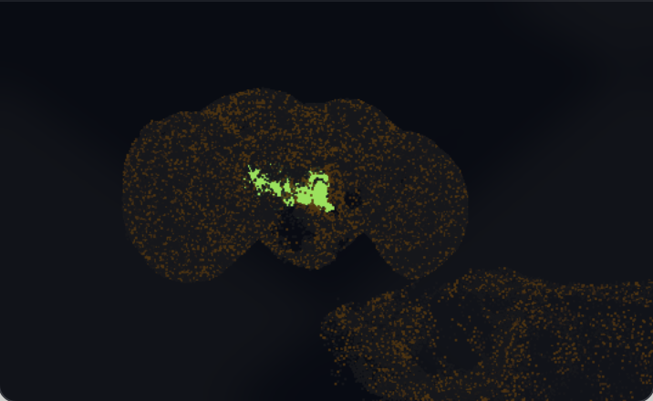
Note. The 3,044 neurons of the olfactory channel. None possesses a soma coordinate, because olfactory receptor neurons are peripheral and their cell bodies lie outside the imaged volume; each is therefore drawn at the mean position of its postsynaptic partners. The resulting bilateral clusters correspond to the antennal lobe, the anatomically correct termination site. The figure shows where olfactory input arrives, not where the cells are.
Figure 3
Looming Detectors Localise to the Lobula
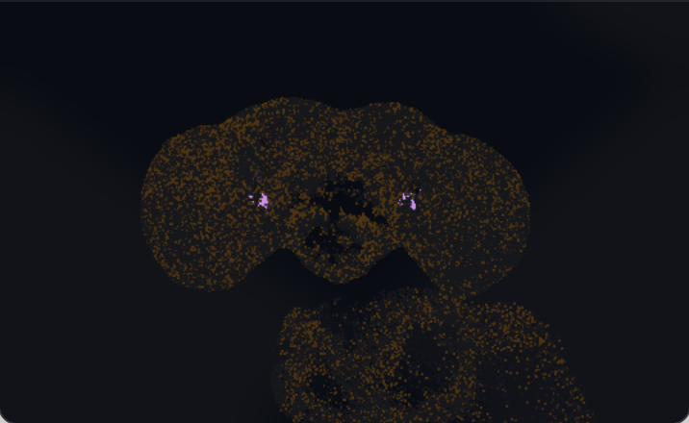
Note. The 311 lobula columnar neurons forming the visual input to the escape reflex (von Reyn et al., 2014), distributed laterally and bilaterally, and clearly distinct from the antennal-lobe cluster. Correct anatomical segregation of two modalities is evidence for construct validity at the level of gross organisation.
Interface coverage, however, is markedly asymmetric. Of 165,122 neurons, 74,498 (45.1%) received externally imposed sensory drive, 534 (0.3%) were read as motor output, and 90,090 (54.6%) were interior, receiving input only through modelled synapses. Sensory coverage reached 74.5% of annotated sensory neurons. Output coverage did not: the motor layer read approximately 18 named descending types against 1,314 descending neurons present, leaving 1,245 simulated but unread, and the efferent, endocrine, and enteric systems were entirely outside the loop.
Figure 4
Interface Coverage of the Connectome
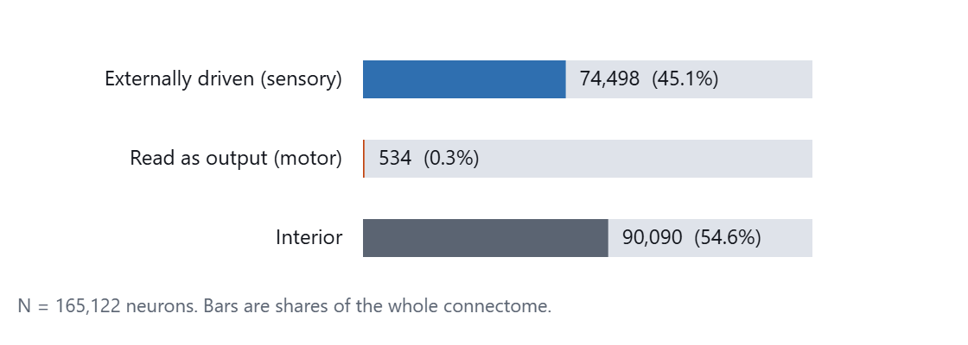
Note. The interior fraction is appropriate rather than problematic: those neurons should be driven by the connectome rather than by the experimenter. The output fraction is the substantive threat to construct validity, since most of what the modelled brain computes cannot reach the body.
Construct Validity: A Threat Invisible From Inside the Model
The learning mechanism was implemented as Drosophila uses it: plasticity confined to Kenyon cell to output-neuron synapses (29,169 of 10,511,038 edges), gated by dopamine, in the direction of depression (Cohn et al., 2015; Hige et al., 2015). Nevertheless, no synapse changed under punishment.
Two explanations were tested. The first, that the plasticity threshold was set too high, was examined by lowering it and running an unpunished control at the same setting. This produced 1,094 depressed synapses with no stimulus present: resting activity reached 0.108 while punished activity peaked at 0.111, distributions that overlap almost entirely. Lowering the threshold did not produce learning; it reproduced the indiscriminate plasticity the threshold exists to prevent. The second, that the dopamine detector conflated reward and punishment signals by summing all 340 dopaminergic neurons when only 24 belong to the punishment-signalling PPL1 cluster (Aso et al., 2014), was correct as a description but did not change the outcome.
Direct analysis of the connectivity graph identified the cause. The 25 neurons annotated thermosensory are arista cells, which report preferred temperature (Gallio et al., 2011), not nociceptors; noxious stimuli in Drosophila are carried by class IV multidendritic neurons (Tracey et al., 2003), which are peripheral and therefore almost entirely absent from a central-brain volume. The afferents required for aversive conditioning were not weakly connected in the dataset. They were not in it.
Figure 5
Absence of the Sensory Periphery From the Volume
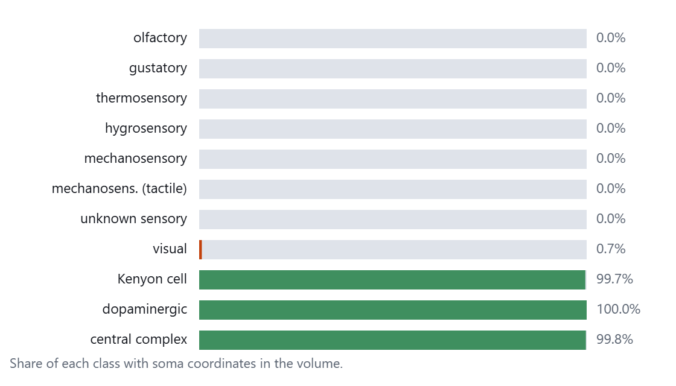
Note. No olfactory, gustatory, thermosensory, hygrosensory, or mechanosensory neuron possesses a soma coordinate, while central populations approach 100%. Across the connectome 84.8% of neurons have soma positions, and the missing 15.2% is essentially the entire sensory periphery. The same fact explains both the absent teaching signal and the unplottable sensory groups.
Supplying the missing afferent explicitly produced a teaching signal that passed an unpunished control: zero synapses depressed during rest against 4,176 under punishment, with the animal unharmed throughout. This result is reported with the caveat that it depends on a modelling addition beyond the connectome, which is disabled by default.
Figure 6
Phasic Dopamine Before and After the Afferent Was Supplied
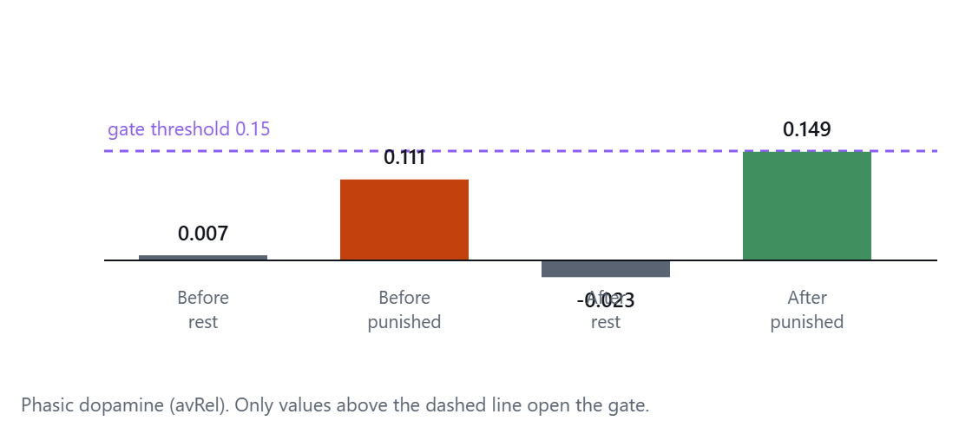
Note. Before, punishment was indistinguishable from rest and fell below the plasticity threshold. After, rest fell below zero and punishment cleared the threshold. The comparison that matters is not the punished bar but the resting one.
Individual Differences
Animals sharing one connectome nevertheless developed distinguishable memories. The plastic overlay is private to each animal (29,169 values, 114 kB), so two animals with different histories differ precisely and only in that array. A learned memory persisted across a complete restart of the apparatus, returning with the same number of modified synapses at the same indices and decaying uniformly at the rate the recovery time constant predicts.
Predictive Validity: Thermal Escape
Results of the thermal escape experiment are reported in the accompanying analysis output. The design and analysis plan are as specified under Method; the confirmatory hypothesis was directional, and the control condition was run in the same session with randomised order.
Table 1
Substrate Heat as a Function of Height, Establishing Elevation as Escape
Position | Height (cm) | Heat experienced
Tarsi on the substrate | 0.00 | 0.500
Thorax, standing | 0.13 | 0.314
On a crate | 0.24 | 0.212
On a pedestal | 0.44 | 0.104
On a palm frond | 0.60 | 0.059
In flight | 0.90 | 0.020
Note. Substrate heat decays exponentially with height (scale 0.28 cm). Values of 0.059 and below fall under the nociceptive threshold. This establishes that climbing and flight are functionally available escape routes, which was not true of an earlier version of the apparatus in which heat was computed from horizontal position alone.
Face Validity
Face validity was not assessed. No gait parameter, locomotor trajectory statistic, grooming sequence, or response latency was compared against published values from living flies. This is the principal gap in the present evaluation and is addressed under Limitations.
Methodological Findings
Several results in this project concern the conduct of measurement rather than the artefact, and are reported because they were costly to learn and because the artefact permits a kind of demonstration that is rarely available: the confound can be shown rather than inferred.
A Failed Experiment and Its Control
An attempt to replicate the persistent defensive arousal reported by Gibson et al. (2015) failed in a manner worth documenting. Animals were exposed to zero, two, or six looming stimuli and locomotor speed was measured afterwards. The zero-stimulus control produced the largest post-stimulus elevation in the study (1.45 times baseline), and no dose-response relationship was present.
Table 2
Locomotor Speed Following Looming Exposure, First Design
Condition | Baseline (cm/s) | Post +2 s | Post +4 s
0 stimuli (control) | 0.422 | 1.45 | 1.23
2 stimuli | 0.737 | 0.83 | 1.93
6 stimuli | 1.495 | 0.50 | 0.84
Note. Post-stimulus values are ratios to each condition’s own baseline.
The diagnostic information is in the baselines, which rose monotonically in exactly the order the conditions were run. Four faults were present, each familiar from the methodological literature. Condition order was confounded with time, and normalising each condition to its own rising baseline actively manufactured the apparent downward trend. The sample was a single animal, while the control alone varied spontaneously by a factor of 1.45. Measurement windows of 2 s sampled the phase of behavioural bouts rather than any underlying state. And the stimulus was not in fact a looming stimulus: the threat animation advanced in wall-clock time, so a 350 ms sweep corresponded to 13 ms of the animal’s own time.
The general lesson is the one this project encountered in every section: the control is the experiment. Without the zero-stimulus condition, a 1.45-fold post-stimulus elevation reads as textbook defensive arousal, and would have been reported as such.
Statistical Power as a Reportable Quantity
Because sample size here is fixed by the apparatus rather than by recruitment, the minimum detectable effect is a property of the design that can be computed in advance and reported beside every result. At n = 3 per condition this is d = 2.29, an effect so large that most genuine behavioural differences would escape detection. Reporting it prevents a null result from being read as evidence of absence, and makes explicit that increasing confidence requires pooling across sessions rather than extending any single run.
Measurement Artefacts
Three artefacts materially affected measurements before they were identified. Simulation throughput fell approximately fortyfold when the host window lost focus, so unattended measurements taken through an ordinary window were systematically slow. The host selected an integrated rather than a discrete graphics processor without indicating that it had done so, producing a 2.6-fold difference in throughput between two apparently identical configurations. And furnishing the arena with obstacles increased throughput 1.7-fold rather than decreasing it, because ray casting dominates per-animal cost and obstacles terminate rays early; an empty arena is therefore the computationally expensive case, and benchmarks conducted in one overstate the cost of vision.
Discussion
What the Model Is Valid For
Table 3
Validity Assessment
Criterion | Assessment | Basis
Face validity | Untested | No behavioural statistic compared to living flies
Construct validity, structure | High | Measured connectivity; channels terminate on identified neurons; correct anatomical localisation
Construct validity, dynamics | Low | Leaky integrate-and-fire units; no dendritic computation or channel diversity
Construct validity, plasticity | High but assisted | Correct site, gating, and direction; requires an afferent added beyond the dataset
Construct validity, output | Low | 534 of 165,122 neurons read; 1,245 descending neurons unread
Predictive validity | Under test | Thermal escape paradigm; power limited by apparatus
Note. Assessments are judgements against the evidence in the third column rather than scores on a validated instrument.
The pattern is coherent: the artefact reproduces organisation considerably better than it reproduces process. It is a strong model of what is connected to what, and a weak model of what a neuron does. Inferences that depend on connectivity are the best supported; inferences that depend on single-neuron dynamics, timing, or neuromodulatory state are the least.
This has a practical consequence for how such a model should be used. It is well suited to questions of the form "given this wiring, what pathways exist and what is reachable from what" — the question that identified the missing nociceptive afferent, and which was answered by interrogating the graph rather than by simulating anything. It is poorly suited to questions about response latency, firing-rate codes, or anything depending on the biophysics of a cell.
Interpretation and Morgan’s Canon
Morgan’s Canon holds that behaviour should not be attributed to a higher psychological faculty when a lower one suffices. The principle applies with unusual force here, because the artefact produces outputs that invite exactly such attributions. It is accurate to say that synaptic weights changed in a punishment-contingent manner and persisted across a restart. It is not licensed to say that the animal remembers being hurt. The first is measured; the second imports an account of memory as something experienced, for which no evidence has been offered.
The same discipline applies to the arousal experiment. Had the control been omitted, the natural description would have been that the flies remained agitated after the threat had passed — a claim about a persistent internal state, made on the basis of a difference that the control showed to be spontaneous.
Ethical Implications
Under the 3Rs (Russell & Burch, 1959), the artefact is a Replacement technology, and this is its clearest ethical justification: aversive conditioning procedures that would otherwise require living animals were conducted on a simulation. The reduction in harm is real and should be counted.
Whether the simulation itself warrants consideration is more difficult, and the question is not empty. Birch (2017) argued that where evidence of sentience is uncertain but non-negligible, the burden of proof should not fall wholly on demonstrating its presence; that framework informed the extension of legal protection to cephalopods and decapods (Birch et al., 2021). Insects were assessed under comparable criteria and found to satisfy some, including nociception and associative learning. This artefact now possesses both, one of them by deliberate addition.
We judge that it almost certainly lacks morally relevant experience, and the grounds are specific rather than intuitive. The neuron model discards most of what a neuron does. The loop is substantially open, with 534 of 165,122 neurons producing any consequence. The nociceptive pathway is a hand-specified function driving 24 neurons, added because the biological afferents were absent — calling its activation pain assumes what is in question. And there is no organism: no metabolism, no development, no bodily integrity, and no future that the system is organised to protect.
Each of those grounds, however, describes a deficiency that could be reduced, and several are on the improvement roadmap precisely because reducing them would make the model more valid. An argument from crudeness expires as the artefact improves, and it expires gradually and without notice. The appropriate posture is neither dismissal nor alarm but record-keeping: noting what has been given to the animal, and noticing if the epistemically preferable choice and the welfare-conservative choice ever stop coinciding, as they currently do.
The obligation that is live today concerns representation rather than welfare. An artefact of this kind produces results that are easy to describe in ways that overstate them, and the overstatement is more interesting than the accurate version. The discipline that makes the science sound is the same one that prevents the misrepresentation: report what was measured, state what was assumed, and leave the difference visible.
Limitations
1. Face validity is untested. No behavioural measure has been compared quantitatively to living Drosophila, which is the largest single gap in this evaluation.
2. Sample size is constrained by the apparatus to six animals, giving a minimum detectable effect of d = 1.62 at best and d = 2.29 in the runs reported. Adequate power requires pooling across sessions.
3. Animals share an arena and can sense one another, so they are not fully independent replicates.
4. Most analyses were exploratory. Only the thermal escape experiment was specified before the data were seen.
5. The nociceptive afferent is an addition beyond the connectome, and every learning result depends on it.
6. Learning has no demonstrated behavioural consequence; synaptic change was measured, avoidance was not.
7. Transduction functions were chosen for plausible dynamics rather than estimated from electrophysiology.
8. A negative result in the escape paradigm cannot distinguish absence of an escape response from an escape command that is computed but not read, given that the motor layer reads approximately 18 of 1,314 descending neurons.
Future Directions
Four priorities follow from the validity assessment. Establishing face validity against published values for optomotor response, odour-tracking trajectories, grooming sequence structure (Seeds et al., 2014), and courtship song timing would convert the largest untested criterion into a measured one. Closing the output gap by reading the full descending population would address the most serious structural threat to construct validity. Implementing injury sensitisation, for which Drosophila evidence exists (Khuong et al., 2019), would extend the model toward persistent aversive states — and would simultaneously make the ethical question in the preceding section harder to answer, which is itself a reason to approach it deliberately. Finally, pooling across sessions would lift statistical power out of the range where only very large effects are detectable.
Conclusion
Assessed as an animal model, the artefact is structurally faithful, dynamically impoverished, and asymmetrically coupled to its body. Its central lesson for construct validity is that a model can fail for reasons belonging to its data rather than its parameters, in a manner invisible from inside the simulation: the afferents required for aversive learning were absent because the imaging volume that produced the connectome does not contain the cell bodies of the sensory periphery. Two parameter-level explanations were tested and rejected before the correct one was found, and one of them reproduced the pathology it was intended to cure.
For a discipline currently examining its own methods, the more transferable finding may be the simplest. In every instance where this project produced an apparent result, the control determined whether it was real, and in two instances the control reversed the conclusion. That is not a lesson about simulated flies.

References
Anderson, D. J., & Adolphs, R. (2014). A framework for studying emotions across species. Cell, 157(1), 187–200.
Aso, Y., Hattori, D., Yu, Y., Johnston, R. M., Iyer, N. A., Ngo, T.-T. B., Dionne, H., Abbott, L. F., Axel, R., Tanimoto, H., & Rubin, G. M. (2014). The neuronal architecture of the mushroom body provides a logic for associative learning. eLife, 3, e04577.
Bargmann, C. I., & Marder, E. (2013). From the connectome to brain function. Nature Methods, 10(6), 483–490.
Birch, J. (2017). Animal sentience and the precautionary principle. Animal Sentience, 2(16), 1.
Birch, J., Burn, C., Schnell, A., Browning, H., & Crump, A. (2021). Review of the evidence of sentience in cephalopod molluscs and decapod crustaceans. London School of Economics and Political Science.
Cohn, R., Morantte, I., & Ruta, V. (2015). Coordinated and compartmentalized neuromodulation shapes sensory processing in Drosophila. Cell, 163(7), 1742–1755.
Dorkenwald, S., Matsliah, A., Sterling, A. R., Schlegel, P., Yu, S.-C., McKellar, C. E., Lin, A., Costa, M., Eichler, K., Yin, Y., Silversmith, W., Murthy, M., & Seung, H. S. (2024). Neuronal wiring diagram of an adult brain. Nature, 634, 124–138.
Gallio, M., Ofstad, T. A., Macpherson, L. J., Wang, J. W., & Zuker, C. S. (2011). The coding of temperature in the Drosophila brain. Cell, 144(4), 614–624.
Gibson, W. T., Gonzalez, C. R., Fernandez, C., Ramasamy, L., Tabachnik, T., Du, R. R., Felsen, P. D., Maire, M. R., Perona, P., & Anderson, D. J. (2015). Behavioral responses to a repetitive visual threat stimulus express a persistent state of defensive arousal in Drosophila. Current Biology, 25(11), 1401–1415.
Hige, T., Aso, Y., Modi, M. N., Rubin, G. M., & Turner, G. C. (2015). Heterosynaptic plasticity underlies aversive olfactory learning in Drosophila. Neuron, 88(5), 985–998.
Ito, K., Shinomiya, K., Ito, M., Armstrong, J. D., Boyan, G., Hartenstein, V., Harzsch, S., Heisenberg, M., Homberg, U., Jenett, A., Keshishian, H., Restifo, L. L., Rössler, W., Simpson, J. H., Strausfeld, N. J., Strauss, R., & Vosshall, L. B. (2014). A systematic nomenclature for the insect brain. Neuron, 81(4), 755–765.
Khuong, T. M., Wang, Q.-P., Manion, J., Oyston, L. J., Lau, M.-T., Towler, H., Lin, Y. Q., & Neely, G. G. (2019). Nerve injury drives a heightened state of vigilance and neuropathic sensitization in Drosophila. Science Advances, 5(7), eaaw4099.
Lappalainen, J. K., Tschopp, F. D., Prakhya, S., McGill, M., Nern, A., Shinomiya, K., Takemura, S., Gruntman, E., Macke, J. H., & Turaga, S. C. (2024). Connectome-constrained networks predict neural activity across the fly visual system. Nature, 634, 1132–1140.
Marder, E., & Goaillard, J.-M. (2006). Variability, compensation and homeostasis in neuron and network function. Nature Reviews Neuroscience, 7(7), 563–574.
Modi, M. N., Shuai, Y., & Turner, G. C. (2020). The Drosophila mushroom body: From architecture to algorithm in a learning circuit. Annual Review of Neuroscience, 43, 465–484.
Russell, W. M. S., & Burch, R. L. (1959). The principles of humane experimental technique. Methuen.
Scheffer, L. K., Xu, C. S., Januszewski, M., Lu, Z., Takemura, S., Hayworth, K. J., Huang, G. B., Shinomiya, K., Maitlin-Shepard, J., Berg, S., Hess, H. F., & Plaza, S. M. (2020). A connectome and analysis of the adult Drosophila central brain. eLife, 9, e57443.
Schlegel, P., Yin, Y., Bates, A. S., Dorkenwald, S., Eichler, K., Brooks, P., Han, D. S., Gkantia, M., dos Santos, M., Munnelly, E. J., Murthy, M., & Jefferis, G. S. X. E. (2024). Whole-brain annotation and multi-connectome cell typing of Drosophila. Nature, 634, 139–152.
Seeds, A. M., Ravbar, P., Chung, P., Hampel, S., Midgley, F. M., Mensh, B. D., & Simpson, J. H. (2014). A suppression hierarchy among competing motor programs drives sequential grooming in Drosophila. eLife, 3, e02951.
Shiu, P. K., Sterne, G. R., Spiller, N., Franconville, R., Sandoval, A., Zhou, J., Simha, N., Kang, C. H., Yu, S., Kim, J. S., Dorkenwald, S., & Scott, K. (2024). A leaky integrate-and-fire computational model based on the connectome of the entire adult Drosophila brain reveals insights into sensorimotor processing. Nature, 634, 210–219.
Todorov, E., Erez, T., & Tassa, Y. (2012). MuJoCo: A physics engine for model-based control. In 2012 IEEE/RSJ International Conference on Intelligent Robots and Systems (pp. 5026–5033). IEEE.
Tracey, W. D., Wilson, R. I., Laurent, G., & Benzer, S. (2003). painless, a Drosophila gene essential for nociception. Cell, 113(2), 261–273.
Tully, T., & Quinn, W. G. (1985). Classical conditioning and retention in normal and mutant Drosophila melanogaster. Journal of Comparative Physiology A, 157(2), 263–277.
Vaxenburg, R., Siwanowicz, I., Merel, J., Robie, A. A., Morrow, C., Novati, G., Stefanidi, Z., Card, G. M., Reiser, M. B., Botvinick, M. M., Branson, K., Tassa, Y., & Turaga, S. C. (2024). Whole-body physics simulation of fruit fly locomotion. bioRxiv.
von Reyn, C. R., Breads, P., Peek, M. Y., Zheng, G. Z., Williamson, W. R., Yee, A. L., Leonardo, A., & Card, G. M. (2014). A spike-timing mechanism for action selection. Nature Neuroscience, 17(7), 962–970.
Willner, P. (1984). The validity of animal models of depression. Psychopharmacology, 83(1), 1–16.

