Addressable Patching
New game content patching is done through addressables. You can access the Addressables Groups by going to Window>Asset Management>Addressables>Groups.
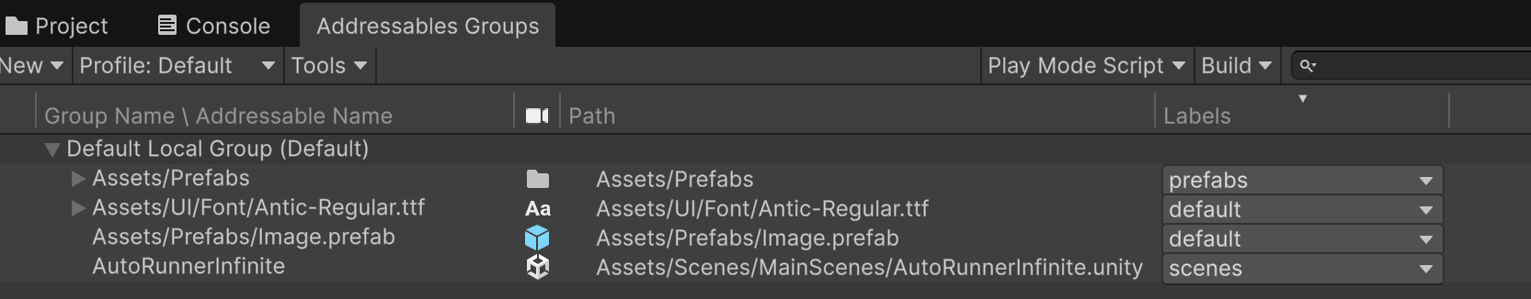
Figure 1 Addressable Groups
Inside these groups, they are given labels. These labels help UpdateProcedure.cs which is attached to the Manager to be able to identify and download packages by name.
Your Play Mode Script determines whether you will download from the server when you play the game in Editor. If you set it to Asset Database, it will use the assets/prefabs within the project files instead of the ones on the server.
This should work for Android too. Note that if you try to download the server assets for the Android build in editor, it will always strip out the shader and leave assets purple. If you want to test, you need an Android device.
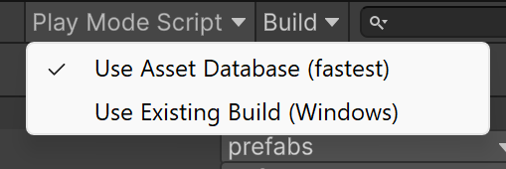
Figure 2 Disabling Addressables in editor
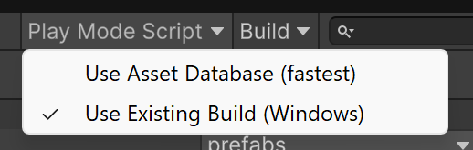
Figure 3 Enabling Addressables in editor
Whenever you make a new update to the game, to introduce the patch, you need to make a Build (Click on Build->New Build->Default Build Script), commit and push this Build to the GitHub Pages Repository (it will be in SpookyRunner/ServerData under the platform you built for), and update the old files with a version number.
To access the GitHub Pages Repository for pushing, reach out to Ryder Claus (@minersheep on Discord)
Put the build within the CurrentBuild/ServerData folder. The root folder will be renamed from ”v1.0.1” to “CurrentBuild”. In the future, when uploading a new build, you will rename this “CurrentBuild” folder to an old version number and replace it with the new build. Please note there needs to be Android and StandaloneWindows64 for Windows builds respectively.
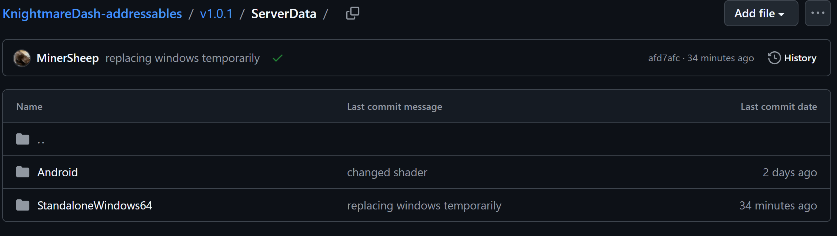
Figure 4 Putting the Build on the GitHub Page

