Game Mechanics

Main Menu
The main menu scene is located at SpookyRunner\Assets\Scenes\MainScenes.
The main menu is in charge of starting the game, changing options, opening the leaderboard (which contacts the server), and viewing the credits. Later down the line we hope to implement the option to change character + items/equipment, add friends on the server, and open a shop with item/equipment transactions.
The main menu canvas has MenuButtons.cs which controls the optional interfaces and buttons.
Main Menu also has a Manager prefab that follows into other levels. This manager has AudioManager, ParticleManager, TelemetryManager, DatabaseManager, Analytics Manager, and UpdateProcedure.
- AudioManager: Stores master, musix, sfx audio along with all audio files used in the game.
- ParticleManager: Unclear, but I think its responsible for spawning effects
- TelemetryManager: Records statistics of the game from when it is launched, to when a run begins. When finished, it communicates with DatabaseManager to send data to the server.
- DatabaseManager: Responsible for sending/retrieving data to the server (planned to be outdated)
- AnalyticsManager: Controls web requests, holds structs of data that are converted to json when they are sent (planned to be outdated)
- UpdateProcedure: Responsible for downloading Addressables patches from a GitHub Page. https://github.com/MinerSheep/KnightmareDash-addressables

AutoRunnerInfinite
Auto Runner Infinite is the main mode of the game, scene is located in the same folder as main menu.
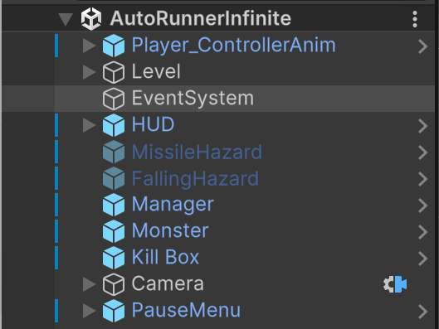
Figure 1 AutoRunnerInfinite entities
Player_ControllerAnim is the player, it has PlayerController.cs, PlayerAnimation.cs, Health.cs, InputBuffer.cs, and DistanceScoreTracker.cs
- PlayerController: Controls the force of the players jump, double jump, crouch, and dash.
- PlayerAnimation: Sets the player’s state based on if the player is jumping (3), crouching (2), attacking (4), moving (1), or idle (0). This state is held in Assets/PlayerCharacterAsset/2.Animation/sword_man.controller.
- InputBuffer: All player input goes through here.
- DistanceScoreTracker: Originally tracked player’s score through distance, now tracks through time.
Player has a GroundTrigger, HeadTrigger, and Model as children. GroundTrigger allows the player to jump when it is touching the ground. HeadTrigger prevents the player from standing up when crouching under platforms.
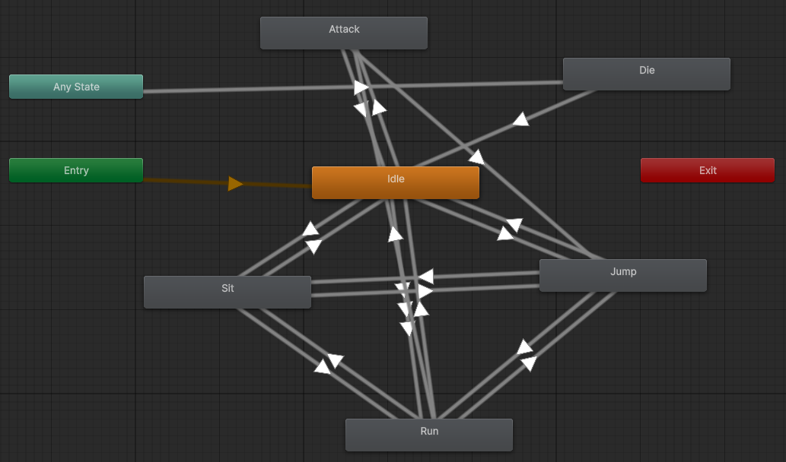
Figure 2 Animation Controller
Level is an auto scrolling entity that builds level chunks containing grids for Grid (collidable) and BG.
- RunnerScene: Controls the speed of the auto scrolling level
- LevelGenerator: Responsible for building chunks sequentially. You can assign Easy, Medium, and Hard chunks and dictate the order they are generated in using Difficulty Sequence.
- HazardManager: Uses the two hazards, MissileHazard and FallingHazard which are prefabs located in the scene. This script is responsible for spawning a new instance along with a Warning prefab on the HUD that will show the player where the hazard is. The hazard becomes visible and active when the warning is destroyed.
Kill Box is a box below the level that follows the player’s x position so when they reach a y threshold, a death is triggered.

