Making a Build
Making a build is easy, but it is definitely complicated for someone who hasn’t made builds with the Addressables system.
Make a standard Unity build by going here: Build Profiles (Ctrl+Shift+B) and make sure the Scene List looks like this
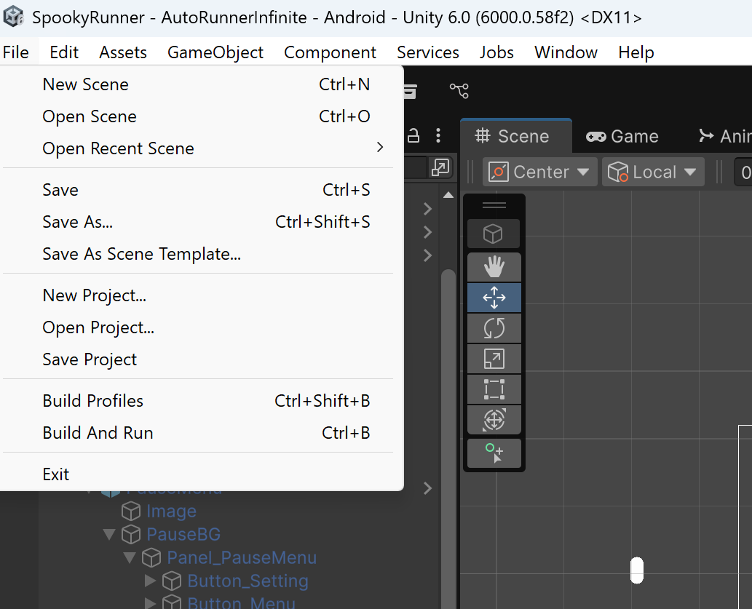
Figure 1 - How to standard build on Unity (Ctrl+Shift+B)
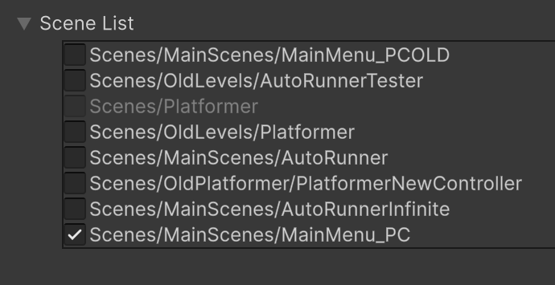
Figure 2 - Scene List
Before making the build on your targeted platform, check Window->Asset Management->Addressables->Groups to make sure that all assets OUTSIDE OF MAINMENU_PC (MainMenu_PC is packaged with the build whilst others are downloaded online) are listed here.
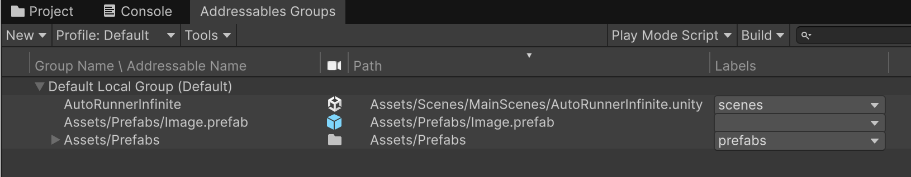
Figure 3 - Addressable Groups
^ In this case, having the scene, “AutoRunnerInfinite” and the Assets/Prefabs folder is sufficient.
You don’t need to know this, but in case it becomes relevant: Notice the labels on the right, you can specify which assets you want to load on Startup with these. Put a label and then on the Manager prefab (in Assets folder), add it to their Update Procedure script.
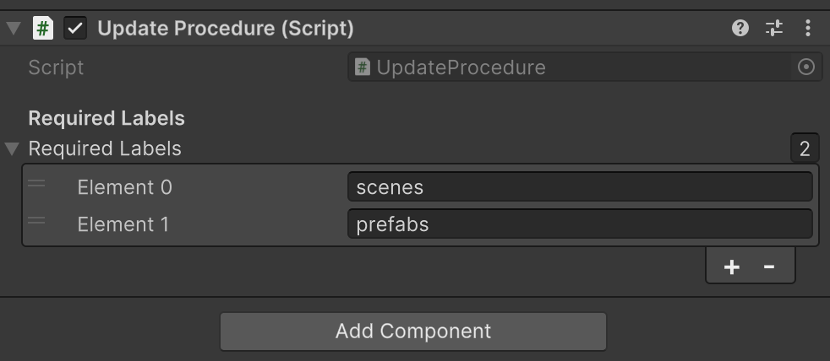
Figure 4 - I want to load Scenes on startup, so I add scenes to Manager prefab Update Procedure
Once the build is done, you need to upload the build files. See AddressablePatching.docx for details on how this is done (skip to the part after Figure 3)

