HW1 -Part5 Report

Write a Java (could be a console app - will only run once to import the data into MongoDB) program to read the access.log file (attached), and insert into access collection.

Insert into MongoDB

Do the followings using MapReduce:

1. Number of times any webpage was visited by the same IP address.

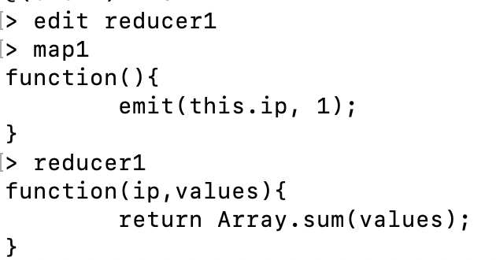

Result:

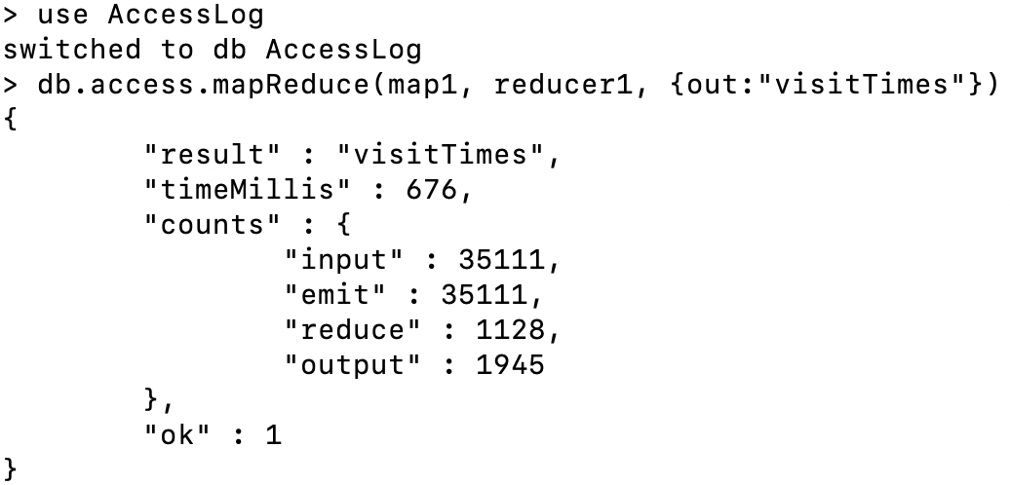

1. Number of times any webpage was visited each month

Result:

