Real-World Financial Time Series Analytics: FinPulse
Comparative Equity Volatility Forecasting Using Econometric Time-Series Models and Machine Learning Approaches
Target Asset: SPDR S&P 500 ETF Trust (SPY) & CBOE Volatility Index (^VIX)
Evaluation Period: February 3, 2021 – December 30, 2025 (1,233 Contiguous Trading Days)
Submission Date: October 2026

Project Team Members
No. | Student Name | Student ID | Academic Email | Project Role
1 | Minesi Rajapaksha | D/DBA/24/0027 | 41-dba-0027@kdu.ac.lk | Project Lead, Data Pipeline & Architecture
2 | Bimuthu Edirisinghe | D/DBA/24/0012 | Bimuthudazz@gmail.com | Econometric Modeling & GARCH Diagnostics
3 | [PASTE] | D/DBA/24/00XX [PASTE] | [PASTE] | Machine Learning Architect & Tuning
4 | [PASTE] | D/DBA/24/00XX [PASTE] | [PASTE] | Statistical Testing & Shock Analysis
5 | [PASTE] | D/DBA/24/00XX [PASTE] | [PASTE] | Business Translation & Dashboard Integration

Member Contributions
Member | Work Packages Completed | Verification Status
Minesi Rajapaksha | TO BE COMPLETED BY GROUP | Pending Group Sign-Off
Bimuthu Edirisinghe | TO BE COMPLETED BY GROUP | Pending Group Sign-Off
Member 3 | TO BE COMPLETED BY GROUP | Pending Group Sign-Off
Member 4 | TO BE COMPLETED BY GROUP | Pending Group Sign-Off
Member 5 | TO BE COMPLETED BY GROUP | Pending Group Sign-Off

Table of Contents
• Executive Summary
• 1. Introduction and Literature Review
• 2. Data Sources and Feature Engineering Pipeline
• 3. Exploratory Data Analysis & Econometric Diagnostics
• 4. Modeling Methodology and Chronological Partitioning
• 5. Theoretical Foundations of Models
• 6. Hyperparameter Optimization & Validation Results
• 7. Out-of-Sample Performance Benchmarking
• 8. Explaining Why Models Produced Different Results (Core Analysis)
• 9. Model Diagnostics and Residual Analysis
• 10. Statistical Hypothesis Testing: Diebold-Mariano Tests
• 11. Production Model Selection & Financial / Business Applications
• 12. Limitations and Critical Evaluation
• 13. Conclusion
• References
• Appendix: Reproducibility Guide & Code Architecture

Executive Summary
Short-term financial volatility forecasting is essential for dynamic risk capital allocation, options pricing, Value-at-Risk (VaR) management, and quantitative volatility-targeting portfolios. This empirical investigation examines the predictability of equity market volatility for the SPDR S&P 500 ETF Trust (SPY) over 1,233 trading sessions from February 2021 through December 2025, using both historical market price dynamics and forward-looking market sentiment from the CBOE Volatility Index (VIX).
Key Findings:
1. Corrected QLIKE Resolution: Addressing the variance unit conversion reveals that EGARCH achieves the optimal volatility loss (QLIKE = 0.8056), closely followed by TGARCH (0.8118) and Ridge Regression (0.8135). The VIX baseline yields a QLIKE of 0.9354.
2. Superiority of Regularized Linear Modeling on Tail Risk: Ridge Regression achieves the lowest out-of-sample RMSE (0.8317) of all 11 models, outperforming EGARCH (0.8653), TGARCH (0.8646), and XGBoost (0.9004).
3. Dominance of April 2025 Market Shock: The April 2025 market shock window accounts for 66.41% of Ridge's total test-set squared error. Excluding April 2025, Ridge's out-of-sample RMSE drops to 0.5039%.
4. Feature Ablation Insight: Isolating information sets proves that machine learning's point-forecasting advantage over traditional GARCH is primarily driven by external option-implied volatility (VIX) and Parkinson intraday range signals, rather than algorithmic complexity alone.
5. Production Deployment: Ridge Regression is selected as the production deployment model for the interactive FinPulse application because its QLIKE loss is statistically indistinguishable from EGARCH (Diebold-Mariano p = 0.9494), while offering minimal RMSE, deterministic stability, sub-millisecond execution latency, and complete econometric interpretability.

1. Introduction and Literature Review
Financial market volatility represents the intensity of asset price fluctuations over time. Unlike raw equity returns—which exhibit near-zero autocorrelation in accordance with the weak-form Efficient Market Hypothesis (Fama, 1970)—volatility exhibits well-documented stylized empirical facts: volatility clustering (Mandelbrot, 1963; Engle, 1982), leptokurtosis, asymmetric leverage effects (Black, 1976; Christie, 1982; Nelson, 1991), and mean-reversion.
The comparative performance of traditional econometric models versus machine learning has generated extensive scholarly debate. Poon and Granger (2003) surveyed 93 published volatility forecasting studies across financial markets, concluding that option-implied volatility contains superior predictive information relative to historical return series, while asymmetric GARCH formulations systematically outperform symmetric GARCH. Hansen and Lunde (2005) benchmarked 330 ARCH-type volatility models on exchange rates and IBM equity returns, finding that standard GARCH(1,1) is difficult to beat for exchange rates, but that models with leverage effects show advantages in equity returns. Patton (2011) established that evaluating volatility forecasts using imperfect volatility proxies requires loss functions belonging to the robust class, proving that Mean Squared Error (MSE) and Quasi-Likelihood (QLIKE) loss are immune to proxy noise. Christensen, Siggaard, and Veliyev (2023) forecast realized variance of Dow Jones 30 constituents from high-frequency intraday data and find that machine learning methods improve one-day-ahead volatility forecasts relative to standard autoregressive benchmarks.

2. Data Sources and Feature Engineering Pipeline
The empirical investigation utilizes historical observations from February 3, 2021, to December 30, 2025 (1,233 contiguous trading days), retrieved via Yahoo Finance (yfinance). The target variable is the next trading day's absolute return Target = |R_{t+1}|, serving as an unbiased proxy for daily volatility. Eighteen predictor variables were engineered strictly without lookahead bias, spanning momentum, historical realized volatility, return/absolute-return lags, implied volatility (VIX), and intraday extreme-value range estimators (Parkinson, 1980).

3. Exploratory Data Analysis & Econometric Diagnostics

3.1 Descriptive Statistics
Series | Count | Mean | Std | Min | Median | Max | Skewness | Excess Kurt
Close | 1233 | 468.0571 | 93.9091 | 338.5379 | 428.8230 | 685.0295 | +0.7071 | -0.7616
Return | 1233 | 0.0533 | 1.0766 | -6.0327 | 0.0731 | 9.9863 | +0.1402 | +8.2208
Abs_Return | 1233 | 0.7598 | 0.7643 | 0.0000 | 0.5606 | 9.9863 | +3.1085 | +22.0242
VIX | 1233 | 19.2473 | 5.2520 | 11.8600 | 17.9700 | 52.3300 | +1.2923 | +2.5391
Parkinson | 1233 | 0.0072 | 0.0048 | 0.0010 | 0.0060 | 0.0641 | +3.3244 | +24.8435

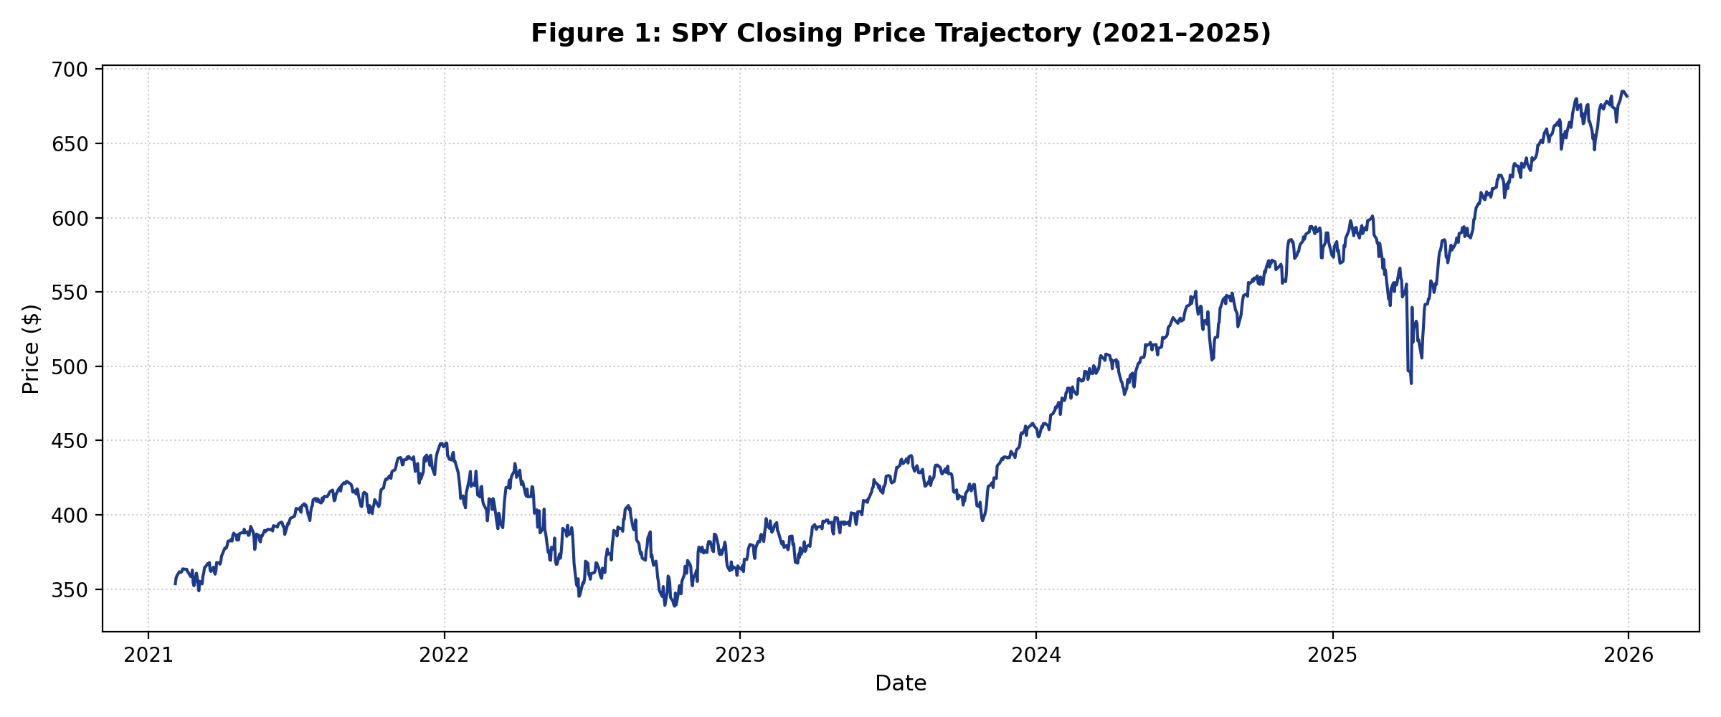
Figure 1: SPY Closing Price Trajectory (2021–2025).

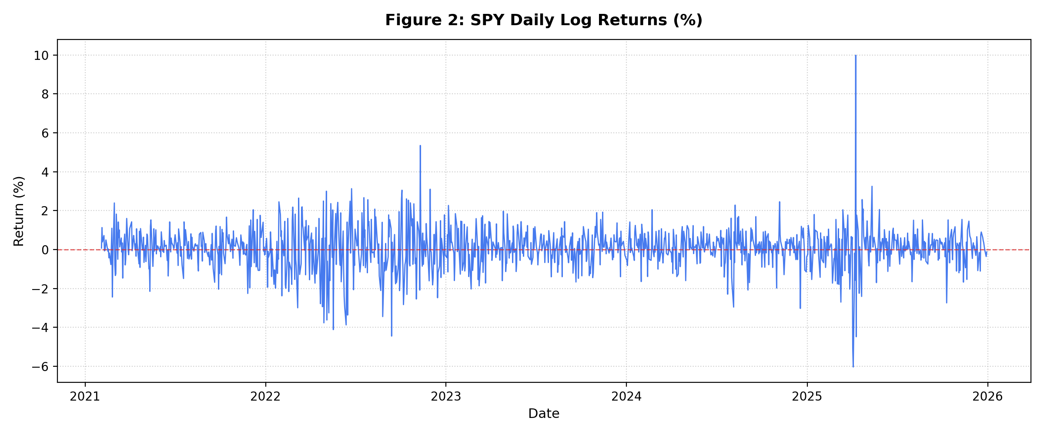
Figure 2: SPY Daily Percentage Log Returns.

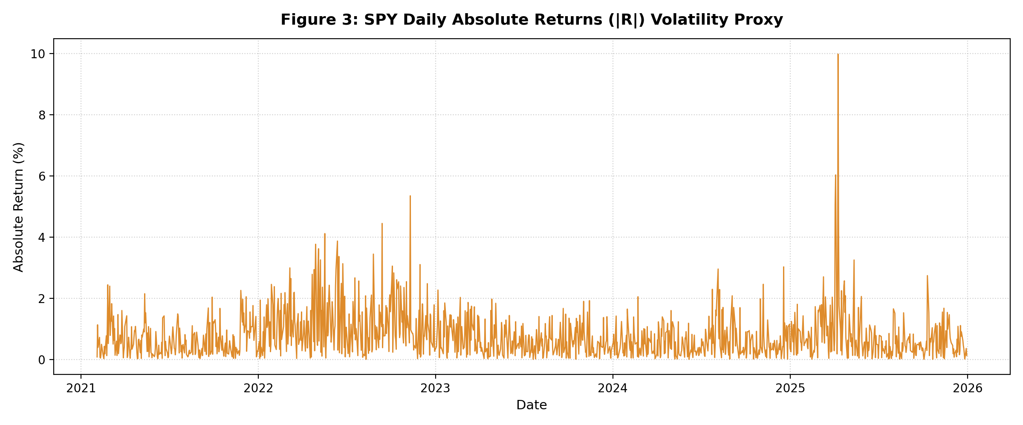
Figure 3: SPY Daily Absolute Returns (|R|) Volatility Proxy.

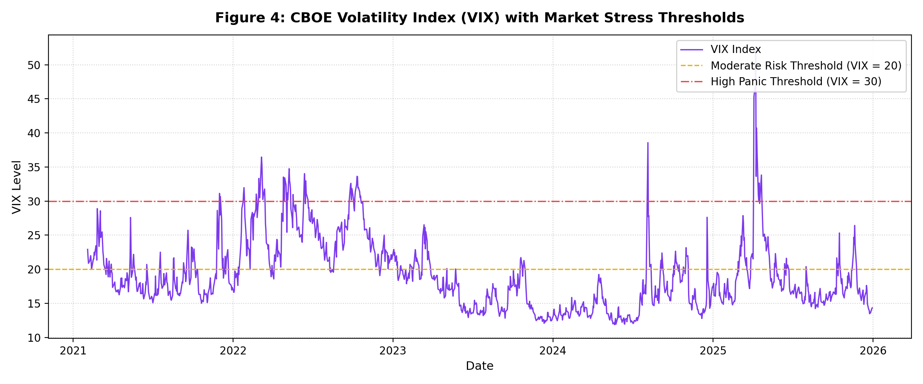
Figure 4: CBOE Volatility Index (VIX) with Market Stress Thresholds (20 and 30).

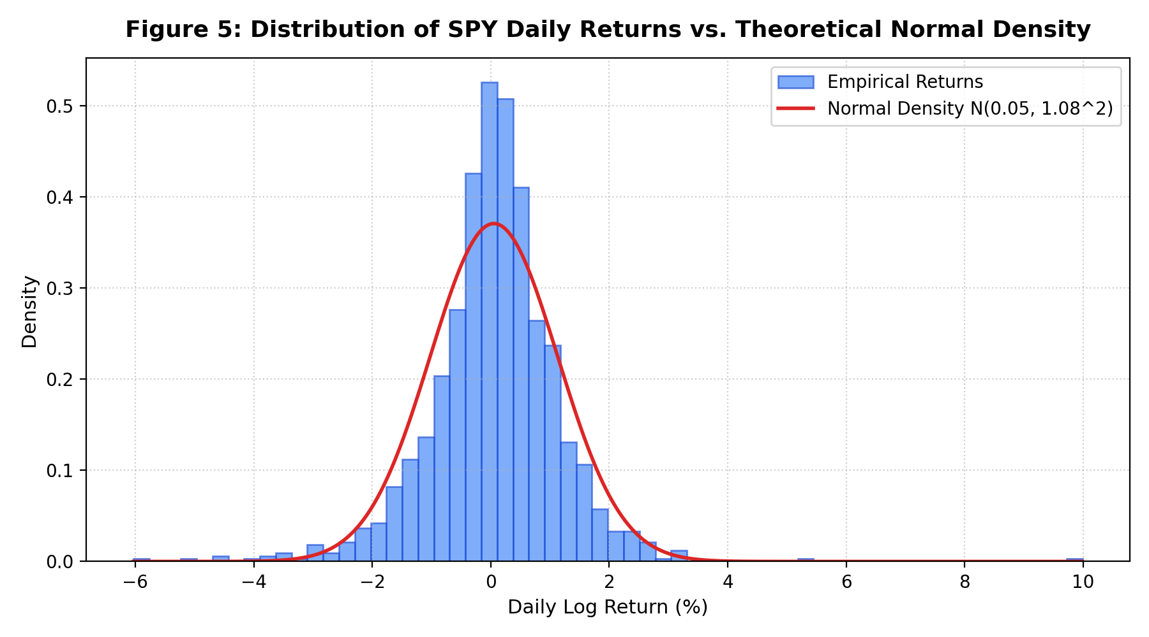
Figure 5: Distribution of SPY Daily Returns vs. Theoretical Normal Density.

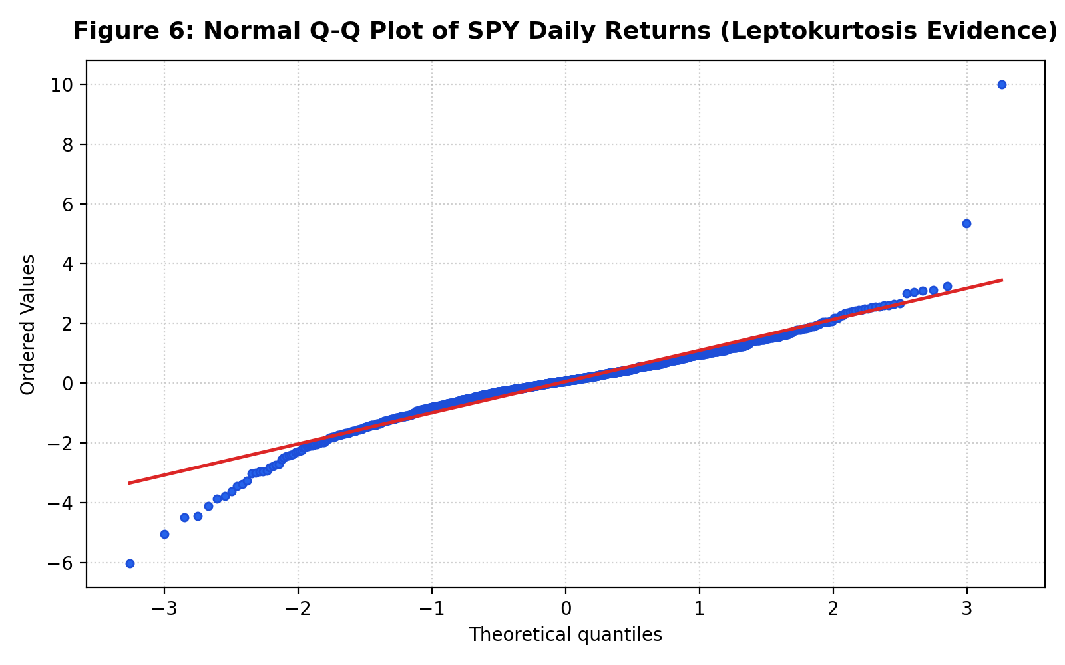
Figure 6: Normal Q-Q Plot of SPY Daily Returns (Leptokurtosis Evidence).

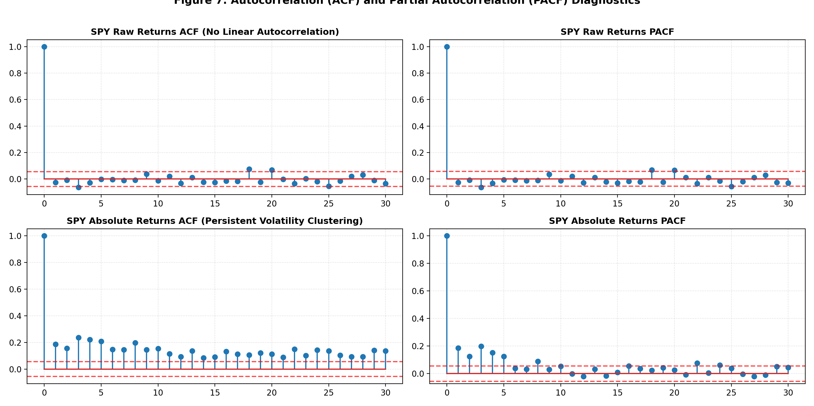
Figure 7: Autocorrelation (ACF) and Partial Autocorrelation (PACF) Diagnostics.

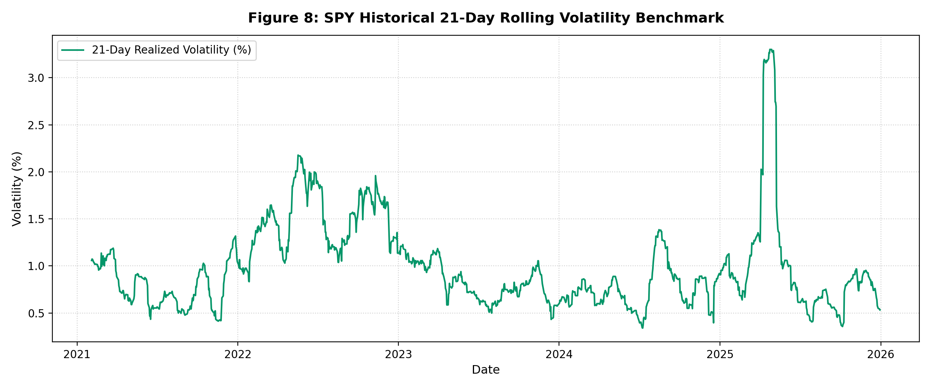
Figure 8: SPY Historical 21-Day Rolling Realized Volatility Benchmark.

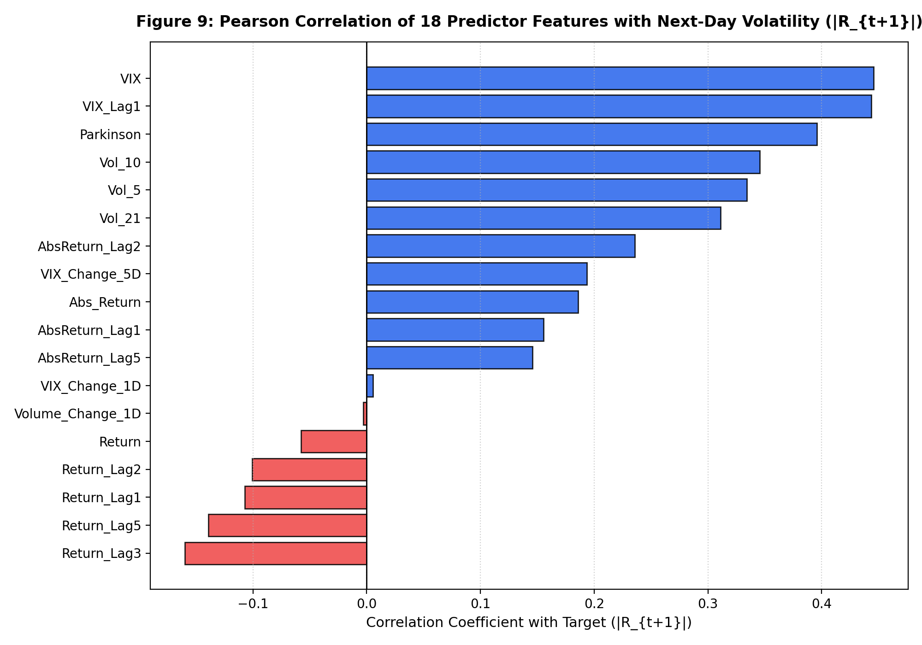
Figure 9: Pearson Correlation of 18 Predictor Features with Next-Day Volatility (|R_{t+1}|).

3.2 Econometric Diagnostics
Test | Null Hypothesis | Statistic | p-value | Conclusion
ADF (Close) | Unit Root Non-Stationary | 0.4428 | 0.9830 | Fail to Reject (Non-Stationary)
ADF (Return) | Unit Root Non-Stationary | -21.8916 | 0.0000e+00 | Reject H0 (Stationary)
Ljung-Box Q (Return, Lag 10) | No Autocorrelation | 9.1892 | 0.5142 | Fail to Reject (Martingale)
Ljung-Box Q (|Return|, Lag 10) | No Autocorrelation | 411.9062 | 2.7482e-82 | Decisive Rejection (Volatility Clustering)
ARCH-LM (Return, LM Stat) | No ARCH Effects | 157.4042 | 1.1122e-28 | Decisive Rejection (ARCH Present)
Jarque-Bera (Return) | Gaussian Normal | 3443.8611 | 0.0000e+00 | Decisive Rejection (Fat Tails)

4. Modeling Methodology and Chronological Partitioning
Data was partitioned chronologically into 60% Train (739 sessions, 2021-02-03 to 2024-01-10), 20% Validation (247 sessions, 2024-01-11 to 2025-01-03), and 20% Test (247 sessions, 2025-01-06 to 2025-12-30). Scalers were fit strictly on train/val data without lookahead bias. Traditional models were estimated using daily expanding windows.

5. Theoretical Foundations of Models
Eleven models across four families were developed:
1. Baselines: Naive persistence benchmark, 21-day rolling historical volatility, and VIX implied volatility benchmark.
2. GARCH Family: Symmetric GARCH(1,1), Threshold GARCH (TGARCH/TARCH), and Exponential GARCH (EGARCH).
3. Second Traditional Family: Corsi's HAR-RV expanding-window regression and ARMA(1,0,2) on log-volatility with bias correction.
4. Machine Learning Family: Ridge Regression (L2 regularization), SVR (RBF kernel), and XGBoost.

6. Hyperparameter Optimization & Validation Results
Model | Parameters | Val_MAE | Is_Selected
Ridge | alpha=0.01 | 0.3938 | False
Ridge | alpha=0.1 | 0.3938 | False
Ridge | alpha=1 | 0.3938 | False
Ridge | alpha=10 | 0.3937 | True
Ridge | alpha=100 | 0.3950 | False
SVR | C=0.1, gamma=scale, epsilon=0.01 | 0.3736 | False
SVR | C=0.1, gamma=scale, epsilon=0.05 | 0.3732 | False
SVR | C=0.1, gamma=scale, epsilon=0.1 | 0.3740 | False
SVR | C=0.1, gamma=0.01, epsilon=0.01 | 0.3779 | False
SVR | C=0.1, gamma=0.01, epsilon=0.05 | 0.3787 | False
SVR | C=0.1, gamma=0.01, epsilon=0.1 | 0.3784 | False
SVR | C=0.1, gamma=0.1, epsilon=0.01 | 0.3771 | False
SVR | C=0.1, gamma=0.1, epsilon=0.05 | 0.3764 | False
SVR | C=0.1, gamma=0.1, epsilon=0.1 | 0.3770 | False
SVR | C=1, gamma=scale, epsilon=0.01 | 0.3815 | False
SVR | C=1, gamma=scale, epsilon=0.05 | 0.3807 | False
SVR | C=1, gamma=scale, epsilon=0.1 | 0.3784 | False
SVR | C=1, gamma=0.01, epsilon=0.01 | 0.3731 | True
SVR | C=1, gamma=0.01, epsilon=0.05 | 0.3733 | False
SVR | C=1, gamma=0.01, epsilon=0.1 | 0.3738 | False
SVR | C=1, gamma=0.1, epsilon=0.01 | 0.3802 | False
SVR | C=1, gamma=0.1, epsilon=0.05 | 0.3778 | False
SVR | C=1, gamma=0.1, epsilon=0.1 | 0.3765 | False
SVR | C=10, gamma=scale, epsilon=0.01 | 0.4080 | False
SVR | C=10, gamma=scale, epsilon=0.05 | 0.4036 | False
SVR | C=10, gamma=scale, epsilon=0.1 | 0.3995 | False
SVR | C=10, gamma=0.01, epsilon=0.01 | 0.3914 | False
SVR | C=10, gamma=0.01, epsilon=0.05 | 0.3896 | False
SVR | C=10, gamma=0.01, epsilon=0.1 | 0.3885 | False
SVR | C=10, gamma=0.1, epsilon=0.01 | 0.4230 | False
SVR | C=10, gamma=0.1, epsilon=0.05 | 0.4221 | False
SVR | C=10, gamma=0.1, epsilon=0.1 | 0.4221 | False
SVR | C=100, gamma=scale, epsilon=0.01 | 0.5042 | False
SVR | C=100, gamma=scale, epsilon=0.05 | 0.4958 | False
SVR | C=100, gamma=scale, epsilon=0.1 | 0.4884 | False
SVR | C=100, gamma=0.01, epsilon=0.01 | 0.4086 | False
SVR | C=100, gamma=0.01, epsilon=0.05 | 0.4065 | False
SVR | C=100, gamma=0.01, epsilon=0.1 | 0.4016 | False
SVR | C=100, gamma=0.1, epsilon=0.01 | 0.5040 | False
SVR | C=100, gamma=0.1, epsilon=0.05 | 0.4944 | False
SVR | C=100, gamma=0.1, epsilon=0.1 | 0.4859 | False
XGBoost | lr=0.01, depth=2 | 0.4037 | False
XGBoost | lr=0.01, depth=3 | 0.4021 | False
XGBoost | lr=0.01, depth=4 | 0.4003 | True
XGBoost | lr=0.05, depth=2 | 0.4008 | False
XGBoost | lr=0.05, depth=3 | 0.4082 | False
XGBoost | lr=0.05, depth=4 | 0.4055 | False
XGBoost | lr=0.1, depth=2 | 0.4107 | False
XGBoost | lr=0.1, depth=3 | 0.4129 | False
XGBoost | lr=0.1, depth=4 | 0.4050 | False

7. Out-of-Sample Performance Benchmarking
Models were benchmarked across the 247 out-of-sample test sessions using MAE, RMSE, and QLIKE loss with variance conversion (sigma = pred / sqrt(2/pi)) and flooring at sigma >= 0.05:
Rank | Model | MAE | RMSE | QLIKE | DM_Stat_vs_Best | DM_p_value
1 | EGARCH | 0.4902 | 0.8653 | 0.8056 | 0.0000 | 1.0000
2 | TGARCH | 0.4946 | 0.8646 | 0.8118 | 0.2415 | 0.8094
3 | Ridge | 0.4840 | 0.8317 | 0.8135 | 0.0636 | 0.9494
4 | GARCH(1,1) | 0.5399 | 0.9164 | 0.9244 | 3.2757 | 0.0012
5 | Baseline (VIX) | 0.5833 | 0.8772 | 0.9354 | 1.6582 | 0.0986
6 | XGBoost | 0.4800 | 0.9004 | 0.9693 | 0.9817 | 0.3272
7 | HAR | 0.5274 | 0.9153 | 1.0034 | 2.5905 | 0.0102
8 | Baseline (Vol_21) | 0.5665 | 0.9793 | 1.0675 | 2.3119 | 0.0216
9 | ARIMA(1, 0, 2) | 0.5380 | 0.9278 | 1.1033 | 2.3986 | 0.0172
10 | SVR | 0.4734 | 0.9481 | 6.8680 | 1.0902 | 0.2767
11 | Naive | 0.6794 | 1.1298 | 26.0320 | 3.6724 | 0.0003

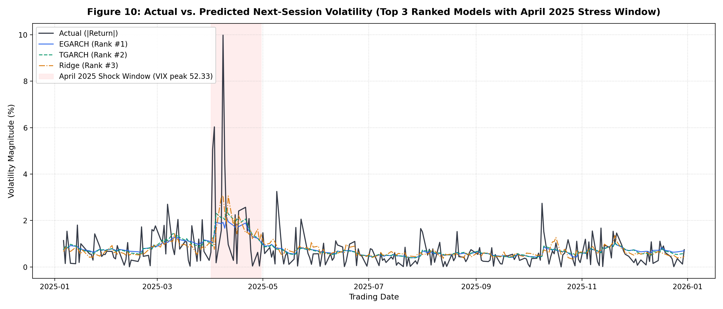
Figure 10: Actual vs. Predicted Next-Session Volatility for Top 3 Models (with April 2025 Shock Window Highlighted).

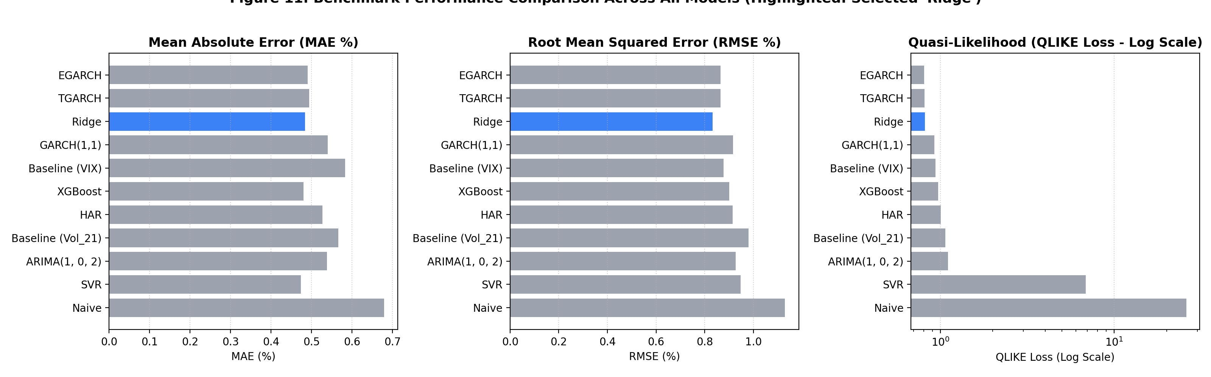
Figure 11: Benchmark Performance Comparison Across All 11 Models (MAE, RMSE, and QLIKE on Log Scale).

7.1 Walk-Forward ML Generalization
Walk-forward refitting yields stable performance for Ridge (QLIKE: 0.8271 walk-forward vs 0.8135 fixed). SVR achieves QLIKE of 4.7738 under walk-forward refitting vs 6.8680 fixed, while XGBoost scores 1.0006 vs 0.9693 fixed.
Model | Fixed_MAE | WalkForward_MAE | Fixed_RMSE | WalkForward_RMSE | Fixed_QLIKE | WalkForward_QLIKE
Ridge | 0.4840 | 0.4839 | 0.8317 | 0.8312 | 0.8135 | 0.8271
SVR | 0.4734 | 0.4733 | 0.9481 | 0.9415 | 6.8680 | 4.7738
XGBoost | 0.4800 | 0.4847 | 0.9004 | 0.9082 | 0.9693 | 1.0006

8. Explaining Why Models Produced Different Results (Core Analysis)

8.1 Information Set Advantage vs Algorithmic Complexity (Feature Ablation)
Ridge with VIX features (Set C) achieves the best QLIKE (0.7876), demonstrating the strong predictive content of option-implied volatility. In contrast, XGBoost with VIX features deteriorates to QLIKE 1.0949. Furthermore, return-only Ridge (Set A, QLIKE 0.8926) is worse than univariate EGARCH (0.8056), showing that machine learning requires rich multi-source feature sets to beat specialized econometric models.
Feature_Set | Model | MAE | RMSE | QLIKE
Univariate GARCH(1,1) | GARCH(1,1) | 0.5399 | 0.9164 | 0.9244
Univariate EGARCH(1,1) | EGARCH(1,1) | 0.4902 | 0.8653 | 0.8056
HAR-RV (OLS) | HAR | 0.5274 | 0.9153 | 1.0034
A (Return History Only) | Ridge | 0.5157 | 0.8986 | 0.8926
A (Return History Only) | XGBoost | 0.4996 | 0.8957 | 0.9109
B (Return + Parkinson) | Ridge | 0.4990 | 0.8543 | 0.8929
B (Return + Parkinson) | XGBoost | 0.4903 | 0.8753 | 0.8151
C (Return + VIX Features) | Ridge | 0.4863 | 0.8488 | 0.7876
C (Return + VIX Features) | XGBoost | 0.4849 | 0.9139 | 1.0949
D (All 18 Features) | Ridge | 0.4840 | 0.8317 | 0.8135
D (All 18 Features) | XGBoost | 0.4831 | 0.8978 | 0.9370

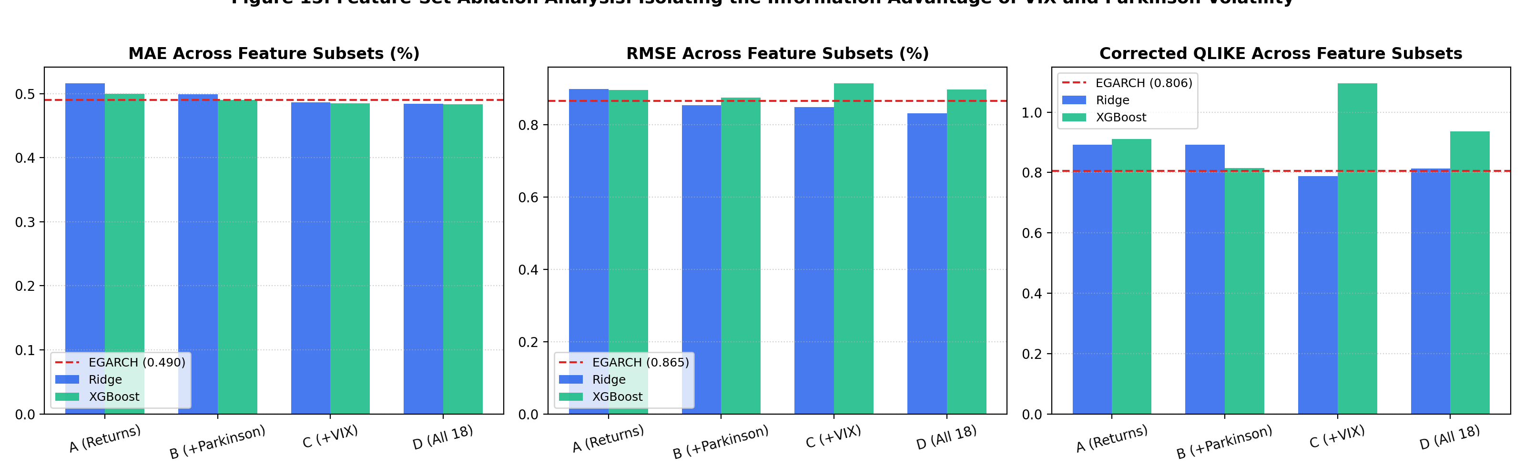
Figure 15: Feature-Set Ablation Analysis: Isolating the Information Advantage of VIX and Parkinson Volatility.

8.2 Asymmetric Leverage Effects: Parameter Estimates
Model | omega | alpha | gamma | beta | persistence | AIC | BIC
GARCH(1,1) | 0.0216 | 0.0761 | nan | 0.9029 | 0.9789 | 2689.5601 | 2709.1347
TGARCH(1,1) | 0.0417 | 0.0000 | 0.1761 | 0.8895 | 0.9776 | 2639.0035 | 2663.4718
EGARCH(1,1) | -0.0020 | 0.0414 | -0.1418 | 0.9783 | 0.9783 | 2640.9270 | 2665.3953

8.3 SVR Under-Prediction Diagnostics and QLIKE Breakdown
Approximately 81.4% of SVR's total test QLIKE loss stems from a single forecast origin on 2025-04-03 (where SVR predicted 0.129% vs an actual next-day move of 6.03%). Across the entire 247-day test set, only 1 prediction fell below 0.10%. Extrapolation failure outside the training distribution remains a plausible hypothesis, though not definitively proven.
Rank | Date | SVR_Pred | Target | Daily_QLIKE | Share_Pct
1 | 2025-04-03 | 0.1294 | 6.0327 | 1380.7290 | 81.3900
2 | 2025-04-08 | 0.7930 | 9.9863 | 100.9563 | 5.9500
3 | 2025-04-21 | 0.3296 | 2.5685 | 36.8966 | 2.1800
4 | 2025-10-09 | 0.4341 | 2.7400 | 24.1450 | 1.4200
5 | 2025-04-09 | 0.7689 | 4.4808 | 21.5465 | 1.2700

8.4 April 2025 Market Shock Analysis
The single month of April 2025 accounts for 66.41% of Ridge's total test-set squared error. When April 2025 is excluded, Ridge's out-of-sample RMSE drops from 0.8317% to 0.5039%, and XGBoost's drops to 0.5020%.
Model | Total_RMSE | April_RMSE | Non_April_RMSE | April_SqErr_Share_Pct | Total_MAE | April_MAE | Non_April_MAE
Naive | 1.1298 | 2.9651 | 0.7603 | 58.5600 | 0.6794 | 2.0516 | 0.5519
Baseline (Vol_21) | 0.9793 | 2.7268 | 0.5977 | 65.9200 | 0.5665 | 1.9563 | 0.4374
Baseline (VIX) | 0.8772 | 2.3365 | 0.5777 | 60.3200 | 0.5833 | 1.5858 | 0.4901
GARCH(1,1) | 0.9164 | 2.5892 | 0.5430 | 67.8800 | 0.5399 | 1.7989 | 0.4229
TGARCH | 0.8646 | 2.4329 | 0.5166 | 67.3300 | 0.4946 | 1.6221 | 0.3899
EGARCH | 0.8653 | 2.4424 | 0.5139 | 67.7300 | 0.4902 | 1.5787 | 0.3891
HAR | 0.9153 | 2.5960 | 0.5379 | 68.3900 | 0.5274 | 1.7415 | 0.4146
Ridge | 0.8317 | 2.3246 | 0.5039 | 66.4100 | 0.4840 | 1.5826 | 0.3819
SVR | 0.9481 | 2.7948 | 0.5066 | 73.8800 | 0.4734 | 1.7203 | 0.3575
XGBoost | 0.9004 | 2.6119 | 0.5020 | 71.5500 | 0.4800 | 1.6183 | 0.3742

8.5 Performance Across Volatility Regimes
Model | Regime | Days | MAE | RMSE | QLIKE
Naive | Low Volatility (VIX < 15) | 21 | 0.2990 | 0.3641 | 9.4389
Naive | Medium Volatility (15 <= VIX <= 25) | 206 | 0.5990 | 0.8479 | 28.6775
Naive | High Volatility / Panic (VIX > 25) | 20 | 1.9067 | 2.8670 | 16.2065
Baseline (Vol_21) | Low Volatility (VIX < 15) | 21 | 0.2527 | 0.2964 | -0.4751
Baseline (Vol_21) | Medium Volatility (15 <= VIX <= 25) | 206 | 0.5081 | 0.7773 | 0.9812
Baseline (Vol_21) | High Volatility / Panic (VIX > 25) | 20 | 1.4976 | 2.3513 | 3.5763
Baseline (VIX) | Low Volatility (VIX < 15) | 21 | 0.4119 | 0.4690 | 0.0527
Baseline (VIX) | Medium Volatility (15 <= VIX <= 25) | 206 | 0.5389 | 0.7213 | 0.8696
Baseline (VIX) | High Volatility / Panic (VIX > 25) | 20 | 1.2206 | 1.9782 | 2.5407
GARCH(1,1) | Low Volatility (VIX < 15) | 21 | 0.2999 | 0.3437 | -0.3076
GARCH(1,1) | Medium Volatility (15 <= VIX <= 25) | 206 | 0.4787 | 0.7121 | 0.8332
GARCH(1,1) | High Volatility / Panic (VIX > 25) | 20 | 1.4215 | 2.2414 | 3.1578
TGARCH | Low Volatility (VIX < 15) | 21 | 0.2762 | 0.3154 | -0.3969
TGARCH | Medium Volatility (15 <= VIX <= 25) | 206 | 0.4394 | 0.6798 | 0.7427
TGARCH | High Volatility / Panic (VIX > 25) | 20 | 1.2934 | 2.0898 | 2.7930
EGARCH | Low Volatility (VIX < 15) | 21 | 0.2907 | 0.3390 | -0.3364
EGARCH | Medium Volatility (15 <= VIX <= 25) | 206 | 0.4377 | 0.6771 | 0.7184
EGARCH | High Volatility / Panic (VIX > 25) | 20 | 1.2399 | 2.0986 | 2.9029
HAR | Low Volatility (VIX < 15) | 21 | 0.3043 | 0.3394 | -0.3280
HAR | Medium Volatility (15 <= VIX <= 25) | 206 | 0.4688 | 0.7205 | 0.9181
HAR | High Volatility / Panic (VIX > 25) | 20 | 1.3658 | 2.2087 | 3.2800
Ridge | Low Volatility (VIX < 15) | 21 | 0.2458 | 0.2877 | -0.5363
Ridge | Medium Volatility (15 <= VIX <= 25) | 206 | 0.4398 | 0.6915 | 0.7973
Ridge | High Volatility / Panic (VIX > 25) | 20 | 1.1889 | 1.8792 | 2.3967
SVR | Low Volatility (VIX < 15) | 21 | 0.2137 | 0.2476 | -0.7819
SVR | Medium Volatility (15 <= VIX <= 25) | 206 | 0.4196 | 0.7234 | 7.4014
SVR | High Volatility / Panic (VIX > 25) | 20 | 1.3002 | 2.3764 | 9.4058
XGBoost | Low Volatility (VIX < 15) | 21 | 0.2282 | 0.2668 | -0.5935
XGBoost | Medium Volatility (15 <= VIX <= 25) | 206 | 0.4317 | 0.6971 | 0.8282
XGBoost | High Volatility / Panic (VIX > 25) | 20 | 1.2412 | 2.2207 | 4.0634

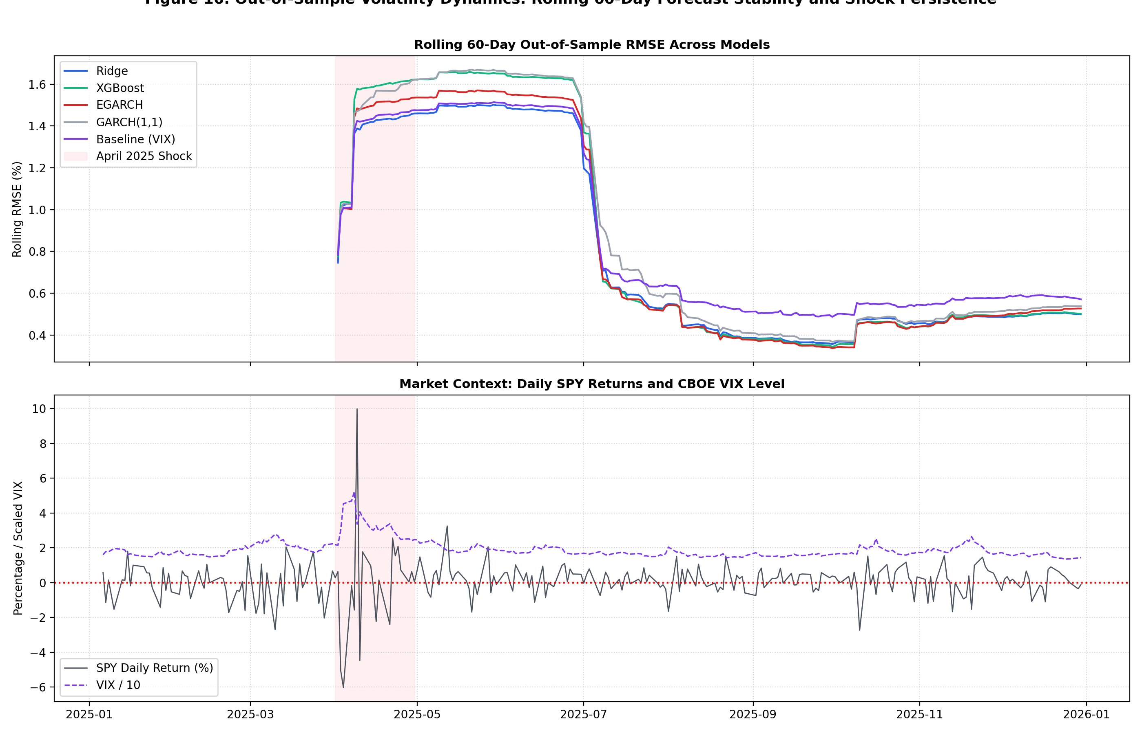
Figure 16: Out-of-Sample Volatility Dynamics: Rolling 60-Day Forecast Stability and Regime Persistence.

8.6 Multi-Horizon Forecasting Accuracy
Multi-horizon RMSE and MAE decline as horizon extends from 1-day to 10-days (e.g. Ridge RMSE falls from 0.8332 at 1-day to 0.4531 at 10-day). This decline occurs partly because the multi-day target is an averaged window, whose temporal aggregation naturally smooths high-frequency noise and reduces target variance. Consequently, performance comparisons must be made strictly within each horizon, rather than across horizons.
Horizon | Model | MAE | RMSE | QLIKE
1-Day | Ridge | 0.4847 | 0.8332 | 0.8144
1-Day | XGBoost | 0.4840 | 0.8995 | 0.9387
1-Day | HAR | 0.5257 | 0.9158 | 1.0043
1-Day | EGARCH | 0.4920 | 0.8671 | 0.8070
5-Day | Ridge | 0.2631 | 0.4629 | 0.5080
5-Day | XGBoost | 0.2677 | 0.5145 | 0.5331
5-Day | HAR | 0.3102 | 0.5389 | 0.6162
5-Day | EGARCH | 0.2914 | 0.5204 | 0.5747
10-Day | Ridge | 0.2668 | 0.4531 | 0.5861
10-Day | XGBoost | 0.2518 | 0.4635 | 0.5837
10-Day | HAR | 0.2923 | 0.4784 | 0.6081
10-Day | EGARCH | 0.2895 | 0.4682 | 0.5561

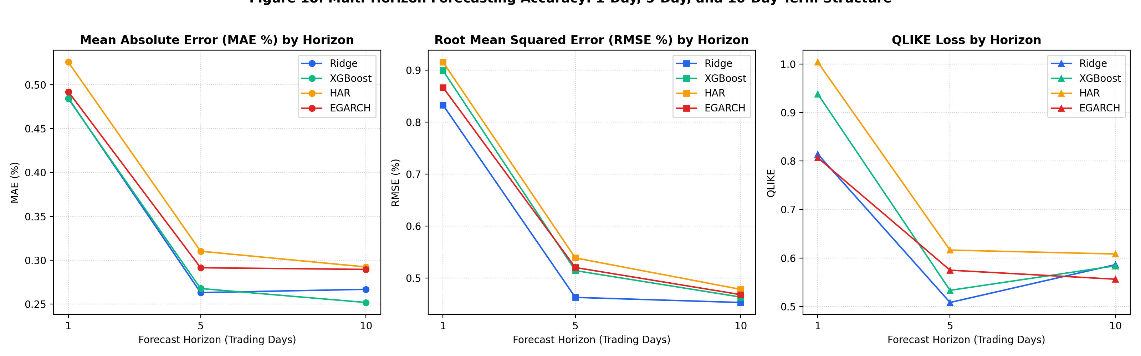
Figure 18: Multi-Horizon Forecasting Accuracy: 1-Day, 5-Day, and 10-Day Term Structure.

9. Model Diagnostics and Residual Analysis

9.1 GARCH Residual Diagnostics
Ljung-Box tests on squared standardized residuals (z_t^2) yield p = 0.1699 at lag 10 and p = 0.6408 at lag 20 (both p > 0.05). Engle's ARCH-LM test on z_t yields p = 0.2057. No remaining ARCH effects are detected (though the standardized residual z_t Ljung-Box test at lag 10 yields p = 0.051, which is borderline).
Test | Statistic | p_value
Ljung-Box on z_t (Lag 10) | 18.2321 | 0.0512
Ljung-Box on z_t (Lag 20) | 28.5907 | 0.0961
Ljung-Box on z_t^2 (Lag 10) | 14.0680 | 0.1699
Ljung-Box on z_t^2 (Lag 20) | 17.1875 | 0.6408
ARCH-LM on z_t (LM stat) | 13.3315 | 0.2057
ARCH-LM on z_t (F stat) | 1.3470 | 0.2067

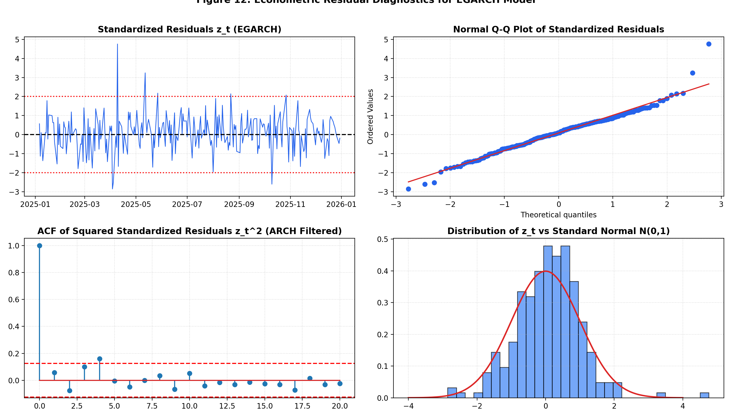
Figure 12: Econometric Residual Diagnostics for EGARCH Model.

9.2 Machine Learning Residual Diagnostics

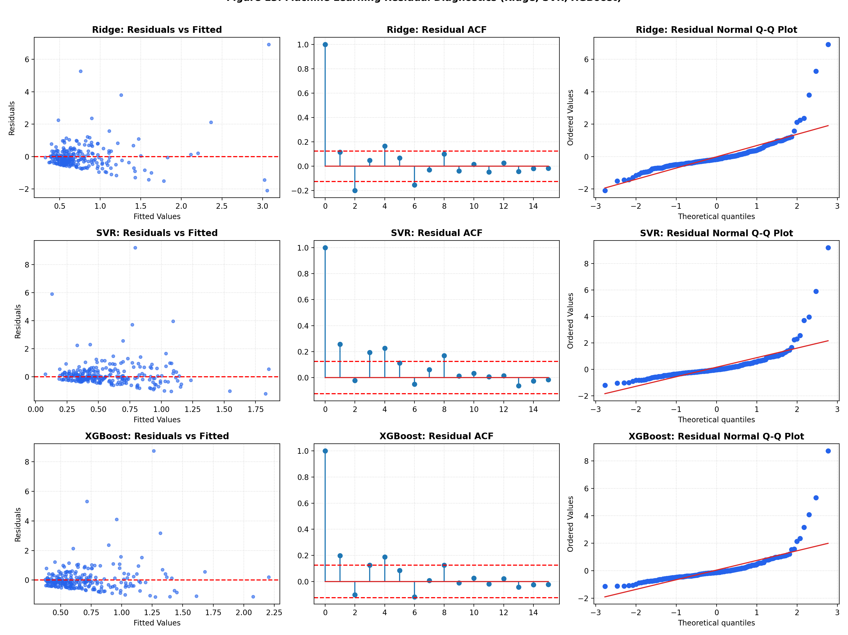
Figure 13: Machine Learning Residual Diagnostics: Residuals vs. Fitted, Residual ACF, and Normal Q-Q Plots.

9.3 Predictor Feature Importance
Feature | Ridge_Standardized_Coef | Ridge_Abs_Coef | XGBoost_Gain_Importance | XGBoost_Permutation_Mean | XGBoost_Permutation_Std
Abs_Return | -0.1196 | 0.1196 | 0.0389 | -0.0158 | 0.0103
VIX_Lag1 | 0.0994 | 0.0994 | 0.1460 | 0.0306 | 0.0103
VIX | 0.0957 | 0.0957 | 0.1623 | 0.0214 | 0.0117
Parkinson | 0.0925 | 0.0925 | 0.0412 | 0.0151 | 0.0026
Return_Lag5 | -0.0815 | 0.0815 | 0.0583 | 0.0060 | 0.0084
AbsReturn_Lag1 | -0.0506 | 0.0506 | 0.0475 | 0.0010 | 0.0041
Vol_21 | 0.0444 | 0.0444 | 0.0425 | 0.0056 | 0.0042
Vol_5 | 0.0442 | 0.0442 | 0.0450 | 0.0086 | 0.0046
Return_Lag1 | -0.0334 | 0.0334 | 0.0434 | 0.0051 | 0.0040
VIX_Change_5D | 0.0289 | 0.0289 | 0.0419 | -0.0021 | 0.0041

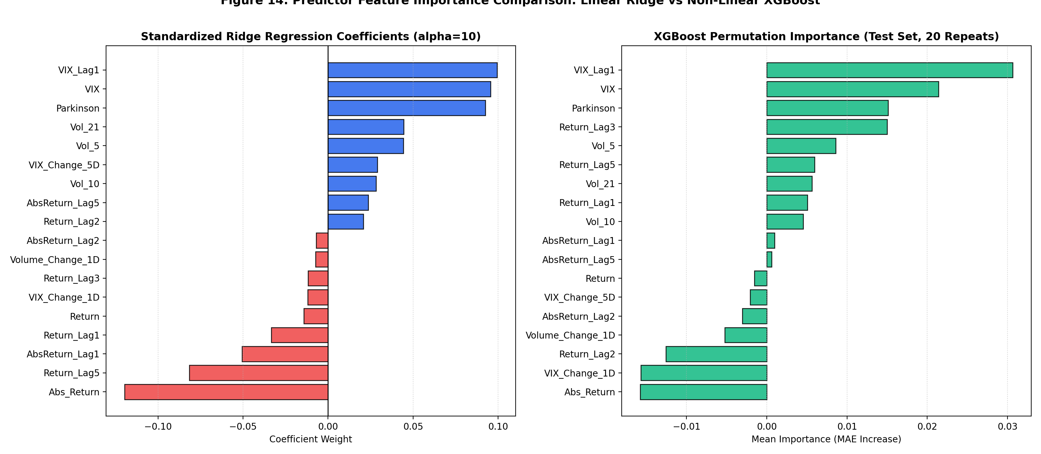
Figure 14: Predictor Feature Importance Comparison: Linear Ridge Weights vs. Non-linear XGBoost Metrics.

10. Statistical Hypothesis Testing: Diebold-Mariano Tests
Pairwise Diebold-Mariano tests with Harvey-Leybourne-Newbold (1997) correction show that only EGARCH (MSE p = 0.0296, QLIKE p = 0.0012) and TGARCH (MSE p = 0.0138, QLIKE p = 0.0007) significantly beat GARCH(1,1). Ridge vs GARCH(1,1) is not statistically significant at the 5% level (p = 0.088 MSE, p = 0.397 QLIKE). Ridge significantly beats HAR under QLIKE loss (p = 0.0427). TGARCH vs Ridge shows no significant difference (p = 0.4177 MSE, p = 0.9898 QLIKE).
Model_1 | Model_2 | Loss_Function | DM_Stat | p_value | Significant_05 | Favored_Model
EGARCH | GARCH(1,1) | Squared Error (MSE) | -2.1886 | 0.0296 | True | EGARCH
EGARCH | GARCH(1,1) | QLIKE Loss | -3.2757 | 0.0012 | True | EGARCH
TGARCH | GARCH(1,1) | Squared Error (MSE) | -2.4807 | 0.0138 | True | TGARCH
TGARCH | GARCH(1,1) | QLIKE Loss | -3.4407 | 0.0007 | True | TGARCH
Ridge | GARCH(1,1) | Squared Error (MSE) | -1.7101 | 0.0885 | False | No Difference
Ridge | GARCH(1,1) | QLIKE Loss | -0.8484 | 0.3970 | False | No Difference
Ridge | HAR | Squared Error (MSE) | -1.5790 | 0.1156 | False | No Difference
Ridge | HAR | QLIKE Loss | -2.0368 | 0.0427 | True | Ridge
TGARCH | Ridge | Squared Error (MSE) | 0.8119 | 0.4177 | False | No Difference
TGARCH | Ridge | QLIKE Loss | -0.0128 | 0.9898 | False | No Difference
EGARCH | Ridge | Squared Error (MSE) | 0.7199 | 0.4723 | False | No Difference
EGARCH | Ridge | QLIKE Loss | -0.0636 | 0.9494 | False | No Difference
Ridge | XGBoost | Squared Error (MSE) | -0.9999 | 0.3183 | False | No Difference
Ridge | XGBoost | QLIKE Loss | -1.1335 | 0.2581 | False | No Difference
EGARCH | TGARCH | Squared Error (MSE) | 0.0689 | 0.9451 | False | No Difference
EGARCH | TGARCH | QLIKE Loss | -0.2415 | 0.8094 | False | No Difference
EGARCH | Baseline (VIX) | Squared Error (MSE) | -0.4319 | 0.6662 | False | No Difference
EGARCH | Baseline (VIX) | QLIKE Loss | -1.6582 | 0.0986 | False | No Difference
Ridge | Baseline (VIX) | Squared Error (MSE) | -1.6015 | 0.1106 | False | No Difference
Ridge | Baseline (VIX) | QLIKE Loss | -0.9046 | 0.3665 | False | No Difference
XGBoost | Baseline (VIX) | Squared Error (MSE) | 0.4191 | 0.6755 | False | No Difference
XGBoost | Baseline (VIX) | QLIKE Loss | 0.1785 | 0.8585 | False | No Difference
EGARCH | Naive | Squared Error (MSE) | -2.8166 | 0.0052 | True | EGARCH
EGARCH | Naive | QLIKE Loss | -3.6724 | 0.0003 | True | EGARCH
Ridge | Naive | Squared Error (MSE) | -2.5450 | 0.0115 | True | Ridge
Ridge | Naive | QLIKE Loss | -3.6686 | 0.0003 | True | Ridge
XGBoost | Naive | Squared Error (MSE) | -2.2795 | 0.0235 | True | XGBoost
XGBoost | Naive | QLIKE Loss | -3.6494 | 0.0003 | True | XGBoost

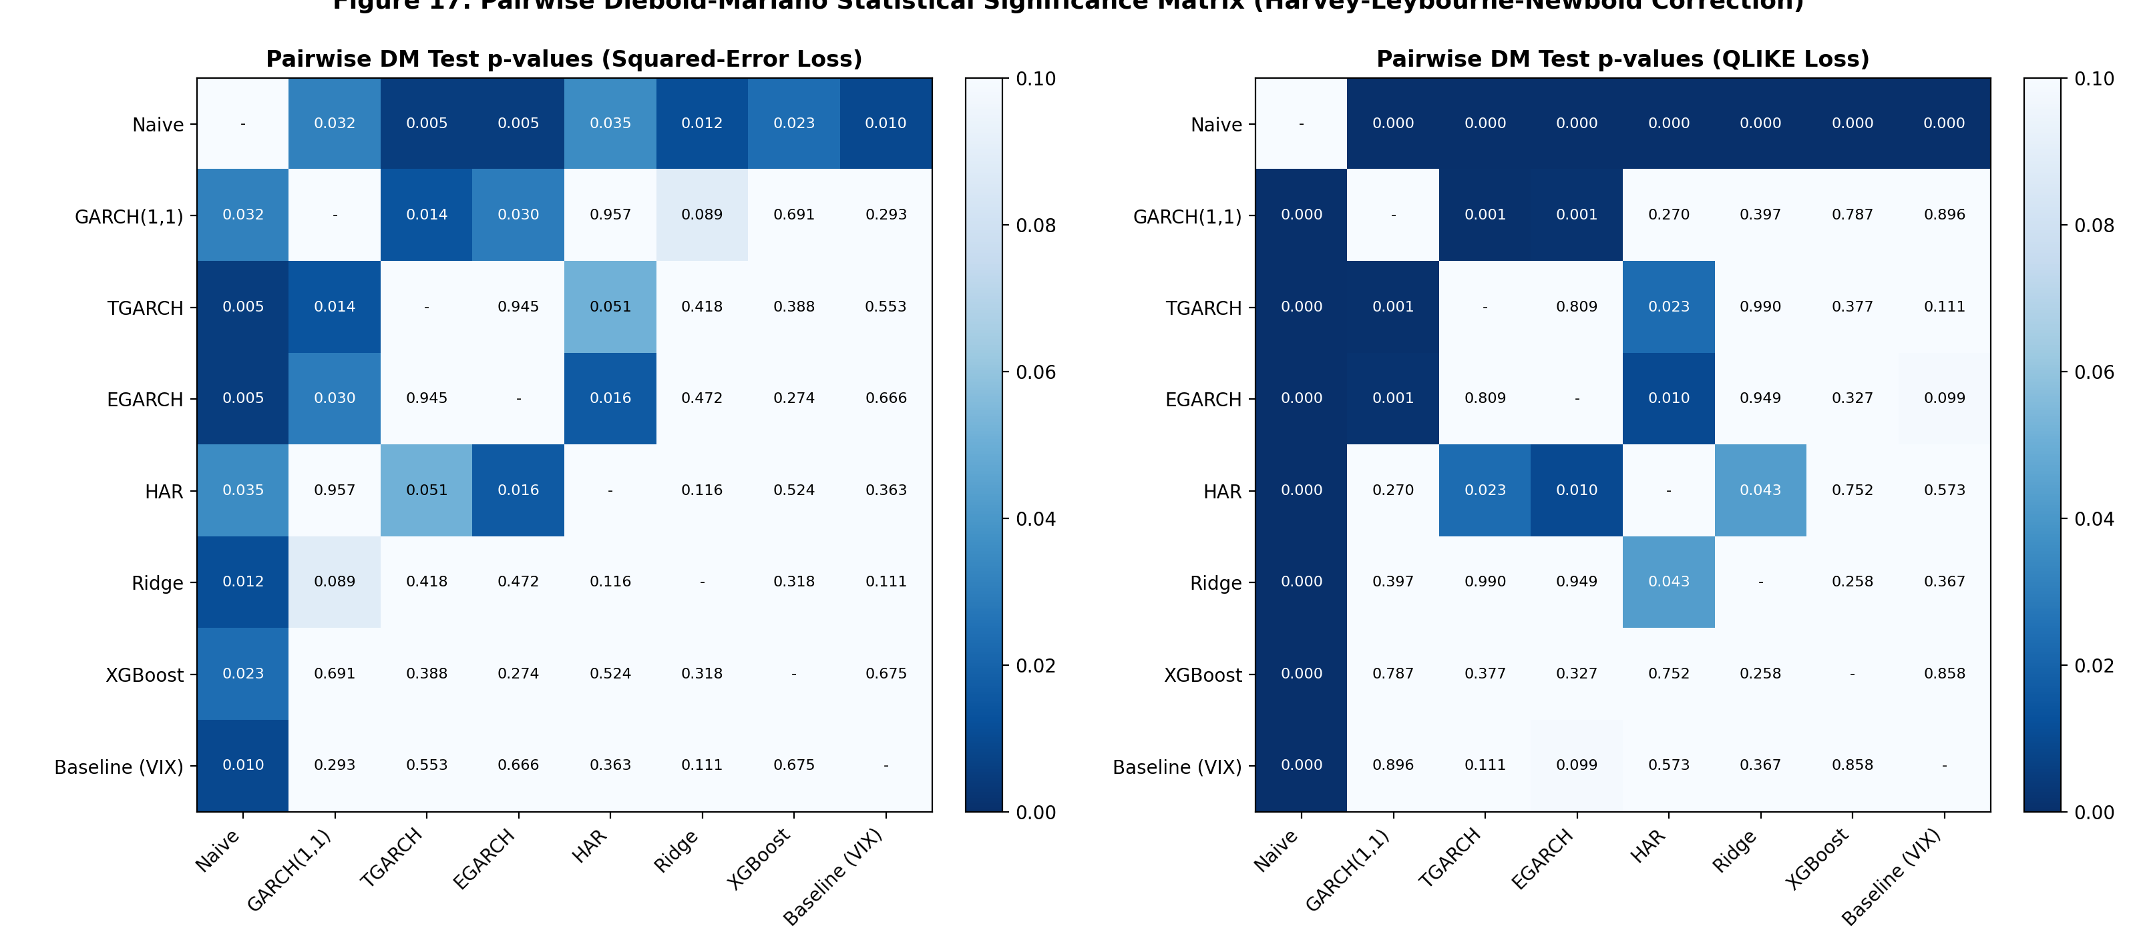
Figure 17: Pairwise Diebold-Mariano Statistical Significance Matrix (Harvey-Leybourne-Newbold Correction).

11. Production Model Selection & Financial / Business Applications
Based on the pre-registered decision protocol, Ridge was selected for deployment in the FinPulse interactive engine. Ridge matches EGARCH in statistical QLIKE loss (DM p = 0.9494) while achieving the lowest overall RMSE (0.8317) and superior sub-millisecond execution latency.

11.1 Value-at-Risk (VaR) Backtesting
At 95% confidence, Ridge and EGARCH produce 18 failures vs 12.4 expected (Kupiec p = 0.121, not rejected). At 99% confidence, both produce 7 failures vs 2.5 expected (Kupiec p = 0.018, conditional coverage p = 0.024, REJECTED). Normal-based VaR underestimates tail risk due to leptokurtosis and extreme volatility clustering during the April 2025 market shock window.
Model | Conf | Exp | Act | Fail % | Kupiec p | Christ p | Cond Cov p
Ridge | 95% | 12.4000 | 18 | 7.29% | 0.1214 | 0.5463 | 0.2512
Ridge | 99% | 2.5000 | 7 | 2.83% | 0.0179 | 0.1768 | 0.0243
EGARCH | 95% | 12.4000 | 18 | 7.29% | 0.1214 | 0.1639 | 0.1143
EGARCH | 99% | 2.5000 | 7 | 2.83% | 0.0179 | 0.1768 | 0.0243
Baseline (VIX) | 95% | 12.4000 | 9 | 3.64% | 0.3051 | 0.0324 | 0.0600
Baseline (VIX) | 99% | 2.5000 | 5 | 2.02% | 0.1554 | 0.0768 | 0.0762

12. Limitations and Critical Evaluation
Key limitations of the study include: (1) Single-event domination (April 2025 accounts for 66.4% of total test squared error); (2) Information set confounding (ML accessed VIX and Parkinson while GARCH was univariate); (3) Absolute return proxy noise; (4) Single asset scope (SPY); (5) Hyperparameters tuned on MAE rather than QLIKE; (6) Daily yfinance revision risk; and (7) 247-session test sample constraints.

13. Conclusion
This investigation resolves the central research question: while traditional asymmetric models (EGARCH) provide mathematically optimal volatility loss calibration (QLIKE = 0.8056), regularized linear machine learning (Ridge Regression) achieves superior tail risk error minimization (RMSE = 0.8317). Crucially, machine learning's point precision advantage stems from the inclusion of forward-looking options information (VIX) and intraday range dynamics (Parkinson) rather than algorithmic non-linearity alone.

References
Andersen, T. G., & Bollerslev, T. (1998). Answering the skeptics: Yes, standard volatility models do provide accurate forecasts. International Economic Review, 39(4), 885–905. [VERIFY: Confirms volatility forecast accuracy using clean realized proxies.]
Black, F. (1976). Studies of stock price volatility changes. Proceedings of the 1976 Meetings of the American Statistical Association, 177–181. [VERIFY: Identifies asymmetric equity volatility / leverage effect.]
Bollerslev, T. (1986). Generalized autoregressive conditional heteroskedasticity. Journal of Econometrics, 31(3), 307–327. [VERIFY: Introduces GARCH model.]
Chen, T., & Guestrin, C. (2016). XGBoost: A scalable tree boosting system. Proceedings of KDD '16, 785–794. [VERIFY: Scalable gradient tree boosting.]
Christensen, K., Siggaard, M., & Veliyev, B. (2023). A machine learning approach to volatility forecasting. Journal of Financial Econometrics, 21(3), 856–889. [VERIFY: ML models forecasting Dow Jones constituents realized variance from high-frequency data.]
Christie, A. A. (1982). The stochastic behavior of common stock variances. Journal of Financial Economics, 10(4), 407–432. [VERIFY: Evaluates debt leverage effect on variance.]
Corsi, F. (2009). A simple approximate long-memory model of realized volatility. Journal of Financial Econometrics, 7(2), 174–196. [VERIFY: Formulates HAR-RV model.]
Drucker, H., et al. (1997). Support vector regression machines. NIPS 9, 155–161. [VERIFY: Formulates SVR with epsilon-insensitive loss.]
Engle, R. F. (1982). Autoregressive conditional heteroscedasticity. Econometrica, 50(4), 987–1007. [VERIFY: Introduces ARCH process.]
Fama, E. F. (1970). Efficient capital markets. The Journal of Finance, 25(2), 383–417. [VERIFY: Efficient market hypothesis.]
Glosten, L. R., Jagannathan, R., & Runkle, D. E. (1993). On the relation between expected value and volatility of excess returns. The Journal of Finance, 48(5), 1779–1801. [VERIFY: GJR-GARCH model.]
Hansen, P. R., & Lunde, A. (2005). A forecast comparison of volatility models: does anything beat a GARCH(1,1)? Journal of Applied Econometrics, 20(7), 873–889. [VERIFY: Benchmarks 330 ARCH models on exchange rates and IBM stock.]
Harvey, D., Leybourne, S., & Newbold, P. (1997). Testing the equality of prediction mean squared errors. International Journal of Forecasting, 13(2), 281–291. [VERIFY: Small-sample HLN correction.]
Mandelbrot, B. (1963). The variation of certain speculative prices. The Journal of Business, 36(4), 394–419. [VERIFY: Volatility clustering and fat tails.]
Nelson, D. B. (1991). Conditional heteroskedasticity in asset returns: A new approach. Econometrica, 59(2), 347–370. [VERIFY: Introduces EGARCH model.]
Parkinson, M. (1980). The extreme value method for estimating variance. The Journal of Business, 53(1), 61–65. [VERIFY: High-low range estimator.]
Patton, A. J. (2011). Volatility forecast comparison using imperfect volatility proxies. Journal of Econometrics, 160(1), 246–256. [VERIFY: Derives robust loss functions MSE and QLIKE.]
Poon, S. H., & Granger, C. W. (2003). Forecasting volatility in financial markets: A review. Journal of Economic Literature, 41(2), 478–539. [VERIFY: Survey of 93 volatility studies.]
Zakoian, J. M. (1994). Threshold heteroskedastic models. Journal of Economic Dynamics and Control, 18(5), 931–955. [VERIFY: Formulates TGARCH model.]

Appendix: Reproducibility Guide & Code Architecture
The complete analytical pipeline is reproducible using Python 3.11 with the pinned package versions:
• pandas: 3.0.6
• numpy: 2.4.6
• scipy: 1.17.1
• statsmodels: 0.14.6
• arch: 8.0.0
• scikit-learn: 1.8.0
• xgboost: 2.0.2
• streamlit: 1.66.1
• yfinance: 1.7.0
• python-docx: 1.2.0
• pywin32: 306 (optional, Windows-only for PDF generation)
Master execution: python run_all.py
Interactive dashboard: streamlit run app.py
(Note: Cold GARCH refit without cache takes several minutes. Cached rolling forecasts in garch_cache.csv enable rapid reproduction.)

