Laboratory

Đoàn Quang Minh – DE170407

Implementation RNN and LSTM on forecasting 1, 3, 5 days. Using Hanoi and Hungyen data.

1. **Training configuration**

Window size is equivalent to half of test size.

Batch size is 64. Training in 100 epochs with early stopping.

Model layers:

* RNN or LSTM. Units 64, activation ReLU.
* RNN or LSTM. Units 32, activation ReLU.
* Flatten
* Linear. Units 128, activation ReLU.
* Linear. Units 1.

1. **Hanoi**
2. Data summary

Hanoi contains 29,224 points. The amount of testing data around 1 year, approximately 2,920 (8 for a day). The Window size is 1,460.

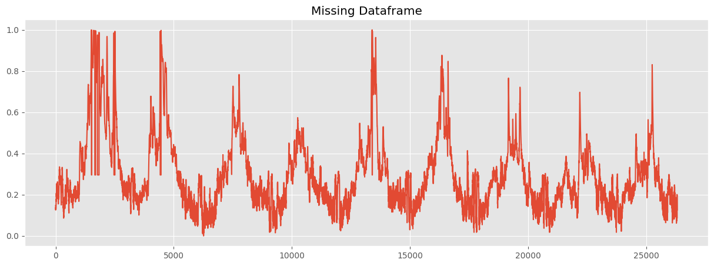

1. Training and Evaluation

The overall similarity was around **99.36%** on RNN, and **99.19%** on LSTM. Training time was 3 hours.

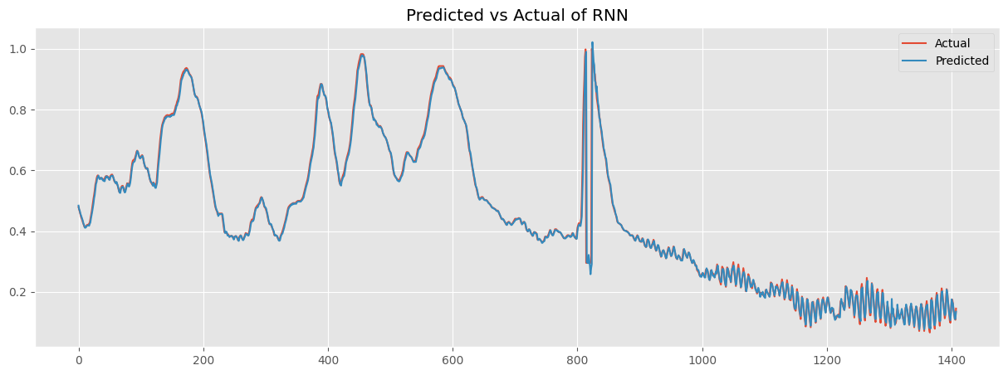

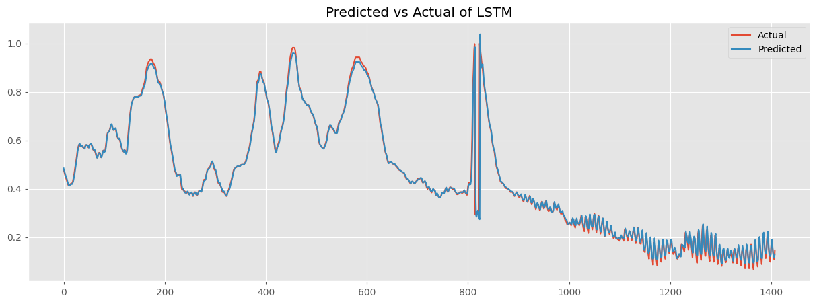

1. Forecasting

* 1 day (8 points)

* 3 days (24 points)

* 5 days (40 points)

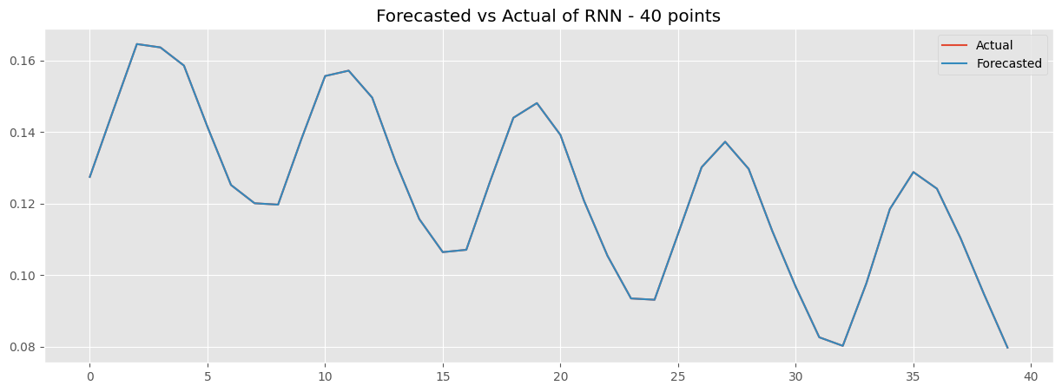

1. **Hungyen**
2. Data summary

Hungyen contains 64,061 points. The amount of testing data around 6 months, approximately 4,320 (24 for a day). The window size is 2,160.

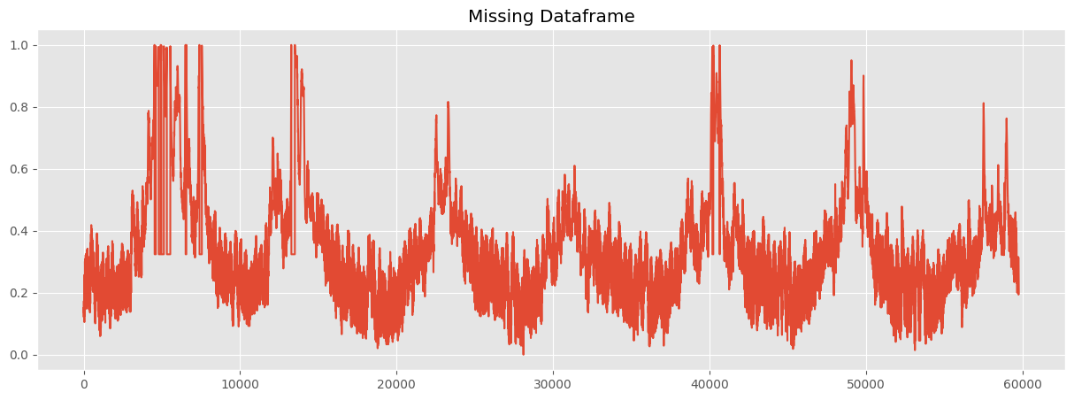

1. Training and Evaluation

The overall similarity was around **99.62%** for RNN, and **99.58%** for LSTM. Training time was 6 hours and 47 minutes.

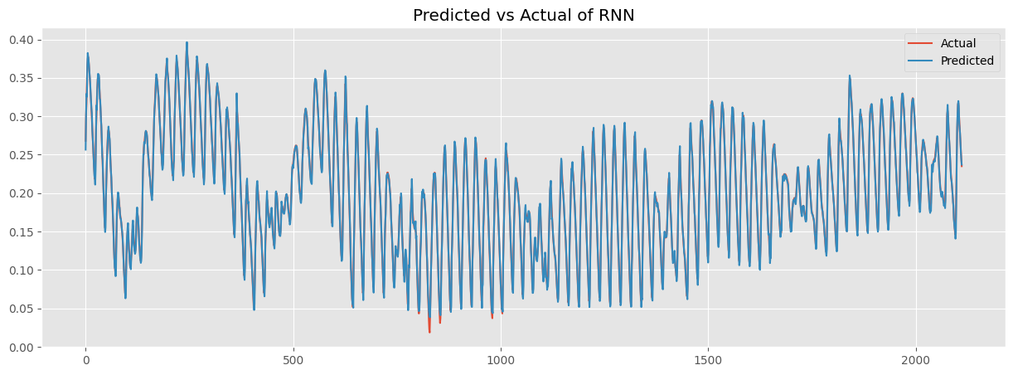

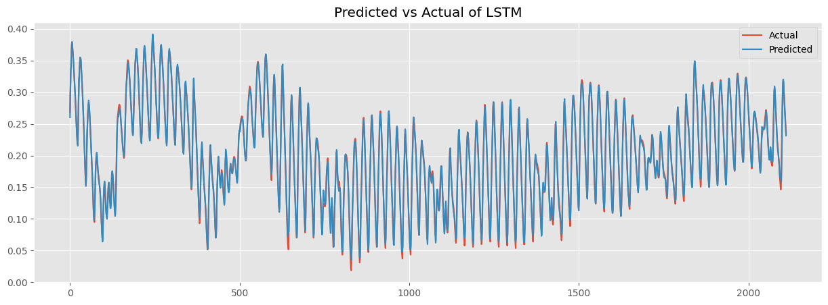

1. Forecasting

* 1 day (24 points)

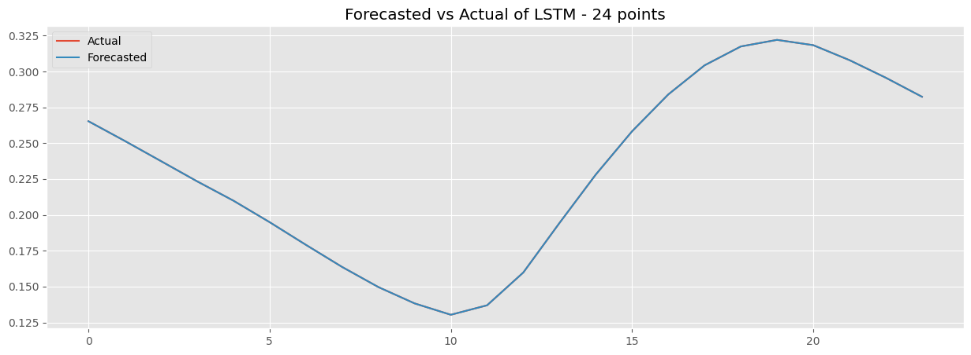

* 3 days (72 points)

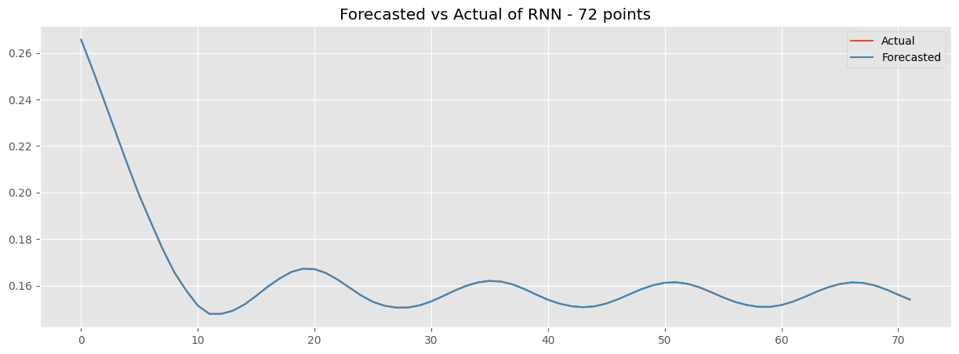

* 5 days (120 points)

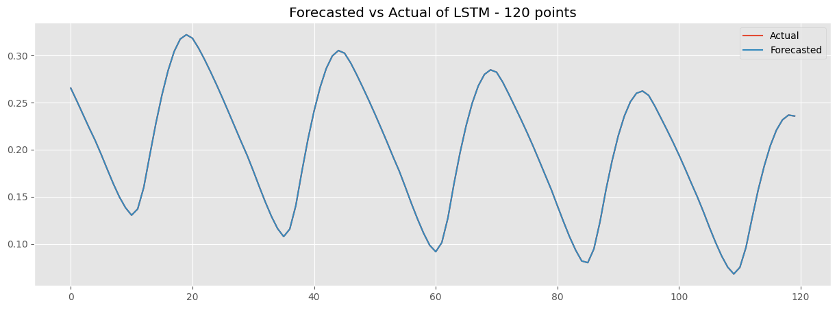

1. **Conclusion**

The RNN shows slightly better similarity between both data than LSTM. However, the forecasting trend was a significant difference.

In the forecasting of Hanoi, the RNN shows the downward trend while the LSTM witness the opposite trend.

In terms of Hungyen, the RNN pitchs at start and fluctuate at the rest of future points, in contrast, the LSTM keeps fluctuating and value range over future points.

Both of forecasting phases use unknown future points.