实验一报告

# 回答问题

请一边熟悉sakila数据库，一边回答以下问题：

1. sakila.mwb模型中，表结构里每个字段前面的小标记分别表示什么意思？

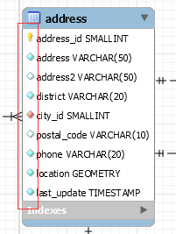

|  |  |
| --- | --- |
| 标记 | 意义 |
|  | 主键 |
|  | 不能为空 |
|  | 可以为空 |
|  | 外码 |

2. 图中哪部分体现影片-演员关系？换句话说，如果要找出演某个影片的演员名字，访问哪几张表可以获得信息？

访问film,film_actor,actor，通过film表的film_id可以与film_actor表进行连接，通过film_actor的actor_id与actor连接即可。

3. 如果已知某个顾客姓名，要找到他租借的所有影片名，需要访问哪几张表？

customer,inventory,rental,film四张表

4. 为什么film和language表间会有2条线？

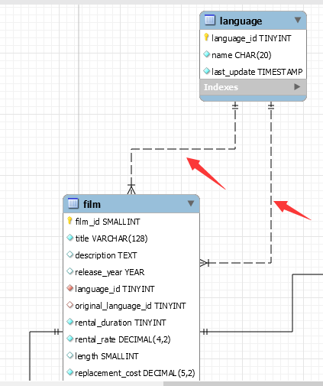

可以通过film表中的language_id和original_language_id都可以访问language表。

# 实验截图

*注意截图清晰，截图时需要体现SQL语句（可复制粘贴）、执行结果、Output窗口*

1. 请列出所有商店的详细地址，显示商店id，商店地址，所在区域，所在城市，所在国家；

SELECT store.store_id,address.address,address.location,address.district,city.city,country.country

FROM store,address,city,country

WHERE store.address_id = address.address_id AND address.city_id = city.city_id AND city.country_id = country.country_id;

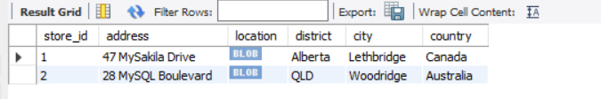



1. 哪些演员出演过影片《WEST LION》？请列出他的姓名；

SELECT actor.first_name,actor.last_name

FROM film,film_actor,actor

WHERE film.film_id = film_actor.film_id AND actor.actor_id = film_actor.actor_id and film.title = 'WEST LION';

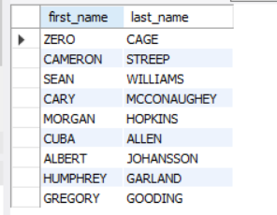



1. 找出租DVD花费最高的前3名，请列出他们的first_name, last_name和每个人花费的金额；

SELECT first_name,last_name,SUM(amount)

FROM customer,payment

WHERE customer.customer_id = payment.customer_id

GROUP BY customer.customer_id

ORDER BY SUM(amount) DESC

LIMIT 3;

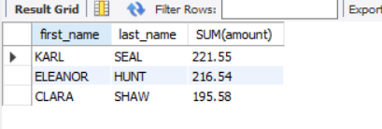



1. 哪个影片获得了总体最高的租金？请列出影片id、影片名、总租金；

SELECT film.film_id,film.title,sum(payment.amount)

FROM film,inventory,rental,payment

WHERE film.film_id = inventory.film_id AND inventory.inventory_id = rental.inventory_id AND rental.rental_id = payment.rental_id

GROUP BY film.film_id

ORDER BY sum(payment.amount) DESC

LIMIT 1;

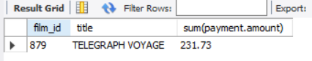



1. 哪个演员出演的电影超过40部？ 请列出演员id、演员名、出演的电影数；

SELECT actor.first_name,actor.last_name,count(film.film_id),actor.actor_id

FROM actor,film_actor,film

WHERE actor.actor_id = film_actor.actor_id AND film_actor.film_id = film.film_id

GROUP BY actor.actor_id HAVING count(film.film_id) > 40;

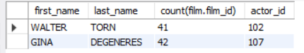



1. 请找出没有租借过电影《WEST LION》的顾客姓名；

SELECT customer.first_name,customer.last_name

FROM customer

WHERE customer.customer_id NOT IN

(SELECT c.customer_id FROM customer c,film,rental,inventory

WHERE c.customer_id = rental.customer_id AND rental.inventory_id = inventory.inventory_id AND inventory.film_id = film.film_id

AND film.title = 'WEST LION'

);

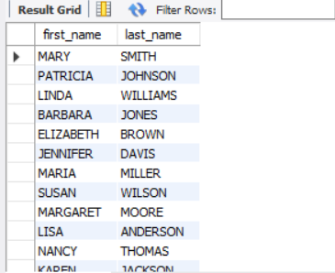



1. 查询演过《FIRE WOLVES》和《JAWBREAKER BROOKLYN》这两部电影的演员，列出其姓名；

SELECT actor.first_name,actor.last_name

FROM actor,film,film_actor

WHERE film.film_id = film_actor.film_id AND film_actor.actor_id = actor.actor_id

AND film.title = 'FIRE WOLVES' AND actor.actor_id in (SELECT actor1.actor_id FROM film film1,actor actor1,film_actor film_actor1

WHERE film1.film_id = film_actor1.film_id AND film_actor1.actor_id = actor1.actor_id AND film1.title = 'JAWBREAKER BROOKLYN'

);

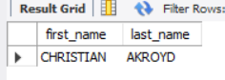



1. 统计每种类型的影片数，显示类型编号、类型名称、该类型影片数；

SELECT category.category_id,count(category.category_id) num,category.name

FROM film,film_category,category

WHERE film.film_id = film_category.film_id AND film_category.category_id = category.category_id

GROUP BY category.category_id;

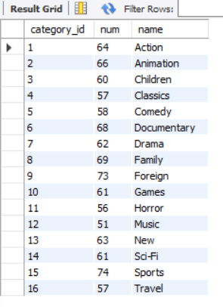



1. 有哪些影片是2个商店都有库存的？

SELECT DISTINCT film1.title

FROM film film1,inventory

WHERE film1.film_id = inventory.film_id AND inventory.store_id=1 AND inventory.film_id in (

SELECT inventory1.film_id

FROM inventory inventory1,film film2

WHERE inventory1.film_id = film2.film_id AND inventory1.store_id=2

);

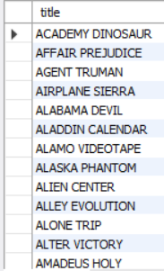



1. 查询单次租借影片最长时间的3位客户，列出其first_name、last_name和当次租借时长；

SELECT customer.first_name,customer.last_name,unix_timestamp(rental.return_date) - unix_timestamp(rental.rental_date) rental_time

FROM customer,rental

WHERE customer.customer_id = rental.customer_id

ORDER BY unix_timestamp(rental.return_date) - unix_timestamp(rental.rental_date) DESC

LIMIT 3;

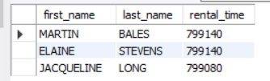



1. 在customer表中新增一条数据，注意customer表与其他表的关系；

通过查询主键的范围可知customer_id可设为700不会冲突，根据参照完整性，其外码应选取作为主码所在表的值，store_id和address_id可以设置为1,5

INSERT customer VALUES (700,1,'张','三','abc@163.com',5,1,NOW(),NOW());



插入后可以进行一条查询语句

SELECT last_update FROM customer WHERE customer.first_name = '张';

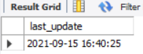

1. 修改刚才在customer表中新增的那条数据；

UPDATE customer SET last_update=NOW() WHERE customer_id=700;



再次执行11所述的查询语句

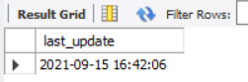

1. 删除第11步新增的那条数据。

DELETE FROM customer WHERE customer_id=700;



再次执行11所述的查询语句

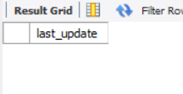

# 思考题

1. 如果insert一条数据到actor表，但actor_id和已有数据重复，会发生什么？同学们请自己尝试一下。



会报错，因为主键不能重复。

1. insert语句还用了一个函数NOW()，是做什么的呢？

获取当前系统时间作为插入该数据的更新时间。