Universidad de Puerto Rico

Recinto de Mayagüez

Tarea LPC

Christian Vázquez

Pedro Colon

## Cepstral features can be related to LP features. Describe the relationship between the two.

The relationship is that we can transform the LP features (coefficients) into the Cepstral features (coefficients). This relationship can be seen with the formula:



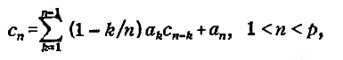

And

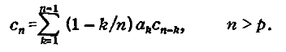

Where ak is the Kth LPC. These are recursive formulas that use previous values to find new ones.

Works Cited

Tokuda, Keiichi, Takao Kobayashi, and Satoshi Imai. "Recursive Calculation of Mel-Cepstrum from LP Coefficients." *TOKUDA, LEE and NANKAKU LABORATORY*. 1 Apr. 1994. Web. 17 Nov. 2014. <http://www.sp.nitech.ac.jp/~tokuda/tips/mgceptr_sa2.pdf>.

"5.3 Linear Prediction Analysis." *5.3 Linear Prediction Analysis*. Web. 17 Nov. 2014. <http://www.ee.columbia.edu/ln/LabROSA/doc/HTKBook21/node53.html>.

Atal, B. S. "Effectiveness of the Linear Prediction Characteristics of the Speech Wave for Automatic Speaker Identification and Verification." 2 Jan. 1974. Web. 17 Nov. 2014. <http://www.ee.columbia.edu/~dpwe/papers/Atal74-lpc.pdf>.

"L9: Cepstral Analysis." Web. 17 Nov. 2014. <http://research.cs.tamu.edu/prism/lectures/sp/l9.pdf>.

## The model for linear prediction includes a gain G on the input excitation. Describe how this gain can be computed.

The model gain, G, to be determined by matching the signal energy with the energy of the linearly predicted samples.

At first glance, the following equation could be used:



The previous equation would be equaled to the equation for the prediction error:



In the ideal case ak=αk, but since this would hardly ever happen, the approximation is not exactly valid. So, instead we can use energy the matching criterion (energy in error signal=energy in excitation). This can be seen in the following equation:

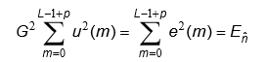

However, to solve for G, we would need to work with the voiced and unvoiced parts of speech. We would make the assumption that:

**For voiced:**

U(n) = δ(n) :

* L order of a single pitch period
* predictor order p large enough to model glottal pulse shape
* vocal tract IR
* radiation

**For unvoiced:**

U(n)

* zero mean
* unity variance
* stationary white noise process

## Solving for the voiced gain:

The excitation is G δ(n) with an output of h(n) because it is the impulse response of the system.

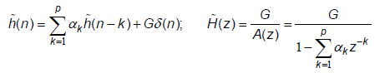

This has an autocorrelation R~(m) (of the impulse response) that satisfies:

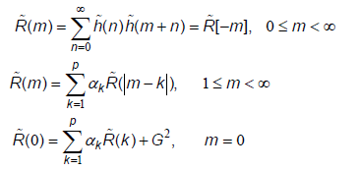

Since R~(m) has the same equation as:



Which is the short term auto correlation of the signal,

We can say that:



Since the total energies in the signal (R(0)) and the impulse response (R~(0)) must be equal, the constant c must be 1, and



## Solving for the unvoiced gain:

The input of the system is white noise with zero mean and unity variance:



If we put in an input Gu(n) and name the output g~(n):

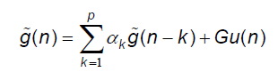

Since the autocorrelation function for the output is the convolution of the autocorrelation function of the impulse response with the autocorrelation of the white noise input:



Where R~(m) is the autocorrelation of the output g~(n). We can also see that:

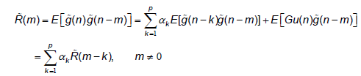

This result is because of:



Because u(n) is uncorrelated with any signal prior to u(n).

Now, solving for m=0 we find:

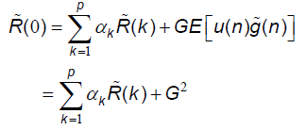

Finally since:



And the energy in the signal must be equal to the energy in the response to Gu(n):

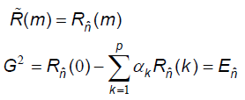

## Demonstrate graphically that the autocorrelation and the auto covariance solutions of the LP approximation yield reasonable solutions. Do this by contrasting the known data and the generated model of the solution for each case.

Looking first at order = 4: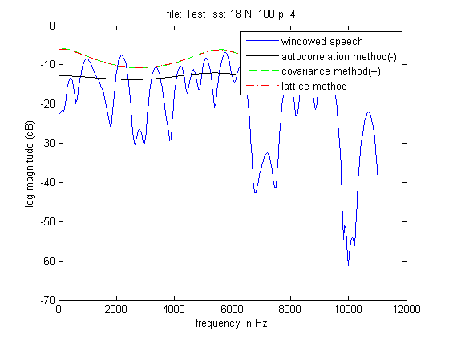

Order = 10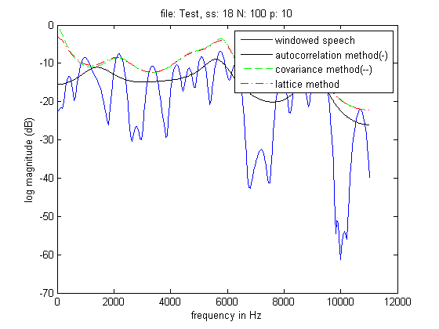

Order = 16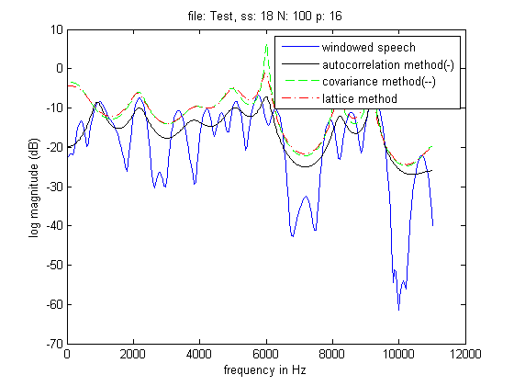

We see that as the order increases the prediction becomes more accurate. We can also see that the covariance and lattice methods tend to follow the envelope of the spectrum vs the covariance method which tries to follow the actual signal.

The difference between the different algorithm options for each method are as follows:



The values calculated are the same, yet the run time and the space complexity for each vary.

These are the Optimized graphs with the distinction between brute-force and optimized algorithms:

Order = 4

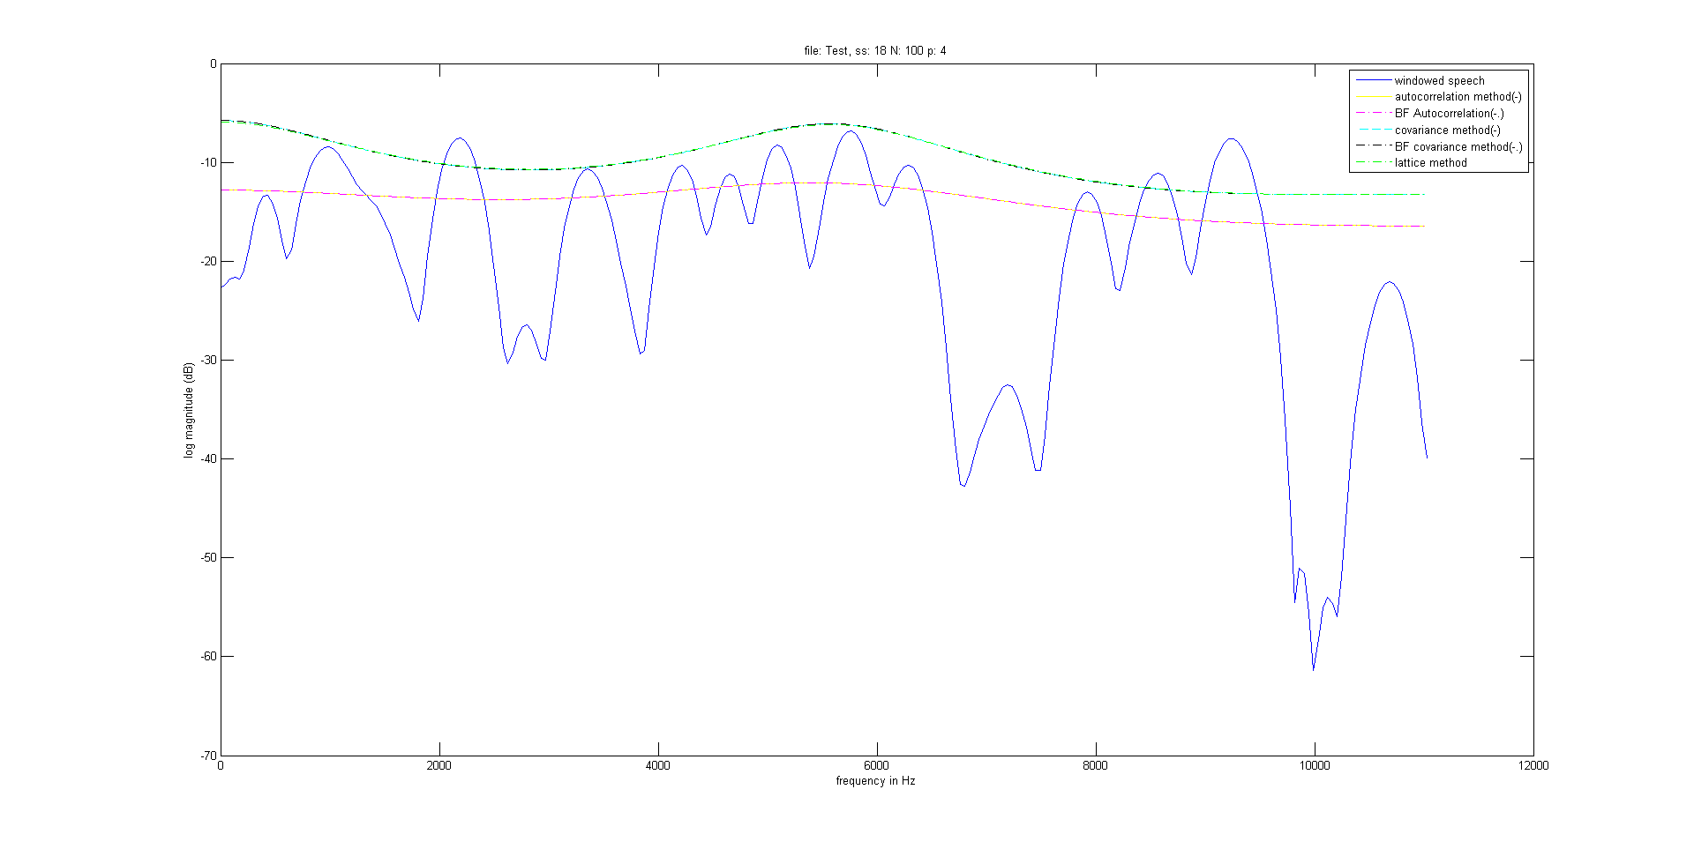

Order=10

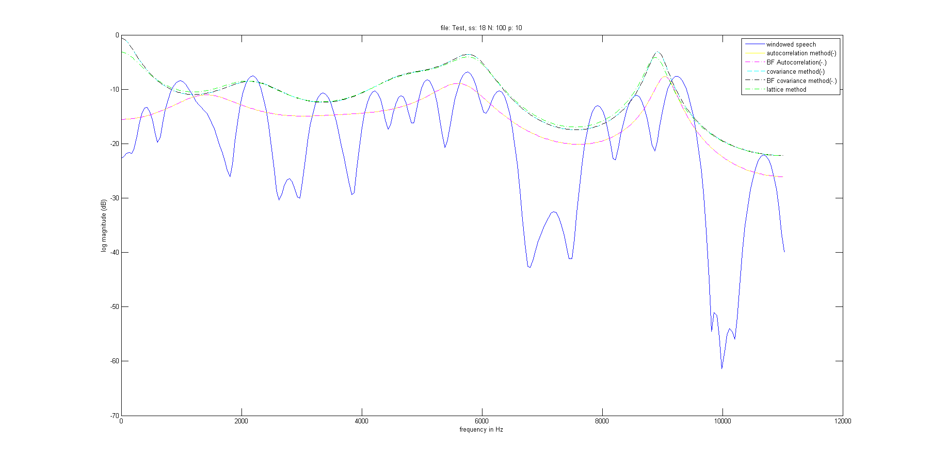

Order=16

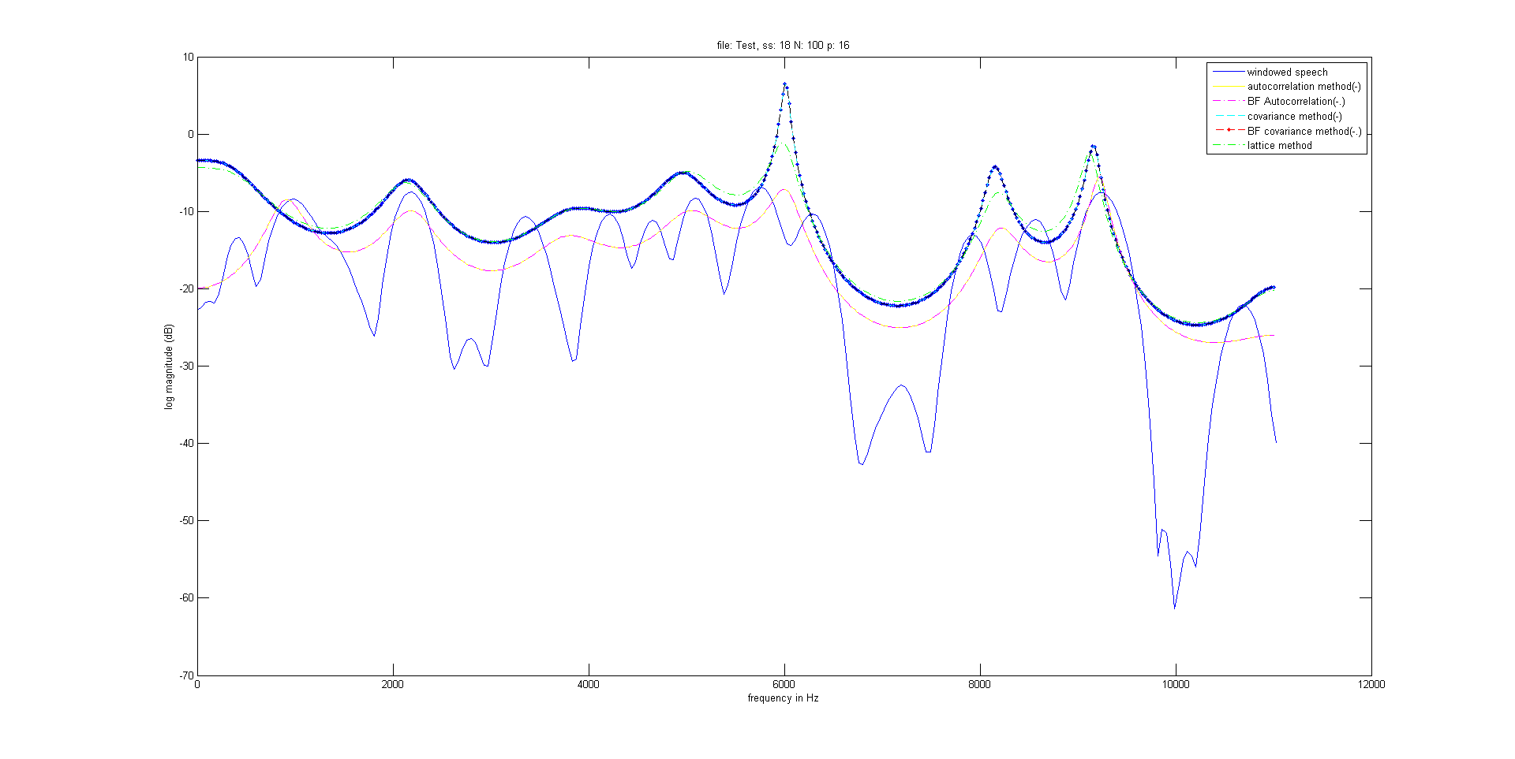

The following sources were used:

"7- 1 Chapter 7 Linear Predic Tive Speech Processing." Web. 20 Nov. 2014. <http://frtk.fri.uniza.sk/jurecka/lpc2.pdf>.

"1 1 Digital Speech Processing— Lecture 13 Linear Predictive Coding (LPC)- Introduction." Web. 20 Nov. 2014. <http://www.ece.ucsb.edu/Faculty/Rabiner/ece259/digital speech processing course/lectures_new/Lecture 13_winter_2012_6tp.pdf>.

"1 1 Digital Speech Processing— Lecture 14 Linear Predictive Coding (LPC)-Lattice Methods, Applications." Web. 20 Nov. 2014. <http://www.ece.ucsb.edu/Faculty/Rabiner/ece259/digital speech processing course/lectures_new/Lecture 14_winter_2012_6tp.pdf>.

"Introduction to Digital Speech Processing." Web. 20 Nov. 2014. <http://www.nowpublishers.com/media/Journal-Article-PDFs/2000000001.pdf>.

"Introduction to Digital Speech Processing." Web. 20 Nov. 2014. <http://www.ece.ucsb.edu/Faculty/Rabiner/ece259/digital speech processing course/lectures_new/Lecture 1_winter_2012_robot_video_6tp.pdf>.

"LPC." Web. 20 Nov. 2014. <http://www.fit.vutbr.cz/~grezl/ZRE/lectures/04_lpc_en.pdf>.

"LPC and Vector Quantization." Web. 20 Nov. 2014. <http://www.fit.vutbr.cz/~grezl/ZRE/comp_labs/02_lpc_vq.pdf>.

"Linear Predictive Coding Methods." Web. 20 Nov. 2014. <http://www.google.com.pr/url?sa=t&rct=j&q=&esrc=s&source=web&cd=1&cad=rja&uact=8&ved=0CB8QFjAA&url=http://my.fit.edu/~vkepuska/ece5525/Projects/Fall2010/Mohamed%20M.%20Eljhani/LPC%20Methods%20Final%20Report.doc&ei=8AdwVLXaMcefg>.

"Linear Prediction." *Wikipedia*. Wikimedia Foundation, 24 Oct. 2014. Web. 20 Nov. 2014. <http://en.wikipedia.org/wiki/Linear_prediction>.

"Matlab Routines for Linear Predictive Coding (LPC)." *Matlab Routines for Linear Predictive Coding (LPC)*. Web. 20 Nov. 2014. <http://www.ee.ic.ac.uk/hp/staff/dmb/voicebox/lpc.html>.

"SPEECH COMPRESSION." Web. 20 Nov. 2014. <http://eeweb.poly.edu/iselesni/EL713/Speech/speech.pdf>.

"SPEECH PROCESSING." Web. 20 Nov. 2014. <http://ssli.ee.washington.edu/courses/ee516/files/UW-Lecture2to4-Reading2.Deng.pdf>.

"Signal Processing Lab 5 : Linear Predictive Coding." Web. 20 Nov. 2014. <http://vision.mas.ecp.fr/Personnel/simon/files/Documents/Teaching/SignalProcessingLabs/lab5.pdf>.

"UNIT 8: LINEAR PREDICTION." Web. 20 Nov. 2014. <http://www.phon.ucl.ac.uk/courses/spsci/dsp/lpc.html>.