Task 1

1. Simulating SDE

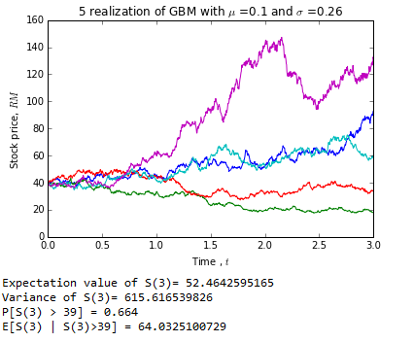

From the diagram, we can see that the expectation value of S(3) is 52.4642595165, the mean of S(3) is calculated using numpy function, which is np.mean(x). Next, the variance of S(3) is 615.616539826, it is calculated using numpy function, np.var(x). Mask is used in the case that stock price at time 3 is greater than 39, the probability of stock price at time 3 is greater than 39 is calculated using total sum of mask divide by total length of mask which the probability is 0.664. Then, I calculate the product of stock price at time 3 with mask to get the stock price at time 3 which is greater than 39 and use the total sum of all the values divide by total sum of mask to get the conditional expectation of stock price at time 3 that greater than 39 which the conditional expectation value is 64.0325100729.

1. Simulating mean reversal process

Alpha, theta, sigma and initial value of R is declared at beginning. Then, array is computed using pylab linspace function with 1000 simulation runs on 1000 paths within the interval zero to one. Then, I plot 5 realizations of the mean reversal process against time and it is shown in the diagram below:

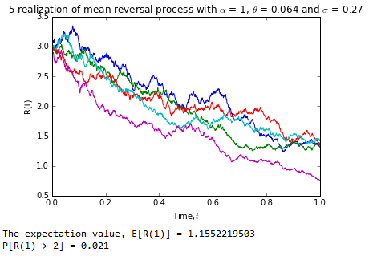

The expectation value of R(1) is 1.1552219503, the value is calculate using np.mean(x) function. Mask is used in a condition that R(1) > 2, the probability that the Riemann sum at time 1 is greater than 2 I calculated by dividing total sum of mask by total number of path, which the probability is 0.021.

Task 2

1. There are 30 component stocks in FTSE Burse Malaysia KLCI Index:

|  |  |  |  |  |  |  |
| --- | --- | --- | --- | --- | --- | --- |
| **No.** | **Stock Name** | **Stock Code** | **Stock sector** | **Weightage(%)** | **PE ratio** | **Net market capital(MYRb)** |
| 1 | AMMB Holdings | [1015](http://www.bursamalaysia.com/market/listed-companies/list-of-companies/plc-profile.html?stock_code=1015) | Financials | 2.38 | 8.82 | 16.97 |
| 2 | Astro Malaysia Holdings | [6399](http://www.bursamalaysia.com/market/listed-companies/list-of-companies/plc-profile.html?stock_code=6399) | Communications | 1.22 | 28.06 | 15.761 |
| 3 | Axiata Group | [6888](http://www.bursamalaysia.com/market/listed-companies/list-of-companies/plc-profile.html?stock_code=6888) | Communications | 5.67 | 24.18 | 55.349 |
| 4 | British American Tobacco (Malaysia) | [4162](http://www.bursamalaysia.com/market/listed-companies/list-of-companies/plc-profile.html?stock_code=4162) | Consumer Staples | 1 | 20.06 | 18.445 |
| 5 | CIMB Group Holdings | [1023](http://www.bursamalaysia.com/market/listed-companies/list-of-companies/plc-profile.html?stock_code=1023) | Financials | 5.96 | 17.52 | 46.694 |
| 6 | Digi.com | [6947](http://www.bursamalaysia.com/market/listed-companies/list-of-companies/plc-profile.html?stock_code=6947) | Communications | 4.04 | 21.02 | 41.830 |
| 7 | Genting | [3182](http://www.bursamalaysia.com/market/listed-companies/list-of-companies/plc-profile.html?stock_code=3182) | Comsumer Discretionary | 3.61 | 19.3 | 30.748 |
| 8 | Genting Malaysia | [4715](http://www.bursamalaysia.com/market/listed-companies/list-of-companies/plc-profile.html?stock_code=4715) | Comsumer Discretionary | 2.5 | 20.21 | 24.097 |
| 9 | Hong Leong Bank | [5819](http://www.bursamalaysia.com/market/listed-companies/list-of-companies/plc-profile.html?stock_code=5819) | Financials | 1.67 | 11.19 | 24.572 |
| 10 | Hong Leong Financial | [1082](http://www.bursamalaysia.com/market/listed-companies/list-of-companies/plc-profile.html?stock_code=1082) | Financials | 0.64 | 9.92 | 16.255 |
| 11 | IHH Healthcare | [5225](http://www.bursamalaysia.com/market/listed-companies/list-of-companies/plc-profile.html?stock_code=5225) | Health Care | 3.28 | 63.15 | 48.758 |
| 12 | IOI | [1961](http://www.bursamalaysia.com/market/listed-companies/list-of-companies/plc-profile.html?stock_code=1961) | Consumer Staples | 2.99 | 73.65 | 26.731 |
| 13 | KLCC Prop & Reits- stapled sec | 5235ss | Financials | 0.63 | 28.22 | 12.728 |
| 14 | Kuala Lumpur Kepong | [2445](http://www.bursamalaysia.com/market/listed-companies/list-of-companies/plc-profile.html?stock_code=2445) | Materials | 2.28 | 29.21 | 23.983 |
| 15 | Malayan Banking | [1155](http://www.bursamalaysia.com/market/listed-companies/list-of-companies/plc-profile.html?stock_code=1155) | Financials | 9.46 | 12.45 | 88.041 |
| 16 | Maxis | [6012](http://www.bursamalaysia.com/market/listed-companies/list-of-companies/plc-profile.html?stock_code=6012) | Communications | 3.45 | 30.05 | 49.409 |
| 17 | MISC | [3816](http://www.bursamalaysia.com/market/listed-companies/list-of-companies/plc-profile.html?stock_code=3816) | Industrials | 2.45 | 15.99 | 35.264 |
| 18 | PETRONAS Chemicals Group | [5183](http://www.bursamalaysia.com/market/listed-companies/list-of-companies/plc-profile.html?stock_code=5183) | Materials | 3.68 | 21.83 | 50.64 |
| 19 | Petronas Dagangan | [5681](http://www.bursamalaysia.com/market/listed-companies/list-of-companies/plc-profile.html?stock_code=5681) | Energy | 1.21 | 37.05 | 20.445 |
| 20 | Petronas Gas | [6033](http://www.bursamalaysia.com/market/listed-companies/list-of-companies/plc-profile.html?stock_code=6033) | Energy | 3.4 | 22.79 | 42.741 |
| 21 | PPB Group | [4065](http://www.bursamalaysia.com/market/listed-companies/list-of-companies/plc-profile.html?stock_code=4065) | Consumer Staples | 1.8 | 18.13 | 18.233 |
| 22 | Public Bank | [1295](http://www.bursamalaysia.com/market/listed-companies/list-of-companies/plc-profile.html?stock_code=1295) | Financials | 11.75 | 15.21 | 73.368 |
| 23 | RHB Capital | [1066](http://www.bursamalaysia.com/market/listed-companies/list-of-companies/plc-profile.html?stock_code=1066) | Financials | 1.06 | 9.18 | 19.129 |
| 24 | SapuraKencana Petroleum | [5218](http://www.bursamalaysia.com/market/listed-companies/list-of-companies/plc-profile.html?stock_code=5218) | Energy | 1.98 | 12.08 | 14.321 |
| 25 | Sime Darby | [4197](http://www.bursamalaysia.com/market/listed-companies/list-of-companies/plc-profile.html?stock_code=4197) | Consumer Discretionary | 5.56 | 21.89 | 52.671 |
| 26 | Telekom Malaysia | [4863](http://www.bursamalaysia.com/market/listed-companies/list-of-companies/plc-profile.html?stock_code=4863) | Communications | 2.96 | 32.34 | 24.915 |
| 27 | Tenaga Nasional | [5347](http://www.bursamalaysia.com/market/listed-companies/list-of-companies/plc-profile.html?stock_code=5347) | Utilities | 9.00 | 9.15 | 69.304 |
| 28 | UMW Holdings | [4588](http://www.bursamalaysia.com/market/listed-companies/list-of-companies/plc-profile.html?stock_code=4588) | Consumer Discretionary | 1.37 | 20.41 | 11.987 |
| 29 | Westports holdings | 5246 | Industrials | 0.93 | 26.60 | 13.913 |
| 30 | YTL Corp | [4677](http://www.bursamalaysia.com/market/listed-companies/list-of-companies/plc-profile.html?stock_code=4677) | Utilities | 1.63 | 14.95 | 16.67 |

1. Calculate 5-day moving average

I made Genting Bhd as my choice for FTSEKLCI component and the stock price for Genting Bhd is downloaded for the period from 1/1/2011 until 1/1/2015. Firstly, I use DR(“3182.KL”,’yahoo’, start, end)[‘Close’] to take the Genting Bhd closing stock price. Then, moving average is calculated by using pandas function which is pd.rolling_mean(genting, avg_days) and the 5-day moving average is plotted as diagram below:

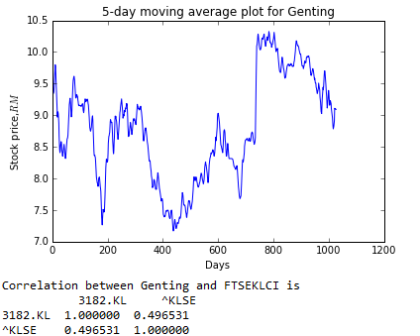

In order to compute the correlation of Genting Bhd with FTSEKLCI, I download the stock price for FTSEKLCI for the same duration as Genting Bhd as well. Then, I combine those data under a variable ‘combine’ and a new variable named ‘new_data’ is used to find the closing stock price of variable ‘combine’. Lastly, the correlation of Genting Bhd with FTSEKLCI is computed using function corr() which the correlation is 0.496531.