**SQL Project: Paytm**

**I.DataBase Diagram**

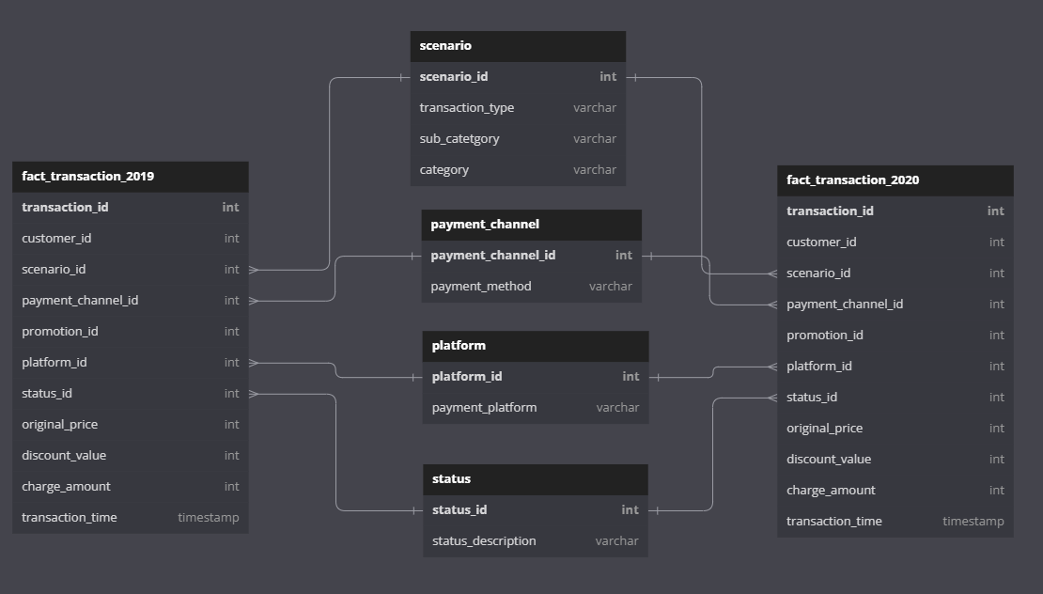

**II. Overview**

Paytm is an Indian multinational financial technology company.

It specialises in digital payment systems, e-commerce and financial services. Paytm wallet is a secure and RBI (Reserve Bank of India)-approved digital/mobile wallet that provides a myriad of financial features to fulfil every consumer’s payment needs. Paytm wallet can be topped up through UPI (Unified Payments Interface), internet banking, or credit/debit cards. Users can also transfer money from a Paytm wallet to the recipient's bank account or their own Paytm wallet.

Below is a small database of payment transactions from 2019 to 2020 of Paytm Wallet. The database includes 6 tables:

* **fact_transaction**: Store information of all types of transactions: Payments, Top-up, Transfers, Withdrawals (2019 and 2020)
* **dim_scenario**: Detailed description of transaction types
* **dim_payment_channel**: Detailed description of payment methods
* **dim_platform**: Detailed description of payment devices
* **dim_status**: Detailed description of the results of the transaction

**III. SQL Queries**

1. Return the result of **successful transactions** for **each month in 2019**.

**SELECT MONTH (transaction_time) AS [month]**

**, COUNT (transaction_id ) AS number_success_trans**

**FROM dbo.fact_transaction_2019**

**LEFT JOIN dim_scenario**

**ON dbo.fact_transaction_2019.scenario_id = dim_scenario.scenario_id**

**WHERE status_id = 1**

**GROUP BY MONTH (transaction_time)**

**ORDER BY [month]**

**Output:  
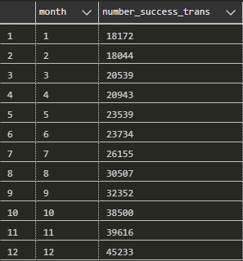**

1. Find the **TOP 3 months** with the **highest** number of **failed transactions** for **each year**.

WITH failed_month_table AS (

SELECT YEAR (transaction_time) AS [year]

, MONTH (transaction_time) AS [month]

, COUNT (transaction_id ) AS number_failed_trans

FROM (SELECT transaction_id, transaction_time, scenario_id, status_id FROM dbo.fact_transaction_2019

UNION

SELECT transaction_id, transaction_time, scenario_id, status_id FROM dbo.fact_transaction_2020) AS fact_table

WHERE status_id != 1 -- giao dịch lỗi

GROUP BY YEAR (transaction_time), MONTH (transaction_time)

-- ORDER BY [year], [month]

)

, rank_table AS (

SELECT *

, RANK () OVER ( PARTITION BY [year] ORDER BY number_failed_trans DESC ) AS rank_column

FROM failed_month_table

-- ORDER BY [year], [month]

)

SELECT *

FROM rank_table

WHERE rank_column < 4

**Output:**

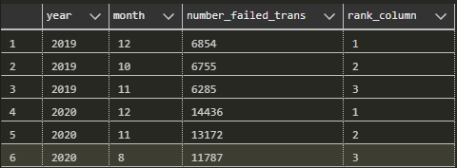

1. **Calculate the average distance between successful payments for each customer in the Telecom group in 2019.**

**WITH customer_table AS (**

**SELECT TOP 1000 customer_id, transaction_id, transaction_time**

**, LAG (transaction_time, 1) OVER ( PARTITION BY customer_id ORDER BY transaction_time ASC ) AS previous_time**

**, DATEDIFF (day, LAG (transaction_time, 1) OVER ( PARTITION BY customer_id ORDER BY transaction_time ASC )**

**, transaction_time) AS gap_day**

**FROM (SELECT customer_id, transaction_id, transaction_time, scenario_id FROM dbo.fact_transaction_2019**

**UNION**

**SELECT customer_id, transaction_id, transaction_time, scenario_id FROM dbo.fact_transaction_2020) AS fact_table**

**LEFT JOIN dbo.dim_scenario**

**ON fact_table.scenario_id = dbo.dim_scenario.scenario_id**

**WHERE category = 'Telco'**

**)**

**SELECT customer_id**

**, AVG (gap_day) AS avg_gap_day**

**FROM customer_table**

**GROUP BY customer_id**

**Output:**

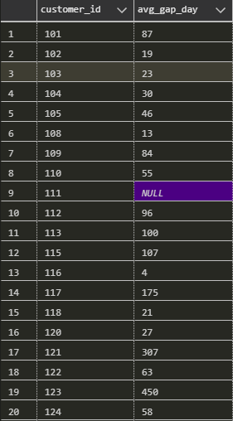

1. **Time Series Analysis**

**Requirements:** Create a table that shows the number of transactions for the 3 sub-categories: Electricity, Internet, and Water, as well as the total transactions for all 3 sub-categories in each month from 2019-2020. Then calculate the percentage of sales for each sub-category in each month compared to the total transactions.

**WITH month_table AS (**

**SELECT**

**YEAR(transaction_time) AS [year]**

**, MONTH (transaction_time) AS [month]**

**, sub_category**

**, COUNT (transaction_id) AS number_trans**

**FROM (SELECT transaction_id, transaction_time, scenario_id, status_id FROM dbo.fact_transaction_2019**

**UNION**

**SELECT transaction_id, transaction_time, scenario_id, status_id FROM dbo.fact_transaction_2020)**

**AS fact_table**

**LEFT JOIN dbo.dim_scenario**

**ON fact_table.scenario_id = dbo.dim_scenario.scenario_id**

**LEFT JOIN dbo.dim_status**

**ON fact_table.status_id = dbo.dim_status.status_id**

**WHERE category = 'Billing'**

**AND fact_table.status_id = 1**

**GROUP BY YEAR(transaction_time), MONTH (transaction_time), sub_category**

**)**

**, pivot_table AS (**

**SELECT [year], [month]**

**, SUM ( CASE WHEN sub_category = 'electricity' THEN number_trans ELSE 0 END ) AS elec_trans**

**, SUM ( CASE WHEN sub_category = 'internet' THEN number_trans ELSE 0 END ) AS internet_trans**

**, SUM ( CASE WHEN sub_category = 'water' THEN number_trans ELSE 0 END ) AS water_trans**

**FROM month_table**

**GROUP BY [year], [month]**

**-- ORDER BY [year], [month]**

**)**

**SELECT \***

**, elec_trans + internet_trans + water_trans AS total_trans_month**

**, FORMAT ( elec_trans *1.0 / ( elec_trans + internet_trans + water_trans ), 'p') AS elec_pct**

**, FORMAT ( internet_trans *1.0 / ( elec_trans + internet_trans + water_trans ), 'p') AS internet_pct**

**, FORMAT ( water_trans *1.0 / ( elec_trans + internet_trans + water_trans ), 'p') AS water_pct**

**FROM pivot_table**

**Output:**

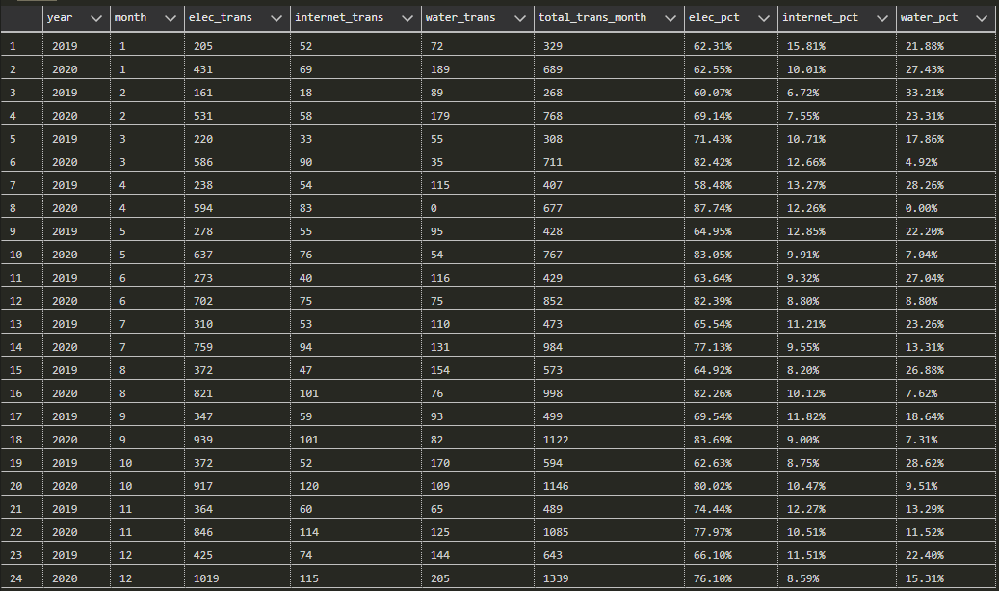

1. **RFM analysis**

Segment all customers in 2019-2020 into 9 distinct groups by percent ranking and count the total customers of each group.

**WITH fact_table AS -- tạo bảng fact chung**

**(SELECT customer_id**

**, transaction_id**

**, transaction_time**

**, charged_amount**

**, sub_category**

**, cast(transaction_time as *date*) as transaction_date**

**FROM fact_transaction_2019 fact_2019**

**JOIN dim_scenario scen ON scen.scenario_id = fact_2019.scenario_id**

**WHERE status_id = 1**

**AND category = 'Billing'**

**UNION ALL**

**SELECT customer_id**

**, transaction_id**

**, transaction_time**

**, charged_amount**

**, sub_category**

**, cast(transaction_time as *date*) as transaction_date**

**FROM fact_transaction_2020 fact_2020**

**JOIN dim_scenario scen ON scen.scenario_id = fact_2020.scenario_id**

**WHERE status_id = 1**

**AND category = 'Billing')**

**,**

**rfm_model as (SELECT customer_id,**

**DATEDIFF(DAY, MAX(transaction_time), '2020-12-31') AS Recency,**

**COUNT(DISTINCT transaction_id) AS Frequency,**

**SUM(charged_amount) AS Monetary**

**FROM fact_table**

**GROUP BY customer_id**

**)**

**,**

**rfm_percent as (**

**SELECT customer_id**

**, PERCENT_RANK() OVER ( ORDER BY Recency DESC) AS r_percent_rank**

**, PERCENT_RANK() OVER ( ORDER BY Frequency ASC) AS f_percent_rank**

**, PERCENT_RANK() OVER ( ORDER BY Monetary ASC) AS m_percent_rank**

**FROM rfm_model**

**)**

**, tier_table as(**

**SELECT customer_id,**

**CASE WHEN r_percent_rank <= 0.25 then 4**

**WHEN r_percent_rank <= 0.5 then 3**

**WHEN r_percent_rank <= 0.75 then 2**

**ELSE 1 end r_tier,**

**CASE WHEN f_percent_rank <= 0.25 then 4**

**WHEN f_percent_rank <= 0.5 then 3**

**WHEN f_percent_rank <= 0.75 then 2**

**ELSE 1 end f_tier,**

**CASE WHEN m_percent_rank <= 0.25 then 4**

**WHEN m_percent_rank <= 0.5 then 3**

**WHEN m_percent_rank <= 0.75 then 2**

**ELSE 1 end m_tier**

**FROM rfm_percent**

**)**

**, score_table as (**

**SELECT customer_id**

**, CONCAT(r_tier, f_tier, m_tier) as score**

**FROM tier_table)**

**, label_table as (**

**SELECT \***

**, (CASE**

**WHEN score = '111' THEN 'Best customers'**

**WHEN score LIKE '[34][34][1-4]' THEN 'Lost Bad Customers'**

**WHEN score LIKE '[34]2[1-4]' THEN 'Lost Customers'**

**WHEN score LIKE '21[1-4]' THEN 'Almost lost'**

**WHEN score LIKE '11[2-4]' THEN 'Loyal customers'**

**WHEN score LIKE '[12][1-3]1' THEN 'Big Spender'**

**WHEN score LIKE '[12]4[1-4]' THEN 'New customers'**

**WHEN score LIKE '[34]1[1-4]' THEN 'Hibernating'**

**WHEN score LIKE '[12][23][2-4]' THEN 'Potential Loyalist'**

**END**

**) as label**

**FROM score_table)**

**SELECT label**

**, COUNT(customer_id) as number_of_customers**

**FROM label_table**

**GROUP BY label**

**ORDER BY number_of_customers**

**Output:**

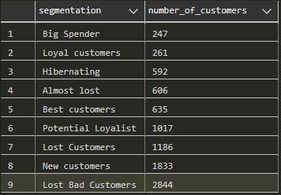

**Note:** The percent_rank function allows for greater flexibility in filtering and sorting data, while the Ntile function divides data into a fixed number of equally-sized groups, which may not be suitable for all use cases. By using percent_rank, I can easily filter data based on a particular percentile, such as the top or bottom 50%, which can be useful in various analysis scenarios.