A provenance-tracked candidate dataset for Portuguese 60 kV topology reconstruction
Author details to be finalized before submission
July 2026
Abstract
Open infrastructure portals often provide geospatial power-network records without explicit bus–branch connectivity or machine-readable distinctions between observed, derived, inferred, and missing information. We assembled PT60-Candidate, a provenance-tracked candidate dataset for Portuguese 60 kV topology reconstruction from E-REDES Open Data. A fail-closed workflow processed 5,334 line features and 586 relevant facility records across 216 reconstruction settings. Version 1.0.0 contains a 484-facility candidate multigraph, 358 retained inter-facility branch records, a complete 1,342-row retained/downgraded/rejected circuit ledger, the sensitivity sweep, provenance records, schemas, checksums, and branch-level public-source triangulation. Internal validation reports 23 passes and two documented warnings across 25 checks. Endpoint-name corruption reduced strong name-based public evidence from 183/358 to 9/358, while spatial displacement reduced corridor evidence from 290/358 to 1/358. Comparison with Portuguese 60 kV OSM/OpenInfraMap records assigns 247 retained branches to strong, 104 to medium, and seven to weak public-evidence categories. These results test record consistency and matcher selectivity; they are not truth labels and do not estimate topology precision or recall. The dataset is intended for topology-reconstruction research, geospatial integration, provenance-aware network analysis, and sensitivity studies. It is not operator validated, is not an operational grid model, and lacks the electrical parameters and operating data required for AC power-flow or OPF studies. The versioned dataset is deposited in figshare under DOI 10.6084/m9.figshare.32984021.
Keywords: power-grid dataset; data provenance; topology reconstruction; distribution networks; technical validation; open data

Background & Summary
Public distribution-network portals can support geospatial and data-integration studies, but the released records rarely correspond directly to an auditable bus–branch dataset. Connectivity must usually be inferred from facility locations and line geometries, while electrical parameters, switching states, and operating conditions remain incomplete or unavailable. In this setting, a reusable dataset should not only publish retained candidate connections; it should also preserve how those candidates were constructed, what evidence supports them, and which fields remain unknown or diagnostic.
PT60-Candidate was assembled to provide such a resource for a Portuguese E-REDES 60 kV layer. The release is explicitly a candidate dataset. It does not represent an operator-confirmed connectivity model, a national Portuguese grid model, or a validated electrical operating case. Instead, it provides a provenance-tracked reconstruction product in which retained branches, downgraded circuits, release manifests, validation outputs, and downstream interface contracts remain inspectable as part of the data record.
The release contains three closely related resource types. First, it provides a core topology layer composed of retained inter-facility branches, an all-facility multigraph, and a complete circuit-classification ledger. Second, it provides validation and provenance records, including a reconstruction-sensitivity sweep, a source manifest, public-source audits, negative controls, and branch-level triangulation outputs. Third, it provides a schema package, field-level data dictionary, join documentation, manifest, checksums, and responsible-use metadata so that the core records can be interpreted without the development repository.
This framing differs from a conventional engineering paper. The central contribution is the release of a documented candidate dataset and its validation boundaries, not a claim of algorithmic novelty or a demonstration of predictive superiority. Prior open-grid resources have shown the value of transparent power-system model construction from public records (Medjroubi et al. 2017; Rivera et al. 2019; Hörsch et al. 2018; Xiong et al. 2025; Wiese et al. 2019). PT60-Candidate extends that tradition to a Portuguese 60 kV distribution-layer reconstruction problem while making rejected circuits, semantic status fields, and downstream release contracts explicit.

Methods

Source datasets
The source snapshot combines AT line geometries, AT substations, switching facilities, MT-substation context, network-characteristics tables, substation-load records, reception-capacity context, and load-diagram indices from the E-REDES Open Data Portal (E-REDES 2026). For the documented snapshot, the topology stage loads 586 technically relevant facilities, comprising 409 AT substations and 177 additional facilities. The same snapshot contains 5,334 valid AT line features, of which 5,323 are labeled 60 kV and 11 are labeled 130 kV in the current local build.
The release uses the portal-level license statement reported by E-REDES for distributable data artifacts. The dataset package records publisher attribution, portal URL, source dataset identifiers, access dates, and transformation notices separately from the repository’s MIT code license. Where topology-critical API catalog responses did not repeat an explicit license field, the release policy follows the recorded portal-level statement rather than inferring a different license from the omission. The topology-critical catalog records were checked on 13 July 2026; per-source timestamps are preserved in provenance/reproduction_source_manifest.json.

Data acquisition
Source files are downloaded and validated through a reproducible workflow that records dataset roles, retrieval checks, and release metadata in a source manifest. The source manifest currently covers 13 datasets and is intended to accompany any public release. Geometry parsing and machine-readability checks occur before reconstruction so that parse failures become explicit blocking states rather than silent exclusions.
The acquisition scope is limited to the E-REDES AT layer represented in the documented snapshot. It does not include a verified REN transmission boundary, complete national generation, measured operating conditions, or authoritative switching-state data. These omissions are treated as scope boundaries of the dataset rather than as gaps to be silently imputed.

Data preprocessing
Preprocessing harmonizes source geometries, facility identifiers, and facility classes before topology inference. The workflow validates geometry type and validity, repairs parseable geometry issues where permitted by the loader, performs coordinate-reference conversions needed for endpoint and corridor calculations, and derives geometry-based quantities such as length. These transformations are recorded as derived rather than observed values.
Facilities are standardized into node candidates with associated codes, names, types, source roles, and footprint-ready geometries. Source line features are standardized into endpoint-bearing line records. Ambiguous matches and unresolved endpoints are retained as explicit states for later classification. This preprocessing stage therefore prepares line and facility inputs for reconstruction without asserting that each input line already corresponds to a valid inter-facility branch.

Provenance model
The release uses a field-level semantic status model so that downstream users can separate copied observations from deterministic derivations, inferred topology, and diagnostic assumptions. For an object $o$ at stage $k$, the workflow records
$$T_{k}\left(o\right)=\left(v,s,q,a,e\right),$$
where $v$ is the value, $s$ its semantic status, $q$ a quality or confidence indicator, $a$ a source or assumption identifier, and $e$ an exclusion or blocking reason.
Semantic statuses used in PT60-Candidate and its derivative interfaces.
Status | Interpretation
Observed | Copied from an E-REDES record, subject to source and join quality.
Derived | Deterministic transformation, such as geometry length.
Inferred | Connectivity produced by matching, clustering, merging, or classification.
Source-backed | Supported by an applicable operator, standard, or catalog source.
Scenario-assumed | Explicit choice used only in a named diagnostic scenario.
Benchmark-only | Non-Portuguese reference value used only for software and interface testing.
Proxy | Surrogate identity, injection, capacity, dispatch, or cost semantics.
Missing | Intentionally unfilled; dependent readiness gates must block use.
These statuses are carried into the released records and metadata so that consumers can apply explicit admissibility rules. The complete field-level dictionary is provided as schema/data_dictionary.csv; schema/file_schema_summary.csv, schema/join_relationships.csv, and manifest.json provide file-level structure, joins, versions, roles, and checksums.

Reconstruction pipeline
Facility records are converted to circular footprints with radii of 50, 100, 250, and 500 m. Three node sets are evaluated: set A contains 409 AT substations, set B contains 484 AT substations and switching facilities, and set C contains all 586 technically relevant facilities. Each source line contributes two endpoints. When an endpoint intersects multiple footprints, the workflow resolves membership by centroid distance and records ambiguity where needed rather than forcing an unqualified assignment.
Endpoints are then clustered at 0.5, 1, 5, 10, 25, and 50 m. Union–find merging groups features into circuit candidates under geometry-only, voltage-aware, or voltage-plus-status-aware compatibility rules. Explicit conflicts block merging in the corresponding compatibility mode. Endpoint-cluster degree is then used to distinguish ordinary terminal pairs from loop, self-loop, isolated, and tap or multi-terminal patterns.
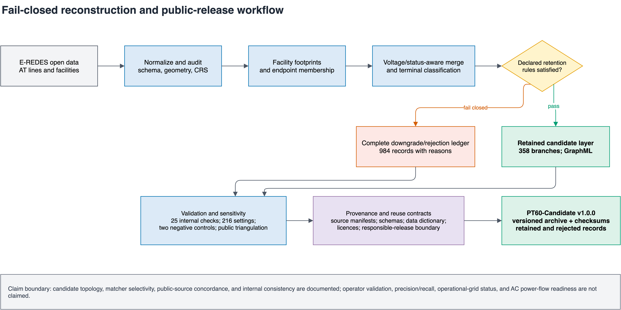
Fail-closed reconstruction and release workflow for PT60-Candidate. Blue boxes denote transformations or validation, the yellow diamond is the declared retention gate, green boxes are deposited release layers, the red box preserves downgraded/rejected records, and the purple box records provenance and reuse contracts. The diagram summarizes workflow structure and claim boundaries rather than measured performance.

Candidate selection
A merged group is retained as an inter-facility candidate branch only when it has exactly two terminals, both terminals match facilities without disqualifying ambiguity, and the two facilities are distinct. Outcomes failing these conditions remain available in the circuit-classification ledger as loop, self-loop, single-facility, isolated, tap or multi-terminal, ambiguous, or otherwise downgraded records.
This selection policy is intentionally conservative. It favors explicit preservation of non-retained outcomes over optimistic retention. Mixed voltage or status conflicts, suspicious spatial matches, and unresolved facility mappings are retained as audit information instead of being absorbed into a simplified final graph.

Parameter sweep
The reconstruction workflow evaluates 216 settings generated by combining three facility sets, four footprint buffers, six endpoint snap thresholds, and three merge modes. The selection rule rewards retained inter-facility yield and interpretable component structure while penalizing ambiguity, explicit conflicts, suspicious matches, and the broadest thresholds. The selected release setting uses node set B, a 100 m facility buffer, a 0.5 m endpoint snap threshold, and voltage-plus-status-aware merging.
The score is a reproducible engineering rule used to choose one documented release point from the 216-setting sweep. It is not a calibrated probability of correctness and is not presented as an external optimum.

Dataset generation
The selected setting converts 5,334 source line features into 1,342 circuit candidates. Of these, 358 satisfy the declared inter-facility rules and are released as retained candidate branches. The remaining 984 circuit candidates are preserved as downgraded records rather than discarded. The selected all-facility GraphML preserves isolated facilities as nodes so that graph outputs remain consistent with the declared isolate policy.
The same workflow packages the reconstruction-sensitivity table, public-source triangulation outputs, negative controls, an independence-risk audit, internal-validation results, source manifests, schemas, and checksum-linked inventory. Electrical diagnostics and Stage 1–5 learning interfaces are excluded from the main v1.0.0 public archive because they depend on incomplete, proxy, benchmark-only, or scenario-derived information.

Data Record

Repository overview
PT60-Candidate version 1.0.0 is deposited in figshare (PortugueseOPD contributors 2026) under DOI 10.6084/m9.figshare.32984021. The repository item contains the frozen release archive PT60-Candidate-v1.0.0.tar.gz. The deposited archive has SHA-256 b4a6c370fbf15c078e15b80a3bbc7f517750fdb763d59147b24f59cd160358d7.
The archive contains 63 documented files. It provides the retained candidate topology, the complete downgrade/rejection ledger, the GraphML multigraph, the 216-setting sensitivity record, provenance manifests, validation outputs, schemas, licensing documents, and checksum-linked inventory. Raw E-REDES downloads, raw OSM history/cache blobs, manuscript work files, optional Stage 1–5 interfaces, and non-operational electrical diagnostics are not part of the main public archive. The reasons and reproducibility consequences of these exclusions are recorded in excluded_artifacts.json.

File organization
The top-level README.md, CITATION.cff, DATA_LICENSE.md, ATTRIBUTION.md, CHANGELOG.md, and LICENSE-CODE-MIT describe citation, licensing, attribution, version history, and scope. The archive-control files manifest.json, checksums.sha256, archive_validation_summary.json, and excluded_artifacts.json identify every released file and verify package integrity.
Directory structure of the deposited PT60-Candidate v1.0.0 archive. Counts refer to files, not data rows.
Path | Files | Contents
core_topology/ | 12 | Retained branches, complete circuit ledger, GraphML, sensitivity sweep, endpoint/facility summaries, voltage inventory, and parameter-readiness summary.
provenance/ | 5 | Source manifests, API validation, licence decisions, and responsible-release boundary.
validation/ | 13 | Internal checks, missingness, two negative controls, public-source concordance, and sanitized independence-risk records.
schema/ | 22 | Field dictionary, file schemas, joins, CRS/geometry documentation, and 15 machine-readable schemas.
inventory/ | 1 | Frozen headline counts and release-scope statements.
Archive root | 10 | Readme, citation, licences, attribution, changelog, manifest, checksums, exclusions, and validation summary.

Released artifacts
Principal machine-readable artifacts in the deposited archive. Paths are relative to the archive root.
Artifact | Rows/items | Purpose
Retained candidate branches CSV | 358 | Inter-facility candidate branches with endpoint facilities, source identifiers, geometry-derived length, status, and confidence metadata.
Circuit-classification ledger CSV | 1,342 | Full retained and downgraded circuit population with terminal structure, conflict flags, and disposition fields.
Selected GraphML multigraph | 484 nodes, 358 edges | All-facility candidate graph including isolates under the declared release policy.
Reconstruction-sensitivity CSV | 216 | Parameter sweep across facility sets, buffers, snap thresholds, and merge modes.
Public-source concordance CSV/JSON | 358 branch records | Public-evidence categories, matching variables, source roles, and supporting summaries.
Negative-control CSV/JSON | 2 controls | Endpoint-name corruption and spatial-displacement matcher-selectivity results.
Source manifests CSV/JSON | 13 sources | Source dataset identifiers, roles, access checks, and attribution metadata.
Data dictionary CSV | 1,090 records | Field, JSON-pointer, and GraphML-attribute definitions across 54 machine-readable paths.

Retained candidate branches CSV.
The retained branch table (core_topology/at_interfacility_candidate_branches.csv) is the principal branch-level record. Its 358 rows contain generated branch and circuit identifiers, endpoint facility identifiers and labels, voltage and status fields, geometry-derived length, segment count, source-line membership, confidence metadata, and explicit electrical placeholders. Fields ending in _m and _km use metres and kilometres, respectively. Missing electrical fields are not backfilled with model defaults.

Circuit-classification ledger CSV.
The circuit-classification ledger (core_topology/at_circuit_classification.csv) contains all 1,342 merged circuit candidates, including the 358 retained records and 984 downgraded or rejected outcomes. Rows include construction-setting identifiers, terminal structure, facility membership, ambiguity and conflict indicators, source-line membership, disposition, and downgrade reason. The ledger exposes what was not retained and why.

Reconstruction-sensitivity CSV.
The sensitivity table (core_topology/at_paper_logic_parameter_sweep.csv) stores all 216 combinations of facility set, facility buffer, endpoint snap threshold, and merge mode together with the corresponding reconstruction summaries. The selected setting is identified in core_topology/at_paper_logic_summary.json.

GraphML multigraph.
The GraphML file (core_topology/at_paper_logic_graph.graphml) represents the selected candidate multigraph. Nodes correspond to facilities in the selected release node set, including declared isolates; edges correspond to retained candidate branches. The branch_id edge identifiers and facility identifiers link the GraphML to the retained branch table and facility summaries. Parallel edges are preserved.

Validation and public-evidence records.
The validation/ directory contains the 25 internal checks and missingness report; endpoint-name and spatial-alignment negative-control records; branch-level OSM/OpenInfraMap concordance; a source-role audit; and a sanitized independence-risk audit. The branch_id field links branch-level validation records to the retained branch table. Evidence categories and independence-risk fields are audit variables, not confirmed topology labels.

Metadata and manifests.
The parallel provenance/reproduction_source_manifest.csv and .json files record dataset identifiers, roles, access checks, and attribution metadata for 13 sources. The release-level manifest.json contains relative path, purpose, semantic role, media type, bytes, SHA-256, row/item count, dataset and schema versions, generator commit, upstream source identifiers, licence class, and public-access class for each file. checksums.sha256 provides an independently checkable path–digest list.

Schema, coordinate systems, units, and missing values
The schema package documents 54 public machine-readable paths using 1,090 field, JSON-pointer, and GraphML-attribute records. schema/data_dictionary.csv defines type, nullability, unit, observed missing representation, allowed values, semantic status, derivation, and key role. schema/join_relationships.csv defines six recommended joins among retained branches, the ledger, validation records, source manifests, and archive checksums. Fifteen JSON schema files cover the principal core, validation, provenance, manifest, and GraphML records.
Released geometries use GeoJSON-style WGS 84 coordinates (EPSG:4326) in longitude–latitude order. Endpoint clustering, facility distances, corridor distances, and length diagnostics use a pipeline-defined local equirectangular metric workspace centred at longitude $−8.532604$ and latitude $39.567953$; this workspace has no EPSG identifier. Voltage fields preserve file-specific source encodings. Common missing representations are empty strings, JSON null, NaN, absent optional keys, and the explicit token MISSING_NOT_ESTIMATED. The complete conventions are recorded in schema/crs_and_geometry.md and its JSON equivalent.

Data Overview
For the selected setting, the release accounts for all 1,342 reconstructed circuit candidates: 358 are retained as inter-facility candidate branches and 984 remain in the ledger with downgrade or rejection dispositions. This overview describes the contents of the deposited files; it does not estimate the correctness or completeness of the physical Portuguese network.
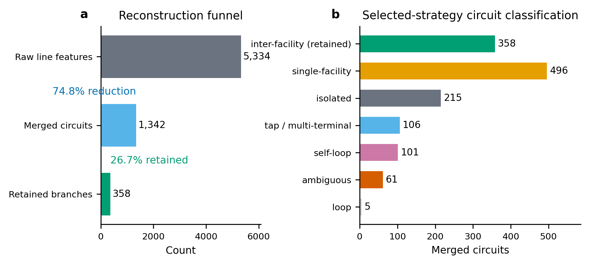
Record disposition for the selected reconstruction setting. The workflow processes 5,334 source line features into 1,342 circuit candidates, retains 358 inter-facility candidate branches, and preserves downgraded classes in the ledger. Retention denotes rule satisfaction under the documented workflow, not operator confirmation.
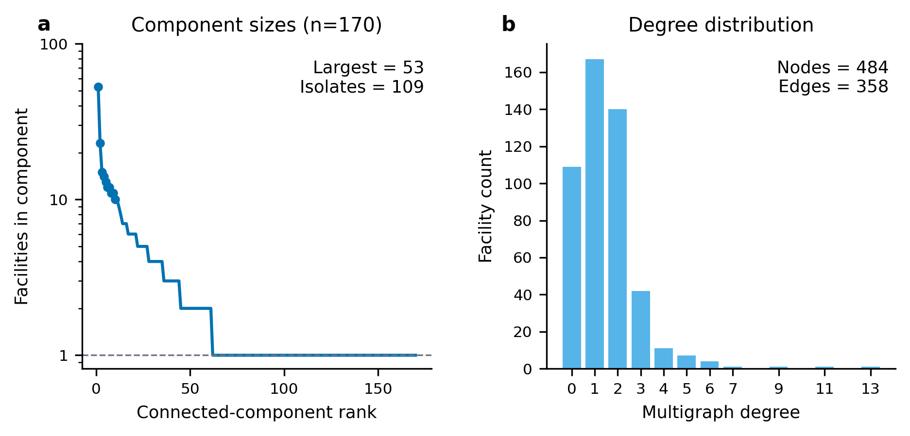
Aggregate structure of the selected candidate multigraph. Component sizes are shown on a logarithmic vertical scale and the degree histogram retains parallel edges. The figure describes the deposited graph artifact rather than the physical Portuguese network.

Technical Validation

Internal validation
The workflow applies fail-closed checks throughout acquisition, reconstruction, validation, and packaging. These checks include geometry-type and geometry-validity screening, coordinate-reference handling, endpoint completeness, facility-membership ambiguity, endpoint-cluster composition, mixed voltage or status conflicts, terminal-count classification, branch-key uniqueness, graph/table parity, schema coverage, manifest coverage, and checksum reconciliation.
Archive-level validation additionally checks that all 63 released files are documented, all manifest and checksum paths resolve, all 54 machine-readable paths have dictionary coverage, and the frozen headline counts agree with the core records. These results support internal usability of the deposited records, but they do not constitute external topology or electrical validation.

Structural validation
Structural validation focuses on whether the reconstructed records satisfy the declared topology-building rules. Under the selected setting, the workflow converts 5,334 line features into 1,342 merged circuit candidates, of which 358 are retained and 984 are downgraded. The downgraded outcomes comprise 496 single-facility records, 215 isolated records, 106 tap or multi-terminal records, 101 self-loops, 61 ambiguous records, and five loop records for the current snapshot. Preservation of these downgraded classes is itself a validation feature because it prevents silent loss of evidence about reconstruction uncertainty.

Schema validation
The release validates that required files, columns, and machine-readable summaries exist and remain aligned across the retained branch table, full ledger, GraphML, provenance, validation, and archive-control surfaces. The schema package distinguishes identifiers, observed and derived values, provenance metadata, validation variables, and explicit missing electrical fields.
For the frozen public-validation route, the internal validation export records 25 machine-readable checks across source geometry parsing, retained-branch completeness, ledger accounting, endpoint summaries, facility footprints, GraphML/table parity, sensitivity rows, and artifact hashes. The result is PASS_WITH_WARNINGS: 23 checks pass and two checks are release-review warnings rather than data-consistency failures. The release geometry and processing workspace are now documented in Data Record, while the exact wording of the upstream portal CRS remains unverified. The deterministic final-tag rebuild reproduces the deposited archive hash from the frozen derived inputs; raw/API reacquisition remains subject to the limitation stated in Usage Notes. The same export records 5,334 valid source geometries and zero invalid/dropped geometries; zero missing required retained-branch fields; zero missing required ledger fields; 358 retained branches; 984 downgraded or rejected records; 1,342 ledger rows; 64,008 endpoint-index rows across six snap thresholds; and 216 sensitivity rows.

Referential integrity
Referential checks confirm that endpoint facility references, GraphML node and edge identifiers, branch-level validation records, source manifests, and manifest-linked artifact relationships resolve to valid upstream records. Graph and table views are checked for parity so that the GraphML, retained branch table, and selected facility set remain consistent with the documented isolate policy.

Graph consistency
The selected all-facility graph contains 484 facilities, 358 multiedges, 170 connected components, a largest component of size 53, 109 isolates, and 28 parallel edges. The edge-induced graph contains 375 incident facilities, while the all-facility GraphML additionally preserves selected isolates. This accounting distinction is stored explicitly because graph artifacts with different isolate policies can otherwise appear inconsistent. Graph-level summaries therefore validate the released artifact against its own declared representation rather than against an external ground-truth network.
The GraphML/table parity check confirms that all 358 retained branch identifiers appear as GraphML edge identifiers, that no extra GraphML branch identifiers are present, and that every retained branch endpoint facility resolves to a GraphML node. The GraphML has 27 parallel facility pairs, 55 edge records participating in parallel pairs, and 28 extra parallel-edge records beyond one edge per facility pair. The missingness export also confirms that all retained-branch electrical fields r, x, b, thermal limits, transformer impedance, and tap settings remain explicitly marked as MISSING_NOT_ESTIMATED; these missing values are part of the release semantics rather than silent nulls.

Sensitivity analysis
Sensitivity analysis addresses whether the selected release point is stable under the declared reconstruction design space. The direct endpoint-to-substation baseline yields 51 merged edges and a six-node largest component, whereas the selected reconstruction yields 358 retained edges and a 53-node largest component for the current snapshot. These values describe yield and connectivity under two workflows; they are not treated as external accuracy improvements.
Across the 216-setting sweep, increasing the facility buffer from 100 m to 500 m at a 0.5 m endpoint snap threshold raises retained branches from 358 to 369 but also increases ambiguity from 61 to 89 and reduces the largest component from 53 to 27. At 50 m endpoint snapping, only three inter-facility circuits remain for each tested buffer. These results support the claim that reconstruction outputs are sensitive to plausible preprocessing settings and that the selected operating point is a documented trade-off rather than a uniquely correct solution.
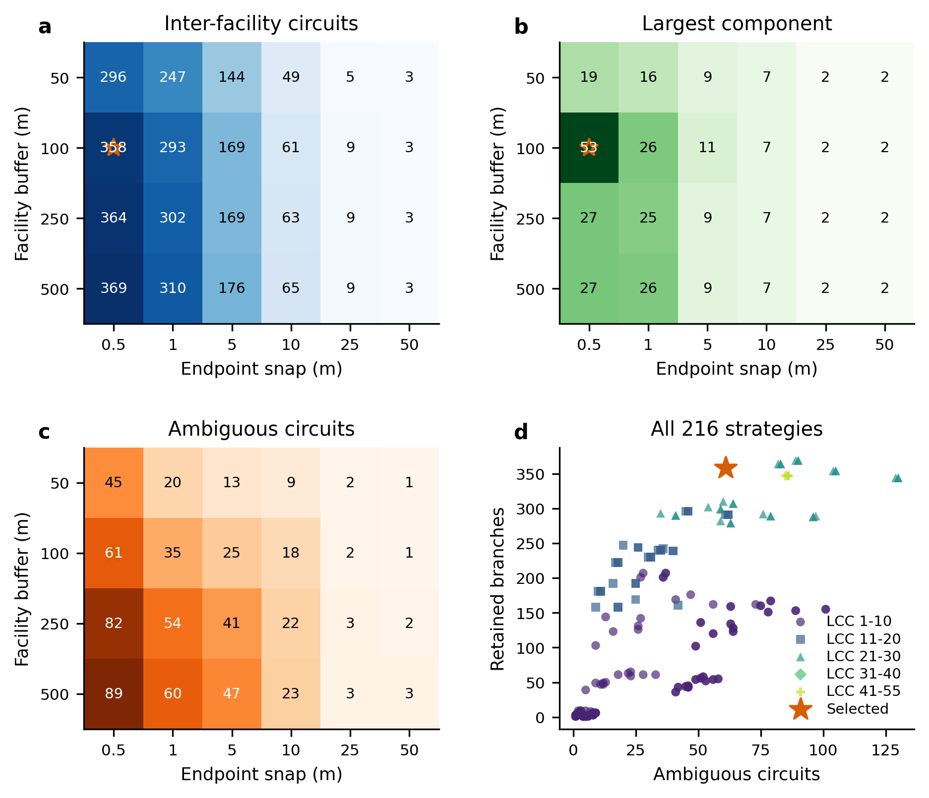
Sensitivity of retained-branch counts, ambiguity, and graph connectivity to facility buffers and endpoint snap thresholds. The marked operating point indicates the documented selected setting for the release; it is not an externally calibrated optimum.

External triangulation
The external triangulation workflow searches for branch-level public evidence outside the selected reconstruction rule. The current implementation uses OSM/OpenInfraMap 60 kV power=line and power=cable records in Portugal, caches the raw Overpass response, parses voltage, operator, name, reference, circuit, and geometry fields, and compares each retained branch against these public records by endpoint-name overlap and corridor proximity.
OSM/OpenInfraMap public-source triangulation for the 358 retained candidate branches. Categories describe review-prioritization evidence, not truth labels.
Evidence category | Branches | Interpretation
OSM_NAME_OPERATOR_STRONG | 183 | Endpoint names appear in a 60 kV E-REDES-labelled OSM record.
OSM_GEOMETRY_OPERATOR_STRONG | 64 | Candidate corridor is close to a 60 kV E-REDES-labelled OSM corridor.
OSM_PARTIAL_NAME_NEARBY | 56 | One endpoint name appears and a nearby 60 kV corridor is present.
OSM_GEOMETRY_MEDIUM | 48 | Candidate overlaps a 60 kV public corridor without strong name evidence.
OSM_NEARBY_WEAK | 7 | A nearby 60 kV public feature is present, but evidence is incomplete.
NO_EXTERNAL_OSM_MATCH | 0 | No retained branch falls in this class for the documented snapshot.
For the current snapshot, 5,551 Portuguese 60 kV public ways are cached and all 358 retained candidate branches receive a non-empty public-evidence category, with 247 strong, 104 medium, and seven weak matches. This result provides public-source concordance and a branch-level evidence index. It does not establish operator validation or branch accuracy, because OSM coverage and tagging are non-authoritative. To audit provenance risk, the release records current OSM metadata for the 5,551 cached public ways and full version histories for the 271 unique OSM ways matched to retained branches, covering 2,326 historical versions. The branch-level audit classifies 266 retained branches as having stronger inspectable public evidence, 87 as unknown independence, and five as possibly same-source or operator-tag-only evidence. These categories distinguish public concordance from more inspectable public corroboration, but they still must not be interpreted as precision, recall, or confirmation of every retained branch.

Claim-bounded validation strategy
The release does not use human-adjudicated truth labels and does not report an accuracy metric. The validation argument is deliberately claim-bounded. Internal tests establish that the released records satisfy their declared schema, classification, provenance, and graph contracts. The 216-setting sweep quantifies sensitivity to reconstruction choices. The external comparison records concordance with a separately maintained public geospatial layer while preserving the evidence category and source caveat for every retained branch. Together, these tests support reproducibility, internal consistency, sensitivity transparency, and public-source triangulation; they do not support a claim that the inferred connections reproduce the operator’s true network.
The public-source comparison is evaluated at branch level but is not converted into binary ground truth. Consequently, the manuscript reports category counts and matching variables rather than precision, recall, $F_{1}$, or confidence intervals. Precision is not independently estimated, and national or real-network recall is not estimable because neither an authoritative branch census nor a probability sample of true Portuguese 60 kV connections is available.
Claim-bounded validation used in the public-source validation route. “Supported” refers to the stated dataset property, not to physical topology truth.
Validation layer | Supported interpretation | Interpretation explicitly excluded
Geometry, CRS, schema, and key checks | Machine-readable and internally coherent release | Correct physical connectivity
Ledger and graph/table parity | Complete accounting under declared rules | Completeness of the real grid
216-setting sensitivity sweep | Dependence on documented reconstruction choices | Externally optimal parameter setting
OSM/OpenInfraMap triangulation | Public-source name and corridor concordance | Operator validation or statistical accuracy
Electrical-readiness gates | Explicit identification of missing or diagnostic fields | AC power-flow or operational readiness
Two deterministic negative controls test whether the public-source matcher responds to deliberately broken evidence channels. First, an endpoint-name control was run on all 358 retained branches. The control keeps each branch geometry, voltage, status, length, confidence score, and branch identifier fixed, but replaces the endpoint-name pair with a length-stratified cyclic shift from another retained branch using seed 20260714. Under the unmodified endpoint names, 183 of 358 branches receive strong name-based OSM/OpenInfraMap evidence. Under corrupted endpoint names, this falls to 9 of 358 branches, a 95.1% relative reduction. Second, a spatial-alignment control keeps endpoint names and tabular branch attributes fixed but translates every branch geometry by +1.75 degrees longitude and +0.85 degrees latitude. All 358 transformed geometries remain valid and no records are excluded after transformation. Under the unmodified geometries, 290 of 358 branches satisfy the corridor-evidence criterion; under displaced geometries, this falls to 1 of 358 branches, a 99.7% relative reduction. These controls support the selectivity of the endpoint-name and corridor components of the matcher. They do not estimate topology accuracy, precision, recall, or operator validation.

Validation boundaries
The current validation evidence supports internal consistency, release transparency, sensitivity analysis, and public-source triangulation. It does not support claims of operator-confirmed topology accuracy, independently estimated branch precision, national-grid recall or completeness, or electrical-operating realism. Optional electrical-readiness artifacts remain diagnostic because branch-specific parameters, transformer details, control states, measured injections, and verified boundaries are incomplete or scenario-derived. The full diagnostic AC power-flow extension therefore remains outside the validated core dataset and should not be used to imply AC power-flow or OPF readiness.

Usage Notes

Intended uses
The core release is intended for topology-reconstruction studies, geospatial data integration, provenance-aware network analysis, uncertainty analysis, dataset-engineering experiments, and development of downstream graph or tabular interfaces that preserve release semantics. The retained branch table and circuit-classification ledger should be used together whenever a study depends on understanding what was retained, what was downgraded, and why.

Non-intended uses
The release is not intended for operational switching studies, protection analysis, security assessment, contingency analysis, congestion forecasting, infrastructure-targeting applications, emergency operations, asset-condition assessment, commercial network-capacity claims, regulatory network-capacity claims, or claims about the actual Portuguese grid. The candidate topology should not be described as operator-validated, and the optional diagnostic electrical and learning layers should not be described as measured system behavior.

Reading provenance and semantic status fields
Users should read semantic status fields before aggregating or modeling the records. Observed, derived, inferred, source-backed, scenario-assumed, benchmark-only, proxy, and missing fields represent distinct evidence types. Studies that require source-backed physical parameters or operator-confirmed connectivity should filter the release accordingly and should not treat inferred or scenario-derived fields as interchangeable with observations.

How to use GraphML
The GraphML is the most direct representation of the released candidate multigraph for graph analysis. It preserves the selected all-facility node set, including isolates, and therefore aligns with the documented component and degree summaries. Users comparing the GraphML with edge-induced views should account for the explicit isolate policy. Parallel edges are part of the released graph structure and should not be collapsed without documenting the transformation.

How to use CSV records
The retained candidate branch CSV is the preferred branch-level topology table. The circuit-classification ledger should be consulted whenever a downstream workflow depends on failure modes, ambiguity, or alternative selection rules. Validation CSV and JSON records document evidence categories, matcher controls, independence-risk categories, missingness, and archive-validation relationships. The six recommended joins in schema/join_relationships.csv should be used in preference to name-based joins.

Limitations
The release has four main limitations. First, it is a candidate topology derived from public E-REDES records rather than an operator-confirmed network model. Second, external triangulation provides public-source concordance categories rather than truth labels: precision is not independently estimated, and national or real-network recall cannot be estimated from the available records. Third, electrical parameters, transformer details, operating controls, and injections are incomplete or absent, so the release is not AC power-flow or OPF ready. Fourth, the DOI archive preserves the versioned derived dataset but not the raw E-REDES snapshots. Source identifiers, URLs, access timestamps, roles, and attribution are recorded, but the three topology-critical v2.1 export URLs returned HTTP 404 during the final clean-room reacquisition audit; raw/API-to-release byte reproduction is therefore not claimed.

Data Availability
PT60-Candidate version 1.0.0 is deposited in figshare (PortugueseOPD contributors 2026) at https://doi.org/10.6084/m9.figshare.32984021. The deposited file is PT60-Candidate-v1.0.0.tar.gz, SHA-256 b4a6c370fbf15c078e15b80a3bbc7f517750fdb763d59147b24f59cd160358d7. It contains the core topology, full circuit ledger, GraphML, sensitivity sweep, provenance, validation, schema, data-dictionary, licensing, attribution, manifest, and checksum records described in Data Record. Raw source downloads and optional diagnostic/interface artifacts are excluded as documented in excluded_artifacts.json. E-REDES-derived records remain subject to the attribution and indication-of-modification terms documented in DATA_LICENSE.md and ATTRIBUTION.md; the software licence does not replace those data terms.

Author Contributions
The author-responsibility statement will be completed when the final author list is supplied and before submission.

Acknowledgements
Acknowledgements, if applicable, will be finalized before submission.

Funding
The funding statement will be finalized before submission.

Competing Interests
The final competing-interests declaration will be supplied before submission.

Code Availability
The source code is publicly available at https://github.com/MingLeiZhou/PortugueseOPD. The deterministic dataset-release builder is frozen under annotated Git tag pt60-candidate-v1.0.0 at commit 1eb690302f35f7c0090c14c994d073539cbb5335; the complete manuscript, validation, packaging, and figure-generation snapshot is frozen under tag pt60-candidate-code-v1.0.0. The reference environment uses Python 3.12.9 and the versioned requirements.txt; the software is MIT licensed. The dataset archive is independently usable without installing the generation pipeline, but full regeneration from raw E-REDES/API responses is subject to the source-reacquisition limitation described in Usage Notes.

References
E-REDES. 2026. “E-REDES Open Data Portal.” Online data portal. https://e-redes.opendatasoft.com/pages/homepage/.
Hörsch, Jonas, Fabian Hofmann, David Schlachtberger, and Tom Brown. 2018. “PyPSA-Eur: An Open Optimisation Model of the European Transmission System.” Energy Strategy Reviews 22: 207–15. https://doi.org/10.1016/j.esr.2018.08.012.
Medjroubi, Wided, Ulf Philipp Müller, Malte Scharf, Carsten Matke, and David Kleinhans. 2017. “Open Data in Power Grid Modelling: New Approaches Towards Transparent Grid Models.” Energy Reports 3: 14–21. https://doi.org/10.1016/j.egyr.2016.12.001.
PortugueseOPD contributors. 2026. “PT60-Candidate: A Provenance-Tracked Candidate Dataset for Portuguese 60 kV Topology Reconstruction.” figshare. https://doi.org/10.6084/m9.figshare.32984021.
Rivera, Jose, Pezhman Nasirifard, Johannes Leimhofer, and Hans-Arno Jacobsen. 2019. “Automatic Generation of Real Power Transmission Grid Models from Crowdsourced Data.” IEEE Transactions on Smart Grid 10 (5): 5436–48. https://doi.org/10.1109/TSG.2018.2882840.
Wiese, Frauke, Ingmar Schlecht, Wolf-Dieter Bunke, Clemens Gerbaulet, Lion Hirth, Martin Jahn, Friedrich Kunz, et al. 2019. “Open Power System Data – Frictionless Data for Electricity System Modelling.” Applied Energy 236: 401–9. https://doi.org/10.1016/j.apenergy.2018.11.097.
Xiong, Bobby, Davide Fioriti, Fabian Neumann, Iegor Riepin, and Tom Brown. 2025. “Modelling the High-Voltage Grid Using Open Data for Europe and Beyond.” Scientific Data 12 (1): 277. https://doi.org/10.1038/s41597-025-04550-7.

