Q4

a.

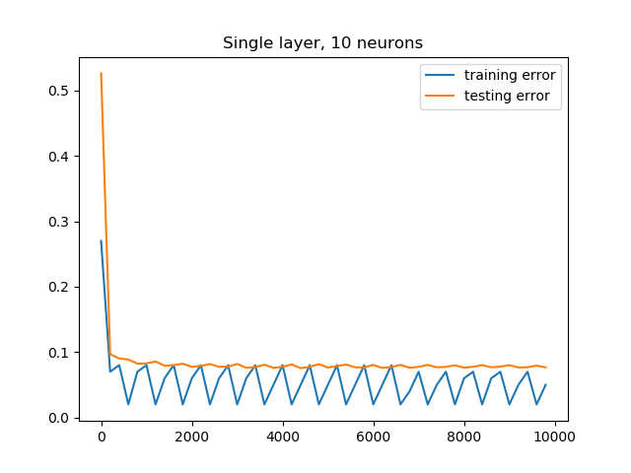

b.

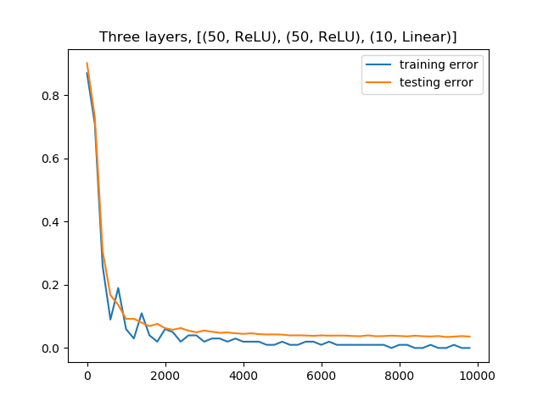

C Four layers, [(50, ReLU), (10, Linear), (50, ReLU), (10, Linear)]

