Contents

TAK BOLEH LOG IN 2

Update the parent name or ic (existing parent) 2

Receipt did not appear 2

Parent don’t have children 3

Parent having wrong school 3

Import student 3

Transfer student to another school 3

The parent with wrong children 4

# TAK BOLEH LOG IN

1. Make sure the admin provide these info (student name, student class, parent name , parent icon or telno)
2. Checking if the user and student exists
3. If not exist:
4. Request the data from the admin if needed
5. import again the data
6. End the process
7. Checking the current ic and telno used by the parent

|  |
| --- |
| **SELECT** *  **FROM** users u  **WHERE** u.telno = "xx" **OR** u.email = "xx" **OR** u.icno = "xx"; |

1. Target the target row to change, set the value to null for the inactive users (basically the user without email is the actual parent link to the student)

# Update the parent name or ic (existing parent)

1. If you have access to the database

|  |
| --- |
| **SELECT** *  **FROM** users u  **WHERE** u.name like “%sss%” |

1. Update the user column value
2. If without database access, login the user profile and update it in the profile page (make sure the admin and parent knowing the change before it)

# Receipt did not appear

1. Run this url, <https://prim.my/adminHandle?type=all>
2. If the problem did not solve try to check these
3. The transaction status in database
4. The transaction and user
5. The transaction with student_fees_new or fees_organization_user
6. Checking directpay
7. The class student end date and start date is between the transaction date

# Parent don’t have children

1. Checking both parent and child is existing
2. Checking the relationship using this query

|  |
| --- |
| **SELECT** ou.*  **FROM** students s  **JOIN** organization_user_student ous **ON** ous.student_id = s.id  **JOIN** organization_user ou **ON** ou.id = ous.organization_user_id  **JOIN** users u **ON** u.id = ou.user_id  **WHERE** s.id =13829; //or u.id = xx |

1. If the relationship is wrongly matched (may check using left or right join)
2. Update (better) or insert the missing row
3. Log in the user account and check again
4. Checking the class student status is active using

|  |
| --- |
| **SELECT** cs.*  **FROM** class_student cs  **WHERE** cs.student_id = “xxx” |

1. Checking the parent having the relationship with the school of his children

# Parent having wrong school

1. If the current organization_user is active, then can ignore it, because the record need to maintain so that previous receipt can be fetched
2. If the new organization_user did not generate well, try to insert new one in the database

# Import student

1. Make sure the organization was exist
2. Make sure the class to be import was exist
3. Make sure the old student was moving to the new class
4. Make sure the yuran did not add before it
5. Get the excel from the export button
6. Update the data to the excel as the format downloaded
7. Import the student, make sure the class and organization is selected correctly
8. Checking again in the compare student tab, and add all student

# Transfer student to another school

1. Same as import student but transfer process can be done by new school admin
2. Need to request the secure key from Mingxuan
3. Continue the process

# The parent with wrong children

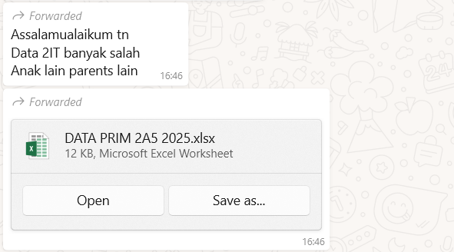

Assumption

* the students was in the same class
* The parent did not pay the yuran yet
* Mistake during the import the student

Steps :

1. Compare the student and parent to find the mis pair

|  |
| --- |
| **SELECT** s.id,s.nama, u.id, u.name  **FROM** students s  **LEFT** **JOIN** organization_user_student ous **ON** s.id = ous.student_id  **LEFT** **JOIN** organization_user ou **ON** ou.id = ous.organization_user_id  **LEFT** **JOIN** users u **ON** u.id = ou.user_id  **WHERE** s.nama **IN** (  'xxx',  'xxxxxx'  )  **ORDER** **BY** s.nama; |

1. Record the student name need to update and change
2. Update the query to select s.* and update the student name only in the result