北京邮电大学软件学院
2020-2021学年第二学期实验报告

课程名称： 大数据原理与技术

项目名称： 实验一：安装单机hadoop系统

项目完成人：
姓名： 殷铭阳 学号： 2018211914

指导教师：______ _____孙鹏飞____ _______

日 期： 2021年 3 月 22 日
- 实验目的
通过该实验完成伪分布式Hadoop系统的安装，并运行Hadoop系统自带的WordCount可执行程序文件，熟悉Hadoop系统的使用方法。

- 实验内容
- 每人在自己本地电脑上正确安装和运行伪分布式Hadoop系统；
- 安装完成后,自己寻找一组英文网页数据,在本机上运行Hadoop系统自带的WordCount可执行程序文件,并产生输出结果；
- 实验结果提交：要求书写一个实验报告，其中包括：
- 系统安装运行的情况
- 实验数据说明（下载的什么网页数据，多少个HTML或text文件）
- 程序运行后在Hadoop Web作业状态查看界面上的作业运行状态屏幕拷贝
- 实验输出结果开头部分的屏幕拷贝
- 实验体会

- 实验环境
- 一台hp计算机
- Linux操作系统（版本为Ubuntu20）
- VMware Workstations虚拟机平台
- SSH（Secure Shell）
- Java 1.8.0

- 实验结果
- 系统安装运行的情况
- 按照课件的过程进行安装和配置，完成后运行start-all.sh命令启动HDFS和MapReduce。
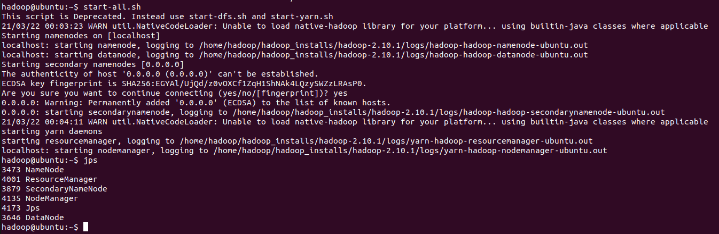
- 用JPS命令检查一下Hadoop是否正常启动，发现显示NameNode等六个进程信息。
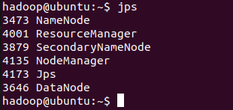
- 由上图可知，HDFS和MapReduce都已启动成功，Hadoop系统可以正常运行。
- 实验数据说明
- 本次实验使用安装配置好的Hadoop系统处理了两个.txt形式的文本文件，分别命名为test1和test2。其中，test1为某篇论文的英文摘要，test2为一篇英语文章。文本文件附在附录中。
- 这两个文本文件被放入名为input的HDFS文件夹中。
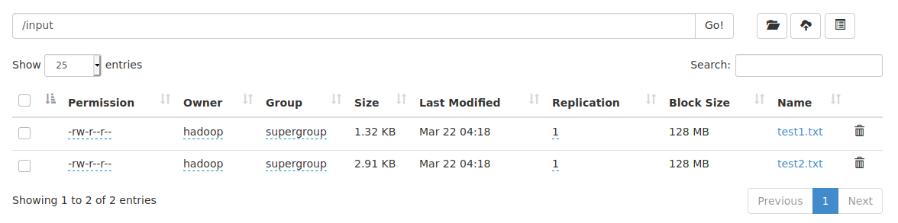
- 程序运行后在Hadoop Web作业状态查看界面上的作业运行状态屏幕拷贝
- 程序运行结束后，查看Hadoop Web页面，得到作业运行状态。发现此时Apps Completed数量变为1，且在下方记录着该作业的信息。
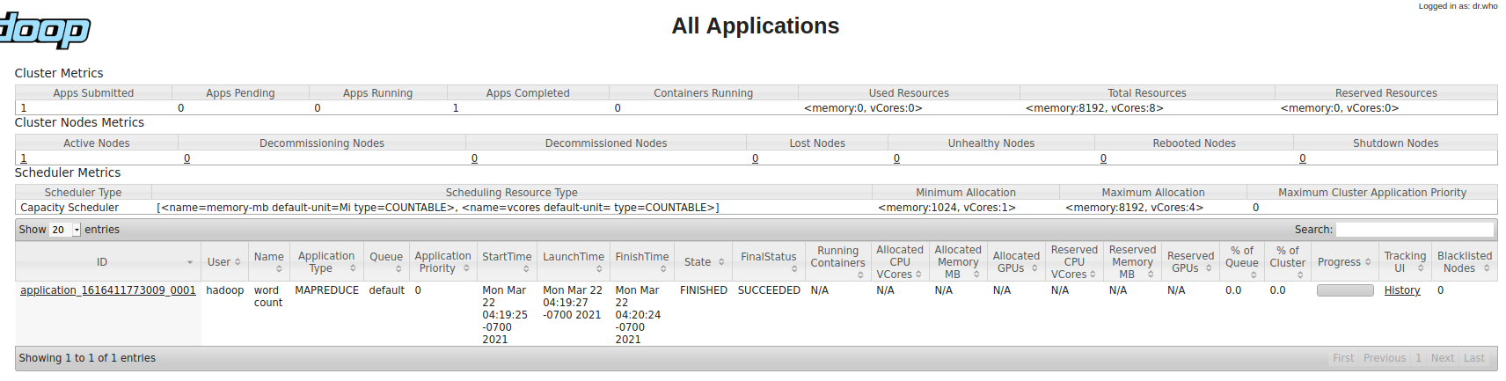
- 点击作业ID，可查看该作业的详细信息。
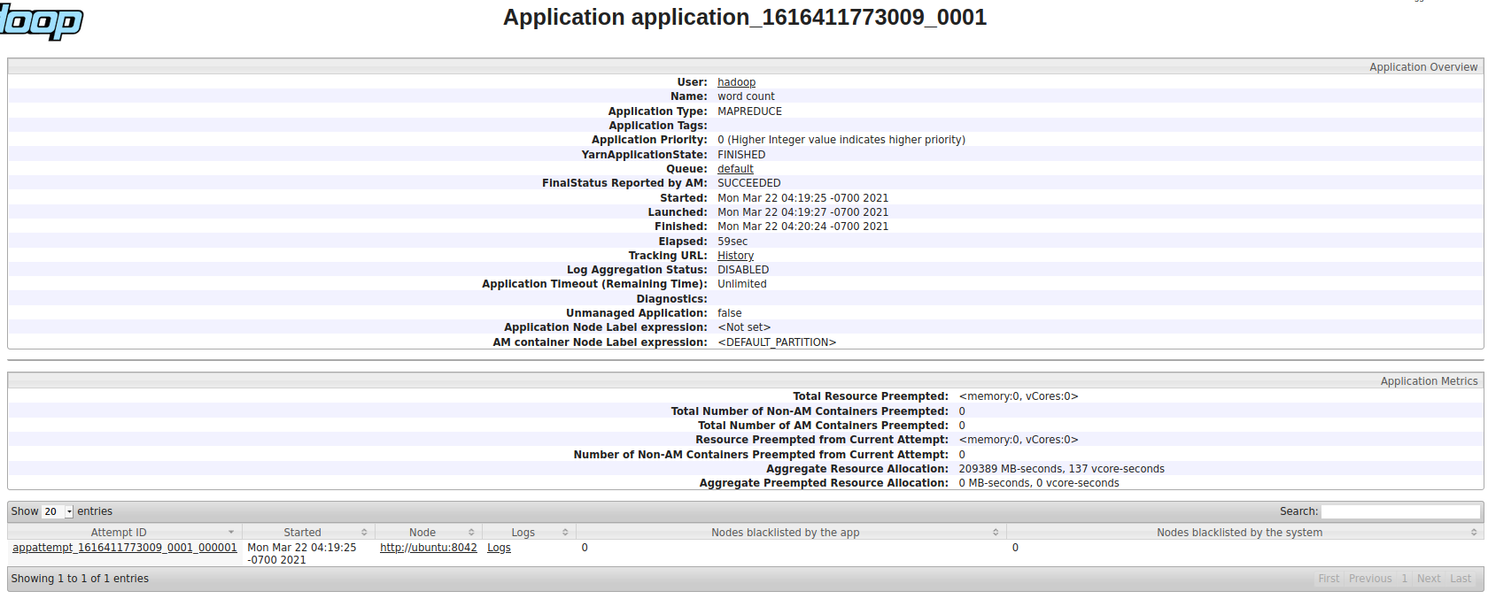
- 实验输出结果开头部分的屏幕拷贝
- 将要处理的文本文件上传至HDFS中，在本机上运行Hadoop系统自带的WordCount可执行程序文件，在终端中产生输出结果（只展示部分输出结果）。
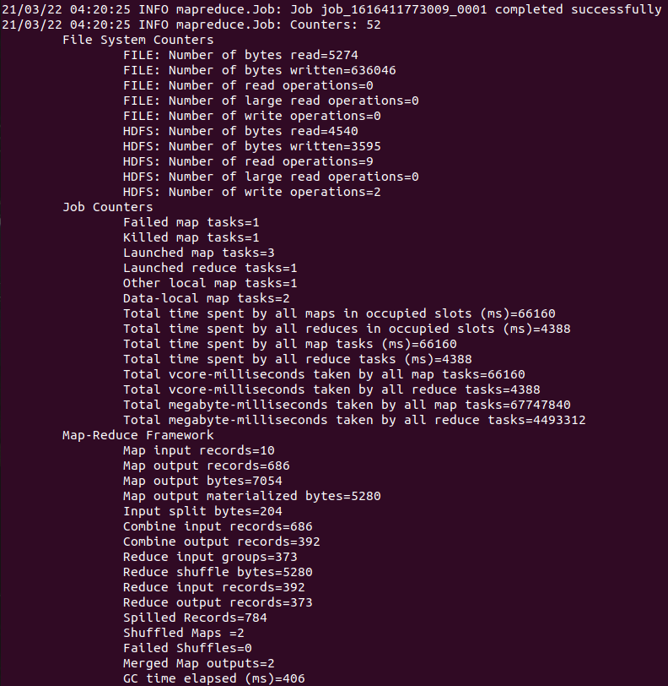
- 在浏览器中访问Browsing HDFS网站，下载输出文件，发现输出文件中成功记录了两个文本文件中出现的单词以及各个单词出现的总次数（在此只展示部分结果）。
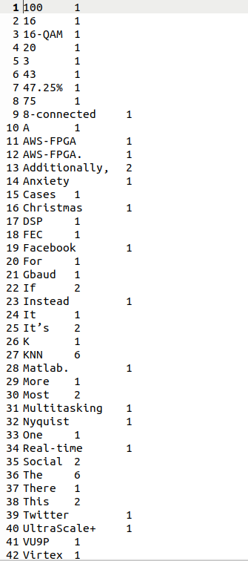
- 实验体会
在这次实验中，我按照老师给的指导步骤安装并部署了Hadoop系统，并在自己寻找的英文数据上运行了Hadoop系统自带的WordCount可执行程序文件，得到了输出结果。
在这次实验之前，Hadoop大数据平台与我而言更像是一个遥远而又模糊的概念，让我似懂非懂。在这次实验中，通过一步一步的安装、部署、使用Hadoop系统，我对Hadoop平台的认识也渐渐深刻起来。在实验中，遇到问题并通过上网查询、询问同学等方式慢慢解决问题的过程不仅锻炼了我的学习能力，也让我对Linux系统的一些命令更加熟悉。
总而言之，通过这次实验，我不仅熟悉了在Linux系统中使用Hadoop平台的方法，也更好的理解了Hadoop应用架构，让我对该大数据平台的理解更加深刻。

- 附录
- 实验数据
- test1.txt
A methodology for scalable and concurrent real-time implementation of highly recurrent algorithms is presented and experimentally validated using the AWS-FPGA. This paper presents a parallel implementation of a KNN algorithm focused on the m-QAM demodulators using high-level synthesis for fast prototyping, parameterization, and scalability of the design. The proposed design shows the successful implementation of the KNN algorithm for interchannel interference mitigation in a 3 × 16 Gbaud 16-QAM Nyquist WDM system. Additionally, we present a modified version of the KNN algorithm in which comparisons among data symbols are reduced by identifying the closest neighbor using the rule of the 8-connected clusters used for image processing. Real-time implementation of the modified KNN on a Xilinx Virtex UltraScale+ VU9P AWS-FPGA board was compared with the results obtained in previous work using the same data from the same experimental setup but offline DSP using Matlab. The results show that the difference is negligible below FEC limit. Additionally, the modified KNN shows a reduction of operations from 43 percent to 75 percent, depending on the symbol’s position in the constellation, achieving a reduction 47.25% reduction in total computational time for 100 K input symbols processed on 20 parallel cores compared to the KNN algorithm.

- test2.txt
relationships and social interactions have a dramatic impact on self-esteem and feelings of self-worth. Social networking sites like Facebook and Twitter have dramatically altered the way that people interact and connect on a daily basis. The popularity and degree to which these social media sites infiltrate everyday activities is changing the face of relationships of every kind. One of the major concerns that has caught the attention of many, is the potential impact that social media may be having on social anxiety disorders.

If removed from their phone for a few hours or a few days, the average person would likely report feeling anxious and stressed out about not being “connected.” Instead of becoming an extension of personal relationships, an online presence often replaces them. More time is being spent interacting digitally than in real settings. Most people have probably experienced a scenario in which they posted a creative photo or a witty status, and waited eagerly to see how many “likes” or “retweets” they received. If this number is lower than expected, the ego is going to take a hit. There is also constant monitoring of the number of “followers” and “friends” that you have, and these numbers can make a direct impact on feelings of acceptance and popularity.

Anxiety can arise from feeling overwhelmed by having too much going on at one time. Multitasking can very quickly lead to increased levels of anxiety. Most people can likely relate to feeling the constant need to check their profiles while driving, during meals or at work. This obsessive desire is actually leading to increased levels of anxiety. The option to be constantly connected invokes the feeling of having to always make yourself available. It is becoming more obvious that rises in anxiety disorders can be attributed, in part, to social media and the pressures to be involved.

Social anxiety is much different than the anxiety one feels from being offline, away from one’s phone or disconnected from social media and the constant status updates we’ve grown so accustomed to getting. It’s a more serious type of anxiety resulting from fear of being judged or evaluated by others while in a social interaction. Cases can range from mild ─ and are often the cause of a lot of “social lubrication” or drinking with others ─ to severe, in which case a person may altogether avoid parties and get-togethers. For the latter types, a company Christmas party makes them cringe with uneasiness.

The degree to which social media and technology are changing our lives and introducing new forms of anxiety is all but deniable. The real question is to what extent is it introducing new disorders or increasing existing ones like social anxiety. It’s certainly a topic worth studying more to determine who is being helped, who is being harmed and more importantly how can social anxiety be treated as social media is added to the mix.

