**INFO 6250 Final Project Report Mingda Ju 001810212**

***Summary***

It is a course registration website, which can help admin manage course database and students account, and help students create account, search courses, create register plan and register courses.

***User Roles and performed tasks***

There are two roles in this system. One is admin. The Admin can manage course database, like add/delete/update new semester, add/delete/update new courses. (The relationship between semester sand courses is OneToMany, which means under one semester, there will be many courses.) Besides, admin can also mange student accounts.

The other one is students. Students can create their accounts and search courses under specific semester, and they can set many limitation keywords to improve their search efficiency. What’s more, they can add courses which they want to take to the register plans they created. (The relationship between users and plans is OneToMany, which means one user can have many plans.) It can help them save time because they can register courses directly under their register plan page instead of searching it. When they successfully register the course, they will receive an email that contain their registration information.

***Functionality***

**Admin:**

In this page, admin can manage course database, they can add/delete/update semesters and add new semesters under each semester then go the course details.

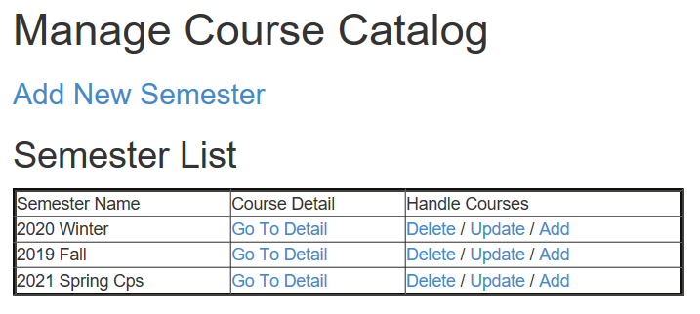

In this page, admin can view the course detail, including course name, professor, CRN, location, credit. And then admin can delete/update course.

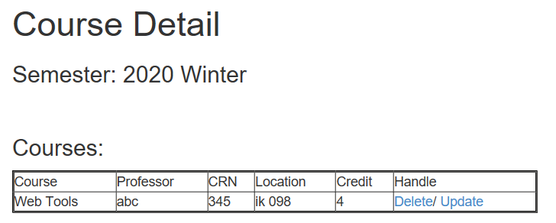

In this page, admin can add courses depend on the number he inputs. It can improve the efficiency of adding work.

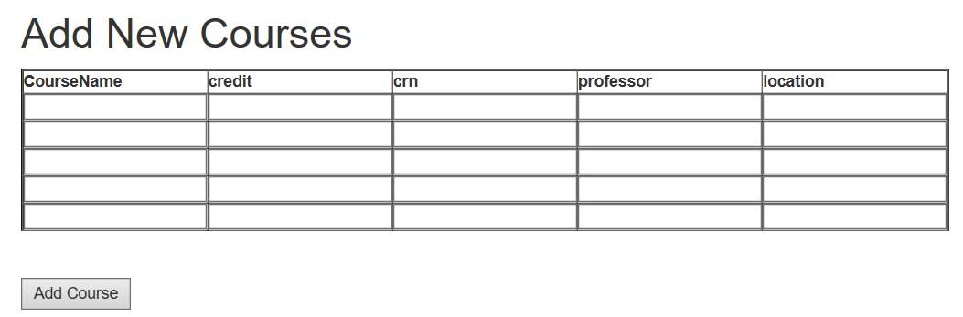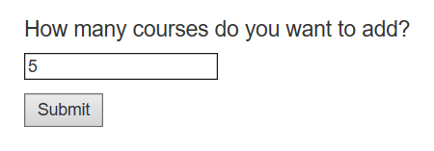

In this page, admin can manage the student account

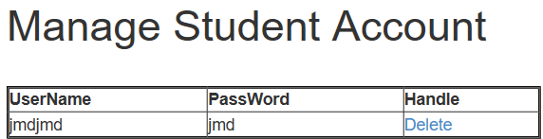

**Students:**

This is the Home Page of the student role. So, students can view their register plan and semester list that admin created.

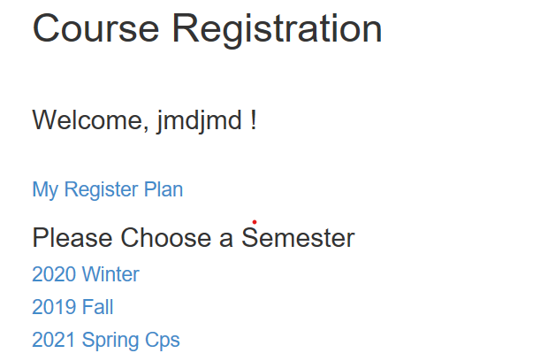

This page is the search course page for student. Students can search courses under many keyword restrictions. And there is also a table for them to see all the courses under this semester.

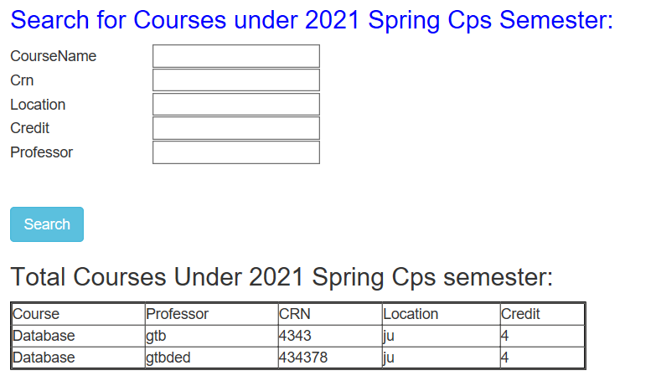

This is the search result page. It will show the courses result to students and they can add their courses to the plan they want to register.

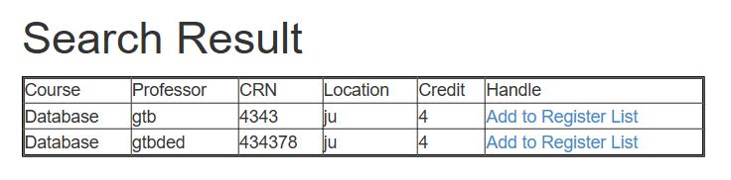

This is the register list page. Student can create new register list. And then they can add courses to the list they select.

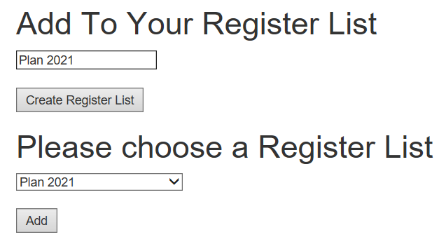

This is the plan details, which show you the courses you want to register under your plan. And click ‘register’ to register course, and then you will receive a confirmation email with the course detail.

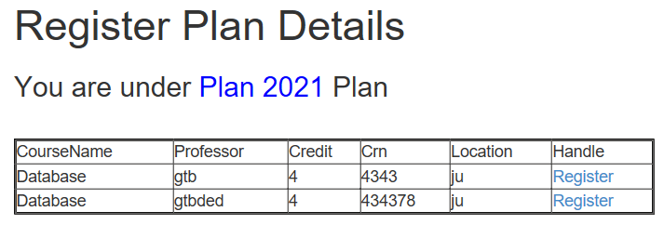

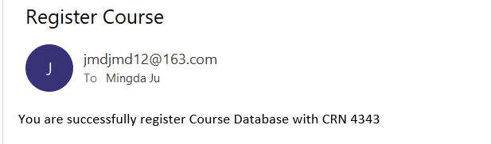

***Technologies***

**Declarative Web Application Security -> For admin Login**

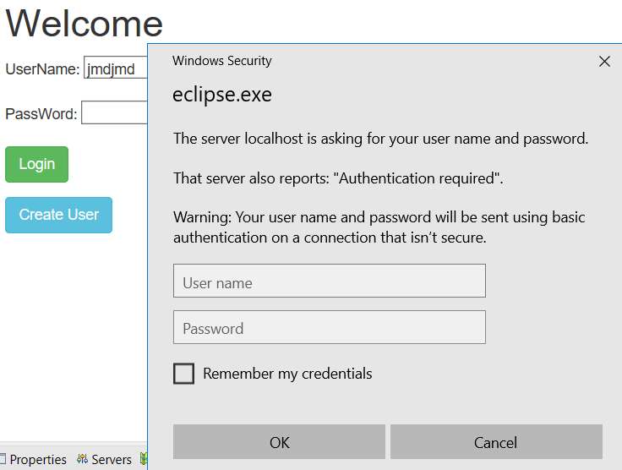

**AJAX -> For checking if the username has been used**

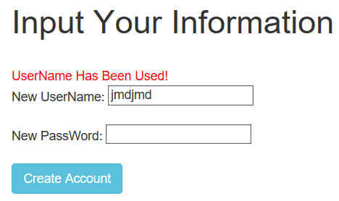 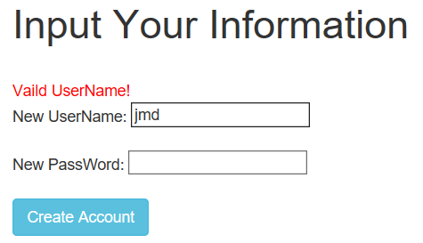

***Controller code***

@Controller

**public** **class** CourseController {

//semester list

@RequestMapping(value="/mingda.htm", method = RequestMethod.***GET***)

**public** String showAllSemesters(HttpServletRequest request ,CourseDao dao){

List<Semester> semlist = dao.showAllSemesters();

HttpSession session = request.getSession();

session.setAttribute("semli", semlist);

**return** "SemesterList";

}

//view all semester

@RequestMapping(value="/mingda/view.htm", method = RequestMethod.***GET***)

**public** String viewSemest(HttpServletRequest request, CourseDao dao, ModelMap map){

**int** semesterid = Integer.*parseInt*(request.getParameter("semid"));

Semester semester = dao.getSemesterId(semesterid);

HttpSession session = request.getSession();

session.setAttribute("semesterid", semesterid);

session.setAttribute("semester", semester);

**if**(semester!=**null**){

**return** "CourseDetail";

}

**else** {

map.addAttribute("errorMessage", "Sorry, Something Wrong!");

**return** "ErroePage";

}

}

//add semester success

@RequestMapping(value="/mingda/addsuccess.htm", method = RequestMethod.***GET***)

**public** String addsem(HttpServletRequest request){

**return** "AddSemester";

}

//add semester

@RequestMapping(value="/mingda/add.htm", method = RequestMethod.***GET***)

**public** String addSemest(HttpServletRequest request){

**return** "redirect:/mingda.htm?";

}

//add semester

@RequestMapping(value="/mingda/add.htm", method = RequestMethod.***POST***)

**public** String addSemesPOST(HttpServletRequest request, CourseDao dao, ModelMap map){

String semestertname = request.getParameter("semname");

Semester semester = **new** Semester();

semester.setSemestername(semestertname);

semester.setCourseList(**new** ArrayList<Course>());

dao.addSemest(semester);

**return** "redirect:/mingda.htm?";

}

//jump to count page

@RequestMapping(value="/mingda/jumpcount.htm", method = RequestMethod.***GET***)

**public** String CourseCount(HttpServletRequest request, ModelMap map){

**int** se = Integer.*parseInt*(request.getParameter("semid"));

HttpSession session = request.getSession();

session.setAttribute("semesterid", se);

**return** "AddCourseCount";

}

//get add courses num

@RequestMapping(value="/mingda/addnum.htm", method = RequestMethod.***GET***)

**public** String handlenumberForm(HttpServletRequest request){

**int** semmid = Integer.*parseInt*(request.getParameter("sseeid"));

HttpSession session = request.getSession();

session.setAttribute("semmid", semmid);

String bookNumber = request.getParameter("count");

**int** bn = Integer.*valueOf*(bookNumber);

request.setAttribute("count", bn);

**return** "AddCourses";

}

//get add courses num

@RequestMapping(value="/mingda/addnum.htm", method = RequestMethod.***POST***)

**public** String handlenumber(HttpServletRequest request){

HttpSession session = request.getSession();

session.getAttribute("semmid");

request.getAttribute("count");

**return** "AddCourses";

}

// add course success

@RequestMapping(value="/mingda/couAdd.htm", method = RequestMethod.***GET***)

**public** String addCouGET(HttpServletRequest request){

**int** seemid = Integer.*parseInt*(request.getParameter("sseeid"));

HttpSession session = request.getSession();

session.setAttribute("sseeid", seemid);

**return** "AddSuccess";

}

//add courses

@RequestMapping(value="/mingda/couAdd.htm", method = RequestMethod.***POST***)

**public** String addCouPOST(HttpServletRequest request, CourseDao dao){

HttpSession session = request.getSession();

**int** semesterid = (Integer)session.getAttribute("semesterid"); //get primary key from semester

String[] coursename = request.getParameterValues("coursename"); //get array of courses added

String[] credit = request.getParameterValues("credit");

String[] professor = request.getParameterValues("professor");

String[] location = request.getParameterValues("location");

String[] crn = request.getParameterValues("crn");

Semester semid = dao.getSemesterId(semesterid);

**for**(**int** i=0;i<coursename.length;i++) { //count how many courses added

Course course = **new** Course();

course.setSemester(semid); //set foreign key

course.setCoursename(coursename[i]);

course.setCredit(credit[i]);

course.setProfessor(professor[i]);

course.setLocation(location[i]);

course.setCrn(crn[i]);

dao.addCourse(course);

}

**return** "AddSuccess";

}

//delete semester

@RequestMapping(value="/mingda/delete.htm", method = RequestMethod.***GET***)

**public** String delSem(HttpServletRequest request, CourseDao dao){

**int** seemm = Integer.*parseInt*(request.getParameter("semid"));

dao.delSemes(seemm);

**return** "redirect:/mingda.htm?";

}

//delete course

@RequestMapping(value="/mingda/coursedel.htm", method = RequestMethod.***GET***)

**public** String deleteCla(HttpServletRequest request, CourseDao dao){

**int** couid = Integer.*parseInt*(request.getParameter("courseid"));

**int** semid = Integer.*parseInt*(request.getParameter("semesdel"));

HttpSession session = request.getSession();

session.setAttribute("semesdel", semid);

dao.delCourse(couid);

**return** "DeleteClass";

}

//update course

@RequestMapping(value="/mingda/couUpdate.htm", method = RequestMethod.***GET***)

**public** String updateCourse(HttpServletRequest request, Model model, CourseDao dao){

HttpSession session = request.getSession();

**int** semid = Integer.*parseInt*(request.getParameter("semesupd"));

**int** courseidd = Integer.*parseInt*(request.getParameter("courseid"));

session.setAttribute("semesupd", semid);

Course thec = dao.getCourse(courseidd);

model.addAttribute("updatecourse",thec);

**return** "update-course";

}

//save update course

@RequestMapping(value="/mingda/cousave.htm", method = RequestMethod.***POST***)

**public** String saveCourse(HttpServletRequest request, Course thec, CourseDao dao) {

dao.update(thec);

**return** "redirect:/mingda.htm?";

}

//update semester

@RequestMapping(value="/mingda/update.htm", method = RequestMethod.***GET***)

**public** String updateSemester(HttpServletRequest request, Model model, CourseDao dao){

**int** semesterid = Integer.*parseInt*(request.getParameter("semid"));

Semester thesemester = dao.getSemesterId(semesterid);

model.addAttribute("updatesemester",thesemester);

**return** "update-semester";

}

//save semester

@RequestMapping(value="/mingda/save.htm", method = RequestMethod.***POST***)

**public** String saveSemester(HttpServletRequest request, Semester semester, CourseDao dao) {

dao.updateSemester(semester);

**return** "redirect:/mingda.htm?";

}

}

**public** **class** AjaxController {

//Check whether username is vaild from database

@RequestMapping(value = "/check.htm", method = RequestMethod.***POST***)

@ResponseBody

**public** String checkUserNameExisted(HttpServletRequest request, UserDAO userdao) {

String username = request.getParameter("username");

User u = userdao.get(username);

**if** (u == **null**) {

**return** "Vaild UserName!";

} **else** {

**return** "UserName Has Been Used!";

}

}

}

**public** **class** EmailController {

**public** EmailController(){

}

//Register course

@RequestMapping(value = "/submitCourse.htm", method = RequestMethod.***GET***)

**public** String submitForm(HttpServletRequest request, User user) {

String cid = request.getParameter("cid"); //get current course info

String crn = request.getParameter("ccrn");

System.***out***.print(cid);

System.***out***.print(crn);

sendEmail("You are successfully register Course " +cid+" with CRN "+crn);

**return** "submitSuccess";

}

//Send Email to User

**public** **void** sendEmail(String mess ) {

**try** {

Email email = **new** SimpleEmail();

email.setDebug(**true**);

email.setHostName("smtp.163.com");

email.setSmtpPort(465);

email.setAuthenticator(**new** DefaultAuthenticator("jmdjmd12@163.com", "Jumd12345")); //get sender email account

email.setSSLOnConnect(**true**);

email.setFrom("jmdjmd12@163.com"); //Sender

email.addTo("ju.m@northeastern.edu"); //Receiver

email.setSubject("Register Course ");

email.setMsg(mess);

email.send();

} **catch** (EmailException e) {

System.***out***.println("Email cannot be sent");

}

}

}

**public** **class** AdminController {

@RequestMapping(value="/admin/login.htm", method = RequestMethod.***GET***)

**public** String adminLogin(HttpServletRequest request){

**return** "AdminHome";

}

@RequestMapping(value="/admin/manageUser.htm", method = RequestMethod.***GET***)

**public** String manageUserAccount(HttpServletRequest request ,UserDAO udao){

List<User> userlist = udao.displayAll();

HttpSession session = request.getSession();

session.setAttribute("userlist", userlist);

**return** "ManageUser";

}

@RequestMapping(value="/admin/registercourse.htm", method = RequestMethod.***GET***)

**public** String receiveCourseInfoGET(HttpServletRequest request){

HttpSession session = request.getSession();

User user = (User) session.getAttribute("currentUser");

List<RegisterPlan> plan = user.getNewPlan();

session.setAttribute("userCourseInfo", plan);

**return** "registerInfo";

}

@RequestMapping(value = "/admin/deleteUser.htm", method = RequestMethod.***GET***)

**public** String deleteUser(HttpServletRequest request,UserDAO userdao) {

**int** user = Integer.*parseInt*(request.getParameter("deleteUser"));

userdao.delete(user);

**return** "redirect:/admin/manageUser.htm";

}

}

@Controller

**public** **class** UserController {

//User Login

@RequestMapping(value = "/user/login.htm", method = RequestMethod.***GET***)

**public** String userLoginGet(HttpServletRequest request) {

**return** "UserLogin";

}

//User Login and Show User all semesters

@RequestMapping(value = "/user/login.htm", method = RequestMethod.***POST***)

**public** String userLoginPost( HttpServletRequest request, UserDAO userdao, ModelMap map, CourseDao dao) {

List<Semester> semesterList = dao.showAllSemesters();

HttpSession session = request.getSession();

session.setAttribute("semesterList", semesterList);

String username = request.getParameter("username");

String password = request.getParameter("password");

**try** {

User user = userdao.get(username, password);

**if** (user != **null** ) {

session.setAttribute("currentUser", user);

//session.setMaxInactiveInterval(120*60);

**return** "userHome";

} **else** {

map.addAttribute("errorMessage", "UserName or PassWord is Wrong");

**return** "ErrorPage";

}

}

**catch** (Exception e) {

System.***out***.println(e.getMessage());

}

**return** "UserLogin";

}

//Create user

@RequestMapping(value = "/user/create.htm", method = RequestMethod.***GET***)

**public** String userCreateGet(HttpServletRequest request){

**return** "user-create";

}

//Create user

@RequestMapping(value = "/user/create.htm", method = RequestMethod.***POST***)

**public** String userCreatePost(HttpServletRequest request,UserDAO userdao, ModelMap map){

String username = request.getParameter("username");

String password = request.getParameter("password");

User newuser = userdao.add(username, password);

request.setAttribute("newuser", username);

**if**(newuser!=**null**){

**return** "createUser";

}

**else** {

map.addAttribute("errorMessage", "UserName Already Exist");

**return** "ErroePage";

}

}

//Go to Courses under which Semester

@RequestMapping(value = "/user/semesterList", method = RequestMethod.***GET***)

**public** String goToSearchGET(HttpServletRequest request, CourseDao dao, ModelMap map ) {

**int** semesterid = Integer.*parseInt*(request.getParameter("semesterid"));

Semester semester = dao.getSemesterId(semesterid);

HttpSession session = request.getSession();

session.setAttribute("semesterid", semesterid);

session.setAttribute("semester", semester);

**if**(semester!=**null**){

**return** "SearchCourse";

}

**else** {

map.addAttribute("errorMessage", "Sorry, Something Wrong!");

**return** "ErroePage";

}

}

}

**public** **class** RegisterController {

**public** RegisterController(){

}

//Go to search page under specific semester

@RequestMapping(value = "/user/search.htm", method = RequestMethod.***GET***)

**public** String search(HttpServletRequest request, CourseDao dao, ModelMap map) {

**int** semesterid = Integer.*parseInt*(request.getParameter("semesterid"));

Semester semester = dao.getSemesterId(semesterid);

HttpSession session = request.getSession();

session.setAttribute("semesterid", semesterid);

session.setAttribute("semester", semester);

**if**(semester!=**null**){

**return** "CourseResult";

}**else** {

map.addAttribute("errorMessage", "Sorry, Something Wrong!");

**return** "ErroePage";

}

}

//Get Search Information

@RequestMapping(value = "/user/search.htm", method = RequestMethod.***POST***)

**public** String searchCourse(HttpServletRequest request, RegisterDao dao) {

HttpSession session = request.getSession();

String searchText = request.getParameter("pro");

String searchTextt = request.getParameter("rcn");

String searchTexttt = request.getParameter("course");

String searchTextttt = request.getParameter("location");

String searchTexttttt = request.getParameter("credit");

List<Course> searchResult = dao.mutiSearchCourse(searchText,searchTextt,searchTexttt, searchTextttt, searchTexttttt);

session.setAttribute("result",searchResult);

**return** "CourseResult";

}

//View Plan List You have

@RequestMapping(value = "/user/jumpToPlanList.htm", method = RequestMethod.***GET***)

**public** String jumpToPlanListGet(HttpServletRequest request) {

HttpSession session = request.getSession();

User user = (User) session.getAttribute("currentUser");

List<RegisterPlan> plan = user.getNewPlan();

session.setAttribute("userPlan", plan);

**int** cuis = Integer.*parseInt*(request.getParameter("courseid"));

session.setAttribute("newcou", cuis);

**return** "coursePlanHome";

}

//add Plan

@RequestMapping(value = "/user/addPlan.htm", method = RequestMethod.***GET***)

**public** String createPlanList(HttpServletRequest request) {

**return** "coursePlanHome";

}

//add plan under current User

@RequestMapping(value = "/user/addPlan.htm", method = RequestMethod.***POST***)

**public** String handlePlaylistForm(HttpServletRequest request, RegisterDao dao ) {

HttpSession session = request.getSession();

String plan = request.getParameter("regname");

User u = (User)session.getAttribute("currentUser");

RegisterPlan reg = **new** RegisterPlan();

reg.setPlanname(plan);

reg.setRegcourse(**new** ArrayList<Course>());

reg.setUser(u); //add currentUser

dao.addPlaylist(reg);

u.getNewPlan().add(reg);

**return** "coursePlanHome";

}

//add course to plan

@RequestMapping(value = "/user/addCoursePlan.htm", method = RequestMethod.***GET***)

**public** String courseToPlanGET(HttpServletRequest request, RegisterDao dao) {

HttpSession session = request.getSession();

**int** cid = Integer.*parseInt*(request.getParameter("courseid"));

session.setAttribute("newcou", cid);

**return** "courseToPlan";

}

//add course to plan

@RequestMapping(value = "/user/addCoursePlan.htm", method = RequestMethod.***POST***)

**public** String courseToPlanPOST(HttpServletRequest request, RegisterDao dao, CourseDao cdao) {

HttpSession session = request.getSession();

**int** pid = Integer.*parseInt*(request.getParameter("selectplanlist"));

**int** cid = (Integer)session.getAttribute("newcou");

Course cur = cdao.getCourse(cid);

RegisterPlan reli = dao.findPlan(pid);

dao.setPlan(reli);

**return** "courseToPlan";

}

//view plan detail

@RequestMapping(value = "/user/viewPlan.htm", method = RequestMethod.***GET***)

**public** String viewPlaylist(HttpServletRequest request, RegisterDao dao) {

**int** reliid = Integer.*parseInt*(request.getParameter("planid"));

RegisterPlan reg = dao.findPlan(reliid);

List<Course> courseList = reg.getRegcourse();

HttpSession session = request.getSession(**false**);

session.setAttribute("playlist", reg);

session.setAttribute("courseList",courseList);

**return** "finalPage";

}

//show all the Plan

@RequestMapping(value = "/viewPlan.htm", method = RequestMethod.***GET***)

**public** String planList(HttpServletRequest request, ModelMap map) {

HttpSession session = request.getSession();

User user = (User) session.getAttribute("currentUser");

List<RegisterPlan> plan = user.getNewPlan();

session.setAttribute("userPlan", plan);

**if**(user!=**null**){

**return** "RegisterPlan";

}**else** {

map.addAttribute("errorMessage", "Sorry, Something Wrong!");

**return** "ErroePage";

}

}

}