Report of Travel Agency

## Introduction

In this assignment, our group aims to design a JAVA application to help the travel agency manage the customers. Besides, we also designed a method the help the customer rent cars from a rental company and book a room from a hotel. In the following part of this report, we will use the sequence diagram and object model to show the structure design and data flow of our program.

The object model is a picture which can show all the object and list that will be created by the program, the picture will also show the attributes of which the object contains. The sequence diagram is a picture to show the data flow from one object to another. We think it is a good way to show users and other readers the concept and implementation of our program by combining these two charts together. In the following part of report, we will thoroughly explain the designment and thinking of these 2 charts.

## Class model

The UML class model shows the structural activities of the system, in which attributes and operations are designed. Different properties like association, aggregation, inheritances are designed and shown in the UML class model.

This figure (Fig1) shows the joint impact of rental part and hotel part. By combining these two parts, we can help the customer to check or manage their travel plan.

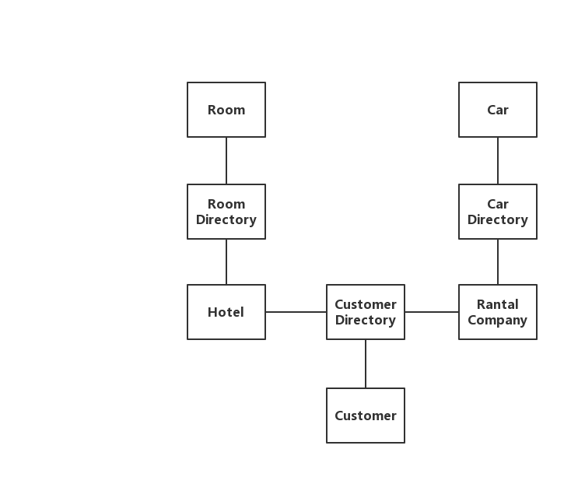

Fig(1)

The Class Model of the rental part is shown as Fig(2). This part of design can help the customers rental a car from a rental company, besides, it can also help the customers to check their orders so that they can manage their travel plan. It contains five major classes, includes Customer, Customer Directory, Rental Company, Car Directory and Car. Customer class has all the information about the customer, such as customer name and the flight number, the car reservation number, the hotel reservation number he/she had booked, so that he/she can manage his/her travel schedule. The customer Directory class stores every customer’s information. The rental company class has attributes that related to the information of the company. Besides, it also has the directory of the cars that it owns. The car class has all the information about the car, such as the car’s VIN, available time, price, brand, etc. Like the Customer Directory class, the Car Directory class includes every car’s information.

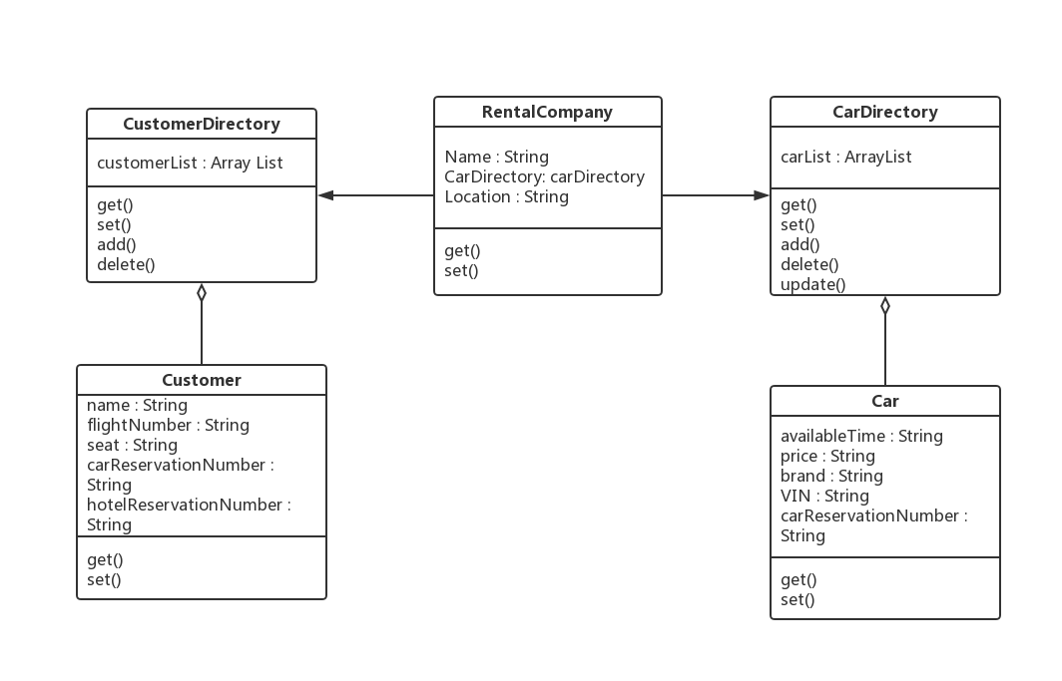

Fig(2)

The Class Model of the hotel part is shown as Fig(3). This part of design can help the customers book a room from a hotel, besides, it can also help the customers to check their orders so that they can manage their travel plan. It contains five major classes, includes Customer, Customer Directory, Hotel, Room Directory and Room. The Customer Directory class and the Customer class are same as the rental part. The Hotel class stores all the information of the hotel, includes name, location. It also has the directory of the rooms that it owns. The room class has the attributes that related to this room, every room has a unique room number, so it will be more convenient for the hotel to book a room for the customer. The room directory has all rooms’ information.

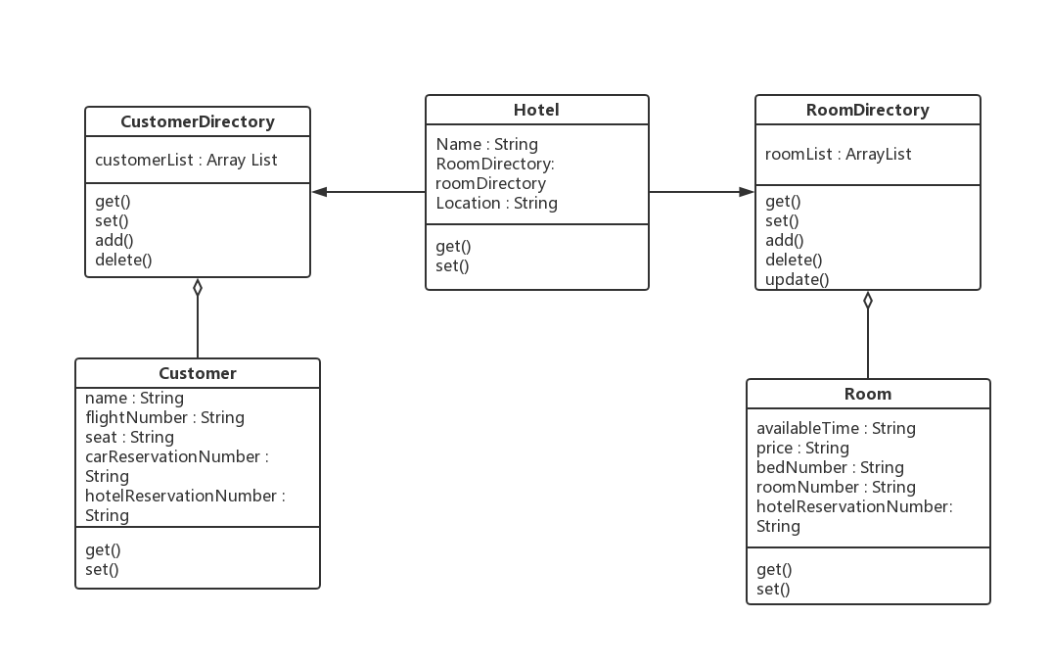

Fig(3)

## Sequence Diagram

A sequence diagram is a set-up of objects and messages. The sequence diagram of the rental part is shown as the Fig(4). This figure shows how a rental company help the customer rent a car. It has four objects which are shown one the diagram in a rectangles box with their class names. These four objects are Rental Company, Car Directory, Customer and Customer Directory. According to this diagram, a customer can search a car they want from the Car Directory by searching the available time, brand or other attributes. Then they can write the car’s VIN down and tell the Rental Company. The company can search this VIN and find the car from the Car Directory, because every car has a unique VIN. After finding the car, the Rental Company can create a new Customer and add it to the Customer Directory. At last, the Customer can search their name then this application will show all the orders they have made. Finally, they can check and let the rental company to cancel their orders.

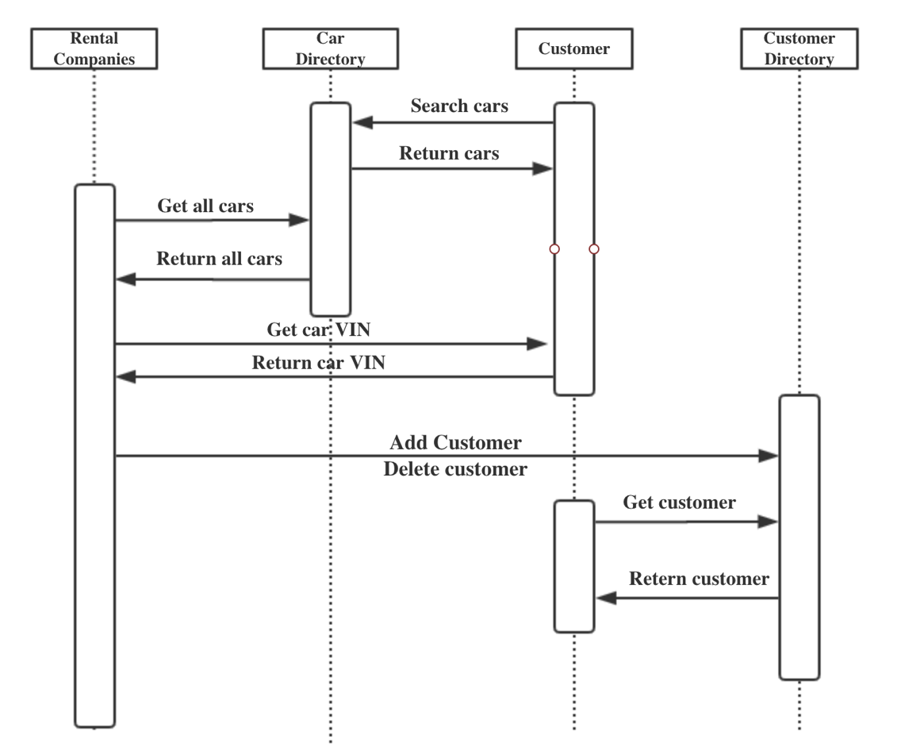

Fig(4)

The sequence diagram of the hotel part is shown on the Fig(5). This figure shows how a hotel help the customer book a room. It has four objects which are shown one the diagram in a rectangles box with their class names. These four objects are Hotel, Room Directory, Customer and Customer Directory. According to this diagram, a customer can search a room they want from the Room Directory by searching the available time or bed numbers. Then they can remember the room number and tell the Hotel. The hotel can search this room number and find the room from the Room Directory, because every room has a unique room number. After finding the room, the Hotel can create a new Customer and add it to the Customer Directory. At last, the Customer can search their name then this application will show all the orders they have made. Finally, they can check and let the rental company to cancel their orders.

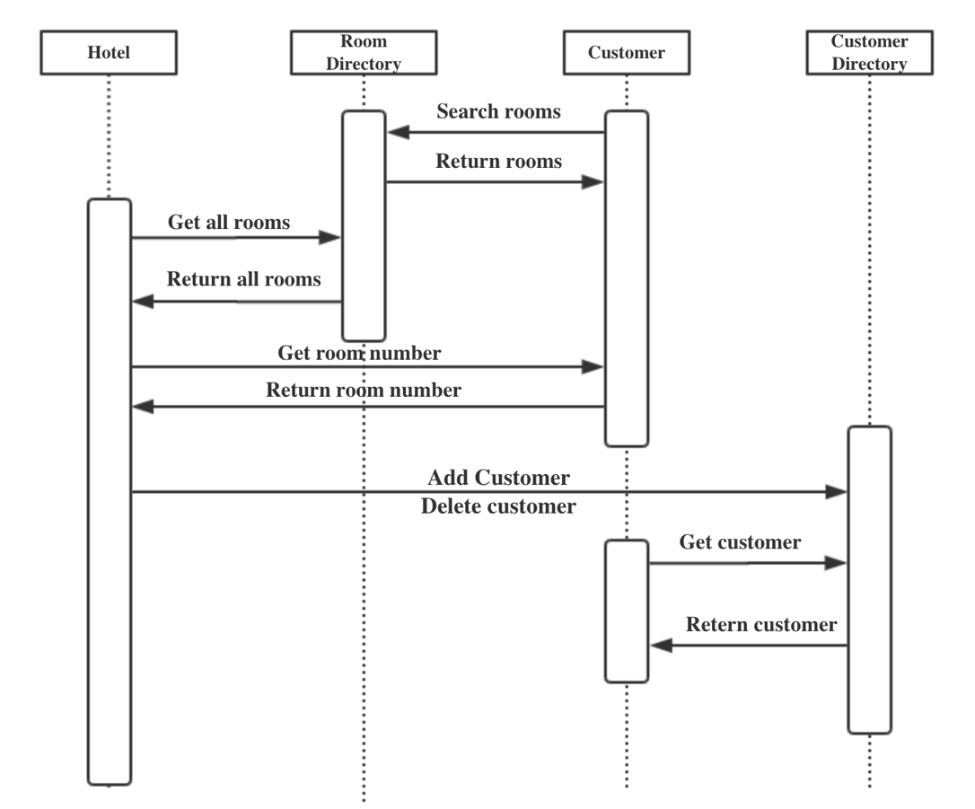

Fig(5)